Modelling Bounded Panel Global Food Insecurity Indicators with Correlated Random Effects

Abstract
Food insecurity has become a major issue of concern in different parts of the world, but empirical analysis is frequently limited by the statistical analyses that do not consider the limited and heterogeneous character of prevalence statistics. This investigation seeks to revisit the world patterns in extreme food insecurity through a coherent statistical panel model that focuses on inference and policy application. In particular, the research is aimed at estimating global and country-specific time dynamics, measuring the unobserved heterogeneity and determining the existence of a homogenous global trend once methodological shortcomings in the previous studies are overcome. A beta mixed effects model of correlated random intercepts and slopes was estimated using a fractional response panel model with more than 29,000 observations on a global country-year panel of more than 20 years. The study findings indicate that there is no statistically significant global linear trend of serious food insecurity prevalence (β_year $=$ 0.0029, p = 0.323) in contrast to the findings of previous linear panel studies. Significant between-country heterogeneity was observed, and there was a positive relationship between baseline prevalence and change across time ($ρ=$ 0.36), which implies country-level heterogeneity through structural differentiation. The suitability of the proposed approach is supported by the model diagnostics and fit statistics (AIC $=$ -33,488.6; BIC $=$ -33,447.6). The novelty of this study is that it combines the statistical assumptions with limited prevalence information and directly models the heterogeneity of countries that are correlated. Policy suggestions point to the implementation of country-specific shock-responsive policies instead of global averages to increase the pace of achieving Sustainable Development Goal 2.
Keywords: Severe food insecurity, beta mixed effects regression, global panel data, country-level heterogeneity, bounded outcome modelling, food security measurement.
Introduction
Food insecurity is among the most consistent development issues the global community has to face, and its health, productivity, social stability, and sustainable development are severely impacted (Ogwu et al., 2024; Gebre and Deshmukh, 2025; Shebanina et al., 2024; Wudil et al., 2022; Ghosh et al., 2024). The most extreme point of food insecurity is severe food insecurity, which is a state where people have lower food consumption, eating habits, and hunger, and is directly related to malnutrition, morbidity, and early mortality (Lonardo et al., 2025; Munialo and Mellor, 2024; Pakravan-Charvadeh et al., 2025). Although the world has made international commitments and policy interventions in the past decades, as it has been recently globalized, global evaluations suggest that the process of food insecurity reduction has been unevenly distributed and, in certain instances, reverted because of economic shocks, climate change, war, and a public health crisis (Xu et al., 2025; Saccone and Vallino, 2025; Nirmal et al., 2025; Wudil et al., 2022; Woodhill et al., 2022)
Effective measurement of food insecurity is crucial to the dynamics of food insecurity and the decision-making to respond effectively. More and more global monitoring programs are based on the model-based harmonised indicators, where one can compare results with the countries of the past and the present (Acs et al., 2025; Sarkar, 2022; A. Al-Ansari et al., 2025; Peters et al., 2025; Ammar et al., 2024). Severe food insecurity percentage, as a percentage of the population, has emerged as an indicator of considerable popularity in measuring the progress in the international development goals and in identifying the vulnerable populations (Gebre et al., 2024; Foini et al., 2023; Manikas et al., 2023). These indicators are normally reported at the country level on an annual basis, forming large-scale panel samples that have long time series and wide cross-country heterogeneity.
The number of empirical studies on food insecurity has grown significantly in the last two decades due to the increased accessibility of global data and increased focus on the policy (Saqib et al., 2025; Beyene, 2023; Abbas et al., 2025; Wudil et al., 2022; Akbari et al., 2022). The research conducted in the early days was mainly based on cross-sectional research or mere descriptions of trends, and frequently the ordinary least squares regression was used to correlate food insecurity outcomes with macroeconomic or demographic indicators (Wang et al., 2025; Salas-García et al., 2025; Nuvey et al., 2022; Affoh et al., 2022). Albeit informative, these methods typically neglected the limited range of prevalence measures and the panel format of data, which might result in inefficiency and limitations in interpretation.
Some studies proposed panel data methods, such as fixed-effects and random-effects linear analysis, to adjust the time-invariant country features(Ceesay et al., 2022; Wubetie et al., 2025; Aweke et al., 2022; Alfidi & El Moutaoukil, 2025). These models enhanced internal validity because they considered unobserved heterogeneity across countries, although they still made the assumption of linearity and normality that do not apply well to proportion data. More specifically, linear specifications are capable of producing predicted values that are not within the admissible range and do not reproduce the nonlinear behaviour of response at the boundaries, as are typical of prevalence indicators.
Other studies have also added high-tech econometric and machine learning techniques to predict food insecurity and evaluate the predictors (Carneiro et al., 2025; Zhao et al., 2025; Gholami et al., 2022; Alehile et al., 2025; Villacis et al., 2024). The machine learning techniques have shown a high predictive capability and the ability to be flexible in the development of complex relationships. Nonetheless, these models tend to be black box models, which have low interpretability and occur with low inferential grounds in policy analysis. Moreover, numerous machine learning studies do not sufficiently consider the problem of serial correlation and long-run structural variations across countries by considering country-level observations to be independent.
There is a relatively smaller amount of literature that applies fractional response models and generalised linear mixed models to development and health studies with bounded outcomes (Ayanwale et al., 2025; Li et al., 2025; Wubetie et al., 2024; Bofa & Zewotir, 2023). These studies show that beta regression and similar studies provide reliable modelling of proportion data when the conditional mean is characterised by nonlinear link functions and heteroskedasticity, which is a property of bounded support. These models can handle both the effects within countries and the variation between countries when generalised to panel data settings with random effects. While these are the advantages, the use of these models in addressing global food insecurity is very minimal, and there is hardly any literature that includes correlated random effects structures where the unobserved variables of a country are correlated with the observed variables.
Additionally, a significant portion of the literature deals with average global or regional patterns, which presupposes the homogeneous dynamics of the countries (Abdi et al., 2025; Bernard et al., 2022; Tackie et al., 2023). These heterogeneity latency strategies distort the varying food insecurity processes, such as stable high-prevalence states, incremental improvement trends, and fluctuating or reversing trends. The inability to consider this heterogeneity inhibits the capacity to develop policy interventions, which may be specific and contextual.
The combined literature has revealed three gaps. To begin with, a large number of empirical studies are based on modelling approaches, making them inconsistent with the limited and piecemeal characteristics of food insecurity indicators. Second, country-level heterogeneity that has not been measured and is correlated to temporal dynamics is not adequately dealt with, and this brings up the issue of biased inference. Third, little focus is paid to the process of discovering structural divergences of the food insecurity paths of countries and modelling them. These gaps drive the current study, which aims at enhancing the literature by employing a strict fractional response panel modelling model to the data on severe food insecurity around the world to enhance the statistical coherence, interpretability and policy implications of the empirical results.
Although such datasets can be important in terms of their information, they have serious statistical properties that create major analytical issues. The outcome variable will range between zero and a hundred percent which contravenes major assumptions that apply to the traditional linear regression models. Besides this, there are recurrent observations over time within countries, which bring about dependence structures, which should be factored out in order to avoid biased inference. Further complications in estimation are the country-specific unobserved factors, which include institutional capacity, agroecological factors, and socio-political stability, when they are also associated with observed time patterns. To meet these difficulties, methodological solutions are needed which acknowledge the limited nature of the data, which explicitly represent the dependence over time, and which address the unobserved heterogeneity in an appropriate manner.

Materials and Methods
Data Source and Data Characteristics
The present research utilises a massive international panel data set on food insecurity, which was acquired as the World Food Security Outcomes (WFSO) database, October 2024 release. The dataset is based on annual observations at the country level with over 20 years of repeated observations per country. The main measure under analysis is the level of severe food insecurity as a percentage of the total population, as a three-year focused average based on model-based approximations. The indicator finds extensive application in international surveillance systems and is in line with the international reporting standards on food security monitoring.
Its dataset is highly skewed as it represents disparities in the availability of data in different countries and years and contains more than 29,000 observations in more than 190 countries. This type of structure is characteristic of global development data sets, and it requires models that can take on to them the characteristics of unequal lengths of observation, serial dependence, and cross-sectional heterogeneity. The storage of the data and the metadata is publicly available on the World Bank Microdata Library: https://microdata.worldbank.org/index.php/catalog, where the methods of constructing the variables, the way the data was estimated, and the assumptions used in the methodology are documented in detail.
Statistical Modelling Framework
In order to deal with the limited scope of the outcome and the structure of the data, which is hierarchical, the study is based on the use of a fractional response panel model that is designed as a beta mixed effects model. Let $y_{it}$ denote the prevalence of severe food insecurity for the country $i$ in year $t$, rescaled to lie in the open interval (0,1). Conditional on covariates and random effects, $y_{it}$ is assumed to follow a beta distribution:
$$y_{it}∣μ_{it},ϕ∼\text{Beta}\left(μ_{it}ϕ,\left(1-μ_{it}\right)ϕ\right),$$
where $μ_{it}$ is the conditional mean and $ϕ$ is a precision parameter governing dispersion? The beta distribution is well-suited for proportion data because it naturally accommodates heteroskedasticity that varies with the mean.
The conditional mean is linked to a linear predictor through a logit link function:
$$\text{logit}\left(μ_{it}\right)=η_{it}.$$
The linear predictor incorporates both fixed effects and random effects:
$$η_{it}=β_{0}+β_{1}\left(t-\overset{‾}{t}\right)+b_{0i}+b_{1i}\left(t-\overset{‾}{t}\right),$$
where $β_{0}$ is the global intercept, $β_{1}$ captures the average temporal trend in severe food insecurity, and $b_{0i}$ and $b_{1i}$ are country‐specific random intercepts and random slopes, respectively. The time variable is centered at its mean $\overset{‾}{t}$ to reduce collinearity between intercepts and slopes.
The random effects are assumed to follow a bivariate normal distribution:
$$\left(\begin{matrix}b_{0i} \\ b_{1i}\end{matrix}\right)∼N\left(\left(\begin{matrix}0 \\ 0\end{matrix}\right),\left(\begin{matrix}σ_{0}^{2} & ρσ_{0}σ_{1} \\ ρσ_{0}σ_{1} & σ_{1}^{2}\end{matrix}\right)\right),$$
where $σ_{0}^{2}$ and $σ_{1}^{2}$ represent the variances of the random intercepts and slopes, respectively, and $ρ$ captures their correlation. Allowing for correlated random effects is a key methodological contribution, as it permits baseline levels of food insecurity to be systematically related to temporal dynamics, addressing a limitation of many previous panel studies that assume independence between country‐specific intercepts and trends.
Estimation and Model Evaluation
The maximum likelihood techniques are used as the model estimation by applying the generalized linear mixed modelling algorithms. The numerical integration methods to high-dimensional random effects are used to fit the beta mixed model. The adequacy of a model is evaluated based on information criteria such as Akaike Information Criterion and Bayesian Information Criterion that balance between model complexity and goodness of fit.
Pearson residuals plotted against fitted values are also used to conduct residual diagnostics to test the mean-variance fit and to test misspecification. Graphical comparisons of observed and model-fitted trajectories are made for a few countries to determine the capacity of the model to represent heterogeneous time patterns. The diagnostics give evidence as to whether the assumed beta distribution and link function are a sufficient representation of the data-generating process.
Results and Discussion
Table 1: Beta Mixed Model (Fractional Response Panel Fixed Effects)
Term | Estimate | SE | z | p | CI_Lower | CI_Upper
Intercept | -2.5444 | 0.0828 | -30.741 | < .001 | -2.7066 | -2.3822
Year (centered) | -0.0029 | 0.0029 | -0.988 | 0.323 | -0.0085 | 0.0028

Table 1 shows the fixed-effects results of the beta mixed model of severe food insecurity prevalence and gives an idea about the average temporal trend in the world, taking into consideration the effect of the constrained character of the phenomenon and country-specific clustering appropriately. The negative and quite substantial intercept is an indication of low probability of severe food insecurity at the proportion scale, which complies with global averages found in current monitoring research (Manikas et al., 2023; Foini et al., 2023). The centred year effect is negative, but it is statistically insignificant, which implies that after accounting for unobserved country heterogeneity, there is no consistent linear worldwide decrease in severe food insecurity throughout the study. This result is different to previous linear panel investigations, which have indicated large decreasing or increasing trends based on ordinary least squares or fixed-effects regressions (Affoh et al., 2022; Ceesay et al., 2022). The difference is due to the fact that the divergence of the studies was brought about by their assumption of linearity and lack of the restricted nature of prevalence measures, while the current framework of fractional response gives a more conservative and statistically consistent inference. Substantively, this finding indicates that the world has not experienced a straight linear trend in the reduction of severe food insecurity, which supports the arguments of Woodhill et al. (2022) and Saccone and Vallino (2025) that the world has not been progressing straight in the right direction in the last several decades. In policy terms, it highlights the importance of new focus on Sustainable Development Goal 2, especially target 2.1 on ending hunger, since global improvements of the aggregate will not be presupposed.
Table 2: Model Fit Statistics
Metric |  | Value
AIC |  | -33,488.60000
BIC |  | -33,447.58000
Log-likelihood |  | 16,750.30000
Random-effects Correlation (Intercept, Slope) |  | 0.36032

Adequacy and novelty of the proposed modelling approach, as shown in Table 2 presents the model fit statistics and random-effects correlation. The significantly negative AIC and BIC values are a strong indication of the empirical support of the beta mixed model over other simple linear specifications that are often used in the literature. This favourable relationship between country-specific intercepts and slopes indicates that countries that have a higher level of severe food insecurity are more likely to have a steeper change in terms of improvement or decline with time. Dependence structure is also not explicitly modelled in current food insecurity research, where the assumption is usually that the conditions and trends are independent of each other at the baseline (Wubetie et al., 2025; Tackie et al., 2023). The current study can be considered a more realistic representation of structural country differences since it allows the correlated effects to be taken into account, which was one of the limitations in the previous studies. This understanding is a direct policy implication because it suggests that countries with high burdens need distinct policies instead of universal interventions in order to attain SDG 2.
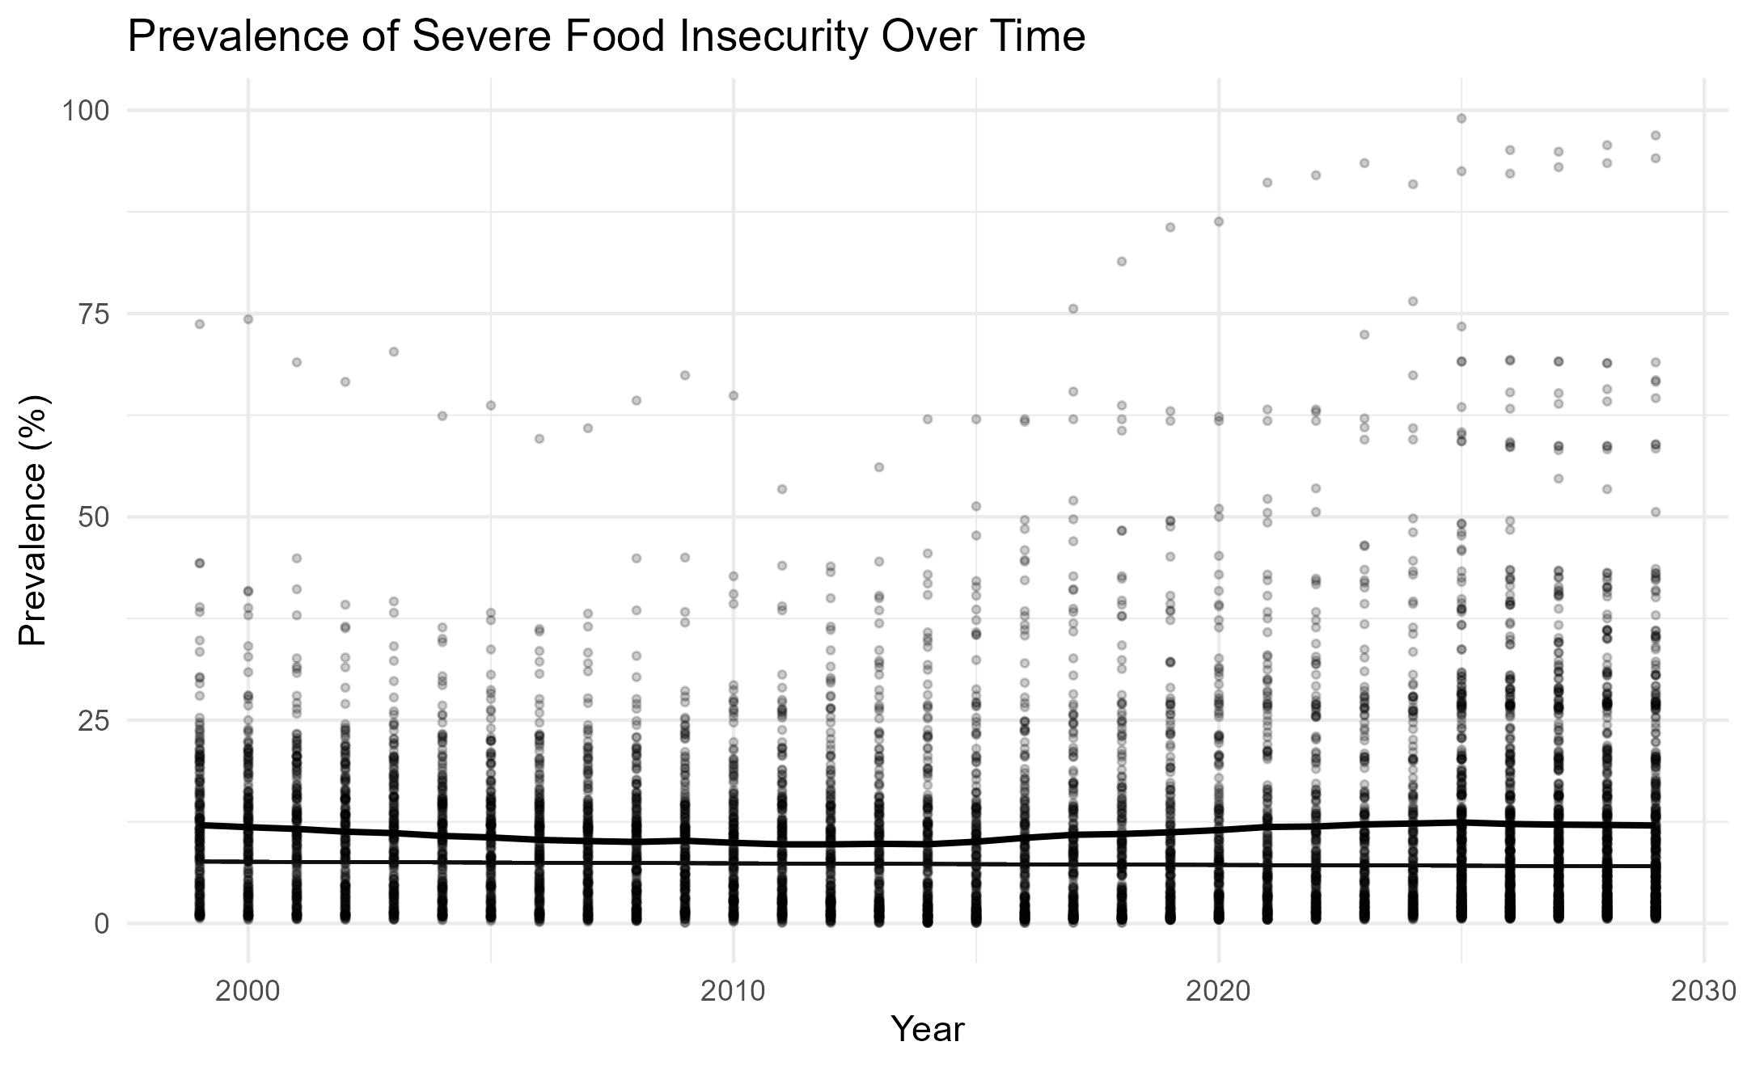
Figure 1: Prevalence of severe food insecurity over time
Figure 1 shows that severe food insecurity is rising over time, with all countries, as well as the marginal fitted trend of the response fractional model. The high vertical heterogeneity of the observations within a specific year points to a significant level of cross-country heterogeneity, which is usually lost when concentrating only on the world averages (Abdi et al., 2025; Bernard et al., 2022). The fitted curve suggests an almost flat world curve with weak nonlinearity, which is consistent with the recent findings that the world food insecurity has not really improved over a period but has stagnated (Xu et al., 2025; Penuelas et al., 2023). The results are superior to the previous descriptive trend models that indicated non-increasing but steady decreases in the long-term because they indicate that these findings can be the result of inappropriate linear modelling. This increases the methodological contribution of the study by demonstrating the effects of acknowledging the fractional nature of the data on substantive interpretation and enhancing the ability to support perceived global shocks involving changes in climate, conflict, and economic instability.
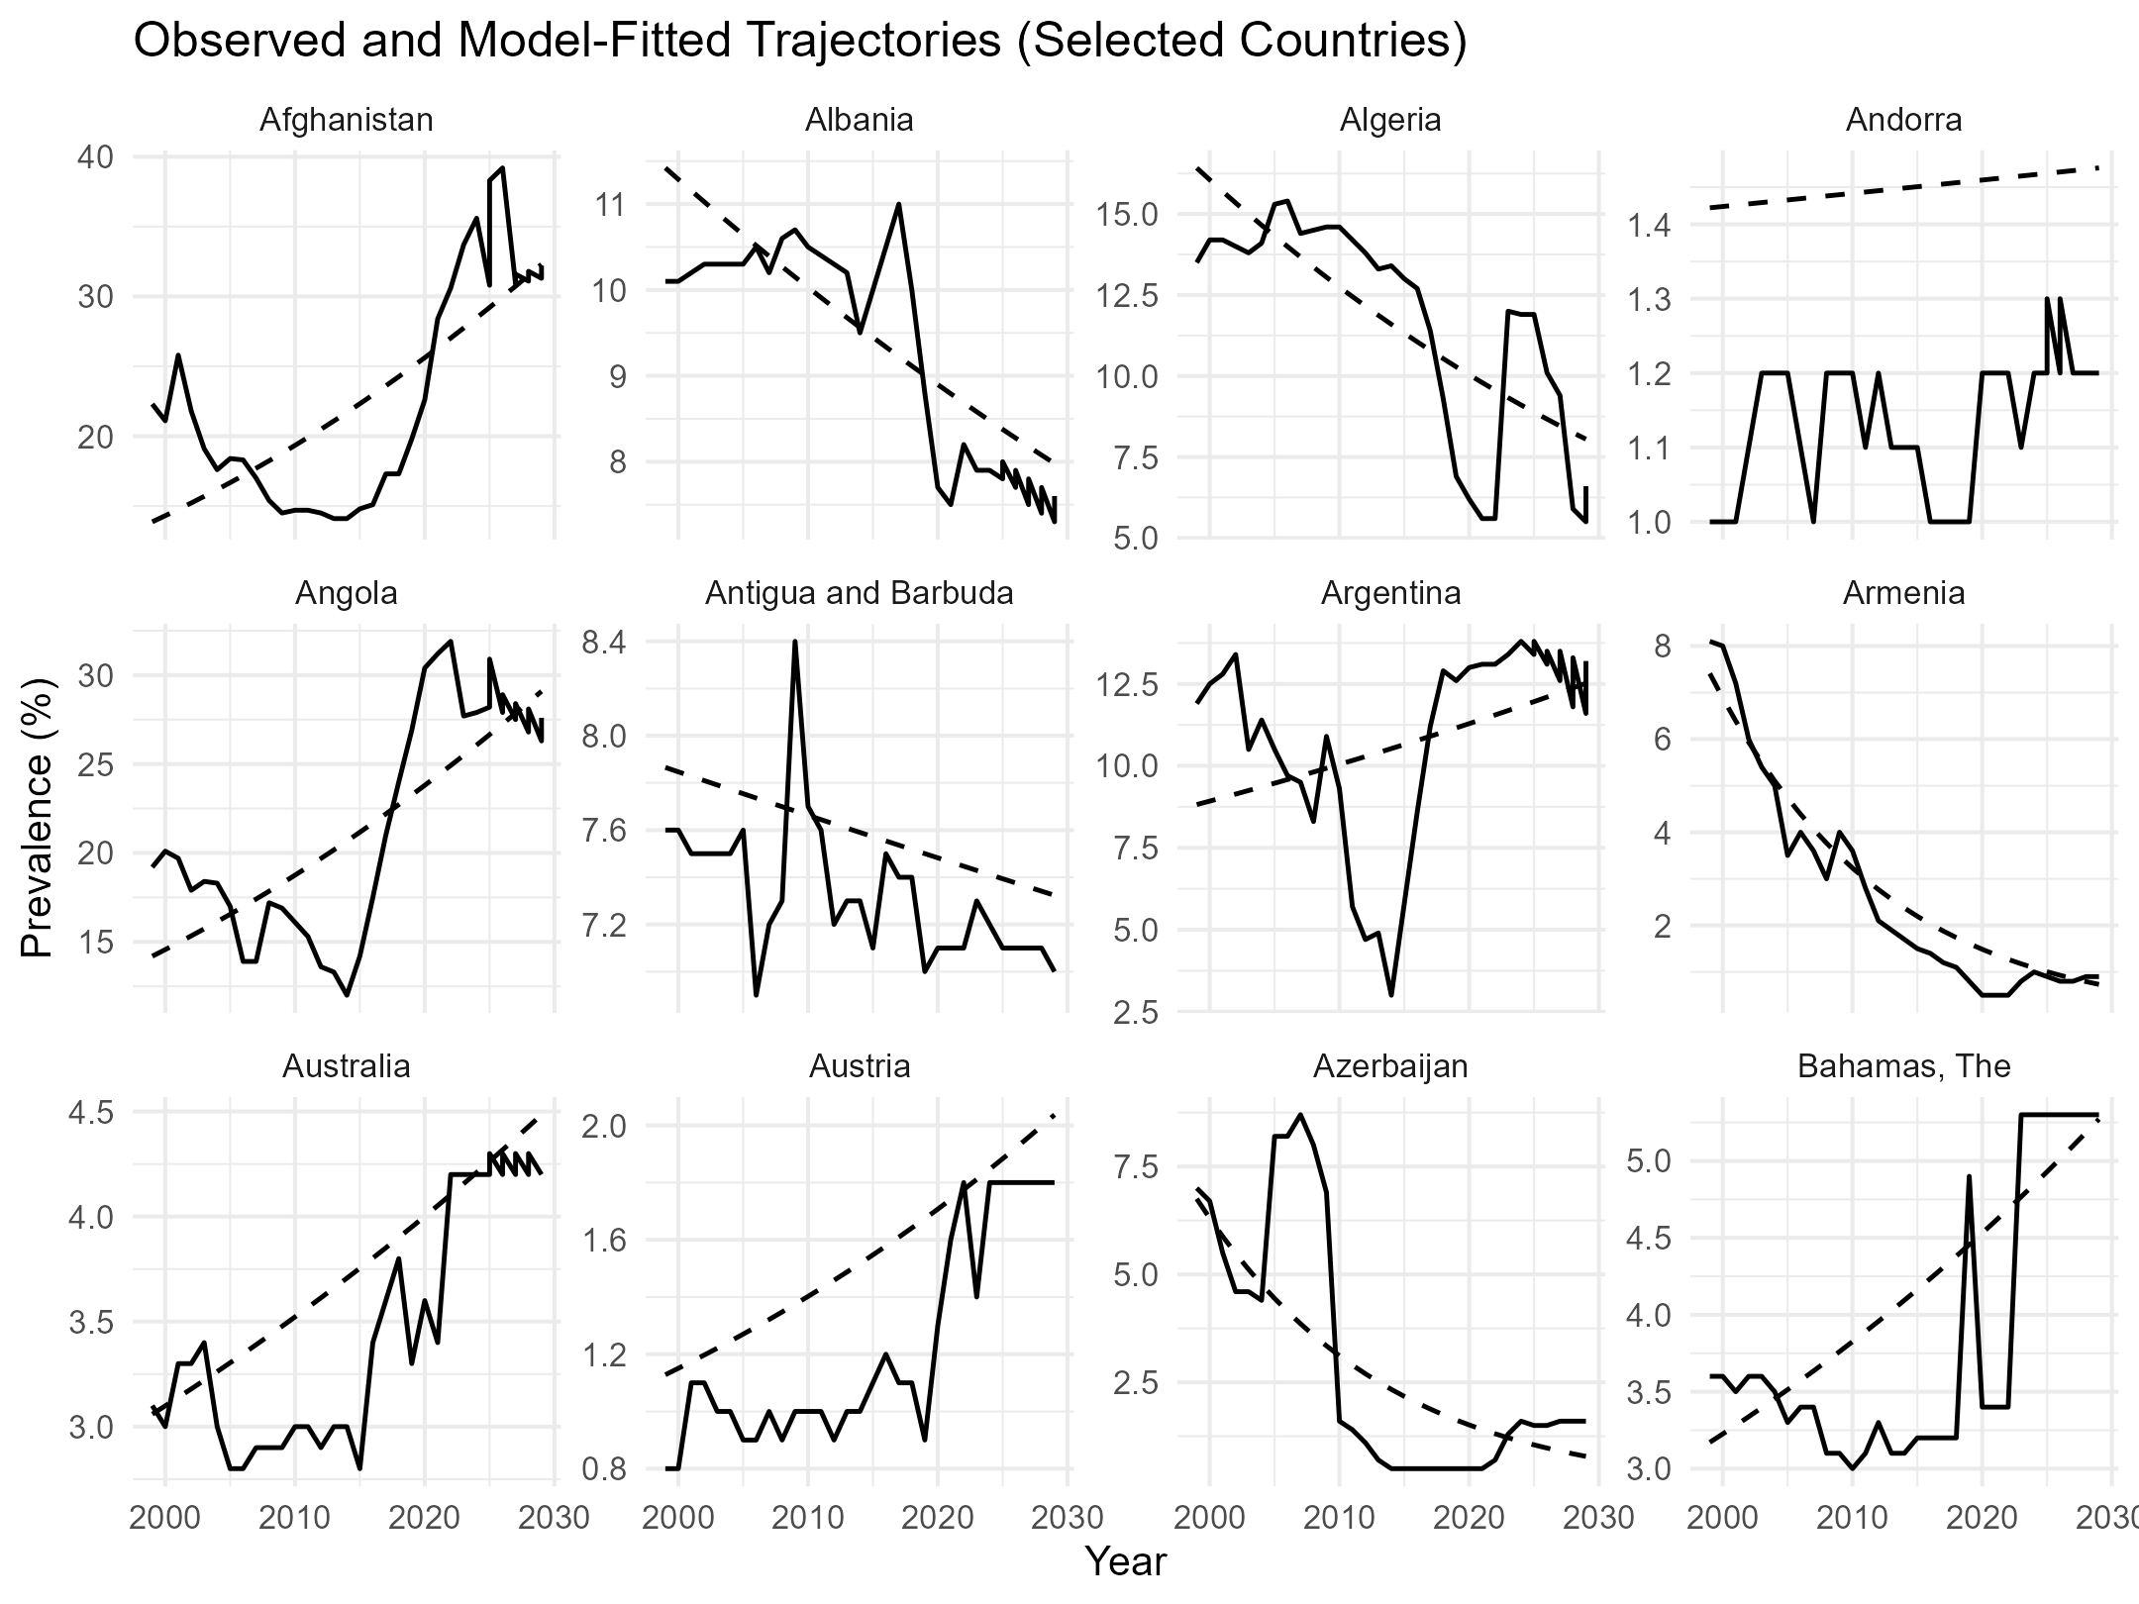
Figure 2: observed and model-fitted Trajectories (Selected countries)
Figure 2 shows observed and model-fitted paths, both of individual national economies, and gives even more insight into the national-level heterogeneous paths. Angola and Afghanistan report high positive changes in severe food insecurity, especially over the past years, which are aligned with conflict- and shock-determined accounts reported in Pakravan-Charvadeh et al. (2025) and Wudil et al. (2022). On the contrary, other countries like Armenia and Austria have declining trends, which are reflective of more structured institutional and socioeconomic settings. The similarity in the observed and fitted paths indicates that it can handle persistence and change without over-smoothing country-specific paths, which is its biggest weakness compared to global forecasting methods and machine learning methods that emphasise prediction rather than understanding (Carneiro et al., 2025; Villacis et al., 2024). These results help to argue that the dynamics of food insecurity are country-specific and that achieving SDG 2 should be assessed at the national level instead of making generalisations on the basis of the world statistics.
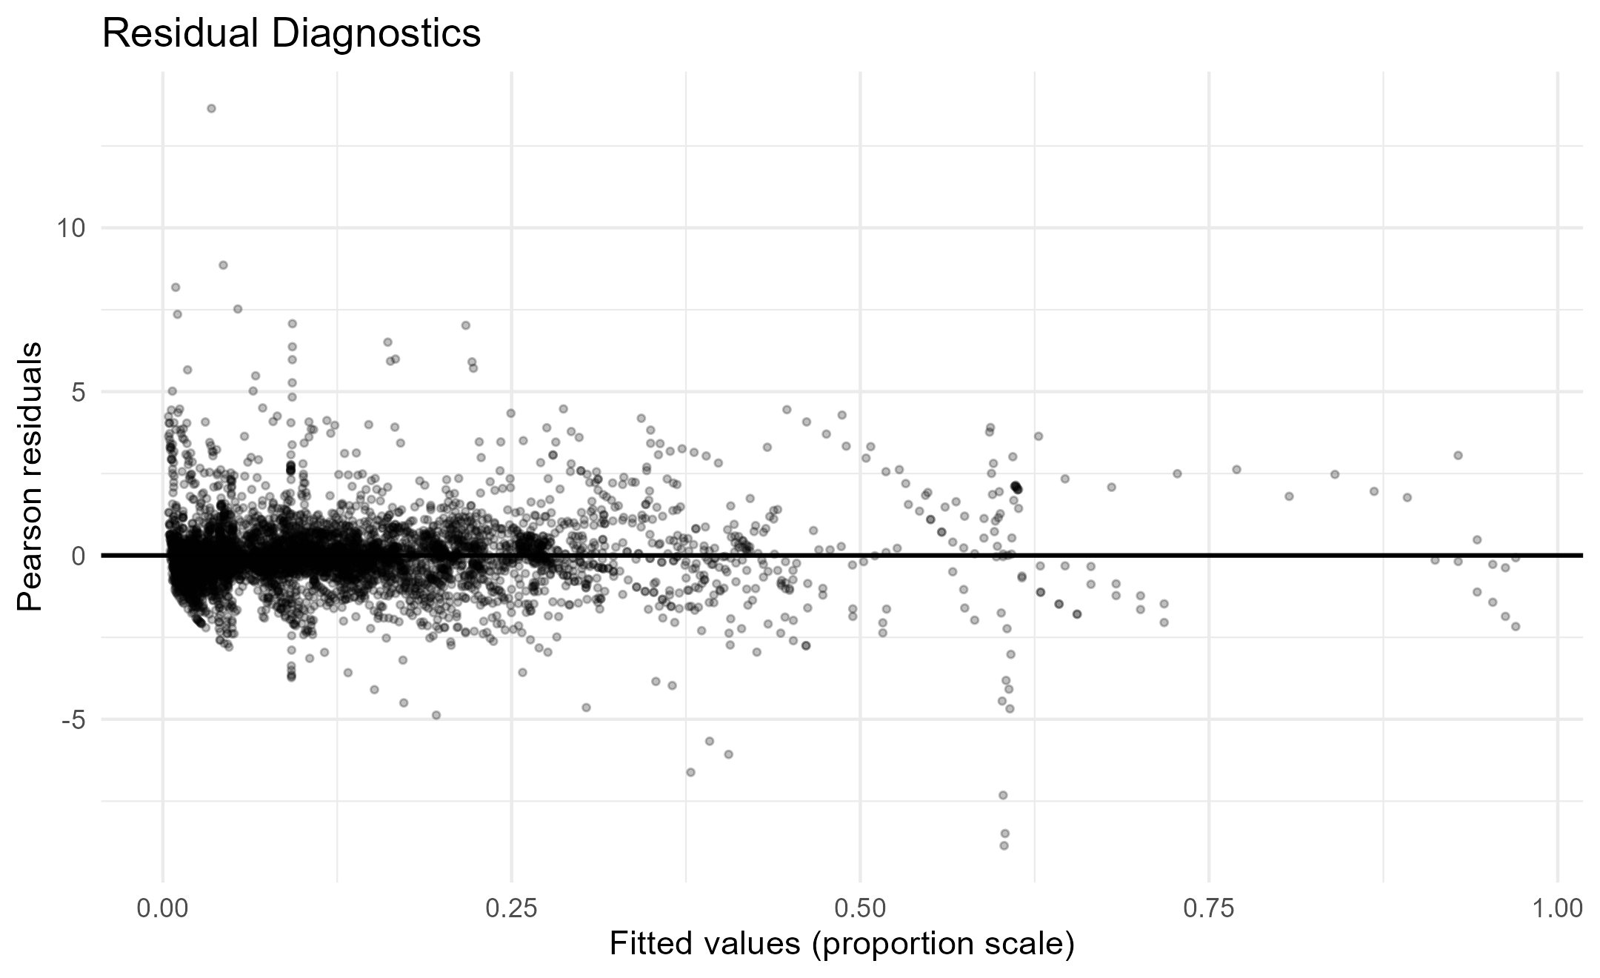
Figure 3: Pearson residuals versus fitted values
Figure 3 presents the plot of Pearson residuals versus fitted values and gives indicator of diagnostic evidence of model suitability. The residuals are symmetric around zero and no strong systematic trend is observed as the fitted range, which shows that beta mixed model is chosen as the appropriate one that describes the mean-variance relation of the limited proportions data. Although there is a certain dispersion at large fitted values, this effect is similar to the growing uncertainty at the countries with extreme food insecurity and has been documented in the corresponding fractional response applications (Bofa & Zewotir, 2023; Li et al., 2025). Notably, the lack of intrusive heteroskedastic effects or boundary artifacts is in contrast to the results of linear panel model diagnostics, which often display strong misspecification using prevalence results. This diagnostic performance enhances the beliefs in the strength of the empirical findings of the study.
On the whole, the discussion in Tables 1 and 2 and Figures 1 to 3 shows that the current research contributes to the food insecurity literature in three significant aspects. First, it offers statistically consistent inference on a global basis by assuming a fractional response panel program in which the data on prevalence is limited. Second, it directly captures correlated heterogeneity at the country level, which is a critical flaw of the previous linear and machine learning methods. Thirdly, it displays a significant heterogeneity of national paths that has direct effects on policy formulation and measurement of SDG 2. The fact that methodological innovation is connected to substantive global food security concerns makes this study a better empirical basis of evaluating progress and making specific interventions that would end extreme food insecurity in the world.
The current paper offers strong empirical findings on the dynamics of extreme food insecurity on the global scale by using a fractional response panel model, which explicitly diminishes the limitations of prevalence data and the temporal characteristics of the country-level evidence. The first significant result is that, after eliminating the unobserved country-specific heterogeneity by random intercepts and slope, the global linear pattern of prevalence of severe food insecurity does not significantly happen uniformly over the period of the study. Descriptive statistics and simple trend analysis may indicate gradual improvements or deteriorations, but the beta mixed model indicates that these apparent trends are in fact due to aggregation effects and modelling assumptions and not necessarily to a consistent underlying global trend. This finding supports the latest evaluations that show stagnations and reversals in food security developments around the world, especially under circumstances of economic shocks, climate stressors and geopolitical instabilities.
The second important discovery is that there is a high level of heterogeneity in the level of severe food insecurity and the trends of time series, which are substantial and systematic in different countries. Both the large variance values of country-specific intercepts show great discrepancies in the prevalence of food insecurity at the baseline, and the estimated value of the variance of country-specific slopes shows that countries have sharply different time trajectories. Notably, the positive association between random intercepts and slopes also suggests that the initial level of severe food insecurity has an impact on the temporal changes, which could either be a rapid decline or a faster improvement. This structural dependence has only been significantly neglected in previous food insecurity literature that has assumed the independence between baseline conditions and trends, and it has shown the value of modelling correlated unobserved heterogeneity.
Third, observed and model-fitted trajectories are analysed graphically, and the proposed model can capture a variety of country-specific dynamics without over-smoothing. The food insecurity trends of countries with long-term conflict, economic vulnerability, or climatic shocks are persistent or intensifying, and those in the more institutionally and economically stable countries are gradual and lasting. The fact that the observed and fitted trajectories are close in several contexts over an extensive range of contexts indicates the flexibility of the model and its ability to accommodate persistence and sudden changes. This result is the apparent methodological improvement over the approaches of global forecasting and machine learning, which need to be predictively accurate but frequently lack interpretable country-level dynamics that can be used in policy formulation.
Lastly, there are tests that show the sufficiency of the fractional response panel model. The residual patterns indicate no systematic deviations over the spectrum of fitted values, which means that the logit link and the beta distribution are suitable to describe the mean- variance relationship of severe food insecurity prevalence. The current method provides statistically coherent inferences and plausible estimates compared to the traditional linear panel models, which often have problems of boundary violation and heteroskedasticity when used on proportion data. Taken together, these insights indicate that methodological decisions have a significant effect on substantive findings concerning the trends and inequalities in food insecurity on a global scale.
Conclusion
The study paves the way toward an empirical study of severe food insecurity in the world by providing a serious fractional response panel model that complements statistical assumptions with intrinsic features of prevalence data. The study overcomes methodological shortcomings that have dominated the existing literature by accounting for the constrained nature of the outcome measure, directly modelling time dependence, and allowing country-specific random effects to be correlated.
The results refute the idea of a universal future of global trends in extreme food insecurity but tend to paint a highly diverse picture of how structural conditions in countries and changing shocks interact. This heterogeneity suggests that there are essential variations in the national experiences that are masked by aggregate world indicators and that can make false judgments of the progress achieved in eradicating hunger. These findings emphasise the idea that, instead of one-size-fits-all approaches, various and context-specific interventions should be employed. The long-term structural support needed by countries with continuously high baseline levels of severe food insecurity and timely shock-responsive policies may be applied to countries with a recent rise in the food insecurity situation.
In addition to its substantive contributions, the study also provides a methodological template upon which future food security studies can be conducted and also on the study of other indicators of bounded development. The fractional response panel method offers interpretable and statistically consistent estimations which are between purely descriptive trend forecasts and opaque machine learning forecasts. The research will help in enhancing the empirical basis of food insecurity monitoring in the world, and thereby a more plausible assessment of achievement of Sustainable Development Goal 2, as well as making evidence-based policy to eliminate severe food insecurity in the world.

Declarations
Data availability
The repository hosting the data and metadata is publicly accessible at the World Bank Microdata Library: https://microdata.worldbank.org/index.php/catalog, which provides detailed documentation on variable construction, estimation procedures, and underlying methodological assumptions.
Ethical Considerations
The research was based solely on publicly available, anonymised data, which did not require ethical consent.
Declaration of competing interest
The authors declare that they have no known competing financial interests or personal relationships that could have influenced the work reported in this paper.
Consent for Publication
Not applicable in the clinic

References
A. Al-Ansari, M., Nabeel, H., Abdella, G. M., & El Mekkawy, T. (2025). Moving Beyond Indices: A Systematic Approach Integrating Food System Performance and Characteristics for Comprehensive Food Security Assessment. Foods, 14(10), 1834.
Abbas, S., Haider, A., Kousar, S., Lu, H., Lu, S., Liu, F., ... & Zulqarnain, R. M. (2025). Climate variability, population growth, and globalization impacting food security in Pakistan. Scientific Reports, 15(1), 4225.
Abdi, A. H., Mohamed, A. A., & Sheikh, S. N. (2025). Navigating paths to food security in East Africa: strengthening rural development amid climate shocks, political instability, and rising food prices. Frontiers in Political Science, 7, 1636407.
Acs, S., Costa Leite, J., Sanye-Mengual, E., Caivano, A., Catarino, R., Druon, J. N., ... & Tóth, K. (2025). Towards sustainable food systems: developing a monitoring framework for the EU. Frontiers in Sustainable Food Systems, 8, 1502081.
Affoh, R., Zheng, H., Dangui, K., & Dissani, B. M. (2022). The impact of climate variability and change on food security in sub-saharan africa: Perspective from panel data analysis. Sustainability, 14(2), 759.
Akbari, M., Foroudi, P., Shahmoradi, M., Padash, H., Parizi, Z. S., Khosravani, A., ... & Cuomo, M. T. (2022). The evolution of food security: where are we now, where should we go next?. Sustainability, 14(6), 3634.
Alehile, K. S., Salami, H., & Otohinoyi, K. D. (2025). Climate change, environmental degradation, and food security in Nigeria: A machine learning analysis. Intelligent Agriculture, 1(1), 26-39.
Alfidi, K., & El Moutaoukil, A. (2025). Food Security in Africa: Challenges of Climate Change and Energy Opportunities. International Journal of Applied Economics, Finance and Accounting, 22(2), 105-115.
Ammar, K. A., Kheir, A. M., Ali, B. M., Sundarakani, B., & Manikas, I. (2024). Developing an analytical framework for estimating food security indicators in the United Arab Emirates: A review. Environment, Development and Sustainability, 26(3), 5689-5708.
Aweke, C. S., Sassi, M., Lahiff, E., & Wordofa, M. G. (2022). Seasonality and food security among smallholder rural households in eastern Ethiopia: Evidence from panel data analysis. Cogent Economics & Finance, 10(1), 2035492.
Ayanwale, A., Ige, A., Kehinde, A., Oyedele, D., & Adebooye, C. (2025). Understanding the factors contributing to food security among under-recognised indigenous vegetable farming households in Nigeria. Development in Practice, 35(7), 1072-1088.
Bernard Jr, B. M., Song, Y., Hena, S., Ahmad, F., & Wang, X. (2022). Assessing Africa’s agricultural TFP for food security and effects on Human development: Evidence from 35 Countries. Sustainability, 14(11), 6411.
Beyene, S. D. (2023). The impact of food insecurity on health outcomes: empirical evidence from sub-Saharan African countries. BMC Public Health, 23(1), 338.
Bofa, A., & Zewotir, T. (2023). The determinants of severe food insecurity in Africa using the longitudinal generalized Poisson mixed model. Lithuanian Journal of Statistics, 62, 1-19.
Carneiro, B., Resce, G., Caravaggio, N., Santangelo, A. E., Ruscica, G., Tucci, G., ... & Coffey, K. (2025). Text mining and machine learning reveal global determinants of food insecurity. Scientific Reports, 15(1), 36709.
Ceesay, E. K., & Moussa, Y. M. (2022). Pooled ordinary least-square, fixed effects and random effects modelling in a panel data regression analysis: A consideration of international commodity price and economic growth indicators in 35 Sub-Saharan African countries. International Journal of Technology Transfer and Commercialisation, 19(1), 23-44.
Foini, P., Tizzoni, M., Martini, G., Paolotti, D., & Omodei, E. (2023). On the forecastability of food insecurity. Scientific Reports, 13(1), 2793.
Gebre, A. A., & Deshmukh, M. S. (2025). Analysis of household food security status in Hadiya Zone, Central Ethiopia. Journal of Agriculture and Food Research, 19, 101652.
Gebre, T., Abraha, Z., Zenebe, A., & Zeweld, W. (2024). A comprehensive analysis of food insecurity in the drought–prone rural areas of Tigray. Journal of Health, Population and Nutrition, 43(1), 66.
Gholami, S., Knippenberg, E., Campbell, J., Andriantsimba, D., Kamle, A., Parthasarathy, P., ... & Ferres, J. L. (2022). Food security analysis and forecasting: A machine learning case study in southern Malawi. Data & Policy, 4, e33.
Ghosh, A., Kumar, A., & Biswas, G. (2024). Exponential population growth and global food security: challenges and alternatives. In Bioremediation of emerging contaminants from soils (pp. 1-20). Elsevier.
Li, C., Camac, J., Robinson, A., & Kompas, T. (2025). Predicting changes in agricultural yields under climate change scenarios and their implications for global food security. Scientific Reports, 15(1), 2858.
Lonardo, A., Zheng, M. H., & Weiskirchen, R. (2025). Food insecurity is an emerging risk factor for liver disease: a scoping review. Expert Review of Gastroenterology & Hepatology, 19(9), 1033-1049.
Manikas, I., Ali, B. M., & Sundarakani, B. (2023). A systematic literature review of indicators measuring food security. Agriculture & food security, 12(1), 10.
Munialo, C. D., & Mellor, D. D. (2024). A review of the impact of social disruptions on food security and food choice. Food Science & Nutrition, 12(1), 13-23.
Nirmal, N., Anyimadu, C. F., Khanashyam, A. C., Bekhit, A. E. D. A., & Dhar, B. K. (2025). Alternative protein sources: Addressing global food security and environmental sustainability. Sustainable Development, 33(3), 3958-3969.
Nuvey, F. S., Nortey, P. A., Addo, K. K., Addo-Lartey, A., Kreppel, K., Houngbedji, C. A., ... & Bonfoh, B. (2022). Farm-related determinants of food insecurity among livestock dependent households in two agrarian districts with varying rainfall patterns in Ghana. Frontiers in Sustainable Food Systems, 6, 743600.
Ogwu, M. C., Izah, S. C., Ntuli, N. R., & Odubo, T. C. (2024). Food security complexities in the global south. In Food safety and quality in the global south (pp. 3-33). Singapore: Springer Nature Singapore.
Pakravan-Charvadeh, M. R., Longworth, Z., Lane, G., Béland, D., Koc, M., Clark, N., ... & Vatanparast, H. (2025). Complexities of food insecurity and quality of life in Afghanistan under the Taliban, moving towards integrated approaches and well-being enhancement. Food Security, 1-19.
Penuelas, J., Coello, F., & Sardans, J. (2023). A better use of fertilizers is needed for global food security and environmental sustainability. Agriculture & Food Security, 12(1), 1-9.
Peters, A. I., Onunga, J. O., & Akwee, P. E. (2025). Terrestrial Biodiversity Data Processing and Sharing Architectural Model Based on IoT Technology for Sustainable Livelihoods: A Conceptual Review. International Journal of Research and Scientific Innovation (IJRSI), 12(10).
Saccone, D., & Vallino, E. (2025). Global food security in a turbulent world: reviewing the impacts of the pandemic, the war and climate change. Agricultural and Food Economics, 13(1), 47.
Salas-García, M. A., Bernal-Orozco, M. F., Díaz-López, A., Betancourt-Núñez, A., Nava-Amante, P. A., & Vizmanos, B. (2025). Associations of Sociodemographic Characteristics with Food Choice Motives’ Importance Among Mexican Adults: A Cross-Sectional Analysis. Foods, 14(2), 158.
Saqib, S. E., Yaseen, M., Ali, S., & Visetnoi, S. (2025). Agricultural Land Conversion and Challenges for Tenant Farmers: Empirical Evidence From Pakistan. Land Degradation & Development, 36(3), 802-815.
Sarkar, P. R. (2022). Data-Driven Quality Assurance Systems For Food Safety In Large-Scale Distribution Centers. ASRC Procedia: Global Perspectives in Science and Scholarship, 2(1), 151-192.
Shebanina, O., Poltorak, A., & Chorniy, D. (2024). Global food security: Challenges in achieving the Sustainable Development Goals. Ukrainian Black Sea Region Agrarian Science, 28(4), 9-20.
Tackie, E. A., Chen, H., Ahakwa, I., Amankona, D., & Atingabili, S. (2023). Drivers of food security in West Africa: Insight from heterogeneous panel data analysis on income-level classification. Environmental Science and Pollution Research, 30(37), 87028-87048.
Villacis, A. H., Badruddoza, S., & Mishra, A. K. (2024). A machine learning‐based exploration of resilience and food security. Applied Economic Perspectives and Policy, 46(4), 1479-1505.
Wang, W., Mensah, I. A., Atingabili, S., Omari-Sasu, A. Y., Nouwati, E., Kunkuaboor, C. Y., & Qiao, M. (2025). The nexus between food security, health outcomes, and climate change: a multisectoral approach to sustainable development in Africa. BMC Public Health, 25(1), 2319.
Woodhill, J., Kishore, A., Njuki, J., Jones, K., & Hasnain, S. (2022). Food systems and rural wellbeing: challenges and opportunities. Food Security, 14(5), 1099-1121.
Wubetie, H. T., Zewotir, T., Mitku, A. A., & Dessie, Z. G. (2024). The spatial effects of the household's food insecurity levels in Ethiopia: by ordinal geo-additive model. Frontiers in Nutrition, 11, 1330822.
Wubetie, H. T., Zewotir, T., Mitku, A. A., & Dessie, Z. G. (2025). The spatial effects of the household's food insecurity levels in Ethiopia. Sustainable and Resilient Food Systems in Times of Crises, 99.
Wudil, A. H., Usman, M., Rosak-Szyrocka, J., Pilař, L., & Boye, M. (2022). Reversing years for global food security: A review of the food security situation in Sub-Saharan Africa (SSA). International Journal of environmental research and Public Health, 19(22), 14836.
Xu, Y., Chou, J., Zhao, W., Li, Y., Hao, Y., & Jin, H. (2025). Constructing a composite index to evaluate multidimensional variations in food security over different regions. Ambio, 54(6), 1057-1073.
Zhao, L., Yang, M., Min, S., & Qing, P. (2025). Prediction of household food insecurity in rural China: an application of machine learning methods. International Food and Agribusiness Management Review, 1(aop), 1-21.

