Original Research Article

Hormonal Steering of Sex Expression in Cucumber (Cucumis sativus L.): Modulatory Effects of GA₃, NAA, AgNO₃ and Ethrel

ABSTRACT
The study was conducted from February to May 2021 at the Vegetable Research Farm, Department of Horticulture, Institute of Agricultural Sciences, Banaras Hindu University, Varanasi (U.P.), India. Cucumber (Cucumis sativus L.), a monoecious species, was recognized as the second most widely cultivated cucurbit after watermelon. As sex expression played a critical role in influencing yield, the experiment aimed to evaluate the effects of various plant growth regulators (PGRs) gibberellic acid (GA₃), naphthalene acetic acid (NAA), silver nitrate (AgNO₃), and ethrel applied at three concentrations alongside a control. The experiment followed a randomized block design (RBD) with thirteen treatments and three replications under open-field conditions. Significant variation (p < 0.05) was observed among treatments for all phenotypic traits. Ethrel at 300 ppm exerted the strongest feminizing effect, resulting in the highest number of female flowers per vine (23.00), the earliest female flower initiation (38.00 days), and the lowest sex ratio (0.48). In contrast, AgNO₃ at 375 ppm induced the highest number of male flowers (24.33) and the highest sex ratio (1.66). GA₃ promoted early flowering while maintaining a balanced sex ratio, whereas NAA increased both male and female flower production without significantly altering sex expression. Control plants exhibited delayed flowering (45.33 days) and a higher nodal position for the first female flower (12.22). Overall, Ethrel proved to be the most effective PGR in enhancing femaleness, highlighting the potential for hormonal manipulation to regulate sex expression and improve cucumber yield.
Keywords: cucumber, ethrel, flowering dynamics, sex expression, yield enhancement
- INTRODUCTION
Cucumber (Cucumis sativus L.) is a widely cultivated and economically significant vegetable, consumed fresh and processed. Its high-water content, cooling effect, and rich composition of vitamins, minerals, and dietary fibre make it vital to human nutrition worldwide (Mir et al., 2019; Gosai et al., 2020). Cucumber is a monoecious plant species, characterized by the presence of both staminate (male) and pistillate (female) flowers on the same plant (Adhikari et al., 2012). However, only the pistillate flowers are capable of setting fruit upon successful pollination and fertilization. Therefore, the ratio and timing of appearance of female flowers directly affect fruit yield and overall productivity of the crop. In this context, sex expression, the relative production and temporal distribution of male and female flowers, becomes a crucial determinant in cucumber cultivation and breeding programs. It is governed by complex genetic mechanisms but is also strongly influenced by environmental factors such as photoperiod, temperature, light intensity, and more importantly, by endogenous hormonal balances (Lai et al., 2018; Luo et al., 2023). Among the various plant hormones, ethylene and gibberellins (GAs) have emerged as the most prominent regulators of sex expression in cucumber (Adhikari et al., 2012; Fu et al., 2015). Ethylene is well-known for its feminizing effects, promoting the initiation and development of pistillate flowers, while gibberellins, particularly gibberellic acid, are known to enhance the formation of staminate (male) flowers (Yamasaki et al., 2003; Alzeaideen, 2022). These hormones influence floral primordia differentiation and can significantly alter the floral sex ratio depending on their endogenous levels or exogenous application (Barsoom and Attala, 2020; Zhang et al., 2017). Additionally, auxins, another important class of phytohormones, have been implicated in modulating sex expression by enhancing ethylene synthesis or sensitivity in floral tissues (Chen et al., 2025). Exogenous application of synthetic auxins like naphthaleneacetic acid has been reported to increase the proportion of female flowers, possibly through ethylene-mediated pathways (Alotaibi et al., 2024; Thappa et al., 2011). Moreover, ethylene action can be specifically inhibited using anti-ethylene compounds such as silver nitrate, which has a masculinizing effect and is widely used in hybrid seed production programs (Karakaya and Padem, 2011; Yamasaki and Manabe, 2011). In gynoecious cucumber lines, which typically produce only female flowers, application of silver nitrate can induce male flower formation, thereby facilitating pollen production for hybridization (Kaur et al., 2024). Ethylene-releasing compounds such as ethephon (commonly known as ethrel) are also used in commercial cultivation to shift the floral balance toward femaleness and enhance yield potential (Manzano et al., 2014). The use of plant growth regulators such as GA₃, NAA, ethrel, and AgNO₃ has become an integral component of modern horticultural practices to modulate growth, flowering behaviour, and sex expression in cucurbitaceous crops (Daryono et al., 2018; Gosai et al., 2020). However, most of the available research on PGR-induced changes in cucumber sex expression has been conducted under controlled or semi-controlled conditions, with limited studies addressing their comparative effects under open-field environments (Barcenas Jr and Barcenas, 2023; Mir et al., 2019). This gap in research is particularly significant, considering the fluctuating environmental variables in field settings that may influence hormonal responses. Therefore, the present investigation was undertaken to systematically evaluate the influence of four major plant growth regulators gibberellic acid, naphthaleneacetic acid, silver nitrate, and ethrel on the flowering behaviour and sex expression of cucumber under open-field conditions. The ultimate goal was to determine the most effective treatments for promoting female flower production and enhancing yield potential, thereby contributing to the development of more efficient cultivation strategies and breeding protocols.
- MATERIALS AND METHODS
The field trial was conducted at the Vegetable Research Farm under the Department of Horticulture, Institute of Agricultural Sciences, Banaras Hindu University, Varanasi (U.P.), India, from February to May 2021. The study utilized a randomized block design comprising 13 treatments with three replicates each, totalling 39 plots. From each treatment, five plants were randomly selected and tagged for measurement of biometric and reproductive characteristics. The cucumber variety ‘Swarna Sheetal’ was used in the experiment. Seeds were sown in a well-prepared field at a spacing of 120 × 60 cm during 2021. Experimental treatments included foliar sprays of gibberellic acid (GA₃) at concentrations of 50, 100 and 150 ppm; naphthalene acetic acid (NAA) at 25, 50 and 75 ppm; silver nitrate at 125, 250 and 375 ppm; and ethrel at 100, 200 and 300 ppm. These were applied at 15, 30, and 45 days after sowing. Various phenological characters were recorded, including days to first male and female flowering, nodal position of the first male and female flowers, days to 50% flowering, number of male and female flowers plant⁻¹ and the sex ratio. The collected data were analysed using Analysis of Variance (ANOVA) and treatment means were compared through the critical difference (CD) test at a 5% significance level. Additionally, the standard error of the mean (SEm ±) was calculated to assess the precision and reliability of the results.
- RESULTS AND DISCUSSION
  - Temporal dynamics of floral initiation
The exogenous application of plant growth regulators significantly modulated the timing of floral differentiation in cucumber, with treatments exhibiting statistically significant effects (p ≤ 0.05) as detailed in Figure 1. The earliest initiation of staminate flowers was observed in the untreated plot (T₁₃) at 34.5 days post-sowing. In contrast, Ethrel applied at 300 ppm (T₁₂) induced the most pronounced delay, with male flower emergence at 38.7 days, corresponding to a 10.9% postponement relative to the control. This delay aligns with the known physiological role of ethylene-releasing agents in antagonizing gibberellin-driven androecy, thereby reallocating assimilates toward pistillate differentiation at the expense of early male floral development (Thappa et al., 2011; Yamasaki et al., 2003). Our findings corroborate this paradigm, demonstrating that exogenous ethylene suppresses the temporal precedence of male floral primordia and potentially alleviates resource competition with subsequent female flowers (Manzano et al., 2011). Conversely, gibberellic acid treatments (T₁–T₃) expedited male floral initiation, with flowering observed between 36.5 and 38.1 days, outperforming most ethrel and NAA treatments. This acceleration supports previous reports that gibberellins enhance androecious gene expression in cucurbits, reinforcing their pivotal role in promoting maleness (Fu et al., 2015; Kaur et al., 2024). Furthermore, ethrel 300 ppm (T₁₂) significantly shifted the nodal position of the first male flower upward to 5.03 nodes from 2.81 nodes in control plants, marking a 79% elevation. This positional shift delays staminate anthesis until the vine attains adequate vegetative biomass, thereby optimizing resource allocation for subsequent fruit set (Barsoom and Attala, 2020).
  - Acceleration of pistillate differentiation
Ethrel exerted a pronounced feminizing effect by substantially advancing the onset of pistillate flowering as depicted in Figure 1. The treatment (T₁₁) with ethrel 200 ppm reduced days to first female flower by 7.66 days compared to the control, flowering at 37.67 days versus 45.33 days, a 16.9% enhancement. This acceleration likely reflects ethylene-mediated upregulation of ACC synthase and downstream ethylene biosynthesis pathways, pivotal for pistillate gene activation (Yamasaki et al., 2003; Manzano et al., 2011). In contrast, the naphthalene acetic acid treatments exhibited a comparatively muted effect, suggesting that the applied auxin concentrations were insufficient to significantly elevate ethylene production (Alotaibi et al., 2024; Thappa et al., 2011). Additionally, ethrel 200 ppm (T₁₁) induced a marked reduction in the nodal position of the first female flower to 7.39, nearly five nodes lower than the control (12.22 nodes). This downward nodal shift enhances sink strength by shortening the photosynthate translocation distance to developing ovaries, a factor positively correlated with increased marketable yield (Fajri et al., 2022).
  - Progression to peak bloom
The interval to 50% flowering was significantly abbreviated in Ethrel-treated vines in Figure 2, ranging from 45.0 days (Ethrel 100 ppm) to 52.67 days in controls. This reduction of 7–8 days accelerates reproductive maturity, an agronomically advantageous trait in short-season or staggered planting systems aiming for continuous harvests (Mir et al., 2019; Gosai et al., 2020).
  - Quantitative shifts in male and female floral production
Application of silver nitrate at 375 ppm (T₉) markedly increased staminate flower production (24.33 flowers per vine), consistent with Ag⁺ ions’ antagonistic action on ethylene receptors, which derepresses male flower development pathways (Li et al., 2022; Yamasaki and Manabe, 2011). This stimulatory effect on maleness is exploited in hybrid seed production to ensure ample pollen availability. In contrast, ethrel at 300 ppm (T₁₂) significantly increased pistillate flower numbers to 23.0 vine⁻¹, representing a 43.5% increase over the control (13.0 flowers). The dose-response within the 100–300 ppm ethrel range was nonlinear, with the intermediate concentration (T₁₁) yielding 21.33 female flowers, indicating a saturation threshold in ethylene responsiveness under the prevailing experimental conditions (Manzano et al., 2014; Jonoubi and Arang, 2024).
  - Optimization of sex ratio
The sex ratio (male: female) varied considerably among treatments Figure 2, shifting from a male-biased ratio of 1.66 under AgNO₃ 375 ppm to a female-biased ratio of 0.48 under Ethrel treatments (100 and 300 ppm). Ethrel-treated vines produced approximately two female flowers per male flower; a ratio deemed optimal for maximizing fruit set while maintaining sufficient pollen in monoecious cultivars (Fajri et al., 2022; Ye et al., 2020). GA₃ treatments maintained near parity (~1.1), underscoring their limited utility for fruit yield enhancement but highlighting their potential for inducing maleness in gynoecious breeding lines (Kaur et al., 2024).
  - Integrative interpretation and agronomic implications
The results collectively demonstrate that the hormonal regulation of sex expression in cucumber is both concentration-dependent and compound-specific. Ethrel significantly advanced pistillate flower initiation, reduced the nodal position of female flowers, shortened the vegetative phase, 50% flowering and increased female flower abundance, collectively enhancing fruiting potential (Barcenas Jr and Barcenas, 2023; Yamasaki et al., 2003). These effects align with ethylene’s central role in biasing floral meristems toward femaleness (Alzeaideen, 2022; Manzano et al., 2011). Conversely, silver nitrate suppressed ethylene perception, favouring male flower development, a desirable trait for hybrid seed production that requires prolific pollen output (Karakaya and Padem, 2011; Yamasaki and Manabe, 2011). GA₃ promoted male flowering and pollen synchrony but delayed female flower emergence and reduced number of pistillate flowers, limiting its use to male flower induction in breeding or specialized cultivation scenarios where vegetative vigour is prioritized over fruit yield (Fu et al., 2015; Ren and Pinheiro, 2022). NAA demonstrated intermediate effects, consistent with its indirect modulation of sex expression via ethylene synthesis pathways. However, its efficacy under the tested dosages was comparatively limited (Alotaibi et al., 2024; Gosai et al., 2020).
(Figure 1)-effect of PGRs on flower initiation timing and nodal position

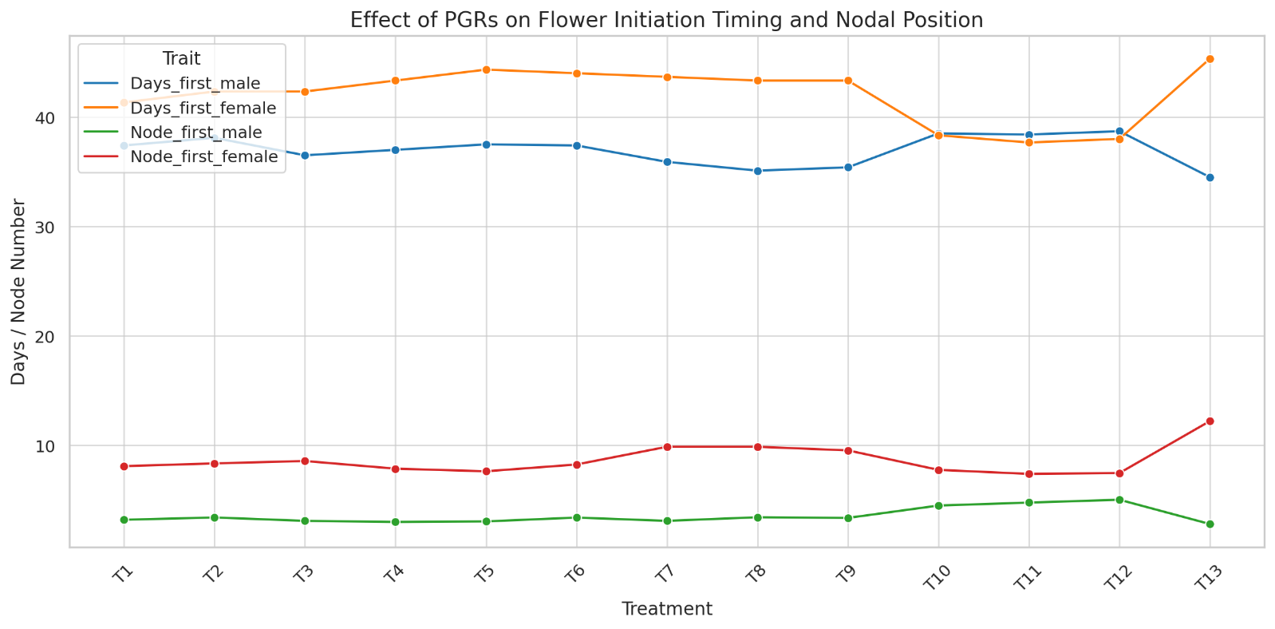

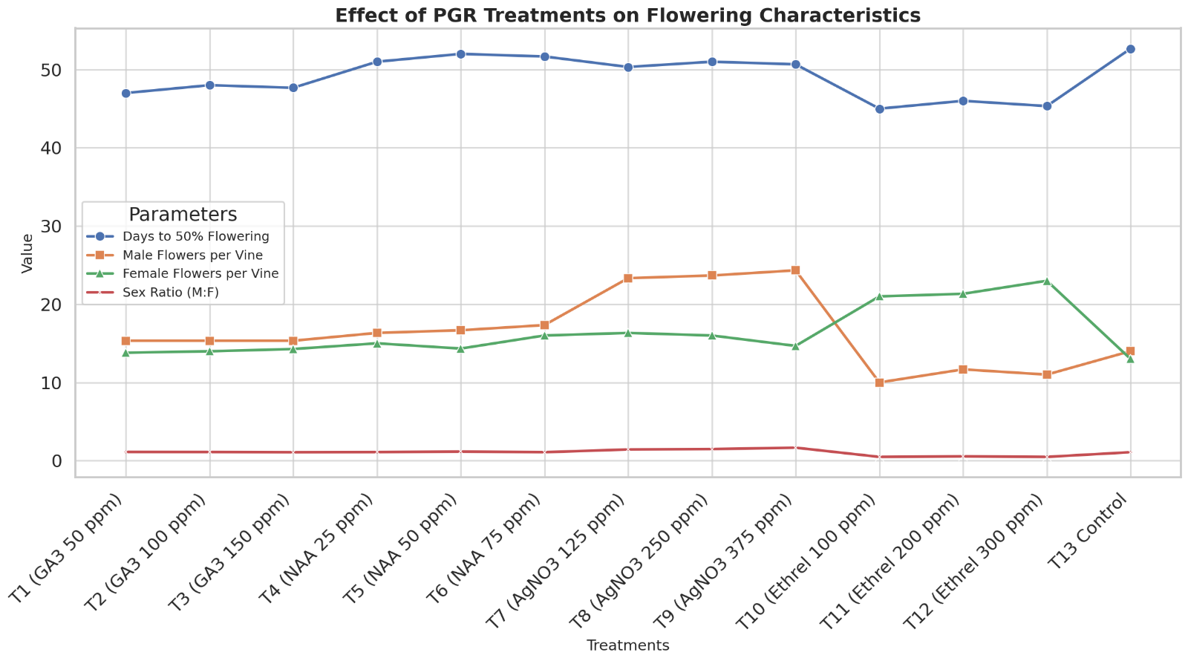
(Figure 2)- effect of PGR treatments on flowering characteristics
- CONCLUSION
The study demonstrated that GA₃, NAA, AgNO₃ and Ethrel significantly influenced sex expression in cucumber plants through changes in flowering behaviour and sex ratios. Ethrel and NAA induced early initiation of female flowers and elevated female-to-male ratios, while GA₃ and AgNO₃ promoted male traits and delayed flower development. These results highlighted how targeted hormonal interventions shaped floral dynamics effectively. Utilizing such plant growth regulators has proven valuable for strategic crop planning, hybrid seed production, enhanced yield outcomes and optimizing cucumber cultivation practices.

REFERENCES

- Adhikari, S., Bandyopadhyay, T. K. and Ghosh, P. (2012). Hormonal control of sex expression of cucumber (Cucumis sativus L.) with the identification of sex-linked molecular markers. Nucleus, 55(2): 115–122.
- Alotaibi, M. M., Nagy, M., Almuziny, M., Alsubeie, M. S., Abo-Zeid, A., Alzuaibr, F. M., Alasmari, A., Albalawi, B. F. A., Abd-Elwahed, A., Ismail, K. A. and Awad-Allah, M. M. A. (2024). The effect of foliar application with naphthalene acetic acid and potassium nitrate on the growth, sex ratio, and productivity of cucumbers (Cucumis sativus L.) under high temperatures in semi-arid areas. Agronomy, 14(6): 1202.
- Alzeaideen, K. (2022). Ethylene plays a dual role in sex determination and fruit shape in cucurbits. Current Biology, 32(11): 2390–2401.
- Barcenas Jr, G. A. and Barcenas, L. M. I. (2023). Vegetative growth characteristics and flower sex expression of Cucumis sativus affected by exogenous application of plant growth regulators. Sarhad Journal of Agriculture, 39(4): 815–822.
- Barsoom, M. A. and Attala, M. A. (2020). Effect of ethrel and gibberellic acid on growth, flowering, sex ratio and yield of luffa plant. Middle East Journal of Agriculture Research, 9(4): 984–993.
- Chen, L., Qiu, Z., Dong, J., Bu, R., Yu, Z., Wang, H. and Hu, L. (2025). CsPHYB–CsPIF3/4 regulates hypocotyl elongation by coordinating the auxin and gibberellin biosynthetic pathways in cucumber (Cucumis sativus L.). Plants, 14(3): 371.
- Daryono, B. S., Prasetya, E., Sumarlina, S. D. and Subiastuti, A. S. (2018). The effect of ethepon treatment on the formation of flower in melon (Cucumis melo L.). Proceedings of the 2nd International Conference on Tropical Agriculture: 7–13.
- Fajri, S. N., Sutari, W. and Hamdani, J. S. (2022). Growth, yield, and fruit quality responses of three cucumber (Cucumis sativus L.) varieties to different ethephon concentrations. Emirates Journal of Food and Agriculture, 34(1): 1–8.
- Fu, X., Gao, X. and Liu, X. (2015). Integration of ethylene and gibberellin signalling. In: Ethylene and Auxin Signal Integration: 153–173. Springer, Dordrecht.
- Gosai, S., Adhikari, S., Khanal, S. and Poudel, P. B. (2020). Effects of plant growth regulators on growth, flowering, fruiting and fruit yield of cucumber (Cucumis sativus L.): A review. Archives of Agriculture and Environmental Science, 5(3): 268–274.
- Jonoubi, P. and Arang, M. (2024). The effect of exogenous gibberellic acid and naphthalene acetic acid on sex determination and yield components of cucumber (Cucumis sativus L.) cultivar Supernia F1. Journal of Plant Biological Sciences, 16(2): 55–70.
- Karakaya, D. and Padem, H. (2011). The effects of silver nitrate applications on the flower quantity of cucumbers (Cucumis sativus L.). Notulae Botanicae Horti Agrobotanici Cluj-Napoca, 39: 139–143.
- Kaur, H., Manchanda, P. and Dhall, R. K. (2024). Effect of foliar application of plant growth regulators on expression of flowering genes in cucumber (Cucumis sativus L.). The Nucleus: 1–11.
- Lai, Y. S., Shen, D., Zhang, W., Zhang, X., Yang, Q., Wang, H., Dou, X., Li, S., Wu, Y., Song, J., Ji, G. and Li, X. (2018). Temperature and photoperiod changes affect cucumber sex expression by different epigenetic regulations. BMC Plant Biology, 18(1): 268.
- Li, Q., Chen, P., Tang, H., Zeng, F. and Li, X. (2022). Integrated transcriptome and hormone analyses provide insights into silver thiosulfate-induced maleness responses in the floral sex differentiation of pumpkin (Cucurbita moschata D.). Frontiers in Genetics, 13.
- Luo, H., Zhang, H. and Wang, H. (2023). Advances in sex differentiation in cucumber. Frontiers in Plant Science, 14: 1186904.
- Manzano, S., Martinez, C., Garcia, J. M., Megias, Z. and Jamilena, M. (2014). Involvement of ethylene in sex expression and female flower development in watermelon (Citrullus lanatus). Plant Physiology and Biochemistry, 85: 96–104.
- Manzano, S., Martinez, C., Megias, Z., Gomez, P., Garrido, D. and Jamilena, M. (2011). The role of ethylene and brassinosteroids in the control of sex expression and flower development in Cucurbita pepo. Plant Growth Regulation, 65(2): 213–221.
- Mir, A. A., Sadat, M. A., Amin, M. R. and Islam, M. N. (2019). Plant growth regulators: One of the techniques of enhancing growth and yield of Bangladeshi local cucumber variety (Cucumis sativus). Plant Science Today, 6(2): 252–258.
- Ren, Z. and Pinheiro, C. C. (2022). Gibberellins regulate lateral root development that is associated with auxin and cell wall metabolisms in cucumber. Plant Science, 317: 110995.
- Thappa, M., Kumar, S. and Rafiq, R. (2011). Influence of plant growth regulators on morphological, floral and yield traits of cucumber (Cucumis sativus L.). Agriculture and Natural Resources, 45(2): 177–188.
- Yamasaki, S. and Manabe, K. (2011). Application of silver nitrate induces functional bisexual flowers in gynoecious cucumber plants (Cucumis sativus L.). Journal of the Japanese Society for Horticultural Science, 80(1): 66–75.
- Yamasaki, S., Fujii, N. and Takahashi, H. (2003). Characterization of ethylene effects on sex determination in cucumber plants. Sexual Plant Reproduction, 16(3): 103–111.
- Ye, H., Wang, T., Lv, L., Hu, Y. and Wang, B. (2020). Ethylene control of flowering and sex differentiation in three sex types of inbred melon lines. Horticultural Science and Technology, 38(4): 512–521.
- Zhang, J., Shi, J., Ji, G., Zhang, H., Gong, G., Guo, S. and Xu, Y. (2017). Modulation of sex expression in four forms of watermelon by gibberellin, ethephon and silver nitrate. Horticultural Plant Journal, 3(3): 91–100.

