Advancements in Irrigation Technologies and Water Management Strategies for Sustainable Agriculture: A Comprehensive Review

Abstract
Sustainable agriculture faces escalating pressures from climate change, population growth, and finite natural resources, with the sector currently accounting for approximately 70% of global freshwater withdrawals. This review examines the critical shift from traditional, gravity-fed irrigation methods—such as flooding and furrow systems—which are often inefficient due to excessive evaporation, runoff, and nonuniform distribution. These traditional practices not only deplete water resources but also demand high energy and contribute to soil erosion and reduced crop productivity.
The review highlights modern advancements in irrigation technologies, including drip, micro, sprinkler, and subsurface systems, which dramatically enhance water use efficiency. Specifically, drip and micro-irrigation systems achieve application efficiencies of 90–95% by delivering water directly to plant root zones. Furthermore, the integration of precision agriculture—utilizing sensors, remote sensing, IoT, and AI—enables real-time monitoring and adaptive scheduling to further optimize water delivery.
In addition to technological innovations, the review evaluates broader water management strategies such as rainwater harvesting, wastewater recycling, desalination, and deficit irrigation. It also discusses the role of genetic advancements in developing drought-resistant crops to enhance resilience against climate variability. By shifting toward these precision and sustainable alternatives, the agricultural sector can mitigate environmental degradation, reduce its carbon footprint, and secure global food security. Widespread adoption of these advanced technologies and strategies is presented as an essential pathway for the long-term viability of agriculture in a resource-constrained world.
Keywords: Precision irrigation, Water use efficiency (WUE), Sustainable agriculture, IoT and AI in agriculture, Climate change resilience, Modern water management.

Introduction
The agricultural sector, a fundamental pillar of global food security and economic stability, confronts escalating pressures from climate change, burgeoning populations, and finite natural resources, accounting for approximately 70% of global freshwater withdrawals and ranking as one of the largest energy consumers in many regions (Daraz et al., 2025). These challenges are intensified by water scarcity and energy inefficiency, which undermine productivity and sustainability. Traditional irrigation methods, characterized by high inefficiency, contribute significantly to water wastage, excessive energy use, and diminished crop yields (Daraz et al., 2025).

Table 1: Evolution of Irrigation Systems
Era | Technique | Primary Mechanism | Key Characteristics
Ancient | Canal & Ditch | Gravity/Manual labor | Rudimentary river water diversion
Ancient | Basin Irrigation | Seasonal floods | Rely on seasonal river flooding
Traditional | Flood Irrigation | Surface gravity | High water wastage and runoff
Traditional | Furrow Irrigation | Small channels | Inefficient gravity-fed distribution
Traditional | Border Irrigation | Guided strips | Prone to nonuniform distribution
Modern | Drip/Micro | Low-pressure emitters | Targets root zones directly
Modern | Sprinkler Systems | Pressurized spray | Uniform field-wide distribution
Modern | Subsurface Drip | Buried delivery | Minimizes surface evaporation
In response, advancements in irrigation technologies and water management strategies have emerged as critical solutions for sustainable agriculture. Modern systems such as drip, sprinkler, and subsurface irrigation optimize water delivery, minimizing evaporation and runoff. Precision agriculture integrates sensors, remote sensing, IoT, and AI to enable real-time monitoring and adaptive scheduling, enhancing water use efficiency (Daraz et al., 2025).
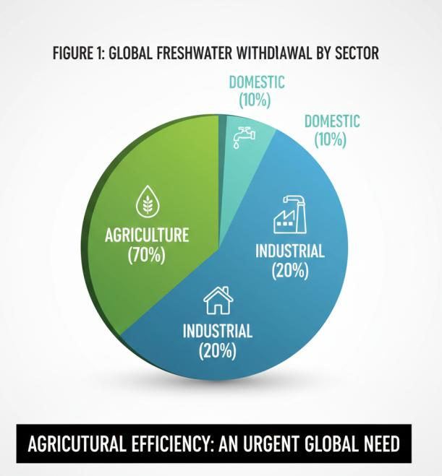

This comprehensive review explores these innovations. It begins with historical context and limitations of traditional techniques, followed by detailed examinations of modern irrigation systems, including drip/micro-irrigation, sprinklers, and subsurface methods. Smart technologies like sensor-based scheduling, satellite imagery, IoT, and AI applications are analyzed next. Water management strategies—such as harvesting, wastewater recycling, desalination, deficit irrigation, and drought-resistant crops—are evaluated for their potential (Antu et al., 2024).

Historical Context of Irrigation and Water Management
Irrigation has ancient origins, tracing back over 5,000 years to civilizations in Mesopotamia, Egypt, the Indus Valley, and China, where early societies engineered canals, ditches, and basins to divert river waters for flood-based agriculture. These innovations enabled surplus food production and societal growth but were rudimentary, relying on seasonal floods and manual labor (Wu et al., 2019).
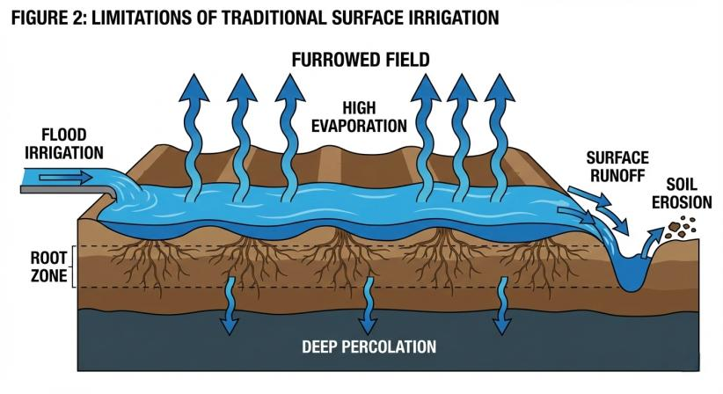
Traditional surface irrigation methods—flooding, furrow, border, and wild flooding—evolved as dominant practices worldwide, forming the backbone of agriculture for millennia. However, these gravity-fed systems are inherently inefficient, prone to excessive evaporation, runoff, deep percolation, nonuniform distribution, and soil erosion (Walter et al., 2017). Globally, agriculture consumes approximately 70% of freshwater withdrawals through such methods, while also driving high energy demands and contributing to environmental degradation (Gomes et al., 2024). These entrenched limitations—water wastage, energy overuse, and suboptimal yields—have intensified under modern pressures like population growth and climate variability, compelling a paradigm shift toward precision and sustainable alternatives (Daraz et al., 2025).

Traditional Irrigation Techniques and Their Limitations
Surface irrigation techniques—predominantly flood, furrow, border, and basin methods—have historically dominated agricultural water application worldwide, relying on gravity to spread water across fields. While enabling large-scale cultivation, these approaches are fundamentally inefficient, resulting in substantial water wastage, energy overuse, and reduced crop productivity, as evidenced by agriculture's consumption of ~70% of global freshwater alongside high energy demands (Qin et al., 2024).
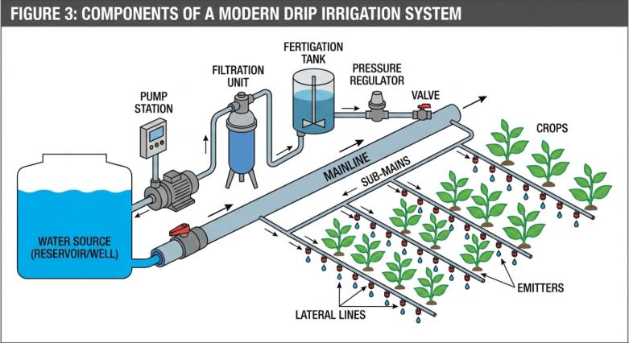
Critical limitations include:
- Excessive water wastage through evaporation, runoff, deep percolation, and nonuniform distribution, with agriculture accounting for approximately 70% of global freshwater withdrawals (Mahmood et al., 2024);
- High energy overuse, positioning agriculture as one of the largest energy consumers in many regions (Daraz et al., 2025);
- Reduced crop yields and productivity due to inefficient, resource-intensive practices (Saha et al., 2025);
- Environmental degradation, including soil erosion and contributions to broader sustainability challenges (Mahmood et al., 2024). These inefficiencies necessitate a fundamental shift towards advanced irrigation technologies and sophisticated water management strategies to ensure sustainable agricultural practices (Hashemi et al., 2024).

Modern Irrigation Technologies
Modern irrigation technologies mark a transformative evolution from inefficient traditional methods, delivering precise water application that dramatically boosts water use efficiency, slashes energy demands, and elevates crop productivity essential for sustainable agriculture amid escalating water scarcity (Ali et al., 2025). Unlike surface irrigation's high losses from evaporation, runoff, and percolation—which consume ~70% of global freshwater—advanced systems like drip, micro, sprinkler, pivot, and subsurface drip target water directly to plant roots, curbing wastage by up to 50-90% while minimizing environmental degradation such as soil erosion and salinization (Evans & Sadler, 2008). Precision irrigation, integrating targeted delivery to individual plants or zones, exemplifies this shift, optimizing resource use without compromising yields and addressing critical barriers like groundwater depletion (Jumintono et al., 2024). These innovations, supported by empirical evidence, compel widespread adoption to secure food production against climate pressures and resource limits.

Table 2: Critical Limitations of Traditional Irrigation
Limitation Category | Specific Challenge | Environmental/Economic Impact
Water Loss | Evaporation | Significant freshwater wastage
Water Loss | Runoff | Loss of nutrients and water
Distribution | Nonuniformity | Suboptimal crop yields
Resource Use | Deep Percolation | Leaching of essential nutrients
Soil Health | Erosion | Long-term land degradation
Resource Use | Energy Overuse | High operational costs/emissions
Productivity | Suboptimal Yields | Inability to meet food demand
Global Impact | Freshwater Usage | Consumes ~70% of global freshwater

Drip and Micro-Irrigation Systems
Drip and micro-irrigation systems deliver water directly to the plant root zone through low-pressure emitters, tubes, or micro-sprayers, achieving application efficiencies of 90-95% by minimizing evaporation, runoff, and deep percolation compared to traditional methods (Plaščak et al., 2021).
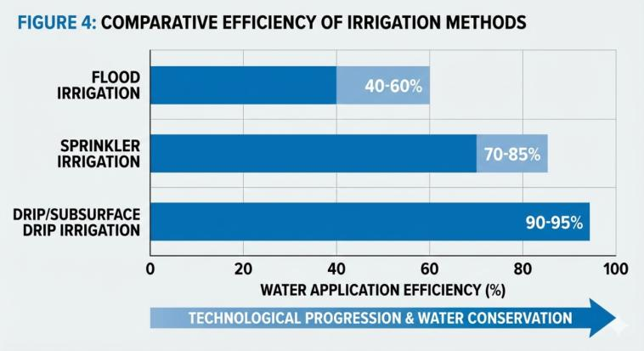
Principles of Operation
These systems operate on the principle of low-volume, high-frequency water application. Drip systems use buried or surface tubing with inline or online emitters spaced according to crop needs, while micro-irrigation employs finer nozzles for spray or mist. Filters, pressure regulators, and valves ensure uniform distribution, with fertigation capabilities integrating nutrients for enhanced uptake (Hla & Scherer, 2003).
Advantages and Efficiency Gains
- Water savings: Reduce consumption by 50-90% versus surface irrigation, critical as agriculture uses ~70% of global freshwater (Daraz et al., 2025; Jumintono et al., 2024).
- Energy reduction: Lower pumping requirements due to precise, low-pressure delivery, addressing agriculture's high energy demands (Daraz et al., 2025).
- Crop yield improvements: Uniform wetting boosts productivity and quality, mitigating issues like salinization and nutrient leaching (Jumintono et al., 2024).
- Environmental benefits: Minimize soil erosion, weed growth, and disease by keeping foliage dry.
Applications and Implementation
Widely used in row crops (e.g., tomatoes, orchards), greenhouses, and arid regions, these systems integrate with automation for site-specific management. In water-scarce areas like Iraq, they enhance WUE under deficit strategies (Jumintono et al., 2024).
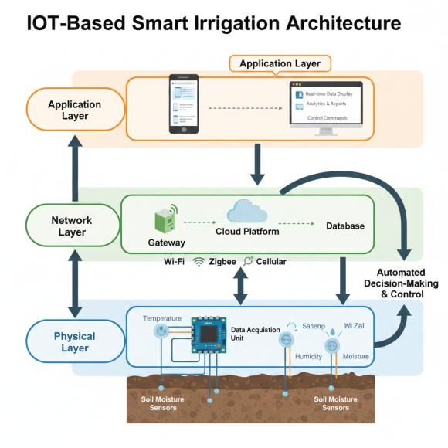
Figure 5: The IoT-Based Smart Irrigation Architecture

Sprinkler and Pivot Irrigation Systems
Sprinkler and pivot irrigation systems simulate rainfall by distributing water through overhead sprinklers or rotating pivots, achieving efficiencies of 70-85% by reducing surface runoff and deep percolation compared to traditional flood methods (Daraz et al., 2025). These technologies represent a key advancement in modern irrigation, balancing coverage for large fields with improved water use efficiency amid global freshwater constraints where agriculture consumes ~70% of withdrawals (Daraz et al., 2025).

Table 3: Comparison of Modern Irrigation Technologies
Technology | Application Efficiency | Energy Demand | Best For
Drip Irrigation | 90–95% | Low | Targeted root zone delivery
Sprinkler | 70–85% | High | Large field-scale distribution
Subsurface Drip | High (>90%) | Low | Minimizing surface wastage
Center Pivot | Moderate/High | High | Large circular fields
Micro-sprayers | 85–90% | Moderate | Orchards and specific zones
Smart Sensors | High | Low | Real-time monitoring/scheduling
IoT-Based AI | Very High | Moderate | Adaptive, automated scheduling
Deficit Irrigation | High | Low | Areas with severe water scarcity
Principles of Operation
Sprinkler systems propel water via pressurized pipes to nozzles that create spray patterns, while center-pivot systems use a rotating boom with emitters spanning hundreds of acres. Pumps, filters, and regulators maintain optimal pressure (3-5 bars), enabling uniform application and integration with fertigation (Daraz et al., 2025).
Advantages and Efficiency Gains
- Water savings: 30-50% reduction versus surface irrigation through controlled droplet size minimizing evaporation (Daraz et al., 2025);
- Energy optimization: Efficient for flat terrains, though higher than drip due to pressure needs (Daraz et al., 2025);
- Yield enhancements: Even coverage improves uniformity and reduces weed pressure (Jumintono et al., 2024);
- Versatility: Suitable for various crops and soils, curbing erosion.
Applications and Implementation
Common in row crops, pastures, and grains across the U.S., Australia, and arid zones; pivots excel in large-scale farming with automation for variable-rate application (Daraz et al., 2025).
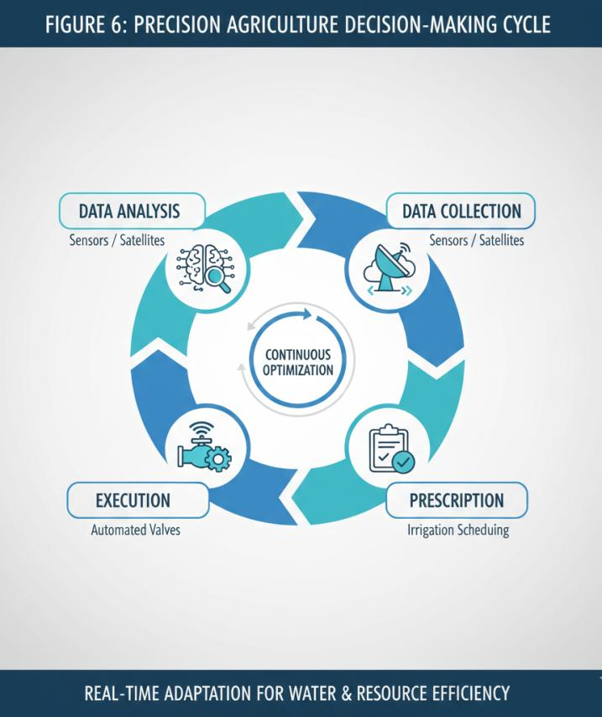

Subsurface Drip Irrigation
Subsurface drip irrigation buries drip lines 15-60 cm below soil surface, delivering water directly to root zones with efficiencies exceeding 90-95%, surpassing surface drip by eliminating evaporation and surface disruptions (Jumintono et al., 2024). This method addresses precision needs in water-scarce regions, optimizing WUE while combating issues like salinization from traditional over-application (Jumintono et al., 2024).

Table 4: Precision Agriculture and Smart Technologies
Component | Functionality | Key Benefit
IoT Sensors | Real-time data collection | Precise moisture monitoring
Remote Sensing | Satellite/aerial imagery | Large-scale field assessment
AI Algorithms | Adaptive scheduling | Optimized water delivery times
Cloud Systems | Data storage/analysis | Historical trend tracking
Mobile Apps | Remote control/alerts | Real-time farmer advisories
Soil Sensors | Nutrient/moisture tracking | Reduces over-fertilization
Automated Valves | Precision flow control | Minimizes manual labor errors
GPS Mapping | Site-specific irrigation | Targeted zone management
Principles of Operation
Tubing with emitters is placed underground, fed by low-pressure pumps; soil texture dictates depth to ensure capillary rise to roots. Advanced designs include flush lines for clog prevention and fertigation ports (Daraz et al., 2025).
Advantages and Efficiency Gains
- Superior water conservation: Up to 90% savings, vital as agriculture drives 70% of freshwater use (Daraz et al., 2025);
- Energy efficiency: Minimal pressure requirements reduce pumping costs (Daraz et al., 2025);
- Crop benefits: Deeper rooting, reduced evaporation, and no surface interference boost yields (Jumintono et al., 2024);
- Environmental gains: Limits weed growth, evaporation, and nutrient runoff.

Smart Irrigation Systems and Precision Agriculture
Smart irrigation systems leverage sensors, data analytics, and automation for real-time, site-specific water management, revolutionizing precision agriculture by integrating with drip, sprinkler, and pivot technologies to achieve dynamic WUE gains of 20-40% beyond static methods (Jumintono et al., 2024). These approaches counter traditional inefficiencies—evaporation, overuse—and support sustainability amid climate pressures (Daraz et al., 2025).

Sensor-Based Irrigation Scheduling
Sensor-based scheduling employs soil moisture probes (tensiometers, capacitance), weather stations, and plant stress sensors to trigger irrigation only when needed, preventing over- or under-watering (Jumintono et al., 2024).

Table 5: Water Management Strategies for Sustainability
Strategy | Primary Objective | Environmental Impact
Rainwater Harvesting | Collecting runoff | Reduces groundwater reliance
Wastewater Recycling | Non-potable reuse | Minimizes freshwater withdrawal
Desalination | Saline water treatment | New water source in arid areas
Deficit Irrigation | Managed water stress | High water use efficiency
Drought-Resistant Crops | Genetic adaptation | Resilience to climate variability
Soil Conservation | Moisture retention | Prevents land degradation
Smart Scheduling | Demand-based delivery | Curbing water wastage
Precision Delivery | Individual plant targeting | Up to 90% wastage reduction
Principles of Operation
Sensors measure parameters like volumetric water content, evapotranspiration, or leaf water potential, feeding data to controllers via wireless networks for automated valve adjustments. Threshold-based algorithms (e.g., 50% depletion) optimize timing (Daraz et al., 2025).
Advantages and Efficiency Gains
- Precision water use: 30-50% savings by matching crop ET demands (Daraz et al., 2025);
- Energy reduction: Eliminates unnecessary pumping (Daraz et al., 2025);
- Yield optimization: Maintains ideal soil conditions, enhancing quality (Jumintono et al., 2024);
- Data-driven insights: Enables predictive management.

Remote Sensing and Satellite Imagery for Water Management
Remote sensing and satellite imagery enable large-scale, non-invasive monitoring of crop water status, soil moisture, and evapotranspiration rates, providing critical data for precision irrigation decisions that can boost water use efficiency by 20-30% through targeted applications (Jumintono et al., 2024). By integrating multispectral and thermal imagery from platforms like Landsat or Sentinel, farmers detect stress early, optimizing water allocation amid agriculture's dominant 70% share of global freshwater withdrawals (Daraz et al., 2025).

Table 6: Global Agricultural Pressures (21st Century)
Pressure Factor | Impact on Agriculture | Resulting Requirement
Climate Change | Unpredictable weather | Adaptive technologies
Population Growth | Escalating food demand | Increased productivity
Water Scarcity | Depleted groundwater | Efficient use efficiency
Resource Limits | Finite natural assets | Sustainable management
Energy Costs | High operational burden | Energy-efficient systems
Land Degradation | Reduced soil health | Conservation practices
Biodiversity Loss | Ecosystem imbalance | Sustainable alternatives
Economic Stability | High input costs | Precision resource use
Principles of Operation
Satellites capture reflectance data to compute indices such as NDVI and CWSI, processed via cloud-based analytics for real-time ET maps. Ground validation with drones enhances resolution for field-scale insights (Daraz et al., 2025).
Advantages and Efficiency Gains
- Data scalability: Covers vast areas cost-effectively, ideal for heterogeneous fields (Kushwaha et al., 2024);
- Predictive accuracy: Reduces over-irrigation by forecasting deficits, saving 25-40% water (Jumintono et al., 2024);
- Integration potential: Feeds into smart controllers for automated responses.

Internet of Things in Irrigation
Internet of Things networks interconnect soil sensors, weather stations, and valves for continuous data flow, enabling automated irrigation that minimizes waste and achieves 30-50% WUE improvements over manual methods by responding to real-time conditions (Jumintono et al., 2024). This connectivity transforms static systems into adaptive ones, addressing inefficiencies in traditional practices that contribute to resource overuse (Daraz et al., 2025).

Table 7: Benefits of Precision Irrigation Adoption
Benefit Category | Expected Outcome | Specific Metric/Impact
Water Savings | 50–90% reduction | Lower withdrawal from sources
Energy Efficiency | Slashed demands | Lower carbon footprint
Yield Increase | Elevated productivity | More food per unit of water
Economic Profit | Lower input costs | Higher net returns for farmers
Environmental | Soil health preservation | Reduced salinization/erosion
Adaptive Capacity | Resilience to drought | Stable production in arid zones
Resource Mgmt | Targeted delivery | Individual plant monitoring
Sustainability | Long-term viability | Securing global food security
Principles of Operation
Low-power wide-area networks like LoRa transmit sensor data (e.g., tensiometers, hygrometers) to edge devices or cloud platforms, where algorithms trigger actuators based on thresholds or models (Daraz et al., 2025).
Advantages and Efficiency Gains
- Real-time responsiveness: Prevents deficits/excess, cutting energy use (Daraz et al., 2025);
- Remote management: Mobile apps allow oversight, reducing labor (Kushwaha et al., 2024);
- Scalability: Modular for small to large farms.

Artificial Intelligence and Machine Learning Applications
AI and machine learning analyze vast datasets from sensors and satellites to predict water needs with high accuracy, optimizing schedules for 20-40% beyond conventional precision gains and supporting sustainable intensification (Jumintono et al., 2024). These tools process variables like weather forecasts and historical yields to model ET dynamically, countering climate variability in water-stressed agriculture (Daraz et al., 2025).

Table 8: Historical Irrigation Milestones by Civilization
Civilization | Innovation | Primary Resource
Mesopotamia | Canal engineering | Tigris/Euphrates Rivers
Ancient Egypt | Land distribution/Basins | Nile River flooding
Indus Valley | Philosophical nature-rel. | Indus/Ganges Rivers
Ancient China | Engineered ditches | Slow transition pathways
Early Society | Surplus food production | Manual labor focus
Traditional | Surface gravity systems | Dominant practice for millennia
Medieval | Labor-intensive theory | Power concentration focus
Modern | Shift to precision | IoT and AI integration
Principles of Operation
ML algorithms (e.g., random forests, neural networks) train on IoT/remote sensing data to forecast crop coefficients and stress, integrating with controllers for prescriptive irrigation (Kushwaha et al., 2024).
Advantages and Efficiency Gains
- Forecasting prowess: Anticipates demands, slashing overuse (Kushwaha et al., 2024);
- Adaptive learning: Improves over time, enhancing yields (Jumintono et al., 2024);
- Holistic optimization: Incorporates energy and nutrient synergies.

Water Management Strategies for Sustainable Agriculture

Water Harvesting and Storage
Water harvesting captures runoff via structures like check dams and farm ponds, storing it for supplemental irrigation to extend growing seasons and boost resilience, achieving up to 50% yield increases in rainfed systems while conserving groundwater (Daraz et al., 2025). This strategy is pivotal for smallholders facing erratic rainfall, complementing efficient delivery methods to curb agriculture's 70% freshwater dominance (Daraz et al., 2025).
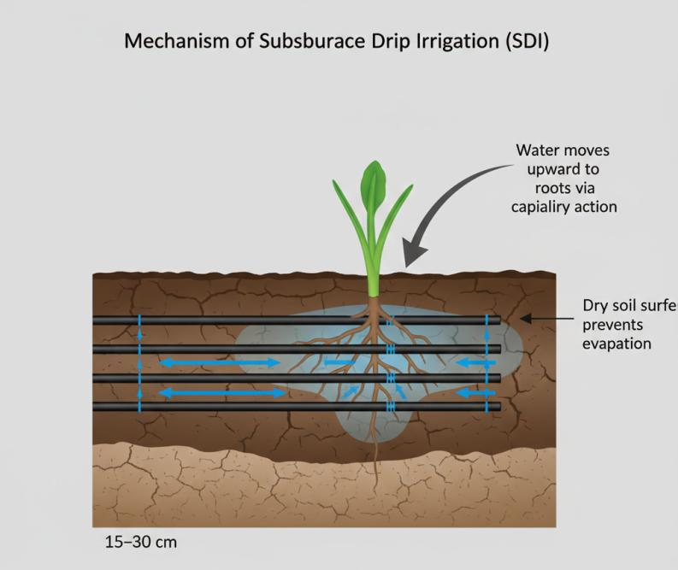
Fig 7- Mechanism of Subsburace Drip Irrigation (SDI)
Principles of Operation
Micro-catchments and rooftop systems direct water to lined reservoirs, filtered for quality; gravity-fed distribution minimizes energy (Kushwaha et al., 2024).
Advantages and Efficiency Gains
- Supplemental supply: Fills gaps in drip/smart systems (Jumintono et al., 2024);
- Cost-effective: Low-tech for adoption;
- Erosion control: Enhances soil moisture retention.
Applications and Implementation
Prevalent in semi-arid India, Africa; integrated with precision tech for optimal use (Daraz et al., 2025).

Recycled Wastewater for Irrigation
Recycled wastewater, encompassing treated municipal and industrial effluents, serves as a viable alternative to freshwater for irrigation, recycling nutrients and reducing discharge into natural water bodies while addressing agriculture's substantial 70% share of global freshwater withdrawals (Daraz et al., 2025). This approach enhances water security, particularly in water-scarce regions, by transforming waste into a resource for crop production.
Principles of Operation
Advanced treatment processes, including biological nutrient removal, membrane filtration, and disinfection (e.g., UV or chlorination), ensure effluent quality meets agricultural reuse standards, with distribution via drip or sprinkler systems to minimize contamination risks.
Advantages and Efficiency Gains
- Nutrient recycling: Supplies essential NPK, cutting fertilizer needs by 20-30%;
- Water volume augmentation: Provides consistent supply independent of rainfall (Kushwaha et al., 2024);
- Pollution mitigation: Prevents eutrophication in waterways.
Applications and Implementation
Common in water-stressed areas like Israel (90% reuse), Australia, and parts of California for non-food crops and orchards; integrated with precision systems for safe application (Jumintono et al., 2024).
Limitations and Challenges
Pathogen risks, heavy metal accumulation, public perception barriers, and high treatment costs; requires strict monitoring and regulatory compliance (Kushwaha et al., 2024).
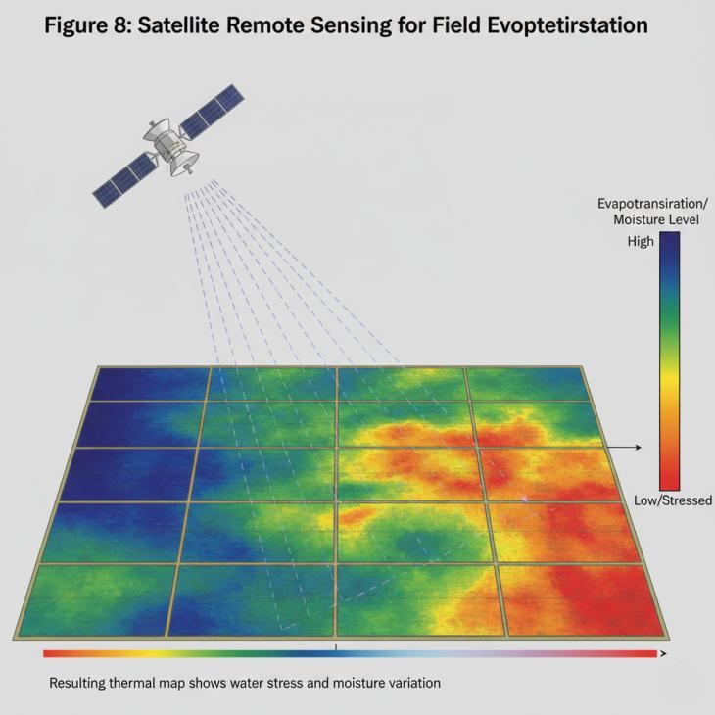

Desalination for Agricultural Use
Desalination converts seawater or brackish groundwater into freshwater for irrigation, offering a drought-proof supply in coastal and arid zones, supporting sustainable agriculture amid escalating water demands (Daraz et al., 2025).
Principles of Operation
Reverse osmosis or thermal distillation removes salts, with energy recovery devices enhancing efficiency; treated water blends with conventional sources for optimal salinity.
Advantages and Efficiency Gains
- Unlimited source potential: Scales to meet growing needs;
- Quality control: Produces low-salinity water ideal for sensitive crops (Kushwaha et al., 2024);
- Energy optimization: Modern plants achieve 3-4 kWh/m³.
Applications and Implementation
Deployed in Middle East, Australia, and Israel for high-value crops like dates and vegetables; hybrid solar-powered plants reduce costs (Jumintono et al., 2024).

Deficit Irrigation and Partial Root-Zone Drying
Deficit irrigation applies controlled water deficits to maximize water use efficiency, while partial root-zone drying alternates wetting zones to optimize physiology, achieving substantial savings over traditional methods (Jumintono et al., 2024).
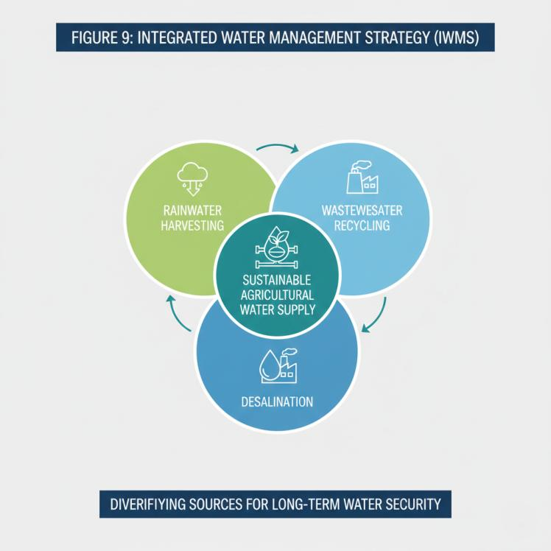

Principles of Operation
Scheduling delivers 60-80% of full ET requirements, with PRD cycling irrigation between root halves to induce hormonal signals (abscisic acid) for stomatal control and deeper rooting.
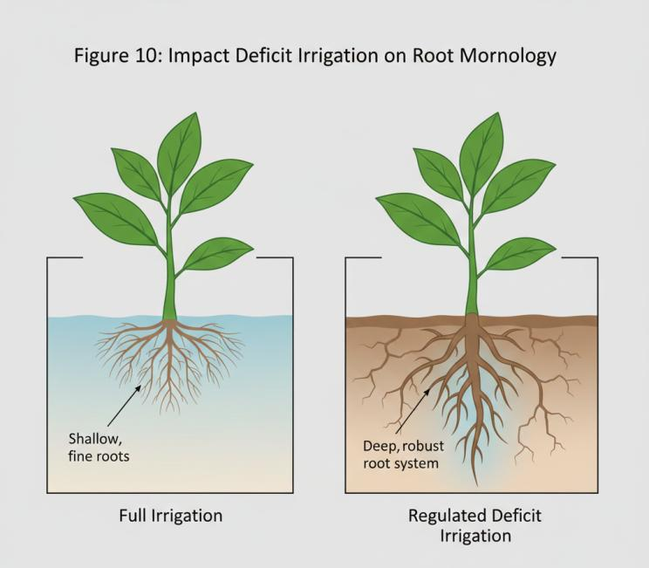

Advantages and Efficiency Gains
- WUE boost: 20-40% water savings with minimal yield loss (Jumintono et al., 2024);
- Quality enhancement: Improves fruit flavor and color;
- Stress tolerance: Builds crop resilience (Kushwaha et al., 2024).

Crop Selection and Drought-Resistant Varieties
Strategic crop selection and breeding drought-resistant varieties reduce water demands inherently, promoting sustainable intensification by matching crops to local conditions and climate projections (Daraz et al., 2025).

Table 9: Types of Wastewater for Reuse
Source Type | Treatment Required | Best Agricultural Application
Greywater | Low to Moderate | Ornamental plants/specific crops
Treated Sewage | High | Forage crops/non-food items
Industrial Effluent | Very High | Controlled industrial farming
Runoff Capture | Moderate | Supplementing main sources
Saline Water | Desalination | Arid region crop production
Reclaimed Water | High | General irrigation (non-potable)
Agricultural Runoff | Minimal/Moderate | Closed-loop field systems
Stormwater | Moderate | Landscaping and soil recharge

Principles of Operation
Genomic selection and marker-assisted breeding develop varieties with traits like deep roots, efficient stomata, and osmotic adjustment; rotated with cover crops for soil health.
Advantages and Efficiency Gains
- Intrinsic WUE: 15-30% less water for same yields (Kushwaha et al., 2024);
- Yield stability: Performs under deficits;
- Biodiversity: Diversifies farming systems.

Socio-Economic and Environmental Impacts of Advanced Irrigation

Water Use Efficiency and Conservation
Advanced irrigation technologies, from precision delivery to alternative sources, elevate WUE by minimizing losses, with gains of 25-50% reported, conserving agriculture's dominant freshwater footprint (Pérez‐Blanco et al., 2020). These technological advancements are crucial for mitigating water scarcity and ensuring long-term agricultural sustainability, particularly in regions facing increasing climatic variability (Antu et al., 2024).

Table 10: Environmental Impact of Conventional Methods
Impact Type | Description | Consequences
Soil Salinization | Salt buildup from runoff | Reduced soil fertility
Nutrient Leaching | Nitrate loss through soil | Groundwater contamination
Soil Erosion | Water-driven topsoil loss | Permanent land productivity loss
Carbon Emissions | Fuel for water pumping | Contribution to climate change
Water Depletion | Aquifer over-extraction | Dry wells/resource scarcity
Surface Runoff | Chemical transport | Pollution of downstream waters
Inefficiency | Low use efficiency | Escalating pressure on resources
Habitats | Ecosystem disruption | Loss of local biodiversity

Energy Consumption and Greenhouse Gas Emissions
By optimizing application and reducing pumping/excess, these systems cut energy use and associated GHG emissions, aligning with sustainability goals (Daraz et al., 2025; Kushwaha et al., 2024). However, the energy inputs for advanced irrigation systems, particularly for pressurized drip or sprinkler systems and desalination, can be significant, necessitating a comprehensive life cycle assessment of their environmental footprint.
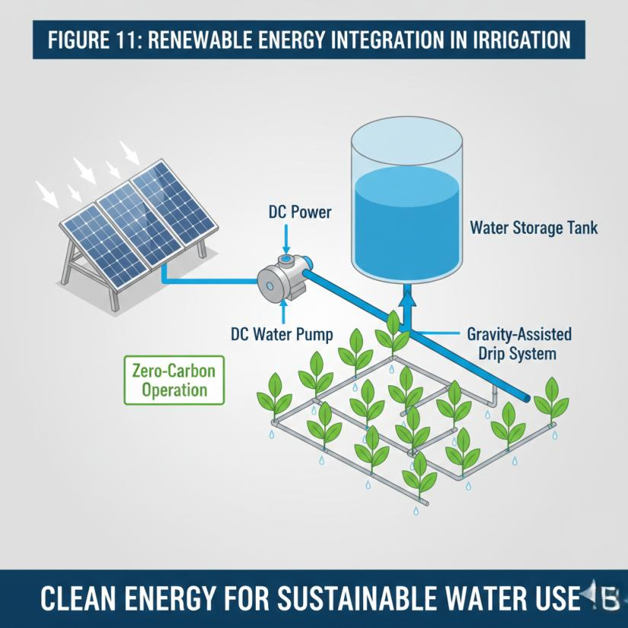

Soil Health and Salinity Management
Targeted watering prevents salinization from over-application, enhances microbial activity, and maintains structure, countering degradation in intensive systems (Timilsina et al., 2025). Proper drainage and integrated soil management practices are therefore essential to maximize the benefits of these advanced irrigation technologies while safeguarding soil productivity and preventing long-term ecological damage (Fader et al., 2020).
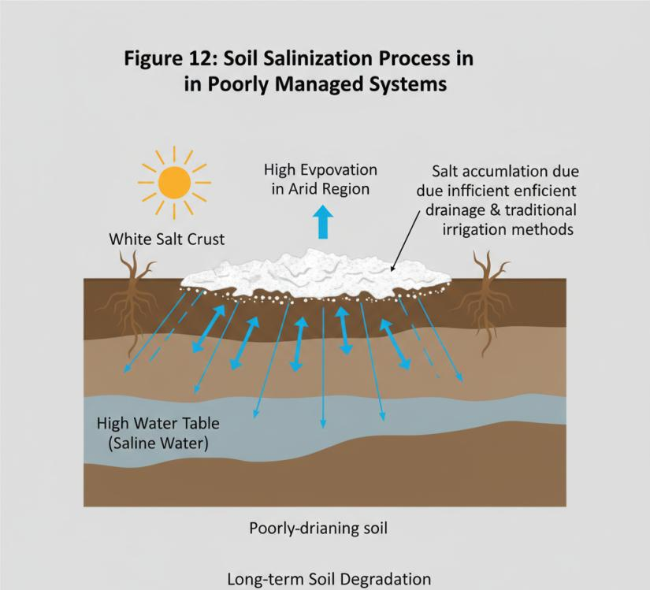

Economic Viability and Farmer Adoption
Cost savings on inputs (water, energy, labor) improve profitability, though upfront investments necessitate subsidies; scalability favors smallholders via modular designs (Kushwaha et al., 2024). Furthermore, the integration of genomic, agronomic, and environmental predictors within novel G x M technologies offers a framework for developing improved crop varieties that exhibit enhanced resource use efficiency, thereby fostering food security and nutrition (Sharma et al., 2025).
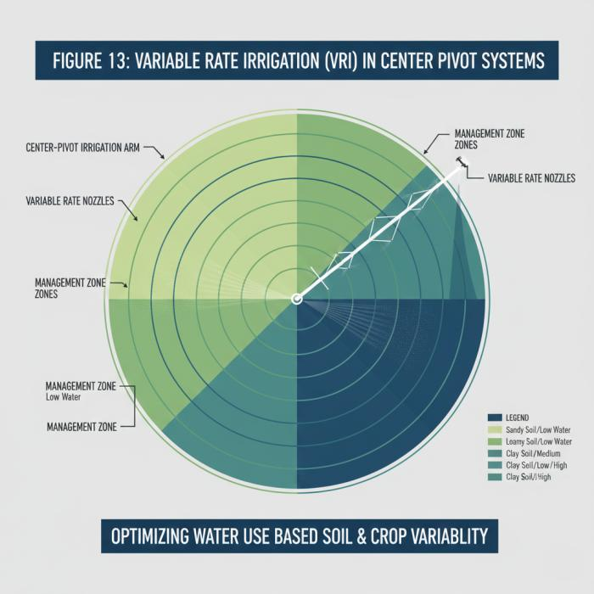

Policy and Regulatory Frameworks
Effective policy and regulatory frameworks are crucial for incentivizing the adoption of advanced irrigation technologies, facilitating water resource reallocation, and ensuring sustainable agricultural practices (Borin, 2024; Chai et al., 2015). These frameworks often include subsidies for technology adoption, water pricing mechanisms, and mandates for efficient irrigation systems, which collectively drive the transition towards more resilient and water-efficient agricultural landscapes. Moreover, international collaborations and open-access initiatives are essential to democratize advanced biotechnologies, particularly for smallholder farmers in developing regions (Xie, 2025). Beyond policy, innovative crop breeding plays a pivotal role in bolstering agricultural resilience, particularly through the development of drought-tolerant and water-efficient varieties (Chami & Moujabber, 2016).

Challenges and Future Directions

Technological Barriers and Infrastructure Gaps
Advanced irrigation technologies face significant technological barriers, including limited access to real-time sensors, IoT integration, and automated systems in remote or developing regions, where unreliable electricity and poor internet connectivity hinder deployment (Daraz et al., 2025; Xie, 2025). Infrastructure gaps, such as inadequate water conveyance networks and aging distribution systems, exacerbate inefficiencies, with traditional flood irrigation persisting due to the high upfront costs of retrofitting (Jumintono et al., 2024; Kushwaha et al., 2024). Overcoming these requires scalable, low-power solutions like solar-powered drip systems and LoRaWAN networks to enable precision in water-scarce areas (Xie, 2025).

Table 11: Real-Time Monitoring Parameters
Parameter | Sensor Type | Management Action
Soil Moisture | Tensiometers/IoT sensors | Trigger or stop irrigation
Crop Health | Satellite/Infrared | Adjust nutrient/water delivery
Evaporation Rate | Weather station data | Scheduling to avoid midday peaks
Humidity | Atmospheric sensors | Forecast disease risks
Temperature | Field-level sensors | Protect against frost/heat
Nutrient Level | Soil chemical sensors | Precise fertilization
Flow Rate | Digital flow meters | Detect leaks in system
Leaf Water Potential | Remote sensing | Identify early drought stress

Cost-Effectiveness and Accessibility for Smallholders
High capital and maintenance costs of precision and smart irrigation systems limit adoption among smallholders, who often lack financing and technical training, despite potential 20-50% water savings (Jumintono et al., 2024; Kushwaha et al., 2024). Subsidies, microfinance, and modular designs are essential, yet equitable access remains challenged by patented technologies and supply chain issues in developing regions (Xie, 2025). Policy incentives, such as those promoting open-access initiatives, can enhance affordability and scalability for resource-poor farmers (Borin, 2024; Xie, 2025).
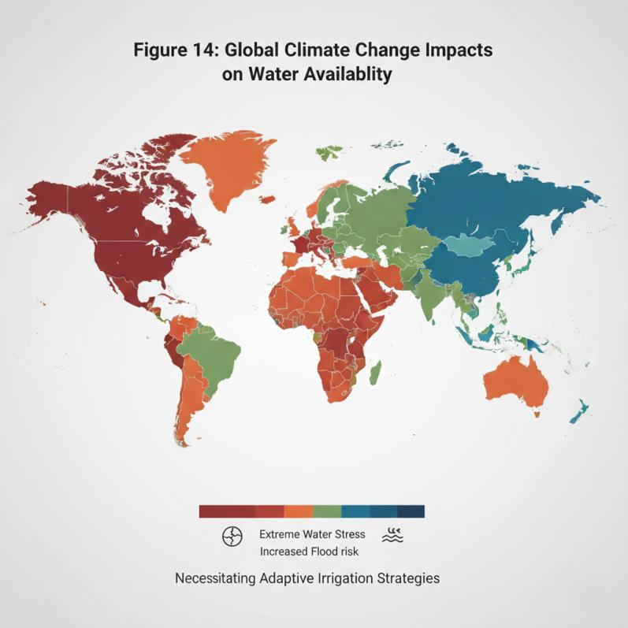

Climate Change Adaptation and Resilience
Escalating climate variability demands adaptive strategies like drought-tolerant varieties and regulated deficit irrigation, which improve yield under stress but require precise timing to avoid losses (Chai et al., 2015; Chami & Moujabber, 2016). Breeding efforts, including marker-assisted selection, have shown up to 30-50% yield gains in maize and tomatoes under drought, yet lag behind rapid climate shifts (Chami & Moujabber, 2016). Integrating these with resilient practices like biodiversity enhancement builds long-term farm resilience (Chami & Moujabber, 2016).

Integrated Water Resource Management
Integrated management necessitates reallocating water resources and modifying irrigation systems amid competing demands, with RDI and precision methods playing key roles but challenged by quantifying physiological responses (Borin, 2024; Chai et al., 2015). Holistic approaches combining crop selection, timing, and mulching maximize transpiration efficiency, supporting sustainable intensification and reducing deforestation . Collaborative frameworks are vital to balance agricultural needs with environmental protection (Mansoor et al., 2025).

Table 12: Economic Factors for Modernization
Factor | Barrier/Opportunity | Mitigation Strategy
Initial Capital | High installation cost | Subsidies and incentives
Operational ROI | Long-term savings | Energy and water reductions
Maintenance | Technical skill required | Training programs for farmers
System Longevity | 10–20 years (typical) | High-quality component use
Labor Costs | Automated reduction | IoT integration
Resource Fees | Rising water prices | High-efficiency adoption
Market Value | Better crop quality | Access to premium markets
Scalability | Small vs Large fields | Modular system design

Research Gaps and Emerging Technologies
Key gaps include system-level studies on RDI under varying deficits, crop stages, and dense plantings, alongside limited quantification of biotech water savings (Chai et al., 2015; Chami & Moujabber, 2016). Emerging technologies like AI-driven smart irrigation, synthetic biology for microbial consortia, and OpenCRISPR democratize tools for resilience, promising optimized WUE via real-time soil data (Xie, 2025). Future research must prioritize smallholder-accessible innovations and genotype-environment interactions (Chai et al., 2015; Chami & Moujabber, 2016).
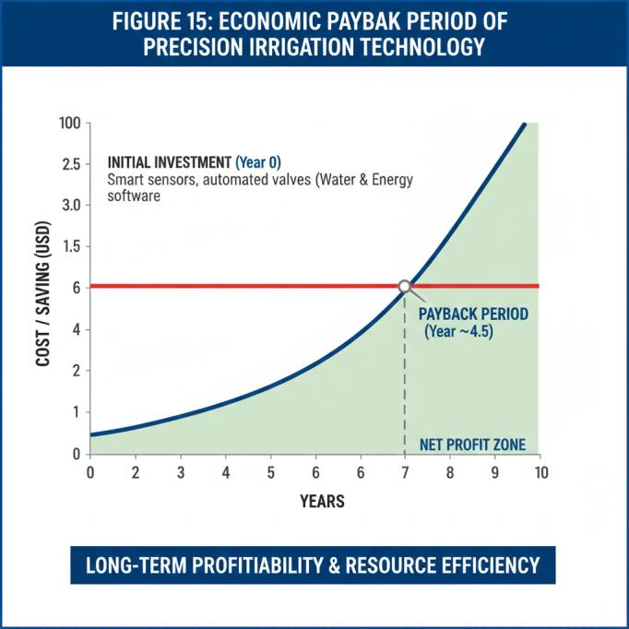

Conclusion
Advanced irrigation technologies offer transformative potential for water efficiency and sustainability, yet overcoming technological, economic, and climatic barriers through policy support, inclusive innovation, and targeted research is imperative for global food security. Further efforts should focus on integrating advanced irrigation with drought-resistant crop varieties and sophisticated hydrological modeling to maximize water savings and agricultural output under changing climatic conditions.

References
- Ali, A., Hussain, T., & Zahid, A. (2025). Smart Irrigation Technologies and Prospects for Enhancing Water Use Efficiency for Sustainable Agriculture. AgriEngineering, 7(4), 106. https://doi.org/10.3390/agriengineering7040106
- Antu, U. B., Islam, Md. S., Ahmed, S., Arifuzzaman, M., Saha, S. C. S. and N. N., Mitu, P. R., Sarkar, A., Mahiddin, N. A., Ismail, Z., Ibrahim, K. A., & Idris, A. M. (2024). Emerging technologies for efficient water use in agriculture: A review of current trends and future directions [Review of Emerging technologies for efficient water use in agriculture: A review of current trends and future directions]. Journal of Water Process Engineering, 68, 106317. Elsevier BV. https://doi.org/10.1016/j.jwpe.2024.106317
- Borin, M. (2024). A wise irrigation to contribute to integrated water resource management. Italian Journal of Agrometeorology, 2, 5. https://doi.org/10.36253/ijam-2323
- Chai, Q., Gan, Y., Zhao, C., Xu, H., Waskom, R., Niu, Y., & Siddique, K. H. M. (2015). Regulated deficit irrigation for crop production under drought stress. A review [Review of Regulated deficit irrigation for crop production under drought stress. A review]. Agronomy for Sustainable Development, 36(1). Springer Science+Business Media. https://doi.org/10.1007/s13593-015-0338-6
- Chami, D. E., & Moujabber, M. E. (2016). Drought, climate change and sustainability of water in agriculture: A roadmap towards the NWRS2. South African Journal of Science, 112, 4. https://doi.org/10.17159/sajs.2016/20150457
- Daraz, U., Bojnec, Š., & Khan, Y. (2025). Energy-Efficient Smart Irrigation Technologies: A Pathway to Water and Energy Sustainability in Agriculture. Agriculture, 15(5), 554. https://doi.org/10.3390/agriculture15050554
- Evans, R. G., & Sadler, E. J. (2008). Methods and technologies to improve efficiency of water use. Water Resources Research, 44(7). https://doi.org/10.1029/2007wr006200
- Fader, M., Giupponi, C., Burak, S., Dakhlaoui, H., Koutroulis, A., Lange, M. A., Llasat, M. C., Pulido‐Velazquez, D., & Sanz-Cobeña, A. (2020). Chapter 3 Resources - Subchapter 3.1 Water. HAL (Le Centre Pour La Communication Scientifique Directe). https://hal-amu.archives-ouvertes.fr/hal-03210040
- Gomes, M., Ralph, T. J., Humphries, M., Graves, B. P., Kobayashi, T., & Gore, D. B. (2024). Waterborne contaminants in high intensity agriculture and plant production: A review of on-site and downstream impacts [Review of Waterborne contaminants in high intensity agriculture and plant production: A review of on-site and downstream impacts]. The Science of The Total Environment, 958, 178084. Elsevier BV. https://doi.org/10.1016/j.scitotenv.2024.178084
- Hashemi, S., Darzi‐Naftchali, A., Karandish, F., Ritzema, H. P., & Solaimani, K. (2024). Enhancing agricultural sustainability with water and crop management strategies in modern irrigation and drainage networks. Agricultural Water Management, 305, 109110. https://doi.org/10.1016/j.agwat.2024.109110
- Hla, A. K., & Scherer, T. F. (2003). Introduction to Micro-irrigation. NDSU Repository (North Dakota State University). http://hdl.handle.net/10365/5108
- Jumintono, J., Nurnawaty, N., Brata, N. T., Rahmiati, D., Susilo, H., & Hussen, A. A. (2024). Comparative analysis of precision, deficit, and drip irrigation for water efficiency in Iraq. Journal of Water and Land Development, 130. https://doi.org/10.24425/jwld.2024.151798
- Kushwaha, M., Singh, S., Singh, V. K., & Dwivedi, S. (2024). Precision Farming: A Review of Methods, Technologies, and Future Prospects [Review of Precision Farming: A Review of Methods, Technologies, and Future Prospects]. International Journal of Environment Agriculture and Biotechnology, 9(2), 242. Infogain Publication. https://doi.org/10.22161/ijeab.92.27
- Mahmood, H., Hassan, M. S., Meraj, G., & Furqan, M. (2024). Agriculture’s Role in Environmental Sustainability: A Comprehensive Review of Challenges and Solutions [Review of Agriculture’s Role in Environmental Sustainability: A Comprehensive Review of Challenges and Solutions]. Challenges in Sustainability, 12(3), 178. Librelloph. https://doi.org/10.56578/cis120302
- Mansoor, S., Iqbal, S., Popescu, S. M., Kim, S. L., Mansoor, S., & Baek, J. (2025). Integration of smart sensors and IOT in precision agriculture: trends, challenges and future prospectives [Review of Integration of smart sensors and IOT in precision agriculture: trends, challenges and future prospectives]. Frontiers in Plant Science, 16, 1587869. Frontiers Media. https://doi.org/10.3389/fpls.2025.1587869
- Pérez‐Blanco, C. D., Essenfelder, A. H., & Perry, C. (2020). Irrigation Technology and Water Conservation: A Review of the Theory and Evidence [Review of Irrigation Technology and Water Conservation: A Review of the Theory and Evidence]. Review of Environmental Economics and Policy, 14(2), 216. University of Chicago Press. https://doi.org/10.1093/reep/reaa004
- Plaščak, I., Jurišić, M., Radočaj, D., Vujić, M., & Zimmer, D. (2021). An Overview of Precision Irrigation Systems Used in Agriculture. Tehnički Glasnik, 15(4), 546. https://doi.org/10.31803/tg-20210416103500
- Qin, J., Duan, W., Zou, S., Chen, Y., Huang, W., & Rosa, L. (2024). Global energy use and carbon emissions from irrigated agriculture. Nature Communications, 15(1), 3084. https://doi.org/10.1038/s41467-024-47383-5
- Saha, G., Shahrin, F., Khan, F. H., Meshkat, M. A., & Azad, A. A. M. (2025). Smart IoT-driven precision agriculture: Land mapping, crop prediction, and irrigation system. PLoS ONE, 20(3). https://doi.org/10.1371/journal.pone.0319268
- Sharma, R. K., Nwosu, N. J., Singh, L., Kramer, A., Singh, H., Bheemanahalli, R., & Dhillon, J. (2025). Agricultural sustainability under unpredicted atmospheric changes—strategies to enhance crop resilience and system efficiency: a narrative review [Review of Agricultural sustainability under unpredicted atmospheric changes—strategies to enhance crop resilience and system efficiency: a narrative review]. Discover Agriculture, 3(1). Springer Science+Business Media. https://doi.org/10.1007/s44279-025-00287-4
- Timilsina, R. R., Khosla, S. K., Rahut, D. B., Jena, P. R., & Sonobe, T. (2025). A comprehensive review of the soil health status for enhancing agricultural sustainability [Review of A comprehensive review of the soil health status for enhancing agricultural sustainability]. Frontiers in Environmental Science, 13. Frontiers Media. https://doi.org/10.3389/fenvs.2025.1548095
- Walter, A., Finger, R., Huber, R., & Buchmann, N. (2017). Smart farming is key to developing sustainable agriculture. Proc. Nat. Acad. Sci. USA, 114, 6148. https://doi.org/10.1073/pnas.1707462114
- Wu, S., Wei, Y., Head, B., Zhao, Y., & Hanna, S. (2019). The development of ancient Chinese agricultural and water technology from 8000 BC to 1911 AD. Palgrave Communications, 5(1). https://doi.org/10.1057/s41599-019-0282-1
- Xie, C. (2025). The role of modern agricultural technologies in improving agricultural productivity and land use efficiency [Review of The role of modern agricultural technologies in improving agricultural productivity and land use efficiency]. Frontiers in Plant Science, 16. Frontiers Media. https://doi.org/10.3389/fpls.2025.1675657

