Organic Farming Practices: Impact on Crop Productivity and Soil Health
Abstract
Organic farming represents a sustainable agricultural paradigm that prioritizes ecological balance, biodiversity, and natural inputs over synthetic chemicals. This review synthesizes evidence on key practices—crop rotation, cover cropping, green manures, composting, integrated pest management, and conservation tillage—and their effects on crop productivity and soil health. Organic systems often yield 10-20% less than conventional counterparts due to nitrogen limitations and pest pressures, yet they excel in nutritional quality, with higher antioxidants and omega-3s in produce. Crops demonstrate greater resilience to abiotic stresses like drought, attributed to robust root systems and microbial symbiosis. Soil health markedly improves: organic matter accumulates, fostering microbial diversity and enzyme activity essential for nutrient cycling. Enhanced soil structure boosts water retention and erosion resistance, while biofumigation and antagonists suppress soil-borne pathogens. Challenges include yield gaps, weed proliferation, and a 2-3 year transition period with productivity dips, impacting economic viability. Long-term studies underscore closing gaps through optimized practices. Future directions encompass comparative trials, advanced metagenomic indicators, and socio-economic models for scaling. Organic farming bolsters food security and ecosystem services, advocating policy support for transition.
Keywords: Organic Farming, Crop Productivity, Soil Health, Crop Rotation, Integrated Pest Management, Sustainability
Introduction
Organic farming represents a sustainable agricultural approach that emphasizes ecological balance, biodiversity conservation, and the use of natural inputs rather than synthetic chemicals or genetically modified organisms. Unlike conventional systems reliant on chemical fertilizers, pesticides, and monocultures, organic methods foster long-term soil fertility and ecosystem health through practices like crop rotation, cover cropping, green manures, composting, integrated pest management, and conservation tillage.
Table 1: Input Reductions in Organic vs. Conventional Farming
Aspect | Organic Reduction | References
Fertilizer & Energy | 30–50% lower | (Elmqvist et al., 2010)
Pesticides | >90% lower | (Elmqvist et al., 2010)
Synthetic fertilizers | Reduced soluble nutrient fractions via biological activity | (Khanal, 2009)
Fuel and oil (direct energy) | Higher efficiency per hectare | (Khanal, 2009)
Indirect energy (inputs) | Lower consumption from synthetic fertilizers/pesticides | (Khanal, 2009)
Pesticide pollution to water | No risk of ground/surface water pollution | (Khanal, 2009)
Nutrient runoff | Tightened internal nutrient cycles | (Khanal, 2009)
Erosion risk | Reduced via higher soil moisture retention | (Khanal, 2009)

Despite these benefits, organic systems typically yield 10-20% less than conventional counterparts, primarily due to nitrogen limitations, pest pressures, and weed competition during the initial transition period of 2-3 years. However, organic produce often exhibits superior nutritional quality, with elevated levels of antioxidants, vitamins, and omega-3 fatty acids, alongside greater resilience to abiotic stresses such as drought and climate variability. This resilience stems from enhanced root systems, improved water retention, and symbiotic relationships with soil microbes.
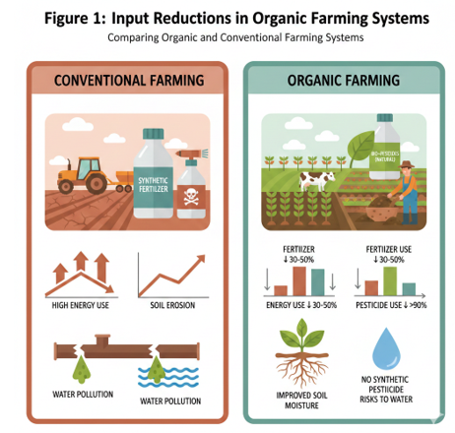
Key practices significantly bolster soil health. Crop rotation disrupts pest cycles and nutrient depletion, while cover cropping and green manures suppress weeds, prevent erosion, and add organic matter. Composting recycles nutrients, enriching soil with humus that promotes microbial diversity and enzyme activity crucial for nutrient cycling (Siabato et al., 2025). IPM employs biological controls and cultural practices to manage pests without synthetics, and reduced tillage preserves soil structure, enhancing aggregation, water-holding capacity, and resistance to erosion. These interventions lead to higher soil organic matter levels—often 20-30% more than conventional soils—fostering antagonistic microbes that suppress pathogens via biofumigation.
From an agroecological perspective, such systems, as observed in olive production, promote biodiversity, regulate biological cycles, and strengthen ecosystem resilience, countering the depletion caused by intensive agriculture (Siabato et al., 2025). Challenges persist, including yield gaps and economic hurdles, yet long-term adoption closes these disparities. This review examines these dynamics, synthesizing evidence to guide sustainable scaling.
Table 2: Yield Impacts During Organic Transition
Impact | Percentage | References
Initial Yield Reduction | 20–30% | (Elmqvist et al., 2010; Zanella et al., 2017)
Long-term yield stability | Improved via soil organic matter | (Meshram et al., 2026)
Yield during droughts | Parity or superiority with water retention | (Sharma, 2024)
Overall yield trade-off | Balanced by land for biodiversity | (Elmqvist et al., 2010)
Biomass productivity | Enhanced with species richness | (Elmqvist et al., 2010)
Crop yields in organic systems | 20% lower but input-independent | (Elmqvist et al., 2010)
Yield resilience to extremes | Higher due to soil health | (Zanella et al., 2017)
Transition revenue risk | Offset by premiums/subsidies | (Zanella et al., 2017)

Background of Organic Farming
- Organic farming originated in the early 1900s as a critique of industrial agriculture's chemical reliance.
- Pioneers like Rudolf Steiner introduced biodynamic principles emphasizing holistic farm ecosystems.
- Sir Albert Howard developed composting techniques inspired by traditional Indian practices.
- Lady Eve Balfour founded the Soil Association in 1946, formalizing organic standards in Europe.
- J.I. Rodale promoted no-till and natural pest control through his U.S.-based publications.
- The 1960s environmental movement, spurred by Rachel Carson's Silent Spring, boosted adoption.
- IFOAM was established in 1972 to unify global organic standards and advocacy.
- Certification systems emerged, enabling market growth despite yield concerns.
- Organic area now spans over 75 million hectares worldwide, focusing on sustainability.
- Agroecological systems enhance biodiversity and soil microbial activity, strengthening resilience (Siabato et al., 2025). These systems prioritize practices such as crop rotation, integration of livestock, and agroforestry, which collectively contribute to enhanced soil fertility, improved water retention, and a reduced need for external synthetic inputs (Chand et al., 2022; Sharma, 2024).
Importance of Crop Productivity and Soil Health
Crop productivity ensures food security and economic viability, while soil health sustains long-term fertility, biodiversity, water retention, and resilience to stresses. In organic farming, practices like crop rotation, livestock integration, and composting enhance nutrient cycling, suppress pests, and close yield gaps, prioritizing ecological balance over synthetic inputs (Chand et al., 2022; Sharma, 2024; Siabato et al., 2025).
Table 3: Ecosystem Services Provided by Organic Agriculture
Area | Environmental Goods and Services | References
Soil | Higher organic matter, fertility, biological activity, nutrient recycling | (Khanal, 2009)
Water | No pollution from synthetic pesticides | (Khanal, 2009)
Air | Carbon sequestration, reduced GHG emissions | (Khanal, 2009)
Energy | Higher efficiency per hectare | (Khanal, 2009)
Biodiversity | Enhanced microbial activity and species richness | (Elmqvist et al., 2010)
Climate adjustment | Better ecosystem adaptation | (Khanal, 2009)
Soil structure | Improved stability and erosion reduction | (Khanal, 2009)
Water retention | Higher capacity reducing desertification risk | (Khanal, 2009)

Scope and Objectives of the Review
This review aims to synthesize current research on the interplay between organic farming practices, crop productivity, and soil health, with a particular focus on identifying scalable strategies for enhancing agricultural sustainability. It will also investigate how organic agriculture mitigates environmental impacts and contributes to human well-being by providing nutritious food, considering the increasing consumer demand for healthy and sustainable options (Bastakoti & Khanal, 2022).
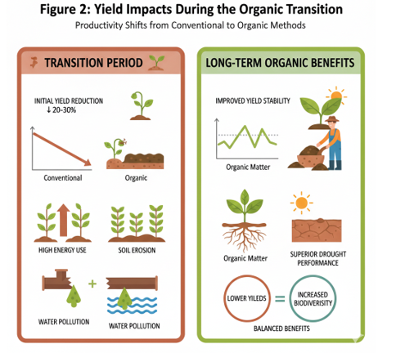
Key Organic Farming Practices
Organic farming employs key practices that mimic natural processes to sustain soil fertility, biodiversity, and crop yields without synthetic inputs. These include crop rotation for nutrient balance and pest disruption, cover cropping and green manures for soil protection and organic matter addition, composting for nutrient recycling, integrated pest management using biological controls, and conservation tillage to preserve soil structure (Bastakoti & Khanal, 2022; Chand et al., 2022; Sharma, 2024). Recent analyses affirm these practices enhance ecosystem resilience, microbial activity, and long-term productivity, particularly through livestock integration and agroforestry (Chand et al., 2022; Sharma, 2024; Siabato et al., 2025). Such integrated approaches also foster increased biodiversity, supporting a wider range of beneficial insects and microorganisms that contribute to overall ecosystem health and stability (Raihan, 2023).
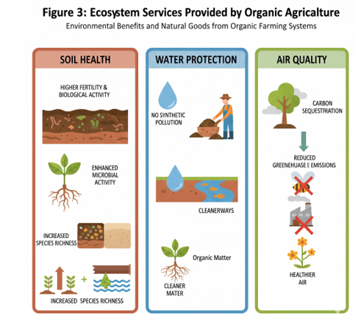
Crop Rotation and Diversification
Crop rotation, a cornerstone of organic agriculture, involves systematically varying the types of crops grown in the same area over successive seasons, which is crucial for maintaining soil fertility, disrupting pest and disease cycles, and reducing the reliance on synthetic inputs (Chand et al., 2022; Raihan, 2023; Sharma, 2024). This practice also enhances soil structure and biological activity while diversifying the farm's output, thereby reducing risk under fluctuating climatic conditions (Chand et al., 2022; Pancholi et al., 2023). This strategic sequencing of different plant families helps to optimize nutrient utilization, suppress weed growth through competitive exclusion, and improve overall soil organic carbon content (Meshram et al., 2026; Sharma, 2024).
Table 4: Research Needs for Soil Fertility Management
Research Focus | Key Recommendation | References
Multi-disciplinary impacts | Identify combined effects within certification standards | (Sapinas & Abbott, 2021)
Transition period assessment | Quantify soil physio-chemical/biological changes | (Sapinas & Abbott, 2021)
Nutrient sources | Re-align standards with local conditions | (Sapinas & Abbott, 2021)
Nutrient availability persistence | Long-term studies under varying conditions | (Thiffault et al., 2024)
Overall soil health | Assess long-term effects | (Thiffault et al., 2024)
Fertilizer optimization | Formulations for nutrient use efficiency | (Mjanja et al., 2025)
Microbial dynamics | Boost activity via metagenomics/metabolomics | (Kumari et al., 2022)
Organic amendments | Impacts on carbon sequestration | (Cerqueira et al., 2023)

Cover Cropping and Green Manure
Cover cropping and green manure incorporation are fundamental practices in organic agriculture, designed to protect soil, suppress weeds, prevent erosion, and replenish organic matter. Cover crops are grown specifically to cover bare soil between cash crop cycles, while green manures are subsequently tilled in to decompose and release nutrients. These methods enhance soil structure, boost water-holding capacity, and support nutrient retention and microbial activity (Meshram et al., 2026; Sharma, 2024). By mimicking natural processes, they foster biodiversity and long-term fertility without synthetic inputs (Siabato et al., 2025).
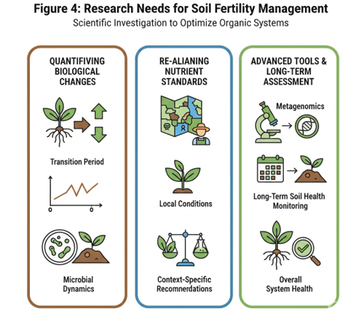
Composting and Organic Amendments
Composting transforms organic wastes—such as crop residues, manure, and green materials—into stable humus through controlled aerobic decomposition, recycling essential nutrients and improving soil quality. Organic amendments like compost and animal manures increase soil organic matter, stimulate microbial diversity, and facilitate enzyme-driven nutrient cycling critical for plant uptake (Bastakoti & Khanal, 2022; Chand et al., 2022; Siabato et al., 2025). These practices reduce reliance on external fertilizers, enhance soil resilience to stresses, and promote ecological balance in farming systems (Sharma, 2024).
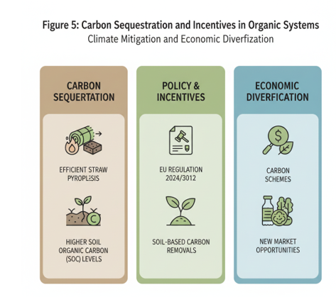

Integrated Pest Management in Organic Systems
Integrated Pest Management in organic systems emphasizes prevention, monitoring, and biological controls over chemical interventions, including habitat provisioning for beneficial predators, crop diversification, and resistant varieties. Mechanical and cultural methods, such as timely cultivation and trap crops, further suppress pests while preserving biodiversity (Chand et al., 2022; Raihan, 2023). This holistic approach maintains ecological harmony, supports beneficial insects and microorganisms, and ensures sustainable pest control without residues (Sharma, 2024).
Table 5: Carbon Sequestration and Incentives in Organic Systems
Aspect | Benefits/Needs | References
Straw pyrolysis efficiency | Mitigate emissions | (Cerqueira et al., 2023)
Rates per hectare | Inform carbon credit schemes | (Brandolini et al., 2025)
EU Regulation 2024/3012 | Supports soil-based carbon removals | (Brandolini et al., 2025)
Soil organic carbon | Higher levels for sequestration | (Meshram et al., 2026)
GHG emissions | Reduced via recycling organic matter | (Khanal, 2009)
Incentive structures | Revenue diversification for adoption | (Brandolini et al., 2025)
Landscape resilience | Enhanced biodiversity/connectivity | (Brandolini et al., 2025)
Emission avoidance | Improve voluntary market transparency | (Brandolini et al., 2025)

Tillage Practices in Organic Farming
Tillage practices in organic farming prioritize conservation and reduced tillage to minimize soil disturbance, preserving aggregation, organic matter, and microbial habitats. No-till or minimal tillage reduces erosion, improves water infiltration and retention, and lowers fuel use through fewer equipment passes (Chand et al., 2022; Pancholi et al., 2023). These techniques enhance structural stability and carbon sequestration, contributing to resilient soils capable of sustaining productivity under variable climates (Raihan, 2023; Sharma, 2024).
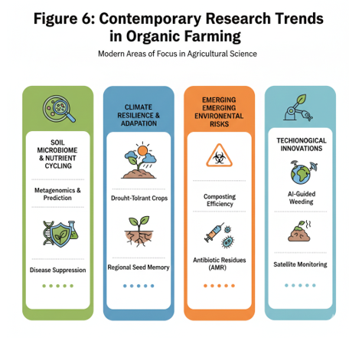
Impact on Crop Productivity
Organic farming practices contribute to crop productivity by enhancing yield stability, nutrient cycling, and ecological resilience, though initial yield gaps may exist compared to conventional systems. Long-term studies indicate that integrated approaches like crop rotation and livestock integration can close these gaps, leading to comparable or superior performance under variable conditions (Chand et al., 2022; Sharma, 2024).
Table 6: Contemporary Research Trends in Organic Farming
Trend | Focus Areas | References
Soil Microbiome | Fertility, nutrient cycling, ecosystem health | (Kumari et al., 2022)
Climate Resilience | Mitigate extreme weather, water efficiency, adaptability | (Kumari et al., 2022)
Certification | Evaluate and enhance standards | (Kumari et al., 2022)
Organic fertilizers | Support microbes, symbiotic relationships | (Turan & Yıldırım, 2021)
Antibiotic residues | Impacts in organic fertilizer | (Turan & Yıldırım, 2021)
Conservation agriculture | Soil moisture, erosion reduction | (Turan & Yıldırım, 2021)
Technological innovations | Scaling agroecological practices | (Pancholi et al., 2023)
Tree-crop interactions | Varying climatic conditions | (Pancholi et al., 2023)

Yield Performance of Organic Crops
Organic crops often exhibit stable yields due to diversified systems that optimize nutrient use and reduce input dependency. Practices such as agroforestry and cover cropping increase yields by up to 40% in mixed systems through synergistic interactions, efficient water usage, and improved soil structure (Meshram et al., 2026; Pancholi et al., 2023; Sharma, 2024). Despite the potential for lower yields in some organic systems compared to conventional methods, the overall sustainability and reduced reliance on external inputs often make organic farming a more resource-efficient and environmentally sound option (Elmqvist et al., 2010; Panday et al., 2024).
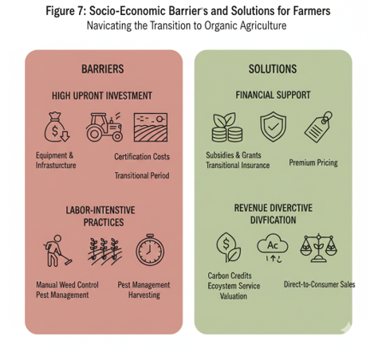
Nutritional Quality of Organic Produce
Organic produce typically offers superior nutritional profiles, with higher levels of antioxidants, vitamins, and minerals, attributed to stress-induced defenses and avoidance of synthetic residues. Enhanced soil microbial activity and biodiversity further support nutrient-dense crops, meeting consumer demand for healthier foods (Bastakoti & Khanal, 2022; Siabato et al., 2025). Furthermore, the absence of synthetic pesticides and herbicides in organic farming methods leads to a reduction in harmful chemical residues in food products, directly benefiting human health and contributing to a safer food supply (Kumari et al., 2022).
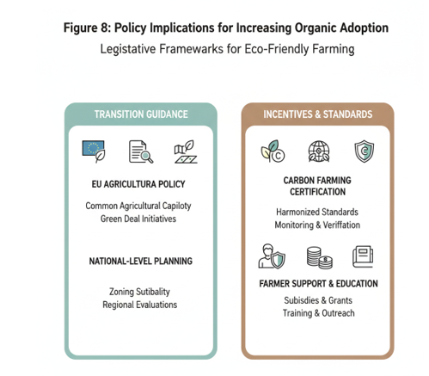
Resilience to Environmental Stressors
Organic systems demonstrate greater resilience to climate variability, pests, and droughts via diversified cropping, habitat provisioning, and soil health improvements. Agroforestry and biological controls buffer against stresses, facilitating species adaptation and reducing risks from fluctuating conditions (Chand et al., 2022; Pancholi et al., 2023; Raihan, 2023). For instance, during periods of drought, organic farms often exhibit higher yields than conventional farms due to their superior soil water retention capabilities (Raihan, 2023).
Table 7: Socio-Economic Barriers and Solutions
Barrier | Solution Needs | References
Upfront investments | Subsidies, insurance, value-chain support | (Abbott & Manning, 2015; Elmqvist et al., 2010)
Market access | Premium pricing, ecosystem services valuation | (Elmqvist et al., 2010)
Certification expenses | Policy incentives like carbon credits | (Brandolini et al., 2025; Elmqvist et al., 2010)
Labor-intensive practices | Targeted support for smallholders | (Elmqvist et al., 2010)
Yield reductions | Market premiums to offset risks | (Elmqvist et al., 2010; Zanella et al., 2017)
Production costs | Mechanical weeding compliance | (Elmqvist et al., 2010)
Farmer decision-making | Models for equitable scalability | (Elmqvist et al., 2010)
Diversified revenues | Resilient livelihoods via valuation | (Abbott & Manning, 2015; Elmqvist et al., 2010)

Impact on Soil Health
Organic practices significantly bolster soil health by increasing organic matter, fostering microbial communities, and promoting natural processes that sustain fertility without external inputs (Meshram et al., 2026; Sharma, 2024; Siabato et al., 2025). This enhanced soil vitality supports robust plant growth, nutrient cycling, and water infiltration, creating a self-sustaining ecosystem less susceptible to degradation (Bastakoti & Khanal, 2022). Such comprehensive approaches contribute to greater long-term productivity and reduce the environmental footprint of agricultural operations by minimizing greenhouse gas emissions and enhancing carbon sequestration (Pancholi et al., 2023).
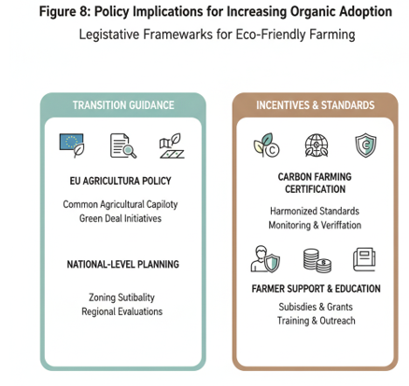
Soil Organic Matter Dynamics
Organic amendments like composting and green manures elevate soil organic matter, enhancing carbon sequestration, nutrient retention, and structural stability. This buildup mitigates climate impacts and supports long-term productivity (Bastakoti & Khanal, 2022; Chand et al., 2022; Meshram et al., 2026). The sustained accumulation of organic matter is crucial for improving soil aggregation, which directly enhances water infiltration and reduces surface runoff, thereby minimizing soil erosion (Zanella et al., 2017). Moreover, the enhanced organic matter content in organic soils provides a more stable environment for beneficial microbial populations, further contributing to nutrient cycling and overall soil fertility (Bastakoti & Khanal, 2022).
Table 8: Policy Implications for Organic Adoption
Policy Aspect | Recommendation | References
Legislative framework | Incentives for eco-friendly practices | (Constantin et al., 2022)
EU Common Agricultural Policy | Transition to cleaner systems with Green Deal | (Constantin et al., 2022)
Trade-off analyses | Economic vs. environmental effects | (Kremmydas et al., 2023)
Support mechanisms | For farmers adopting ecological practices | (Constantin et al., 2022)
Carbon farming | Harmonised certification frameworks | (Brandolini et al., 2025)
F2F strategy targets | EU-wide organic adoption impacts | (Kremmydas et al., 2023)
Incentive systems | Reduce costs for regenerative practices | (Constantin et al., 2022)
Zoning suitability | National-level evaluation for transitions | N/A

Soil Microbial Diversity and Activity
Organic farming boosts microbial diversity and enzyme activity through reduced tillage, diverse residues, and biological inputs, driving nutrient cycling and suppressing pathogens. Organic plots exhibit higher biodiversity and enhanced soil fertility, with inputs of fertilizer and energy reduced by 30–50% and pesticide input by >90%, rendering these systems less dependent on external inputs (Elmqvist et al., 2010). This microbial vitality underpins ecosystem services and resilience (Raihan, 2023; Sharma, 2024; Siabato et al., 2025).
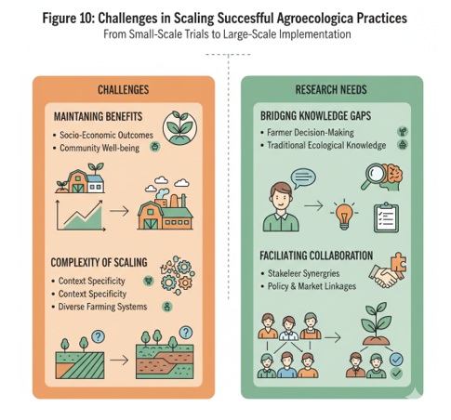
Nutrient Cycling and Availability
Organic farming optimizes nutrient cycling and availability by leveraging microbial diversity, organic amendments, and integrated practices like crop rotations and livestock manure. These approaches enhance mineralization, nutrient retention, and uptake efficiency, reducing reliance on synthetic fertilizers by 30–50% while sustaining soil fertility (Elmqvist et al., 2010; Meshram et al., 2026; Sharma, 2024). Furthermore, the complex interplay between organic matter, soil biota, and plant roots in these systems creates a more efficient nutrient exchange, leading to healthier crops and diminished nutrient leaching into groundwater (Singh et al., 2025).
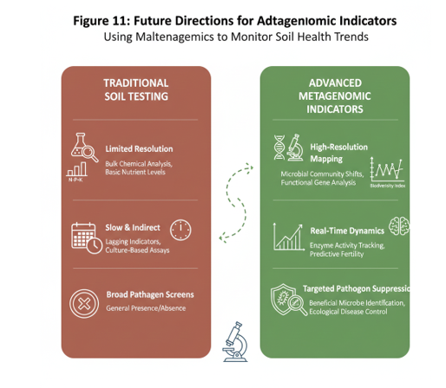
Soil Structure and Water Holding Capacity
Organic amendments such as composting and green manures elevate soil organic matter, improving aggregation, porosity, and water-holding capacity. This fortifies soil against erosion, enhances infiltration, and buffers against drought, with organic soils demonstrating superior retention compared to conventional systems (Meshram et al., 2026; Sharma, 2024; Zanella et al., 2017). This enhanced capacity to store and provide water to crops is especially critical in regions experiencing increasing water scarcity, highlighting the ecological advantages of organic agricultural methods (Khanal, 2009).
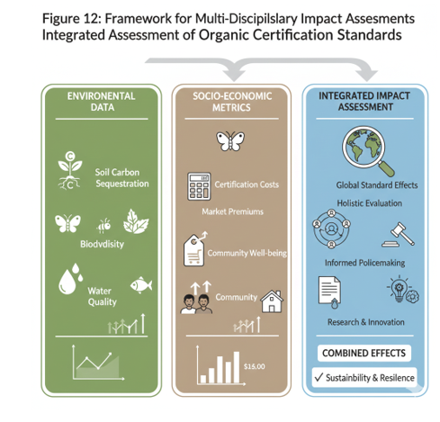
Pest and Disease Suppression in Soil
Organic systems suppress soil-borne pests and diseases through enhanced microbial activity, biological antagonists, and reduced tillage, which preserve suppressive microbiomes. Diverse residues and habitat provisioning promote beneficial organisms that outcompete pathogens, minimizing disease pressure without chemical interventions (Raihan, 2023; Siabato et al., 2025). This comprehensive approach to soil health contributes to improved plant immunity and overall ecosystem stability, further reducing the need for synthetic inputs (Bhanuvally et al., 2024). These practices collectively contribute to the inherent disease resistance of crops and decrease their susceptibility to various environmental stressors (Abbott & Manning, 2015).
Challenges and Limitations of Organic Farming
- Yield Gaps and Economic Viability: Organic yields are often 20–30% lower than conventional due to input restrictions, posing economic challenges in high-demand regions despite long-term sustainability gains (Elmqvist et al., 2010; Zanella et al., 2017).
- Higher production costs and labor requirements for organic certification further impact profitability, necessitating policy support and market incentives to bridge the economic disparity (Elmqvist et al., 2010).
- Weed and Pest Management Challenges: Dependence on mechanical, cultural, and biological controls can increase labor needs and risk incomplete suppression, particularly during transitions (Raihan, 2023).
- Nutrient Management Limitations: Reliance on natural fertility and organic sources may limit nutrient availability and precision, particularly for nitrogen, leading to potential deficiencies and yield plateaus in intensively cropped systems (Mansoor et al., 2025).

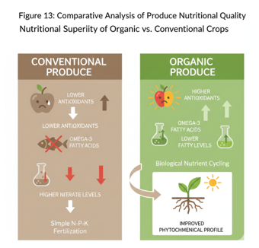
Transition Period Difficulties
The transition to organic farming involves a challenging initial period, typically lasting 2-5 years, during which farms must comply with strict certification standards prohibiting synthetic inputs. This phase often results in yield reductions of 20-30% as soils deplete residual chemicals and rebuild organic matter, microbial diversity, and nutrient cycling capacity, leading to temporary economic strain despite long-term sustainability benefits (Elmqvist et al., 2010; Zanella et al., 2017). Farmers encounter heightened weed pressure, pest outbreaks, and nutrient imbalances, necessitating intensive mechanical weeding, cover cropping, and biological controls that increase labor demands and risk incomplete suppression, especially in high-demand regions (Raihan, 2023).
- Initial yield gaps and revenue losses during soil adaptation
- Surge in weeds and pests requiring non-chemical management
- Temporary nutrient leaching and fertility declines until microbial communities stabilize
Future Research Directions
Ongoing research is essential to address knowledge gaps in organic farming's scalability, resilience, and integration with emerging technologies, building on evidence of its soil health and environmental benefits (Kumari et al., 2022; Sharma, 2024). Prioritizing interdisciplinary studies will help optimize transitions, close yield gaps, and quantify ecosystem services under varying climates.
- Long-term comparative studies on yields, soil health, and climate resilience across diverse regions (Pancholi et al., 2023; Raihan, 2023)
- Development of advanced soil health indicators, including microbial activity and carbon sequestration metrics (Meshram et al., 2026; Siabato et al., 2025)
- Socio-economic analyses of transition costs, farmer livelihoods, and market viability (Elmqvist et al., 2010; Zanella et al., 2017)
Long-Term Comparative Studies
Long-term comparative studies, for instance through extended monitoring in varied agroecological zones, demonstrate enhanced carbon sequestration, biodiversity, and nutrient cycling in organic plots, mitigating climate impacts and supporting sustainable intensification (Khanal, 2009; Meshram et al., 2026; Pancholi et al., 2023). Such long-term data reveal initial yield reductions of 20–30% during transitions but eventual parity or superiority under drought or variable climates due to enhanced soil organic matter and water retention (Elmqvist et al., 2010; Sharma, 2024; Zanella et al., 2017). These findings are critical for informing agricultural policies, refining organic management protocols, and promoting broader adoption of resilient farming practices capable of meeting future food security and environmental stewardship goals (Kumari et al., 2022). Research on how organic fertilizers support such beneficial microbes, along with investigations into soil ecosystems and plant-microbial symbiotic relationships, is also critical (Turan & Yıldırım, 2021).
Table 9: Agroforestry Research Gaps
Gap Area | Specific Need | References
Tree-crop interactions | Under varying climatic conditions | (Pancholi et al., 2023)
Economic valuation | Long-term viability vs. other land uses | (Pancholi et al., 2023)
Social impacts | Undocumented traditional techniques | (Pancholi et al., 2023)
Social systems | Influence of configurations on local needs | (Pancholi et al., 2023)
Biodiversity benefits | Scale-specific assessments | (Brandolini et al., 2025)
Productivity shifts | Upfront costs and revenue | (Brandolini et al., 2025)
Horizontal learning | Stakeholder synergies | N/A
Community organizations | Collaboration for adoption | N/A

Advanced Soil Health Indicators
Further investigation into advanced soil health indicators, beyond traditional physical and chemical parameters, should incorporate microbial community profiling through metagenomics and metabolomics to comprehensively assess ecological function and resilience (Pancholi et al., 2023). This approach enables a deeper understanding of how organic practices influence soil fertility, nutrient cycling, and overall ecosystem health (Kumari et al., 2022). This could involve assessing the transformation of soil conditions over the transition period to organic farming, quantifying changes in soil physicochemical and biological properties (Sapinas & Abbott, 2021). Moreover, future studies should explore how these changes impact the persistence of nutrient availability and long-term soil health under varying environmental conditions (Thiffault et al., 2024).
Moreover, there is a need for robust, long-term studies to assess the persistence of these effects on nutrient availability and overall soil health (Thiffault et al., 2024). Future studies should also evaluate the long-term impact of organic amendments on carbon sequestration rates per hectare to inform incentive structures and carbon credit schemes (Brandolini et al., 2025; Cerqueira et al., 2023). In addition, future research should focus on optimizing organic fertilizer formulations and application strategies to maximize nutrient use efficiency and minimize environmental impacts (Mjanja et al., 2025). Research focusing on the interactions between different tree species and agricultural crops under varying climatic conditions is also essential for optimizing agroforestry systems (Pancholi et al., 2023).

Socio-Economic Aspects of Organic Transition
Economic analyses reveal that while organic farming can achieve comparable or higher profitability through reduced input costs—such as 30–50% lower fertilizer and energy use and over 90% less pesticides—initial yield reductions of 20–30% during transitions pose significant revenue risks and necessitate market premiums or subsidies to offset certification expenses and labor-intensive practices (Elmqvist et al., 2010; Zanella et al., 2017). Higher production costs, including mechanical weeding and compliance with standards, amplify financial pressures, particularly for smallholder farmers, underscoring the need for policy incentives like carbon credits and targeted support to enhance adoption and long-term viability (Brandolini et al., 2025; Elmqvist et al., 2010). Comprehensive socio-economic studies highlight barriers such as upfront investments and market access limitations, yet emphasize potential for diversified revenues and resilient livelihoods through ecosystem services valuation and premium pricing (Abbott & Manning, 2015; Elmqvist et al., 2010). Future research should prioritize farmer-centric models assessing transition subsidies, insurance schemes, and value-chain integration to promote equitable scalability (Elmqvist et al., 2010).

Summary of Findings
This would allow for a more comprehensive investigation of the trade-offs between economic and environmental effects during the transition of the EU farming sector towards greater adoption of organic production (Kremmydas et al., 2023). Such an evaluation would be critical for informing policy and developing robust support mechanisms for farmers adopting ecological practices (Constantin et al., 2022). Bridging research gaps, embracing technological innovations, and formulating strategies for scaling up agroecological practices are crucial steps in advancing this field (Pancholi et al., 2023). Translating successful small-scale agroecological practices to larger agricultural systems presents challenges, necessitating research into scalable strategies that maintain socio-economic benefits and address gaps in understanding farmer decision-making and community outcomes (Fiore et al., 2024).
Table 10: Challenges in Scaling Agroecological Practices
Challenge | Research Need | References
Small-scale to large-scale | Strategies maintaining socio-economic benefits | (Fiore et al., 2024)
Farmer decision-making | Gaps in social/economic impacts and community outcomes | (Fiore et al., 2024)
Socio-economic benefits | Preservation during scaling | (Fiore et al., 2024)
Community outcomes | Understanding dynamics | (Fiore et al., 2024)
Technological innovations | Bridging research gaps | (Pancholi et al., 2023)
Stakeholder synergies | Formulating scalable strategies | (Pancholi et al., 2023)
Policy support | EU farming sector transitions | (Kremmydas et al., 2023)
Long-term viability | Multi-disciplinary assessments | (Sapinas & Abbott, 2021)
Implications for Sustainable Agriculture
Long-term comparative studies across agroecological zones highlight organic farming's advantages in carbon sequestration, biodiversity enhancement, and nutrient cycling, which mitigate climate impacts and enable yield parity or superiority during droughts via improved soil organic matter and water retention (Elmqvist et al., 2010; Khanal, 2009; Meshram et al., 2026; Pancholi et al., 2023; Sharma, 2024; Zanella et al., 2017). Advanced soil health indicators incorporating metagenomics and metabolomics reveal how organic practices boost microbial activity, fertility, and resilience, necessitating research on fertilizer optimization, tree-crop interactions in agroforestry, and carbon sequestration for policy incentives like credits (Brandolini et al., 2025; Cerqueira et al., 2023; Kumari et al., 2022; Mjanja et al., 2025; Pancholi et al., 2023; Sapinas & Abbott, 2021; Thiffault et al., 2024). Socio-economic evaluations show profitability from 30–50% reduced inputs and premium markets offsetting 20–30% transition yield losses, though smallholders need subsidies, insurance, and value-chain support for equitable scaling (Abbott & Manning, 2015; Brandolini et al., 2025; Elmqvist et al., 2010; Zanella et al., 2017). Comprehensive trade-off analyses between economic and environmental effects, alongside farmer-centric models, inform EU policies for organic adoption (Constantin et al., 2022; Kremmydas et al., 2023). Bridging gaps through innovations, scalable agroecology, and stakeholder synergies advances food security and stewardship (Fiore et al., 2024; Pancholi et al., 2023; Turan & Yıldırım, 2021).
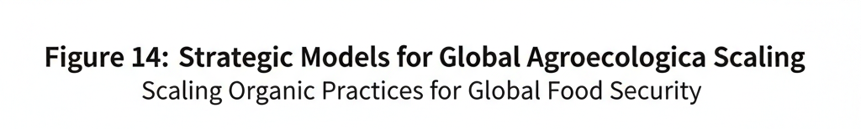
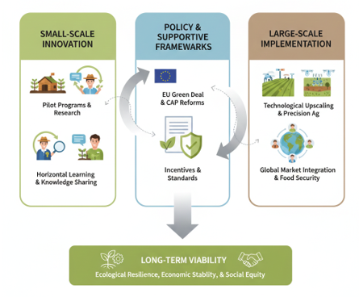
Conclusion
This comprehensive strategy should be developed in collaboration with local authorities, NGOs, and community organizations to ensure widespread adoption and long-term success. Future research should also consider how varied agroecological configurations influence social systems and local needs, promoting beneficial synergies and horizontal learning among stakeholders. Furthermore, an evaluation of this system design at the national level, encompassing a zoning of the project's suitability, is recommended to facilitate the transition from conventional to organic production.

References
- Abbott, L. K., & Manning, D. A. C. (2015). Soil Health and Related Ecosystem Services in Organic Agriculture. Sustainable Agriculture Research, 4(3), 116. https://doi.org/10.5539/sar.v4n3p116
- Bastakoti, B., & Khanal, D. (2022). ORGANIC FARMING: A FEASIBLE SOLUTION TO AGRICULTURAL SUSTAINABILITY: A DETAILED REVIEW [Review of ORGANIC FARMING: A FEASIBLE SOLUTION TO AGRICULTURAL SUSTAINABILITY: A DETAILED REVIEW]. INWASCON Technology Magazine, 4, 25. Zibeline International Publishing. https://doi.org/10.26480/itechmag.04.2022.25.27
- Bhanuvally, M., Sunitha, N. H., Sharanabasava, S., Ravi, S., & Mahadevaswamy, M. (2024). EFFECT OF ORGANIC FARMING PRACTICES ON SOIL BIOLOGICAL PROPERTIES. PLANT ARCHIVES, 24(1). https://doi.org/10.51470/plantarchives.2024.v24.no.1.211
- Brandolini, F., Gurgel, A., & Zerboni, A. (2025). Data-driven scenario analysis supports the revival of historic silvoarable systems for carbon smart rural landscapes. Scientific Reports, 15(1). https://doi.org/10.1038/s41598-025-18950-7
- Cerqueira, H. M., Roxo, M. J. L. B., & Calvo‐Cases, A. (2023). Burying the carbon to dig up the future. Cuadernos de Investigación Geográfica, 50(1), 59. https://doi.org/10.18172/cig.5767
- Chand, R., Juyal, R., & Prasad, R. (2022). Principles And Practices Of Agro-Ecology And Organic Agriculture That Are Both Convergent And Divergent: A Review [Review of Principles And Practices Of Agro-Ecology And Organic Agriculture That Are Both Convergent And Divergent: A Review]. Journal of Survey in Fisheries Sciences. Green Wave Publishing of Canada. https://doi.org/10.53555/sfs.v8i3.2391
- Constantin, M., Deaconu, M. E., Petrescu, I.-E., Istudor, M., & Tărăşilă, G. A. (2022). A review on the competitiveness and performance of ecological, organic and regenerative agricultural systems [Review of A review on the competitiveness and performance of ecological, organic and regenerative agricultural systems]. Proceedings of the ... International Conference on Business Excellence, 16(1), 304. De Gruyter Open. https://doi.org/10.2478/picbe-2022-0030
- Elmqvist, T., Maltby, E., Barker, T., Mortimer, M., Perrings, C., Aronson, J., De Groot, R., Fitter, A., Mace, G., Norberg, J., Sousa Pinto, I., Ring, I., Grimm, V., Jax, K., Leemans, R., & Salles, J.-M. (2010). Biodiversity, ecosystems and ecosystem services.
- Fiore, V., Borrello, M., Carlucci, D., Giannoccaro, G., Russo, S., Stempfle, S., & Roselli, L. (2024). The socio-economic issues of agroecology: a scoping review [Review of The socio-economic issues of agroecology: a scoping review]. Agricultural and Food Economics, 12(1). Springer Nature. https://doi.org/10.1186/s40100-024-00311-z
- Khanal, R. C. (2009). Climate Change and Organic Agriculture. Deleted Journal, 10, 116. https://doi.org/10.3126/aej.v10i0.2136
- Kremmydas, D., Ciaian, P., & Baldoni, E. (2023). Modeling conversion to organic agriculture with an EU-wide farm model. Bio-Based and Applied Economics, 12(4), 261. https://doi.org/10.36253/bae-13925
- Kumari, S., Ikram, M., Nautiyal, M., & Juyal, R. (2022). From Seed To Sustainability: A Perspective On Organic Farming. Journal of Survey in Fisheries Sciences. https://doi.org/10.53555/sfs.v8i3.2397
- Mansoor, S., Iqbal, S., Popescu, S. M., Kim, S. L., Mansoor, S., & Baek, J. (2025). Integration of smart sensors and IOT in precision agriculture: trends, challenges and future prospectives [Review of Integration of smart sensors and IOT in precision agriculture: trends, challenges and future prospectives]. Frontiers in Plant Science, 16, 1587869. Frontiers Media. https://doi.org/10.3389/fpls.2025.1587869
- Meshram, S., Mansor, H., & Adhikari, T. B. (2026). Recent advances in organic agriculture: innovations, challenges, and opportunities. Frontiers in Plant Science, 16. https://doi.org/10.3389/fpls.2025.1681928
- Mjanja, B. E., Shitindi, M. J., Massawe, B. H. J., & Mulashani, G. R. (2025). Driving sustainability in tea farming: insights on organo-mineral fertilizers. Frontiers in Soil Science, 5. https://doi.org/10.3389/fsoil.2025.1629846
- Pancholi, R., Yadav, R. P., Gupta, H., Vasure, N., Choudhary, S., Singh, M. N., & Rastogi, M. (2023). The Role of Agroforestry Systems in Enhancing Climate Resilience and Sustainability- A Review [Review of The Role of Agroforestry Systems in Enhancing Climate Resilience and Sustainability- A Review]. International Journal of Environment and Climate Change, 13(11), 4342. Sciencedomain International. https://doi.org/10.9734/ijecc/2023/v13i113615
- Panday, D., Bhusal, N., Das, S., & Ghalehgolabbehbahani, A. (2024). Rooted in Nature: The Rise, Challenges, and Potential of Organic Farming and Fertilizers in Agroecosystems. Sustainability, 16(4), 1530. https://doi.org/10.3390/su16041530
- Raihan, A. (2023). A review of agroforestry as a sustainable and resilient agriculture [Review of A review of agroforestry as a sustainable and resilient agriculture]. Journal of Agriculture Sustainability and Environment, 2(1), 49. Global Society of Scientific Research and Researchers. https://doi.org/10.56556/jase.v2i1.799
- Sapinas, I. P., & Abbott, L. K. (2021). Soil Fertility Management Based on Certified Organic Agriculture Standards - a Review [Review of Soil Fertility Management Based on Certified Organic Agriculture Standards - a Review]. AgEcon Search (University of Minnesota, USA). University of Minnesota Rochester. http://ageconsearch.umn.edu/record/309766
- Sharma, S. (2024). Organic Agriculture for Sustainable Food Systems: A Comprehensive Review of Benefits and Constraints [Review of Organic Agriculture for Sustainable Food Systems: A Comprehensive Review of Benefits and Constraints]. Turkish Journal of Agriculture - Food Science and Technology, 12(8), 1476. Turkish Science and Tecnology (TST). https://doi.org/10.24925/turjaf.v12i8.1476-1481.6482
- Siabato, A. I. B., Castro-Triana, A. M., Colmenares‐Cruz, R. A., & López, N. M. M. (2025). Evaluation of agroecological processes implemented in olive production systems: an analysis in Boyacá, Colombia. Frontiers in Sustainable Food Systems, 9. https://doi.org/10.3389/fsufs.2025.1666553
- Singh, A. K., Narender, DR., Dinesh, M. S., Panghaal, D., Golui, K., Phogat, P., & Saini, M. L. (2025). Land suitability assessment of soils under organic cultivation of CCSHAU, Hisar for improved land use planning. Journal of Environmental Biology, 46(5), 701. https://doi.org/10.22438/jeb/46/5/mrn-5598
- Thiffault, N., Nordin, P., Wotherspoon, A., Hjelm, K., & Olofsson, E. (2024). A trans-Atlantic perspective on successful plantation establishment in boreal ecosystems: lessons learned and research opportunities [Review of A trans-Atlantic perspective on successful plantation establishment in boreal ecosystems: lessons learned and research opportunities]. New Forests, 56(1), 16. Springer Science+Business Media. https://doi.org/10.1007/s11056-024-10086-2
- Turan, M., & Yıldırım, E. (2021). New Generation of Organic Fertilizers. In IntechOpen eBooks. IntechOpen. https://doi.org/10.5772/intechopen.95683
- Zanella, A., Geisen, S., Ponge, J., Jagers, G., Benbrook, C., Dilli, T., Vacca, A., Kwiatkowska-Malina, J., Aubert, M., Fusaro, S., Nobili, M. D., Lomolino, G., & Gomiero, T. (2017). Humusica 2, article 17: techno humus systems and global change − three crucial questions. Applied Soil Ecology, 122, 237. https://doi.org/10.1016/j.apsoil.2017.10.010

