Effects of Seed Priming with Ginger (Zingiber officinale) and Neem (Azadirachta indica) Extracts on Germination, Germination Kinetics, and Moisture Retention of Bambara Groundnut (Vigna subterranea) Under Water Stress Conditions

Abstract
Seed priming with botanical extracts represents a sustainable strategy to enhance crop establishment and resilience under water-limited conditions. This study investigated the effects of ginger (Zingiber officinale) and neem (Azadirachta indica) seed priming at varying concentrations on the germination kinetics and early vegetative development of two genotypes (ZM 1856 and ZM 2656) of Bambara groundnut (Vigna subterranea L.). A factorial experiment was conducted using different concentrations of ginger extract (0–20% w/v) and neem extract (0–4% w/v). Results revealed significant genotype x priming treatment interactions for seedling vigor index (SVI), shoot length, and total dry matter (p<0.05). Effect size analysis () demonstrated that botanical treatments exerted a large effect on number of root nodules (0.548) relative moisture content (0.40), germination rate (0.442) and seedling vigor (0.444). Post-hoc mean separation identified ginger priming at 10–15% as the most effective for enhancing early growth kinetics, seed vigour index, and leaf efficiency (LE). Pearson correlation analysis further demonstrated strong interdependencies among variables such as SVI and germination (r=0.972), leaf efficiency and total dry matter (r=0.524). These findings demonstrate the positive effects of botanical seed priming in improving the resilience of Bambara groundnut, offering a sustainable tool for stabilizing yields in semi-arid environments.
Keywords: Azadirachta indica, botanical bio stimulants, effect size, heat map, leaf efficiency, seed vigor index, Zingiber officinale

1 Introduction
Bambara groundnut (Vigna subterranea L. Verdc.) is a critical grain legume indigenous to Africa, predominantly cultivated by small-scale farmers in semi-arid regions of Sub-Saharan Africa under low-input production systems (Mubaiwa et al 2018; Majola et al 2021). Despite its potential as a "complete balanced diet" rich in carbohydrates (63–69%) and protein (18–24%), national average yields in regions like Zambia remain significantly below their documented potential of 3,000 kg/ha (Khan et al, 2021; Majola et al, 2021). This productivity gap is exacerbated by the increasing frequency of droughts, which now occur almost every 4 to 5 years due to global climate change (Hamududu and Ngoma 2019; ZamStats 2024).
Drought is a major factor limiting plant survival, particularly during germination when water constraints impair seedling establishment, leading to yield losses of up to 40% (Ahluwalia et al, a 2021; IAPRI 2023). Seed priming has been proposed as a key low-cost intervention to enhance seedling vigor and yield stability under such conditions (Ntshalintshali, et al, 2026). This strategy induces biochemical mechanisms, including the activation of antioxidant systems and reserve mobilization, preparing the seedling for future stress through "stress memory" (Wojtyla et al 2016a; Johnson and Puthur 2021).
Botanical extracts such as ginger and neem are gaining interest as sustainable bio stimulants (Naz et al, 2022; Queslati et al. 2025). Ginger rhizome extracts are rich in phenolics that enhance oxidative defense, while neem leaf extracts contain bioactive limonoids like nimbolide B, which exhibit potent allelopathic activity but also growth-regulating benefits at controlled doses (Noguchi, et al, 2014). This study investigates the physiological and morphophysiological responses to these extracts in alleviating drought-associated stress in Vigna subterranea.

2 Materials and methods

2.1 Experimental workflow
The study followed a multi-phase approach to transition from seed-level laboratory bio stimulation to whole-plant greenhouse evaluation under moisture deficit conditions.

2.2 Preparation of priming extracts and growth conditions
Seeds of two genotypes (ZM 1856 and ZM 2656) were obtained from the National Plant Genetic Resources Center.¹ Priming solutions were prepared using fresh ginger rhizomes and neem leaves blended with distilled water: ginger (0–20% w/v) and neem (0–4% w/v). Seeds were surface-sterilized with 1% sodium hypochlorite, soaked in botanical extracts for 24 hours at (25+2°C in darkness, and planted in 20litre buckets filled with a mixture of top soil, sand and compost in a ratio of 1:1:1. The experiment used a randomized complete block design (RCBD) with four replications thus employing a 2 x 10 factorial arrangement.

Germination and Early Seedling Growth
Seed germination was monitored daily for 21 days. A seed was considered germinated when the plumule was clearly visible above the soil surface. The following indices were calculated:
- Germination Rate (GR): Expressed as the final percentage of seeds that germinated relative to the total number of seeds sown.
- Mean Germination Time (MGT): Calculated using the formula:
MGT =∑(nxd)/N
where n is the number of seeds germinated on day d, and N is the total number of germinated seeds.
- Germination Index (GI): Computed to reflect both germination percentage and speed:
GI = ∑(n/d)
where Gt is the number of germinated seeds on day t and Dt is the corresponding day of culture.
- Seed Vigour Index (SVI): Determined using the following relationship:
SVI = Germination % x Seedling Length

Nodulation and Biomass Allocation
At 28 days after sowing (DAS), plants were harvested to assess growth and symbiotic performance.
- Root Nodules per Plant: Roots were carefully washed under a gentle stream of water to remove soil particles. All visible nodules were detached and counted manually to determine the mean number of nodules per plant.
- Dry Matter Accumulation: Plants were partitioned into roots and shoots. Samples were oven-dried at 70°C for 72 hours until a constant weight was achieved.
  - Root Dry Weight (RDW) and Shoot Dry Weight (SDW) were recorded using a precision analytical balance.
  - Total Dry Matter (TDM) was calculated as the sum of RDW and SDW.
  - Root: Shoot Ratio was determined by dividing RDW by SDW to assess biomass partitioning.

Physiological and Stress Parameters
To evaluate the water status of the plants under experimental conditions, the following were recorded:
- Relative Moisture Content (RMC): Also referred to as Relative Water Content (RWC), this was determined using leaf discs. The fresh weight (FW) was recorded immediately, followed by the turgid weight (TW) after immersion in distilled water for 24 hours, and finally the dry weight (DW) after oven-drying.
RMC (\%) = (FW - DW) (TW - DW) x 100
- Wilting Scores: Visual symptoms of water stress were assessed using a standardized 1–5 scale, where 1 indicated a healthy plant with full turgidity and 5 indicated a completely wilted or necrotic plant.

2.4 Data analysis
Data were subjected to a two-way ANOVA using Jamovi statistical package version. Treatment means were separated using Tukey’s HSD test at p< 0.05. Effect sizes were calculated as partial eta squared (). Pearson correlation coefficients (r) assessed relationships between growth and physiological variables. Derivative statistics, including the Coefficient of Variation (CV%) and Least Significant Difference (LSD at 0.05), were calculated for each trait using the residual mean squares from the ANOVA models.

3 Results

3.1 ANOVA and derivative statistics for establishment traits
Analysis of variance results indicate that botanical priming treatments exerted a considerable effect on major traits, particularly number of root nodules () and germination rate (=0.442).
Table 1: ANOVA and effect sizes () for Germination and Growth Traits
F-Values for Sources of Variation and their Effect Sizes | No. Leaves | Germ Rate (%) | Seed Vigour Index | Germination Index | Mean Germination Time | Shoot Length | Number of Root Nodules | Relative Moisture Content  (%)
TREATMENT (F) | 2.78** | 5.02  *** | 5.07  *** | 103.7*** | 41.22*** | 1.56 | 7.45  *** | 66.19***
Genotype (F) | 47.80*** | 52.05*** | 58.29  *** | 645.8*** | 564.8*** | 33.13  *** | 1.29 | 291.7***
Interaction (Genotype x Treatment) (F) | 1.63 | 1.73 | 2.14* | 66.14*** | 23.3*** | 2.44* | 1.6 | 56.9***
Effect Size (Treatments () | 0.305 | 0.442 | 0.444 | 0.418 | 0.307 | 0.197 | 0.540 | 0.40
Effect Size (Genotypes) () | 0.456 | 0.477 | 0.506 | 0.281 | 0.467 | 0.368 | 0.022 | 0.199
Effect Size (Interactions)() | 0.205 | 0.215 | 0.252 | 0.265 | 0.174 | 0.278 | 0.202 | 0.35
*** p < 0.001 (Highly Significant), ** p < 0.01 (Significant), p < 0.05 (Moderately Significant)
Germination Index
Analysis of Variance (ANOVA) revealed that the Germination Index (GI) was significantly influenced by the main effects of botanical treatment (p < .001) and genotype (p < .001). A highly significant Treatment X Genotype interaction (p < .001) indicated that the response to priming extracts was genotype-specific. For ZM 1856, the highest ZM 1856 was recorded under G15 (16.82), while the lowest was observed in the N4 treatment (9.20). Conversely, ZM 2656 achieved its maximum GI at G10 (13.50), suggesting a higher sensitivity to lower concentrations of ginger extract compared to ZM 1856 (Figure 1).

Mean Germination Time (MGT)
MGT was significantly affected by treatment (p < .001), genotype (p < .001), and their interaction (p < .001). ZM 1856 generally exhibited faster germination (lower MGT) than ZM 2656. The most rapid germination for ZM 1856 occurred at G15 (5.90 days), whereas N4 significantly delayed germination to 8.10 days. In ZM 2656, G10 emerged as the most effective treatment for reducing MGT (7.10 days) compared to its control (8.40 days). These results suggest that botanical priming not only improves the total germination percentage but also significantly accelerates the germination process.

Germination Kinetics and Seed Vigour Index
The germination percentage (Germ %) and Seed Vigour Index (SVI) showed a distinct sensitivity to botanical concentrations, particularly in ZM 1856 (ZM 1856). For ZM 1856, the control group maintained a high SVI (3161), but as the concentration of Neem and Ginger increased, both germination and vigour significantly declined. The lowest germination (23.3%) and SVI (944) were recorded at Neem 3%.
In contrast, ZM 2656 appeared much more resilient to the botanical treatments. The highest germination (90.0%) and SVI (4032) were observed under Ginger 10%. Even at higher concentrations like Ginger 20%, ZM 2656 maintained a high germination rate (80.0%) and SVI (3747), suggesting a genotype-specific tolerance to these botanical extracts.
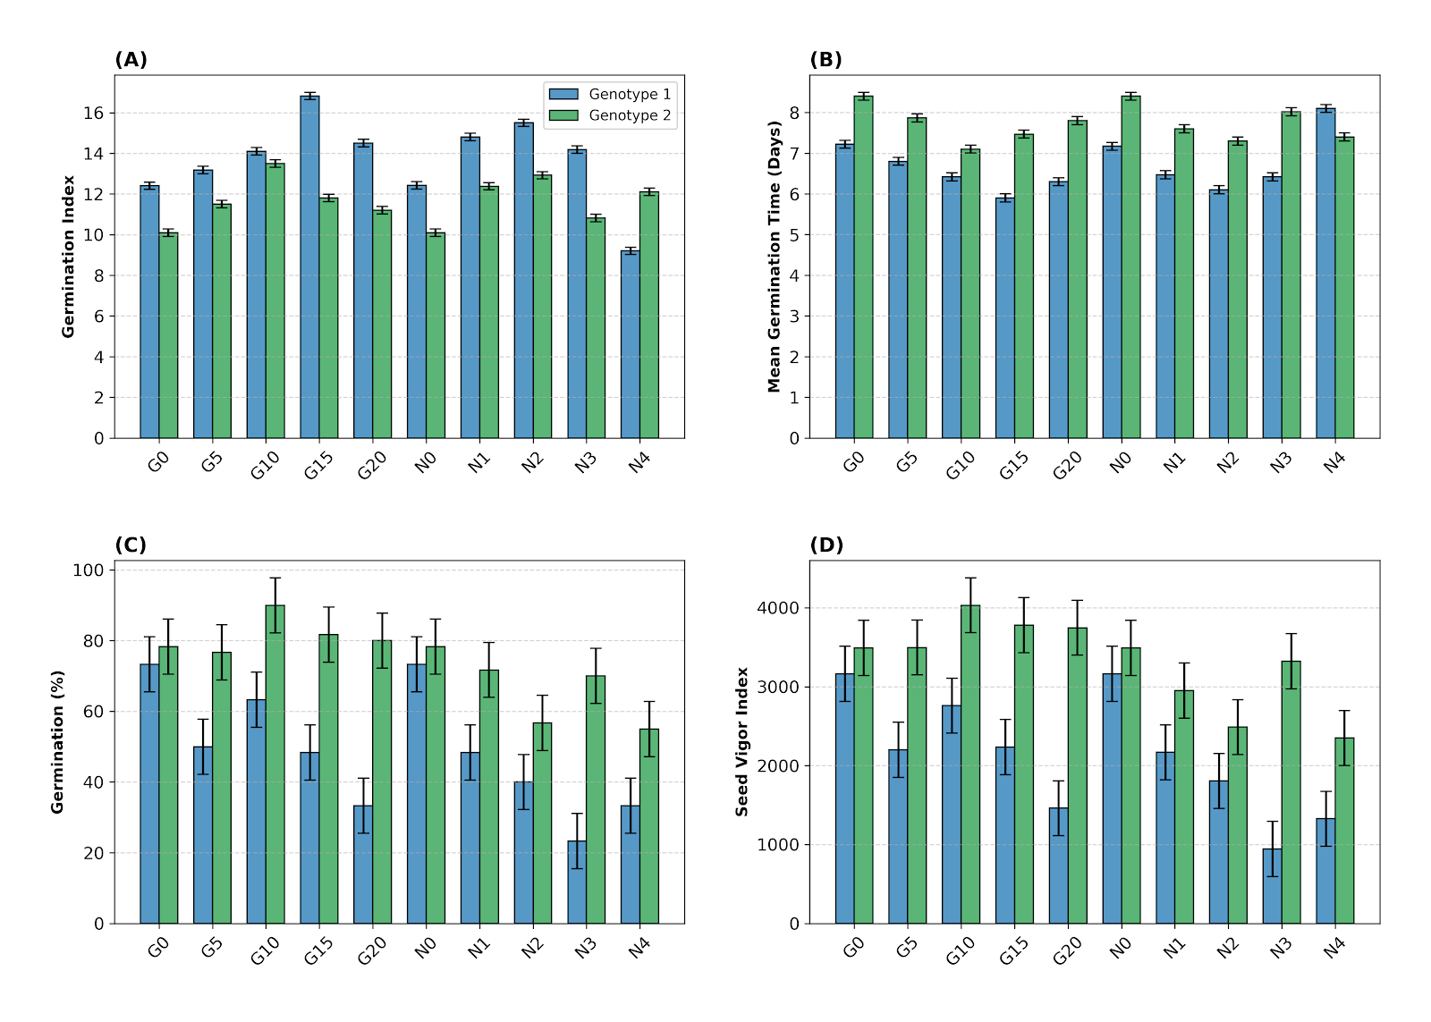Figure 1-Effects of botanical priming with Ginger (G) and Neem (N) extracts on (A) Germination Index, (B) Mean Germination Time, (C) Germination Percentage, and (D) Seed Vigor Index of two Bambara groundnut genotypes. Error bars represent + Standard Error. G0/N0 represent non-primed controls.

3. Root Nodule Development
Nodule formation, a key indicator of symbiotic efficiency and plant health, was significantly enhanced by Ginger treatments across both genotypes. For ZM 1856, the highest number of root nodules (61.1) was recorded with Ginger 10%, nearly doubling the count of the control group (32.0), while with ZM 2656, the highest nodule count (62.0) was observed at the highest concentration of Ginger 20%. Whereas neem treatments also improved nodule counts compared to the control in some instances (e.g., ZM 1856 Neem 1% at 45.5), they generally did not match the stimulatory effect seen with the Ginger extracts

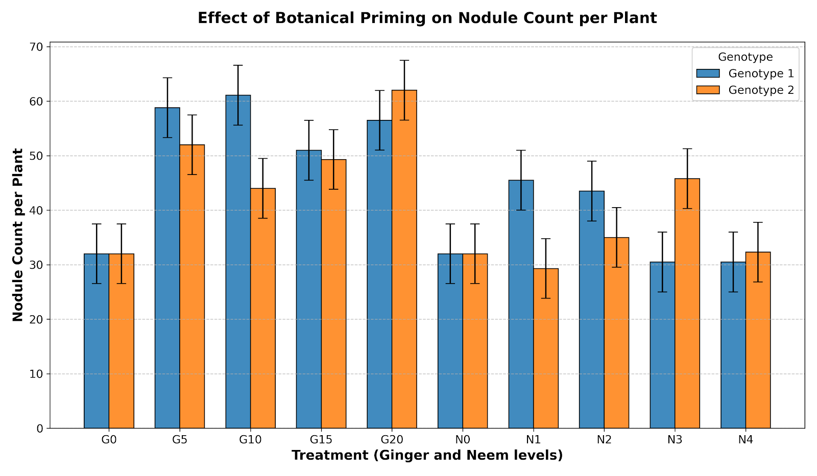
Figure 2: Effect of seed priming with varying concentrations of Ginger (G) and Neem (N) botanical extracts on the nodule count per plant in two Bambara groundnut genotypes. Error bars indicate the Standard Error of the Mean (SEM). G0 and N0 represent the non-primed control groups for each treatment series.
The application of botanical extracts significantly affected the biomass parameters of both genotypes compared to the control (0%). In ZM 1856, the highest root dry weight (0.9g), shoot dry weight (5.52g), and total dry matter (6.47g) were recorded under the Ginger 20% treatment. These values represented a significant increase over the control, which recorded the lowest total biomass (3.3g). Neem treatments in ZM 1856 also showed an upward trend in biomass compared to the control, with Neem 3% reaching a total dry matter of 5.12g, though it remained statistically comparable to the mid-range ginger treatments.
In ZM 2656, a similar trend was observed. The Ginger 20% treatment again yielded the highest root dry weight (1.125g) and total dry matter (5.45g). Notably, while the control for ZM 2656 had a low shoot dry weight (2.85g), both Ginger 20% and Neem 3% significantly enhanced shoot growth (4.32g and 4.35g, respectively).

3.2 Biomass Partitioning and Physiological Traits
Table 2: ANOVA and effect sizes for biomass and physiological traits.
Source of Variation | Root Fresh Wt | Shoot Fresh Wt | Total Fresh Wt | Root Dry Wt | Shoot Dry Wt | Root: Shoot Ratio | Total Dry matter | Wilting Scores
TREATMENT (F) | 5.39  *** | 4.19  *** | 4.53  *** | 6.16  *** | 2.90  ** | 3.97  *** | 3.66  *** | 3.62  ***
Genotype (F) | 0.318 | 14.62*** | 13.18*** | 0.528 | 5.16* | 4.49* | 4.16* | 17.61***
Interaction  (Treat*Gen)(F) | 1.43 | 1.13 | 1.14 | 0.81 | 0.46 | 0.414 | 0.44 | 1.2
Effect Size (Treatments () | 0.46 | 0.398 | 0.417 | 0.493 | 0.314 | 0.385 | 0.366 | 0.364
Effect Size (Genotype () | 0.006 | 0.204 | 0.188 | 0.009 | 0.083 | 0.073 | 0.068 | 0.236
Effect Size (Interactions) () | 0.184 | 0.151 | 0.153 | 0.114 | 0.067 | 0.142 | 0.065 | 0.159
*** p < 0.001 (Highly Significant), ** p < 0.01 (Significant), p < 0.05 (Moderately Significant)
Treatment effects were highly significant for root dry weight (η²p=0.493) and total biomass (0.366) (Table 2).
ZM 1856 achieved peak dry matter productivity (6.47 g/plot) under 20% ginger, while Neem 3% yielded the lowest wilting score in ZM 1856 (1.00 b) (T

Figure 3: Effects of botanical priming of bambara groundnuts genotypes (ZM 2656 and ZM 1856) on water status under water stress as measured by % moisture content against control treatments and wilting scores
Wilting scores, which indicate the level of plant stress, were highest in the untreated controls for both genotypes (ZM 1856:ZM 2656. The application of botanicals effectively reduced these scores. In ZM 1856, the most substantial reduction in wilting was observed with Neem 3% (1.0), which was significantly lower than the control. In ZM 2656, while all treatments reduced wilting, the most effective were Ginger 10% and Ginger 20%, alongside Neem 4%, all showing scores 2.75 compared to the control's 4.5.
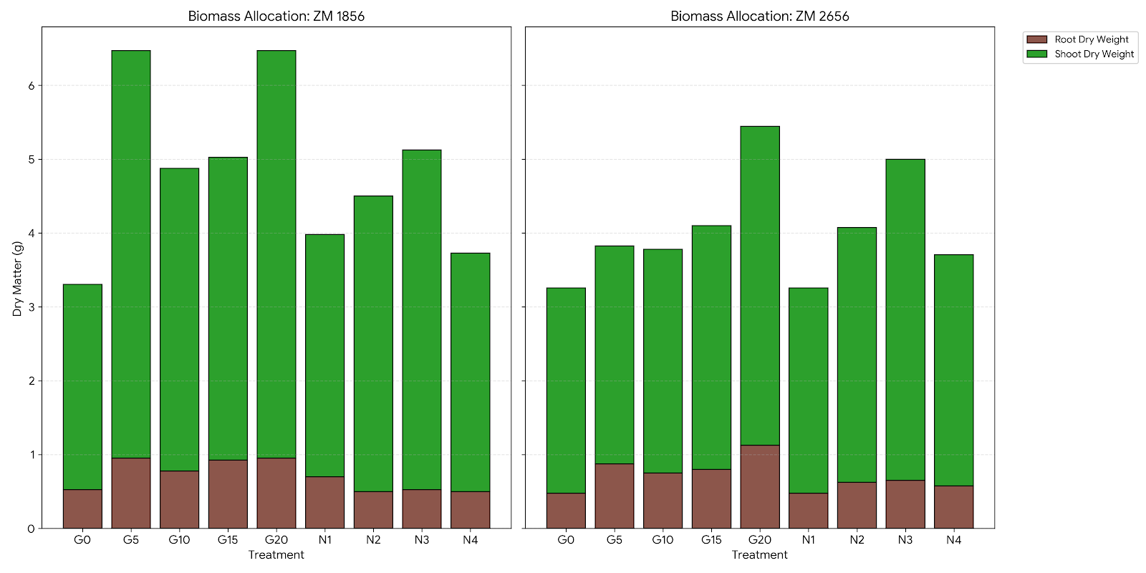
Figure 4: Biomass allocation in two Bambara groundnut genotypes (ZM 1856 and ZM 2656) following seed priming with Ginger G) and Neem (N) botanical extracts. Stacked bars represent total dry matter (g), partitioned into Root Dry Weight (brown) and Shoot Dry Weight (green). G0 and N0 serve as the non-primed control groups.

3. Leaf Efficiency
Leaf efficiency, calculated as total dry matter/total number of leaves varied across treatments and genotypes. For ZM 1856, the highest efficiency was observed in the Ginger 20% group (0.462g/leaf). Interestingly, for ZM 2656, the highest leaf efficiency was recorded in the Neem 3% treatment (0.678g/leaf), which significantly outperformed the control (0.406g/leaf). Across both genotypes, the higher concentrations of Ginger generally maintained or improved leaf efficiency, while the performance of Neem was more concentration-specific,

Figure 5: Comparative analysis of (A) Biomass Partitioning (Root: Shoot Ratio) and (B) Physiological Performance (Leaf Efficiency) in two Bambara groundnut genotypes (ZM 1856 and ZM 2656) subjected to seed priming with various concentrations of Ginger (G) and Neem (N) botanical extracts. Data points represent the mean values for each treatment (G0–G20 and N1–N4).

Correlation Analysis
The Pearson correlation analysis revealed several significant relationships among the studied plant traits, ranging from strong positive associations to notable negative correlations.

1. Strong Positive Correlations (Germination and Early Growth)
A very strong and highly significant positive correlation was observed between Germination Percentage (Germ %) and the Seed Vigour Index (SVI) (r = 0.972, p < 0.001), indicating that treatments promoting higher germination rates concurrently enhanced seedling vigour. Both Germ % and SVI were also significantly and positively correlated with Shoot Length (r = 0.670 and r = 0.704, respectively; p < 0.001).

2. Biomass and Nodulation Relationships
Total dry matter accumulation showed a significant positive correlation with several key traits such as number of root nodules (r=0.521, p < 0.001) and leaf efficiency (r = 0.524, p < 0.001). The correlation with root length was not significant (r=0.168).

3. Root Characteristics and Leaf Efficiency
Root Length exhibited a significant positive correlation with the number of root nodules (r = 0.487, p < 0.001), confirming that a more extensive root system provides more sites for nodule formation. Furthermore, Leaf efficiency was significantly and positively correlated with all other parameters except for total dry matter accumulation, with notable links to Shoot Length (r = 0.438, p < 0.001) and number of root nodules (r = 0.401, p < 0.001).

4. Significant Negative Correlations
Total Dry matter exhibited a significant negative correlation with Germination % (r = -0.437, p < 0.001) and SVI (r = -0.370, p < 0.001). This inverse relationship suggests that under the specific botanical treatments used, conditions that maximized initial germination and vigour may not have necessarily translated to the highest final dry matter, or that certain high-biomass treatments may have had a suppressive effect on the initial germination phase.

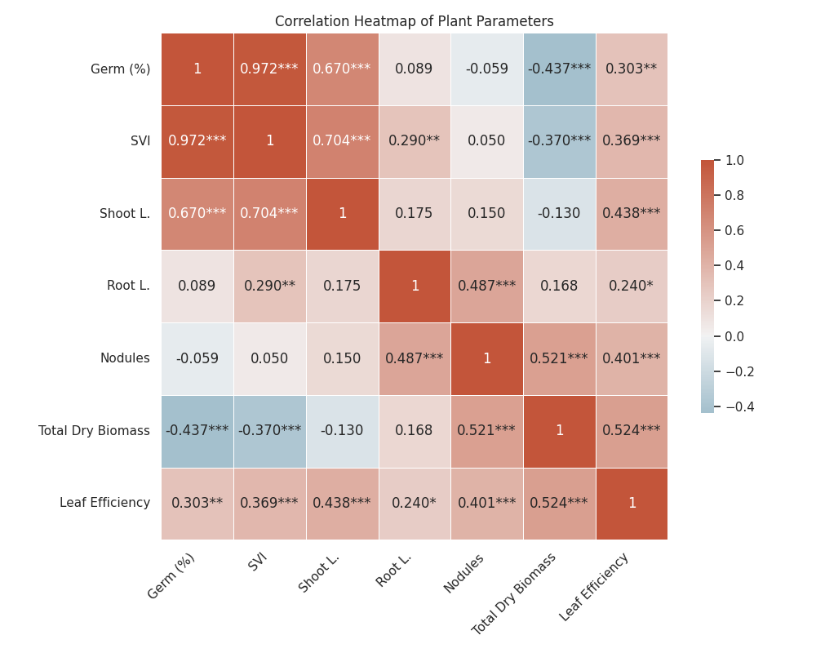
Figure 6: Pearson correlation matrix heat map representing the interdependencies between establishment, growth, and physiological variables of Bambara groundnut genotypes under botanical priming. The color ramp indicates the strength and direction of the correlation coefficients (r), ranging from +1.0 (vibrant red; strong positive correlation) to -1.0 (cool blue; strong negative correlation). *** p < 0.001 (Highly Significant), ** p < 0.01 (Significant), p < 0.05 (Moderately Significant)

4 Discussion

4.1 Germination kinetics, Seed Vigour Index and Physiological Traits
The study revealed a significant genotype priming interaction for the seedling vigor index (SVI) (p< 0.05), with a large treatment effect size ().¹ The visual Heat Map confirms a near-linear interdependence between SVI and germination rate (r=0.972), indicating that the physiological stamina of the seed directly dictates the rate of stand establishment.¹ Ginger priming at 10–15% significantly improved both parameters, likely because gingerols facilitate a faster transition from Phase II to Phase III of imbibition by mobilizing food reserves more effectively (Ali, et al, 2008; Queslati et al. 2025). The large effect size confirms the utility of biostimulants choice in driving seedling performance. (Cohen 1988).

4.2 Biomass Partitioning and Leaf Efficiency
One critical observation was in leaf efficiency (LE), which showed a significant genotype effect () peaking at 0.678 in ZM 2656 under 3% neem, correlated positively with total dry matter (r=0.524). This relationship suggests that biostimulants enhance the functional capacity of the photosynthetic surface area to assimilate carbon under stress. The positive correlation between shoot length and leaf efficiency (r=0.438) indicates that successful genotypes reorganize biomass partition to prioritize vertical growth and light interception area when total biomass is constrained by drought (Mateva, et al 2022).

4.3 Symbiotic Potential and Root Infrastructure
Heat Map analysis revealed root nodules were significantly associated with root length (r=0.487) and total dry matter (r=0.521). This highlights that root infrastructure is a limiting factor for biological nitrogen fixation in legumes under stress (Mohale, et al 2014). Ginger priming, which facilitated root nodulation (max 62.0 in ZM 2656), likely created a more conducive rhizosphere for rhizobia colonization. In contrast, the substantial reduction in wilting rate under neem priming () despite suppressed early growth suggests a triggered physiological pathway for water-use efficiency (Naz, et al, 2022).

5 Conclusions
Botanical seed priming is a viable strategy for improving drought resilience in Bambara groundnut. Large effect sizes and mean separation confirm that ginger extract at 10–15% is optimal for enhancing germination, SVI, and leaf efficiency. While neem offers survival benefits via reduced wilting, under water stress conditions, careful concentration management is needed to avoid suppressive thresholds. These findings provide a foundation for stabilizing yields in semi-arid environments.

References
- Ahluwalia, O., Singh, P.C. and Bhatia, R. (2021) 'A review on drought stress in plants: Implications, mitigation and the role of plant growth promoting rhizobacteria', Resources, Environment and Sustainability, 5, p. 100032. Available at: https://doi.org/10.1016/j.resenv.2021.100032.
- Ali, B.H., Blunden, G., Tanira, M.O. and Nemmar, A. (2008) 'Some phytochemical, pharmacological and toxicological properties of ginger (Zingiber officinale Roscoe): A review of recent research', Food and Chemical Toxicology, 46(2), pp. 409–420. Available at: https://doi.org/10.1016/j.fct.2007.09.085.
- Alharbi, K., Al-Osaimi, A.A. and Alghamdi, B.A. (2022) 'Sodium chloride (NaCl)-induced physiological alteration and oxidative stress generation in Pisum sativum (L.): a toxicity assessment', ACS Omega, 7, pp. 20819–20832. Available at: https://doi.org/10.1021/acsomega.2c01427.
- Andrade, C.A., de Souza, K.R.D., de Oliveira Santos, M., da Silva, D.M. and Alves, J.D. (2018) 'Hydrogen peroxide promotes the tolerance of soybeans to waterlogging', Scientia Horticulturae, 232, pp. 40–45. Available at: https://doi.org/10.1016/j.scienta.2017.12.048.
- Anjum, N.A., Gill, S.S., Corpas, F.J., Ortega-Villasante, C., Hernández, L.E., Tuteja, N., Sofo, A., Hasanuzzaman, M. and Fujita, M. (2022) 'Editorial: recent insights into the double role of hydrogen peroxide in plants', Frontiers in Plant Science, 13, p. 843274. Available at: https://doi.org/10.3389/fpls.2022.843274.
- Chaudhry, S. and Sidhu, G.P.S. (2022) 'Climate change regulated abiotic stress mechanisms in plants: a comprehensive review', Plant Cell Reports, 41, pp. 1–31. Available at: https://doi.org/10.1007/s00299-021-02759-5.
- Cohen, J. (1988) Statistical power analysis for the behavioral sciences. Hillsdale: Lawrence Erlbaum.
- El Bilali, H., Kiebre, Z., Nanema, R.K., Guimbo, I.D., Rokka, V.-M., Gonnella, M., Tietiambou, S.R.F., Dambo, L., Nanema, J. and Grazioli, F. (2024) 'Mapping Research on Bambara Groundnut (Vigna subterranea (L.) Verdc.) in Africa: Bibliometric, Geographical, and Topical Perspectives', Agriculture, 14, p. 1541. Available at: https://doi.org/10.3390/agriculture14091541.
- FAO (2020) FAOSTAT Statistical Database: Crops and Livestock Products. Rome: FAO. Available at: https://www.fao.org/faostat/en/#data/QCL.
- Hamududu, B.H. and Ngoma, H. (2019) 'Impacts of climate change on water resources availability in Zambia', Water, 11(6), p. 1146. Available at: https://doi.org/10.3390/w11061146.
- Hasegawa, P.M., Bressan, R.A., Zhu, J.K. and Bohnert, H.J. (2000) 'Plant cellular and molecular responses to high salinity', Annual Review of Plant Physiology and Plant Molecular Biology, 51, pp. 463–499. Available at: https://doi.org/10.1146/annurev.arplant.51.1.463.
- Hossain, M.A., Bhattacharjee, S., Armin, S.M., Qian, P., Xin, W., Li, H.Y., Burritt, D.J., Fujita, M. and Tran, L.P. (2015) 'Hydrogen peroxide priming modulates abiotic oxidative stress tolerance: insights from ROS detoxification', Frontiers in Plant Science, 6, p. 420. Available at: https://doi.org/10.3389/fpls.2015.00420.
- IAPRI (2023) Zambian Agriculture Status Report 2023. Lusaka: Indaba Agricultural Policy Research Institute. Available at: https://www.iapri.org.zm/.
- Johnson, R. and Puthur, J.T. (2021) 'Seed priming as a cost effective technique for developing plants with cross tolerance', Plant Physiology and Biochemistry, 162, pp. 247–257. Available at: https://doi.org/10.1016/j.plaphy.2021.02.034.
- Khan, M.M.H., Rafii, M.Y., Ramlee, S.I., Jusoh, M. and Al-Mamun, M. (2021) 'Bambara Groundnut (Vigna subterranea L. Verdc): A Crop for the New Millennium', Sustainability, 13, p. 5530. Available at: https://doi.org/10.3390/su13105530.
- Kunene, S., Gerrano, A.S. and Odindo, A.O. (2025) 'Drought tolerance assessment of Bambara groundnut accessions based on morphological and physiological traits', South African Journal of Botany, 184, pp. 880–894. Available at: https://doi.org/10.1016/j.sajb.2025.07.002.
- Kunene, S., Odindo, A.O., Gerrano, A.S. and Mandizvo, T. (2022) 'Screening Bambara Groundnut Genotypes for Drought Tolerance at the Germination Stage', Plants, 11, p. 3562. Available at: https://doi.org/10.3390/plants11243562.
- Levine, T.R. and Hullett, C.R. (2002) 'Eta squared, partial eta squared, and misreporting of effect size in communication research', Human Communication Research, 28, pp. 612–625. Available at: https://doi.org/10.1111/j.1468-2958.2002.tb00828.x.
- Lichtenthaler, H.K. (1987) 'Chlorophylls and carotenoids: pigments of photosynthetic biomembranes', Methods in Enzymology, Academic Press, pp. 350–382. Available at: https://doi.org/10.1016/0076-6879(87)48036-1.
- Liu, X., Quan, W. and Bartels, D. (2022b) 'Stress memory responses and seed priming correlate with drought tolerance in plants: an overview', Planta, 255, p. 45. Available at: https://doi.org/10.1007/s00425-022-03828-z.
- Mabhaudhi, T., Chibarabada, T.P. and Modi, A.T. (2018) 'Bambara groundnut: A climate-smart crop for food security', Agronomy Journal, 110, pp. 1215–1226. Available at: https://doi.org/10.2134/agronj2017.10.0583.
- Majola, N.G., Gerrano, A.S. and Hussein, S. (2021) 'Bambara Groundnut (Vigna subterranea [L.] Verdc.) Production, Utilisation and Genetic Improvement', Agronomy, 11, p. 1345. Available at: https://doi.org/10.3390/agronomy11071345.
- Mateva, K.I., Chai, H.H., Mayes, S. and Massawe, F. (2022) 'Genotypic variation in root systems of Bambara groundnut', Frontiers in Plant Science, 13, p. 760879. Available at: https://doi.org/10.3389/fpls.2022.760879.
- Mubaiwa, J., Fogliano, V., Chidewe, C., Bakker, E.J. and Linnemann, A.R. (2018) 'Utilization of bambara groundnut for sustainable food security', PLOS ONE, 13(10), p. e0204817. Available at: https://doi.org/10.1371/journal.pone.0204817.
- Naz, H., Akram, N.A., Ashraf, M., Hefft, D.I. and Jan, B.L. (2022) 'Leaf extract of neem (Azadirachta indica) alleviates adverse effects of drought in quinoa', Saudi Journal of Biological Sciences, 29, pp. 1367–1374. Available at: https://doi.org/10.1016/j.sjbs.2022.01.035.
- Noguchi, H.K., Salam, M.A., Oono, O. and Suenaga, K. (2014) 'Nimbolide B and Nimbic Acid B, Phytotoxic Substances in Neem Leaves', Molecules, 19, pp. 6929–6939. Available at: https://doi.org/10.3390/molecules19066929.
- Ntshalintshali, S., Mngoma, M., Mabuza, N., Nkomo, M. and Buthelezi, L.G. (2026) 'Effect of seed priming on Bambara groundnut under salinity stress', BMC Plant Biology, 25, p. 225. Available at: https://doi.org/10.1186/s12870-025-08078-1.
- Pasipanodya, J.T., Horn, L.N., Achigan-Dako, E.G., Musango, R. and Sibiya, J. (2022) 'Utilization of plant genetic resources of Bambara groundnut', Agriculture, 12, p. 492. Available at: https://doi.org/10.3390/agriculture12040492.
- Paul, S. and Roychoudhury, A. (2017) 'Seed priming with spermine and spermidine regulates abiotic stress-responsive genes', Plant Gene, 11, pp. 124–132. Available at: https://doi.org/10.1016/j.plgene.2017.04.004.
- Queslati, S. et al. (2025) 'Effects of seed priming with ginger extract on phenolic content and antioxidant activity', Notulae Botanicae Horti Agrobotanici Cluj-Napoca, 53(4), p. 14869. Available at: https://doi.org/10.15835/nbha53414869.
- Saha, D., Choyal, P., Mishra, U.N., Singhal, R.K. et al. (2022) 'Drought stress responses and inducing tolerance by seed priming', Plant Stress, 4, p. 100066. Available at: https://doi.org/10.1016/j.stress.2022.100066.
- Schmutterer, H. (1990) 'Properties and potential of natural pesticides from the neem tree', Annual Review of Entomology, 35, pp. 271–297. Available at: https://doi.org/10.1146/annurev.en.35.010190.001415.
- Wojtyla, L., Lechowska, K., Kubala, S. and Garnczarska, M. (2016a) 'Different modes of hydrogen peroxide action during seed germination', Frontiers in Plant Science, 7, p. 66. Available at: https://doi.org/10.3389/fpls.2016.00066.
- Wojtyla, L., Lechowska, K., Kubala, S. and Garnczarska, M. (2016b) 'Molecular processes induced in primed seeds—increasing the potential to stabilize crop yields under drought conditions', Journal of Plant Physiology, 203, pp. 116–126. Available at: https://doi.org/10.1016/j.jplph.2016.04.008.
- ZamStats (2024) 2024 Integrated Agricultural Survey Results. Lusaka: Government of Zambia. Available at: https://www.zamstats.gov.zm/.
- Zhang, D., Chen, L., Li, D., Lv, B., Chen, Y., Chen, J. and Liang, J. (2014) 'OsRACK1 involved in abscisic acid signaling', PLoS ONE, 9, p. e97120. Available at: https://doi.org/10.1371/journal.pone.0097120.

