Original Research Article
Assessment of Trait Dynamics for Selection under Terminal Heat Stress in Bread Wheat (Triticum aestivum L.)
Abstract
Terminal heat stress is a major constraint to wheat productivity in warming environments. The present investigation was undertaken to assess genetic variability under contrasting heat regimes, examine the association of component traits with grain yield, and identify key selection traits through path coefficient analysis for improving heat tolerance in Triticum aestivum. A panel of 500 genotypes was evaluated under timely sown (TS), late sown (LS) and very late sown (VLS) conditions using an α-lattice design. Significant effects of genotype, environment and genotype × environment interaction were observed for all studied traits, indicating substantial genetic variability and strong environmental modulation. Progressive delay in sowing resulted in marked reductions in chlorophyll content, grain filling duration, grain weight, grain number and grain yield, confirming effective imposition of terminal heat stress. Correlation and path coefficient analyses revealed environment-dependent shifts in yield determination. Under TS, grain yield was primarily governed by thousand kernel weight and number of grains per spike. Under LS, the contribution of phenological and physiological traits increased, while under VLS, spike fertility emerged as the strongest direct determinant of yield, accompanied by greater influence of chlorophyll retention and early heading. The increasing residual effects under severe stress suggested greater complexity of yield expression. Overall, the results highlight the need for environment-specific selection strategies, with emphasis shifting from grain weight under optimal conditions to reproductive efficiency and stress-resilience traits under terminal heat stress.
Key words: Terminal heat stress, Trait dynamics, Genotype × environment interaction, Path coefficient analysis; Spike fertility.
Introduction
Wheat (Triticum aestivum L.) is one of the most important cereal crops globally and serves as a staple food for millions of people. It contributes nearly one-fifth of the total dietary calories and protein worldwide and plays a central role in global food and nutritional security (Reynolds et al., 2018; Lobell et al., 2012). In India, wheat is the second most important cereal after rice and is predominantly cultivated across the Indo-Gangetic Plains, a region increasingly vulnerable to rising temperatures and climate variability (Kumar et al., 2023). With global wheat production estimated at approximately 800.43 million metric tons (USDA FAO, 2024-25) and national demand projected to rise substantially, sustaining wheat productivity under changing climatic conditions remains a major challenge. Bread wheat is an allohexaploid species (2n = 6x = 42) comprising A, B and D genomes and possesses a large and complex genome structure. Despite its wide adaptability, wheat productivity is highly sensitive to temperature fluctuations, particularly during reproductive and grain filling stages. Terminal heat stress characterized by exposure to elevated temperatures during anthesis and grain filling has emerged as one of the primary yield-limiting factors in wheat production systems worldwide (Asseng et al., 2015). Even modest increases in temperature can accelerate phenological development, shorten grain filling duration and reduce grain weight, ultimately leading to significant yield penalties (Singh et al., 2011; Aggarwal, 2008). Heat stress affects wheat at multiple biological levels, including impaired photosynthesis, accelerated senescence, pollen sterility, reduced grain number and lower assimilate accumulation (Farooq et al., 2011; Chen et al., 2018). Recent ideotype-based breeding strategies emphasize canopy cooling, stay-green behaviour, reproductive resilience and stress escape through early phenology as key adaptive mechanisms for improving heat tolerance (Reynolds et al., 2018; Jha et al., 2024). Field-based screening through delayed and very late sowing has been validated as an effective approach to simulate terminal heat stress under Indian conditions. Although several studies have documented yield reduction under heat stress, comparatively fewer investigations have systematically evaluated how trait relationships and yield-determining mechanisms shift across contrasting heat regimes. Understanding environment-dependent trait dynamics is critical because yield is a complex, quantitatively inherited trait strongly influenced by genotype × environment interactions. Correlation analysis provides insight into associations among yield components, while path coefficient analysis partitions these relationships into direct and indirect effects, thereby facilitating identification of reliable selection criteria (Singh et al., 2011). However, limited information is available on how the relative importance of physiological, phenological and yield traits changes under progressively increasing terminal heat stress. Therefore, evaluating trait behaviour across timely, late and very late sown environments can provide deeper insight into heat-adaptive mechanisms and facilitate the development of environment-specific selection strategies. In this context, the present investigation was undertaken to assess genetic variability under contrasting heat regimes, examine the association of component traits with grain yield, and identify key selection traits through path coefficient analysis for improving heat tolerance in Triticum aestivum.

2. MATERIALS AND METHODS
2.1 Study Site, Plant Material and Experimental Design

The field experiment was conducted during the Rabi season of 2022–23 at the Wheat Research Farm of Dr. Rajendra Prasad Central Agricultural University, Pusa, Samastipur, Bihar, India (25°05′ N, 85°41′ E; 55 m above mean sea level). The region falls under the North-West Alluvial Plains agro-ecological zone and is characterized by sandy loam alluvial soils with moderate organic matter content. The area receives an average annual rainfall of approximately 1222 mm, with a mean annual temperature of 25.2°C. A total of 500 bread wheat genotypes of Triticum aestivum, comprising advanced breeding lines from CIMMYT, NGSN stocks, local varieties, and two standard checks (DBW-14 and HD-2967), were evaluated. The experiment was laid out in an α-lattice design with three replications. Each replication consisted of 20 incomplete blocks containing 25 entries per block. Each plot comprised three rows spaced 20 cm apart. The genotypes were evaluated under three sowing environments to impose contrasting heat regimes: timely sown (TS; 15 November), late sown (LS; 22 December), and very late sown (VLS; 3 January). Uniform agronomic practices were followed across all environments to ensure reliable comparison.

2.2 Trait Measurement

Five competitive plants per genotype were randomly selected from the central rows of each plot for recording observations. Chlorophyll content of the flag leaf was measured at 50% heading and grain-filling stages using a SPAD-502 chlorophyll meter (Konica Minolta, Japan). Canopy temperature was recorded at anthesis and grain filling using a handheld infrared thermometer between 11:00 and 13:00 h. Phenological traits included days to 50% heading and days to physiological maturity. Grain filling duration was computed as the difference between anthesis and physiological maturity. Spike fertility (%) was calculated as the proportion of fertile spikelets to total spikelets per spike. Number of grains per spike was recorded from the main spike at harvest. Yield-related traits included thousand-grain weight (g) and grain yield per plant (g), measured at maturity.

2.3 Statistical Analysis

Analysis of variance for the α-lattice design was performed using mixed linear models in R software (version 3.4.0). Genotype, environment, and genotype × environment interaction effects were tested for significance. Best linear unbiased predictions (BLUPs) were estimated using the “lme4” package to obtain adjusted genotypic values across environments. Descriptive statistics were computed separately for each environment. Pearson’s correlation coefficients and their significance levels were estimated using the “metan” package in R. Path coefficient analysis was performed to partition direct and indirect effects of component traits on grain yield, considering grain yield per plant as the dependent variable.

3. RESULTS AND DISCUSSION
3.1 Variability under Contrasting Heat Regimes
Pooled analysis of variance revealed highly significant (p ≤ 0.01) effects of environment, genotype and genotype × environment (G×E) interaction for all studied traits, including SPADH, SPADM, CT, DFH, SF, GFD, DPM, TGW, NGS and GYP. The substantially higher mean squares due to environment, particularly for DFH, DPM, SF and GYP, confirm the strong influence of terminal heat stress on phenological, physiological and yield attributes in Triticum aestivum. Significant genotypic effects across traits indicate the presence of considerable genetic variability among the 500 genotypes, suggesting ample scope for selection under both optimal and heat stress conditions. The consistent significance of G×E interaction further highlights differential genotype performance across timely, late and very late sown environments, emphasizing the need for environment-specific breeding strategies. Similar strong environmental sensitivity and G×E effects under heat stress have been reported in earlier wheat studies (Beemanahalli et al., 2019; Mohammadi, 2012; Cheabu et al., 2018; Kumar et al., 2023). Overall, the results demonstrate substantial genetic diversity coupled with pronounced environmental modulation, providing a robust foundation for subsequent trait association and path coefficient analyses aimed at identifying reliable selection criteria for heat tolerance.
Table 1. Pooled analysis of variance (ANOVA) for physiological, phenological and yield-related traits of bread wheat genotypes evaluated under contrasting heat regimes (TS, LS and VLS).
Source of Variation | df | SPADH | SPADM | CT | DFH | SF | GFD | DPM | TGW | NGS | GYP
Environment | 2 | 79248.00** | 69917.00** | 2368.50** | 183341.00** | 423690.50** | 68407.00** | 475468.00** | 130168.00** | 257743.50** | 73957.00**
Genotype | 499 | 207.13** | 117.43** | 33.74** | 156.06** | 301.57** | 43.35** | 97.69** | 68.53** | 287.08** | 53.20**
Environment:Replication | 6 | 48.83** | 12.17** | 7.00** | 3.00 | 29.50 | 25.50** | 35.83** | 11.33* | 29.33** | 8.33**
Environment:Genotype | 998 | 24.79** | 16.17** | 7.11** | 27.56** | 33.21** | 25.85** | 46.67** | 27.16** | 47.11** | 16.39**
Environment:Replication:Block | 171 | 34.30** | 9.88** | 9.16** | 7.26** | 51.16** | 15.40** | 27.19** | 14.40** | 28.02** | 7.32**
Residuals | 2823 | 9.22** | 2.78** | 2.35** | 3.40** | 14.41** | 5.69** | 9.81** | 4.16** | 8.14** | 2.13**

Table 2. Descriptive statistics of studied traits across three sowing environments.
WHOLE DATA SET (2022-23)
 | Mean |  |  | Minimum |  |  | Maximum |  |  | Standard Deviation |  |  | CV
TRAITS | TS | LS | VLS | TS | LS | VLS | TS | LS | VLS | TS | LS | VLS | TS | LS | VLS
SPADH | 47.04 | 39.83 | 32.49 | 27.93 | 23.64 | 17.11 | 59.52 | 50.00 | 43.31 | 6.04 | 4.73 | 5.15 | 12.84 | 11.89 | 15.85
SPADM | 27.62 | 21.67 | 13.99 | 12.26 | 10.59 | 7.87 | 38.32 | 30.00 | 22.85 | 5.12 | 3.96 | 2.86 | 18.54 | 18.26 | 20.45
CT | 23.50 | 23.04 | 25.42 | 20.00 | 17.99 | 19.74 | 27.00 | 31.77 | 35.25 | 1.68 | 2.42 | 2.75 | 7.15 | 10.51 | 10.82
DFH(%) | 82.31 | 69.53 | 60.00 | 71.81 | 60.36 | 50.17 | 92.81 | 78.68 | 70.00 | 5.03 | 4.40 | 4.75 | 6.12 | 6.32 | 7.91
SF | 82.40 | 79.97 | 52.04 | 66.40 | 63.69 | 40.00 | 94.89 | 90.90 | 65.84 | 6.80 | 6.36 | 6.19 | 8.25 | 7.95 | 11.89
GFD | 47.60 | 40.62 | 33.95 | 40.72 | 31.11 | 22.56 | 54.34 | 46.52 | 43.33 | 3.20 | 3.53 | 3.10 | 6.72 | 8.68 | 9.13
DPM | 129.91 | 110.15 | 93.94 | 115.81 | 99.40 | 80.99 | 139.03 | 123.89 | 103.56 | 5.21 | 4.21 | 3.78 | 4.01 | 3.82 | 4.03
TKW | 42.06 | 32.62 | 23.44 | 32.00 | 24.00 | 16.00 | 50.00 | 44.00 | 32.00 | 3.06 | 4.28 | 3.72 | 7.28 | 13.12 | 15.87
NGS | 50.04 | 43.59 | 24.75 | 31.00 | 26.58 | 12.17 | 75.00 | 65.00 | 37.33 | 7.18 | 6.27 | 6.04 | 14.35 | 14.38 | 24.41
GYP | 24.00 | 17.52 | 10.00 | 16.00 | 12.00 | 5.00 | 32.00 | 24.00 | 14.99 | 3.84 | 2.87 | 2.39 | 16.01 | 16.40 | 23.93

3.2 Trait Dynamics under Contrasting Heat Regimes
Descriptive statistics indicated a consistent shift in trait expression across timely (TS), late (LS) and very late sown (VLS) environments (Table 2; Fig. 1). Progressive delay in sowing exposed genotypes to increasing terminal heat stress, resulting in marked reductions in physiological, phenological and yield-related traits in Triticum aestivum.
Physiological Traits
SPAD at heading (SPADH) declined from 47.04 (TS) to 32.49 (VLS), and SPAD at maturity (SPADM) from 27.62 to 13.99, indicating accelerated chlorophyll degradation and premature senescence under heat stress. Similar reductions in chlorophyll and photosynthetic efficiency under elevated temperature have been reported by Feng et al. (2013) and Vennapusa et al. (2023), with recent studies emphasizing the importance of stay-green traits for heat tolerance (Reynolds et al., 2018; Jha et al., 2024). In contrast, canopy temperature (CT) increased from 23.50°C (TS) to 25.42°C (VLS), reflecting impaired canopy cooling under stress. Increased CV for SPAD traits under VLS suggests enhanced genotypic variability in physiological response.
Phenological Traits
Days to heading (DFH), days to physiological maturity (DPM) and grain filling duration (GFD) declined progressively from TS to VLS, indicating shortened crop duration and life-cycle compression under heat stress. Such phenological adjustment as a stress escape mechanism has been widely documented (Talukder et al., 2014; Liu et al., 2016). Lower CV for DPM across environments suggests relative stability of maturity compared to yield traits.
Yield and Yield Components
Substantial reductions were observed in yield-related traits with delayed sowing. Thousand kernel weight declined from 42.06 g (TS) to 23.44 g (VLS), number of grains per spike from 50.04 to 24.75, and grain yield per plant from 24.00 g to 10.00 g, indicating severe yield penalties under terminal heat stress. Similar yield reductions under reproductive-stage heat have been reported by Prasad et al. (2014), Khan et al. (2020), Mirosavljević et al. (2021), and global assessments (Asseng et al., 2015; Lobell et al., 2012). The increased CV for grain yield under VLS (23.93%) further suggests greater genotypic variability and selection scope under stress. Overall, the coordinated decline in chlorophyll content, grain filling duration and yield attributes, along with increased canopy temperature under VLS, confirms effective heat stress imposition and highlights environment-dependent trait expression under contrasting heat regimes.
3.3 Comparative Distribution of Traits under Contrasting Heat Regimes
The distribution pattern and spread of traits across contrasting sowing environments are illustrated through boxplot analysis (Fig. 1). The boxplots clearly depict the progressive decline in chlorophyll content, grain filling duration and yield-related traits from timely sown (TS) to very late sown (VLS) conditions. A noticeable shift in median values along with wider interquartile ranges under VLS indicates increased variability and differential genotypic response under terminal heat stress. The upward shift in canopy temperature distribution under VLS further confirms the intensified heat load during reproductive stages.
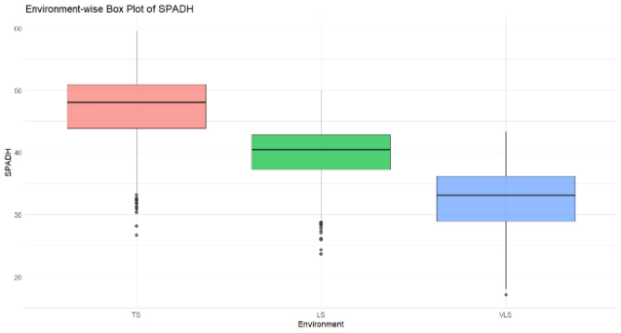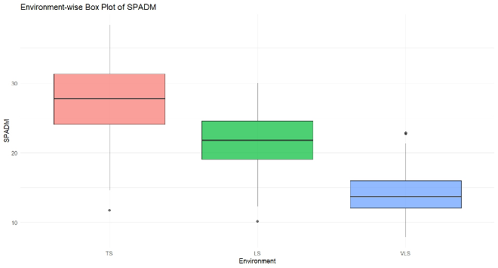
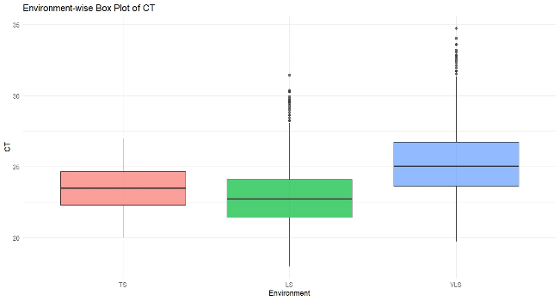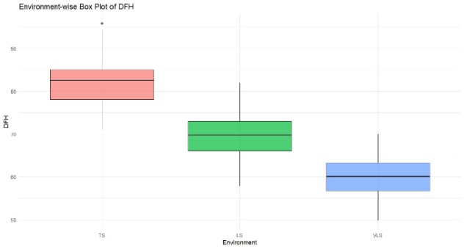

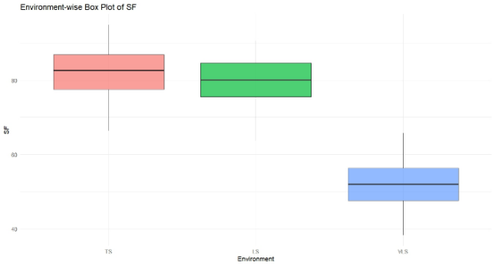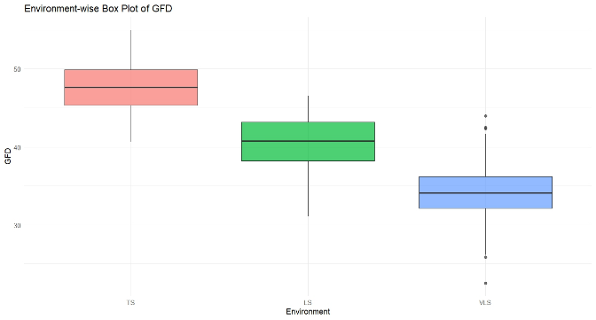

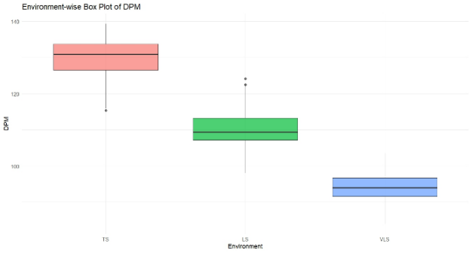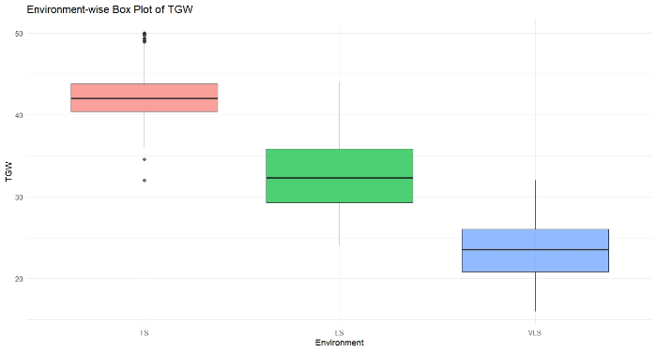

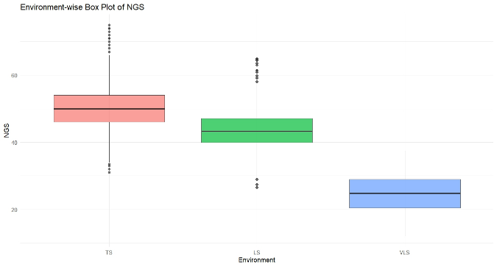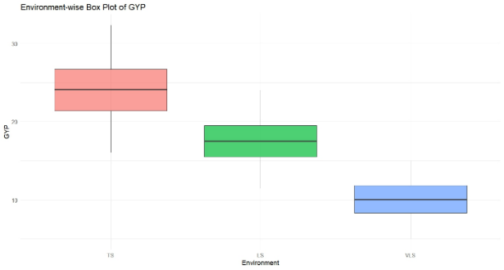

Fig.1: Boxplot showing the distribution of physiological, phenological and yield-related traits of bread wheat (Triticum aestivum L.) genotypes under timely sown (TS), late sown (LS) and very late sown (VLS) conditions during 2022–23.
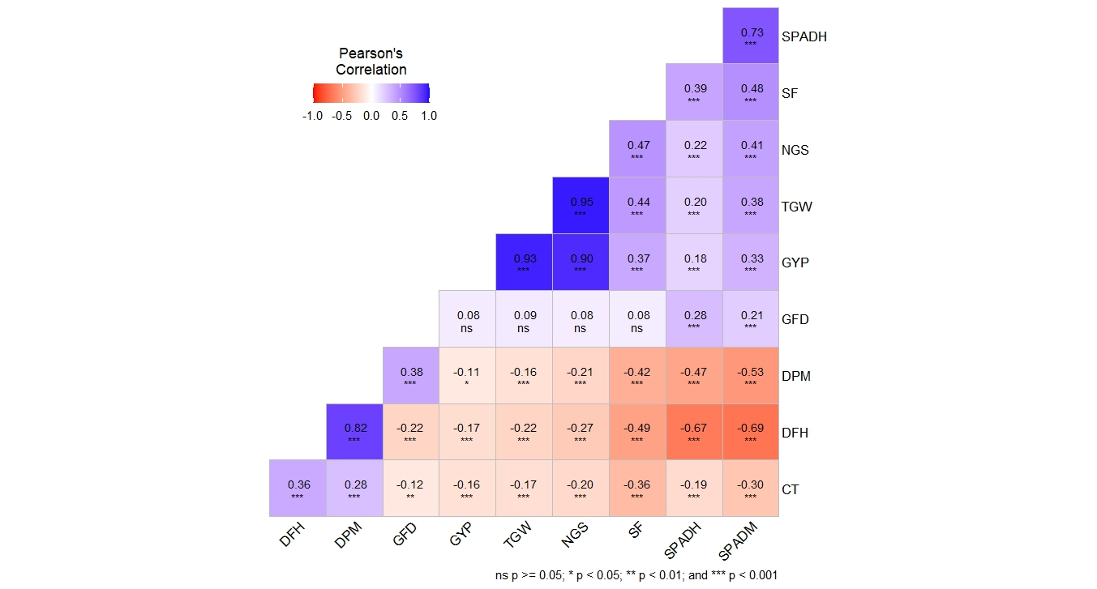
Fig. 2: Pearson’s correlation heatmap of studied traits under timely sown (TS) condition.

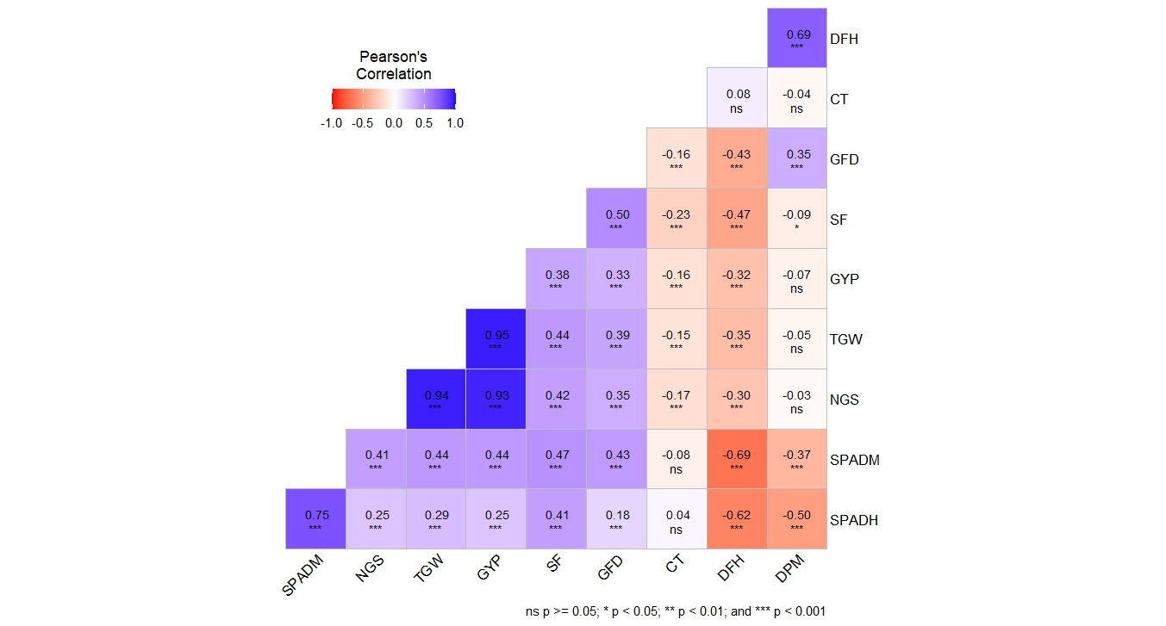
Fig. 3: Pearson’s correlation heatmap of studied traits under late sown (LS) condition.
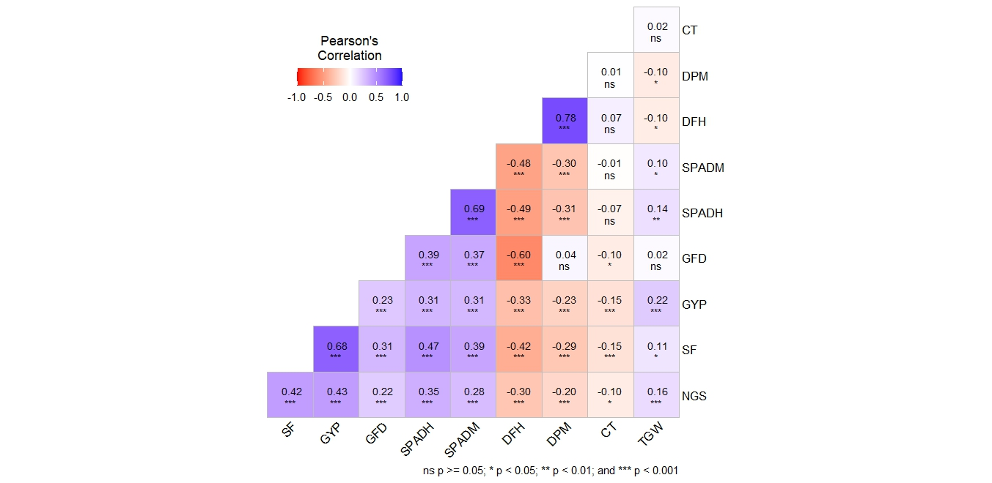
Fig. 4: Pearson’s correlation heatmap of studied traits under very late sown (VLS) condition.
Comparative analysis across timely, late and very late sown conditions revealed clear shifts in the magnitude and direction of trait associations with grain yield. Under timely sown conditions, yield was primarily governed by grain weight and grain number, whereas under late and very late sown environments, the influence of reproductive efficiency and chlorophyll retention traits became increasingly pronounced. The strengthening negative association of phenological traits with yield under stress highlights the importance of stress escape mechanisms at elevated temperatures. Similar environment-dependent shifts in trait importance have been reported by Sherawat et al. (2021) and Pankaj et al. (2022), with recent studies further emphasizing the growing role of physiological resilience traits under heat stress (Jha et al., 2024). These findings justify the need to partition direct and indirect effects through path coefficient analysis to identify reliable selection criteria under contrasting heat regimes in Triticum aestivum.
3.5 Path Coefficient Analysis
Table 3. Direct and indirect effects of physiological, phenological and yield-related traits on grain yield under timely sown (TS) condition in bread wheat (Triticum aestivum L.)
 | SPADH | SPADM | CT | DFH | SF | GFD | TGW | NGS | GYP
SPADH | 0.0523 | -0.027 | 0.0041 | -0.0329 | -0.0196 | 0.002 | 0.1508 | 0.0518 | 0.1816
SPADM | 0.0384 | -0.0368 | 0.0066 | -0.0341 | -0.0243 | 0.0015 | 0.2838 | 0.0936 | 0.3286
CT | -0.0098 | 0.011 | -0.0221 | 0.018 | 0.0179 | -0.0008 | -0.1264 | -0.0465 | -0.1585
DFH | -0.0348 | 0.0255 | -0.0081 | 0.0494 | 0.0245 | -0.0015 | -0.1645 | -0.0626 | -0.1721
SF | 0.0204 | -0.0178 | 0.0079 | -0.024 | -0.0504 | 0.0006 | 0.3259 | 0.1077 | 0.3703
GFD | 0.0148 | -0.0079 | 0.0027 | -0.0109 | -0.004 | 0.0069 | 0.065 | 0.0179 | 0.0845
TGW | 0.0106 | -0.014 | 0.0037 | -0.0109 | -0.022 | 0.0006 | 0.7453 | 0.2191 | 0.9324
NGS | 0.0118 | -0.0149 | 0.0044 | -0.0134 | -0.0235 | 0.0005 | 0.7083 | 0.2305 | 0.9037
Residual Effect: 0.35
Table 4. Direct and indirect effects of physiological, phenological and yield-related traits on grain yield under late sown (LS) condition in bread wheat (Triticum aestivum L.)
 | SPADH | SPADM | CT | DFH | SF | GFD | TGW | NGS | GYP
SPADH | -0.0778 | 0.0821 | -0.0005 | 0.0087 | -0.0186 | -0.0089 | 0.1797 | 0.0857 | 0.2504
SPADM | -0.0584 | 0.1093 | 0.0009 | 0.0097 | -0.0212 | -0.0212 | 0.2795 | 0.1405 | 0.4391
CT | -0.003 | -0.0084 | -0.0116 | -0.0011 | 0.0102 | 0.0077 | -0.0947 | -0.0565 | -0.1575
DFH | 0.0484 | -0.0757 | -0.0009 | -0.014 | 0.0209 | 0.0211 | -0.2207 | -0.1027 | -0.3237
SF | -0.0322 | 0.0516 | 0.0026 | 0.0065 | -0.0449 | -0.0245 | 0.2793 | 0.1427 | 0.3812
GFD | -0.014 | 0.0471 | 0.0018 | 0.006 | -0.0223 | -0.0494 | 0.2444 | 0.1202 | 0.3338
TGW | -0.0222 | 0.0485 | 0.0017 | 0.0049 | -0.0199 | -0.0192 | 0.6297 | 0.3216 | 0.9452
NGS | -0.0195 | 0.045 | 0.0019 | 0.0042 | -0.0188 | -0.0174 | 0.5931 | 0.3414 | 0.93
Residual Effect: 0.2932
Table 5. Direct and indirect effects of physiological, phenological and yield-related traits on grain yield under very late sown (VLS) condition in bread wheat (Triticum aestivum L.) representing severe terminal heat stress.
 | SPADH | SPADM | CT | DFH | SF | GFD | TGW | NGS | GYP
SPADH | -0.1315 | 0.0622 | 0.0041 | 0.0161 | 0.2885 | 0.0022 | 0.0186 | 0.0518 | 0.312
SPADM | -0.0908 | 0.0901 | 0.0003 | 0.0156 | 0.235 | 0.0021 | 0.0133 | 0.0423 | 0.3079
CT | 0.0097 | -0.0006 | -0.0559 | -0.0023 | -0.0929 | -0.0006 | 0.003 | -0.0153 | -0.1548
DFH | 0.0646 | -0.0429 | -0.0039 | -0.0328 | -0.2569 | -0.0034 | -0.0132 | -0.0446 | -0.3331
SF | -0.0624 | 0.0348 | 0.0085 | 0.0138 | 0.6082 | 0.0017 | 0.0153 | 0.0634 | 0.6835
GFD | -0.0515 | 0.0333 | 0.0056 | 0.0198 | 0.1857 | 0.0057 | 0.003 | 0.0323 | 0.2339
TGW | -0.0179 | 0.0087 | -0.0012 | 0.0032 | 0.0677 | 0.0001 | 0.137 | 0.0232 | 0.2209
NGS | -0.0455 | 0.0254 | 0.0057 | 0.0098 | 0.2579 | 0.0012 | 0.0212 | 0.1496 | 0.4253
Residual Effect: 0.6948
A comparative evaluation of path coefficients across timely, late and very late sown conditions revealed a clear shift in yield-determining mechanisms with increasing heat stress. Under timely sown conditions, grain yield was predominantly governed by thousand kernel weight, with grain number also contributing substantially, indicating that sink strength was the principal determinant under optimal environments. Under late sown conditions, although grain weight and grain number remained important, the influence of phenological and physiological traits became more pronounced, suggesting partial adjustment to moderate heat stress. In contrast, under very late sown conditions, spike fertility emerged as the strongest direct contributor to yield, while the relative contribution of grain weight declined considerably. This transition indicates that under severe terminal heat stress, yield stability depends more on chlorophyll retention, reproductive efficiency and stress escape mechanisms rather than solely on grain weight. Similar restructuring of yield architecture under heat stress has been documented in wheat ideotype and stress-adaptation studies (Reynolds et al., 2018). Furthermore, the increased residual effect under severe stress suggests that yield expression becomes more complex and influenced by additional stress-adaptive mechanisms. Collectively, these findings indicate that selection criteria for grain yield in Triticum aestivum should be environment-specific, with emphasis shifting from grain weight under optimal conditions to reproductive efficiency and physiological resilience under severe terminal heat stress.
Conclusion
The present study demonstrates that terminal heat stress significantly modifies trait expression and yield-determining mechanisms in Triticum aestivum across contrasting sowing environments. The significant genetic variability and genotype × environment interaction observed for all traits confirm the availability of substantial exploitable diversity for heat resilience. Under timely sown conditions, grain yield was primarily governed by thousand kernel weight and grain number, whereas under late and very late sown environments, the relative importance of spike fertility, chlorophyll retention and early phenology increased markedly. The progressive shift in trait importance under increasing heat stress underscores the need for environment-specific selection strategies. In particular, spike fertility emerged as a reliable selection criterion under severe terminal heat stress. Overall, the findings provide a clear framework for identifying and prioritizing adaptive traits to enhance heat tolerance in bread wheat breeding programs.

Disclaimer (Artificial intelligence)

Author(s) hereby declare that NO generative AI technologies such as Large Language Models (ChatGPT, COPILOT, etc.) and text-to-image generators have been used during the writing or editing of this manuscript.

References:
- Aggarwal, P. K., Hebbar, K. B., Venugopalan, M. V., Rani, S., Bala, A., Biswal, A. and Wani, S. P. (2008). Quantification of yield gaps in rain-fed rice, wheat, cotton and mustard in India (43).
- Asseng, S., Ewert, F., Martre, P., et al. (2015). Rising temperatures reduce global wheat production. Nature Climate Change, 5(2), 143–147. https://doi.org/10.1038/nclimate2470
- Beemanahalli, R., Sunoj, V. J., Saripalli, G., Prasad, P. V., Balyan, H. S., Gupta, P. K., and Jagadish, S. K. (2019). Quantifying the impact of heat stress on pollen germination, seed set, and grain filling in spring wheat. Crop Science, 59(2), 684-696.
- Cheabu, S., Moung-Ngam, P., Arikit, S., Vanavichit, A., and Malumpong, C. (2018). Effects of heat stress at vegetative and reproductive stages on spikelet fertility. Rice Science, 25(4), 218-226.
- Chen, Y., Zhang, Z., Tao, F., Palosuo, T. and Rötter, R. P. (2018). Impacts of heat stress on leaf area index and growth duration of winter wheat in the North China Plain. Field Crops Research, 222, 230-237.
- El Hassouni, K., Belkadi, B., Filali-Maltouf, A., Tidiane-Sall, A., Al-Abdallat, A., Nachit, M., and Bassi, F. M. (2019). Loci Controlling Adaptation to Heat Stress Occurring at the Reproductive Stage in Durum Wheat. Agronomy, 9(8), 414.
- FAOSTAT. (2024). FAO statistical database. Food and Agriculture Organization of the United Nations. https://www.fao.org/faostat/
- Farooq, M., Bramley, H., Palta, J. A. and Siddique, K. H. (2011). Heat stress in wheat during reproductive and grain-filling phases. Critical Reviews in Plant Sciences, 30(6), 491507.
- Feng, B., Liu, P., Li, G., Dong, S. T., Wang, F. H., Kong, L. A., and Zhang, J. W. (2014). Effect of heat stress on the photosynthetic characteristics in flag leaves at the grain‐filling stage of different heat‐resistant winter wheat varieties. Journal of Agronomy and Crop Science, 200(2), 143-155.
- Jager, K., Fabian, A. and Barnabas, B. (2008). Effect of water deficit and elevated temperature on pollen development of drought sensitive and tolerant winter wheat (Triticum aestivum L.) genotypes. Acta Biologica Szegediensis, 52(1), 67–71.
- Jha, S., Kumar, U., Prasad, R. and Joshi, A. K. (2024). Stay-green trait improves wheat performance under terminal heat stress. Frontiers in Plant Science, 15, 1289456. https://doi.org/10.3389/fpls.2024.1289456
- Khan, A., Ahmad, M., Shah, M. K. N. and Ahmed, M. (2020). Performance of wheat genotypes for Morpho-Physiological traits using multivariate analysis under terminal heat stress. Pakistan Journal of Botany, 52(6), 1981-1988.
- Kumar, D., Rana, V., Rana, A., and Guleria, P. (2023). Genetic variability, correlation and path analysis studies for grain yield and morpho-physiological traits under moisture-stress conditions in bread wheat (Triticum aestivum L.) under north- western Himalayan conditions. Journal of Cereal Research ,15 (1): 92-102.
- Liu, B., Asseng, S., Liu, L., Tang, L., Cao, W. and Zhu, Y. (2016). Testing the responses of four wheat crop models to heat stress at anthesis and grain filling. Global Change Biology, 22(5), 1890-1903.
- Lobell, D. B., Sibley, A. and Ortiz-Monasterio, J. I. (2012). Extreme heat effects on wheat senescence in India. Nature Climate Change, 2(3), 186–189. https://doi.org/10.1038/nclimate1356
- Mirosavljevic, M., Mikic, S., Kondic-Spika, A., Zupunski, V., Zhou, R., Abdelhakim, L., and Ottosen, C. O. (2021). The effect of heat stress on some main spike traits in 12 wheat cultivars at anthesis and mid-grain filling stage. Plant, Soil and Environment, 67(2), 71-76 .
- Mohammadi, M. (2012). Effects of kernel weight and source-limitation on wheat grain yield under heat stress. African Journal of Biotechnology, 11(12), 2931–2937. https://doi.org/10.5897/AJB11.2698
- Moore, G., Devos, K. M., Wang, Z., and Gale, M. D. (1995). Cereal genome evolution: grasses, line up and form a circle. Current biology, 5(7), 737-739.
- Pankaj, Y. K., Kumar, R., Pal, L., et al. (2022). Mapping QTLs for morpho-physiological traits related to grain yield under late sown conditions in wheat (Triticum aestivum L.). Cereal Research Communications, 50, 779–788. https://doi.org/10.1007/s42976-021-00234-1
- Prasad, P. V., and Djanaguiraman, M. (2014). Response of floret fertility and individual grain weight of wheat to high temperature stress: sensitive stages and thresholds for temperature and duration. Functional Plant Biology, 41(12), 1261-1269.

- Vennapusa, A. R., Nimmakayala, P., Zaman-Allah, M. A. and Ratnakumar, P. (2023). Editorial: Physiological, molecular and genetic perspectives of environmental stress response in plants. Frontiers in Plant Science, 14, 1213762. https://doi.org/10.3389/fpls.2023.1213762

- Reynolds, M. P., Pask, A. J. D., Hoppitt, W. J. E., et al. (2018). Correction to: Strategic crossing of biomass and harvest index—source and sink—achieves genetic gains in wheat. Euphytica, 214(1), 9. https://doi.org/10.1007/s10681-017-2086-y

- Shehrawat, S. and Kumar, Y. (2021). Genetic Architecture of Morpho-Physiological Traits in Wheat Accessions under Terminal Heat Stress. Ekin Journal of Crop Breeding and Genetics, 7(1), 34-42.

- Singh, A., Singh, D., Kang, J. and Aggarwal, N. (2011). Management practices to mitigate the impact of high temperature on wheat: A review. IIOAB Journal, 2(1), 11–22.
- Talukder, A. S. M. H. M., McDonald, G. K., and Gill, G. S. (2014). Effect of short- term heat stress prior to flowering and early grain set on the grain yield of wheat. Field Crops Research, 160, 54-63.

