“ NUTRITIONAL, HEALTH AND SOCIAL STATUS OF YOUNG PEOPLE AGED 18-35 [male or female] CONSUMING STRONG ALCOHOLIC BEVERAGES IN THE CITY OF NGOZI ”

ABSTRACT
Alcohol is a psychoactive substance that can lead to addiction; it is also a toxic substance with harmful effects on health. A beverage is considered highly alcoholic if it contains more than 20% alcohol by volume. This study aims to assess the nutritional, health, and social status of young people aged 18-35 who consume highly alcoholic beverages in the city of Ngozi.
This is a prospective study with an analytical focus. The route-based approach was used. Data collection took place over a two-month period, from June 1st to July 31st, 2025. Schwartz's formula was used regarding the sample size of 576. Scales and measuring tapes were used to measure height and weight in order to calculate Body Mass Index (BMI). The data collected on a survey form were entered into Microsoft Office Excel 2010 on a laptop computer and then imported into SPSS for statistical analysis.
80.6% of respondents consume alcoholic beverages, and among them, 39.7% consume strong alcoholic beverages. The most commonly consumed types of strong alcoholic beverages are : Kick (24.15%), Vodka (20.45%), Gin (13.64%), and Kanyanga (11.65%). Visible symptoms of alcohol abuse include headaches (31.6%), vomiting (17.7%), memory problems (16.5%), diarrhea (11.4%), and gait disturbances (13.9%). 12.5% ​​of respondents have a BMI below 18.5 (malnutrition). For those who consume alcohol, there are significant differences depending on whether they consume hard liquor or not.
The relationship between the consumption of strong alcoholic beverages and nutritional status is complex and multidimensional. It is essential to address these issues in an integrated manner to develop effective solutions to promote the health of young people.

Keywords: Nutritional status, youth, strong alcoholic beverages, Ngozi

I. INTRODUCTION
Alcohol has an impact on more than 200 diseases and injuries. In most cases, the impact is negative; in some cases, it is beneficial. In a minority of consumers, most often older men who drink little, the health benefits outweigh the negative effects. At the population level, the negative health effects far outweigh the negative effects in all countries worldwide [1].
Harmful alcohol consumption usually stems from an individual choice, but it has social and nutritional consequences. The harm suffered by people other than the consumers themselves, for example victims of traffic accidents and acts of violence, but also children suffering from fetal alcohol syndrome, is the most visible manifestation of these consequences for society. The cost of healthcare and crime and the decline in productivity are other important consequences [2].

According to Lottin T, Exbrayat M. (2008), young people represent a vulnerable population with a potential for addiction. Pathologies associated with alcohol consumption affect eating behavior, for which alcoholic beverages can serve as a food substitute to alleviate feelings of hunger [3].
Consumption of strong alcoholic beverages also increases the risk of unprotected sex or sex with multiple partners, particularly among young people [4].
Alcohol consumption leads to decreased mental clarity, fatigue, and memory loss. Alcohol, when consumed in large quantities, is a risk factor for numerous diseases, including cancer, cardiovascular and digestive diseases, nervous system disorders, and cognitive and mental health problems [4].

In Africa, alcohol consumption has been practiced for centuries, but contact with Western civilization has led to an increase in consumption since decolonization [4].
Beer production in Africa increased by more than 400% between 1960 and 1980, while consumption increased by 250% to 1000% depending on the country [5].
In Burundi, for young people, consuming alcohol is a source of pleasure. The pleasure of being with friends, having fun, and trying new things. Most consumers use it in moderation and enjoyment, in other words, in a way that does not harm themselves or others [6].
In Burundi, alcoholic beverages occupy an important place in the culture. Various alcoholic drinks are consumed, but what is most concerning is that they are consumed largely by underage youth. It is especially in terms of abusive behavior that these trends are worrying. Despite the over-reporting of alcohol consumption among young people in recent years, adults remain the heaviest consumers [6].
A 2017 study conducted by the Burundi Guides Association (AGB) and the Burundi Scouts Association (ASB) on alcohol consumption in Kayanza (Kayanza, Gatara, and Matongo communes) and Cankuzo (Cankuzo, Kigamba, and Mishiha communes) revealed that even children under 14 years of age consume alcohol in large numbers (66.7%), and 83.9% of them started drinking at a very young age. Consumption increases with age. Nine out of ten people (9/10) consume alcohol in the over-24 age group [6]. [reformulation[
This study on "the nutritional, health, and social status of young people aged 18-35 [male or female] who consume strong alcoholic beverages in the city of Ngozi" is essential for promoting better health and social well-being. This study will not only help to reduce the risks associated with alcohol consumption, but also to strengthen prevention and education initiatives within communities.

II. METHODOLOGY [Where the method with modern references]

II.1. Study Location
The study took place in the city of Ngozi, located in northern Burundi. It is the capital of Butanyerera Province, one of the country's five provinces.

II.2. Sample Size Calculation
In this study, a maximum of 50% [Of what???] was used as the reference proportion for calculating the sample size. Schwartz's formula was used for the determination of sample size [7] :
n = 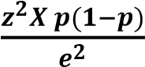
n = sample size; z = z-score at 95% (1.96); p = prevalence of malnutrition due to deficiency (0.5); e = margin of error (0.05).
Therefore, n = 384.16, or 384
Considering the cluster effect, the sample size was multiplied by the cluster effect d=1.5. The sample size then becomes 384 x 1.5=576.

II.3. Sampling Technique
The route-based sampling method, or Politz method, was used. Starting from randomly chosen points on a map, the interviewer is given strict rules regarding the route to follow [8].
For this purpose, the starting point was the Muremera market on National Route 6 (RN6), the road leading to the central market of Ngozi. This starting point was randomly selected from a total of three points (the three entrances to the city of Ngozi coming from Bujumbura, one from Gitega, and one from Muyinga or Kirundo). Both paved and asphalt roads were considered. At the first intersection, we turned left, and at the second intersection, we turned right, alternating between the two. Only houses occupied by households were considered, and the individuals interviewed were those aged 18 to 35 [How many samples used /each age].

II.4. Data Collection, Tools Used, and Informed Consent
Data were collected through a comprehensive survey using a questionnaire. After providing information and obtaining verbal informed consent from the respondent, emphasis was placed on their freedom of expression. Participation was voluntary, as each respondent spoke freely, which demonstrated the reliability of the results.
Thus, each young person [Any age] in the sample was interviewed using systematic, non-random recording. For this purpose, the SCARE scale and a measuring tape were used to measure height in order to calculate BMI, facilitating the classification of nutritional status.
Body Mass Index (BMI) is the preferred indicator for measuring nutritional status in adults who are neither pregnant nor breastfeeding. BMI is calculated by dividing an individual's weight (in kg) by their height (in meters) squared [9].
Due to the bivariate analysis, we classified malnutrition into undernourished (BMI less than 18.5) on the one hand, and good nutritional status or overweight (BMI greater than or equal to 18.5) on the other. This variable was dicthomized.[Reformulation]
II.5. Administrative considerations and Informed Consent
We requested a data collection request letter from the University of Ngozi, which was then sent to the administrator of the Ngozi commune.
The administrator provided us with the data collection authorization letter, which was then sent to the neighborhood chiefs in the city of Ngozi. Following this, we personally met with young people in their homes within the city of Ngozi. Each young person was interviewed, and their weight and height were measured.
After providing information and obtaining verbal informed consent from the respondent, emphasis was placed on respecting their freedom of expression. Participation was voluntary, as each respondent spoke freely, which demonstrated the reliability of our results.

II.6. Data Analysis
The data was analyzed using SPSS software. For quantitative variables, the mean ± standard deviation will be calculated when the distribution is normal; otherwise, the median ± interquartile range will be used. For qualitative variables, we will calculate the frequency and percentage of each category.
The relationship between the dependent variable and the various independent variables will be analyzed using the chi-square (independence test) test at a 95% confidence level.
Following the descriptive analysis, a bivariate and multivariate analysis was performed using simple logistic regression, with a 5% alpha risk (p = 0.05), to analyze the relationship between the dependent variable and the independent variables.
This analysis involved calculating the odds ratio (OR) and its 95% confidence interval. Variables with an OR confidence interval other than 1 (p < 0.05) were considered statistically significant.

III. RESULTS AND DISCUSSION
III.1. Sociodemographic Characteristics of Respondents
Table 1: Respondent Identification
Respondent identification
Age range | Frequency N=576 |  | %
18 to 25 years | 240 |  | 41,7
26 to 35 years | 336 |  | 58,3
Sex
Male |  | 321 |  | 55,7
Female |  | 255 |  | 44,3
Marital status
In a relationship |  | 289 |  | 50,2
Single |  | 287 |  | 49,8
Number of people in the household
More than 6 people |  | 264 |  | 45,8
6 people or more |  | 312 |  | 54,2
Accommodation
Living with my parents |  | 320 |  | 55,6
Own accommodation |  | 256 |  | 44,4
Educational level
Low (no level, did not go beyond 6th grade) |  | 376 |  | 65,3
High (Secondary and above) |  | 200 |  | 34,7
Occupations
Farmers |  | 320 |  | 55,6
State employee |  | 72 |  | 12,5
Bicycle taxi or Motorcycle taxi |  | 32 |  | 5,6
Baggage porters |  | 56 |  | 9,7
Land brokers and Others |  | 49 |  | 8,5
Sex Worker |  | 47 |  | 8,2
Religion
Catholic |  | 351 |  | 61,0
Muslim |  | 104 |  | 18,1
Protestant |  | 121 |  | 21,0

The respondents were 41.7% between 18 and 25 years old, with an average age of 26.75 years. Males represented 55.7%. Nearly half of the respondents (50.2%) were in a relationship. 54.2% lived in households with more than six people. 65.3% of respondents had not completed secondary school (6th grade). The majority of our respondents (55.6%) identified as farmers. The Catholic religion was predominant, with 61% of respondents adhering to it.

In Mbira C.'s (2014) series on alcohol consumption among students: Survey of FMPOS students, the most represented age group was 18 to 23 years old. Males were the most represented sex at 55%. The majority of respondents had their own accommodation, at 56%. Most of the respondents interviewed were married, at 90% [10].

III.2. Alcohol and strong alcoholic beverages (SAB)
Table 2: Alcohol consumption and type of alcohol consumed

Alcohol consumption | Type of alcohol consumed | Frequency | %
Yes (464 respondents, or 80.6%) | Brarudi beers, Brewery beers (a) (≤ 6%) | 181 | 39,0
Yes (464 respondents, or 80.6%) | Beers sold in plastic bottles (b) (≤ 16%) | 23 | 5,0
Yes (464 respondents, or 80.6%) | High-alcohol beverages (c) (≥ 20%) | 28 | 6,0
Yes (464 respondents, or 80.6%) | (a) + (b) + (c) | 60 | 12,9
Yes (464 respondents, or 80.6%) | (a) + (c) | 96 | 20,7
Yes (464 respondents, or 80.6%) | (a) + (b) | 76 | 16,4
No (112 respondents, or 19.4%)

In our stady, 80.6% of respondents consume alcoholic beverages, with 184 respondents (39.7%) consuming strong alcoholic drinks.

In the Collective Expertise Collection, Inserm (2021), the estimated prevalence of strong alcoholic beverage consumption in the CONSTANCES cohort was highest in 2014 among subjects under 35 years of age (30.7%) [11].
In Mbira C.'s series (2014) [number in references list], a prevalence of alcoholism of 61.6% was found among students who participated in the survey. Beer (27%), champagne (21%), vodka (40%), whiskey (20%), wine (14%), martini (7%), and rum (5%) were the preferred alcoholic beverages of the students surveyed [9]. According to a study by the LINK Institute, alcohol consumption in 2009 among the 16-34 age group falls into three main categories: beer, wine, and spirits, which together account for nearly 95% of alcohol consumed [12].
In the Collective Expertise Collection, Inserm (2021), the most frequently consumed alcoholic beverages among teenagers are hard liquor (whiskey, vodka – between 70 and 80% of those who reported drinking in the previous month consumed them), followed by beer (approximately 70%), champagne (less than 60%), and then wine (more than 50%) [11].

Table 3: Types of strong alcoholic beverages (SAB) consumed
Type of strong alcoholic beverages | Frequency | %
Kanyanga (42%) | 41 | 11,65
Vodka (42%) | 72 | 20,45
Cognac (42%) | 33 | 9,38
Rhum (40-43%) | 16 | 4,55
Gin (40-46%) | 48 | 13,64
Kick (42%) | 85 | 24,15
whiskey (40-50%) | 24 | 6,82
Liqueurs (25-40%) | 33 | 9,38
Total responses | 352 | 100,00

The most consumed types of strong alcoholic beverages are: Kick (24.15%), Vodka (20.45%), Gin (13.64%), and Kanyanga (11.65%). The remaining percentages are below 10%.

Table 4: Distribution of respondents who consume alcohol according to their level of alcoholic beverage consumption

Level of alcoholic beverage consumption | Frequency | %
Low | 119 | 25,6
Medium | 104 | 22,4
High | 241 | 52,0
Total | 464 | 100,0

Alcohol consumption levels were high according to 241 respondents (52%), and medium according to 104 respondents (22.4%).
The health effects of alcohol depend on the quantity and frequency of consumption, as well as the consumption pattern (episodic, chronic) [11].
In 2014, Richard J.B., Beck F., and Spilka S. [number in references list], reported monthly binge drinking among 28% of female students (19% in 2010; 11% in 2005), repeated drunkenness among 28% (19% in 2010; 8% in 2005), and regular drunkenness among 11% (7% in 2010; 2% in 2005).
Early consumption, estimated by the alcohol use of 15-17 year olds, seems stable relative to 2010: 15% of adolescents of this age consume alcohol every week, 34% have experienced an episode of binge drinking (defined as having 6 or more drinks on the same occasion) during the year and 16% every month [13].

Figure 1: Age of Alcohol Initiation

The age of alcohol initiation is under 14 years for 329 respondents (70.9%). It is between 14 and 17 years for 96 respondents (20.7%), and 18 years and over for 39 respondents (8.4%).

In the Collective Expertise Collection, Inserm (2021); among adolescents, surveys conducted by the French Monitoring Centre for Drugs and Drug Addiction (OFDT) since the 2000s, and for the first two combined in the class-based system, provide information on the level of alcohol consumption of young people aged 12 to 17 on a regular basis (every 2 to 4 years) [11].

In 2014, Richard J.B., Beck F., Spilka S. reported that monthly binge drinking (defined as consuming 6 or more drinks on a single occasion) affected 28% of female students (19% in 2010; 11% in 2005), repeated drunkenness also affected 28% (19% in 2010; 8% in 2005), and regular drunkenness affected 11% (7% in 2010; 2% in 2005). The early onset of alcohol consumption, as estimated by the drinking habits of 15-17 year olds, appears to have remained stable compared to 2010: 15% of adolescents in this age group consumed alcohol weekly, 34% had experienced binge drinking during the year, and 16% monthly [13].

Figure 2: Visible Symptoms of Abuse
Out of a total of 632 responses, the visible symptoms of abuse were headaches (31.6%), vomiting/anorexia (17.7%), memory problems (16.5%), diarrhea (11.4%), gait disturbances (13.9%), and sometimes sores/muscle pain of unknown cause (8.9%). [References]

According to Mizrahi A. and Mizrahi A. (2000) [number in references list],, generally speaking, depending on the methods and types of alcohol consumed, the risks to which young people are particularly exposed include: digestive disorders, psychological and physical dependence, disinhibition, decreased self-control, impaired reflexes and alertness, visual disturbances, poor coordination, drowsiness, compulsive alcohol consumption, loss of control over alcohol consumption, and a negative emotional state in the absence of use, etc. [14].

In the CAPES study (2023) [number in references list],, headaches accounted for 4.6% of all young people. However, it was noted that alcohol consumers experienced other health problems that non-consumers did not. These include accidents/injuries (1.7%), headaches (6.1%), and problems with blood pressure (0.9%) and throat (0.9%). These health problems, experienced only by alcohol consumers, could be related to alcohol consumption [15].

Figure 3: Abnormal Behaviors Due to Alcohol Consumption

Out of a total of 696 responses, the following abnormal behaviors were reported as follows: aggression (6.9%), shame (66.7%), sadness (16.1%), and hilarity (10.3%) [Related modern references].

Finally, it should be noted that studies have shown that the psychotropic pharmacological action of alcohol is not the only effect linked to violence. Alcohol can thus be consumed with the aim of committing violence or of preemptively justifying planned violent acts [16].
Some recent work in experimental psychology shows that a drinker's anticipations of the effects of future consumption have a significant impact on their aggression in response to provocation from a third party, even when the ingested beverage is ultimately a placebo [16].

Table 5: Distribution of survey responses according to the reason for consuming strong alcoholic beverages

Reason for consuming strong alcoholic beverages | Frequency | %
To relax and feel good | 144 | 19,1
To quench my thirst | 141 | 18,7
Because I don't dare refuse | 32 | 4,2
Because I like the taste | 24 | 3,2
Because it's the only way to "let loose" at a party | 63 | 8,4
Because the people I hang out with drink a lot | 80 | 10,6
To celebrate an event | 8 | 1,1
To forget my worries or cope with heartbreak | 40 | 5,3
To boost my confidence or feel more at ease | 24 | 3,2
To get "high" | 53 | 7,0
When I'm angry | 56 | 7,4
Because I have nothing else to do | 72 | 9,6
Out of habit | 16 | 2,1
Total responses | 753 | 100,0

Among the responses given, the most common reasons for consuming hard liquor were: to relax and feel good (19%), to quench thirst (18.7%), because their friends drink a lot (10.6%), because they have nothing else to do (9.6%), because it's the only way to "let loose" at a party (8.4%), and when they are angry (7.4%). Other reasons, such as not daring to refuse, taste, celebrating an event, forgetting worries or coping with grief, boosting confidence or feeling more at ease, getting drunk, and habit, were less common, at less than 6%.

Mbiya K. (2014) [number in references list], showed that the reasons for consuming hard liquor were related to pleasure, blind imitation, and stress relief [17].

Kayaninziire J. (2008), in his work entitled "CAP on Alcoholism Among Secondary School Students in the Goma Commune," showed that alcohol consumption among adolescents is caused by bad company [18].
In Mbira C.'s series (2014) [number in references list],, "the only way to have a blast" was the most frequently cited reason by consumers, at a frequency of 25.8% of cases, followed by 22.6% to celebrate an event, 12% to get high, and 8.2% to relax [10].
Room and Mäkelä (2000) [number in references list], conducted a thorough literature review of the 1940s and early anthropological works on alcohol consumption, distinguishing between two approaches: the holocultural approach and the sociocultural approach [19].

Holocultural theories have focused on the functions of alcohol consumption at the individual level, namely reducing anxiety, mitigating feelings of dependence, or increasing feelings of power [19].
In the study conducted by CAPES (2023), data analysis shows that 69.1% of young people consume alcohol simply for pleasure or relaxation [15].

Table 6: Distribution of respondents according to psychiatric disorders

Psychiatric disorders | Frequency | %
Yes | 32 | 5,6
No | 544 | 94,4
Total | 576 | 100,0

Based on this table, 32 respondents, or 5.6%, developed psychiatric disorders.

Table 7: Distribution of respondents' responses according to pathologies known to be chronic

Pathologies known to be chronic | Frequency | %
High blood pressure | 16 | 2,8
Diabetes | 40 | 6,9
Alcoholic hepatitis | 4 | 0,7
Cirrhosis | 7 | 1,2
I don't know | 512 | 88,4
Total responses | 579 | 100,0

Among the responses given, the pathologies known to the respondents were: hypertension (2.8%), diabetes (6.9%), alcoholic hepatitis (0.7%), and cirrhosis (1.2%) [Related modern references]. It should be noted that 512 respondents, or 88.4%, did not know whether they had a chronic condition.

In the Mbira C. study (2014) [number in references list],, the level of information among respondents questioned about the harmful effects of alcoholism in the development of specific pathologies such as liver cancer (58.1%), liver cirrhosis (53.6%), and hypertension (51.2%) was quite good [10].

However, gaps exist, particularly regarding the role of alcohol in the development of cardiomyopathies (38.7%), cancers of the upper aerodigestive tract (37%), anxiety (22.1%), malnutrition (15.2%), acute gastritis (30.8%), alcoholic hepatitis (42.5%), malnutrition (23.9%), eating disorders (21.4%), neurosis (14.5%), gastroesophageal reflux disease (GERD) (33.5%), hepatic steatosis (14.2%), and arrhythmias (32.9%) [10].

Alcohol is a drug, a carcinogenic molecule, and toxic to many organs, its toxicity partly mediated by its metabolite, acetaldehyde. Alcohol consumption is directly or indirectly responsible for approximately sixty diseases, and alcohol is found in 200 items of the International Classification of Diseases (ICD-10) used in the French national hospital discharge database (PMSI) [11].

The PubMedCentral PMC-alcohol model explicitly considers ten conditions whose incidence varies according to the volume and/or habits of alcohol consumption. These conditions are: alcohol use disorder; injuries; liver cirrhosis; liver cancer; epilepsy; ischemic heart disease; cerebrovascular diseases; esophageal cancer; cancers of the mouth and oropharynx; and breast cancer. According to the most recent WHO estimates at the time the model was defined [20], this group of diseases accounts for approximately 98% of fatal strokes and 93% of alcohol-related deaths.

Figure 4: Changes in Eating Behavior

A change in eating behavior was observed in 208 respondents (44.8%) following the consumption of alcoholic beverages.

III.3. Statistical Analysis

Figure 5: Nutritional status

From this figure, 72 respondents, or 12.5%, have a BMI lower than 18.5 (malnutrition/undernutrition).

Table 5: Anthropometric variables with their means and standard deviations, categorized by nutritional status.

 | Variables |  | Mean |  | Standard deviation |  | P  Value
Height |  | Undernutrition |  | 1,66 | 0,05 | 0,00
 |  | Normal |  | 1,56 | 0,12
Weight |  | Undernutrition |  | 48,11 | 2,86
 |  | Normal |  | 58,9 | 9,84
BMI |  | Undernutrition |  | 17,4 | 0,47
 |  | Normal |  | 23,97 | 3,36

Weight, height, and BMI are highly significant, with a p-value of 0.00, depending on nutritional status (presence or absence of malnutrition). The ANOVA test shows a large and significant difference between these three variables.

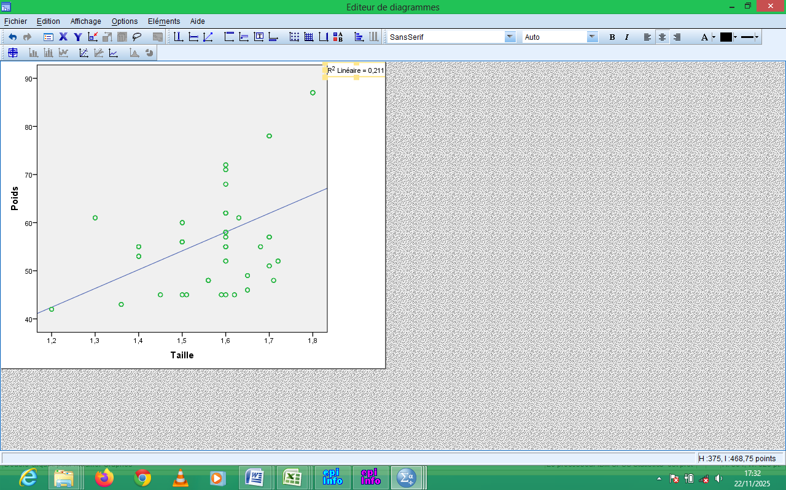

Figure 6: Graphical visualization of a regression line

The correlation is 0.46, which is between 0.2 < r < 0.5, meaning the correlation is moderate. According to Rejaibi Salsabil (2022), the strength of the correlation between two variables is interpreted as follows: r < 2 = weak; 0.2 < r < 0.5 = moderate; 0.5 < r < 0.7 = strong; and r > 0.7 = very strong [21].

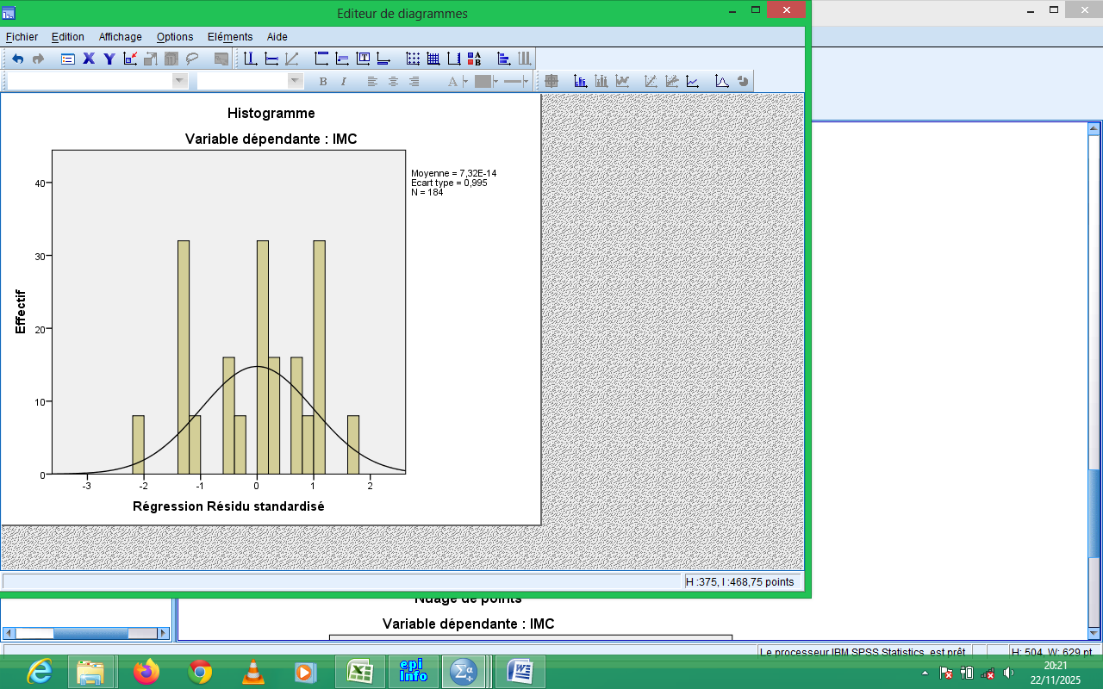

Figure 7: Standardized residual regression for respondents who consumed strong alcoholic beverages

This figure shows that it follows a normal Gaussian distribution, meaning that taller individuals tend to have a higher weight. This contrasts with the malnourished respondents, who are likely taller but whose weight is not proportional to their height, as it falls outside the Z-score range of -2.

Table 6: Distribution of respondents according to malnutrition and alcohol consumption

Alcohol intake/ Undernutrition (BMI˂18.5) | Yes | No | Total
Yes | 64 | 400 | 464
No | 8 | 104 | 112
Total | 72 | 504 | 576

The incidence of malnutrition with BMI less than 18.5 is 13.8% (64/464) among respondents who take alcohol, it is 7.1% (8/112) among respondents who do not take alcohol, with P = 0.035, OR of 2.080 and chi-square of 3.92.

The relationships between alcohol consumption and nutrition have several aspects [22] [What are these aspects].

Alcohol can have a direct effect on nutritional status, leading to malnutrition through substitution of other nutrients, or even changes in eating behavior. Indirectly, alcohol consumption can lead to malnutrition through poor digestion or malabsorption linked to organic complications (liver, pancreas, small intestine). In fact, a large part of alcohol-related malnutrition is a consequence of cirrhosis [23].
Interactions also exist, with certain nutritional deficiencies or problems increasing the effects of alcohol, and alcohol increasing the effect of nutritional disorders. Undernutrition increases the risk of alcoholic liver disease. Finally, alcohol modifies nutrient metabolism [23].
Table 8 : Distribution of respondents according to alcohol consumption, consumption of strong alcoholic beverages, and sex
Alcohol consumption/ Sex | Yes | No | Total | P Value = 0,000  OR = 2,74  RR=1,22  χ²=22,17
Male | 281 | 40 | 321 | P Value = 0,000  OR = 2,74  RR=1,22  χ²=22,17
Female | 183 | 72 | 255 | P Value = 0,000  OR = 2,74  RR=1,22  χ²=22,17
Total | 464 | 112 | 576 | P Value = 0,000  OR = 2,74  RR=1,22  χ²=22,17
Consumption of strong alcoholic beverages/  Sex | Yes | No | Total | P Value = 0,001  OR = 1,93  RR=1,50  χ²=10,83
Male | 128 | 152 | 280 | P Value = 0,001  OR = 1,93  RR=1,50  χ²=10,83
Female | 56 | 128 | 184 | P Value = 0,001  OR = 1,93  RR=1,50  χ²=10,83
Total | 184 | 280 | 464 | P Value = 0,001  OR = 1,93  RR=1,50  χ²=10,83
Regarding sex, the incidence of alcohol consumption was 87.5% (281/240) in males and 71.8% (280/336) in females, with a p-value of 0.000, an OR of 2.74, a relative risk (RR) of 1.22, and a chi-square of 22.17. The incidence of strong alcoholic drinks was 45.7% (128/280) in males and 30.3% (56/185) in females, with a p-value of 0.00, an OR of 1.93, an RR of 1.50, and a chi-square of 10.83.
There is a very significant difference. The probability of being a consumer is higher for men than for women, which aligns with the findings of several authors.
In Mbira's series (2014) [number in references list],, in the comparative analysis of alcohol consumption between boys and girls, one trend emerges repeatedly: men are heavier consumers of alcohol (67% of men versus 55.1% of women). This author explains that there is what could be called a "typical male consumption of alcoholic beverages"; this most often involves group consumption. This male predominance could be linked to sociocultural norms [10].

In the Collective Expertise Collection, Inserm (2021); on average, during adolescence boys still consume more alcohol than girls [References], but the ratio between the sexes has decreased over time. Boys, on the other hand, still tend to have higher levels of regular consumption, i.e. 10 times or more in the month (sex ratio in 2017=2.62), or to present repeated binge drinking, i.e. 3 times or more in the month (1.99) or regular binge drinking (defined as having drunk 6 or more drinks on a single occasion), i.e. 10 times or more in the month (4.28) [11].
In the 2015 study by Basset and Rigaud [number in references list],, among men, binge drinking peaks between the ages of 25 and 34: two-thirds (67%) experienced at least one episode of heavy episodic drinking in the past year, 37% every month, and nearly half reported at least one episode of drunkenness in the past year (47%). Among women, such drinking most often occurs before the age of 25: 43% of 15-24 year olds experienced at least one episode of heavy episodic drinking in the past year, 19% every month, and a third (34%) experienced drunkenness in the past twelve months. 38% of 15-75 year olds reported at least one episode of heavy episodic drinking in the past year, significantly more than in 2010 (36%), particularly among women (24% vs. 21%; p < 0.001) [24].

Table 9: Distribution of respondents according to malnutrition and some associated factors
Taking highly alcoholic beverages/Undernutrition | Yes | No |  | Total | P /OR/  Chi-square
Yes | 40 | 144 |  | 184 | P = 0,00  OR =2,96  χ²=16,19
No | 24 | 256 |  | 280 | P = 0,00  OR =2,96  χ²=16,19
Consumption level |  |  |  |  | P = 0,00  χ²=69,29
Bottom | 0 |  | 120 | 120 | P = 0,00  χ²=69,29
Average | 1 |  | 104 | 105 | P = 0,00  χ²=69,29
High | 63 |  | 176 | 239 | P = 0,00  χ²=69,29
Alcoholic habit |  |  |  |  | P = 0,01  χ²=13,74
Regularly, every day | 17 | 88 |  | 105 | P = 0,01  χ²=13,74
Often | 47 | 240 |  | 287 | P = 0,01  χ²=13,74
Rarely | 0 | 72 |  | 72 | P = 0,01  χ²=13,74
Total | 64 | 400 |  | 464

The incidence of undernutrition with BMI less than 18.5 is 21.7% (40/184) among respondents who take highly alcoholic drinks, it is 8.6% (24/280) among respondents who take alcohol but not highly alcoholic drinks [References], with (P=0.00), (OR=2.96) and (χ2=16.19).
Regarding the level of consumption, the incidence of malnutrition with BMI less than 18.5 is 26.4% (63/239) among respondents with a high level of alcohol consumption, it is 1% (1/105) among respondents with an average level of alcohol consumption, with (P=0.00) and (χ²=69.29).

Romero et al. 2004[number in references list],, in his study, among excessive consumers hospitalized for complications of alcohol poisoning, severe malnutrition was observed: insufficient protein intake, signs of protein malnutrition, low body mass index (BMI), thin tricipital skin fold, reduced muscle mass. In a study of hospitalized chronic excessive consumers (n = 60), 33% had myopathy defined by atrophy of the muscle fiber on biopsy. These subjects are the most malnourished (100% malnourished vs. 34.6%, vs. 23.6%; the tricipital skin fold as well as brachial circumferences and surface area are also significantly reduced [25].
At the tissue level, alcohol replaces normal substrates, with the liver being the most affected organ. Malnutrition is a primary etiological factor of hepatic dysfunction [22].
However, alcohol causes cirrhosis in primates even with an adequate diet and fatty liver or damage in humans even in the absence of nutritional deficiency. Protein malnutrition reduces the secretion of lipoproteins, which potentiates hepatic storage of lipids under the direct effect of alcohol. However, even with a protein-enriched diet, alcohol causes significant changes in lipids in the liver [22].
At the same level of alcohol consumption, malnourished excessive consumers have a higher blood alcohol level which lasts longer than normally nourished individuals [22].
The great variability in the nutritional status of excessive consumers, however, reflects differences in their diet, their socioeconomic status and their organic complications.

Table 10 : Consumption of highly alcoholic beverages during meals / Malnutrition (BMI˂18.5)
Taking highly alcoholic drinks during meals / undernutrition | Yes | No | Total | P /OR  / Chi-square
never | 24 | 48 | 72 | P = 0,01  χ²=27,26
sometimes | 9 | 16 | 25 | P = 0,01  χ²=27,26
often | 7 | 16 | 23 | P = 0,01  χ²=27,26
always | 0 | 64 | 64 | P = 0,01  χ²=27,26
The incidence of undernutrition with BMI less than 18.5 is 33.3% (24/72) among respondents who take highly alcoholic drinks with empty sales, it is 0% among respondents who take highly alcoholic drinks when they have eaten, with (P = 0.00) and (χ² = 27.26).
Ethanol is a small molecule absorbed by simple diffusion. This diffusion is slow in the stomach and the majority (70% to 80%) is absorbed in the small intestine (duodenum and jejunum) [References],. When alcohol is ingested on an empty stomach, the maximum concentration is reached quickly, approximately half an hour after ingestion [26].
Food ingestion slows gastric emptying by causing closure of the pyloric lock and reducing gastric motility, particularly at the antral level. Consequently, the ingestion of food, by prolonging the residence time of ethanol in the stomach, will modify the kinetics of ethanol absorption [26].
The effect of food is not only on gastric emptying, but also on metabolism. Strong alcohols (with a concentration greater than 20%) cause a pyloric spasm which delays gastric emptying and therefore slows absorption [27].

VI. CONCLUSION
12.5% of respondents have a BMI below 18.5 (undernutrition). For those who drink alcohol, there are significant differences following the consumption of highly alcoholic or non-alcoholic beverages. The relationship between consumption of highly alcoholic beverages and nutritional status is complex and multidimensional. It involves economic, social and health factors that interact to worsen the living conditions of individuals and communities. It is essential to address these issues in an integrated manner to develop effective solutions to promote the health of young people.

REFERENCE

- European Commission, (2007). Attitudes towards alcohol 2006. Special Eurobarometer p. 272.
- Beck F, Guillemont J, & Legleye S. (2009). Alcohol use among young people: the contribution of the epidemiological approach. In News and Public Health Report, (67) 2009, pp 12-59.
- Lottin T, Exbrayat M. 2008. «Attitudes to adopt when working with people with problematic alcohol consumption», Liege, pp 49-89.
- La Breton D. 2003: The teenager took a risk. Hachette literature, Paris, pp 21-27.
- Smith R. 1982 Alcohol in the Third World : a chance to avoid a miserable trap. Br. Med. J., pp 203-212.
- MSPLCS (Ministry of Public Health and the Fight against AIDS), 2020: Awareness guide on the harm caused by the excessive consumption of alcoholic beverages, National Integrated Program for the Fight against Chronic Non-communicable Diseases (PNILMCNT), pp 9-38.
- Serhier Z, Bendahhou K, Abdelaziz A-B. and Bennani M. 2020 Othmani : Methodological sheet n°1: How to calculate the size of a sample for an observational study?, Laboratoire Neurosciences cliniques et santé mentale, Université Hassan 2 Casablanca.
- Pereira I. (2024), Qualitative methods, University of Rouen-Normandie, Hal. sciences/hal-05246051.
- PNIN. 2021. Technical sheet-Forms and measures of malnutrition-PNIN, 2021.
- Mbira C. (2014) Alcohol consumption among students: Survey of students at FMPOS, University of Sciences, Techniques and Technologies of Bamako; Faculty of Medicine and Odontostomatology, p. 56-109.
- INSERM. 2021: Effects of alcohol on the cardiovascular system. In: Alcohol, Health effects. INSERM edition. Legal deposit :, pp 175-192.
- Federal Alcohol Authority (FRG) (2009). Study of alcohol consumption among young people aged 16 to 34, Final synthesized report Based on: LINK Institute, Consumption and purchasing behavior of alcoholic beverages among young people aged 16 to 34 in Switzerland, Mandate of the Federal Alcohol Authority, Berne. P. 3-15.
- Richard J.B, Beck F. et Spilka S. «Alcohol consumption among 18-25 year olds in 2010 in France: specificities and changes since 2005». BEH, 2013, 16-18 : p. 176-179.
- Mizrahi A. et Mizrahi A. 2000, Arguments socio-économiques pour la santé. Consommation d’alcool et de tabac. Paris-France.
- Center for Analysis of Economic and Social Policies (CAPES) (2023), study of the socio-economic impact of alcohol consumption by Burkinabe youth, Ouagadougou 01, BURKINA FASO, P.8-85.
- Peretti-Watel P, Beck F. et Legleye S. The social uses of drugs. The social bond, Paris-France, 2007.
- Mbiya K. (2014). Problem of the consumption of highly alcoholic drinks by young people in the city of Katuba, p3-59.
- Kayaninziire J. (2008). KAP (Knowledge, Attitude and Practice). on alcoholism among secondary school students in the commune of Goma, p. 2-89.
- Room, R. & Mäkelä K. (2000). Typologies of the cultural position of drinking. Journal of Studies on Alcohol, 61(3), 475-483.
- OMS (2014).Global Status Report on Alcohol and Health, OMS, Genève.
- Rejaibi S. (2022), Linear regression and correlation, survival analysis, Clinical research training program for medical intensive care residents, session 5.
- Lieber CS. Alcohol : Its metabolism and interaction with nutrients. Annu Rev Nutr 2010, 20 : 395-430.
- Vignon X. Anonyme (2019). Nutritional deficiencies. Etiologies and screening. Éditions Inserm, Collective expertise collection, Anonyme of 2019.
- Basset, B. and Rigaud, A. (2015). Alcohol and health: Consumption behaviors and their evolution, National Institute for Prevention and Health Education (Inpes) P. 2-53
- Romero JC, Santolaria F, Gonzalez-Reimers E, Diaz-Flores L, Conde A, et al. (2004) Chronic alcoholic myopathy and nutritional status. Alcohol, 11 : 549-555.
- Jones AW, Jönsson KA. 1994 Food-induced lowering of blood ethanol profiles and increased rate of elimination immediately after a meal. J Forensic Sci 1994, 39 : 1084-1093.
- Jones AW, Jönsson KA, Kechagias S. 1997 Effect of high-fat, high-protein, and highcarbohydrate meals on the pharmacokinetics of a small dose of alcohol. Br J Clin Pharmacol, 44 : 521-526.

