The Molecular Science of Fragrances: Chemistry, Synthesis, and New Trends

.
ABSTRACT

This mini-review looks at important milestones in fragrance chemistry by combining historical developments with modern advances in molecular and industrial aspects. It focuses on major odorant classes like musks, woody notes, and sandalwood fragrances. The review traces the evolution of musk odorants, starting from early nitro musks to today's synthetic compounds. It also highlights synthetic sandalwood fragrances, new fragrance precursors, and ideas like “anti-perfumes.” This shows how scientific design and chance play a role in fragrance innovation. Along with chemical synthesis and structure-odor relationships, the review includes practical insights. These cover essential oil extraction and gas chromatography-mass spectrometry (GC-MS) analysis. The review discusses current challenges in fragrance science, especially sustainability, regulatory compliance, and environmental impact. It addresses these through discussions on green chemistry and bio-based production methods. New technologies such as biotechnology and artificial intelligence-assisted fragrance design are introduced as promising tools for speeding up odorant discovery. These methods can lead to safer, more efficient, and environmentally friendly fragrance development. Overall, this review offers a straightforward framework that connects molecular science, industry practices, and future innovation in fragrance chemistry.

Keywords : Fragrance Precursors, Musks, Ionones, Odorants, Sandalwood.

1. INTRODUCTION

Fragrances sit at a unique crossroads of science and art, where chemists become creators and molecules trigger memories. They bring joy to billions worldwide. People enjoy fragrances every day, from refreshing shower gels in the morning to scented candles that enhance evening settings. Even shopping experiences are often accompanied by pleasing scents. Consumers choosing personal or household care products frequently find multiple fragrance options from the same brand [1]. Fragrance chemistry looks at the chemical compounds that affect our sense of smell and their use in areas like perfumery, cosmetics, and household items. The history of perfume use goes back a long way. In biblical times, people offered aromatic substances “through smoke” (*per fumum*), presenting nature’s gifts to please the gods. Ancient civilizations used natural materials like resins, flowers, and spices for rituals, medicine, and personal grooming. After Napoleon Bonaparte’s decree in 1810, which required a clear separation between pharmaceuticals and perfumes, eaux de Cologne were no longer consumed orally. As perfumes became more focused on natural ingredients such as essential oils, they evolved into luxury items cherished by royalty and the elite. The late nineteenth century brought a turning point with synthetic ingredients, which revolutionized modern perfumery and greatly expanded the creative options for perfumers [1].

The first recorded perfumer was a woman chemist named Tapputi, documented on Mesopotamian clay tablets from the second millennium BC. In ancient Egypt, fragrance held significant importance in high society. Perfumes were made by distilling natural ingredients with unscented oils, and popular scents included floral, woody, and fruity notes. Notable figures like Queen Cleopatra and Queen Hatshepsut used perfumes for their bodies, living spaces, and baths, and they even placed perfumes in tombs for the afterlife [2]. Similarly, ancient Persian culture valued fragrance highly. Persian civilizations controlled perfume trade routes for centuries and are known for developing alcohol-based perfumes. Persian rulers often had exclusive “signature scents” just for themselves. While the use of perfume temporarily dipped in parts of Europe, other cultures embraced it. In India, fragrances played a key role in Tantric rituals and temple ceremonies. In China, perfumes were used to purify and disinfect, based on the belief that scents could ward off disease [2].
A significant event in modern perfumery occurred in 1882 when Paul Parquet created *Fougère Royale*, a blend featuring coumarin, oakmoss, geranium, and bergamot. Its release by Houbigant opened a new olfactory chapter. Later innovations led to iconic fragrances like *Chypre* (1917), bringing a new leathery accord, and *Shalimar* (1919), combining vanilla, resins, and floral notes, thus shaping the oriental fragrance category. As fashion changed, perfumes became more expressive and diverse. After World War II, economic growth made perfumes more available, leading to their use in everyday products. Today, fragrances are common, and many people own several perfumes, choosing them based on mood or occasion. In the past, perfumes were rare and exclusive, and people often stuck to a single scent for years. Now, fragrance use reflects a broader variety and personalization for both men and women.
The fragrance industry, situated between the petrochemical and pharmaceutical sectors, has seen significant growth over the last century, reaching an estimated market size of around 7 billion CHF. While the production volumes are similar to those of pharmaceuticals, pricing resembles that of bulk chemicals. Some ingredients with very low odor thresholds are produced only in kilogram amounts, while others, particularly those in detergents and home products, are made in several thousand tons each year. Examples include linalool (8,000–10,000 t/a), 2-phenylethanol (7,000–9,000 t/a), benzyl acetate (7,000–9,000 t/a), Galaxolide® (7,000–8,000 t/a), Lilial (5,000–6,000 t/a), Hedione® (4,000–5,000 t/a), and Iso E Super® (2,500–3,000 t/a) [1]. This manuscript aims to highlight key milestones linked to major fragrance notes, shedding light on the progression of fragrance chemistry, the factors driving its development, and possible future trends in the industry [1]. Despite the widespread use of fragrances and essential oils in aromatherapy, our scientific understanding of how aroma molecules affect human physiology and psychology is still limited. Traditionally, aromatherapy relied mainly on practical knowledge and cultural practices. However, recent strides in molecular chemistry, neurobiology, and analytical methods have started to clarify how specific odorant molecules engage with olfactory receptors and influence the neural pathways related to mood, memory, and emotional control. In this context, fragrance chemistry provides a vital scientific framework to help transition aromatherapy from experience-based practice to one founded on evidence.

The journey of fragrance chemistry reflects a continuous interaction among cultural traditions, practical methods, and scientific progress. Early perfumery heavily relied on natural extracts and ritualistic use, while the rise of synthetic chemistry allowed for the thoughtful design of scent molecules with better stability, accessibility, and safety. Recent advancements in analytical methods such as gas chromatography and mass spectrometry (GC–MS) have shifted fragrance development from artisanal work to a data-driven approach. These advancements enable the industry to meet growing demands for sustainability, regulatory compliance, and consumer safety while expanding creative and functional options in scent design.
This review primarily focuses on the molecular science behind fragrance chemistry and synthesis. However, it also goes beyond chemical principles by including historical events, timelines of odorants, and cultural influences to demonstrate how experiential knowledge shapes modern molecular design. Additionally, it discusses sustainability challenges and new technologies, including artificial intelligence and biotechnology, reflecting the interdisciplinary and forward-thinking nature of contemporary fragrance science. This integrated perspective forms a clear framework connecting foundational knowledge with future research paths.The sources cited in this review encompass both the historical background and modern developments in fragrance chemistry. Essential references are included to provide historical context and trace the evolution of key odorant classes, while recent peer-reviewed studies highlight progress in molecular fragrance design, analytical methods, sustainability, chemoinformatics, and biotechnology. This balanced approach connects classical knowledge with current scientific practices. This manuscript serves as a mini-review that combines historical developments, molecular fragrance chemistry, industrial practices, and emerging technologies. It does not present original experimental research; instead, it offers a structured overview of important concepts, milestones, and future directions in fragrance science. This review adds to the scientific community by combining historical views with recent developments in fragrance chemistry. It offers a clear understanding of how molecular science has influenced perfumery throughout history. By connecting key discoveries with today’s methods in analysis, synthesis, and sustainability, the manuscript shows how chemistry continues to play an important role in fragrance innovation.

2.Timelines of Odor Notes

2.1. Musks
The historical timelines of key odor notes like musks, ionones, and sandalwood give important context for understanding how fragrance chemistry has evolved. These developments show how early natural materials and practical discoveries led to modern synthetic methods, regulatory knowledge, and sustainable options used in the fragrance industry today. Musk is a class of aromatic substances commonly used as base notes in perfumery. They include glandular secretions from animals such as the musk deer, numerous plants emitting similar fragrances and artificial substances with similar odors. Musk was a name originally given to a substance with a strong odor obtained from a gland of the musk deer. The substance has been used as a popular perfume fixative since ancient times and is one of the most expensive animal products in the world. Since deer musk requires killing an endangered animal, most musk fragrances today are synthetic, known as “white musk”. They are classified into three types: aromatic nitro musks, polycyclic musks and macrocyclic musk compounds. The first two are widely used in cosmetics and detergents but have raised health and environmental concerns, leading to restrictions. Macrocyclic musks are considered safer and are expected to replace them. [3]
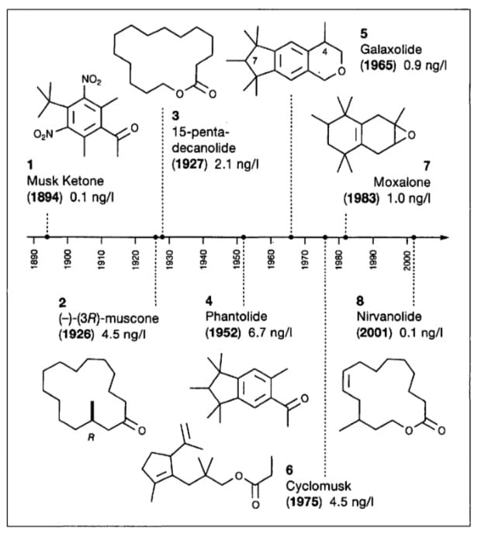
Figure 1:The Musk Timeline

“Musk is often associated with religious significance. In Islam, musk is considered to be the most fragrant of the scents. It was widely used by the Islamic prophet Muhammad and his companions. Alexander the Great is also said to have perspired with the odor of musk. Popular scents in Arab Muslim tradition include jasmine, amber, musk and oud” (agarwood) [4]. Musk has been used to attract wild animals, including in man-made perfume mixtures. For example, in 2018 Indian authorities used the perfume Obsession by Calvin Klein to attract and thus trap a wild tiger that had attacked and killed more than a dozen humans. Synthetic musks covered in this review fall into three categories based on chemical and structural features: nitro musks, polycyclic musks, and macrocyclic musks. This classification considers their molecular structure and historical background. It also matches common naming practices in fragrance chemistry literature.

2.2. Ionone/Woody odorants
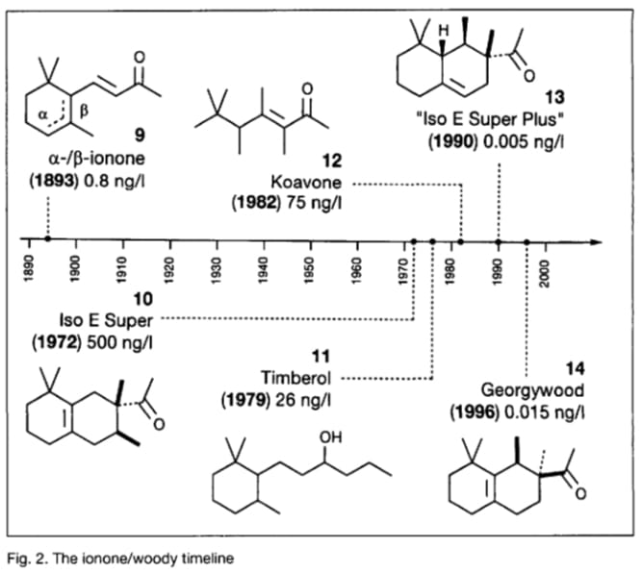
“Empress Josephine’s wedding dress was embroided with violets for her marriage with Napoleon, 'crystallized violets' sprinkled with castor sugar are a delicacy, and violet petals have been used in cosmetic formulations and were spread amongst the laundry of those who could afford it. Today, with all the affordable violet-smelling toilet soaps available, one easily forgets that violet flower oil was the most expensive of all essential oils - at the times when it was still economic to be produced, For the production of one kilogram of this oil 33000 kg of violet blossoms for ca, 2.50 German gold mark per kilogram were needed. That makes 82500 German gold marks for material costs alone per kilogram of the oil, much more than even the most precious musk grains. This high price was the reason that a synthetic violet odorant was highest on the agenda of the young fragrance industry” [1].

Figure 2: The Ionone/woody timeline
“Violet flower oil was too expensive to be used for isolation and structure elucidation with traditional techniques. Therefore assuming the same odour principles,the similarly smelling but much cheaper oil was used for the investigations named orris root oil.Via its phenylhydrazone, Tiemann and Kruger isolated the odorous principle irone and (incorrectly) determined its molecular formula by elemental analysis as C₁₃H₂₀O.This incorrect elemental analysis together with some oxidative degradation products let them believe that irone could be a base-catalyzed condensation product of acetone with citral. But the product of this reaction possessed 'a strange but not very characteristic odor'; however, when they cleaned the glassware with diluted sulfuric acid, Tiemanns nose detected the typical scent of violets in bloom. What they had actually discovered was ionone” (9), and because of the similar smell and their incorrect elemental analysis of the earlier isolated irone, they concluded that the latter compound must be a double-bond isomer of the synthesized ionone (9). “The correct constitution of the irones, homologs of the ion ones (9), was not established until more than 50 years later, in 1947, by Naves et al. of Givaudan, and independently by Ruzicka and co-workers at Firmenich”.[1]. “Ionone is a ketone compound composed of 13 carbons with a monocyclic terpenoid backbone. The term ionone derived from “iona” (Greek for violet) referring to the violet scent and “ketone” in relation to its structure” [5].

“Several isomeric ionones exist in Nature, including α-ionone, β-ionone and others. Ionones are found as secondary plant metabolism products that share mevalonic acid as a common precursor. They are widely present in fruits and vegetables comprising β-carotene and are found in plant oils, for example oils from Petunia hybrida, Boronia megastigma Nees and especially Viola odorata. It can be found in cow’s milk where is passively transferred after consumption of alfalfa pasture. α-Ionone and β-ionone are 3-buten-2-ones substituted by 2,6,6-trimethyl-2-cyclohexen-1-yl and 2,6,6-trimethyl-1-cyclohexen-1-yl groups respectively, at position 4 . The ionone stereoisomers, α-ionone and β-ionone, are pale yellow-to-yellow liquids with a woody floral scent. However, the former has an extra honey olfactory aspect. α-Ionone and β-ionone share similar physicochemical properties. They are both soluble in most fixed oils, alcohol and propylene glycol but insoluble/very slightly soluble in glycerin/water, respectively” [5]. The term ionones refers to the family of C₁₃-norisoprenoid ketones that come from carotenoid breakdown. Irones refer to similar compounds primarily found in orris root. The names used here follow standard terms in aroma chemistry to separate these closely related groups of odorants.

2.3. Sandalwood Synthetics
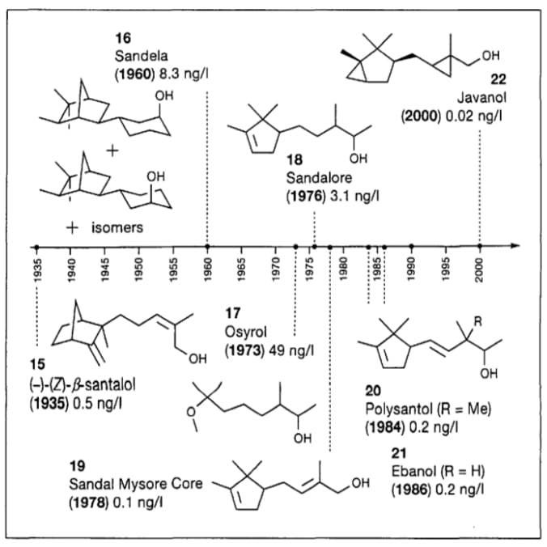
“Sandalwood (Santalum album L.) is a prized gift of the plant kingdom woven into the culture and heritage of India. It is one of the most valuable trees in the world. The natural distribution of Sandalwood extends from 30°N to 40°S from Indonesia in the east to Juan Fernandez Islands (Chile) in the west and from Hawaiian Archipelago in the north to New Zealand in the south. It is a small to medium-sized hemiparasitic tree, distributed rather widely in India. The populations are more concentrated in the southern region, especially Karnataka, Tamil Nadu and Kerala. For more than 5000 years, India has been the traditional leader of Sandalwood oil production for perfumery and pharmaceuticals. The aroma of the oil and the wood is esteemed by people belonging to three major religions of the world – Hinduism, Buddhism and Islam. According to Vamana Purana, the wood is recommended for worshipping God Shiva. Goddess Lakshmi is believed to reside in the Sandalwood tree (Brahma Vaivarta Purana)”[6].
Figure 3: The Sandalwood timeline
There are many synthetic Sandalwood molecules, but they are no substitute for natural Sandalwood. They are used to boost natural Sandalwood and should be handled with caution. Among the synthetic Sandalwood molecules, we can mention: Polysantol, Sandalore, Sandella, Ebanol. Sandalwood contains 230 molecules, but not all of them are fragrant. Sandalwood can now be fractionated and only the interesting fractions kept. Santalol, terpenes, beta-caryophyllene, santalines, bergamotol are the main components of Sandalwood.Good quality Sandalwood should contain at least 90% of santalol.
Traditionally more associated with men's fragrances, Sandalwood is now used in women's fragrances to add a woody note or to reinforce certain powdery notes. It is most often found in woody, orientals or fern fragrances. It is sometimes used to accompany floral notes such as iris for example: Sandalwood can be used as a main note, but it can be used in all olfactory families with different effects, it is even used with fresh notes. It was beautifully worked in Chanel's Bois Noir, later called Egoïste. In Guerlain's Samsara, it was used in an overdose for the first time in perfumery. Almost 20% of the formula is enhanced with other Sandalwood notes such as polysantol and associated with jasmine and ylang-ylang.[7]. The sandalwood scent mainly comes from the sesquiterpene alcohols α-santalol and β-santalol. Together, these compounds are the main components responsible for the scent of Santalum album oil. This manuscript clearly differentiates between the natural components and their synthetic versions. Throughout the odorant timelines in this review, chemical names and classifications follow conventions commonly found in fragrance and aroma chemistry literature. This approach keeps everything consistent with established scientific usage [22][23]. The important discussion of key odorant classes, such as musks, ionones, and synthetic sandalwood derivatives, shows how chemical structure, environmental effects, and regulatory factors work together to shape fragrance development. These cases highlight the shift from using ingredients based on experience to creating designed molecules that meet safety, sustainability, and performance needs.

3.Art and Science of Perfume Formulation
“Perfume formulation is a delicate blend of artistry and science,where creativity meets chemistry to create captivating scents that delight the senses.Behind every bottle of perfume lies a meticulous process of selecting,combining and balancing fragrance ingredients to achieve a harmonious olfactory composition.This guide offers a detailed exploration of the formulation of perfumes,shedding light on the key ingredients,techniques and considerations involved in crafting exquisite fragrances” [6]. While early fragrance development relied on practical knowledge and cultural traditions, modern chemistry changed perfumery into a science based on molecular understanding. The following sections focus on the chemical principles, synthesis strategies, and analytical tools that shape today's fragrance chemistry.

3.1.Understanding perfume ingredients:
At the heart of perfume formulation are fragrance ingredients ,which impart distant scents and contribute to the overall olfactory profile of the perfume.These ingredients can be derived from natural sources,such as essential oils and plant extracts, or synthesized in laboratories to mimic natural aromas.Common fragrance ingredients include:
- Essential oils: Extracted from plant materials through distillation or cold pressing,essential oils are aromatic compounds that provide fragrances with natural scents.Examples include lavender, rose, Sandalwood and citrus oils.
- “Synthetic Aroma Chemicals: Synthetic fragrance compounds are created through chemical synthesis to replicate the scents of natural materials or to achieve novel olfactory effects.These aroma chemicals offer a wide range of olfactory profiles,from floral and fruity to woody and musky” [8].
- “Absolutes and Extracts: Absolutes and extracts are highly concentrated aromatic material obtained through solvent extraction or enfleurage methods. They capture the pure essence of botanicals and are prized for their intensity and complexity. Examples include jasmine absolute, vanilla extract and tonka bean absolute” [7].
- “Fixatives and Modifiers: Fixatives are ingredients that help stabilize the fragrance, prolong its longevity and enhance its diffusion on the skin. Common fixatives include resins, balsams and synthetic musk’s. Modifiers are used to adjust the overall character of the fragrance, balancing its intensity, sweetness or freshness” [8].

3.2 Molecular Basis of Aroma Perception and Relevance to Aromatherapy

The perception of aroma starts at the molecular level. Volatile fragrance compounds bind selectively to olfactory receptors in the nasal epithelium. Each odorant molecule has unique structural features, such as functional groups, molecular size, and stereochemistry, that determine how receptors activate. These signals go straight to the olfactory bulb and then to the limbic system, a brain region closely tied to emotion, memory, stress response, and behavior.
This direct connection in the brain explains why some fragrances are said to promote relaxation, improve alertness, or trigger emotional responses. For instance, ionones with violet and woody notes have been linked to calming and comforting sensations. Sandalwood components like α- and β-santalol have been associated with anxiety relief and meditation effects. Musks act as fixatives and interact with human skin chemistry, leading to long-lasting scent experiences that may affect emotional well-being over time.
Understanding the molecular makeup of fragrance ingredients and their structure-odor relationships is essential for creating effective aromatherapy products. Advances in tools like GC-MS, combined with insights from chemoinformatics and receptor biology, help identify bioactive aroma molecules for specific wellness uses. This molecular view offers a scientific basis for evolving aromatherapy from traditional methods to a more predictable and reliable science.From an industrial perspective, fragrance chemistry plays a critical role in the development of cosmetic, personal care, and household products, where performance, stability, and consumer perception must be carefully balanced. The ability to tailor odorant volatility, fixation, and release profiles at the molecular level enables the formulation of fragrances that remain consistent across diverse product matrices such as detergents, creams, and aerosols. Moreover, an improved understanding of structure–odor relationships supports the rational selection of aroma chemicals that meet both aesthetic and functional requirements, including long-lasting freshness and reduced allergenic potential. These considerations underscore the importance of fragrance chemistry not only as an artistic endeavor but also as a key component of material science and consumer product innovation. This review connects basic molecular chemistry with practical industrial processes by using analytical techniques, formulation strategies, and considerations for production scale. This integration highlights the real-world challenges and opportunities in the fragrance industry. It also emphasizes how important chemical research is for consumer products.

2. material and methods

- “Collection of plant samples: Lavender (Lavandula angustifolia) flowers and leaves were collected from Egerton University main campus,Njoro,Kenya. The flowers and leaves were separately washed with running tap water and finally with distilled water to sterilize them” [9]
- “Extraction of essential oils: A sample of 400g of fresh lavender flowers and leaves was separately loaded into 2-Litre round bottom flask containing 1.5 liters of water and placed on a heating mantle having a power rating of 450 watt and timed. The samples were boiled with water which helps to release the oil held within the matrix of the flowers and leaves. The volatile oils evaporated along with the water into the condenser connected to the flask at 100ºC and atmospheric pressure. The condensed steam and oils were collected in a separating funnel where the essential oil and water were separated. The water was drained off gently and the oils were separately collected in a 10ml measuring cylinder and measured. The measurement was taken at an interval of 20minutes for 180minutes. The cumulative volume of the oil was measured and recorded. The traces of water in the essential oils were removed by adding 1 gram of magnesium sulfate in the oil as a drying agent after which the yield obtained was calculated using the formula” (Seid et al., 2014)[10];
Yield of essential oil (%) =amount of essential oil obtained(g) *100 (1)
number of raw materials used(g)
- “Determination of essential oil constituents: In order to identify the chemical constituents of the essential oils and therefore determine their quality, the extracted essential oil samples were analyzed using Gas Chromatography Mass Spectrometry (GC-MS) Agilent 6890 gas chromatography instrument coupled to an Agilent 5973 mass spectrometer and an Agilent Chem. The following operating parameters were used for the essential oil sample: capillary GC column HP-5MS 5% phenylmethyl siloxane\(30 x 0.25mm i.d. x 0.25 mm film thickness), a carrier gas Helium (flow rate 1.2mL min-1) and a split-less injection mode. Injector temperature was 250°C; Oven temperature was set initially at 50°C and then raised to 250°C at 10°C min-1 rate till the end of the analysis. The eluted analyses detected using (5973 network) mass selective detector and Electron Impact ionization (EID) was carried out at 70 eV” [10].
- Making of perfumes: The essential oils from flowers and leaves were separately blended together according to a formula given by Andrea et al.[11]. The oils were mixed with varying proportions of methanol, ethanol and formaldehyde to develop the scent. The perfume was aged for 4 months,after which the quality was determined as high or low based on standards described by Chouitah et al.[12]. Formaldehyde is brought up here for historical and scientific reasons. Its direct use in modern fragrance formulas is limited or banned under current cosmetic safety rules, and it is not advised.
- Data Analysis: Data was presented using frequency tables. The relationship between time and yield of essential oils was determined using Pearson correlation. The differences in yield of essential oils and the percentage of compounds in the flowers and leaves were calculated using t-test. All the data analysis procedures were carried out using Statistical Package for Social Sciences (SPSS) version 17.0 software. The GC-MS analysis serves as a typical example of the analytical methods often used in fragrance chemistry, featuring lavender essential oil as the model system.

Table 1:Yield of Essential Oil extracted from flowers and leaves of the lavender plant

Table 2: GC-MS analysis of Lavender leave oil extracted using different methods

Table 3: Quality of perfume from flowers and leaves of lavender plant after addition of other ingredients

3. results and discussion

Extraction of Essential Oils: The percentage yield of essential oils varied from 4.5 after the sampled were heated for 180 minutes to 0.5 after heating for 20 minutes in flowers (Table 1). On the other hand, the percentage yield in leaves ranged from 3.5 after the samples were heated for 180 minutes to 0.1 after heating for 20 minutes. The weights of the plant samples, volume of distilled water and the heating temperature were maintained constant at 400g, 1.5 L, 100oC respectively. There was a relationship between heating time and yield of essential oils from flowers (r=1) and leaves (r=0.99). Conversely, there was no significant difference in the amount of essential oils produced by flowers and leaves (P=0.08).
Constituents of essential oils: The percentage composition of myrcene in flowers was 4.02 and in leaves 4.30, nerol (20.00, 24.99), citral (16.09, 15.06), limonene oxide (0.20, 0.91), cineole (10.29, 11.02), berbenol (2.10, 1.56) and oleic acid (25.76, 24.86) (Table 2). There was no significant difference in the percentage composition of the different compounds in the essential oil extract from flowers and leaves (P= 0.46).

Making of perfumes: The addition of a mixture of methanol and formaldehyde to the scented products gave perfume of the highest quality (Table 3). In addition, addition of methanol yielded a product of high quality. However, a mixture of ethanol and formaldehyde gave low quality product just like the addition of ethanol alone.
- Sustainability in Fragrance Chemistry
“With increasing awareness around environmental impact, the fragrance industry is moving toward more sustainable practices. This includes the use of green chemistry techniques to create synthetic molecules that mimic natural scents without depleting natural resources. Additionally, many fragrance houses are opting for biodegradable ingredients and ethically sourced natural oils to meet consumer demand for eco-friendly products. The future of fragrance chemistry lies in striking a balance between innovation and environmental responsibility” [13]. “Sustainability in fragrance chemistry involves caring for the environment, protecting human health, and responsibly sourcing raw materials. Replacing animal-derived and long-lasting harmful compounds with biodegradable synthetic and natural molecules is a significant step forward. Principles of green chemistry, such as reducing solvents, using energy-efficient methods, and minimizing waste, are being incorporated more and more into fragrance production.These changes are especially important for consumer products and aromatherapy, where repeated exposure requires careful safety assessments, biodegradability tests, and evaluations of long-term environmental effects. By merging molecular design with predictive safety studies and life-cycle assessments, fragrance chemistry can help create safer and more sustainable products. Recent progress in fragrance chemistry focuses more on sustainability and technological innovation. Using green chemistry principles, biotechnological production methods, and data-driven tools like artificial intelligence offers a natural expansion of molecular fragrance science. This approach allows for safer, more efficient, and environmentally friendly design of aroma compounds” [24][25].
- The Future of Fragrance Chemistry: AI and Biotechnology
“The future of fragrance creation is set to be transformed by emerging technologies like artificial intelligence (AI) and biotechnology. AI algorithms can analyze vast databases of fragrance compounds and consumer preferences to predict new scent combinations with high precision. Meanwhile, biotechnology is being used to create bio-identical fragrance molecules that replicate natural scents without harming the environment. These innovations allow perfumers to push the boundaries of creativity while ensuring sustainability, and they also pave the way for custom-tailored fragrances based on individual preferences and skin chemistry” [13]-[21].
“Emerging technologies are quickly changing the field of fragrance chemistry. Artificial intelligence and machine learning are increasingly used to analyze large sets of data that include odor structures, sensory descriptions, and consumer preferences. This helps predict scent properties and speeds up the discovery of new fragrance molecules. These data-driven methods lessen the need for trial-and-error and support more efficient and focused innovation. At the same time, biotechnology provides sustainable options to traditional extraction and chemical methods. Using microbial fermentation and enzyme-assisted processes, complex fragrance molecules can be made with less environmental harm and greater consistency. These bio-based methods are especially useful for recreating rare or endangered natural scents. This approach helps preserve biodiversity while ensuring the scents remain authentic. Together, AI and biotechnology are transforming fragrance chemistry into a precise, sustainable, and interdisciplinary field” [26][27]. Emerging approaches like green chemistry, biotechnology-based synthesis, and artificial intelligence-assisted fragrance design are important tools for the next generation of perfumery. Including them in this review sheds light on future research directions and innovation paths. It highlights how data-driven and sustainable methods are changing fragrance science.

4. Conclusion

Over the past 150 years, the fragrance industry has experienced a continuous interplay of scientific discoveries and innovation which enabled the creation of a multi-billion industry. This has encompassed advances in new molecule discovery, characterization techniques, manufacturing processes, and controlled release technologies[14]. This progress has been fueled by the development and diversification of consumer goods, accompanied by the utilization of novel formulation and packaging materials, presenting scientists in the fragrance industry with an ever-expanding arena of challenges and opportunities. Historically, research and innovation in the realm of scent and consumer goods have relied, to some extent, on empirical approaches. Some of the greatest inventions in the field are owed to sheer serendipity. We believe serendipity will keep playing an important role in the future, as perfumery embodies both artistry and science. We are currently witnessing a growing integration of artificial intelligence (AI) into very diverse aspects of scent innovation, such as new molecule discovery, raw material procurement, and consumer understanding .Looking ahead, we anticipate that societal demands for a better sustainable footprint of consumer products, the integration of digital technologies into our homes, lives, and product usage, and the rise of e-commerce will provide fresh impetus for innovation in the scent industry. These factors will drive the utilization of materials with an enhanced sustainability/circularity profile and the creation of novel products and services for household and personal hygiene/grooming segments with scent playing a central role in enhancing consumer experience [15]. In addition to their beauty and market value, fragrance molecules have important potential for applications that benefit human well-being. By explaining the chemistry, synthesis, and behavior of odorants, this work adds to our scientific understanding of aromatherapy. This knowledge can help create more effective, safe, and research-supported aromatic products. It also opens new connections between chemistry, neuroscience, and health sciences. In conclusion, fragrance chemistry has become a complex scientific field that combines historical tradition, molecular science, and technological innovation. This review includes chemical synthesis, analytical characterization, principles of sustainability, and new tools like artificial intelligence and biotechnology. It offers a broad view of the basics and future paths of fragrance science. The insights shared here improve our understanding of odorant chemistry and help in creating next-generation fragrances, consumer products, and wellness-focused applications. This positions fragrance chemistry as a key part of modern chemical and material sciences. This review combines molecular chemistry and synthesis with historical insight, odorant development timelines, sustainability concerns, and new technologies. It shows the wide-ranging yet connected nature of fragrance science. The molecular perspective provides a common foundation that connects past discoveries with future innovations. This approach explains the thoroughness of this manuscript. While fragrance chemistry is inherently interdisciplinary, references from adjacent scientific domains are included only where they provide methodological insight or contextual relevance to fragrance research. Emphasis is placed on studies that directly contribute to understanding odorant chemistry, formulation, analytical characterization, or sustainable production [28][29]. By combining historical context with molecular science and future technologies, this mini-review shows the diverse nature of fragrance chemistry. The field keeps growing due to improvements in analytical chemistry, sustainable synthesis, and data-driven design. This overview aims to be an introductory reference that encourages more research and innovation in fragrance science. Overall, this mini-review aims to be an easy-to-understand but scientifically solid reference for researchers, students, and professionals interested in fragrance chemistry. It combines historical context with molecular science and new technologies. This approach provides a clear framework for understanding the basics and future direction of the field.

Disclaimer (Artificial intelligence)

Author(s) hereby declare that NO generative AI technologies such as Large Language Models (ChatGPT, COPILOT, etc.) and text-to-image generators have been used during the writing or editing of this manuscript.

References

- Gautschi Markus, Bajgrowicz Jerzy A. and Kraft Philip (2001).
- Serras Leanna (2021) The Fascinating History of Perfume.
- Rimkus, Gerhard G. (ED); Sommer Cornelia (2004).
- Aloum Lujain,Alefishat Eman,Adem Abdu,Petroianu Georg (2020) Kumar Arun A.N., Joshi Geeta and Ram Mohan H.V. (Sandalwood:History,uses, present status and the future) www.sylvaine-delacourte.com
- Nimbalkar Janvi M., Dr. Ahmed Sana “Scents that endure: Exploring the longevity of perfumes” (2024), www.ijnrd.org
- Waithaka Njenga Paul,Gathuru Eliud Mugu, Githaiga Benson Muriuki,Kwoko Jane Mbithe (Making of perfumes from essential oils extracted from lavender plant collected from Egerton Universitym,Main Campus Njoro, Kenya) (13th December ,2016)
- Seid, Y., Manoharan,J. and Omprakash, S. (2014). Extraction of essential oil from Eucalyptus leaves as Antibacterial Application on Cotton Woven Fabric. International Journal of Bacteriology, Virology and Immunology
- Andrea, C., Massimo,E. and Andrea, O. (2013). Supercritical Fluid Extraction of Plant Flavors and Fragrances. Molecules
- Chouitah, O., Meddah, B. and Aoues, A. (2011). Chemical composition and Antimicrobial Activities of the essential oil from Glycyrrhiza glabra leaves, Jeobp
- BMV Fragrances (2023) M.Yudov, “Calone” can be found under www.fragrantica.com (02 June 2023)
- David R.P. Olivier and Doro France Eur.J.Org.Chem. (2023)
- Chemoinformatics and big data analytics: Revolutionizing chemical research-A review: https://doi.org/10.1063/5.0221539
- CHARACTERIZATION OF AN ENTOMOPHAGOUS MEDICINAL FUNGUS CORDYCEPS SINENSIS (BERK.) SACC. OF UTTARAKHAND, INDIA https://thebioscan.com/index.php/pub/article/view/2282
- Role of Soil Amendments in Dissipation of Chlorpyriphos in Mollisols: https://www.indianjournals.com/article/prj-22-2-009
- Governance Frameworks for Smart Systems https://doi.org/10.1007/978-3-031-76152-2_11
- Groundwater Contamination in Bathinda, India: A Case Study in the Malwa Region https://www.taylorfrancis.com/chapters/edit/10.1201/9781032665443-76/groundwater-contamination-bathinda-india-case-study-malwa-region-rajni-verma-tanu-nimisha-singh
- Effect of soil–solarization integrated with organic amendments and bio agents on population dynamics of soil microbial populations https://thebioscan.com/index.php/pub/article/view/259
- Future Directions in Computational Intelligence: Anticipating the Next Wave: https://doi.org/10.1007/978-3-031-96871-6_3
- Revolutionizing Mental Healthcare with Generative Deep Learning Techniques for Enhanced Diagnosis and Treatment: https://doi.org/10.1007/978-3-031-91147-7_17
- Physio-Chemical Analysis on Assesment of Ground water in Malwa region https://www.thepharmajournal.com/archives/?year=2023&vol=12&issue=1&ArticleId=18344
- Vegetable Grafting: Surgical tool for yield enhancement and nematode resistance under vegetable production systems https://www.thepharmajournal.com/archives/?year=2023&vol=12&issue=1&ArticleId=18324
- Smith, J. et al. Advances in GC–MS Applications for Aroma Profiling. J. Chromatogr. A, 2021.
- Lee, M. & Zhang, Q. State-of-the-Art Aroma Compound Characterization in Complex Matrices. Anal. Chem., 2023.
- Patel, R., & Green, D. Biodegradable Musk Compounds: Design and Environmental Profiles. Green Chem., 2022.
- Ahmed, S. Solvent-Free Synthesis of High-Value Aroma Chemicals. Sustainable Chem. Processes, 2021.
- Liu, Y. et al. Machine Learning Models for Olfactory Prediction of Novel Odorants. Chem. Sci., 2024.
- Gupta, A. & Singh, P. AI-Driven Fragrance Optimization: Tools and Trends. J. Perfum. Flavor., 2023.
- Rodriguez, T. et al. Microbial Production of High-Value Fragrance Molecules. Biotechnol. Adv., 2022.
- Zhao, H. Enzyme Catalysis in the Sustainable Synthesis of Aroma Chemicals. Biocatal. Biotransform., 2024.

