Original Research Article

Gender And Socio-Cultural Dimensions Of Shea Tree Economy In Nigeria

.
ABSTRACT

Aims: Examine the gender, cultural, social and religious dimensions of shea economy in Nigeria and determine how they aid in income and welfare.
Study design: The study was conducted in Nigeria which is in Western Africa. Multi-stage sampling procedure was employed in sampling the location and the collection of primary data for this study
Place and Duration of Study: Selected states in the shea belt of Nigeria between December 2020 and April 2021.
Methodology: A total of 305 pickers, 204 processors and 102 traders giving a total of 611 respondents for the study. Data for this study were collected using interview schedules with the aid of trained enumerators. The data were analysed using descriptive statistics, exploratory and confirmatory factor analysis using structural equation modelling (SEM).
Results: The results revealed that overwhelming majority of the actors involved in shea business were female married actors (92%), most of whom were Muslims (60%) with 35% Christians. Also, the females have more ownership and control than their male counterpart, but the ownership is community-based (52.34%) with a mean income of N2,514,190.30. Traders are the highest income earners but the pickers are more in number. SEM indicated that there is inter-relationship between shea tree ownership as a common resource and other latent variables which could be tapped by every member in the community with some form of community consent systems and the proceeds or income generated from the shea business is shared based on consent hierarchy.
Conclusion: It was recommended that women should be given full access and right by the community to gather shea nuts regardless of their marital status and without seeking permission from any member of the community. The sharing of the proceeds or income generated from shea business should be based on level of participation and not the hierarchical consent system.

Keywords: Shea tree ownership, Shea proceeds, Shea trading, Structural Equation Modelling, Sustainable livelihoods.

1. INTRODUCTION

“Shea tree (Vitellaria paradoxa) is a unique agroforestry tree species central to sustaining local livelihoods and the farming environments of rural communities across Africa. Recognized as the second most important oil crop in Africa after palm oil, shea tree is among the most economically and culturally important indigenous tree species in Africa where oil palm does not grow” (Hale et al., 2021). “Shea production are characterized by rain-fed subsistence arable farming on compound and bush farms, irrigated dry season ‘market gardening’ on small protected plots and extensive livestock grazing based on crop residues, bush farm fallows and dry season transhumance along the river valleys and within protected areas” (Wardell and Fold, 2013). “However, shea tree is traditionally not planted because of its extensive juvenile period (commonly 10–25 years) and local abundance, not to mention the challenges associated with being unable to differentiate naturally regenerated from planted trees. Instead, shea agroforestry parklands, comprised of annual crops and scattered shea trees that can reach densities of 20–50 trees/ha in areas of strong shea culture, result from self-sown propagation and systematic management (selection and protection) by farmers through successive fallow and cultivation cycles. Farmer selection of preferred individuals and removal of inferior trees for charcoal production or building materials serve to increase the levels of locally valued traits, resulting in what has been called a semi-domestication of the species” (Maranz and Wiesman, 2003). “Shea consistently features at the top of farmers’ lists of priority species; and surveys indicate that farmers would plant shea trees if improved varieties were available and visually” distinguishable (for purposes of clarifying ownership) from naturally regenerated trees (Poudyal, 2011). Like all high-value fruit trees planted in these systems, deliberately planted shea stands could be established in closer proximity to household compounds, thus reducing walking and collection times.
“Based on population and daily shea butter consumption data, the number of women taking part in shea nut collection across the shea belt in Africa is estimated at over 18 million” (Naughton et al., 2015). I”ndeed, shea has been called “women’s gold” because it is one of only a few resources that female members of rural households in the region have control over, from harvesting to commercialization” (Elias and Carney, 2007). “The sale of shea products allows women to secure additional food for themselves and their children once cereal harvests are exhausted” (Pouliot, 2012) and to generate cash for household expenses including clothing, medicine, and school fees. “The seasonality of shea availability is also critical to farming households’ nutrition. Shea fruits are the only widely available, energy-rich food source at the time when land is tilled and crops are planted at the end of the dry season. The fruits supply significant amounts of protein, sugar, calcium, potassium, and essential fatty acids” (Honfo et al., 2014) during this annual ‘hungry season’ when cereal stocks in granaries are lowest and labour requirements for field preparations with the coming of the rains are highest (Maranz et al., 2004).
“Although there are laws that governance forest resources conservation in Nigeria, it does not serve as the only instrument of social control in the society as public opinion, religion and custom play very important role in shea economy” (Omon and Ilobekemen, 2018). Indeed the 1999 Nigerian constitution, in section 20, stated that “The State shall protect and improve the environment and safeguard the water, air and land, forest and wildlife of Nigeria”. However, a number of factors continue to constrain the achievements of these laudable goals and laws of our forest resources conservation. The major constraints include coordination problems, lack of supportive comprehensive policies on environmental laws and issues, inadequate legal framework for implementation and sanction against violations and lack of implementation of the Forest Act of 1999. In addition, there are issues of inadequate budget allocation and investment, poor maintenance of biological diversity and limited local participation, inadequate mainstreaming of environmental and climate change issues into other sector policies and programmes as well as slow implementation of the National policy on the Environment to reduce conflict related to land use. The apparent failures of all these laws and others not listed but have been enacted by the government through legislation, communities and corporate organizations have brought about social barriers, cultural and religious norms that inhibit property ownership and natural resource entitlements. Becker (2001) found out that shea trees are usually considered the property of clan lineages. A woman married into a founding lineage thus collects from trees retained in fields and fallows of her husband’s lineage and from common-pool forested areas.
1.1 Problem Statement
In developing countries like Nigeria, women are usually very dependent on common property resources for water, compost for farmland and wild herbs, mushrooms, fruits and nuts, as it is usually their responsibility to ensure that the family is supplied with these goods. However, when these commonly held resources become scarce and property rights are exerted because of a perceived market value, their control tends to be assumed by men, although women’s role as the supplier to the family of these resources does not change.
According to Hammond et al. (2019), “one of the challenges faced by smallholder farm households particularly women are degradation of forest resources due to over exploitation, weak governance and conflict of use over shea trees. Rural women often have a wealth of knowledge on natural resources, such as land, water and forests, as they are often in charge of their management, not only in their role as farmers, foresters and fisher folk but also as primary providers of water, food and energy at the household and community level. Despite this, rural women still face major gender-based constraints that limit their potential as economic agents and their capacity to reap the full benefits of their work. The root cause of these discriminations lies in social norms, attitudes and beliefs, which shape how women and men are expected to behave, the opportunities that are offered to them and the aspirations they can pursue. Discriminatory sociocultural norms affect how policies and legal frameworks are formulated and implemented; who participates in decision-making processes and governance mechanisms; how rural institutions are managed; how service providers target their clients and prioritize their needs; and, ultimately, how resources are allocated and decisions are taken within households and communities. Therefore, the aim of this paper is to critically examine the gender, cultural, social and religious dimensions of shea trees ownership and exploitation in Nigeria and determine how they aid in income and welfare generation. The specific objectives were to determine shea tree ownership disaggregated by gender and religious strata as well as estimate the income generated from shea processing and marketing. The inter-relationship between ownership, gender, religion and some social factors were also examined”.
1.2 Justification
Shea tree is a very important parkland tree species and collection of its fruit is considered a women’s activity by rural people in Africa. Policy makers and development practitioners consider shea as a potential income generating activities available to all rural women equally (Rousseau et al., 2017). However, most literature on shea (Naughton et al., 2015; Rousseau et al., 2017; Hammond et al., 2019; Hale et al., 2021) mainly focuses on shea nut production, butter processing and marketing. As such, there is a global literature gap on the gender and sociocultural dimensions of shea tree ownership. This knowledge gap could be a driver of household allocation of shea income and inequalities among rural people involved in shea activities.
Shea nut production supports the achievement of Climate Smart Agriculture objectives through increasing food security, increasing adaptive capacity, and mitigation of greenhouse gas emissions (Campbell et al., 2014; Lipper et al., 2014; Hammond et al., 2019). Shea production has a positive impact on adaptive capacity by enhancing the economic value of shea trees, it encourages the retention of trees in the landscape which will continue to provide buffering ecosystem services, promoting water and soil retention and guarding against desertification (Sinare et al., 2016). A healthy shea nut industry therefore promotes landscape-scale adaptation to climate change. Lending credence to this, Hammond et al. (2019) argued that increased shea butter production, supported by better business infrastructure leads to increased incomes and makes households more resilient to negative shocks.
Local communities collect a large range of non-timber forest products such as shea for subsistence use and for sale in local periodic markets. Shea nuts and shea butter products continue to be of critical importance in sustaining rural livelihoods. Becker (2001) affirmed that “women earn 55% of their personal income from the sale of shea butter compared to 24% from the sale of firewood in Mali. According to the traditional division of labour, women are responsible primarily for the cultivation and harvesting of subsistence crops such as millet, maize and rice. They are also responsible for collecting the fruits that fall from shea trees. In Burkina Faso, shea nuts are commonly referred to as women’s gold”. “They are used to produce shea butter and are coveted as active ingredients in soaps, cosmetics, moisturizers and lotions (United Nations Development Programme” (UNDP), 2012). The employment opportunities generated through shea have empowered local women to escape the margins of poverty by using traditional knowledge and a widely available and abundant resource. New sources of income provide a degree of financial autonomy and have created revenue streams that are channelled into filling service gaps in the areas of education, health, and food security.
1.3 Literature Review
This study is conceptualized on the view of gender politics and agrarian change literature (Rousseau et al., 2017) on socio-economic differentiation processes around shea activity that affect rural people. “In the aspect of gender politics, the focus is on analysing the household as a political scene” (Apusigah, 2009) which explores power relationships within the household. This makes it possible to investigate within-household control of activities, distribution of income, and social justice in all their complexity. “The literature successfully identified the mechanisms by which men and women gain control over activities and over income within the household. These mechanisms are based on: the politics of access to land and resources with the importance of the interpretation and reinterpretation of rules of access and the labelling of resources and or land; the control of labour and the interpretation and reinterpretation of gendered division of tasks including the activities connected with child care and household tasks which limit women’s productive work and the politics of meaning, that is, the interpretation and reinterpretation of the meaning of cash crop activities and the use of the money from these activities as a power resource” (Duflo and Udry, 2004; Somé, 2013; Quisumbing et a1., 2014). “Analysing gender politics within households made it possible to go beyond the simplistic dichotomy of the mechanisms of dispossession and exploitation of women by men and the mechanisms of empowerment of women, and reveal the negotiation processes between spouses, the strategies, the compensation conceded and the trade-offs involved. The aim of this literature was to consider gender categories not just through opposition to one another, that is, man vs. woman, but with reference to a host of other social markers including age, income and origin that matter in explaining social change and power relationships” (Elmhirst, 2011).
“The agrarian change literature on the other hand, has succeeded in explaining rural social change through the analysis of power relationships. Agrarian change literature is heir to Marxist literature. It deals with the process of integrating the agricultural world into the capitalist economy” (Akram-Lodhi and Kay, 2010). “Understanding the relevance of the agrarian change perspective requires analysing the effects of the development of capitalism and the process of commodification on peasants” (Akram-Lodhi and Kay, 2010). “Commodification takes place when economic value is assigned to something not previously considered in economic terms” (Razavi, 2017). Several authors (Akram-Lodhi and Kay 2010; Gray and Dowd-Uribe, 2013; Rousseau et al., 2017) showed that “the globalization and the commodification of natural resources are neither linear nor coherent. The literature on agrarian change in Africa focuses on how globalization shapes social and power relationships and hence socio-economic differentiation. Literature on agrarian change in Africa” (Gray and Dowd-Uribe, 2013; Rousseau et al., 2017) underlines two key elements to understand the specificity or socio-economic differentiation in rural Africa. First, access to natural resources is embedded in social, familial and customary relationships and is an object of negotiation, and claims that change rules of access may lead to conflicts. Second, globalization entail s social and economic differentiation crossing different variables including age, status in the household, gender, and religion.
The first principle is concerns the critical role played by access in the development of inequalities. This study defines “access” in line with Ribot and Peluso (2003) as “the ability to benefit from things including material objects, persons, institutions, and symbols. This definition allows a dynamic analysis of the social and power relationships that enable or hinder access to resources, with a locus on processes and negotiation. The focus is on the mechanisms by which people control, maintain or gain access to natural resources. The second analytical principle implies that, to uncover the sociocultural and religious dimensions of shea tree ownership, there is a need to analyse which social groups are gaining, maintaining or controlling access, and to the disadvantage of which social group”.
This study also takes a look at the theory of the common with the view that common resources are collectively owned by the membership of a defined social group. “Non-members of the community can access such resources once they have negotiated this right. Common resources can include pasture or grazing lands, fishing rights, water bodies and forest” (Bugri and Yeboah, 2017). “In most African countries, Nigeria inclusive, access to shea nuts and other forest fruits like Dawadawa are common resource rights. Women are the primary collectors and main beneficiaries of these fruits. Large-scale land acquisition and investments are preventing and restricting access to these common resources, causing hardship in the broader community and leading to violence in some cases. With increasing competition over these resources, community members usually develop coping mechanisms and adaptation strategies, such as rationing how frequently individuals can access these common resources. One of the comparative strengths of the shea tree is its resilience and the ability to survive a harsh, unforgiving climate prone to prolonged periods of drought. With a lifespan of up to 200 years, the shea tree produces fruit after its fifteenth year and reaches full production potential in its twenty-fifth year. The shea tree has been an important resource for the people of West Africa. In the face of encroaching desertification, the shea tree also helps prevent wind erosion and adds organic matter back to the soil. The nuts are processed to obtain shea butter, which is used as cooking oil, for making soap, as medicine, and in cosmetics. Shea butter is increasingly valued throughout the world for its superb healing and moisturizing properties and is widely used in creams, sunscreen lotions, conditioners and in the treatment of burns and muscle pain” (UNDP, 2012).
Evidence trend Wardell and Fold (2013); Omon and Ilobekemen (2018) shows that “female income opportunities with shea butter depend fundamentally on access to the tree’s nuts. As the shea tree is not deliberately planted, its distribution on different types of land confers varying access rights. Shea trees are found on household landholdings as well as on unclaimed land used by villages for pasture, fuelwood and the gathering of medicinal. In open-access forests, women collect nuts on a first-come-first-served basis. On cultivated or fallow fields, only women with privileged access hold the rights to gather the nuts”. “Rural households follow a tenure pattern typical of Sahelian common property systems, dividing their landholding into personal and family fields. If a shea tree grows on her personal field, a woman is entitled to collect the fruits and the value of marketed butter from shea tree that grows on her personal farmland. Whereas, when tree grows on family fields, the male family head grants female members of the household the right to gather shea fruits” (Boffa et al., 1996). Nut collection remains a female activity. However, women are being made to share shea revenues with male household heads. The men do not process the nuts, but sell them directly to wholesalers.
However, the density of shea trees on farmed fields thus remains closely linked with the economic value of the tree’s products to the household economy (Schreckenberg, 2004). Gender issues also appear crucial in shea conservation strategies. Elias and Carney (2007) opined that “more shea trees were found per hectare on women personal fields compare to men, with male household heads maintain densities of 20 shea trees per hectare on their personal fields while female-managed areas averaged shea densities of 27 trees per hectare”. Despite this, Kousseau et al. (2017) found out that “nearly a quarter of women’s personal income from shea are transferred to the husbands which is an indication of men’s successful strategies to change the rules of access to shea trees and to be recognized as the owners of shea trees”.

2. methodology

The study was conducted in Nigeria which is in Western Africa with a total area of 923,768 km² (356,669mi²) and estimated population of over 216 million (World Fact Book, 2022a). Nigeria is made up of a Federal Capital Territory and 36 states. Its borders span about 4,047 kilometres, it shares borders with Republic of Benin (773 km) in the west, Niger (1,497 km) in the north, Chad (87 km), and Cameroon (1,690 km) in the east and Gulf of Guinea in the south with coastline of about 853 km (World Fact Book, 2022b). Nigeria lies between Latitudes 4° and 14°N, and Longitudes 2° and 15°E. The highest point in Nigeria is Chappal Waddi at 2,419 m (7,936 ft). The main rivers are the Niger and the Benue, which converge and empty into the Niger Delta. This is one of the world's largest river deltas and the location of a large area of Central African mangroves. The climate varies across the country with an equatorial climate in the south, tropical in the central region, and arid in the north (Index Mundi, 2018).
Nigeria is made up of a Federal Capital Territory and 36 states, bordering the, the Republic of Benin in the west, Chad and Cameroon in the east, and Niger in the north. Nigeria has a varied landscape. The far south is defined by its tropical rainforest climate, where annual rainfall is 1,500 to 2,000 millimetres (60 to 80 in) per year (Geographical Alliance of Iowa, 2009). In the southeast stands the Obudu Plateau. Coastal plains are found in both the southwest and the southeast (Encyclopedia, 2011). Mangrove swamps are found along the coast (Geographical Alliance of Iowa, 2010). The far north is savannah (insignificant tree cover, with grasses and flowers located between trees). Rainfall is more limited to between 500 and 1,500 millimetres (20 and 60 in) per year (Geographical Alliance of Iowa, 2009). The savannah zone's three categories are Guinean forest-savanna mosaic, Sudan savannah, and Sahel savannah. Tropical grassland occupies the area north of the forest belt and is studded with shea, baobab, tamarind, and locust bean trees. The country has an estimated land use of 31.29% for arable land, 2.96% permanent crops and 65.75% for others with 2,330km² irrigated land. As of 2020, about 34.66% of Nigerians are employed in agriculture with 22.35% contributions to Nigeria’s GDP. The major crops grown include beans, sesame, cashew nuts, cocoa beans, groundnuts, gum Arabic, kolanut, maize (corn), melon, millet, palm kernels, palm oil, plantains, rice, rubber, sorghum, soybeans and yams. Cocoa is the leading non-oil foreign exchange earner (Nations Encyclopedia, 2022). Rubber is the second-largest non-oil foreign exchange earner (Nations Encyclopedia, 2022).
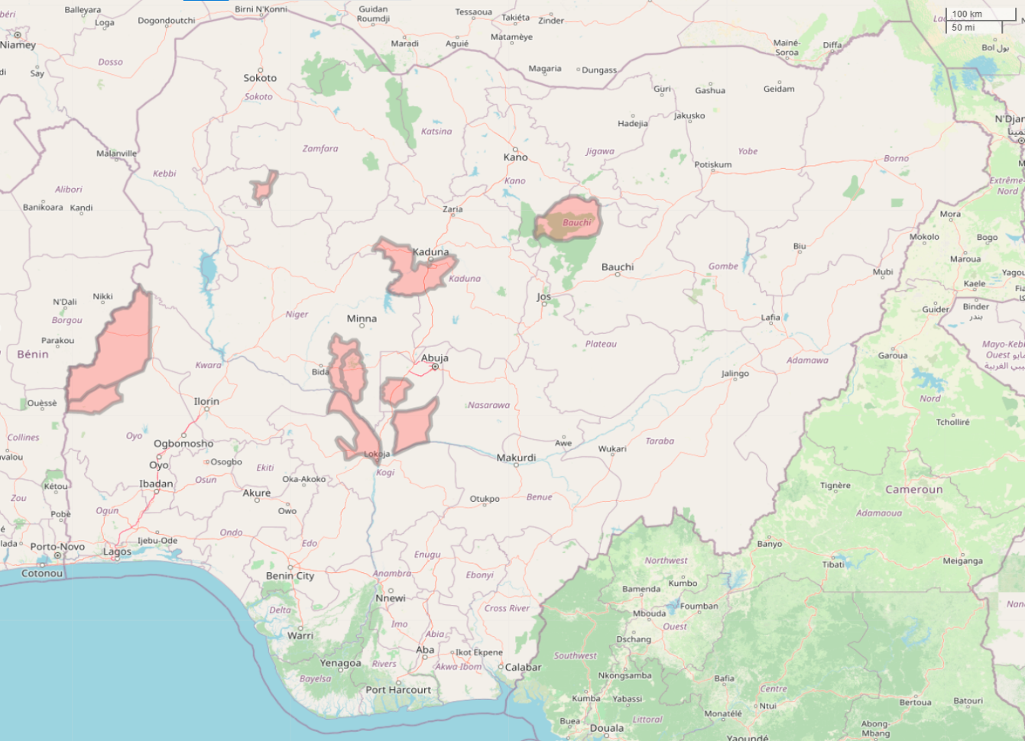
Figure 1: Map of Nigeria showing the sampled states
Multi-stage sampling procedure was employed in sampling the location and the collection of primary data for this study. In the first stage, nine (9) states (Bauchi, Kaduna, Kebbi, Kogi, Kwara, Nasarawa, Niger, Federal Capital Abuja and Oyo) were purposively selected because of the high density of shea trees, high level of shea butter production activities and trade in the states. In the second stage, one (1) local government area with predominant shea trees were selected from the selected states, except Niger State were two (2) local government areas were selected because the state has the largest collection of shea trees in the world and controlling about 54% of all trees in Nigeria (Olumide, 2018). Giving a total of ten (10) local government areas. The third stage involved random selection of two (2) communities from the selected local government areas, giving a total of twenty (20) communities. In the fourth stage, fifteen (15) pickers, ten (10) processors and five (5) traders were randomly selected from the selected communities except for one community in Niger state under Agaie were twenty (20) pickers, fourteen (14) processors and seven (7) traders were selected. This gives a total of six hundred and eleven (611) respondents for the study. Data for this study were collected using interview schedules with the aid of trained enumerators.
The data were analysed using descriptive statistics, Z-test, exploratory and confirmatory factor analysis (Structural Equation Modelling).
The Exploratory factor model is presented in eqn. (1) as:
$Y_{1}$ = $a_{11}X_{1}$ + $a_{12}X_{2}$ + *** + $a_{1n}X_{n}$
$Y_{2}$ = $a_{21}X_{1}$ + $a_{22}X_{2}$ + *** + $a_{2n}X_{n}$
$Y_{3}$ = $a_{31}X_{1}$ + $a_{32}X_{2}$ + *** + $a_{3n}X_{n}$ (1)
* *
* *
$Y_{n}$ = $a_{n1}X_{1}$ + $a_{n2}X_{2}$ + *** + $a_{nm}X_{n}$

Where:
$Y_{1}$, $Y_{2}$, ……, $Y_{n}$ = Observed variables;
$a_{1}$ - $a_{n}$ = Correlation coefficients;
$X_{1},X_{2}$, …...,$X_{n}$ = Unobserved underlying factors.
SEM are models consisting of a combination of multivariate analysis, factor analysis and regression analysis, used to validate or reject one or more hypothesis about an existing relation between different variables. It estimates simultaneously dependency relations between variables (observed or latent) and estimate measurement error in model’s variables. Holzinger and Swineford (1939) proposed one of the most famous CFA models. In the model estimates, x_{i} are exogenous variables that record scores and y_{i} are latent (and endogenous) variables respectively, double-headed arrows represent an association between y₁, y₂, and y₃, single-headed arrows represent direct effects, and ε_{i} represent error terms. It estimates factor loading, which is a measurable effect reflecting the incidence of an observed variable over another either observed or latent variable. Interpreting factor loadings is equivalent to interpreting direct effects in a linear econometric model. According to Fox (2002) and Kline (2005) CFA becomes a causal model if all latent variables are defined by observed variables. CFA is presented in eq. (2)
Definition of latent variable
F1 =~ x1 + x2 + x3
F2 =~ y1 + a*y2 + b*y3 + c*y4 (2)
F3 =~ y5 + a*y6 + b*y7 + c*y8
…..
FK =~ y_{i +K}+ a*y_{i+K} + b*y_{i+K} + c*y_{i+K}
The regressions
F1 ~ F2
F2 ~ F4 + F9 (3)
F5 ~ F6 + F7
Residual correlations
y1 ~~ y5
y2 ~~ y4 + y6
y3 ~~ y7 (4)
y4 ~~ y8
y6 ~~ y8.

3. results and discussion

The results of the gender, marital status and religion characteristics of shea actors presented in Figure 2 revealed that overwhelming majority of the actors involved in shea business were female accounting for 92%. This result has confirmed the opinion that shea business is a feminist business. Probably because shea (Naughton et al., 2015) is one of the few resources female members in rural households have control over from picking to marketing. In addition, majority of these female actors were married accounting for 90%. The possible reason for this, is due to the fact that employment opportunities generated through shea helps to empower rural women financially especially those that have personal and family responsibilities. This is in accordance with the findings of Hammond et al. (2019) who affirmed that shea business leads to increase income and makes households more resilient to negative shocks.

More so, majority of the married women were Muslims that is, they practice Islam as their religion accounting for 60%. While 35% of the married women were Christians that is, they practice Christianity as their religion. This implies that most of the shea actors belongs to the two major religion in the country and only 5% of the actors practice African traditional and other religion. This indicated that the two major faiths (Islam and Christianity) encourages participation of women in shea business in Nigeria. Furthermore, only 8% of the actors were male. This implies that the rural men in Nigeria focuses more on other livelihood activities than shea business.
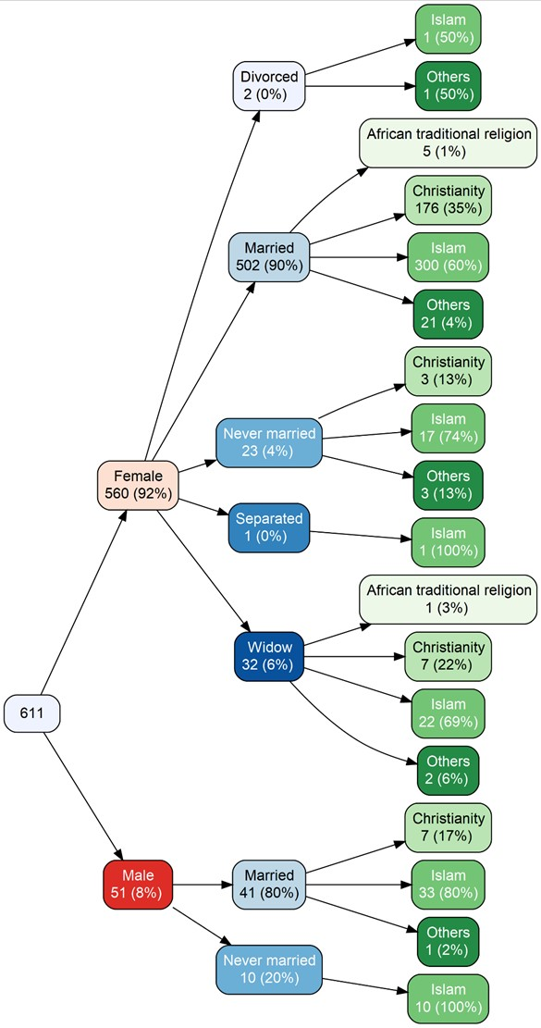
Figure 2: Gender, marital status and religion characteristics of shea actors.

The findings on shea tree ownership on gender basis presented in Figure 3 revealed that female have more ownership and control over shea trees than male counterpart in Nigeria. The access and control are more under the community ownership that is, shea trees belonging to the community which accounted for over 50%. Then ownership by household head which accounted for 21.34%. This indicated that shea trees are mostly owned as a common resources in Nigeria. However, only few which is less than 10% of the pickers accepted that shea trees belong to an individual and self each. This result agrees with the findings of Wardell and Fold (2013); Omon and Ilobekemen (2018) which found that “shea trees are mostly not planted deliberately in Nigeria and the nuts are usually collected on a first- come- first-served basis on unclaimed land used by the community”.

Figure 3: Shea tree ownership on gender basis.

The result of the shea tree ownership based on marital status as presented in Figure 4 revealed that all the categories of shea tree ownership in Nigeria were mostly owned by married individuals in the community. “Ownership by community accounted for 47.97%, then ownership by household head which accounted for 20.41, followed by ownership by self and individuals outside the household accounting for 10.45% and 9.66% respectively. This implies that married rural people possesses more ownership and control over shea trees in Nigeria. The possible reason for this is that women who are owners of cultivated lands have the right to pick the nuts on their lands, they are also given privilege access and rights over shea trees on their husbands’ land. Although women have control over the shea, however the revenue generated from the shea is been shared by the other household members especially the male household head” (Boffa et al., 1996).

Figure 4: Shea tree ownership by marital status.

Results of the shea tree ownership based on gender and religious strata presented in Figure 5 revealed that more than half (52.34%) of the shea trees are owned and controlled by the female. However, most of the owners accounting for 31.46% practice Islamic religion which are more under the community. This is followed by shea tree owners that practice Christianity which are more under the community ownership accounting for 20.87%. This indicated that majority of shea trees in Nigeria are owned by Muslims and Christians.

Figure 5: Shea tree ownership on the basis of gender and religious strata.

Results in Table 1 shows the gross income distribution of shea actors on annual basis in which the frequency follows the normal distribution but bimodal. The Table was sorted by the amount of income which revealed that the mean income was N2,514,190.30. In addition, the result also revealed that the shea economy is female dominated and they earn the most income. In terms of the actors, traders are the highest income earners but the pickers are the most income earners in terms of number. The result further revealed that there seems to be a little bit domination by a particular religion, with more Muslim women earning at the top of the income ladder. More so, most of the female on top of the ladder are married. The previous held belief that shea trade might have some religious inclinations needs to be critically examined. The implication of this findings is that shea business is very lucrative in Nigeria which might help the actors to escape the margins of poverty that is common in the rural areas in the country.

This result agrees with the findings of Matanmi et al. (2011) who reported that most shea actors were married. Also, in accordance with the findings of Okolo et al. (2016) who affirmed that religion had no influence in shea activities and average income of N795,772 was reported for all the actors in North Central States of Nigeria.

Table 1: Gross Income Distribution of Shea Actors on annual basis
Gender | Marital Status | Religion | Actor | Income Class Interval | Freq.
Female | Married | Islam | Traders | 76300000 - 81900000 | 1
Female | Married | Christianity | Traders | 65400000 - 70900000 | 1
Male | Married | Islam | Pickers | 49100000 - 54500000 | 1
Female | Married | Islam | Pickers | 38200000 - 43600000 | 1
Female | Married | Islam | Pickers | 32700000 - 38200000 | 3
Female | Married | Islam | Pickers | 21800000 - 27300000 | 2
Female | Married | Islam | Pickers | 16400000 - 21800000 | 1
Female | Married | Christianity | Pickers | 10900000 - 16400000 | 3
Female | Married | Islam | Pickers | 10900000 - 16400000 | 1
Female | Married | African traditional religion | Pickers | 5460000 - 10900000 | 1
Female | Married | Christianity | Pickers | 5460000 - 10900000 | 9
Female | Married | Christianity | Processors | 5460000 - 10900000 | 3
Female | Married | Christianity | Traders | 5460000 - 10900000 | 8
Female | Married | Islam | Pickers | 5460000 - 10900000 | 20
Female | Married | Islam | Processors | 5460000 - 10900000 | 2
Female | Married | Islam | Traders | 5460000 - 10900000 | 2
Female | Married | Others | Pickers | 5460000 - 10900000 | 5
Female | Married | Others | Traders | 5460000 - 10900000 | 1
Female | Never married | Christianity | Pickers | 5460000 - 10900000 | 1
Female | Never married | Islam | Pickers | 5460000 - 10900000 | 1
Female | Never married | Others | Pickers | 5460000 - 10900000 | 1
Female | Widow | Christianity | Pickers | 5460000 - 10900000 | 1
Female | Widow | Islam | Pickers | 5460000 - 10900000 | 1
Male | Married | Islam | Pickers | 5460000 - 10900000 | 1
Male | Married | Islam | Processors | 5460000 - 10900000 | 2
Female | Divorced | Islam | Processors | 69800 - 5460000 | 1
Female | Divorced | Others | Pickers | 69800 - 5460000 | 1
Female | Married | African traditional religion | Pickers | 69800 - 5460000 | 1
Female | Married | African traditional religion | Processors | 69800 - 5460000 | 2
Female | Married | African traditional religion | Traders | 69800 - 5460000 | 1
Female | Married | Christianity | Pickers | 69800 - 5460000 | 72
Female | Married | Christianity | Processors | 69800 - 5460000 | 57
Female | Married | Christianity | Traders | 69800 - 5460000 | 23
Female | Married | Islam | Pickers | 69800 - 5460000 | 108
Female | Married | Islam | Processors | 69800 - 5460000 | 118
Female | Married | Islam | Traders | 69800 - 5460000 | 41
Female | Married | Others | Pickers | 69800 - 5460000 | 14
Female | Married | Others | Processors | 69800 - 5460000 | 1
Female | Never married | Christianity | Pickers | 69800 - 5460000 | 1
Female | Never married | Christianity | Processors | 69800 - 5460000 | 1
Female | Never married | Islam | Pickers | 69800 - 5460000 | 12
Female | Never married | Islam | Processors | 69800 - 5460000 | 3
Female | Never married | Islam | Traders | 69800 - 5460000 | 1
Female | Never married | Others | Pickers | 69800 - 5460000 | 2
Female | Separated | Islam | Processors | 69800 - 5460000 | 1
Female | Widow | African traditional religion | Processors | 69800 - 5460000 | 1
Female | Widow | Christianity | Pickers | 69800 - 5460000 | 2
Female | Widow | Christianity | Processors | 69800 - 5460000 | 3
Female | Widow | Christianity | Traders | 69800 - 5460000 | 1
Female | Widow | Islam | Pickers | 69800 - 5460000 | 12
Female | Widow | Islam | Processors | 69800 - 5460000 | 6
Female | Widow | Islam | Traders | 69800 - 5460000 | 3
Female | Widow | Others | Pickers | 69800 - 5460000 | 2
Male | Married | Christianity | Pickers | 69800 - 5460000 | 2
Male | Married | Christianity | Processors | 69800 - 5460000 | 1
Male | Married | Christianity | Traders | 69800 - 5460000 | 4
Male | Married | Islam | Pickers | 69800 - 5460000 | 13
Male | Married | Islam | Processors | 69800 - 5460000 | 1
Male | Married | Islam | Traders | 69800 - 5460000 | 15
Male | Married | Others | Pickers | 69800 - 5460000 | 1
Male | Never married | Islam | Pickers | 69800 - 5460000 | 9
Male | Never married | Islam | Traders | 69800 - 5460000 | 1

The results of the structural equation modelling are presented in Tables 2 and 3, Figures 7 and 8. The results in Table 2 revealed that Kaiser-Meyer-Olkin (KMO) measure of sampling adequacy was 0.577 which is good and Bartlett’s test of sphericity (P < 0.001, df = 276, $X^{2}$ = 3571) was significant at 1% probability level. Based on the exploratory factor analysis presented in Table 3, nine (9) latent factors were identified (shea tree ownership as a common resources, shea proceeds shared with others, religion factor, shea ownership by community, shea tree population, extension contact and age factor, size of land on which shea tree grows, experience on shea trading and shea trees and land ownership) which explained 69% of the total variance. The scree plot in Figure 7 confirmed the number of factors retained, which is the number of factors above the simulated data.

The results of the confirmatory factor analysis of the extracted factors presented in Figure 8 shows that the hypothesized nine factor model fit the data well. This result indicated that there is inter-relationship between shea tree ownership as a common resources, shea proceeds shared with others, religion factor, shea ownership by community, shea tree population, extension contact and age factor, size of land on which shea tree grows, experience on shea trading and shea trees and land ownership in Nigeria. In addition, the research found out that shea tree is perceived as a common resources which could be tapped by every member in the community with the consent of either the village head, household head or the husband without religion or age discrimination. However, the proceeds or income generated from the shea activities are usually shared with the village head, household head or husbands and other members in the household. This result is in accordance with the findings of Kousseau et al. (2017) who found out that nearly a quarter of women’s personal income from shea are transferred to the husbands which is an indication of men’s successful strategies to change the rules of access to shea trees and to be recognized as the owners of shea trees.

Table 2: Kaiser-Meyer-Olkin measure of sampling adequacy and Bartlett's test of sphericity
Analysis | Value
KMO | 0.577
Bartlett test: Approx. Chi-square | 3571
Degrees of freedom | 276
Sig. | 0.000
Source: Field survey, 2020.

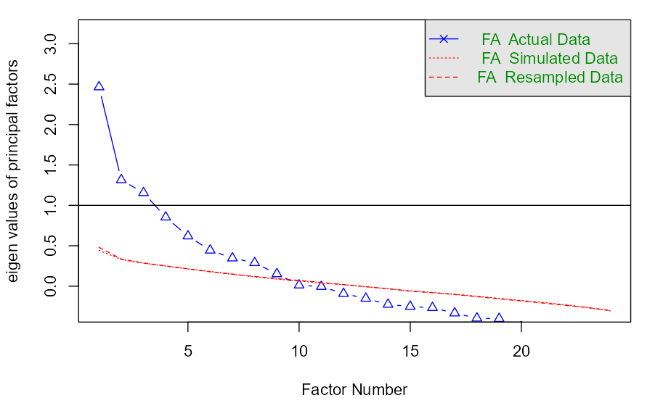
Figure 6: Scree plot of retained factors.

Table 3: Principal components of inter-relationship between ownership, gender, religion and social factors
Latent Factors | Observed variables | Factors  loadings
Shea tree ownership as a common resources | Taking permission before picking shea nuts | 0.793
Shea tree ownership as a common resources | Ownership of shea tree outside the household | 0.590
Shea tree ownership as a common resources | Number of people that collect shea from the same tree with the pickers | 0.432
Shea proceeds shared with others | Ratio of the shea proceeds share | 0.837
Shea proceeds shared with others | What happens to the proceeds obtained from shea nuts activities | 0.543
Religion factor | Religion | 0.961
Religion factor | Leased land | 0.512
Shea ownership by Community | Shea ownership by Community | 0.858
Shea tree population | Number of shea tree use that grows on cultivated land | 0.967
Shea tree population | Number of shea tree use that grows on uncultivated land | 0.542
Extension contact and age factors | Number of extension visit | 0.703
Extension contact and age factors | Age of the actor | 0.483
Size of land on which shea tree grows | Size of self-owned land on which shea tree grows | 0.573
Size of land on which shea tree grows | Size of household owned land on which shea tree grows | 0.480
Experience on shea trading | Years of experience in shea nut/butter trading | 0.564
Shea trees and land ownership | Who owns the shea nut trees you use | 0.484
Shea trees and land ownership | Other lands | 0.416
Source: Computed from field survey data, 2020.
Extraction method: Principal Component Analysis.
Rotation method: varimax with Kaiser Normalization
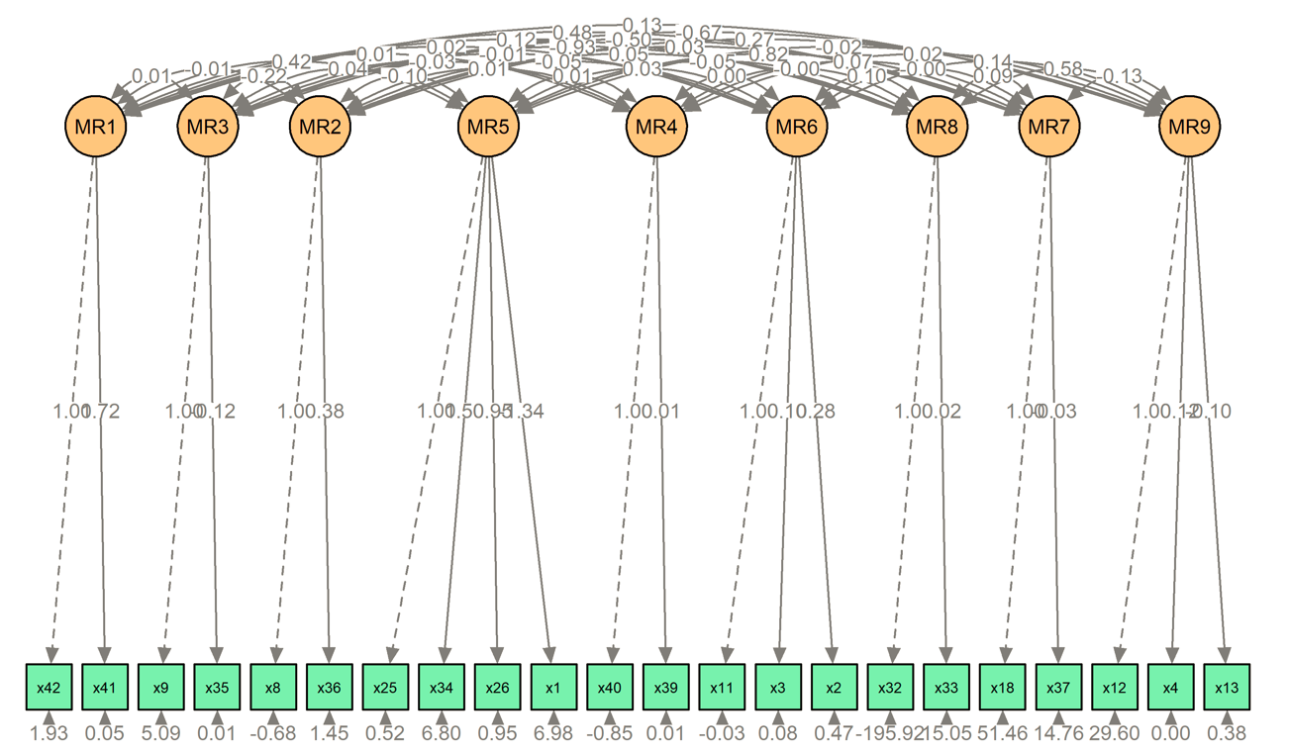
Figure 7: Confirmatory factor analysis of the extracted factors from the exploratory factor analysis

4. Conclusion

This research concludes that shea is female dominated and they also earn the most income which could help to empower rural women financially. Most of the shea actors belongs to the two major religions (Islam and Christianity) in the country. More so, shea trees are mostly owned as a common resources in Nigeria. However, married rural people possesses more access and control over shea trees than other members in the community. Furthermore, shea business is very lucrative in Nigeria with mean gross income of N2,514,190.30 which would help the actors to escape the margins of poverty that is common in the rural areas in the country. In addition, the study concludes that there is inter-relationship between shea tree ownership as a common resources, shea proceeds shared with others, religion factor, shea ownership by community, shea tree population, extension contact and age factor, size of land on which shea tree grows, experience on shea trading and shea trees and land ownership in Nigeria. Based on the findings, the research recommended that women should be given full access and right by the community to gather shea nuts regardless of their marital status and without seeking permission from any member of the community. The sharing of the proceeds or income generated from shea business should be discouraged by the community.

AcknowledgEments

The authors wish to acknowledge TETFund (TETF/DR&D/CE/NRF/STI/03) for providing the grant for the study and Federal University of Technology, Minna Management for the enabling environment to undertake the study. We are grateful to the reviewers for their constructive feedback, which significantly enhanced the quality of this paper.

Disclaimer (Artificial intelligence)
Author(s) hereby declare that NO generative AI technologies such as Large Language Models (ChatGPT, COPILOT, etc.) and text-to-image generators have been used during the writing or editing of this manuscript.

References
Akram-Lodhi, A. H. and Kay, C. (2010). Surveying the agrarian question (part 2): current debates and beyond. The Journal of Peasamt Studies 37, 2(1): 255—84.
Apusigah, A. A. (2009). The gendered politics of farm households’ production and the shaping of women’s livelihoods in Northern Ghana. Feminist Africa, 12(1): 51-68.
Becker, L. C. (2001). Seeing green in Mali’s woods: Colonial legacy, forest use, and local control. Annals of the Association of American Geographers, 91(3): 504–526.
Boffa, J, M., Yam´eogo, G., Niki´ema, P. and Knudson, D. M. (1996). Shea nut (Viellaria paradoxa) production and collection in agroforestry parklands of Burkina Faso in R. R. B. Leakey et al. (eds), Domestication and Commercialization of Non-Timber Forest Products in Agroforestry Systems: non-wood forest products. Rome: FAO.
Bugri, J. T. and Yeboah, E. (2017). Understanding changing land access and use by the rural poor in Ghana. Research report by International Institute for Environment and Development IIED order no: 17595IIED London.
Campbell, B., Thornton, P., Zougmoré, R., Asten, P. V. and Lipper, L. (2014). Sustainable intensification: what is its role in climate smart agriculture?. Current Opinion Environmental Sustainability, 8(1):39–43.
Duflo, E. and Udry, C. (2004). Intra household resource allocation in Cote d’Ivoire: Social norms, separate accounts and consumption choices. National Bureau of Economic Research, working Paper No. 10498.
Elias, M. and Carney, J. (2007). African shea butter: Afeminized subsidy from nature. Africa, 77(1): 1-28.
Elmhirst, R. (2011). Introducing new feminist political ecologies. Geoforum, 42(2): 129-132.
Encyclopedia (2011). Nigeria. Encarta. Microsoft. Retrieved from https://web.archive.org/web/20031111170137/http://encarta.msn.com/encyclopedia_761557915/Nigeria.html on 31st July, 2022.
Geographical Alliance of Iowa (2009). Regions Used to Interpret the Complexity of Nigeria.Nigeria background information. University of Northern Iowa. Retrieved from https://web.archive.org/web/20090414075757/http://www.uni.edu/gai/Nigeria/Background/Standard5.html on 31st July, 2022.
Geographical Alliance of Iowa (2010). The Human and Physical Characteristics of Nigeria. Nigeria background information. University of Northern Iowa. Retrieved from https://web.archive.org/web/20100328172528/http://www.uni.edu/gai/Nigeria/Background/Standard4.html on 31st July, 2022.
Gray, L. and Dowd-uribe, B. (2013). A political ecology of socio-economic differentiation: Debt, input and liberalization reform in Southwestern Burkina Faso. Journal of Peasant Studies, 40(4): 683-702.
Hale, I., Ma, X., Melo, A. T. O., Padi, F. K., Hendre, P. S. et al. (2021) Genomic Resources to Guide Improvement of the Shea Tree. Frontier in Plant Science, 12(1): 1-19.
Hammond, J., Wijk, M. V., Pagella, T., Carpena, P., Skirrow, T. et al. (2019). The climate smart agriculture papers. Chapter 18. Shea butter: A pro-poor, pro-female route to increased income. Rosenstock. T. S. et al. (eds).
Honfo, F. G., Akissoe, N., Linnemann, A. R., Soumanou, M. and Boekel, M. A. J. S. V. (2014). Nutritional Composition of Shea Products and Chemical Properties of Shea Butter: a Review. Critical Reviews in Food Science and Nutrition, 54(1): 673–686.
Index Mundi-Country Facts. https://www.indexmundi.com/. Accessed 13th July, 2022.
Lipper, L., Thornton, P., Campbell, B., Baedeker, T., Braimoh, A. et al (2014) Climate-smart agriculture for food security. Nature Climate Change, 4(12):1068–1072.
Matanmi, B. M., Adesiji G. B., Olasheinde, E. M and Oladipo F. O. (2011). Assessment of Usage of Upgraded Shea Butter Processing Technology by Women Processors in Kwara State, Nigeria. Agrosearch. www.ajol.info/index/agrosh/artucle/view/75054.
Maranz, S. and Wiesman, Z. (2003). Evidence for indigenous selection and distribution of the shea tree, Vitellaria paradoxa, and its potential significance to prevailing parkland savanna tree patterns in sub-Saharan Africa north of the equator. Journal of Biogeography, 30(1): 1505–1516.
Maranz, S., Kpikpi, W., Wiesman, Z., De Saint Sauveur, A. and Chapagain, B. (2004). Nutritional values and indigenous preferences for Shea Fruits (vitellaria paradoxa C. F. Gaertn. F.) in African Agroforestry Parklands. Economic Botany, 58(1): 588–600.
Nations Encyclopedia (2022). Agriculture – Nigeria – export, growth, area, crops, farming, sector. Retrieved from https://www.nationsencyclopedia.com/Africa/Nigeria-AGRICULTURE.html on 31 July 2022.
Naughton, C. C., Lovett, P. N. and Mihelcic, J. R. (2015). Land suitability modeling of shea (Vitellaria paradoxa) distribution across sub-Saharan Africa. Applied Geography, 58, 217–227.
Okolo, C. C., Omorogbee, F. E. and Alufohai, G. E. (2016). Income generation from shea butter production by women in North Central States of Nigeria. Journal of Agricultural Extension, 20(1): 27-39.
Olumide, S. (2018). Niger seeks economic turnaround through shea butter production. The Guardian. Available at: https://guardian.ng/features/niger-seeks-economic-turnaround-through-shea-butter-production/. Accessed on 3rd August, 2022.
Omon, E. J. and Ilobekemen, O. M. (2018). Legal and regulatory reforms of forest resources conservation in Edo South, Edo State, Nigeria. Journal of Law, Policy and Globalization, 72(1): 38-46.
Poudyal, M. (2011). Chiefs and Trees: tenures and Incentives in the Management and Use of Two Multipurpose Tree Species in Agroforestry Parklands in Northern Ghana. Society & Natural Resources, 24(1): 1063–1077.
Pouliot, M. (2012). Contribution of women’s gold to West African livelihoods: the case of shea (Vitellaria paradoxa) in Burkina Faso. Economic Botany, 66(1): 237–248.
Quisumbing, A., Meinzen-Dick, R., Raney, T. L., Croppenstedt, A., Behrman, J. A. and Peterman, A. (2014). Closing the knowledge gap on gender in agriculture. In Gender in agriculture: closing the knowledge g ip, eds. A.R. Quisumbing, R. Meinzen-Dick, T.L. Raney, A. Croppenstedt, J.A. Behrman, and A. Peterman, 3—27. Dordrecht: Springer.
Razavi, S. (2017). Agrarian debates and gender relations: ‘Now you see them, now you don’t’. In Du grain à moudre: Genre, développement rural et alimentation, ed. C. Verschuur, 47—58. Genève: Graduate Institute Publications.
Ribot, J. C., and Peluso, N. L. (2003). A theory of access. Rural Sociology, 68(2): 153—181.
Rousseau, K., Gautier, D. and Wardell, D. A. (2017). Socio-economic differentiation and shea globalization in Western Burkina Faso: Integrating gender politics and agrarian change. The Journal of Peasant Studies, 10(1):1-21.
Schreckenberg, K. (2004). Products of a managed landscape: Non-timber forest products in the parklands of the Bassila region, Benin. Global Ecology and Biolography, 8(3): 279-289.
Sinare, H., Gordon, L. and Kautsky, E. (2016). Assessment of ecosystem services and benefits in village landscapes: a case study from Burkina Faso. Ecosystem Service, 21(1):141–152.
Somé, B. (2013). ‘Hot money’: Gender and the politics of negotiation and control over income in West African smallholder households. Africa: Journal of the International African Institute, 83(2): 251—69.
United Nations Development Programme (UNDP). (2012). Songtaab-Yalgre association, Burkina Faso. Equator initiative case study series. New York.
Wardell, A. and Fold, N. (2013). Globalization in a nutshell: Historical perspectives on the changing governance of the shea commodity chain in Northern Ghana. International Journal of the Commons, 7(2): 367-405.
World Fact Book (2022a). Rank order – area. Central Intelligence Agency. Retrieved from: https://web.archive.org/web/20140209041128/https://www.cia.gov/library/publications/the-world-factbook/rankorder/2147rank.html on 31st July, 2022.
World Fact Book (2022b). Africa: Nigeria. Central Intelligence Agency. Retrieved from https://www.cia.gov/the-world-factbook/countries/nigeria/ on 31st July, 2022.

