A Preliminary Community-Based Assessment of Water Sources and Prevalence of Waterborne Diseases in Giri, FCT Abuja, Nigeria

Abstract
Waterborne diseases remain a major contributor to illness and death in many developing countries, largely due to limited access to safe drinking water and adequate sanitation. This community based investigation assessed household water sources and the prevalence of water-related diseases in Giri, Gwagwalada Area Council, Federal Capital Territory (FCT), Abuja, Nigeria, with the aim of identifying associated public health risks. A cross-sectional study design was adopted, combining structured questionnaires administered to 50 randomly selected households with reviews of hospital records. Results showed that females constituted 76% of respondents, underscoring their primary role in domestic water management. Children under five years of age represented the most affected demographic group (46%), indicating increased vulnerability. Cholera and dysentery were the most commonly reported waterborne illnesses (30% each), while diarrhoea and typhoid fever accounted for 20% each. Overall, the findings reveal a strong link between the high burden of waterborne diseases in Giri and the consumption of unsafe water. The study therefore calls for immediate action by government and local authorities, including the provision of reliable potable water systems, improved healthcare services, and comprehensive sanitation and hygiene awareness programs to reduce the public health impact.

Keywords: Giri community, Groundwater contamination, Public health, Waterborne diseases

Introduction
Waterborne diseases remain a major public health challenge in developing countries, particularly in sub-Saharan Africa, where inadequate access to safe drinking water, sanitation, and hygiene (WASH) facilitates the transmission of pathogens through the fecal–oral route (Bain et al., 2014; World Health Organization [WHO], 2022). These diseases, including cholera, typhoid fever, dysentery, and diarrhoeal illnesses, arise primarily from the consumption of water contaminated with human or animal feces containing pathogenic bacteria, viruses, protozoa, or parasites (Ramírez-Castillo et al., 2015; Devipriya and Kalaivani, 2022). Globally, unsafe water and sanitation account for millions of preventable illnesses and an estimated 2.2 million deaths annually, with children under five years disproportionately affected due to their developing immune systems (WHO, 2019; WHO and UNICEF, 2025).
In Nigeria, waterborne diseases remain endemic and are characterized by recurrent outbreaks of cholera, typhoid, dysentery, and diarrhoea, driven by rapid urbanization, inadequate waste management, flooding, and climate variability (Mike-Ogburia et al., 2025; UNICEF, 2025a). Groundwater sources such as boreholes and wells constitute the primary domestic water supply in many peri-urban and rural communities; however, these sources are increasingly compromised by anthropogenic activities, including proximity to pit latrines, agricultural runoff, abattoir waste, and industrial effluents (Afolabi et al., 2022; Musa and Ahanonu, 2023). Consequently, groundwater contamination with fecal coliforms, nitrates, and heavy metals has been widely reported across Nigerian communities, often exceeding World Health Organization permissible limits (Etuk et al., 2022; Odelami-Abdulrasheed et al., 2025).
Despite global and national commitments toward achieving Sustainable Development Goal 6 ensuring universal access to safe water and sanitation Nigeria continues to lag behind, particularly in rural and peri-urban settlements (WHO and UNICEF, 2025). Communities such as Giri in Gwagwalada Area Council exemplify these challenges, where reliance on untreated groundwater and poor sanitation practices heighten exposure to waterborne pathogens. Understanding the link between domestic water sources and disease prevalence in such settings is essential for informing targeted public health interventions and improving water safety management. This study aims to: (i) examine water sources for domestic use, and (ii) identify prevalent waterborne diseases among residents.
Materials and Methods
Study Area
The study was conducted in Giri community, Gwagwalada Area Council, Federal Capital Territory (FCT), Abuja, Nigeria. Giri is a peri-urban settlement within Gwagwalada, which spans approximately 1,043 km². The area has a tropical savanna climate with average temperatures ranging from 21°C to 34°C (Nigerian Meteorological Agency [NIMET], 2021). Residents are predominantly from lower socioeconomic backgrounds, engaged in informal sector activities. Environmental challenges include poor waste management, open defecation, and reliance on potentially contaminated groundwater.
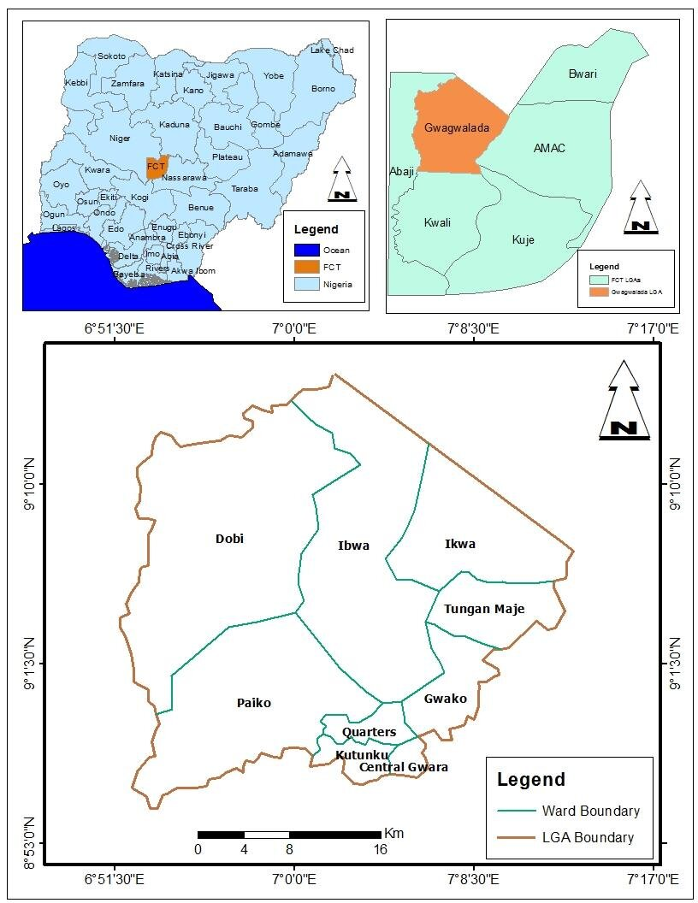
Figure 1. Map of Nigeria, Abuja Area council indicating Gwagwalada Area council and Giri, the study area and its environ.

Study Design
A cross-sectional descriptive design was employed, combining quantitative methods: a household survey using structured questionnaires, and review of hospital records, were integrated between (July – September, 2025).
Sampling Technique and Sample Size
A multi-stage sampling technique described by Kothari (2004) was employed for the study. The Giri community was deliberately chosen because of its documented susceptibility to waterborne diseases and its heavy dependence on non-piped water sources. Within the community, households were selected through a systematic random sampling method based on residential clusters comprising approximately 200 households. From this sampling frame, a total of 50 households were selected, applying a sampling interval of every fourth (4th) household, calculated using the formula k = N/n.
K = sampling interval (the step size)
N = total number of households in the sampling frame c
n = desired sample size
Respondents were primarily household heads or adult members responsible for water management.
Data Collection
Questionnaire Survey: A pre-tested, structured questionnaire was administered to 50 respondents, capturing socio-demographic data, water sources, and knowledge of waterborne diseases, illness history, and hygiene practices. Hospital Records Review: Secondary data on waterborne disease cases were obtained from local health facilities.
Data Analysis
Data from the questionnaires were cleaned, coded, and analyzed using descriptive statistics. Frequencies and percentages were calculated for categorical variables (example, gender, age groups, and disease prevalence) to summarize the data.

Results
Table 1 below highlights that groundwater sources particularly boreholes and hand-dug wells constitute the primary sources of domestic water in Giri community, reflecting a common pattern in peri-urban settlements across Nigeria.
Table 1. Sources of Water for Domestic Use in Giri Community, Gwagwalada Area Council, FCT Abuja
Water Source | Description / Use Pattern
Boreholes | Primary source for drinking, cooking, and bathing
Hand-dug wells | Used for domestic chores and occasionally for drinking
Surface water (streams) | Used occasionally during water scarcity
Rainwater harvesting | Seasonally collected for household use
Sachet / bottled water | Used mainly for drinking by households that can afford it

Socio-Demographic Characteristics of Respondents
The study involved 50 respondents. As shown in Table 2, the majority (76%) were female, underscoring their pivotal role in domestic water management. Regarding age distribution and vulnerability, nearly half of the disease-ridden (46%) were children under five years old, followed by children over five (34%) and adults (20%), indicating a study population heavily weighted toward the most vulnerable demographic.
Table 2. Respondents ‘Based on Gender Distribution

Gender | Frequency | Percentage (%)
Male | 12 | 24%
Female | 38 | 76%
Total | 50 | 100%

Table 2. above reveal that the majority of respondents were female (76%), while males accounted for only 24% of the population. This suggests that women were more actively represented in this study, possibly because they are often more involved in household water collection, usage, and management.

Table 3; Disease-ridden based on Age Group/Biodata Distribution
Age Group | Frequency | Percentage (%)
Children < 5 yrs | 23 | 46%
Children > 5 yrs | 17 | 34%
Adults > 18 yrs | 10 | 20%
Total | 50 | 100%

Table 3 shows that Children under five years constituted the largest group of disease-ridden (46%), followed by children over five years (34%), and adults (20%). This age distribution highlights the vulnerability of young children, who are often the most affected by water-related illnesses such as diarrhea and cholera due to weaker immune systems.

Figure 2: Percentage (%) Prevalence of Water-Related Diseases Reported by Respondents

Figure 2, shows that the most commonly reported water-related diseases were cholera and dysentery, each accounting for 30% of the cases. Diarrhea and typhoid followed each contributing 20% of reported cases. This pattern suggests that water contamination is a significant public health concern, with cholera and dysentery being major contributors to the disease burden in the community. Improving water quality and sanitation practices could significantly reduce these incidences.

Discussion
The groundwater sources particularly boreholes and hand-dug wells are the dominant sources of domestic water in Giri community, a trend widely reported in peri-urban and rural settlements across Nigeria (Afolabi et al., 2022; Ukpong and Okon, 2023). Although boreholes are commonly regarded as safer alternatives to surface water, their safety is highly dependent on proper construction, maintenance, and adequate separation from sanitation facilities.
Hand-dug wells and surface water sources exhibit an even higher susceptibility to contamination, particularly during the rainy season when runoff introduces pathogens into water bodies (Bain et al., 2014; Odewade et al., 2025). The reliance on water vendors and sachet water reflects adaptive strategies to cope with water scarcity; however, inconsistent quality control, poor handling practices, and affordability constraints limit their effectiveness as reliable sources of safe drinking water (WHO, 2019; UNICEF, 2025a). Collectively, the diversity and vulnerability of water sources used in Giri provide a plausible explanation for the high prevalence of waterborne diseases reported in the community.
According to the research findings showed in Table 2, women made up the majority of respondents (76%), which is indicative of their crucial role in managing household water.
The demographic profile of disease-ridden, with a high representation of children fewer than five in Table 3, is particularly of significance. This age group possesses a developing immune system and is more prone to severe outcomes from diarrheal diseases, which aligns with global patterns where children bear the greatest burden of waterborne illnesses (WHO, 2019).

Children under five years accounted for nearly half (46%) of reported waterborne disease cases, underscoring their disproportionate vulnerability. This finding is consistent with global and regional evidence indicating that young children bear the highest burden of water-related illnesses due to their immature immune systems, higher exposure through hand-to-mouth behaviours, and greater susceptibility to dehydration and malnutrition resulting from diarrhoeal diseases (WHO, 2019; WHO and UNICEF, 2025).

Repeated episodes of diarrhoea in early childhood are associated not only with increased mortality but also with long-term consequences such as stunted growth, impaired cognitive development, and reduced educational attainment (Wolf et al., 2022). The high proportion of affected children in Giri therefore signals an urgent need for targeted child-focused WASH interventions, including safe household water treatment, improved sanitation, and hygiene education for caregivers.
The disease profile observed cholera and dysentery (30% each), followed by diarrhoea and typhoid fever (20% each) is characteristic of communities with inadequate water, sanitation, and hygiene (WASH) infrastructure. These diseases are classically transmitted via the fecal–oral route and are strongly associated with unsafe drinking water, poor sanitation, and suboptimal hygiene practices (Devipriya and Kalaivani, 2022; Wolf et al., 2022).
Evidence from similar Nigerian settings supports this linkage. Studies in Kaduna, Ekiti, and Katsina States have reported comparable disease patterns in communities relying on contaminated groundwater and practicing open defecation (Amatobi and Adenaike, 2021; Bello and Kurmi, 2024; Odewade et al., 2025). In Giri, environmental sanitation challenges such as inadequate toilet facilities, poor waste disposal, and proximity of latrines to water sources likely facilitate the continuous recycling of pathogens between the environment and households, sustaining endemic transmission.
Study limitations
Despite its important findings, this study has some limitations that should be acknowledged. First, the relatively small sample size (50 households) limits the generalizability of the findings to the wider Gwagwalada Area Council or other peri-urban communities. Second, reliance on self-reported illness history and hospital records may introduce recall bias or underreporting, particularly for mild cases that do not present to health facilities. Third, the water quality assessment was preliminary and did not include seasonal variation or pathogen-specific identification, which could provide deeper insight into contamination dynamics.
Nevertheless, the consistency of the findings with hospital data, environmental assessments, and existing literature strengthens the validity of the observed associations and highlights critical public health concerns that warrant urgent intervention.
Conclusion
This study concludes that poor water quality from contaminated groundwater sources is a major contributor to the high prevalence of waterborne diseases in Giri community. The frequent reporting of cholera, dysentery, diarrhea, and typhoid underscores the urgent need for improved water infrastructure and public health interventions. Addressing these issues requires coordinated efforts from government, healthcare providers, and community stakeholders to ensure sustainable access to safe water and reduce disease burden.

Recommendations
Based on these findings, the following recommendations are proposed:
- Infrastructure Intervention: The government, in collaboration with non-governmental organizations, should prioritize the provision of sustainable and safe potable water infrastructure, such as protected boreholes with functional treatment systems, to break the cycle of disease transmission.
- Strengthened Healthcare: Local health care facilities should be equipped with adequate resources for the rapid diagnosis, treatment, and surveillance of waterborne diseases to reduce morbidity and mortality.
- Community Sanitation and Hygiene Education: The local authority should implement robust environmental sanitation programs, including the construction of public toilets and organized waste collection services. Concurrently, community-wide health education campaigns on the dangers of open defecation and the importance of proper water storage and household water treatment should be conducted.

Consent
Informed consent was obtained from all participants. Anonymity and confidentiality were maintained throughout the study.

Disclaimer (Artificial intelligence)

Author(s) hereby declare that NO generative AI technologies such as Large Language Models (ChatGPT, COPILOT, etc.) and text-to-image generators have been used during the writing or editing of this manuscript.

References
Afolabi, O. T., Adewumi, J. R., and Olatunji, O. S. (2022). Groundwater quality assessment and health risk implications in peri-urban communities of southwestern Nigeria. Environmental Monitoring and Assessment, 194(5), 1–16. https://doi.org/10.1007/s10661-022-09984-3
Amatobi, D. A., and Adenaike, O. O. (2021). Water sanitation practices and prevalence of waterborne diseases in rural Nigerian communities. Journal of Water, Sanitation and Hygiene for Development, 11(3), 458–467. https://doi.org/10.2166/washdev.2021.243
Bain, R., Cronk, R., Hossain, R., Bonjour, S., Onda, K., Wright, J., Yang, H., Slaymaker, T., Hunter, P., Prüss-Ustün, A., and Bartram, J. (2014). Global assessment of exposure to faecal contamination through drinking water based on a systematic review. Tropical Medicine & International Health, 19(8), 917–927. https://doi.org/10.1111/tmi.12334
Bello, S. A., and Kurmi, A. M. (2024). Sanitation infrastructure and endemic waterborne diseases in northern Nigerian settlements. African Journal of Environmental Health Sciences, 18(1), 33–45.
Devipriya, S. P., and Kalaivani, T. (2022). Waterborne diseases: Transmission, prevention, and control strategies. Journal of Environmental Health Science and Engineering, 20(1), 455–469. https://doi.org/10.1007/s40201-022-00753-9
Etuk, E. U., Akpan, E. R., and Udoh, I. S. (2022). Microbial and physicochemical quality of groundwater sources in southern Nigeria. Journal of Water and Health, 20(4), 602–614. https://doi.org/10.2166/wh.2022.017
Kothari, C. R. (2004). Research methodology: Methods and techniques (2nd ed.). New Age International Publishers.
Mike-Ogburia, E., Adeola, A. M., and Olorunfemi, F. B. (2025). Climate variability, flooding, and waterborne disease outbreaks in urban Nigeria. Environmental Challenges, 9, 100640. https://doi.org/10.1016/j.envc.2024.100640
Musa, J. J., and Ahanonu, J. J. (2023). Impact of anthropogenic activities on groundwater contamination in Nigerian peri-urban environments. Applied Water Science, 13(2), 1–12. https://doi.org/10.1007/s13201-023-01785-4
Nigerian Meteorological Agency. (2021). Climate data for Abuja and surrounding areas. NIMET.
Odelami-Abdulrasheed, A., Lawal, I. O., and Jimoh, T. A. (2025). Nitrate and faecal contamination of groundwater in rapidly urbanizing Nigerian communities. Environmental Monitoring and Assessment, 197(1), 88. https://doi.org/10.1007/s10661-024-11203-6
Odewade, A. A., Ogunleye, O. O., and Alabi, A. O. (2025). Seasonal variation in groundwater contamination and diarrhoeal disease incidence in southwest Nigeria. Journal of Water and Health, 23(1), 112–124. https://doi.org/10.2166/wh.2024.198
Ramírez-Castillo, F. Y., Loera-Muro, A., Jacques, M., Garneau, P., Avelar-González, F. J., Harel, J., and Guerrero-Barrantes, A. (2015). Waterborne pathogens: Detection methods and challenges. Pathogens, 4(2), 307–334. https://doi.org/10.3390/pathogens4020307
Ukpong, E. C., and Okon, I. E. (2023). Borehole water safety and microbial risks in rural Nigerian communities. International Journal of Environmental Studies, 80(4), 695–709. https://doi.org/10.1080/00207233.2023.2181147
UNICEF. (2025a). Progress on household drinking water, sanitation and hygiene 2000–2024. United Nations Children’s Fund.
World Health Organization. (2019). Drinking-water. WHO.
World Health Organization. (2022). Guidelines on sanitation and health. WHO.
World Health Organization, & United Nations Children’s Fund. (2025). Progress on drinking water, sanitation and hygiene in households: 2025 update. WHO/UNICEF Joint Monitoring Programme.
Wolf, J., Johnston, R., Hunter, P. R., Gordon, B., Medlicott, K., and Prüss-Ustün, A. (2022). Impact of drinking water, sanitation and hand hygiene on child health: Updated global burden of disease estimates. International Journal of Hygiene and Environmental Health, 240, 113896. https://doi.org/10.1016/j.ijheh.2022.113896

