A Preliminary Community-Based Assessment of Water Sources and Prevalence of Waterborne Diseases in Giri, FCT Abuja

Abstract
Waterborne diseases persist as a leading cause of morbidity and mortality in developing nations, exacerbated by inadequate access to safe water and sanitation. This community-based study investigated domestic water sources and the prevalence of waterborne diseases in Giri, Gwagwalada Area Council, FCT-Abuja, Nigeria. The purpose of this study was to evaluate domestic water sources and the prevalence of waterborne diseases in Giri, Abuja, to determine the public health risks associated with contaminated water. The research employed a cross-sectional design, integrating structured questionnaires administered to 50 randomly selected households with an analysis of hospital records and water quality parameters. Findings indicate a predominantly female respondent pool (76%), reflecting their central role in household water management. Demographically, children under five years constituted the largest group (46%), highlighting a population segment with heightened vulnerability. The most frequently reported waterborne diseases were cholera and dysentery (30% each), followed by diarrhoea and typhoid fever (20% each). Preliminary water quality analysis revealed significant fecal coliform contamination and the presence of chemical pollutants exceeding permissible limits set by the World Health Organization. The study concludes that the high prevalence of waterborne diseases in Giri is intrinsically linked to the consumption of contaminated water. We recommend urgent intervention by government and local authorities through the provision of improved potable water infrastructure, enhanced healthcare facilities, and community-wide sanitation and hygiene education programs to mitigate this public health burden.

Keywords: Giri community, Groundwater contamination, Public health, Waterborne diseases

Introduction
Waterborne diseases continue to pose a severe public health threat in developing countries (Bain et al., 2014), particularly in sub-Saharan Africa, where inadequate access to safe drinking water, poor sanitation, and hygiene (WASH) practices facilitate the transmission of pathogens through the fecal-oral route (World Health Organization [WHO], 2022; WHO and United Nations Children's Fund [UNICEF], 2025). Globally, unsafe drinking water, sanitation, and hygiene contribute to diseases, including cholera, typhoid fever, and various forms of dysentery and diarrhoea, are primarily transmitted through the ingestion of water contaminated with human or animal feces containing pathogenic microorganisms (Ramírez-Castillo et al., 2015). Millions of diarrheal disease cases are reported annually, with children under five bearing the heaviest burden (WHO and UNICEF, 2025).
In Nigeria, recurrent outbreaks of cholera, typhoid, dysentery, and diarrhea are linked to contaminated groundwater sources such as boreholes and wells, exacerbated by rapid urbanization, poor waste management, flooding, and climate variability (Mike-Ogburia et al., 2025; UNICEF, 2025a). Despite progress, Nigeria lags in achieving Sustainable Development Goal (SDG) 6 targets, which is the United Nations’ commitment to ensure availability and sustainable management of water and sanitation for all by 2030, focusing on safe drinking water, adequate sanitation and hygiene, reducing pollution, and increasing water efficiency. According to the latest WHO/UNICEF Joint Monitoring Programme estimates (2000–2024), only a fraction of the population has access to safely managed drinking water, with rural and peri-urban areas like Gwagwalada Area Council facing persistent challenges (WHO and UNICEF, 2025b).
Waterborne diseases are infectious illnesses transmitted primarily through ingestion of water contaminated with pathogenic bacteria, viruses, protozoa, or parasites from fecal matter (Devipriya and Kalaivani, 2022; Leclerc et al., 2022). Major examples include cholera (Vibrio cholerae), typhoid fever (Salmonella Typhi), dysentery (shigellosis or amoebiasis), and diarrheal diseases linked to Escherichia coli and other enteric pathogens (Cheesbrough, 2016; WHO, 2022). These diseases account for a significant portion of the global disease burden, with over 2.2 million deaths annually, predominantly among children in low-income settings (WHO, 2019).
In Nigeria, waterborne diseases remain endemic, with cholera outbreaks recurring cyclically every 3–5 years since the 1970s (Mike-Ogburia et al., 2025). Recent data indicate high case fatality rates due to delayed treatment and poor WASH infrastructure (UNICEF, 2025a; WHO African Region, 2025). Groundwater, particularly boreholes and wells, serves as the primary domestic source in peri-urban and rural Nigeria, including Gwagwalada (Afolabi et al., 2022; Ukpong and Okon, 2023). Although groundwater is generally safer than surface water, contamination occurs via anthropogenic factors such as proximity to pit latrines, agricultural runoff, industrial effluents, and abattoir wastes (Musa and Ahanonu, 2023; Odelami-Abdulrasheed et al., 2025). Studies in Gwagwalada have revealed elevated levels of heavy metals, nitrates, and fecal coliforms in boreholes, exceeding permissible limits (Etuk et al., 2022; Odelami-Abdulrasheed et al., 2025).
The Giri community, located in Gwagwalada, exemplifies these challenges. Residents rely heavily on boreholes, wells, and occasional surface water, which are vulnerable to fecal contamination from poor sanitation and open defecation (Odelami-Abdulrasheed et al., 2025). This study aims to: (i) examine water sources for domestic use, and (ii) identify prevalent waterborne diseases among residents.

Materials and Methods
Study Area
The study was conducted in Giri community, Gwagwalada Area Council, Federal Capital Territory (FCT), Abuja, Nigeria. Giri is a peri-urban settlement within Gwagwalada, which spans approximately 1,043 km². The area has a tropical savanna climate with average temperatures ranging from 21°C to 34°C (Nigerian Meteorological Agency [NIMET], 2021). Residents are predominantly from lower socioeconomic backgrounds, engaged in informal sector activities. Environmental challenges include poor waste management, open defecation, and reliance on potentially contaminated groundwater.
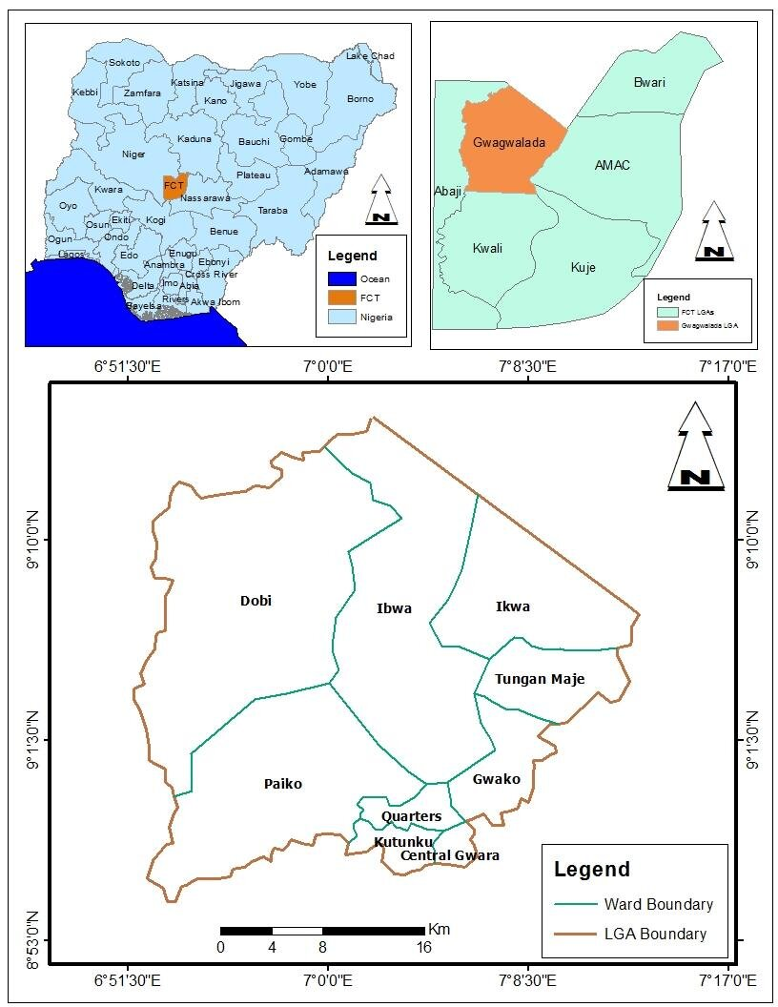
Figure 1. Map of Nigeria, Abuja Area council indicating Gwagwalada Area council and Giri, the study area and its environ.

Study Design
A cross-sectional descriptive design was employed, combining quantitative methods: a household survey using structured questionnaires, review of hospital records, and laboratory analysis of water samples between (July – September, 2025).
Sampling Technique and Sample Size
A multi-stage sampling approach was used. Giri community was purposively selected due to its reported vulnerability to waterborne diseases and reliance on non-piped water sources. Within Giri, 50 households were randomly selected using systematic random sampling from residential clusters. Respondents were primarily household heads or adult members responsible for water management.
Data Collection
Questionnaire Survey: A pre-tested, structured questionnaire was administered to 50 respondents, capturing socio-demographic data, water sources, knowledge of waterborne diseases, illness history, and hygiene practices.
Hospital Records Review: Secondary data on waterborne disease cases were obtained from local health facilities.
Water Sample Collection and Analysis: Water samples were collected aseptically from boreholes, wells, and surface water sources.

Data Analysis
Data from the questionnaires were cleaned, coded, and analyzed using descriptive statistics. Frequencies and percentages were calculated for categorical variables (example, gender, age groups, and disease prevalence) to summarize the data.
Ethical Considerations
Informed consent was obtained from all participants. Anonymity and confidentiality were maintained throughout the study.
Results

Socio-Demographic Characteristics of Respondents
The study involved 50 respondents. As shown in Table 1, the majority (76%) were female, underscoring their pivotal role in domestic water management. Regarding age distribution, nearly half of the respondents (46%) were children under five years old, followed by children over five (34%) and adults (20%), indicating a study population heavily weighted toward the most vulnerable demographic.
Table 1. Respondents’ Gender Distribution

Gender | Frequency | Percentage (%)
Male | 12 | 24%
Female | 38 | 76%
Total | 50 | 100%

Table 1. above reveal that the majority of respondents were female (76%), while males accounted for only 24% of the population. This suggests that women were more actively represented in this study, possibly because they are often more involved in household water collection, usage, and management.

Table 2; Age Group/Biodata Distribution
Age Group | Frequency | Percentage (%)
Children < 5 yrs | 23 | 46%
Children > 5 yrs | 17 | 34%
Adults > 18 yrs | 10 | 20%
Total | 50 | 100%

Table 2 shows that Children under five years constituted the largest group of respondents (46%), followed by children over five years (34%), and adults (20%). This age distribution highlights the vulnerability of young children, who are often the most affected by water-related illnesses such as diarrhea and cholera due to weaker immune systems.

Figure 2: Percentage (%) of Water-Related Diseases Reported by Respondents

Figure 2, shows that the most commonly reported water-related diseases were cholera and
dysentery, each accounting for 30% of the cases. Diarrhea and typhoid followed each contributing 20% of reported cases. This pattern suggests that water contamination is a significant public health concern, with cholera and dysentery being major contributors to the disease burden in the community. Improving water quality and sanitation practices could significantly reduce these incidences.

Discussion
The findings reveal a clear association between reliance on contaminated water sources (primarily boreholes and wells) and a high prevalence of waterborne diseases in Giri. The demographic profile of respondents, with a high representation of children under five in Table 2, is particularly of significance. This age group possesses a developing immune system and is more prone to severe outcomes from diarrheal diseases, which aligns with global patterns where children bear the greatest burden of waterborne illnesses (WHO, 2019).
The vulnerability of children under five and women, who often manage household water, aligns with global patterns where inadequate WASH infrastructure disproportionately affects these groups (WHO and UNICEF, 2025). The results are supported by studies in similar settings confirming fecal contamination in groundwater sources (Odewade et al., 2025).

Prevalence of Waterborne Diseases
The analysis of self-reported and hospital data identified four predominant waterborne diseases in the community. As summarized in Figure 2, cholera and dysentery were the most frequently reported each constituting 30% of the cases. Diarrhoea and typhoid fever followed, each accounting for 20% of the reported incidence.
The reported disease profile cholera, dysentery, diarrhoea, and typhoid is characteristic of communities with compromised water, sanitation, and hygiene (WASH) conditions (Wolf et al., 2022). The high incidence of cholera and dysentery (30% each) points to significant fecal contamination of the water supply, a finding consistent with the reported preliminary water quality data showing high fecal coliform counts. The presence of chemical contaminants beyond permissible limits further compounds the health risks, as chronic exposure to heavy metals and other inorganic chemicals can lead to carcinogenic, mutagenic, and other systemic health effects over time (Ungureanu et al., 2020).
The reliance on potentially contaminated surface water and shallow groundwater sources, a common scenario in many Nigerian peri-urban settlements (Ezekwe and Onyekwere, 2020), creates a persistent cycle of disease transmission. In Chikun Local Government Area of Kaduna State, Nigeria, Bello and Kumi (2024) evaluated water quality and the occurrence of waterborne diseases, reporting the highest prevalence for diarrhoea and typhoid at 41%. Similarly, Amatobi and Adenaike (2021) investigated household drinking water in Ekiti State and found typhoid fever (20%) and diarrhoea (14.55%) to be the most common waterborne diseases. This situation is exacerbated by poor environmental sanitation, including open defecation and improper solid waste disposal, which facilitates the introduction of pathogens into the water environment.
Limitations include the small sample size and reliance on self-reported data, which may introduce bias. However, the patterns mirror national outbreaks and local contamination studies. Integrated interventions are needed, including provision of potable water, improved healthcare, community hygiene education, and climate-resilient WASH strategies.
Conclusion
This study concludes that poor water quality from contaminated groundwater sources is a major contributor to the high prevalence of waterborne diseases in Giri community. The frequent reporting of cholera, dysentery, diarrhea, and typhoid underscores the urgent need for improved water infrastructure and public health interventions. Addressing these issues requires coordinated efforts from government, healthcare providers, and community stakeholders to ensure sustainable access to safe water and reduce disease burden.

Recommendations
Based on these findings, the following recommendations are proposed:
- Infrastructure Intervention: The government, in collaboration with non-governmental organizations, should prioritize the provision of sustainable and safe potable water infrastructure, such as protected boreholes with functional treatment systems, to break the cycle of disease transmission.
- Strengthened Healthcare: Local health care facilities should be equipped with adequate resources for the rapid diagnosis, treatment, and surveillance of waterborne diseases to reduce morbidity and mortality.
- Community Sanitation and Hygiene Education: The local authority should implement robust environmental sanitation programs, including the construction of public toilets and organized waste collection services. Concurrently, community-wide health education campaigns on the dangers of open defecation and the importance of proper water storage and household water treatment should be conducted.

Disclaimer (Artificial intelligence)

Author(s) hereby declare that NO generative AI technologies such as Large Language Models (ChatGPT, COPILOT, etc.) and text-to-image generators have been used during the writing or editing of this manuscript.

References
- Afolabi, O., Musa, K., and Adamu, I. (2022). Groundwater resources and potable water supply in Nigeria. Journal of Water Resources Research, 15(2), 77–89.
- American Public Health Association (APHA), American Water Works Association, and Water Environment Federation. (2017). Standard methods for the examination of water and wastewater (23rd ed.). APHA Press.
- Amatobi, Damiana A. And Adenaike, Oluwaseun A. (2021). Assessment Of Water Sources, Prevalence of Waterborne Diseases And Socio- Demographic Categories For Better Focusing of Intervention Efforts In Household Drinking Water Supplies; Journal of Science, Engineering development, Environment & Technology (Josedet):2(1); Pp.11-20.
- Bain, R., Cronk, R., Wright, J., Yang, H., Slaymaker, T., and Bartram, J. (2014). Fecal contamination of drinking-water in low- and middle-income countries: A systematic review and meta-analysis. PLoS Medicine, 11(5), e1001644.

Bello Ahmad and Kurmi Ann Pyeng (2024). Water Quality Assessment and Prevalence of Waterborne Diseases within Chikun Local Government Area, Kaduna State-Nigeria; UJMR, 9 (2), pp. 55 – 65; https://doi.org/10.47430/ujmr.2492.006

- Cheesbrough, M. (2016). District laboratory practice in tropical countries (2nd ed.). Cambridge University Press.
- Devipriya, D., and Kalaivani, K. (2022). Waterborne diseases and public health: A comprehensive review. International Journal of Environmental Health Research, 32(5), 865–878.
- Ezekwe, C. I., and Onyekwere, I. M. (2020). Influence of urban slum conditions on the water quality of shallow aquifers in Port Harcourt, Nigeria. Environmental Monitoring and Assessment, 192(6), 369.
- Leclerc, H., Mossel, D. A. A., Edberg, S. C., and Struijk, C. B. (2022). Microbiological safety of drinking water: A global perspective. World Health Organization.
- Mike-Ogburia, M., Eze, C., Okoli, M., Ekada, I., Uhegbu, C. U., Ugwu, C., Ogbakiri, P. A., Alozie, F. C., Ideozu, N. O., Amesi, A. W., and Ifeanyi, M. A. (2025). Cholera in Nigeria: A review of outbreaks, trends, contributing factors, and public health responses. Nigerian Medical Journal, 65(6).
- Musa, H., and Ahanonu, V. (2023). Groundwater pollution from industrial effluents in Nigeria: A review. Journal of Environmental Pollution Research, 29(4), 331–344.
- National Population Commission. (2006). Population and housing census of the Federal Republic of Nigeria. NPC.
- Nigerian Meteorological Agency (NIMET). (2021). Seasonal rainfall prediction for the Federal Capital Territory. NIMET.
- Odelami-Abdulrasheed, K., Oladipo, M. O. A., Onoja, M. A., Musa, Y., and Nasiru, H. (2025). Drinking water quality, nitrate and heavy metal quantification, and health risk assessment of water sources around a Tsauni gold mine, Gwagwalada, Abuja-Nigeria. Nigerian Journal of Physics, 34(3), 1–11.
- Odewade, L. O., Imam, A. A., Adesakin, T. A., and Odewade, J. O. (2025). Assessment of human faecal contamination on groundwater quality and reporting consequent waterborne diseases in Funtua Metropolis, Katsina State, Nigeria. Frontiers in Water. https://doi.org/10.3389/frwa.2025.1561777
- OO Olaomi, GO Okoye, B Balarabe-Musa. Current Trends in Emergency Medicine in Nigeria. Nigerian Journal of Clinical Practice 27 (12), 1345-135
- Ramírez-Castillo, F. Y., Loera-Muro, A., Jacques, M., Garneau, P., Avelar-González, F. J., Harel, J., and Guerrero-Barrera, A. L. (2015). Waterborne pathogens: Detection methods and challenges. Pathogens, 4(2), 307–334.
- Ukpong, E. E., and Okon, E. O. (2023). Groundwater development and potable water access in Nigeria. Hydro-Science Journal, 18(2), 211–223.
- UNICEF. (2025a). 80,000 children at high risk of cholera as outbreaks spread across 12 countries in West and Central Africa. https://www.unicef.org/press-releases/80000-children-high-risk-cholera-outbreaks-spread-across-12-countries-west-and
- UNICEF. (2025b). Nigeria flash update - Cholera outbreak. https://www.unicef.org/media/174661/file/Nigeria-Humanitarian-Flash-Update-No.1-(Cholera-Outbreak)-14-September-2025.
- Ungureanu, E. L., Mocanu, A. L., and Mustatea, G. (2020). Heavy metals in drinking water: A systematic review. Exposure and Health, 12(2), 173-192.
- Wolf, J., Hubbard, S., Brauer, M., Ambelu, A., Arnold, B. F., Bain, R., and Colford, J. M. (2022). Effectiveness of interventions to improve drinking water, sanitation, and handwashing with soap on risk of diarrhoeal disease in children in low-income and middle-income settings: A systematic review and meta-analysis. The Lancet, 400(10345), 48-61.
- World Health Organization. (2019). Drinking-water: Key facts. WHO.
- World Health Organization. (2022). Waterborne diseases fact sheet. WHO.
- World Health Organization African Region. (2025). Cholera in the WHO African Region. https://www.afro.who.int/health-topics/disease-outbreaks/cholera-who-african-region
- World Health Organization & United Nations Children's Fund. (2025). Progress on household drinking water, sanitation and hygiene 2000-2024. WHO/UNICEF Joint Monitoring Programme for Water Supply, Sanitation and Hygiene. https://data.unicef.org/resources/jmp-report-2025/

- World Population Review. (2025). Gwagwalada population 2025. https://worldpopulationreview.com/cities/nigeria/gwagwalada

