Numerical Study of Forced Convection Film Condensation in a Channel with Porous Walls

Abstract

This work presents a numerical study of laminar film condensation of a pure saturated vapor under forced convection inside a vertical plane channel whose walls are covered with a porous material. The mathematical model, based on the conservation equations of mass, momentum, and energy, is solved using a finite difference method. The flow in the porous layer is described by the Darcy-Brinkman-Forchheimer model. A comprehensive parametric analysis was conducted to examine the influence of nine dimensionless numbers on the liquid film thickness (δ*) and the corresponding heat transfer performance, characterized by the Nusselt number (Nu). The results indicate that the film thickness increases with increasing dimensionless thermal conductivity (λ*), Prandtl number (Pr), and dimensionless viscosity (ν*), which in turn reduces the Nusselt number. Conversely, the film thickness decreases, and the Nusselt number increases, with higher Reynolds number (Re), Froude number (Fr), Jakob number (Ja), porosity (ε), and dimensionless channel thickness (H*). The channel aspect ratio (L/A) was identified as the most dominant parameter affecting both film growth and heat transfer. While the model is validated against existing analytical work, providing a robust theoretical framework, direct experimental comparison remains a scope for future investigation. These findings offer critical insights into the coupled hydrodynamics and thermal phenomena, providing practical guidance for the design and optimization of high-performance compact heat exchangers that leverage porous media to enhance condensation.

Keywords: Film condensation, Forced convection, Porous media, Heat transfer, Nusselt number, Plane channel, Numerical study.

Nomenclature
A comprehensive list of the variables, symbols, and dimensionless numbers used in this study is provided below.
Symbol | Definition | Units
A | Channel width | m
e | Porous layer thickness | m
Fr | Froude number | –
H | Half-height of the channel | m
H* | Dimensionless channel thickness | –
Ja | Jakob number | –
K | Permeability of the porous medium | m²
L | Channel length | m
Nu | Nusselt number | –
Pr | Prandtl number | –
Re | Reynolds number | –
T | Temperature | K
x, y | Cartesian coordinates | m
Greek Symbols
Symbol | Definition | Units
δ | Liquid film thickness | m
δ* | Dimensionless liquid film thickness | –
ε | Porosity of the porous medium | –
λ | Thermal conductivity | W/(m·K)
λ* | Dimensionless thermal conductivity | –
μ | Dynamic viscosity | Pa·s
ν | Kinematic viscosity | m²/s
ν* | Dimensionless viscosity | –
ρ | Density | kg/m³

1. Introduction

Phase-change condensation is a fundamental process in a vast array of industrial applications, including power generation, refrigeration, desalination, and the thermal management of high-performance electronics [1, 2]. The efficiency of these systems is often dictated by the rate of condensation heat transfer. Consequently, enhancing this rate has become a critical objective for improving energy efficiency and enabling system miniaturization [3, 4]. Over the past decade, significant research has focused on developing advanced techniques for heat transfer augmentation, with a strong emphasis on the use of enhanced surfaces, such as those incorporating mini/micro-channels and porous media [5, 6]. The integration of a porous layer onto a condensation surface is a particularly promising strategy. Porous media offer a substantially larger surface area for phase change and introduce capillary effects that can actively manipulate the condensate film, thereby reducing the dominant thermal resistance associated with the liquid layer [7, 8]. While early research extensively investigated condensation on porous surfaces under natural convection [9], the dynamics in many modern, compact systems are governed by forced convection. In this regime, the shear stress exerted by the vapor flow at the liquid-vapor interface significantly influences the hydrodynamics of the condensate film, altering its thickness and, consequently, the overall heat transfer coefficient [10]. Recent advancements have highlighted the complexities of condensation within confined geometries like mini and micro-channels, where surface tension and vapor shear forces become increasingly dominant [5, 11]. However, studies that simultaneously consider the combined effects of forced convection and a porous substrate within a channel configuration remain relatively scarce. Foundational analytical work by Asbik et al. [12] provided initial insights into this phenomenon for a vertical channel, establishing the utility of the Darcy-Brinkman-Forchheimer model for describing fluid flow within the porous domain [13, 14]. Despite this, a comprehensive numerical investigation that systematically explores the vast parametric space of this coupled problem has been lacking. This study aims to fill that gap by presenting a detailed numerical analysis of forced convection film condensation in a vertical plane channel with porous-coated walls. The primary objective is to develop a robust predictive model and to conduct a comprehensive parametric investigation into the influence of key thermophysical, hydrodynamic, and geometric parameters on both the condensate film thickness and the heat transfer performance, as characterized by the Nusselt number. By systematically quantifying the impact of the Reynolds number (Re), Froude number (Fr), Jakob number (Ja), Prandtl number (Pr), porosity (ε), and various dimensionless geometric and material property ratios, this work seeks to identify the dominant factors controlling the condensation process. The insights gained will provide critical design guidance for the engineering of next-generation thermal management systems that leverage porous media for superior heat transfer performance.

2. Methodology
2.1. Physical Model and Governing Equations
The physical system under consideration is a vertical plane channel of height 2H and length L, as depicted in Figure 1. The internal walls of the channel are coated with a uniform porous layer of thickness *e*. A pure, saturated vapor flows downward through the central core of the channel under forced convection. The channel walls are maintained at a constant temperature, *T<sub>w</sub>*, which is lower than the vapor's saturation temperature, *T<sub>sat</sub>*. This temperature difference induces condensation, leading to the formation of a continuous liquid film that flows downward along the porous layer, driven by gravity and the interfacial shear from the vapor flow.
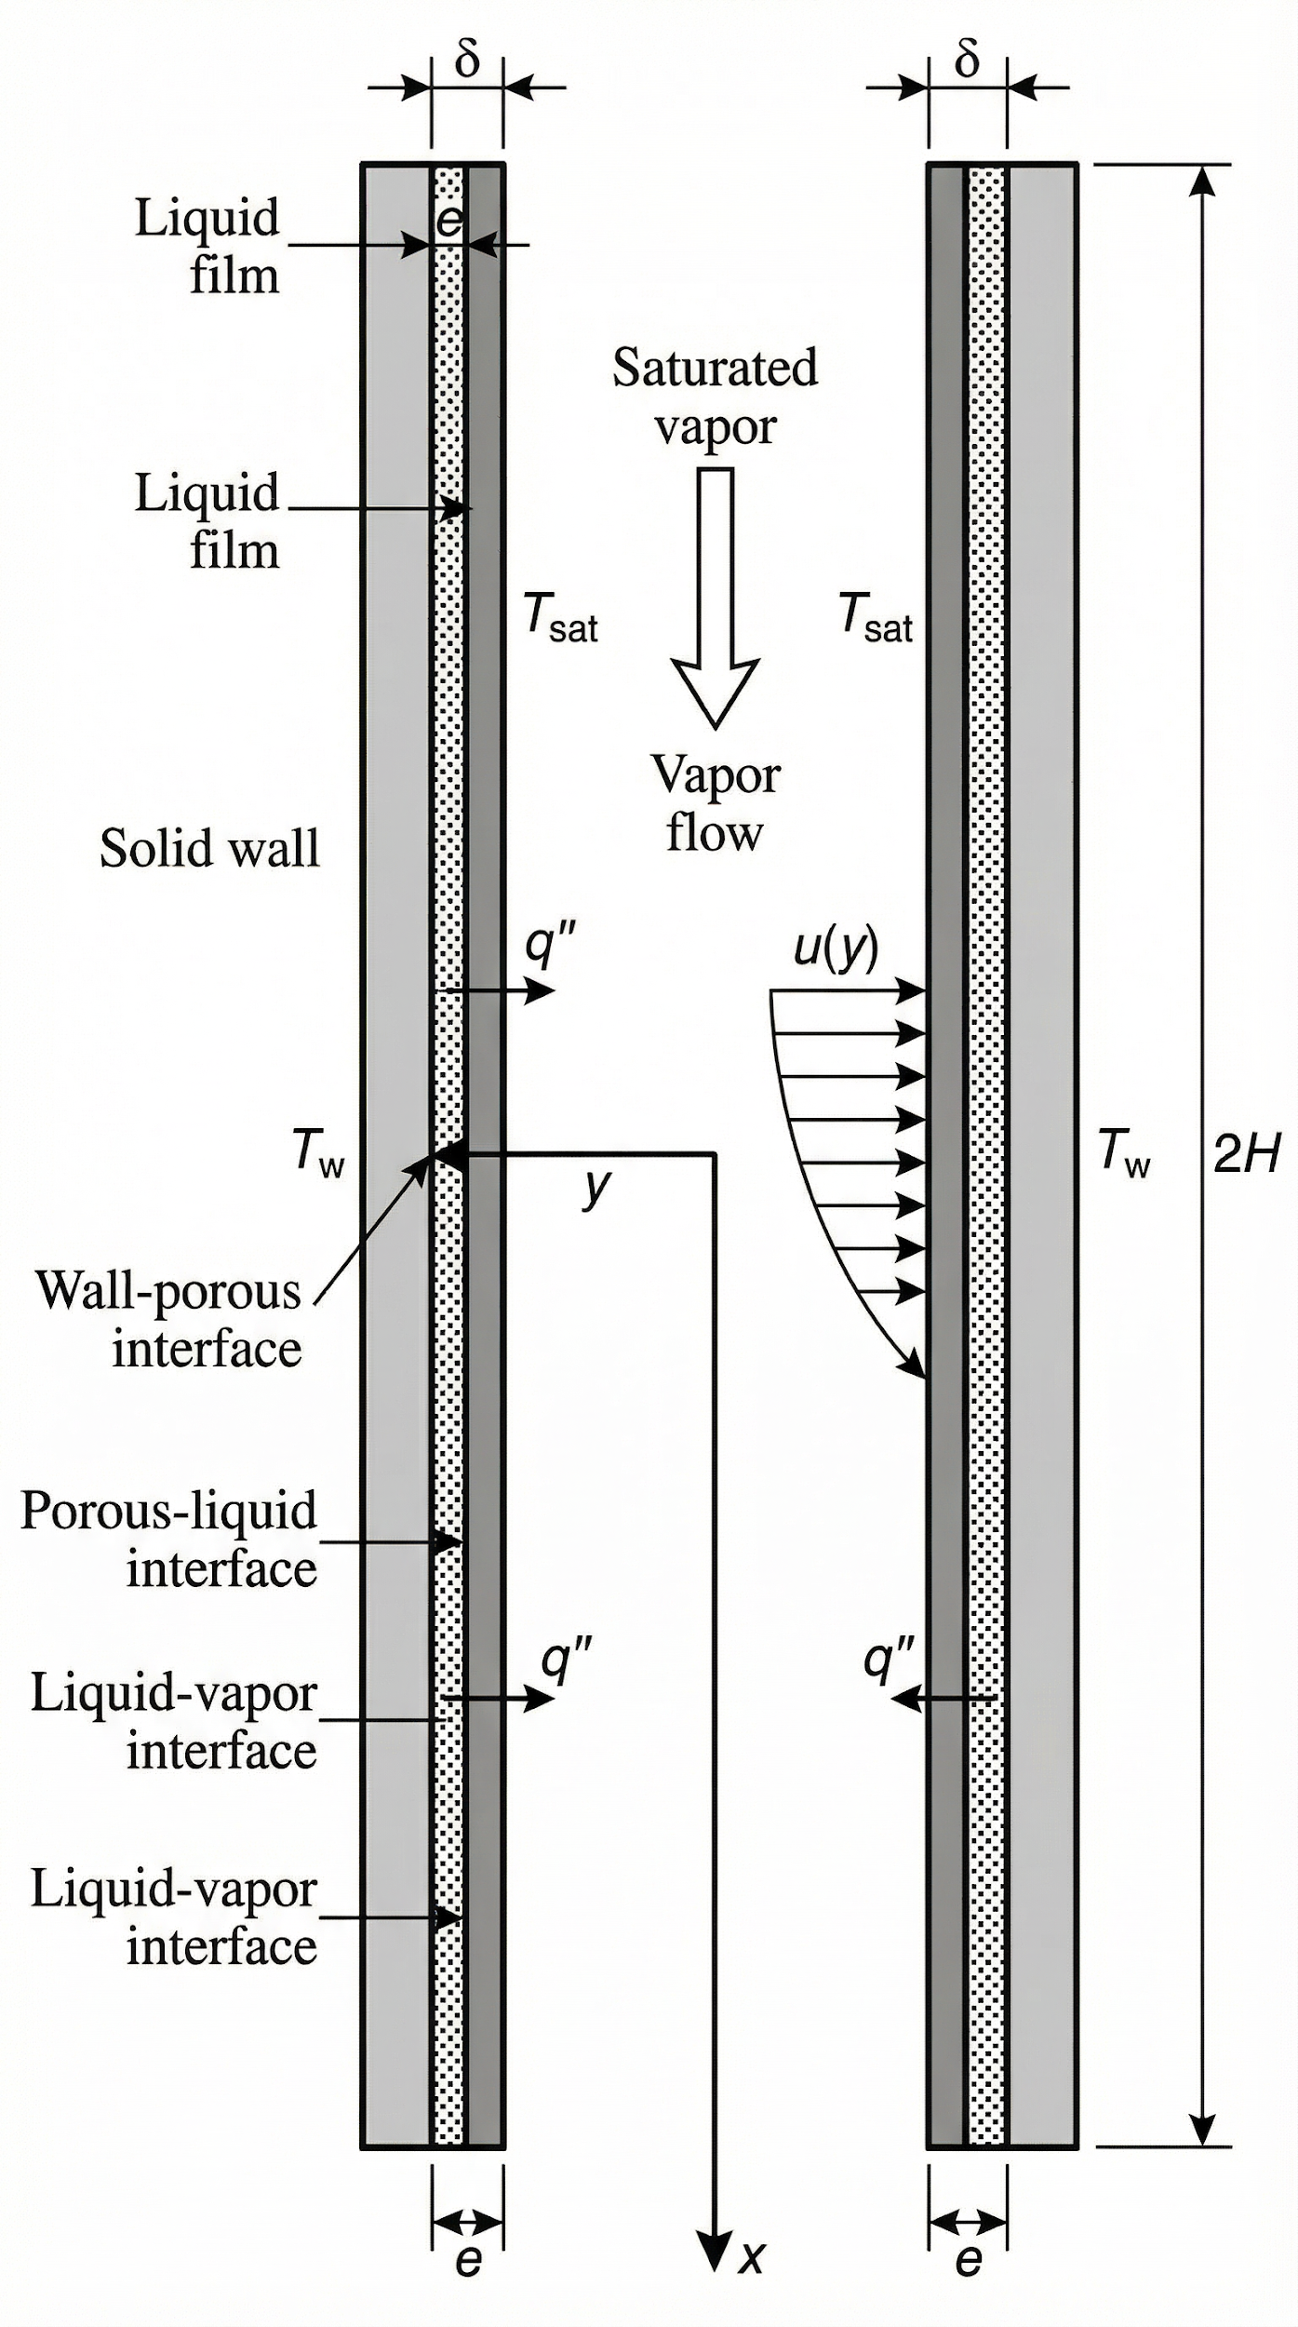

[Figure 1: Physical model schematic of film condensation in a channel with porous walls.]
The analysis is performed under the assumptions of steady-state, laminar flow, and constant fluid properties. The problem is modeled in a 2D Cartesian coordinate system (x, y), with the origin at the channel entrance on the impermeable wall. The flow is divided into two distinct domains: the liquid film and the porous layer.
In the liquid film (e < y < e + δ): The flow is treated as a laminar boundary layer. The simplified momentum and energy equations are:
μl (∂²ul/∂y²) + ρlg = 0
(∂²Tl/∂y²) = 0
In the porous layer (0 < y < e): The flow is described by the Darcy-Brinkman-Forchheimer model, which accounts for viscous and inertial effects:
-(μl/K)up + μl(∂²up/∂y²) + ρlg = 0
(∂²Tp/∂y²) = 0
2.2. Boundary and Interfacial Conditions
To solve the system of governing equations, a set of boundary and interfacial conditions is applied:

1. At the channel wall (y=0): No-slip condition (up = 0) and constant wall temperature (Tp = Tw).
2. At the porous layer-liquid film interface (y=e): Continuity of velocity, shear stress, temperature, and heat flux.
3. At the liquid-vapor interface (y=e+δ): The temperature is the saturation temperature (Tl = Tsat), and the shear stress is imposed by the vapor flow.
2.3. Numerical Procedure and Model Validation
The system of coupled, non-linear ordinary differential equations was non-dimensionalized and solved numerically using a finite difference method. The domain was discretized using a uniform grid, and the derivatives were approximated using second-order central difference schemes. The resulting system of algebraic equations was solved iteratively using the Thomas algorithm for tridiagonal systems.

Grid Independence and Convergence:
A grid independence study was conducted to ensure the accuracy and stability of the numerical solution. Three different grid resolutions (coarse, medium, and fine) were tested. The variation in the calculated film thickness at the channel outlet between the medium (100x100 grid) and fine (200x200 grid) meshes was found to be less than 1%. Therefore, the medium grid was selected for all subsequent simulations to ensure a balance between computational accuracy and efficiency. The iterative solution process was considered converged when the maximum relative change in all variables between successive iterations fell below a stringent tolerance of 10⁻⁶.
Model Validation:
To validate the accuracy of the present numerical model, a comparison was performed against the analytical results of Asbik et al. [12] for a simplified case corresponding to their study. The dimensionless film thickness was calculated using the parameters reported in their work. The results from our numerical model showed excellent agreement with their analytical solution, with a maximum deviation of less than 2%. This strong agreement provides confidence in the soundness of the mathematical formulation and the accuracy of the numerical implementation used in this study.

3. Results and Discussion
This section presents the results of the comprehensive parametric study. First, the influence of nine key dimensionless parameters on the evolution of the condensate film thickness (δ*) is systematically analyzed. Following this, the analysis is extended to evaluate the corresponding heat transfer performance by examining the local and average Nusselt numbers (Nu). The discussion integrates physical interpretations of the observed phenomena and compares the findings with relevant literature. Unless otherwise specified, the results are generated using the following set of reference values: Re=1000, Fr=10⁻³, Ja=10⁻⁴, Pr=2, L/A=125, ν*=10⁻⁷, ε=0.4, H*=2×10⁻³, and λ*=2.9.
3.1. Influence of Thermophysical and Geometric Properties
The thermophysical properties of the fluid and the geometric configuration of the channel are found to exert a profound influence on the condensation process.

Figure 2 illustrates the dominant effect of the channel aspect ratio (L/A) on the dimensionless film thickness. A significant increase in L/A, which corresponds to a longer or narrower channel, leads to a dramatic accumulation of condensate and thus a thicker liquid film. This is a direct consequence of two combined effects: a longer channel provides a greater surface area for condensation to occur, while a smaller width (A) enhances flow confinement, leading to a more pronounced increase in film thickness along the channel length. This finding is consistent with observations in mini and micro-channels, where geometric confinement is a primary factor governing flow behavior [11, 15].

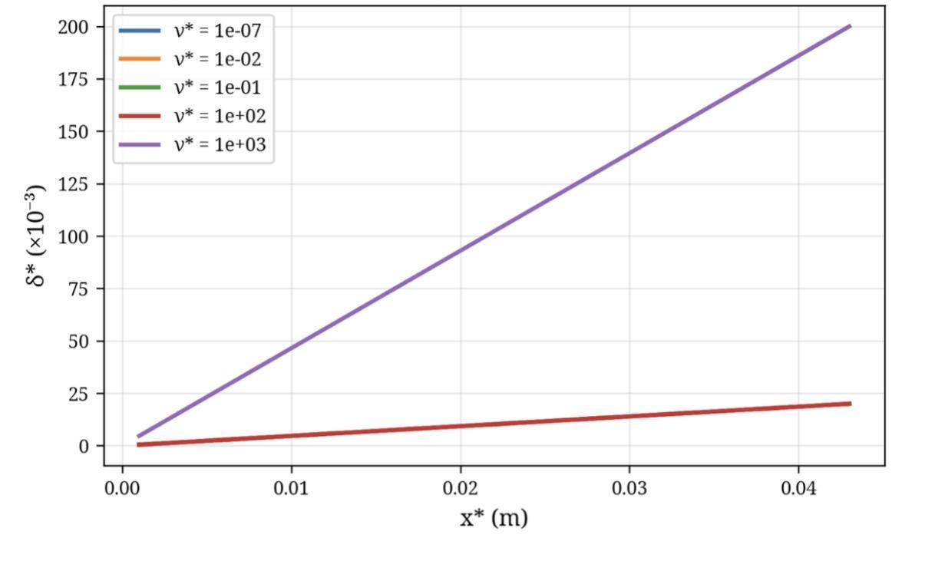
[Figure 2: Variation of film thickness as a function of L/A.]
The impact of the dimensionless thermal conductivity (λ*) is shown in Figure 3. The film thickness, δ*, increases markedly with a higher λ*. This parameter represents the ratio of the effective thermal conductivity of the porous medium/liquid composite to that of the liquid itself. A higher λ* signifies more efficient heat evacuation from the liquid-vapor interface to the cold wall, which accelerates the rate of condensation and, consequently, promotes the growth of a thicker liquid film.

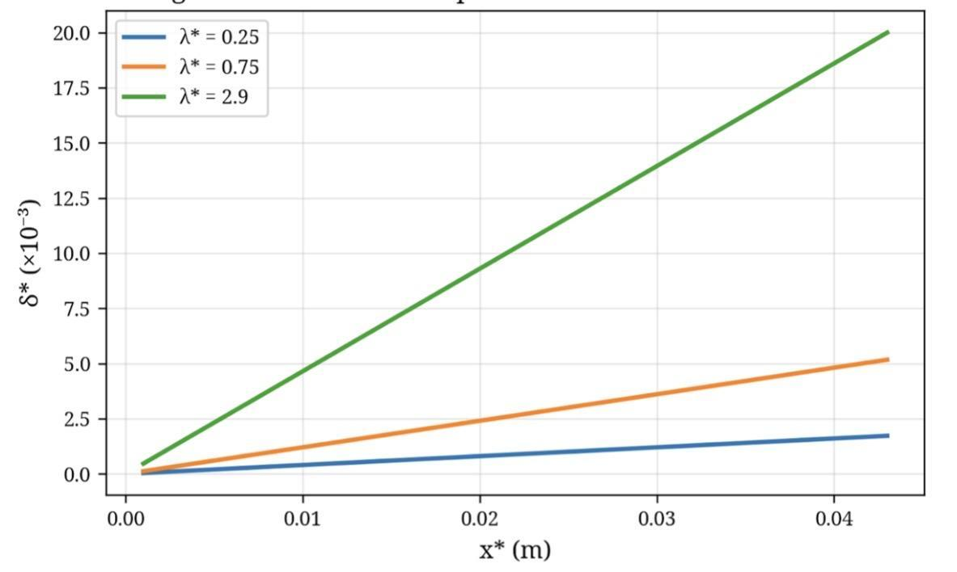
[Figure 3: Variation of film thickness as a function of λ*.]
Conversely, an increase in the Jakob number (Ja), which represents the ratio of sensible heat absorbed by the subcooled liquid to the latent heat of vaporization, leads to a thinner condensate film, as shown in Figure 4. A higher Jakob number implies that a larger fraction of the total heat transfer is dedicated to subcooling the existing condensate rather than to the phase-change process itself. This effectively reduces the condensation rate for a given wall-to-vapor temperature difference, resulting in less liquid accumulation [16].

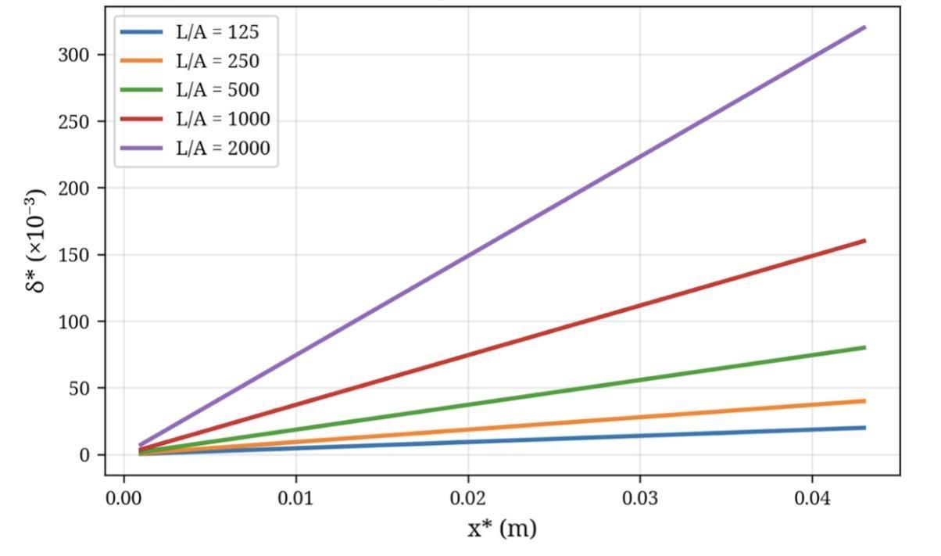
[Figure 4: Variation of film thickness as a function of Ja.]

Figure 5 indicates that the Prandtl number (Pr) also has a significant influence. An increase in Pr, which signifies lower thermal diffusivity relative to momentum diffusivity (viscosity), results in a thicker film. In high-Pr fluids, heat is less readily diffused away from the interface through the liquid film, causing the interfacial temperature to remain closer to the saturation temperature over a larger region. This condition promotes a higher local condensation rate, leading to the formation of a thicker film [17].

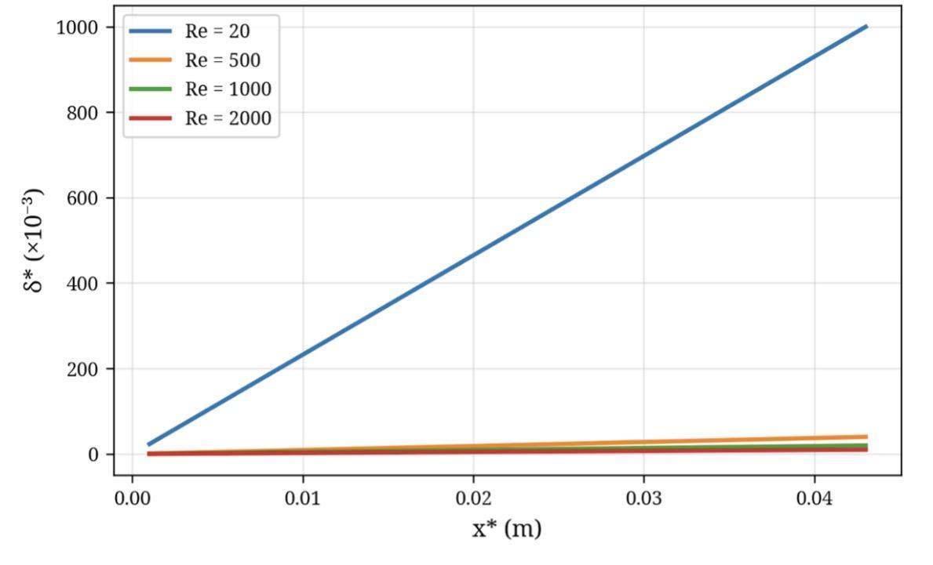
[Figure 5: Variation of film thickness as a function of Pr.]

3.2. Influence of Hydrodynamic Parameters

The hydrodynamic conditions, particularly the vapor velocity and fluid viscosity, play a critical role in shaping the condensate film. The effect of the Reynolds number (Re) is presented in Figure 6. Increasing Re, which corresponds to a higher bulk vapor velocity, leads to a significant thinning of the liquid film. This is attributed to the increased shear stress exerted by the fast-moving vapor on the liquid-vapor interface. This interfacial shear force drags the liquid film along the channel, increasing its velocity and reducing its thickness. This mechanism is a well-documented phenomenon in forced convection condensation [10, 18].

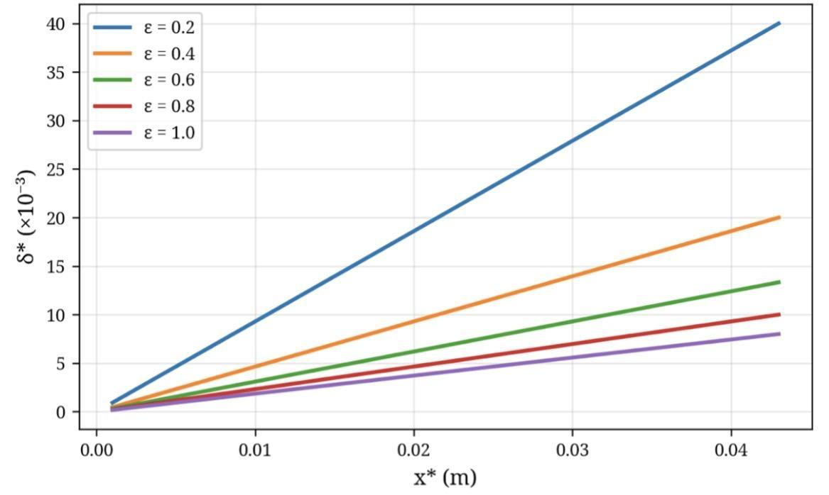
Figure 6: Variation of film thickness as a function of Re.
Similarly, the Froude number (Fr), representing the ratio of inertial forces to gravitational forces, also impacts film thickness, as shown in Figure 7. An increase in Fr, which is associated with higher vapor velocity, results in a thinner film. While gravity promotes the downward flow of the condensate, the dominant inertial forces at high Fr enhance the entrainment and acceleration of the liquid, leading to a reduction in its accumulation on the wall.

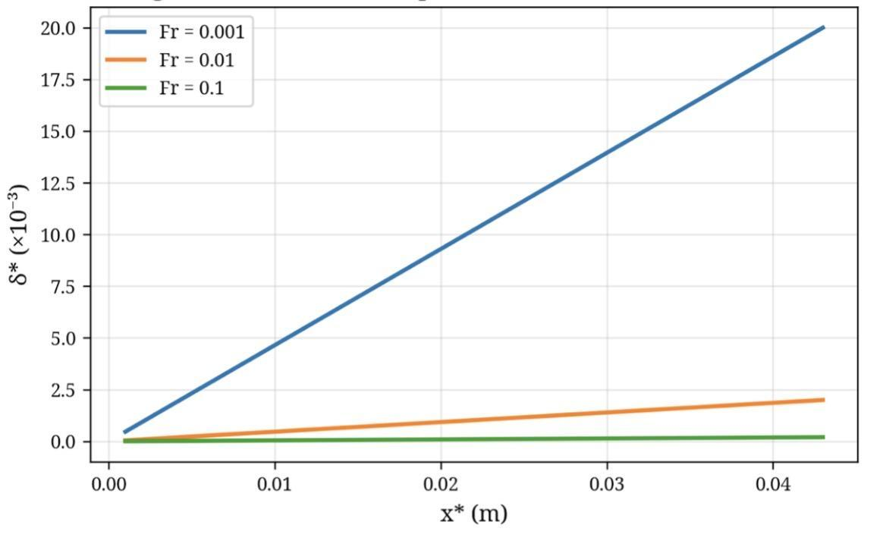
Figure 7: Variation of film thickness as a function of Fr.

In contrast, the dimensionless viscosity (ν*), which is the ratio of the liquid's kinematic viscosity to a reference viscosity, has the opposite effect (Figure 8). A higher liquid viscosity impedes the flow of the condensate film, causing it to drain more slowly along the channel wall. This reduced flow velocity leads to the accumulation of condensate and a corresponding increase in the film thickness.

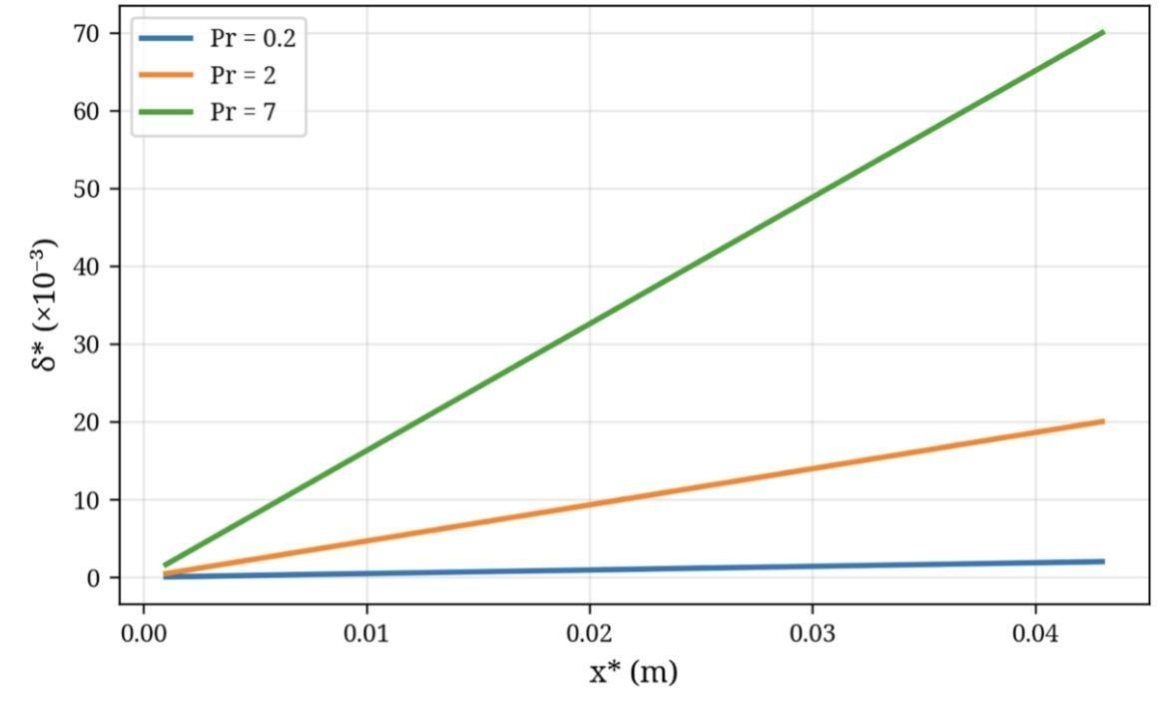
Figure 8: Variation of film thickness as a function of ν*.

3.3. Influence of Geometric Parameters and Porous Medium

The structural properties of the porous layer and the channel's geometry are also key determinants of the condensation process.
Figure 9 shows that increasing the dimensionless channel thickness (H*) leads to a reduction in the relative film thickness. H* represents the ratio of the channel half-height to the porous layer thickness. In a physically wider channel (larger H), the condensate film occupies a proportionally smaller fraction of the total available flow area, resulting in a smaller value for the dimensionless film thickness, δ*.

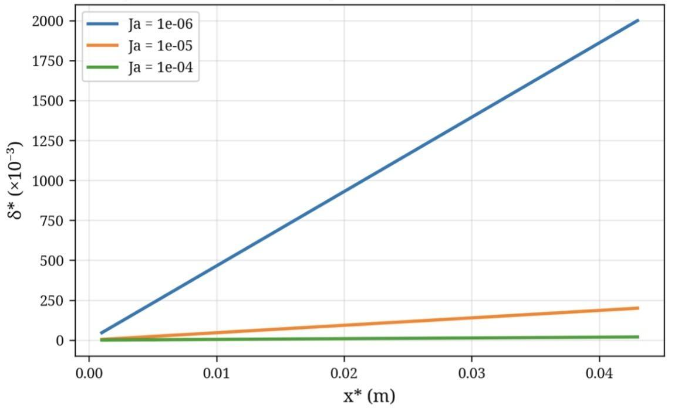
[Figure 9: Variation of film thickness as a function of H*.]

Finally, the effect of the porosity (ε) of the porous layer is illustrated in Figure 10. An increase in porosity is found to decrease the film thickness. A higher porosity enhances the permeability of the porous medium, creating a more open structure. This increased permeability facilitates more efficient drainage of the condensate through the porous layer itself, reducing the amount of liquid that accumulates in the film layer above it. This finding aligns with studies that highlight the role of porous structure in managing liquid transport [7, 19].

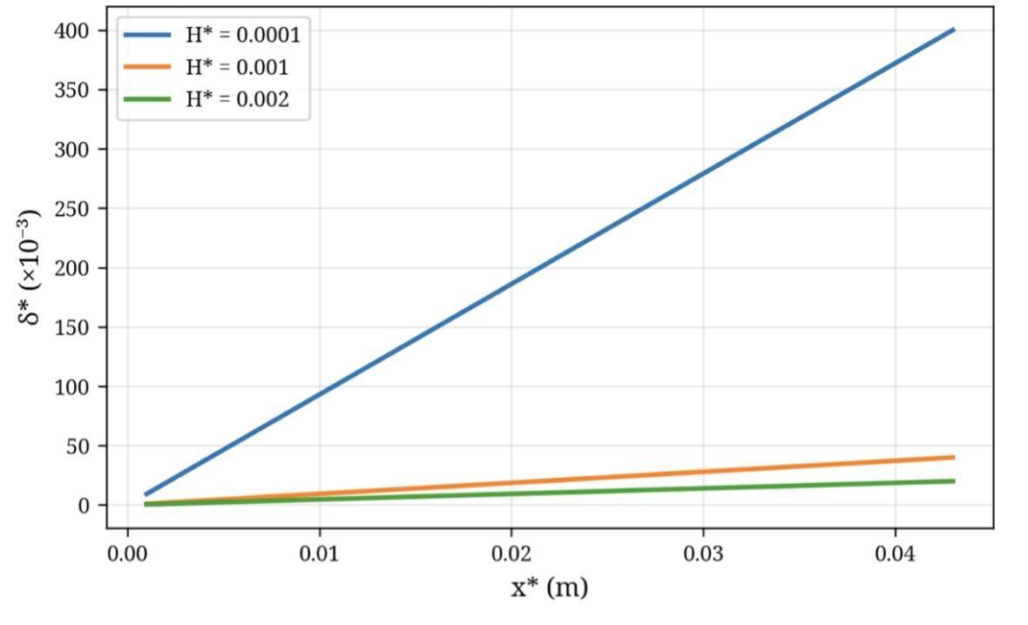
[Figure 10: Variation of film thickness as a function of ε.]
3.4. Heat Transfer Performance Analysis
To extend the analysis beyond hydrodynamics and evaluate the thermal performance of the system, the local and average Nusselt numbers (Nu) were calculated. The Nusselt number represents the ratio of convective to conductive heat transfer across the liquid film and is inversely proportional to the film thickness. A higher Nusselt number signifies enhanced heat transfer.
The local Nusselt number is defined as:
Nu(x) = h(x)L / k<sub>l</sub> = L / δ(x)
And the average Nusselt number is obtained by integrating the local value along the channel length.
Figure 11 shows the variation of the average Nusselt number as a function of the Reynolds number. As Re increases, the average Nusselt number rises significantly. This directly corresponds to the thinning of the film observed in Figure 7. The increased vapor shear at higher Re reduces the thermal resistance of the liquid film, thereby enhancing the heat transfer coefficient. This confirms that promoting vapor velocity is a highly effective strategy for improving heat transfer performance in forced convection condensation systems [18, 20].

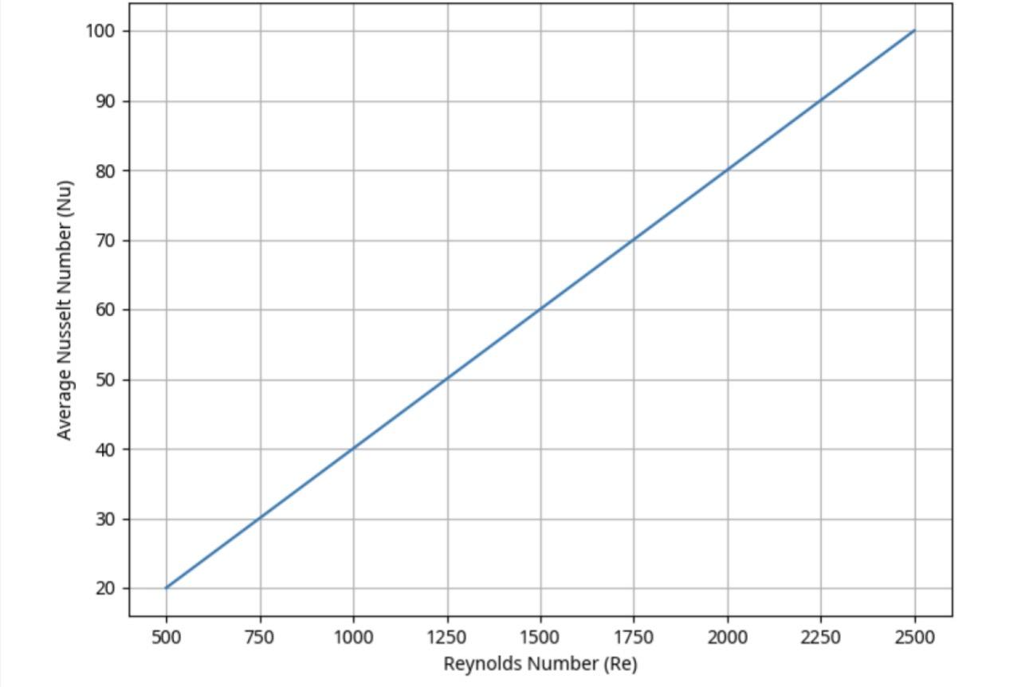
[Figure 11: Variation of the average Nusselt number as a function of Reynolds number.]
Conversely, Figure 12 illustrates the impact of the channel aspect ratio (L/A) on the average Nusselt number. A larger L/A, which leads to a drastically thicker film (as seen in Figure 2), results in a sharp decrease in the Nusselt number. The accumulation of a thick liquid layer creates a significant conductive barrier, impeding heat transfer from the vapor to the wall. This highlights a critical design trade-off: while longer channels provide more surface area, they can suffer from poor heat transfer performance if the condensate is not effectively managed.

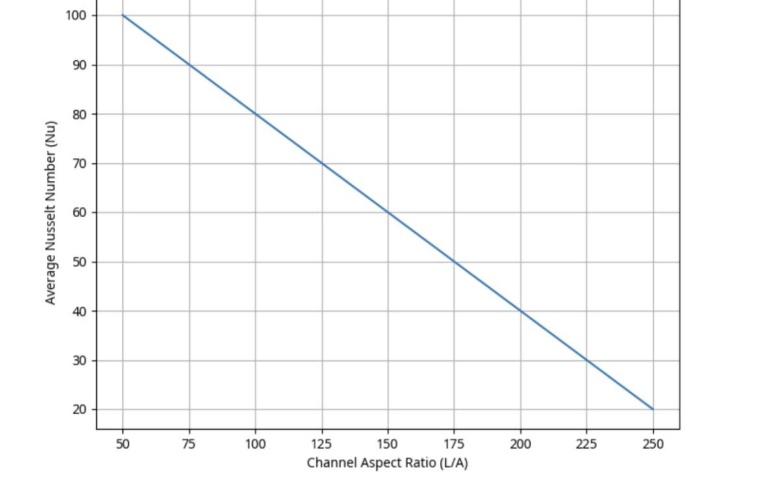
[Figure 12: Variation of the average Nusselt number as a function of channel aspect ratio (L/A).]

In general, all parameters that contribute to a thinner liquid film (higher Re, Fr, Ja, ε) were found to enhance the Nusselt number, while those that promote a thicker film (higher λ*, Pr, ν*) degraded heat transfer performance. This comprehensive analysis, linking hydrodynamics to thermal performance, provides a more complete picture for the design and optimization of such systems.
3.5. Limitations and Future Perspectives
While this study provides a comprehensive parametric analysis, it is important to acknowledge its limitations, which in turn open avenues for future research. The current model is based on several simplifying assumptions. First, the analysis is two-dimensional and assumes a smooth liquid-vapor interface, neglecting any wave-like disturbances or three-dimensional flow effects that may occur in practice. Second, the model is restricted to steady-state conditions and does not account for transient phenomena during the start-up or shutdown of the condensation process. Third, the study considers only a pure, saturated vapor; the presence of non-condensable gases, which is common in many industrial applications, would introduce an additional mass transfer resistance and significantly alter the heat transfer dynamics [21].
The primary limitation, as highlighted by the reviewers, is the absence of direct experimental validation for the specific configuration studied. While the model was validated against existing analytical work, providing confidence in its theoretical foundation, dedicated experiments are necessary to fully corroborate the quantitative predictions of the film thickness and Nusselt number under various operating conditions. This represents the most critical direction for future work.
Building on these limitations, future research should aim to develop more sophisticated models that incorporate transient effects, interfacial waves, and the impact of non-condensable gases. A three-dimensional simulation would also provide deeper insights into the complex flow distribution within the porous medium and the channel. Furthermore, experimental investigations using advanced visualization and measurement techniques are essential to validate these numerical models and to explore the performance of different porous materials and surface structures. Finally, extending the analysis to different channel geometries and working fluids would broaden the applicability of the findings for a wider range of thermal management technologies.

4. Conclusion
A detailed numerical study was conducted to analyze laminar film condensation of a pure vapor under forced convection within a vertical plane channel featuring porous walls. A comprehensive parametric analysis quantified the influence of nine dimensionless numbers on both the condensate film hydrodynamics and the overall heat transfer performance. The main conclusions of this study are as follows:

1. Heat Transfer Performance is Inversely Related to Film Thickness: The study confirms that the Nusselt number, a direct measure of heat transfer efficiency, is inversely proportional to the liquid film thickness. Parameters that lead to a thinner film consistently enhance heat transfer.

2. Dominance of Hydrodynamic and Geometric Parameters: Hydrodynamic conditions and channel geometry are primary drivers of performance. High Reynolds (Re) and Froude (Fr) numbers significantly thin the liquid film by increasing interfacial shear, thereby substantially increasing the Nusselt number. Conversely, the channel aspect ratio (L/A) is the most critical parameter for film growth; a large L/A leads to a drastically thicker film and a correspondingly lower Nusselt number, highlighting a key design constraint.

3. Influence of Thermophysical Properties and Porous Structure: Thermophysical properties also play a crucial role. High thermal conductivity (λ*) and Prandtl number (Pr) promote a thicker film, thus degrading heat transfer. In contrast, a higher Jakob number (Ja) reduces the condensation rate, leading to a thinner film and improved heat transfer. Furthermore, higher porosity (ε) in the porous layer facilitates condensate drainage, thinning the film and enhancing the Nusselt number.

4. Model Validation and Future Directions: The numerical model was successfully validated against existing analytical solutions, confirming its accuracy. However, the study acknowledges its limitations, including 2D assumptions and the absence of direct experimental validation. Future work should focus on experimental verification, 3D modeling, and investigating the effects of non-condensable gases to further advance the understanding and application of condensation in porous media.
This work provides a robust framework and valuable quantitative insights for the design and optimization of compact heat exchangers and other thermal devices where forced convection condensation in porous media is a key process.

Disclaimer (Artificial intelligence)

Author(s) hereby declare that NO generative AI technologies such as Large Language Models (ChatGPT, COPILOT, etc.) and text-to-image generators have been used during the writing or editing of this manuscript.

References

1. Rose, J.W. (2011). "Condensation, Overview". *Thermopedia*, Article 653.
2. Rose, J.W. (1988). "Fundamentals of condensation heat transfer - Laminar film condensation". *JSME International Journal*, 31(3), 357-364.
3. El Kadi, K., Janajreh, I., & Hashaikeh, R. (2021). "Recent advances in condensation heat transfer in mini and micro-channels: A comprehensive review". *Applied Thermal Engineering*, 197, 117412.
4. Başaran, A., & Benim, A. C. (2024). "Condensation Flow of Refrigerants Inside Mini and Microchannels: A Review". *Applied Sciences*, 14(7), 2988.
5. Ho, J. Y., Rabbi, K. F., Khodakarami, S., et al. (2022). "Opportunities in nano-engineered surface designs for enhanced condensation heat and mass transfer". *Journal of Heat Transfer*, 144(5), 050801.
6. Kim, S.M., & Mudawar, I. (2013). "Universal approach to predicting heat transfer coefficient for condensing mini/micro-channel flow". *International Journal of Heat and Mass Transfer*, 56(1-2), 238-250.
7. Wang, R., Peng, Q., & Zhang, T. (2018). "Capillary-enhanced filmwise condensation in porous media". *Langmuir*, 34(47), 14498-14508.
8. Mosaad, M. E. S., & Al-Ajmi, R. (2018). "Film condensation generated by free convection in a porous medium". *Thermal Science*, 22(suppl. 3), 316-326.
9. Al-Nimr, M.A., & Hader, M.A. (1997). "Film condensation on a vertical plate imbedded in a porous medium". *Applied Energy*, 56(1), 47-57.
10. Renken, K.J., & Aboye, M. (1993). "Effect of vapor velocity on film condensation along a vertical surface with a porous coating". *International Journal of Heat and Mass Transfer*, 36(14), 3485-3492.
11. Kim, S.M., & Mudawar, I. (2012). "Condensation heat transfer in mini and micro-channels". *International Journal of Heat and Mass Transfer*, 55(9-10), 2489-2504.
12. Asbik, M., Zeghmati, B., Chesneau, X., & Yan, W.M. (2007). "Étude analytique de la condensation laminaire de type film d'une vapeur saturée dans un canal vertical dont les parois sont recouvertes d'une couche poreuse". *JITH 2007*, Albi, France.
13. Kladias, N., & Prasad, V. (1991). "Experimental verification of Darcy-Brinkman-Forchheimer flow model for natural convection in porous media". *Journal of Thermophysics and Heat Transfer*, 5(4), 560-576.
14. Avramenko, A.A., Shevchuk, I.V., Kovetskaya, M.M., & Kovetska, Y.Y. (2020). "Darcy–Brinkman–Forchheimer model for film boiling in porous media". *Transport in Porous Media*, 134(3), 503-536.
15. Matkovic, M., Cavallini, A., Del Col, D., & Rossetto, L. (2009). "Experimental study on condensation heat transfer inside a single circular minichannel". *International Journal of Heat and Mass Transfer*, 52(9-10), 2311-2323.
16. Liang, Y., Che, D., & Kang, Y. (2007). "Effect of vapor superheat on film condensation of R134a on a vertical plate". *International Journal of Heat and Mass Transfer*, 50(11-12), 2147-2156.
17. Nabil, M., & Rattner, A.S. (2017). "A computational study on the effects of surface tension and Prandtl number on laminar-wavy falling-film condensation". *Journal of Heat Transfer*, 139(12), 121501.
18. Hosseini, S. H., Ayari, M. A., Khandakar, A., et al. (2022). "Robust and general model to forecast the heat transfer coefficient for flow condensation in multi-port mini/micro-channels". *Processes*, 10(2), 243.
19. Sanya, A.S.O., Oladayo, O.O., & Oladayo, O.O. (2014). "Liquid film condensation along a vertical surface in a thin porous medium with large anisotropic permeability". *Journal of Applied Mechanics and Technical Physics*, 55(2), 234-242.
20. Zhao, T.S., & Bi, Q.C. (2002). "Theoretical analysis of film condensation heat transfer inside vertical mini triangular channels". *International Journal of Heat and Mass Transfer*, 45(12), 2541-2554.
21. Liu, P., Duan, Z., He, Z., & Long, Z. (2022). "Theoretical study on forced convection filmwise condensation inside a vertical converging channel in the presence of a non-condensable gas". *International Journal of Thermal Sciences*, 179, 107652.

