Optimization of a Building's Indoor Temperature and Sensitive Air-Conditioning Loads Using the BLT-Parpaing Hollow Double Wall

Abstract
In hot, dry tropical climates (sahelian), such as Ouagadougou (Burkina Faso), high demand for air conditioning in buildings poses a major energy challenge. This study aims to optimize the indoor temperature and sensible air conditioning loads of a typical three-bedroom F3 building with cavity walls, using a double-wall system combining lightweight concrete blocks and hollow concrete blocks (LBC-hollow block), a solution rarely studied in these climatic conditions. The methodology consisted of characterizing the thermal properties of the materials and simulating the building in reference and optimized scenarios using KoZiBu software. The results show that the use of BLT-cinder block double walls reduces the average indoor temperature by 2 to 2.6°C depending on the room, with a maximum decrease of 4.1°C in February in room 2, compared to a single-wall building made of hollow cinder blocks. This improvement translates into annual energy savings of 24.06%. However, to promote the adoption of the system, it would be relevant to compare these savings with the additional cost of implementing the BLT double wall.

Key words : bioclimatic design, optimization, simulation, temperature, air-conditioning loads.

- INTRODUCTION
The building sector is one of the world's largest energy consumers, accounting for around 32% of total annual consumption [1]. Against a backdrop of increasingly scarce energy resources, the need to design energy-efficient buildings is becoming ever more pressing. In Burkina Faso, which has a hot and dry tropical climate, air conditioning needs are particularly high, which increases demand for electricity, even though domestic production does not fully cover needs. In sub-Saharan Africa, energy consumption in public and private buildings and the tertiary sector is estimated at between 250 and 450 kWh/m²/year, depending on the number of floors. Heating, ventilation, and air conditioning (HVAC) systems alone account for between 50 and 70% of buildings' electricity consumption [2]. For the public sector, consumption related to air conditioning equipment was estimated in 2012 at around 30,000 MWh/year, at a cost of around 3.4 billion CFA francs/year [3]. This high energy demand contributes to overbilling, overconsumption, and irregularities in electricity supply. Added to this is a low national electrification rate, estimated at 18.3% in 2015, with significant disparities between urban and rural areas [4]. In response to these challenges, much research is focusing on the use of building materials with better thermal performance, particularly local materials. Several solutions are being studied, such as adobe (banco), cut laterite blocks (BLT), compressed earth bricks (BTC), and cement blocks. Experimental and numerical work has been carried out to characterize their thermal and mechanical properties in order to identify optimal formulations that combine strength, durability, and thermal performance. AMADOU OUMAROU Fati et al. [5] proposed a passive approach to optimizing the thermal envelope through simulation, comparing different materials commonly used in Burkina Faso. Their results show that the use of local materials can significantly reduce cooling requirements, with energy savings of around 4 kW for a classroom in a hot and dry climate. Similarly, A. Compaoré et al. [6] showed, using a numerical heat transfer model applied to compressed earth block walls, that local materials can maintain lower indoor temperatures than cement blocks, thanks to their better thermal inertia. However, excessive ventilation can reduce these benefits during hot periods. In addition, other innovative solutions, such as the integration of phase change materials (PCMs), have also demonstrated their potential to improve thermal storage, reduce heating and cooling requirements, and increase the energy efficiency of buildings [7]. Improving the energy performance of buildings depends not only on the choice of materials, but also on the quality of the architectural and thermal design. Optimizing the building envelope, wall thickness, air renewal, and construction configurations is essential to ensuring the thermal comfort of occupants while reducing electricity consumption. In this context, thermal simulation tools play a central role. They make it possible to evaluate the thermal behavior of buildings, compare different construction solutions, and guide design choices before the construction phase. Numerical simulations thus provide a reliable framework for analyzing internal temperatures, cooling loads, and the impact of construction parameters, contributing to the design of more energy-efficient buildings that are better adapted to local climatic conditions.
Given the relevance of this topic, research work has been carried out on building materials, including: E. Malbila [8] carried out an experimental analysis of heat transfer in two houses built with cement breezeblock and cut laterite blocks (BLT). The results show that the use of BLTs makes it possible to approach thermal comfort in the building by combining natural ventilation by thermal draught and without increased use of air-conditioning; this helps to reduce energy consumption. E. Ouédraogo et al [9] carried out an experimental study to characterize local materials used in building construction. These materials are Compressed Earth Blocks (CEB) stabilized with cement and/or paper. These composite materials used for building envelopes are highly water-stable. The results of measurements of mechanical and thermophysical properties showed a discrepancy. The compressive and tensile strengths of earth-cement and earth-cement-paper blocks are similar, and around twice as high as those of earth-paper and three times as high as those of earth. The thermophysical property values of materials incorporating paper (cellulose) show an improvement in their thermal insulation performance. Arnaud Louis Sountong-Noma Ouedraogo et al. [10] conducted a comparative study between the thermal comfort of compressed earth brick (CEB) and cement brick buildings in the hot and dry climate of Ouagadougou. The results show that after optimization (plastering, waterproofing, ventilation), hours of discomfort are greatly reduced, with better performance for CEB, which is an appropriate ecological and economical solution to replace cementitious materials. Hassane Seini Moussa et al. [11] conducted a study to determine the coefficients for estimating the compressive strength of lateritic stone and cement mortar masonry, based on laboratory tests on blocks and assemblies. They propose a formula adapted to complement Eurocode 6, incorporating material properties and geometric parameters, which shows good agreement with the experimental results. Mr. Dlimi et al. [12] propose improving the insulation of exterior walls by filling hollow bricks with a bio-based insulator, hempcrete, in order to reduce costs, construction time, and greenhouse gas emissions. Three brick configurations (8, 12, and 16 holes) were analyzed using CFD simulations. The results show that double walls with 12- and 16-hole bricks meet Moroccan regulatory thermal requirements (R and U). Dynamic building-scale simulations with TRNSYS confirm the thermal gains. The approach is also economically and environmentally advantageous and applicable to hot Mediterranean climates. Etienne Malbila et al. [13] examined the incorporation of shea butter residue (SBr) and hydrated lime (HL) to stabilize compressed earth blocks (CEB). The results show that a mixture of 5% HL and 5% SBr improves the durability, mechanical strength, and water properties of CEBs. Higher levels of SBr (25%) reduce thermal performance. The study highlights that the judicious use of these agricultural and industrial by-products makes it possible to produce more efficient and durable CEBs.
Cement breezeblocks are mechanically strong and moisture-resistant. They are generally manufactured on site and are highly appreciated for their ease of installation. A. Kemajou et al [14] explore ways of improving thermal comfort in homes by using suitable building materials, while integrating socio-cultural considerations. By comparing traditional materials (wood, mud brick, rammed earth) with modern materials (cement breeze block) using simulations with Pléiades+Comfie software, the results show that traditional materials offer better thermal performance, especially in specific climates. Traditional housing, better adapted to local climatic constraints, achieves a good level of thermal comfort by optimizing the shape, orientation and size of openings in the home. A. Kaboré [15] carried out hygrothermal modeling of a concrete building envelope. His aim was to find an alternative to traditional construction by integrating new materials with a low ecological footprint to improve the hygrothermal performance of the building envelope. Hence the interest in carrying out a study of the thermal performance of hemp concrete as a material, and above all its integration and hygrothermal behavior in the envelope studied.
In addition, a certain degree of thermal comfort can be achieved by lowering indoor temperatures, which in turn can lead to energy savings in buildings, if architectural design and the choice of building materials take into account the thermal behavior of buildings to minimize the need for air-conditioning. Burkina Faso has enormous potential in local materials (BLT, BTC, BTM or adobe, etc.). Several studies have been carried out on the contribution of local materials to thermal comfort, but few on the combination of materials in double-walled buildings. With this in mind, we propose to study the influence of the BLT-hollow breeze-block double wall on a building in a hot, dry tropical climate such as Burkina Faso, to achieve a certain level of thermal comfort in the indoor environment. The overall aim is to optimize the indoor temperature and sensitive air-conditioning loads of the reference building.
- MATERIALS AND METHODS
2.1 KoZiBu model description and material properties
2.1.1 KoZiBu software
KoZiBu is a simulation software package for dynamic analysis of a building's thermal and water performance. In addition, it is designed to carry out studies of heating and cooling, air conditioning and ventilation, and the choice of insulation materials. KoZiBu's main objective is to predict energy consumption and the amplitude of temperature and humidity variations. KoZiBu can be used to estimate the heating or air-conditioning power required to maintain a given setpoint, or to determine temperature trends when the heating or air-conditioning system is insufficient. Humidity is treated in the same way. KoZiBu is based on the assembly of simple bricks to form a complex building with its equipment. Using the graphical interface, the user builds a model of his building using basic elements (air volumes, walls, windows). The user can add internal loads and control elements to the building model, and then perform thermal calculations [15].
2.1.2 Materials properties
Table 1 below summarizes the composition and properties of the different types of walls and openings considered for the building in the reference situation [16, 17, 18].
Table 1 : Thermo-physical properties of materials under reference conditions in hollow breezeblock and openings
Designation | Materials | Thermal  Conductivité  (W/m.K) | Specific  Capacity  (J/kg.K) | Density  (Kg/m)³ | Thickness  (m)
Exterior walls | -Cement plaster  -Hollow block  -Cement plaster | 0.87  0.67  0.87 | 1050  880  1050 | 2200  1250  2200 | 0.025  0.150  0.025
Ventilated attic floor | False ceiling | 0.22 | 772 | 359 | 0.005
Interior partitions | Cement plaster  -Hollow block  -Cement plaster | 0.87  0.67  0.87 | 1050  880  1050 | 2200  1250  2200 | 0.025  0.150  0.025
Floor on solid ground | -Stoneware tiles  -Concrete | 1.20  1.75 | 1000  653 | 2000  2100 | 0.005  0.100
Glass entrance  door | Glass | 1.15 | 1000 | 840 | 0.005
Interior door | Wood | 0.12 | 2510 | 593 | 0.035
Windows (single glazing) | Glass | 1.15 | 1000 | 840 | 0.005
Table 2 summarizes the composition and properties of the different types of walls and openings that were considered for the building in the optimized situation. The optimization of walls and openings in the optimized building, as summarized in Table 2, consisted in improving thermal and energy performance to increase the building's overall efficiency. This optimization involved
- Improved thermal insulation ;
- Reduced thermal transmittance (U-value) ;
- Increased air tightness ;
- Optimization of glazing and openings ;
- Installation of solar protection systems ;
- Natural light management.
In summary, optimization involved a series of measures to improve insulation, solar gain management, airtightness and the use of natural light to enhance the building's energy efficiency and thermal comfort. [16, 17, 18].
Table 2 : Thermo-physical properties of materials in optimized conditions
Designation | Materials | Thermal  Conductivité  (W/m.K) | Specific  Capacity  (J/kg.K) | Density  (Kg/m)³ | Thickness  (m)
Exterior walls | -Gypsum plaster  -Hollow block  -hemp wool  -Air blade  -BLT | 0.520  0.670  0.038  0.280  0.444 | 1000  880  1000  1000  1143.95 | 1300  1250  30  1.00  1813.02 | 0.015  0.150  0.100  0.030  0.200
Ventilated attic floor | False ceiling | 0.220 | 772 | 359 | 0.015
Interior partitions | Gypsum plaster  -Hollow block  -Gypsum plaster | 0.52  0.67  0.52 | 1000  880  1000 | 1300  1250  1300 | 0.015  0.150  0.015
Floor on solid ground | -Stoneware tiles  -hemp wool  -Concrete | 1.20  0.038  1.75 | 1000  1600  653 | 2000  30  2100 | 0.005  0.100  0.100
Glass entrance  door | Glass | 1.15 | 1000 | 840 | 0.005
Interior door | Wood | 0.12 | 2510 | 593 | 0.035
Windows (single glazing) | -Glass  -Argon  -Glass | 1.15  0.018  1.15 | 1000  520  1000 | 840  1.70  840 | 0.005  0.016  0.005

Table 3 shows the thermal resistance of the materials used [16, 17, 18].
Table 3 : Thermal resistance of materials used
Material | Hollow breeze-block walls |  | BLT walls | Double glazing | Single  glazing | BLT-hollow breeze-block walls | Cement plaster | Gypsum plaster
Thermal  Resistance (m².K/W) | 0.224 | 0.454 |  | 0.898 | 0.004 | 3.417 | 0.029 | 0.029

We've already noted that BLT-hollow breeze-block walls have a higher thermal resistance than simple BLT or hollow breeze-block walls. Double glazing also has a higher thermal resistance than single glazing.
2.2 Modeling the house with KoZiBu
2.2.1 Building description
The study we're carrying out concerns a residential dwelling with a surface area of 81.09 m² and a volume of 195.978 m3, with its main facade facing east. It's a F3 building with two bedrooms, a living room, a hallway, a shower room, a kitchen and a storeroom.
Uninsulated exterior walls are 15 cm thick hollow breeze-block for all materials ; partitions are 15 cm thick hollow breeze-block. The low floor is 10 cm thick concrete, covered with 5 cm thick tiles. The roof is made of aluminium-zinc sheet metal, with a ventilated roof space below.
The interior doors are wooden, the exterior glazed in metal. Windows are single-glazed, 5 mm thick, with iron frames. False ceiling height is 2.90 m. Average floor temperature in Ouagadougou : 26°C.
2.2.2 Multi-zone modeling
In order to model the building more precisely according to its use, each room is modeled by a single thermal zone. In our case, we have subdivided the building into six (6) zones, thus determining their dimensions for description in KoZiBu :
Zone 1 : Living room ;
Zone 2 : Kitchen ;
Zone 3 : Bedroom 1 ;
Zone 4 : Bedroom 2 ;
Zone 5 : Store ;
Zone 6 : Powder room.

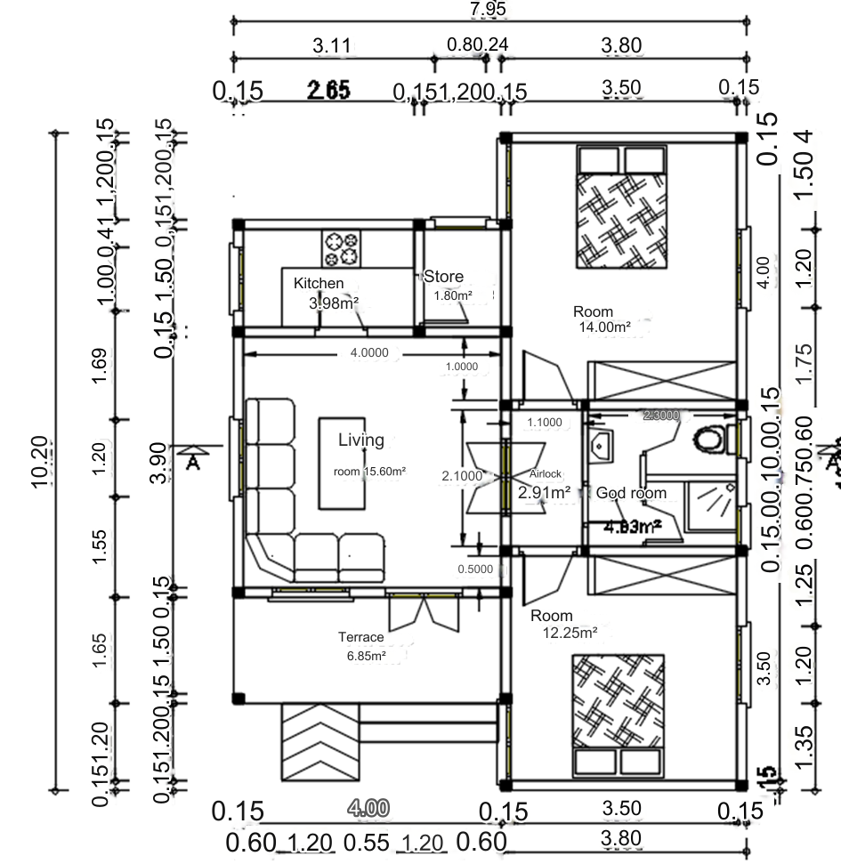
West
North
South
East

Figure 1 : Plan of typical F3 building
2.2.3 Meteorological data
As the building is located in the city of Ouagadougou, METEONORM meteorological data for this city are used for the simulation.
2.2.4 Internal loads and control devices
We assume that the air conditioner is switched on when the indoor temperature rises above 26°C with a relative humidity of 50%. Ventilation and infiltration are set at one volume per hour. Weekday and weekend occupancy scenarios have been created for the bedrooms and living room. The number of occupants is 4 for the living room and 2 per bedroom. For lighting, a total of 06 9W/m2 fluorescent lamps are used in the building. The living room is equipped with a 64W television and a 60W Canal+ decoder, a 70W refrigerator and two 80W laptops, each with a duty cycle of 100%.
- RESULTS AND DISCUSSION
Modeling and simulation using KoZiBu gave us results that we present in this section. These results are curves showing indoor temperatures and sensible air conditioning loads, tables showing indoor temperature differences and sensible air conditioning loads for the building with hollow concrete block walls and the building with double BLT-hollow concrete block walls. The purpose of discussing these results is to demonstrate that the indoor temperatures and sensible air conditioning loads of the building in the reference situation have been significantly optimized by the use of the BLT-hollow concrete block double wall.
3.1 Comparison of maximum indoor temperatures
- Evaluation of maximum indoor temperature curves
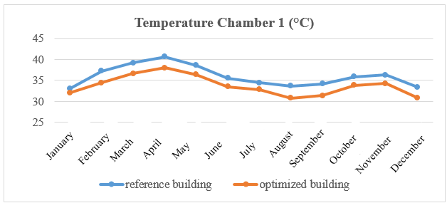

Figure 2 : Maximum indoor temperature curves for room 1 of the building in the reference and optimized situations.
The readings for Room 1 show that the temperatures in the reference building are consistently higher than those in the optimized building throughout the year. A critical heat peak is observed during the month of April, when the temperature exceeds 40°C in the reference configuration, while it is reduced to around 38°C in the optimized version. The winter months, particularly August, currently have the lowest temperatures, but the difference remains significant in favor of the optimized building, which maintains a temperature closer to the comfort zone.

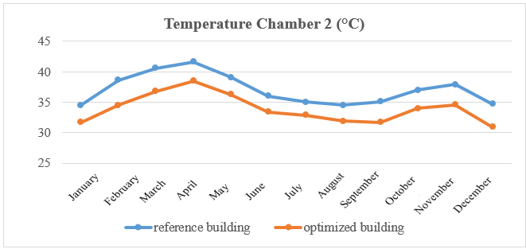

Figure 3 : Maximum indoor temperature curve for room 2 of the building in the reference and optimized situations.
For Room 2, the thermal profile is almost identical to that of the first room, confirming similar exposure or design. The reference building reaches its maximum in April, approaching 42°C, which represents very uncomfortable living conditions. Optimization significantly reduces this temperature (by approximately 3°C), and this advantage is maintained during the second heat wave in November, thus preventing excessive overheating at the end of the year.
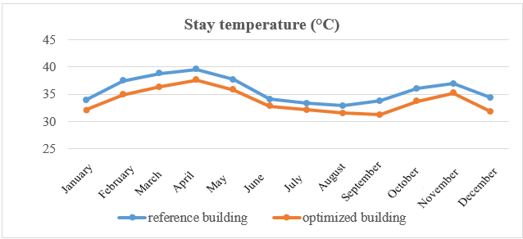

Figure 4 : Maximum indoor temperature curve for the building's living areas in the reference and optimized situations.
The living area follows the same seasonal pattern, with the temperature curve for the optimized building remaining consistently below that of the reference building. Although the peak in April remains the hottest point (approaching 40°C in the reference building compared to around 37.5°C in the optimized building), it can be seen that the living area benefits from a constant reduction in heat. Between July and September, temperatures in the optimized building stabilize around 31-32°C, providing a much more comfortable environment than the reference building, which remains above 33-34°C during the same period.
The figures above show the curves for maximum monthly indoor temperatures in bedroom 1, bedroom 2 and the living room of the building in the reference situation and also in the optimized situation.
These curves show a drop in indoor temperature in the optimized building compared with the reference building, especially in chamber 2, where the variation in indoor temperature is greater. In particular, we note temperature peaks of 41.60°C in the reference building and 38.50°C in the optimized building for the month of April, the hottest month of the year in Burkina Faso. This can be explained by the fact that the hollow breezeblocks in the reference building store more heat during the day, due to the absence of thermal insulation and a wall providing protection from the elements. As a result, the heat stored during the day by the air trapped in the hollow walls is released into the room at night, raising the interior temperature. Hence the importance of BLT and thermal insulation in the design of the double wall, which reduced the heat stored in the hollow breezeblocks of the optimized building, resulting in a lower interior temperature. Double glazing also helped to improve the building's insulation in the optimized situation.
- Evaluation of temperature differences inside the building.
The tables below show the maximum indoor temperature variations for room 1, room 2 and the building's living room in the reference and optimized situations.
In the table 4, we can see that the indoor temperature in room 2 dropped by 4.1°C in February. This shows that building optimization is more effective in this month and in this part of the building, which achieves better temperature reductions than the others. As for the table 5, we can see that over the year, the average difference in indoor temperature is greater in room 2. We can therefore conclude that optimization has a greater impact in room 2, and this could be explained by the fact that the orientation of its walls and openings adds to optimization through the use of double walls.
Table 4. Maximum indoor temperature difference between the reference and optimized building situations.
Properties | January | February | March | April | May | June | July | August | September | October | November | December
Room 1  (°C) | 1 | 2.8 | 2.6 | 2.6 | 2.2 | 2 | 1.6 | 2.9 | 2.8 | 2.1 | 2 | 2.5
Room 2  (°C) | 2.8 | 4.1 | 3.8 | 3.1 | 2.8 | 2.6 | 2.1 | 2.6 | 3.4 | 3 | 3.3 | 3.8
Stay  (°C) | 1.8 | 2.6 | 2.5 | 2 | 1.9 | 1.3 | 1.2 | 1.4 | 2.6 | 2.3 | 1.7 | 2.6

Table 5. The average difference in maximum indoor temperatures between the building in the reference situation and in the optimized situation.
Properties | Average
Room 1 | 2.25
Room 2 | 2.6
stay | 2

3.2 Sensitive loads, latent loads and total air-conditioning loads
The figures below compare the building's sensible air-conditioning loads and total air-conditioning loads in the reference and optimized situations.

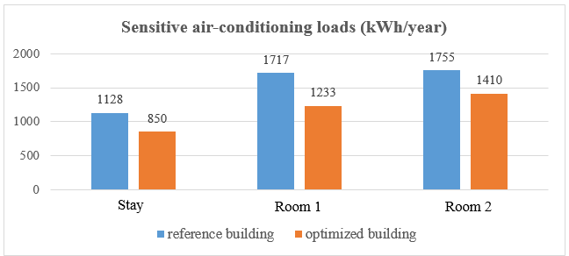

Figure 5 : Diagram of sensitive air-conditioning loads in kWh/year
The sensitive air-conditioning load values obtained for the building in the reference situation are higher than those in the optimized situation. We note that loads are higher in room 2, which could be explained by the higher temperatures in this part of the building. However, this does not detract from the fact that we can see a reduction in these loads by optimizing the reference building with the BLT-hollow block double wall, which retains the coolness due to air-conditioning and reduces sensitive air-conditioning loads.

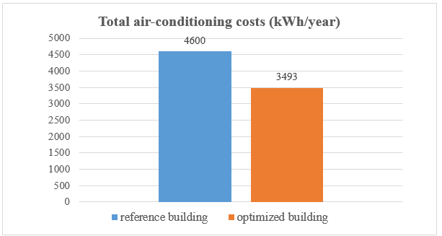

Figure 6: Total air-conditioning load diagram for the building in reference and optimized situations.
Figure 6 shows that total air-conditioning loads in the reference situation are much higher than in the optimized situation. The difference in air-conditioning loads between the building in the reference situation and in the optimized situation is 1107 kWh/year, or approximately 24.06%.
- CONCLUSION
This study demonstrated the significant impact of architectural optimization on the thermal and energy performance of a building in a Sahelian climate, particularly in the city of Ouagadougou. Using KoZiBu simulation software, we were able to model and analyze the effects of various design strategies on indoor temperatures and cooling energy requirements.
Optimization by using the BLT-hollow breeze-block double wall showed promising results, with a notable average reduction in maximum interior temperatures : 2.25°C in bedroom 1, 2.6°C in bedroom 2 and 2°C in the living room. These temperature reductions are particularly significant in a hot climate like that of Ouagadougou, where thermal comfort is a major issue for the well-being of occupants.
Optimization has also led to a substantial reduction in the energy required for air conditioning, with a 24.06% reduction in sensitive loads. This translates into a reduction in the building's energy consumption, contributing to a more sustainable and economical use of energy resources. This reduction in air-conditioning demand not only cuts energy costs, but also reduces the building's carbon footprint, bringing construction practices into line with sustainable development objectives.
Beyond the scope of this thesis, several approaches could provide further insight or new perspectives for analyzing building performance :
- Improving the properties of BLTs for greater efficiency in buildings, especially in terms of thermal comfort ;
- A more in-depth study on the construction of double-wall buildings using all types of materials used in Burkina Faso, while taking into account bioclimatic architectural design. In addition, conducting an experimental study on a constructed building and evaluating the additional cost associated with double walls ;
- Integrating passive air conditioning systems such as Canadian wells and evaporative cooling systems into buildings.

Disclaimer (Artificial intelligence)

Author(s) hereby declare that NO generative AI technologies such as Large Language Models (ChatGPT, COPILOT, etc.) and text-to-image generators have been used during the writing or editing of this manuscript.
REFERENCE
- Energy efficiency in buildings in the Mediterranean, Henri-Luc. Director of Plan Bleu, El Habib El Andaloussi. In charge of Energy at Plan Bleu, No. 376, July-August 2011.
- Energy Management Unit- Burkina Faso. Implementation of a curative and preventive maintenance program for the Burkinabé administration's electrical equipment. Ouagadougou-Burkina Faso, 2010.
- P. Y. Gagnon and P. H. Nfaoui, “Renewable energies: Distributed and community production”, article, pp. 3–5, 2013.
- Sector policy letter from the Ministry of Energy [Burkina Faso], October 2016
- AMADOU OUMAROU Fati, Ramchandra BHANDARI, MAMADOU Lewamy, KY Thierry S.M, OUEDRAOGO Souleymane, Rabani Adamou, COMPAORÉ Abdoulaye, BATHIEBO Dieudonné Joseph « Determination and Evaluation of the Cooling Load of a Building Made by Different Local Material of Construction » IRA-International Journal of Applied Sciences ISSN 2455-4499 ; Vol.15, Issue 01 (Q1 2020).
- Abdoulaye Compaore, Boureima Dianda, Gilbert Nana, D. Joseph Bathiebo, Belkacem Zeghmati, Xavier Chesneau and Stéphane Abide « Modeling of Heat Transfer in a Habitat Built in Local Materials in Dry Tropical Climate » Physical Science International Journal, 17(1) : 1-11, 2018 ; Article no.PSIJ.38931 ISSN: 2348-0130
- Khaireldin Mohammad Khair Farai, “Use of Phase Change Materials in Buildings: In-depth Review, Experimentation, Parametric Study, and Physical Analysis,” Thesis, March 2021.
- Etienne MALBILA, “Comparative experimental and numerical studies of the hygrothermal performances of two houses built from cut lateritic block and concrete block : highlighting the influence of thermal inertia on thermal comfort in a dry tropical climate”. Single doctoral thesis, Ouaga 1 Joseph KI-ZERBO University, 2018.
- Emmanuel Ouedraogo, Ousmane Coulibaly, Abdoulaye Ouedraogo, Adamah Messan, “Mechanical and Thermophysical Properties of Cement and/or Paper (Cellulose) Stabilized Compressed Clay Bricks”, vol. 2, p. 68‑76, 2015.
- Arnaud Louis Sountong-Noma Ouedraogo, Césaire Hema, Sjoerd Moustapha N’guiro, Philbert Nshimiyimana, Adamah Messan, « Optimisation du confort thermique des bâtiments dans un climat tropical chaud et sec : approche comparative entre les enveloppes en terre comprimée et en blocs de béton », Journal of Minerals and Materials Characterization and Engineering, vol. 12, p. 1-16, 2024.
- Hassane Seini Moussa, Decroly Djoubissié Denouwé, Abdou Lawane, Anne Pantet, Mamadou Diop, Koami Wisdom Boko, « An Empirical Formula for Assessing the Characteristic Strength of Unreinforced Laterite Stone Masonry », Civil Engineering Journal, Vol. 10, No 04, April 2024.
- M. Dlimi, R. Agounoun, I. Kadiri, R. Saadani, M. Rahmoune, « Thermal performance assessment of double hollow brick walls filled with hemp concrete insulation material through computational fluid dynamics analysis and dynamic thermal simulations. », e-Prime - Advances in Electrical Engineering, Electronics and Energy, Vo. 3 (2023) 100124.
- Etienne Malbila, Césaire Hema, Oumarou Yougbare, Mahamadi Nikiema, Adamah Messan, « Effect of the Combining Use of Hydrated Lime and Shea Butter Residue as Stabilizers on the Compressed Earth Blocks Physical, Mechanical, Thermal and Hydric Properties », Open Journal of Civil Engineering, Vol. 14, p. 678-700, 2024.
- Alexis Kemajou, Léopold Mba “Construction materials and thermal comfort in hot zones. Application to the case of Cameroonian climatic regions”, Revue des Energies Renewables Vol. 14 No. 2 (2011) 239 – 248.
- Aguérata KABORE, “Hygrothermal modeling of the building envelope with hemp material”, l’école technol. great. As required. partial to obtaining master's degree with mem. conc. energ. renewable eff. Msca Energy, Jan. 2020.
- Institute of Energy and the Environment of the Francophonie (IEPF), PRISME Works, Energy efficiency of air conditioning in tropical regions, Thermal Assessment. Volume 1 : Design of new buildings, http://www.iepf.org, 2002.
- Institute of Energy and the Environment of the Francophonie (IEPF), PRISME Works, Energy efficiency of air conditioning in tropical regions, Thermal Assessment. Volume 2 : operation of existing installations, ISBN : 2-89481-010-5, http://www.iepf.org, 2002.
- Institute of Energy and the Environment of the Francophonie (IEPF) 2006, PRISME Technical Sheets, Energy quality codes for buildings.w

