Impact of Chromatic Dispersion on NRZ, RZ and DPSK Modulation Formats in different optical links of a 402 km Metropolitan Optical Backbone

.
ABSTRACT

The use of optical fiber has revolutionized the optical telecommunications sector. Optical fiber enables faster data transmission in telecommunications networks. Data transmitted in fiber optic systems are affected by several phenomena during their propagation such as chromatic dispersion (CD). This phenomenon causes signal broadening and inter symbol interferences, resulting in signal distortion and data loss. This reduces the data transmission capacity in the optical fiber. The transmitted data is modulated according to a specific modulation format before being sent into the fiber. It is therefore important to choose a good modulation format in order to reduce the dispersion effect. In this article we aim to present a comparative analysis of CD effect on signals modulated with NRZ, RZ and DPSK modulation formats respectively. The study is carried out by simulation with OPTISYSTEM software, considering a 402 km metropolitan backbone of a telecommunication operator in Togo (West Africa). The study takes into account both the full 402 km link and individual sections of the backbone using an ITU-T G.652.D optical fiber at 10 Gbps and 100 Gbps bits rate with a wavelength of 1550 nm. In order to evaluate the quality of transmission we used performance indicators such as Min BER and Q-Factor. The results show that chromatic dispersion reduces signal quality during transmission and that the NRZ modulation format outperforms RZ and DPSK formats in terms of signal quality at 10 Gbps but all formats fail at 100 Gbps.

Keywords: optical fiber, Chromatic Dispersion, telecommunications networks, signal broadening

1. INTRODUCTION

“Data exchange in telecommunications networks has increased considerably in recent years [1]. “This increase is due to the use of optical fiber as a transmission channel” [2]. “In optical transmission, data is modulated into an optical signal that is transmitted through an optical fiber. And to modulate a signal it is important to choose an appropriate modulation format. In optical communication we note many modulations format such as Non-Return to Zero (NRZ), Return to Zero (RZ), Differential Phase Shift Keying (DPSK), Dual-Polarization Quadrature Amplitude Modulation (DP QAM) ... But NRZ, RZ and DPSK formats are generally the most used” [3 -7]. “The NRZ format is a modulation format in which each bit occupies the entire symbol period and is represented by a constant level. A high level represents a bit 1, and a low (or zero) level represents a bit 0 [4, 8, 9]. It is characterized by low spectral occupancy, and a simple implementation. The RZ format is a format where each bit is represented by a pulse that occupies only a fraction of the symbol interval. A 1 bit is represented by a pulse that rises to a high level and then returns to zero before the end of the bit, and a 0 bit is generally represented by an absence of a pulse for the entire duration of the bit. Here, the pulse always returns to zero between two bits, even if two consecutive bits have the same value” [4, 9]. “This format offers high bandwidth but is also a source of high-power consumption. DPSK is a differential phase modulation in which binary information is not transmitted by the absolute phase of a symbol, but by the phase difference between two consecutive symbols. A bit 1 is often represented by a phase change, and a bit 0 is represented by the absence of a phase change” [9].
A signal propagating through the optical fiber undergoes effects that affect its quality. These effects are due to certain phenomena such as chromatic dispersion which causes signal broadening, inter symbol interferences and the distortion of the transmitted signal. These effects can be reduce using an appropriate modulation format. “Chromatic dispersion is a phenomenon due to the variation of the refractive index of the fiber as a function of the wavelength. This index variation causes the different components of the signal to propagate at different speeds” [10], thus causing signal widening [11] and inter symbol interference (ISI) [12]. “This results in distortion and degradation of the transmitted signal, causing data loss, which limits the transmission capacity of the fiber” [11, 13]. “It is therefore important to study the CD in order to reduce its impact on a transmitted signal. This study will aim to identify the modulation format that would reduce the effect of chromatic dispersion on the signal” [23].
In this work, we investigate through simulations, with the OptiSystem software, the effects of chromatic dispersion on an entire line as well as on individual sections of the fiber optic link of a long-distance telecommunications network installed in Togo. More precisely, this work analyzes the effect that CD can have on a transmitted signal by choosing different modulation format. It also checks if the link can withstand an increase in bit rate. After a brief presentation of material and methods (the OptiSystem software, and chromatic dispersion) in section 2, we will present the simulation results and their discussion in section 3 and in section 4 we will conclude.

2. material and methods
2.1 OptiSystem software
OptiSystem is a design software for testing and simulating optical transmission links of optical networks. It is a powerful tool that allows to visualize the effect of a phenomenon on a signal transmitted through an optical fiber [14]. It has all the components needed to design any optical transmission system.
2.2 Chromatic dispersion
The chromatic dispersion in optical fibers results from the fact that the refractive index of the fiber varies according to the wavelength of the transmitted signal. The equation for modelling the propagation of an electromagnetic wave, not taking into account nonlinear effects, is given by the linear Schrödinger equation (LSE = Linear Schrödinger Equation) [15] :
 | $$i\frac{∂A(z,t)}{∂z}-\frac{β_{2}}{2}\frac{∂^{2}A(z,t)}{∂t^{2}}=0$$ | (1)
With A(z,t): the electric field envelope; $β_{2}$: Group Velocity Dispersion (GVD).
In this equation the parameter $β_{2}$is responsible for chromatic dispersion. It is the second derivative of the propagation constant. It can take positive, null or negative values. The physical interpretation of these values depends on the degree of signal widening [16]. It is connected to chromatic dispersion by equation (2) [17] :
 | $$D=\frac{d}{dλ}\left(\frac{1}{v_{g}}\right)=-\frac{2πc}{λ^{2}} β_{2}$$ | (2)
Where λ is the wavelength and $v_{g}$is the group velocity. Chromatic dispersion can be expressed in terms of two types of dispersion: waveguide dispersion and material dispersion.
Material dispersion, in optical fibers, results from the variation of the refractive index of silica as a function of wavelength. It expresses the absorption of electromagnetic radiation by silica, the material used to make optical fibers [17].
Waveguide dispersion can be approximated by assuming that the refractive index of the fiber does not vary as a function of wavelength, which is obviously incorrect. It results from the difference in signal power distribution between the core and cladding of the fiber, especially at longer wavelengths [18].
The effects of chromatic dispersion are manifested by the fact that the spectral components of the signal propagate at different group velocities, causing broadening and distortion of the signal.

  - Simulation
The OptiSystem software was used to analyze in more details the effects of chromatic dispersion on a signal modulated with different modulation formats. For the simulation, a 402 km metropolitan backbone of a telecommunication operator in Togo (West Africa) is considered. The backbone is designed around six (6) nodes which are: TELESSOU, KEVE, KPALIME, ATAKPAME, NOTSE and ADETICOPE. The lengths of the different links of this backbone are: 45 km (TELESSOU to KEVE), 87 km (KEVE to KPALIME), 115 km (KPALIME to ATAKPAME), 67 km (ATAKPAME to NOTSE), 73 km (NOTSE to ADETICOPE) and 15 km (ADETICOPE to TELESSOU), as shown in Figure 1. The Corning SMF-28 Ultra 200 optical fiber [19] is used in the optical cables installed in this backbone and this optical fiber is compliant with ITU-T G.652.D [20]. The operating wavelength of the different optical links is 1550 nm. Table 1 shows the general parameters of the fiber used (Attenuation Coefficient, Chromatic Dispersion Coefficient); Table 2 shows the different attenuation for each link sections. These attenuations take into account the linear losses of the fiber itself (0,18 dBm/km) as well as the splicing (0,1 dBm) and interconnection losses (0,5 dBm). Table 3 shows the parameters of the signal injected into the fiber in the input.
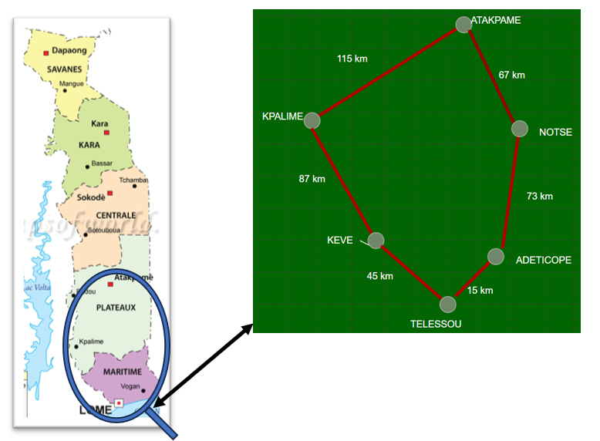

Fig. 1. Optical Network link

Table 1. General optical fiber parameters
Parameters | Values
Attenuation Coefficient | 0,18 dBm/km at 1550 nm
Chromatic Dispersion Coefficient | 18 ps/(nm.km) at 1550 nm
Table 2. Attenuation for individual link sections and the entire link
Distance | 45 km | 87 km | 115 km | 67 km | 73 km | 15 km | 402 km
Attenuation (dBm/km) | 0,23 | 0,22 | 0,22 | 0,23 | 0,23 | 0,27 | 0,22

Table 3. Signal parameters
Parameters | Values
Bit rates | 10 Gbps; 100 Gbps
Wavelength | 1550 nm
Power | 10 dBm (10 mW)
Binary sequence | 0101101110
Frequency | 193.41 THz
Modulation format | NRZ, RZ and DPSK

Figure 2 shows the setup designed in OptiSystem to enable simulation. This diagram consists of a binary sequence generator, a modulation system, and a laser emitting a frequency of 193.41 THz (1550 nm). The digital signal from the modulation system and the wave from the laser are combined in the Mack Zender modulator (MZ modulator) to obtain the optical signal, which is sent through the optical fiber after passing through an optical amplifier. At the output, we have a signal detector (PIN Photodiode) and an Eye diagram analyzer that allows us to evaluate the quality of the output signal.
Bit rates of 10 Gbps and 100 Gbps are respectively considered to assess the robustness of the link to an increasing of bit rates especially since the demand for quality service is pushing telecommunications operators to increase transmission speeds.

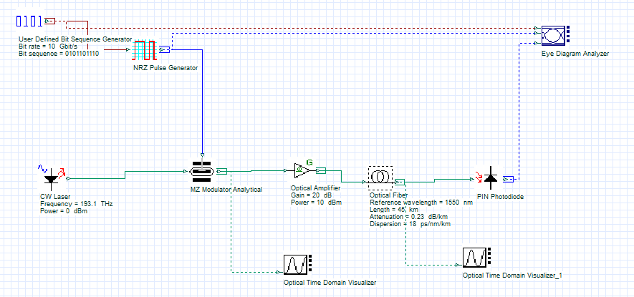
Fig. 2. Simulation setup

3. results and discussion
3.1 results
To evaluate the quality of the signal at the end of the optical link and the performance of the backbone we measured performance parameters or metrics such as Minimum Bit Error Rate (Min BER) and Q-Factor, which are excellent parameters for assessing transmission quality in the presence of chromatic dispersion. In optical transmission systems, the Q-factor is a metric used to evaluate signal quality at the output. It is widely used to estimate the bit error rate (BER). A high Q-factor value indicates good bit separation and a high-quality signal. This value indicates a low BER. Inversely, a low Q-factor value indicates strong inter-symbol interference (ISI) and therefore a high BER. In this case, the signal is severely degraded.

Figure 3 and Figure 4 present the variation of the Q-Factor as a function of distance for each modulation format respectively for bit rate of 10 Gbps and 100 Gbps. Figure 3 shows for example that for a length of 15 km the Q-Factor value is 13, 41 for the NRZ modulation format. We have 3,15 and 0 for respectively RZ and DPSK modulation format. Figure 3 shows that for all modulation format, at 100 Gbps, the Q-Factor is 0 for any distance.

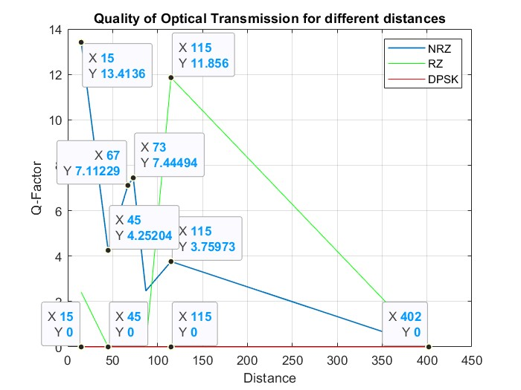
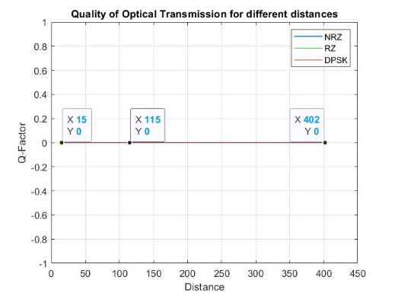

Fig. 3. Q-Factor for different modulation formats at bit rate of 10 Gbps
Fig. 4. Q-Factor for different modulation formats at bit rate of 100 Gbps

Figure 5 and Figure 6 present the variation of Minimum Bit Error Rate (Min BER) as a function of distance for each modulation format respectively for a bit rate of 10 Gbps and 100 Gbps. Figure 5 shows for example that for all distance the Min BER for the DPSK modulation format is 1 similarly like the Q-Factor in figure 4.
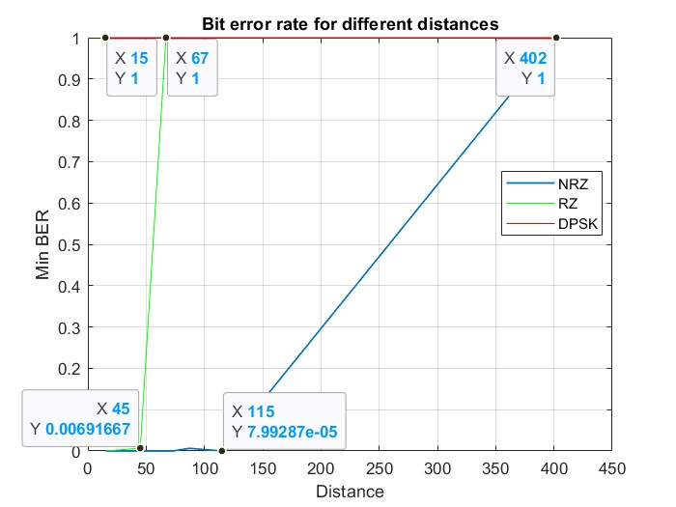
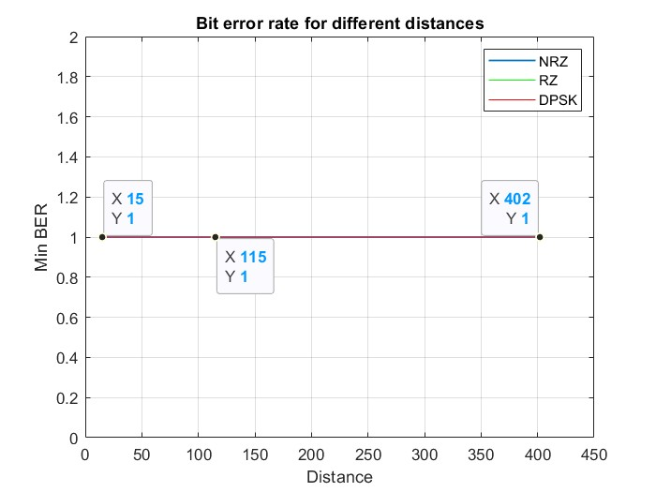

Fig. 6. Min BER for different modulation formats at a bit rate of 100 Gbps
Fig. 5. Min BER for different modulation formats at bit rate of 10 Gbps

3.2 Discussion
For the bit rate of 10 Gbps, the Q-Factor decreases as a function of distance. The more the distance increases, the more the value of the Q-Factor decreases until it becomes null at a distance of 402 km for the NRZ format while it is already null from 67 km for the RZ format. For any distance the DPSK format presents a null Q-Factor. These values indicate that “at this bit rate the inter symbol interference (ISI) phenomenon and the distortion caused by chromatic dispersion (CD) is relatively low for the signal modulated using NRZ format compared to signal modulated with other modulation formats” [23]. These observations explain the different values of Q -Factor and Minimum Bit Error Rate (Min BER). For the NRZ format, the full-length rectangular shape reduces the bandwidth required, making this format particularly suitable for long-distance transmissions. Meet Kumari and al find the similar results in their work [21] . The values ​​obtained for DPSK can stem from several reasons. Among other things, there may be a problem with detection of DPSK signal at the output, strong chromatic dispersion that completely erases the phase difference between successive bits, spreading the pulses until they perfectly overlap, resulting in total inter-symbol interference. “For the bit rate of 100 Gbps all Q-Factor values are zero for any modulation format. This is due to the fact that at 100 Gbps the transmission speed has increased and the time separating two bits is relatively short. This increases the inter symbol interference (ISI) phenomenon and an accentuation of signal distortion leading to a total loss of information” [23]. These observations explain the Min BER value 1. Irrespective of the modulation format under consideration, the minimum BER is 1 and the Q-Factor is null at a bit rate of 100 Gbps. This indicates that the link under consideration is not suitable for an increase of bite rates around 100 Gbps unless compensation methods are used or the optical fiber cable is changed. “For a spectral consideration all these observations are due to the fact that the RZ format presents a better temporal distinction between symbols, a good robustness against noise and a wide spectral width, while the NRZ format is good for long distances due to its narrow spectral width or small bandwidth and present a better tolerance to chromatic dispersion compared to other modulation formats” [22, 23].

4. Conclusion

This paper investigated by simulation the effect of chromatic dispersion on NRZ, RZ and DPSK signals propagating in different optical links of a 402 km metropolitan backbone of a telecommunication operator in Togo (West Africa). The performances of this optical system are evaluated using performance metrics like the Min BER and the Q-factor. The simulation is performed first on the different sections of the backbone and then on the entire link. The results show that the NRZ modulation format is better than RZ and DPSK at the bit rate of 10 Gbps considering all distances. For the bit rate of 100 Gbps all modulations formats are not better for all distances. It means that the link studied cannot support an increase in data rate. One can see that the signal distortion depends not only on the width and shape of the input pulses but also on the propagation distance, the bit rate used in the transmission system and the modulation format. For the telecommunication system studied, it is important to use compensation systems like the Dispersion Compensating Fiber or Fiber Bragg Gratings to perform the quality of the signal. It will be the aim of future work.
Disclaimer (Artificial intelligence)

Author(s) hereby declare that NO generative AI technologies such as Large Language Models (ChatGPT, COPILOT, etc.) and text-to-image generators have been used during the writing or editing of this manuscript.

References

[1] | A. Maskooki, G. Sabatino and N. Mitton, Modeling and Simulation of Computer Networks and Systems: Methodologies and Applications, M. S. Obaidat, P. Nicopolitidis and F. Zarai, Eds., 2015, pp. 601-627.
[2] | Z. Junyao, "The Design and Optimization of Optical Fibers for High-Speed Data Transmission," Journal of Materials Science and Chemical Engineering, vol. 13, no. 1, pp. 87-92, 31, January 2025.
[3] | A. A.-H. Aqeel, G. Basim, A. S. Ali and B. Mustafa, "Technique to Improve Mitigating Chromatic Dispersion," Recent Trends and Applications of Soft Computing in Engineering (RTASCE), vol. 1273, p. 117, 2025.
[4] | T. Priyanka and B. Manisha, "Performance analysis of NRZ, duobinary, CSRZ & VSB-CSRZ modulation formats for 32-channel WDM radio-over-fiber systems using single drive Mach-Zehnder modulator," Journal of Optics, pp. 1-11, 03 March 2025.
[5] | H. Attila and F. Andrea, "Dispersion Limitation of Digital Signal and Carrier Distribution in Optical-Wireless Networks," 35th International Conference Radioelektronika (RADIOELEKTRONIKA), pp. 1-6, 23 May 2025.
[6] | H. I. Zainab, J. J. Noor and N. J. Zainab, "Performance study of different dispersion compensations schemes: review," Journal of Optics, 31 January 2025.
[7] | A. Farman, K. Yousaf and S. Q. Shahryar, "Transmission Performance Comparison of 16*100 Gbps Dense Wavelength Division Multiplexed Long Haul Optical Networks at Different Advance Modulation Formats under the Influence of Nonlinear Impairments," Journal of Optical Communications, vol. 43, no. 1, pp. 1-10, 31 January 2019.
[8] | Rajeev and K. Chakresh, "Performance Investigation of NRZ-DQPSK, CSRZ-DQPSK and MDRZ-DQPSK Modulation Techniques for 450 Channel UD-WDM System for Long Haul Communication," Journal of Scientific & Industrial Research, vol. 82, pp. 870-884, August 2023.
[9] | J. Mauro and S. Raghavan, Advanced modulation formats for fiber optic communication systems, D. Springer, Ed., 2008, p. 283–312.
[10] | C. Xin, E. H. Jason, S. S. Jeffery and L. Ming-Jun, "Chromatic Dispersion Measurements of Single-Mode Fibers, Polarization-Maintaining Fibers, and Few-Mode Fibers Using a Frequency Domain Method," Photonics, vol. 10, no. 215, 2023.
[11] | A. Y. Saniya, R. S. and V. J. P., "Study of Chromatic Dispersion in Single-Mode Optical Fiber," Journal of Physics: Conference Series, vol. 2426 (2023) 012026, 2023.
[12] | I. Nsengiyumva, E. Mwangi and G. Kamucha, "A comparative study of chromatic dispersion compensation in 10 Gbps SMF and 40 Gbps OTDM systems using a cascaded Gaussian linear apodized chirped fibre Bragg grating design," Heliyon , vol. 8, no. 4, 2022.
[13] | C. Xin, E. H. Jason, S. S. Jeffery and L. Ming-Jun, "Chromatic Dispersion Measurements of Single-Mode Fibers,Polarization-Maintaining Fibers, and Few-Mode Fibers Using a Frequency Domain Method," Photonics, vol. 10, no. 215, 2023.
[14] | Optiwave, "Innovative Photonics Design Software," Optiwave, [Online]. Available: https://optiwave.com/. [Accessed 11 mars 2025].
[15] | G. P. Agrawal, "Nonlinear Fiber Optics," 5th ed., Academic Press, 2013.
[16] | W. Shukree, "Characterization of chromatic dispersion in single mode fibre,," Nelson Mandela Metropolitan University, December 2014.
[17] | G. P. AGRAWAL, Fiber-optic communication system, 3e ed., W. John, Ed., New York: John Wiley & Sons, Inc, 2002.
[18] | M. Fedor, Fiber Optics, Physics and Technology, New York, Springer-Verlag Berlin Heidelberg: Springer, 2009.
[19] | Corning, "Corning® SMF-28® Ultra 200 Optical Fiber," 2024.
[20] | ITU-T, "Recommendation ITU-T G.652," 11/2016.
[21]  [22] | K. Meet, S. Neha, C. Rahul, J. Kireet and K. Amit, "Design of OWC System Using RZ/NRZ Data Formats," 2024 Asia Pacific Conference on Innovation in Technology (APCIT), pp. 1-4, 2024.  Gerd, K. (2021) Optical Fiber Communications. 6th Edition, Springer  [23] Kolah, A. D., Mao, B. M., Ling, Q., & Chen, D. (2025). Simulation of Chromatic Dispersion Effects in a Metropolitan ITU-T G. 652. D Optical Fiber Link at 10 Gbps, 100 Gbps and 200 Gbps with NRZ and RZ Modulation Format. Journal of Electromagnetic Analysis and Application, 17(5), 79-91.

