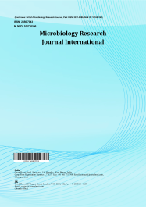
Microbiology Research Journal International

Volume XXX, Issue XX, Page XX-XX, 20YY; Article no.MRJI.151428
ISSN: 2456-7043, NLM ID: 101726596
(Past name: British Microbiology Research Journal, Past ISSN: 2231-0886, NLM ID: 101608140)

Multidrug-Resistant Aeromonas hydrophila in Retail Fish Markets: Prevalence, Survival and Public Health Implications

Authors’ Name……………………………………………………

Affiliations……………………………………………………….………………

Authors’ contributions

This work was carried out in collaboration among all authors. ‘Author A’ designed the study, performed the statistical analysis, wrote the protocol, and wrote the first draft of the manuscript. ‘Author B’ and ‘Author C’ managed the analyses of the study. ‘Author C’ managed the literature searches. All authors read and approved the final manuscript.

Article Information

DOI: 10.9734/MRJI/2026/XXXXX

Open Peer Review History:
This journal follows the Advanced Open Peer Review policy. Identity of the Reviewers, Editor(s) and additional Reviewers, peer review comments, different versions of the manuscript, comments of the editors, etc are available here:

Received: DD/MM/20YY
………… Article
Published: DD/MM/20YY

Abstract

Aeromonas hydrophila is a widespread opportunistic pathogen commonly associated with aquatic environments and is responsible for infections in fish and other aquatic organisms. This study investigated during January to February 2025, the prevalence, survival ability and antibiotic resistance of Aeromonas hydrophila isolated from local fish markets in and around Salem, Tamil Nadu. The bacterium was detected in 33.29% out of 48 fish samples obtained, indicating a significant level of contamination, while 20% of Musca domestica samples (1/5), also tested positive, suggesting their role as potential mechanical vectors. Antibiotic susceptibility profiling revealed that the potential isolate (CS1) showed resistant to ampicillin, amoxyclav, cephalexin, cefazolin, methicillin, oxacillin and vancomycin, indicating the presence of multidrug resistant strains. Survival studies showed that Aeromonas hydrophila could adhere to and persist on commonly used market surfaces such as stainless steel, wood, iron and thermocol. It also exhibited tolerance to a wide range of pH and temperature conditions. Experiments with common Indian cooking ingredients demonstrated varying inhibitory effects and several disinfectants and antiseptics were effective against the isolates. These findings highlight Aeromonas hydrophila contamination may cause public health issues such as gastrointestinal tract infections, septicaemia, peritonitis in specifically in immunosuppressive persons. Emphasize the need for improved hygiene and handling practices in fish markets.

Keywords: Aeromonas hydrophila; fish; Musca domestica; survival; inhibitory effects; gastrointestinal tract infections.

1. Introduction

Fish is a vital, globally consumed food source providing high quality protein, essential fatty acids and crucial micronutrients like iodine, selenium and vitamin D. As a reasonable protein, it combats malnutrition and promotes cardiovascular health by reducing blood pressure and supporting heart function. It is a well-established fact that now a day fish in many global aquatic environments are contaminated with various pollutants due to a combination of natural and human related factors. Bacterial contamination in fish is a significant and widespread concern today, posing risks to both fish populations and human health. Contamination can occur at any point from the aquatic environment to the consumer's plate, and the rise of antibiotic-resistant bacteria in fish farming is an emerging issue. Aeromonas hydrophila (A. hydrophila) is a Gram-negative, facultative anaerobic, rod-shaped species with a monotrichous flagellated bacteria (Kaur et al., 2024) and it is a common pathogen found in various aquatic flora and fauna, freshwater, wastewater and coastal regions (Chen et al., 2021). It is a widespread pathogen that causes infections in aquatic animals, particularly fish. They are commonly found in meats from poultry, aquatic animals, as well as in raw milk, vegetables and fresh water (Stratev & Odeyemi, 2016). They can survive in food items like uncooked, ready-to-eat, re-contaminated and food that has been washed with contaminated water. These bacteria may be serious health risks associated with their inclusion in food items (Lee et al., 2023). Their presence in preserved food products suggests that they can thrive under preservation conditions and produce toxins. Consequently, they pose a public health risk as foodborne pathogens (Kim et al., 2022).

A. hydrophilla is an opportunistic pathogen, as it can be transmitted through contaminated water and foods, causing gastrointestinal and wound infections in immunocompromised individuals, leading to a higher risk of disease in those populations (Fernández-Bravo et al., 2020; and Casabianca et al., 2015). In recent studies reported that, A. hydrophilla developed antimicrobial resistant properties such as bla (for beta-lactamases) and tetA (for tetracycline resistance) are common, high resistance to Penicillin (around 80%), Oxytetracycline (around 70%), and Macrolides (around 68%). Some toxins also responsible for the antimicrobial resistance such as extracellular nuclease, acyltransferase, phospholipase, hemolysin, elastase, aerolysin and cytotoxic enterotoxins (Bakiyev, et al., 2022). Additionally, it can produce a biofilm for biotic or abiotic surfaces, which contributes to its resistance against antibiotics (Liu et al., 2020). However, the overuse and improper use of antibiotics cause drug residues to accumulate the animals and the environment and also encourage the growth of antibiotic-resistant and multidrug-resistant bacteria (Odeyemi et al., 2016; Khor et al., 2018). A. hydrophila strains are resistant to several common antibiotics such as ampicillin, penicillin and tetracycline (Pal et al., 2020).

Fish is a valuable food source due to its delicious taste, easy digestion and high nutritional value. It is more common and less expensive than other animal protein sources. It is also one of the fastest growing food production sectors, which could play a big role in eradicating hunger, malnutrition and nutrient-deprivation globally (Mohanty et al., 2019). A. hydrophila can enter fish markets through contaminated people, equipment and water. Once introduced, it can survive on fish handlers’ hands, knives, chopping boards and fish surfaces, spread during handling and processing (Igbinosa et al., 2012).

Other ways, Musca domestica are commonly found within human activity areas such as hospitals, food markets, slaughterhouses, restaurants, poultry and livestock farms. They constitute a significant nuisance not only due to their presence because they are carriers on their body surfaces and act like potential vectors of many pathogenic microorganisms including bacteria, viruses, fungi, protozoa and parasitic worms (Sarwar et al., 2015; Nayduch et al., 2017). It can also serve as a mechanical carrier of A. hydrophila, contributing to its environmental spread and possible transmission to humans or animals (Adesewa et al., 2024). A higher proportion of bacteria (74%) was recovered from the internal parts of the flies, whereas only 26% originated from their external surfaces (Gioia et al., 2022).

Salem is a landlocked district in the state of Tamil Nadu. On the South Indian coasts, fish and crustaceans are caught and transported to Salem. Some fishery farms in and around Salem transport fish to markets and retail shops. The study examined the prevalence of this organism in fish samples that were collected from local areas in and around the fish markets of Salem District, Tamil Nadu. Hence, this study was aimed at investigating the source of cross-contamination in retail outlets and characterizing their survival capacity on different types of wood, metal, thermocol and fish samples. Further, the potential role of Musca domestica, the common name houseflies in the epidemiology of this pathogen was investigated by examining the prevalence of A. hydrophila, disinfectants and antiseptic agents. The antibacterial activity of the A. hydrophila strains were also carried out and the resistant pattern has also been investigated.

2. Materials and Methods

2.1 Sample Collection

The study was carried out on the fish and houseflies namely M. domestica collected from fish retail markets of Salem City of Tamil Nadu, India. The samples were collected between 7.00 AM and 9.00 AM for a period of one month during the winter seasons (January and February 2025). The samples after received to the laboratory, small pieces of fish intestine were placed in alkaline peptone water (APW). A sterile cotton swab was used to wipe the fish's gills and body's exterior surfaces (Fig. 1). After transferring the swabs to 6 ml of APW, it was incubated for 24 h at 37°C (Rajakumar et al., 2012). Whole M. domestica were dipped into screw-cap bottles containing 6 ml of APW (Fig. 2) to transfer the bacterial load into APW and incubated at 37°C for 24 h (Nayduch et al., 2001).

2.2 Isolation and Identification of A. hydrophila

The enriched cultures were streaked on Starch Ampicillin Agar (SAA) plates and incubated at 37˚C for 24 h (Palumbo et al., 1985). To identify amylase producing colonies, the plates were treated with 5 mL of iodine solution, after which clear zones around colonies indicated positive isolates. These selected cultures were then purified by streaking them multiple times on nutrient agar and kept in nutrient agar slants for further studies. The confirmation of isolated A. hydrophila strains were further examined using Gram staining, the motility test and the oxidase test.

2.3 Antibacterial Sensitivity Test

Antibacterial susceptibility testing was performed using the kirby-Bauer disk diffusion technique on Muller Hinton agar plates. A total of 11 colonies isolated from fish retail shops were tested against 14 standard antibiotics. The antibiotics used were Ampicillin (10 mcg), Amoxyclav (30 mcg), Amikacin (30 mcg), Ceftazidine (30 mcg), Csphalothin (30 mcg), Cefazolin (30 mcg), Kanamycin (30 mcg), Methicillin (5 mcg), Nalidixic Acid (30 mcg), Neomycin (30 mcg), Oxacillin (10 mcg), Streptomycin (10 mcg), Sulphafurazole (300 mcg) and Vancomycin (30 mcg). The antibiotic susceptibility patterns were determined using the zone sizes which were then interpreted, according to the NCCLS standard. The strain CS1 showed a high level of antimicrobial resistance and not sensitive to any of the tested antibiotics, as mentioned in the results. Hence, this strain was selected for further experiments.

2.4 Influence of pH on the Growth of A. hydrophila (CS1)

The effect of pH on the growth of A. hydrophila (CS1) was investigated using nutrient broth adjusted to pH values between 3.0 and 12.0. The desired pH levels were obtained by adding 1.0 M HCl or 1.0 M NaOH. Each culture tube was inoculated with an overnight grown A. hydrophila (CS1) culture and incubated at 37°C for 24 h. After incubation, bacterial growth was evaluated by determining the optical density at 600 nm with a spectrophotometer (Li et al., 2017).

2.5 Survival of A. hydrophila (CS1) on Fish Meat at Various Temperatures

In this study, about 6g muscle pieces of Oreochromis niloticus meat were used to prepare three sets of samples namely, one unsterilized and two sterilized at 121°C under pressure heat. The bacterium A. hydrophila (CS1), isolated from a fish sample was employed throughout the survival study. The isolate was cultured in nutrient broth at 37°C for 18 h to obtain an enriched inoculum. Subsequently, about 1 ml of the culture was inoculated into each portion of fish meat and incubated at 30, 10 and 4°C for 72 h. At 24 h intervals, 1 g of meat was aseptically collected and homogenized. Pour plate technique was performed using starch agar (SAA) medium and the plates were incubated at 37 °C for 24 h. After incubation, approximately 5 ml of Lugol’s iodine solution was added to each plate. Colonies exhibiting amylase activity appeared yellow to honey colored and oxidase positive colonies were also identified.

2.6 Survival of A. hydrophila (CS1) on Stainless Steel, Wood, Iron and Thermocol Pieces

Cross contamination of A. hydrophila in retail fish markets may occurs when processing and other retail operations. The transformation of fish pathogen might be due to improper maintenance of fish meat, surfaces, workers, often exacerbated by poor hygiene, inadequate cold chain management and shared equipment. From the retail fish market, high risk practices include using the same cutting boards, knives or contaminated ice for raw and cooked items. Based on these circumstances, a laboratory test has been carried out for survival of A. hydrophila (CS1) on stainless steel, wood, iron and thermocol pieces. In this study, pieces of stainless steel, wood, iron and thermocol, each measuring 2.5 cm by 3 cm were prepared and sterilized at 121°C under 15 Lbs pressure. These materials were selected based on their common use in fish retail shops, including items such as balances, chopping boards, knives and transport and storage equipment. The strain A. hydrophila (CS1) was cultivated in nutrient broth at 37°C for 18 h. About 1 ml of the culture sample was taken and spread evenly over the surface of each material using a sterile cotton swap, ensuring complete coverage. The materials were then incubated at 30°C for 48 h. At 8 h intervals, the materials were removed and washed thoroughly with sterile distilled water. The pour plate method was employed to count the number of A. hydrophila colonies using SAA medium.

2.7 Survival of A. hydrophila (CS1) in Fish Meat Under Traditional Cooking Ingredients

A total of 6g of unsterilized Oreochromis niloticus meat samples were collected and inoculated with A. hydrophila (CS1). The samples were then incubated at 37°C for 4 h. A readymade mixture of fish curry cooking ingredients, which included 1g each of salt, turmeric powder, tamarind, garlic paste and ginger paste was prepared. These ingredients were combined with sterile distilled water until a sticky consistency was achieved.

The resulting mixture was applied to each meat sample under aseptic conditions and allowed to air dry in a sterile chamber for one hour. Following this, the samples were incubated at 30°C for 72 h. At 24-hour intervals, 1g of each meat sample was taken and homogenized under aseptic conditions. The pour plate technique was then employed using SAA and the plates were incubated at 37°C for 24 h. After this incubation period, approximately 5 ml of Lugol’s iodine solution was applied to the plates.

2.8 Susceptibility of A. hydrophila in Various Disinfectants and Antiseptic Agents

The antibacterial activity of various chemical agents was determined using the disc diffusion method on Soyabean Casein Digest Agar (Tryptone Soya Agar). The surface of each plate was inoculated with bacterial cultures of A. hydrophlla using a sterile cotton swab dipped into a bacterial suspension adjusted to the 0.5 McFarland standards. The inoculation was done by streaking the swab horizontally, vertically and around the edge to ensure uniform growth. Sterile paper discs were immersed in different chemical solutions - phenol (1:40), Lysol (1:50), bleaching powder (1:100), ethyl alcohol (70%), hydrogen peroxide (40%), formaldehyde (8%), iodine (1:20), crystal violet (1:20), Dettol (1:30) - and one control disc soaked in sterile water. Each disc was gently pressed to ensure proper contact with the agar surface. The plates were inverted and incubated at 37°C for 24 to 48 h. After incubation, the antibacterial effect of each chemical was evaluated by observing and measuring the diameter of the clear zones of inhibition around the discs.

3. Results

3.1 Incidence of A. hydrophila in Fish Samples during the Study Period

In the present study, a total of 12 isolates of A. hydrophila were recovered from the collected 48 samples (Table 1). Of these 11 isolates originated from the fish samples obtained from retail markets, while only 1 isolate was detected from M. Domestica. The presence of A. hydrophila in both fish and M. domestica indicates a possible link between aquatic products and the surrounding environment, suggesting that M. domestica may function as a potential mechanical carrier of the bacterium. Among the fish isolates, the incidence rates varied according to body parts, with 14.48% recovered from the body surface, 8.33% from the gill surface and 10.48% from the intestinal region. The prevalence and incidence of A. hydrophila in the collected fish samples is summarized in Table 2 and Table 3. The isolate from M. domestica was obtained from the external body surface of the fly. These results collectively emphasize the possible involvement of M. domestica in the dissemination of A. hydrophila in fish-handling environments. The prevalence and incidence of A. hydrophila in the collected fish samples is summarized in Table 4.

3.2 Antibacterial Sensitivity Test

The results of the antibacterial sensitivity test for A. hydrophila isolates obtained from fish retail shops and M. domestica are summarized in Table 5. All isolates exhibited moderated resistance to the following antibiotics: ampicillin, amoxicillin, cephalothin, cefazolin, methicillin, oxacillin and vancomycin. In contrast, the lowest resistance rate was observed against streptomycin, neomycin and nalidixic acid, at 6.25%. Antibiotics such as amikacin, ceftazidime, kanamycin and sulfamethoxazole demonstrated high efficacy, showing susceptibility in over 90% of the tested isolates. These findings indicate that A. hydrophila isolates from fish retail environments possess multidrug resistance, particularly to β-lactam antibiotics, while still being sensitive to certain aminoglycosides and sulfonamides.

Strain CS1 showed a high level of antimicrobial resistance and no sensitivity to any tested antibiotics. Hence, this strain was selected for further experiments.

3.3 Influence of pH on the Growth of A. hydrophila

The optical density (OD) measurements were recorded to assess the influence of different pH levels on the growth of A. hydrophila (CS1). The findings revealed that A. hydrophila (CS1) exhibited optimal growth within the pH range of 5 to 8, as shown in Fig. 3.

3.4 Survival of A. hydrophila (CS1) on Fish Meat at Various Temperatures

The survival of A. hydrophila in Oreochromis niloticus samples was examined at three different temperatures namely, 30°C, 10°C and 4°C and the results are presented. The experiment was conducted over a period of 3 days using fish samples inoculated with A. hydrophila (CS1). In fish meat, the bacterial cell count increased significantly on day 1 and day 2 but showed a marked decrease by day 3 across all temperature conditions. Furthermore, the growth of A. hydrophila was found to be higher in sterilized fish samples compared to unsterileized ones at all tested temperatures. A comparative analysis of bacterial growth between sterilized and unsterilized fish samples is presented in Tables 7 and 8.

3.5 Survival of A. hydrophila (CS1) on Stainless steel, Wood, Iron and Thermocol pieces

The survival study of A. hydrophila (CS1) on stainless steel, wood, iron and thermocol surfaces revealed that the bacterium was capable of adhering to commonly used materials such as knives, chopping boards, weighing balances and thermocol boxes. This experiment was conducted using materials typically found in fish retail shops, at different time intervals (8, 16, 32, 40 and 48 h) with an inoculum concentration of 1 ml, as shown in Fig. 4. During the initial stages, the bacterial population was relatively low; however, it increased significantly, reaching a Too Numerous to Count (TNTC) level after 48 h on the thermocol surface and the results are presented in Table 9. In contrast, bacterial growth on other materials such as wood, stainless steel and iron showed a decline after 48 h of incubation.

3.6 Survival of A. hydrophila (CS1) in Fish Meat Under Traditional Cooking Ingredients

The survival of A. hydrophila (CS1) in Oreochromis niloticus meat sample was evaluated after incorporation with A. hydrophila (CS1) and various Indian traditional cooking ingredients and the results are given in Table 10. The study demonstrated an overall increase in bacterial growth across all treated samples. Among the different treatments, the tamarind-infused fish sample showed the highest bacterial growth after 72 h, whereas the salt-infused fish sample exhibited a noticeable reduction in growth over the same period. The experiment included six different ingredients combined with A. hydrophila (CS1), as illustrated in Fig. 5.

3.7 Susceptibility of A. hydrophila in Various Disinfectants and Antiseptic Agents

The susceptibility of A. hydrophila strains isolated from fish retail shops to various disinfectants and antiseptic agents was assessed and the results are presented in Table 11. The findings indicated that most chemical agents tested were ineffective against the isolates. However, ethyl alcohol and hydrogen peroxide exhibited strong antibacterial activity against the test organism.

Table 1. Sample collecting sites

S. No | Sample collecting sites | No of samples
1 | Salem Junction | 9
2 | Mettur | 9
3 | Old bus stand | 3
4 | Pudhu road | 6
5 | Hasthampatti | 6
6 | Four roads | 6
7 | Karuppur | 9
 | Total | 48

Table 2. Prevalence of A. hydrophila in fish samples during the study period

Name of the fishes | No of samples | Prevalence (%)
Oreochromis niloticus  Ompok spp  Xenentodon cancila  Piarachus brachypormus  Labeo rohita  Labeo catla  Sardinella fimbriata  Channa striata  Sphyraena sphyraena  Etroplus suratensis  Total | 15  3  3  3  3  3  3  3  6  6  48 | 10.41 (5 +ve)  2.08 (1 +ve)  2.08 (1 +ve)  2.08 (1 +ve)  2.08 (1 +ve)  2.08 (1 +ve)  2.08 (1 +ve)  4.16 (2 +ve)  2.08 (1 +ve)  4.16 (2 +ve)  33.29 (16+ve)

Table 3. Incidence of A. hydrophila in fish samples during the study period

Fish samples | No of samples | Prevalence (%)
Body surface  Gill surface  Intestine  Total | 16  16  16  48 | 14.58 (7 +ve)  8.33 (4 +ve)  10.41 (5 +ve)  33.32 (16+ve)

Table 4. Incidence of Aeromonas hydrophila in M. domestica samples

 | No of samples | Prevalence (%)
M. domestica  Total | 5  5 | 20% (1 +ve)  20% (5 +ve)

Table 5. Antibacterial sensitivity test

Antibiotics | CSBS | TBS | TG3I1 | TG | SBS | TG3I | TG3I2 | CSI | SG | TG4B | SI
Ampicillin (10 mcg) | R | R | R | S | S | R | R | R | R | R | R
Amoxyclav (30 mcg) | R | R | R | R | S | S | R | R | R | R | R
Amikacin (30 mcg) | I | S | I | S | S | S | S | R | S | S | S
Ceftazidine (30 mcg) | I | I | R | R | R | R | R | R | I | R | R
Csphalothin (30 mcg) | R | R | R | S | S | R | R | I | R | R | R
Cefazolin (30 mcg) | R | R | R | S | S | R | R | R | R | R | R
Kanamycin (30 mcg) | S | I | S | S | S | R | R | R | S | R | S
Methicillin (5 mcg) | R | R | S | R | R | R | S | R | I | R | R
Nalidixic Acid (30 mcg) | S | S | I | S | S | R | R | R | S | R | R
Neomycin (30 mcg) | I | R | I | I | S | I | I | R | I | S | S
Oxacillin (10 mcg) | R | R | R | R | R | R | R | R | R | R | R
Streptomycin (10 mcg) | I | I | S | R | S | S | S | R | R | S | S
Sulphafurazole (300 mcg) | S | S | I | S | S | S | S | I | S | S | I
Vancomycin (30 mcg) | R | R | I | S | S | R | R | R | R | I | R
(S –Sensitive, I – Intermediate, R – Resistance)

Table 6. Survival of Aeromonas hydrophila (CSI) on fish meat at various temperatures

Fish samples | Temperatures | Dilution | Day 1 | Day 2 | Day 3
Unsterilized fish | 30˚C | 10⁻²  10⁻³  10⁻⁴ | 326  43  0 | TNTC  TNTC  297 | 93  0  0
Sterilized fish | 30˚C | 10⁻²  10⁻³  10⁻⁴ | TNTC  2  1 | TNTC  TNTC  600 | TNTC  273  102
Unsterilized fish | 10˚C | 10⁻²  10⁻³  10⁻⁴ | 14  1  0 | TNTC  TNTC  304 | TNTC  312  53
Sterilized fish | 10˚C | 10⁻²  10⁻³  10⁻⁴ | 50  2  0 | TNTC  TNTC  600 | TNTC  85  14
Unsterilized fish | 4˚C | 10⁻²  10⁻³  10⁻⁴ | 0  15  0 | 1  0  0 | 12  0  0
Sterilized fish | 4˚C | 10⁻²  10⁻³  10⁻⁴ | 32  60  0 | 17  0  0 | 0  0  0
(TNTC – Too Numerous To Count, TFTC – Too Few To Count)

Table 7. Survival of Aeromonas hydrophila (CSI) on sterilized fish meat at various temperatures

Fish samples | Temperatures | Dilution | Day 1 | Day 2 | Day 3
Sterilized fish | 30˚C | 10⁻²  10⁻³  10⁻⁴ | TNTC  2  1 | TNTC  TNTC  600 | TNTC  273  102
Sterilized fish | 10˚C | 10⁻²  10⁻³  10⁻⁴ | 50  2  0 | TNTC  TNTC  600 | TNTC  85  14
Sterilized fish | 4˚C | 10⁻²  10⁻³  10⁻⁴ | 32  60  0 | 17  0  0 | 0  0  0
(TNTC – Too Numerous To Count, TFTC – Too Few To Count)

Table 8. Survival of Aeromonas hydrophila (CSI) on unsterilized fish meat at various temperatures

Fish sample | Temperatures | Dilution | Day 1 | Day 2 | Day 3
Unsterilized fish | 30˚C | 10⁻²  10⁻³  10⁻⁴ | 326  43  1 | TNTC  TNTC  297 | 93  0  0
Unsterilized fish | 10˚C | 10⁻²  10⁻³  10⁻⁴ | 14  1  0 | TNTC  TNTC  600 | TNTC  312  53
Unsterilized fish | 4˚C | 10⁻²  10⁻³  10⁻⁴ | 0  15  0 | 1  0  0 | 12  0  0
(TNTC – Too Numerous To Count, TFTC – Too Few To Count)

Table 9. Survival of Aeromonas hydrophila (CSI) on Stainless steel, Wood, Iron and Thermocol pieces

Materials name | Dilution | 8 hrs | 16 hrs | 24 hrs | 32 hrs | 40 hrs | 48 hrs
Thermocol | 10⁻¹ | TNTC | TNTC | TNTC | TNTC | TNTC | TNTC
Stainless steel | 10⁻¹ | 290 | 300 | 173 | TNTC | 1 | 0
Wood | 10⁻¹ | 250 | 234 | 168 | 0 | 0 | 0
Iron | 10⁻¹ | 37 | 23 | 1 | 0 | 0 | 0
(TNTC – Too Numerous To Count, TFTC – Too Few To Count)

Table 10. Survival of Aeromonas hydrophila (CSI) in fish meat under traditional cooking ingredients

Materials name | Dilution | Day 1 | Day 2 | Day 3
Unsterilized fish with salt | 10⁻¹  10⁻²  10⁻³ | TNTC  TNTC  TNTC | 350  298  296 | 306  200  5
Unsterilized fish with garlic | 10⁻¹  10⁻²  10⁻³ | TNTC  TNTC  TNTC | TNTC  TNTC  TNTC | 480  401  300
Unsterilized fish with turmeric | 10⁻¹  10⁻²  10⁻³ | TNTC  TNTC  TNTC | TNTC  TNTC  TNTC | 667  520  340
Unsterilized fish with tamarind | 10⁻¹  10⁻²  10⁻³ | TNTC  TNTC  TNTC | TNTC  TNTC  TNTC | 650  610  450
Unsterilized fish with fish masala | 10⁻¹  10⁻²  10⁻³ | TNTC  TNTC  TNTC | TNTC  TNTC  TNTC | 633  521  435
Unsterilized fish with ginger | 10⁻¹  10⁻²  10⁻³ | TNTC  TNTC  TNTC | TNTC  TNTC  TNTC | 680  523  385
Unsterilized fish with test organism only | 10⁻¹  10⁻²  10⁻³ | TNTC  TNTC  TNTC | TNTC  TNTC  TNTC | 460  401  357
(TNTC – Too Numerous To Count, TFTC – Too Few To Count)
Table 11. Susceptibility of Aeromonas hydrophila in various disinfects & antiseptic agents

Zone of inhibition (mm)
Disinfectant & Antiseptic | CSBS | SG | CSI | TG3I2 | TG4B
Phenol (1:40) | _ | _ | _ | _ | _
Bleaching powder (1:100) | _ | _ | _ | _ | _
Lysol (1:40) | 5 | 6 | _ | _ | _
Ethyl alcohol (70%) | 33 | 24 | 21 | 23 | 20
Hydrogen peroxide (30%) | 18 | 15 | 12 | 11 | 11
Formaldehyde (8%) | _ | _ | _ | _ | _
Iodine (1:10) | 8 | 6 | 5 | 5 | 5
Crystal violet (1:10) | 6 | 6 | 8 | _ | _
Dettol (1:20) | 5 | 7 | _ | _ | _

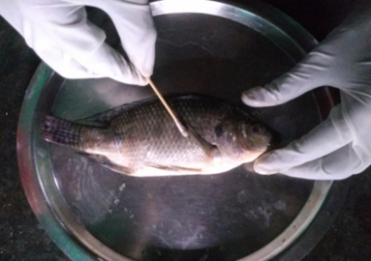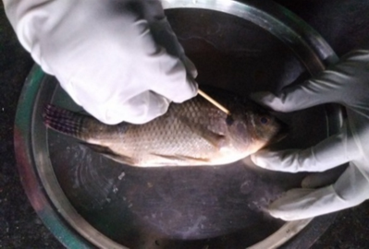

A. Body surface B. Gill surface

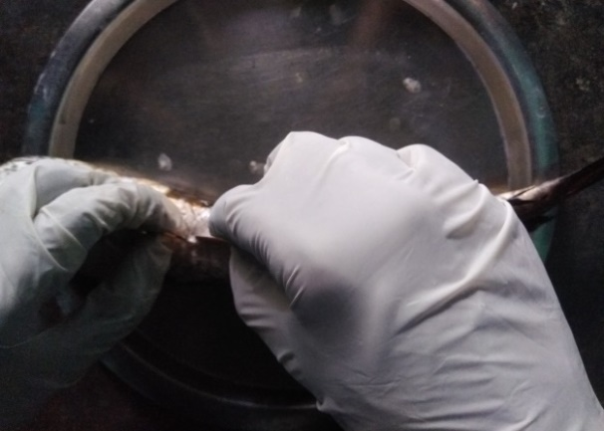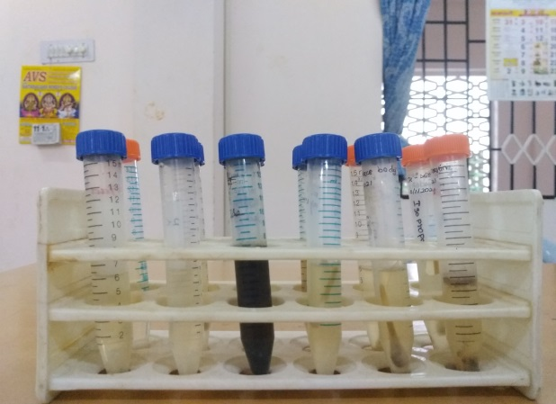

C. Intestine D. APW

Fig. 1. Sample collection
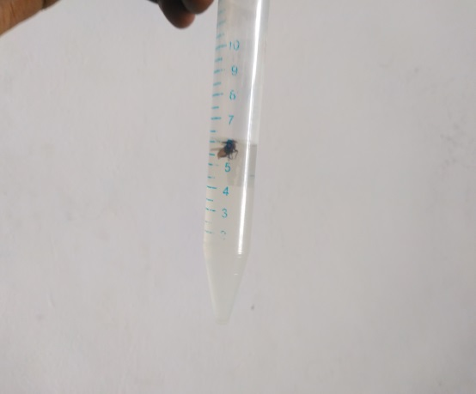

Fig. 2. Collection of M. domestica

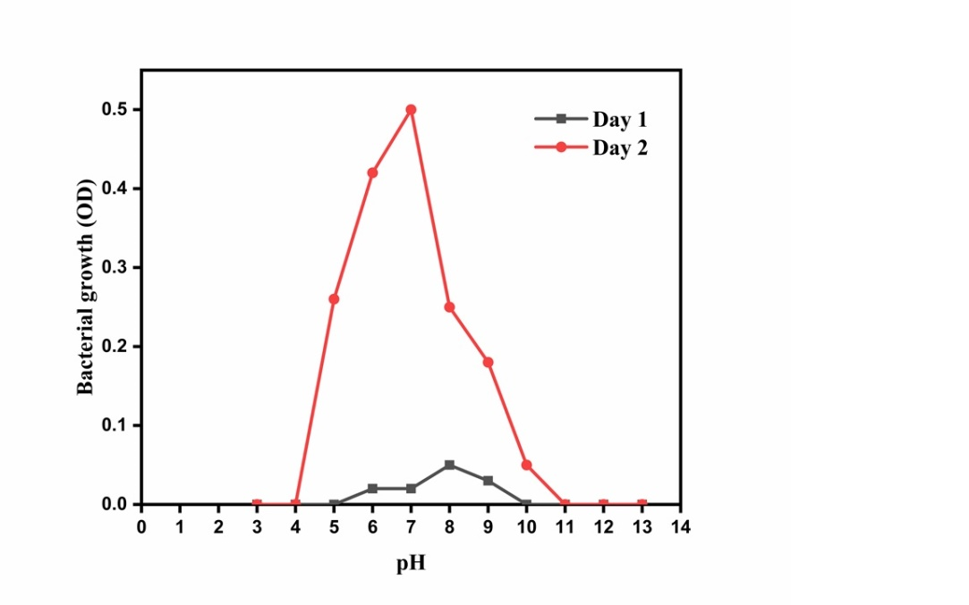

Fig. 3. Influence of pH on the Growth of Aeromonas hydrophila

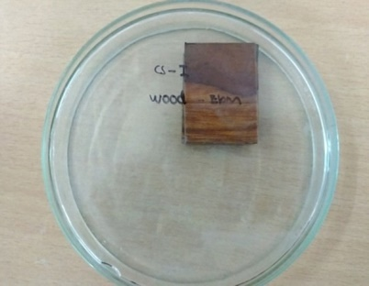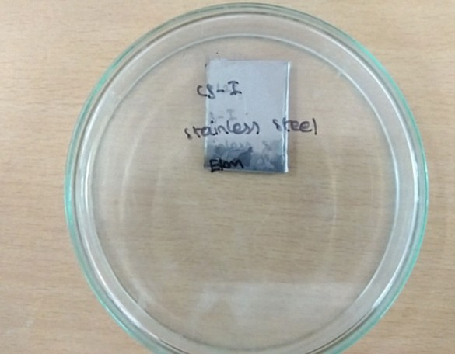

A. Wood inoculated with CSI B. Stainless steel inoculated with CSI

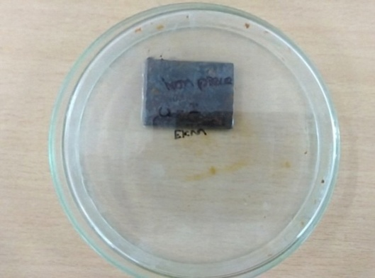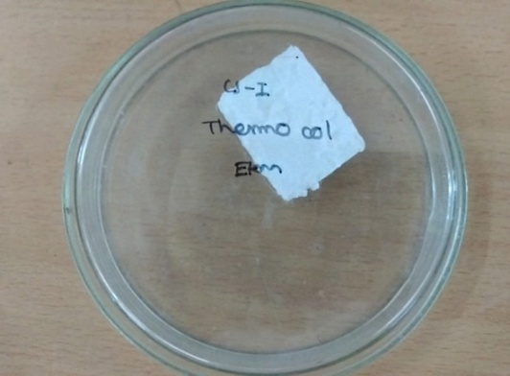

C. Iron inoculated with CSI D. Thermocol inoculated with CSI

Fig. 4. Survival of Aeromonas hydrophila (CSI) on Stainless steel, Wood, Iron and Thermocol pieces

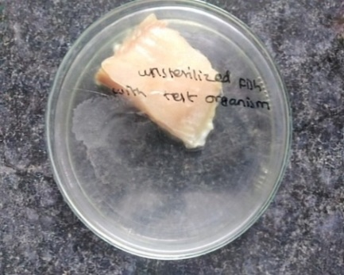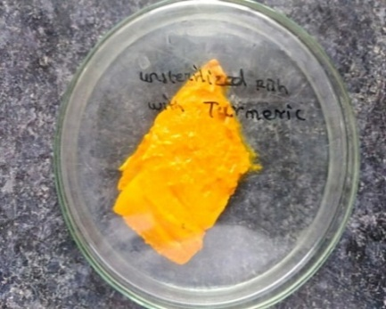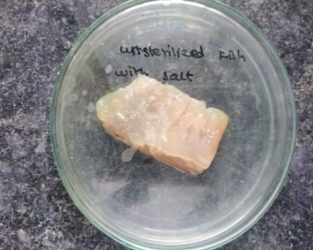

A. Test organism B. Turmeric C. Salt

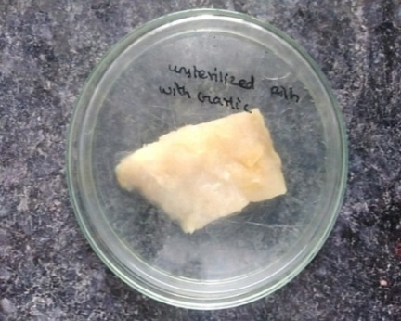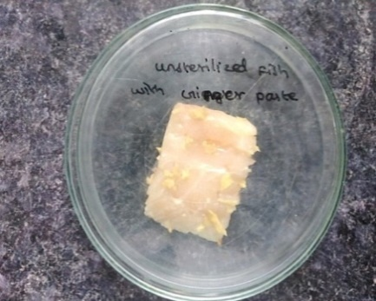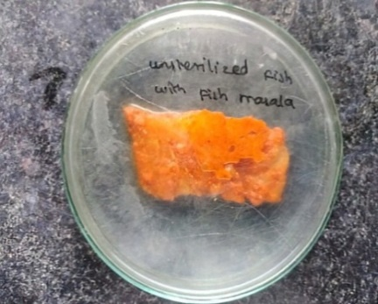

D. Garlic E. Ginger Paste F. Fish Masala

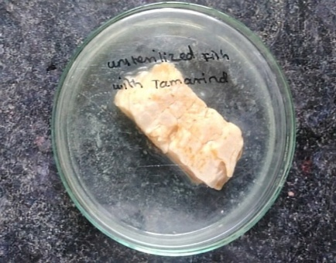

G. Tamarind

Fig. 5. Survival of Aeromonas hydrophila (CSI) in fish meat under traditional cooking ingredients

4. Discussion

In the present study, A. hydrophila was detected in 33.29% of fish samples collected from local markets, with 16/48 samples tested positive. Although this prevalence was lower than that reported by Tartor et al. (2021), Nhinh et al. (2021) and Morshdy et al. (2022), who documented contamination rates of 50, 46.4 and 38%, respectively, it exceeded the findings of Suresh et al. (2023), Adah et al. (2021) and Zaher et al. (2021), who reported rates ranging from 19.2% to 27%. These variations among studies may arise from differences in sampling procedures, environmental and seasonal factors, handling conditions and methodological approaches used for bacterial detection. The relatively higher incidence of A. hydrophila observed in the current investigation likely reflects unhygienic practices, cross-contamination during handling and the use of untreated or contaminated water in retail fish markets (Kaur et al., 2024). These outcomes underline the necessity for improved hygienic standards, proper handling and processing protocols and routine microbiological monitoring in fish retail environments. Considering the pathogen’s virulence potential and its increasing resistance to antimicrobial agents, the presence of A. hydrophila in market fish poses a public health concern that warrants further investigation.

Approximately 20% prevalence of A. hydrophila was also recorded in M. domestica samples, indicating the possibility of M. domestica functioning as mechanical vectors in its transmission. This observation aligns with the reports of Lin et al. (2024), McGaughey et al. (2009) and Gupta et al. (2012), who similarly described M. domestica as potential carriers contributing to bacterial dissemination.

Antibiotic resistance testing on A. hydrophila strains collected from fish markets revealed that all isolates were resistant to ampicillin, amoxyclav, cephalexin, cefazolin, methicillin, oxacillin and vancomycin. The lowest resistance was observed for neomycin, nalidixic acid and streptomycin (6.25%). More than 90% of the strains were sensitive to amikacin, ceftazidime, kanamycin and sulphafurazole. Total resistance to ampicillin has also been documented by Thaotumpitak et al. (2023), while partial resistance was noted to oxytetracycline, tetracycline, trimethoprim and oxolinic acid. Kaur et al. (2024) similarly reported notable resistance, with the highest levels against chloramphenicol, followed by amikacin and gentamicin. Borella et al. (2020) reported widespread resistance to cloxacillin, spiramycin and tilmicosin, with antimicrobial resistance frequencies above 95% for tylosin, penicillin and sulfadiazine. In contrast, resistance below 10% was observed for danofloxacin, enrofloxacin, flumequine, ceftiofur, aminosidine, colistin, doxycycline, gentamicin, marbofloxacin and florfenicol.

To evaluate the influence of pH on bacterial development, A. hydrophila was exposed to pH levels ranging from 3 to 12. The organism demonstrated optimal growth within the pH range of 5 - 8, with particularly enhanced growth at 28°C under pH 6.5 and 7.2 conditions, suggesting its capability to withstand a wide pH spectrum (Lambert and Bildas, 2007). These findings are in agreement with earlier studies, which reported a decline in growth under alkaline conditions (Janda and Abbott, 2010). The ability of A. hydrophila to survive in acidic environments contributes to its environmental persistence and pathogenicity, as evidenced by survival between pH 5.0 and 9.0 (Awan et al., 2018).

A survival study was conducted to assess the effect of temperature on the growth of A. hydrophila in fish samples stored at 30°C, 10°C and 4°C. The results indicated that bacterial growth was highest at 30°C, with a greater increase observed in cleaned fish compared to uncleaned samples. However, the organism was also capable of surviving and multiplying at lower temperatures. In a similar study by Kim et al. (2022), bacterial counts were observed to progressively increase during storage at 5°C, 8°C and 11°C, reaching 1-4.8 log CFU/g at 5°C and 6.8-8.7 log CFU/g at 8°C and 11°C after seven days. These results confirm that A. hydrophila can grow across a broad temperature range, including standard refrigeration conditions (5 - 11°C), suggesting that contamination during storage and transportation can facilitate bacterial persistence and potential spoilage (Chihib et al., 2005; Daskalov et al., 2006; Jahid et al., 2014).

Another study examined the adhesion ability of A. hydrophila to different surface materials, including thermocol and stainless steel. Cell attachment is a complex process influenced by microbial characteristics, environmental conditions and the physicochemical properties of the surface (Bechet et al., 2003; Elhariry et al., 2011). Aeromonas species are known to attach to both biotic and abiotic surfaces (Assanta et al., 1998). In the present study, A. hydrophila adhered readily to all tested surfaces after short exposure periods of 1 to 4 h at both 4°C and 20°C. Attachment was more pronounced on thermocol than on stainless steel, indicating that surface texture and hydrophobicity may influence adhesion efficiency. These observations align with Eliwi et al. (2014), who reported that adhesion to surfaces such as stainless steel, copper and polybutylene varied with contact time and temperature. Overall, the results suggest that A. hydrophila can establish initial attachment under a wide range of conditions, contributing to its persistence in processing and storage environments.

The effect of common Indian cooking ingredients such as fish curry mix, salt, turmeric, tamarind, garlic paste and ginger paste on the growth of A. hydrophila applied to fish samples was also evaluated. The bacterium survived on masala-coated fish blocks even after 72 h of storage at 30°C, indicating that these ingredients did not completely eliminate bacterial presence. Although all tested ingredients are known to possess antimicrobial properties (Muniruzzaman et al., 2004; Sahu et al., 2008), in this study, their combination within the paste resulted in low concentrations of active compounds, potentially reducing overall inhibitory activity (Pianetti et al., 2009; Tril et al., 2014; Abdel-Tawwab et al., 2017). Consequently, the mixture may have provided nutrients that supported limited bacterial survival or growth. In contrast, some individual ingredients demonstrated greater bacterial reduction, suggesting variable antimicrobial effectiveness.

A separate test was performed to determine the effectiveness of disinfectants and antiseptics against A. hydrophila isolated from fish markets. Alcohol-based disinfectants and hydrogen peroxide were highly effective, while several other chemical agents failed to inhibit bacterial growth. Sodium hypochlorite (0.5, 1 and 1.5 %) and hydrogen peroxide (5, 10 and 15 %) were also tested on bacteria attached to polyethylene fragments under both static and shaking water conditions and their application significantly reduced bacterial counts. Goñi-Urriza et al. (2000) reported complete inactivation of 138 Aeromonas strains upon exposure to 50 ppm chlorine, cetylpyridinium chloride, peracetic acid and 1600 ppm glutaraldehyde, demonstrating high susceptibility to commonly used disinfectants. Similarly, Wanja et al. (2020) found A. hydrophila to be fully sensitive to hydrogen peroxide and formalin but resistant to sodium hypochlorite at recommended user dilutions. Park et al. (2012) further showed that combining sodium hypochlorite with gamma irradiation or vitamin B₁ effectively controlled A. hydrophila, suggesting potential applications for improving seafood safety.

5. Conclusion

Multidrug-Resistant (MDR) Aeromonas hydrophila is a significant public health concern found in retail fish, originating from aquaculture and spreading via cross-contamination in markets, posing risks of foodborne illnesses like gastroenteritis and septicemia in humans. Its significance has grown due to its widespread presence in aquatic environments, its diverse virulence factors and its ability to proliferate even at low temperatures. Although traditional Indian cooking practices such as boiling and the use of antimicrobial spices may inactivate the bacterium, the heat-stable toxins produced by A. hydrophila can persist in food and pose health risks. The prevalence of virulent and multidrug resistant of A. hydrophila in aquaculture provide significant risks to fish health, economic productivity and public health. Hence, detection of fish pathogens is essential for effective disease control, preventing mass mortalities and spread of diseases, ensuring food safety for human consumption, and minimizing significant economic losses in the aquaculture industry.

Disclaimer (Artificial Intelligence)

Author(s) hereby declare that NO generative AI technologies such as Large Language Models (ChatGPT, COPILOT, etc) and text-to-image generators have been used during writing or editing of this manuscript.

Competing Interests

Authors have declared that no competing interests exist.

References

Abdel-Tawwab, M., & Abbass, F. E. (2017). Turmeric powder, Curcuma longa L., in common carp, Cyprinus carpio L., diets: Growth performance, innate immunity and challenge against pathogenic Aeromonas hydrophila infection. Journal of the World Aquaculture Society, 48(2), 303–312. https://doi.org/10.1111/jwas.12349
Adah, A. D., Saidu, L., Oniye, S. J., Kazeem, H. M., & Adah, S. A. (2021). Prevalence and risk factors associated with Aeromonas hydrophila infection in Clarias gariepinus and pond water from fish farms in Kaduna State, Nigeria. Jordan Journal of Biological Sciences, 14(3), 477–484. https://doi.org/10.54319/jjbs/140313
Adesewa, A. Z., Fatima, O., Dauda, O. G., & Aremu, H. K. (2024). Bacterial communities of the Musca domestica housefly in different urban habitats and their antimicrobial susceptibility profiles. African Journal of Pure and Applied Sciences, 5(1). https://doi.org/10.33886/ajpas.v5i1.492
Assanta, M. A., Roy, D., & Montpetit, D. (1998). Adhesion of Aeromonas hydrophila to water distribution system pipes after different contact times. Journal of Food Protection, 61(10), 1321–1329. https://doi.org/10.4315/0362-028X-61.10.1321
Awan, F., Dong, Y., Wang, N., Liu, J., Ma, K., & Liu, Y. (2018). The fight for invincibility: Environmental stress response mechanisms and Aeromonas hydrophila. Microbial Pathogenesis, 116, 135–145. https://doi.org/10.1016/j.micpath.2018.01.023
Bakiyev, S., Smekenov, I., Zharkova, I., Kobegenova, S., Sergaliyev, N., Absatirov, G., et al. (2022). Isolation, identification and characterization of pathogenic Aeromonas hydrophila from critically endangered Acipenser baerii. Aquaculture Reports, 26, 101293. https://doi.org/10.1016/j.aqrep.2022.101293
Bechet, M., & Blondeau, R. (2003). Factors associated with the adherence and biofilm formation by Aeromonas caviae on glass surfaces. Journal of Applied Microbiology, 94(6), 1072–1078. https://doi.org/10.1046/j.1365-2672.2003.01931.x
Borella, L., Salogni, C., Vitale, N., Scali, F., Moretti, V. M., Pasquali, P., et al. (2020). Motile aeromonads from farmed and wild freshwater fish in northern Italy: An evaluation of antimicrobial activity and multidrug resistance during 2013 and 2016. Acta Veterinaria Scandinavica, 62(1), 6. https://doi.org/10.1186/s13028-020-0504-y
Casabianca, A., Orlandi, C., Barbieri, F., Sabatini, L., Di Cesare, A., Sisti, D., et al. (2015). Effect of starvation on survival and virulence expression of Aeromonas hydrophila from different sources. Archives of Microbiology, 197(3), 431–438. https://doi.org/10.1007/s00203-014-1074-z
Chen, J. S., Hsu, G. J., Hsu, B. M., Yang, P. Y., Kuo, Y. J., Wang, J. L., et al. (2021). Prevalence, virulence-gene profiles, antimicrobial resistance and genetic diversity of human pathogenic Aeromonas spp. from shellfish and aquatic environments. Environmental Pollution, 287, 117361. https://doi.org/10.1016/j.envpol.2021.117361
Chihib, N. E., Tierny, Y., Mary, P., & Hornez, J. P. (2005). Adaptational changes in cellular fatty acid branching and unsaturation of Aeromonas species as a response to growth temperature and salinity. International Journal of Food Microbiology, 102(1), 113–119. https://doi.org/10.1016/j.ijfoodmicro.2004.12.005
Daskalov, H. (2006). The importance of Aeromonas hydrophila in food safety. Food Control, 17(6), 474–483. https://doi.org/10.1016/j.foodcont.2005.02.009
Elhariry, H. M. (2011). Biofilm formation by Aeromonas hydrophila on green-leafy vegetables: Cabbage and lettuce. Foodborne Pathogens and Disease, 8(1), 125–131. https://doi.org/10.1089/fpd.2010.0642
Eliwi, S., Musleh, R., & Sabah, M. (2014). Study adhesion ability of Aeromonas hydrophila strains isolated from raw and drinking water in Baghdad city. Iraqi Journal of Science, 55(1), 70–83.
Fernández-Bravo, A., & Figueras, M. J. (2020). An update on the genus Aeromonas: Taxonomy, epidemiology and pathogenicity. Microorganisms, 8(1), 129. https://doi.org/10.3390/microorganisms8010129
Gioia, G., Freeman, J., Sipka, A., Santisteban, C., Wieland, M., Gallardo, V. A., et al. (2022). Pathogens associated with houseflies from different areas within a New York State dairy. JDS Communications, 3(4), 285–290. https://doi.org/10.3168/jdsc.2021-0200
Goñi-Urriza, M., Pineau, L., Capdepuy, M., Roques, C., Caumette, P., & Quentin, C. (2000). Antimicrobial resistance of mesophilic Aeromonas spp. isolated from two European rivers. Journal of Antimicrobial Chemotherapy, 46(2), 297–301. https://doi.org/10.1093/jac/46.2.297
Gupta, A. K., Nayduch, D., Verma, P., Shah, B., Ghate, H. V., Patole, M. S., et al. (2012). Phylogenetic characterization of bacteria in the gut of house flies (Musca domestica L.). FEMS Microbiology Ecology, 79(3), 581–593. https://doi.org/10.1111/j.1574-6941.2011.01248.x
Igbinosa, I. H., Igumbor, E. U., Aghdasi, F., Tom, M., & Okoh, A. I. (2012). Emerging Aeromonas species infections and their significance in public health. The Scientific World Journal, 2012(1), 625023. https://doi.org/10.1100/2012/625023
Jahid, I. K., Han, N., & Ha, S. D. (2014). Inactivation kinetics of cold oxygen plasma depend on incubation conditions of Aeromonas hydrophila biofilm on lettuce. Food Research International, 55, 181–189. https://doi.org/10.1016/j.foodres.2013.11.005
Janda, J. M., & Abbott, S. L. (2010). The genus Aeromonas: Taxonomy, pathogenicity and infection. Clinical Microbiology Reviews, 23(1), 35–73. https://doi.org/10.1128/cmr.00039-09
Kaur, S., Kaur, H., Kaur, B., Kumar, B. N., Tyagi, A., Singh, P., et al. (2024). Isolating pathogenic multidrug-resistant Aeromonas hydrophila from diseased fish and assessing the effectiveness of a novel lytic Aeromonas veronii bacteriophage (AVP3) for biocontrol. Microbial Pathogenesis, 196, 106914. https://doi.org/10.1016/j.micpath.2024.106914
Khor, W. C., Puah, S. M., Koh, T. H., Tan, J. A. M. A., Puthucheary, S. D., & Chua, K. H. (2018). Comparison of clinical isolates of Aeromonas from Singapore and Malaysia with regard to molecular identification, virulence and antimicrobial profiles. Microbial Drug Resistance, 24(4), 469–478. https://doi.org/10.1089/mdr.2017.0083
Kim, J. Y., Jeon, E. B., Song, M. G., Park, S. H., & Park, S. Y. (2022). Development of predictive growth models of Aeromonas hydrophila on raw tuna Thunnus orientalis as a function of storage temperatures. LWT, 156, 113052. https://doi.org/10.1016/j.lwt.2021.113052
Lambert, R. J., & Bidlas, E. (2007). An investigation of the gamma hypothesis: A predictive modelling study of the effect of combined inhibitors (salt, pH and weak acids) on the growth of Aeromonas hydrophila. International Journal of Food Microbiology, 115(1), 12–28. https://doi.org/10.1016/j.ijfoodmicro.2006.10.011
Lee, H. J., Tokle, I. F., Lunestad, B. T., Lerfall, J., Hoel, S., & Jakobsen, A. N. (2023). The effect of food processing factors on the growth kinetics of Aeromonas strains isolated from ready-to-eat seafood. International Journal of Food Microbiology, 384, 109985. https://doi.org/10.1016/j.ijfoodmicro.2022.109985
Li, Q., Wu, Y., Lu, H., Wu, X., Chen, S., Song, N., et al. (2017). Construction of supramolecular nanoassembly for responsive bacterial elimination and effective bacterial detection. ACS Applied Materials & Interfaces, 9(11), 10180–10189. https://doi.org/10.1021/acsami.7b00873
Lin, C., Liu, J., Yuan, Y., Yu, S., Feng, L., Gu, et al. (2024). Unveiling the hidden dangers: Enteropathogens carried by flies in Pudong New Area. BMC Infectious Diseases, 24(1), 569. https://doi.org/10.1186/s12879-024-09448-0
Liu, J., Gao, S., Dong, Y., Lu, C., & Liu, Y. (2020). Isolation and characterization of bacteriophages against virulent Aeromonas hydrophila. BMC Microbiology, 20(1), 141.
McGaughey, J., & Nayduch, D. (2009). Temporal and spatial fate of GFP-expressing motile and nonmotile Aeromonas hydrophila in the house fly digestive tract. Journal of Medical Entomology, 46(1), 123–130. https://doi.org/10.1603/033.046.0116
Mohanty, B. P., Mahanty, A., Ganguly, S., Mitra, T., Karunakaran, D., & Anandan, R. (2019). Nutritional composition of food fishes and their importance in providing food and nutritional security. Food Chemistry, 293, 561–570. https://doi.org/10.1016/j.foodchem.2017.11.039
Morshdy, A. E. M., Abdelhameed, N. S. A., El Bayomi, R. M., & Abdallah, K. (2022). Prevalence of antibiotic resistant Aeromonas and molecular identification of Aeromonas hydrophila isolated from some marketed fish in Egypt. Journal of Advanced Veterinary Research, 12(6), 717–721.
Muniruzzaman, M. A., & Chowdhury, M. B. R. (2004). Sensitivity of fish pathogenic bacteria to various medicinal herbs. Bangladesh Journal of Veterinary Medicine, 2(1), 75–82. https://doi.org/10.3329/bjvm.v2i1.1941
Nayduch, D., & Burrus, R. G. (2017). Flourishing in filth: House fly–microbe interactions across life history. Annals of the Entomological Society of America, 110(1), 6–18. https://doi.org/10.1093/aesa/saw083
Nayduch, D., Honko, A., Noblet, G. P., & Stutzenberger, F. (2001). Detection of Aeromonas caviae in the common housefly Musca domestica by culture and polymerase chain reaction. Epidemiology & Infection, 127(3), 561–566. https://doi.org/10.1017/S0950268801006240
Nhinh, D. T., Le, D. V., Van, K. V., Huong Giang, N. T., Dang, L. T., & Hoai, T. D. (2021). Prevalence, virulence gene distribution and alarming the multidrug resistance of Aeromonas hydrophila associated with disease outbreaks in freshwater aquaculture. Antibiotics, 10(5), 532. https://doi.org/10.3390/antibiotics10050532
Pal, M., Ayele, Y., & Durglishvili, N. (2020). Emerging role of Aeromonas hydrophila as a foodborne pathogen of public health concern. EC Microbiology, 16, 55–58.
Palumbo, S. A., Maxino, F., Williams, A. C., Buchanan, R. L., & Thayer, D. W. (1985). Starch-ampicillin agar for the quantitative detection of Aeromonas hydrophila. Applied and Environmental Microbiology, 50(4), 1027–1030. https://doi.org/10.1128/aem.50.4.1027-1030.1985
Park, S. Y., Kim, B. Y., Song, H. H., & Ha, S. D. (2012). The synergistic effects of combined NaOCl, gamma irradiation and vitamin B1 on populations of Aeromonas hydrophila in squid. Food Control, 27(1), 194–199. https://doi.org/10.1016/j.foodcont.2012.03.015
Pianetti, A., Battistelli, M., Citterio, B., Parlani, C., Falcieri, E., & Bruscolini, F. (2009). Morphological changes of Aeromonas hydrophila in response to osmotic stress. Micron, 40(4), 426–433. https://doi.org/10.1016/j.micron.2009.01.006
Rajakumar, S., Ayyasamy, P. M., Shanthi, K., Song, Y. C., & Lakshmanaperumalsamy, P. (2012). Incidence, survival and antibiotic resistance of Aeromonas hydrophila isolated from lamb and chicken meat retail outlets. Journal of Current Perspectives in Applied Microbiology, 2278, 1250.
Sahu, S., Das, B. K., Mishra, B. K., Pradhan, J., Samal, S. K., & Sarangi, N. (2008). Effect of dietary Curcuma longa on enzymatic and immunological profiles of rohu, Labeo rohita (Ham.), infected with Aeromonas hydrophila. Aquaculture Research, 39(16), 1720–1730. https://doi.org/10.1111/j.1365-2109.2008.02048.x
Sarwar, M. (2015). Insect vectors involving in mechanical transmission of human pathogens for serious diseases. International Journal of Bioinformatics and Biomedical Engineering, 1(3), 300–306.
Stratev, D., & Odeyemi, O. A. (2016). Antimicrobial resistance of Aeromonas hydrophila isolated from different food sources: A mini-review. Journal of Infection and Public Health, 9(5), 535–544. https://doi.org/10.1016/j.jiph.2015.10.006
Suresh, K., & Pillai, D. (2023). Prevalence and characterization of virulence-associated genes and antimicrobial resistance in Aeromonas hydrophila from freshwater finfish farms in Andhra Pradesh, India. Biologia, 78(10), 2931–2939. https://doi.org/10.1007/s11756-023-01454-y
Tartor, Y. H., El-Naenaeey, E. S. Y., Abdallah, H. M., Samir, M., Yassen, M. M., & Abdelwahab, A. M. (2021). Virulotyping and genetic diversity of Aeromonas hydrophila isolated from Nile tilapia (Oreochromis niloticus) in aquaculture farms in Egypt. Aquaculture, 541, 736781. https://doi.org/10.1016/j.aquaculture.2021.736781
Thaotumpitak, V., Sripradite, J., Atwill, E. R., & Jeamsripong, S. (2023). Emergence of colistin resistance and characterization of antimicrobial resistance and virulence factors of Aeromonas hydrophila, Salmonella spp. and Vibrio cholerae isolated from hybrid red tilapia cage culture. PeerJ, 11, e14896. https://doi.org/10.7717/peerj.14896
Tril, U., Fernández-López, J., Álvarez, J. Á. P., & Viuda-Martos, M. (2014). Chemical, physicochemical, technological, antibacterial and antioxidant properties of rich-fibre powder extract obtained from tamarind (Tamarindus indica L.). Industrial Crops and Products, 55, 155–162. https://doi.org/10.1016/j.indcrop.2014.01.047
Wanja, D. W., Mbuthia, P. G., Waruiru, R. M., Bebora, L. C., Ngowi, H. A., & Nyaga, P. N. (2020). Antibiotic and disinfectant susceptibility patterns of bacteria isolated from farmed fish in Kirinyaga County, Kenya. International Journal of Microbiology, 2020(1), 8897338. https://doi.org/10.1155/2020/8897338
Zaher, H. A., Nofal, M. I., Hendam, B. M., Elshaer, M. M., Alothaim, A. S., & Eraqi, M. M. (2021). Prevalence and antibiogram of Vibrio parahaemolyticus and Aeromonas hydrophila in the flesh of Nile tilapia, with special reference to their virulence genes detected using multiplex PCR technique. Antibiotics, 10(6), 654. https://doi.org/10.3390/antibiotics10060654

Disclaimer/Publisher’s Note: The statements, opinions and data contained in all publications are solely those of the individual author(s) and contributor(s) and not of the publisher and/or the editor(s). This publisher and/or the editor(s) disclaim responsibility for any injury to people or property resulting from any ideas, methods, instructions or products referred to in the content.
_________________________________________________________________________________
© Copyright (2026): Author(s). The licensee is the journal publisher. This is an Open Access article distributed under the terms of the Creative Commons Attribution License (http://creativecommons.org/licenses/by/4.0), which permits unrestricted use, distribution, and reproduction in any medium, provided the original work is properly cited.

