Orinal Research Paper

High-Rise Syndrome–Associated Stillbirth and Obstructive Dystocia in a Pregnant Rhesus Macaque (Macaca mulatta)

ABSTRACT
Stillbirth in non-human primates represents failure of the maternal–fetal–placental unit and may result from abnormal fetal presentation, maternal compromise, or trauma. Documentation of trauma-associated dystocia in free-ranging rhesus macaques remains limited. An adult pregnant rhesus macaque (Macaca mulatta) was rescued following suspected high-rise trauma based on clinical presentation and external injury patterns consistent with blunt force impact. The animal presented deeply unconscious in lateral recumbency with respiratory depression, cardiovascular instability, hyperthermia, and multiple abdominal contusions. Per-vaginal examination revealed complete cervical dilation with bilateral forelimb flexion, confirming obstructive dystocia secondary to fetal malposture. Emergency stabilization was initiated using intravenous fluid therapy, cardiopulmonary resuscitation performed in accordance with veterinary RECOVER guidelines, corticosteroids, and supportive care. Per-vaginal mutation was performed to correct limb flexion, followed by assisted extraction using obstetrical forceps, resulting in delivery of a dead female fetus. Morphometric assessment indicated near-term gestation (approximately 168 days), consistent with established gestational parameters for the species. Maternal parameters improved following intervention, and hemorrhage was effectively controlled. The findings indicate an association between suspected high-rise trauma, advanced gestation, and obstructive dystocia; however, definitive causality cannot be established in the absence of placental examination and fetal necropsy. This study underscores the importance of rapid clinical stabilization and timely obstetrical management in trauma-associated reproductive emergencies in urban free-ranging primates. Limitations included unknown timing of injury and absence of hematological or biochemical evaluation due to emergency rescue constraints.
Keywords: Fetal malpresentation; Obstetrical intervention; rhesus macaque; Stillbirth; Trauma-associated dystocia.
INTRODUCTION
The rhesus macaque (Macaca mulatta) is a well-characterized non-human primate with established reproductive parameters, including a mean gestation length of approximately 166 days under captive colony conditions (Silk et al., 1993). Parturition in rhesus macaques has been described as typically rapid and behaviourally coordinated, with delivery usually occurring within a short duration under normal physiological conditions (Brandt & Mitchell, 1973). Successful pregnancy depends upon the integrity of the maternal–fetal–placental unit, and disruption of this system may result in fetal compromise, dystocia, or stillbirth. Stillbirth in non-human primates is recognized as a form of reproductive failure arising from late-gestation fetal death and has been documented in both captive and free-ranging populations (Roura-Torres et al., 2024; Saiyed et al., 2018). Colony-based analyses in macaques indicate that stillbirths are frequently multifactorial in origin, involving placental abnormalities, maternal compromise, fetal trauma, or abnormal presentation (Sesbuppha et al., 2008). Abnormal fetal positioning has been specifically associated with increased risk of stillbirth in cynomolgus macaques, emphasizing the importance of fetal orientation during labor (Cho et al., 1985). Reports of stillbirth in free-ranging macaques further highlight the ecological and behavioral complexity surrounding reproductive failure (Kaigaishi & Yamamoto, 2023).

Dystocia in non-human primates may result from fetal malposture, uterine dysfunction, or maternal systemic compromise and is a recognized risk factor for perinatal mortality (Stockinger et al., 2011). Obstetrical intervention is indicated when obstructive dystocia compromises maternal or fetal viability (Noakes et al., 2018). Trauma during advanced gestation presents an additional threat, as blunt abdominal injury may impair uteroplacental circulation, disrupt placental attachment, and precipitate intrauterine fetal death. Although fall-related trauma (“high-rise syndrome”) is well described in companion animals (Davis, 2006), its obstetrical and reproductive implications in non-human primates remain insufficiently characterized in the literature. Urban free-ranging macaques are increasingly exposed to anthropogenic hazards, including falls from height and vehicular impact, potentially predisposing pregnant individuals to trauma-associated reproductive emergencies. Despite expanding urban–primate interactions, systematic clinical documentation linking suspected high-rise trauma, fetal malposture, and dystocia in free-ranging rhesus macaques is scarce. Most available reproductive data derive from captive colony studies, leaving a gap in understanding emergency obstetrical outcomes under wildlife rescue conditions. The present study describes a clinically investigated case of suspected high-rise syndrome associated with stillbirth complicated by obstructive dystocia in a near-term rhesus macaque, emphasizing emergency stabilization, morphometric fetal assessment, and assisted obstetrical intervention as critical components of maternal survival.

Materials and Methods
Case presentation and History
An adult female rhesus macaque (Macaca mulatta), weighing approximately 6–7 kg, was rescued from a roadside area in Bareilly, Uttar Pradesh, India, following suspected high-rise trauma based on external injury patterns and rescue history. The reproductive history was unknown. According to the rescuers, the animal was found in lateral recumbency and was unconscious at the time of retrieval. In one instance, history included straining and vulvar discharge observed since morning prior to rescue. On initial presentation, the animal exhibited severe systemic compromise. Mentation was severely depressed, and the animal was deeply unconscious with absent voluntary responses. The macaque remained in lateral recumbency and demonstrated labored breathing (Fig. 1). Ocular examination revealed sunken eyeballs, suggestive of dehydration and circulatory insufficiency. Mucous membranes were pale pink to congested on repeated assessments, indicating variable peripheral perfusion status.

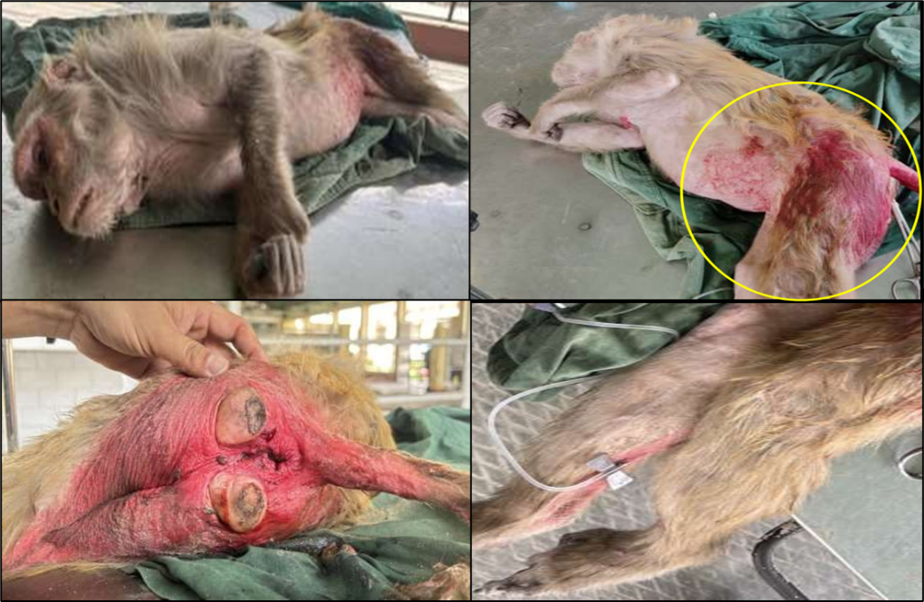

Fig. 1. Clinical findings at presentation in a pregnant rhesus macaque (Macaca mulatta) following suspected high-rise trauma, illustrating lateral recumbency, abdominal and perineal contusions, and intravenous catheter placement for emergency resuscitation.

Rectal temperature ranged between 103°F and 105°F, indicating hyperthermia. Cardiovascular assessment revealed heart rates ranging between 60–70 bpm, representing severe bradycardia relative to established adult rhesus macaque reference intervals (approximately 160–220 bpm), consistent with advanced cardiovascular compromise. Respiratory rate ranged from 10 to 15 breaths per minute, consistent with hypoventilation and respiratory depression. Physical examination identified multiple contusions and bruises over the ventral abdomen, lateral body wall, caudal hindlimbs, and perineal region, strongly suggestive of blunt force impact. A consolidated summary of signalment, anamnesis, and clinical findings at admission is presented in Table 1. The combination of abdominal trauma, altered mentation, respiratory compromise, and evidence of active vulvar discharge raised suspicion of advanced gestation complicated by trauma-associated fetal compromise and possible dystocia. The patient was immediately stabilized under emergency protocols prior to obstetrical assessment and intervention. Hematological and biochemical analyses were not performed due to the critical emergency condition and limited diagnostic infrastructure at the time of rescue, with priority given to life-saving stabilization.

Table 1. Signalment, Anamnesis and Clinical Findings at Presentation
Category | Parameter | Findings
Signalment | Case number | G73
Signalment | Species | rhesus macaque (Macaca mulatta)
Signalment | Sex | Female
Signalment | Weight | ~7 kg
Signalment | Coat color | Brown
Signalment | Age | Not determined
Signalment | Rescue location | Bareilly, Uttar Pradesh, India
Anamnesis | History source | NGO rescue report
Anamnesis | History of trauma | Suspected fall from height (high-rise trauma)
Anamnesis | Condition at retrieval | Unconscious, lateral recumbency
Anamnesis | Reported prior signs | Straining and vulvar discharge since morning
Anamnesis | Breathing difficulty | Present
Anamnesis | Previous medical history | Unknown
Clinical Examination | General appearance | Depressed
Clinical Examination | Mentation | Comatose
Clinical Examination | Posture | Lateral recumbency
Clinical Examination | Mucous membranes | Pale pink to congested
Clinical Examination | Eyeball condition | Sunken
Clinical Examination | Rectal temperature | 103–105°F
Clinical Examination | Heart rate | <60–70 bpm (cardiovascular instability)
Clinical Examination | Respiratory rate | 10–15 cycles/min
Clinical Examination | External injuries | Contusions over ventral abdomen, lateral body wall, caudal hindlimbs, perineal region
Emergency Stabilization and Obstetrical Management
Immediate resuscitative measures were initiated. The posterior tibial vein was catheterized, and intravenous fluid therapy was administered using Ringer’s lactate (200 mL) followed by dextrose normal saline (100 mL) to address hypovolemia and circulatory compromise. Due to weak cardiac activity and hypoventilation, cardiopulmonary resuscitation was performed in accordance with veterinary RECOVER guidelines, emphasizing continuous chest compressions (approximately 100–120 compressions per minute) with asynchronous assisted ventilation. Dexamethasone (0.5 mg/kg IV) was administered to mitigate traumatic shock and systemic inflammatory response. Following partial stabilization, per-vaginal examination revealed complete cervical dilation. A fetus was palpable within the birth canal; however, both forelimbs were flexed and retained, confirming obstructive dystocia secondary to fetal malposture. Because the animal was deeply unconscious and non-responsive, general anesthesia was not administered during obstetrical manipulation. A per-vaginal mutation procedure was performed to correct limb flexion, and both forelimbs were carefully extended into the pelvic canal. Subsequently, controlled traction using obstetrical forceps enabled extraction of a dead female fetus.
Post-extraction management included administration of oxytocin (10 IU intramuscularly and 5 IU intravenously) to enhance uterine contraction and reduce postpartum hemorrhage. Enrofloxacin (5 mg/kg IM) was administered for antimicrobial coverage, tranexamic acid (10 mg/kg IV) for hemorrhage control, and meloxicam (0.3 mg/kg IM) for analgesia. Neuroprotective supplementation and tetanus toxoid were also administered. Gauze tamponing of the vaginal canal was performed to assist in hemorrhage control.
RESULTS
Emergency stabilization followed by obstetrical intervention resulted in successful extraction of a dead female fetus. Per-vaginal examination revealed complete cervical dilation with bilateral forelimb flexion, confirming obstructive dystocia secondary to fetal malposture. Mutation was performed to extend both forelimbs into the pelvic canal, after which controlled traction using obstetrical forceps enabled delivery without surgical intervention (Fig. 2).

Fig. 2. Assisted vaginal delivery of a dead near-term female fetus following per-vaginal mutation and controlled traction using obstetrical forceps in a pregnant rhesus macaque (Macaca mulatta). Bilateral forelimb flexion causing obstructive dystocia was corrected prior to extraction.
The fetus showed absence of reflexes and no detectable cardiac activity at extraction. Cranial deformation was observed, consistent with intrapelvic compression during obstructed labor; contribution of antecedent trauma cannot be excluded. Morphometric evaluation (Fig. 3) revealed a crown–rump length of 160 mm, femur length of 49 mm, fetal limb length of 145 mm, and head circumference of 191 mm. These measurements correspond to approximately 168 days of gestation, consistent with near-term pregnancy in rhesus macaques (Silk et al., 1993). Maternal parameters improved following fluid resuscitation, corticosteroid administration, uterotonic therapy, and antimicrobial coverage. Hemorrhage was effectively controlled, and the dam regained consciousness during post-procedural monitoring. No immediate post-extraction complications were observed during the observation period.

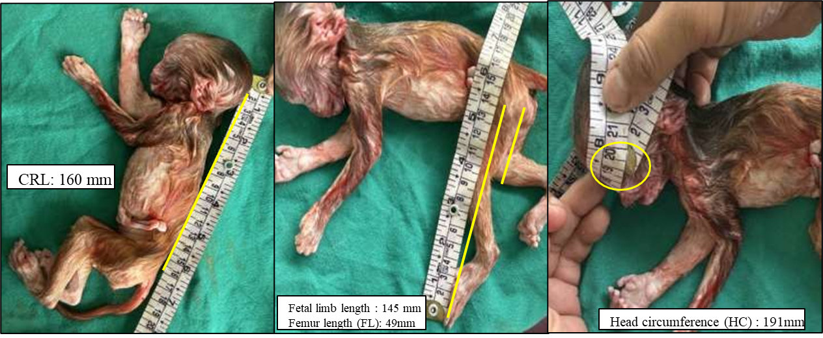
Fig. 3. Extracted near-term female fetus from a rhesus macaque (Macaca mulatta) following assisted obstetrical intervention. Cranial deformation was observed, consistent with intrapelvic compression during obstructed labor. Morphometric measurements included crown–rump length (160 mm), femur length (49 mm), total fetal limb length (145 mm), and head circumference (191 mm), corresponding to approximately 168 days of gestation, consistent with near-term pregnancy in rhesus macaques (Silk et al., 1993).

DISCUSSION
This case documents suspected high-rise trauma–associated stillbirth complicated by obstructive dystocia in a near-term rhesus macaque. The animal presented with systemic compromise and external signs of blunt abdominal trauma, consistent with high-impact injury; however, the temporal relationship between trauma and onset of dystocia cannot be definitively established. In pregnant mammals, abdominal trauma may impair uteroplacental perfusion, disrupt placental attachment, or induce fetal hypoxia, potentially resulting in intrauterine fetal death. Although placental examination and fetal necropsy were not performed, trauma remains a biologically plausible contributing factor within the clinical context of this case.
Stillbirth in non-human primates is frequently multifactorial and reflects failure of the maternal–fetal–placental unit (Roura-Torres et al., 2024; Sesbuppha et al., 2008). In macaque populations, abnormal fetal presentation has been associated with increased risk of stillbirth (Cho et al., 1985). The bilateral forelimb flexion observed in this case produced mechanical obstruction, necessitating per-vaginal correction. Dystocia itself is recognized as a contributor to perinatal mortality in macaques, particularly when associated with malposture and prolonged parturition (Stockinger et al., 2011).
Normal parturition in rhesus macaques is typically rapid (Brandt & Mitchell, 1973). Deviation from physiological presentation may prolong delivery and increase fetal risk. Whether fetal death occurred prior to the onset of dystocia or secondary to prolonged obstruction cannot be conclusively determined. Both trauma-induced fetal compromise and prolonged obstructive dystocia remain plausible and potentially interacting mechanisms. Fetal morphometry confirmed advanced gestation consistent with established gestational norms for rhesus macaques (Silk et al., 1993), making prematurity unlikely as the primary cause of death. Cranial deformation observed at delivery was consistent with intrapelvic compression during obstructed labor, although contribution of antecedent trauma cannot be excluded.
Stillbirths have been documented in both captive and free-ranging primate populations (Saiyed et al., 2018; Kaigaishi & Yamamoto, 2023), yet reports linking suspected high-rise trauma and obstructive dystocia in rhesus macaques remain limited. Urban free-ranging macaques increasingly encounter anthropogenic hazards, including falls from height. While fall-related trauma is well described in companion animals, its reproductive implications in non-human primates remain insufficiently characterized in the scientific literature.
From a clinical perspective, rapid stabilization, correction of fetal malposture, and timely assisted extraction were essential for maternal survival, consistent with established veterinary obstetrical principles (Noakes et al., 2018). This case highlights the need for structured emergency obstetrical protocols in wildlife rescue and urban primate management contexts.
Limitations of this investigation include unknown timing of injury, absence of hematological and biochemical evaluation, and lack of placental or fetal histopathological examination. Therefore, interpretation of trauma as a causative factor should be approached with appropriate clinical caution.
CONCLUSION
This study documents suspected high-rise syndrome–associated stillbirth complicated by obstructive dystocia in a near-term free-ranging rhesus macaque. While definitive causality between trauma and fetal demise cannot be established due to absence of placental and histopathological evaluation, the concurrence of systemic maternal compromise, external blunt-force injuries, and obstructive fetal malposture indicates a clinically meaningful association. The case emphasizes the importance of rapid cardiopulmonary stabilization, prompt recognition of fetal malposture, and timely assisted obstetrical intervention to safeguard maternal survival in wildlife rescue contexts. Structured documentation of similar trauma-associated reproductive emergencies will enhance understanding of obstetrical outcomes in urban free-ranging primates and support development of evidence-based emergency protocols.
STATEMENTS AND DECLARATIONS
Artificial Intelligence Disclosure
The authors declare that generative AI tools were used solely for language refinement and structural editing during manuscript preparation. All clinical data, analysis, interpretation, and scientific conclusions are the responsibility of the authors.
Competing Interests
The authors declare that they have no competing.

References
Brandt, E. M., & Mitchell, G. (1973). Labor and delivery behavior in rhesus monkeys (Macaca mulatta). American Journal of Physical Anthropology, 38(2), 519–522. https://doi.org/10.1002/ajpa.1330380259
Cho, F., Hanari, K., Suzuki, M. T., & Honjo, S. (1985). Relationship between fetal position and stillbirth in the cynomolgus monkeys (Macaca fascicularis): Retrospective analysis. Journal of Medical Primatology, 14(3), 169–174. https://doi.org/10.1111/j.1600-0684.1985.tb00398.x
Davis, K. L. (2006). The everything cat book. Simon & Schuster.
Kaigaishi, Y., & Yamamoto, S. (2023). A report of stillbirth and subsequent maternal cannibalism observed in a free-ranging group of Japanese macaques at Awajishima, Japan. Primates. https://doi.org/10.1007/s10329-023-01091-8
Noakes, D. E., Parkinson, T. J., & England, G. C. W. (Eds.). (2018). Arthur’s veterinary reproduction and obstetrics (10th ed.). Elsevier Health Sciences.
Roura-Torres, B., Amblard-Rambert, P., Lepou, P., Kappeler, P. M., & Charpentier, M. J. E. (2024). Stillbirth of a mandrill (Mandrillus sphinx) in the wild: Perinatal behaviors and delivery sequences. Primates, 65(2), 75–80.
Sahu, U. K., Singh, K., Pandiyan, N., Kumar, B., & Khan, M. H. (2024a). Fetal mummification in a doe: A case report. The Indian Journal of Animal Reproduction, 45(1), 107–108.
Saiyed, S. T., Liubicich, R. C., Fidino, M., & Ross, S. R. (2018). Stillbirth rates across three ape species in accredited American zoos. American Journal of Primatology, 80(6), e22870. https://doi.org/10.1002/ajp.22870
Sesbuppha, W., Chantip, S., Dick, E. J., Jr., Schlabritz-Loutsevitch, N. E., Guardado-Mendoza, R., Butler, S. D., Frost, P. A., & Hubbard, G. B. (2008). Stillbirths in Macaca fascicularis. Journal of Medical Primatology, 37(4), 169–172. https://doi.org/10.1111/j.1600-0684.2007.00275.x
Silk, J., Short, J., Roberts, J., & Kusnitz, J. (1993). Gestation length in rhesus macaques (Macaca mulatta). International Journal of Primatology, 14(1), 95–104.
Stockinger, D. E., Torrence, A. E., Hukkanen, R. R., Vogel, K. W., Hotchkiss, C. E., & Ha, J. C. (2011). Risk factors for dystocia in pigtailed macaques (Macaca nemestrina). Comparative Medicine, 61(2), 170–175.

