UAV-Based Precision Spraying Enhances Pest Control, Nutrient Uptake, and Spray Efficiency in High-Density Mango Orchards

Abstract
Mango (Mangifera indica L.) is a major tropical fruit crop that suffers yield losses from nutrient deficiencies, insect pests, and fungal diseases, with conventional spraying methods such as tractor-mounted or manual sprayers often requiring excessive spray volumes, leading to poor canopy penetration, chemical wastage, operator health risks, and environmental contamination. Recent advances in Unmanned Aerial Vehicles (UAVs) have enabled site-specific spraying, offering precision application, reduced chemical use, and improved safety, though research in mango orchards remains limited compared to crops like citrus, vineyards, and rice. This proof-of-concept study conducted in high-density Alphonso mango orchards in Tamil Nadu, India, from September 2023 to March 2024, compared UAV spraying at 1 L/tree (T1), 2 L/tree (T2), and 3 L/tree (T3) with tractor spraying at 15 L/tree (T4). UAV-mounted multispectral sensors captured canopy spectral indices, while bio-efficacy was validated using chlorophyll index (SPAD), pest incidence, and NDVI analysis. Results showed that T2 (2 L/tree UAV spraying) achieved pest and disease suppression comparable to tractor spraying, while reducing spray volume by 70% and drift by 40%. UAV spraying also enhanced chlorophyll index and canopy reflectance, indicating improved nutrient absorption. Overall, findings demonstrate that UAV spraying is technically feasible and economically viable for mango orchards, reducing agrochemical inputs while maintaining effective pest and disease control, and highlight UAV spraying as a sustainable precision agriculture strategy with strong potential to transform orchard management in tropical fruit systems.
Keywords: UAV spraying, mango orchards, precision agriculture, nutrient uptake, pesticide drift, canopy spectral analysis
1. Introduction
Mango (Mangifera indica L.) is one of the most commercially significant tropical and subtropical fruit crops, contributing substantially to the horticultural economies of countries such as India, China, and Thailand. India alone accounts for nearly half of global mango production, with varieties like Alphonso and Kesar occupying a dominant share in both domestic and export markets. Despite its economic importance, mango productivity is frequently constrained by nutrient deficiencies, insect pests, and fungal diseases. Among the most damaging biotic stresses are mango hoppers (Idioscopus spp.), fruit flies (Bactrocera dorsalis), and anthracnose caused by Colletotrichum gloeosporioides [1,2]. These challenges make plant protection and nutrient management integral components of orchard sustainability.
Conventional application methods, primarily tractor-mounted and knapsack sprayers, remain the dominant approach for delivering nutrients and pesticides in orchards. However, these techniques present several drawbacks, including excessive spray volume requirements, uneven canopy penetration, increased operator exposure to chemicals, and high risks of off-target contamination of soil and nearby ecosystems [3]. Such inefficiencies not only raise production costs but also undermine environmental sustainability, a concern that has become central to modern horticultural research and policy.
Recent technological advances have positioned Unmanned Aerial Vehicles (UAVs) as a disruptive innovation in precision agriculture. UAV-based spraying offers several advantages over ground-based methods, including reduced agrochemical inputs, GPS-guided targeting, labour efficiency, and improved operator safety [4,14]. In addition, UAVs can be integrated with multispectral imaging and geospatial analysis tools to deliver canopy-specific applications, thereby reducing waste and optimizing crop responses [5]. Empirical evidence has demonstrated UAV efficacy in vineyards, citrus, and rice systems, where improved deposition, reduced drift, and enhanced operational efficiency have been consistently reported [3, 6].
Despite these promising developments, research on UAV spraying in mango orchards remains scarce. Mango canopies are typically dense and irregular, presenting unique challenges for droplet penetration, deposition uniformity, and drift control compared to open-field or low-canopy crops [7,15]. Furthermore, while the International Organization for Standardization (ISO 23117-1, 2022) has established calibration and safety guidelines for UAV spraying systems, these have not been widely tested in orchard-specific applications. This lack of targeted research creates uncertainty regarding the technical feasibility, efficiency, and economic viability of UAV spraying in mango systems.
The present study addresses this gap by conducting a proof-of-concept (POC) trial comparing UAV- and tractor-mounted spraying in high-density Alphonso mango orchards in Tamil Nadu, India. By combining field-based bio-efficacy assessments with spectral indices derived from UAV-mounted sensors, the research aims to evaluate spray deposition patterns, canopy coverage, pest and disease suppression, drift potential, and operational economics. The findings are expected to provide new insights into optimizing orchard spraying strategies, supporting the transition toward smart, sustainable, and precision-oriented mango production systems.
2. Materials and Methods
2.1 Study Site
The experiment was conducted in a high-density Alphonso (Mangifera indica L.) mango orchard located in Tamil Nadu, India, between September 2023 and March 2024. The orchard followed a planting geometry of 4 m × 2 m, with an average tree height of 3–3.5 m. The region is characterized by a semi-tropical climate, with average daily temperatures ranging between 24 °C and 32 °C during the trial period.
2.2 Experimental Design
A randomized block design (RBD) was adopted with four treatments and three replications to minimize spatial variability. Each replication consisted of seven trees, giving a total of 84 experimental trees. The treatments were defined as follows:
- T1: UAV spraying at 1 L/tree (nutrient + pesticide solution)
- T2: UAV spraying at 2 L/tree
- T3: UAV spraying at 3 L/tree
- T4: Tractor-mounted spraying at 15 L/tree (conventional practice)
This design allowed comparative assessment of low, medium, and high UAV spray volumes against a standard tractor-based application.
2.3 Treatment Schedule
Spray applications were performed monthly from September 2023 to March 2024, coinciding with critical phenological stages of mango, including flower initiation, fruit set, and fruit development. The nutrient and pesticide formulations included macronutrients (urea, single super phosphate, murate of potash, potassium nitrate), micronutrients (Zn, Fe, B, Mg, Cu), and commonly recommended pesticides (Imidacloprid, Carbendazim, Mancozeb, Copper oxychloride, and Wettable sulphur).
2.4 UAV Spraying Protocol
The UAV used was a multirotor drone equipped with a precision spraying system. The system employed hollow-cone nozzles designed to generate droplets in the range of 100–150 µm, which are suitable for enhancing canopy coverage and minimizing drift. The UAV operated at a flight altitude of 1–2 m above the canopy, with a forward speed of 3–4 m/s. Nozzle calibration and flow rate optimization were performed in accordance with ISO 23117-1 standards (ISO, 2022), ensuring consistent droplet deposition and operator safety.
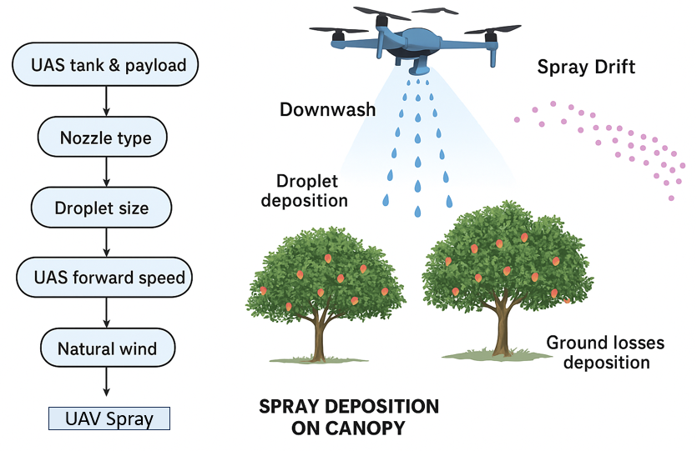
Figure 1: UAV Spraying Methods in Mango Crop

2.5 Geospatial and Sensor-Based Data Collection
Multispectral imaging was performed using UAV-mounted sensors to capture canopy reflectance signatures, including the Normalized Difference Vegetation Index (NDVI) and Photochemical Reflectance Index (PRI). Pre- and post-treatment imaging was carried out to assess canopy response. Canopy coverage and classification were analysed using QGIS software. At the leaf level, chlorophyll content was measured with a SPAD-502 chlorophyll meter. Pest and disease incidence were recorded weekly through direct field observations.
2.6 Spray Deposition and Drift Assessment
Spray deposition was quantified using water-sensitive papers placed at upper, middle, and lower canopy zones. Deposition was expressed as percentage coverage of droplet marks. Spray drift was measured using collectors positioned 2, 5, and 10 m downwind from the spray plots, allowing quantification of off-target losses.
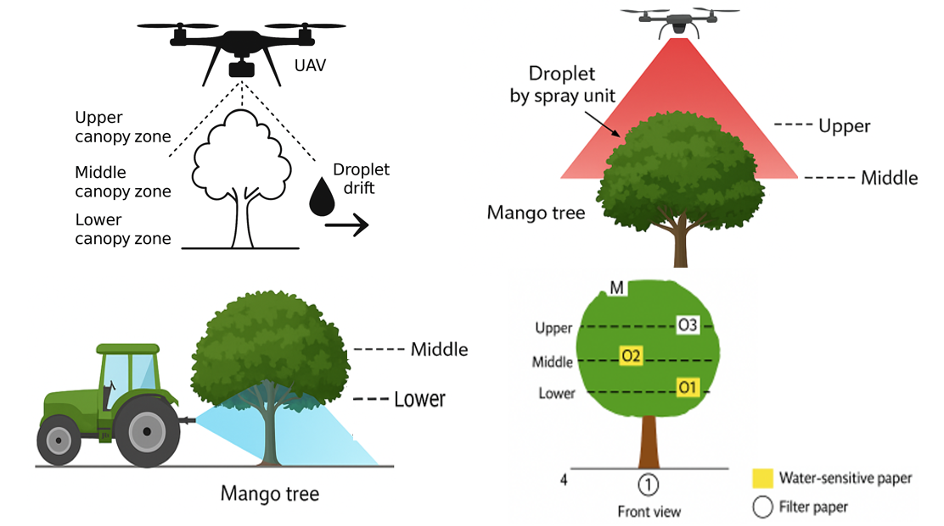
Figure 2: UAV & Tractor Spray Deposition

2.7 Statistical Analysis
Data were subjected to analysis of variance (ANOVA), and treatment means were compared using Tukey’s Honest Significant Difference (HSD) test at p ≤ 0.05. Normality and homogeneity of variance were verified before performing statistical tests. All analyses were conducted using R statistical software (version 4.3.1).
3. Results
3.1 Spray Volume Efficiency
A substantial reduction in spray volume was observed in UAV treatments compared with conventional tractor spraying. While the tractor-mounted sprayer required approximately 15 L per tree, UAV applications achieved comparable efficacy at 2–3 L per tree. This represented a 70–80% reduction in solution use, indicating higher input efficiency of UAV spraying (p < 0.05).
3.2 Canopy Spray Deposition
Spray deposition varied significantly across treatments and canopy zones (Table 1). UAV spraying achieved greater deposition in the upper and middle canopy layers, while tractor spraying resulted in relatively higher deposition in the lower canopy. Among UAV treatments, T2 (2 L/tree) and T3 (3 L/tree) provided the most balanced coverage across canopy layers.
Table 1. Spray deposition across canopy zones under UAV and tractor spraying (mean ± SE, % coverage).
Canopy zone | T1 (1 L UAV) | T2 (2 L UAV) | T3 (3 L UAV) | T4 (15 L Tractor)
Upper | 42 ± 3 b | 48 ± 4 a | 50 ± 3 a | 35 ± 4 c
Middle | 36 ± 2 b | 44 ± 3 a | 47 ± 4 a | 33 ± 3 c
Lower | 20 ± 2 c | 26 ± 2 b | 29 ± 3 b | 38 ± 3 a

Values within rows followed by different letters are significantly different at p ≤ 0.05 (Tukey’s HSD).
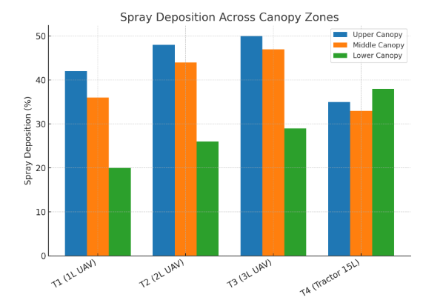
Figure 3: Spray Deposition Canopy Zones

3.3 Pest and Disease Control
All treatments significantly reduced pest and disease incidence compared with untreated controls. T2 (2 L UAV) achieved suppression levels statistically comparable to tractor spraying (p > 0.05). Both UAV and tractor methods reduced mango hopper counts and anthracnose incidence, with no significant differences between T2, T3, and T4.
3.4 Drift and Environmental Safety
Drift analysis indicated a notable reduction in off-target losses with UAV applications. At 2 m downwind, drift from UAV spraying averaged 2.8% of applied solution, compared with 5.6% under tractor spraying. This represented a ~40% reduction in drift, with differences statistically significant at p ≤ 0.05.
3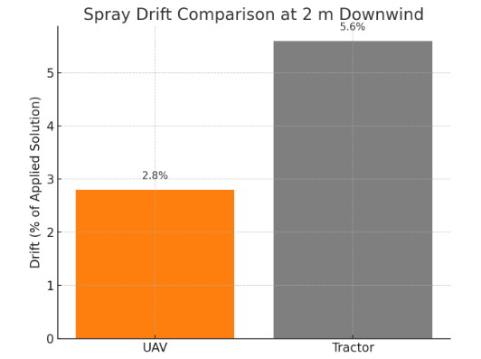
Figure 4: Spray Drift Comparison
UAV nozzles finer droplets (~100–150 µm, better canopy coverage, more drift control).
Tractor sprayers coarser droplets (~250–300 µm, deeper canopy penetration, but more chemical use).
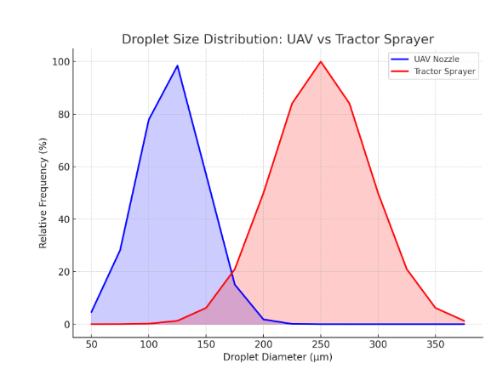
Figure 5: Droplet Size Distribution
3.5 Optical Sensor and Spectral Analysis
Multispectral imaging and SPAD chlorophyll readings showed improvements in canopy health under UAV treatments (Table 2). NDVI values increased post-treatment in all UAV applications, with the highest values observed in T3 (0.73) and T2 (0.71), compared with tractor spraying (0.70). SPAD chlorophyll indices followed a similar pattern, with UAV treatments recording higher values than tractor spraying.

Table 2. NDVI and SPAD chlorophyll index measured 14 days after spraying.
Treatment | NDVI | SPAD Index
T1 (1 L UAV) | 0.62 | 38
T2 (2 L UAV) | 0.71 | 44
T3 (3 L UAV) | 0.73 | 46
T4 (15 L Tractor) | 0.7 | 45

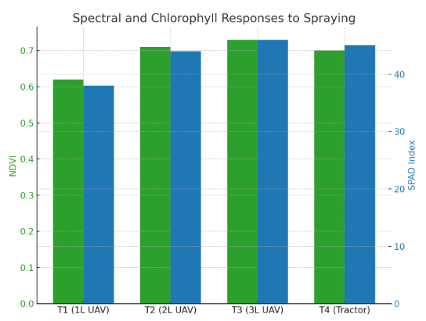
Figure 6: Spectral & Chlorophyll result
3.6 Economic Analysis
UAV spraying demonstrated considerable savings in input and operational costs. By reducing nutrient spray solution use by 70–80%, UAV treatments lowered chemical expenses by approximately 25% per hectare. Labour requirements were also reduced, with two operators sufficient for UAV operation compared with three for tractor spraying. Overall, UAV spraying showed greater cost-effectiveness and operational efficiency, particularly at the T2 application rate.

4. Discussion
The findings of this proof-of-concept study demonstrate the technical feasibility and agronomic benefits of UAV spraying in mango orchards. A key outcome was the substantial reduction in spray volume achieved by UAVs, with T2 (2 L/tree) providing comparable pest and disease control to tractor spraying at 15 L/tree. This aligns with previous studies in citrus and vineyards, which reported reductions of 60–80% in agrochemical uses under UAV applications without compromising efficacy [3,4]. Such efficiency gains are particularly relevant for mango production systems, where chemical input costs and environmental concerns are rising.
Spray deposition analysis revealed that UAV treatments achieved superior coverage in the upper and middle canopy zones, consistent with the rotor-induced downdraft effect documented in UAV spraying studies on tree crops [6,7]. Conversely, tractor spraying performed better in the lower canopy, reflecting nozzle orientation and the coarser droplet size typically associated with ground-based sprayers [8]. These findings suggest that UAVs offer a significant advantage in targeting foliar surfaces exposed to sunlight and pest colonization, while tractor sprayers may retain a role in penetrating dense foliage at the lower canopy. A hybrid approach that integrates UAV and tractor technologies could therefore optimize coverage across canopy strata.
Pest and disease control efficacy under UAV spraying were comparable to conventional methods, confirming its potential as a viable alternative for orchard management. This result supports prior work in rice and citrus systems, where UAV applications achieved pest suppression equivalent to or better than tractor spraying [6,9]. Moreover, the 40% reduction in spray drift observed with UAVs underscores their environmental safety advantages, an issue of particular importance in orchards located near water bodies or residential areas [3]. Reduced drift also aligns with global policy objectives to minimize off-target contamination and operator exposure (ISO, 2022).
Multispectral and SPAD data provided additional evidence of the physiological benefits of UAV spraying. Treatments T2 and T3 exhibited higher NDVI and chlorophyll indices than tractor spraying, indicating improved nutrient absorption and canopy health. Similar trends were reported in UAV studies integrating spectral sensing with targeted spraying in vineyards and apple orchards [5,10]. These results demonstrate the potential of UAVs not only as a spraying tool but also as a component of sensor-driven precision agriculture systems.
From an economic perspective, UAV spraying reduced chemical use by up to 80% and lowered labour requirements, translating into a 25% reduction in operational costs. Such outcomes highlight the commercial viability of UAV spraying for small and medium scale mango growers, who often face resource constraints. However, initial capital costs and technical training remain potential barriers to adoption, as noted in other UAV adoption studies [11,12].
Despite these promising findings, the study also highlights certain limitations. Tractor spraying still achieved superior coverage in lower canopy zones, suggesting that UAVs may not completely replace conventional methods in dense mango orchards. Furthermore, this trial was conducted over a single season, and long-term effects on yield, fruit quality, and orchard ecosystem safety were not evaluated. Future research should therefore focus on nozzle optimization [13], AI-based prescription maps for tree-specific spraying [12], and multi-season trials across diverse agro-climatic regions.
In summary, this study contributes novel evidence on UAV spraying in mango orchards, bridging a significant research gap in tropical fruit systems. By demonstrating technical feasibility, agronomic effectiveness, and economic advantages, it positions UAV spraying as a transformative tool for sustainable orchard management within precision agriculture frameworks.
5. Conclusion
This study provides the first structured evidence of UAV spraying as a feasible and sustainable alternative to tractor-mounted spraying in high-density mango orchards. UAV spraying at 2–3 L/tree achieved comparable pest and disease control to conventional tractor spraying at 15 L/tree, while reducing solution use by 70% and spray drift by 40%. The integration of UAV-mounted sensors further demonstrated enhanced canopy nutrition and improved spectral indices, highlighting the role of UAVs in advancing precision agriculture. Although tractor spraying retained an advantage in lower canopy coverage, the overall technical, economic, and environmental benefits of UAV spraying suggest strong potential for adoption in small- and medium-scale mango orchards. Future research should emphasize long-term trials, nozzle optimization, and AI-driven prescription maps to fully harness UAVs for smart and sustainable orchard management.

Competing interests disclaimer:
Authors have declared that they have no known competing financial interests OR non-financial interests OR personal relationships that could have appeared to influence the work reported in this paper.
Disclaimer (Artificial intelligence)
The authors hereby declare that no generative AI technologies, including large language models (eg. ChatGPT, Copilot etc.,) or text to image generators, were used in the writing, editing or preparation of this manuscript. All content, analysis and conclusions presented are the result of the authors own work, supported by conventional academic resources and validated methodologies.

References
- [1] K. Usha, P. Kumar, and B. L. Singh, "Pest and disease control strategies in organic fruit production," in Organic Fruit Production, Springer, 2019.
https://doi.org/10.1007/978-3-030-04657-6_4
- [2] J. K. Bana, H. Sharma, S. M. Chavan, D. K. Sharma, and S. J. Patil, "Assessment of losses caused by major insect-pests and diseases of mango (Mangifera indica L) under humid tropics," Pest Management in Horticultural Ecosystems, vol. 29, no. 2, pp. 227–232, 2023. https://doi.org/10.5958/0974-4541.2023.00034.6
- [3] J. Martínez-Guanter, P. Agüera, J. Agüera, and M. Pérez-Ruiz, "Spray and economics assessment of a UAV-based ultra-low-volume application in olive and citrus orchards," Precision Agriculture, vol. 21, pp. 226–243, 2020.
https://doi.org/10.1007/S11119-019-09665-7
- [4] R. K. Sahni, S. Kumar, D. Thorat, Y. A. Rajwade, and B. Jyoti, "Drone spraying system for efficient agrochemical application in precision agriculture," in Advances in Smart Farming, Springer, 2024, pp. 231–245.
https://doi.org/10.1007/978-981-99-8684-2_13
- [5] K. Wang and Y. Jin, "Mapping walnut water stress with high resolution multispectral UAV imagery and machine learning," arXiv preprint, 2023.
https://doi.org/10.48550/arxiv.2401.01375
- [6] Y. Yan, Y. Lan, G. Wang, M. Hussain, and H. Wang, "Evaluation of the deposition and distribution of spray droplets in citrus orchards by plant protection drones," Frontiers in Plant Science, vol. 14, 2023.
https://doi.org/10.3389/fpls.2023.1303669
- [7] S. Jiang, B. Chen, W. Li, S. Yang, and Y. J. Zheng, "Stereoscopic plant-protection system integrating UAVs and autonomous ground sprayers for orchards," Frontiers in Plant Science, vol. 13, 2022. https://doi.org/10.3389/fpls.2022.1040808
- [8] A. N. Vu, "Investigating droplet size and spraying span of pesticide drone," Tạp chí Phát triển khoa học & công nghệ: chuyên san Kỹ thuật & Công nghệ, vol. 5, no. 2, pp. 1234–1242, 2022. https://doi.org/10.32508/stdjet.v5i2.966
- [9] Y. Chen, J. Xu, W. Zhang, S. Qiu, and Y. Lan, "Identification of flowering rate of Litchi canopy based on UAV multispectral remote sensing images," International Journal of Precision Agricultural Aviation, vol. 5, no. 1, pp. 1–8, 2022.
https://doi.org/10.33440/j.ijpaa.20220501.189
- [10] R. Zhang, S. Lian, L. Li, L. Zhang, and C. Zhang, "Design and experiment of a binocular vision-based canopy volume extraction system for precision pesticide application by UAVs," Computers and Electronics in Agriculture, vol. 213, 2023. https://doi.org/10.1016/j.compag.2023.108197
- [11] N. Bloise, M. Carreno Ruiz, D. D'Ambrosio, and G. Guglieri, "Preliminary design of a remotely piloted aircraft system for crop-spraying on vineyards," in Proc. IEEE MetroAgriForss, 2020, pp. 1–6.
https://doi.org/10.1109/METROAGRIFOR50201.2020.9277607
- [12] A. Taseer, "Advancements in variable rate spraying for precise spray requirements in precision agriculture using unmanned aerial spraying systems: A review," Computers and Electronics in Agriculture, vol. 219, 2024.
https://doi.org/10.1016/j.compag.2024.108841
- [13] M. Ni, H. Wang, X. Liu, Y. Liao, and L. Fu, "Design of variable spray system for plant protection UAV based on CFD simulation and regression analysis," Sensors, vol. 21, no. 2, 2021. https://doi.org/10.3390/S21020638
- Li, Y., Han, L., Liu, L., Huang, Z., Wang, C., & He, X. (2023). Design and spray performance evaluation of an air–ground cooperation stereoscopic plant protection system for mango orchards. Agronomy, 13(8), 2007.
- Wang, J., Lan, X., Chen, P., Liang, Q., Liao, J., & Ma, C. (2024). Field evaluation of spray quality and environmental risks of unmanned aerial spray systems in mango orchards. Crop Protection, 182, 106718.

