Economic analysis of sugarcane cultivation in Kerala, India

Abstract
The study analysed the economics and resource use efficiency in sugarcane cultivation of Sugarcane cultivation in Kerala. A multi-stage random sampling technique was adopted for the data collection and information was gathered from 120 sugarcane farmers. The computed value of sugarcane cultivation in terms of cost A₂ was Rs.3,18,115 ha⁻¹. It is also noted that the cost of hired human labour accounts for 54.80 per cent of cost A₂. The net return at cost C₂ was Rs. 1,02,221 ha-1. The computed B:C ratio at cost C₂ was 1.27, indicating the profitability of sugarcane cultivation. The study examined the input-output relationship and resource use efficiency of sugarcane production using the Cobb- Douglas production function. It was observed from the fitted regression that inputs viz., setts, fertilizers and human labour were positively and significantly contributing to sugarcane production. The marginal productivity analysis further revealed the over-utilisation of organic manures and human labourers and the under-utilisation of resources like setts, chemical fertilizers and hired machine labour.
.
Keywords: Sugarcane, costs, returns, resource use efficiency, Cobb-Douglas, Marginal productivity

Introduction
Sugarcane (Saccharum officinarum) is one of the primary sources of sugar in the world and has a prominent position as a cash crop in the tropics. Sugarcane supplies about 60 per cent of the global demand for sugar, while the remaining 40 per cent comes from sugar beet (Saravanan, 2016). Sugarcane is a very important crop in India’s agriculture landscape as being the world’s second largest producer and largest consumer of sugar (Saini, et al. 2022). Sugarcane juice is used to make white sugar, brown sugar (Khandsari) and Jaggery (Gur). Further, it generates casual employment for over five lakh people in sugar factories. Moreover, 35 million farmers and their families were engaged in the cultivation of sugarcane (Chandra et al. 2022).
The global area, production, and productivity of sugarcane were 26.08 million hectares, 19.22 million tonnes, and 65.5 tonnes, respectively (FAO, 2022). Brazil is the largest producer of sugarcane in the world and contributes 37.83 per cent of global production, followed by India China and Thailand.
In India, sugarcane was cultivated in an area of 5.83 million hectares in 2022-23, with production of 494.22 million tonnes and productivity of 84.01 tonnes per hectare (GOI, 2023). In India, Uttar Pradesh is the leading producer of sugarcane, followed by Maharashtra, and Karnataka, and these states together account for 77 per cent of the total sugarcane production.
The area, production and productivity of sugarcane in Kerala was 931 hectares, 1,01,240 tonnes and 108 tonnes per ha, respectively (GOK, 2023). In Kerala, Idukki district is the leading producer of sugarcane, accounting for 93 per cent of the state production (10,076.95 tonnes) followed by Alappuzha and Palakkad.
Although Kerala's contribution to sugarcane production in the country is negligible, an economic analysis of sugarcane production in the state is essential as the production of Marayoor jaggery with Geographical Indication (GI) status is concentrated in Idukki district.
The entire production in the Marayoor area is used to prepare the Marayoor jaggery. As the demand for jaggery is increasing and likely to increase in the coming years, there is considerable scope for expansion of sugarcane cultivation. Hence, it is crucial to analyse the economics of sugarcane cultivation and feasibility analysis of Marayoor jaggery to know the potential of crop and jaggery enterprise to augment the income and standard of living of farmers. To examine the feasibility of sugarcane cultivation, a comprehensive understanding of costs and returns is required.
The analysis of cost of cultivation in major producing states revealed that growers were receiving better profit from sugarcane cultivation after the introduction of Fair and Remunerative Prices (FRP) in 2009 (Vikas, 2020). However, sugarcane cultivation in the state was showing a declining trend. As sugarcane is not considered an important crop in the state, there was little government support, and this reduced the interest among farmers in continuing sugarcane cultivation (Nisha et al. 2021). The rising cost of cultivation of sugarcane was reported as the major limitation confronted by the sugarcane farmers in various states (Upreti and Singh, 2017), which may be one of the reasons for the declining area of sugarcane crops in Kerala. Hence, the farmers need to ensure the prudent use of inputs to reduce the cost of cultivation and increase profitability. In this context, the analysis of existing resource use and allocative efficiency place significant importance.
Research Methodology
The primary data was used for analyse the specific objectives of the study. A multi-stage random sampling technique was adopted and the data was gathered from 120 farmers using a well-structured pre-tested interview schedule. In the first stage, Idukki district, which has the largest sugarcane cultivation in Kerala, was selected for the study. During the second stage, Devikulam block was selected for the study on the basis of high acreage and production of sugarcane. Two-gram panchayats Marayoor and Kanthalloor were selected from the Devikulam block after discussion with the officials of the Department of Agriculture and Farmer’s Welfare. A Complete list of sugarcane farmers was collected from the respective Krishi Bhavans. From the list, 60 farmers were randomly selected from each panchayat, thus making a total sample size of 120 farmers. The data on socio economic profile, farm inventory, land utilization pattern, cropping pattern, expenses towards various material and labour inputs in sugarcane cultivation and details of returns in sugarcane cultivation were collected from the selected farmers.
Analytical tools and techniques
Percentages and averages
The percentage and average calculations were used to analyze the socio-economic attributes of the farmers.
Commission for Agricultural Costs and Prices: Cost concepts
CACP cost concepts, Cost A₁, A₂, B₁, B₂, C₁, and C₂ were used to estimate the cost of cultivation of sugarcane for the year 2022-23.
Cost A₁ includes
- Cost of hired and human labour
- Cost of hired machine labour
- Cost of setts
- Cost of manures (owned and purchased)
- Cost of fertilizers
- Cost of plant protection chemicals and weedicides
- Land revenue
- Irrigation charges
- Depreciation on machinery and implements
- Interest on working capital
- Miscellaneous expenses
Cost A₂: Cost A₁+ rent paid for leased in land
Cost B₁: Cost A₁+ interest on the value of owned fixed capital assets excluding land
Cost B₂: Cost B₁+ rental value of owned land+ rent paid for leased in land
Cost C₁: Cost B₁+ imputed value of family labour
Cost C₂: Cost B₂ + imputed value of family labour
Return analysis
Gross return
Gross return from sugarcane was estimated as the product of the average quantity of sugarcane produced per year and the prevailing unit price. The average market price of sugarcane during the study period (2023-24) was 4796 Rs/tonne, and the same was used for the computation.
Gross return = Quantity of product x unit price

Net Returns
The net return was calculated by subtracting the annual maintenance expenses from the gross return.
Net return = Gross return – Cost of cultivation (Cost C)
Benefit-Cost (BC) ratio
The BC ratio unveils the efficiency of production, and it is determined by dividing the total benefits by the total production expenditure.
B-C ratio = Gross return/ Cost of cultivation (cost C)
Resource use efficiency
Production function approach was employed to determine the resource use efficiency of sugarcane cultivation. The purpose of the analysis was to determine how the farmers are utilizing the resources and how they allocate those resources in the cultivation of sugarcane. It is possible to determine whether or not the resources are being used as efficiently as possible in the production programme by looking at the resource use efficiency. The collected data was analysed by fitting the Cobb-Douglas production function of the form.
Y = a X₁^{b1} X₂^{b2} X₃^{b3}……..X_{n}^{bn} .e^{u}

The fitted Cobb-Douglas production function for sugarcane cultivation in the Idukki district is given by:
Y = a X₁^{b1} X₂^{b2} X₃^{b3}X₄^{b4} X₅^{b5} e^{u}
This is modified into linear equation by application of logarithm.
Ln Y = ln a + b₁ ln X₁ + b₂ ln X₂ + b₃ ln X₃ + b₄ ln X₄ + b₅ ln X₅ + U
Where,
Y = Output (kg)
a = Intercept
b₁…..b₅ = Elasticity coefficients of respective inputs and summation of these gives returns to scale.
e^{u} = Error term
X₁ = Setts
X₂ = Farmyard manure (Rs/ ha)
X₃ = Fertilizer (Rs/ ha)
X₄ = Human labour (Rs/ ha)
X₅ = Hired machine labour (Rs/ ha)

Allocative Efficiency
To ascertain the extent of utilisation of available resources, the calculation of allocative efficiency was conducted individually for each cultivated crop. To ensure maximum profit and efficiency of resources, farmers must utilize the resources at the level where their marginal value product (MVP) is equal to their marginal factor cost (MFC). The efficiency of a resource would be determined by the ratio of the Marginal Value Product (MVP) of inputs and the MFC.
Mathematically,
$$AE=\frac{MVP}{MFC}$$
Where, AE= Allocative Efficiency
MVP = Marginal Value Product
MFC = Marginal Factor Cost
Here, MVP = MPP_{i}×P_{y}
MPP_{i} = Marginal Physical Product of i^{th} input
P_{y} = Price of output (Rs/Kg)
Based on AE (K_{i}), the following inferences were made
- If K_{i} >1, indicates the underutilisation of the resources
- If K_{i} =1, indicates the optimal/ prudent use of the resources
- If K_{i} <1, indicates the overutilisation of resources
Results and discussion
The socioeconomic attributes such as age, gender, education, family size, occupation and family income were tabulated and analysed with percentage analysis and the results are shown in Figure 1. The majority of the respondent farmers (47%) were in the age group of 45-60 years. Regarding educational status, most of the farmers (61.67%) in the study area had an education up to the primary level. About 60 per cent of the farmers had a family size of less than four members. Exactly 84.17 per cent of farmers were dependent on agriculture as their main source of income. Regarding the type of land holding, 48.33 per cent of the farmers in the study area had a marginal land holding of less than one hectare. The majority of the farmers (61.70%) had an annual income between ₹ 1-5 lakh. A study conducted by Jagatpal et al. (2017) in Uttar Pradesh also revealed that the majority (47%) of the respondents were marginal farmers. According to the study conducted by Verma et al. (2022) among the sugarcane growers in district Lakhimpur Kheri, majority of the respondents (79%) had agriculture as primary occupation.
Costs of cultivation of sugarcane
The cost of cultivation of sugarcane, based on CACP cost concepts is calculated and presented in Table 1. The estimated value of cost A₂ in the study area was Rs. 3,18,115 ha⁻¹. While as per the latest price policy report, the all-India average cost of cultivation based on Cost A₂ was Rs. 80,062 ha⁻¹ (GOI, 2021). They emphasized that the cost of cultivation varied between states and the variations were primarily due to changes in input costs required for production. It is observed from Figure 2, that 54.80 per cent of cost A₂ is accounted for the cost of hired human labour and 9.89 per cent is accounted for the cost of fertilizers. The difference in the wage rate of labour between the states may cause large variations in costs across various states. Compared to other states, the wage rates of males and females were remarkably higher in Kerala, which accounts for the large difference in cost A₂ between Kerala and other states. Along similar lines, Arthi (2015) also observed that human labour accounted for a high share of operational costs, and was 51.20 per cent of the total operational cost of sugarcane cultivation in Tamil Nadu. The cost of cultivation based on cost C₁ and cost C₂ were Rs. 2,82,851 and Rs.3,74,842 per ha, respectively. The computed value of cost A₂+FL was Rs. 3,31,875 ha⁻¹, while the estimated average value of cost of cultivation of sugarcane in India based on cost A₂+FL was Rs. 92,720 ha⁻¹ (GOI, 2021). As the support price is fixed based on cost A₂+FL, the government may take into consideration the large variation in the cost, before fixing the state advisory prices to promote the cultivation of sugarcane.

Table 1. Cost of cultivation of sugarcane in Kerala
Sl. No. | Item | Cost (Rs/ha) | Per cent to cost A₂
1 | Setts | 5,329 | 1.67
2 | Chemical fertilizers | 31,493 | 9.89
3 | Organic manures | 12,026 | 3.78
4 | Weedicides | 233 | 0.07
5 | Hired human labour | 1,74,351 | 54.80
6 | Hired machine labour | 17,582 | 5.52
7 | Land revenue | 316 | 0.09
8 | Depreciation | 5,690 | 1.78
9 | Interest on working capital | 16,824 | 5.28
 | Cost A₁ | 2,63,844 | -
10 | Rental value of leased in land | 54,271 | 17.06
 | Cost A₂ | 3,18,115 | 100
11 | Interest on owned fixed capital excluding land | 5,247 | -
 | Cost B₁ | 2,69,091 | -
12 | Rental value of owned land | 37,720 | -
 | Cost B₂ | 3,61,082 | -
13 | Imputed value of family labour | 13,760 | -
 | Cost C₁ | 2,82,851 | -
 | Cost C₂ | 3,74,842 | -
 | A₂+FL | 3,31,875 | -

Returns from sugarcane cultivation
The details of returns from sugarcane cultivation are depicted in Table 2. The average yield of sugarcane in the study area was 101 tonnes ha⁻¹, which is remarkably higher when compared to the average yield of sugarcane in India during 2023 (84.01 t ha⁻¹). The average market price of sugarcane in the study area during the year 2022-23 was Rs 4,796 per tonne. The gross return was estimated to be Rs. 4,77,063 ha⁻¹. The net returns based on cost A₁, cost A₂, cost B₁, cost B₂, cost C₁ and cost C₂ were Rs. 2,13,219, Rs. 1,58,948, Rs. 2,07,972, Rs. 1,15,981 and Rs 1,94,212 and Rs 1,02,221, respectively. The study conducted by Kant et al. (2015) in Uttar Pradesh also observed a similar finding that the net return at cost C₂ was Rs. 1,07,628 ha⁻¹. The study conducts by Singh et al. (2018) in East Champaran district Bihar also observed a similar finding that the net return. Contradictory to this, Janjire et al. (2018) carried out a study on costs, returns and profitability of sugarcane in the district of Pune in Maharashtra and reported that the computed cost of cultivation of sugarcane cost C, was Rs. 1,93,177 ha⁻¹ and the gross returns stood at Rs. 3,76,290 ha⁻¹ using drip irrigation.
Table 2. Returns from sugarcane cultivation in Kerala

Sl. No. | Particulars | Value
1 | Yield (t/ha) | 101
2 | Price (Rs/t) | 4,796
3 | Gross returns (Rs/ha) | 4,77,063
4 | Net returns at Cost A₁ (Rs/ha) | 2,13,219
5 | Net returns at Cost A₂ (Rs/ha) | 1,58,948
6 | Net returns at Cost B₁ (Rs/ha) | 2,07,972
7 | Net returns at Cost B₂ (Rs/ha) | 1,15,981
8 | Net returns at Cost C₁ (Rs/ha) | 1,94,212
9 | Net returns at Cost C₂ (Rs/ ha) | 1,02,221

Benefit-Cost ratio
The BC ratio of sugarcane cultivation is depicted in Table 3. The BC ratio of sugarcane cultivation at cost A₁, cost A₂, cost B₁, cost B₂, cost C₁ and cost C₂ was found to be 1.81, 1.50, 1.77, 1.32, 1.69 and 1.27, respectively. The BC ratio of more than one indicated the profitability of sugarcane cultivation in Kerala. A similar study conducted by Mishra et al. (2021) and Ranjan et al. (2020) also observed that the BC ratio at cost C₂ was 1.22 in sugarcane cultivation.
Table 3. Computed value of Benefit-Cost (BC) of sugarcane cultivation
Sl. No. | B-C Ratio
1 | at cost A₁ | 1.81
2 | at cost A₂ | 1.50
3 | at cost B₁ | 1.77
5 | at cost B₂ | 1.32
6 | at cost C₁ | 1.69
7 | at cost C₂ | 1.27

Resource use efficiency
The findings of the fitted regression model pertaining to sugarcane cultivation in the Idukki district are depicted in Table 4. The value of adjusted R² in the fitted regression was 0.95, indicating that 95 per cent of the variation in sugarcane yield is contributed by all the selected independent variables in the model viz., setts, organic manures, chemical fertilizers, human labour and hired machine labour. It was observed from the table that inputs viz., setts, fertilizers and human labour were positively and significantly contributing to sugarcane production. The value of the coefficient indicated that a one per cent increase in the level of the inputs such as setts, fertilizers and human labour would increase the yield by 0.44, 0.23 and 0.27 per cent, respectively. The returns to scale, represented as ∑bi, was estimated to be 0.95, indicating the prevalence of decreasing returns to scale. A similar study conducted by, Gouraj et al. (2022) also observed a positive and significant relationship between planting material (setts) and human labour to the yield of sugarcane in the Belagavi district of Karnataka. Moreover, Mishra et al. (2021) conducted a study in Sultanpur district of eastern Uttar Pradesh and observed a positive relationship between the application of chemical fertilizers and the production of sugarcane in Uttar Pradesh.
Table 4. Resource use efficiency of sugarcane cultivation in Kerala
Sl. No. | Particular | Coefficient | Standard Error | P value
1 | Intercept | -3.8156 | 0.57 | 0
2 | Setts | 0.4498** | 0.09 | 0.00
3 | Organic manures | 0.0002 | 0.00 | 0.91
4 | Fertilizers | 0.2323* | 0.11 | 0.04
5 | Hired human labour | 0.2710* | 0.12 | 0.03
6 | Hired machine labour | 0.0022 | 0.00 | 0.51
7 | R² | 0.95
8 | Adjusted R² | 0.95
9 | Calculated F | 487
 | ∑b_{i} | 0.95
 | No. of observations | 120
* Significant at 5 per cent level
**Significant at 1 per cent level
Allocative efficiency of Sugarcane cultivation in Kerala
The allocative efficiency of sugarcane farmers in Kerala is reported in Table 5. The marginal productivity analysis revealed that the K value (MVP to MFC ratio) of organic manures and hired human labour was found to be below one, signifying its excessive utilization in the production of sugarcane in Kerala. On the other hand, the K values of setts, chemical fertilizers and hired machine labour exceeded one, indicating that these resources were under-utilized in the production process.

Table 5. Marginal productivity analysis of sugarcane cultivation in Kerala.
Sl. No. | Particulars | Geometric mean | MVP | MFC | K | Inference
1 | Setts | 4933.35 | 2.48 | 0.06 | 41.32 | Under utilized
2 | Organic manures | 893.37 | 0.19 | 0.63 | 0.31 | Over utilized
3 | Chemical Fertilizers | 30439.81 | 80.96 | 23.41 | 3.46 | Under utilized
4 | Hired human labour | 195479.7 | 383.96 | 611.15 | 0.63 | Over utilized
5 | Hired machine labour | 484.07 | 183.47 | 86.43 | 2.12 | Under utilized

Therefore, potential exists for their further use as each extra unit of money spent on the inputs viz., setts, chemical fertilizers and hired machine labour would increase the revenue by 41.32, 3.46 and 2.12 per cent, respectively. The study conducted by Bey et al. (2022), analysed the effectiveness of resource utilisation in sugarcane cultivation in Assam. The estimated K values were more than unity for setts, chemical fertilizers and hired machinery and it depicted the potentiality of these resources for their further use. The study conducted by Kashyap et al. (2018) analysed production efficiency and optimal allocation of resources in the cultivation of sugarcane in the Kabirdham district in Chhattisgarh finding similar study manure and fertilizer and machinery found under utilized
Conclusion
Costs of cultivation based on cost A₂ was Rs.3,18,115 ha⁻¹ and 54.80 per cent of the cost is accounted for hired human labour. The computed value of cost A₂+FL was Rs. 3,31,875 ha⁻¹, which was three times higher than the all-India average value of cost of cultivation of sugarcane in terms of cost A₂+FL. As the support price is fixed based on cost A₂+FL, the government may take into account the large variation in the cost before fixing the state advisory prices to promote the cultivation of sugarcane. The estimated BC ratio of more than one indicated the profitability of sugarcane cultivation in the study area. As the cultivation is found profitable, the government may take suitable measures to bring more land under sugarcane cultivation through area expansion programmes. The analysis of resource use efficiency further revealed the over utilisation of organic manures and human labourers and underutilisation of resources like setts, chemical fertilizers and hired machine labour. Providing proper awareness regarding the optimum usage of inputs and appropriate policy measures such as alertness and training on the adoption of the recommended package of practices to get maximum profit may be promoted. The labourers are over utilised in the study area, cost of production can be reduced by reducing the number of labour days and intervention of machinery in inter-cultural activities. Further, subsidy on machinery would make the tillage cheaper

Disclaimer (Artificial intelligence)
Author(s) hereby declare that NO generative AI technologies such as Large Language Models (ChatGPT, COPILOT, etc.) and text-to-image generators have been used during the writing or editing of this manuscript.

References
Arthi, K. 2015. Economic analysis of sugarcane cultivation under conventional and sustainable sugarcane initiative method in Tamil Nadu. M.Sc. (Ag) thesis, Tamil Nadu Agricultural University, Coimbatore, 131p.
Bey, B.S., Singh, R., Gogoi, J., Ahmed, R., Lapasam, R., Buragohain, R. and Deka, N. 2022. Resource use in sugarcane cultivation under tenant and owner farms of Assam: A comparative economic analysis. Indian J. of Agric. Eco. 77(2).
Chandra, S., Rawat, V. K., Verma, S. C. and Singh, O. P. 2022. Cost and returns analysis of sugarcane production in Basti district of Eastern Uttar Pradesh, India. The Pharma Inno. J. 11, 1309-12.
FAO [Food and Agriculture Organization] 2022. Agricultural Production Statistics [online]. Available. Agricultural production statistics 2022 (fao.org). [15 November, 2023]
GOI (Government of India) 2023. Agricultural statistics. [online]. Available: https://sugarcane.icar.gov.in/index.php/en/. [15 November 2023]
GOI (Government of India) 2021. Sugarcane price policy report, [online]: Available: https://cacp.dacnet.nic.in/KeyBullets.aspx?pid=41. [6 January2024]
GOK [Government of Kerala]. 2023. Agricultural statistics. [online]. Available: www.agriculture.kerala.gov.in. [23 November, 2023].
Gouraj, V., Choudhary, V. K., and Katre, P. K. 2022. Resource use efficiency of sugarcane production in Belagavi district of Karnataka. The Pharma Inno. J. 11(9S): 1917-1919.

Jagatpal, Doharey, R. K. Prasad, K., Singh, S.N., Singh, R. K. and Kumar, M. 2017. Socio Economic Profile of the Sugarcane Growers in Sitapur District (U.P.), India. Int. J. Curr. Microbiol. App. Sci. 6(3)
Janjire, N. B., Nagargoje, S. R. and Gore, M. H. 2018. Costs, returns and profitability of sugarcane with drip and surface irrigation in Pune district. J. of Pharmacog. and Phytochem. 7(3): 3594-3596.

Kant, K., Tripathi, S. P. and Meena, M. 2015. Cost of cultivation of
sugarcane crop in Meerut district of Uttar Pradesh. Int. J. of For. and Crop Improv. 6(1): 35-42.
Kashyap, Y., Sahu, R. and Nahatkar, S.B. 2018. Production efficiency and optimal allocation of resource in cultivation of sugarcane. J. of Pharmacog. and Phytochem. 7(1S): 2869-2872
Mishra, A., Kushwaha, R. R., and Singh, P. 2021. A Study on Resource Use Efficiency and Cost and Return of Sugarcane Cultivation in Sultanpur District of Eastern Uttar Pradesh. Int. J. Curr. Microbiol. App. Sci. 10(01): 3255-3261.
Nisha, M., Chandran, K., Gopi, R., Mahendran, B. and Gireesan, P. P. 2021. Status of sugarcane cultivation in Kerala vis-a-vis product diversification options. J. of Sugarcane Res. 11(2) 130-136.
Ranjan, A. K., Kushwaha, R. R., Verma, R. R., Singh, V. K., Mishra, A. and Yadav, R. 2020. A study on resource use efficiency of sugarcane production in Ghazipur district of eastern Uttar Pradesh. J. of Pharmacog. and Phytochem. 9(2S): 440-442.
Saini, S., Khatri, P. Hussain, S. 2022. Indian sugar policies: connecting production, consumption and health. Agrl. Econ. Res. Rev. 35(2):1-25.
Saravanan, A. 2016. An analysis of cost and returns of sugarcane production in Erode district of Tamil Nadu. Indian J. Econ. Dev.4(8): 1-4.
Singh, S., Singh, H., Kumari, M., Minnatullah, M., Chand, H. and Kumar, B. 2018. Economics analysis of production, resource use efficiency and constraints analysis of sugarcane cultivation in east Champaran district of north Bihar. Int. J. of Curr. Microbiol. and Appl. Sci. 7(10): 512-519.
Upreti, P., & Singh, A. 2017. An economic analysis of sugarcane cultivation and its productivity in major sugar producing states of Uttar Pradesh and Maharashtra. Econ. Affairs. 62(4): 711-718.
Verma, A. K., Sachan, B. S., Kumar, B., Yadav, B. and Choudri, H. P. 2022. Socio-economic profile of sugarcane growers in district Lakhimpur Kheri, India. Asian J. of Agric. Ext., Econ. and Soc. 40(9): 411-415.
Vikas, A. B., 2020. Economic viability of sugarcane cultivation: A comparative analysis. J. Sugarcane Res. 10: 158-173.

Fig. 1. Classification of farmers based on socio-economic characteristics of respondents
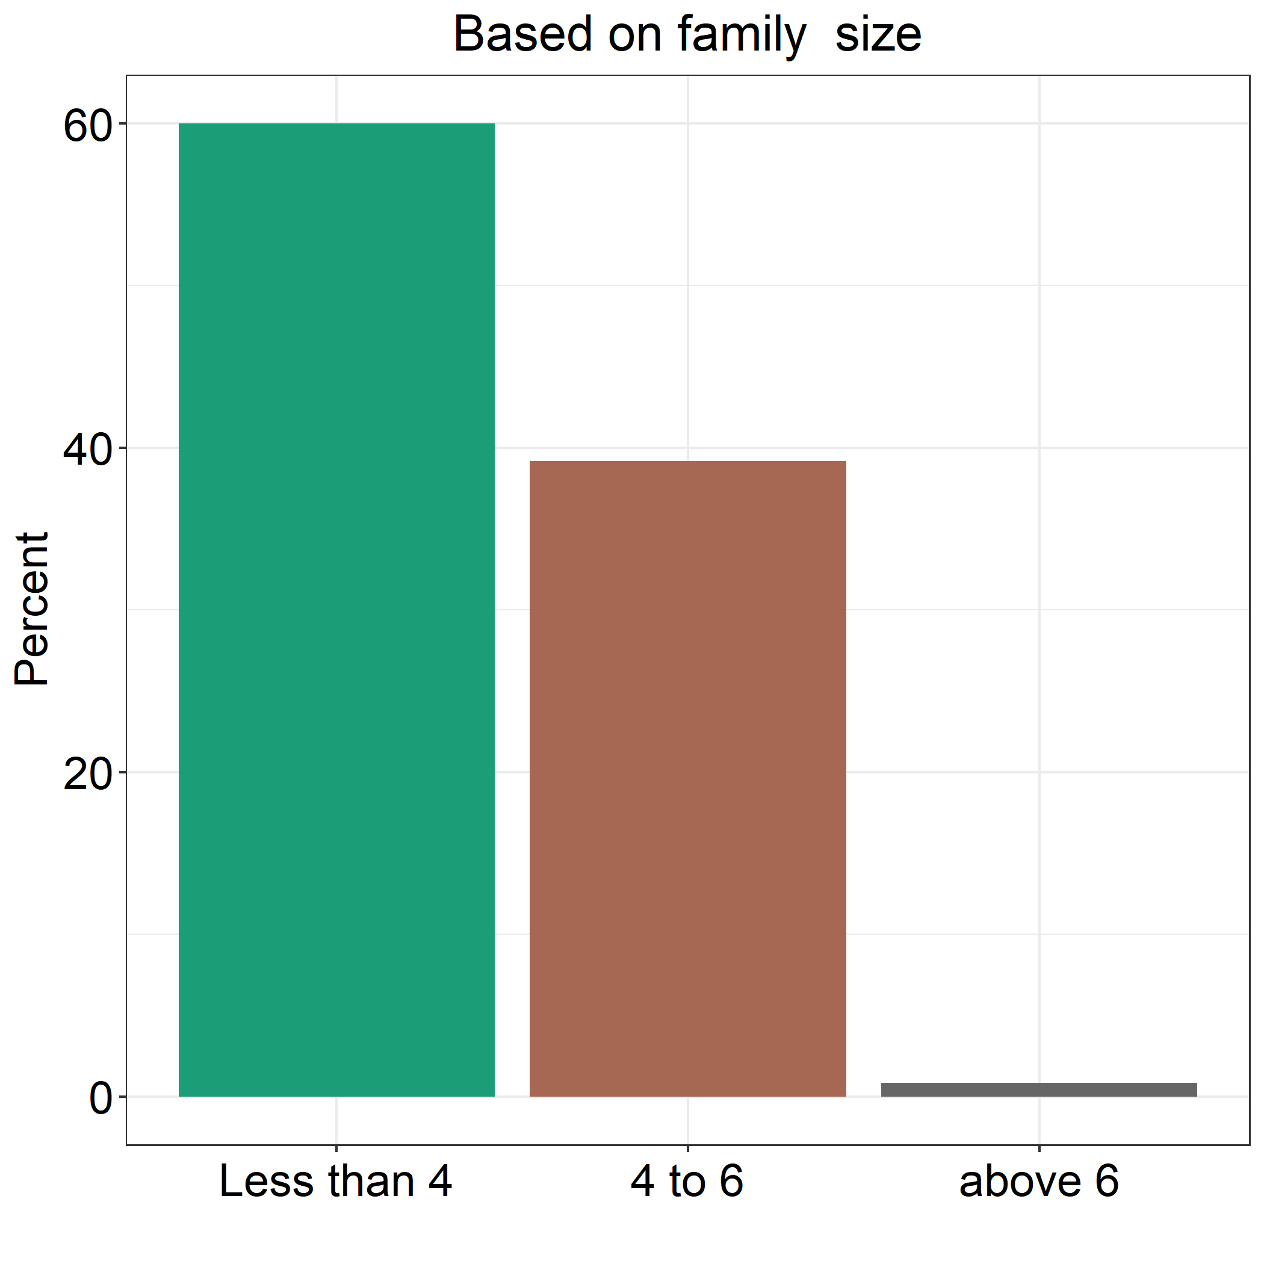
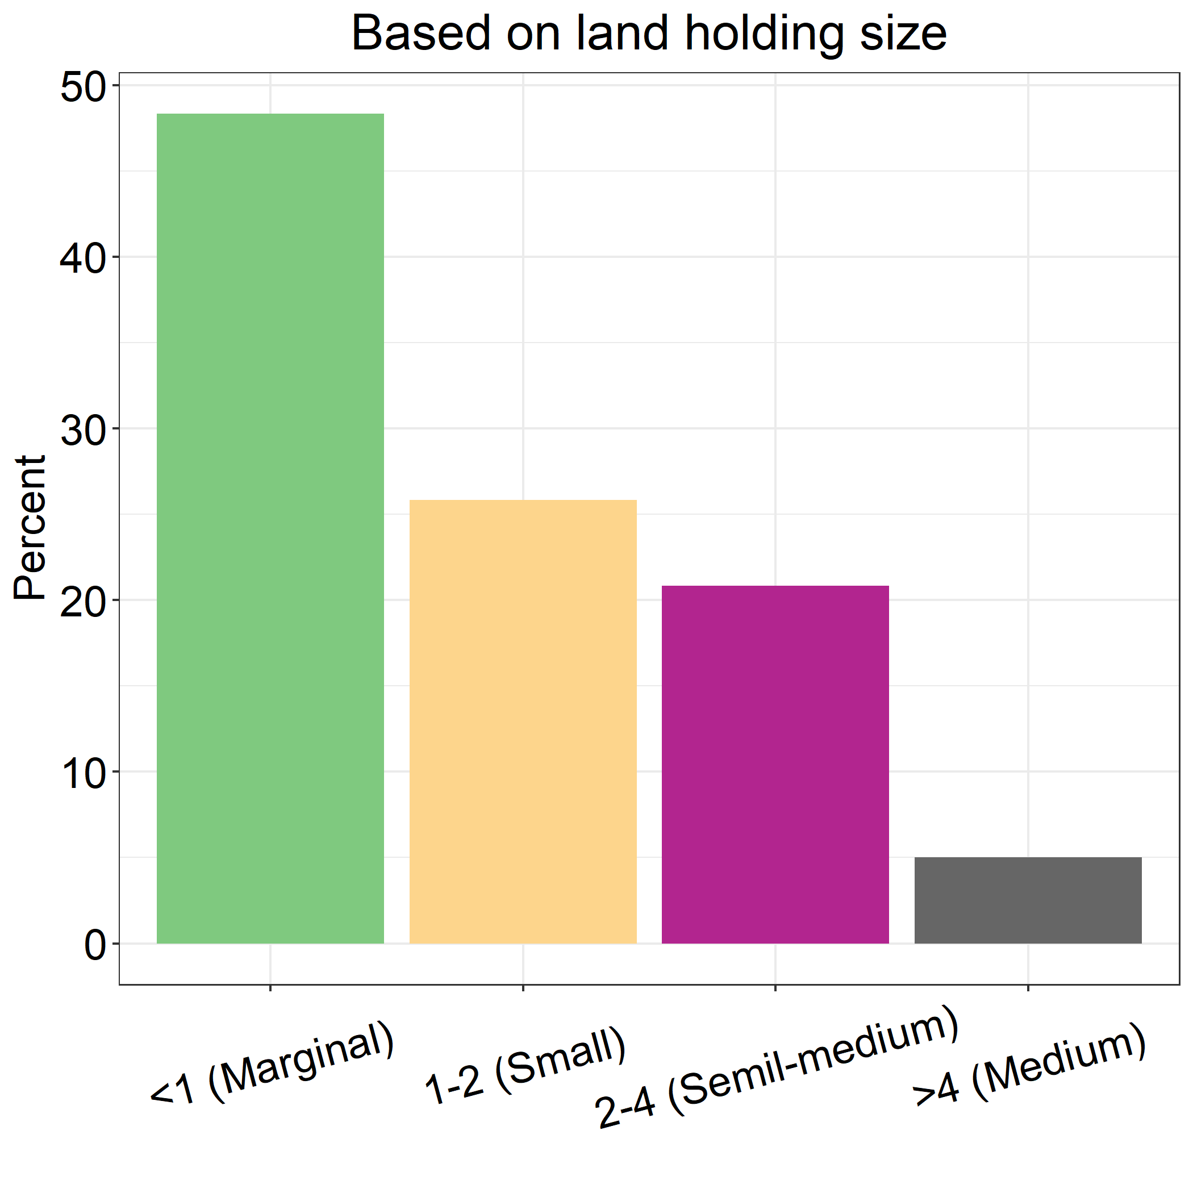
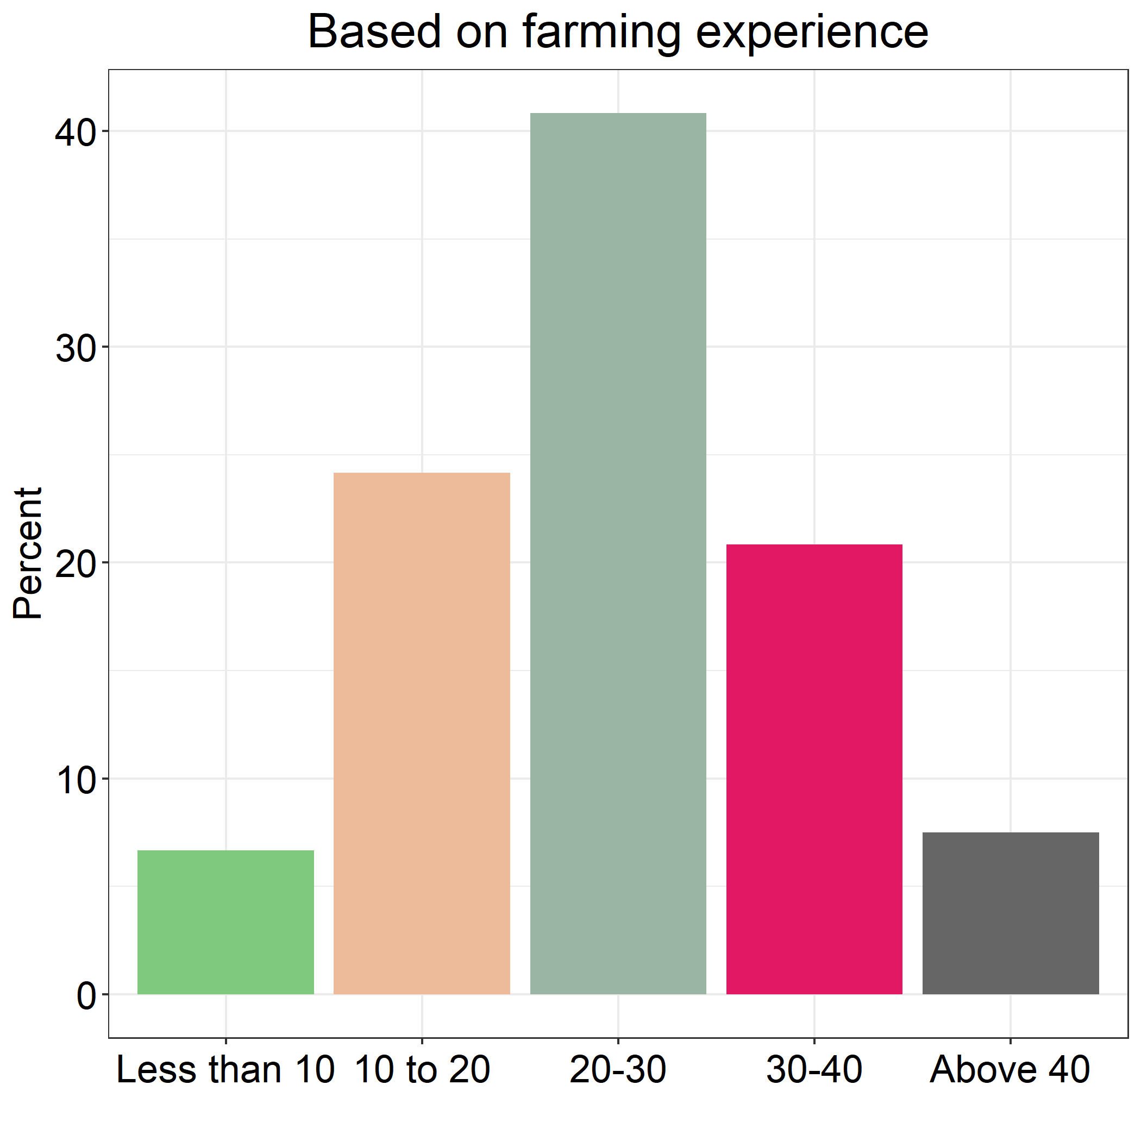
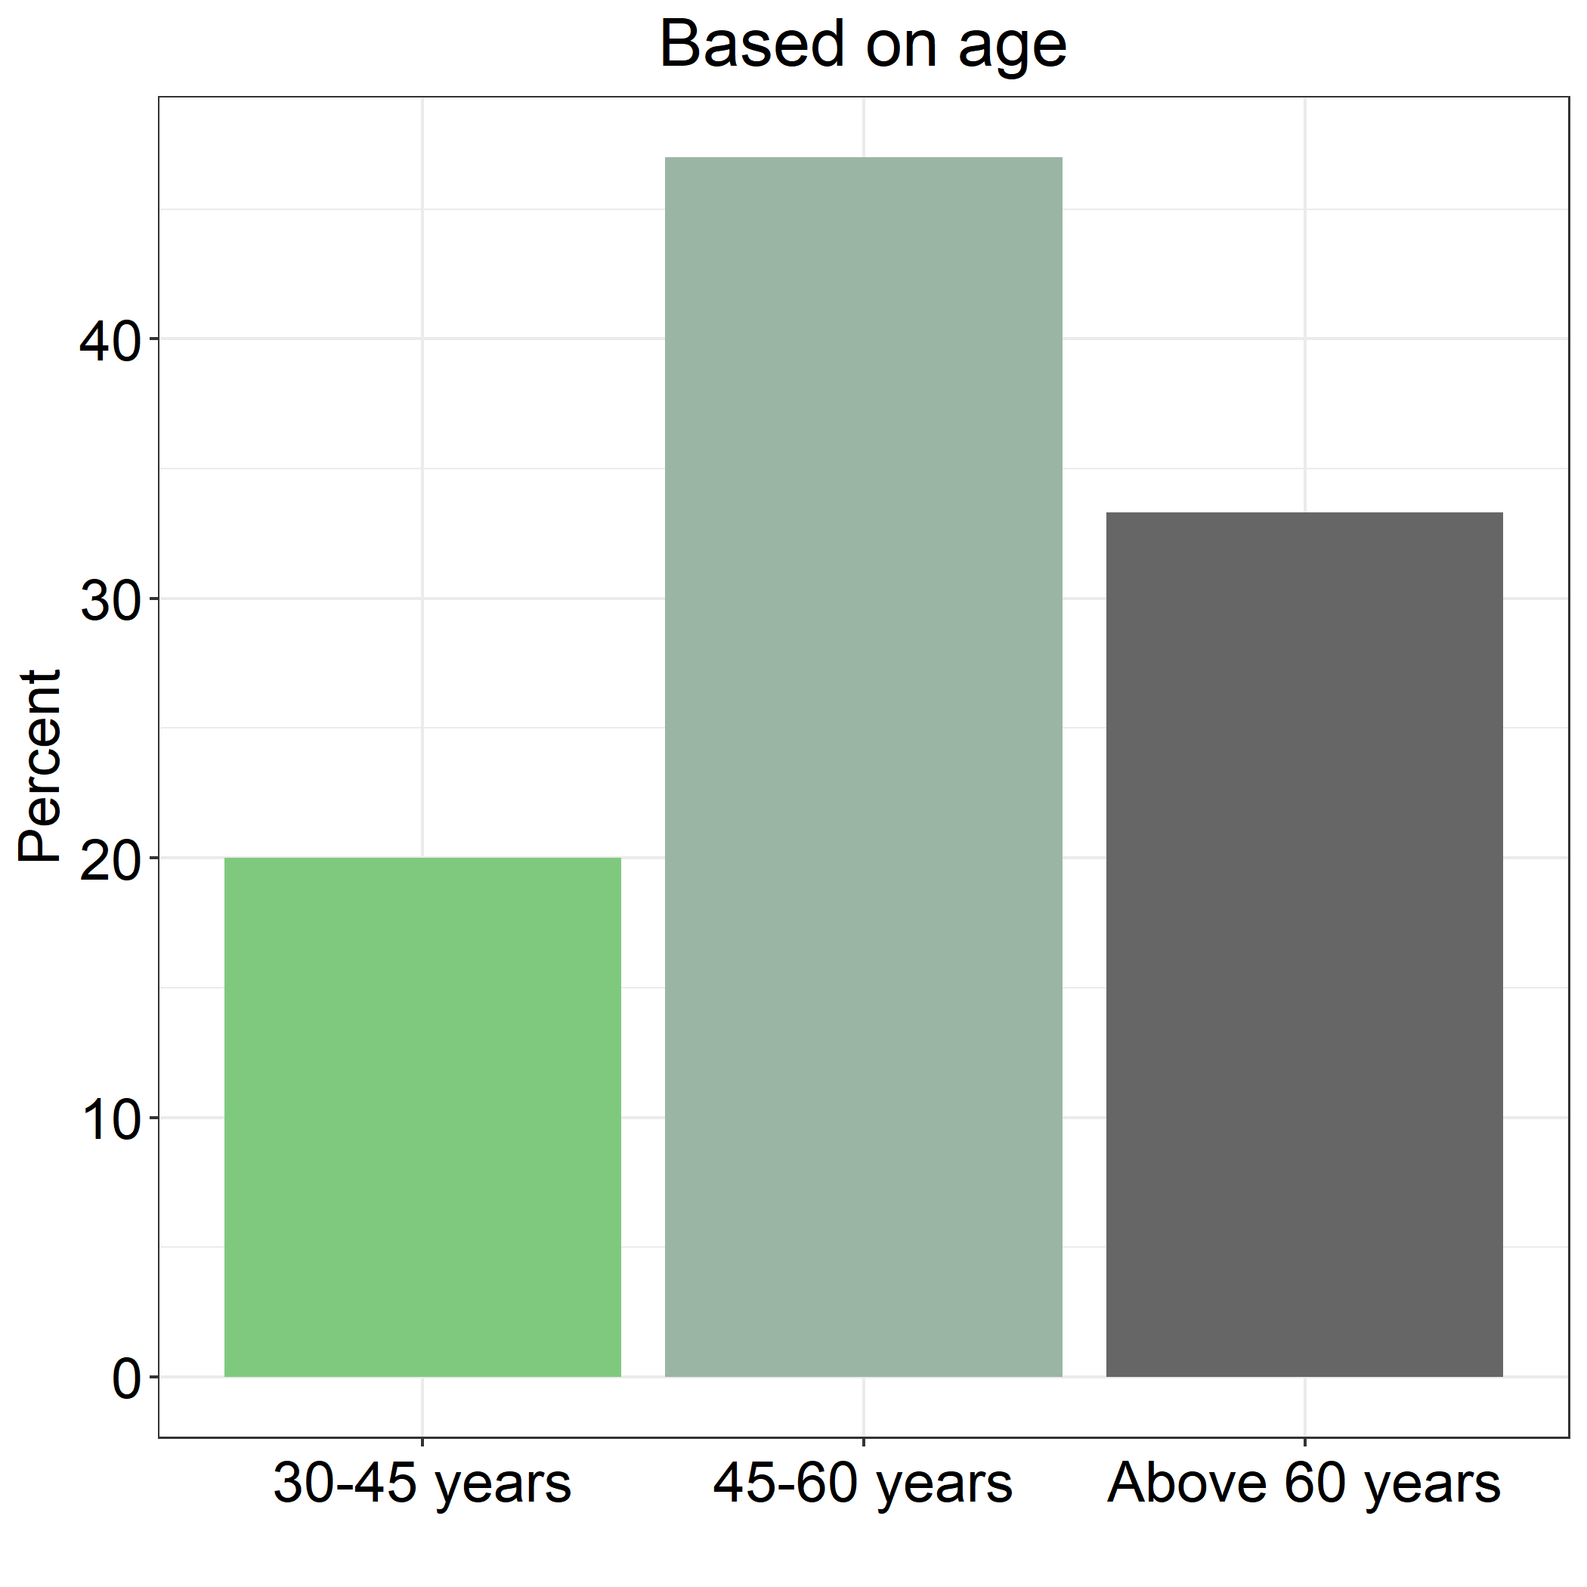

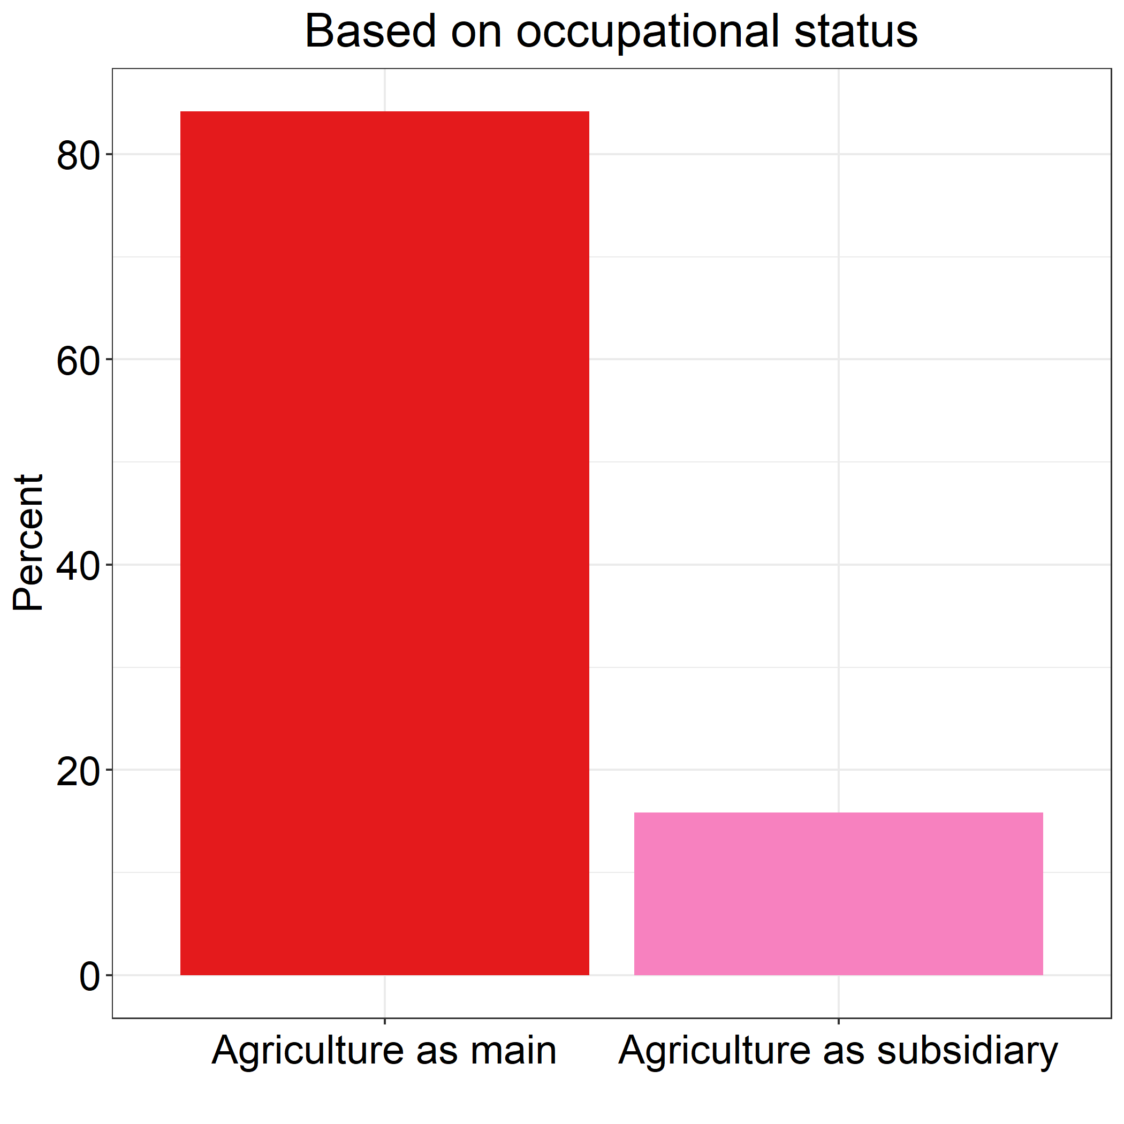
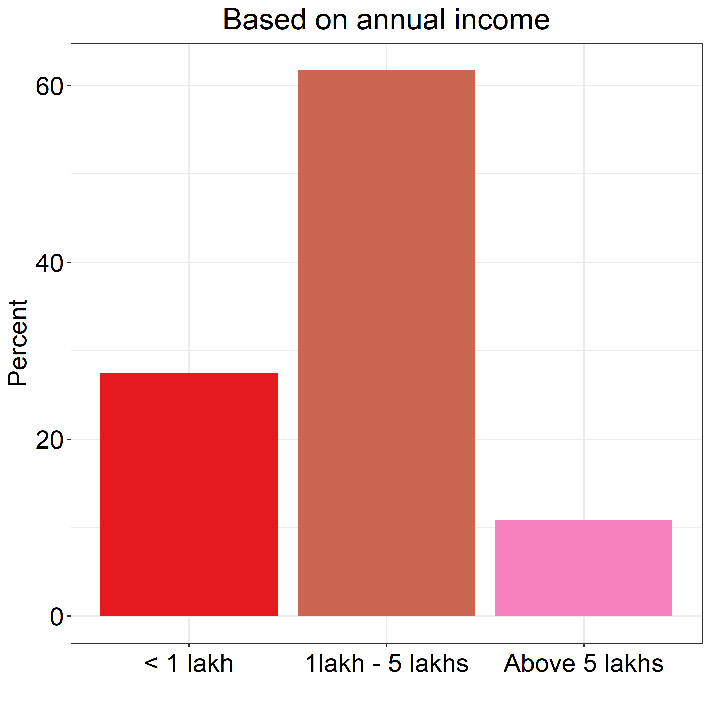

Fig. 2 The share of different factors in cost A₂

