DEVELOPMENT OF A SMALL-SCALE AUTOMATIC DESEEDING MACHINE FOR AMLA (Phyllanthus emblica)

ABSTRACT
Phyllanthus emblica L. (commonly known as amla) is a tree native to India and Southeast Asia, producing fruits that are rich in bioactive compounds. These compounds have gained significant attention due to the growing interest in naturally occurring substances with potential biological activity . Traditionally, amla stones are removed using manual punching, crushing machines, or boiling methods. However, these conventional techniques are time-consuming, labor-intensive, tedious, unhygienic, and uneconomical.To overcome these limitations, an innovative amla deseeding machine equipped with a hopper and three punchers has been developed. The machine is designed to punch each amla fruit efficiently, separating the seed while preserving the maximum amount of pulp. The segmented fruit pieces are collected in trays, thereby streamlining the process and reducing manual handling. This approach enhances productivity, ensures uniformity in fruit size and quality, and is highly suitable for small- and medium-scale processing units.

KEYWORDS: Phyllanthus emblica, Amla deseeding, Mechanical fruit processing, Pulp preservation, Processing efficiency, Small and medium-scale units

1. INTRODUCTION

Amla or aonla (Emblica officinalis Gaertn.), commonly known as Indian gooseberry, is a minor subtropical deciduous fruit tree indigenous to the Indian subcontinent. Owing to its hardy nature and adaptability to dry and marginal lands, amla can be cultivated successfully in wastelands and neglected regions (Salwe et al.). Traditionally, amla has been processed into pickles and preserves using indigenous household practices passed down through generations. In addition to its traditional uses, amla is highly valued for its nutritional and medicinal properties, being one of the richest natural sources of vitamin C and antioxidants, which enhance immunity and overall health (Eyarkai Nambi et al., 2012). It also plays a significant role in Ayurveda for its rejuvenating and therapeutic benefits (Vijay Raj Singh et al., 2022).

Conventional amla deseeding methods rely heavily on manual operations, which are labor-intensive, time-consuming, unhygienic, and inefficient, leading to higher post-harvest losses (Ganvir et al., 2015). To overcome these limitations, amla deseeding machines have been developed as a key innovation in the agricultural and food processing sector. These machines are extensively used in industries producing amla-based products such as candy, murabba, juice, and pickles. Most deseeding machines operate using punching or pressing mechanisms that separate the seed while minimizing pulp damage (Wankhade and Verma, 2019; Wankhade et al., 2019; Komatineni et al., 2025).

Amla deseeding machines are available in manual, semi-automatic, and fully automatic forms. Manual machines are economical but offer limited output, whereas automatic machines provide higher efficiency and uniformity, making them suitable for large-scale processing units (Singh Raj Vijay et al., 2019; Aslam & Alam, 2024; Sandeep et al., 2022). Automatic models can process approximately 200–500 kg h⁻¹ of amla, significantly reducing labor requirements and improving productivity (Swarnakar et al., 2019). Despite challenges such as high initial cost and power dependency, improved machine design and institutional support can enhance adoption and promote value addition in amla processing

2. METHODOLODY
The methodology involves feeding cleaned amla fruits into a hopper, where they are aligned and subjected to a three-puncher mechanism that efficiently removes the seed while retaining maximum pulp. The deseeded fruit segments and separated seeds are collected separately for further processing and quality evaluation.
.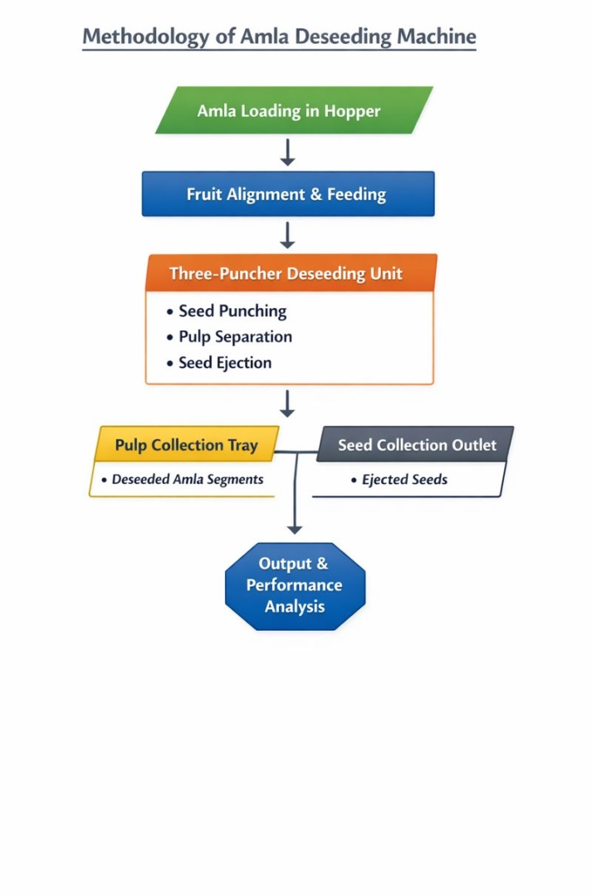
Figure-1: Methodology of automatic amla deseeding machine.
2.1.PROBLEM STATEMENT
- Manual deseeding of amla is labor - intensive, time-consuming, and unsafe, making it unsuitable for large-scale processing.
- High pulp wastage during manual methods reduces and its efficiency and product quality.
- Lack of an efficient mechanized solution limits productivity, increases cost, and affects the profitability of farmers and processors.
2.2.OBJECTIVES
- To design and develop a safe and efficient mechanized amla deseeding system that reduces dependency on manual labor and minimizes health and safety risks to workers.
- To significantly reduce pulp wastage during the deseeding process, thereby improving raw material utilization and enhancing final product quality.
- To increase processing speed and operational efficiency so that amla deseeding
3.DESIGN
The fruit and seed punching machine is designed with clearly defined dimensions to ensure structural stability and efficient operation. The machine is supported on a rigid stand/frame having an overall height of about 700 mm, a front-view width of 200 mm, and a side-view base length of 750 mm. At the top, a hopper of approximately 120 mm width and 20 mm height is provided for feeding fruits. Just below the hopper, a 450 mm long crankshaft is mounted horizontally and supported at both ends by bearing blocks, each having a mounting width of about 160 mm. Rotary power is supplied by a motor mounted on the side platform, and motion is transmitted to the crankshaft through a coupler/shaft end.
The crankshaft converts rotary motion into reciprocating motion of three punching rods, which are vertically aligned and spaced evenly, with an effective punching stroke region of about 120 mm guided by supporting plates located at mid-height. Below this, the punching die or bottom plates are positioned at a suitable clearance above the base to perform the fruit punching and seed separation. Finally, the separated fruit pulp and seeds are collected in the fruit and seed collection area provided at the bottom, having a depth of approximately 200 mm. This dimensioned arrangement ensures smooth operation, proper alignment of moving parts, and efficient seed extraction.
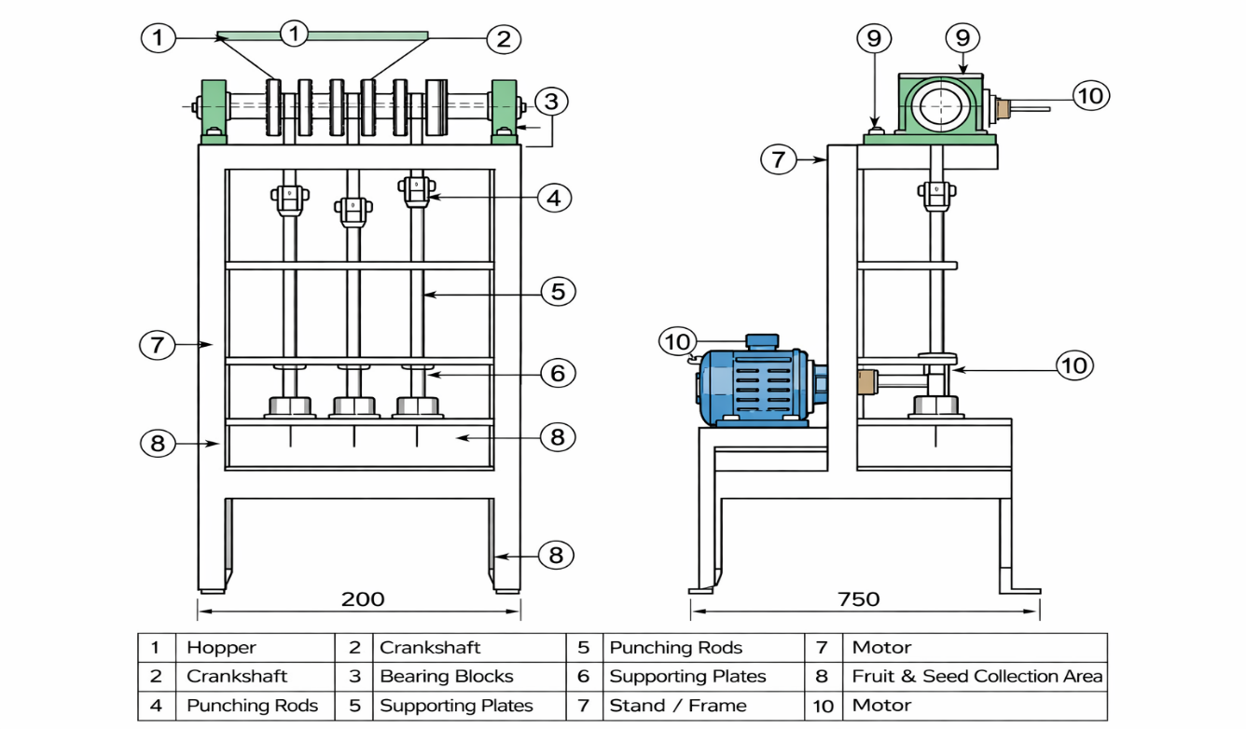
Figure-2: 2D Desugn of automatic amla deseeding machine.
4.COMPONENTS
4.1.HOPPER
The hopper has a capacity of about 2 kg, allowing continuous feeding of amla fruits and reducing manual handling. Its sloped stainless-steel design ensures smooth and uniform distribution of fruits into each punching die without clogging.The hopper capacity is suitable for small- and medium-scale processing units, supporting efficient operation.
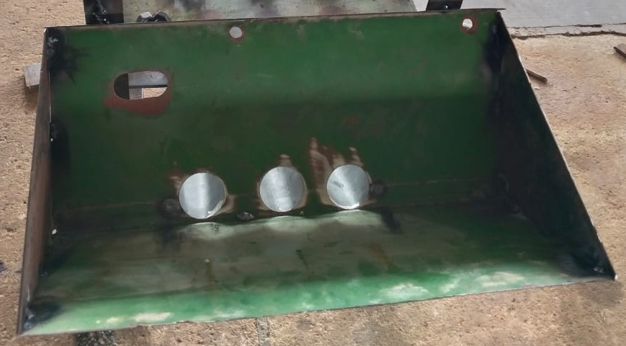
Figure-3:Hopper
4.2.CRANK SHAFT
A multi-throw crankshaft is mounted at the top of the machine to convert rotary motion into reciprocating motion, thereby driving the punching rods. The crankshaft has an outer diameter of 250 mm and an inner diameter of 120 mm, which enables effective and synchronized operation of multiple punching rods.
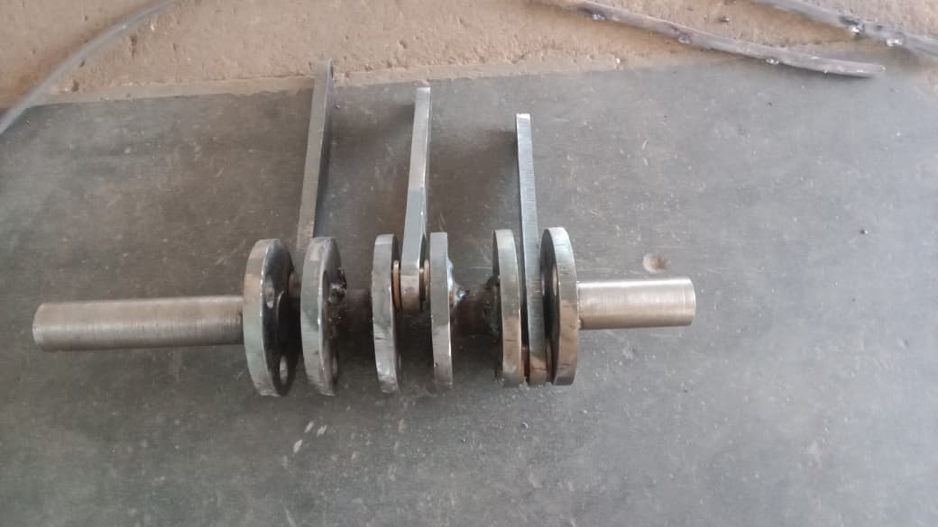
Figure-4: CRANK SHAFT
4.3.Bearing Blocks:
Bearing blocks are positioned on both sides of the crankshaft to provide support and ensure smooth rotation. Each bearing block has an inner diameter of 25 mm and an outer diameter of 52 mm, helping to reduce friction and maintain proper alignment of the crankshaft during operation.
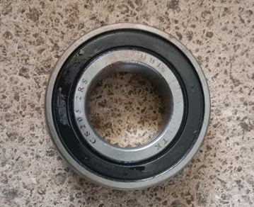
Figure-5: Bearing Blocks
4.4.Punching Rods:
Vertical stainless-steel punching rods are used to carry out the punching and seed extraction action. Each rod has a length of 300 mm, a stroke of 30 mm, and a slot diameter of 16 mm, with a hollow opening that facilitates seed movement. As the rod moves upward during operation, the seed follows the rod, enabling effective separation from the fruit pulp.
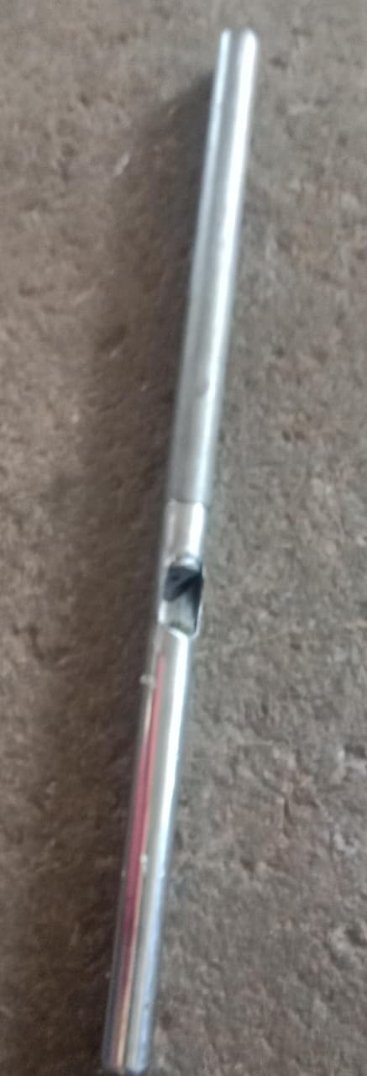
Figure-6: Punching Rods:

4.5.Supporting Plates:
Two horizontal supporting plates are provided with accurately drilled holes to guide the punching rods. These plates help maintain proper alignment and stability of the rods during reciprocating motion. Each supporting plate has a length of 360 mm, a width of 100 mm, and a thickness of 10 mm, ensuring adequate strength and rigidity.
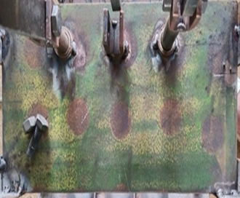
Figure-7: Supporting Plates
4.6.Punching Die / Bottom Plate:
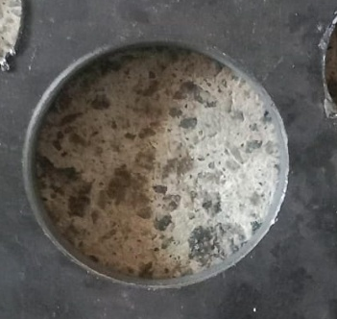
Figure-8: Punching Die / Bottom Plate

The punching die is mounted on the lower platform where the fruits are positioned during the punching operation. It is provided with shallow, shaped holes to securely hold the amla fruits in place, ensuring proper alignment during punching. This design enables efficient partial removal of seeds without damaging the fruit. The punching die has an inner diameter of 22 mm and an outer diameter of 40 mm, making it suitable for accommodating amla of standard size.
4.7.Motor:
A 0.5 HP single-phase induction motor is used to drive the machine, ensuring smooth and continuous operation with minimal maintenance requirements. The motor operates at a speed of 1440 rpm and delivers sufficient torque to drive multiple punching rods simultaneously without overloading, thereby maintaining stable and efficient performance.
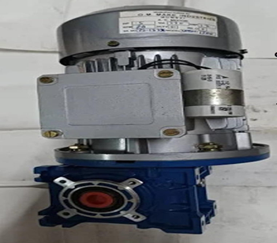
Figure-9: Motor
4.8.Coupler / Shaft End:
It connects the motor shaft to the crankshaft for efficient power transmission, reduces vibration and mechanical stress during operation, and has a length of 40 mm, a diameter of 25 mm, with a 25 mm keyway.
4.9.Stand:
The stand consists of four strong mild-steel legs that provide stability to the machine during operation. These rigid legs prevent movement and vibration during punching, ensuring accurate alignment of all components.
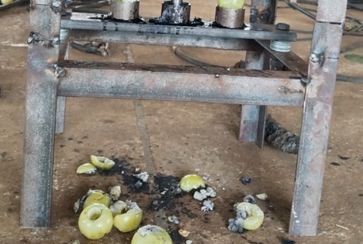
Figure-10: Stand

4.10.Fruit & Seed Collection Area:
Separate trays are provided for collecting the punched amla fruits and the extracted seeds. This arrangement allows neat collection, prevents fruit wastage, and helps maintain cleanliness and hygiene during operation.
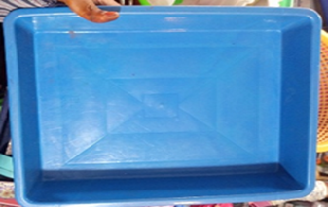
Figure-11: Fruit & Seed Collection Area

5.FABRICATION AND TESTING
The fabrication, assembly, and testing of the automatic amla deseeding machine are carried out through a systematic and well-structured process to ensure efficient and reliable operation. Fabrication begins with constructing a rigid frame using mild-steel square pipes, which are measured, cut, and welded to form a stable base capable of withstanding vibration and operational loads. Bearing blocks are accurately positioned and fixed on the frame to support the crankshaft, which is precisely machined and assembled to ensure smooth rotation. Stainless steel is used for food-contact components such as punching rods, punching dies, hopper, and collection trays to maintain hygiene and corrosion resistance, while mild steel provides strength and durability for structural parts.
During assembly, the frame is levelled, followed by mounting and aligning the bearing blocks, crankshaft, punching rods, supporting plates, and punching dies to allow free and accurate vertical motion. The hopper is installed above the dies for proper feeding of amla fruits, and the motor is securely mounted on its platform and connected to the crankshaft using a flexible coupler to transmit power while minimizing vibration. Separate trays are placed below to collect seeds and fruit pulp neatly. Welding ensures strong and permanent joints, maintaining alignment and long-term stability. Finally, testing is performed to verify smooth motor operation, effective power transmission, proper punching action, reliable seed separation, and overall durability of the machine, ensuring consistent performance during continuous fruit-processing operations.

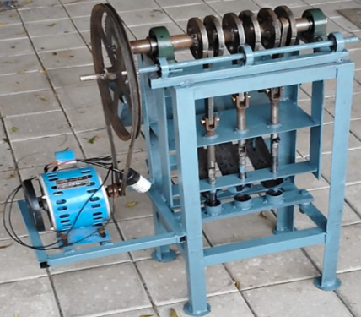

Figure-12: Automatic amla deseeding machine.

6.WORKING PRINCIPLE
The amla punching machine works on the crank, motor and connecting-rod mechanism, which converts rotary motion into vertical reciprocating motion. A hopper feeds individual amla fruits into three punching dies. Each die is connected to the crankshaft through a separate metal square rod. When the crank rotates, the square rods move the punching rods up and down. During the downward stroke, the slotted punching tip pieces the amla and pushes the seed upward through the slot. As the rod moves up, the punched fruit is released, and the next fruit drops automatically. This continuous cyclic action ensures fast and uniform punching.
7. RESULT AND DISCUSSION
Table 1: Performance of amla stone removing cum pulp slicing equipment
Experiment Number | Number of amla | Weight (g) | Total pulp (g) | Pulp recovery % | Pulp loss % | Time taken
1 | 38 | 1202 | 1193 | 99.1 | 1.9 | 2 min 10 s
2 | 36 | 1103 | 1091 | 98.02 | 1.98 | 2 min 08 s
3 | 32 | 1098 | 1068 | 97.02 | 2.98 | 1 min 59 s

Table 2: Manual stone removing and pulp slicing of amla (Ajay Kumar Swarnakar.et.al.,2018)
Experiment Number | Number of amla | Weight (g) | Total pulp (g) | Pulp recovery % | Pulp loss % | Time taken
1 | 27 | 1104 | 1054 | 99.5 | 0.5 | 52min 12 s
2 | 24 | 1012 | 960 | 99.54 | 0.46 | 59min 32 s
3 | 30 | 1030 | 980 | 99.45 | 0.55 | 54 min 31 s

In manually stone removing and slicing of amla take more time as compare to Automatic Amla (Phyllanthus Emblica) Deseeding Machine (Table 1 and 2).

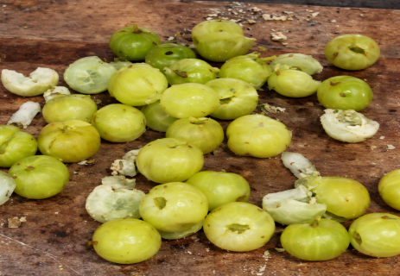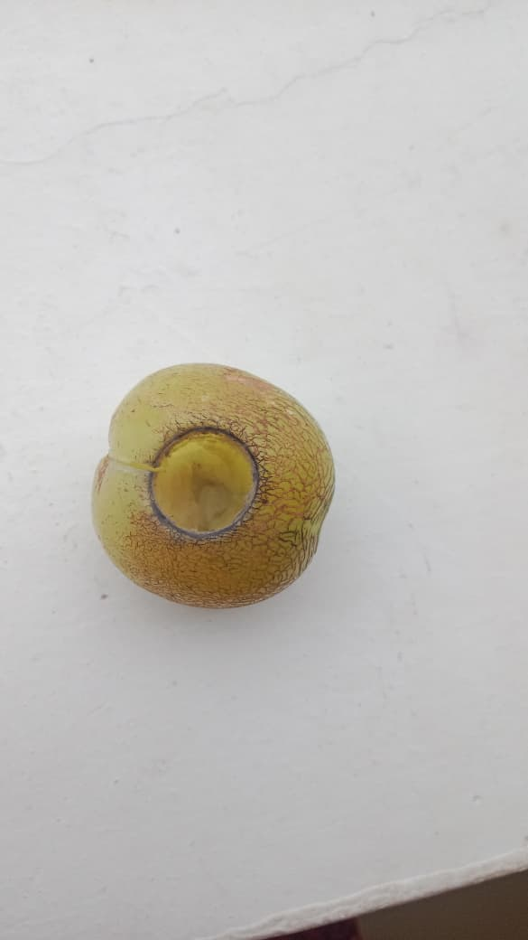
Figure-13. Samples of Amla deseeding.
A comparative analysis of Table 1 and Table 2 clearly demonstrates the performance differences between the mechanized amla stone removing cum pulp slicing equipment and the manual stone removing and pulp slicing method reported by Ajay Kumar Swarnakar et al. (2018). The comparison highlights significant variations in processing capacity, time efficiency, pulp recovery, and operational suitability for large-scale applications. In terms of processing capacity, the mechanized equipment in Table 1 handled a higher number of amla fruits per experiment (32–38 fruits) compared to the manual method in Table 2 (24–30 fruits). Despite processing more fruits, the machine maintained consistent performance across trials, indicating its ability to handle larger batch sizes efficiently. This suggests that the mechanized system is better suited for continuous or semi-continuous industrial operations, whereas the manual method is constrained by human endurance and speed.

With respect to time efficiency, the difference between the two methods is substantial. The mechanized equipment completed each experiment within approximately 2 minutes, whereas the manual method required 52 to 59 minutes to process comparable quantities of amla. This indicates that the machine reduces processing time by nearly 25–30 times compared to manual operation. Such a drastic reduction in time directly translates into increased throughput, lower labor requirements, and improved overall productivity, which are critical factors in commercial amla processing units. Regarding pulp recovery percentage, the manual method shows slightly higher recovery values (99.45–99.54%) compared to the mechanized equipment (97.02–99.1%). Correspondingly, pulp loss in manual processing is marginally lower (0.46–0.55%) than that observed in the machine (1.9–2.98%). This difference can be attributed to the careful and controlled nature of manual handling, where individual fruits are processed with greater precision. However, the slightly higher pulp loss in the mechanized system remains within acceptable limits for industrial food processing, especially when weighed against the significant gains in speed and labor efficiency.

In terms of consistency and operational reliability, the mechanized equipment shows relatively stable performance across experiments, with minor variations in pulp recovery and processing time. This consistency is advantageous for standardizing production and ensuring uniform product quality.
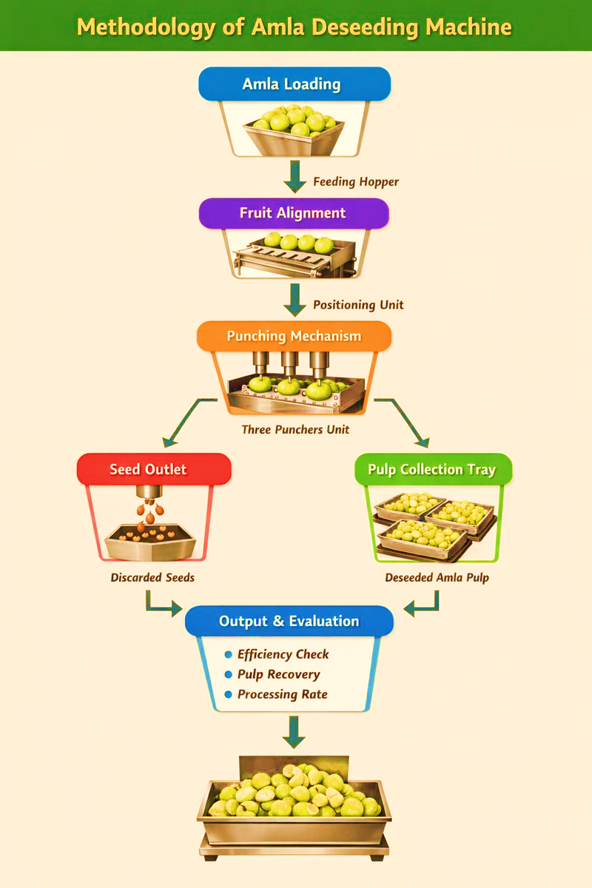

FIG 14: Flow chart showing manual processing of Amla

Manual processing, on the other hand, is more susceptible to variations due to operator skill, fatigue, and working conditions, which can affect long-term consistency. From an economic and practical perspective, the mechanized amla stone removing cum pulp slicing equipment offers clear advantages. Although manual processing yields marginally higher pulp recovery, it is highly labor-intensive, time-consuming, and unsuitable for large-scale or commercial operations. The mechanized system significantly reduces labor dependency, enhances safety, and improves processing efficiency, making it more viable for industrial and entrepreneurial applications. In conclusion, while manual stone removing and pulp slicing of amla provides slightly better pulp recovery and lower pulp loss, the mechanized equipment far outperforms it in terms of time efficiency, processing capacity, and scalability. Therefore, for large-scale processing and commercial adoption, the mechanized amla stone removing cum pulp slicing equipment is a more efficient and economically feasible solution.
Force and Power Requirement Calculation
Table 3: Force and Power calculations

Experiment | No. of Amla | Time taken | Total Force (N) | Work (J) | Power (W)
1 | 38 | 130 | 570 | 5.70 | 0.044 W
2 | 36 | 128 | 540 | 5.40 | 0.042 W
3 | 32 | 119 | 480 | 4.80 | 0.040 W

Total force and power requirement decrease with a reduction in the number of amla processed, reflecting lower mechanical load on the deseeding mechanism. The very low power consumption (0.040–0.044 W) demonstrates the energy efficiency of the machine, making it suitable for small-scale food processing applications.

8. CONCLUSION
The processing of amla traditionally involves labor-intensive and time-consuming manual pricking methods, leading to inconsistent quality and low productivity. The development of the amla de-seeding machine effectively solves these challenges by introducing a mechanized, hygienic, and highly efficient system suitable for small and large processing units. With the integration of a 0.5 HP single-phase motor, crankshaft mechanism, hopper feeding, and precision punching components, the machine ensures uniform pricking, reduced labor dependency, and continuous operation. The sturdy frame and food-grade materials enhance durability and safety during prolonged use. Experimental performance shows improved output quality, faster processing rates, and better seed loosening, supporting the growing demand for value-added amla products such as murabba, candy, and pickles. The machine provides a cost-effective, user-friendly, and scalable technology that significantly strengthens India’s agro processing sector and supports rural entrepreneurship and small-scale industries.

FUTURE SCOPE:
Here are future scope points for an automated amla de-seeding machine:
- Integration of sensors for automatic fruit size detection and improved accuracy.
- Development of a fully automated feeding and collecting system to increase throughput.
- Use of stainless steel and food-grade materials to enhance durability and hygiene.
- Incorporation of a speed-control mechanism to adjust punching speed for different varieties of amla.
- Introduction of safety features such as automatic stoppage during jamming or overload.
- Miniaturization of the machine to make it suitable for household or small-scale users.
- Implementation of IoT-based monitoring for performance tracking and predictive maintenance.
- Improvement of energy efficiency with optimized motor design.
- Modular design to allow easy cleaning, maintenance, and part replacement.
DISCLAIMER (ARTIFICIAL INTELLIGENCE)
Author(s) hereby declare that generative AI technologies such as Large Language Models, etc. have been used during the writing or editing of manuscripts. This explanation will include the name, version, model, and source of the generative AI technology and as well as all input prompts provided to the generative AI technology
Details of the AI usage are given below:
ChatGPT -Image editing of this manuscript.

COMPETING INTERESTS DISCLAIMER:

Authors have declared that they have no known competing financial interests OR non-financial interests OR personal relationships that could have appeared to influence the work reported in this paper.

REFERENCES
- Ajay Kumar Swarnakar et.al., (2018) entitled as “Design And Development Of Aonla Stone (Seed) Removing Cum Slicing Equipment et.al., Journal of Pharmacognosy and Phytochemistry, E-ISSN.2278-4136.
- Apporva M Kakade et.al., (2012) entitled as “Utility Of Technology For Rural Area An Amla Punching Machine”, Raisoni college of engineering.
- Bharat Kumar et.al., (2025) entitled as “Development And Evaluation Of Punching Mechanism For De-Seeding Of Ber Fruit”. College of agricultural engineering and postharvest technology.
- Nikita Tidke et.al., (2020) entitled as “Indian Gooseberry Deseeding Machine”, Department of Electronics and Telecommunication Engineering, ISSN: 2395-7549 Vol(06).
- Nitin Kumar et.al., (2014) entitled as “Performance Evaluation 0f Power Operated Anola Pricking Machine Considering Physical And Nutritional Properties Anola”, ISSN : 0970-0420 Vol(18).
- Vijay Raj Singh et.al., (2022) entitled as “Testing Of Developed Anola Pricking Machine”, Department of farm machinery and power Engineering, vol(18).
- Vijay Raj Singh et.al., (2022) entitled as “Ergonomics Evalution Of Paddle Operated Aonla Pricking Machine”, Department of Farm Machinery and Power Engineering, ISSN :0973-130X, vol(18).
- V. eyarkai nambi et.al., (2012) entitled as “A pneumatic assisted electronically controlled continuous aonla seed removing machine”, Tamil Nadu Agricultural University .CIGR joural.
- VR Wankhade, RC Verma (2019) et.al., entitled as “Status Of Technological Development In Processing Of Aonla Fruits And Seeds”, International Journal of Chemical Studies 2019; 7(3): 385-388.
- SHAIK, N. H., RAO, D. B., BHAGATH, B. B., & VARDHAN, S. V. (2016). Design and Development of Multi Seated Aonla Deseeding Machine. Advances in Life Sciences, 5, 8749-8753.
- Wankhade, V. R., Verma, R. C., Jain, H. K., & Jain, B. S. N. (2019). Status of technological developments in processing of Aonla fruits and seeds. IJCS, 7(3), 385-388.
- Komatineni, B. K., Manjula, B., Meena, S. S., Kumar, V. K., Dwivedi, U., Saikumar, A., ... & Vishwakarma, S. K. (2025). Development and evaluation of punching mechanism for de-seeding of ber fruit. Discover Agriculture, 3(1), 1-16.
- Aslam, R., & Alam, M. S. (2024). Storage behaviour of ohmic heated and ultrasonicated amla juice: AI mediated correlation between ascorbic acid content and color attributes. Journal of Food Measurement and Characterization, 18(6), 4972-4983.
- Sandeep, B. S., Panda, N., Sethy, K., & Nath, S. (2022). Effect of dietary supplementation of amla (Emblica officinalis) powder and equivalent synthetic vitamin C on growth performance in black rock broiler chicken. Pharma Innov. J, 11, 2002-2007.

