Original Research Article
Relationship between socio-economic attributes and livelihood security of Integrated Farming System farmers under the Farmer FIRST Programme in Morena district, Madhya Pradesh,India
______________________________________________________________________________

Abstract
The study was conducted in Morena district of Madhya Pradesh to examine the relationship between socio-economic and psychological attributes of Integrated Farming System (IFS) farmers with their livelihood security under the Farmer FIRST Programme (FFP). A sample of 60 farmers was selected using census sampling. An ex post facto research design was used in study. Pearson’s correlation analysis was employed to explore the relationship between sixteen independent variables and the Livelihood Security Index (LSI). Results revealed that education (r = 0.450**), IFS experience (r = 0.441**), enterprise combination (r = 0.436**), knowledge of IFS practices (r = 0.423**), and adoption of IFS practices (r = 0.452**) showed strong positive and significant correlation with livelihood security at the 1% level. Annual income (r = 0.342*), mass media exposure (r = 0.352**), extension contact (r = 0.274*), cropping pattern (r = 0.271*), and scientific orientation (r = 0.312*) were also positively correlated at the 5% level. However, age, family size, and landholding size showed no significant relationship. The findings suggest that educational, economic, psychological, and informational attributes significantly contribute to strengthening livelihood security among IFS farmers.
Keywords: Adoption, Education, Farmer FIRST Programme, Integrated Farming System, Livelihood security, Socio-economic attributes

Introduction
Livelihood security is a multidimensional concept encompassing food, income, employment, and social well-being. For small and marginal farmers, achieving livelihood security is particularly challenging due to fragmented holdings, limited resources, and market uncertainties (Scoones, 2015). Integrated Farming System (IFS) has been widely recognized as a sustainable approach to enhance productivity and resilience by integrating crops, livestock, and allied enterprises.
The study is conceptually grounded in the Sustainable Livelihoods Framework (SLF), which emphasizes human, social, physical, financial, and natural capital as key determinants of livelihood outcomes. Within this framework, socio-economic and psychological attributes such as education, experience, information access, and adoption behaviour are treated as components of human and social capital that mediate livelihood security. Integrated Farming Systems operationalize this framework by enhancing asset interaction, income stability, and resilience, particularly for smallholders.
Socio-economic attributes play a critical role in shaping farmers’ production decisions, adoption behaviour, and livelihood outcomes. Attributes such as education, income level, farming experience, access to information, extension contact, and psychological orientation influence farmers’ capacity to understand innovations, manage farm resources efficiently, and respond to risks. Empirical studies across developing countries consistently show that higher educational attainment, better information access, and stronger extension linkage enhance livelihood security by improving income stability, food availability, and employment generation (Dessart et al., 2019).
Globally, livelihood security of smallholder farmers has emerged as a major development concern, particularly in Asia, Africa, and Latin America, where agriculture remains the primary source of income and employment. International evidence highlights that diversified and integrated farming systems contribute significantly to income stabilization, food security, and resilience against climate and market shocks. Studies from Sub-Saharan Africa and South Asia demonstrate that integration of crops with livestock and allied enterprises enhances resource-use efficiency and reduces vulnerability among smallholders. In this global context, Integrated Farming Systems represent a widely accepted pathway for achieving sustainable livelihood outcomes.
The Farmer FIRST Programme (FFP), initiated by ICAR, emphasizes participatory and need-based interventions to strengthen farmers’ socio-economic resilience. By promoting enterprise diversification, training, and demonstrations, FFP aims to improve resource-use efficiency and enhance rural livelihoods (ICAR, 2016).
Understanding the relationship between socio-economic and psychological attributes such as education, income, experience and motivation and livelihood security is essential to identify the factors that influence adoption and sustainability of IFS (Hasanain et al., 2020). With this context, the present study was conducted in Morena district of Madhya Pradesh to analyze the correlation between socio-economic characteristics of IFS farmers and their livelihood security.
In recent years, livelihood security has emerged as a central concern in agricultural and rural development discourse, particularly in the context of small and marginal farmers. Livelihood security extends beyond income generation and encompasses access to food, employment, assets, social participation, and resilience against economic and climatic shocks (Chambers & Conway, 1992). In rainfed and semi-arid regions like Madhya Pradesh, farming households remain highly vulnerable due to resource constraints, climate variability, and market uncertainties, necessitating sustainable and diversified farming approaches (Birthal and Hazrana, 2019).
Integrated Farming System (IFS) has gained recognition as an effective strategy for enhancing livelihood security by integrating crops with livestock, horticulture, fisheries, and other allied enterprises. The synergistic interaction among farm enterprises under IFS improves resource-use efficiency, ensures year-round income, generates on-farm employment, and enhances nutritional security. Unlike mono-cropping systems, IFS reduces production risk and supports ecological sustainability through recycling of farm residues and efficient nutrient management.
However, the success of IFS does not solely depend on physical integration of enterprises; it is significantly influenced by farmers’ socio-economic and psychological attributes. Factors such as education, farming experience, access to information, extension contact, scientific orientation, and risk-taking ability play a decisive role in determining the extent of adoption and effective management of IFS components. Understanding how these attributes interact with livelihood security outcomes is crucial for designing targeted interventions and extension strategies.
The Farmer FIRST Programme (FFP), initiated by the Indian Council of Agricultural Research (ICAR), represents a paradigm shift from top-down technology transfer to participatory, farmer-centric research and extension. The programme emphasizes farmer–scientist interaction, need-based technological interventions, and capacity building to address location-specific problems. Through demonstrations, training and enterprise diversification, the Farmer FIRST Programme seeks to strengthen farmers’ adaptive capacity, innovation readiness, and livelihood resilience (FAO, 2021).
Through demonstrations, training, and enterprise diversification, FFP seeks to strengthen farmers’ adaptive capacity and livelihood resilience.
Despite the growing emphasis on IFS and participatory extension approaches, empirical studies examining the relationship between socio-economic attributes and livelihood security of IFS farmers under the Farmer FIRST Programme remain limited, particularly at the micro-level. Morena district of Madhya Pradesh provides a relevant setting to explore these relationships due to the predominance of smallholders and the active implementation of IFS modules under FFP (ICAR, 2016; Government of India, 2021).
In this context, the present study aims to analyze the relationship between selected socio-economic and psychological attributes of Integrated Farming System farmers and their livelihood security. The findings are expected to generate empirical evidence useful for policymakers, extension agencies, and development practitioners in strengthening IFS-based livelihood interventions and enhancing the effectiveness of programmes like Farmer FIRST (ICAR, 2016).
In addition to socio-economic factors, the study explicitly examines psychological attributes such as scientific orientation, economic motivation, and risk orientation to understand their role in influencing adoption behaviour and livelihood security under Integrated Farming Systems.

Methodology
The study was conducted in Morena district of Madhya Pradesh under the Farmer FIRST Programme. An ex post facto research design was adopted, with a census sampling of 60 farmers practicing IFS modules. Sixteen independent variables were considered: age, education, landholding size, family size, IFS experience, annual income, information source utilization, cropping pattern, enterprise combination, extension contact, mass media exposure, economic motivation, scientific orientation, risk orientation, knowledge of IFS practices, and adoption of IFS practices. The dependent variable was Livelihood Security Index (LSI), measured across eight dimensions. Pearson’s correlation coefficient was computed to assess the relationship between socio-economic and psychological attributes with livelihood security.
The use of Pearson’s correlation coefficient is appropriate in this study, as the variables were measured on interval and index scales, and the objective was to assess the strength and direction of linear relationships. While correlation does not imply causation, the statistically significant associations provide strong empirical evidence for identifying key determinants of livelihood security under IFS. These findings can serve as a foundation for future multivariate or path analysis studies (Kothari, 2004).
Pearson’s correlation coefficient has been widely used in livelihood and agricultural extension studies to examine the strength and direction of relationships between socio-economic attributes and outcome variables measured on interval and index scales. Several recent studies have successfully employed correlation analysis to identify key determinants of livelihood security, adoption behaviour, and farm performance (Dessart et al., 2019).
Results and Discussions
Correlation refers to the association between two attributes with its strength quantified by the correlation coefficient, which varies between -1 to +1. A positive correlation implies that as one variable increases, the other does too, whereas a negative correlation means that an increase in one result in a decrease in the other. When changes in one variable do not influence the other, the variables are considered uncorrelated.
Table 1: The correlation coefficient between the selected variables of respondents and livelihood security of IFS practices beneficiaries.
S. No. | Independent Variables | Correlation Coefficient (r)
1. | Age | 0.012^{NS}
2. | Education | 0.450**
3. | Size of land holding (ha.) | 0.161^{NS}
4. | Family Size | 0.059^{NS}
5. | IFS Experience | 0.441**
6. | Annual income | 0.342*
7. | Information source utilization | 0.269*
8. | Cropping pattern | 0.271*
9. | Enterprise combination | 0.436**
10. | Extension contacts | 0.274*
11. | Mass media exposure | 0.352**
12. | Economic Motivation | 0.269*
13. | Scientific orientation | 0.312*
14. | Risk orientation | 0.273*
15. | Knowledge of IFS practices | 0.423**
16. | Adoption of IFS practices | 0.452**
** Significant at 0.01 level of probability. * Significant at 0.05 level of probability. NS – non-significant.
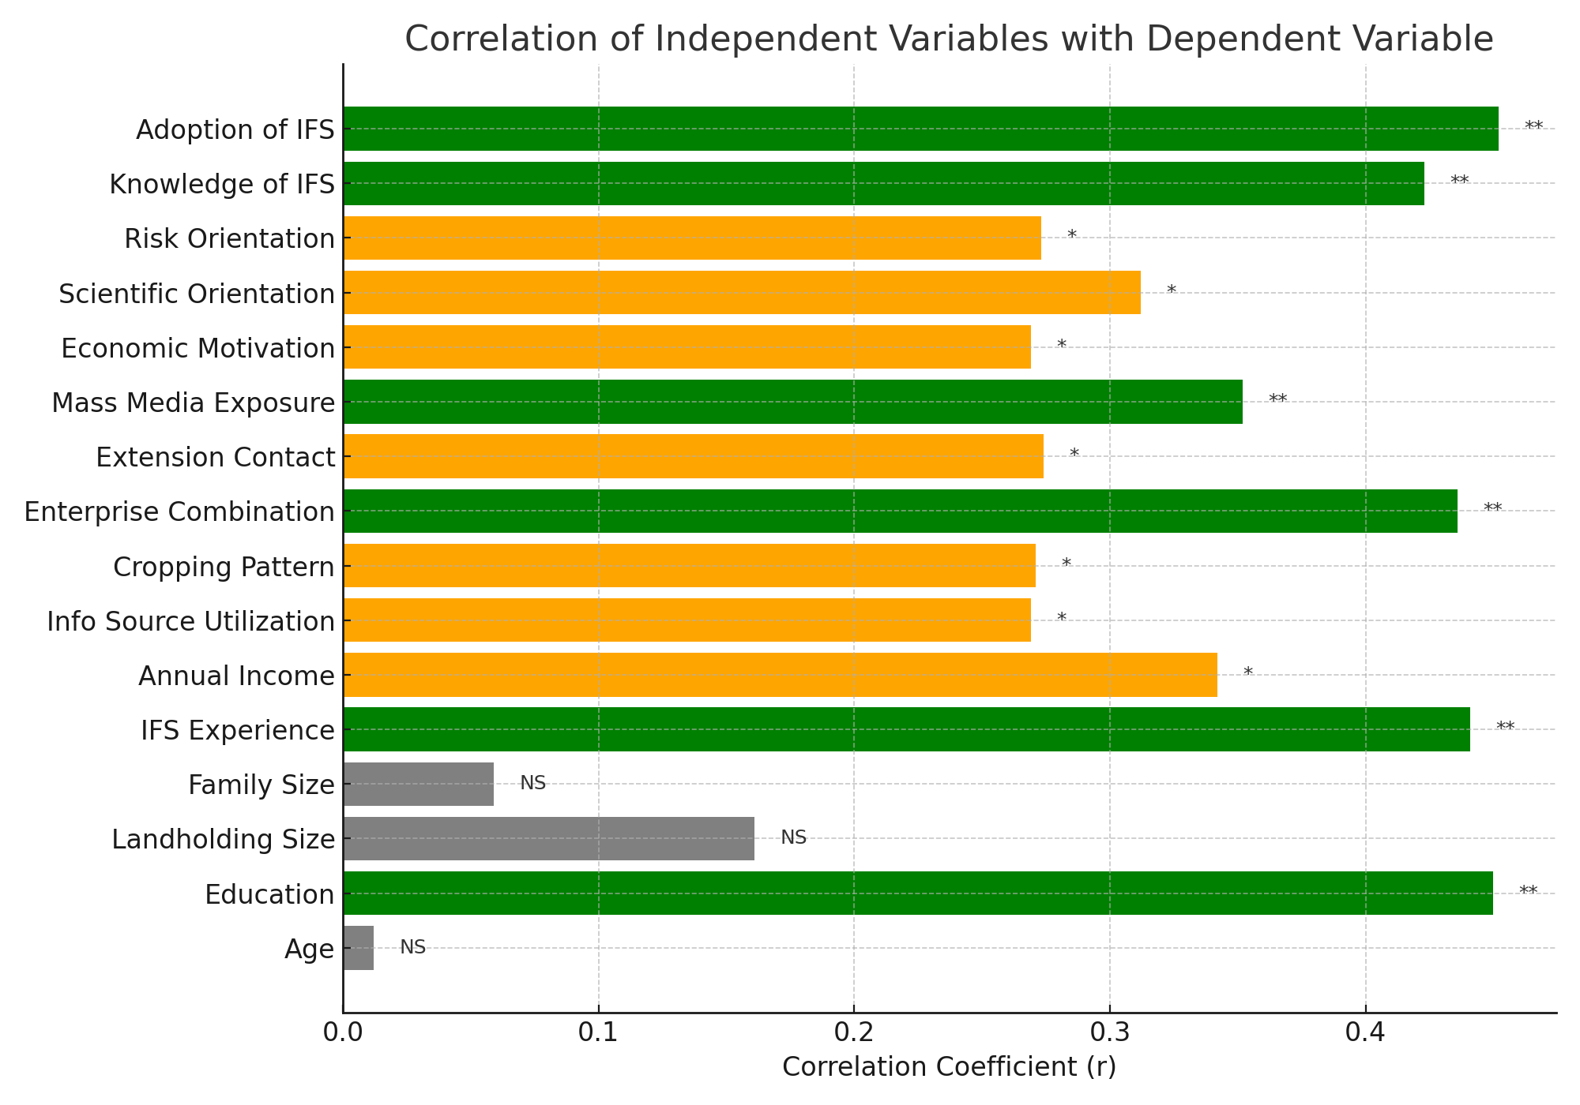Figure 1: Correlation coefficients of significant socio-economic attributes with livelihood security.
The correlation analysis clearly demonstrates that livelihood security among IFS farmers is not merely a function of physical resources but is strongly shaped by human, informational, and behavioral attributes. The highly significant positive correlation of education with livelihood security (r = 0.450**) indicates that educated farmers are better positioned to understand integrated enterprise linkages, adopt improved practices, and efficiently manage farm resources. Education enhances decision-making capacity, exposure to innovations, and receptivity to extension interventions, thereby strengthening overall livelihood outcomes.
Similarly, IFS experience (r = 0.441**) emerged as a crucial determinant, suggesting that prolonged engagement with integrated farming systems enables farmers to optimize enterprise synergies, reduce risks, and stabilize income streams. Experienced farmers are more adept at balancing crop–livestock interactions, recycling farm residues, and adjusting enterprise combinations according to seasonal and market conditions.
Enterprise combination (r = 0.436**) showed a strong association with livelihood security, underscoring the core principle of IFS—diversification as a risk-buffering mechanism. Farmers practicing multiple enterprises such as crops, dairy, poultry, and horticulture benefited from year-round income, improved food security, and enhanced employment generation. This diversification reduces dependency on a single enterprise and improves resilience against climatic and market shocks.
Knowledge (r = 0.423**) and adoption of IFS practices (r = 0.452**) were among the strongest correlates, confirming that knowledge conversion into action is pivotal for livelihood enhancement. Farmers with higher technical knowledge and adoption levels were better able to implement scientific nutrient recycling, integrated pest management, and enterprise integration, leading to improved productivity and livelihood stability.
Variables significant at the 5% level—such as annual income, mass media exposure, extension contact, cropping pattern, scientific orientation, economic motivation, and risk orientation—highlight the enabling role of information access and psychological readiness. Mass media exposure (r = 0.352**) and extension contact (r = 0.274*) facilitate timely access to innovations and advisory services, reinforcing informed decision-making. Scientific orientation and risk orientation indicate farmers’ willingness to experiment and adopt new technologies, which directly contributes to livelihood advancement under IFS.
Conversely, age, landholding size, and family size exhibited non-significant relationships with livelihood security. This finding is particularly important, as it implies that IFS benefits are scale-neutral, making it suitable for small and marginal farmers. Livelihood security under IFS depends more on how resources are managed rather than how much land is owned.
Consequently, the null hypothesis for variables X₂, X₅, X₆, X₇, X₈, X₉, X₁₀, X₁₁, X₁₂, X₁₃, X₁₄, X₁₅ and X₁₆ is rejected, except for X₁, X₃ and X₄ which do not exhibit significant correlations.
The results further reveal that socio-economic and psychological attributes exert a differentiated influence on livelihood security under Integrated Farming Systems. The strong association of education with livelihood security reflects the role of human capital in enhancing farmers’ analytical ability, technological understanding, and adaptive decision-making. Educated farmers are better positioned to interpret extension messages, adopt scientific practices, and manage complex enterprise combinations efficiently. Similar observations have been reported in recent livelihood studies emphasizing education as a catalyst for sustainable farm transformation.
Experience in IFS practices emerged as another critical determinant, highlighting that long-term engagement with integrated enterprises enables farmers to refine enterprise synergies, optimize resource recycling, and stabilize income flows. Experienced farmers tend to internalize system-based thinking rather than enterprise-specific management, which strengthens resilience against climatic and market uncertainties.
Enterprise combination showed a highly significant relationship with livelihood security, reinforcing the central principle of diversification in sustainable farming systems. The integration of crops with dairy, poultry, horticulture, or other allied enterprises ensures continuous income, improves household nutrition, and generates on-farm employment throughout the year. Diversification thus acts as a buffer against production and price risks, particularly for small and marginal farmers.
Knowledge and adoption of IFS practices exhibited the strongest correlations with livelihood security, underscoring that mere access to resources is insufficient unless accompanied by effective knowledge application. Farmers with higher adoption levels demonstrated better nutrient recycling, integrated pest management, and efficient enterprise coordination, resulting in improved productivity and livelihood stability.
Variables such as extension contact, mass media exposure, scientific orientation, economic motivation, and risk orientation also contributed significantly. These attributes reflect farmers’ informational access and psychological readiness to embrace innovation. Regular extension interaction and media exposure facilitate timely access to technologies and advisories, while scientific and risk orientation enhance farmers’ willingness to experiment with diversified enterprises.
Interestingly, age, landholding size, and family size did not show significant relationships with livelihood security. This finding highlights that livelihood improvement under IFS is not scale-dependent but management-dependent, confirming the suitability of IFS as an inclusive development strategy for smallholders.

Conceptual Linkage Between Attributes and Livelihood Security
Figure 2. Conceptual linkage between socio-economic and psychological attributes and livelihood security under Integrated Farming Systems
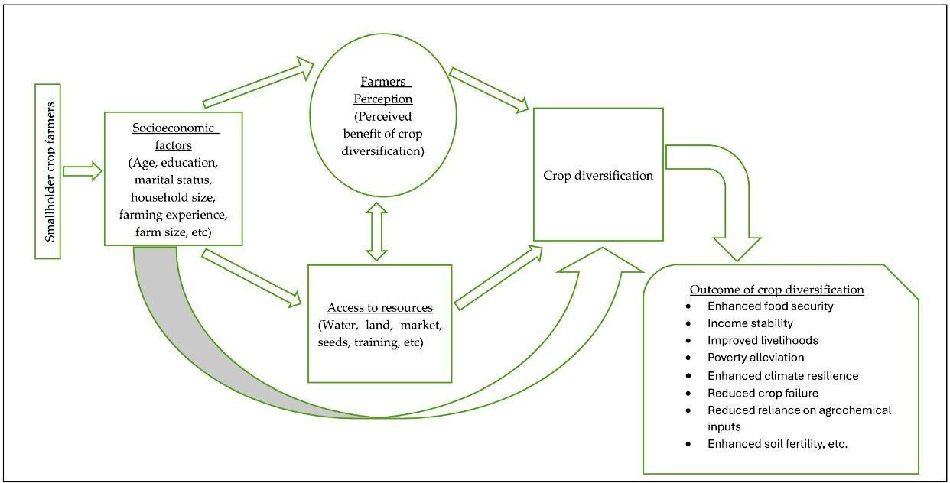
Source: Adapted from the Sustainable Livelihoods Framework (Scoones, 1998)
The conceptual framework illustrates the interrelationships between socio-economic and psychological attributes, adoption behaviour, and livelihood security under Integrated Farming Systems. Socio-economic factors such as education, experience, and farm resources influence farmers’ perceptions and access to information, which in turn shape enterprise diversification decisions. Psychological attributes including scientific orientation and risk-taking ability mediate adoption behaviour and effective system management. These interactions collectively determine livelihood outcomes in terms of income stability, food security, employment generation, and resilience, consistent with the Sustainable Livelihoods Framework (Scoones, 2015).
The findings support a conceptual pathway wherein education, experience, and information exposure enhance knowledge and adoption, which in turn strengthen livelihood security across income, food, employment, and social dimensions. The Farmer FIRST Programme acts as a catalyst by providing participatory learning platforms, demonstrations, and institutional support, thereby accelerating this linkage.

Conclusion
The study concludes that socio-economic attributes such as education, IFS experience, enterprise diversification, knowledge, and adoption of IFS practices were the most influential factors determining livelihood security among farmers. Other factors like income, media exposure, scientific orientation, and extension contact also contributed significantly. In contrast, age, family size, and landholding size did not significantly influence livelihood security. These findings highlight the importance of strengthening farmer education, promoting diversified enterprise combinations, and enhancing access to knowledge and information for improving sustainable livelihoods under IFS.
The study empirically establishes that livelihood security of IFS farmers is predominantly influenced by educational, experiential, informational, and psychological factors rather than structural characteristics such as landholding or family size. The Farmer FIRST Programme has played a critical role in strengthening these attributes by fostering participatory learning and enterprise integration. The results strongly advocate for policy interventions that focus on knowledge enhancement, enterprise diversification, and behavioral transformation to achieve sustainable livelihood security among farming households.

Policy and Extension Implications
- Capacity building should be prioritized, with greater emphasis on farmer education, skill development, and experiential learning.
- Enterprise diversification must be promoted as a central strategy for livelihood security, particularly for small and marginal farmers.
- Strengthening extension contact and mass media utilization can significantly enhance awareness, knowledge, and adoption of IFS practices.
- Programmes like Farmer FIRST should integrate behavioral dimensions such as scientific orientation and risk-taking ability into their intervention design.
- Since landholding size was not a limiting factor, IFS can be effectively scaled across all farm sizes, making it a powerful inclusive development approach.

Way Forward
The findings of the study highlight the need to strengthen capacity-building interventions focusing on education, technical knowledge, and adoption of Integrated Farming System (IFS) practices. Extension agencies should prioritize enterprise diversification, enhanced extension contact, and effective use of mass media to improve information dissemination. Programmes like the Farmer FIRST Programme should emphasize participatory learning, skill-oriented trainings, and behavioral attributes such as scientific and risk orientation to further strengthen livelihood security. Scaling up IFS models across different agro-ecological regions can contribute significantly to sustainable and inclusive rural development.
- Socio-economic attributes: The findings of the study clearly indicate that socio-economic and psychological attributes play a decisive role in shaping livelihood security among Integrated Farming System farmers. Therefore, future interventions should prioritize strengthening farmers’ human and social capital through targeted capacity-building programmes focusing on education, technical knowledge, and information access. Extension strategies under programmes such as Farmer FIRST should be redesigned to enhance regular extension contact, improve mass media utilization, and promote experiential learning approaches that strengthen scientific orientation and risk-taking ability. Special attention should be given to enterprise combination planning and experience-based learning, enabling farmers to optimize system synergies and resource recycling. Strengthening these attributes will not only improve adoption behaviour but also enhance farmers’ decision-making capacity and resilience under changing agro-ecological and market conditions.
- Livelihood security: From a livelihood security perspective, the study underscores the need to promote Integrated Farming Systems as a holistic development strategy rather than a set of isolated enterprises. Policy initiatives should focus on scaling up IFS models across diverse agro-ecological regions while ensuring location-specific customization of enterprise combinations. Strengthening institutional support through credit access, input supply, market linkage, and risk-mitigation mechanisms can further stabilize income and employment opportunities for farm households. Future research should adopt longitudinal and multivariate analytical approaches to capture causal relationships between socio-economic attributes, adoption behaviour, and livelihood outcomes. Such evidence will support the formulation of inclusive and sustainable rural development policies aimed at enhancing income stability, food security, and overall livelihood resilience of small and marginal farmers.

Limitations of the Study
The study was conducted with a relatively small sample size confined to a single district, which may limit the generalization of the findings to other regions. The use of correlation analysis indicates the strength and direction of relationships but does not establish causality between the variables. Additionally, the study relied on self-reported responses, which may be subject to recall bias or respondent subjectivity.

Scope for Future Research
Future studies may employ multivariate analytical techniques such as multiple regression analysis or structural equation modelling to assess the causal relationships and relative contribution of socio-economic, psychological, and institutional factors to livelihood security. Expanding the sample size across diverse agro-climatic zones and incorporating longitudinal data could provide deeper insights into the long-term impacts of Integrated Farming Systems on livelihood sustainability. Inclusion of qualitative approaches may further enrich understanding of farmer perceptions and adoption dynamics.

Disclaimer (Artificial intelligence)
Author(s) hereby declare that NO generative AI technologies such as Large Language Models (ChatGPT, COPILOT, etc.) and text-to-image generators have been used during the writing or editing of this manuscript.

References
- Behera, U.K., France, J. (2016). Integrated farming systems and the livelihood security of small and marginal farmers in India and other developing countries. Adv. Agron, 138: 235–282. https://doi.org/10.1016/bs.agron.2016.04.001.
- Birthal, P.S., Hazrana, J. (2019). Crop diversification and resilience of agriculture to climatic shocks: Evidence from India. Agricultural Systems, 173: 345-354. https://doi.org/10.1016/j.agsy.2019.03.005
- Chambers, R., & Conway, G. R. (1992). Sustainable rural livelihoods: Practical concepts for the 21st century. IDS Discussion Paper No. 296. Institute of Development Studies, Brighton.
- Dessart, F. J. (2019). Farmers’ views on EU agri-environmental policies. Contributing to the Common Agricultural Policy Impact Assessment with evidence from focus groups. Publications Office of the European Union, Luxembourg, ISBN 978-92-76-01439-3, doi:10.2760/049327
- Ellis, F. (2000). Rural livelihoods and diversity in developing countries. Oxford University Press.
- Food and Agriculture Organization of the United Nations. (2021).The State of Food and Agriculture 2021: Making agrifood systems more resilient to shocks and stresses. Rome: FAO.
- Government of India. (2021). Agricultural Census 2015–16 (Phase II). Ministry of Agriculture & Farmers Welfare, New Delhi.
- Hasanain, M., Fatima, A., Maurya, D. K., Verma, S. K., Singh, P. K., Singh, S., & Mishra, R. (2020). Integrated farming system for livelihood security to small and marginal farmers. Food and Scientific Reports, 36–38. ISSN 2582-5437.
- ICAR (2016). Agricultural Technology Application Research Institute, ATARI, ZONE-X, HYDERABAD.
- Khobragade, S., Mohapatra, S., Mahananda, M., Singh, A., Singh, A. (2021). Integrated farming system (IFS): a review. Int. J. Econ. Plants 8(3): 181–187. http://ojs.pphouse.org/index.php/IJEP/article/view/4689.
- Kothari, C.R. (2004) Research Methodology: Methods and Techniques. 2nd Edition, New Age International Publishers, New Delhi.
- Kumar, P., V, P., KK, M., 2022. Rice-Based integrated farming system for sustainable coastal agroecosystem of India. J. Rice Res., 15(Special Issue). https://doi.org/10.58297/HTAV4445.
- Scoones, I. (1998). Sustainable rural livelihoods: a framework for analysis. IDS Working Paper 72. Brighton: Institute for Development Studies.
- Scoones, I. (2015). Sustainable rural livelihoods and rural development. Fernwood Publishing, 137pp. ISBN: 9781853398759
- Singh, R. P. & Singh, R. K. (2017). Integrated farming systems for sustainable livelihoods of small and marginal farmers. Indian Journal of Agricultural Sciences, 87(10), 1295–1302.
- Singh, V.K., Rathore, S.S., Singh, R.K., Upadhyay, P.K., Shekhawat, K. (2020). Integrated farming system approach for enhanced farm productivity, climate resilience and doubling farmers' income. Indian J. Agric. Sci., 90(8): 1378–1388. https://doi.org/10.56093/ijas.v90i8.105884
- Yadav, B., Sahu, R.K., Kumar, B., Kumar, K. and Singh, P. (2022). Assessment of IFS model in context of doubling farmers income in district Banda; A Micro Study. Econ. Aff., 67(4). https://doi.org/10.46852/0424-2513.4.2022.9.

