Personal, Psychological and Socio-economic Characteristics of Tomato Growers on Green Technologies in Southern Karnataka

ABSTRACT
Tomato growers play a crucial role in vegetable production, and understanding their profile characteristics is essential for promoting green technologies. The study was conducted in 2024-2025 in Doddaballapur taluk of Bengaluru Rural district and Malur taluk of Kolar district of Karnataka, involving 60 tomato growers selected randomly. Data were collected through personal interviews and analyzed using appropriate statistical tools. The results revealed that 66.67 per cent of the tomato growers belonged to middle-age group, and most (33.33 %) had education up to high school level. Medium family size was predominant (60.00 %), and 83.34 per cent of growers reported low to medium annual income. More than half of the growers had medium farming experience (56.67 %), medium extension contact (38.33 %), and medium extension participation (40.00 %). Medium information-seeking behavior (41.66 %), achievement motivation (43.34 %), risk orientation (40.00 %), innovative proneness (38.33 %), and scientific orientation (46.67 %) were also predominant. Differences between the two taluks were observed in extension participation, family size, and information-seeking behavior. The study indicates that most tomato growers possess moderate socio-economic, communicational, and psychological characteristics, which influence their adoption of green technologies. These findings can guide extension agencies and policymakers in designing targeted interventions to enhance the adoption of green technologies and improve productivity in Southern Karnataka.
Keywords: Tomato growers, Profile characteristics, Green technologies, Southern Karnataka
1. INTRODUCTION
Tomato is one of the key commercial vegetable crops grown in Karnataka, valued for its strong market demand and ability to provide substantial income to farmers. In the context of rising concern for sustainable agriculture, greater attention is now being directed toward green technologies that conserve resources, minimize environmental impact and support climate-resilient farming. These include drip and mulching systems, integrated nutrient and pest management, biofertilizers, soil health practices, protected cultivation, water-saving methods and others that aim to enhance productivity while minimizing ecological damage. However, farmer’s willingness and capacity to adopt these technologies largely depend on their socio-economic characteristics, awareness levels, access to information and innovative behaviour.
Southern Karnataka is an important tomato-growing region marked by diverse farmer profiles and varied production environments. Despite the availability of proven green technologies promoted by research institutions and extension agencies, their adoption remains uneven across districts due to differences in education, farm size, income, experience, risk orientation and extension contact. Understanding these profile characteristics is essential for identifying the strengths, gaps and behavioural patterns that influence farmer’s acceptance of sustainable technologies. Hence, this study aims to analyse the personal, socio-economic, psychological and communication characteristics of tomato growers in Southern Karnataka and examine how these characteristics relate to grower’s utilisation and adoption of green technologies.
1.1 Objective of the study
- To study the personal, psychological and socio-economic characteristics of the tomato growers on green technologies
2. METHODOLOGY
The study was conducted in Southern Karnataka, specifically in Doddaballapur taluk of Bengaluru Rural district and Malur taluk of Kolar district, which were purposively selected based on the highest area under tomato cultivation and also exposure to green technology initiatives is high. A total of 60 tomato growers in which 30 growers from Doddaballapur and 30 growers from Malur taluks were selected using a simple random sampling technique. Primary data were collected through personal interviews using a well-structured and pre-tested interview schedule covering personal, socio-economic and psychological characteristics relevant to green technologies. The collected information was tabulated and analysed using appropriate statistical tools like frequency and percentage to assess the profile characteristics of tomato growers in the study area. An ex-post facto research design with simple random sampling technique was adopted to carry out the study.
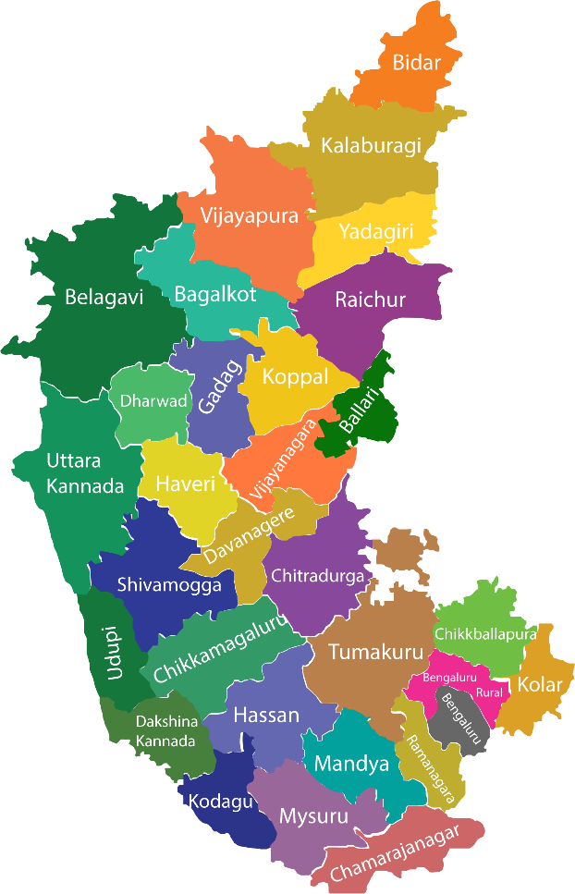
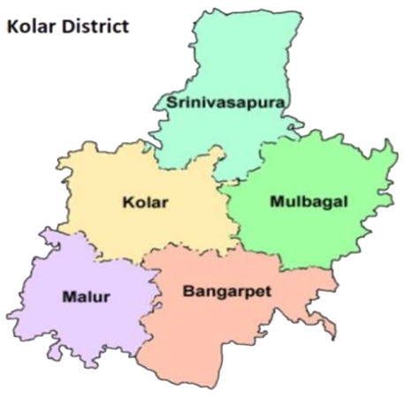
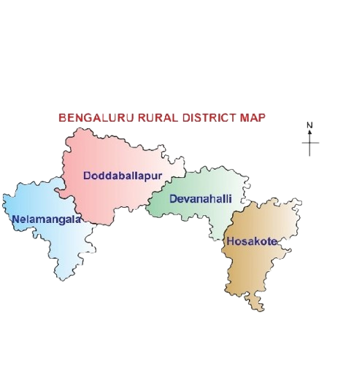

Karnataka state

Fig. 1: Map of the study area
3. RESULTS AND DISCUSSION
Table 1: Profile characteristics of tomato growers

Sl.  No. | Particulars | Category | Doddaballapur (n_{a}= 30) |  | Malur  (n_{b}= 30) |  | Overall tomato growers  (n₁=60)
Sl.  No. | Particulars | Category | f | % | f | % | f | %
1 | Age | Young (<35 years) | 7 | 23.33 | 4 | 13.34 | 11 | 18.33
1 | Age | Middle (35-55 years) | 18 | 60.00 | 22 | 73.33 | 40 | 66.67
1 | Age | Old (>55 years) | 5 | 16.67 | 4 | 13.33 | 9 | 15.00
2 | Education | Illiterate | 3 | 10.00 | 9 | 30.00 | 12 | 20.00
2 | Education | Primary | 5 | 16.67 | 5 | 16.67 | 10 | 16.67
2 | Education | High school | 11 | 36.66 | 9 | 30.00 | 20 | 33.33
2 | Education | PUC | 6 | 20.00 | 5 | 16.67 | 11 | 18.33
2 | Education | Degree | 5 | 16.67 | 2 | 6.66 | 7 | 11.67
3 | Family size | Sma ll (1-4) | 13 | 43.33 | 7 | 23.33 | 20 | 33.33
3 | Family size | Medium (5- 6) | 13 | 43.33 | 23 | 76.67 | 36 | 60.00
3 | Family size | Large (>7) | 4 | 13.34 | 0 | 0.00 | 4 | 6.67
4 | Annual income  Mean=420666.67  SD=593541.95 | Low (<123895.69) | 12 | 40.00 | 13 | 43.33 | 25 | 41.67
4 | Annual income  Mean=420666.67  SD=593541.95 | Medium (123895.69 -717437.64) | 10 | 33.33 | 15 | 50.00 | 25 | 41.67
4 | Annual income  Mean=420666.67  SD=593541.95 | High (> 717437.64) | 8 | 26.67 | 2 | 6.67 | 10 | 16.66
5 | Farming experience | Low (< 10 Years) | 3 | 10.00 | 3 | 10.00 | 6 | 10.00
5 | Farming experience | Medium (10-20 Years) | 17 | 56.67 | 17 | 56.67 | 34 | 56.67
5 | Farming experience | High (> 20 Years) | 10 | 33.33 | 10 | 33.33 | 20 | 33.33
6 | Extension contact  Mean=7.05  SD=5.63 | Low (< 4.23) | 8 | 26.67 | 14 | 46.67 | 22 | 36.67
6 | Extension contact  Mean=7.05  SD=5.63 | Medium (4.23-9.86) | 12 | 40.00 | 11 | 36.66 | 23 | 38.33
6 | Extension contact  Mean=7.05  SD=5.63 | High (>9.86) | 10 | 33.33 | 5 | 16.67 | 15 | 25.00
7 | Extension participation  Mean=5.15  SD=3.92 | Low (<3.19) | 4 | 13.33 | 18 | 60.00 | 22 | 36.67
7 | Extension participation  Mean=5.15  SD=3.92 | Medium (3.19-7.11) | 14 | 46.67 | 10 | 33.33 | 24 | 40.00
7 | Extension participation  Mean=5.15  SD=3.92 | High (>7.11) | 12 | 40.00 | 2 | 6.67 | 14 | 23.33
8 | Information seeking behavior  Mean=14.01  SD=4.19 | Low (< 11.92) | 9 | 30.00 | 6 | 20.00 | 15 | 25.00
8 | Information seeking behavior  Mean=14.01  SD=4.19 | Medium (11.92 – 16.11) | 656 | 20.00 | 19 | 63.33 | 25 | 41.66
8 | Information seeking behavior  Mean=14.01  SD=4.19 | High (> 16.11) | 15 | 50.00 | 5 | 16.67 | 20 | 33.34
9 | Achievement motivation  Mean=12.01  SD=1.81 | Low (< 11.11) | 9 | 30.00 | 6 | 20.00 | 15 | 25.00
9 | Achievement motivation  Mean=12.01  SD=1.81 | Medium (11.11 – 12.92) | 130 | 43.33 | 13 | 43.33 | 26 | 43.34
9 | Achievement motivation  Mean=12.01  SD=1.81 | High (> 12.92) | 8 | 26.67 | 11 | 36.67 | 19 | 31.66
10 | Risk orientation  Mean=3.01  SD=0.86 | Low (< 2.58) | 4 | 13.33 | 12 | 40.00 | 16 | 26.67
10 | Risk orientation  Mean=3.01  SD=0.86 | Medium (2.58 - 3.45) | 14 | 46.67 | 10 | 33.33 | 24 | 40.00
10 | Risk orientation  Mean=3.01  SD=0.86 | High (> 3.45) | 12 | 40.00 | 8 | 26.67 | 20 | 33.33
11 | Innovative proneness  Mean=15.11  SD=3.98 | Low (< 13.13) | 12 | 40.00 | 7 | 23.33 | 19 | 31.67
11 | Innovative proneness  Mean=15.11  SD=3.98 | Medium (13.13 –17.10) | 6 | 20.00 | 17 | 56.67 | 23 | 38.33
11 | Innovative proneness  Mean=15.11  SD=3.98 | High (> 17.10) | 12 | 40.00 | 6 | 20.00 | 18 | 30.00
1 12 | Scientific orientation  Mean=7.73  SD=2.68 | Low (< 6.39) | 7 | 23.33 | 10 | 33.33 | 17 | 28.33
1 12 | Scientific orientation  Mean=7.73  SD=2.68 | Medium (6.39 - 9.07) | 15 | 50.00 | 13 | 43.34 | 28 | 46.67
1 12 | Scientific orientation  Mean=7.73  SD=2.68 | High (> 9.07) | 8 | 26.67 | 7 | 23.33 | 15 | 25.00

The results which are furnished in Table 1 represent the profile characteristics of the tomato growers of Doddaballapur and Malur taluks.
3.1 Age
Table 1 shows that the majority (66.67 %) of tomato growers belonged to the middle-age group, while 18.33 % were young and 15.00 % were in the older age category. Specifically, in Doddaballapur taluk, 60.00 % of the growers were middle-aged, 23.33 % were young and 16.67 % were older. In Malur taluk, about three-fourths (73.33 %) of the growers fell into the middle-age category, with 13.34 % young and 13.33 % older.
These results indicate that middle-aged individuals constitute a significant portion of tomato growers. This could be due to their relatively higher education levels, motivation and physical ability compared to older farmers, as well as greater experience, family responsibilities, and work efficiency than younger farmers. Similar trends have been observed in other studies. The findings are in line with Katole et al. (2017).
3.2 Education
With regard to the educational status of the respondents, Table 1 shows that about one-third (33.33 %) of the tomato growers had studied up to high school. This was followed by illiterate growers (20.00 %), those educated up to PUC level (18.33 %), primary schooling (16.67 %) and a smaller proportion (11.67 %) who were graduates. In Doddaballapur taluk, slightly more than one-third (36.66 %) of the growers had completed high school education, while 20.00 per cent had PUC qualification. Another 16.67 per cent each had primary education and graduation and 10.00 per cent of the respondents were illiterate.
Among the Malur growers, just under one-third (30.00 %) had high school education and an equal proportion (30.00 %) were illiterate. A further 16.67 per cent had completed primary schooling and PUC respectively, while 6.66 per cent were graduates.
Overall, the findings reveal that most tomato growers had education up to the high school level. This may be due to limited availability of higher educational institutions in rural areas, low inclination towards extended schooling and financial constraints faced by farming families. Similar observations were also reported by Rakesh and Naik (2022).
3.3 Family size
A review of Table 1 shows that 60.00 per cent of the tomato growers had families of medium size, while 33.33 per cent belonged to small families and only 6.67 per cent were from large families. In Doddaballapur taluk, 43.33 per cent of the respondents each reported medium and small family sizes, with the remaining 13.34 per cent falling under the large family category. In Malur taluk, a considerable majority, slightly over three-fourth (76.67 %), had medium-sized families, followed by 23.33 per cent with small families.
Overall, the findings suggest that most growers were part of medium-sized families. This may be attributed to the predominance of middle-aged growers with basic educational backgrounds, which might have increased their awareness about family planning initiatives. Additionally, the shift away from joint family structures and the growing influence of urbanization and modern lifestyle preferences could have contributed to this pattern. These observations are in agreement with the findings of Jha and Das (2019).
3.4 Annual income
An examination of Table 1 shows that about 83.34 per cent of the tomato growers fell under the low to medium annual income categories, while only 16.66 per cent reported high annual income. In Doddaballapur taluk, 40.00 per cent of the respondents belonged to the low-income group, followed by 33.33 per cent in the medium-income group and 26.67 per cent in the high-income group. Among the Malur respondents, half (50.00 %) had medium annual income, whereas 43.33 per cent were in the low-income category and 6.67 per cent were in the high-income bracket.
The differences in income levels may be explained by variations in landholding size, engagement in subsidiary enterprises and the extent to which growers adopted green technologies, which could have contributed to better yields and higher earnings, particularly among those in the medium-income group. These findings align with those reported by Patel et al. (2017), Darling et al. (2018).
3.5 Farming experience
A review of Table 1 shows that 56.67 per cent of the tomato growers possessed a medium level of farming experience, while 33.33 per cent had high experience and 10.00 per cent had low experience. The pattern was identical in both Doddaballapur and Malur taluks, where a little over half (56.67 %) of the growers reported medium farming experience, followed by high (33.33 %) and low (10.00 %) experience levels.
The overall results indicate that the majority of respondents had moderate farming experience. This could be attributed to the fact that many growers were in the middle-age bracket of 35-55 years and had taken up vegetable cultivation after discontinuing formal education, resulting in several years of hands-on field experience. Similar trends were documented by Behera et al. (2022).
3.6 Extension contact
As shown in Table 1, 38.33 per cent of the tomato growers had a medium level of extension contact, followed by 36.67 per cent with a low level and 25.00 per cent with a high level of contact. In Doddaballapur taluk, 40.00 per cent of the growers reported medium extension contact, while 33.33 per cent had high contact and 26.67 per cent had low contact. In Malur taluk, however, 46.67 per cent of the respondents had low extension contact, followed by 36.66 per cent with medium and 16.67 per cent with high contact levels.
Overall, the findings indicate that most growers fell under the medium extension contact category. This may be due to the presence of a Krishi Vigyan Kendra in the Doddaballapur region and active agricultural and horticultural departments at the taluk level in Malur, which helped farmers maintain regular interactions with scientists and field staff. Continuous engagement with Raith Samparka Kendras in both areas may also have contributed to this trend. Similar results were reported by Kumar et al. (2019).
3.7 Extension Participation
Table 1 shows that 40.00 per cent of the tomato growers had a medium level of extension participation, followed by 36.67 per cent with low participation and 23.33 per cent with high participation. Among the growers of Doddaballapur, nearly 46.67 per cent reported medium participation, while 40.00 per cent had high participation and 13.33 per cent had low participation. In contrast, in Malur taluk, 60.00 per cent of the respondents recorded low participation, followed by 33.33 per cent with medium and 6.67 per cent with high participation.
The overall pattern suggests that most growers were moderately involved in extension programmes. This could be attributed to the presence of the Krishi Vigyan Kendra in the Doddaballapur region and the activities of the agriculture and horticulture departments at the taluk level in Malur, which provided opportunities for growers to engage in various extension events. However, limited time availability and low personal interest among some growers may have resulted in reduced participation. These findings are supported by the reports of Rajesh et al. (2023), Chidagoli et al. (2020).
3.8 Information seeking behavior
An examination of Table 1 shows that 41.66 per cent of the tomato growers exhibited a medium level of information-seeking behavior, followed by 33.34 per cent with a high level and 25.00 per cent with a low level. In Doddaballapur taluk, half of the growers (50.00 %) demonstrated a high tendency to seek information, while 30.00 per cent showed low and 20.00 per cent showed medium information-seeking behavior. In contrast, in Malur taluk, nearly two-thirds (63.33 %) of the respondents fell under the medium category, followed by 20.00 per cent with low and 16.67 per cent with high information-seeking behavior.
Overall, the results indicate that most tomato growers were moderately active in seeking agricultural information. This may be due to their convenient access to local personal sources such as neighbours, friends, relatives, progressive farmers and community leaders, along with impersonal cosmopolite sources like WhatsApp groups, YouTube, mobile messages and other digital platforms. Similar findings were reported by Patel et al. (2017).
3.9 Achievement motivation
Table 1 indicates that 43.34 % of tomato growers demonstrated a medium level of achievement motivation, while 31.66 % showed a high level and 25.00 % a low level. In Doddaballapur taluk, slightly over two-fifths (43.33 %) of the respondents had medium achievement motivation, 30.00 % had low, and 26.67 % exhibited high motivation. A similar trend was observed among Malur growers, with 43.33 % in the medium category, 36.67 % in the high, and 20.00 % in the low achievement motivation category.
These findings indicate that most growers possessed a moderate level of achievement motivation. This may be attributed to the grower’s basic educational background and their willingness to take moderate risks to enhance income, especially considering the commercial importance of tomato cultivation. Such motivation likely encouraged them to adopt green technologies. These observations are supported by the results of Poonam and Surya (2016).
3.10 Risk orientation
Table 1 reveals that 43.34 % of tomato growers had a medium level of achievement motivation, followed by 31.66 % with a high level and 25.00 % with a low level. In Doddaballapur taluk, just over two-fifths (43.33 %) of respondents exhibited medium achievement motivation, 30.00 % had low motivation, and 26.67 % showed high motivation. A similar distribution was seen in Malur taluk, where 43.33 % of growers were in the medium category, 36.67 % in the high, and 20.00 % in the low category.
Overall, the results suggest that most growers possessed a moderate tendency to take risks. This could be due to the nature of green technologies, which require considerable investment, encouraging farmers to take calculated or moderate risks in anticipation of higher returns. These findings are in agreement with those of Sakthivel and Kanagasabapathi (2020).
3.11 Innovative proneness
A review of Table 1 indicates that 38.33 per cent of the tomato growers exhibited a medium level of innovative proneness, while 31.67 per cent showed low and 30.00 per cent showed high levels of innovativeness. In Doddaballapur, about 40.00 per cent of the respondents fell into both the low and high innovative proneness categories, with only 20.00 per cent in the medium group. In contrast, in Malur taluk, more than half (56.67 %) of the growers reported a medium level of innovative proneness, followed by 23.33 per cent with low and 20.00 per cent with high innovative proneness.
Overall, the findings suggest that most growers demonstrated a moderate inclination toward adopting new ideas and practices. This may be linked to their medium to high risk-bearing capacity, which encourages them to explore innovations for better returns. Their moderate levels of extension contact and participation may also have contributed to their willingness to adopt new technologies. These results align with the observations of Jagadish et al. (2024).
3.12 Scientific orientation
An analysis of Table 1 shows that 46.67 % of tomato growers possessed a medium level of scientific orientation, while 28.33 % had low and 25.00 % had high scientific orientation. In Doddaballapur taluk, half of the respondents (50.00 %) demonstrated medium scientific orientation, 26.67 % showed high, and 23.33 % had low orientation. Among Malur growers, 43.34 % were in the medium category, 33.33 % in the low, and 23.33 % in the high scientific orientation category.
Overall, the results indicate that the majority of respondents possessed a moderate scientific outlook. This may be attributed to their educational background, risk-bearing capacity, farming experience and regular interaction with extension agencies, which collectively encourage a more scientific approach to farming practices. However, the presence of low scientific orientation among some growers may be due to their continued reliance on traditional methods. These findings align with those reported by Kumar et al. (2019).
4. POLICY IMPLICATIONS
- Training programs should focus on medium-educated, middle-aged tomato growers, emphasizing practical skills and knowledge of green technologies to improve adoption rates and farm productivity.
- Digital platforms, mobile advisory services, and local extension centers should be strengthened to enhance growers’ access to timely information, innovative practices, and scientific guidance for sustainable farming.
- Financial incentives, credit support, and risk-mitigation schemes can motivate growers with moderate risk orientation and innovative tendencies to adopt environmentally friendly and resource-efficient agricultural practices.
- Group learning, farmer groups, and community-based extension initiatives should be promoted to increase participation, encourage peer-to-peer learning, and foster a collective approach to adopting green technologies.
4. CONCLUSION
The study clearly indicates that tomato growers in the selected areas of Southern Karnataka possess a balanced mix of socio-economic and psychological characteristics that influence their engagement with green technologies. The dominance of middle-aged growers, along with their moderate levels of education, farming experience, income and family size forms a stable base for adopting improved and sustainable cultivation practices. Their medium levels of extension contact, participation, information-seeking behaviour and scientific orientation further highlight their willingness to learn and experiment, though the extent of adoption is still influenced by access to resources and timely advisory support. Growers also demonstrated moderate achievement motivation, risk orientation and innovative proneness, reflecting their readiness to take calculated risks in commercial tomato cultivation. Strengthening these attributes through targeted extension interventions, continuous capacity-building programmes, and improved access to technical information would greatly enhance their ability to adopt and effectively use green technologies. Overall, understanding growers’ profile characteristics provides valuable insights for designing more responsive and need-based extension strategies that can accelerate the spread of green technologies and promote sustainable tomato farming in the region.

Disclaimer (Artificial intelligence)
Option 1:
Author(s) hereby declare that NO generative AI technologies such as Large Language Models (ChatGPT, COPILOT, etc.) and text-to-image generators have been used during the writing or editing of this manuscript.
Option 2:
Author(s) hereby declare that generative AI technologies such as Large Language Models, etc. have been used during the writing or editing of manuscripts. This explanation will include the name, version, model, and source of the generative AI technology and as well as all input prompts provided to the generative AI technology
Details of the AI usage are given below:
1.
2.
3.

- REFERENCES

BEHERA J, DAS S, MOHAPATRA BP, DASH A AND BEHERA K. 2022. Socioeconomic profile of the vegetable growers of Odisha: An analytical study. Pharma Innov J.11(9):712-717. https://www.thepharmajournal.com/specialissue?ArticleId=15435&issue=9S&vol=11&year=2022&utm
CHIGADOLLI M., KRISHNAMURTHY B. & SHIVALINGAIAH Y.N. 2020. Relationship and extent of contribution of profile characteristics of turmeric growers towards their knowledge about improved cultivation practices in Belagavi, Karnataka. Indian J Extn Edu. 56(1):28–33. https://www.researchgate.net/publication/341571126_Relationship_and_extent_of_contribution_of_profile_characteristics_of_turmeric_growers_towards_their_knowledge_about_improved_cultivation_practices_in_Belagavi_Karnataka
DARLING B, SUJI AND AM SATISH KUMAR. 2018. A study on the characteristics of the farmers and adoption of eco-friendly technologies. Plant Arch. 18:331-334. https://www.plantarchives.org/SPL%20ISSUE%20PDF/Plant_Archieves_14.pdf
JAGADISH H.M., M.V. SRINIVASA REEDY, Y.N. SHIVALINGAIAH, GAJANAND SHANTAPPA BHAIRAGOND & MEGHANA N. 2024. Personal, socio-economic and psychological characteristics of onion growers in Chitradurga district of Karnataka. Int. J. Agric. Extension Social Dev 7(3):187-190. https://www.extensionjournal.com/article/view/426/7-2-71
JHA KK AND DAS R. 2019. Adoption of recommended production technology by chilli growers in Tripura. Indian J Extn Edu. 55(3):117-122. https://www.researchgate.net/publication/341611087_Adoption_of_Recommended_Production_Technology_by_Chilli_Growers_in_Tripura
KATOLE, R. T., CHINCHMALATPURE, U. R., & MORE, G. B. 2017. Constraints faced by the farmers in adoption of bio-fertilizers. Agric. Update, 12(4), 628–633. https://doi.org/10.15740/HAS/AU/12.4/628-633
KUMAR, P. P., DHOREY, R. K., & SINGH, S. N. 2019. Profile Characteristics of Farmers in Adoption of BT Cotton. Int J Cur Microbio Appl Sci, 8(1), 2373-2378. https://doi.org/10.20546/ijcmas.2019.801.249
PATEL DB, MISTRY JJ AND PATEL VM. 2017. Farmers’ perception on use of bio fertilizers. Gujarat J Extn Edu. 28(2): 357-360. https://www.gjoee.org/papers/795.pdf
POONAM P, SURYA R. 2016. A study on impact of personal attributes of Programme Coordinators (PCs) of Krishi Vigyan Kendras on their managerial skills. Int J Agric Sci. 8(53):2678-2681. https://www.researchgate.net/publication/318635011_IMPACT_OF_PERSONAL_ATTRIBUTES_OF_PROGRAMME_COORDINATORS_PCs_OF_KRISHI_VIGYAN_KENDRAS_ON_THEIR_MANAGERIAL_SKILLS
RAJESH C.M., SHIVALINGAIAH Y.N. & HANUMANTHARAYA B.G. 2023. Personal, socio-economic and psychological characteristics of horticulture crop growers practicing protected cultivation: A critical analysis. Int. J. Plant Soil Sci. 35(2):12–22. https://www.researchgate.net/publication/397455273_Personal_Socioeconomic_and_Psychological_Characteristics_of_Horticulture_Crop_Growers_Practicing_Protected_Cultivation_A_Critical_Analysis?utm

RAKESH, K., & NAIK, R. M. 2022. Characteristics of the Farmers Using the Private Bio-Fertilizers. Asi J Agri Exten Econo Sociol, 40(11): 219-225. https://doi.org/10.9734/ajaees/2022/v40i111704

SAKTHIVEL V. & KANAGASABAPATHI K. 2020. Socio-economic and psychological characteristics of tapioca growers in major tapioca growing districts of Tamil Nadu. Adv. Agric. Sci. 23:93–104. https://www.extensionjournal.com/uploads/archives/8-2-36 223.pdf

