Protective effect of Irvingia gabonensis leaf extract and fractions on N-methyl-nitrosourea (NMU) and testosterone induced prostate cancer in rats

ABSTRACT
Background: The urgency of alternative, effective and less toxic treatment options has driven research towards natural products of plant sources. Irvingia gabonensis possesses promising anticancer properties due to its rich phytochemical content and antioxidant potential. Objective: This study investigated the antioxidant properties and anticancer effect of I. gabonensis leaf extract and its fractions in a rat model of prostate cancer. Method: Prostate cancer was induced in Wistar rats using N-methyl-nitrosourea (NMU) and testosterone. Prostate-specific antigen (PSA) levels, liver function enzymes, and antioxidant markers (catalase, GSH, SOD) were evaluated, and histological analyses of prostate and liver tissues were performed by Hematoxylin and Eosin staining. Phytochemical characterisation of the crude extract was conducted using Gas Chromatography-Mass Spectroscopy. Data analysis was performed by ANOVA at 95% confidence level. Result: Treatment with the I. gabonensis extract and fractions led to consistent weight gain and decreased PSA levels that were significant (p<0.05) compared to the cancer control group. The dichloromethane fraction significantly (p<0.05) increased catalase activity, and the methanol fraction significantly (p<0.05) increased GSH levels. Histological examination revealed preserved prostate tissue integrity in the treated groups compared to the untreated cancer group, although the treated groups exhibited some changes in liver function markers and histology. Phytol (17.07%), hexadecanoic acid, methyl ester (16.28%), 9-hexadecenoic acid, methyl ester (5.36%), 7-octadecenoic acid, methyl ester (7.11%), n-hexadecanoic acid (7.45%), and oleic acid (5.84%) were identified in abundance. Conclusion: I. gabonensis leaf extract and fractions exhibited anti-prostate cancer effects by modulating antioxidant defence mechanisms, but the observed effects on liver function require further investigation.
Keyword: I. gabonensis; liver function; oxidative stress; plant extract; Prostate cancer

INTRODUCTION
Prostate cancer is the second most common disease in men and the fifth largest cause of cancer mortality worldwide (Schafer et al., 2024; Naiki‐Ito et al., 2025). In 2018, an estimated 1.2 million cases were diagnosed (Rawla, 2019). By 2022, the number of cases had risen to 1,460,000, with 396,000 recorded deaths (Bray et al., 2024). Due to ageing and an increasing global population, prostate cancer is predicted to reach 2.4 million cases and 712,000 deaths by 2040 (Ferlay et al., 2020). Africa, Asia, and Latin America are projected to experience most of the predicted morbidity and mortality (Withrow et al., 2022).
Factors including age, race, family history, genetics, and lifestyle are frequently linked to the development of prostate cancer (Shukla et al., 2020; Oczkowski et al., 2021). Whereas one major mechanism for the progression is oxidative stress, which arises from a state of redox imbalance between the reactive oxygen species (ROS) and the antioxidant enzymes (Zhang et al., 2022; Naiki‐Ito et al., 2025). An increase in intracellular ROS level resulting from increased ROS production or impaired antioxidant defence causes oxidative damage to diverse cellular components such as the nuclei acid, proteins, lipids and carbohydrates (Schieber and Chandel, 2014; Biesiadecki et al., 2024). By oxidizing the biomolecules, an excessive buildup of ROS promotes the development of DNA adducts, lipid peroxidation, and protein carbonylation, which results in dysregulated apoptosis and mitochondrial malfunction, consequently transforming normal cells into cancerous and eventual death (Naiki‐Ito et al., 2025).
Due to the high incidence rate, there is an urgent need for more effective, less toxic anticancer treatment (Wang et al., 2024). Despite the advances in cancer therapy, the cure rate for prostate cancer is still very low and the death rate from this deadly disease is rising (Zhou et al., 2021; Wang et al., 2024).
The use of plant products in the treatment of cancer has continually been on the increase because of their many bioactive components and their capacity to promote apoptosis, among other effects (Olufunso et al., 2025). Commonly called African or bush mango, Irvingia gabonensis is a wild plant with promising anticancer properties because of its varied phytochemical contents, which include flavonoids, tannins, and saponins, among others. The ability of these chemicals to induce apoptosis in malignant cells and modify signalling pathways involved in cancer progression is contributed by their potent antioxidant properties (Olorundare et al., 2020; Yoon et al., 2022). These constituents have demonstrated anti-proliferative, apoptotic, and anti-angiogenic effects in various cancer models, indicating their potential (Hoseinkhani et al., 2020). Moreover, I. gabonensis has shown promise in modulating key cellular pathways involved in cancer progression, including those related to inflammation, oxidative stress, and immune response (Hassan et al., 2024). These observations emphasized the need for a more thorough investigation into the mechanisms by which I. gabonensis exerts anti-cancer effects, particularly in relation to prostate cancer. While existing research provides significant preliminary evidence, there is a dearth of laboratory trial and scientific evidence.
The present study provided valuable data to support potential antioxidant properties and the effect of I. gabonensis in prostate cancer treatment, providing a potential source of new and effective anticancer. The study extracted and fractionated I. gabonensis leaves, evaluated their antioxidant properties, and assessed their anticancer effects in prostate cancer-induced rats.

MATERIALS AND METHODS
Chemicals
Methanol, n-hexane, dichloro-methane, ethyl-acetate, and butanol were of analytical grade. Testosterone was acquired from SD Fine Chemicals in Mumbai, India, NMU (N-Methyl N-Nitroso Urea) (Cat. No. N4766) was purchased from Sigma Chemicals, United States, and propylene glycol from Qualigen Fine Chemicals in Mumbai, India.
Sample Collection
Fresh leaves of I. gabonese were collected from National Centre for Genetics Resources and Biotechnology (NAGRAB) MOOR Plantation, Ibadan, Oyo state, Nigeria, in March 2024. Plant identification and authentication were done by the Department of Botany at NAGRAB Research Institute at MOOR Plantation, Ibadan. The leaves were pruned from the branches of the trees and air-dried under laboratory conditions.
Preparation of sample
Prior to the drying of the leaves, they were thoroughly rinsed with distilled water to remove dirt then air dried at room temperature for two weeks. The leaves were then pulverized with a mechanical blender and stored in an air-tight container until extraction.
Extraction of Plant
Approximately 1000 g of pulverized (powdered) leaves were macerated in a stoppered flask with 10 L methanol. The tank was vigorously shaken on a frequent basis to ensure homogeneity. After 72 hours, the liquid was filtered into a beaker.
The extract was concentrated at 40 °C in a rotary evaporator (Model Labrota 4002) and the concentrated extract, referred to as crude methanol extract (ME), was maintained in a beaker and dried at room temperature to a constant weight of 143.4 g (32.2% yield). The sample was divided into two; one which serves as the crude extract and the other half was fractionated using a vacuum liquid chromatographic technique.
Fractionation using Vacuum Liquid Chromatography
A 1:1 ratio of the extract and silica gel was thoroughly mixed until the silica gel completely absorbed the extract, then spread on a flat surface for efficient drying. The dry adsorbent TLC (thin layer chromatography) graded silica gel was loaded into the sintered glass funnel and first allowed to settle under gravity with gentle tapping of the column with a rubber tube as in case of column chromatography (CC), then n-hexane was used to wash the silica gel. The prepared extract was introduced on top of the loaded silica gel in the sintered glass funnel and evenly distributed to a height of 1.5 cm. Gradient elusion was carried out sequentially with n-hexane (n-Hex), dichloromethane (DCM), ethyl-acetate and methanol (Me-OH). Each of the solvents was added and the eluent was collected in a glass bottle. When a clear eluent is observed, the next solvent will be added and the whole process will be repeated continuously. Each fraction was subsequently concentrated using a rotary evaporator and refrigerated in a glass bottle
Experimental design
Thirty-six male Wistar rats, aged 10–12 weeks, were procured from a breeder. They were housed in a well-ventilated plastic cage and were acclimatized to laboratory conditions for two weeks (12 hours natural light and 12 hours dark). The rats were fed with commercial grower feed for a period of two weeks, after which they were fed with finisher feed for the remaining period of the experiment. The cages, feed and water containers were cleaned on a regular basis while their feeds were also changed daily.

Animal grouping
Randomization was done according to animal mass. Each group consisted of six rats.
Group A – Control group
Group B – Cancer induced + crude methanol extract (500 mg/kg/bw)
Group C – Cancer induced + ethyl acetate fraction (500 mg/kg/bw)
Group D – Cancer induced + DCM fraction (500 mg/kg/bw)
Group E – Cancer induced + Methanol fraction (500 mg/kg/bw)
Group f- Cancer induced without treatment
Prostate induction
The method of Palanirajan et al. (2022) was employed for the induction of prostate cancer in this study. Intraperitoneal injection of testosterone (100 mg/kg in 0.3 mL propylene glycol) was administered for 3 days. Beginning from day four, the rats received a single intravenous dose (50 mg/kg/bw) of N-methyl- N-nitroso urea dissolved in saline at (10 mg kg⁻¹) for one week through the tail vein. Thereafter, rats resumed daily intraperitoneal injection of 2 mg/kg/bw simultaneously with oral administration of plant extract and fractions for sixty days.
Experimental endpoint and tissue collection
Animals were euthanized through cervical dislocation, 24 hours after the last treatment. The blood sample was collected into plane sterile bottles while the prostate tissue was stored in an ice-cold normal saline and kept in the refrigerator pending the time of homogenization. The liver and a portion of prostate tissue for histological analysis were fixed in 10% neutral buffered formal saline
Preparation of Homogenate
Homogenate of the prostate was prepared in phosphate-buffered saline (pH 7.4) (10% w/v). The homogenate was centrifuged at a speed of 3000 rpm for 10 mins. The supernatant was collected through careful decantation, and the pellet was discarded. The supernatant was stored in well labelled plain sample bottles and kept in a refrigerator.
Biochemical analysis
All biochemical assays were performed spectrophotometrically as mentioned in manufacturer’s protocol. The biochemical markers included catalase, reduced glutathione (GSH), superoxide dismutase (SOD), aspartate aminotransferase (AST), albumin, alanine aminotransferase (ALT), gamma glutamyl transferase (GGT), conjugated and unconjugated bilirubin.
Prostate Specific Antigen Assay
PSA was assayed from the serum using the Cobas e411 analyser, developed by Roche Diagnostics. The equipment uses electrochemiluminescence technology for immunoassay analysis.
Histological Analysis
Histopathological evaluation of the prostate and liver tissue was performed by embedding the tissues in paraffin blocks and eventual staining in Hematoxylin and Eosin (H & E) stain.
Gas Chromatography-Mass spectroscopic (GC–MS) analysis
The GC–MS analysis was performed on Agilent Technologies 789OA coupled with mass spectrophotometer with triple axis detector (VL5675C) equipped with an auto injector. The compounds were identified by comparing the spectrum of the separated components with the standard mass spectra from the National Institute of Standards and Technology Library (NIST), Maryland, USA (Olasunkanmi et al., 2022).
Statistical Analysis
All data was expressed as Mean ± Standard Deviation (SD) and were analysed for statistical difference by one way analysis of variance (ANOVA) and Tukey Test using IBM SPSS statistics version 21.0. Significance was considered at 95% confidence level.

RESULTS

Effects of I. gabonensis extract and fractions on the body weight and PSA level of prostate cancer bearing rats
The result of the body weight change depicted in Figure 1 indicates the decreased weight gain in the prostate cancer bearing rats. Weight gain was consistent in the groups of prostate cancer bearing rats treated with ethyl acetate, dichloromethane, methanol fractions and crude extracts of I. gabonensis (Figure 1a). The PSA level was also significantly elevated in the prostate cancer bearing rats. Whereas the level in the treated groups was insignificantly different from the normal control group (Figure 1b)

Figure 1: Effect of I. gabonensis extract and fractions on the body weight (A) and prostate specific antigen (PSA) (B) of both control and experimental groups. Values are expressed as mean ± standard deviation. *Represent significant difference with the cancer induced (untreated control) while #represent significant difference with the normal control.

Effects of I. gabonensis extract and fractions on the liver function of prostate cancer bearing rats

In Figure 2, the activities of liver function enzymes and the level of some markers were presented. The observation in the result included significant increases (p<0.05) in the activities of ALT and AST in both the treated and untreated groups relative to the control. The activities of GGT decreased significantly (p<0.05) in all the extract and fraction-treated groups relative to the untreated control group. The level of albumin and conjugated bilirubin in all the groups were insignificantly different (p>0.05) compared to the controls. The level of unconjugated bilirubin was significantly (p<0.05) increased in the group treated with the ethyl acetate fraction of I. gabonensis.

Effects of I. gabonensis extract and fractions on the redox status of prostate cancer bearing rats
The result of the effects of the extract and fractions of I. gabonensis on the antioxidant parameters is depicted in Figure 3. Only the group treated with dichloromethane fraction of I. gabonensis increased the catalase activities significantly (p<0.05) and the group treated with the methanol fraction only increased the GSH level significantly (p<0.05). No significant (p>0.05) change was observed in the activities of superoxide dismutase in all the groups.

Effects of I. gabonensis extract and fractions on the histology of the prostate and liver tissues of prostate cancer-bearing rats

Hematoxylin and Eosin (H & E) stained sections of prostate tissues are presented in figure 4. In the cancer untreated group, area of concretions in the acinar lumen and the extensive area of hyperplasia of the epithelial lining of the prostatic acini were observed. The histological integrity was, however, preserved due to treatment with extract and fractions of I. gabonensis. The plates for the treated groups show normal prostatic acini with corpora amylacea (slender arrows) but focal area of slight glandular degeneration (thick arrows). The liver sections in Figure 5 show moderate to marked microvesicular steatosis (green arrows) in the treated groups while the cancer-un-treated group shows necrosis of the hepatocytes (slender arrows).

Figure 2: Effect of I. gabonensis extract and fractions on the ALT (A), GGT (B), conjugated bilirubin (C), unconjugated bilirubin (D), albumin (E), and AST (F) of both control and experimental groups. Values are expressed as mean ± standard deviation. *Represent significant difference with the cancer induced (untreated control) while #represent significant difference with the normal control.

Figure 3: Effect of I. gabonensis extract and fractions on the GSH (A) levels, catalase (B), and SOD (C) activities of both control and experimental groups. Values are expressed as mean ± standard deviation. *Represent significant difference with the cancer induced (untreated control) while #represent significant difference with the normal control.
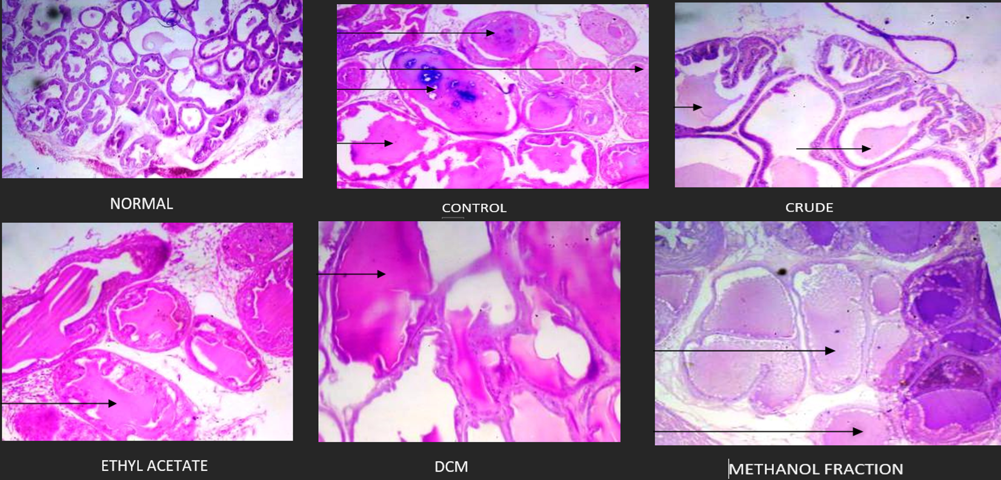 Figure: 4. Hematoxylin and eosin-stained section of prostates from prostate cancer bearing rats treated with I. gabonensis extract and fractions with control (400×).
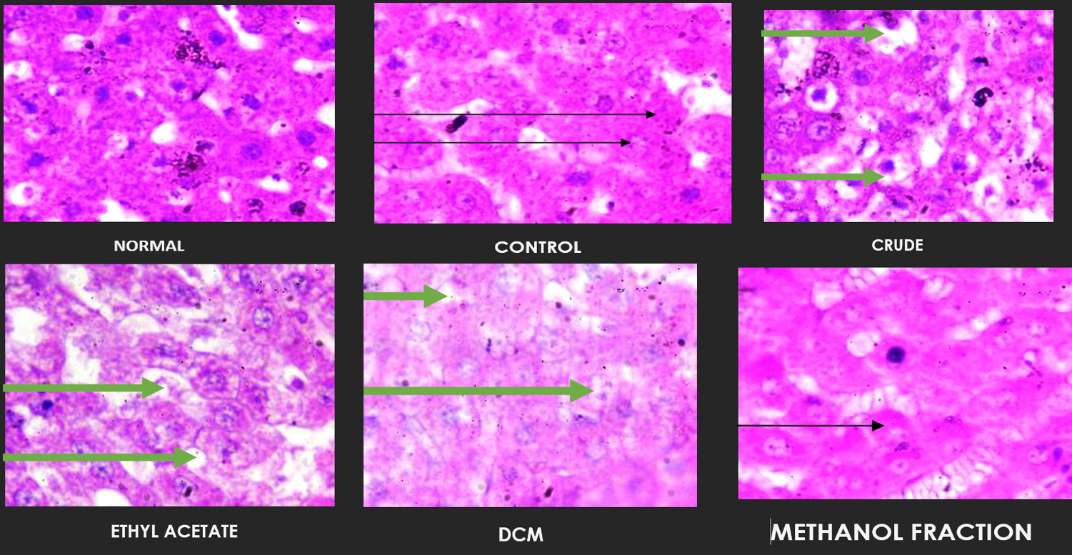
Figure: 5. Hematoxylin and eosin-stained section of liver from prostate cancer bearing rats treated with I. gabonensis extract and fractions with the control (400 Necrosis of the hepatocytes (slender arrows) and portal congestion (blue arrows)

GC-MS profile of phytochemicals in the crude extracts of I. gabonensis
The Gas chromatography-mass spectrometry (GC-MS) analysis of the crude extracts led to the identification of common bioactive compounds previously identified in different extracts of I. gabonensis. Different peaks with retention times ranging from 4.758 to 19.595 minutes were depicted in Figure 6. The major constituents identified included methyl esters of fatty acids and long-chain hydrocarbons.
Based on the peak percentage, phytol (17.07%) and hexadecanoic acid, methyl ester (16.28%) were the most abundance phytochemical identified at 14.995 min and 13.501 min, respectively (Table 1). Other notable phytochemicals included 9-hexadecenoic acid, methyl ester (5.36%), 7-octadecenoic acid, methyl ester (7.11%), n-hexadecanoic acid (7.45%), and oleic acid (5.84%).
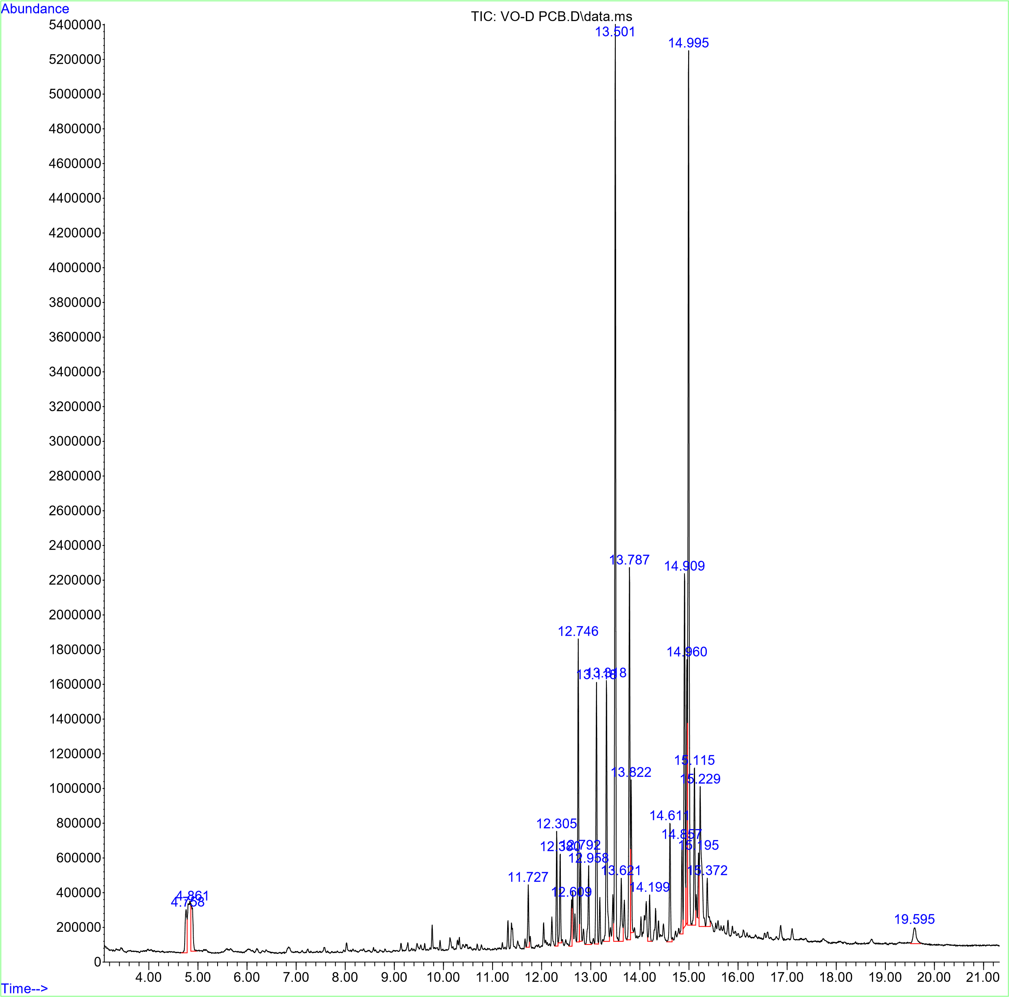
Figure 6: GC-MS chromatogram of crude extract of I. gabonensis

Table 1: GC-MS profile of compounds identified in the crude extract of I. gabonensis
S/N | Compounds | Retention time | Concentration (%)
 | Benzoic acid, methyl ester | 4.86 | 1.56
 | Methyl tetradecanoate | 11.727 | 1.10
 | Tetradecanoic acid, 12-methyl- | 12.380 | 1.52
 | Pentadecanoic acid | 12.609 | 0.91
 | Neophytadiene | 12.746 | 5.17
 | 2-Pentadecanone, 6,10,14-trimethyl- | 12.792 | 1.48
 | 9-Hexadecenoic acid, methyl ester | 13.318 | 5.36
 | Hexadecanoic acid, methyl ester | 13.501 | 16.28
 | 1 9-Hexadecenoic acid | 13.621 | 1.62
 | n-Hexadecanoic acid | 13.787 | 7.45
 | cis-10-Heptadecenoic acid, methyl ester | 14.199 | 0.91
 | 2-Pentyl-4-(tetrahydro-pyran-2-yloxy)-cyclohexanol | 14.611 | 2.33
 | 9,12-Octadecadienoic acid (Z,Z)-, methyl ester | 14.857 | 1.70
 | 7-Octadecenoic acid, methyl ester | 14.909 | 7.11
 | 9-Octadecenoic acid (Z)-, methyl ester | 14.960 | 5.12
 | Phytol | 14.995 | 17.07
 | Heptadecanoic acid, 16-methyl-, methyl ester | 15.115 | 2.95
 | Oleic acid | 15.195 | 5.84
 | Octadecanoic acid | 15.372 | 1.20
 | Docosanoic acid, methyl ester | 19.595 | 0.93
DISCUSSION

This study assessed the anti-prostate cancer potential of I. gabonensis leaf extract and fractions in Wistar rats. The investigation of the plant as a potential anti-prostate cancer agent aligns with the growing interest in natural products for cancer therapy. Observation in this study shows decreased weight gain in the cancer group, which is a common occurrence in cancer development and progression (Hariyanto and Kurniawan, 2020). The methanol extract and fractions of I. gabonensis treatment of the rats, however, resulted in consistent weight gain, suggesting a potential protective effect of the plant against cancer-induced weight loss. Furthermore, NMU and testosterone significantly elevated the level of prostate-specific antigen (PSA) in the prostate cancer-induced rats, indicating successful induction of prostate cancer in rats. PSA is a well-established biomarker for prostate cancer diagnosis (Toivanen and Shen, 2017). The histological pattern found in the rats validates the induction of prostate cancer as the untreated group showed concretions in the acinar lumen and an extensive area of hyperplasia of the epithelial lining of the prostatic acini. In a study, fibrosis was observed in prostate tissue, and the underlying cause of tissue fibrosis is typically a chronic inflammatory response (Arroyo-Acevedo et al., 2017). Both inflammation and oxidative stress are interconnected (Ogunjinmi et al., 2024) and the development of prostates in this study can be associated with inflammation and oxidative stress. Therefore, the protective potential of the extract was evidently demonstrated by the lower PSA levels recorded and the preservation of the prostate tissue integrity. This is a crucial finding as it suggests that the I. gabonensis extract and its fractions possess the ability to significantly reduce PSA levels in prostate cancer rats, potentially indicating an inhibitory effect on prostate cancer progression. Previous studies have shown protective effects of plant extracts using similar indicators (Arroyo-Acevedo et al., 2017; Kumar et al., 2012; Palanirajan et al., 2022).
Oxidative stress, characterised by an imbalance between reactive oxygen species (ROS) and antioxidant enzymes, is a major mechanism implicated in prostate cancer development and progression (Joshi et al., 2016; Arroyo-Acevedo et al., 2017). This study, therefore, assessed the impact of I. gabonensis extract and fractions on key antioxidant parameters. The results showed that only the group treated with the dichloromethane fraction of I. gabonensis exhibited a significant increase in catalase activity. Catalase is an important antioxidant enzyme that breaks down hydrogen peroxide to oxygen and water. Similarly, the methanol fraction significantly improved the level of reduced glutathione (GSH). GSH is a crucial non-enzymatic antioxidant that plays a vital role in detoxifying harmful compounds and protecting cells from oxidative damage (Adegbola et al., 2024). Overall observation of the antioxidant properties of the I. gabonensis is an indication of the contributory role it played in protecting against cancer development. It is, however, necessary to explore other possible mechanisms through which the plant protects against prostate cancer induction in the rats. Acevedo et al. (2017) associated the antioxidant properties of C. spinosa to its flavonoid constituents.
The analysis of liver function enzymes revealed significant increases in the activities of Alanine aminotransferase (ALT) and Aspartate aminotransferase (AST) in both the treated and untreated cancer-induced groups compared to the normal control (Palanirajan et al., 2022). Elevated levels of ALT and AST are indicators of liver damage or dysfunction. The fact that these enzymes were elevated even in the treated groups suggests that the induction of prostate cancer and/or the treatment regimen might have exerted some stress on the liver. Interestingly, the activities of Gamma glutamyl transferase (GGT) were significantly decreased in all the extract and fraction-treated groups relative to the untreated cancer control group. While GGT is also a marker of liver damage, its reduction in the treated groups compared to the untreated cancer group might be a complex effect requiring further investigation. GGT is highly expressed in cancer and can serve as major indicator for progressive and metastatic cancer (Palanirajan et al., 2022). Lowering of the activity of GGT further gives credence to the potential of I. gabonensis.
The levels of albumin and conjugated bilirubin showed no significant differences across all the groups, indicating that these specific aspects of liver function were largely unaffected by the cancer induction and the treatments. However, the level of unconjugated bilirubin was significantly increased in the group treated with the ethyl acetate fraction of I. gabonensis. This observation suggests that the ethyl acetate fraction might have a specific impact on bilirubin metabolism, which warrants further scrutiny. Histological examination of the liver tissue provided visual evidence of the protective effects of I. gabonensis. The histology showed necrosis of the hepatocytes, indicating liver damage associated with the induced cancer. Interestingly, the treated groups exhibited moderate to marked microvesicular steatosis. Microvesicular steatosis is characterized by the accumulation of small lipid droplets in the cytoplasm of hepatocytes. This finding aligns with the observed changes in liver enzyme activities and suggests that while the I. gabonensis treatments might have protected against hepatocellular necrosis seen in the untreated cancer group, they induced a different form of liver alteration, possibly related to lipid metabolism.
The compounds identified in the extract were predominantly fatty acid methyl esters, long-chain hydrocarbons, phytol, and related derivatives. They are compounds that have been consistently found in different morphological organs of I. gabonensis (Igwe and Obiukwu, 2017; Sunday et al., 2021; Ugwu and Ezema, 2022; Amakiri et al., 2024). Phytol, the major identified compound, is a diterpene alcohol commonly found in chlorophyll. This compound was reported in the seeds and leaves of I. gabonensis and contributed to its antioxidant and anti-inflammatory properties (Silva et al., 2014; Costa et al., 2016; Atanu et al., 2022). The presence of phytol might have therefore contributed to the antioxidant effects of the dichloromethane fraction in this study. Both Hexadecanoic acid, methyl ester and n-hexadecanoic acid (palmitic acid), which were equally abundant in the plant, have been documented in I. gabonensis seed oil and leaf and are known for their anti-inflammatory, antioxidant, and anti-lipidemic activities (Sunday et al., 2021; Atanu et al., 2022; Amakiri et al., 2024). Neophytadiene and 2-pentadecanone, 6,10,14-trimethyl- reported with antimicrobial and anti-inflammatory activities were identified and all these compounds in the extracts of I. gabonensis give credence to the effects observed in this study

CONCLUSION
The result of this study provides evidence of the potential protective effects of I. gabonensis leaf extract and its fractions against N-methyl-nitrosourea (NMU) and testosterone-induced prostate cancer in rats. The treatment led to improved body weight gain, significant reduction in PSA levels, modulation of antioxidant enzyme activities and GSH levels, and preservation of prostate tissue histology. However, the observed alterations in liver function markers and histology in the treated groups indicate the need for further investigation into the potential hepatotoxic effects of I. gabonensis at the tested dosage. These findings underscore the need for more comprehensive research to fully elucidate the mechanisms of action and safety of I. gabonensis in the context of prostate cancer treatment.

Abbreviations
AST: aspartate amino transferase
ALT: alanine amino transferase
ANOVA: Analysis of variance
CAT: Catalase
DCM: dichloromethane
GC–MS: Gas Chromatography-Mass spectroscopic
GGT: gamma glutamyl transferase
GSH: reduced glutathione
H&E: Hematoxylin and eosin
MDA: Malondialdehyde
NAGRAB: National Center for Genetics Resources and Biotechnology
NMU: N-methyl-nitrosourea
PSA: Prostate specific antigen
ROS: reactive oxygen species
SOD: Superoxide dismutase
TLC: thin layer chromatography

COMPETING INTERESTS DISCLAIMER:
Authors have declared that they have no known competing financial interests OR non-financial interests OR personal relationships that could have appeared to influence the work reported in this paper.

Disclaimer (Artificial intelligence)

Author(s) hereby declare that NO generative AI technologies such as Large Language Models (ChatGPT, COPILOT, etc.) and text-to-image generators have been used during the writing or editing of this manuscript.

REFERENCES
- Adegbola, P. I., Aborisade, A. B., Olaniyi, T. D., & Adetutu, A. (2024). Evaluation of long-term effects of nickel and benzo [a] anthracene contaminated diets in rats' kidney; mimicking human exposure from food. International journal of biochemistry and molecular biology, 15(1), 8–19.
- Amakiri, O.K., Sunday, E.A., Gift, W.P. (2024). “Phytochemical Profile and Bioactive Compounds in Aqueous Seed Extract of Irvingia gabonensis: A GC-MS Analysis”. Asian Journal of Research in Biochemistry 14 (6):138-43
- Arroyo-Acevedo, J., Herrera-Calderón, O., Chávez-Asmat, R., Anampa-Guzmán, A., Chumpitaz-Cerrate, V., & Enciso-Roca, E. (2017). Protective effect of Chuquiraga spinosa extract on N-methyl-nitrosourea (NMU) induced prostate cancer in rats. Prostate international, 5(2), 47-52.
- Atanu, F. O., Ikeojukwu, A., Owolabi, P. A., & Avwioroko, O. J. (2022). Evaluation of chemical composition, in vitro antioxidant, and antidiabetic activities of solvent extracts of Irvingia gabonensis leaves. Heliyon, 8(7), e09922.
- Biesiadecki, M., Mołoń, M., Balawender, K., Kobylińska, Z., & Galiniak, S. (2024). Shedding light on the shadows: Oxidative stress and its pivotal role in prostate cancer progression. Frontiers in Oncology, 14, 1393078.
- Bray, F., Laversanne, M., Sung, H., Ferlay, J., Siegel, R. L., Soerjomataram, I., & Jemal, A. (2024). Global cancer statistics 2022: GLOBOCAN estimates of incidence and mortality worldwide for 36 cancers in 185 countries. CA: a cancer journal for clinicians, 74(3), 229-263.
- Costa, J. P., Islam, M. T., Santos, P. S., Ferreira, P. B., Oliveira, G. L., Alencar, M. V., Paz, M. F., Ferreira, É. L., Feitosa, C. M., Citó, A. M., Sousa, D. P., & Melo-Cavalcante, A. A. (2016). Evaluation of Antioxidant Activity of Phytol Using Non- and Pre-Clinical Models. Current pharmaceutical biotechnology, 17(14), 1278–1284.
- Hariyanto, T. I., & Kurniawan, A. (2020). Cachexia in Cancer Patients: Systematic Literature. Asian Journal of Oncology. 06(03);107-115
- Hassan, Y. R., El-Shiekh, R. A., El Hefnawy, H. M., & Michael, C. G. (2024). Irvingia gabonesis baill. (African Mango): A comprehensive review of its ethnopharmacological significance, unveiling its long-standing history and therapeutic potential. Journal of ethnopharmacology, 326, 117942. https://doi.org/10.1016/j.jep.2024.117942
- Hoseinkhani, Z., Norooznezhad, F., Rastegari-Pouyani, M., & Mansouri, K. (2020). Medicinal Plants Extracts with Antiangiogenic Activity: Where Is the Link? Advanced Pharmaceutical Bulletin, 10(3), 370–378. https://doi.org/10.34172/apb.2020.045
- Igwe, O. U., & Obiukwu, U. C. (2017). GC/MS Characterization of volatile components of hydrocolloids from Irvingia gabonensis and Mucuna sloanei seeds. Chem. Int, 3, 410-415.
- Joshi, S., Gupta, N., Khan, R., Kumar, R., Sharma, M., Kumar, L., & Sharma, A. (2016). Interrelationship between angiogenesis, inflammation and oxidative stress in Indian patients with multiple myeloma. Clinical and Translational Oncology, 18, 132-137.
- Kumar, D. G., Parvathi, V., Meenakshi, P., Rathi, M. A., & Gopalakrishnan, V. K. (2012). Anticancer activity of the ethanolic extract of Crateva nurvala bark against testosterone and MNU-induced prostate cancer in rats. Chinese Journal of Natural Medicines, 10(5), 334-338.
- Naiki‐Ito, A., Naiki, T., & Takahashi, S. (2025). Exploring experimental models of prostate cancer in chemoprevention: Oxidative stress as a key pathway to translational research. Pathology International. 75(3), 131–144.
- Oczkowski, M., Dziendzikowska, K., Pasternak-Winiarska, A., Włodarek, D., & Gromadzka-Ostrowska, J. (2021). Dietary factors and prostate cancer development, progression, and reduction. Nutrients, 13(2), 496.
- Ogunjinmi, O. E., Adegbola, P. I., Odedele, J. O., & Adedokun, G. A. (2024). Antioxidant and anti-inflammatory potentials of the leaf extracts of Calotropis procera and Enantia chlorantha. European Journal of Chemistry, 15(3), 220-225.
- Olasunkanmi, A. A., Fadahunsi, O. S., & Adegbola, P. I. (2022). Gas chromatography-Mass spectroscopic, high-performance liquid chromatographic and In-silico characterization of antimicrobial and antioxidant constituents of Rhus longipes (Engl). Arabian Journal of Chemistry, 15(2), 103601.
- Olorundare, O., Adeneye, A., Akinsola, A., Kolo, P., Agede, O., Soyemi, S., ... & Mukhtar, H. (2020). Irvingia gabonensis seed extract: an effective attenuator of doxorubicin‐mediated cardiotoxicity in Wistar rats. Oxidative Medicine and Cellular Longevity, 2020(1), 1602816.
- Olufunso, A. B., Elizabeth, A. F., Comfort, B. D., Oyebimpe, O. I., Michael, O. A., Blessing, F., & Olamide, O. O. (2025). Anticancer Mechanisms of Indigenous Food Plants in Nigeria. Future Integrative Medicine, (000), 0-0.
- Palanirajan, A., Kannappan, P., & Kanniappan, G. V. (2022). Anticancer activity of Alpinia purpurata (Vieill) K. Schum. against MNU and testosterone induced prostate cancer in male Wistar albino rats. Pharmacological Research-Modern Chinese Medicine, 3, 100105.
- Rawla P. (2019). Epidemiology of prostate cancer. World J Oncol. (2019) 10:63–89. doi:10.14740/wjon1191.
- Schafer, E. J., Laversanne, M., Sung, H., Soerjomataram, I., Briganti, A., Dahut, W. & Jemal, A. (2024). Recent patterns and trends in global prostate cancer incidence and mortality: an update. European Urology.
- Schieber M. and Chandel N.S. (2014). ROS function in redox signaling and oxidative stress. Curr Biol. 24:R453–62. doi: 10.1016/j.cub.2014.03.034
- Shukla, S., Srivastava, J. K., Shankar, E., Kanwal, R., Nawab, A., Sharma, H., ... & Gupta, S. (2020). Oxidative stress and antioxidant status in high-risk prostate cancer subjects. Diagnostics, 10(3), 126.
- Silva, R. O., Sousa, F. B., Damasceno, S. R., Carvalho, N. S., Silva, V. G., Oliveira, F. R., Sousa, D. P., Aragão, K. S., Barbosa, A. L., Freitas, R. M., & Medeiros, J. V. (2014). Phytol, a diterpene alcohol, inhibits the inflammatory response by reducing cytokine production and oxidative stress. Fundamental & clinical pharmacology, 28(4), 455–464.
- Sunday, E. A., Nnedimma, N. C., Peter, W. G., & Orlando, G. B. (2021). Phytochemistry and Antioxidant Activity of Irvingia gabonensis (Bush mango) Seed Sample. Asian J. Biochem. Genet. Mol. Biol, 7, 25-34.
- Toivanen, R., & Shen, M. M. (2017). Prostate organogenesis: tissue induction, hormonal regulation and cell type specification. Development, 144(8), 1382-1398.
- Ugwu, K. E., & Ezema, C. G. (2022). Metal Analysis and Fuel Potentials of Irvingia gabonensis Seed. Bio-Research, 20(3), 1712-1720.
- Wang, M., Li, Y., Pan, T., & Jia, N. (2024). Plant natural compounds in the cancer treatment: A systematic bibliometric analysis. Heliyon, 10(14).
- Withrow, D., Pilleron, S., Nikita, N., Ferlay, J., Sharma, S., Nicholson, B., & Lu‐Yao, G. (2022). Current and projected number of years of life lost due to prostate cancer: A global study. The Prostate, 82(11), 1088-1097.
- Yoon, S. Y., Kim, J., Lee, B. S., Baek, S. C., Chung, S. J., & Kim, K. H. (2022). Terminalin from African mango (Irvingia gabonensis) stimulates glucose uptake through inhibition of protein tyrosine phosphatases. Biomolecules, 12(2), 321.
- Zhang, B., Pan, C., Feng, C., Yan, C., Yu, Y., Chen, Z., ... & Wang, X. (2022). Role of mitochondrial reactive oxygen species in homeostasis regulation. Redox Report, 27(1), 45-52.

