The Effect of Aerobic Exercise on Cognition and Sleep Quality in Individuals with Insomnia: A Systematic Review and Meta-analysis

Abstract
The systematic review and meta-analysis explored the effects of aerobic exercise on cognition and sleep quality in individuals with insomnia. The research was important to identify effectiveness of mild, brisk, moderate and aerobic exercise among adults diagnosed with insomnia. The researchers searched multiple databases using PubMed, Cochrane, EBSCO, PsycINFO, Medline, and ScienceDirect to identify relevant journal articles. The keywords used for various search combinations were “insomnia,” “sleep,” “cognition,” “REM sleep,” and “aerobic exercise,” with the use of the Boolean operator “AND” and “OR” with terms associated with “quality of sleep.” Studies included qualitative and quantitative studies using the eligibility criteria as outlined in the PRISMA. registries.The research analyzed exercise in a routine for a person with insomnia improves their sleep quality and has a beneficial impact on their cognition. An interesting finding showed that daily aerobic exercise had a significant impact on enhancing the quality of sleep. A compelling finding revealed that sleep efficiency resulted in improved sleep latency which resulted in a decreased timeframe for falling asleep. An interesting finding was that sleep hygiene education was effective in improving the quality of sleep and mood among adults. An expected outcome was that age may play an important role in managing insomnia. An unexpected finding was that increased aerobic activity levels more than 150 minutes per week may benefit persons with insomnia. Though further research is needed to broaden knowledge about exercise on cognition and sleep quality, this systematic review contributes to the body of literature.

Introduction
Insomnia can be subclassified as primary (short-term) or chronic insomnia. An individual with symptoms occurring for less than three months is classified as having primary insomnia. Chronic insomnia occurs when symptoms persist longer than three months and more than three times a week.⁹ Pharmacological and non-pharmacological therapies are considered for treatment of insomnia. Non-drug therapies include cognitive behavioral therapy for insomnia (CBT-I), sleep hygiene education (SHE), cognitive therapy, and behavioral interventions.⁹ Other non-drug therapies include aerobic exercise, mindfulness interventions, and relaxation techniques. Therefore, there is a need to conduct research on the effects of aerobic exercise on cognition and sleep quality in individuals with insomnia.
Aerobic exercise can be classified as any physical activity that leads to increase in heart rate and the body’s usage of oxygen. Research shows that moderate aerobic physical activity with SHE has been effective in improving quality of sleep and mood among adults diagnosed with insomnia.²⁷ Though research shows the quality of sleep, research is limited in showing how aerobic exercise is cognitively beneficial and improves the sleep quality for individuals with insomnia. Moderate aerobic exercise training has shown to reduce the sleep onset latency (SOL), wake after sleep onset (WASO), and increase the sleep efficiency (SE).²⁴ While research revealed the relevance of moderate aerobic exercise effects, there is a gap in knowledge about the effects of aerobic and quality of sleep efficiency. Moreover, a randomized controlled trial (RCT) was conducted for sedentary individuals with insomnia, which showed that the intervention groups who increased physical activity improved sleep and reduced anxiety and depression in these individuals.¹³ Since there is a lack of research specifically on sleep quality and insomnia, there is a need to analyze aerobic exercise is cognitively beneficial and improves the sleep quality for individuals with insomnia.
Literature Review
The literature review was conducted to analyze the effects of aerobic exercise on insomnia and cognition using a systematic review. Existing research shows the effects of sleep on humans, especially on different small populations in relation to sleep and insomnia. Research has been explored on the data and studies for the effectiveness of aerobic exercise on improving pain and depressive symptoms (mood, fatigue, and anxiety).^{12,27} However, there is no sufficient data on the effects of aerobic exercise on improving sleep quality and cognition without other medical conditions attached. Therefore, there is a compelling reason to explore the gap in the literature to explore relevant studies about aerobic exercise on insomnia and cognition.
Research unveiling knowledge gaps in relation to understanding available data about the effectiveness of aerobic exercise on sleep quality may contribute to the body of literature. Sleep and quality of life in older adults can be improved by moderate aerobic exercise.^{24,32} The study evaluated the ability of moderate exercise to treat insomnia, determined the ability of its effectiveness to enhance the quality of life (QoL) for older adults, and establish if its applicable to the western cultural settings. The research showed that moderate aerobic exercise may be beneficial in improving sleep quality. Research further showed that aerobics increased sleep efficiency.³² A randomized controlled trial (RCT) compared the effects of mindfulness-based cognitive therapy (MBCT-I) and sleep psycho-education with exercise(PEEC) on chronic insomnia. The research revealed although short-term benefits were seen, no long-term benefits were observed in MBCT-I compared with PEEC.³² More studies are needed in this area of low-intensity mindfulness and cognitive therapy on chronic insomnia.
Physical and mind-body exercise may provide beneficial outcomes for sleep quality. Research showed that the systematic review of RCTs on the effects of exercise on sleep quality and insomnia in adults used Pittsburgh Sleep Quality Index (PSQI), Insomnia Severity Index (ISI), and Epworth Sleepiness Scale (ESS) for sleep evaluation were beneficial.³³ The type of exercise varied including walking, regular exercise on a regular basis for at least two months, cycling, and mind-body exercise such as regular yoga. The results showed an analysis of interventions for improvement of sleep in the short term (< three months) compared to long term ( >three months). Though the study showed an improvement in sleep patterns when using mind-body exercise, there is a need for research to explore the effects of aerobic exercise on insomnia and cognition.
Research shows that participants included in insomnia studies are those with primary insomnia and chronic insomnia. Literature revealed that participants were diagnosed with insomnia according to standard diagnostic criteria. Diagnostic criteria such as DSM (Diagnostic and Statistical Manual of Mental Disorders), AASM (American Academy of Sleep Medicine), Sleep Questionnaire, Research Diagnostic Criteria (RDC), International Classification of Sleep Disorders, 2nd Edition (ICSD-2), International Classification of Diseases (ICD-10) or established standard measures and criteria.^{16,22}
Research shows many studies have been conducted on cognition and sleep quality including the effectiveness of aerobic exercise. A face-to-face cognitive-behavioral therapy (CBT) study was conducted whereby the researchers used digital cognitive behavioral therapy (dCBT) and compared it to Sleep Hygiene Education (SHE) therapy which revealed low adherence and compliance issues were noted to be a predictor of treatment success or failure for sleep quality.¹⁰ The researchers concluded using 58% parti that there were gaps in the CBT intermediaries as well as its implementation with rationales of cognition and sleep quality.
A research study used the CogniFit® digital cognitive training program to test sleep quality and cognitive functioning among older adults diagnosed with chronic insomnia. This study showed low adherence and motivation toward the computerized cognitive training program. The trial was completed by only 61% of the participants, but there were many complaints about software breakdowns and related technical problems that led to dropouts. Unintended consequences of the computerized cognitive training program, such as fatigue, mood symptoms, and mental health are among the factors that led to attrition.¹² The study results suggested that cognitive training may be beneficial for insomnia to initiate and maintain sleep.¹² Since there is a gap in literature about the prevalence of sleep quality, research is necessary to explore the effects of aerobic exercise on insomnia and cognition.
A clinical trial study evaluated increase in aerobic exercise and sleep quality using Insomnia Severity Index (ISI) and depression symptoms (mood, fatigue, and daytime sleepiness), as secondary outcomes using Beck Depression Inventory (BDI). The team also used Fatigue Severity Scale (FSS and State-Trait Anxiety Inventory (STAI-T) in the same research for the end goals.¹³ Additionally, literature found that moderate aerobic physical activity with sleep hygiene education was effective in improving the quality of sleep and mood among adults.²⁷ The results were interested in finding many correlations with sleep and mood. The results showed that the inclusion of additional measures to increase aerobic activity levels more than the current recommended threshold of 150 minutes per week may benefit persons with insomnia.^{13,27}
Multiple studies concluded that exercise training or effects of different types of exercises can be an effective non-pharmacological alternative in managing insomnia. A clinical trial found that exercise training can be considered as a non-pharmacological modality for modifying sleep quality, psychological well being, and immune system among subjects with chronic primary insomnia.¹ The study provided interesting findings that showed that there is a benefit in exercise on sleep quality. Furthermore, one non-randomized crossover study concluded that the effects of acute aerobic exercise vary among persons with insomnia, especially those who go to sleep early and those who sleep later at night.²² The researchers also noted that age may also play an important role in managing insomnia.
Research revealed that long-term moderate aerobic exercise has significant improvements in sleep, QoL, anxiety and mood in individuals with chronic primary insomnia.²⁶ The research was significant in providing a correlation with anxiety and mood in relationship to sleep quality. Research was further conducted that related immune function, antidepressant response, and sleep quality.²⁵ Literature reviews show that there is a need for further research to examine the potential long-term benefits of cognitive training combined with CBT-I and its effect on insomnia.³² Research also showed that long-term moderate aerobic exercise has significant improvements in sleep, QoL, and mood in individuals with chronic primary insomnia.²⁴ Therefore, exploring the effect of aerobic exercise on cognition and sleep quality in individuals with insomnia.
Clinical trials have found significant results in managing insomnia but had very small sample sizes. A clinical trial study found that six months of aerobic exercise had a positive effect on sleep quality and concluded that the results were convincing though the sample size was small.³¹ A clinical study concluded that enough sleep influences the next day's exercise rather than exercise influencing sleep, although the study had significant results, the sample was very small (n =11).⁴ Another clinical trial study found that the quality of sleep improved significantly in the exercise group, however, the sample was small to generalize the study.¹⁶ The results yielded results that showed that sleep quality and exercise played were essential for overall health. Research showed that moderate resistance exercise and stretching compared to the control group also noted that the sample size was too small to achieve statistical power.⁷ The researchers had a high number of attrition and concluded that more studies are needed to validate such significance. Therefore, it is essential to analyze why aerobic exercise is cognitively beneficial and improves the sleep quality for individuals with insomnia.

Methods
The systematic review research conducted to explore how aerobic exercise is cognitively beneficial and improves the sleep quality for individuals with insomnia. The methods and design were conducted by evaluating the quality of quantitative and qualitative. The literature review search was carried out electronically by using Saint James School of Medicine’s research databases, using PubMed, Cochrane, EBSCO, PsycINFO, Medline, and ScienceDirect to identify relevant journal articles. The keywords used for various search combinations were “insomnia,” “sleep,” “cognition,” “REM sleep,” and “aerobic exercise,” with the use of the Boolean operator “AND” and “OR” with terms associated with “quality of sleep.”
There were 289 articles identified that consisted of quantitative and qualitative studies. Of the 289 articles, 253 articles were excluded due to not focusing on the purpose of this systematic review and because of a lack of information on sleep, insomnia, and exercise. The final inclusion of 36 articles in this systematic review was selected based on literature exploring the effect of aerobic exercise on insomnia and cognition. The 36 articles consisted of 2401 participants in sleep studies. The included articles consisted of 22 quantitative articles and 14 qualitative articles which yielded relevant data. The inclusion criterion consisted of 1) female or male adults diagnosed with insomnia >18 years old; 2) female or male adults with poor sleep or sleep deprivation; 3) participants in studies engaging in physical exercise; 4) participants in studies engaging in cognitive sleep interventions; 5) relevant articles within the last 15 years; and 6) article published in English language only. Exclusion included non-relevant articles and articles that did not include the variables such as sleep, exercise and insomnia. Data was extracted by two student researchers and reviewed by two other student researchers including external independent volunteers. Risk of biases was assessed and reviewed by the team of researchers and independent volunteers for accuracy and omissions. The data analysis for each inclusion article in the systematic review analysis was carried out by using Revman 5.4 software and Microsoft Excel conducted data analysis, assess quality of the articles, evaluated level of risk for bias, and store data.The inclusion and exclusion criteria is illustrated in the below Figure 1. PRISMA Flow Diagram.¹⁵ 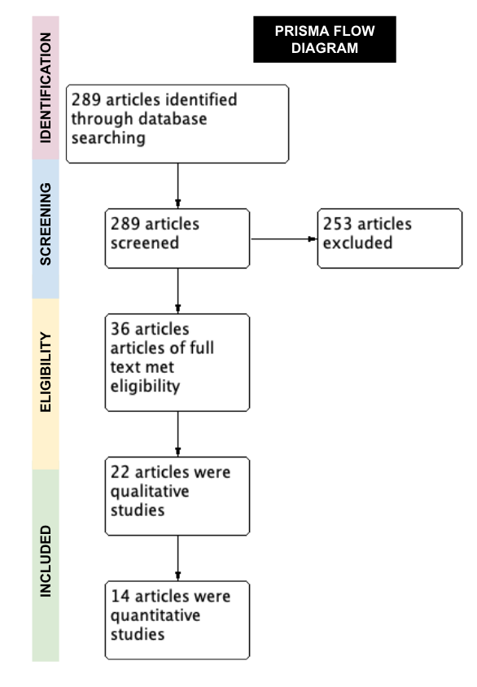

Figure 1. PRISMA Flow Diagram¹⁵

Results
The results in this systematic review present data gathered to analyze why aerobic exercise is cognitively beneficial and improves the sleep quality for individuals with insomnia. The results were determined by data from the quantitative and qualitative articles with consideration of assessing the risk of bias by applying the Revman 5.4. The results were evaluated by assessing the risk with usage of the Risk of Bias (Rob). The Rob tool includes a random sequence generation (selection bias), allocation concealment (selection bias), blinding of participants and personnel and blinding to outcome assessment (performance and detection bias), incomplete outcome data (attrition bias), selective outcome reporting (reporting bias), and any other biases.¹⁵ The RoB incorporated to assess the quality of the articles. The results were concise in identifying potential biases which were evaluated based on imprecision, population diversity, and other measures of quality, such as ethical approvals and funding. The data used in this systematic review was generated from articles. The articles were classified as either having a low risk of bias, a high risk of bias, or having an unclear risk of bias as illustrated below in
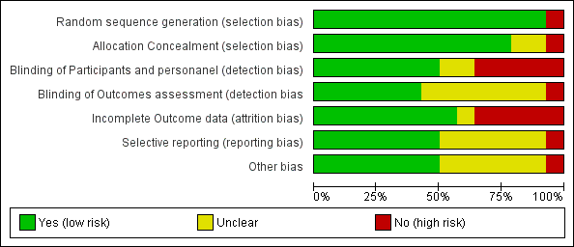
Table 1. Risk of Bias Graph
The risk of bias for each according to the Cochrane risk of bias tool.
The risk level for random sequence generation and allocation concealment was low risk of bias for all studies except one which expressed at least one aspects of high risk of bias that the treatment and control groups are not comparable in the sleep quality studies.²² Five studies showed a high risk for blinding of participants and personnel due to no blinding, incomplete or broken blinding, and outcome likely to be influenced, loss to follow up, withdrawals, other missing data correlated with sleep quality and cognition.^{4,12,13,27,31} Five studies had one element that was considered as a high risk of bias due to loss to follow up, withdrawals, and other missing data when evaluating effects of sleep quality.^{4,11,12,24,25} Selective reporting demonstrated that one study was high risk risk due to the outcome being not described in sufficient detail. For other biases, one study showed high risk of bias due to treatment and control groups are not comparable, issues specific to the study design.^{16,22} The risk of bias summary for all studies included in the systematic review is depicted below in Table 2: Risk of Bias Summary.
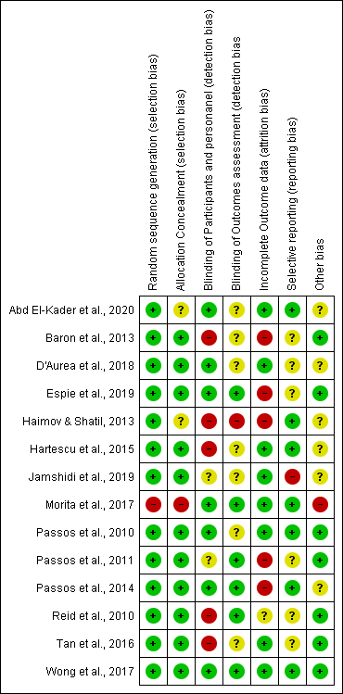
Table 2. Risk of bias summary
Data on outcome measures were analyzed using fixed-effects models. The following information was collected from pre-intervention: mean, standard deviation (SD), and the total number of participants. For continuous outcomes (SOL, WASO, SE, and TST) researchers calculated mean differences (MDs) with 95% confidence intervals (CIs) according to the Cochrane Handbook.¹⁵ The results revealed data assessed by heterogeneity through visual analysis of forest plots of SOL, WASO, SE, and TST scale outcomes. Researchers used Cochran chi-square and the $I^{2}$. The results of this study reviewed data on sleep quality, cognition, aerobic exercise, accordingly to Cochrane Handbook, $I^{2}$values of 0-40% represent minimal heterogeneity, 30-60% represent moderate heterogeneity, 50%-90% represent substantial heterogeneity, and 75-100% represent considerable heterogeneity.¹⁵ The combined data from the results revealed P<0.05 was considered statistically significant, whereas P>0.05 was considered statistically insignificant for studies analyzing sleep quality.²¹
A Forest Plot analysis was conducted on SOL, WASO, SE, and TST variables gathered from PSQI, polysomnography, and actigraphy outcomes measurements for SOL as shown below in Table 3: Forest Plot of Sleep Onset Latency. The final results of these studies proposed that aerobic exercise had a significant influence on sleep quality in adults with insomnia versus the comparison group. The SOL combined MD was a total of -0.46 (95% Cl -1.57 to 0.65, p=0.41). The heterogeneity for SOL accounts for 30%. P value is reported as more than 0.05 that states the data is not statistically significant. However, the results were relevant.
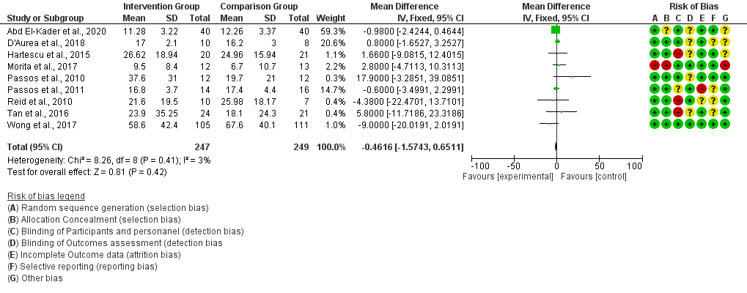
Table 3. Forest Plot of Sleep Onset Latency (SOL)
The data for several studies below retrieved from the usage of WASO results revealed a total of -2.71 (95% Cl -6.03 to 0.61, p=0.17). The studies focused on wake time after sleep onset. The data used was heterogeneity accounted for 30% and p valueForest is 0.11 which was considered statistically insignificant.The results of the study showed effectiveness of sleep quality after repeat wake times and sleep onsets. The data from the studies are revealed below Table 4: Forest Pilot of Wake-time After Sleep Onset. 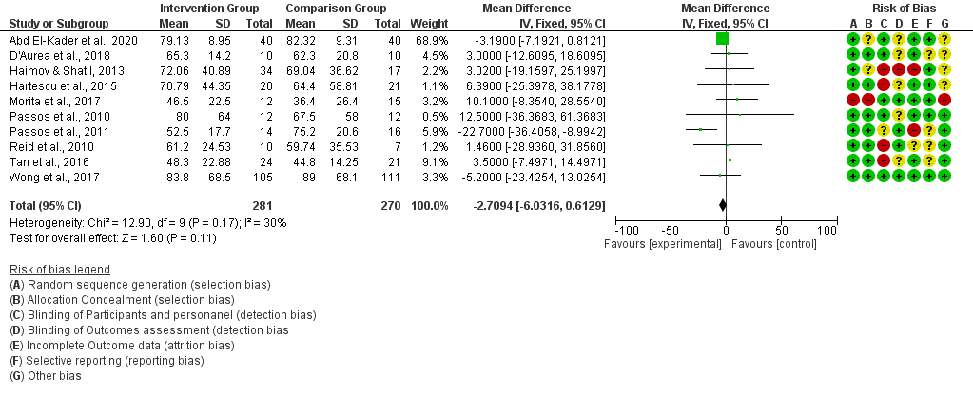
Table 4. Forest Plot of Wake-Time After Sleep Onset (WASO)

The results from many studies showed the improvement in sleep efficiency after aerobic exercises. The combined studies show SE resulted in a total of 1.05 (95% Cl -0.41 to 2.50, p= .0005). The combined data show substantial heterogeneity accounted for 70% for SE. The data from the studies are demonstrated below in Table 5: Forest Plot of Sleep Efficiency (SE).
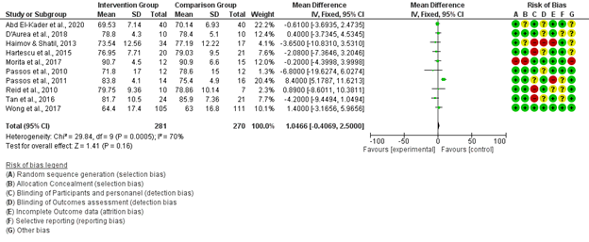
Table 5. Forest Plot of Sleep Efficiency (SE)
The results from studies analyzed the total sleep time associated with aerobic exercise (resistance, anaerobic exercise). The results showed a Total Sleep Time (TST) score which revealed a mean difference of 30.04 (95% Cl 21.40 to 38.68, p<0.00001). The TST results showed considerable heterogeneity of 96%. The results from studies are illustrated below in Table 6: Forest Plot of Total Sleep Time (TST).
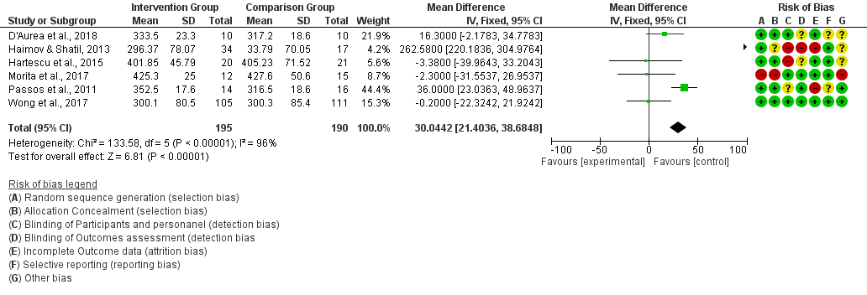


Table 7- Characteristics of Exercise Training

The tables below (Table 8, Table 9, Table 10, and Table 11) summarize the subjective and objective outcome measures for the research. A total of three studies reported PSQI global score, two of those studies examined aerobic exercise (AE), and one study examined anaerobic exercise (AAE) and resistance exercise (RE).^{4,7,25} The aerobic exercise demonstrated a significant improvement in sleep quality with a significant reduction in PSQI global score from 10.2 in pre-intervention to 5.1 in 16 weeks post-intervention.⁴ Another study showed a significant reduction of 4.8 in the PSQI global score.²⁷ As a comparison, a study reported a PSQI global score of -3.9 (AAE) and -5.3 (RE) in post-intervention suggesting that no improvement in sleep quality with anaerobic and resistance exercise interventions.²⁵ The data revealed from Table 11 analyzed sleep stages in studies which were split into 4 stages. The following information can be found under Table 11.
The content for Table 8, Table 9, Table 10, and Table 11 illustrated below.
Table 8- Objective Sleep Quality Outcome Measure | Table 09- Subjective Sleep Quality Outcome Measure | Table 10- Subjective Cognitive Functioning Outcome Measure | Table 11- Sleep Stages

Discussion
This research study was conducted as a systematic review to evaluate the effectiveness of aerobic exercise on sleep quality, cognition and insomnia. The results revealed data using participants from the United States of America, China, Asia, Africa, and Europe. The study collected data using multiple tools and variables were analyzed to determine the effectiveness of SOL, WASO, SE, TST, PSQI and polysomnography. Sleep stages of one to three, sleep hygiene education, Median Motor Time (MMT), Median Cognitive Reaction Time (MCRT) and dCBT were all variables collected in the 36 articles used with a total of 2, 401 participants. The results validate the significance of studying sleep quality as seen in multiple small studies. The analysis of the research supports the current data literature.
In two studies, actigraphy findings did not show any significant results among aerobic exercise intervention groups and control groups (CG).^{13,27} Five studies reported the polysomnography findings. The results reported no significant differences between AAE, RE, and CG interventions.^{1,7,22,24,26} The findings demonstrated significant improvement in SOL, TST, and SE.²⁴ Several studies tested for aerobic exercise to see differences in morning and afternoon aerobic exercises.²⁶ In comparison with morning exercises, no significant differences were observed in afternoon exercises. Although the studies found improvements in SE by 87.2%²⁶, several compared morning and evening exercise with no significant distinction.²² The data showed that several studies tested to see if aerobic exercise has an impact in individuals who have difficulty initiating sleep (DIS), which results showed improvement in SE by 91.5% and TST by 434 minutes. The combined data revealed improvements in SOL by 14.87 min and SE by 80.6%.¹
The data from Table 8 and Table 9 summarized information from several studies that showed that results were extracted and synthesized data from sleep quality outcomes. Multiple tools were reconciled and standard deviation of all the data was collected and analyzed from these tools listed such: Sleep Onset Latency (SOL), Total Sleep Time (TST), Wake-after Sleep Onset (WASO), and Sleep Efficiency (SE). Subjective sleep quality measures include; data from Sleep Diary, Linear Mixed Models (LMM), Pittsburgh Sleep Quality Index (PSQI), Insomnia Severity Index (ISI), Sleep Condition Indicator (SCI), Epworth Sleepiness Scale (ESS), Glasgow Sleep Impact Index (GSII), and Fatigue Severity Scale (FSS). The PSQI assessment method for evaluating sleep quality and sleep patterns, which has 19 items, was used with a global score (0-21).1,4,7,11,12,13,22,24,25,26,27,31,32,35 Sleep quality is deemed to be good when the PSQI scores are lower. Some studies used ISI is a 7-item scale that measures subjective sleep problems and the severity of insomnia.⁵
The data in Table 11 analyzed sleep stages in studies which were split into 4 stages. As no significant changes were observed from baseline scores to post-intervention scores, the baseline scores were taken into account. The results showed that Stage 1 highlighted good sleep quality for the following studies, ^{24,25,26} whereas for Stage 2 good score was allocated to sleep efficiency.^{7,26} Furthermore, for Stage 3, the results focused lastly for REM sleep .^{26,27} Other studies used the Sleep Condition Indicator (SCI) which is an eight-item rating scale that measures insomnia.¹⁰ Data shows that several studies used ESS to evaluate daytime sleepiness(Narcolepsy) in clinical settings with scores from 0-24.¹⁹ The presence of an 11 or higher ESS score was indicative of sleep disorders with excessive daytime sleepiness.¹⁹ Furthermore, data showed that GSII measures the sleep-related quality of life impairment in insomniacs.⁸ Data also revealed that a FSS questionnaire included 9 components that revealed a rating of the severity of fatigue symptoms.¹⁹ More specifically, sleep quality included both sleep onset latency and sleep efficiency whereas cognitive performance included avoiding distractions, working memory, visual memory, general memory, and naming.¹²
In contrast, Sleep Hygiene Education (SHE) and dCBT were analyzed in the intention-to-treat analysis. Based on the results, dCBT was associated with a small improvement in functional health when compared to SHE.¹⁰ When determining median cognitive reaction time (MCRT) and median motor time (MMT), several studies revealed it was suggested that both times were improved after low-intensity aerobic exercise training as p=0.001.¹⁶
The combined data revealed that insomnia significantly negatively impacts one's quality of life, and mental and physical health. The results showed that insomnia is also a very important symptom of many diseases, including hyperthyroidism, spongiform encephalopathy, asthma, Alzheimer disease, chronic pain, and many more. The data showed that aerobic exercise can improve sleep quality and cognition in insomniacs. The pooled results for polysomnography, actigraphy, mixed models, and PSQI indicate improvement were shown in the studies. Although biases were high and heterogeneity was significant in some studies due to the sample size and other factors, there was a great deal of improvement to the state that aerobic exercise does positively affect sleep quality and cognition. Also, the results of studies showed significant improvements in low-intensity aerobic exercise¹⁶. The data showed that both motor and cognitive reaction times were improved by aerobic exercise training (p=0.001), whereas no significant changes were observed in the control group (p>0.05).¹⁶ Based on the tier of data, aerobic exercise could be good treatment for insomnia as it could also impact one’s cognition. The results of several studies showed that there was relevance to analyzing aerobic exercise on cognition and sleep quality in individuals with insomnia. Therefore, the systematic review was essential to adding to the body of literature to narrow knowledge gaps about exercise on cognition and sleep quality.

Recommendation for Future Research
The study examined the effects of aerobic exercise on individuals suffering with insomnia as well as its effect on cognition. Though this systematic review contributes to the body of literature, future research is necessary. There is a need for future research on the effects of aerobic exercise on insomnia and cognition of non-English speaking participants. To enlarge the study's scope, it could be useful to include translated studies or to recruit people from nations other than the United States. Taking cultural differences into consideration, the findings may yield new results on the effects of aerobic exercise with various age populations. Incorporating other research from non-English studies may not only resolve the limitation of having an inadequate amount of available research, but also provide more relevant information to include in the meta-analysis.
Future research is needed to focus on heterogeneity of effects based on the low quality of available RCTs. Since this study included more males as participants, future research should be conducted using several females. Including a more even number of male and female participants may provide more concise information considering human anatomy and brain function differ between the sexes. For future studies, it may be crucial to develop more detailed and targeted interventions (Yoga, walking, jogging, biking, pacing, etc.) including a more diverse, but gender balanced population. Thus, more research is needed for cognition assessment in elderly individuals as well as children associated with sleep quality. Focusing on clear-cut exercise-related endpoints should be assessed via a medical approach to recognize the effect exercise has on not only insomnia, but on cognition as well.

Limitations of Research
This study was conducted as a systematic review and meta-analysis to explore the effects of aerobic exercise on insomnia and cognition. Although the results point to a favorable outcome, we must acknowledge there were several limitations. Though this research contributes to existing literature, there were limitations. The primary limitation of this study is the limited amount of available research on the effects of aerobic exercises on insomnia and cognition. A second limitation of this study is due to only a small number of included studies halted from data collection because there was little relevant information. A tertiary limitation of this study is the heterogeneity of result evaluation by different studies causing difficulty to put together reasonable comparisons to draw relevant conclusions. A quaternary limitation of this study is the exclusion of non-English research studies due to language barriers. Further limitation of this study is that there was only one study which evaluated aerobic exercise’s effect on cognition. Though this research had limitations, the systematic review was relevant to conclude the benefits of aerobic exercise on cognitive improvements.
Clinical Implications
This systematic review and meta-analysis indicates that aerobic exercise is associated with improvements in sleep quality among individuals with insomnia, with preliminary signals suggesting potential cognitive benefits. From a clinical standpoint, these findings support consideration of structured aerobic exercise as a non-pharmacological adjunct in insomnia management, particularly for patients seeking behavioral or lifestyle-based interventions.
Aerobic exercise may represent a viable component of multimodal insomnia treatment strategies alongside established approaches such as cognitive behavioral therapy for insomnia (CBT-I), sleep hygiene optimization, and circadian rhythm regulation. Given the favorable safety profile of exercise compared with long-term pharmacotherapy, clinicians may reasonably discuss exercise prescriptions with appropriate patients, especially those with contraindications or reluctance toward hypnotic agents.
Future high-quality RCTs with standardized insomnia and cognition endpoints, sex-balanced cohorts, diverse populations, and clearly defined exercise parameters (intensity, duration, modality, adherence) are needed to inform precise clinical guidelines. Such data would help determine optimal exercise prescriptions, identify responder profiles, and clarify causal pathways linking exercise, sleep architecture, and cognitive performance.

Conclusion
This systematic review incorporated aerobic exercise in management of individuals with insomnia. Aerobic exercise improves sleep quality and has a positive effect on their cognition. Sleep quality and efficiency is shown to contribute to healthier life interventions that are applicable to populations with high rates of insomnia. Therefore, this systematic review and Meta-analysis was essential to show the benefit of aerobic exercise on sleep quality. The study further adds to the body of medicine what we already know, the gaps and limitations in the area of insomnia and non-pharmacological activities that can improve quality of life.
References
- Abd El-Kader, S. M., & Al-Jiffri, O. H. (2020). Aerobic exercise affects sleep, psychological wellbeing and immune system parameters among subjects with chronic primary insomnia. African health sciences, 20(4), 1761–1769. https://doi.org/10.4314/ahs.v20i4.29

- Amir-Behghadami, M., & Janati, A. (2020). Population, intervention, comparison, outcomes and study (picos) design as a framework to formulate eligibility criteria in systematic reviews. Emergency Medicine Journal, 37(6), 387–387. https://doi.org/10.1136/emermed-2020-209567

- Banno, M., Harada, Y., Taniguchi, M., Tobita, R., Tsujimoto, H., Tsujimoto, Y., Kataoka, Y., & Noda, A. (2018). Exercise can improve sleep quality: a systematic review and meta-analysis. PeerJ, 6, e5172. https://doi.org/10.7717/peerj.5172

- Baron, K. G., Reid, K. J., &amp; Zee, P. C. (2013, August 15). Exercise to improve sleep in insomnia: Exploration of the bidirectional effects. Journal of clinical sleep medicine : JCSM : official publication of the American Academy of Sleep Medicine. Retrieved May 27, 2022, from https://www.ncbi.nlm.nih.gov/pmc/articles/PMC3716674//

- Bastien, C. H., Vallières, A., & Morin, C. M. (2001). Validation of the Insomnia Severity Index as an outcome measure for insomnia research. Sleep medicine, 2(4), 297–307. https://doi.org/10.1016/s1389-9457(00)00065-4

- Chung, K. F., Lee, C. T., Yeung, W. F., Chan, M. S., Chung, E. W., & Lin, W. L. (2018). Sleep hygiene education as a treatment of insomnia: a systematic review and meta-analysis. Family practice, 35(4), 365–375. https://doi.org/10.1093/fampra/cmx122

- D'Aurea, C., Poyares, D., Passos, G. S., Santana, M. G., Youngstedt, S. D., Souza, A. A., Bicudo, J., Tufik, S., & de Mello, M. T. (2019). Effects of resistance exercise training and stretching on chronic insomnia. Revista brasileira de psiquiatria (São Paulo, Brazil : 1999), 41(1), 51–57. https://doi.org/10.1590/1516-4446-2018-0030

- Doos Ali Vand, H., Ahmadian Vargahan, F., Charkhabi, M., Sadeghniiat Haghighi, K., Dutheil, F., & Habibi, M. (2020). Glasgow Sleep Effort Scale: Translation, Test, and Evaluation of Psychometric Properties of the Persian Version. Nature and science of sleep, 12, 843–854. https://doi.org/10.2147/NSS.S258471

- Dopheide J. A. (2020). Insomnia overview: epidemiology, pathophysiology, diagnosis and monitoring, and nonpharmacologic therapy. The American journal of managed care, 26(4 Suppl), S76–S84. https://doi.org/10.37765/ajmc.2020.42769

- Espie, C. A., Farias Machado, P., Carl, J. R., Kyle, S. D., Cape, J., Siriwardena, A. N., & Luik, A. I. (2018). The Sleep Condition Indicator: reference values derived from a sample of 200 000 adults. Journal of sleep research, 27(3), e12643. https://doi.org/10.1111/jsr.12643

- Espie, C. A., Emsley, R., Kyle, S. D., Gordon, C., Drake, C. L., Siriwardena, A. N., Cape, J., Ong, J. C., Sheaves, B., Foster, R., Freeman, D., Costa-Font, J., Marsden, A., & Luik, A. I. (2019). Effect of Digital Cognitive Behavioral Therapy for Insomnia on Health, Psychological Well-being, and Sleep-Related Quality of Life: A Randomized Clinical Trial. JAMA psychiatry, 76(1), 21–30. https://doi.org/10.1001/jamapsychiatry.2018.2745

- Haimov, I., & Shatil, E. (2013). Cognitive training improves sleep quality and cognitive function among older adults with insomnia. PloS one, 8(4), e61390. https://doi.org/10.1371/journal.pone.0061390

- Hartescu, I., Morgan, K., & Stevinson, C. D. (2015). Increased physical activity improves sleep and mood outcomes in inactive people with insomnia: a randomized controlled trial. Journal of sleep research, 24(5), 526–534. https://doi.org/10.1111/jsr.12297

- Hermans, L., Regis, M., Fonseca, P., Overeem, S., Leufkens, T., Vermeeren, A., & van Gilst, M. M. (2021). Assessing sleep-wake survival dynamics in relation to sleep quality in a placebo-controlled pharmacological intervention study with people with insomnia and healthy controls. Psychopharmacology, 238(1), 83–94. https://doi.org/10.1007/s00213-020-05660-3

- Higgins, Julian, et al., editors. Cochrane Handbook for Systematic Reviews of Interventions. 6.3 version, 2022, Cochrane Training, https://training.cochrane.org/handbook/current.

- Jamshidi, O., Seghatoleslami, A., & Salmanpour, M. (2018). Low Intensity Aerobic Exercise Improves the Motor Perceptual Functions in Aged Males with Insomnia. Sleep And Hypnosis - International Journal, 21(2), 112-116. doi: 10.5350/sleep.hypn.2019.21.0179

- Kelley, G. A., & Kelley, K. S. (2017). Exercise and sleep: a systematic review of previous meta-analyses. Journal of evidence-based medicine, 10(1), 26–36. https://doi.org/10.1111/jebm.12236

- Kreutz, C., Schmidt, M. E., & Steindorf, K. (2019). Effects of Physical and mind-body exercise on sleep problems during and after breast cancer treatment: A systematic review and meta-analysis. Springer Science+Business Media, LLC , 176, 1-15.

- Laberge, L., Gagnon, C., Jean, S., & Mathieu, J. (2005). Fatigue and daytime sleepiness rating scales in myotonic dystrophy: a study of reliability. Journal of neurology, neurosurgery, and psychiatry, 76(10), 1403–1405. https://doi.org/10.1136/jnnp.2004.043455

- Lowe, H., Haddock, G., Mulligan, L. D., Gregg, L., Fuzellier-Hart, A., Carter, L. A., & Kyle, S. D. (2019). Does exercise improve sleep for adults with insomnia? A systematic review with quality appraisal. Clinical psychology review, 68, 1–12. https://doi.org/10.1016/j.cpr.2018.11.002

- McLeod, S. (2019). What a p-value tells you about statistical significance. Retrieved June 25, 2022, from. https://www.simplypsychology.org/p-value.html

- Morita, Y., Sasai-Sakuma, T., & Inoue, Y. (2017). Effects of acute morning and evening exercise on subjective and objective sleep quality in older individuals with insomnia. Sleep medicine, 34, 200–208. https://doi.org/10.1016/j.sleep.2017.03.014

- Passos, G. S., Poyares, D. L., Santana, M. G., Tufik, S., & Mello, M. T. (2012). Is exercise an alternative treatment for chronic insomnia?. Clinics (Sao Paulo, Brazil), 67(6), 653–660. https://doi.org/10.6061/clinics/2012(06)17

- Passos, G. S., Poyares, D., Santana, M. G., D'Aurea, C. V., Youngstedt, S. D., Tufik, S., & de Mello, M. T. (2011). Effects of moderate aerobic exercise training on chronic primary insomnia. Sleep medicine, 12(10), 1018–1027. https://doi.org/10.1016/j.sleep.2011.02.007

- Passos, G. S., Poyares, D., Santana, M. G., Teixeira, A. A., Lira, F. S., Youngstedt, S. D., dos Santos, R. V., Tufik, S., & de Mello, M. T. (2014). Exercise improves immune function, antidepressive response, and sleep quality in patients with chronic primary insomnia. BioMed research international, 2014, 498961. https://doi.org/10.1155/2014/498961

- Passos, G. S., Poyares, D., Santana, M. G., Garbuio, S. A., Tufik, S., & Mello, M. T. (2010). Effect of acute physical exercise on patients with chronic primary insomnia. Journal of clinical sleep medicine : JCSM : official publication of the American Academy of Sleep Medicine, 6(3), 270–275.

- Reid, K. J., Baron, K. G., Lu, B., Naylor, E., Wolfe, L., & Zee, P. C. (2010). Aerobic exercise improves self-reported sleep and quality of life in older adults with insomnia. Sleep medicine, 11(9), 934–940. https://doi.org/10.1016/j.sleep.2010.04.014

- Rubio-Arias, J. Á., Marín-Cascales, E., Ramos-Campo, D. J., Hernandez, A. V., & Pérez-López, F. R. (2017). Effect of exercise on sleep quality and insomnia in middle-aged women: A systematic review and meta-analysis of randomized controlled trials. Maturitas, 100, 49–56. https://doi.org/10.1016/j.maturitas.2017.04.003

- Salari, N., Khazaie, H., Hosseinian-Far, A., Khaledi-Paveh, B., Ghasemi, H., Mohammadi, M., & Shohaimi, S. (2020). The effect of acceptance and commitment therapy on insomnia and sleep quality: A systematic review. BMC neurology, 20(1), 300. https://doi.org/10.1186/s12883-020-01883-1

- Shergis, J. L., Ni, X., Jackson, M. L., Zhang, A. L., Guo, X., Li, Y., Lu, C., & Xue, C. C. (2016). A systematic review of acupuncture for sleep quality in people with insomnia. Complementary therapies in medicine, 26, 11–20. https://doi.org/10.1016/j.ctim.2016.02.007

- Tan, X., Alén, M., Wiklund, P., Partinen, M., & Cheng, S. (2016). Effects of aerobic exercise on home-based sleep among overweight and obese men with chronic insomnia symptoms: a randomized controlled trial. Sleep medicine, 25, 113–121. https://doi.org/10.1016/j.sleep.2016.02.010

- Wong, S. Y., Zhang, D. X., Li, C. C., Yip, B. H., Chan, D. C., Ling, Y. M., Lo, C. S., Woo, D. M., Sun, Y. Y., Ma, H., Mak, W. W., Gao, T., Lee, T. M., & Wing, Y. K. (2017). Comparing the Effects of Mindfulness-Based Cognitive Therapy and Sleep Psycho-Education with Exercise on Chronic Insomnia: A Randomised Controlled Trial. Psychotherapy and psychosomatics, 86(4), 241–253. https://doi.org/10.1159/000470847

- Xie, Y., Liu, S., Chen, X. J., Yu, H. H., Yang, Y., & Wang, W. (2021). Effects of Exercise on Sleep Quality and Insomnia in Adults: A Systematic Review and Meta-Analysis of Randomized Controlled Trials. Frontiers in psychiatry, 12, 664499. https://doi.org/10.3389/fpsyt.2021.664499

- Yang, P. Y., Ho, K. H., Chen, H. C., & Chien, M. Y. (2012). Exercise training improves sleep quality in middle-aged and older adults with sleep problems: a systematic review. Journal of physiotherapy, 58(3), 157–163. https://doi.org/10.1016/S1836-9553(12)7010

- Zhong, Q. Y., Gelaye, B., Sánchez, S. E., & Williams, M. A. (2015). Psychometric Properties of the Pittsburgh Sleep Quality Index (PSQI) in a Cohort of Peruvian Pregnant Women. Journal of clinical sleep medicine : JCSM : official publication of the American Academy of Sleep Medicine, 11(8), 869–877. https://doi.org/10.5664/jcsm.4936

- Zou, L., Yeung, A., Quan, X., Boyden, S. D., & Wang, H. (2018). A Systematic Review and Meta-Analysis of Mindfulness-Based (Baduanjin) Exercise for Alleviating Musculoskeletal Pain and Improving Sleep Quality in People with Chronic Diseases. International Journal of Environmental Research and Public Health , 15 (206), 2-19.

