Spatial and temporal evolution of urban heat islands in a warm sub humid city (2019–2024): The Guadalajara Metropolitan Area, Mexico

.
ABSTRACT
The rapid growth of the Guadalajara Metropolitan Area (GMA), Jalisco, Mexico, has caused the urban heat island effect to increase its average annual temperature year after year, with record maximum temperatures recently recorded during the spring, specially in 2023 and 2024. This context motivates the present study, which analyzes the spatial and temporal evolution of the heat island effect in order to identify patterns and trends that can inform decision-making to mitigate the long-term adverse effects in specific areas of the study region. The approach is quantitative, using descriptive statistics, vector calculus tools and the thermal gradient analysis. Maximum temperature data were obtained from the ERA5-Land reanalysis and were adjusted in Python based on the National Meteorological Service (SMN) meteorological station database. The ERA5-Land data were bias-adjusted using station data to strengthen methodological transparency. The results show an increase in the average maximum temperature over the last 6 years in most of the GMA, with a trend toward an increase in the average monthly minimum temperature of ≈0.1°C per year in the municipalities of Guadalajara and Tlaquepaque, and ≈0.5°C/year in Tonalá. The heat island effect was concentrated in the south and east of Guadalajara, areas with the highest population density and the lowest density of green space per inhabitant. All of the above highlights the need to strengthen the mitigation strategies that have been implemented in the study area to reduce the development of the urban heat island effect, especially in the south and east of Guadalajara.

Keywords: Urban heat islands; climate change; warm subhumid climate, Guadalajara Metropolitan Area

1. INTRODUCTION

Unsustainable cities often face serious difficulties due to the increase in ambient temperature (global warming) that has been recorded worldwide in recent years (Ángel, Ramirez & Dominguez, 2010), especially during dry periods when rainfall is scarce or nonexistent.
In the case of the Guadalajara Metropolitan Area GMA (Figure 1), which is considered the third most important city in Mexico due to its accelerated urban-industrial growth (García-Guadalupe et al, 2013) in recent years, growth that, according to the Institute of Statistical and Geographic Information, has exceeded 15% in the last 15 years (IIEE 2020). This development has been both spatial and vertical (Jauregui, 2022; Obras, 2024 and N+, 2024), a situation that favors the increase in ambient temperature (UNAM, 2025), particularly during dry periods (March-May, when rainfall is scarce or nonexistent) (IAM,s.f). In this context, it is essential to monitor and mitigate the temperature increase in the urban area, as the city, with its warm subhumid climate (Clima Jalisco, s.f.), could face risks to the health of its inhabitants due to the rising temperatures. Therefore, the present study focuses on analyzing the spatial and temporal evolution of the heat islands in the Guadalajara Metropolitan Area, México.
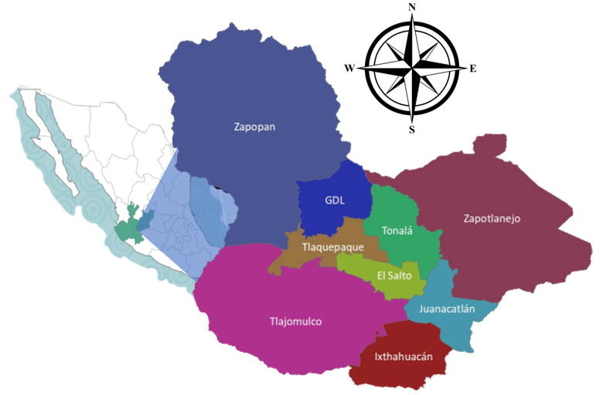
Figure 1. Study area, Guadalajara Metropolitan Area (GMA) of Jalisco, Mexico (Jalisco,,s.f).
The Urban Heat Island (UHI) phenomenon occurs year-round (Brito, 2016) and refers to the presence of significantly higher air temperatures in certain areas of urban environments compared to the surrounding rural regions (UNAM, 2025). This effect results from the interaction of solar radiation with materials such as asphalt, concrete, and bricks (Angel, Ramirez & Dominguez, 2023; Ibredola, s.f), which heat up more quickly than vegetation because they require less energy to increase their temperature (having a relatively low specific heat). Moreover, these materials cool slowly due to their high heat retention capacity (acting as thermal insulators), allowing them to store heat during the day and gradually release it at night (Oke & Cleugh,1987; Santamouris, 2001; Akbari, Pomerantz & Taha, 2001; Chan & Davydova, 2020). Consequently, urban areas experience nights with higher minimum temperatures than in previous decades, when these areas were covered by vegetation. Plants, unlike urban materials, do not heat up as much and serve as thermal regulators, as their water content gives them a relatively high specific heat, enabling them to retain and release heat more efficiently (Monteith & Unsworth, 2013; Gutierrez-Rivera, 2022). Another factor contributing to the high temperatures in specific urban areas (heat islands) is the dense concentration of vertical buildings located in areas where wind flow is restricted, as they hinder heat dissipation and limit the dispersion of pollutants (Zhang & Chen, 2018, Leal Filho et al., 2018).
This phenomenon was identified in 1994 in the central and southern areas of Guadalajara, showing a strong correlation with building density (Bello-Fuentes, 1994). Later, other studies indicated that this heat island phenomenon resulted in an annual increase of 0.05°C in average temperatures, primarily due to the rapid expansion and industrialization of Guadalajara in the 1980s (Tereshchenko & Filonov, 2001; Onu-Habitat, 2016). However, these warmer environments are moderated by the La Primavera Forest (Díaz-Vera, Filonov & Tereschenko, 2005), which is cooler (with an average temperature of 18.6°C) compared to the urban area (with an average temperature of 20.8°C). Over time, urban development has made the presence of heat islands more evident, increasing the minimum temperature by 0.94°C per decade and the maximum temperature by 2.27°C per decade (Davydova & Chan, 2019). Additionally, heat islands in the Guadalajara Metropolitan Area (GMA) have been studied from a thermal comfort perspective, revealing that the intensity of the heat island is classified as mildly warm, with the highest values found in the industrial area of Tlaquepaque and in the central and eastern parts of Guadalajara (Chan & Davydova, 2020).
Record-breaking maximum temperatures have recently been recorded in the Guadalajara Metropolitan Area (GMA). For example, on June 13, 2023, temperature records were broken at three locations in the GMA. At the Colomos meteorological station (Zapopan), a temperature of 40.5°C was recorded, surpassing the previous record of 39.5°C set on June 7, 2010. In Tlaquepaque, 40.5°C was measured, exceeding the previous maximum of 40°C recorded on June 4, 1982. Additionally, in the Minerva area of Guadalajara, 37.9°C was reached, surpassing the 37.2°C recorded in June 1995 (Saavedra, 2023; Gutiérrez, 2023). Similarly, on November 10, temperatures reached 32.4°C, breaking the 32.3°C record set in 2017. The temperature remained high in December, reaching 31°C on the 1st, surpassing the 30.5°C recorded in 1995 (Barajas, 2024).
As a result, the Jalisco Institute of Statistical and Geographic Information (IIEG) conducted a series of interviews with residents of the GMA, who confirmed the rise in temperatures in the region (IIEE, 2023). This phenomenon was further confirmed in the spring of 2024, when ice production could not keep up with demand, as ice makers were unable to meet the increased need (Admin, 2024; Beas, 2024). There were also multiple complaints about water shortages, especially in the outlying neighborhoods of the metropolis. As evidenced in the previous paragraphs, the temperature records broken were recorded within the heat island. Therefore, it is necessary to analyze how urban heat islands have evolved spatially and temporally over the last six years in the GMA. This is the objective of this research.
The answer helps identify the areas within the study area that are most vulnerable to heat-related illnesses, such as heat stroke and dehydration, which lead to higher energy demand due to the intensive use of air conditioning and refrigeration systems, ultimately resulting in increased carbon emissions. This information is crucial for those aiming to design local adaptation plans to mitigate the adverse effects of climate change.

2. material and methods

To achieve the purpose of this research, a quantitative methodology was employed, using descriptive statistics and considering two key characteristics of urban heat islands:
- They show an increase in minimum temperatures over time due to changes in land use (Monteith & Unsworth, 2013; Gutierrez-Rivera, 2022; Jáuregui, 2012).
- The air temperature is significantly higher than that of the surrounding areas (UNAM, 2025).
Based on the aforementioned, the methodology is divided into two parts: the analysis of temporal and spatial evolution:
Temporal
Meteorological stations of the National Water Commission (CONAGUA) under the National Meteorological Service (SMN), located within and around the study area (Figure 2), were selected to obtain data on the Average Monthly Minimum Temperature (AMMT) from different points in the Guadalajara Metropolitan Area. It is important to note that only real observation data from CONAGUA (SMN, s.f) were used, as the meteorological stations of this official institution adhere to the standards established by the World Meteorological Organization (WMO). Data from private meteorological stations or those not supervised by official entities were discarded, as they might not meet inter-national standards for reliable measurements.
Furthermore, in the first part of this section, only data from meteorological stations were chosen, not from the ERA5-Land reanalysis, because direct measurements allow us to later detect any anomalies in the reanalysis data, thus providing more accurate information on the heat island phenomenon.
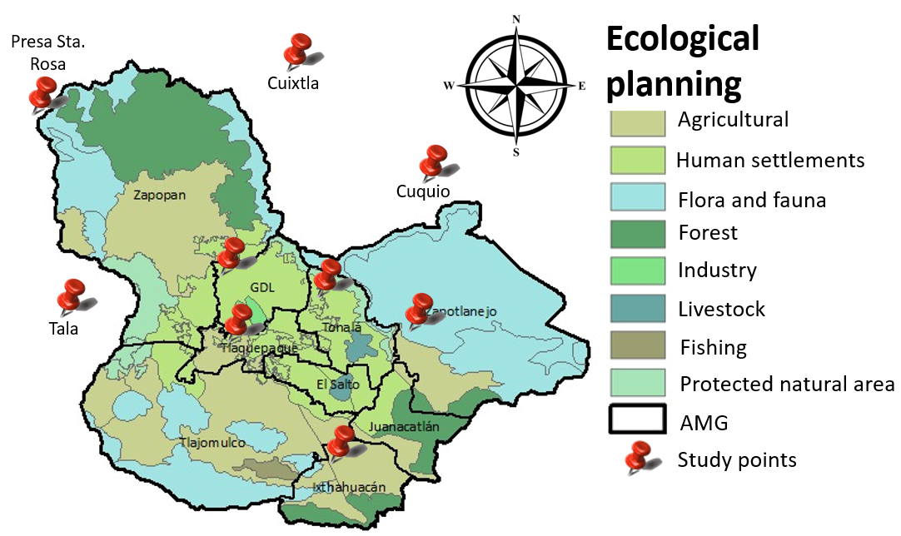
Figure 2. INEGI ecological planning map (INEGI, s.f), showing the location of the CONAGUA meteorological stations (SMN, s.f). Prepared by the authors.
Once the database was built, the quality of the information from the meteorological stations was assessed, and time series with significant data gaps were eliminated. If only a few data points were missing (one or two), these gaps were filled with the average of the time series to prevent incorrect or biased statistical results.
The consistency test for the average minimum temperature time series (Cervantes-Osornio et al, 2023) was also conducted. This test ensures that the maximum of the monthly average minimum temperatures is equal to or greater than the average minimum temperature and is also equal to or greater than the minimum temperature of the average minimums. Additionally, all three temperatures should be greater than the lowest extreme minimum temperature (Figure 3).
Once the data meeting these criteria were selected, the trend line of the data scatter plot was calculated using Microsoft Excel. This function also displays the slope (which indicates how many degrees the average monthly minimum temperature increases or decreases each year) and the coefficient of determination R², with values between 0 and 1 (Posada Hernández, 2016; Browckwell & Davis, 1991), indicates how closely the data fit the regression line.
The process was then repeated for the entire ERA5-Land average monthly minimum temperature field from 2019 to 2024 (CDS, 225), which combines measurements and observations from around the world, along with data from the European ECMWF model, providing a complete and globally coherent dataset based on the laws of physics (Google, s.f). This means there are no gaps in the time and spatial series, and the resolution grid is approximately 9 x 9 km. This database is a three-dimensional array, and data adjustments (such as the slope) were calculated in the same manner as for the meteorological stations, but now for each node of the ERA5-Land grid (which was adjusted to the data from the stations), resulting in a map that shows zero, positive, and/or negative slopes. This map allowed us to delimit the heat island based on the observed increases and decreases in the average minimum temperature, providing a clearer view of the thermal dynamics in the region.

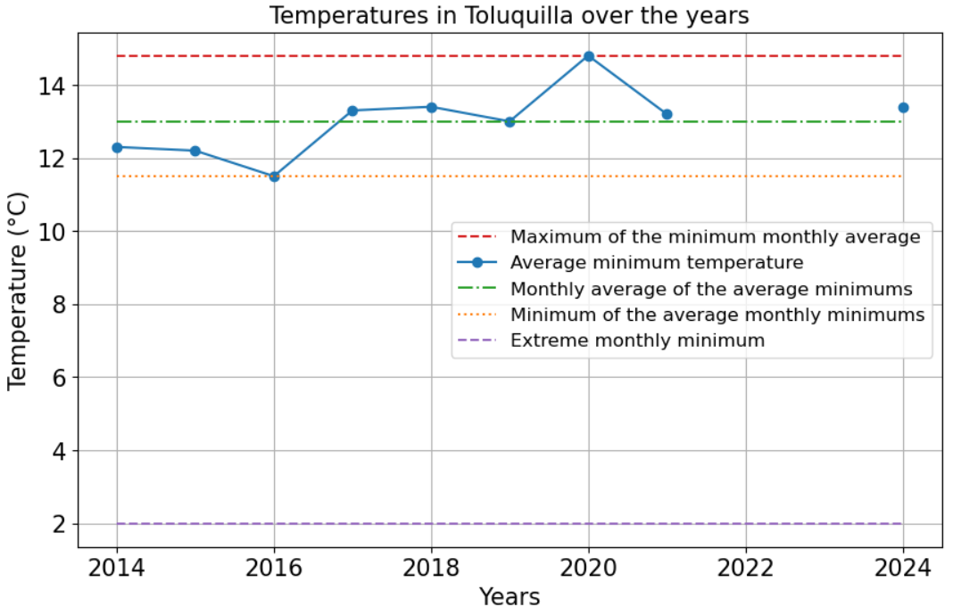
Figure 3. Evaluation of the quality of data from the meteorological stations of the National Meteorological Service. Prepared by the authors.
Spatial Analysis
The monthly maximum temperature is graphically represented in two dimensions to obtain a spatial view of the heat island (HI), identifying its center where the highest values are recorded. This will be done only for the spring months, typically March, April, May, and part of June, when maximum temperature records have been broken. These months pose a risk to society due to the heat islands. Furthermore, to strengthen the identification and delimitation of the HI, the average maximum temperature gradient is calculated for each month and year:
$∇T=\frac{∂T(x,y,z)}{∂x} \hat{I}+\frac{∂T(x,y,z)}{∂y} \hat{J}$(1)
Where ∇T is the gradient of a scalar function T(x,y,z) to which the gradient operator (∇) is applied, resulting in the vector field ∇T. The components of this vector field are represented by the partial derivatives ∂T/∂x in the direction of the unit vector $\hat{I}$ indicating the changes in average monthly maximum temperature (AMMxT) with respect to longitude, and ∂T/∂y in the direction of the unit vector $\hat{J}$ (Spiegel, 2009). This calculation will allow us to visualize, through the vectors, where the AMMxT increases the most at different points in the study area.

3. results and discussion

The results obtained in the first part of the methodology (temporal analysis) reveal that urban heat islands have changed over time, with minimum temperatures increasing in recent years. Fig 4 shows the trend in average monthly minimum temperatures at different meteorological stations in the study area during the months with the highest correlation between average monthly minimum temperatures and weather patterns. Guadalajara and Tonalá showed an increase in average monthly minimum temperatures of approximately 0.05°C to 0.1°C per year, with moderate certainty supported by a squared correlation coefficient of 0.4 to 0.6. Tlaquepaque also showed an increasing trend in minimum temperatures of approximately 0.1°C, but since the time series was shorter, the correlation coefficient was ≤ 0.3.
Likewise, Ixtlahuacán de los Membrillos shows a downward trend in minimum temperature, but with very little or no certainty due to the correlation coefficient values being below 0.24, caused by the wide range of variation in the average minimum temperature. Meanwhile, in Zapotlanejo, no significant trend is observed, as the slope and the correlation coefficient are close to zero, indicating that the minimum temperature does not change over the years.
Fig 4. Temporal evolution of the average minimum temperature of the warm months of the GMA.
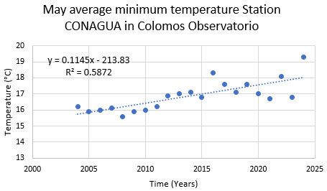 | 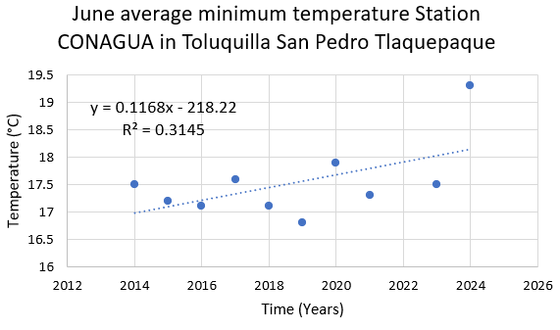
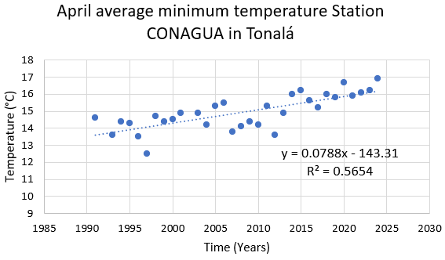 | 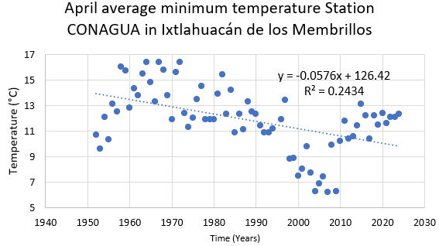
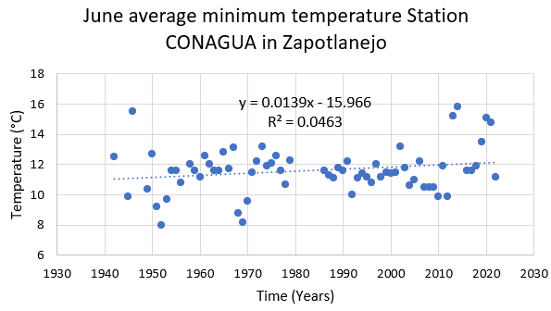
¹ Prepared by the authors.

This explains why municipalities with industrial land use and settlements in Tonalá, Guadalajara, and part of Zapopan do not show significant variation in average minimum temperatures, but rather a gradual increase over the years. The same is true for Tlaquepaque, which also has areas with human settlements as well as agricultural land in Toluquilla, so it shows an upward trend in temperature, albeit to a lesser extent. In contrast, the municipalities with fauna and flora land use (Zapotlanejo) as well as agricultural land use (Ixtlahuacán de los Membrillos) show more variation in average minimum temperature values, but no significant trend in the case of fauna and flora land, and a tendency towards decreasing temperatures in agricultural land.
Applying the above to the entire study area, Fig 5 shows maps of the trend towards an increase (red) or decrease (blue) in minimum temperature in the municipalities of the GMA, where an increase in minimum temperature is observed each year in May and June, with values of 0.2°C and 0.5°C, respectively. Appendix Fig A6 shows March and April with values between 0°C and 0.1°C in most of the GMA. The results in this study only provide the trend behavior of the last 6 years, offering greater certainty regarding the spatial increase in temperatures, with a resolution of 9 km x 9 km. The greatest increase in temperature in May appears to occur in the Minerva area of Guadalajara and its borders with Zapopan. However, in June, a greater increase is usually observed in surrounding regions, possibly associated with the onset of the rains, which increases humidity and decreases temperatures. This effect is likely due to the presence of agricultural land, more green areas, and lower population density in that area, characteristics that retain humidity and contribute to the temperature decrease. Similarly, to the south of Tonalá, where there is land use for livestock and lower population density, according to data from SIGmetro (SIGMetro, s.f.).
Regarding the results of the second part of the methodology (spatial analysis), and considering that urban heat islands exhibit significantly higher air temperatures than the surrounding rural areas, as well as an increase in minimum temperatures compared to previous periods, the figures in Figures 6 and 7 show the maximum temperatures recorded during the months of March, April, May, and June from 2019 to 2024. In most cases, these figures indicate that the maximum temperature values are concentrated in the municipalities of Tonalá, Guadalajara, Tlaquepaque, Zapopan, Zapotlanejo, and a small part of Ixtlahuacán del Río. The center of the heat island (where the highest temperature is recorded) is generally located in the Libertad sector of Guadalajara (south of the Huentitán and Oblatos areas).
Fig 5. Linear fit slope showing the minimum temperature trend for each GMA coordinate (2019-2024). The trend of the minimum temperature to increase is the red color and the trend of the decrease is the blue color.
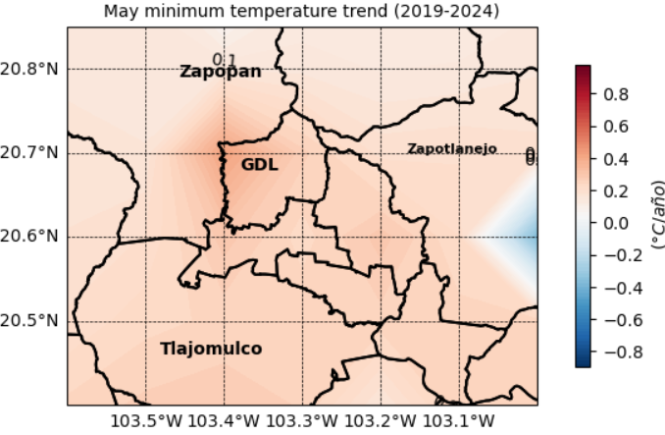 | 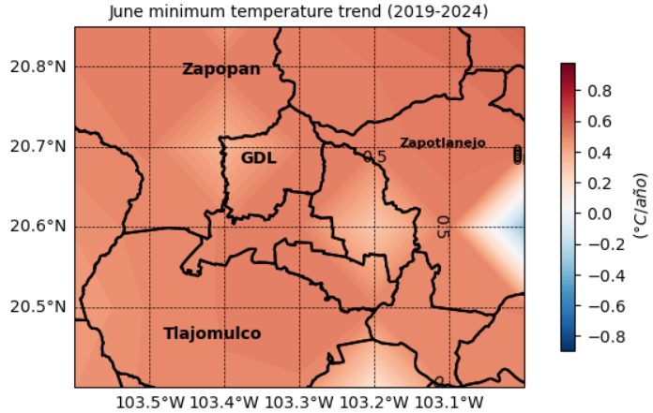
² Prepared by the authors.

Furthermore, the white arrows of the temperature gradient (Figures 6 and 7) indicate the direction and magnitude of each vector, and the size of the arrow illustrates whether the increase is small or large. The non-symmetrical dynamics of the average monthly minimum temperature are also shown; that is, at some points in the GMA, the most significant arrows (medium and large) converge toward the highest temperatures (March 2019, April 2019, April 2020, and April 2022), indicating the location of the heat sland. Meanwhile, in the months of May and June, an anticyclonic circulation of the maximum temperature is observed, with the highest maximum temperatures located at the center of the vortex, thus also delimiting the urban heat island. While almost every month showed higher maximum temperatures centered in Guadalajara, there were exceptions, such as March and April 2019 and March 2023, where the heat island was concentrated in Zapopan, Tlaquepaque, and Zapotlanejo, rather than in the Guadalajara area (Huentitán, Oblatos, and Tetlán areas) as seen in the other months.
Finally, it is important to mention that in some months, higher temperatures were observed in the municipal seat of Zapotlanejo than in the surrounding areas, specifically in April 2020 and 2021, May and June 2021, and June 2022.

Fig 6. Spatial distribution of the average maximum temperature of March and April of the GMA and the average monthly maximum temperature gradient (white arrows).
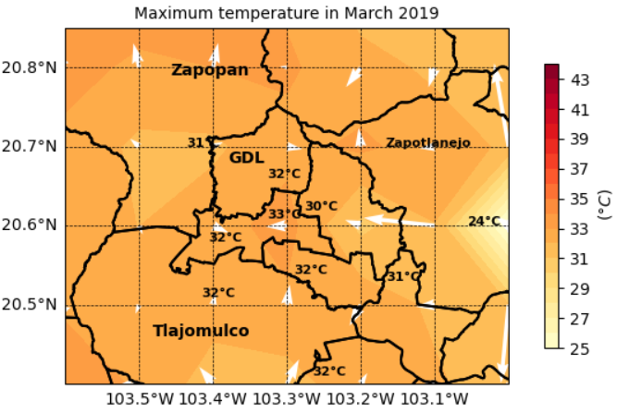 | 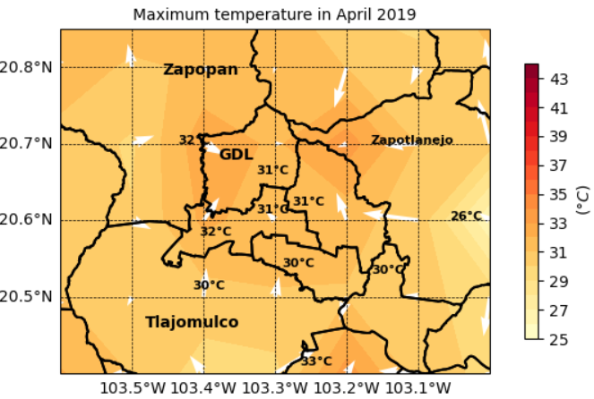
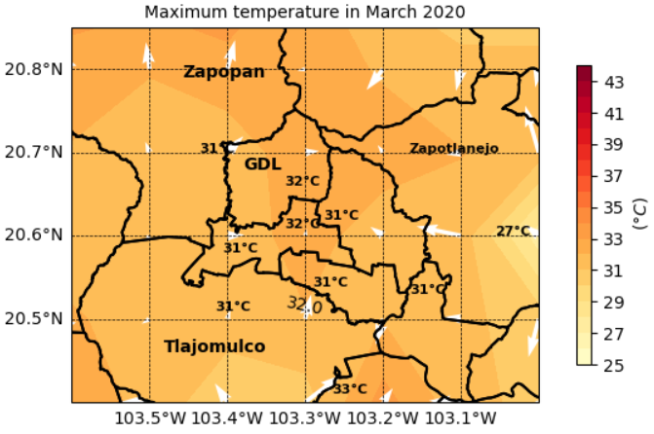 | 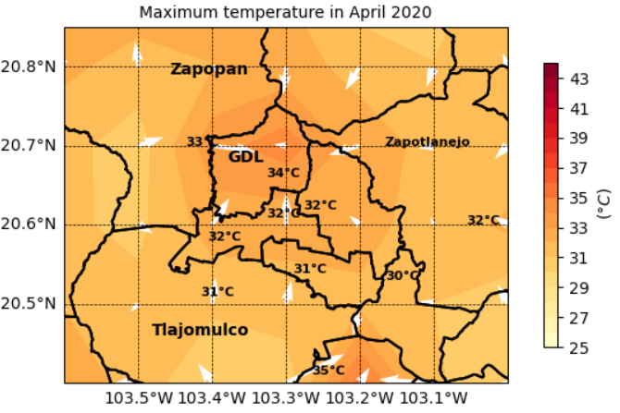
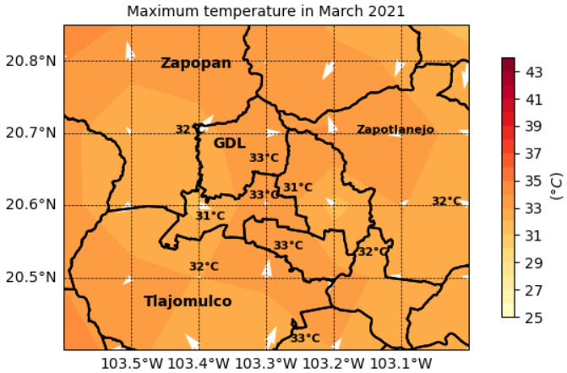 | 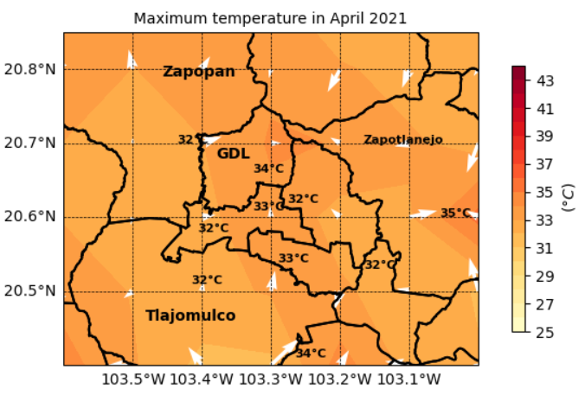
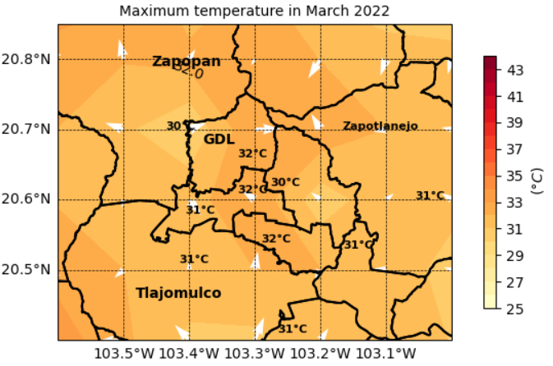 | 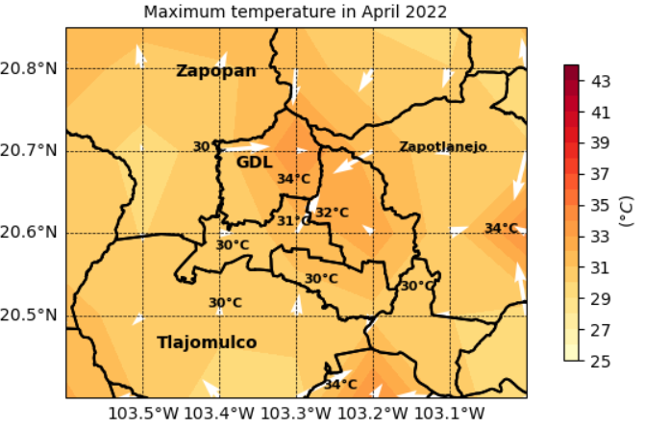
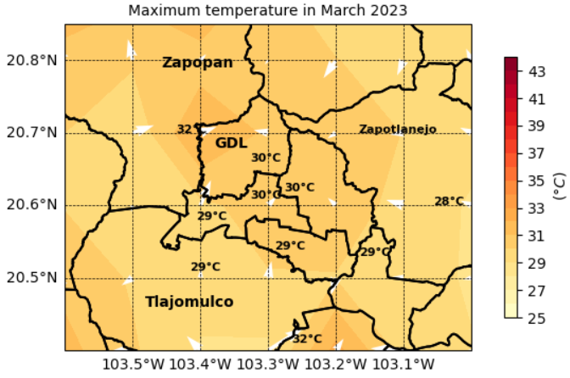 | 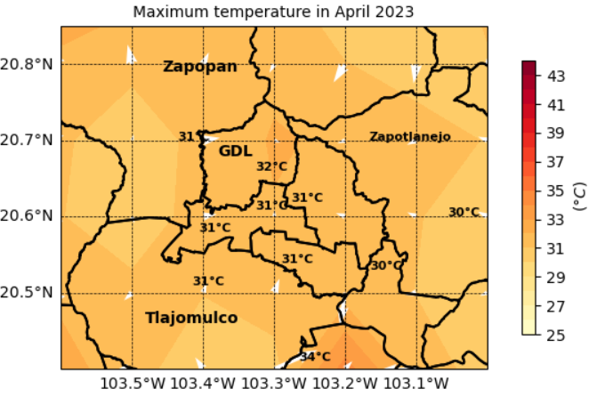
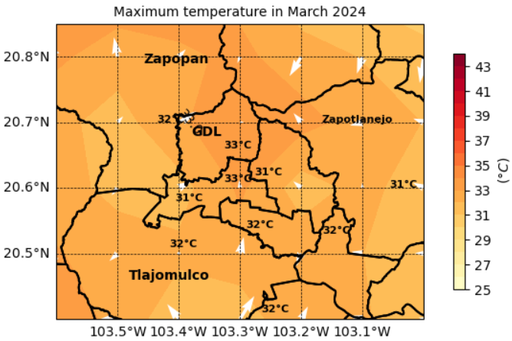 | 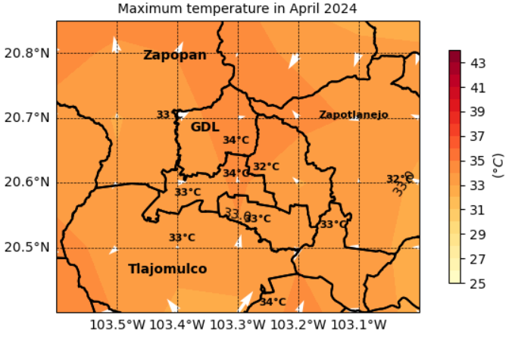
² Prepared by the authors.

Fig 7. Spatial distribution of the average maximum temperature of May and June of the GMA and the average monthly maximum temperature gradient (white arrows).
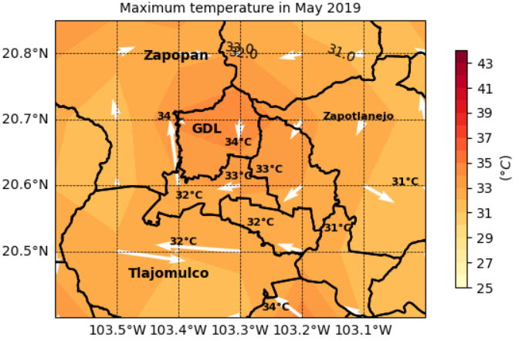 | 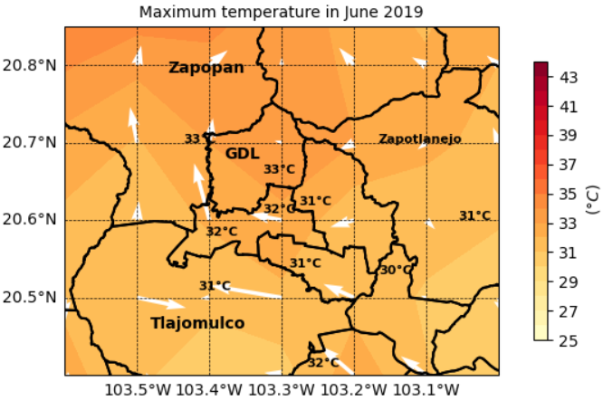
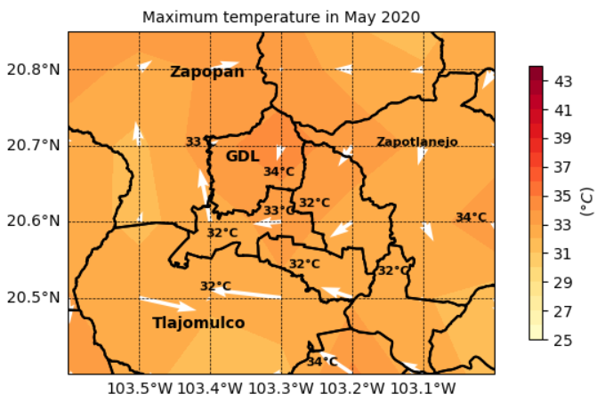 | 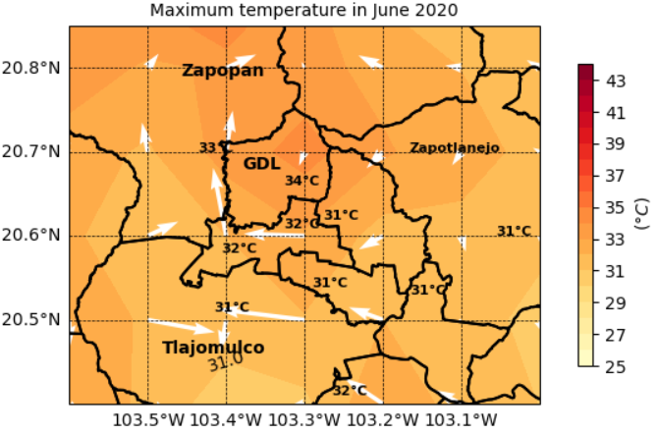
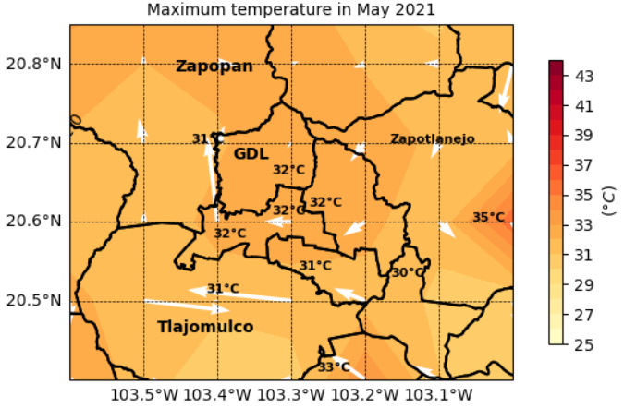 | 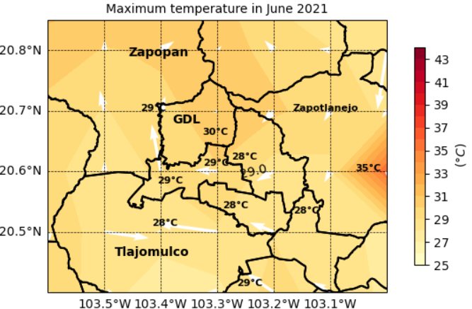
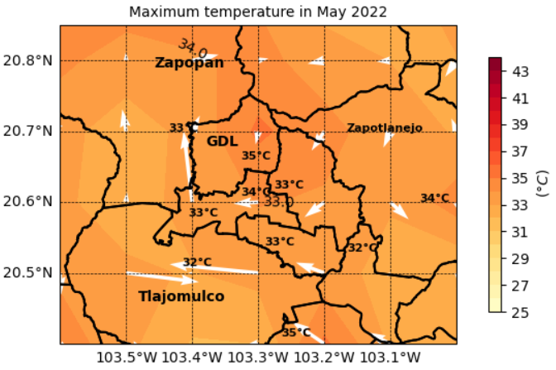 | 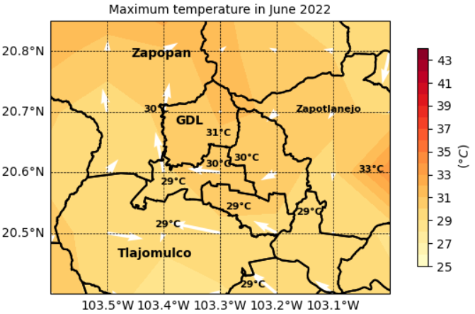
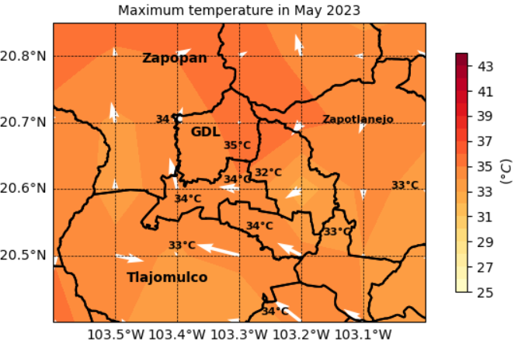 | 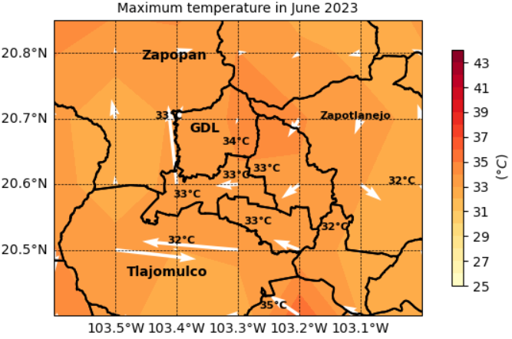
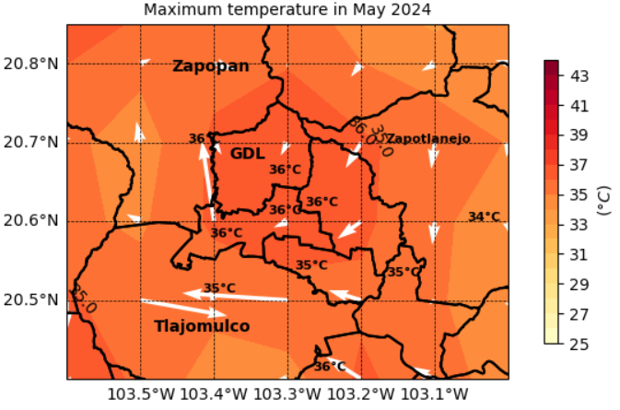 | 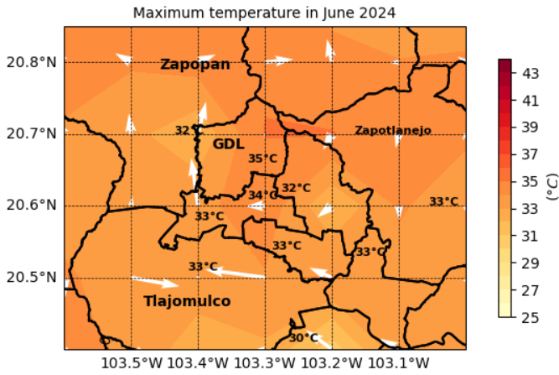
² Prepared by the authors.
The results obtained in this study confirm the findings of previous research, as they show that the highest temperature values are in Guadalajara. However, in recent years, these values were not detected in the central zone (Obras, 2024), but now they have been observed in the eastern part of the city (Huentitán, Oblatos, Olímpica, and Tetlán areas) (Bello-Fuentes, 1994). According to data from IMEPLAN's SIGmetro, these areas are the most densely populated in the urban area per Basic Geostatistical Area (Figure 8) and have the lowest density of green spaces per inhabitant (Figure 9).
Furthermore, the research shows a positive correlation between minimum temperature and the passage of time in most of the Guadalajara Metropolitan Area, with the exceptions of Zapotlanejo and Ixtlahuacán de los Membrillos. The range of variation in this correlation depends on the location within the GMA, ranging from 0.4°C to 1.14°C every 10 years, which coincides with the results of Davydova & Chan, 2019, who reported an increase of 0.94°C in the minimum temperature on the heat island every 10 years. On the other hand, Chan & Davydova, 2020 found maximum temperatures ranging between 30°C and 34°C for the period (1999-2018). However, according to the results of this study, recent years (from 2022 onwards) have recorded temperatures of 35°C and 36°C in May.
Regarding the smaller range of minimum temperature variation in the municipalities of Tonalá, Guadalajara, and part of Zapopan in the GMA, compared to municipalities with green areas, Díaz-Vera, Filonov & Tereschenko, 2005 agrees, stating that the urban area is warmer and exhibits less temperature variation.
It should be noted that previous and current studies used different measurements from the same study area, corresponding to different time periods and employing different methodologies. Nevertheless, the results and conclusions of both are consistent. This suggests that the findings on the heat island in the GMA are robust and reliable because they do not depend on a single approach or data set.
However, this study has some limitations regarding the time series, which should be considered when interpreting the results. First, the trends observed in the maps over the last six years should not be interpreted as a prediction of what will occur in the coming years. This is because the data sample is small, and the results only reflect the increases or decreases observed during that period, making it unwise to project future behavior with certainty.
Another limiting factor was the lack of longer time series (over 30 years) from meteorological stations (for example, in Zapotlanejo), as well as a denser network of stations, especially in municipalities such as Tlajomulco, El Salto, and Ixtlahuacán del Río. The availability of both elements could have provided a more accurate and comprehensive view of the heat islands. As the temperature in the urban heat island continues to rise, one strategy that could be implemented is the use of cellular concrete, which is ideal for buildings where high temperatures are reached. Additionally, increasing areas with vegetation, installing green roofs on buildings (Cardador-Vázquez, 2021), creating linear parks, and constructing the city in a way that allows winds to pass through are also recommended.
Finally, it is recommended to continue researching this phenomenon, incorporating an analysis of the interaction between wind flow and the vertical growth of the city. This approach will provide a better understanding of how vertical construction may or may not have influenced the intensification of this phenomenon.
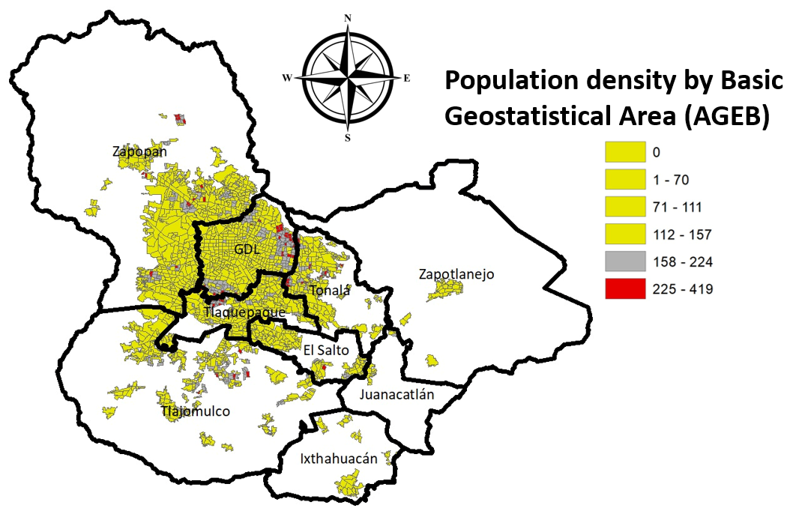
Figure 8. Population density map by Basic Geostatistical Area (AGEB). Information taken from SIGmetro (SIGMetro, s.f.). Prepared by the authors.

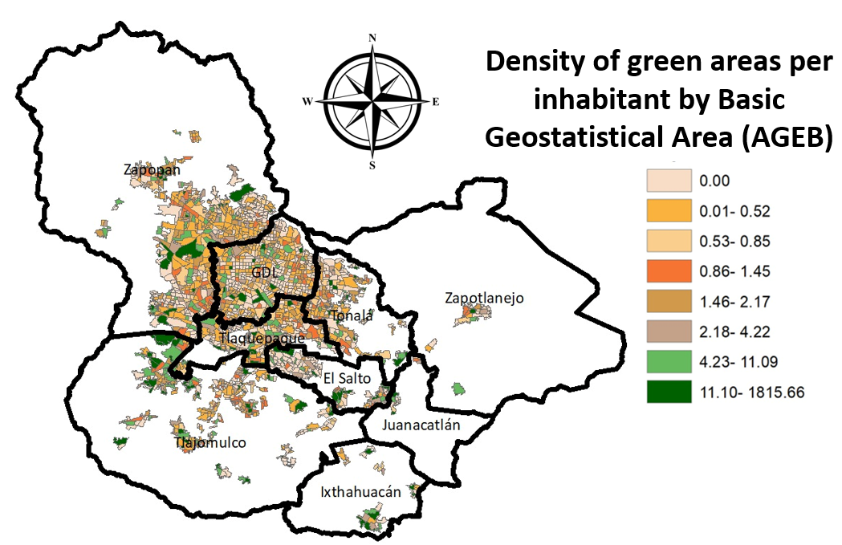
Figure 9. Green area density map per inhabitant by basic geostatistical area (AGEB). Information taken from Sigmetro (SIGMetro, s.f.). Prepared by the authors.
4. Conclusion

This paper answers the research question: How have urban heat islands evolved spatially and temporally in the last 6 years in the GMA? The temporal analysis of historical data from CONAGUA meteorological stations indicates that minimum temperatures have continued to rise in recent years in Guadalajara, Tonalá, and Tlaquepaque, with low to moderate certainty, supported by a squared correlation coefficient between 0.3 and 0.6. This contrasts with Ixtlahuacán de los Membrillos, which shows a decrease in minimum temperatures, with very low or no confidence due to the wide range of variation in the average minimum temperature. Meanwhile, in Zapotlanejo, no significant trend is observed, which is why the slope is zero, indicating stability in minimum temperatures over the years. The municipalities with the least temperature variation are those with predominantly industrial and settlement land use in Tonalá, Guadalajara, parts of Zapopan, and Tlaquepaque. Municipalities with flora and fauna land use (Zapotlanejo) and agricultural land use (Ixtlahuacán de los Membrillos) show greater variation in average minimum temperature values. This confirms that variability in temperature ranges is associated with land use.
Regarding the seasonal behavior of the last 6 years, it was found that in March and April, the minimum temperature increased each year by between 0° and 0.1°C in most of the GMA, and by between 0.2° and 0.5°C in May and June. Furthermore, the spatial analysis reveals and confirms that the highest temperatures in the heat island are found in the municipalities of Tlaquepaque, Tonalá, Guadalajara, parts of Zapopan, and Zapotlanejo. The highest maximum temperatures are found in the south and east of Guadalajara (Huentitán, Oblatos, Olímpica, and Tetlán), which are the areas with the highest population density in the city.
Furthermore, it was observed that the center of the heat island is not concentrated in a single location. In months such as March and April 2019 and March 2023, the heat was concentrated in Zapopan, Tlaquepaque, and Zapotlanejo, rather than in the Guadalajara area (Huentitán, Oblatos, and Tetlán), as observed in the other months. It would be interesting to analyze the past 30 years to verify whether these isolated events also occurred, whether they were more frequent, and to conduct more localized studies to understand the causes of these anomalies.
Finally, thanks to the application of the thermal gradient technique, it was possible to observe that in March and April, the vectors converge, indicating the direction in which the temperature increases most intensely, thus pinpointing the location of the heat island. In contrast, in May and June, an anticyclonic circulation of maximum temperatures is observed, with the center of the vortex showing the highest temperatures, thus delimiting the urban heat island.

Disclaimer (Artificial intelligence)

Author(s) hereby declare that NO generative AI technologies such as Large Language Models (ChatGPT, COPILOT, etc.) and text-to-image generators have been used during the writing or editing of this manuscript.

References
- Ángel, L., Ramírez, A., & Domínguez, E. (2010). Urban heat island and spatio-temporal temperature changes in the city of Bogotá. Journal of the Colombian Academy of Exact, Physical and Natural Sciences, 34(131), 173–183.
- Akbari, H., Pomerantz, M., & Taha, H. (2001). Cool surfaces and shade trees to reduce energy use and improve air quality in urban areas. Journal of Solar Energy Engineering, 123(2), 101–109.
- Admin. (2024, May 28). High temperatures deplete ice in the Guadalajara Metropolitan Area. Jalisco Noticias. https://noticias.jaliscotv.com/altas-temperaturas-agotan-hielo-en-el-amg/
- Barajas, D. (2024, December 11). Should we bundle up until the end of December? This is what an expert says about the "warm winter" in Guadalajara. Telediario México. https://www.telediario.mx/comunidad/record-historico-temperaturas-guadalajara-invierno-2024
- Beas, D. (2024, May 27). Ice is scarce and its price is rising in the Guadalajara Metropolitan Area. Quadratín Jalisco. https://jalisco.quadratin.com.mx/principal/escasea-el-hielo-y-sube-su-precio-en-el-area-metropolitana-de-guadalajara/
- Bello-Fuentes, A. (1994). The urban heat island and land uses in Guadalajara. Geographical Series, 4, 83–97. https://ebuah.uah.es/dspace/bitstream/handle/10017/1032/La%20Isla%20de%20Calor%20y%20los%20Usos%20del%20Suelo%20en%20Guadalajara.pdf
- Brito, J. S. L. (2016). Dynamics of the heat island and thermal inversions in the Guadalajara Metropolitan Area (Master's thesis). University of Guadalajara, CUCEI.
- Brockwell, P. J., & Davis, R. A. (1991). Time series: Theory and methods. Springer.
- Cardador Vázquez, L. (2021). Modeling and numerical simulation of the energy balance in a vegetated roof: Comparison with conventional roofs (Master's thesis). Polytechnic University of Madrid.
- CDS (2025) ERA5-Land hourly data from 1950 to present. (2025). Copernicus Climate Data Store. https://cds.climate.copernicus.eu/datasets/reanalysis-era5-land
- Cervantes-Osornio, R., Arteaga-Ramírez, R., Vázquez-Peña, M. A., & Ojeda-Bustamante, W. (2023). Data quality of automatic weather stations located in three states of Mexico. Technology and Water Sciences, 14(1), 432–469. https://doi.org/10.24850/j-tyca-14-01-10
- Chan, D., & Davydova-Belitskaya, V. (2020). Heat island and thermal comfort in the Guadalajara Metropolitan Area. https://doi.org/10.13140/RG.2.2.14579.04646
- Davydova-Belitskaya, V., & Alamilla Chan, D. (2019). Temperature variation related to the intense development of the Guadalajara metropolitan area, Mexico (1996–2018). Ecorfan Journal, 63–75.
- Development. (n.d.). Climatological statistical information. National Meteorological Service. https://smn.conagua.gob.mx/es/climatologia/informacion-climatologica/informacion-estadistica-climatologica
- Díaz-Vera, A., Filonov, A., & Tereshchenko, I. (2005). Influence of the La Primavera Forest on the urban climate of the Guadalajara Metropolitan Area, Mexico. https://www.organicaeditores.mx/biblioteca/i_foro_blp/pdf/extensos/222_228_ext_Diaz_Vera_Influencia.pdf
- García Guadalupe, M., Ramírez-Sánchez, H., Ulloa, H., García, O., Meulenert, Á., & García, J. (2013). Concentration of SO₂, NO₂ pollutants and correlation with H⁺, SO₄²⁻ and NO₃⁻ during the rainy season in the Guadalajara Metropolitan Area. Chilean Journal of Respiratory Diseases, 29(2), 81–88. https://doi.org/10.4067/S0717-73482013000200004
- Google (n.d.) ERA5-Land monthly aggregated – ECMWF climate reanalysis. (n.d.). Google Earth Engine. https://developers.google.com/earth-engine/datasets/catalog/ECMWF_ERA5_LAND_MONTHLY_AGGR
- Gutiérrez-Rivera, M. (2022). Mitigation of urban heat island intensity by green areas: A 2D numerical simulation (Master's thesis). University of Guadalajara. https://riudg.udg.mx/visor/pdfjs/viewer.jsp?in=j&pdf=20.500.12104/91113/1/MCUCEI10391FT.pdf
- Gutiérrez, Ó. E. (2023, June 15). Today's Weather in Guadalajara: Unprecedented! Jalisco breaks three records due to high temperatures. El Informador. https://www.informador.mx/jalisco/Clima-de-hoy-Guadalajara-Insolito-Jalisco-rompe-tres-records-por-las-altas-temperaturas-20230615-0079.html
- Institute of Astronomy and Meteorology. (n.d.). Climatology | University of Guadalajara. http://iam.cucei.udg.mx/climatologia
- INEGI. (n.d.). Publications and maps. https://www.inegi.org.mx/app/mapas/
- Institute of Statistical and Geographic Information [IIEG]. (2020). General analysis of the Guadalajara Metropolitan Area. https://iieg.gob.mx/ns/wp-content/uploads/2022/03/Análisis-General-del-Área-Metropolitana-de-Guadalajara-2020.pdf
- Institute of Statistical and Geographic Information [IIEG]. (2023). Perception of the heat wave. https://iieg.gob.mx/ns/wp-content/uploads/2024/07/Encuesta-de-Percepcion-de-la-Ola-de-Calor-2024-20240729.pdf
- Jáuregui, E. (2012). Impact of land use on the climate of Mexico City. Investigaciones Geográficas, (55), 46–60. https://doi.org/10.14350/rig.30110
- Jáuregui, I. S. (2022, December 2). Vertical housing Vertical housing in the Guadalajara Metropolitan Area is classist and gentrifying. Gaceta UDG. https://www.gaceta.udg.mx/vivienda-vertical-en-el-amg-es-clasista-y-gentrificadora/
- Leal Filho, W., Icaza, L. E., Neht, A., Klavins, M., & Morgan, E. A. (2018). Coping with the impacts of urban heat islands. A literature based study on understanding urban heat vulnerability and the need for resilience in cities in a global climate change context. Journal of Cleaner Production, 171, 1140-1149.
- Monteith, J., & Unsworth, M. (2013). Principles of environmental physics: Plants, animals, and the atmosphere. Academic Press.
- N+, R. (2024, April 18). Guadalajara Metropolitan Area opts for vertical growth due to housing demand. N+. https://www.nmas.com.mx/guadalajara/zona-metropolitana-de-guadalajara-opta-por-crecimiento-vertical-ante-demanda-de-viviendas/
- Oke, T. R., & Cleugh, H. A. (1987). Urban heat storage derived as energy balance residuals. Boundary-Layer Meteorology, 39, 233–245.
- UN-Habitat. (2016). Building metropolitan citizenship: The case of the Guadalajara Metropolitan Area (AMG). https://onu-habitat.org/index.php/construyendo-la-ciudadania-metropolitana-el-caso-del-area-metropolitana-de-guadalajara-amg
- Posada Hernández, G. J. (2016). Basic elements of descriptive statistics for data analysis. Editorial Luis Amigó. https://www.funlam.edu.co/uploads/fondoeditorial/120_Ebook-elementos_basicos.pdf
- Saavedra, V. (2023, June 13). Heat in Jalisco breaks historical record: More than 40 degrees Celsius. El Occidental. https://oem.com.mx/eloccidental/local/calor-en-jalisco-rompe-record-historico-mas-de-40-grados-centigrados-15834359
- Santamouris, M. (Ed.). (2001). Energy and climate in the urban built environment (1st ed.). Routledge. https://doi.org/10.4324/9781315073774
- SIGMetro. (n.d.). Metropolitan Geographic Information System. https://sigmetro.imeplan.mx/mapa
- Spiegel, M. R. (2009). Vector Analysis (Schaum's Outline Series). McGraw-Hill.
- Tereshchenko, I., & Filonov, A. (2001). Air temperature fluctuations in Guadalajara, Mexico, from 1926 to 1994 in relation to urban growth. International Journal of Climatology, 21, 483–494. https://doi.org/10.1002/joc.602
- UNAM. (2025). Why is it so hot? UNAM answers. https://unamglobal.unam.mx/global_revista/olas-de-calor-causas-unam/
- Zhang, Y., & Chen, L. (2018). Effects of urban vertical construction on wind environment and air quality in Guangzhou, China. Environmental Pollution, 243, 1–10. https://doi.org/10.1016/j.envpol.2018.08.027

APPENDIX a
Fig a1. Temporal evolution of the average minimum temperature of the warm months of the CONAGUA meteorological station located at the Colomos observatory.
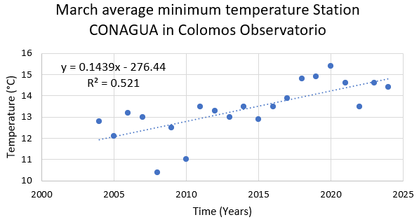 | 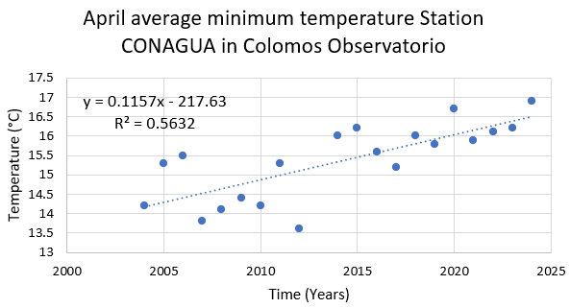
 | 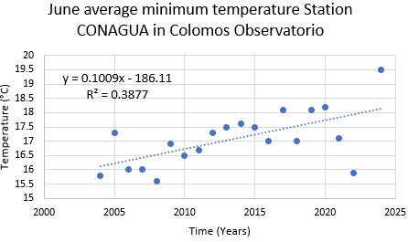

Fig a2. Temporal evolution of the average minimum temperature of the warm months of the CONAGUA meteorological station located at the Toluquilla-San Pedro Tlaquepaque.
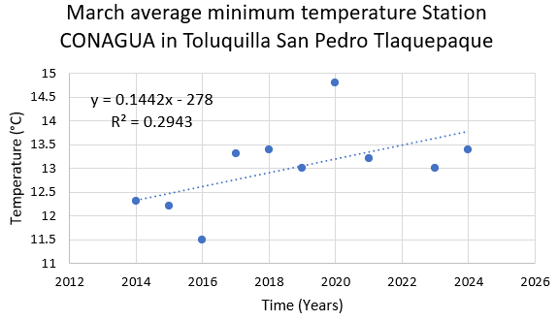 | 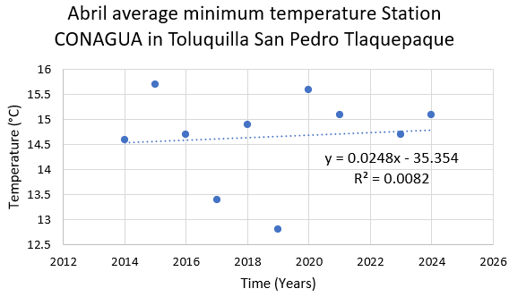
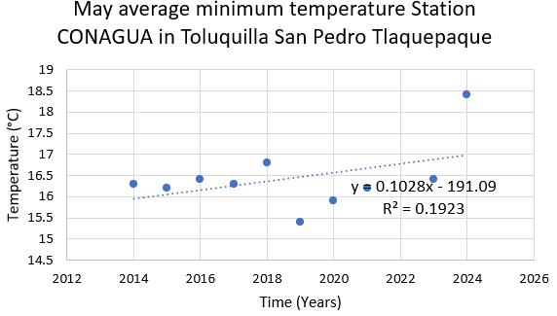

Fig A3. Temporal evolution of the average minimum temperature of the warm months of the CONAGUA meteorological station located at the Tonalá.
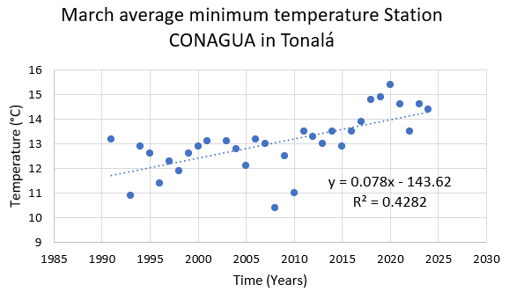
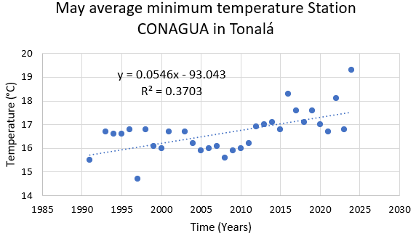 | 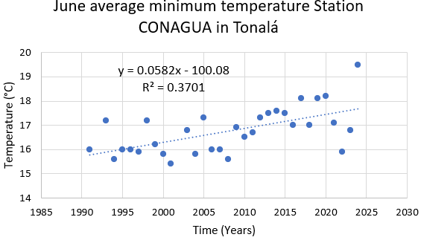
Fig A4. Temporal evolution of the average minimum temperature of the warm months of the CONAGUA meteorological station located at the Ixtlahuacán de los Membrillos.
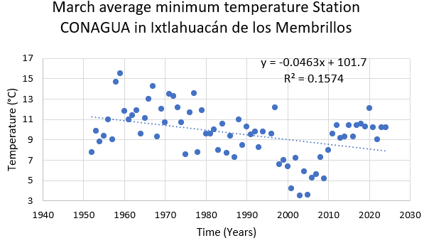
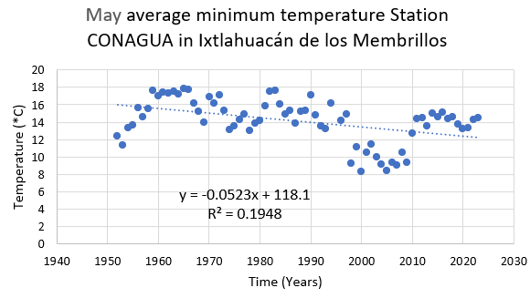 | 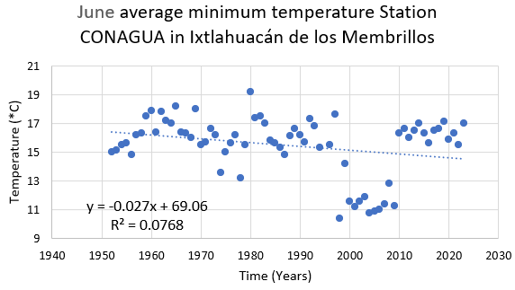

Fig A5. Temporal evolution of the average minimum temperature of the warm months of the CONAGUA meteorological station located at the Zapotlanejo.
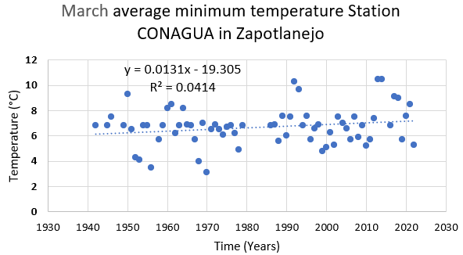 | 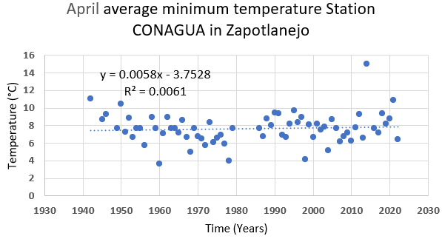
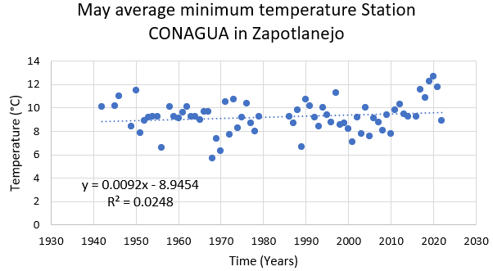

Fig A6. Linear fit slope showing the minimum temperature trend for each GMA coordinate (2019-2024).
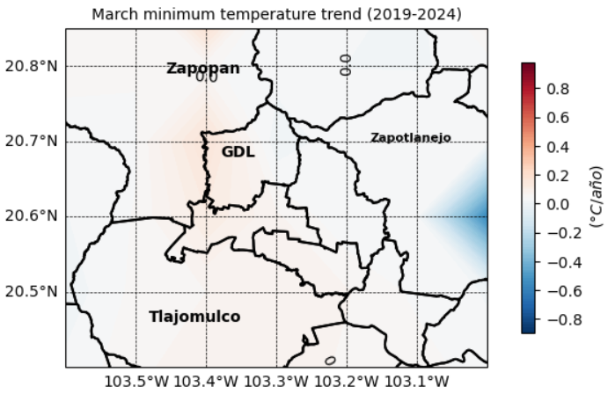 | 