Spatio-temporal catchment-scale land- use changes in the Shahpura Lake, India (1980-2021)

.
ABSTRACT

Rapid urbanisation is a major driver of land use and land cover (LULC) transformation in urban lake catchments, often threatening the long-term sustainability of lake ecosystems. This study aimed to quantify and analyse long-term spatio-temporal LULC dynamics within the Shahpura Lake catchment, Bhopal, India, over 40 years (1980–2021). The lake catchment was delineated using a DEM-based hydrological approach derived from Shuttle Radar Topography Mission (SRTM) data. Multi-temporal Landsat imagery was analysed using supervised classification with a Maximum Likelihood algorithm to generate LULC maps for five reference years. Temporal changes were assessed using area statistics, linear trend analysis, and correlation analysis at the catchment scale. The results reveal a statistically significant expansion of built-up land, increasing by 220.7% (+0.062 km²/year; R² = 0.94; p < 0.01), accompanied by substantial declines in vegetation (−40.1%) and barren land (−39.6%). A strong inverse correlation between built-up and vegetation cover (r = −0.96; p < 0.05) confirms urban expansion as the dominant driver of land transformation. The surface area of Shahpura Lake remained relatively stable throughout the study period, showing no significant long-term trend. The study emphasises the importance of catchment-scale assessment for understanding urban lake dynamics. It also presents a remote sensing and GIS-based framework to support sustainable planning and management of urban lake ecosystems in rapidly urbanising regions.

Keywords: Land use and land cover (LULC); Urban Lake catchment; Spatio-temporal analysis; Landsat imagery; Remote sensing and GIS.

1. INTRODUCTION

Urbanisation is one of the most pervasive drivers of land use and land cover (LULC) change worldwide, particularly in rapidly developing regions of Asia and Africa. Expansion of built-up areas, transformation of natural landscapes, and increasing impervious surfaces have significantly altered hydrological processes, ecosystem functions, and environmental quality in urban environments (Seto et al., 2012; Grimm et al., 2008). Among the most vulnerable components of urban ecosystems are urban lakes, which are directly influenced by land use practices in their contributing catchments. Urban lakes provide multiple ecosystem services, including water storage, flood regulation, groundwater recharge, microclimate regulation, biodiversity support, and recreational opportunities (Huang et al., 2021). However, rapid and unplanned urban growth often results in catchment-level modifications that increase surface runoff, sediment load, and nutrient inflows, thereby degrading lake water quality and ecological integrity (Wang et al., 2021). Consequently, understanding long-term land use dynamics at the catchment scale is critical for the sustainable management of urban lake systems. Remote sensing (RS) and geographic information systems (GIS) have emerged as indispensable tools for monitoring spatio-temporal LULC changes over extended periods. The availability of long-term satellite archives, particularly Landsat imagery, enables consistent analysis of landscape transformation across decades (Weng, 2012; Shafizadeh-Moghadam & Helbich, 2015). Numerous studies have employed RS- and GIS-based techniques to quantify urban expansion and associated land cover changes. These studies have demonstrated the effectiveness of RS and GIS in capturing both gradual and abrupt transformations in urban landscapes (Herold et al., 2005; Li et al., 2017).

Several studies have specifically examined the relationship between land use change and urban lake degradation. For instance, Wang et al. (2021) reported that rapid urban expansion in the Dianchi Lake basin, China, led to significant reductions in natural land cover and deterioration of ecosystem services. Using multi-temporal RS data, studies have shown that increasing impervious surface cover significantly influences urban hydrological processes and lake water quality. Spatio-temporal LULC changes within urban lake basins strongly affect nutrient concentrations and water quality indicators, emphasising the importance of basin-scale assessments. Recent studies have demonstrated that catchment-scale land use change significantly influences the hydrological and ecological functioning of urban lakes (Abdulkareem et al., 2018; Matlhodi et al., 2019; Maheshwari & Vyas, 2025). Despite growing global attention, long-term catchment-scale LULC studies of urban lakes in Indian cities remain limited, particularly those spanning multiple decades. Indian cities are undergoing rapid urbanisation, often characterised by fragmented planning and intense land transformation around water bodies (Paul & Nagendra, 2017; Gopinath et al., 2022). While several studies have assessed short-term land use changes or focused primarily on lake surface dynamics, comprehensive multi-decadal analyses that integrate catchment delineation, land use transitions, and urban growth patterns remain scarce. Bhopal, the capital city of Madhya Pradesh, represents a unique urban landscape where lake systems are deeply embedded within the city’s spatial structure. Among its urban lakes, Shahpura Lake plays a crucial role in stormwater retention, fisheries, recreation, and partial sewage management. Over recent decades, the lake’s catchment has experienced substantial urban expansion, raising concerns regarding long-term ecological sustainability and hydrological functioning. Although several international studies have examined urban lake catchments using RS and GIS approaches (McDonald et al., 2011; Wang et al., 2021), long-term, multi-decadal catchment-scale analyses remain limited in Indian cities. Most Indian studies have primarily focused on short-term land use change or lake-centric indicators (Maheshwari & Vyas, 2025; Ramachandra et al., 2016; Nagendra et al., 2014), with insufficient attention to statistically linking catchment-scale land transformation to sustained urban expansion over extended periods. This study addresses the following research question: The present study aims to assess long-term spatio-temporal land use and land cover dynamics within the Shahpura Lake catchment over 40 years (1980–2021) using multi-temporal Landsat data and GIS-based analysis. To achieve this, the study will
(i) Quantify decadal land use changes within the catchment between 1980 and 2021.
(ii) Identify dominant land transformation trajectories.
(iii) Statistically evaluate the relationship between built-up expansion and vegetation decline.

By quantifying decadal land use transitions and examining patterns of urban expansion, this study seeks to provide insights into the extent and nature of landscape transformation around an urban lake. The findings support evidence-based urban planning. They also contribute to sustainable management strategies for urban lake ecosystems in rapidly developing cities.

2. methodology

2.1 STUDY AREA

Bhopal, the capital city of Madhya Pradesh in central India, is widely recognised as the “City of Lakes” for its numerous natural and artificial water bodies integrated into its urban landscape. The city is situated on the Malwa Plateau, between 23°12′–23°18′ N and 77°18′–77°30′ E, and has experienced rapid urban growth in recent decades. Shahpura Lake is a prominent artificial urban lake located in the southern part of Bhopal at 23°12′17″ N and 77°25′35″ E. Constructed during 1974–1975 under the Betwa Irrigation Project, the lake was initially developed for irrigation. The lake has evolved into a multifunctional urban water body supporting fisheries, recreational activities, stormwater retention, and partial sewage management through treated effluent inflows. Owing to its urban setting, the lake plays a significant role in receiving surface runoff, moderating the local microclimate, and mitigating flooding during periods of intense rainfall. Shahpura Lake represents a typical urban lake in rapidly growing Indian cities, making it a suitable model system for examining long-term catchment-scale land transformation.

2.2 Catchment Characteristics

The Shahpura Lake catchment, delineated using a Digital Elevation Model (DEM)-based hydrological approach, covers approximately 8.29 km² (Figure 1). The catchment is predominantly urban and comprises residential areas, transportation networks, open lands, vegetation patches, and the lake. The terrain is gently undulating, promoting surface runoff towards the lake during monsoon periods. Over the past four decades, land use within the catchment has undergone substantial transformation. The changes have altered drainage characteristics and hydrological processes within the catchment. All these make Shahpura Lake system well-suited for analysing long-term land use dynamics in an urban lake environment.
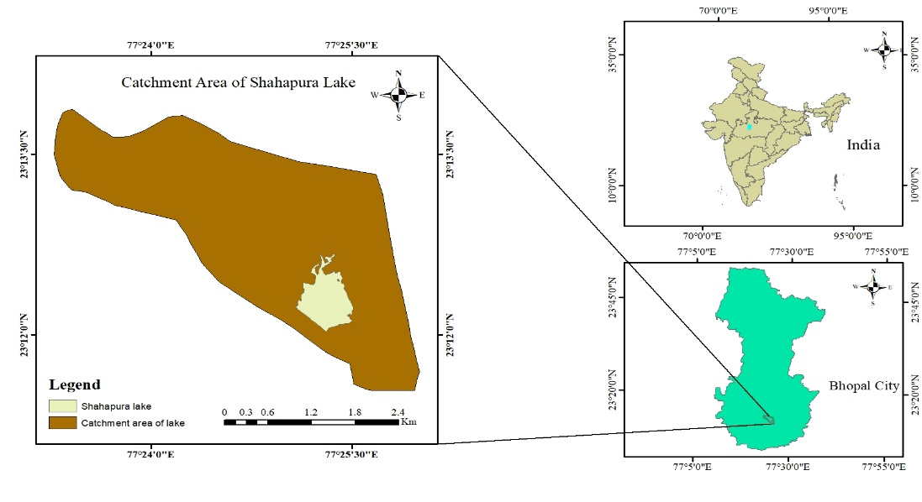

Figure 1. Location of the study area showing Shahpura Lake and its catchment

Unlike studies that apply fixed-distance buffer zones around lake boundaries, the present study adopts a catchment-based analytical framework. The Shahpura Lake catchment was delineated using DEM-based hydrological modelling, which provides a physically meaningful boundary for assessing land use influences on the lake system. No fixed-distance buffer zone was used in this study. Instead, a hydrologically defined watershed boundary derived from DEM analysis was adopted to ensure physical accuracy and avoid arbitrary spatial assumptions. As catchment-scale analysis more accurately captures surface runoff pathways and land transformation processes influencing urban lakes.

2.3 Data Source

A 30-m Shuttle Radar Topography Mission (SRTM) DEM, obtained from the USGS Earth Explorer platform, was used to delineate the Shahpura Lake catchment boundary. The DEM provided the elevation information required to define drainage patterns and catchment extent, thereby ensuring consistent spatial boundaries for subsequent LULC analysis. DEMs provide a digital representation of surface elevation and are widely used to characterise topography, relief, and elevation variability, which are essential for watershed delineation and terrain analysis (Croneborg et al., 2015). Using this dataset, sub-catchments within the study area were delineated to support hydrological and spatial assessments.

To evaluate LULC dynamics, multispectral Landsat imagery was acquired from the USGS archives for the period 1980–2021. The study period was chosen to trace and detect land use changes in the catchment area since its creation. The study period also sought to capture the pre- and post-liberalisation phases of urban growth in India. The continuous availability of Landsat imagery, enabled consistent long-term analysis of land use dynamics. Satellite imagery captures spectral reflectance information of Earth’s surface and enables the identification of vegetation, water bodies, built-up structures, and other land cover features (Shafaey et al., 2018). These images served as the primary source for mapping temporal landscape transformations in the Shahpura Lake catchment. Classification accuracy was evaluated using an error matrix, and overall accuracy and the Kappa coefficient were computed for each classified image (Table 1). Accuracy assessment of the classified LULC maps was conducted using 50 stratified random sample points per reference year. This ensured adequate representation of all LULC classes. The sampling strategy involved proportional allocation of points across classes to minimise bias. Reference information for validation was obtained through visual interpretation of high-resolution satellite imagery and ancillary data available from Google Earth and historical maps. An error matrix was generated for each classified image, and overall accuracy and the Kappa coefficient were computed to evaluate classification performance.

Table 1. Accuracy assessment of remote sensing analysis

Classified Image | Total reference points | Correctly classified points | Overall Accuracy (%) | Kappa coefficient
Landsat MSS 3 (1980) | 50 | 42 | 84.00 | 0.74
Landsat TM 5 (1991) | 50 | 43 | 86.00 | 0.78
Landsat ETM+ 7 (2001) | 50 | 44 | 88.00 | 0.81
Landsat TM 5 (2011) | 50 | 41 | 82.00 | 0.71
Landsat OLI 8 (2021) | 50 | 45 | 90.00 | 0.85

2.4 Delineation of Catchments

Catchment delineation was carried out using a standard DEM-based workflow implemented in ArcGIS (Figure 2). The SRTM DEM was processed to derive flow direction and flow accumulation grids, which were used to define drainage patterns and delineate the Shahpura Lake catchment boundary. The resulting watershed polygon was subsequently refined through minor spatial adjustments to ensure accurate alignment with topographic divides and drainage features visible in the elevation data.

Figure 2: DEM-based hydrological workflow for catchment (Zardari et al., 2019)

2.5 Land Use Classification

LULC classification was carried out using a supervised classification approach, which is widely recognised for its reliability and accuracy in remote sensing applications (Jensen, 2016). Supervised classification was adopted as it enables the selection of representative training samples for each land cover class, thereby improving spectral separability and thematic accuracy. A comprehensive set of training signatures was developed for all major LULC categories, and the Maximum Likelihood Classifier (MLC) was employed due to its robust statistical foundation and proven performance in multispectral image classification (Richards and Jia, 2006). Additional preprocessing and refinement procedures were applied to improve class discrimination and ensure consistent classification results. The overall workflow adopted for multi-temporal LULC mapping is illustrated in Figure 3. The resulting LULC maps effectively represent the ground conditions of the Shahpura Lake catchment with high thematic fidelity.
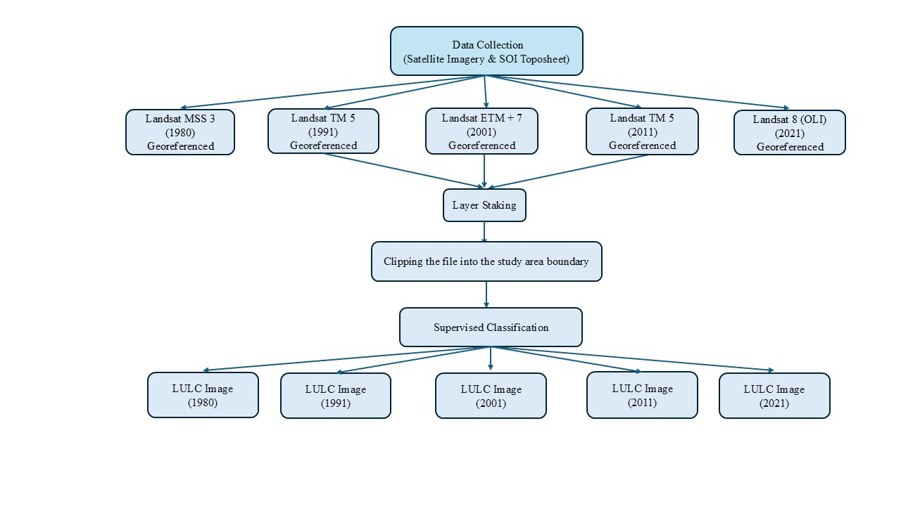

Figure 3. Methodological workflow for multi-temporal Landsat-based LULC classification (1980–2021)

2.6 Statistical and Trend Analysis

Statistical analyses were performed to quantify temporal trends and relationships among land use and land cover classes within the Shahpura Lake catchment. Linear trend analysis was conducted using ordinary least squares (OLS) regression, with time (years) as the independent variable and class-wise area (km²) as the dependent variable. The slope of the regression line represents the rate of change in land cover area, while the coefficient of determination (R²) was used to evaluate the strength of the trend. Statistical significance of trends was assessed at the 95% confidence level (p < 0.05).

Pearson’s correlation coefficient (r) was employed to examine the relationship between built-up area and vegetation cover over the study period. Corresponding p-values were calculated to test the statistical significance of the observed correlations, with significance evaluated at the 95% confidence level. All statistical analyses were conducted using standard statistical procedures.

3. results And DISCUSSION

3.1 Catchment-scale LULC dynamics and temporal context

The Shahpura Lake catchment (8.29 km²) has undergone substantial LULC transformation over the last four decades (1980–2021), as revealed by multi-temporal Landsat analysis (Tables 2 and 3; Figures 4 and 5). The results indicate a clear and directional shift toward urban land use, with built-up areas expanding at the expense of vegetation and open land. Similar spatio-temporal land transformation patterns have been reported in other tropical and semi-arid catchments using remote sensing approaches (Wilken et al., 2017; Matlhodi et al., 2019). Such long-term, directional LULC change has been widely recognised as a dominant driver of urban lake degradation in rapidly growing cities (McDonald et al., 2011; Seto et al., 2012). Land use and land cover maps for 1980, 1991, 2001, 2011, and 2021 are presented in Figures 6–10, respectively.

Table 2. Class-wise area (Km²) for each analysed year

Class | 1980 | 1991 | 2001 | 2011 | 2021
Barren land | 2.88 | 2.64 | 2.55 | 2.27 | 1.74
Built-up | 1.21 | 2.16 | 3.01 | 3.05 | 3.88
Vegetation | 3.79 | 3.05 | 2.30 | 2.50 | 2.27
Waterbody | 0.37 | 0.42 | 0.42 | 0.47 | 0.40
Total | 8.29 | 8.29 | 8.29 | 8.29 | 8.29

Table 3. Change summary: absolute and percentage change (1980 → 2021)

Class | 1980 (km²) | 2021 (km²) | Absolute change (km²) | % change vs 1980
Barren land | 2.88 | 1.74 | –1.14 | –39.6%
Built-up | 1.21 | 3.88 | +2.67 | +220.7%
Vegetation | 3.79 | 2.27 | –1.52 | –40.1%
Waterbody | 0.37 | 0.40 | +0.03 | +8.1%

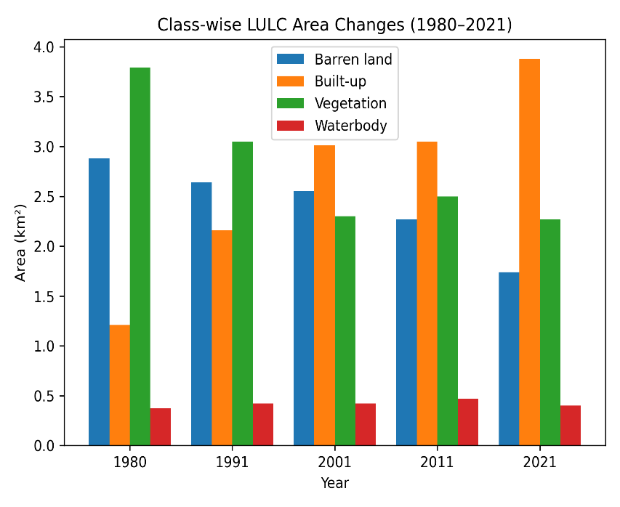
Figure 4. Temporal variation in LULC classes within the Shahpura Lake catchment from 1980 to 2021

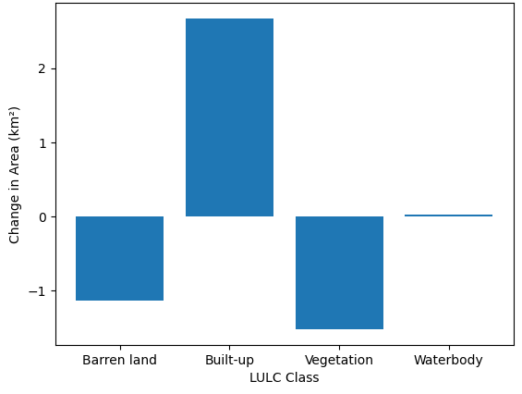

Figure 5. Absolute change in LULC classes in the Shahpura Lake catchment from 1980 to 2021
Figure 6. LULC Classification Map for the Year 1980
Figure 7. LULC Classification Map for the Year 1991
Figure 8. LULC Classification Map for the Year 2001
Figure 9. LULC Classification Map for the Year 2011
Figure 10. LULC Classification Map for the Year 2021

3.2 Built-up expansion as the primary driver of catchment degradation

Built-up land increased from 1.21 km² in 1980 to 3.88 km² in 2021, representing a net increase of 220.7%. Linear trend analysis confirms a statistically significant positive trajectory (+0.062 km²/year; R² = 0.94; p < 0.01), indicating sustained and systematic urban expansion rather than episodic land conversion. This rapid growth of impervious surfaces is the dominant factor driving catchment degradation, as it fundamentally alters surface hydrology by increasing runoff volume, shortening flow paths, and reducing infiltration capacity (Arnold & Gibbons, 1996; Shuster et al., 2005). Similar magnitudes of built-up expansion have been reported for urban lake catchments in Bengaluru (Ramachandra et al., 2016) and Pune (Mundhe & Jaybhaye, 2014), where accelerated urbanisation has been directly linked to declining lake water quality and increased flooding frequency.

3.3 Decline in vegetation and loss of ecological buffering capacity

Vegetation cover declined by 40.1% over the study period, with a statistically significant negative trend (–0.036 km²/year; p < 0.05). The strong inverse correlation between built-up and vegetation cover (r = –0.96; p < 0.05) provides quantitative evidence that urban expansion has occurred mainly through the conversion of vegetated land.

Vegetation loss represents a critical mechanism of catchment degradation, as riparian and catchment vegetation plays a key role in sediment retention, nutrient uptake, and regulation of surface runoff (Allan, 2004; Groffman et al., 2003). Studies on Indian urban lakes have demonstrated that reduced vegetated buffers accelerate sediment inflow and eutrophication, leading to structural and functional degradation of lake ecosystems (Ramachandra et al., 2016).

3.4 Transformation of barren land and intensification of land utilisation

Barren land declined by 39.6% (–0.027 km²/year; p < 0.01), indicating progressive utilisation of previously undeveloped surfaces. This pattern reflects an advanced stage of urbanisation in which easily convertible open land is exhausted, forcing expansion into vegetated areas. Similar sequential land conversion trajectories—from barren to built-up, followed by vegetation loss—have been documented in urban catchments of Delhi and Chennai (Nagendra et al., 2014; Chandrasekar et al., 2020). This intensification of land use increases spatial connectivity between impervious surfaces and the lake, enhancing pollutant delivery efficiency during rainfall events and increasing pressure on lake sediment dynamics.

3.5 Apparent stability of lake surface area and hidden structural impacts

The areal extent of Shahpura Lake remained relatively stable (+8.1%) over four decades, with no statistically significant long-term trend (p > 0.05). However, previous studies have cautioned that surface area stability does not imply ecological stability in urban lakes (Carpenter et al., 1998). Catchment-scale urbanisation alters lake structure by increasing sediment deposition, reducing storage capacity, and modifying littoral zones, even when surface area remains unchanged. Empirical studies on urban lakes in India have shown that increased catchment runoff leads to shallowing of the lake, loss of macrophyte diversity, and deterioration of benthic habitats (Ramachandra et al., 2016). The results of the present study suggest that Shahpura Lake is increasingly vulnerable to such structural degradation due to intensified land transformation within its catchment.

3.6 Implications for the hydrological and ecological functioning of Shahpura Lake

The combined effects of built-up expansion, vegetation loss, and land use intensification indicate a transition of the Shahpura Lake catchment toward a more impervious, hydrologically less responsive system. Increased surface runoff and reduced infiltration are likely to elevate peak inflows during storm events, enhance sediment and nutrient loading, and accelerate eutrophication processes (Paul & Meyer, 2001; Walsh et al., 2005). These catchment-driven pressures alter lake functioning. They modify residence time, thermal structure, and nutrient cycling. As a result, water quality and ecosystem services are affected. Similar catchment–lake interactions have been identified as primary causes of urban lake decline across tropical and subtropical regions (Lopes et al., 2020).

The observed expansion of built-up land within the Shahpura Lake catchment is consistent with ongoing urban development patterns in Bhopal, including the growth of residential colonies, expansion of road networks, and increased impervious surfaces associated with urban infrastructure. Similar trends have been reported in other Indian cities, where rapid urban expansion around lakes has altered catchment hydrology and increased environmental stress on urban water bodies. The results of this study reflect broader urban planning challenges, where lake catchments are often subjected to unregulated land conversion despite their hydrological importance. These findings underscore the need to integrate catchment-scale land use considerations into urban development plans and lake management strategies to mitigate long-term ecological degradation.

3.7 Comparative synthesis and scientific contribution

Compared with other urban lake catchment studies in India, the Shahpura Lake system exhibits a comparable or higher rate of built-up expansion per catchment area, despite its relatively small spatial extent. This finding underscores the disproportionate vulnerability of urban lake catchments to rapid land transformation, a factor often overlooked in large-scale urban studies. The present study contributes to urban lake research by demonstrating that statistically significant, long-term catchment-scale land use change can critically influence lake vulnerability, even in the absence of substantial changes in lake surface area. This reinforces the need to shift urban lake management from lake-centric restoration to integrated catchment-scale planning and regulation.

4. Conclusion

This study presents a long-term spatio-temporal assessment of LULC dynamics within the Shahpura Lake catchment using multi-temporal Landsat imagery spanning four decades (1980–2021). The results demonstrate that the catchment has undergone a systematic and statistically significant transformation, driven primarily by sustained urban expansion. Built-up land increased by more than threefold, while vegetation and barren land declined by approximately 40%. These changes indicate a clear shift toward a more impervious and anthropogenically modified landscape. Statistical trend analysis confirms that these changes are non-random and directional, with built-up expansion showing a strong positive trend (R² = 0.94; p < 0.01) and vegetation and barren land exhibiting significant declining trends (p < 0.05). The strong negative correlation between built-up land and vegetation cover further establishes urban growth as the dominant driver of catchment degradation. Although the areal extent of Shahpura Lake has remained relatively stable over the study period, the surrounding catchment has transitioned toward a more hydrologically responsive system, increasing the lake’s vulnerability to altered runoff regimes, sediment influx, and nutrient loading. The spatial patterns observed in the LULC maps corroborate the quantitative and statistical findings, revealing progressive urban encroachment across the catchment, particularly after 2001. These spatio-temporal patterns highlight that lake surface area alone is an insufficient indicator of lake health, and that catchment-scale land use dynamics play a decisive role in governing the long-term structural and functional integrity of urban lakes. Despite providing valuable insights into long-term land use and land cover dynamics, this study has certain limitations. The analysis is based on medium-resolution Landsat imagery, which may not capture fine-scale land use changes in dense urban environments. Additionally, the study primarily focuses on the spatial and statistical assessment of land transformation and does not incorporate in situ hydrological or water-quality measurements. Future research should integrate higher-resolution satellite data, field-based observations, and hydrological or water-quality modelling to strengthen the understanding of catchment–lake interactions. Expanding the analytical framework to include socio-economic drivers and urban planning scenarios would further enhance the applicability of catchment-scale assessments for sustainable urban lake management. The study underscores the need to shift urban lake management from lake-centric restoration approaches to integrated catchment-scale planning, including regulating the expansion of built-up areas, protecting and restoring vegetated buffers, and incorporating land use controls into urban development policies. The methodological framework provides a transferable approach for assessing urban lake vulnerability in rapidly growing cities. It also contributes empirical evidence to support sustainable urban water resource management in India and similar contexts.

Disclaimer (Artificial intelligence)

Author(s) hereby declare that NO generative AI technologies such as Large Language Models (ChatGPT, COPILOT, etc.) and text-to-image generators have been used during the writing or editing of this manuscript.

References

- Abdulkareem, J. H., Sulaiman, W. N. A., Pradhan, B., & Jamil, N. R. (2018). Long-term hydrologic impact assessment of non-point source pollution measured through land use/land cover (LULC) changes in a tropical complex catchment. Earth systems and environment, 2(1), 67-84.
- Allan, J. D. (2004). Landscapes and riverscapes: the influence of land use on stream ecosystems. Annu. Rev. Ecol. Evol. Syst., 35(1), 257-284.
- Arnold Jr, C. L., & Gibbons, C. J. (1996). Impervious surface coverage: the emergence of a key environmental indicator. Journal of the American planning Association, 62(2), 243-258.
- Carpenter, S. R., Caraco, N. F., Correll, D. L., Howarth, R. W., Sharpley, A. N., & Smith, V. H. (1998). Nonpoint pollution of surface waters with phosphorus and nitrogen. Ecological applications, 8(3), 559-568.
- Chandrasekar, V., Mahamad, S., & Latha, G. (2020). Impact of Urbanization on Megacities’ Lakes Using Remote Sensing Technique: A Case Study of Water Quality Analysis in Ambattur Lake, Chennai, India. In Urban Health Risk and Resilience in Asian Cities (pp. 327-341). Singapore: Springer Singapore.
- Croneborg, L., Woldai, T., Smits, P., Chatterjee, R. S., & Abdullahi, S. (2015). Digital elevation models and their applications in hydrology and terrain analysis. International Journal of Applied Earth Observation and Geoinformation, 35, 1–12.
- Gopinath, R., Cu, A., & Me, M. (2022). Time-Line Based Aerial Analysis for Impact of Rampant Urbanization on Lakes of Bengaluru (India). Civil and Environmental Engineering Reports, 32(1).
- Grimm, N. B., Faeth, S. H., Golubiewski, N. E., Redman, C. L., Wu, J., Bai, X., & Briggs, J. M. (2008). Global change and the ecology of cities. Science, 319 (5864), 756-760.
- Groffman, P. M., Bain, D. J., Band, L. E., Belt, K. T., Brush, G. S., Grove, J. M., ... & Zipperer, W. C. (2003). Down by the riverside: urban riparian ecology. Frontiers in Ecology and the Environment, 1(6), 315-321.
- Herold, M., Couclelis, H., & Clarke, K. C. (2005). The role of spatial metrics in the analysis and modeling of urban land use change. Computers, environment and urban systems, 29(4), 369-399.
- Huang, J., et al. (2021). Impacts of urbanization on lake ecosystems: A review. Science of the Total Environment, 748, 141272.
- Jensen, J. R. (2016). Introductory digital image processing: a remote sensing perspective. ed.; Glenview, IL: 608 Pearson Education.
- Li, X., Zhou, Y., Asrar, G. R., Imhoff, M., & Li, X. (2017). The surface urban heat island response to urban expansion: A panel analysis for the conterminous United States. Science of the Total Environment, 605, 426-435.
- Lopes, F. A., Davies-Colley, R., Júlia, P., Silveira, J. S., Leite, A. C., & Azevedo, L. N. I. (2020). Challenges for contact recreation in a tropical urban lake: Assessment by a water quality index. Environment, Development and Sustainability, 22(6), 5409-5423.
- Maheshwari, S., & Vyas, S. (2025). Evaluation of urban waterbody under the influence of land use land cover (LULC) in the catchment: A case of Hataikheda Lake, Bhopal (India). Environmental Monitoring and Assessment, 197(11), 1175.
- Matlhodi, B., Kenabatho, P. K., Parida, B. P., & Maphanyane, J. G. (2019). Evaluating land use and land cover change in the Gaborone dam catchment, Botswana, from 1984–2015 using GIS and remote sensing. Sustainability, 11(19), 5174.
- McDonald, R. I., Green, P., Balk, D., Fekete, B. M., Revenga, C., Todd, M., & Montgomery, M. (2011). Urban growth, climate change, and freshwater availability. Proceedings of the National Academy of Sciences, 108(15), 6312-6317.
- Mundhe, N. N., & Jaybhaye, R. G. (2014). Impact of urbanization on land use/land covers change using Geo-spatial techniques. International journal of geomatics and geosciences, 5(1), 50-60.
- Nagendra, H., Sudhira, H. S., Katti, M., Tengö, M., & Schewenius, M. (2014). Urbanization and its impacts on land use, biodiversity and ecosystems in India.
- Paul, M. J., & Meyer, J. L. (2001). Streams in the urban landscape. Annual review of Ecology and Systematics, 32(1), 333-365.
- Paul, S., & Nagendra, H. (2017). Factors influencing perceptions and use of urban nature: Surveys of park visitors in Delhi. Land, 6(2), 27.
- Ramachandra, T. V., Vinay, S. M. D. V. S., Mahapatra, D. M., Varghese, S., & Aithal, B. H. (2016). Water situation in Bengaluru. Energy and Wetlands Research Group, Centre for Ecological Sciences, Indian Institute of Science, Bangalore, India.
- Richards, J. A., & Jia, X. (2006). Interpretation of hyperspectral image data. In Remote sensing digital image analysis: An introduction (pp. 313-337). Berlin, Heidelberg: Springer Berlin Heidelberg.
- Seto, K. C., Güneralp, B., & Hutyra, L. R. (2012). Global forecasts of urban expansion to 2030 and direct impacts on biodiversity and carbon pools. Proceedings of the National Academy of Sciences, 109(40), 16083-16088.
- Shafaey, M., Khalaf, F., & El-Maaty, A. (2018). Use of Landsat multispectral imagery for land cover classification and environmental monitoring. Journal of Remote Sensing and GIS, 7(2), 45–56.
- Shafizadeh-Moghadam, H., & Helbich, M. (2015). Spatiotemporal variability of urban growth factors: A global and local perspective on the megacity of Mumbai. International Journal of Applied Earth Observation and Geoinformation, 35, 187-198.
- Shuster, W. D., Bonta, J., Thurston, H., Warnemuende, E., & Smith, D. R. (2005). Impacts of impervious surface on watershed hydrology: A review. Urban Water Journal, 2(4), 263-275.
- Walsh, C. J., Roy, A. H., Feminella, J. W., Cottingham, P. D., Groffman, P. M., & Morgan, R. P. (2005). The urban stream syndrome: current knowledge and the search for a cure. Journal of the North American Benthological Society, 24(3), 706-723.
- Wang, R., Bai, Y., Alatalo, J. M., Yang, Z., Yang, Z., Yang, W., & Guo, G. (2021). Impacts of rapid urbanization on ecosystem services under different scenarios: A case study in Dianchi Lake Basin, China. Ecosystem Services, 52, 101367.
- Weng, Q. (2012). Remote sensing of impervious surfaces in the urban areas: Requirements, methods, and trends. Remote sensing of Environment, 117, 34-49.
- Wilken, F., Wagner, P. D., Narasimhan, B., & Fiener, P. (2017). Spatio-temporal patterns of land use and cropping frequency in a tropical catchment of South India. Applied Geography, 89, 124-132.
- Zardari, N. H., Shirazi, S. M., & Imran, H. M. (2019). Watershed delineation and hydrological modelling using DEM and GIS techniques. Hydrological Sciences Journal, 64(3), 350–362.

