Original Research Article
Assessing Erosion Vulnerability and Soil Loss Dynamics in the Eastern Himalayas: A USLE-Based Approach in the Kiile Watershed, Arunachal Pradesh, India

.
ABSTRACT
Quantifying erosion vulnerability at the watershed scale is imperative for understanding sediment dynamics and formulating effective soil conservation strategies. In this study, the erosion vulnerability of the Kiile watershed was evaluated using the Universal Soil Loss Equation (USLE) model to quantify soil loss dynamics across ten distinct sub-watersheds. The model integrated multi-source geospatial datasets, including high-resolution Digital Elevation Model (DEM), satellite-derived land use/land cover (LULC) maps, and long- term rainfall records. These datasets were used to compute the standard USLE parameters: rainfall erosivity (R), soil erodibility (K), slope length and steepness (LS), cover management (C), and conservation practice (P). The analysis revealed that the average annual soil loss in the Kiile watershed ranges between 0 and 138 t ha⁻¹ yr⁻¹, with a mean annual loss of 2.4 t ha⁻¹ yr⁻¹. Based on erosion severity, the study area was categorised into five classes: very high, high, moderate, low, and very low. The SW-8 recorded the highest soil loss of 4.52 t ha⁻¹ yr⁻¹, highlighting an urgent need for site-specific conservation strategies. The findings reveal that intense rainfall, erodible sandy clay loam textures and increasing urban development are the principal determinants of soil loss in this sub-watershed. This study highlights the necessity of integrating climatic and anthropogenic drivers into watershed planning to mitigate soil loss in vulnerable sub-watersheds. The study provides a foundation for decision-makers to formulate effective resource management and conservation strategies, ensuring long-term sustainability of the watershed.

Keywords: Conservation, Management, USLE, Vulnerability, Watershed

1. INTRODUCTION
The problem of soil erosion is a worldwide issue and is a serious threat, especially in developing countries, where it is generally associated with agricultural practices. The intensive cultivation and socio-economic pressure for more land have accelerated soil erosion in many regions (Shi et al., 2004). According to the Food and Agriculture Organisation (FAO), the loss of productive agricultural land due to erosion varies between 5 and 7 M ha yr⁻¹. The average soil erosion rates worldwide are estimated between 12 and 15 t ha⁻¹ yr⁻¹ (Biggelaar et al., 2004). In the humid tropics of Asia, due to the practice of subsistence crops in the sloping land, the soil becomes highly erosive with an average rate of soil loss of 138 t ha⁻¹ yr ⁻¹ (Sfeir-Younis, 1986). Such a large erosion of soil not only degrades soil quality but also reduces a reservoir's storage capacity through the tremendous delivery of sediment. Soil erosion in India, like in any other developing country, affects the agricultural sector to a major extent (Bera, 2017). The Himalayan foothills, spanning the northern and eastern regions of India, are primarily composed of sandstone, shale, conglomerate and deep soil profiles. These areas are highly susceptible to erosional processes owing to the inherent instability of their geological formation (Jain et al., 2001). Hence, a usual phenomenon of soil erosion and land degradation is observed, particularly in the mountainous watersheds of north-east India. Since watersheds form a natural boundary to focus on all the effects of downhill runoff, a systematic assessment of soil erosion within the watershed would provide reliable information to draw strategies for managing soil erosion. Managerial practices that prevent soil erosion require precise data on erosion intensity and its spatial distribution. While logistic and temporal constraints often limit the scope of traditional field-based assessments, the integration of geospatial technologies, specifically Remote Sensing and Geographical Information Systems (GIS), has significantly enhanced the accuracy and efficiency of spatial erosion modelling at the watershed scale. Among various empirical models, the Universal Soil Loss Equation (USLE) model developed by Wischmeier and Smith (1978) is one of the most widely applied empirical models for soil loss assessment. The application of this model has expanded beyond agricultural lands to include basins with varied land-use characteristics, yielding satisfactory results at national, regional, and watershed scales through the effective use of GIS-based procedures (Erdogan et al., 2007; Ozcan et al., 2008; Moges and Tegbaru, 2025; Marake et al., 2026). Hui et al. (2010) highlighted this efficiency in the Liao watershed, citing the model’s suitability for regions with limited data. Practical application of such modelling is further evidenced by Brhane and Mekonen (2009), who translated soil loss estimates into actionable planning measures, including bund stabilization and watershed re-vegetation in the Ethiopian highlands. The model’s flexibility stems from its compatibility with various data inputs, including field measurements, remote sensing, and GIS (Benavidez et al., 2018; Makhdumi et al., 2023). Hence, estimating soil loss through the integration of critical USLE parameters (rainfall erosivity (R), soil erodibility (K), slope length and steepness (LS), cover management (C), and conservation practice (P) is significant in combating the erosion threat, particularly in a fragile mountainous watershed like Kiile.
  - Study Area
The Kiile watershed lies within the intermontane valley of Ziro, situated in the Lower Subansiri district of Arunachal Pradesh, India. The watershed extends between latitudes 27°30ʹ N and 27°38ʹ N and longitudes 93°45ʹ E and 93°55ʹ E, covering an area of 147.44 km² (Figure 1). Hydrologically, the watershed is drained by the Kiile (River), which traverses the basin in a predominantly north-south direction. Its physiographic gradient, with elevations declining from about 2672 m in the northern highlands to nearly 1535 m in the southern valley floor, promotes the concentration of surface runoff and sediment transport toward the valley bottom, thereby increasing susceptibility to soil erosion across the sub-watersheds. The basin displays the characteristics of an intermontane valley interspersed with small, isolated hillocks, representing a distinctive geomorphic setting (Rupa, 2015). Geologically, the basin is believed to have originated under lacustrine conditions (Agarwal et al., 2009). According to the Geological Survey of India (2000), the region comprises five major lithological units, namely the Bomdila, Chilliepam, Hapoli, Khetabari, and Tenga formations. Climatically, the area falls within a high-rainfall zone, with the southwest monsoon commencing during March-April and continuing until September. The mean annual rainfall ranges from 2240 mm to 2910 mm, with the maximum precipitation recorded in June and July (Patnaik, 2017). The interplay of fragile terrain, intensive agricultural practices, and rainfall variability increases susceptibility to sediment detachment, making the watershed suitable for USLE-based soil erosion modelling.

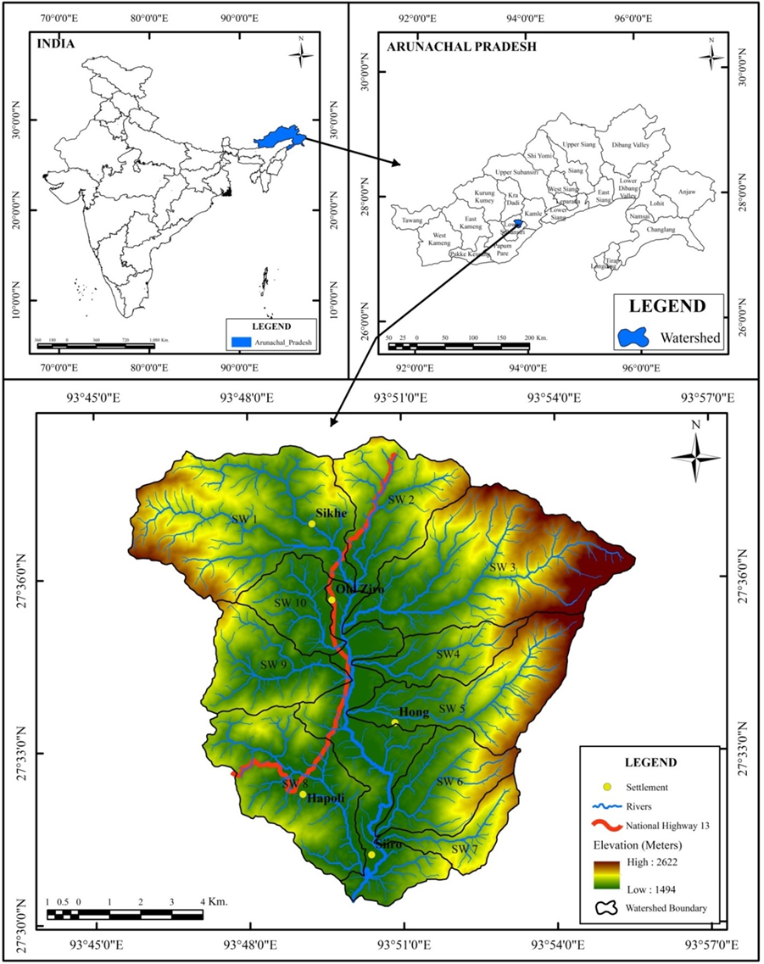

Fig. 1. Location Map of the Study Area
2. methodology
The watershed was delineated using a high-resolution digital elevation model (DEM) derived from the advanced land observing satellite–phased array type L-band synthetic aperture radar (ALOS PALSAR) with a spatial resolution of 30 m. Based on the derived drainage network, a total of ten sub-watersheds (SW1–SW10) were delineated. Rainfall data was downloaded from Climate Hazards Group InfraRed Precipitation with Station data (CHIRPS) for the period of 41 years (1981-2022). Soil information and maps were sourced from the National Bureau of Soil Survey and Land Use Planning (NBSS&LUP) and supplemented by field-collected soil samples from various geomorphic units of the study area. Landsat 9 satellite images obtained from the United States Geological Survey (USGS) were processed in ERDAS IMAGINE software to generate the LULC map using supervised image classification techniques. The long-term average annual soil loss was computed by multiplying the five contributing factors of the Universal Soil Loss Equation (USLE) Eq. (1).
A= R x K x LS x C x P (1)
Where, A= Average annual soil loss (t ha-¹ yr -¹). Figure 2 illustrates the methodological framework adopted for the present study.

Fig. 2 Methodology flow chart for USLE model

2.1 Rainfall Erosivity Factor (R)
Rainfall erosivity refers to the ability of rainfall to detach soil particles through raindrop impact (Ghosal & Bhattacharya, 2020). Wischmeier and Smith (1978) defined the rainfall erosivity factor (R) as the product of rainfall kinetic energy (E) and the maximum 30-minute rainfall intensity, commonly expressed as EI₃₀, which provides a reliable measure for estimating rainfall-induced erosion potential. However, detailed rainfall data required for computing EI₃₀, such as kinetic energy and short-duration rainfall intensity, were not available for the study area. Consequently, the empirical equation for the R factor proposed by Singh (1981) Eq. (2) was employed, as the Kiile watershed falls within a climatic regime comparable to that considered in Singh’s formulation.
R= 79 + 0.363 x AAP (2)
Where ‘R’ is the rainfall erosivity factor, ‘AAP’ is the average annual precipitation in mm. The Inverse Distance Weighting (IDW) interpolation technique was applied to estimate the spatial distribution of rainfall erosivity, and the R-factor map was subsequently generated using Eq. (2) through the raster calculator in ArcGIS.

2.2 Soil Erodibility Factor (K)
The soil erodibility (K) factor represents the inherent susceptibility of soil to erosion and is defined as the rate of soil loss per unit of rainfall erosivity under standard plot conditions (Wischmeier and Smith, 1978). It reflects the combined influence of key soil properties, including soil texture (proportions of sand, silt, and clay), organic matter content, and soil permeability (Balasubramani et al., 2015). The K-factor values generally range between 0 and 1, with higher values indicating greater vulnerability to erosion and lower values signifying more resistant soil conditions (Mohapatra, 2022). To determine soil texture, a total of 30 soil samples were collected from representative locations across the study area. The textural classes of these samples were analyzed using the hydrometer method in the soil laboratory of the Department of Geography, Rajiv Gandhi University. Organic carbon content for all soil samples was determined at the laboratory of the Directorate of Agriculture, Krishi Bhavan, Naharlagun, Government of Arunachal Pradesh. The soil erodibility (K) factor for the study area was calculated using Eq. (3) proposed by Sharpley and Williams (1990), expressed as:

$K = F_{csand}× F_{si-cl}× F_{orgc}× F_{hisand}× 0.1317$ (3)

$$F_{csand}= 0.2 + 0.3.exp\left[-0.0256.SAN\left(1 -\frac{SIL}{100}\right)\right]$$

$F_{si-cl}={\left[\frac{SIL}{CLA+SIL}\right]}^{0.3}$

$F_{orgc}=\left[1.0-\frac{0.25 C}{C + exp(3.72 - 2.95C)}\right]$

$F_{hisand}=\left[1.0 - \frac{0.70 {SN}_{1}}{{SN}_{1}+ exp(-5.51 + 2.95 {SN}_{1}}\right]$

Where, SAN = sand content (%)
SIL = silt content (%)
CLA = clay content (%)
C = soil organic carbon content (%)
SN₁ = 1 − (SAN / 100)

2.3 Slope Length and Slope Steepness Factor (LS)
The slope length (L) and slope steepness (S) factors were computed using the equation proposed by Wischmeier and Smith (1957). The combined topographic factor (LS) was calculated as:
$LS={\left(\frac{λ}{Ψ}\right)}^{m}$ (4)
where λ represents the slope length or flow path length (m), derived from the Digital Elevation Model (DEM) using the relationship:
$λ=\text{flow accumulation}×\text{cell size}$ (5)
and Ψ (22.13 m) denotes the standard reference slope length in the USLE framework. This value serves as the denominator in the slope-length ratio and does not act as an exponent. The slope-length exponent (m) is a critical parameter that governs the influence of slope length on soil erosion. In the present study, m was computed for each grid cell as a function of local slope using the standard USLE relationship:

$m=\frac{β}{1+β}, \text{where }β=\frac{\sin{θ}}{0.0896}$ (6)
Here, θ represents the slope angle derived from the ALOS PALSAR DEM. The LS factor was finally generated by implementing the above equations in the raster calculator environment of ArcGIS.
2.4 Cover Management Factor (C)
The cover management (C) factor represents the combined effect of soil-disturbing activities, such as cropping patterns and land management practices, on the rate of soil erosion (Balasubramani et al., 2015). Vegetation cover and cropping systems have a large influence on the runoff and rate of erosion as they dissipate the kinetic energy of the raindrops before impacting the soil surface (Erdogan et al., 2007). The cover management (C) factor was determined using land use/land cover data generated from Landsat 9 imagery through supervised classification in ERDAS IMAGINE. The study area comprises seven LULC categories, and C-factor values were assigned to each class based on published literature (USDA-SCS, 1972, FAO 1977, Wischmeier and Smith, 1978, Rao, 1981; Erdogan et al., 2007). The value of the ‘C’ factor usually ranges between 0 and 1, where 0 indicates a strong cover effect, and 1 indicates no cover effect (Erencin, 2000).

2.5 Conservation Practice Factor (P)
The conservation practice (P) factor represents the influence of soil conservation measures such as contour farming, terracing, strip cropping, cross-slope cultivation, and grassed waterways on reducing soil erosion (Jang et al., 2015). The implementation of these practices decreases surface runoff, thereby lowering erosion rates. The P-factor values typically range from 0 to 1, where a value of 1 denotes the absence of conservation measures, while lower values indicate the presence and effectiveness of erosion-control practices. In areas where no conservation practices are adopted, the P-factor is conventionally assigned a value of 1 (Ghosal and Bhattacharya, 2020).

3. results and discussion
The average annual soil loss of the Kiile watershed was estimated using the Universal Soil Loss Equation (USLE) as the multiplicative integration of six causal factors, expressed as:

A= R x K x LS x C x P
Where,
A= Average annual soil loss (t ha⁻¹ yr ⁻¹)
R= Rainfall erosivity factor (MJ mm ha⁻¹ h⁻¹ yr⁻¹)
K= Soil erodibility factor (t h MJ⁻¹ mm⁻¹)
L= Slope length factor (Dimensionless)
S= Slope steepness factor (Dimensionless)
C= Cover management factor (Dimensionless)
P= Conservation practice factor (Dimensionless)
3.1 Rainfall Erosivity Factor (R)
The Kiile watershed received an average annual rainfall ranging from 1568 mm to 1886 mm during the period 1981–2022, with the southern part of the watershed experiencing comparatively higher precipitation (Figure 3. a). This spatial pattern is reflected in the distribution of rainfall erosivity, where the R-factor values vary between 648.31 and 763.65 MJ mm ha⁻¹ h⁻¹ yr⁻¹ and attain maximum values in the southern part of the study area (Figure 3. b). The higher R-factor values indicate a higher erosive potential of rainfall in these areas, thereby enhancing the capacity of raindrops to detach and transport topsoil (Handique et al., 2023).
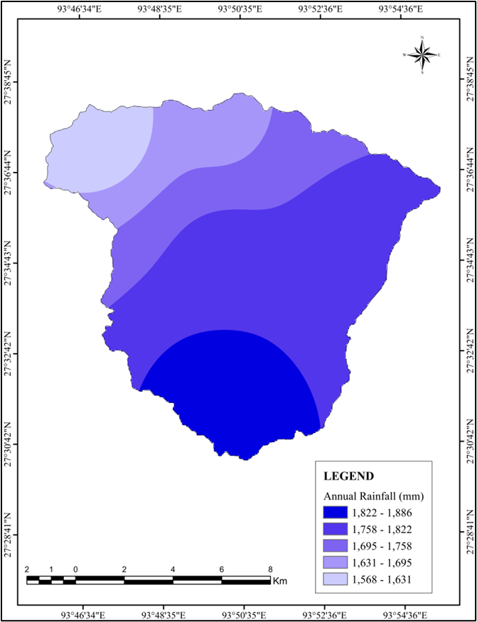
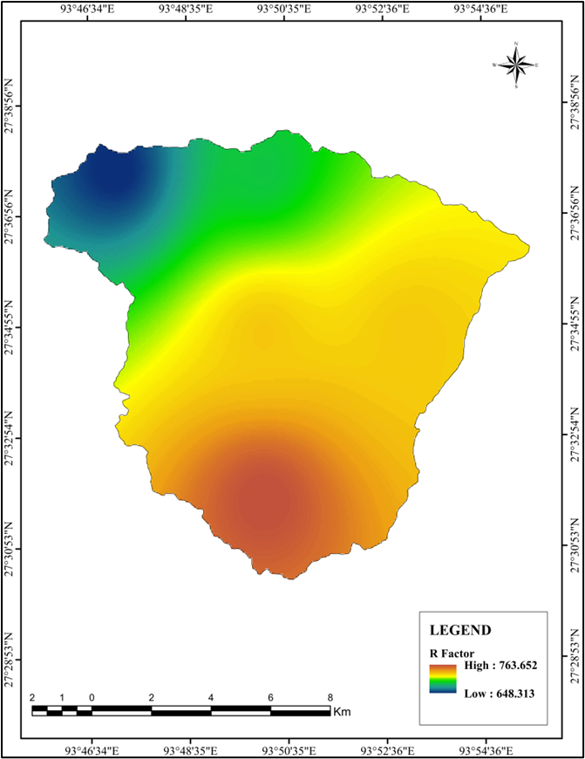
Fig. 3 (a) Average annual rainfall 1981-2022; (b) R factor map
3.(a)
3.(b)

3.2 Soil Erodibility Factor (K)
According to the National Bureau of Soil Science and Land Use Planning, the study area is characterized by two dominant soil types, Red sandy soil and Sub-montane soil (Figure 4.a). Textural analysis reveals that sand content ranges from 58.5% to 60.0%, silt from 17.84% to 19.28%, and clay from 21.44% to 22.88% (Table 1). Based on these properties, the soil erodibility (K) factor values were found to vary between 0.0203 and 0.0208 t h MJ⁻¹ mm⁻¹ (Figure 4. b). Lower K values indicate greater resistance to erosion, whereas higher values reflect increased susceptibility to soil loss (Mohapatra, 2022). Relatively higher K-factor values (0.0208 t h MJ⁻¹ mm⁻¹), denoting greater erosion vulnerability, are predominantly concentrated in the central valley region, which is characterized by finer soil fractions, intensive agricultural activity, and relatively gentle slopes that promote sediment detachment under sustained rainfall. In contrast, areas exhibiting lower K values (0.0203 t h MJ⁻¹ mm⁻¹) are comparatively less susceptible to erosion and are largely associated with upland zones having coarser soil texture and better vegetative cover (Table 1).

Table 1. Soil properties (%) and the values of Fcsand, Fsi-cl, Forgc and Fhisand and K- factor of the study area.
Sample Sand Silt Clay OC Fcsand Fsi-cl Forgc Fhisand K factor
1 59.28 18.56 22.16 0.36 0.200001 0.7900 0.9994 0.9938 0.0207
2 59.28 18.56 22.16 0.58 0.200001 0.7900 0.9982 0.9938 0.0206
3 59.28 18.56 22.16 0.75 0.200001 0.7900 0.9964 0.9938 0.0206
4 58.56 19.28 22.16 0.96 0.200002 0.7949 0.9928 0.9946 0.0207
5 58.56 19.28 22.16 0.89 0.200002 0.7949 0.9941 0.9946 0.0207
6 58.56 19.28 22.16 0.78 0.200002 0.7949 0.9959 0.9946 0.0207
7 59.28 18.56 22.16 0.85 0.200001 0.7900 0.9948 0.9938 0.0206
8 58.56 19.28 22.16 0.96 0.200002 0.7949 0.9928 0.9946 0.0207
9 59.28 18.28 21.44 0.95 0.200001 0.7923 0.9930 0.9938 0.0206
10 59.28 18.28 21.44 0.69 0.200001 0.7923 0.9971 0.9938 0.0207
11 59.28 18.56 22.16 0.88 0.200001 0.7900 0.9943 0.9938 0.0206
12 59.28 18.56 22.16 0.75 0.200001 0.7900 0.9964 0.9938 0.0206
13 59.28 18.28 21.44 0.49 0.200001 0.7923 0.9988 0.9938 0.0207
14 59.28 18.56 22.16 0.89 0.200001 0.7900 0.9941 0.9938 0.0206
15 59.28 17.84 22.88 0.91 0.200001 0.7807 0.9937 0.9938 0.0203
16 59.28 17.84 22.88 0.63 0.200001 0.7807 0.9977 0.9938 0.0204
17 60.00 18.56 21.44 0.46 0.200001 0.7942 0.9989 0.9928 0.0207
18 60.00 18.56 21.44 0.74 0.200001 0.7942 0.9965 0.9928 0.0207
19 59.28 18.28 21.44 0.43 0.200001 0.7923 0.9991 0.9938 0.0207
20 59.28 18.28 21.44 0.68 0.200001 0.7923 0.9972 0.9938 0.0207
21 59.28 18.28 21.44 0.75 0.200001 0.7923 0.9964 0.9938 0.0207
22 59.28 18.28 21.44 0.85 0.200001 0.7923 0.9948 0.9938 0.0206
23 59.28 18.28 21.44 0.45 0.200001 0.7923 0.9990 0.9938 0.0207
24 59.28 18.28 21.44 0.78 0.200001 0.7923 0.9959 0.9938 0.0207
25 57.84 19.28 22.88 0.65 0.200002 0.7908 0.9975 0.9954 0.0207
26 58.56 19.28 22.16 0.56 0.200002 0.7949 0.9983 0.9946 0.0208
27 58.56 19.28 22.16 0.88 0.200002 0.7949 0.9943 0.9946 0.0207
28 58.56 19.28 22.16 0.97 0.200002 0.7949 0.9925 0.9946 0.0207
29 58.56 18.56 22.88 0.48 0.200001 0.7859 0.9988 0.9946 0.0206
30 58.56 19.28 22.16 0.52 0.200002 0.7949 0.9986 0.9946 0.0208
OC (Organic Carbon)

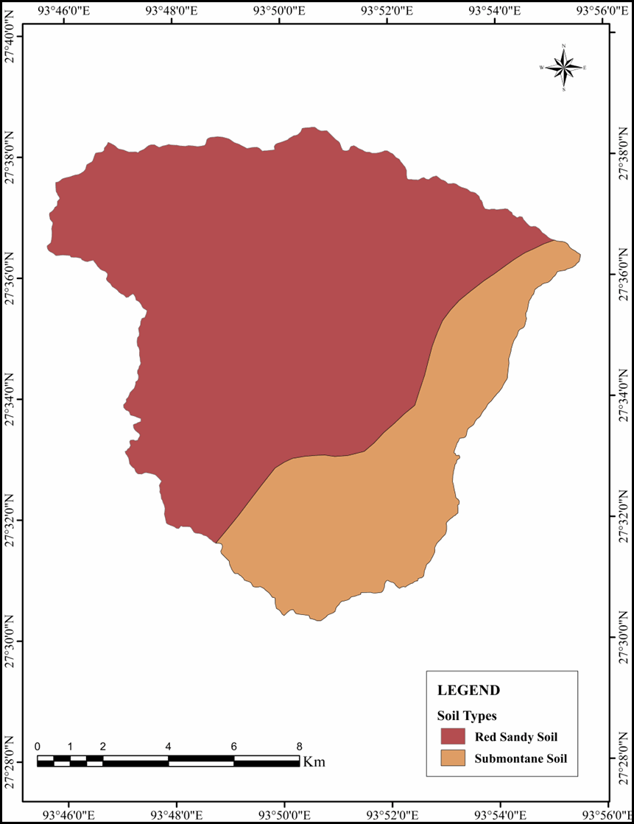
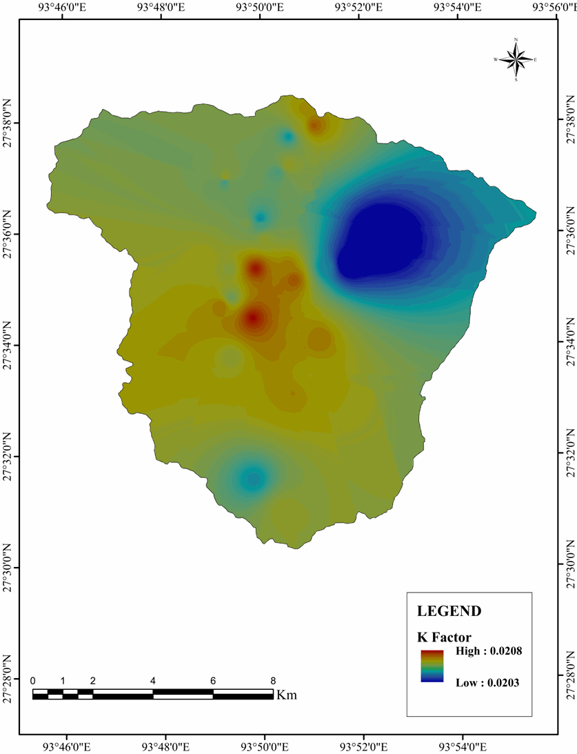
Fig. 4 (a) Soil Types; (b) K factor map

4.(a)
4.(b)

3.3 Slope Length and Slope Steepness Factor (LS)
The slope length and steepness (LS) factor integrates the combined influence of slope length and slope gradient on soil erosion processes (Panagos et al., 2015). Higher LS values signify a greater potential for soil erosion and associated erosion risk (Chakrabortty et al., 2020). The slope within the watershed varies from 0° to 54.66° (Figure 5. a). Steeper slopes are concentrated in the upper reaches of the watershed, whereas the remaining areas, particularly the valley region, are characterized by moderate to low sloping terrain. The LS factor across the watershed ranges from 0 to 19.95 (Figure 5. b). Higher LS values are predominantly concentrated in the upland regions, whereas lower LS values occur in the valley areas. The hilly portions of the watershed, marked by rugged topography and a dense drainage network, are more susceptible to sheet and rill erosion compared to the valley plains.

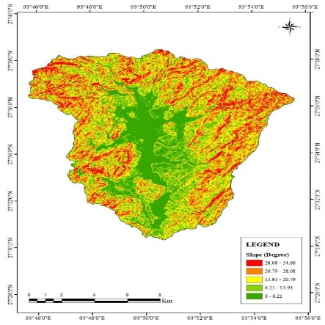
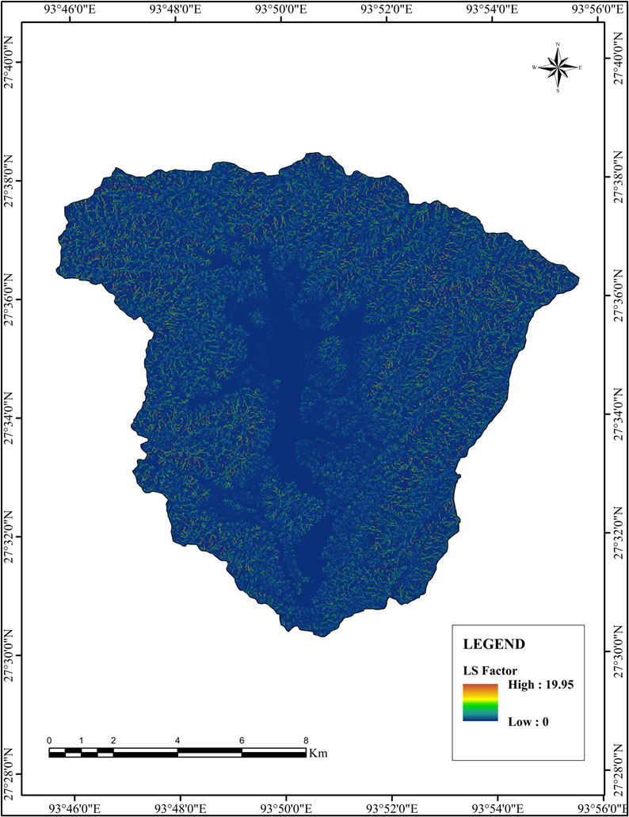
5.(a)

5.(b)

Fig. 5 (a) Slope in degrees; (b) LS factor map
3.4 Cover Management Factor (C)
The cover management factor (C) shows a direct influence of vegetation cover on soil loss. The GIS-based land use/land cover (LULC) classification identified seven major categories within the study area, namely vegetation, cropland, fallow land, barren land, water bodies, built-up areas, and scrub (Figure 6. a). The cover–management (C) factor generally ranges from 0 to 1, where lower values indicate effective surface cover and higher values denote minimal or no cover protection (Erencin, 2000). Accordingly, areas with dense vegetation exhibit lower C values, whereas barren and fallow lands are characterized by higher C values due to limited protective cover. In the present study, the maximum C-factor value of 1 was assigned to barren land, reflecting the absence of cover-management practices. C-factor values for all LULC classes were allocated based on established literature (USDA-SCS, 1972; FAO, 1977; Wischmeier and Smith, 1978; Rao, 1981; Erdogan et al., 2007) (Table 2). The spatial distribution of the C factor (Figure 5. b) reveals higher values in the valley region, indicating greater susceptibility to soil erosion, while lower values dominate the upland areas where dense vegetation cover reduces erosion potential compared to the valley floor.

Table 2. Land use and Land cover classes and associated ‘C’ and ‘P’ factor values
LULC CLASS Area (ha) Area (%) C factor value P factor value
Vegetation 10752.6 72.92 0.015 1.00
Cropland 1964.35 13.32 0.400 0.28
Fallow land 639.61 4.34 0.180 1.00
Barren land 292.76 1.99 1.00 1.00
Water bodies 92.14 0.62 0.00 1.00
Built up 406.27 2.76 0.003 1.00
Scrub 596.62 4.05 0.05 1.00
Source: USDA-SCS, 1972; FAO, 1977; Wischmeier and Smith, 1978; Rao, 1981 and Erdogan et al. 2007
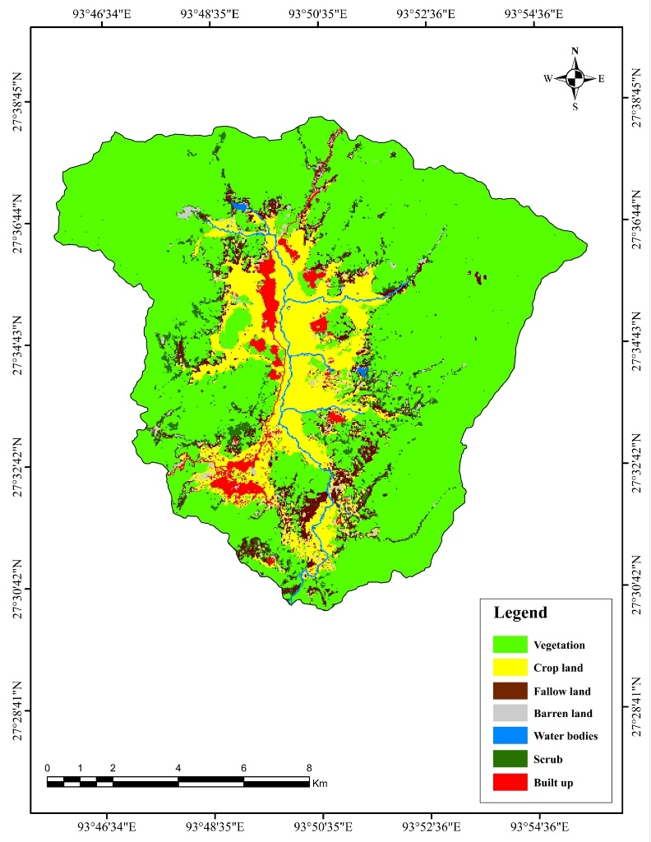
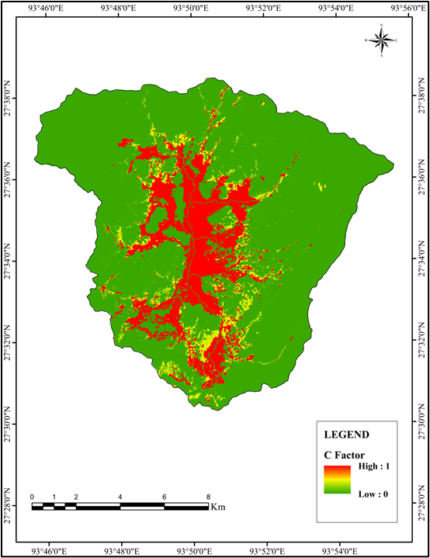
Fig. 6 (a) Land use and land cover types; (b) C factor map
6.(a)
6.(b)

3.5 Conservation Practice Factor (P)
In the study area, soil conservation practices are primarily observed in agricultural lands in the form of terraced wet rice cultivation supported by earthen bunds. While these bunds are mainly designed to retain water, they also function as effective barriers that limit runoff and reduce soil erosion between successive terraces. Based on cropping patterns, the conservation practice (P) factor was assigned following the values proposed by Rao (1981). Given that cropland in the watershed is largely managed under traditional cultivation practices, a P-factor value of 0.28 was applied to agricultural areas. A P-factor value of 1 was assigned to non-paddy and non-agricultural land uses, reflecting the absence of conservation measures in these areas. Lower P-factor values indicate the presence of effective conservation practices, whereas a value of 1 denotes a lack of such interventions (Prasannakumar, 2011). The distribution of P-factor values across different LULC categories in the Kiile watershed is presented in Table 2. Apart from cropland, where conservation practices are evident, all other land use categories were assigned a P-factor value of 1, as no significant soil conservation measures were observed in those areas.
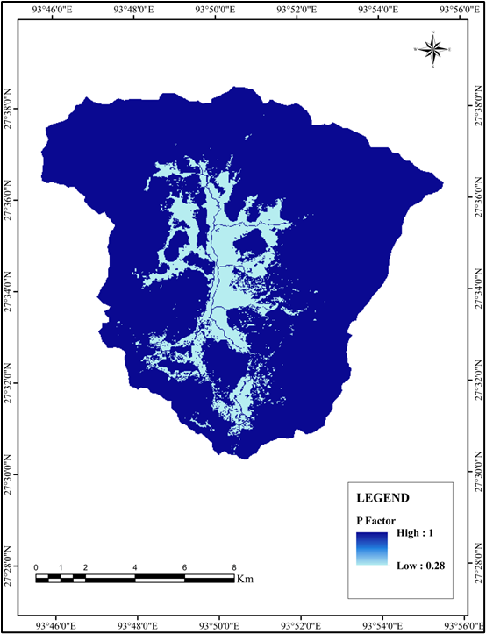

Fig. 7 P factor map

3.6 Soil Loss Estimation
The average annual soil loss for the Kiile watershed and its sub-watersheds was estimated using Equation (1) by integrating the R, K, LS, C, and P thematic layers through spatial overlay analysis in the ArcGIS environment. The estimated soil loss across the watershed ranges from 0 to 138 t ha⁻¹ yr⁻¹, with a mean annual loss of 2.4 t ha⁻¹ yr⁻¹. Based on erosion severity, the Kiile watershed was classified into five categories: very high (75–138 t ha⁻¹ yr⁻¹), high (40–75 t ha⁻¹ yr⁻¹), moderate (15–40 t ha⁻¹ yr⁻¹), low (3–15 t ha⁻¹ yr⁻¹), and very low (0–3 t ha⁻¹ yr⁻¹) (Table 3). Areas experiencing very high and high erosion cover 1.75 ha (0.12%) and 5.35 ha (0.14%) of the watershed area, respectively and are confined to isolated patches in the northern and southwestern parts. These zones are mainly associated with barren land devoid of vegetation cover and conservation measures, which significantly increases their vulnerability to soil erosion. Immediate conservation interventions are therefore required, as anthropogenic activities such as deforestation, quarrying, sand mining, and unsustainable land-use practices further accelerate erosion in these zones. Average annual soil loss varies substantially among the sub-watersheds, ranging from 1.58 to 4.52 t ha⁻¹ yr⁻¹ (Table 4). The SW-8, covering 16.40 km², emerges as the most erosion-prone sub-watershed, followed by SW-2 (11.96 km²). These spatial patterns are closely associated with higher rainfall erosivity, steeper slope conditions, and lesser vegetation cover due to increasing urban expansions.
Table 3. Soil loss severity class
Severity Class Erosion rate (t ha-¹ yr-¹) Area (ha) Area (%)
Very high 75-138 1.75 0.12
High 40-75 5.35 0.14
Moderate 15-40 15.12 0.21
Low 3-15 95.54 0.75
Very low 0-3 14550.6 98.78

The predominance of low erosion severity across the watershed reflects the combined protective effect of vegetation cover, agricultural land, scrubland, fallow land, built-up areas, and water bodies, which together reduce rainfall impact, control runoff generation, and limit soil detachment, leading to lower soil loss estimates in the USLE analysis.

Table 4. Estimated mean annual soil loss in Kiile sub-watersheds using the USLE model
Sub-watersheds Area (km²) MSL (t ha-¹ yr-¹) Priority Rank
SW-1 25.44 1.94 7
SW-2 11.96 3.02 2
SW-3 25.97 1.59 9
SW-4 6.25 1.58 10
SW-5 14.08 2.51 5
SW-6 9.12 2.99 3
SW-7 4.71 1.96 6
SW-8 16.40 4.52 1
SW-9 9.98 1.87 8
SW-10 6.36 2.82 4
Kiile watershed 147.44 2.40

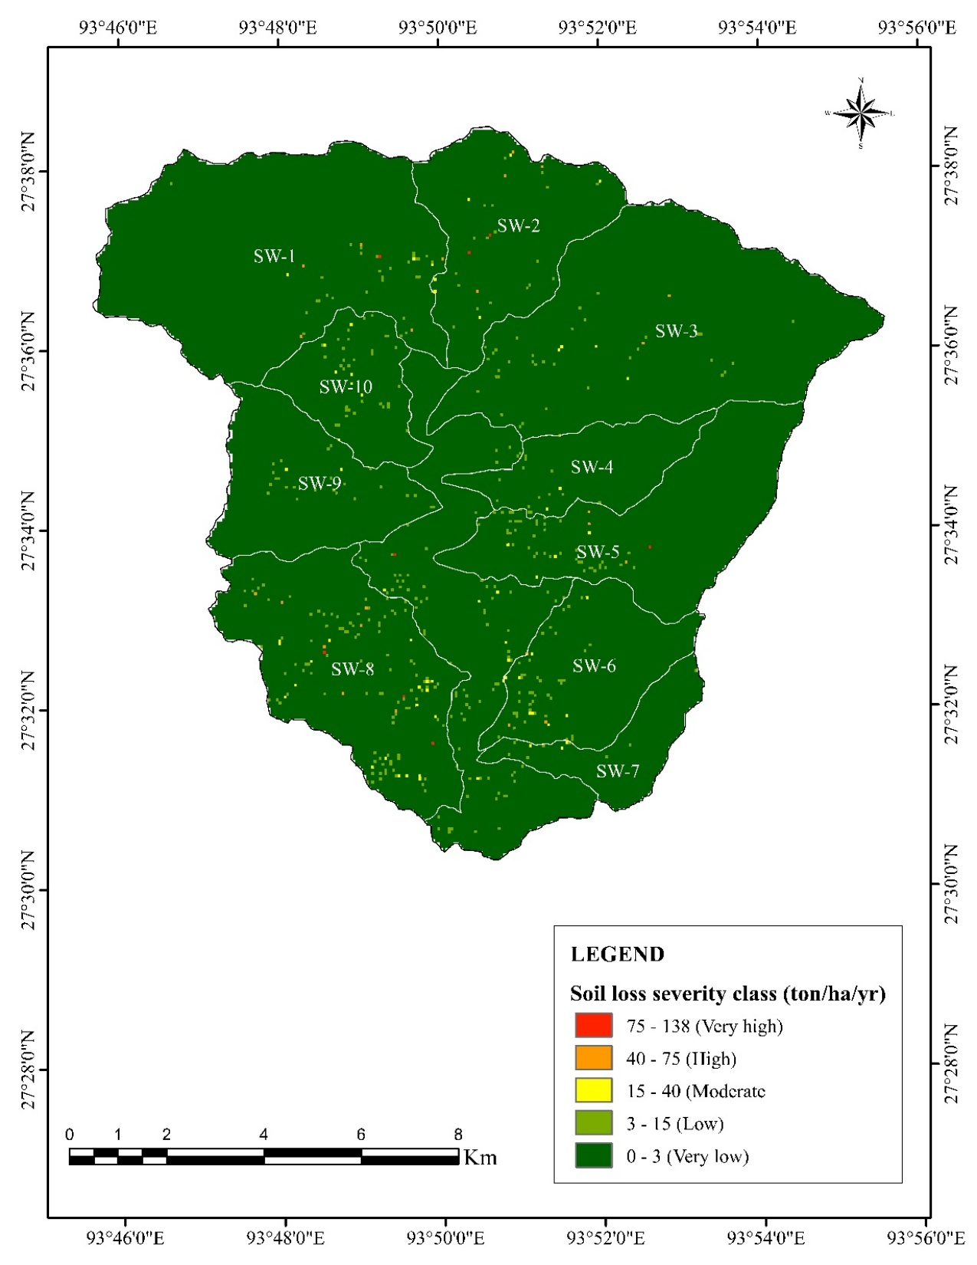

Fig. 8 Soil Loss Severity Map

4. Conclusion
This study assessed the annual soil loss in the Kiile watershed using the USLE model integrated in a GIS environment. The analysis showed that 0.12% of the area experiences very high erosion (75-138 t ha⁻¹ yr ⁻¹), 0.14% high (40-75 t ha⁻¹ yr ⁻¹), 0.21% moderate (15-40 t ha⁻¹ yr ⁻¹), 0.75% low (3-15 t ha⁻¹ yr ⁻¹), and 98.78% very low (0-3 t ha⁻¹ yr ⁻¹). Very high erosion is confined to a few isolated areas in the northern and southwestern regions of the watershed, largely due to anthropogenic pressures such as deforestation, quarrying, sand mining, and adverse land-use practices. Although these zones occupy a limited spatial extent at present, the absence of timely conservation measures may exacerbate erosion risks and pose significant threats in the future. The findings, therefore, underscore the urgent need for targeted soil and water conservation interventions in these critical areas to prevent further land degradation.
Disclaimer (Artificial intelligence)

Author(s) hereby declare that NO generative AI technologies such as Large Language Models (ChatGPT, COPILOT, etc.) and text-to-image generators have been used during the writing or editing of this manuscript.

References

- Agarwal, K. K., Bali, R., Kumar, G., Srivastava, P., & Singh, P. V. (2009). Active tectonics in and around Kimin–Ziro area, Lower Subansiri District, Arunachal Pradesh, NE India. Zeitschrift für Geomorphologie, 53(1), 109–118.
- Balasubramani, K., Veena, M., Kumaraswamy, K., & Saravanabavan, V. (2015). Estimation of soil erosion in a semi-arid watershed of Tamil Nadu (India) using revised universal soil loss equation (RUSLE) through GIS. Model Earth Systems Environment 1, 1–17. https://doi.org/10.1007/s40808-015-0015-4
- Benavidez, R., Jackson, B., Maxwell, D., & Norton, K. (2018). A review of the (revised) universal soil loss equation ((R)USLE): towards improving global applicability and soil loss estimates. Hydrol Earth System Science 22(11):6059–6086. https://doi.org/10.5194/hess-22-6059-2018
- Bera, A. (2017). Assessment of soil loss using the universal soil loss equation (USLE) model and GIS: a case study of the Gumti River basin, Tripura, India. Modeling Earth System Environment 3, 1–9.
- Brhane, G., & Mekonen, K. (2009). Estimating soil loss using universal soil loss equation (USLE) for conservation planning in the Medego watershed, northern Ethiopia. Journal of American Science 5(1), 58–69.
- Biggelaar, C.D., Lal, R., Wiebe, K., & Breneman, V. (2004). The global impact of soil erosion on productivity: I. Absolute and relative erosion-induced yield losses. Advances in Agronomy 81, 1–48. https://doi.org/10.1016/S0065-2113(03)81001-5
- Chakrabortty, R., Pal, S.C., Sahana, M., Mondal, A., Dou, J., Pham, B.T., & Yunus, A.P. (2020). Identification of soil erosion hotspot zones using machine learning and statistical approaches in eastern India. Natural Hazards 104(2),1259–1294.
- Erdogan, E.H., Erpul, G., & Bayramin, I. (2007). Prediction of soil loss in a semiarid agricultural watershed using USLE and GIS. Environmental Monitoring Assessment 131, 153–161. https://doi.org/10.1007/s10661-006-9464-6
- Erencin, Z., Shrestha, D. P., & Krol, I. B. (2000). C-factor mapping using remote sensing and GIS: A case study from Lom Sak–Lom Kao, Thailand. M.Sc. Thesis, Geographical Institute, Justus-Liebig University Giessen, in cooperation with the International Institute for Aerospace Survey and Earth Sciences (ITC), Enschede, The Netherlands.
- FAO (1977). A Framework for Land Evaluation. FAO Soils Bulletin No. 32, Food and Agriculture Organization of the United Nations, Rome.
- Ghosal, K., & Das Bhattacharya, S. (2020). Review of the RUSLE model. Journal of Indian Society of Remote Sensing 48, 689–707. https://doi.org/10.1007/s12524-019-01097-0
- Handique, A., Dey, P., & Patnaik, S.K. (2023). Application of RUSLE for soil erosion estimation and prioritization of erosion-prone areas in Majuli Island, Assam, India. Journal of Applied Natural Science 15(4), 1667–1678. https://doi.org/10.31018/jans.v15i4.5176
- Hui, L., Xiaoling, C., Lim, K.J., Xiaobin, C., & Sagong, M. (2010). Assessment of soil erosion and sediment yield using USLE, GIS, and remote sensing in Liao watershed, China. Journal of Earth Science 21(6), 941–953. https://doi.org/10.1007/s12583-010-0147-4
- Jain, S.K., Kumar, S., & Varghese, J. (2001). Estimation of soil erosion for a Himalayan watershed using GIS techniques. Water Resource Management 15, 41–54. https://doi.org/10.1023/A:1012246029263
- Jang, C., Shin, Y., Kum, D., Kim, R., Yang, J.E., Kim, S.C., & Jung, Y. (2015). Assessment of soil loss based on land-cover types in South Korea. Stochastic Environment Research Risk Assessment 29, 2127–2141. https://doi.org/10.1007/s00477-015-1027-3
- Makhdumi, W., Shwetha, H.R., & Dwarakish, G.S. (2023). Soil erosion across agroecological regions of India: a review of USLE-based modeling. Environmental Monitoring and Assessment 195(9),1112. https://doi.org/10.1007/s10661-023-11687-8
- Marake, M. V., Abegunrin, T. P., Awe, G. O., Seutloali Thamae, K., & Motšoane, M. P. (2026). Quantifying the Influence of Soil Condition, Topography and Land Use on Soil Loss in a Watershed in Phuleng-e-Nyane, Lesotho. Journal of Geography, Environment and Earth Science International, 30(1), 17-32.
- Moges, A., & Tegbaru, G. (2025). Estimation of climate- and watershed management-induced potential soil loss using the USLE in the Demjer watershed, Blue Nile Basin, Ethiopia. Geology, Ecology, and Landscape 9(3), 952–970.
- Mohapatra, R. (2022). Soil erosion assessment and prioritization using RUSLE in a semi-arid river basin of India. Modeling Earth Systems and Environment 8(4), 4883–4896. https://doi.org/10.1007/s40808-022-01388-5
- Ozcan, A.U., Erpul, G., Basaran, M., & Erdogan, H. E. (2008). Assessment of soil erosion risk using USLE, GIS, and geostatistics in Indagi Mountain Pass, Turkey. Environment Geology 53, 1731–1741. https://doi.org/10.1007/s00254-007-0779-6
- Panagos, P., Borrelli, P., & Meusburger, K. (2015). A new European slope length and steepness (LS) factor for soil erosion modeling. Geosciences 5(2), 117–126.
- Patnaik, S.K. (2017). Land holding, ownership, and customary laws governing land fragmentation in Ziro valley, Arunachal Pradesh. Neo Geographia 4(2), 1–12.
- Prasannakumar, V., Shiny, R., Geetha, N., & Vijith, H.J. (2011). Spatial prediction of soil erosion risk using remote sensing, GIS, and RUSLE. Environmental Earth Science 64, 965–972. https://doi.org/10.1007/s12665-011-0913-3
- Rao, Y. (1981). Evaluation of cropping management factor in universal soil loss equation under natural rainfall conditions at Kharagpur, India. In: Proc Southeast Asian Reg Symp Soil Erosion and Sedimentation, AIT, Bangkok, pp. 241–254.
- Rupa, T. (2015). Hydro geomorphologic analysis of upper Kiiley river basin using remote sensing technique. Neo Geographia, 4(2).
- Sharpley, A. N., & Williams, J. R. (1990). EPIC—Erosion/productivity impact calculator: Model documentation (USDA Technical Bulletin No. 1768). Washington, DC: U.S. Department of Agriculture.
- Shi, Z.H., Cai, C.F., Ding, S.W., Wang, T.W., & Chow, T.L. (2004). Soil conservation planning using RUSLE and GIS at the small watershed scale, Three Gorges area, China. Catena 55, 33–48.
- Singh, G. (1981). Soil loss prediction research in India. Dehradun, India: Central Soil and Water Conservation Research and Training Institute (CSWCRTI).
- Sfeir-Younis, A. (1986). Soil conservation in developing countries. Washington, DC: World Bank.
- USDA-SCS (1972). National Engineering Handbook, Section 4: Hydrology. U.S. Department of Agriculture, Soil Conservation Service, Washington, D.C.
- Wischmeier, W. H., & Smith, D. D. (1978). Predicting rainfall erosion losses: A guide to conservation planning (Agriculture Handbook No. 537). Washington, DC: U.S. Department of Agriculture.

