Harnessing Neural Networks for Accurate Potential Evapotranspiration Forecasting Using the Thornthwaite Method: A Case Study in Semi-Arid Aurangabad District of Maharashtra, India

Abstract
Potential evapotranspiration (PET) is a crucial parameter for effective water resource management, particularly in semi-arid regions like Aurangabad district. PET was estimated for nine stations in this region using the Thornthwaite method, which is a widely-used approach for determining this important variable. Time series analysis revealed significant autocorrelation and stationarity, confirming the suitability of the data for modeling. A feed-forward neural network with 12 input, 4 hidden, and 1 output neuron was implemented for PET forecasting. The FFNN (Feed Forward Neural Network) demonstrated robust accuracy, with training mean absolute error of 7.86–11.52 and validation MAE of 11.21–16.83. RMSE ranged from 10.32 to 15.12 during training and 14.94 to 23.06 during validation. Percent bias remained below 2.2%, and Nash-Sutcliffe efficiency exceeded 0.97 in training and 0.92 in validation. Vaijapur performed best, achieving a validation RMSE of 14.94, MSE of 223.35, and R² of 0.95. Conversely, Sillod recorded the highest validation errors, highlighting regional variability. The FFNN effectively captured PET dynamics with minimal over-fitting, supporting its application in optimizing water use and agricultural planning. Localized calibration is recommended for stations with higher errors to enhance accuracy
Keywords: PET Forecasting, ANN, Thornthwaite Method, water resource management
Introduction
Potential evapotranspiration (PET) is a critical parameter in the hydrological cycle, representing the maximum amount of water that could be transferred to the atmosphere through evaporation and transpiration under ideal environmental conditions (Laaboudi et al., 2012; Adnan et al., 2017; Mirambell et al., 2017; Chia et al., 2020). Accurate forecasting of PET is essential for effective water resource management, irrigation planning, and agricultural productivity. Among various estimation methods, the Thornthwaite method, which uses temperature as a primary variable, is widely applied due to its simplicity and adaptability, especially in regions with limited climatic data availability (Umar & Yusuf, 2019; Adem et al., 2017; Maeda et al., 2010; Barros et al., 2021).
However, the Thornthwaite method has been shown to underestimate PET, particularly in arid and semi-arid regions (Nia et al., 2008). In recent years, the use of artificial neural networks has emerged as a promising approach for PET forecasting(Zhao et al., 2021;Tegos et al., 2017;Jang et al., 2021;Majhi & Naidu, 2021).
Forecasting PET as a time series variable allows for the prediction of future values based on historical trends, enabling informed decision-making for water resource planning and agricultural management (Jain & Ormsbee, 2002;Bata et al., 2020;Alsumaiei, 2020). Traditional stochastic models, such as Autoregressive Integrated Moving Average (ARIMA) (Popale and Gorantiwar, 2014; shrikant et al., 2023; Mallikarjun Reddy et al. 2023; Rahul et al., 2020) have been extensively utilized for hydrological forecasting (Nigam et al., 2014;Essenfelder et al., 2020;Koutsoyiannis, 2000). However, the nonlinear and complex nature of PET processes often requires more advanced approaches. Artificial Neural Networks (ANN), with their ability to model nonlinear relationships and learn from historical data patterns, have emerged as a robust alternative for time series forecasting(Panja et al., 2022;Tealab, 2018;Benidis et al., 2022;Faloutsos et al., 2020;Sezer et al., 2019;Yeo et al., 2018;Gutierrez et al., 2007).
This approach aims to address the limitations of traditional models by incorporating the flexibility and predictive power of ANN, making it particularly suitable for regions with diverse climatic conditions(Jang et al., 2021;Grabar et al., 2023;Zang et al., 2020).
One lead-time prediction of PET is critical for real-time decision-making in irrigation scheduling and water resource management(Zhao et al., 2021;Agyeman et al., 2021;Qiu & Cheng, 2023). By providing a reliable forecast of PET, the study supports efficient water allocation and helps mitigate the adverse impacts of water scarcity on agricultural productivity (Agyeman et al., 2023;Zhao et al., 2021;Yu & Shang, 2020). The integration of the Thornthwaite method for PET estimation with ANN-based forecasting models offers a comprehensive framework for understanding and predicting PET dynamics, contributing to the sustainable management of water resources in the Aurangabad district.
Materials and methods
Study Area
Aurangabad district, located in the Marathwada region of Maharashtra, experiences a semi-arid climate with distinct seasonal variations. Summers are hot, with temperatures often exceeding 40°C, while winters are mild. The average annual rainfall ranges between 600-800 mm, primarily received during the monsoon season (June to September). The district includes talukas such as Aurangabad, Gangapur, Kannad, Khuldabad, Paithan, Phulambri, Sillod, Soegaon, and Vaijapur. Talukas like Kannad and Khuldabad, situated at higher elevations, experience relatively cooler temperatures and slightly higher rainfall. Paithan, influenced by the Godavari River, supports agriculture, while other talukas largely depend on monsoonal rains for water resources. In this study, the PET time series for Aaurangabad district, estimated using the Thornthwaite method, is analyzed and forecasted using an ANN-based model for one lead-time prediction. The ANN model leverages historical PET data to capture intricate temporal patterns and provide accurate forecasts. The estimation of the monthly potential evapotranspiration (PET) was calculated for a period of 1970 – 2023.
Thornthwaite method (Potential evapotranspiration)
The potential evapotranspiration is calculated by:
$$\text{PET=16K}{\left(\frac{\text{10T}}{\text{I}}\right)}^{\text{m}}$$
Where T is monthly mean temperature (°C); I is heat index calculated as the sum of 12 month index values; m is the coefficient dependent on I.
m=6.75 × 10⁻⁷·I³ – 7.71 × 10⁻⁷·I² + 1.79 × 10 ⁻²·I + 0.492
K is a correction coefficient computed as a function of the latitude and month.

Auto correlation test (Box Ljung test)
The null hypothesis of the Box Ljung Test, H₀, is that our model does not show lack of fit (or in simple terms—the model is just fine). The alternate hypothesis, H_{a}, is just that the model does show a lack of fit. A significant p-value in this test rejects the null hypothesis that the time series isn’t auto correlated.

Stationary test (Dickey fuller test)
A time series is said to be stationary (in the weak sense) if its statistical properties do not vary with time (means and variance). If the compute p values are greater than 0.05 the series is said to be non stationary. The time series need to be in stationary form in order to fit to stochastic models.
Artificial Neural Network (ANN)
An Artificial Neural Network (ANN) is an advanced information processing system inspired by the structure and functioning of the human brain (Kumar et al., 2002). ANN modeling has evolved significantly with improvements in calibration and computational methodologies. ANNs are highly versatile and capable of modeling complex relationships between independent and dependent variables. Unlike traditional models, ANNs do not require explicit definitions of intermediate relationships between inputs and outputs, making them well-suited for complex processes such as time series forecasting (Ghiassi & Nangoy, 2009)(Lai et al., 2017).
In this study, ANNs are applied to forecast potential evapotranspiration (PET) time series data using a direct one-time-step-ahead forecasting approach. While many neural network architectures exist, the feed-forward network remains the most widely used for time series forecasting. This model uses input nodes representing lagged observations and processes them through hidden layers with nonlinear transfer functions, generating forecasts as output (Fig. 1). In this context, 80% of the available PET data was used for training the ANN model, while the remaining 20% was reserved for validation. This approach ensures that the model effectively learns patterns in the data while maintaining robustness during testing. By focusing on one-step-ahead forecasting, the study aims to deliver precise predictions, enabling improved water resource management and agricultural planning.

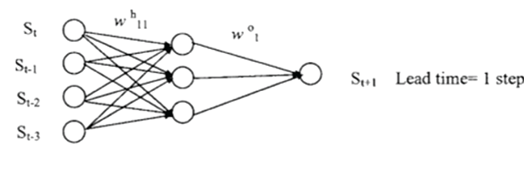
Fig. 1 Feed Forward Neural Network (FFNN) for univariate time series
Results and discussion
Autocorrelation of Potential Evapotranspiration (PET) time series
The results of the Ljung-Box test for autocorrelation across all stations in the Aurangabad district indicate significant autocorrelation in the PET time series data (Table 1). High chi-squared values were observed for all stations, ranging from 336.51 (Phulambri) to 348.35 (Vaijapur), with 1 degree of freedom and P-values < 0.001, confirming statistical significance. This demonstrates that past values strongly influence the PET data across all stations, with Vaijapur showing slightly higher autocorrelation compared to the others. These results highlight the necessity of using advanced time series models that account for temporal dependencies for accurate PET forecasting.
Table 1. Auto correlation test for different station of Aurangabad Districts
Station | chi-squared | df | P-value
Aurangabad | 338.78 | 1 | <0.001
Gangapur | 338.63 | 1 | <0.001
Kannad | 336.88 | 1 | <0.001
Khuldabad | 338.89 | 1 | <0.001
Paithan | 338.44 | 1 | <0.001
Phulambri | 336.51 | 1 | <0.001
Sillod | 336.69 | 1 | <0.001
Soageon | 336.92 | 1 | <0.001
Vaijapur | 348.35 | 1 | <0.001

Stationarity test of Potential Evapotranspiration (PET) using Dickey –Fuller Method
The results of the Dickey-Fuller Test for stationarity across all stations in the Aurangabad district indicate that the PET time series data is stationary. The test statistics (Dickey-Fuller values) are highly negative, ranging from -24.79 (Vaijapur) to -26.86 (Soegaon), with a lag order of 8 for all stations. The corresponding P-values are <0.01 for all cases, indicating that the null hypothesis of non-stationarity is rejected at a 99% confidence level. These findings confirm that the PET time series data for all stations is stationary and suitable for time series modeling techniques such as ARIMA or ANN.
Table 2. Stationarity test of the monthly potential evapotranspiration timeseries for stations of Aurangabad District.
Station | dickey-Fuller | lag-order | P-value
Aurangabad | -25.68 | 8 | <0.01
Gangapur | -25.67 | 8 | <0.01
Kannad | -26.84 | 8 | <0.01
Khuldabad | -25.69 | 8 | <0.01
Paithan | -25.66 | 8 | <0.01
Phulambri | -26.83 | 8 | <0.01
Sillod | -26.85 | 8 | <0.01
Soageon | -26.86 | 8 | <0.01
Vaijapur | -24.79 | 8 | <0.01

Architecture and parameters of Feed forward neural network (FFNN)
The table 3 presents the implementation of a feed-forward neural network (FFNN) with a consistent (12-4-1) architecture across multiple stations for forecasting potential evapotranspiration (PET). The architecture consists of 12 input neurons representing lagged time series values, which correspond to the previous 12 time steps of PET or relevant meteorological variables, enabling the model to capture temporal dependencies. The hidden layer comprises 4 neurons designed to learn and model non-linear relationships, while the output layer, with a single neuron, predicts the PET value for the next time step. Each station—Aurangabad, Gangapur, Kannad, Khuldabad, Paithan, Phulambri, Sillod, Soegaon, and Vaijapur—uses the same architecture and configuration, with 57 trainable parameters per model. These parameters include weights and biases distributed across the input, hidden, and output layers. The uniformity in architecture and parameter count across stations reflects a standardized approach to modeling PET forecasts, ensuring consistency in the methodology while accommodating location-specific data inputs.
Table. 3. FFNN Architecture and the parameter brief for different station of Aurangabad District
Station | Architecture | parameters
Aurangabad | 12-4-1 | 57
Gangapur | 12-4-1 | 57
Kannad | 12-4-1 | 57
Khuldabad | 12-4-1 | 57
Paithan | 12-4-1 | 57
Phulambri | 12-4-1 | 57
Sillod | 12-4-1 | 57
Soageon | 12-4-1 | 57
Vaijapur | 12-4-1 | 57

Forecasting of Potential Evapotranspiration (PET) time series using FFNN for Aurangabad District
The forecasting results for potential evapotranspiration (PET) time series across nine locations—Aurangabad, Gangapur, Kannad, Khuldabad, Paithan, Phulambri, Sillod, Soageon, and Vaijapur—were assessed using multiple performance metrics to evaluate the model's predictive capability during both training and validation phases (Table 4 & 5). The mean absolute error (MAE), which measures the average prediction error, ranged from 7.86 to 11.52 in the training phase and increased slightly in validation, ranging from 11.21 to 16.83, indicating that while the model was highly accurate in training, it generalized well to unseen data with only a minor increase in error. Mean squared error (MSE) and root mean squared error (RMSE), which give greater weight to larger errors, followed a similar trend. Training MSE ranged from 106.51 in Vaijapur to 228.7 in Kannad, with corresponding RMSE values between 10.32 and 15.12. Validation MSE and RMSE were higher, with Vaijapur maintaining the lowest values (223.35 and 14.94, respectively), while Sillod recorded the highest validation errors (MSE: 531.82, RMSE: 23.06), indicating greater predictive challenges in this region. Percent bias (PBIAS), which quantifies the model’s tendency to over- or under-predict, remained consistently low across all locations, with a maximum deviation of 2.2% in validation, suggesting negligible systematic bias. The relative standard deviation (rSD) values, which compare the variability of predictions to the observed data, ranged narrowly from 1.02 to 1.09 in both training and validation phases, demonstrating that the model maintained stable variance irrespective of the dataset or region. High Nash-Sutcliffe efficiency (NSE) values, exceeding 0.97 during training and remaining above 0.92 during validation, reflected the model's strong performance in replicating observed PET dynamics. Similarly, correlation coefficients (r) ranged between 0.98 and 0.99 in both phases, further underscoring the close agreement between observed and predicted values. The coefficient of determination (R²) values, which measure the proportion of variance in observed PET explained by the model, were consistently high, with Vaijapur achieving the highest R² of 0.95 in validation, indicating the model’s superior accuracy in this location. Comparing regions, Vaijapur consistently exhibited the best performance across metrics, likely due to its less complex PET dynamics. In contrast, locations like Kannad and Sillod showed higher validation errors, suggesting greater variability or environmental factors affecting predictability. Despite these regional differences, the model maintained robust overall performance, generalizing well from training to validation with minimal overfitting. These results highlight the model’s effectiveness in forecasting PET across diverse climatic and geographic conditions, providing a reliable foundation for applications in water resource management and agricultural planning, while also suggesting potential for further calibration in regions with higher predictive challenges. The forecasted time series of the training and the validation visualization are been shown in fig 2 and 3 for Aurangabad station.
Table 4. Performance of the FFNN model under for training dataset for different stations of Aurangabad District
Parameter | Aurangabad | Gangapur | Kannad | Khuldabad | Paithan | Phulambri | Sillod | Soageon | Vaijapur
MAE | 14.76 | 14.75 | 16.07 | 14.7 | 14.85 | 16.05 | 16.83 | 16.22 | 11.21
MSE | 427.97 | 410.12 | 522.02 | 423.28 | 432.81 | 511.44 | 531.82 | 504.21 | 223.35
RMSE | 20.69 | 20.25 | 22.85 | 20.57 | 20.8 | 22.62 | 23.06 | 22.45 | 14.94
PBIAS % | 1.3 | 1.6 | 2 | 1.5 | 1.2 | 2 | 2.2 | 2.2 | 1.6
rSD | 1.08 | 1.08 | 1.08 | 1.08 | 1.08 | 1.08 | 1.09 | 1.08 | 1.07
NSE | 0.92 | 0.93 | 0.92 | 0.93 | 0.92 | 0.92 | 0.92 | 0.92 | 0.94
r | 0.97 | 0.97 | 0.97 | 0.97 | 0.97 | 0.97 | 0.97 | 0.97 | 0.98
R2 | 0.94 | 0.94 | 0.93 | 0.94 | 0.94 | 0.94 | 0.93 | 0.94 | 0.95

Table 5. Performance of the FFNN model under for validation dataset for different stations of Aurangabad District
Parameter | Aurangabad | Gangapur | Kannad | Khuldabad | Paithan | Phulambri | Sillod | Soageon | Vaijapur
MAE | 10.03 | 10.16 | 11.52 | 9.99 | 10.01 | 9.11 | 11.38 | 11.41 | 7.86
MSE | 175.42 | 182.76 | 228.7 | 178.51 | 176.54 | 143.2 | 225.8 | 224.49 | 106.51
RMSE | 13.24 | 13.52 | 15.12 | 13.36 | 13.29 | 11.97 | 15.03 | 14.98 | 10.32
PBIAS % | 0 | 0 | 0 | 0 | 0 | 0 | 0 | 0 | 0
rSD | 1.02 | 1.02 | 1.02 | 1.02 | 1.02 | 1.02 | 1.02 | 1.02 | 1.02
NSE | 0.97 | 0.97 | 0.97 | 0.97 | 0.97 | 0.97 | 0.97 | 0.97 | 0.97
r | 0.99 | 0.98 | 0.98 | 0.98 | 0.99 | 0.99 | 0.98 | 0.98 | 0.99
R2 | 0.97 | 0.97 | 0.97 | 0.97 | 0.97 | 0.98 | 0.97 | 0.97 | 0.97

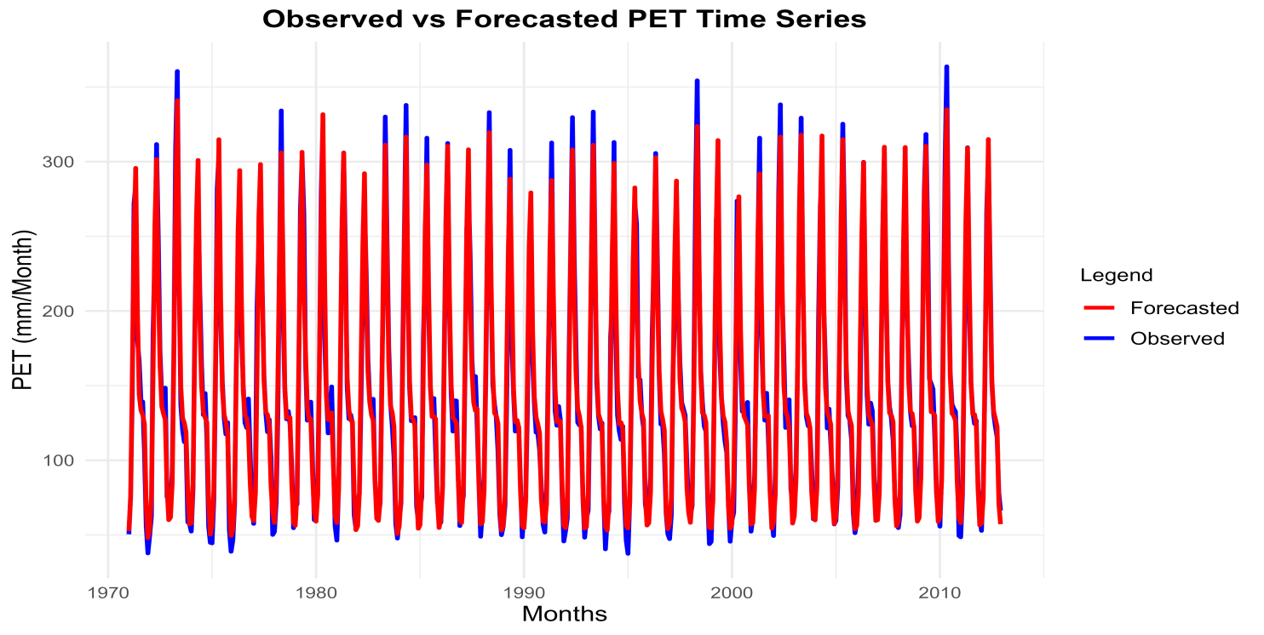
Fig. 2 Modelled time-series representation of observed and Forecasted PET using FFNN during training.

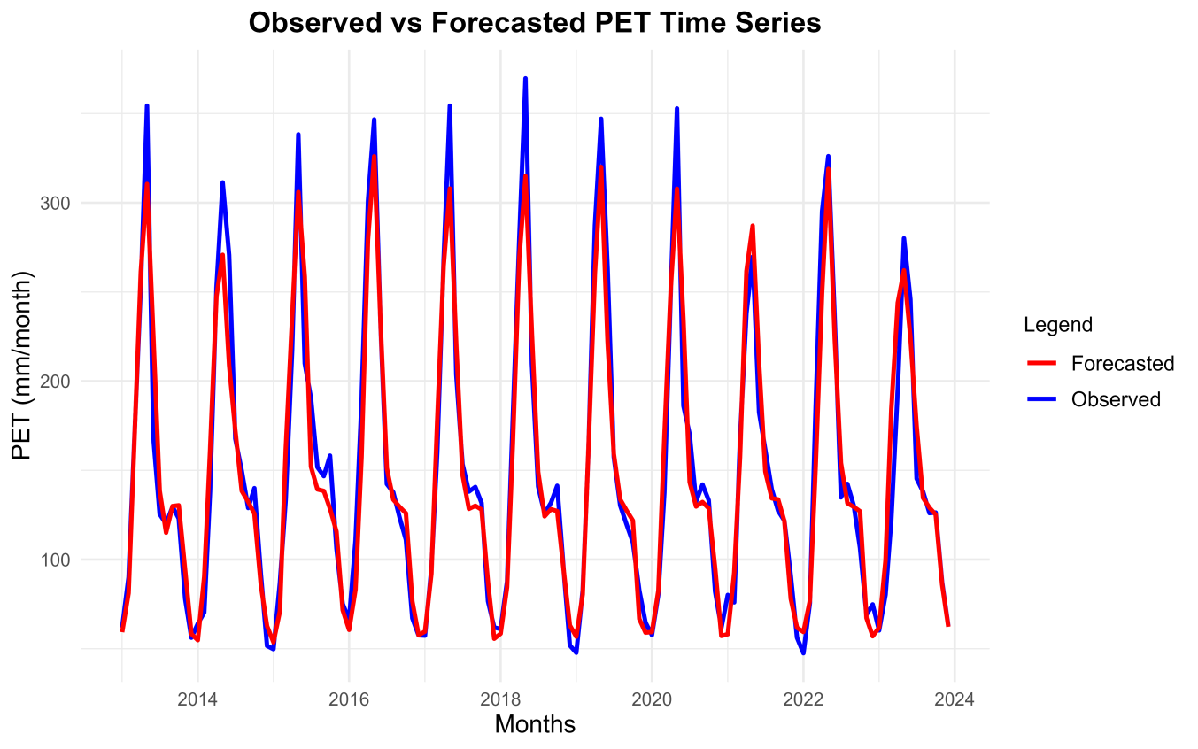
Fig. 3 Modelled time-series representation of observed and Forecasted PET using FFNN during testing.

Summary and Conclusion
The analysis of potential evapotranspiration (PET) time series data across nine stations in the Aurangabad district revealed significant autocorrelation, with chi-squared values ranging from 336.51 (Phulambri) to 348.35 (Vaijapur) and P-values below 0.001, confirming the strong influence of past values on PET dynamics. Stationarity tests using the Dickey-Fuller test further validated the suitability of the data for time series modeling, with highly negative test statistics ranging from -24.79 (Vaijapur) to -26.86 (Soegaon) and P-values below 0.01 at a lag order of 8.
A feed-forward neural network (FFNN) architecture with 12 input neurons, 4 hidden neurons, and 1 output neuron was implemented across all stations to forecast PET. The model demonstrated robust performance, with mean absolute error (MAE) ranging from 7.86 to 11.52 during training and increasing slightly to 11.21 to 16.83 during validation. Root mean squared error (RMSE) values followed a similar trend, ranging from 10.32 to 15.12 in training and increasing to 14.94 to 23.06 during validation. Percent bias (PBIAS) remained below 2.2% across all stations, indicating negligible systematic bias, while Nash-Sutcliffe efficiency (NSE) values exceeded 0.97 in training and remained above 0.92 during validation, reflecting the model's strong ability to replicate observed PET dynamics. Correlation coefficients were consistently high, ranging from 0.98 to 0.99 in both phases, and R² values reached as high as 0.95 during validation, particularly in Vaijapur. Vaijapur emerged as the best-performing station, with validation MSE and RMSE values of 223.35 and 14.94, respectively, and the highest R² of 0.95. Conversely, stations such as Sillod and Kannad faced greater predictive challenges, with Sillod recording the highest validation errors, including an MSE of 531.82 and RMSE of 23.06, suggesting more complex environmental variability in these regions.
The present study employs potential evapotranspiration (PET) computed using the Thornthwaite method, which relies simply on air temperature. Although this method's simplicity and low data needs make it useful in areas with little data, it does not specifically take into consideration other significant climatic factors that affect evapotranspiration, such as solar radiation, wind speed, and atmospheric humidity. As a result, the physical variability of evapotranspiration under various climatic conditions may not be adequately captured by the PET estimates. Model generalisation and forecasting performance may be improved by adding more meteorological variables or PET estimates obtained from physically based techniques (such as Penman-Monteith) as inputs to the ANN framework. Multi-variable ANN designs may be investigated in future research to increase prediction accuracy, especially in the context of shifting climate conditions.
Overall, the FFNN model provided accurate and reliable PET forecasts across diverse climatic and geographic conditions, with minimal overfitting and stable variance between observed and predicted values. These results underscore the model's potential for applications in water resource management and agricultural planning. However, regions with higher validation errors, such as Sillod and Kannad, may benefit from localized model calibration to enhance predictive performance further.
Disclaimer (Artificial intelligence)

Author(s) hereby declare that NO generative AI technologies such as Large Language Models (ChatGPT, COPILOT, etc.) and text-to-image generators have been used during the writing or editing of this manuscript.

References
- Adem, A. A., Aynalem, D. W., Tilahun, S. A., & Steenhuis, T. S. (2017). Predicting Reference Evaporation for the Ethiopian Highlands. In Journal of Water Resource and Protection (Vol. 9, Issue 11, p. 1244). Scientific Research Publishing. https://doi.org/10.4236/jwarp.2017.911081
- Adnan, M., Ahsan, M., Abaid-ur-Rehman, & Nazir, M. (2017). Estimating Evapotranspiration using Machine Learning Techniques. In International Journal of Advanced Computer Science and Applications (Vol. 8, Issue 9). Science and Information Organization. https://doi.org/10.14569/ijacsa.2017.080915
- Agyeman, B. T., Naouri, M., Appels, W. M., Liu, J., & Shah, S. L. (2023). Integrating machine learning paradigms and mixed-integer model predictive control for irrigation scheduling. In arXiv (Cornell University). Cornell University. https://doi.org/10.48550/arxiv.2306.08715
- Agyeman, B. T., Sahoo, S. R., Liu, J., & Shah, S. L. (2021). LSTM-based model predictive control with discrete inputs for irrigation scheduling. In arXiv (Cornell University). Cornell University. https://doi.org/10.48550/arxiv.2112.06352
- Alsumaiei, A. A. (2020). A Nonlinear Autoregressive Modeling Approach for Forecasting Groundwater Level Fluctuation in Urban Aquifers. In Water (Vol. 12, Issue 3, p. 820). Multidisciplinary Digital Publishing Institute. https://doi.org/10.3390/w12030820
- Barros, F. da C., Martins, S. da C. F., Lyra, G. B., Silva, L. D. B. da, Francisco, J. P., Abreu, M. C., & Lyra, G. B. (2021). Thornthwaite and mather soil water balance model adapted for estimation of real evapotranspiration of the pasture. In Revista Engenharia na Agricultura - REVENG (Vol. 29, p. 146). Federal University of Viçosa. https://doi.org/10.13083/reveng.v29i1.11703
- Bata, M. H., Carriveau, R., & Ting, D. S. ‐K. (2020). Short-Term Water Demand Forecasting Using Nonlinear Autoregressive Artificial Neural Networks. In Journal of Water Resources Planning and Management (Vol. 146, Issue 3). American Society of Civil Engineers. https://doi.org/10.1061/(asce)wr.1943-5452.0001165
- Benidis, K., Rangapuram, S. S., Flunkert, V., Wang, Y., Maddix, D. C., Türkmen, C., Gasthaus, J., Schneider, M., Salinas, D., Stella, L., Aubet, F.-X., Callot, L., & Januschowski, T. (2022). Deep Learning for Time Series Forecasting: Tutorial and Literature Survey [Review of Deep Learning for Time Series Forecasting: Tutorial and Literature Survey]. ACM Computing Surveys, 55(6), 1. Association for Computing Machinery. https://doi.org/10.1145/3533382
- Chia, M. Y., Huang, Y. F., Koo, C. H., & Fung, K. F. (2020). Recent Advances in Evapotranspiration Estimation Using Artificial Intelligence Approaches with a Focus on Hybridization Techniques—A Review. In Agronomy (Vol. 10, Issue 1, p. 101). Multidisciplinary Digital Publishing Institute. https://doi.org/10.3390/agronomy10010101
- Essenfelder, A. H., Larosa, F., Mazzoli, P., Bagli, S., Broccoli, D., Luzzi, V., Myšiak, J., Mercogliano, P., & Valle, F. D. (2020). Smart Climate Hydropower Tool: A Machine-Learning Seasonal Forecasting Climate Service to Support Cost–Benefit Analysis of Reservoir Management. In Atmosphere (Vol. 11, Issue 12, p. 1305). Multidisciplinary Digital Publishing Institute. https://doi.org/10.3390/atmos11121305
- Faloutsos, C., Flunkert, V., Gasthaus, J., Januschowski, T., & Wang, Y. (2020). Forecasting Big Time Series: Theory and Practice. In Companion Proceedings of the The Web Conference 2018 (p. 320). https://doi.org/10.1145/3366424.3383118
- Gorlapalli A, Kallakuri S, Sreekanth PD, Patil R, Bandumula N, Ondrasek G, Admala M, Gireesh C, Anantha MS, Parmar B, et al. Characterization and Prediction of Water Stress Using Time Series and Artificial Intelligence Models. Sustainability. 2022; 14(11):6690. https://doi.org/10.3390/su14116690
- Grabar, V., Marusov, A., Zaytsev, A., Maximov, Y., Sotiriadi, N., & Bulkin, A. (2023). Long-term drought prediction using deep neural networks based on geospatial weather data. In arXiv (Cornell University). Cornell University. https://doi.org/10.48550/arxiv.2309.06212
- Gutierrez, R. S., Solis, A. O., & Mukhopadhyay, S. (2007). Lumpy demand forecasting using neural networks. In International Journal of Production Economics (Vol. 111, Issue 2, p. 409). Elsevier BV. https://doi.org/10.1016/j.ijpe.2007.01.007
- Jain, A., & Ormsbee, L. (2002). Short‐term water demand forecast modeling techniques—CONVENTIONAL METHODS VERSUS AI. In American Water Works Association (Vol. 94, Issue 7, p. 64). Wiley. https://doi.org/10.1002/j.1551-8833.2002.tb09507.x
- Jang, J.-C., Sohn, E.-H., Park, K., & Lee, S. (2021). Estimation of Daily Potential Evapotranspiration in Real-Time from GK2A/AMI Data Using Artificial Neural Network for the Korean Peninsula. In Hydrology (Vol. 8, Issue 3, p. 129). Multidisciplinary Digital Publishing Institute. https://doi.org/10.3390/hydrology8030129
- Koutsoyiannis, D. (2000). A generalized mathematical framework for stochastic simulation and forecast of hydrologic time series. In Water Resources Research (Vol. 36, Issue 6, p. 1519). Wiley. https://doi.org/10.1029/2000wr900044
- Laaboudi, A., Mouhouche, B., & Draoui, B. (2012). Conceptual Reference Evapotranspiration Models for Different Time Steps. In Journal of Petroleum & Environmental Biotechnology (Vol. 3, Issue 4). OMICS Publishing Group. https://doi.org/10.4172/2157-7463.1000123
- Maeda, E. E., Wiberg, D., & Pellikka, P. (2010). Estimating reference evapotranspiration using remote sensing and empirical models in a region with limited ground data availability in Kenya. In Applied Geography (Vol. 31, Issue 1, p. 251). Elsevier BV. https://doi.org/10.1016/j.apgeog.2010.05.011
- Majhi, B., & Naidu, D. (2021). Differential evolution based radial basis function neural network model for reference evapotranspiration estimation. In SN Applied Sciences (Vol. 3, Issue 1). Springer Nature. https://doi.org/10.1007/s42452-020-04069-z
- Mirambell, A. B., Silva, C. F. da, Barbosa, F. de S., & Ribeiro, C. B. de M. (2017). A Methodological Proposal Based on Artificial Neural Networks for Evapotranspiration Assessment. In Journal of Agricultural Science (Vol. 9, Issue 5, p. 142). Canadian Center of Science and Education. https://doi.org/10.5539/jas.v9n5p142
- Nia, A. M., Gousheh, M. G., Piri, J., Amin, S., & Han, D. (2008). Evaporation estimation using artificial neural networks and adaptive neuro-fuzzy inference system techniques. In Advances in Water Resources (Vol. 32, Issue 1, p. 88). Elsevier BV. https://doi.org/10.1016/j.advwatres.2008.10.005
- Nigam, R., Nigam, S., & Mittal, S. K. (2014). Stochastic modelling of rainfall and runoff phenomenon: a time series approach review. In International Journal of Hydrology Science and Technology (Vol. 4, Issue 2, p. 81). https://doi.org/10.1504/ijhst.2014.066437
- Panja, M., Chakraborty, T., Kumar, U., & Hadid, A. (2022). Probabilistic AutoRegressive Neural Networks for Accurate Long-range Forecasting. In arXiv (Cornell University). Cornell University. https://doi.org/10.48550/arxiv.2204.09640
- Patil, R., Nagaraj, D.M., Polisgowdar, B.S. and Rathod, S., 2022. Forecasting potential evapotranspiration for Raichur district using seasonal ARIMA model. Mausam, 73(2), pp.433-440.
- Qiu, B., & Cheng, W. (2023). Intelligent Control of Agricultural Irrigation through Water Demand Prediction Based on Artificial Neural Network. https://downloads.hindawi.com/journals/cin/2021/7414949.pdf
- Reddy, Mallikarjun & Basavareddy, & Patil, Rahul & Pragna, Guguloth & Premkumara,. (2023). Forecasting Potential Evapotranspiration for Yadgir District Karnataka, India using Seasonal Arima Model. Ecology, Environment and Conservation. 29. 154-160. 10.53550/EEC.2023.v29i06s.025.
- Sezer, Ö. B., Gudelek, M. U., & Özbayoğlu, A. M. (2019). Financial Time Series Forecasting with Deep Learning : A Systematic Literature Review: 2005-2019. In arXiv (Cornell University). Cornell University. https://doi.org/10.48550/arxiv.1911.13288
- Shrikant, Reddy, G. Manjunath, M. & Patil, Rahul & Kulkarni, Prasad. (2023). Predicting Potential Evapotranspiration for Kalaburagi District using a Seasonal Arima Model. International Journal of Environment and Climate Change. 13. 2073-2082. 10.9734/ijecc/2023/v13i113367.
- Tealab, A. (2018). Time series forecasting using artificial neural networks methodologies: A systematic review [Review of Time series forecasting using artificial neural networks methodologies: A systematic review]. Future Computing and Informatics Journal, 3(2), 334. Elsevier BV. https://doi.org/10.1016/j.fcij.2018.10.003
- Tegos, A., Malamos, N., Efstratiadis, A., Tsoukalas, I., Καρανάσιος, Α., & Koutsoyiannis, D. (2017). Parametric Modelling of Potential Evapotranspiration: A Global Survey. In Water (Vol. 9, Issue 10, p. 795). Multidisciplinary Digital Publishing Institute. https://doi.org/10.3390/w9100795
- Umar, R., & Yusuf, M. (2019). Determination of the Growing Season for Dry Land Agriculture Based on Thornthwaite Method in Bulukumba Regency, South Sulawesi Province. In Journal of Physics Conference Series (Vol. 1244, Issue 1, p. 12032). IOP Publishing. https://doi.org/10.1088/1742-6596/1244/1/012032
- Yeo, K., Melnyk, I., Nguyen, N., & Lee, E. K. (2018). DE-RNN: Forecasting the Probability Density Function of Nonlinear Time Series. In 2021 IEEE International Conference on Data Mining (ICDM). https://doi.org/10.1109/icdm.2018.00085
- Yu, B., & Shang, S. (2020). Estimating Growing Season Evapotranspiration and Transpiration of Major Crops over a Large Irrigation District from HJ-1A/1B Data Using a Remote Sensing-Based Dual Source Evapotranspiration Model. In Remote Sensing (Vol. 12, Issue 5, p. 865). Multidisciplinary Digital Publishing Institute. https://doi.org/10.3390/rs12050865
- Zang, H., Liu, L., Sun, L., Cheng, L., Wei, Z., & Sun, G. (2020). Short-term global horizontal irradiance forecasting based on a hybrid CNN-LSTM model with spatiotemporal correlations. In Renewable Energy (Vol. 160, p. 26). Elsevier BV. https://doi.org/10.1016/j.renene.2020.05.150
- Zhao, L., Xu, F., Xia, J., & Wu, H. (2021). Applicability of 12 PET estimation methods in different climate regions in China. In Hydrology Research (Vol. 52, Issue 3, p. 636). UWA Publishing. https://doi.org/10.2166/nh.2021.128

