Original Research Article
Assessment Of The Spatiotemporal Variations Of Turbidity Flow In Lake Pontchartrain Using Remote Sensing (Ndti Method)

ABSTRACT

Turbidity flow plays a critical role in sediment transport, water quality degradation, and ecosystem functioning in lacustrine and estuarine environments, particularly in urbanized coastal regions. Lake Pontchartrain, one of the largest estuaries along the Gulf Coast of the United States, has experienced increasing turbidity driven by sediment inflow, resuspension processes, hydrodynamic forcing, and anthropogenic pressures. This study assesses the spatiotemporal variations of turbidity flow in Lake Pontchartrain using multispectral remote sensing and the Normalized Difference Turbidity Index (NDTI). Sentinel-2 MSI imagery acquired monthly throughout 2023 was processed using Google Earth Engine and ArcGIS Pro to generate turbidity distribution maps. The Normalized Difference Water Index (NDWI) was first applied to delineate open water, followed by NDTI computation to classify turbidity into low, medium, and high categories using a quantile classification scheme. Results reveal pronounced seasonal and spatial variability in turbidity patterns, with higher turbidity concentrations predominantly observed along nearshore zones, river inflow areas, and during periods of increased runoff and sediment resuspension. Conversely, lower turbidity conditions prevailed during periods of reduced discharge and calmer hydrodynamic conditions. The findings demonstrate the effectiveness of NDTI-based remote sensing for monitoring turbidity dynamics and highlight critical zones of sediment influence within Lake Pontchartrain. This study provides valuable insights for environmental monitoring, water quality management, and sustainable conservation planning in estuarine lake systems.
Keywords: Turbidity flow; Lake Pontchartrain; Remote sensing; NDTI; Sentinel-2; Spatiotemporal variation; Sediment dynamics

1 INTRODUCTION
Lakes along river valleys particularly in urban areas, though only a small fraction of the aquatic environment, have numerous ecological, economic, and social importance. They provide water for municipal and industrial use, support subsistence and artisanal fisheries, receive runoff from catchment areas, recharge groundwater aquifers, regulate stream flow, and provide habitats for plants and animals (Akiyama et al., 1996); (Yepez et al., 2015). Hence, their design requires an accurate understanding and prediction of the input, throughput, and output of the host drainage basin, as rivers and streams carry sediments in their flows.
Sediments are naturally occurring materials that are broken down by the action of weathering and erosion and subsequently transported by water (fluvial processes), wind (aeolian processes), and glaciers. The sediment-laden flow could be laminar or turbulent depending on the velocity of the flow, which is usually influenced by several factors such as river regime, flood frequency, reservoir geometry and operation, sediment transport and distribution, possible land use change, and occurrence of turbidity flow (Churchill, 1948). Turbidity flows belong to the family of gravity/density currents. They are sediment-laden water that moves downslope within otherwise still waters (De Cesare et al., 1999). They are produced as a result of a high concentration of suspended sediments, which makes the density of the in-flowing current greater than the density of the ambient water (Fig. 1.), thus providing the driving force. It can also occur as a result of salinity and temperature differences and is greatly influenced by both anthropogenic and environmental factors (Akiyama et al. 1996).
Studies have shown that turbidity flow is one of the determining processes for the transport and deposition of sediments in reservoirs, as they sporadically transport large volumes of sediments through the lakes even to the dam axis (Commandeur, 2015). This underwater avalanche is usually characterized by high suspended sediment concentration and follows the thalweg of the lake to the deepest area near the dam. Turbidity flows promote accelerated reservoir sedimentation, significantly compromise the capacity and functionality of the reservoir due to deposition over the years, and hinder the safe operation of outlet structures such as intakes and sluice pipes and valves that are often smothered (De Cesare et al., 1999).
Reservoir sedimentation due to turbidity flow has been recognized as one of the most crucial issues in this century. This is a result of their complex and turbulent flow structure (Kneller et al., 2000), and their tendency to promote the rapid elimination of reservoirs (Yum et al., 2008). Hence, accelerated erosion with the attendant sediment transportation in the form of turbidity flow has become of great concern in the world (Rapp et al., 1972); (Rapp, 1975); (Jeje, 1987). There are estimates of sediment accumulation in reservoirs reducing reservoir storage capacity by 1% per year (Graf, 1971); (Mahmood, 1987); (Slof, 1997).
Consequently, studies have established a positive correlation between suspended sediment concentration and remotely sensed data based on suspended sediment concentration reflectance due to optical and physical properties of the sediment type, sensor observation angle, etc. (Ritchie and Schiebe 1986); (Chen et al. 1991); (Novo et al., 1991); (Somvanshi et al., 2011); (Mishra et al., 2024); (Singh et al., 2024). Thus, the Normalized Difference Turbidity Index (NDTI) technique plays a crucial role in identifying and quantifying the sediment characteristics/turbidity by providing insights into understanding the spatiotemporal variations of the different turbidity flow/cover in Lake Pontchartrain towards the effective overall functioning of these dynamic ecosystems.

1.1 Statement of the Problem
Lake Pontchartrain is a significant geographic and hydrological feature in southeastern Louisiana, providing great economic, social, and ecological values to the region since its formation thousands of years ago (2600 – 4000 years ago). It is the second-largest inland saltwater body in the United States and together with the adjacent lakes (Lake Maurepas and Lake Borgne) forms one of the largest estuaries in the Gulf Coast region (Figure 1). The Lake also hosts the longest continuous bridge over water in the world (The Lake Pontchartrain Causeway which crosses over the lake) and has been a source of pull factor of rapid development and urbanization to the region over the past 300 years (Figure 2).
However, the lake has experienced significant environmental challenges over the past several decades (shoreline erosion, wetland losses/deterioration, water and sediment pollution, saltwater intrusion, subsidence, sea-level rise, etc.) thereby increasing siltation. The key factors driving these changes are the sediment transport and redistribution during strong wind events and flooding, re-suspension of fine-grained sediments due to wind-driven waves and currents, storms, discharge from Mississippi River, Bonnet Carre Spillway and tributaries, climate change, and the anthropogenic activities around the lake (urban and agricultural runoff). These environmental stresses have resulted in the turbidity of the lake leading to continued losses of wetland and estuarine habitats, water and sediment pollution, and diminished fish and wildlife resources in the lake (Dahm et al., 2015).
Turbidity flow impact on lakes is a large-scale process that leads to diverse negative consequences (Govorushko, 2016) which has over time increased erosional processes, resulting in high sediment yield, and attendant massive siltation leading to reduced storage capacity and functional efficiency. Studies have also shown that turbidity flow has several other detrimental effects apart from degrading reservoir storage capacity and the ancillary benefits associated with it. It is one of the leading causes of water quality impairment in the nation (Environmental Protection Agency, 1998; 2000), and has a huge impact on the ecology, sediment balance, nutrient budget, and lake/river morphology. It causes stream bed degradation, increases scour at structures (bridges), smothers and eliminates spawning beds of aquatic fauna, smothers water intake appurtenances, and accelerates abrasion of hydraulic machinery, thereby decreasing efficiency, increasing maintenance costs, and nullifying investments (Graf, 1984); (ICOLD, 1989); (Morris and Fan, 1998).
Thus, reservoir sedimentation due to turbidity flow is a problem with increasing significance, and currently, little information is available to predict changes in the distribution of turbid waters in the lake basin. It should therefore be apposite to understand the spatiotemporal variations of the turbidity flow in Lake Pontchartrain given the ecological importance of the lake and the threats it faces. This data is critically needed to guide conservation efforts and sustainable management strategies for this significant ecosystem (Setterfield et al., 2014).

1.2 Aim and Objectives
This study aims to apply remote sensing techniques to assess the turbidity flow in Lake Pontchartrain using the NDTI method.
The specific objectives are to:
i. Determine the occurrence of the turbidity flow in Lake Pontchartrain.
ii. Document the spatiotemporal variations of the turbidity pattern in Lake Pontchartrain.

1.3 Justification for Using Remote Sensing (NDTI) for the Study
Regularly, to monitor hydrological parameters, a traditional point-based procedure is adopted with sampling providing high-quality data, but the limitation of this approach is that data collected usually represent isolated sampling points and do not fully reflect comprehensive spatial and temporal variations within the aquatic ecosystem e.g., the monitoring of turbidity flow in rivers was based traditionally on fixed stations by collecting water samples and then analyzing them in the laboratory using gravimetric analysis. This method was tedious, time-consuming, and costly. Consequently, in overcoming these challenges, remote sensing techniques are increasingly being applied and have been recognized as an optimal solution, leveraging advancements in sensors and methodologies (Nikoo et al., 2024), wide area coverage, as well as long-term and continuous water turbidity measurements and monitoring of sedimentation to improve understanding of the spatiotemporal variations of this hydrological phenomenon by adapting the Normalized Difference Turbidity Index (NDTI) using multispectral remote sensing data (Molo et al., 1989); (Collins & Walling, 2004); (Ward et al., 2009); (Yepez, et al., 2015).
Also, remote sensing offers a comprehensive and immediate perspective of aquatic, atmospheric, and terrestrial systems based on extensive utilization of satellite technology in monitoring changes in the observation and study of spatiotemporal variations of surface water bodies (lakes) at both local, regional, and global scales providing spatial resolutions reaching the scale of meters and a temporal frequency surpassing daily interval. It has significant advantages over traditional monitoring methods, including large-scale coverage, real-time/ continuous monitoring capabilities, and cost-effectiveness. The method also provides valuable insights into evidence-based decision-making that is essential for disaster preparedness and resilience building, particularly in flood-prone regions.
2 STUDY AREA
Lake Pontchartrain is the second-largest inland saltwater body in the United States, located in southeastern Louisiana, between approximately 30°05’-30°20’N latitude and 90°00’-90°30’W longitude. It covers parts of six Louisiana parishes: St. Tammany, New Orleans, Jefferson, St. John the Baptist, St. Charles, and Tangipahoa. The lake was named after Louis II, Count of Pontchartrain in France by Pierre de la Mondibaville in 1699 (the first European to view the lake) and played a major role in the development of New Orleans in 1718 by Bienville due to the lake’s easy access to the Mississippi River.
Lake Pontchartrain, though classified as a lake is technically an estuary that connects to the Gulf of Mexico via the Rigolets strait and together with the adjacent lakes (Lake Maurepas and Lake Borgne) forms one of the largest estuaries in the Gulf Coast region. The lake is roughly oval in shape (fig. 1) and covers an area of 630 square miles (1,630 km²) with an average depth of 12-14 feet (3.7 - 4.3 m). The maximum length is about 40 miles (64 km) from west to east, the maximum width is about 24 miles (39 km) from south to north and the maximum depth is about 20m.
The lake experiences small tidal changes and receives fresh water from several tributaries north of the lake, including the Pearl River, which helps dilute the tidal saltwater flow. The lake and its surrounding aquifers provide an important source of fresh water for industry and other uses (Boating and water sports, fishing, Kayaking and canoeing, Bird watching, tourism, etc.) in the region and serve about 1.5 million people.
Lake Pontchartrain's water circulation is characterized by wind, current, tide, turbidity, salinity, and temperature which influence the transportation, deposition, distribution, and re-suspension of polluted bottom sediments concentration. Historical trends show that Lake Pontchartrain has experienced declining water quality and decreased productivity in recent decades, accompanied by increased algal blooms and turbidity.

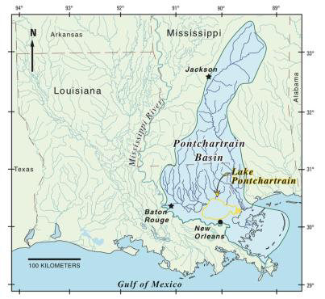 | 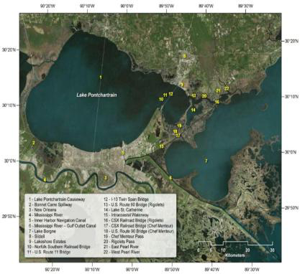
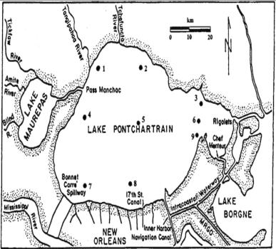  Figure 1: Map of the Study Area | 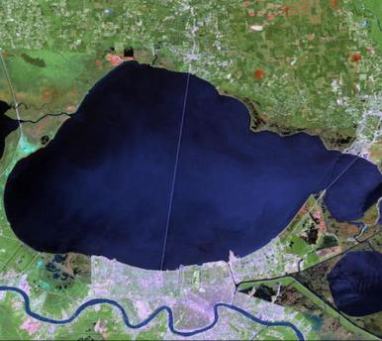

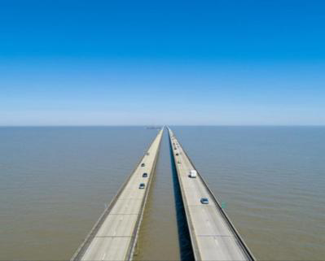Figure 2: Lake Pontchartrain Causeway

3 METHODOLOGY
3.1 Data Source
The study uses multispectral remote sensing Sentinel 2 data (Corpenicus/S2_Sr_Harmonized) obtained from the Google Earth Engine to construct classified turbidity maps and document the area of variable concentration of turbidity in Lake Pontchartrain for each month in 2023 using ArcGIS Pro software (Table 1). A total of 12 RGB images were collected and used for the study, involving the first data of each month with less than 20% cloud cover (Table 2).
3.2 Dataset Characteristics
Platform | Sensor | Spatial Res. (m) | Spatial Extent (km) | Number of Bands | Temporal Res. (e.g. daily) | Temporal Res. (Start Year – End Year) | Source
Sentinel 2 | MSI | 10 m | 290 km (field of view) | 13 | 5 days | 2023 | Google Earth Engine
Table 1. Dataset Characteristics

Month | Jan | Feb | Mar | April | May | June | July | Aug | Sept | Oct | Nov | Dec
Date | 5th | 4th | 3rd | 17th | 2nd | 11th | 1st | 15th | 7th | 2nd | 1st | 11th
Table 2. Dates of Data Acquisition in 2023 for Analysis
3.3 Satellite Image Analysis
The multispectral analysis involving two optical/infrared indices (NDWI and NDTI) was used to extract bands 3, 4, and 8 (green, red, and NIR respectively) from the image collection.
The Normalized Difference Water Index (NDWI) is the ratio of the Green and Near Infrared bands (band 3 and band 8 respectively). i.e. NDWI = (Green band − NIR band) ∕ (Green band + NIR band). The NDWI is commonly used to map open water bodies, including river channels and deep lagoons, this makes it easier to delineate the water area by masking out the water pixels (Gao, 1996); (McFeeters, 1996).
NDTI is the ratio of red and green bands (band 4 and band 3 respectively). The band combination formula for determination of the NDTI is (red band − green band) ∕ (red band + green band) based on signature statistics, mean, and standard deviations of the NDTI values (Townshend and Justice 1986; Tucker and Sellers 1986; Sharma et al. 2014).
Water bodies were first delineated using the Normalized Difference Water Index (NDWI) to accurately extract surface water pixels and mask non-water features prior to turbidity analysis, This preprocessing step ensured that NDTI calculation were restricted to water surfaces, thereby improving the reliability of turbidity mapping.
In this method, clear or sediment-free water has a specific radiometric response. Its reflectance is weak in green (less than 10%), becomes very small in red, and quasi-null in NIR. The increase in turbidity and its associated radiometric responses make the open water features behave like bare soil (Guyot 1989); (Lacaux et al., 2007); (Gardelle et al., 2010). As the turbidity level of water increases due to the increase of suspended particles in water, the reflectance of the red band is more than that of the green band (Islam & Sado, 2006). This spectral characteristic of the turbid water makes it possible for the detection of turbid water pixels using the NDTI. Since the values of the red radiometric responses are much larger than those of the green ones, the relationship between green and red wavelengths is reversed (Verbyla, 1995); (Campbell, 1996).

3.4 Image Classification Method
NDTI values range from -1 to +1 but generally vary from -0.2 to greater than +0.25, such that a lower value indicates clear water and a higher value is representative of highly turbid water (Alka et al., 2014); (Bid and Siddique, 2019). The resulting image of the NDTI image was exported as a Geo Tiff file into ArcGIS Pro, and classification using the quantile method was performed to group the classes of turbidity considered in the lake for each month.

4 RESULTS AND DISCUSSIONS
Turbidity is the amount of light scattered particles in the water, influenced by suspended sediment concentration. According to the NDTI values, three turbidity ranges are recorded (low, medium, and high) based on the unique pixel values derived from the NDTI maps prepared by the ArcGIS Pro software.
The following turbidity maps were produced with green indicating a low turbid water area, yellow representing a medium turbid water area, and brown representing a high turbid area (Figure 3).
Data related to different turbidity classes (low, medium, and high) in Lake Pontchartrain for each month in 2023 are presented (Table 3).

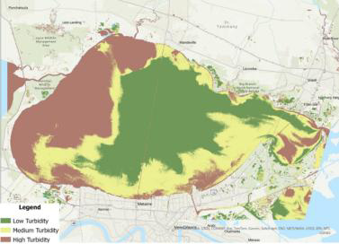  January, 2023 | 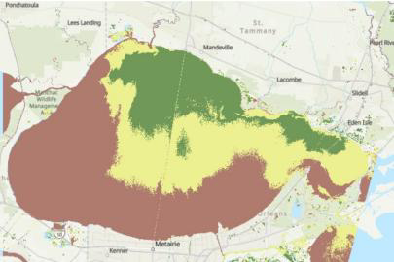  February, 2023
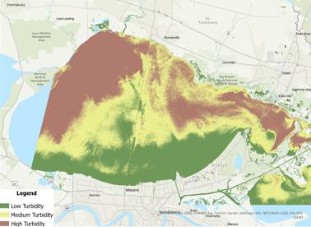  March, 2023 April, 2023 | 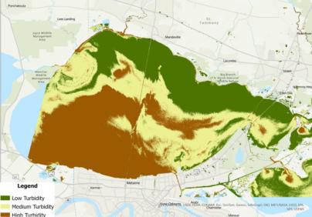  April, 2023
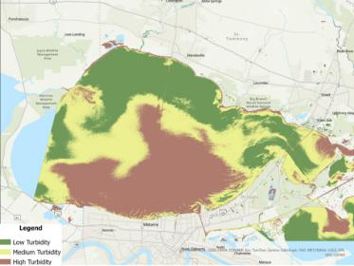  May, 2023 | 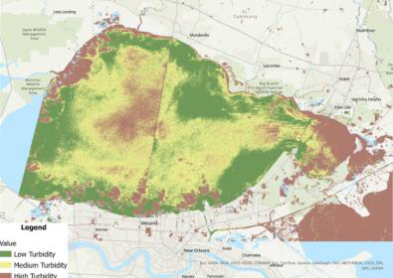  June, 2023

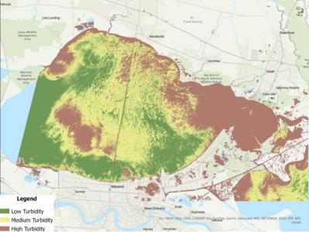  July, 2023 | 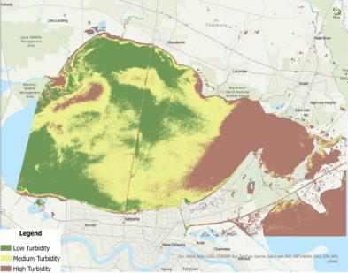  August, 2023
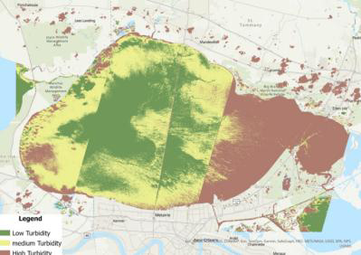  September, 2023 | 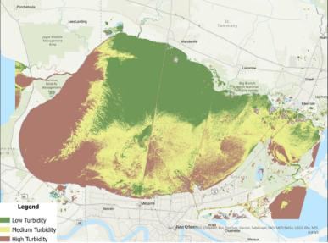  October, 2023
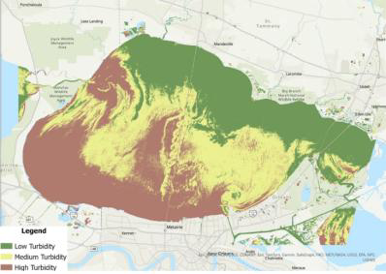  November, 2023 | 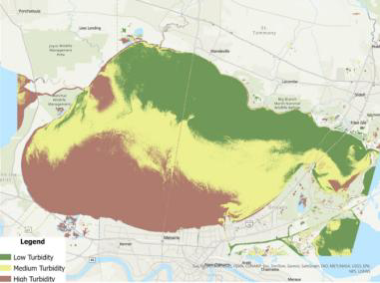  December, 2023
Figure 3. Turbidity Maps of Lake Pontchartrain from January – December, 2023
4.1 Turbidity Ranges (Upper-Class Values) and Monthly Variation in 2023 Calculated based on NDTI Values

Month | Low Turbidity | Medium Turbidity | High Turbidity
January | - 0.207 | - 0.153 | 0.387
February | - 0.059 | - 0.068 | 0.465
March | 0.045 | 0.074 | 0.489
April | - 0.066 | - 0.023 | 0.458
May | - 0.114 | - 0.074 | 0.458
June | - 0.166 | - 0.135 | 0.564
July | - 0.214 | - 0.186 | 0.431
August | - 0.212 | - 0.160 | 0.625
September | - 0.159 | - 0.097 | 0.624
October | - 0.144 | - 0.101 | 0.481
November | - 0.085 | - 0.031 | 0.429
December | - 0.226 | - 0.091 | 0.92
Table 3. Turbidity Ranges (Upper-Class Values) and Monthly Variation in 2023 Calculated based on NDTI Values

4.2 Spatiotemporal Variations of Turbidity Pattern in Lake Pontchartrain in 2023
January
Based on the map across Lake Pontchartrain, high turbidity covers the greatest areal extent and is observed in the Northwestern region and nearshore/periphery of the lake. This is due to the influx of sediment from tributaries that debouch into the lake and sediment concentration decreases with increasing distance from the shore inward. Low turbid water exists at the Central and Northeastern parts of the lake and also covers a substantial area extent indicating relatively clear water. The medium turbid area is observed majorly at the Southeastern part of the lake.
February
Maximum incidence of high turbid water dominates the larger portion of the lake covering more area extent from the near shore to almost the middle of the lake's southwestern and southeastern parts, followed by medium turbidity which dominates the central zone of the lake, while the low turbidity covers the least extent area for the month. The increase in turbidity could be attributed to the influx of suspended sediments from the catchment’s runoff and discharge from tributaries that debouch into the lake.
March
The lake is mostly turbid, with high and medium turbid water dominating substantial portions, particularly in the northwestern, and southeastern coastal areas and the central respectively, which could be attributed to the influx of sediments from Lake Maurepas and other rivers that debouch into the lake from the North (Tangipahaa River and Tchefuncta River) and resuspension of suspended sediments in the lake. Low turbidity is only observed at the nearshore/southeastern parts of the lake due to a lack of low discharge or runoff from the Mississippi River.
April
Low turbidity dominates and covers a significant portion of the northeastern parts of the lake, indicating that these areas have relatively clear or low turbidity waters compared to the higher turbidity zones. High Turbidity also occupies substantial portions, particularly in the southwestern and coastal areas while medium turbidity covers the least area extent interspersed throughout the lake.

May
There is more concentration of low turbidity which covers a greater area extent particularly the Northern part of the lake, followed by high turbidity which dominates the southern part, and medium turbidity dominating the central portion of the lake.
June
Due to the limited amount of precipitation during summer influencing runoff and discharge from tributaries, almost all the lake area is covered by medium and low turbidity, with pockets of high turbidity occurring at the middle of the lake due to resuspension and the Rigolets openings which may be due to tidal influence.
July
Low turbidity is dominant covering much area extent, particularly the southwestern parts, followed by medium turbidity and high turbidity which dominate the eastern part of the lake where it debouches into the Gulf of Mexico. This could be attributed to the effect of strong tidal influence.
August
The same phenomenon as July is observed, low turbidity is dominant covering much area extent, particularly the southwestern parts, Northern area, and some parts of the lake center, followed by medium turbidity which dominates the center, and high turbidity covers the least area extent.

September
Low turbidity dominates especially at the central part of the lake, but there is a progression of high turbidity from the Southeast area of the Lake, followed by medium turbidity

October
Medium turbidity dominates and covers the largest extent area, followed by low turbidity which dominates the Northern parts, and high turbidity which dominates the western parts of the lake, however, there is an onset of sediment concentration due to discharge and runoff from tributaries from the southwest area of the lake.
November
Due to more increase in rainfall, high turbidity covers the largest area extent, particularly the southwestern region of the lake, followed by low turbidity which is observed in the Northeastern part of the lake, and medium turbidity which is observed between the high and low turbidity area (central),
December
The high turbidity dominates the Southwestern part of the lake, medium turbidity is observed between the high and low turbidity area (central), while low turbidity is observed at the Northeastern part of the lake.
5 FACTORS ENGENDERING TURBIDITY
The increased turbidity observed could be associated with more influx of sediments into the lake due to increased precipitation and runoff from urban areas (agricultural, municipal, and industrial), shoreline erosion and wetland loss, saltwater intrusion due to sea level rise, freshwater diversion, etc. This could also be a result of temperature and salinity differences between the inflow and ambient water in the lake.
Studies have shown that sediment concentration decreases with increasing distance from the headwater/shore into lakes/reservoirs and increases at the confluence. This is due to a reduction in the flow velocity as a result of contact with an increasingly larger body of water as inflows enter and propagate through it causing progressive siltation. (Commandeur, 2015); (Ogunkoya & Olowu, 2020). The NDTI mas confirm this assertion as high turbidity is more pronounced at the headwater/shores and tributaries debouching into the lake (Lake Maurepas, Tangipahaa River, Tchefuncta River, Mississippi River, Bonnet Carre Spillway, and Lake Borgne).
6 SUMMARY AND CONCLUSIONS
This study "Assessment of the Spatiotemporal Variations of Turbidity Flow in Lake Pontchartrain Using Remote Sensing (NDTI Method)" provides an in-depth analysis of the spatiotemporal variations of turbidity flow in Lake Pontchartrain using remote sensing and the Normalized Difference Turbidity Index (NDTI) method.
Lake Pontchartrain, located in southeastern Louisiana, is a significant geographic and hydrological feature with ecological, economic, and social importance. The lake has faced environmental challenges such as shoreline erosion, wetland losses, water and sediment pollution, saltwater intrusion, and subsidence, leading to increased siltation and turbidity. The study aims to apply remote sensing techniques to assess the turbidity flow in Lake Pontchartrain using the NDTI method, with specific objectives to determine the occurrence and spatiotemporal variations of turbidity patterns in the lake.
The study highlights the importance of understanding the spatiotemporal variations of turbidity flow in Lake Pontchartrain due to its ecological significance and the threats it faces. Recent studies worldwide have demonstrated that RS based monitoring of turbidity provides critical data for conservation and reservoir management, reinforcing the significance of such assessments in Lake Pontchartrain. (Mishra et al., 2024); (Singh et al., 2024). The study utilizes multispectral remote sensing Sentinel 2 data to construct classified turbidity maps and document the area of variable concentration of turbidity in Lake Pontchartrain for each month in 2023. The resulting turbidity maps indicate low, medium, and high turbidity ranges, with high turbidity being more pronounced at the headwaters, shores, and tributaries debouching into the lake.
The limitations of the work include the reliance on satellite-based observations, which may not fully capture in-situ turbidity conditions due to atmospheric effects, sensor limitations, and the absence of field calibration data. Also, the use of a single cloud-free image per month may not represent average monthly conditions, particularly during intense rainfall. Future studies should integrate field measurements and statistical analyses to validate remotely sensed turbidity estimates and strengthen quantitative interpretation. Additionally, the study focuses on a specific time period (2023) and may not capture long-term trends in turbidity flow. Future studies could involve integrating field measurements with remote sensing data to validate the accuracy of the NDTI method. Long-term monitoring and analysis of turbidity flow in Lake Pontchartrain would also provide valuable insights into the dynamics of turbidity over time and its impact on the lake's ecosystem. Furthermore, future studies could explore the influence of climate change and anthropogenic activities on turbidity flow in Lake Pontchartrain. Additionally, the study could benefit from incorporating predictive modeling to forecast changes in the distribution of turbid waters in the lake basin. This would provide valuable information for conservation efforts and sustainable management strategies. Overall, this study demonstrates the effectiveness of Setinel-2 imagery and the NDTI method for assessing spatiotemporal turbidity variations in Lake Pontchartrain. The result reveals distinct seasonal and spatial turbidity patterns strongly influenced by tributary inflows, shoreline processes, and hydrodynamic conditions. While the approach provides a cost effective framework for large-scale water quality monitoring, integrating advanced statistical analyses would enhance accuracy and predictive capability. The findings offer valuable insights for environmental monitoring, lake management, and sustainable water resource planning in coastal and estuarine systems.The NDTI-based remote sensing framework used in this study is transferable and can be applied to other large and small water bodies, including rivers, reservoirs, and lakes, subject to appropriate calibration and local environmental conditions.
Disclaimer (Artificial intelligence)

Author(s) hereby declare that NO generative AI technologies such as Large Language Models (ChatGPT, COPILOT, etc.) and text-to-image generators have been used during the writing or editing of thismanuscript.

REFERENCES
- Akiyama, J., Ura, M., & Ikeda, S. (1996). Turbidity currents in reservoirs. Journal of Hydraulic Engineering, 122(4), 217–226. https://doi.org/10.1061/(ASCE)0733-9429(1996)122:4(217)
- Alka, S., Bid, S., & Siddique, G. (2014). Assessment of turbidity using satellite data. International Journal of Remote Sensing, 35(10), 3954–3968. https://doi.org/10.1080/01431161.2014.902546
- Bid, S., & Siddique, G. (2019). Monitoring sediment dynamics using the Normalized Difference Turbidity Index (NDTI). Environmental Monitoring and Assessment, 191, 245. https://doi.org/10.1007/s10661-019-7360-3
- Campbell, J. B. (1996). Introduction to remote sensing (2nd ed.). London, UK: Taylor & Francis.
- Chen, Z., Hu, C., & Muller-Karger, F. E. (1991). Monitoring sediment transport using satellite remote sensing. Remote Sensing of Environment, 35, 41–54. https://doi.org/10.1016/0034-4257(91)90006-L
- Churchill, M. A. (1948). Discussion of analysis of sedimentation in lakes. Transactions of the American Society of Civil Engineers, 113, 1109–1120.
- Collins, A. L., & Walling, D. E. (2004). Documenting catchment sediment sources: Problems, approaches and prospects. Journal of Hydrology, 291, 1–23. https://doi.org/10.1016/j.jhydrol.2003.12.024
- Commandeur, J. (2015). Reservoir sedimentation and turbidity currents. Hydrological Sciences Journal, 60, 1235–1248. https://doi.org/10.1080/02626667.2014.928288
- Dahm, C. N., Candelaria‐Ley, R. I., Reale, C. S., Reale, J. K., & Van Horn, D. J. (2015). Extreme water quality degradation following a catastrophic forest fire. Freshwater Biology, 60(12), 2584-2599.
- De Cesare, G., Schleiss, A. J., & Hermann, F. (1999). Impact of turbidity currents on reservoir sedimentation. Journal of Hydraulic Engineering, 125(10), 1053–1062. https://doi.org/10.1061/(ASCE)0733-9429(1999)125:10(1053)
- Environmental Protection Agency. (1998). National water quality inventory: Report to Congress. Washington, DC: U.S. Environmental Protection Agency.
- Environmental Protection Agency. (2000). Water quality conditions in the United States. Washington, DC: U.S. Environmental Protection Agency.
- Gao, B. C. (1996). NDWI—A normalized difference water index for remote sensing of vegetation liquid water. Remote Sensing of Environment, 58, 257–266. https://doi.org/10.1016/S0034-4257(96)00067-3
- Gardelle, J., Arnaud, Y., & Berthier, E. (2010). Monitoring lake surface turbidity using remote sensing. Remote Sensing of Environment, 114, 2543–2556. https://doi.org/10.1016/j.rse.2010.05.017
- Graf, W. L. (1971). Sedimentation and reservoir storage loss. Water Resources Research, 7, 1183–1190. https://doi.org/10.1029/WR007i005p01183
- Graf, W. L. (1984). Hydraulics of sediment transport. Journal of Hydraulic Engineering, 110, 1498–1514. https://doi.org/10.1061/(ASCE)0733-9429(1984)110:11(1498)
- Govorushko, S. M. (2016). Natural hazards and environmental impacts. Springer International Publishing. https://doi.org/10.1007/978-3-319-27738-8
- Guyot, G. (1989). Signatures spectrales des surfaces naturelles. Paris, France: Masson.
- ICOLD. (1989). Sedimentation of reservoirs. Bulletin No. 67. Paris, France: International Commission on Large Dams.
- Islam, M. R., & Sado, K. (2006). Flood hazard assessment using remote sensing. Journal of Hydrology, 333, 198–210. https://doi.org/10.1016/j.jhydrol.2006.08.021
- Jeje, L. K. (1987). Sediment yield and erosion processes. Journal of Environmental Management, 24, 87–96.
- Kneller, B., Bennett, S., & McCaffrey, W. (2000). Turbidity currents and sediment gravity flows. Sedimentology, 47, 105–123. https://doi.org/10.1046/j.1365-3091.2000.00294.x
- Lacaux, J. P., Tourre, Y. M., & Vignolles, C. (2007). Surface water monitoring by remote sensing. Remote Sensing of Environment, 109, 66–75. https://doi.org/10.1016/j.rse.2006.12.012
- Mahmood, K. (1987). Reservoir sedimentation: Impact, extent, and mitigation. World Bank Technical Paper No. 71.
- McFeeters, S. K. (1996). The use of NDWI in the delineation of open water features. International Journal of Remote Sensing, 17, 1425–1432. https://doi.org/10.1080/01431169608948714
- Molo, J., Ritchie, J. C., & Schiebe, F. R. (1989). Suspended sediment monitoring using Landsat data. Water Resources Bulletin, 25, 595–605.
- Morris, G. L., & Fan, J. (1998). Reservoir sedimentation handbook. New York, NY: McGraw-Hill.
- Mishra, K., Choudhary, B., & Fitzsimmons, K. E. (2024). Predicting and evaluating seasonal water turbidity in Lake Balkhash using remote sensing and GIS. Frontiers in Environmental Science.
- Nikoo, M. R., et al. (2024). Mapping reservoir water quality from Sentinel-2 data using Bayesian maximum entropy. Scientific Reports, 14, 16438.
- Novo, E. M. L. M., Hansom, J. D., & Curran, P. J. (1991). Turbidity estimation using satellite data. International Journal of Remote Sensing, 12, 195–208. https://doi.org/10.1080/01431169108929670
- Ogunkoya, O. O., & Olowu, T. U. (2020). Turbidity flow in Opa reservoir, Ile-Ife, Southwest Nigeria. Journal of Mining and Geology, 56(2), 211-222.
- Rapp, A. (1975). Sediment yield and erosion processes. Geografiska Annaler, 57, 107–123.
- Rapp, A., Axelsson, V., & Ståhl, K. (1972). Sediment transport processes. Zeitschrift für Geomorphologie, 16, 255–276.
- Setterfield, S. A., Douglas, M. M., & Hutley, L. B. (2014). Environmental stressors and sedimentation impacts. Wetlands Ecology and Management, 22, 289–304. https://doi.org/10.1007/s11273-013-9335-5
- Sharma, R., Tateishi, R., & Hara, K. (2014). Remote sensing of sediment dynamics. Remote Sensing, 6, 889–910. https://doi.org/10.3390/rs6020889
- Singh, R., Saritha, V., & Pande, C. B. (2024). Monitoring wetland turbidity using multi-temporal Landsat-8 and Landsat-9 images. Environmental Research, 241, 117638.
- Somvanshi, S. S., Kunwar, P., & Singh, N. B. (2011). Turbidity mapping using satellite imagery. Journal of Hydrology, 397, 165–173. https://doi.org/10.1016/j.jhydrol.2010.11.036
- Townshend, J. R. G., & Justice, C. O. (1986). Analysis of remote sensing indices. International Journal of Remote Sensing, 7, 1327–1348. https://doi.org/10.1080/01431168608948931
- Tucker, C. J., & Sellers, P. J. (1986). Satellite remote sensing of vegetation. International Journal of Remote Sensing, 7, 1395–1416. https://doi.org/10.1080/01431168608948944
- Verbyla, D. L. (1995). Satellite remote sensing of natural resources. Boca Raton, FL: CRC Press.
- Ward, P. J., van Balen, R. T., & Verstraeten, G. (2009). Sediment dynamics and monitoring. Earth Surface Processes and Landforms, 34, 151–164. https://doi.org/10.1002/esp.1706
- Yepez, S., Laraque, A., & Filizola, N. (2015). Remote sensing of sediment transport in aquatic systems. Hydrological Processes, 29, 3715–3727. https://doi.org/10.1002/hyp.10462
- Yum, B. W., Lee, S. J., & Park, Y. S. (2008). Reservoir sedimentation and turbidity currents. Water Resources Management, 22, 1367–1382. https://doi.org/10.1007/s11269-007-9225-4

