Periodic market typology and spatial dynamics in Menoua Division, Cameroon

Abstract: Global literature has consistently emphasised the complex challenges and opportunities associated with periodic market systems and spatial organisations. Despite this board attention, empirical evidence at the regional level is limited, particularly in African contexts where periodic markets play a central role in shaping local economies. This study uses the case of Menoua Division to: (i) to identify the typology of periodic markets (ii) to determine the spatial variations in periodic market and (iii) to analyse the determinants of spatial variations in periodic markets. This study employed a random sample of 350 households involved in periodic marketing to reflect variations in market participation, spatial accessibility and socio-economic characteristics from six sub-divisions –Dschang, Santchou, Fokoue, Fongo-Tongo, Penka-Michel and Nkong-ni. This was complemented by focus group discussions and interviews. Descriptive and inferential analyses led to the following results: First, periodic markets exhibit distinct typologies (semi-daily and weekly markets) shaped by frequency, scale and functional roles. Second, significant spatial variations are evident across the division, reflecting differences in population characteristics, transport development, and agricultural outputs. The spatial distribution of periodic markets and transport development(r=.620, p< .001), spatial market location and agricultural output (r= -.186, p=.004). The typological diversity of periodic markets, expressed in their varying frequency, scale of operation and functional roles complicates efforts to establish coherent classification. Also, the spatial disparities in distribution and accessibility create disparities in participation, connectivity and uneven opportunities for communities. This undermines the capacity of periodic markets to serve as inclusive and efficient platforms for trade and development. Sustainable improvement in market and transport infrastructures could reduce spatial disparities, robustly strengthening market governance and security which could mitigate the challenges posed by typological diversity such as inconsistencies in classification and variations in functional roles while also addressing spatial disparities through improved accessibility and integration.
Keywords: Periodic markets, Market typology, spatial variations, Determinants of spatial variations, Menoua Division.
1. Introduction
Periodic markets known as organised gatherings of buyers and sellers at designated locations constitute a fundamental component of rural economies, providing spaces for trade, social interaction and cultural exchange (Chen Chen, 2024).Yet, they are characterised by considerable diversity in frequency, scale of operation and functional orientation which complicates systematic classifications(periodic market typology). Spatial variations in these periodic markets intensify disparities in participation and weaken the coherence and equity in periodic market organisation Ahmed and Manoj (2020).With rural areas in the world subjected to aggravated poverty, high population pressure, constrained land resources and unfinished agricultural reforms, many households have diversified their income sources by engaging in periodic markets(Addai et al.,2024).According to Anupama et al., (2023), there has been a remarkable increase in the number of periodic markets in the late 20th and early 21st centuries, with almost 70% of farm operator households engaged in periodic marketing. This importance is deeply rooted in their typology which operates following rotational calendars often organised on daily, weekly, bi-weekly, monthly or bi-monthly basis (Shaikh, 2020). These rotational calendars regulate commodity flows, synchronise trading activities and ensure equitable access (Pakorn, 2023). Their spatial dynamics are equally significant as most of these periodic markets are often strategically located along transport corridors, near administrative centers and within densely populated settlements (Schappo and Melik, 2020).
Millions of people in Sub-Saharan Africa, particularly those in the rural areas depend on periodic markets for their livelihoods (FAO, 2020).These markets not only serve as dynamic nodes of exchange, enabling the circulation of agricultural produce but also links agricultural producers, traders and consumers across diverse ecological and cultural landscapes (IMF, 2022). Periodic markets in this region are defined by their cyclical typology and spatial dynamics, which together shape rural-urban linkages, trade flow and regional development (Olutegbe, 2021). These markets operate on fixed schedules, often daily, weekly and bi-weekly, supplying approximately 80 to 90 percent of the food consumed in African cities and providing small-scale farmers with essential access to urban markets (Alliance for a Green Revolution in Africa, 2020). The typology of periodic markets in this region is defined by frequency, scale and functional orientation closely tied to rotational calendars that structure trade and foster complementarity among settlement (Salamun and Sarah, 2020).These periodic markets are unevenly distributed across the region with periodic markets selling mainly fruits located closer to the road junctions, and those selling agricultural produce located closer to the farms Mbazirra (2024).Periodic markets selling mainly manufactured items are located around community areas were people gather regularly (Hong and Neng, 2024).
Periodic market spaces are fundamental to urban life in Cameroon, serving as key centers for commerce, social interaction, and cultural exchange operating on fixed schedules (Chianebeng et al., 2025).Rural households in Cameroon(62%) are involved in the trading of non-farm produce and 38% involved in the trading of off-farm produce in periodic markets (Wirba et al., 2021).According to Mbarga et al., 2024, periodic markets in Cameroon are no just sites of economic exchange but complex institutions whose typology and spatial dynamics structure rural life. These markets exhibit diverse typology varying in frequency and scale ranging from semi -daily markets to weekly and bi weekly markets (Fongang et al., 2021). These markets are unevenly distributed across the regions. For instance in the centre region, women began operating spontaneous markets especially around junctions, busy roads and around bus stations to sell perishables like vegetables, fruits, fish and cooked food (Nkwi et al., 2017).The spatial dynamics of these markets reflect deliberate locational choices along transport roads, within densely populated settlements and mostly in rural areas (Monga, 2022).
In Menoua Division, the typology of periodic markets represents a crucial aspect of local economic and social organisation, shaping the rhythm of trade and community life across sub-divisions ((Fuein, 2022).The emergence of these periodic market typologies in the 1990s was as a direct response to the shifting economic liberalisation policies and structural adjustment programs (Racaud, 2021). These markets emerged as survival strategies in the face of declining formal employment and rising poverty, allowing women to generate income from items that required quick turn over (Tlholohelo et al., 2023).Initially rooted in subsistence exchange among villages with no fixed schedules, these periodic markets gradually expanded in frequency and scale, evolving in to structured periodic market typologies ranging from semi-daily to weekly markets (Tadele, 2020).Their spatial dynamics mirror broader socio economic transformations, clustering along road sides and within densely populated settlements to maximise accessibility and integration (Sakai, 2023).
The circulation and exchange of goods in periodic markets is strengthened through the interplay of structured typology and spatial dynamics, which together create structured and flexible trade networks. However, challenges such as small scale nature of market activities, rigid typological classification, uneven spatial distribution, poor infrastructure and limited trade integration of some rural areas weaken market efficiency, market circulation and restricts the full developmental potential of periodic markets in Menoua Division. The impacts are felt by households whose livelihoods and wellbeing are tied to periodic markets. From the identified issues, this study seeks to (i) to identify the typology of periodic markets (ii) to determine the spatial variations in periodic market and (iii) to analyse the determinants of spatial variations in periodic markets.
This study contributes theoretically by advancing market and development theories through its analysis of periodic market typology and spatial dynamics. It provides empirical evidence on how markets function in time and space to minimise transport costs and maximise consumer/vendor interaction. The study also introduces a spatio-temporal dimension which explains how the location, distribution, and periodicity of periodic markets shape accessibility, market operations and community participation. It equally refines existing market theories by showing that markets are not static institutions but dynamic systems whose typology, location and spatial variations influence household welfare and shapes local economies.
2. Materials and Methods.
2.1. Study Area
Menoua Division as seen in (Figure 1) is located between latitude 5⁰11’0’N and 5⁰40’N of the Equator and between longitudes 10⁰066’7’E and 10⁰’21’E of the Greenwich Meridian. It is bounded by Bamboutous division to the North, Haut-Nkam to the south, Mifi to the east and South-west region to the west. It is situated in the West Region of Cameroon .Periodic markets in this division began in the early 19th century as small gatherings for local farmers to sell farm produce. The typology of these markets range from semi-daily to weekly markets and form a critical part of the socio-economic fabric, facilitating exchange between producers, traders and consumers. The spatial distribution of these periodic markets is uneven across the six sub-divisions reflecting both historical settlement patterns and contemporary mobility networks. The landscape is made up of over 100 villages, each hosting diverse ethnic groups especially Bamilekes, Mbo, Bangwa and Mouankou that contribute to the cultural richness of the area. The Bamelikes are the original inhabitants of the area and most dominant population. 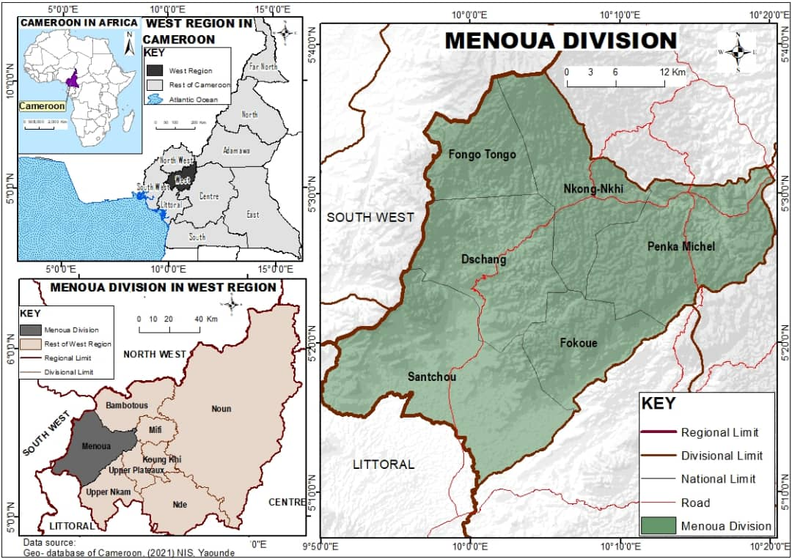
Figure 1: Location of the study area
2.2. Survey and Sampling
The study employed the mixed methods approach combining quantitative and qualitative techniques to gain a comprehensive understanding of periodic market typology and spatial variations in periodic markets. To identify periodic market typology, determine the spatial variations in periodic markets and analyse the determinants of spatial variations in periodic markets. Focus group discussions were conducted with producers (farmers), transporters, traders, buyers and service providers. This allowed for a nuanced exploration of the typology of periodic markets and the determinants of the spatial variations in periodic markets. The study was carried out in Menoua Division which is composed of 150 villages distributed across its six sub-divisions with an estimated population of 405746 people. Empirical investigation spanned from September 2023 to February 2024 and April 2024. Institutions like the Regional and Divisional delegations of small and medium size enterprises, Regional and Divisional Delegations of commerce, Regional and Divisional delegation of Agriculture, traditional councils, palaces and traders associations provided relevant information. Primary data were obtained through field observation, focus group discussions and interviews. A checklist of themes for semi-structured interviews and focus group discussions was established, and the main quantitative instrument used was the household structured questionnaire. The questionnaire contained 60 questions on periodic market typology, spatial variations in periodic markets and determinants of spatial variations in periodic markets. About 95% of the questions captured in the questionnaire were structured, while less than 5% were unstructured. The questionnaires were administered randomly through a ballot system whereby households were selected proportionally based on sub-division population figures to ensure that every household had an equal chance of representation in the sample process—See Table 1. Also, the interview guide was used with a focus on the Market masters, Regional /Divisional delegate of commerce, Municipal Council officials, the heads of trader associations and village leaders (chiefs). Traders, vendors, transporters and service providers involved in periodic marketing for over 10 years were equally interviewed. A common questioning framework was applied to every Interviewee to obtain convergent and divergent opinions. The study considered 19 periodic markets and the six sub-divisions in Menoua Division .These include Dschang, Santchou, Penka-Michel, Nkong-ni, Fokoue and Fongo-Tongo. Three hundred and fifty households involved in periodic markets were randomly sampled using a 10% rule based on the total number of households in each community, to ensure the representativeness and robustness of the research process. Six research assistants with cultural geographic knowledge of the landscape were employed to assist in data collection. Questions were translated in to the dialect of the people, and responses were in French and some in Pidgin English to ease communication and comprehension.

Table 1: Distribution of Questionnaire
Sub-Divisions/Periodic Markets | Population per neighbourhood | Target population | Sample population | Effective responses
Dschang Sub-Division | 1700 | 330 | 41 | 40
Centre commercial
Azeunla(Marche B) | 1022 | 220 | 27 | 27
Foto | 1125 | 221 | 28 | 27
Tsinferm | 1300 | 126 | 16 | 15
Penka Michel Sub-Division | 1140 | 138 | 17 | 17

Penka Michel
Bakassa | 1000 | 122 | 15 | 15
Balessing | 1050 | 227 | 28 | 27
Nkong-Ni Sub-Division | 1100 | 125 | 16 | 16

Douzem
Samaya | 1013 | 140 | 18 | 17
Baleveng | 975 | 96 | 12 | 12
Santchou Sub-Division | 1200 | 201 | 25 | 24

Marche Central commercial
Marche Mboukop | 1080 | 126 | 16 | 15
Marche Ntiengue | 713 | 120 | 15 | 15
Fongo-Tongo Sub-Division | 950 | 118 | 15 | 14
Marche Melang
Marche Loung | 930 | 114 | 14 | 14
Marche Mami wata | 605 | 114 | 14 | 13
Fokoue Sub-Division | 592 | 70 | 9 | 9

Fotemena(mbu,dkbu)
Fotsa-Touala(mbunjwa) | 850 | 107 | 13 | 13
Fomopea(Djan) | 601 | 85 | 11 | 11
Total | 18946 | 2800 | 350 | 341

2.3. Data Treatment and Analysis
Descriptive content analysis was used to analyse qualitative data. Coding and analysis of periodic market typology, spatial variations and determinants of variations in periodic markets were performed to identify emerging themes and recurring patterns. Data collected was analysed using software packages such as the Microsoft Excel software version 10 and SPSS version 20. The Pearson Product - Moment correlation coefficient was used for this study. The Pearson correlation coefficient revealed the dependent variable (Market accessibility) had a strong positive correlation with transport development(r=0.620,p< 0.001), a moderate negative correlation with agricultural outputs(r=-0.186,p= 0.004),and perfect correlation with population characteristics(r=1.000). The mathematical formula for the Pearson correlation coefficient used in this analysis, is expressed in Equation (1).

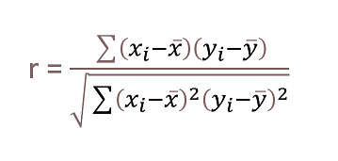

Where
r = Pearson correlation coefficient
xi Value of independent variable(Transport, population and agricultural output)
yi Value of dependent variable(Market accessibility)
$x$ = mean of Transport, population and agricultural output
y= mean of Market accessibility

3. Results
Transport development(r=0.620,p< 0.001), agricultural outputs(r=-0.186,p= 0.004),and population characteristics (r=1.000) significantly the spatial distribution of periodic markets in Menoua Division. There exists a perfect correlation (see Table 2). The correlation coefficient of spatial the location of periodic markets is 1,000, which strongly correlate with market location factors with calculated P-value =.001.

Table 2: Pearson correlation test of spatial periodic market location
Variables control |  |  | Influence of population characteristics | Transport development | Agriculture output
Valid  350 | Spatial location of periodic markets in the Menoua | Corrélation | 1,000 | ,620 | -,186
Valid  350 | Spatial location of periodic markets in the Menoua | Sig. (1tailed) | . | ,000* | ,004
Valid  350 | Spatial location of periodic markets in the Menoua | df1 | 0 | 198 | 198
Valid  350 | Spatial location of periodic markets in the Menoua | Correlation | ,620 | 1,000 | ,027
Valid  350 | Spatial location of periodic markets in the Menoua | Sig. (1tailed) | ,000* | . | ,054
Valid  350 | Spatial location of periodic markets in the Menoua | df2 | 198 | 0 | 198
Valid  350 | Spatial location of periodic markets in the Menoua | Correlation | -,186 | ,027 | 1,000
Valid  350 | Spatial location of periodic markets in the Menoua | Sig (1tailed) | ,004 | ,054 | .
Valid  350 | Spatial location of periodic markets in the Menoua | df3 | 198 | 198 | 0

3.1. Periodic Market Typology
Periodic markets in Menoua Division reflect a dynamic typology and spatial coordination that balances frequency with community needs. The typology of periodic markets in this Division is defined by two dominant types: Semi-daily and Weekly markets. This division hosts a total of nineteen periodic markets (six semi-daily markets and twelve weekly markets). Figure 2 presents this periodic market typology.

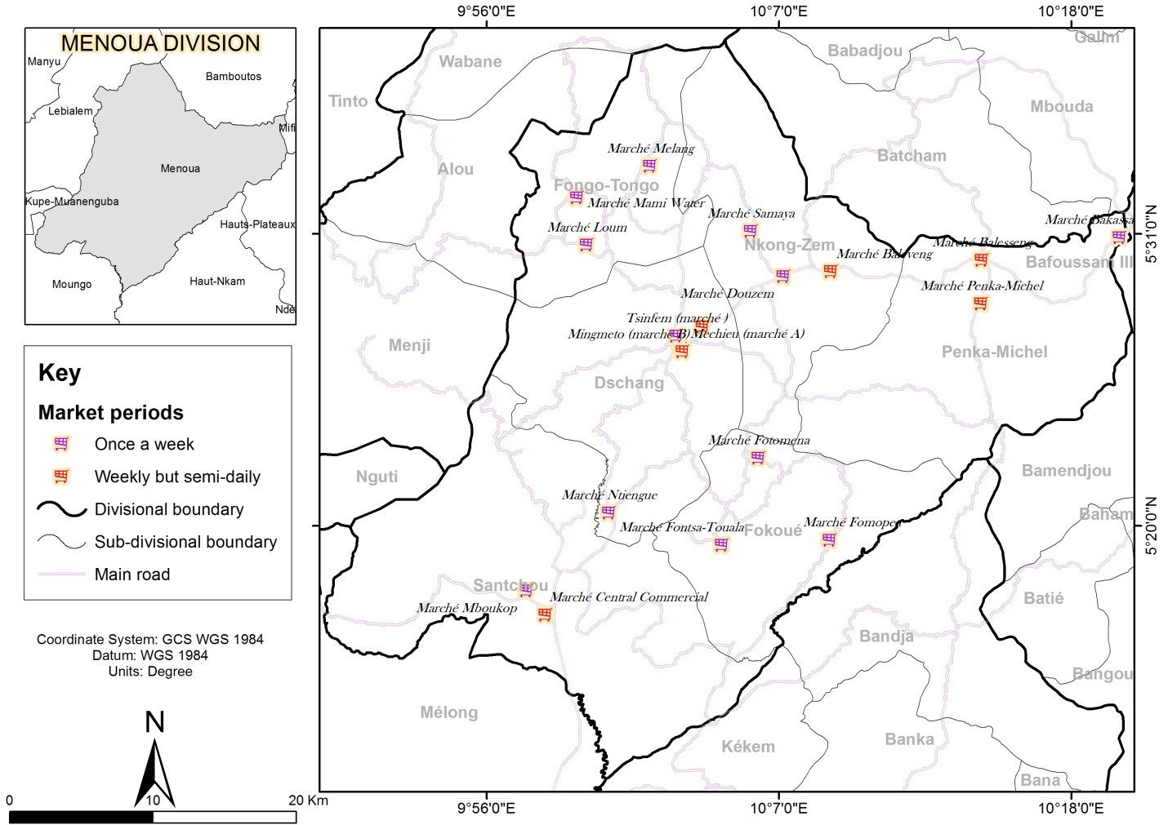
Figure 2: Spatial configuration of markets in Menoua
Source: Field work 2024
The semi-daily markets function as intermediaries between periodic markets and permanent market places while maintaining the flexibility needed for rural economies. These markets operate on a structured scheduled that allows traders and buyers to engage in frequent exchange. Periodic markets like Marche A, Marche B and Marche Foto in Dschang sub-division, Marche Penka Michel in Penka Michel sub-division, Marche Baleveng in Nkong-Ni sub-division and Marche central commercial in Santchou sub-division are semi-daily in nature. Conversely, the weekly periodic markets operate on rotational basis usually once a week, with specific days designated for trading in different locations. These markets play a vital role in local commerce, fostering economic activity and social interaction. Periodic markets like Marche Tsinferm in Dschang sub-division, Marche Bakassa in Penka Michel Sub-division, Marche Samaya and Marche Douzem in Nkong-Ni sub- division, Marche Mboukop and Marche Ntiengue in Santchou sub-division, Marche division Melang, Mami water and Loum in Fongo-Tongo sub-division, Marche Fotemena, Fotsa-Touala and Fomopea in Fokoue Sub-Division function as weekly markets.
There exists a typology of periodic market operations within these periodic markets. There are made up of diverse traders namely: traders of agricultural produce, livestock, food stuff, local implements, urban consumables, handcrafts, and many others responsible for facilitating commercial transactions. This ensures the availability of diverse products, price negotiation and the economic vitality of the market. Their typology reflects diverse scales of operation, levels of participation and commodity specialisation. Figure 3 presents this typology in periodic market operations.

Figure 3: Typology of periodic market operations
Source: Field work, 2024
Traders of agricultural produce constitute the highest category with 36% while traders of agricultural inputs constituted 4%.Agricultural produce constitute the most marketed commodity in periodic markets in the study area. The favourable climatic conditions and fertile soils encourage the vast and intensive cultivation of food crops. In these markets, traders come from within and out of these sub-divisions to exchange goods such as agricultural produce, livestock, textiles and household items.
3.2 .Spatial variations in the distribution of periodic markets in Menoua Division
Periodic markets in Menoua Division exhibit spatial variations in their distribution, scale of operation, accessibility and economic specialisation. While some periodic markets like those in Dschang and Santchou sub-division act as major economic hubs attracting traders from distant localities, periodic markets in Fokoue and Fongo-Tongo sub-divisions remain small and involved in village based exchanges serving primarily local needs. The spatial distribution of these markets reflects the interplay between geography, infrastructure and settlement dynamics. There is a high concentration of periodic markets in the central and eastern parts of the division. These parts of the division have more economic activities and infrastructure attracting more vendors and buyers. Also, these areas have higher population density which could imply that they receive more potential customers. Semi-daily markets and large periodic markets are typically concentrated in semi urban areas like Dschang and Santchou sub-division. These markets are concentrated along major transport roads, where accessibility and population density encourage diverse participation and commodity exchange. The close proximity of these markets to transportation routes facilitates the movement of goods and people to and from the markets. Conversely, weekly markets and small periodic markets are more common in rural areas like Fokoue and Fongo-Tongo sub-division, serving localised needs with limited goods and smaller market participation. All of these factors combined create an environment where periodic markets can thrive and serve the needs of the local community effectively.
3.2.1. Variations in key commodities sold in periodic markets in Menoua Division
The principal items traded in these periodic markets are market gardening crops like (leafy vegetables, spices and carrots), tubers like (cocoyam, yams, sweet potatoes, and Irish potatoes) and cereals (Maize and Rice). Apart from food items, these markets also sell livestock like (Table birds, Goats, Pigs and Sheep) and manufactured products like (Bags, Clothes, shoes and Art crafts).These periodic markets engage in the selling of market gardening crops like leafy vegetables, tomatoes, spices and carrots at varying degrees. This is presented on Figure 4.

Figure 4: Market Gardening crops sold in Periodic markets in Menoua Division.
Source: Field work 2023
Market gardening crops particularly leafy vegetables are the most marketed market gardening crops in Menoua Division. It is most dominant in periodic markets in Penka Michel; Fongo-Tongo and Fokoue sub-divisions. Over 40% of the traders in these markets are engaged in the sale of leafy vegetables. This high concentration is attributed to favourable climatic conditions conducive for vegetable cultivation. Carrots and spices are the least marketed market gardening crops in the division. Over 23% of traders in these periodic markets engage in the sale of spices and carrots. However, this crop type is most dominant in periodic markets in Dschang sub-division. Being the divisional capital, periodic markets in Dschang benefit from better infrastructure and road network which increases traders’ accessibility in to these markets.
Tubers which are primary staples in local diets are widely sold in periodic markets in Menoua division. These periodic markets sell a variety of tubers such as cocoyam, yams, sweet potatoes, Irish potatoes and cassava at varying degrees as seen on Figure 5.

Figure 5: Tubers sold in Periodic markets in Menoua Division.
Source: Field work 2023
Tubers like sweet potatoes and Irish potatoes are the most traded tubers in Menoua Division. Even though traded in all the sub divisions, it is most dominant in periodic markets in Penka Michel and Fokoue sub-divisions. Over 39% of traders in these markets are involved in the sale of Irish/sweet Potatoes. The extensive cultivation of sweet/Irish potatoes, high market demand and dietary significance makes it the most traded tuber in these sub-divisions. Also, favourable climatic conditions, fertile soils and the close location of periodic markets in these sub-divisions to farming zones make these tubers the most traded. On the other hand, yams are the least traded tubers in the Division. It is only dominant in periodic markets in Penka- Michel sub-division, with 19% of traders actively involved. This is associated with the ideal climatic conditions and fertile soils.
In addition to agricultural produce, periodic markets in Menoua division also sell a wide variety of livestock (table birds, goats, pigs and sheep).There exist variations as seen on Figure 6.

Figure 6: Livestock sold in Periodic markets in Menoua Division.
Source: Field work 2023
Table birds are the most widely traded livestock in periodic markets in Menoua Division. Table birds are highly traded in periodic markets in Dschang and Santchou sub-divisions. Majority of the traders (29-33%) in these periodic markets are involved in the sale of table birds. Their strategic locations along key transportation routes make these markets very accessible to traders and buyers. Pigs also constitute a dominant category of livestock traded in periodic markets in especially in Dschang sub-division. The strong culinary tradition places pork at the centre of many communal and ceremonial meals. Also, this is due to the existence of designated livestock sections in periodic markets like Marche Tsinferm in Dschang sub-division. Goats are the least traded livestock in the division. With accessible grazing areas and adaptable terrain 20% of traders are involved in the sale of goats.
Periodic markets in Menoua Division offer an array of manufactured items like bags, shoes, clothes and art craft. Figure 7 shows variations in the sale of these manufactured items.

Figure 7: Manufactured goods sold in Periodic markets in Menoua Division.
Source: Field work 2023
The centrally located periodic markets in Dschang and Santchou sub-divisions are characterised by a predominant trade in manufactured goods particularly clothing while simultaneously selling art crafts which reflects their cultural richness. In Dschang sub-division, clothes are widely sold in Marche A with 33% of traders involved and art crafts widely sold in Marche Tsinferm with 30% of traders involved. In the same light, 32% of traders in Marche central commercial in Santchou Sub-division while 19% of traders are involved in the sale of art crafts. Their close proximity to artisan communities, frequent visit of culturally inclined visitors and strategic location along major transit routes makes them very accessible to local residents and visitors from other sub-divisions, divisions and regions. In contrast, clothes, shoes and bags are very limited in smaller periodic markets in rural areas like those in Fongo-Tongo and Fokoue sub-divisions. Only 7% of traders engage in sale of these manufactured items as they rather focus on the sale of art crafts with 17% of traders involved. Their artisanal traditions and the presence of touristic sites like Mami water waterfall and Ndemvoh caves in Fongo-Tongo attracts tourists and visitors enhancing market demand for home made goods.
3.2.2. Determinants of spatial variations in periodic markets in Menoua.
The spatial variations in periodic markets in Menoua Division are greatly influenced by a combination of physical and human factors that collectively determine the location, operational frequency and functional scope of these periodic markets. The key physical factors include climate, soils, vegetation and topography each contributing to suitability and accessibility of periodic markets. The key human factors include population density, transport and accessibility, economic activities and Administrative influence. Figure 8 presents these factors.

Figure 8: Physical and Human factors that influence the spatial variations in periodic markets.
Source: Field Survey, 2024.
Topography is the most contributing physical factor and constitutes 52%. This division is characterised by mountains, deeply incised valleys, plains and hills. These landforms directly influence the concentration of settlements, periodic markets and transport networks in flat and accessible areas. The strategic location of periodic-markets in Dschang, Santchou and Penka-Michel sub-divisions is influenced by the topography which directly influences accessibility. This division has diverse vegetation such as natural forest, artificial forest, and savannah usually occupying the flanks and summits of mountains. The vegetation influences spatial variations in periodic markets the least .It only accounts for 8% as it only plays a supporting role in shaping agricultural zones and influencing land conversion but does not determine where the markets are located.
The spatial variations in periodic markets in Menoua division are also intricately linked to a variety of human factors. Transport and accessibility is the most dominant human factor (45%). The well-developed road networks and reliable transport systems facilitate the movement of goods, traders and consumers. This explains the strategic location of periodic markets in Dschang, Santchou and Penka Michel along the main road. Administrative influence is the least contributing factor and only accounts for 8%. Periodic market organisation in this division is driven by local actors (Traders, farmers and traditional leaders) who respond more to community needs than the Administration. Also, market schedules and locations are determined by cultural norms and economic necessity rather than formal planning.
4. Discussion
4.1. Periodic Market Typology
From Figure 2, the typology of periodic markets in Menoua division highlights a structured hierarchical system in which markets are organised according to size, function and frequency of operations. Initially, these markets were rooted in subsistence exchange among villages like small gatherings with no fixed schedules. Over the years these periodic markets have gradually expanded in frequency and scale, evolving in to structured periodic market typologies ranging from semi-daily to weekly markets. The semi-daily markets function as intermediaries between periodic markets and permanent market places. These markets operate on a structured schedule that allows traders and buyers to engage in frequent exchange.The weekly periodic markets operate on rotational basis usually once a week, with specific days designated for trading in different locations. This is consistent with the findings of Tadele (2020), who emphasised that periodic markets are classified based on their periodicity of occurrence, location, stakeholders and transacted commodities. In the same light, Kini et al., (2020) reported that periodic markets are classified on the basis of periodicity of occurrence and these markets can either be weekly, bi-weekly, tri-weekly, monthly and bi-monthly periodic markets. Elsewhere, periodic markets of Dupont circle located in the centre of Washington District of Columbia take place once a week( every Sunday), and the Naples Coldiretti Farmers’ market is held bi-monthly (every second and fourth Sunday) in the centre of the city in the Villa Comunale Park(Parkorn,2023). The 331 New Jersey periodic markets are seasonal markets (Stacey et al., 2021). In North East Europe periodic markets in rural areas of France are mostly seasonal markets and are held bi-monthly (Chen et al., 2024).
In addition, there exists a typology of periodic market operations within these periodic markets in Menoua Division. These markets consists of diverse traders namely: traders of agricultural produce, livestock, food stuff, local implements, urban consumables, handcrafts, and many others responsible for facilitating commercial transactions, ensuring the availability of diverse products, negotiating prices and maintaining the economic vitality of the market. In terms of transacted commodities and typological operations, periodic markets in African countries are classified in to vegetable periodic markets, plantain periodic markets, livestock periodic markets and mixed product periodic markets (Addai et al., 2024).These markets are visited by three kinds of people (i) sellers (ii) consumers (iii) by-standers and administrators (Karg et al., 2020). Sellers are those people who sell their commodities in the markets. They may be divided as producer-sellers, part-time traders, full-time traders and buying traders (Rijal, 2020).The producer, sellers visit the markets once or twice a week to sell their own surplus and work on their farms during the remaining days of the week (Satyam et al., 2022).The full-time traders are those who visit, almost, all the markets held in a week (Safayet, 2020). Consumers are those persons who visit the markets for buying commodities for their daily needs (Mukwaya, 2021). By-standers are the persons who visit the markets for meeting the people or for just going around the markets while the administrators are responsible for the maintenance of law and order in the markets (Sugandhi and Mulimani 2025).The typology in periodic market operations reflects diverse scales of operation, levels of participation and commodity specialisation.
4.2. Spatial variations in Periodic markets.
Spatial variations in these periodic markets reflect both geographic and social logic: These markets are strategically located along roads, fertile valleys and settlement clusters ensuring accessibility. In Menoua Division, the semi daily markets are concentrated along major transport roads, where accessibility and population density encourage diverse participation and commodity exchange. The weekly markets and small periodic markets are more common in rural areas, serving localised needs with limited goods and smaller participation. This is in line with the findings of Tripathi et al., (2021), they indicated that most periodic markets in South East Asian countries like India, Thailand and Korea are strategically located in the center of the community, near important palaces and others along major road links. In the same light, Chapoto et al.,(2020) suggested that periodic markets are highly concentrated in settlement areas with less than 20,000 populations and a majority of these markets are in the rural areas. In contrast, in countries like Ghana, Nigeria and Togo, urban periodic markets are found at central locations in urban areas while the rural periodic markets which range from farmers’ markets that open up few kilometers from the farms and on relatively more central empty locations on certain days of the week, to periodic markets that open up in central locations in the village, along roadside and football fields on certain days of the week (Zamboni, 2021).
4.3. Determinants of Spatial variations in Periodic markets.
The spatial variations in periodic markets in Menoua Division are greatly influenced by a combination of physical and human factors that collectively determine the location, operational frequency and functional scope of these periodic markets. The most significant physical factor is Topography. The undulating topography characterised by mountains, deeply incised valleys, plains and hills, directly influences the distribution of periodic markets and accessibility. There is a high concentration of settlements, and transport networks in flat and accessible areas. The least contributing physical factor is vegetation. Even though blessed with a diverse vegetation (natural forest, artificial forest, and savannah), it only plays a supporting role in shaping agricultural zones and influencing land conversion but does not determine where the markets are located or how they operate. In line with this analysis, Mbuli et al., (2021), highlight that mountainous terrain and poor road network in rural Cameroon constrain accessibility creating uneven spatial distribution of periodic markets and limiting participation. Studies by Kato et al.,(2025) further demonstrates that ecological constraints, particularly in forested regions in Cameroon ,shape periodic market organisation and trade flows, underscoring the importance of topography in determining market resilience. Conversely, Addai et al., (2024), in their study emphasise the importance of climate variability, rainfall patterns and seasonal changes as determinants of periodic market location and diversity in typology. More so, spatial variations in periodic markets in Menoua division are also intricately linked to a variety of human factors. Transport and accessibility is the most dominant human factor. The well-developed road networks and reliable transport systems facilitate the movement of goods, traders and consumers. The least contributing human factor is Administrative influence. Periodic market organisation in this division is driven by local actors (Traders, farmers and traditional leaders) who respond more to community needs than the Administration. Also, market schedules and locations are determined by cultural norms and economic necessity rather than formal planning. On the contrary, studies carried out by Kursimeja (2024) emphasises that cultural traditions and socio-cultural practices strongly shape the rhythm and organisation of periodic markets, with vendor-consumer interactions and community rituals defining the market environment. In the same light, Denis et al., (2025) notes that market cycles in East Africa particularly periodic markets in Mwanza region in Tanzania are deeply entwined with agricultural calendars(exist year to year) and traditional governance structures(held once a week), influencing both the timing of market days, consumers preference and type of goods traded.
5. Conclusion
The findings from the study on periodic market typology and spatial dynamics in Menoua Division reveal some significant insights into the typology of these markets, spatial variations in periodic markets and determinants of these spatial variations. The analysis identified a diverse range of periodic market forms ranging from semi-daily to weekly markets, each varying in frequency, scale and functions. The study equally demonstrates evident spatial variations with certain sub-divisions exhibiting dense periodic market clusters while others remain undeserved. These disparities highlight uneven accessibility and infrastructure across Menoua Division, reflecting broader socio-economic and planning challenges. These uncoordinated market layouts and inadequate infrastructures hinder efficient movement and limit economic potential. The study further reveals that the determinants of these spatial variations in periodic markets in Menoua Division are shaped by a complex interplay of physical and human factors. On the physical side, Topography stands out as the most decisive factor, as it directly shapes accessibility, influences settlement patterns and determines the ease with which traders and consumers can reach these markets. With respect to human aspects, transport and accessibility constitute the most critical determinant as it directly influence the frequency, scale and efficiency of periodic market operations. Reliable transport networks facilitate the circulation of goods, traders and buyers, enabling these markets to thrive and integrate in wider economic systems. Critically, the findings highlight the necessity for a coordinated planning and inclusive management strategies that involves all stakeholders. By prioritizing participatory design methods and context-specific solutions, spatial equity can be enhanced, functionality improved and the resilience of periodic markets strengthened. In this way, these markets are positioned as vital engines of sustainable economic growth and social cohesion within Menoua Division.
6. Recommendations
Based on the findings from the study, the following key recommendations are proposed to guide policymakers in Menoua Division toward sustainable urban market management that meets future generations' needs.
- i. Participatory Planning: The planning and design of marketplaces should prioritise the genuine spatial needs of periodic market traders. This can be achieved through integration of socio-cultural practices and local knowledge in to market organisation to ensure relevance and sustainability. Also, participatory approaches that involve collaboration among traders, customers, municipal authorities, architects, planners, and other stakeholders to ensure the project meets diverse requirements.
- ii. Improved Infrastructure and Accessibility: Expand and maintain road networks to connect isolated communities with major market centers. Improved infrastructure will enhance accessibility for both traders and customers, ultimately boosting economic activity.
- iii. Develop context –specific strategies: Tailor interventions to the unique physical and human conditions of each locality, avoiding uniform solutions. Effective implementation of these strategies will enhance spatial equity, improve functionality and strengthen the resilience of periodic markets.
- iv. Stakeholder Collaboration: Active collaboration among all market trading stakeholders is vital. This collaborative approach will not only facilitate the provision of adequate trading spaces but also ensure the protection of both private and public interests.
- v. Sustainability and Environmental Considerations: Incorporate sustainable practices in market design, such as eco-friendly materials, efficient waste management systems, renewable energy solutions and water saving infrastructures to minimize environmental impact while fostering resilience, inclusiveness and long-term functionality of periodic markets.
- vi. Evaluation system to assess the effectiveness of market policies and infrastructure over time. This will help in adapting strategies as needed and ensuring that market spaces evolve in response to changing community needs.
CONSENT
Informed consent was obtained from all participants involved in the surveys and observations. Confidentiality of the collected data was maintained to protect the privacy of the respondents. The research adhered to ethical guidelines to ensure the well-being and rights of the participants were respected at all times.

Disclaimer (Artificial intelligence)
Author(s) hereby declare that NO generative AI technologies such as Large Language Models (ChatGPT, COPILOT, etc.) and text-to-image generators have been used during the writing or editing of this manuscript.

References
- Addai, G., Suh.J.,Bardsley,D.,(2024) Social interactions in Urban periodic markets and their contributions to livelihoods. Journal of social science and Humanities,2024,Vol.4.No.4.
- Alliance for a Green Revolution in Africa., (2020). Feeding Africa’s Cities: Opportunities, Challenges, and Policies for Linking African Farmers with Growing Urban Food Markets. Nairobi, Kenya.
- Ahmed Gouher and Manoj Kumar (2020).The Dynamics of Rural Marketing in Emerging Market Economy of India .the Journal of Global Business Management Vol 12, Number 1.
- Anupama.P, Shilpa.S, Jessica.S and Shweta.D (2023).Local food Entrepreneurship in Rural India: Modeling the Challenges. International Journal of Rural Management .Vol.20.
- Chen Chen(2024)The nexus between livelihood goals and livelihood strategy selection: Evidence from rural China. Journal of Applied Economics, Vol.56, pp; 5012-5034.
- Chapoto.A,Thomas.S.J and Scott.R. (2020).The impacts of trade barriers and market interventions on Maize price predictability: Evidence from Eastern and Southern Africa. MSU International Development Working Paper,No;102.Chen,Y.,Wu,L.,Xu,R., and Zhang,R(2024)Periodic trading activities in financial markets:Mean-field liquidation game with minor players .Journal of Financial markets,68,101-120.
- Chianebeng J, K,. Diom J, N, and Doumtso M(2025). Spatial Configuration of Market Spaces: Accessibility and Management Challenges in Bamenda City, Cameroon. Journal of Geography, Environment and Earth Science International. Volume 29, Issue 1, Page 1-20, 2025.
- Denis ,F,S,.Titus,M, and Yohana,J,M.(2025).Consumer Preferences for rural Periodic markets and their influence on Commodity Access: Insights from selected market centers in Magu, District, Tanzania. Journal of Rural Planning, Vol.27, Page 138-160.
- Food and Agricultural Organization of the United Nations (FAO). (2020). A New Rural Development Paradigm for the 21st Century. OECD. Available at http://www.fao.org/family-farming/detail/en/c/1111188/.
- Fongang .F. G.H., Tchinda. K. U.S. and Melachio .N. M.(2021).Dissemination and Adoption ofImproved Varieties of Leguminous Seed Promoted by the Agricultural Research Institutefor Development (IRAD) among Producers in Penka-Michel Subdivision, West Regionof Cameroon. International Journal of Agricultural extension and Rural development, Vol.13, pp123-130.
- Fuein Vera Kum(2022).Impact of Access to credit on Women’s Entrepreneurship. NKAFU POLICY Institute. Journal of Small Business Economics,Vol.58,pp985-996.
- Hong,Jiang.,W and Neng.W(2024)Trading and returns under periodic market closures. Journal of Finance,Vol.55,pp;297-354.
- International Monetary Fund.(IMF),(2022).World Economic Outlook:Countering the cost of living crisis. Internationalmonetaryfund.Availableat:https://www.imf.org/en/publications/WEO/Issue/2022/10/11/world-economic-outlook.
- Khan.R. and Morrissey.O (2020) Income diversification and household welfare in Tanzania. Research Report20/4, Uongozi Institute.
- Kini, J., Pouw, N. & Gupta, J. (2020). Organic vegetables demand in urban area using a countoutcome model: case study of Burkina Faso. Agricultural and Food Economics, 8(22):2–16.
- Karg, H., Bellwood-Howard, I., Akoto-Danso, E.K., Schlesinger, J., Chagomoka, T.and Drescher, A. (2020). Small-town agricultural markets in northern Ghana and their connections to rural and urban transformation. The European Journal of Development Research, Vol.31 ,pp: 95–117.
- Kursimeja,Arben.(2024).Cultural determinants of periodic market variations in West Africa .Journal of African Studies,18(2),45-62.
- Kato,S,N,.Mojoko,F,M.,Godswill,N,N,.Eunice,W and Hudjicarel.K.(2025).Conservation and trade dynamics of non-timber products in local markets in South West Region,Cameroon.Journal of Biodiversity and Environmental Sciences.Vol.27,p.58-69.
- Monga,C.(2022).The oxford handbook of the economy of Cameroon.Oxford University Press.https://academic.oup.com/edited-volume /45500.
- Mbuli,S.,Neba,A., and Ndenecho,E.(2021)Climate change and rural market accessibility in Cameroon.African Journal of Rural Development,12(3),77-95.
- Mbarga ,E.,Molua,l.,Meliko,M., and Djomo,F.(2024)An asssesement of the cassava market structure and performance of cassava marketers in Cameroon.RUFORUM Working Document Series,22(1),273-283.
- Mukwaya Paul(2021).The dynamics and resilence of periodic markeys in the Mt Elgon Region Uganda:A geographical Prespective.
- Mbaziira James(2024)Role of Periodic Markets in Rural Development. A Dissertation.Mkereke University.Mpigi District in Uganda.
- Nkwi, P.N., Fonsah, E.G., & Mba,C.I., (2017).The spatial organization of markets and urban development in Cameroon. Africa Geographical Review, 36(1), 38- 56.
- Olutegbe Siji Nathaniel (2021).Well-being of rural households around Ikere-Gorge Dam in Oyo State, Nigeria. Journal Agricultura Tropica et Subtropica.Vol.54,pp 43-51.
- Pakorn Meksangsouy(2023) Roles of Periodic Markets in Urban Lifestyle: A Case Study of Asokemontri Road, A Central Business District in Bangkok, A Dissertation, Srinakharinwirot University, Bangkok, Thailand.
- Rijal Uran (2020), The Spatio-Temporal System of Periodic Market (hat Bazar) in Sunsari District, M.A. Dissertation, Kathmandu: Geography Department, T.U.
- Racaud, R. (2021). Chasing a pair of Chinese sandals: Markets and trade routes in Cameroon.
    - Journal of Urban Research, 12(12): 1–22.
- Sugandhi S.B and Mulimani A.A (2025) Consumer behaviour and traders travel pattern of periodic markets in Belgaum District-Karnataka state, International Journal Of Creative Research Thoughts, Volume 13.
- Sakai Makiko(2024).Sociological study of periodic market networks in Cameroon.Tokyo University of foreign studies.
- Stacey .P, Richard.G and Martin.O.(2021).Food for thought: Urban market planning and entangled governance in Accra, Ghana. Habitat international Journal, Vol.115, pp.102400.
- Shaikh. Eskander. S. (2020) The peasant farmers of India: the need to classify and recognise their rights Bhavana Rao : ILI Law Review
- Safayet Hossain(2020)Periodic markets and rural development:A case study of Bangladesh.Journal of Rural and Community Development,15(3),45-62.
- Satyam.S,Aithal,R.K., and Pradhan .D(2022).Resilience of an evolved retail agglomeration:Case of rural periodic markets in emerging economies.Journal of Retailing and Consumer services,65,102- 118.
- Salamun R.and Sarah J. (2020) Revamping Non-farm household incomes and productivity in the rural areas of Pakistan. SAGE Journals. 16p.
- Schappo, P. & Melik, R. (2020). Meeting on the marketplace: on the integrative potential of theHague market. Journal of Urbanism, Vol.10, pp;318–332.
- Tadele Zemede Wubayehu(2020).Conceptualizing Rural Development In The Twenty-First Century .International Journal of Agricultural Extension and Rural Development Studies, Vol.7, No.4, pp.18-26.
- Tlholohelo,M,.Siamabele,B,.Kabila ,M,and Mumba R,P.(2023).Women in Informal trade amidst COVID 19:SOA Market, Cameroon.Journal of social sciences,19(2),96-105.
- Tripathi.V, Chattopadhyaya .S, Bhadauria .A, Sharma.S, Giasin .K, Singh .S and Gautam.G.D (2021) An Agile system to enhance productivity through a modified value stream mapping approach in industry. Journal -sustainability, Vol.13.
- Wirba ,E,L.,Akem,F,A and Baye,F.M (2021) Pathways to Gender-Inclusive Economic Development In Sub-Saharan Africa: A sectoral Analysis. Euro monitor International.
- Zamboni, L. (2021). The urbanisation of northern Italy: contextualizing early settlement nucleation in the Po Valley. Journal of Archaeological Research, 1(29): 2–42.

