A comparative analysis of Remote Sensing derived spectral indices of Valanchery micro watershed, Kerala, India
ABSTRACT
Spectral indices derived from multispectral satellite data provide a useful means to assess the temporal dynamics of land surface features. The study on spectral indices is important to detect the Land use change and the trend of urbanization and vegetation pattern of the watershed. The Normalized Difference Vegetation Index (NDVI), Normalized Difference Water Index (NDWI), and Normalized Difference Built-up Index (NDBI), three important remote sensing-based spectral indices, were compared for the Valanchery micro-watershed of Kerala for the study period (2015-2023). This study area was specifically carried out in this study area, since the study area is majorly covered with vegetation and plantation land use, and the study area is undergoing rapid urbanization. Multi-temporal spectral analysis (2015–2023) revealed an increase in the vegetation, with NDVI range of 0.45 to 0.52. NDWI ranged between (-0.47 to 0.13), and there was an increase in NDWI of 0.13 in the year 2020, indicating temporal moisture variability. NDBI values ranging between (−0.27 to 0.22), maximum NDBI values of 0.22 were observed during the year 2023 and showed an increase in built-up, with urban land. The findings of the study show that over the research period, there was a visible increase in built-up areas combined with a steady increase in vegetation greenness, especially within plantation and thick vegetation classifications. Holistic Integrated analysis of the spectral indices, such as NDVI, NDWI and NDBI revealed an improvement of vegetation with an increase in urban expansion and a decline in surface moisture conditions. The study is an important for multi-temporal spectral indices analysis and cloud-based processing usage to monitor landscape changes in micro-watersheds that are undergoing rapid urbanization.
KEYWORDS: Spectral indices, NDVI, NDWI, NDBI, Vegetation index, Google Earth Engine
- INTRODUCTION
Remote sensing products are useful in viewing, classifying and analysing the land use changes in watersheds. Based on their resolution, electromagnetic spectrum, energy source, imaging media and number of bands, these data are classified. Greater satellite data resolution will help in achieving a higher degree of accuracy during classification (Zeng et al. 2020). The assessment of physical features and landscape changes over wide geographical and temporal dimensions is made possible by remote sensing. Remote sensing has become an essential tool for environmental monitoring and land surface characterization.
In order to understand the changes in land use in the Valanchery micro watershed using different spectral indices, Landsat 8 satellite images were downloaded from the USGS Earth Explorer website. Landsat 8 satellite images have two different sets of images that are from Operational Land Imager (OLI) sensor with nine bands (band 1 to 9) and Thermal Infrared sensor (TIRS) with two bands (band 10 and 11) (Roy et al., 2014). In this study, Landsat bands like red band, NIR (Near-infrared band), Green band and Short-Wave Infrared (SWIR) band were used to study the spectral indices, because they influence various surfaces to reflect or absorb light wavelengths. Landsat data is most widely used for the studies on spectral indices (Patel et al 2024; Tiwari and Kanchan, 2024). Earth surface has special spectral signatures due to their physical properties and their relationship with the electromagnetic radiation (Montero et al. 2023).
The greenness of vegetation is effectively illustrated using the near-infrared (NIR) band, as healthy green leaves strongly reflect NIR radiation (Lillesand et al., 2015). Among the various vegetation indices, the Normalized Difference Vegetation Index (NDVI) is the most widely and routinely used. Higher NDVI values are generally interpreted as indicating greater vegetation density and greenness. Huete (1988) developed an improved vegetation index that accounts for the differential extinction of red and near-infrared radiation through the vegetation canopy.
Normalized spectral indices, such as the Normalized Difference Vegetation Index (NDVI), Normalized Difference Water Index (NDWI), and Normalized Difference Built-up Index (NDBI), are commonly used among metrics derived from remote sensing because of their convenience of use, sensor-agnostic formulations, and demonstrated capability to recognize important surface features (such as vegetation, water bodies, and impervious surfaces) from multispectral imagery. To guarantee consistent preprocessing and index calculation, the Google Earth Engine platform was used to acquire Landsat-8 Operational Land Imager data for the years 2015, 2020, and 2023. NDBI was used to detect built-up and impermeable surfaces, NDVI was used to evaluate plant condition and greenness, and NDWI was used to look at surface moisture and water presence. Together, these indices support a comprehensive assessment of surface characteristics critical to environmental change detection, land use planning, and resource management. Their integration with cloud computing platforms such as Google Earth Engine further enables scalable processing of long-term satellite. These vegetation attributes were used in various models to study surface albedo, photosynthesis, carbon budgets (Situmorang et al., 2016; Alademomi et al.,2022; Aravind et al., 2022), study on mangroves (Kolli et al., 2022) water balance and related processes. Many studies reported that considering Landsat satellite imagery for modelling vegetation, would pave a roadmap for several spatial and temporal studies like biomass estimation, crop water requirement and crop management practice (Ramachandran et al., 2019; Fatima et al.,2022). The urbanization trends and climate change implications lead to either an increase/decrease in vegetative cover or long-term modifications to planting and cropping techniques. Valanchery micro-watershed of Kerala is a rapidly transforming humid tropical landscape, where conventional agriculture practices are dominated by paddy fields, plantations, and mixed vegetation which has been influenced by urban growth, transportation infrastructure, and related land use changes in recent decades. The study aimed to analyze and compare the past and present spectral indices of the years 2015,2020 and 2023 of Valanchery micro watershed, to analyze the trends in vegetation, urban settlements and water bodies. The specific objectives of the study are: (i) To assess the changes in vegetation based on NDVI, (ii) To quantify urban growth patterns using NDBI, and (iii) To study the surface water availability dynamics using NDWI over the period 2015–2023, at the micro-watershed scale.
- MATERIALS AND METHODS

Study area
Valanchery micro watershed in Kerala's Malappuram district was selected as the research area for the land use and land cover classification and its relation with the spectral indices. Valanchery Micro watershed is located between latitudes 76.03°E and 76.12°E and longitudes 10.84°N and 10.97°N. Due to the development of National Highway NH66, the selected research region is rapidly getting urbanized. The total watershed area is around 76 km². The study region has a humid climate with an annual precipitation of about 2750 mm. The research area's elevation ranges from 0 to 34.31 m. Study area is depicted in Figure 1.
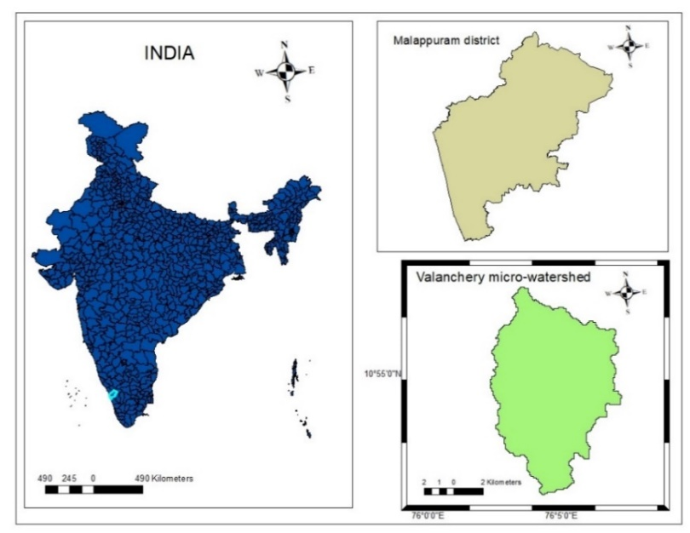

Fig. 1. Study area map of Valanchery micro watershed
  - Data used
To study the LULC classifications and their relationship with the spectral indices, United States Geological Survey (USGS) Multi-spectral Landsat data was accessed using the Google Earth Engine platform. The study was carried out for the years 2015, 2020, 2023 and the satellite imagery used had a cloud cover of less than 5%. The details of Landsat imagery used in this study are provided in Table 1.

Table 1. Particulars of the Landsat 8 image used in this study
Acquisition Date  (yyyy–mm–dd) | Landsat imagery used | Cloud Cover  (%)
2015-02-21 | LANDSAT/LC08/C02/T1_L2/LC08_145052_20150221 | 3.4
2020-02-28 | LANDSAT/LC08/C02/T1_L2/LC08_144053_20200228 | 3.3
2023-03-08 | LANDSAT/LC08/C02/T1_L2/LC08_144053_20230308 | 4.73
  - Google Earth Engine
Google Earth Engine (GEE) is a platform for planetary-scale analysis and Earth studies. It combines the ability to analyze data at a global scale with the multi-petabyte collection of imagery from satellites and geographical dataset (Gorelick et al. 2017). GEE can be used to analyze large-scale satellite information in a cloud-based environment. It is the computational platform for creating and evaluating spectral indices. Image filtering, cloud masking, and temporal compositing are among the standard preprocessing procedures made possible by the platform's access to harmonized, multi-temporal earth observation data from sensors like Landsat and Sentinel. In order to ensure consistent application of equations during all research periods, spectral indices were calculated using sensor-specific reflectance bands within the GEE JavaScript environment.
  - Methodology

Spectral indices
Spectral Indices are the proportional mathematical combination of various spectral bands of satellite images. Spectral indices can be used to highlight the specific features of the land surface, such as vegetative cover, water cover, built-up scenario or burned areas (Shafiq et al. 2025). Spectral indices can be used for extracting some key information by concentrating on the features to be studied and minimizing the influence of other factors. The research region's vegetation state, surface moisture, and built-up surfaces were measured using spectral indices that were created from multispectral satellite photography. By applying these indices uniformly to all picture datasets, land surface features and their spatiotemporal dynamics may be compared.
Normalized Difference Vegetation Index (NDVI)
NDVI is the most commonly used vegetation index for global observation of green conditions. Healthy vegetation in general in the visible range is a good absorber of the electromagnetic spectrum. Chlorophyll contained in green plants highly absorbs Blue (0.4 - 0.5 µm) and Red (0.6 - 0.7 µm) spectrum and reflects Green (0.5 – 0.6 µm) spectrum. Therefore, the human eye perceives healthy vegetation as green. Healthy plants have high reflectance in the Near Infrared (NIR) band between 0.7 to 1.3 µm. This is primarily due to the internal structure of plant leaves. NDVI is primarily used in agriculture, ecology and environmental studies to study on the vegetation and its health (Aryalekshmi et al., 2020; De Ocampo, 2023). The NIR and Red bands are used to calculate NDVI because of the high reflectance in NIR band and high absorption in Red band (Guha.,2021). Using following formula, Normalized Difference Vegetation Index (NDVI) is calculated
(1)
$NDVI=\frac{NIR-RED BAND}{NIR+RED BAND}$ (2)
The NDVI value varies from -1 to 1. Higher the value of NDVI, reflects high Near Infrared (NIR), indicating dense greenery. Generally, NDVI values are classified as given below:
NDVI = -1 to 0 represents water bodies
NDVI = -0.1 to 0.1 represent Barren rocks, sand, or snow
NDVI = 0.2 to 0.5 represent Shrubs and grasslands or senescing crops
NDVI = 0.6 to 1.0 represent Dense vegetation or tropical rainforest
The NDVI value can be calculated using the Google Earth Engine Code editor by providing the above formula in the form of code.
Normalized Difference Built-up Index (NDBI)
NDBI identifies and maps the urban areas and built-up land using a remote sensing in a particular area. It compares the shortwave-infrared (SWIR) and near-infrared (NIR) bands using reflectance data from satellite imagery or aerial photography. NDBI is a standard method in the process of urban mapping and in the quantification of the urban growth phenomenon (Ali et al. 2025). A larger positive NDBI value usually indicates built-up regions, such as roads and buildings, while a negative value indicates non-built-up areas, such as vegetation, water, and bare soil. NDBI values vary from -1 to +1.
$NDBI=\frac{(SWIR-NIR)}{(SWIR+NIR)}$ (3)
Where SWIR is Shortwave Infrared band, NIR indicates the Near Infrared band
Normalized Difference Water Index (NDWI)
Delineating open water features, enhancing their visibility in remotely sensed imagery, and analyzing changes in water content over time are the main uses of NDWI. NDWI is used to identify and monitor water bodies and determine the water content of plants. It makes use of the variation in reflectance values between satellite imagery's green band and shortwave infrared (SWIR) bands. Greater water content or the presence of open water is often indicated by higher NDWI readings. The efficiency of these water indices in capturing the spectral features of surface water in optical remote sensing imaging justifies their application on water resources (Pandey et al. 2024). NDWI can be sensitive to built-up areas, potentially leading to overestimation of water bodies. Buildings, highways, and industrial farms are examples of impermeable areas that increase absorption of shortwave radiation and decrease energy loss from longwave radiation emission (Das et al. 2021).
$NDBI=\frac{(GREEN BAND-SWIR)}{(GREEN BAND+SWIR)}$ (4)
Where, NIR-Near Infrared
- RESULTS AND DISCUSSIONS
  - Normalized Difference Vegetation Index
NDVI map (2015-2023) shows more intense green pixels representing denser vegetation in 2023 compared with 2015 (Fig. 2). From the NDVI it can be seen that the maximum NDVI increased from 0.45 (2015) to 0.52 (2023) which is a clear indication that maximum green cover increased in the study area. From these analyses, it can be observed that there is an increase in the vegetation cover. This study reveals that the most vegetated areas maintain the highest medians of NDVI values across years and, in most cases, they show an increased median by 2023. This indicates either improved vegetative cover condition, plantation growth or reforestation in those classes.
There is an increase in the NDVI from 0.45 to 0.52, which is due to the increase in plantation crops when compared with the baseline period. The results of the study are in accordance with the previous studies (Eastman et al. 2013; De Ocampo, 2023). Vegetation type and crop growth period will affect the NDVI, which shows an increased trend of vegetation (Eastman et al.2013).
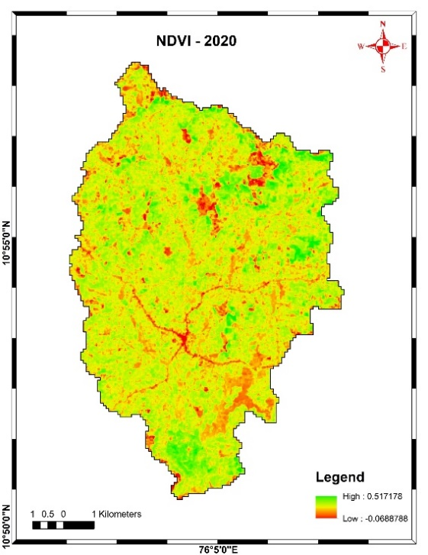
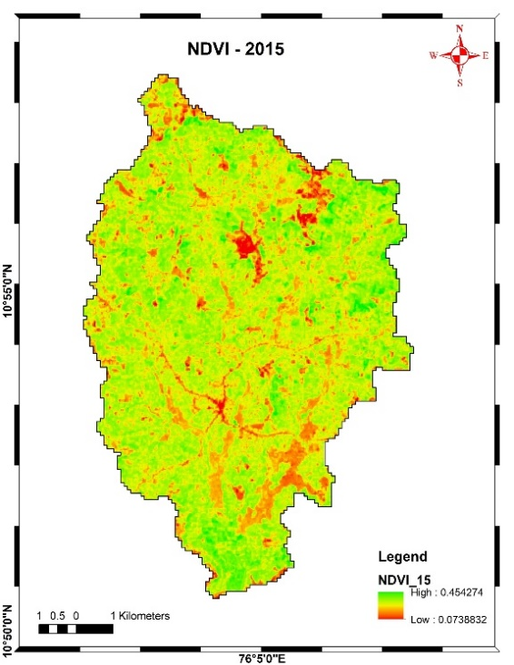
a) b)

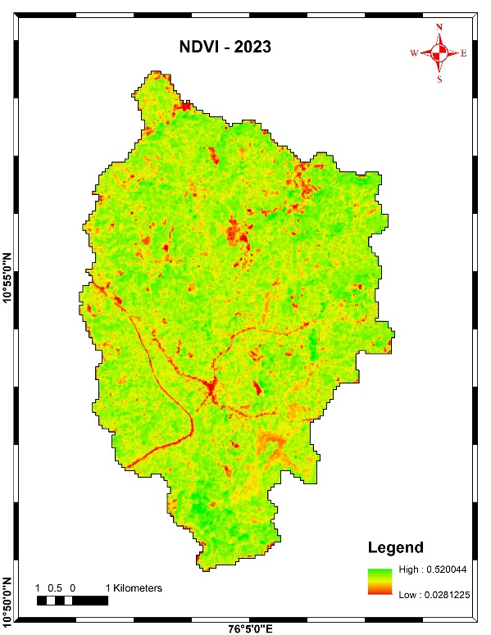
c)

Fig. 2. a) NDVI map of 2015 b) NDVI map of 2020
c) NDVI map of 2023
  - Normalized Difference Water Index (NDWI)
NDWI analysis is significant for the monitoring of water bodies, which is a combination of NIR and green band to study the terrestrial environment, while the decrease of reflectance of the water bodies. NDWI of 2020 (0.13) shows a positive value while 2015 and 2023 show mostly negative values (Fig.3). Due to ongoing climate changes in the Valanchery Micro watershed, the rainfall over the area is shifting from distributed to seasonally concentrated pattern leading to increased runoff, affecting the NDWI. The changes in NDWI may be due to the variation of rainfall, change in the rainfall pattern and the shift of monsoon due to the climate change actions (Sharma et al., 2026; Ali et al. 2025). Extraction of Water spread area and the analysis on waterbodies can be done through single band or multi band satellite imagery (Anand et al., 2024). Similar results were found in the Sharma et al. (2026) in the study conducted in the Himalayan regions. Landsat image used was in the summer months to avoid cloud cover problems. Due to the dryness of the surface and low stream flow, NDWI values were comparatively lower.
That implies temporal variation in surface/moisture conditions, and 2020 may contain standing water. LULC classes that contain more vegetation have higher NDWI medians and narrower ranges, consistent with the persistent presence of water or flooded fields. There was an increase in low NDWI values which showed a decrease in surface extent of moisture, which may be due to the reduction of waterbodies.

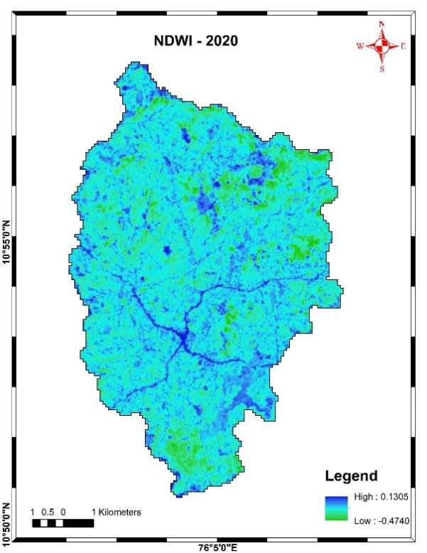
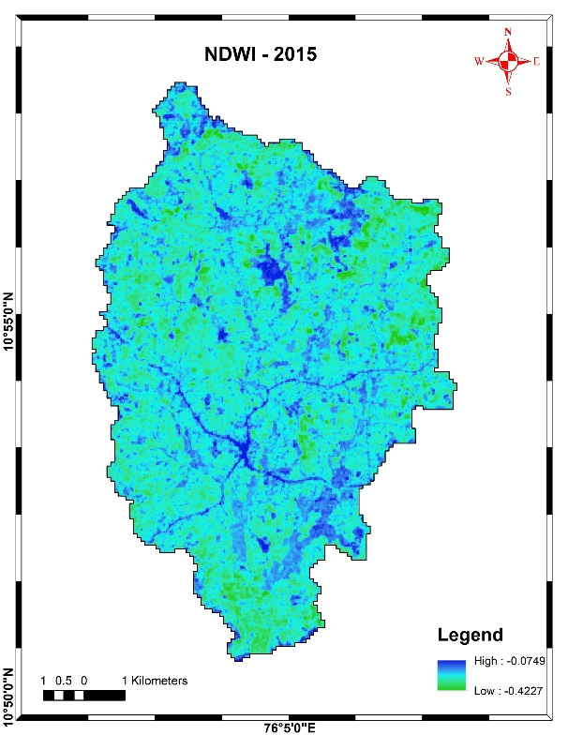
a) b)

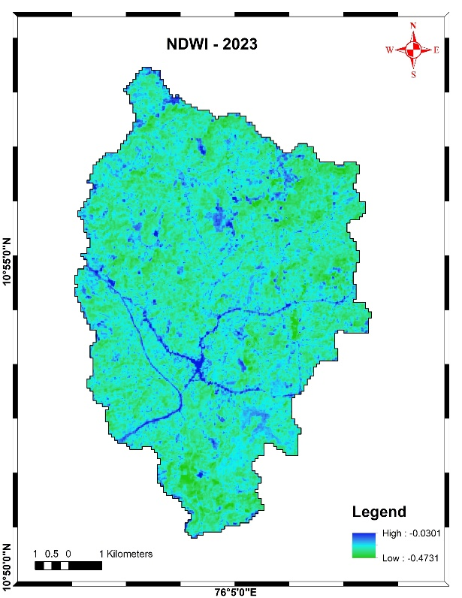
c)

Fig. 3. a) NDWI map of 2015 b) NDWI map of 2020
c) NDWI map of 2023
  - Normalized Difference Built-up Index (NDBI)
The maximum NDBI values during 2015, 2020 and 2023 are almost in the same range (-0.27 to 0.22), but the spatial extent of NDBI patches increased in 2023 (Fig. 4). The urban patches show a higher median NDBI which corresponds to built-up pixels. The increase in NDBI extent/magnitude supports small but consistent urbanization between 2015 and 2023. When NDBI increase coincide with NDVI decreases, and NDWI decreases at the same locations, the change is very likely the conversion to impervious surface (Fig.4). There is an increase in the NDBI (0.17-0.21), which was supported by the increased urban land use (1.18 km²). The construction of NH 66 also has an effect on the increase in the NDBI of 2023.
This study is highly important to reduce the time taken for analysis and depends on humans for the decision-making process in urban planning and management. When analyzed holistically, it can be said that the spectral indices values were related with the ongoing Land use changes. All the three important spectral indices like NDVI, NDWI and NDBI are highly related with the ongoing urbanization and its effects on the environment. These spectral indies are related to one another, based on the ongoing relationship over a decade that has implications on the decrease of vegetation and water resources with an increase in the urban cover in the Valanchery micro watershed.
From 2015 to 2023, the Valanchery micro-watershed's distinct land surface changes have been assessed using a multitemporal Landsat-8 study. With maximum values increasing from 0.45 in 2015 to 0.52 in 2023, the NDVI demonstrated an increase in vegetation, especially in the plantation and paddy land use classes. NDWI showed significant temporal fluctuation, reaching a positive maximum of 0.13 in 2020, whereas mainly negative values between 2015 and 2023 indicated decreased surface moisture. NDBI values were in the similar range (−0.27 to 0.22), by 2023 there was an increase spatially, indicating an increase in urban land, confirming the gradual transformation of permeable and vegetative surfaces into impermeable built-up areas.
Holistic and combined Integrated analysis of the spectral indices, such as NDVI, NDWI and NDBI revealed an improvement of vegetation with an increase in urban expansion and a decline in surface moisture conditions. The global trend of urbanization increases the land use pressure on the other major land use, which is the one of main reason for the shift of spectral indices of Valanchery microwatershed.

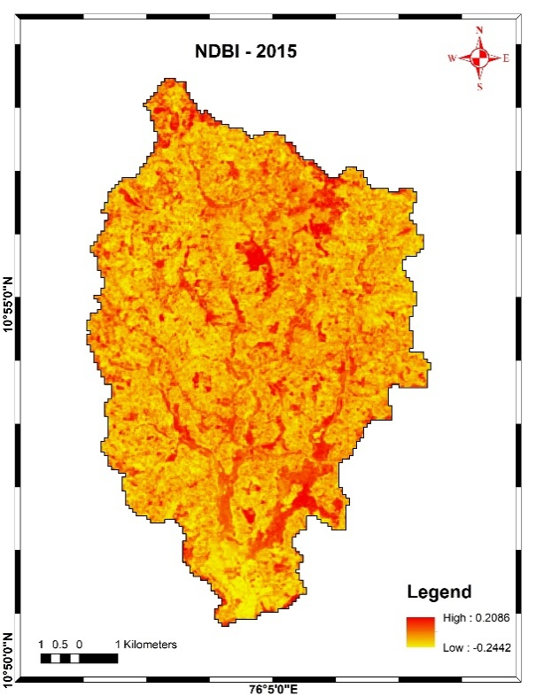
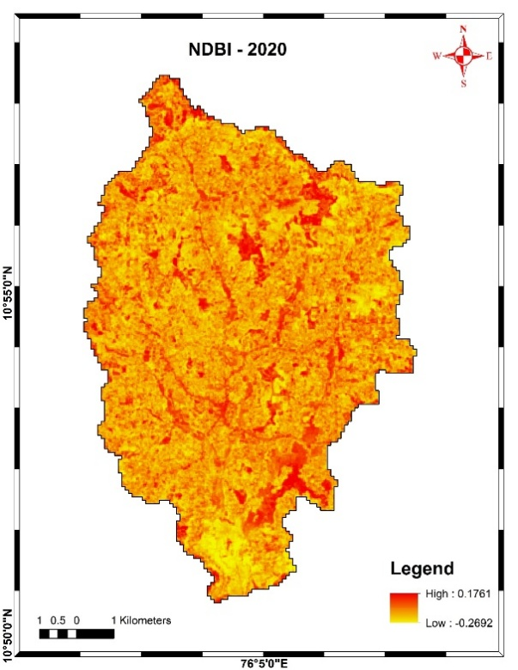
a) b)

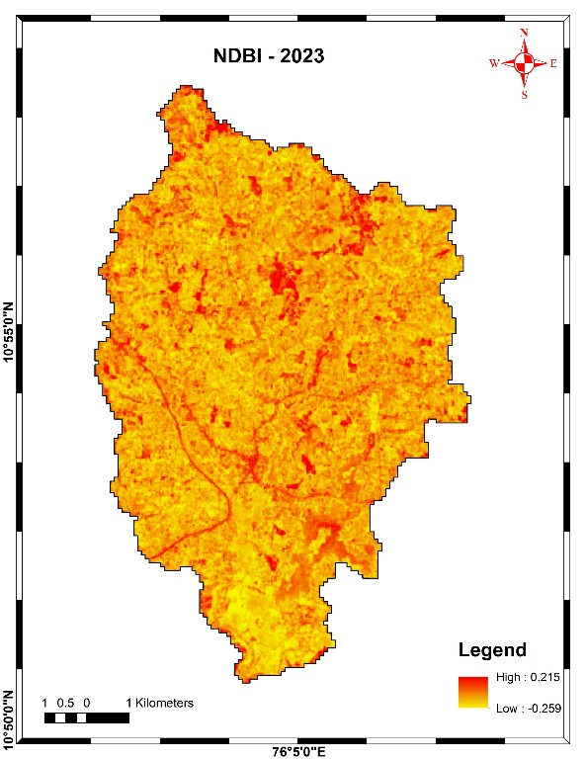
c)

Fig. 4. a) NDBI map of 2015 b) NDBI map of 2020 c) NDBI map of 2023
- SUMMARY AND CONCLUSIONS
This study used multi-temporal Landsat-8 imagery by Google Earth Engine to assess the spatiotemporal variance of NDVI, NDWI, and NDBI to analyze vegetation dynamics, surface moisture conditions, and urban growth. The maximum and median NDVI values increased significantly between 2015 and 2023, especially in the plantation, Dense vegetation, and paddy land use classes. The reliability of NDVI for evaluating vegetation state and spatial variability in humid tropical environments is demonstrated by the agreement between spectral patterns. The NDVI values occur in the plantation cropping areas followed by the dense vegetation and paddy, which means that there is an increase of vegetation in the study area. A clear temporal variation in NDWI was noted, with comparatively larger values in 2020 than in 2015 and 2023. NDBI analysis showed a progressive increase in the expansion of built-up regions between 2015 and 2023. Urban expansion and infrastructural development were in good agreement with the rise in NDBI values. Some locations were initially waterbodies but were converted due to ongoing climate change and urbanization. Due to which there is a shrinkage of waterbodies with an increase in encroachments and finally they are converted to barren lands which are later transformed to urban settlements over time.
It can be concluded from the study that the land surface changes within the watershed was established by the combined interpretation of NDVI, NDWI, and NDBI. The analysis indicated an increasing vegetation, with NDVI (0.45 to 0.52), especially in plantation and paddy areas. NDWI peaked at 0.13 in 2020, reflecting moisture variability. NDBI increased with a range (0.17–0.21), confirming progressive urban growth and increasing surface imperviousness. The study demonstrates that spectral indices are reliable methods for tracking environmental change, assisting with land use planning, and evaluating the effects of rapid urbanization with cloud-based platforms. This study underscores the need for integrated management of land and water resources to mitigate the effects on environment.

Disclaimer (Artificial intelligence)

Author(s) hereby declare that NO generative AI technologies such as Large Language Models (ChatGPT, COPILOT, etc.) and text-to-image generators have been used during the writing or editing of this manuscript.
- REFERENCES
- Alademomi, A. S., Okolie, C. J., Daramola, O. E., Akinnusi, S. A., Adediran, E., Olanrewaju, H. O.,& Odumosu, J. (2022). The interrelationship between LST, NDVI, NDBI, and land cover change in a section of Lagos metropolis, Nigeria. Applied Geomatics, 14(2), 299-314.
- Ali, A., Hussain, B., Hissan, R.U., Al Aiban, K.M., Radulescu, M. and Magazzino, C., 2025. Examining the landscape transformation and temperature dynamics in Pakistan. Scientific Reports, 15(1), p.2575.
- Anand, B., Rekha, R. S., Remitha, K. R., Maniyammai, V., Ramaswamy, K., & Gautam, S. (2024). Dynamic change analysis of water spread region and its impact assessment using spectral indices of remotely sensed data. Environment, Development and Sustainability, 26(7), 17635-17652.
- Aravind, P., Selvakumar, S., Thiyagarajan, G., Kannan, B., & Boomiraj, K. (2022). Estimation of land surface temperature for Coimbatore District using Landsat imagery. Journal of Applied and Natural Science, 14(SI), 8.
- Aryalekshmi, B. N., & Biradar, R. C. (2020). Land surface temperature estimation of mandya district using LANDSAT-8 data. Journal of Applied Science and Engineering, 23(4), 583-591.
- Das, N., Mondal, P., Sutradhar, S. and Ghosh, R., 2021. Assessment of variation of land use/land cover and its impact on land surface temperature of Asansol subdivision. The Egyptian Journal of Remote Sensing and Space Science, 24(1), pp.131-149.
- De Ocampo, A.L.P., 2023, March. Normalized difference vegetation index (NDVI) estimation based on filter augmented imaging. In 2023 International Electrical Engineering Congress (iEECON) (pp. 84-88). IEEE.
- Eastman, J.R., Sangermano, F., Machado, E.A., Rogan, J. and Anyamba, A., 2013. Global trends in seasonality of normalized difference vegetation index (NDVI), 1982–2011. Remote Sensing, 5(10), pp.4799-4818.
- Fatima, N., Alamgir, A., Khan, M. A., Fatima, S. U., & Malik, E. (2022). Monitoring of environmental resources using normalized difference vegetation index (NDVI) and normalized difference water index (NDWI) in the coastal areas of Sindh, Pakistan. International Journal of Biology and Biotechnology, 19(3), 379-393.
- Gorelick, N., Hancher, M., Dixon, M., Ilyushchenko, S., Thau, D. and Moore, R., 2017. Google Earth Engine: Planetary-scale geospatial analysis for everyone. Remote sensing of Environment, 202, pp.18-27.
- Guha, S., 2021. A long-term monthly assessment of land surface temperature and normalized difference vegetation index using Landsat data. urbe. Revista Brasileira de Gestão Urbana, 13, p.e20200345.
- Huete, A.R., 1988. A soil-adjusted vegetation index (SAVI). Remote sensing of environment, 25(3), pp.295-309.
- Kolli, M.K., Pham, Q.B., Thi Thuy Linh, N., Ngoc Hoai, P., Costache, R. and Anh, D.T., 2022. Assessment of change in the extent of mangrove ecosystems using different spectral indices in Google Earth Engine based on random forest model. Arabian Journal of Geosciences, 15(9), p.889.
- Lillesand, T., Kiefer, R.W. and Chipman, J., 2015. Remote sensing and image interpretation. John Wiley & Sons.
- Montero, D., Aybar, C., Mahecha, M.D., Martinuzzi, F., Söchting, M. and Wieneke, S., 2023. A standardized catalogue of spectral indices to advance the use of remote sensing in Earth system research. Scientific Data, 10(1), p.197.
- Pandey, V., Pandey, P.K., Lepcha, P.T. and Devi, N.N., 2024. Assessment of surface water dynamics through satellite mapping with Google Earth Engine and Sentinel-2 data in Manipur, India. Journal of Water and Climate Change, 15(3), pp.1313-1332.
- Patel, S., Indraganti, M. and Jawarneh, R.N., 2024. A comprehensive systematic review: Impact of Land Use/Land Cover (LULC) on Land Surface Temperatures (LST) and outdoor thermal comfort. Building and Environment, 249, p.111130.
- Ramachandran, J., R. Lalitha and S. Vallal Kannan. 2019. Remote Sensing Based Greenness Modeling of Different Crops in Lalgudi Block Using Landsat 8 Image. Journal of Soils and Crops. 29(2). 232-235
- Roy, D.P., Wulder, M.A., Loveland, T.R., Ce, W., Allen, R.G., Anderson, M.C., Helder, D., Irons, J.R., Johnson, D.M., Kennedy, R. and Scambos, T.A., 2014. Landsat-8: Science and product vision for terrestrial global change research. Remote sensing of Environment, 145, pp.154-172.
- Shafiq, H., Hissan, R.U., Mariam, A., Ali, S., Nassani, A.A., Radulescu, M., Batool, K. and Hussain, B., 2025. Spatio-temporal assessment of urban temperature variations and landscape characteristics using spectral indices. Gondwana Research, 139, pp.148-165.
- Sharma, M., Mahajan, S., Chander Dutt, H., Sharma, K., Parsad, G., & Taloor, A. K. (2026). Estimation of LST, NDBI and NDWI in the Jammu Kathua Samba regions of the Northwestern Himalayas, India. Discover Geoscience, 4(1), 35.
- Situmorang, J.P. and Sugianto, S., 2016. Estimation of Carbon Stock Stands using EVI and NDVI vegetation index in production forest of lembah Seulawah sub-district, Aceh Indonesia. Aceh International Journal of Science & Technology, 5(3).
- Tiwari, A.K. and Kanchan, R., 2024. Analytical study on the relationship among land surface temperature, land use/land cover and spectral indices using geospatial techniques. Discover Environment, 2(1), p.1.
- Zaitunah, A., Ahmad, A. G., & Safitri, R. A.2018. Normalized difference vegetation index (NDVI) analysis for land cover types using landsat 8 oli in besitang watershed, Indonesia. In IOP Conference Series: Earth and Environmental Science .Vol. 126: 1, p. 012112.
- Zeng, H., Wu, B., Wang, S., Musakwa, W., Tian, F., Mashimbye, Z.E., Poona, N. and Syndey, M., 2020. A synthesizing land-cover classification method based on Google Earth engine: A case study in Nzhelele and Levhuvu Catchments, South Africa. Chinese Geographical Science, 30(3), pp.397-409.

