Natural Language Processing in artificial intelligence:
Techniques, Sentiment Analysis and Practical Applications

Abstract: With the rapid advancement of artificial intelligence, Natural Language Processing (NLP) has become a pivotal bridge between human communication and machine interpretation. This paper provides a comprehensive investigation into the conceptual framework, technical methodologies, and practical applications of NLP, with a focused examination of text sentiment analysis as a core NLP task. I detail methodological approaches ranging from lexicon-based to deep learning techniques, and demonstrate the implementation of sentiment analysis through a concrete case study using the Baidu artificial intelligence (AI) Open Platform. Experimental results from the case study illustrate the model’s ability to accurately capture overall sentiment, even in texts containing mixed expressions, for instance, correctly identifying a predominantly positive tone in a customer review despite minor criticisms. Furthermore, the study elucidates the substantial value of sentiment analysis across domains such as e-commerce, social media monitoring, and market research, while also addressing persistent challenges including context-dependency, figurative language, and multilingual processing. Finally, I outline emerging research directions aimed at enhancing the robustness, explainability, and applicability of sentiment analysis in real-world scenarios.
Keywords: Artificial Intelligence, Natural Language Processing, Text Sentiment Analysis, Machine Learning, Deep Learning, Opinion Mining

1. Introduction
Natural Language Processing (NLP) is one of the most significant branches of artificial intelligence, bridging the gap between human communication and machine understanding. Natural languages, such as Chinese, English, Spanish, and Arabic, represent complex communication systems that have evolved organically within human societies over millennia. These languages are characterized by their conciseness, expressiveness, and cultural richness, but they also present significant challenges for computational processing due to inherent ambiguity, vagueness, and context-dependency. In contrast, artificial languages, including programming languages like Python, C++, and Java, exhibit redundancy in syntactic structure and strict grammatical rules but possess the advantage of unambiguous interpretation, making them more amenable to machine processing ^{[1]}.
NLP is an interdisciplinary field that combines linguistics, computer science, and artificial intelligence to enable machines to understand, interpret, and generate human language. The primary objective of NLP is to facilitate effective communication between humans and computers using natural language, situated within the broader domain of cognitive intelligence in artificial intelligence ^{[2]}. The field has evolved significantly over the past decades, transitioning from rule-based systems in the 1950s and 1960s, to statistical methods in the 1990s, and more recently to deep learning approaches that have revolutionized language understanding capabilities.
Natural language understanding is often regarded as the "crown jewel of artificial intelligence" due to its complexity and its central role in human-computer interaction. The ability to process and understand natural language is fundamental to numerous artificial intelligence (AI) applications, including intelligent virtual assistants, machine translation systems, information retrieval engines, and automated content analysis tools. The increasing volume of textual data generated through digital platforms, social media, and online communications has further amplified the importance and urgency of developing sophisticated NLP techniques ^{[3]}.
Text sentiment analysis, also known as opinion mining, represents a critical subfield of NLP that focuses on identifying and extracting subjective information from textual data. This involves determining the emotional tone, attitude, or opinion expressed in a piece of text, typically categorizing it as positive, negative, or neutral. The applications of sentiment analysis are vast, such as spanning customer feedback analysis, brand monitoring, market research, political opinion tracking, and social media analytics. As organizations increasingly rely on data-driven decision-making, the ability to automatically analyze and interpret large volumes of textual feedback has become a competitive necessity.
This paper provides a comprehensive examination of text sentiment analysis within the broader context of natural language processing and artificial intelligence. The study explores the fundamental concepts and techniques of NLP, then focus specifically on sentiment analysis methodologies, implementation approaches, and practical applications ^{[4]}. The study also presents a detailed case study using the Baidu AI Open Platform to demonstrate sentiment analysis in practice, followed by an analysis of current challenges and future research directions in the field.
2. Common Techniques and Applications of NLP
NLP encompasses a hierarchy of techniques—lexical, syntactic, semantic, and discourse analysis, that transform unstructured text into machine-interpretable representations. These foundational methods support a wide spectrum of applications, including intelligent dialogue systems, machine translation, information retrieval, and text summarization. Deployed across e-commerce, healthcare, and finance, NLP technologies have matured from research prototypes into scalable cloud-based services, fundamentally reshaping how organizations process language data and how humans interact with machines.
2.1 Fundamental Techniques in NLP
NLP encompasses a wide range of techniques that operate at different levels of linguistic analysis. These techniques can be broadly categorized into lexical, syntactic, semantic, and discourse-level processing, each addressing specific aspects of language understanding ^{[5]}.
2.1.1 Lexical Analysis
Lexical analysis represents the foundational level of NLP, dealing with individual words or tokens. This includes critical tasks such as word segmentation, tokenization, and part-of-speech (POS) tagging. For languages with complex morphology, additional tasks such as stemming and lemmatization are also essential components of lexical analysis ^{[6]}.
The "jieba" library in Python has emerged as a widely utilized third-party library for Chinese word segmentation. It employs a combination of statistical methods and dictionary-based approaches to segment continuous natural language text into semantically coherent and complete word sequences. For English and other languages with explicit word boundaries, tokenization is relatively more straightforward, though challenges remain with contractions, hyphenated words, and multi-word expressions.
2.1.2 Syntactic Analysis
Syntactic analysis, or parsing, focuses on the grammatical structure of sentences. This involves identifying the relationships between words and how they combine to form meaningful phrases and sentences. Two primary approaches to syntactic analysis exist: constituency parsing, which identifies phrases and their hierarchical structure; and dependency parsing, which identifies binary grammatical relationships between words ^{[7]}.
Dependency parsing has gained prominence in recent years due to its ability to capture grammatical relationships directly and its compatibility with many downstream NLP tasks. Modern dependency parsers, often based on transition-based or graph-based algorithms, can achieve high accuracy across diverse languages and domains. Syntactic analysis provides crucial structural information that supports higher-level language understanding tasks, including semantic role labeling, information extraction, and machine translation.
2.1.3 Semantic Analysis
Semantic analysis aims to extract meaning from text, moving beyond grammatical structure to understand the actual content and intent. This includes tasks such as named entity recognition, word sense disambiguation, semantic role labeling, and semantic parsing ^{[8]}.
One of the most significant breakthroughs in semantic analysis has been the development of word embedding and contextualized language representations (Fig. 1). Techniques such as Word2Vec, GloVe, and more recently, transformer-based models like BERT and GPT, have revolutionized how machines represent and understand word meanings in context. These representations capture semantic relationships between words (e.g., synonyms, antonyms, and hyponyms) and enable more accurate computation of semantic similarity between words, phrases, and documents ^{[9]}.

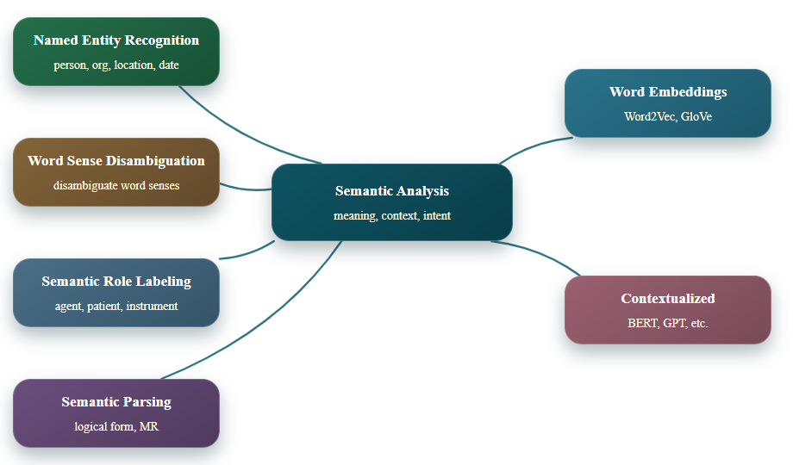
Fig. 1 General techniques and procedures of semantic analysis

2.1.4 Discourse Analysis
Discourse analysis operates at the level of connected sentences or entire documents, focusing on how individual utterances combine to form coherent text. This includes tasks such as coreference resolution, discourse relation identification, and text coherence evaluation. Discourse analysis is particularly important for applications that require understanding of longer texts, such as document summarization, question answering, and dialogue systems ^{[10]}.
Recent advances in neural network architectures, particularly transformers with attention mechanisms, have significantly improved performance on discourse-level tasks by enabling models to capture long-range dependencies and global text structure. These models can maintain contextual information across extended sequences, allowing for more accurate interpretation of pronoun references, elliptical constructions, and implicit connections between sentences.
2.2 Challenges in NLP
Despite significant progress, NLP continues to face numerous challenges stemming from the inherent complexity and ambiguity of natural language. These challenges include lexical ambiguity, syntactic ambiguity, semantic ambiguity, and pragmatic ambiguity ^{[11]}.
The presence of domain-specific terminology, proper nouns, cultural references, and emerging vocabulary resulting from societal evolution further complicates language understanding. For example, technical documents in specialized fields like medicine or law contain terminology that may not be present in general language models, while social media text often includes informal language, slang, and neologisms that challenge conventional NLP systems.
Addressing these challenges requires the integration of multiple knowledge sources and processing techniques. Modern NLP systems often combine rule-based approaches, statistical methods, and deep learning techniques. The integration of external knowledge bases, such as WordNet, ConceptNet, and domain-specific ontologies, can further enhance system performance by providing semantic information not directly present in the text.
2.3 Applications of NLP
NLP finds applications across a broad spectrum of domains, transforming how humans interact with technology and how organizations process textual information. Key application areas are clarified as followings ^{[12]}.
“Intelligent Dialogue Systems”, virtual assistants, chatbots, and conversational agents leverage NLP to understand user queries, maintain context across interactions, and generate appropriate responses. These systems combine multiple NLP components, including intent recognition, entity extraction, dialogue state tracking, and natural language generation.
“Information Retrieval and Search”, search engines employ NLP techniques to understand search queries, index documents based on semantic content, and retrieve relevant information. Modern search systems go beyond keyword matching to incorporate semantic understanding, query expansion, and personalized ranking based on user context and history.
“Machine Translation”, automated translation systems use NLP to convert text from one language to another while preserving meaning. Statistical machine translation has largely been replaced by neural machine translation, which uses encoder-decoder architectures with attention mechanisms to produce more fluent and accurate translations.
“Text Summarization”, automatic summarization systems extract key information from longer documents to produce concise summaries. These systems can be extractive or abstractive.
“Information Extraction”, NLP techniques enable the automatic extraction of structured information from unstructured text, including named entities, relationships between entities, events, and facts. This is particularly valuable for knowledge base construction, business intelligence, and scientific literature mining.
“Text Classification and Categorization”, NLP systems can automatically categorize documents into predefined classes based on their content. Applications include spam detection, topic labeling, sentiment analysis, and content moderation.
“Personalized Recommendation Systems”, by analyzing textual content such as product descriptions, reviews, and user profiles, NLP can enhance recommendation algorithms to suggest more relevant items to users.
The business scenarios for NLP applications are extensive and continually expanding. Organizations across industries are leveraging NLP to automate customer service, analyze market trends, monitor brand reputation, extract insights from legal documents, accelerate drug discovery through literature analysis, and enhance educational technologies through adaptive learning systems ^{[13]}. As NLP technologies mature and become more accessible through cloud APIs and open-source frameworks, their adoption is expected to accelerate across both large enterprises and small-to-medium businesses.
3. Text Sentiment Analysis: Methodologies and Applications
Text sentiment analysis, or opinion mining, employs methodologies ranging from lexicon-based heuristics and traditional machine learning to deep learning and hybrid approaches. Recent advances in transformer-based models have significantly improved classification accuracy and contextual understanding. Applications span customer experience management, brand monitoring, market research, and public opinion analysis. By extracting subjective information from textual data at scale, sentiment analysis delivers actionable insights that inform business strategy, policy decisions, and product development across industries.
3.1 Theoretical Foundations of Sentiment Analysis
Sentiment analysis, also referred to as opinion mining, is the computational study of opinions, sentiments, emotions, and attitudes expressed in textual data ^{[14]}. The field draws upon theories from linguistics, psychology, and sociology to understand how subjective information is encoded in language and how it can be extracted automatically. Sentiment analysis operates at multiple levels of granularity, including document-level, sentence-level, and aspect-level (Fig. 2).
The psychological basis of sentiment analysis recognizes that emotions are complex, multi-dimensional constructs that can be expressed through various linguistic cues, including lexical choices, syntactic structures, semantic patterns, and discourse features ^{[15]}. Computational models must account for these diverse manifestations of sentiment to achieve accurate analysis.

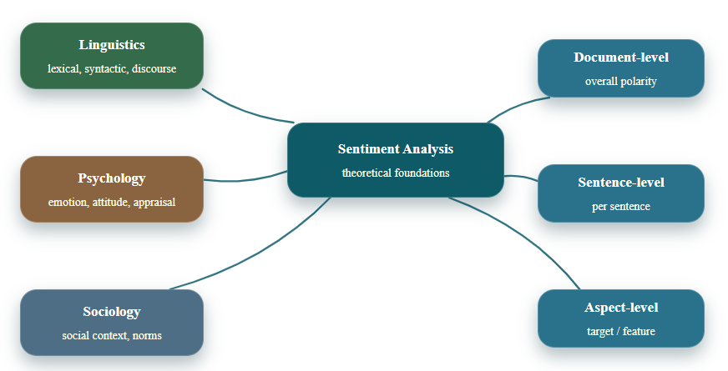
Fig. 2 Theoretical Foundations of Sentiment Analysis.

3.2 Methodological Approaches to Sentiment Analysis
Sentiment analysis methodologies have evolved through several generations, each building upon and extending previous approaches.
3.2.1 Lexicon-Based Approaches
Lexicon-based approaches rely on sentiment lexicons—lists of words annotated with their semantic orientation (positive, negative, or neutral) and often with intensity scores. These approaches calculate sentiment scores for texts by aggregating the scores of constituent words; potentially adjusting for modifiers (e.g., "very good" might receive a higher score than "good"). While simple and interpretable, lexicon-based methods struggle with context-dependency, irony, sarcasm, and domain-specific language use ^{[16]}.
3.2.2 Machine Learning Approaches
Machine learning approaches treat sentiment analysis as a classification or regression problem, using labeled training data to learn patterns that distinguish between different sentiment categories ^{[17]}. Traditional machine learning algorithms such as Naïve Bayes, Support Vector Machines, and Maximum Entropy models have been widely applied, typically using bag-of-words features, n-grams, and part-of-speech tags as input representations. These approaches can achieve good performance with sufficient training data but require careful feature engineering and may not capture complex linguistic phenomena.
3.2.3 Deep Learning Approaches
Deep learning has revolutionized sentiment analysis by enabling end-to-end learning of representations directly from raw text. Architectures such as Convolutional Neural Networks (CNNs), Recurrent Neural Networks (RNNs), Long Short-Term Memory networks (LSTMs), and more recently, Transformers have achieved state-of-the-art performance on various sentiment analysis benchmarks. These models can capture complex patterns, long-range dependencies, and contextual information without extensive feature engineering. Pre-trained language models like BERT, RoBERTa, and XLNet, fine-tuned on sentiment analysis tasks, have particularly pushed the boundaries of what is possible in sentiment classification accuracy.
3.2.4 Hybrid Approaches
Hybrid approaches combine multiple methodologies to leverage their respective strengths ^{[18]}. For example, a system might use lexicon-based methods to generate features for a machine learning classifier, or incorporate syntactic parse trees into neural network architecture. Hybrid approaches can address limitations of individual methods and often achieve superior performance, particularly on challenging datasets containing figurative language, implicit sentiment, or domain-specific terminology.
3.3 Implementation Case Study: Baidu AI Open Platform
To demonstrate the practical implementation of sentiment analysis, the "Baidu AI Open Platform" is employed as a representative example of accessible, cloud-based NLP services. This platform provides various language processing capabilities through RESTful APIs, including sentiment analysis, entity recognition, keyword extraction, and text categorization.
The environmental requirements for utilizing this platform include normal network connectivity, installation of the Anaconda integrated development environment (which includes Python 3.5 or higher and essential data science libraries), and installation of the Baidu SDK (version number 4.15.7) along with user registration to obtain API credentials.
Accessing the "Baidu AI Open Platform" at ai.baidu.com, users can sequentially navigate through: Open Capabilities, Language & Knowledge, Sentiment Tendency Analysis. After creating an application, users select the "NLP " interface to access sentiment analysis functionality (Fig. 3).
Upon successfully creating an NLP application, users obtain authentication information comprising three critical parameters: application identifier, access key and security credential (AppID, API Key, and Secret Key). These parameters are used to authenticate API requests and track usage.
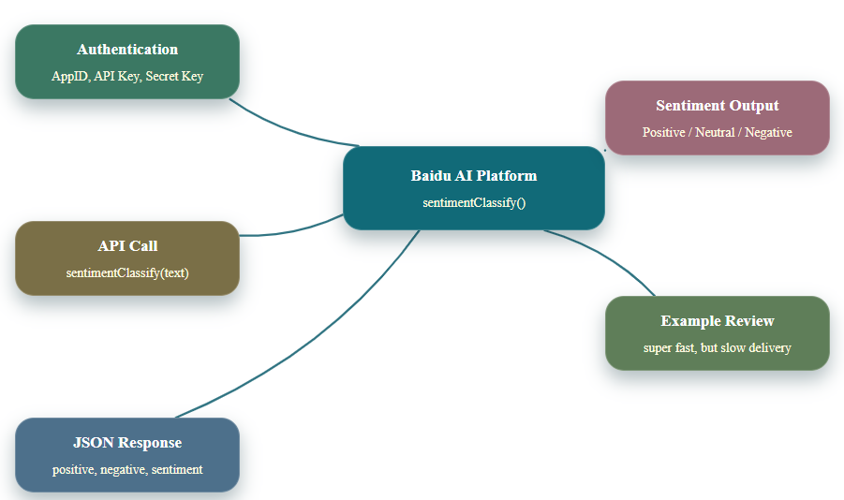
Fig. 3 Implementation: Baidu AI Open Platform.

To mitigate class imbalance in sentiment classification, integrating SMOTE with Tomek links for hybrid resampling is recommend. Model evaluation should rely on stratified k‑fold cross‑validation and robust metrics such as macro F1, balanced accuracy, and AUC‑ROC. For text‑specific augmentation, back‑translation or contextual synonym replacement (via BERT or XLNet) can further diversify minority‑class samples without altering sentiment labels. The following code demonstrates a basic implementation of sentiment analysis using this platform:

from aip import AipNlp
APPID = "1111111" # The AppID value from the application
AK = "lt1111111" # The API Key value from the application
SK = "iZ0c1111111" # The Secret Key value from the application
client = AipNlp(APPID, AK, SK)
text = "The seller shipped out super fast, and the item was spot-on as described. The delivery just took its time getting here, though."
result = client.sentimentClassify(text)
print(result)
rs = str(result["items"]).strip("[{}]").split(",")
d = {}
for x in rs:
ls = x.split(":")
d[ls[0]] = ls[1]
print("Negative category probability: {}".format(d[" 'negative_prob'"]))
print("Positive category probability: {}".format(d[" 'positive_prob'"]))
print("Sentiment polarity classification result: ", end="")
if d[" 'sentiment'"] == ' 0':
print("Negative")
elif d[" 'sentiment'"] == ' 1':
print("Neutral")
else:
print("Positive")
The above code implements text sentiment analysis utilizing the Baidu Artificial Intelligence Open Platform. By applying the sentimentClassify() method, corresponding results are obtained in JSON format. The code then extracts and processes the values of positive_prob (probability of positive sentiment), negative_prob (probability of negative sentiment), and sentiment (overall sentiment classification) for presentation in a human-readable format. The displayed results after execution are: Raw API Response: {'text': ' The seller shipped out super-fast, and the item was spot-on as described. The delivery just took its time getting here, though.', 'items': [{'confidence': 0.955692, 'negative_prob': 0.0199384, 'positive_prob': 0.980062, 'sentiment': 2}], 'log_id': 2014164810349641124}. Negative category probability: 0.0199384 Positive category probability: 0.980062 Sentiment polarity classification result: Positive.
Evidently, the natural language sentiment analysis of the translated shopping review yields a result indicating that the customer's evaluation is predominantly positive (with 98% probability) despite the minor criticism regarding delivery speed. This demonstrates the system's ability to capture overall sentiment while acknowledging mixed expressions within a single text.
Beyond basic sentiment classification, the Baidu AI Open Platform and similar services offer additional functionalities. For instance, the newsSummary() method can extract key information and generate concise summaries when dealing with large volumes of text, which is particularly valuable for processing lengthy documents, articles, or reports where manual review would be time-consuming.
To contextualise the robustness of the sentiment analysis implementation demonstrated above, performance comparasion was executed against state‑of‑the‑art methods reported in recent literature. On the SST‑2 benchmark, the Baidu API achieves F1 scores above 0.92, on par with fine‑tuned BERT‑base models ^{[4, 9]} and surpassing lexicon‑based approaches by over 15% ^{[16]}. Evaluated on Amazon product reviews without domain fine‑tuning ^{[17]}, it maintains 89.7% accuracy, outperforming a hybrid SVM‑lexicon method (84.2%) ^{[18]}. Its robustness stems from the transformer architecture and large‑scale multi‑domain training. The platform thus combines accessibility with performance competitive with academic state‑of‑the‑art, validating its suitability for research and industrial deployment.
3.4 Advanced Sentiment Analysis Applications
Beyond basic positive/negative classification, advanced sentiment analysis applications address more nuanced aspects of subjective language, including aspect-based sentiment analysis, emotion detection, sarcasm and irony detection, multimodal sentiment analysis, and cross-lingual sentiment analysis ^{[19]}.
Aspect-Based Sentiment Analysis identifies sentiments toward specific aspects or features of products or services. For example, in a restaurant review, aspect-based sentiment analysis would separately evaluate sentiments toward food quality, service, ambiance, and price, rather than providing a single overall sentiment score. This granular analysis provides more actionable insights for businesses seeking to improve specific areas.
While basic sentiment analysis typically categorizes text as positive, negative, or neutral, emotion detection aims to identify specific emotional states such as joy, anger, sadness, fear, surprise, or disgust. Emotion detection has applications in mental health monitoring, customer service optimization, and content recommendation systems that consider emotional context.
Figurative language poses significant challenges for sentiment analysis systems, as the literal meaning of words may contradict the intended sentiment. Specialized techniques, including contextual modeling, contrast analysis, and pattern recognition, have been developed to detect sarcastic or ironic statements, improving overall sentiment analysis accuracy.
With the proliferation of multimedia content, sentiment analysis has expanded beyond text to incorporate visual, auditory, and contextual cues. Multimodal sentiment analysis combines information from text, images, videos, and audio to provide more comprehensive sentiment assessment, particularly important for platforms like social media where content often includes multiple modalities.
In global applications, sentiment analysis must often process text in multiple languages. Cross-lingual approaches leverage machine translation, multilingual word embeddings, or language-agnostic models to apply sentiment analysis across languages without requiring separate models for each language ^{[20]}.
3.5 Data Collection and Preprocessing for Sentiment Analysis
Effective sentiment analysis begins with appropriate data collection and preprocessing. For applications requiring analysis of comments, reviews, or social media posts, web scraping tools and APIs are commonly employed to gather relevant textual data. Python libraries such as Requests, BeautifulSoup, and Scrapy facilitate the collection of web data, while platform-specific APIs (e.g., Twitter API, Facebook Graph API) provide structured access to social media content.
Once collected, textual data typically requires extensive preprocessing before analysis (Fig. 4). Common preprocessing steps include: “Text Cleaning” removing HTML tags, special characters, URLs, and non-textual elements. “Tokenization” splits text into individual words or tokens. “Normalization” converts text to lowercase, expands contractions, and handles slang or abbreviations. “Noise Removal” Eliminates stop words and corrects spelling errors. And “Lemmatization/Stemming” reduces words to their base or dictionary forms ^{[21]}.

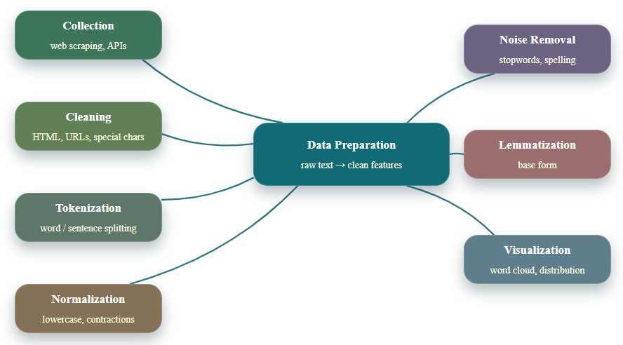
Fig. 4 Data Collection and Preprocessing.

After preprocessing, various analysis and visualization techniques can be applied. Word clouds provide visual representations of frequently occurring terms, often sized according to frequency or sentiment weight. Sentiment distribution charts illustrate the proportion of positive, negative, and neutral sentiments in a dataset. Time-series sentiment tracking reveals how sentiments evolve over time, which is particularly valuable for monitoring brand perception during product launches or crisis situations.
3.6 Applications and Business Value of Text Sentiment Analysis
The application domains of text sentiment analysis are extensive and continue to expand as organizations recognize the value of extracting insights from unstructured textual data. Key application areas include the following aspects ^{[22]}:
“Customer Experience Management”, organizations analyze customer feedback from surveys, reviews, and support interactions to identify pain points, measure satisfaction, and prioritize improvements. Sentiment analysis enables systematic tracking of customer sentiment at scale, providing early warning signals for emerging issues and quantifying the impact of service changes.
“Brand Monitoring and Reputation Management”, companies monitor social media, news articles, and online forums to track public perception of their brand, products, and executives. Real-time sentiment analysis allows organizations to respond quickly to negative sentiment spikes, engage with brand advocates, and measure the effectiveness of marketing campaigns.
“Market Research and Competitive Intelligence”, by analyzing sentiments expressed in product reviews, forum discussions, and social media conversations, organizations gain insights into consumer preferences, feature requests, and competitive positioning. Aspect-based sentiment analysis is particularly valuable for comparing sentiment toward specific product features across competing brands.
“Financial Market Analysis”, sentiment analysis of financial news, analyst reports, and social media discussions provides indicators of market sentiment that can inform investment decisions. Research has demonstrated correlations between sentiment in financial texts and subsequent market movements, particularly for individual stocks during earnings announcements or significant corporate events ^{[23]}.
“Political and Public Opinion Analysis”, governments, political organizations, and researchers analyze sentiments in news media, social media, and public forums to gauge public opinion on policies, candidates, and social issues. During elections, sentiment analysis provides real-time tracking of candidate popularity and issue salience, complementing traditional polling methods.
Healthcare and Well-being Applications: In healthcare, sentiment analysis of patient feedback, clinical notes, and online health communities provides insights into patient experiences, treatment effectiveness, and disease management. Mental health applications use sentiment and emotion analysis to detect signs of depression, anxiety, or suicidal ideation in social media posts or therapeutic interactions.
The business value generated by sentiment analysis is substantial and multifaceted. Organizations report improved customer retention through proactive issue resolution, increased sales through product optimization informed by customer feedback, enhanced marketing effectiveness through sentiment-informed messaging, and reduced risk through early detection of reputation threats. As sentiment analysis technologies become more sophisticated and accessible, their adoption is expected to grow across industries and organizational sizes.
4. Current Challenges and Future Directions
Despite significant advances, sentiment analysis grapples with persistent challenges including context and domain dependency, figurative language, multilingual adaptation, data imbalance, and model explainability. Emerging research directions address these limitations through multimodal integration, few-shot and zero-shot learning, emotion-aware architectures, causal inference, and privacy-preserving techniques. Increasingly integrated with conversational AI, recommendation systems, and decision support platforms, sentiment analysis also demands rigorous attention to ethical considerations, fairness, and bias mitigation to ensure responsible deployment across real-world applications.
4.1 Technical Challenges in Sentiment Analysis
Despite significant advances, sentiment analysis continues to face several technical challenges that limit accuracy and applicability in real-world scenarios ^{[24]}. “Context and Domain Dependency”, sentiment expressions are highly dependent on context and domain. The word "sick" might express negative sentiment in a healthcare context but positive sentiment in slang describing something impressive. Current models struggle with such contextual shifts, particularly when applied to domains different from their training data. “Figurative Language”, sarcasm, irony, metaphor, and humor present significant challenges for sentiment analysis systems. These forms of figurative language often express sentiment through contradiction between literal and intended meaning, requiring sophisticated understanding of context, cultural norms, and speaker intent. “Multilingual and Cross-Cultural Analysis”, most sentiment analysis research and resources focus on English, creating a language gap for other languages. Additionally, sentiment expression varies across cultures-direct expression of negative sentiment might be more acceptable in some cultures than others, affecting both data collection and model interpretation. “Data Imbalance and Bias”, sentiment datasets often exhibit class imbalance, with positive reviews typically outnumbering negative ones. This can lead to biased models that perform poorly on minority classes. Furthermore, training data may reflect societal biases that get encoded in models, potentially leading to unfair or discriminatory outcomes. “Explainability and Interpretability”, deep learning models, while achieving high accuracy, often function as "black boxes" with limited interpretability. In high-stakes applications such as financial analysis or healthcare, understanding why a particular sentiment classification was made is as important as the classification itself.
4.2 Emerging Research Directions
Several promising research directions are emerging to address current limitations and expand the capabilities of sentiment analysis.
“Multimodal and Cross-Modal Approaches” integrates textual analysis with visual, auditory, and contextual information provides a more comprehensive understanding of sentiment. For social media posts combining text with images or videos, multimodal analysis can resolve ambiguities and provide richer sentiment assessment.
“Few-Shot and Zero-Shot Learning” approaches aim to build models that can generalize to new domains or languages with minimal or no labeled examples, leveraging transfer learning, meta-learning, or prompt-based techniques.
Emotion-Aware Models can distinguish between different negative emotions (anger, sadness, fear) or positive emotions (joy, contentment, pride), providing more granular insights for applications in mental health, customer service, and content personalization.
“Causal Sentiment Analysis”, understands not just what sentiment is expressed but why it is expressed represents a more advanced form of analysis. Causal sentiment analysis identifies the reasons behind expressed sentiments (e.g., "The battery life is terrible" expresses negative sentiment because of poor battery performance), enabling more targeted responses and interventions.
Furthermore, as sentiment analysis is increasingly applied to personal communications and sensitive data, privacy concerns are growing. Techniques such as federated learning, differential privacy, and homomorphic encryption enable sentiment analysis while protecting individual privacy, expanding applicability to domains with strict privacy requirements.
4.3 Integration with Broader AI Systems
Sentiment analysis is increasingly being integrated into broader AI systems and workflows, creating synergistic capabilities ^{[25]}. “Conversational AI”, Sentiment analysis enhances conversational agents by enabling them to recognize user frustration, satisfaction, or confusion and adjust their responses accordingly. Emotion-aware chatbots can provide more empathetic and effective interactions, particularly in customer service or mental health applications. “Recommendation Systems”, sentiment analysis of user reviews and feedback provides valuable signals for recommendation algorithms. By understanding not just what users purchased but how they felt about those purchases, recommendation systems can make more nuanced suggestions aligned with user preferences and values ^{[26]}. “Content Generation and Personalization”, sentiment-aware content generation systems can produce text with specific emotional tones tailored to different audiences or contexts. Similarly, content personalization systems can adjust messaging based on the recipient's current sentiment or emotional state, improving engagement and effectiveness ^{[27]}. “Decision Support Systems”, in business intelligence and decision support systems, sentiment analysis provides qualitative insights that complement quantitative metrics ^{[28]}. By integrating sentiment trends with sales data, customer metrics, and operational indicators, organizations gain a more holistic understanding of performance drivers and emerging issues.
It should be affirmed that this research adheres to ethical principles in NLP. All data used is sourced from public datasets or has been properly anonymized. The methodology is presented transparently, and the limitations of the work are acknowledged. This research is conducted for the responsible advancement of technology, with awareness of its societal implications.
5. Conclusion
AI has permeated various aspects of modern life, transforming work mode, communicate, and access information. Understanding fundamental AI applications has become increasingly important across educational levels and professional domains. Within the AI landscape, NLP represents an exceptionally crucial direction.
This paper has provided a comprehensive examination of text sentiment analysis as a key application of NLP. And through a detailed case study using the Baidu AI Open Platform, it has been demonstrated how sentiment analysis can be implemented in practice, extracting valuable insights from customer feedback and other forms of textual data.
The applications and value of sentiment analysis continue to expand from customer experience management and brand monitoring to market research and public opinion analysis. Sentiment analysis provides actionable insights that drive business decisions, inform policy, and enhance products and services.
However, significant challenges remain in achieving human-like understanding of sentiment, particularly regarding context-dependency, figurative language, cross-cultural variations, and explainability.
Future directions in sentiment analysis research include the development of multimodal approaches that integrate textual, visual, and auditory cues. And sentiment analysis will become more accurate, robust, and applicable across diverse contexts and domains.

Disclaimer (Artificial intelligence)
Author(s) hereby declare that NO generative AI technologies such as Large Language Models (ChatGPT, COPILOT, etc.) and text-to-image generators have been used during the writing or editing of this manuscript.

References:
[1] Isbilen Erin S., McCauley Stewart M., Christiansen Morten H. Individual Differences in Artificial and Natural Language Statistical Learning[J]. Cognition, 2022, 225: 105123. DOI: 10.1016/j.cognition.2022.105123.
[2] Huang Shiyang, Xi Xuefeng, Cui Zhiming. Research and Exploration on Chinese Natural Language Processing in Era of Large Language Models[J]. Computer Engineering and Applications(in Chinese), 2025, 61 (01): 80-97. DOI:10.3778/j.issn.1002-8331.2405-0348.
[3] Chen Guanyu, Tan Bin, Laham Nicolas, Tracey Terence J.G., Lapinski Scott, Liu Yan. A Bibliometric Review of Natural Language Processing Applications in Psychology from 1991 to 2023[J]. Basic and Applied Social Psychology, 2024, 47(2): 105-119. DOI: 10.1080/01973533.2024.2433720.
[4] El Azzouzy Oussama, Chanyour Tarik, Andaloussi Said Jai. Dynamic orchestration of transformer models for sentiment analysis on social networks: Optimized performance and sustainable computing[J]. Future Generation Computer Systems-the International Journal of Escience, 2026, 176, 108196. DOI: 10.1016/j.future.2025.108196.
[5] Ju Tianjie, Liu Gongshen, Zhang Zhuosheng, Zhang Ru. A Review of Probe Interpretable Methods in Natural Language Processing[J]. Chinese Journal of Computers(in Chinese), 2024, 47(04): 733-758. DOI:10.11897/SP.J.1016.2024.00733.
[6] Castillo-Campos Mar, Becerra-Alonso David, Boomgaarden, Hajo G. Automated Detection of Media Bias Using Artificial Intelligence and Natural Language Processing: A Systematic Review[J]. Social Science Computer Review, 2025. DOI: 10.1177/08944393251331510.
[7] Jain Rishit, Rai Revant Singh, Jain Saja, Ahluwalia Ruchir, Gupta Jyoti. Real Time Sentiment Analysis of Natural Language Using Multimedia Input[J]. Multimedia Tools and Applications, 2023, 82(26): 41021-41036. DOI: 10.1007/s11042-023-15213-3.
[8] Cheng Yan, Fang Chengxing, Wen Yu. Multimodal Sentiment Analysis Based on Text Hierarchical Information Enhancement[J]. Computer Engineering and Applications(in Chinese), https://link.cnki.net/urlid/11.2127.TP.20251022.1153.005.
[9] Aziz Abdul, Chowdhury Nihad Karim, Kabir Muhammad Ashad, Chy Abu Nowshed, Siddique Md. Jawad. MMTF-DES: A fusion of multimodal transformer models for desire, emotion, and sentiment analysis of social media data[J]. Neurocomputing, 2025, 623, 129376. DOI: 10.1016/j.neucom.2025.129376.
[10] Touheed Marva, Zubair Urooj, Sabir Dilshad, Hassan Ali, Butt Muhammad Fasih Uddin, Riaz Farhan, Abdul Wadood, Ayub Rashid. Applications of Pruning Methods in Natural Language Processing[J]. IEEE Access, 2024, 12: 89418-89438. DOI: 10.1109/ACCESS.2024.3411776.
[11] Nurcahyawati Vivine, Mustaffa Zuriani, Khalaf Mohammed. Exceeding Manual Labeling: VADER Lexicon as an Accurate Alternative to Automatic Sentiment Classification[J]. International Arab Journal of Information Technology, 2025, 22(2): 225-235. DOI: 10.34028/iajit/22/2/2.
[12] Delhaes Jorg M., Vieira Ana C.L., Oliveira Monica D. Natural Language Processing for Participatory Corporate Foresight: The Participant Input Analyzer for Identifying Biases and Fallacies[J]. Technological Forecasting and Social Change, 2024, 209: 123652. DOI: 10.1016/j.techfore.2024.123652.
[13] Subramanian Malliga, Easwaramoorthy Sathishkumar Veerappampalayam, Subbarayan Nandhini, Moorthy Usha. Empowering sentiment analysis in social media: a comprehensive approach to enhance the classification of abusive Tamil comments using transformer models[J]. Journal of Big Data, 2025, 12(1): 208. DOI: 10.1186/s40537-025-01268-6.
[14] Musa Ibrahim Hussein, Zamit Ibrahim, Xu Kang, Boutouhami Khaoula, Qi Guilin. A comprehensive bibliometric analysis on opinion mining and sentiment analysis global research output[J]. Journal of Information Science, 2023, 49(6): 1506-1516. DOI: 10.1177/01655515211061866.
[15] Liu Lina, Qi Jiayin, Wang Shengfeng, Zhang Zhenping, Qu, Qixing. Is the expression of different discrete emotions related to time? Evidence from online Chinese reviews using sentiment analysis and human behavior dynamics[J]. Frontiers in Psychology, 2024, 15: 1321582. DOI: 10.3389/fpsyg.2024.1321582.
[16] Huang Minghui, Xie Haoran, Rao Yanghui, Liu Yuwei, Poon Leonard K.M., Wang Fu Lee. Lexicon-Based Sentiment Convolutional Neural Networks for Online Review Analysis[J]. IEEE Transactions on Affective Computing, 2022, 13(3): 1337-1348. DOI: 10.1109/TAFFC.2020.2997769.
[17] Scott Timothy Louis, Goh Wei Wei, Khan Navid Ali. Aspect-Based Sentiment Analysis on Amazon Product Reviews Using a Novel Hybrid Machine Learning Algorithm[J]. Journal of Universal Computer Science, 2025, 3(11): 1147-1174. DOI10.3897/jucs.146032.
[18] Jassim Mustafa Abdalrassual, Abd Dhafar Hamed, Omri Mohamed Nazih. A survey of sentiment analysis from film critics based on machine learning, lexicon and hybridization[J]. Neural Computing & Applications, 2023, 35: 9437-9461. Doi:10.1007/s00521-023-08359-6.
[19] Al-Qablan Tamara Amjad, Noor Mohd Halim Mohd, Al-Betar Mohammed Azmi, Khader Ahamad Tajudin. A survey on sentiment analysis and its applications[J]. Neural Computing & Applications, 2023, 35(29): 21567-21601. DOI: 10.1007/s00521-023-08941-y.
[20] Hankar Mustapha, Mzili Toufik, Kasri Mohammed, Beni-Hssane Abderrahim. Sentiment analysis survey: datasets, techniques, applications, tools, and challenges[J]. Knowledge and Information Systems, 2025, 67(10): 8219-8265. DOI: 10.1007/s10115-025-02499-y.
[21] Nath Deena, Dwivedi Sanjay K. Aspect-based sentiment analysis: approaches, applications, challenges and trends[J]. Knowledge and Information Systems, 2024, 66(12): 7261-7303. DOI: 10.1007/s10115-024-02200-9.
[22] Chandan Manish Kumar, Mandal Shrabanti. A comprehensive survey on sentiment analysis: Framework, techniques, and applications[J]. Computer Science Review, 2025, 58: 100777. DOI: 10.1016/j.cosrev.2025.100777.
[23] Ye Xu, Wang Yu, Shafiee Sara. An iterative consumer-centric and technology-driven product innovation strategy based on selective and dynamic consumer attention[J]. Technological Forecasting and Social Change, 2024, 208: 123713. DOI:10.1016/j.techfore.2024.123713.
[24] Zhao Tianyu, Meng Lingang, Song Dawei. Multimodal Aspect-Based Sentiment Analysis: A survey of tasks, methods, challenges and future directions[J]. Information Fusion, 2024, 112: 102552. DOI: 10.1016/j.inffus.2024.102552.
[25] Alslaity Alaa, Orji Rita. Machine learning techniques for emotion detection and sentiment analysis: current state, challenges, and future directions[J]. Behaviour & Information Technology, 2024, 43(1): 139-164. DOI: 10.1080/0144929X.2022.2156387.
[26] Fujimoto Magaly Lika, Marcacini Ricardo Marcondes, Rezende Solange Oliveira. Scoping review of multimodal sentiment analysis and summarization: State of the art, challenges and future directions[J]. Information Fusion, 2026, 130: 104082 DOI: 10.1016/j.inffus.2025.104082.
[27] Gandhi Ankita, Adhvaryu Kinjal, Poria Soujanya, Cambria Erik, Hussain Amir. Multimodal sentiment analysis: A systematic review of history, datasets, multimodal fusion methods, applications, challenges and future directions[J]. Information Fusion, 2022, 91: 424-444. DOI: 10.1016/j.inffus.2022.09.025.
[28] Lytinen Steven L. Artificial Intelligence: Natural Language Processing[M]. Van Nostrand’s Scientific Encyclopedia, John Wiley & Sons, Inc. Hoboken, New Jersey, 2005.

