The Neuromarketing Landscape in India: A Theoretical Review of Evolution, Methodologies and Ethical Frontiers
Abstract
Neuromarketing is fostering interdisciplinary research by integrating the fields of neuroscience, cognitive science, and psychology to uncover consumer decision-making in terms of brand recall, intention, loyalty, and consumer behaviour. It measures the consumer responses beyond the conscious self-report measures. The study employed a conceptual and theoretical research design based on secondary sources to disclose the historical evolution, key tools, applications, advantages, and limitations in contemporary research. The study classifies neuromarketing tools as neuroimaging, physiological, self-report, and behavioural techniques, and conceptually explains how such techniques can complement traditional methods that are limited in accessing the consumer's subconscious mind. The neuromarketing industry is slowly growing in India, but there is a clear theoretical gap exists in the practical context of neuromarketing. The study provides a structural framework to neuromarketing by connecting an affective, cognitive, and behavioural process with marketing applications such as branding, promotion, pricing, and new product development. The study clarifies the challenges, including ethics, privacy, high costs, and a limited methodological approach in the social science context. The paper provides a theoretical roadmap for future empirical researchers in emerging markets, particularly in India.
Keywords – Neuromarketing, Neuroscience, Cognitive processes, Affective processes, Behavioural processes, Neuromarketing techniques, Consumer behaviour, Marketing applications
1. Introduction
The world's digital transformation has reshaped marketing strategies and consumer behaviour. In today’s competitive markets, the field of marketing has evolved by incorporating concepts, theories and methods from psychology, sociology, and anthropology to better capture the multifaceted nature of customer preferences. For instance, emotions, biases, and ideals increasingly serve as key drivers of consumer decisions (Stasi et al., 2018).
Subconscious psychological factors significantly influence buying behaviour (Ali, 2019). Marketers must identify stimuli that trigger purchase decisions. According to Gerald Zaltman, “The subconscious thought processes account for 95 per cent of our purchase decisions”. Traditional techniques like surveys, focus groups and website analytics capture only conscious responses, often missing concealed subconscious opinions due to privacy concerns.
Conventional approaches fail to probe the subconscious mind, necessitating neuromarketing tools to uncover hidden stimuli driving purchases. Neuromarketing integrates neuroscience, psychology, and marketing to assess physiological and neural signals, revealing motivations, preferences, and decisions. It is grounded in the principle that brain cell networks reveal unconscious or affective aspects of consumer decision-making.
Consumers encounter thousands of marketing messages daily, but retain only a few. Neuromarketing examines brain responses to identify what makes a message memorable and detects physiological reactions to stimuli. It measures cognitive processes (e.g., memory, attention, sensory perception), affective responses (e.g., emotions toward products/services), and behavioural outcomes (e.g., brand loyalty, recall).
2. Review of Literature
The study was carried out relating to neuromarketing, and it has been described in the following paragraph.
Origin and development
The field of neuromarketing has undergone significant development since its inception, evolving into a powerful tool for understanding consumer behaviour. The term "neuromarketing" was first coined by Ale Smidts in 2002 and gained prominence in 2004 after the groundbreaking Coca-Cola and Pepsi experiments using fMRI, which revealed how subconscious brain activity influences consumer preferences (Cenizo, 2021). This marked the beginning of a new era in marketing research, where neuroscience techniques were applied to decode the complexities of consumer decision-making. Over time, researchers have developed a wide array of tools and methodologies to measure and analyze consumer responses.
Tools and methodological expansion
Gurgu et al., (2020) highlighted the use of fMRI and EEG to track brain activity, eye-tracking to capture visual attention, and galvanic skin response (GSR) to assess emotional arousal. Sung et al., (2020) further expanded the toolkit to include facial expression analysis, facial electromyography (FEMG), functional near-infrared spectroscopy (fNIRS), electrodermal activity (EDA), and heart rate (HR), all of which provide deeper insights into consumer behaviour. Neuromarketing faces methodological challenges that develop with technological advancements, and needs a balance of scientific rigour with applied research feasibility in marketing contexts (Guo Song et al., 2025).
Application across the domains
These tools have been applied across various industries, from branding and product design to advertising and online services, enabling marketers to predict consumer preferences with unprecedented accuracy (Devaru, 2018). Neuromarketing integrates with the marketing mix to enhance price, product, promotion, and placement strategies by connecting neural responses with consumer decision-making (Ahmed Alsharif et al.,2023). In the tourism sector, for instance, Halkiopoulos et al., (2022) demonstrated how neuromarketing techniques, combined with neurocognitive analysis, can influence destination selection and predict consumer behaviour by examining gender trends, perception, and cognition.
Challenges & Ethics
Despite its advancements, neuromarketing faces significant challenges, including high costs, ethical concerns, limited sample sizes, and a lack of standardised methodologies, as noted by Cenizo (2021). Butler (2008) addressed these gaps by proposing a novel Neuromarketing Research Model, which integrates basic, applied, and media research reporting within an authoritative framework. The emerging commercial adoption of neuromarketing has outpaced the regulatory development, raising concerns about transparent ethical standards, accountability, and the absence of international policy, which highlights the need for strong international policy to protect consumers (Kawalpreet Singh and Arvind Kumar, 2025).
Emerging technologies
While the integration of artificial intelligence (AI) and virtual reality (VR) has further enhanced neuromarketing's capabilities, particularly in data collection and analysis (Adeola et al., 2022), the field still grapples with unresolved issues. A combination of artificial intelligence and data analytics with neuromarketing provides an interpretation of neural and behavioural signals, enabling more accurate targeting and personalised marketing strategies (Juan David Cruz Negrete et al., 2025).
Research gaps
Despite these advancements, previous studies remain incoherent, specifically in terms of tools, applications, and ethical challenges within the framework. The study addresses this conceptual gap by integrating the historical evolution, tools, applications, and challenges of neuromarketing in future research.
3. Research Problem
Neuromarketing has arisen as a groundbreaking and substantial evolution in the field of marketing research. As Fisher et al. (2010) demonstrate, it represents a distinctive form of qualitative research methodology that delivers both visual representations and measurable results. Now, it has been recognised as a significant factor that influences consumer buying behaviour (Manot, 2020). However, there is a lack of awareness of neuromarketing, even though consumers are benefiting from its application (Raitanen, 2021). In emerging markets, awareness plays a key role in the adoption of neuromarketing practices, but there is a lack of conceptual explanation regarding the translation of awareness into strategic applications (Garima Kachhara and Jyoti Jain, 2025).
In India, there are limited studies related to neuromarketing. One of the Indian research projects cited that Neuromarketing is unpopular in Northeast India (Gogai, 2021). Recent studies from India employ awareness of neuromarketing in agriculture and the food industry, but have not implemented a research framework of neuromarketing (Sachin Rathour et al., 2025). Earlier research highlights a persistent lack of awareness and adoption in the Indian context, creating a theoretical gap for academic exploration. This study theoretically examines neuromarketing to enhance comprehension, particularly in India and addresses the following research questions:
  - How has neuromarketing evolved in global and Indian contexts?
  - What tools are available for neuromarketing research, and how do they analyse human cognitive, affective, and behavioural processes?
  - What are the significance, benefits, and challenges of neuromarketing research in India?
4. Objectives
The following are verbalised as the objectives of the current study:
- To explore the history of neuromarketing, including its origins and Indian context
- To identify and describe neuromarketing tools that analyse cognitive, affective, and behavioural processes
- To examine the significance, benefits, and challenges of neuromarketing in the current scenario
5. Research Methodology
The study adopts a conceptual and theoretical approach, drawing on secondary sources. The secondary sources were identified and collected from academic databases such as Scopus, Google Scholar, and publisher repositories relevant to neuromarketing.
6. History of Neuromarketing
Neuromarketing is an interdisciplinary field that emerged from neuroscience and psychology. This section focuses on the history of neuromarketing with the categorisation of the evolution of neuromarketing and neuromarketing in the Indian context.
6.1. Evolution of neuromarketing
The term neuromarketing is a new concept in the marketing field. The United States of America marketing professor Gerald Zaltman and the United Kingdom entrepreneur Gemma Calvert piloted a neuromarketing experiment in the late 20s. Professor Gerald Zaltman invented the Zaltman Metaphor Elicitation Method (ZMET), which is used to measure the conscious and unconscious thoughts of consumers (Fisher, 2010). ZMET is predicated on the idea that people experience the world visually, that thoughts are mostly based on images, and that perceptions frequently happen subconsciously (Coulter, 1994). The largest corporations, such as Coca-Cola, GM, Nestle, and Procter & Gamble, also used ZMET to predict consumers' subconscious thoughts. In 1999, Zaltman used the fMRI technique to elaborate on the connection between human brain activity and marketing activity.
In 2002, Philippe Morel coined the term neuromarketing at the National School of Architecture of Paris-Belleville in his master’s thesis. In 2002, Dutch professor Ale Smidts used the term neuromarketing in his article published by Atlanta-based marketing firm Bright House. In 2003, Baylor College of Medicine professor Read Montague conducted an experiment that was an extended version of the 1975 blind test. The neuromarketing field emerged in 2004 due to blind tests by Pepsi and Coca-Cola blind tests. After that, an article entitled “Brain Scam,” released in the Journal of Natural Neuroscience, looked at the ethics behind neuromarketing. The field of neuromarketing also faces privacy criticism. Carl Marci created an innerscope in neuromarketing research in 2006. Innerscope Research was purchased by Nielsen Company in May 2015; after that, it operated under the moniker Nielsen Consumer Neuroscience.
6.2. Neuromarketing in India
By analysing the Scopus database, there are 780 papers related to the neuromarketing period between 2014 and 2023 (Mokhtar, 2023). Neurons Inc. India, situated in Mumbai, is one of India's most popular neuromarketing companies. It will accurately foresee consumer responses and explore global online panel testing of implicit responses by using EEG, eye-tracking, and behavioural responses. A global neuromarketing company, NielsenIQ BASES, is also located in India. It helps to build influential brands by applying neuroscience, like EEG and eye-tracking, to a universal standard. Isenses-Incorporation, Chatterjee Foundation, AssessHub, Nirvesh Enterprises, etc., also provide insights into neuromarketing research in India. The future of neuromarketing has the potential for policy support, academic integration, and ethical frameworks to foster responsible growth in India.
7. Significance of Neuromarketing in Marketing Applications
The term marketing is a process of buying and selling products. It includes various marketing applications such as promotion, branding, product design, advertisement, etc. In today's competitive marketing environment, understanding the driving forces behind consumer decision-making has become ever more crucial. The fundamental question of what persuades consumers to select specific products from numerous substitutions and how they form associations with specific brands lies at the heart of modern marketing stratagem (Iloka et al., 2020).
In 1980, Coca-Cola dominated the US market. After the introduction of Pepsi, the market share of Coca-Cola dropped, so the company conducted an internal taste test. The study found that the consumer-preferred taste was different from Coca-Cola, so they introduced a new, modified version of Coca-Cola in 1985. After that, the company received many complaint letters, and sales also dropped continuously. The company understood that the customers were emotionally bound by the original version of Coca-Cola, so the company withdrew the modified version. Hence, in the purchase procedure, affective processes such as emotions, motivations, and positive recollections hold more weight than the purely technical features of a product (Antoniak, 2020).
7.1. Neuromarketing in Product & Branding
The term neuromarketing emerged as a significant tool for analyzing human behaviour. Neuromarketing becomes a powerful tool for brand positioning by discovering consumers’ emotions, motivations, and purchase decisions, empowering personalised and effective branding strategies (Tania Yasmina Copaja Arocutipa et al., 2025). Understanding the consumer's sensory perception generates a good product design that produces more sales and brand image.
7.2. Neuromarketing in promotions
Promotion is a crucial tool in marketing. Certain brain areas are stimulated by advertisements. The ventromedial prefrontal cortex and ventral striatum are two areas of the brain that are stimulated by successful commercials (Kenning, 2011). Understanding and analyzing the cognitive, affective, and behavioural processes helps to frame impactful slogans that make creative advertisement campaigns. Science Daily reports that neuromarketing is being utilized to create more effective promotional campaigns and to provide a comprehensive grasp of the preferences and tastes of consumers.
7.3. Neuromarketing in pricing and distribution
The most difficult aspect of marketing is setting a product's price and connecting it to a customer's choice to buy it (Evanschitzky, 2004). Efficient pricing tactics assist a business in achieving its financial objectives and fostering client trust (Gao, 2023). By engaging in neuromarketing practices, the investigator can discover the price that charms the brain more than others. Supermarket shelves and racks are efficiently arranged, distributed, and displayed with the application of neuromarketing techniques.
7.4. Neuromarketing in positioning
The best and most efficient way to organize items to grab clients' attention is to employ neuromarketing strategies (Ailawadi, 2004). Neuromarketing can predict the consumer's mind through the examination of their behaviour processes, so it will also measure future marketing trends. Companies hire neuromarketing companies to position their brand name in consumers' minds efficiently.
7.5. Neuromarketing for new product development
The in-depth inspection of customer buying behaviour is essential for new product development. Neuromarketing plays a crucial role in new product development by providing insights into consumer subconscious responses that enhance product design and increase consumer engagement (Pavan Kumar and Badrinarayanan, 2025). Recognising cognitive and affective responses related to product attributes aligned with new product offerings to meet consumer expectations, leading to a sustainable competitive advantage.
8. Tools for Neuromarketing
Neuromarketing analysis is the analysis of a consumer's subconscious memory. Neuromarketing measures the cognitive, affective, and behavioural processes of the human brain in various fields. Research tools for neuromarketing provide the ability to examine the consumer's brain and address several unresolved issues. A research tool that allows for the firsthand monitoring of how the brain reacts to advertising and other marketing stimuli. The neuromarketing tools are classified into four categories (Romsoy, 2015), as given below.
Table 1. Tools for neuromarketing
S.NO. | CLASSIFICATION | TOOLS
1 | Neuroimaging | fMRI, PET, fNIRS, MEG, SST
2 | Physiological | EEG, ET, EMG, GSR
3 | Self-report | Surveys, Interviews, and focus groups
4 | Behavioural | IAT
(Source – Alsharif et al.,2021; Romsoy, 2015)
fMRI measures the human brain's neural activity indirectly through the BOLD (Blood-Oxygen-Level-Dependent) signal. The spatial distribution of neuronal activity in the brain under various cognitive situations is mapped using functional magnetic resonance imaging (Buchbinder, 2016). fMRI analyzes the prefrontal cortex and hippocampus brain network, which have control over cognitive functions such as working memory, spatial attention, and decision-making. By examining the amygdala, nucleus accumbens, and insula, researchers will analyze how this region responds to different stimuli like positive and negative emotions about the product. The examination of the ventromedial prefrontal cortex, orbitofrontal cortex, and striatum helps to understand consumer purchase intentions and brand engagement.
The powerful imaging method, Positron Emission Tomography (PET), allows for the in vivo study of brain functioning. It makes it possible to measure cerebral blood flow, metabolism, and receptor binding non-invasively (Tai, 2004). By investigating glucose metabolism in the prefrontal cortex and hippocampus, the researcher will find cognitive functions like learning, memory, and decision-making. Dopamine and serotonin activity in the amygdala and nucleus accumbens are associated with the affective variables such as emotions, motivations, and rewards. Analysing the striatum helps to recognise the emotional and behavioural development by acting as a modulatory transmitter station between emotional centres and the execution of goal-directed actions.
Functional near-infrared Spectroscopy (fNIRS) is an excellent neuroimaging tool that measures cognitive, affective, and behavioural functions by analyzing changes on cerebral oxygenation of haemoglobin (oxy-Hb) and deoxygenated haemoglobin (deoxy-Hb) in the human brain (Herold, 2018).
Electrodes are positioned on the scalp during electroencephalography (EEG), which detects the electrical activity of sizable groups of neurons firing simultaneously in the brain (Light, 2010). The cognitive functions will be measured within the investigation of the prefrontal & parietal cortex, and affective functions will be examined using patterns in alpha, beta, & gamma waves.
The measurement of the magnetic field produced by neuronal electrical activity is known as magnetoencephalography (MEG). Mostly, MEG is utilised as a non-invasive tool to identify the real-time neural responses using localisation techniques to identify interictal epileptic discharges, such as spikes, to measure the cognitive, affective, and behavioural responses of respondents (Singh, 2014).
Steady State Topography, or SST, records and monitors brain activity. Due to its great temporal resolution, SST may be used for neuromarketing testing on television advertisements, and depending on the moisture content, changes in the electrical characteristics of the skin are measured by the galvanic skin response or skin conductance (Orzan, 2012).
Electrocardiography is a Physiological test that measures electrical signals produced by the heart and is used in marketing applications. An infrared camera records the corneal and pupillary light responses from each eye in an eye-tracking system (ET) while the respondents watch a visual stimulus, a person, a colour, or an image on a computer display. It helps to find out which person, colour, or image attracts more consumers (Charters, 2020).
In Self-report classification, the researcher utilises Surveys, interviews, and focus groups to evaluate the consumer's conscious attitudes, perceptions and reported attitudes. An Implicit Association Test (IAT) helps to identify associative links between concepts presented in memory. Recently, it has been utilised in neuromarketing, neuroscience, psychology, and research. By choosing the images, the researcher will uncover the hidden cognitive, affective, and behavioural processes through a Zaltman Metaphor Elicitation Technique (ZMET).
Artificial Intelligence has significantly improved the capacity to integrate with the neuromarketing tools by providing insights from neurophysiological and behavioural data. AI algorithms are fused with EEG, eye-tracking, and physiological responses through pattern recognition and predictive modelling, providing more accurate insights about consumer attention, emotional engagement, and cognitive load. However, the use of AI in neuromarketing requires methodological transparency and ethical considerations, particularly when such tools are employed in real-world marketing contexts.
Figure 1. Conceptual flow chart for Neuromarketing
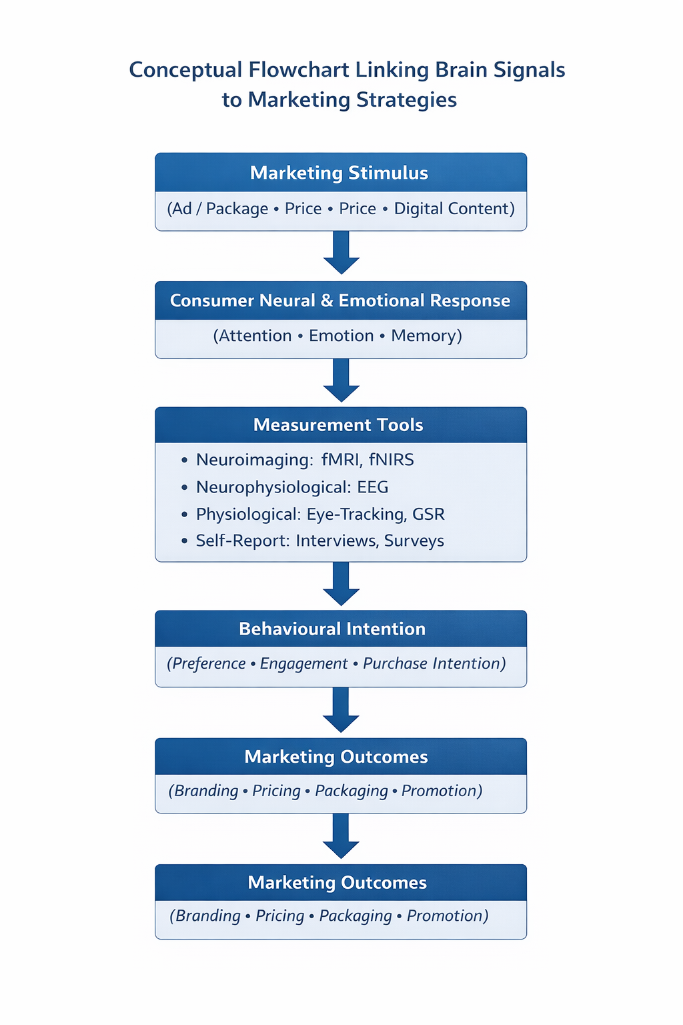
(Source – Self-developed)
This framework illustrates how consumer cognitive and emotional responses to marketing stimuli are measured using neuroimaging, neurophysiological, physiological, and self-report tools, and translated into behavioural intentions and marketing outcomes.
9. Benefits of Neuromarketing
Neuromarketing is a dominating industry that provides an accurate insight into people's psychological reactions to stimuli and gives more insights into human behaviour. It provides more results of exactly what is wanted by the customer (Dangwal 2023). Neuromarketing eliminates the human choice component in market research and discloses an individual’s actual and unfiltered responses. This helps marketers to gain a more complete understanding of consumer motivation and buying behaviour, which stimulates marketing decisions.
Respondents may not express themselves clearly in the traditional approach, so neuromarketing accurately articulates consumers' crucial subconscious motives. It fills the blind spots of a traditional approach. It gives moment-by-moment insights into consumer behaviour. The companies will understand the honest respondents' opinions about the companies. A neuromarketing analysis will assist companies in gaining market share, growing their clientele, and gaining the loyalty of new customers (Frederick, 2022).
By analysing an affective process, the researcher identifies the emotions and motivations behind the purchasing decision. The behaviour process teaches a consumer’s engagement and loyalty towards the products. By investigating cognitive processes, the marketer will understand the memory, attention, sensory perception, and recall of the products.
It helps to find out which marketing strategy, pricing strategy, and distribution strategy are more attractive and suitable for companies. It aims to fix the target audience for a particular product in the segment.
Figure 2. Benefits of neuromarketing
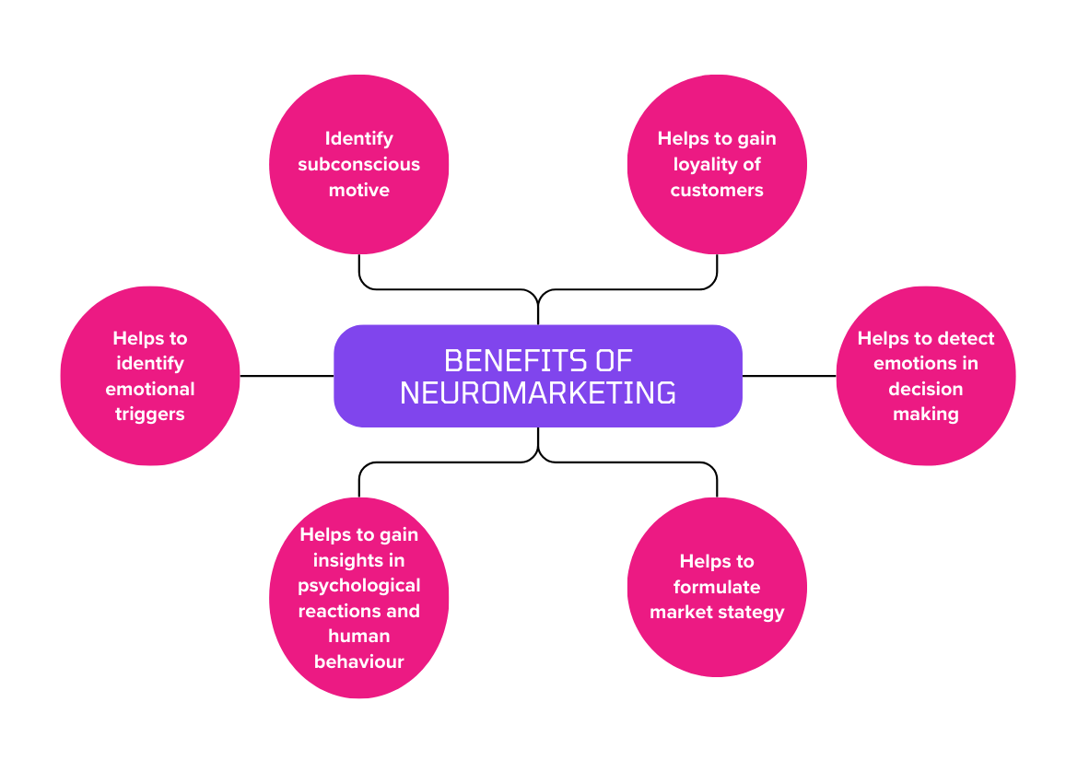
(Source – Self-developed)
10. Challenges in neuromarketing
Neuromarketing impacts different aspects of marketing, such as new product development, branding, packaging, and distributing products (Reynolds, 2006). Neuromarketing faces severe methodological and societal challenges. Lack of trust in the research process is the primary challenge in neuromarketing analysis. The core beliefs of neuromarketing are unverified, as they lack empirical support and are commonly employed to further economic and political motives (Conejo et al., 2007).
Neuromarketing analyzes concealed memory, so it faces privacy and ethical considerations. Critics claim that by gathering, disseminating, and modifying data obtained by scanning and testing human brain activity, neuromarketing may be utilized to rob clients of their freedom (Antoniak, 2020). It is the manipulation of consumer behaviour. Neuromarketing is more scientific and expensive than traditional research. There is complexity and variability in neuromarketing research, so there is a need for scientific skills to interpret the results. There are limited social science tools available to conduct neuromarketing research. These concerns are examined within the domain of neuroethics, which addresses autonomy, consent, privacy, and responsible interpretation of neural data in marketing contexts.
Figure 3. Challenges in neuromarketing
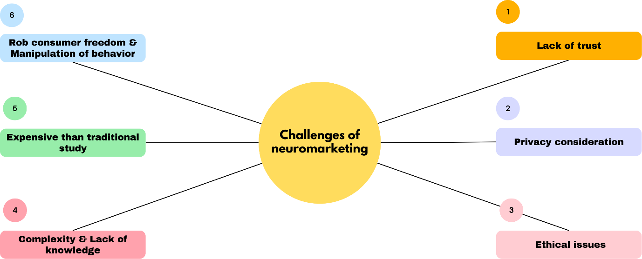
(Source – Self-developed)
11. Conclusion
Neuromarketing (NM) emerges as a promising domain aimed at addressing marketing challenges by examining subconscious cognitive, affective, and behavioural mechanisms in consumers, given that a large portion of decision-making processes occurs without conscious awareness. As a result, Neuromarketing is poised to revolutionize the marketing landscape by offering insights into decision-making processes that remain elusive through conventional marketing strategies (Alsharif et al., 2021). India's digital ecosystem rapidly grows, characterised by intense digital clutter and heterogeneous consumers, where traditional tools faced limitations such as bias and cultural differences. In this context, Neuromarketing plays a crucial role by decoding attention, perceptions, and emotions, which improves marketing applications such as branding, advertising, promotions, etc. Many multinational companies hire neuromarketing firms to position their brands effectively in consumers' minds. Numerous neuroscience startups are operating in digital India (F6S community, 2024). In India, neuromarketing companies like Neurons Inc. India and NielsenIQ BASES provide forecasting, analysis, and branding services to businesses, even as ethical and privacy issues persist.
Disclaimer (Artificial intelligence)
We Author hereby declare that no generative AI technologies such as Large Language Models (ChatGPT, COPILOT, etc.) and text-to-image generators have been used during the writing or editing of this manuscript.
References
Ailawadi KL, and Keller KL (2004). Understanding retail branding: Conceptual insights and research priorities. Journal of Retailing 80(4),331-342.
Ali, Mubarak. (2020). Influence of the Subconscious Mind in Consumer Psychology of Buying in the Contemporary ERA. Shanlax International Journal of Commerce,7(3),1-10.
Alsharif, A. H., Md Salleh, N. Z., & Baharun, R. (2021). Neuromarketing: Marketing research in the new millennium. Neuroscience Research Notes, 4(3), 27–35.
Alsharif, A. H., Salleh, N. Z. M., Abdullah, M., Khraiwish, A., & Ashaari, A. (2023). Neuromarketing Tools Used in the Marketing Mix: A Systematic Literature and Future Research Agenda. Sage Open, 13(1). https://doi.org/10.1177/21582440231156563.
Bradley R. Buchbinder (2016). Functional magnetic resonance imaging. Handbook of Clinical Neurology,135,61-92.
Butler, M. J. (2008). Neuromarketing and the perception of knowledge. Journal of Consumer Behaviour: An International Research Review, 7(4‐5), 415-419.
Casado‐Aranda, L. A., Sánchez‐Fernández, J., Bigne, E., and Smidts, A. (2023). The application of neuromarketing tools in communication research: A comprehensive review of trends. Psychology & Marketing, 40(9), 1737-1756.
Cenizo, C. (2022). Neuromarketing: concept, historical evolution and challenges. Journal ICONO, 14(20), 1.
Charters L (2020). Cutting-edge neuro-ophthalmology: Combining artificial intelligence and eye tracking. Ophthalmology Times,45(17).
Copaja, T., Condori, B. Y Romero-Carazas, R. (2025). Neuromarketing como herramienta para el posicionamiento de una marca. Región Científica, 4(1), 2025361. https://doi.org/10.58763/ rc2025361
Coulter, R. and Zaltman, G. (1994). Using the Zaltman metaphor elicitation technique to understand brand images. Advances in Consumer Research, 21,501-507.
Dangwal, A., Bathla, D., Kukreti, M., Mehta, M., Chauhan, P., & Sarangal, R. (2023). Neuromarketing Science: A Road to a Commercial Start-Up. In M. Gupta, K. Shalender, B. Singla, & N. Singh (Eds.), Applications of Neuromarketing in the Metaverse (pp. 223-232). IGI Global. https://doi.org/10.4018/978-1-6684-8150-9.ch017.
Dsouza Prima Frederick. (2022). Recent Trends in Neuro marketing – An Exploratory Study. International Journal of Case Studies in Business, IT and Education (IJCSBE), 6(1), 38–60. https://doi.org/10.47992/IJCSBE.2581.6942.0148
Emma Katriina Raitanen (2021). Attitude towards neuromarketing among Finnish consumers (Bachelor's thesis, Tallinn University of Technology). https://digikogu.taltech.ee/et/Download/6f0d407b-96b6-42b0-968a-6e2222f08e49.
Evanschitzky H, Kenning P, and Vogel V (2004) Consumer price knowledge in the German retail market. Journal of Product and Brand Management 13(6), 390-405.
Fisher, C. E., Chin, L., & Klitzman, R. (2010). Defining neuromarketing: Practices and professional challenges. Harvard review of psychiatry, 18(4), 230-237.
Francisco, Conejo., C, Khoo., Geoffrey, Harvey, Tanakinjal., Lin, Yang. (2007). Neuromarketing: Will It Revolutionise Business?. The International Journal of Business and Management, 2(6):72-76.
Guo Song, Abu Issa Gazi, Abdul Waaje, Mustaqim Roshid, Rejaul Karim, Atikur Rahaman, Zhang Min, and Abdul Rahman bin Senathirajah (2025). The Neuromarketing: Bridging Neuroscience and Marketing for Enhanced Consumer Engagement. IEEE Access, 13, 40331-40353. doi: 10.1109/ACCESS.2025.3545742.
Gurgu, E., Gurgu, I. A., and Tonis, R. B. M. (2020). Neuromarketing for a better understanding of consumer needs and emotions. Independent Journal of Management & Production, 11(1), 208-235.
Halkiopoulos, C., Antonopoulou, H., Gkintoni, E., and Aroutzidis, A. (2022). Neuromarketing as an Indicator of Cognitive Consumer Behaviour in the Decision-Making Process of Tourism Destination—An Overview. In: Katsoni, V., Şerban, A.C. (eds) Transcending Borders in Tourism Through Innovation and Cultural Heritage. Springer Proceedings in Business and Economics. Springer, Cham. https://doi.org/10.1007/978-3-030-92491-1_41.
Herold, F., Wiegel, P., Scholkmann, F., and Müller, N. G. (2018). Applications of Functional Near-Infrared Spectroscopy (fNIRS) Neuroimaging in Exercise-Cognition Science: A Systematic, Methodology-Focused Review. Journal of Clinical Medicine, 7(12), 466.
Iloka, C. B., Onyeke, K. J., & Department of Marketing, Enugu State University of Science and Technology(ESUT), Enugu, Nigeria. (2020). Neuromarketing: a historical review (Universiti Putra Malaysia/Harvard Medical School, Boston, USA, Ed.) [Journal-article]. https://doi.org/10.31117/neuroscirn.v3i3.54.
Kachhara, G., & Jain, J. (2025). A Study on the Awareness towards Neuromarketing among Marketing Professionals. Journal of Information Systems Engineering and Management,10(42s), 860-868. https://doi.org/10.52783/jisem.v10i42s.8204.
Kenning P, and Linzmajer M (2011) Consumer neuroscience: An overview of an emerging discipline with implications for consumer policy. Journal für Verbraucherschutz und Lebensmittelsicherheit 6(1): 111-125.
Light, G. A., Williams, L. E., Minow, F., Sprock, J., Rissling, A., Sharp, R., Swerdlow, N. R., and Braff, D. L. (2010). Electroencephalography (EEG) and event-related potentials (ERPs) with human participants. Current protocols in neuroscience,6, 6.25.24.
Marcin Antoniak (2020). Benefits and threats of neuromarketing: theoretical background and practical use. Scientific Papers of Silesian University of Technology, 148, 9-25.
Mehak Manot (2020). Impact of neuromarketing on consumer behaviour (Master’s thesis, Delhi Technological University). http://dspace.dtu.ac.in:8080/jspui/bitstream/repository/17972/1/2k18MBA067_mehak manot.pdf
Mokhtar Rabhi, Ahlam Thamri, Elhadja Saida Benahmed and Mohammed Said Djoual (2023). Neuromarketing Research Trends Over the Last Ten Years: A Bibliometric Analysis of The Scopus Databases. Marketing and Digital Technologies,7(3), 7-23.
Mubarak Ali (2019). Influence of the Sub Conscious Mind in Consumer Psychology of Buying in Contemporary ERA. Shanlax International Journal of Commerce,7(3),1-10.
Negrete, J. D. C., Mora, H. V. V., & Mazenett, G. de J. C. (2025). Converging Technologies in Neuromarketing: Analysis of Trends and Ethics. European Journal of Sustainable Development, 14(3), 210. https://doi.org/10.14207/ejsd.2025.v14n3p210
Ogechi Adeola., Olaniyi Evans., Jude Edeh., and Isaiah Adisa (2022). The Future of Marketing: Artificial Intelligence, Virtual Reality, and Neuromarketing. Marketing Communications and Brand Development in Emerging Economies Volume I: Contemporary and Future Perspectives. DOI Number: 10.1007/978-3-030-88678-3_12.
Orzan, G., Zara, I. A., and Purcarea, V. L. (2012). Neuromarketing techniques in pharmaceutical drug advertising. A discussion and agenda for future research. Journal of medicine and life, 5(4), 428–432.
Pinky Gogoi and Subung Mochahari (2021). Awareness Of Neuromarketing Among the Selected Indigenous Startups of North East India. Journal of Contemporary Issues in Business and Government,27(2), 2844- 2852.
Ramsøy, T. Z. (2015). Introduction to neuromarketing & consumer neuroscience. Neurons Inc.
Rathour, S., Badal, P. S., Kamalvanshi, V., Kushwaha, S., Kemboi, E., Mannepalli, B. K., & Deep, P. (2025). Exploring Neuromarketing Techniques for Advancing Sustainability in India’s Food and Agribusiness Sector. Sustainable Food Connect, 1(1), 1-10.
Reynolds, J. (2006). Measurement and Analysis for Marketing. Journal of Targeting, 14(3),189–190.
Runting Gao (2023). On the Importance of Pricing Strategy in Marketing Strategy: A Case Study of Lululemon. Frontiers in Business, Economics and Management,10(1), 158-161.
Singh S. P. (2014). Magnetoencephalography: Basic principles. Annals of Indian Academy of Neurology, 17(1), 107–112.
Singh, K., & Kumar, A. (2025). Exploring the Evolving Landscape of Neuromarketing Ethics. International Journal of Market Research, 68(1), 108-131. https://doi.org/10.1177/14707853251383629.
Stasi, G. Songa, M. Mauri, A. Ciceri, F. Diotallevi, G. Nardone, and V. Russo (2018). Neuromarketing empirical approaches and food choice: A systematic review. Food Research International,108,560-664.
Sung, B., Wilson, N. J., Yun, J. H., and Lee, E. J. (2020). What can neuroscience offer marketing research? Asia Pacific Journal of Marketing and Logistics, 32(5), 1089-1111.
Susheela Devi B Devaru (2018). Significance Of Neuromarketing on Consumer Buying Behaviour. International Journal of Technical Research & Science,3(3),114-121. DOI Number: 10.30780/IJTRS.V3.I3.2018.015.
Tai YF, and Piccini P (2003). Applications of positron emission tomography (PET) in neurology. Journal of Neurology, Neurosurgery & Psychiatry,75,669-676.
Tranfield, D., Denyer, D., and Smart, P. (2003). Towards a methodology for developing evidence‐informed management knowledge employing systematic review. British journal of management, 14(3), 207-222.
15 top Neuroscience companies and startups in India in 2024. F6S community available at https://www.f6s.com/companies/neuroscience/india/co.

