Review Article
Synergistic Resilience: A Critical Review of ML-Driven Fault Management in High-Renewable Distribution Networks

.
ABSTRACT

Machine learning (ML) techniques have become increasingly prominent in power systems applications due to their ability to model complex, nonlinear relationships across large-scale datasets. Existing ML-based studies and survey papers, however, often focus on algorithmic performance comparisons while overlooking critical limitations such as data dependency, generalisation across operating conditions, interpretability, scalability, and practical deployment challenges in real-world power systems. Moreover, many prior reviews treat ML techniques in isolation, with limited emphasis on their suitability for specific power system problems, evolving grid architectures, and operational constraints. This review provides a structured and critical analysis of ML-based approaches applied to power systems, moving beyond descriptive summaries to systematically evaluate their methodological limitations, application gaps, and practical feasibility. Unlike earlier surveys, the paper explicitly categorises ML techniques according to power system domains, highlights unresolved challenges related to data quality, model robustness, and explainability, and examines emerging trends that address these shortcomings. By synthesising recent advances and identifying open research directions, this review offers a comprehensive framework that supports both researchers and practitioners in selecting, adapting, and deploying ML methods for reliable and sustainable power system operation.

Keywords: Machine Learning, Fault Management, Distribution Network Resilience, Renewable Energy Integration, Predictive Protection

1. INTRODUCTION

The rapid decarbonisation of the electric power sector has fundamentally altered the structure and operation of distribution networks worldwide. Driven by climate policies, declining costs of renewable technologies, and the proliferation of distributed energy resources (DERs), distribution systems are increasingly hosting high penetrations of inverter-based Renewable Energy Sources (RES) such as photovoltaic (PV) systems and wind turbines. While these developments promise environmental sustainability and operational flexibility, they simultaneously introduce unprecedented challenges to system protection, control, and resilience. Traditional distribution network paradigms, designed for predictable power flows and centralised generation, are no longer adequate for managing the dynamic and stochastic behaviour of renewable-rich grids. Consequently, advanced data-driven intelligence, particularly Machine Learning (ML), is emerging as a critical enabler for maintaining secure and resilient operation under these evolving conditions.
Throughout this review, the term synergistic resilience is used to describe the combined resilience gains that arise when machine learning techniques are jointly applied across forecasting, protection, control, and operational decision layers, rather than being deployed in isolation.

1.1 The Evolving Distribution Landscape

Historically, power distribution networks were engineered as passive, radial systems supplied by centrally dispatched generation through hierarchical transmission infrastructures. Power flowed unidirectionally from substations to end-users, and operational decision-making relied on deterministic planning assumptions and static protection settings. Under this paradigm, distribution automation was minimal, and fault management strategies were largely reactive, focusing on isolation and restoration following disturbances (Short, 2014).

The large-scale integration of distributed RES has transformed this landscape into one characterised by active distribution systems (ADS). Modern feeders now host significant embedded generation, energy storage systems (ESS), electric vehicles, and controllable loads, resulting in bidirectional power flows and frequent topology changes (CIGRÉ Working Group C6.11, 2020). Advanced inverter functionalities further enable voltage regulation, frequency support, and synthetic inertia, blurring the traditional boundaries between transmission and distribution responsibilities (Lasseter, 2011; Kundur et al., 2021).

This transition has increased system observability requirements and operational complexity. Variability in renewable generation, driven by weather and diurnal cycles, introduces rapid fluctuations in voltage, current, and fault levels. Consequently, distribution networks are evolving from deterministic infrastructures into cyber-physical systems that demand continuous situational awareness and adaptive decision-making (Parhizi et al., 2015). The emerging operational reality necessitates intelligent frameworks capable of interpreting high-resolution data streams and responding in near real time. Fig. 1 illustrates the evolution of the distribution network.

1.2 Defining Resilience Versus Reliability

Within this evolving context, it is essential to distinguish between reliability and resilience, concepts that are often used interchangeably but represent fundamentally different performance objectives. Reliability traditionally refers to the power system’s ability to deliver electricity continuously under normal operating conditions. It is commonly quantified using steady-state metrics such as the System Average Interruption Duration Index (SAIDI) and the System Average Interruption Frequency Index (SAIFI), which measure average outage duration and frequency over extended periods (IEEE Power & Energy Society, 2012).

Resilience, by contrast, encompasses the system’s capability to anticipate, withstand, absorb, adapt to, and rapidly recover from high-impact, low-probability events, including extreme weather, cascading failures, cyber-attacks, and large-scale equipment outages (Panteli & Mancarella, 2015). Unlike reliability, resilience explicitly accounts for uncertainty, dynamic adaptation, and post-event recovery trajectories rather than steady-state performance alone. Fig. 2 highlights a core relationship between resilience and reliability.

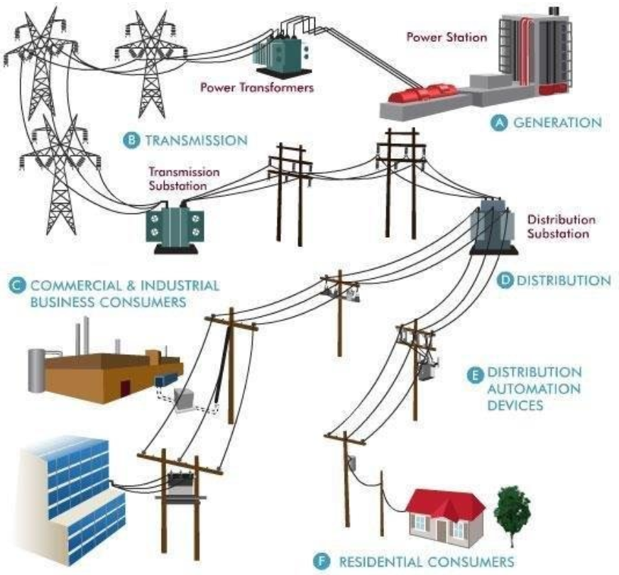

(a)
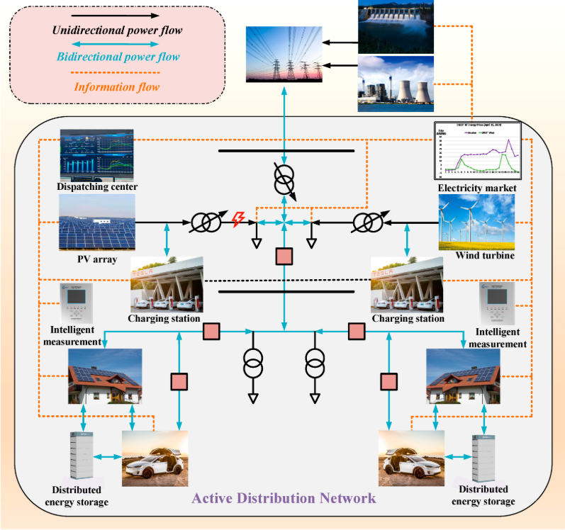
(b)
Fig. 1. Evolution of distribution network (a) passive radial distribution networks (Ghalib et al., 2019) (b) active renewable-rich distribution systems (Xu et al., 2023)
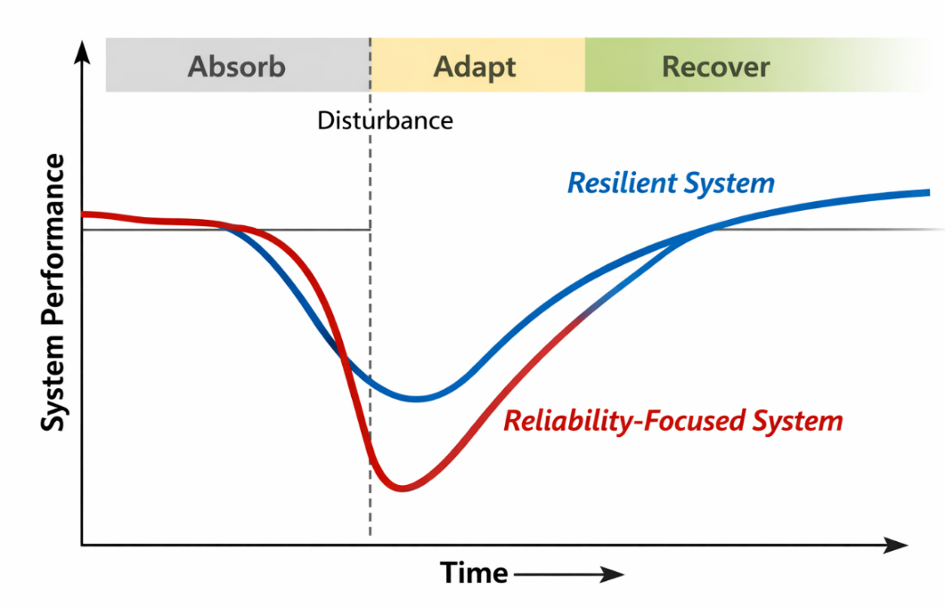
Fig. 2. Conceptual distinction between reliability and resilience in power distribution systems

Renewable-rich distribution networks intensify the importance of resilience-oriented planning. Extreme events increasingly coincide with renewable variability, compounding system stress during critical periods (Wang et al., 2019). As such, resilience assessment extends beyond component redundancy to include adaptive protection, autonomous control, and intelligent coordination of distributed assets. This shift underscores the need for operational strategies that move from static robustness toward dynamic, learning-enabled resilience.

1.3 The Need for Real-Time Intelligence

Conventional distribution protection schemes were developed under the assumption of stable short-circuit levels and predictable fault current directions. Overcurrent and distance relays are typically configured using offline studies and fixed settings, a “set-and-forget” philosophy that presumes limited variation in network conditions (Horowitz & Phadke, 2014). High penetrations of inverter-based RES fundamentally violate these assumptions.

Inverter-interfaced generation produces limited, highly controlled fault currents, typically constrained to 1.1–1.3 per unit of rated current, and may disconnect rapidly during disturbances. Furthermore, bidirectional power flows can reverse fault current direction, leading to protection blinding, nuisance tripping, or failure to trip altogether (Blaabjerg et al., 2017). These phenomena severely degrade the selectivity, sensitivity, and speed of legacy protection systems.

Static protection settings are therefore inadequate in environments where fault characteristics vary continuously with RES output, network topology, and operating mode. Real-time intelligence is required to interpret high-frequency measurements, infer system states, and dynamically adapt protection and control actions. Machine learning techniques have gained increasing attention in modern power systems because of their ability to process large volumes of data and model complex nonlinear relationships. These capabilities are particularly valuable in applications such as fault detection, protection coordination, and renewable energy integration. Such applications have become increasingly challenging with the growing penetration of distributed energy resources. Comparative characteristics of ML techniques in power system applications are presented in Table 1.

Table 1: Comparative characteristics of ML techniques in power system applications

ML Technique | Typical Accuracy Range | Data Requirement | Computational Cost | Interpretability | Suitability
SVM | 85–95% | Medium | Medium–High | Moderate | Small–medium datasets
ANN | 88–96% | High | High | Low | Nonlinear steady-state problems
CNN | 90–98% | Very High | Very High | Low | Spatial/grid-image data
LSTM | 92–99% | High | Very High | Low | Time-series, dynamic systems
Ensemble | 93–99% | High | High | Moderate | Heterogeneous datasets

Although deep learning models such as CNNs and LSTMs demonstrate superior predictive accuracy in fault detection and load forecasting, as seen in Table 1, their performance gains are often achieved at the expense of high computational complexity and reduced interpretability. In contrast, classical methods such as SVMs and decision trees, while slightly less accurate, offer faster training and greater transparency, making them more suitable for real-time or resource-constrained power system environments.

2. THE “DOUBLE-EDGED” ROLE OF RENEWABLES IN GRID RESILIENCE

The increasing penetration of RES in distribution networks introduces a paradoxical impact on grid resilience. On the one hand, inverter-based generation alters fault behaviour, voltage regulation, and system inertia, complicating protection and control. On the other hand, distributed renewables, particularly when coordinated with energy storage and advanced control, offer unprecedented opportunities for localised resilience, rapid restoration, and self-sustained operation during significant disturbances. Understanding this dual role is essential for designing fault-management frameworks that exploit the benefits of RES while mitigating their adverse effects.

2.1 Challenges Introduced by RES

2.1.1 Intermittency and operating variability

The stochastic nature of solar irradiance and wind speed introduces continuous variability into distribution system operating conditions. Rapid fluctuations in RES output can cause voltage deviations, flicker, and frequency excursions, particularly in weak or lightly meshed networks with high renewable penetration (Shahab et al., 2024). These effects are exacerbated during cloud transients or wind ramps, where generation can change significantly within seconds.
From a fault-management perspective, intermittency complicates the differentiation between regular operational disturbances and fault-induced transients. Traditional protection schemes assume relatively stable pre-fault conditions; however, in renewable-rich networks, pre-fault voltage and current profiles may already deviate substantially from nominal values. This reduces fault detection sensitivity and increases the likelihood of misclassification, delayed tripping, or unnecessary disconnections (Bollen & Hassan, 2011).

2.1.2 Protection Blindness and Reduced Inertia

A more fundamental challenge arises from the interaction between inverter-based RES and legacy protection devices. Unlike synchronous generators, power electronic interfaces contribute limited short-circuit current and often actively control fault response to protect semiconductor components. As a result, fault current magnitudes may fall below relay pickup thresholds, leading to protection blindness (El-Ela et al., 2022).

Bidirectional power flows further undermine coordination assumptions embedded in overcurrent and distance protection schemes. Fault current direction may reverse depending on RES location and output level, confusing directional relays and compromising selectivity. Additionally, Ulbig et al. (2014) stated that the displacement of synchronous machines by inverter-based generation reduces system inertia, accelerating frequency dynamics during disturbances and narrowing the available response window for protection and control actions.

2.2 Resilience Opportunities Offered by RES

Despite these challenges, RES can significantly enhance distribution system resilience when properly integrated and controlled. Their distributed nature, fast controllability, and compatibility with advanced automation enable new resilience-oriented operating paradigms.

2.2.1 Localized supply and load support

Distributed RES reduce dependence on upstream transmission infrastructure by supplying loads locally, particularly during wide-area disturbances. When combined with energy storage systems (ESS), renewables can maintain voltage support, reduce feeder loading, and sustain critical services even when the primary grid is unavailable (Raj et al., 2025). This localisation of supply limits the spatial propagation of outages and shortens restoration times.
Empirical studies following extreme weather events have demonstrated that feeders with high levels of distributed generation and storage exhibit faster recovery and shorter outage durations than conventional feeders (Panteli et al., 2017). Such findings highlight the resilience value of RES beyond their contribution to energy production.

2.2.2 Islanding and microgrid operation

Intentional islanding represents one of the most powerful resilience mechanisms enabled by RES. Microgrids equipped with distributed generation, storage, and intelligent control can autonomously disconnect from the primary grid during disturbances and continue supplying prioritised loads. This capability transforms fault management from a purely protective function into an operational strategy for service continuity (Lasseter & Paigi, 2004).

Advanced microgrid controllers can coordinate multiple RES units, regulate voltage and frequency, and seamlessly transition between grid-connected and islanded modes (Ahamed et al., 2025). When integrated with adaptive protection and situational awareness, islanding can be triggered pre-emptively in anticipation of faults or extreme events, significantly enhancing resilience outcomes.

2.2.3 Black-start and accelerated restoration

RES paired with ESS also enable decentralised black-start capabilities, traditionally the domain of large synchronous generators. Battery-supported PV or wind systems can energise local buses, restore auxiliary services, and facilitate staged reconnection of loads and feeders after a blackout (Chen et al., 2020). This decentralised restoration paradigm reduces reliance on centralised black-start resources and accelerates system recovery.
Moreover, inverter-based resources offer fast response and precise control, allowing coordinated restoration strategies that minimise inrush currents, avoid secondary faults, and adapt dynamically to evolving network conditions. These attributes position RES as active agents in post-fault recovery rather than passive elements requiring protection. The dynamics of RES and BSS in relation to challenges and opportunities are depicted in Fig. 3.

Fig. 3. Challenges and resilience opportunities introduced by high RES penetration

For short-term wind and solar forecasting, Raj et al. (2025) noted that LSTM-based models typically achieve MAPE values between 2–6%, compared to 8–15% for traditional regression-based approaches. Nevertheless, forecast accuracy deteriorates significantly during extreme weather events or under rapid ramping conditions.

3. MACHINE LEARNING ARCHITECTURES FOR FAULT MANAGEMENT

The increasing complexity and variability of renewable-rich distribution networks necessitate fault-management approaches capable of learning from data, generalising across operating conditions, and adapting in real time. Machine Learning (ML) architectures have emerged as practical tools for addressing these requirements by extracting latent patterns from high-resolution measurements and supporting intelligent decision-making. Within the fault-management pipeline, ML models can be broadly categorised according to their functional roles: fault detection and classification (perception), predictive analytics (anticipation), and adaptive control (action).

3.1 Fault Detection and Classification (The “Eyes”)

Fault detection and classification constitute the first layer of intelligent fault management, providing rapid identification of abnormal events and discrimination among fault types. Early ML-based approaches predominantly employed Support Vector Machines (SVMs) due to their robustness in high-dimensional feature spaces and effectiveness with limited training data. By mapping voltage and current features into nonlinear decision boundaries, SVMs demonstrated improved classification accuracy compared to traditional threshold-based methods, particularly under noisy conditions and variable fault resistances (Samantaray, 2009).

More recent studies have shifted toward deep learning architectures, especially Convolutional Neural Networks (CNNs), which can directly process raw time-domain waveforms or transformed representations such as wavelet coefficients and spectrograms. CNNs automatically learn hierarchical feature representations, eliminating the need for manual feature engineering and enabling superior performance under complex fault scenarios (Zhang et al., 2014). This capability is particularly valuable in renewable-dominated networks, where inverter controls and fluctuating pre-fault conditions often distort fault signatures.

Compared to impedance-based protection schemes, ML-driven detection models exhibit enhanced sensitivity to nonlinear and low-magnitude fault characteristics. Empirical evaluations consistently report higher classification accuracy, reduced detection latency, and improved robustness to system variability, positioning ML-based “perception” layers as viable replacements or complements to legacy relays in active distribution systems (Nxumalo & Awodele, 2022). However, most reported results are obtained under simulated conditions with predefined fault types and limited topology variation. Consequently, the generalisation of these ML-based detection models to real-world feeders with frequent reconfiguration and diverse inverter controls remains an open challenge.

Reported studies indicate that ML-based relays reduce fault detection times to 5–20 ms compared to 30–50 ms for conventional impedance-based relays under high-impedance fault conditions. However, these improvements are highly dependent on training data diversity and network topology.

3.2 Predictive Analytics (The “Brain”)

Beyond event detection, resilience-oriented fault management requires the ability to anticipate disturbances before they manifest as faults or outages. Predictive analytics addresses this requirement by modelling temporal dependencies between system states, environmental conditions, and failure precursors. Time-series learning models, particularly Long Short-Term Memory (LSTM) networks, have gained prominence due to their ability to capture long-range dependencies and non-stationary dynamics.

LSTM-based frameworks have been applied to predict voltage instability, incipient equipment failures, and fault likelihood by combining historical grid measurements with exogenous data such as weather forecasts and load patterns (Kong et al., 2019). In renewable-rich environments, these models can forecast variability-induced stress conditions, such as rapid voltage excursions or frequency deviations, that increase fault susceptibility.

The predictive capability of LSTM models represents a fundamental shift from reactive to proactive fault management. Instead of responding after protection thresholds are violated, operators and automated controllers can initiate preventive actions—such as adjusting relay settings, reconfiguring network topology, or preparing microgrids for islanding—based on predicted risk levels. This anticipatory intelligence forms the cognitive core of resilient distribution systems.

3.3 Adaptive Control (The “Hands”)

The final layer of intelligent fault management involves translating perception and prediction into optimal control actions. Deep Reinforcement Learning (DRL) has emerged as a powerful paradigm for this purpose, enabling agents to learn optimal policies through interaction with the power system environment. Unlike supervised learning approaches, DRL does not require labelled datasets; instead, it learns control strategies by maximising cumulative rewards associated with operational objectives such as fault-isolation speed, load restoration, and stability margins.

Recent studies have demonstrated the effectiveness of DRL for dynamic protection coordination, optimal operation of sectionalising switches, and post-fault service restoration in distribution networks with high DER penetration (Cao et al., 2021). By continuously updating policies based on observed system responses, DRL agents can adapt to changes in RES output, load behaviour, and network topology. While these studies demonstrate promising performance, most assume fully observable system states and rely on offline training within digital simulation environments. The stability and safety of DRL policies under real-time operational constraints and rare fault events remain areas requiring further validation.

Importantly, DRL-based control frameworks support closed-loop operation, in which actions influence future states and learning is ongoing. This adaptability is critical in renewable-dominated systems, where static control policies quickly become obsolete. When integrated with ML-based detection and prediction layers, DRL provides the actuation mechanism required to realise fully autonomous, resilience-oriented fault management. The application of ML models in fault management follows a typical operational mechanism, as shown in Fig. 4.

Fig. 4. Machine learning-enabled fault-management pipeline in active distribution networks

4. THE SYNERGISTIC FRAMEWORK: INTEGRATING MACHINE LEARNING WITH RENEWABLE ENERGY SOURCES

The convergence of ML and Renewable Energy Sources (RES) enables a paradigm shift in fault management, transforming distributed renewables from stochastic disturbances into coordinated resilience assets. Rather than treating RES variability as an external uncertainty, the synergistic framework leverages predictive, adaptive, and topology-aware intelligence to orchestrate protection and restoration actions across active distribution systems. This section synthesises recent advances into a cohesive framework that integrates forecasting, adaptive relaying, and intelligent restoration in renewable-heavy networks. This concept is illustrated in Fig. 5.

4.1 Forecasting Intermittency for Pre-emptive Action

RES intermittency is a primary driver of operational uncertainty in distribution networks. ML-based forecasting models, particularly deep learning architectures, have demonstrated strong capability in predicting short-term variations in solar and wind output using meteorological inputs, historical generation data, and spatial correlations. Accurate short-horizon forecasts (minutes to hours ahead) are especially valuable for resilience, as they provide actionable lead time for preventive control (Hong et al., 2019).

Fig. 5. Synergistic integration of ML and renewable resources for resilient fault management

Within a synergistic framework, RES forecasts are coupled with grid-state estimation to anticipate stress conditions that elevate fault risk, such as low-voltage margins, feeder overloading, or protection miscoordination. For example, predicted PV output drops due to cloud cover can trigger pre-emptive activation of ESS, adjustment of voltage control setpoints, or preparation for controlled islanding. This anticipatory operation reduces the likelihood that benign variability will escalate into protection events or cascading failures.

Representative studies such as Hong et al. (2019) and Home-Ortiz et al. (2025) demonstrate resilience gains under forecast-driven operation; however, these studies typically assume accurate weather inputs and reliable communication infrastructure, which may not be guaranteed during extreme events.

4.2 Adaptive Relaying under Variable Renewable Output

Adaptive protection is a cornerstone of resilient operation in active distribution systems. ML enables relay settings to be continuously adjusted in response to real-time operating conditions, including RES penetration level, inverter control mode, and network topology. Unlike conventional adaptive schemes based on predefined logic or lookup tables, ML-based relaying learns complex, nonlinear relationships between system states and optimal protection parameters.

Supervised and reinforcement learning approaches have been applied to dynamically tune overcurrent pickup values, time dial settings, and directional thresholds to maintain selectivity and sensitivity across wide operating ranges (Ates et al., 2016). By incorporating RES output forecasts and real-time measurements, adaptive relays can compensate for reduced fault-current contribution and bidirectional flows, thereby mitigating protection blindness.

Crucially, adaptive relaying within the ML–RES framework operates as a closed-loop system: protection actions influence network states, which in turn update the learning model. This feedback-driven adaptation aligns protection behaviour with the continuously evolving characteristics of renewable-rich feeders, enhancing both dependability and security.

4.3 Topology-Aware Restoration Using Graph-Based Learning

Post-fault restoration in decentralised distribution networks involves complex reconfiguration decisions, particularly when multiple RES, microgrids, and controllable switches are present. Traditional heuristic or rule-based restoration strategies struggle to scale with network size and dynamic topology. Graph Neural Networks (GNNs) offer a promising solution by explicitly modelling the distribution system as a graph, where nodes represent buses or resources and edges represent electrical connections.

GNNs learn representations that capture both electrical proximity and topological constraints, enabling intelligent reasoning about feasible switching actions and restoration sequences (Gautam et al., 2022). When integrated with ML-based fault localisation and RES availability assessment, topology-aware models can identify optimal reconfiguration strategies that maximise load restoration while respecting voltage, thermal, and protection constraints.
In renewable-heavy systems, topology-aware restoration also facilitates coordinated microgrid operation. GNN-driven controllers can determine which sections should island, which RES and ESS should supply critical loads, and how re-synchronisation should be performed once upstream supply is restored. This capability positions ML as the orchestrator of distributed resilience, coordinating diverse RES assets into a coherent recovery strategy.

5. CRITICAL GAPS AND IMPLEMENTATION CHALLENGES

Despite significant progress in ML-driven fault management for renewable-rich distribution systems, practical deployment remains limited. Most published solutions are validated in simulation environments or under idealised assumptions that do not fully capture operational constraints. Bridging the gap between research prototypes and field-ready resilience solutions requires addressing several interrelated technical and organisational challenges.

5.1 The Real-Time Constraint

A dominant limitation in existing literature is the reliance on offline training and batch processing of historical data. While such approaches are valuable for proof-of-concept validation, resilience-oriented fault management demands real-time or near-real-time intelligence. Protection and control actions must be executed within strict latency bounds, often on the order of milliseconds to seconds, to prevent fault escalation or cascading outages (Gómez-Expósito et al., 2018).

Many deep learning models, particularly large CNNs and LSTM networks, impose significant computational overhead, making them difficult to deploy on edge devices such as intelligent electronic devices (IEDs) or feeder-level controllers. Furthermore, online learning introduces stability and convergence concerns, as continuously updating models may behave unpredictably during rare but critical events. These challenges underscore the need for lightweight architectures, hardware-aware model design, and hybrid schemes that combine fast rule-based protection with ML-driven adaptation at slower timescales.

5.2 Data Scarcity and Quality

High-quality, labelled fault data are essential for supervised ML approaches, yet such datasets are scarce in real-world renewable-dominated distribution networks. Fault events are inherently rare, diverse, and often poorly documented, particularly in systems with limited monitoring infrastructure. As a result, many studies rely on synthetic datasets generated through simulation, which may not accurately reflect field conditions, sensor noise, or unmodeled equipment behaviour (Gonzalez-Jimenez et al., 2021).

Data imbalance further complicates model training, as standard operating conditions vastly outnumber fault instances. This imbalance can bias classifiers toward non-fault states, reducing sensitivity during critical events. Additionally, RES-induced variability blurs the distinction between normal transients and fault signatures, increasing the risk of mislabelling. Addressing these issues requires advanced data augmentation techniques, semi-supervised and unsupervised learning methods, and standardised data-sharing frameworks across utilities and research institutions.

5.3 Cyber-Physical Security Risks

The integration of ML models with protection and control systems expands the cyber-physical attack surface of distribution networks. Unlike traditional protection devices with limited communication interfaces, ML-enabled controllers often depend on wide-area measurements, cloud-based analytics, and bidirectional data exchange with distributed RES. This connectivity exposes critical infrastructure to data poisoning, model manipulation, denial-of-service attacks, and adversarial inputs (Teixeira et al., 2010).

Cybersecurity concerns are particularly acute when ML outputs directly influence protective actions such as relay tripping, islanding decisions, or restoration switching. A compromised model could induce false trips or inhibit legitimate protection responses, exacerbating outages rather than mitigating them. Consequently, resilience-oriented ML frameworks must incorporate secure communication protocols, robust model validation, anomaly detection, and fail-safe fallback mechanisms that preserve system safety in the event of cyber compromise.

5.4 Applicability Across Network Configurations

ML-based protection schemes demonstrate higher reliability in radial distribution networks, where fault patterns are more predictable. In contrast, their performance in meshed transmission networks and systems with frequent topology changes remains inconsistent, highlighting the need for adaptive or hybrid protection frameworks. Hence, considering suitability in terms of network type, Table 2 gives an appropriate comparative highlight.

Table 2: Comparative suitability matrix

Network Context | Best-Suited ML Methods | Limitations
High RES penetration | LSTM, hybrid DL | Requires large datasets
Weak grids | Ensemble ML | Stability issues
Microgrids | ANN, reinforcement learning | Scalability concerns

Despite the fact that deep learning architectures consistently report higher accuracy, their deployment in real-world power systems remains constrained by data availability, computational burden, and regulatory requirements, suggesting that hybrid or physics-informed ML approaches may offer a more balanced solution.

6. FUTURE DIRECTIONS AND CONCLUSION

The preceding sections have demonstrated that achieving resilience in high-renewable distribution networks requires a fundamental shift from static, component-centric protection philosophies toward adaptive, system-level intelligence. While Machine Learning (ML)–driven fault management has shown considerable promise, its full potential can only be realised through emerging research directions that address scalability, security, and operational realism.

6.1 Federated Learning for Distributed Intelligence

Federated Learning (FL) has emerged as a compelling paradigm for training ML models across geographically distributed assets without requiring centralised data aggregation. In the context of renewable-rich distribution networks, FL enables local controllers at feeders, microgrids, or RES sites to train models on private operational data while sharing only model updates with a coordinating server (Li et al., 2020).

This approach directly addresses data privacy concerns, regulatory constraints, and communication bandwidth limitations that hinder centralised learning. Moreover, FL enhances resilience by decentralising intelligence, reducing dependence on single points of failure, and enabling localised adaptation to feeder-specific characteristics. Recent studies indicate that federated approaches achieve performance comparable to centralised models while preserving data confidentiality and improving robustness against cyber compromise (Yang et al., 2019). As monitoring infrastructure expands, FL is expected to play a central role in scalable, utility-grade ML deployment.

6.2 Digital Twins for Safe Training and Validation

Digital twins—high-fidelity, real-time virtual replicas of physical power systems—provide a safe, controlled environment for training and validating ML-based fault-management agents. By continuously synchronising with field measurements, digital twins can emulate evolving network states, RES variability, and fault scenarios without risking real-world disruptions (Fuller et al., 2020).

For reinforcement learning and adaptive protection applications, digital twins are particularly valuable, as they enable extensive exploration of rare but critical events that are impractical or unsafe to observe in live systems. Coupling digital twins with hardware-in-the-loop testing further bridges the gap between simulation and deployment, ensuring that ML agents respect operational constraints and protection requirements. This synergy is expected to accelerate the transition of ML-driven resilience solutions from research to practice.

4. Conclusion

Resilience in modern distribution systems cannot be achieved solely through incremental enhancements to legacy protection schemes. The increasing penetration of Renewable Energy Sources fundamentally alters fault behaviour, system dynamics, and restoration pathways, rendering static and reactive approaches insufficient. This review has shown that Machine Learning provides the analytical and decision-making capabilities required to manage these complexities, enabling predictive fault management, adaptive protection, and intelligent restoration. When integrated within a synergistic framework, ML transforms distributed renewables from sources of uncertainty into active resilience assets. Forecasting models anticipate variability, adaptive relays respond to real-time conditions, and topology-aware controllers orchestrate post-fault recovery. While challenges related to real-time execution, data availability, and cybersecurity remain, emerging paradigms such as federated learning and digital twins offer viable pathways toward practical implementation. Ultimately, resilient power distribution systems will be defined not by their ability to avoid disturbances, but by their capacity to anticipate, adapt, and recover. The coordinated integration of ML and RES represents a decisive step toward this proactive and intelligence-driven resilience paradigm.

Disclaimer (Artificial intelligence)

Author(s) hereby declare that NO generative AI technologies such as Large Language Models (ChatGPT, COPILOT, etc.) and text-to-image generators have been used during the writing or editing of this manuscript.

References

Ahamed, A., Fardin, H., Hasan, E., Rimon, S. T. H., & Haque, M. M. (2025). A Review of Machine Learning Approaches for Optimizing Hybrid Renewable Energy Systems (HRES) in Decentralized Smart Grids: Enhancing Energy Efficiency and Grid Stability. Iranian Journal of Science and Technology, Transactions of Electrical Engineering, 1-14.
https://link.springer.com/article/10.1007/s40998-025-00807-4
Aryanfar, M., Fotuhi-Firuzabad, M., Azad, S., Dehghanian, P., & Peyghami, S. (2024). Resilience vs. reliability metrics in power systems: A conceptual overview. In M. T. Ameli, K. Jalilpoor, S. Azad, M. Daneshvar, M. S. Sepasian, B. Mohammadi-Ivatloo, & M. Shafie-Khah (Eds.), Future modern distribution networks resilience (pp. 67–90). Elsevier. https://doi.org/10.1016/B978-0-443-16086-8.00004-X
Ates, Y., Boynuegri, A. R., Uzunoglu, M., Nadar, A., Yumurtacı, R., Erdinc, O., Paterakis, N. G., & Catalão, J. P. S. (2016). Adaptive Protection Scheme for a Distribution System Considering Grid-Connected and Islanded Modes of Operation. Energies, 9(5), 378. https://doi.org/10.3390/en9050378
Blaabjerg, F., Yang, Y., Yang, D., & Wang, X. (2017). Distributed power-generation systems and protection. Proceedings of the IEEE, 105(7), 1311–1331. https://doi.org/10.1109/JPROC.2017.2696878
Bollen, M. H. J., & Hassan, F. (2011). Integration of distributed generation in the power system. Wiley-IEEE Press.
Cao, D., Hu, W., Xu, X., Wu, Q., Huang, Q., Chen, Z., & Blaabjerg, F. (2021). Deep reinforcement learning-based approach for optimal power flow of distribution networks embedded with renewable energy and storage devices. Journal of Modern Power Systems and Clean Energy, 9(6), 1101–1110. https://doi.org/10.35833/MPCE.2020.000557
Chen, C., Wang, J., Qiu, F., & Zhao, D. (2020). Resilient distribution system by microgrids formation after natural disasters. IEEE Transactions on Smart Grid, 11(1), 13–24. https://doi.org/10.1109/TSG.2019.2924817
CIGRÉ Working Group C6.11. (2020). Planning and optimisation methods for active distribution systems. CIGRÉ Technical Brochure.
El-Ela, A. A. A., El-Sehiemy, R. A., Shaheen, A. M., & Ellien, A. R. (2022). Review on Active Distribution Networks with Fault Current Limiters and Renewable Energy Resources. Energies, 15(20), 7648. https://doi.org/10.3390/en15207648
Fuller, A., Fan, Z., Day, C., & Barlow, C. (2020). Digital twin: Enabling technologies, challenges and open research. IEEE Access, 8, 108952–108971. https://doi.org/10.1109/ACCESS.2020.2998358
Gautam, M., Abdelmalak, M., Mansourlakouraj, M., Benidris, M., & Livani, H. (2022). Reconfiguration of distribution networks for resilience enhancement: A deep reinforcement learning-based approach. Proceedings of the IEEE Industry Applications Society Annual Meeting (IAS), 1–6. https://doi.org/10.1109/IAS54023.2022.9939854
Ghalib, M., Shehata, E., Thomas, J., & Mostafa, R. (2019). Power management of low voltage DC microgrid. ResearchGate. https://doi.org/10.13140/RG.2.2.17314.17606
Gómez-Expósito, A., Conejo, A. J., & Cañizares, C. A. (2018). Electric energy systems: Analysis and operation (2nd ed.). CRC Press.
Gonzalez-Jimenez, D., del-Olmo, J., Poza, J., Garramiola, F., & Madina, P. (2021). Data-driven fault diagnosis for electric drives: A review. Sensors, 21(12), 4024. https://doi.org/10.3390/s21124024
Home-Ortiz, J., Yamaguti, L., Yumbla Romero, J. G., Melgar Dominguez, O., Monaro, R., & Mantovani, J. (2025). Resilience-oriented planning for distribution systems combining distributed generation allocation and dynamic operational strategies. IEEE Access, 13, 1–1. https://doi.org/10.1109/ACCESS.2025.3603962
Hong, T., Xie, J., & Black, J. (2019). Global energy forecasting competition 2017: Hierarchical probabilistic load forecasting. International Journal of Forecasting, 35(4), 1389–1399. https://doi.org/10.1016/j.ijforecast.2019.02.006
Horowitz, S. H., & Phadke, A. G. (2014). Power system relaying (4th ed.). Wiley.
IEEE Power & Energy Society. (2012). IEEE Guide for Electric Power Distribution Reliability Indices, in IEEE Std 1366-2012 (Revision of IEEE Std 1366-2003) , vol., no., pp.1-43, 31 May 2012, doi: 10.1109/IEEESTD.2012.6209381
Kong, W., Dong, Z. Y., Jia, Y., Hill, D. J., Xu, Y., & Zhang, Y. (2019). Short-term residential load forecasting based on LSTM recurrent neural network. IEEE Transactions on Smart Grid, 10(1), 841–851. https://doi.org/10.1109/TSG.2017.2753802
Kundur, P., Balu, N. J., & Lauby, M. G. (2021). Power system stability and control (reprint ed.). McGraw-Hill.
Lasseter, R. H. (2011). Smart distribution: Coupled microgrids. Proceedings of the IEEE, 99(6), 1074–1082. https://doi.org/10.1109/JPROC.2011.2114630
Lasseter, R. H., & Paigi, P. (2004). Microgrid: A conceptual solution. IEEE Power Electronics Specialists Conference, 4285–4290. https://doi.org/10.1109/PESC.2004.1354758
Li, T., Sahu, A. K., Talwalkar, A., & Smith, V. (2020). Federated learning: Challenges, methods, and future directions. IEEE Signal Processing Magazine, 37(3), 50–60. https://doi.org/10.1109/MSP.2020.2975749
Nxumalo, E., & Awodele, K. O. (2022). Finding protection-based distributed generation medium voltage opportunity networks using machine learning. Proceedings of the IEEE PES/IAS PowerAfrica Conference, Kigali, Rwanda, 1–5. https://doi.org/10.1109/PowerAfrica53997.2022.9905260
Panteli, M., & Mancarella, P. (2015). The grid: Stronger, bigger, smarter? Presenting a conceptual framework of power system resilience. IEEE Power and Energy Magazine, 13(3), 58–66. https://doi.org/10.1109/MPE.2015.2397334
Panteli, M., Trakas, D. N., Mancarella, P., & Hatziargyriou, N. D. (2017). Power systems resilience assessment: Hardening and smart operational enhancement strategies. Proceedings of the IEEE, 105(7), 1202–1213. https://doi.org/10.1109/JPROC.2017.2691357
Parhizi, S., Lotfi, H., Khodaei, A., & Bahramirad, S. (2015). State of the art in research on microgrids: A review. IEEE Access, 3, 890–925. https://doi.org/10.1109/ACCESS.2015.2443119
Raj, H., Jaiswal, S., Gupta, P., & Patil, A. (2025). Optimal security-constrained scheduling of a renewable energy-based multi-microgrid with compressed air energy storage and demand response. Sustainable Energy, Grids and Networks, 44, 101959. https://doi.org/10.1016/j.segan.2025.101959
Samantaray, S. (2009). Decision tree-based fault zone identification and fault classification in flexible AC transmissions-based transmission line. Generation, Transmission & Distribution, IET. 3. 425 - 436. 10.1049/iet-gtd.2008.0316.
Shahab, M., Abbas, S., & Usman, A. (2024). A simplified protection scheme for renewable energy integrated AC microgrids. Proceedings of the IEEE Khwarzimic High Tech Conference (KHI-HTC), 1–6. https://doi.org/10.1109/KHI-HTC60760.2024.10482068
Short, T. A. (2014). Electric power distribution handbook (2nd ed.). CRC Press.
Teixeira, A., Dán, G., Sandberg, H., & Johansson, K. H. (2010). A cybersecurity study of a SCADA energy management system: Stealthy deception attacks on the state estimator. Proceedings of the IFAC World Congress, 1–6.
Ulbig, A., Borsche, T. S., & Andersson, G. (2014). Impact of low rotational inertia on power system stability and operation. IFAC Proceedings Volumes, 47(3), 7290–7297. https://doi.org/10.3182/20140824-6-ZA-1003.02615
Wang, Jun & Zheng, Xiaodong & Tai, Nengling & Wei, Wei & Li, Lingfang. (2019). Resilience-Oriented Optimal Operation Strategy of Active Distribution Network. Energies. 12. 3380. 10.3390/en12173380.
Xu, L., Fan, S., Zhang, H., Xiong, J., Liu, C., & Mo, S. (2023). Enhancing Resilience and Reliability of Active Distribution Networks through Accurate Fault Location and Novel Pilot Protection Method. Energies, 16(22), 7547. https://doi.org/10.3390/en16227547
Yang, Q., Liu, Y., Chen, T., & Tong, Y. (2019). Federated machine learning: Concept and applications. arXiv preprint arXiv:1902.04885. https://doi.org/10.48550/arXiv.1902.04885
Zhang, Y., Wang, J., & Wang, X. (2014). Review on probabilistic forecasting of wind power generation. Renewable and Sustainable Energy Reviews, 32, 255–270. https://doi.org/10.1016/j.rser.2014.01.033

