Original Research Article

Development and Characterisation of Cassava Starch–PVA Bioplastic Films as Sustainable Alternatives to Petroleum-Based Plastics

.
ABSTRACT
This study focuses on the development and characterisation of biodegradable films produced from cassava starch blended with polyvinyl alcohol (PVA) and glycerol. Cassava starch, extracted at a yield of 80.06%, served as a sustainable polymer base owing to its abundance and renewability. Produced films were prepared and characterised in triplicate for each formulation to ensure reproducibility. The films exhibited low water absorption (4%), indicating improved hydrophobicity and structural integrity suitable for packaging applications. Biodegradation tests revealed complete decomposition within 20 - 28 days, with faster rates observed at shallower burial depths due to increased microbial and oxygen activity. Fourier Transform Infrared Spectroscopy (FTIR) confirmed intermolecular bonding and crosslinking through functional groups such as O–H, C=O, and C–O–C. Surface morphology was assessed using Scanning Electron Microscopy (SEM), while thermal stability was evaluated through Thermogravimetric Analysis (TGA/DTG), thereby reducing redundancy in listing characterisation techniques. Thermal analysis showed stability up to approximately 150°C, beyond which major decomposition occurred. Film thickness ranged between 0.18 and 0.27 mm, correlating with starch and glycerol concentrations. The results collectively validate cassava starch-PVA films as eco-friendly alternatives to petroleum-based plastics, offering biodegradability, thermal stability, structural integrity, and suitability for low-temperature short-term applications.

Keywords: Cassava starch; bioplastics; bio-based plastics; bio-based polymers; biodegradable films; biodegradability; plasticiser; sustainable packaging; sustainability

1. INTRODUCTION
Plastic materials have emerged as indispensable components of modern society due to their advantageous properties, including lightweight nature, low maintenance requirements, excellent weathering resistance, minimal toxicity, optical transparency, and cost-effectiveness. These characteristics have facilitated widespread adoption across industrial, commercial, and agricultural sectors (Geyer et al., 2017; Plastics Europe, 2019). Global plastic production has experienced exponential growth, with an estimated 8.3 billion metric tons manufactured worldwide between 1950 and 2018, representing an average annual growth rate of 5 to 8% (Geyer et al., 2017; Our World in Data, 2019). However, this unprecedented production surge has generated a critical waste management crisis. Current statistics indicate that approximately 76% of global plastic production ultimately becomes waste, distributed as follows: 72% is landfilled or released directly into the environment, 14% undergoes recycling processes, and 14% is subjected to thermal treatment through incineration (Geyer et al., 2017; Jambeck et al., 2015). This imbalance is further illustrated in Figure 1, depicting cumulative plastic waste generated alongside amounts discarded, incinerated, and recycled. It clearly demonstrates that waste generation substantially exceeds all management options, with recycling contributing the least.
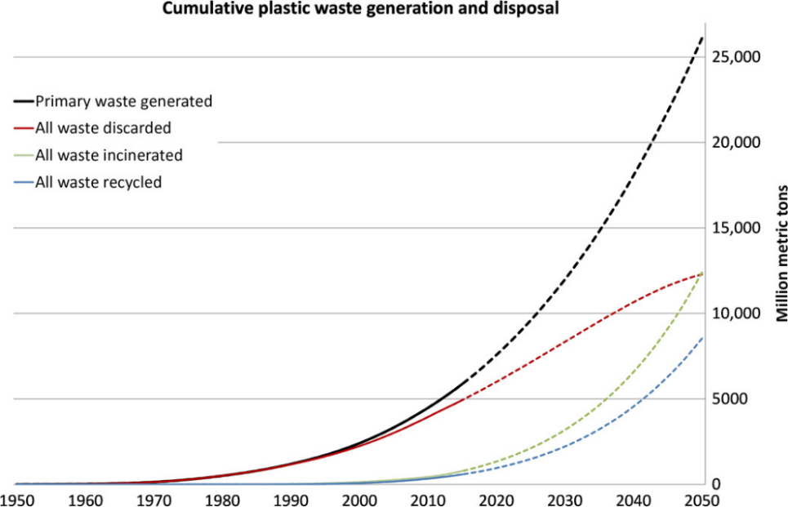
Figure 1: Cumulative plastic waste generation and disposal (Geyer et al., 2017)
Plastic waste accumulation poses severe environmental threats. Annual plastic waste generation is projected to exceed 400 million tonnes by 2025, reaching 1.6 billion tonnes by 2050 (UNEP, 2021). Conventional plastics require over 500 years for decomposition, causing soil degradation and releasing harmful pollutants including carbon monoxide, dioxins, and nitrogen oxides (Chamas et al., 2020; Ncube et al., 2021; Dokl et al., 2024). Marine pollution is exemplified by the North Pacific Garbage Patch, where plastic debris degrades into microplastics that infiltrate food webs and reach human consumption (Lebreton et al., 2018; Thompson et al., 2015).
Figure 2 shows waste management evolution from 2000 – 2019, revealing that landfilled waste declined from 60% to 50%, mismanaged waste from 30% to 20%, while incineration increased from 10% to 20%, and recycling grew from <5% to 10% (OECD, 2023). Despite progress, recycling remains minimal relative to disposal methods.
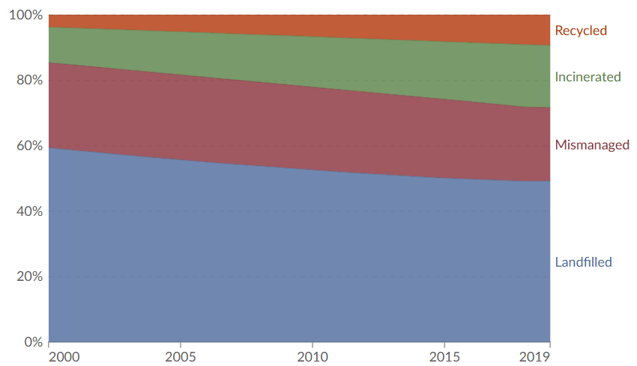
Figure 2: Global annual plastic waste by disposal method (OECD, 2023)
1.1 Recent Global Policy Responses to Plastic Use and Recycling
The escalating global plastic pollution crisis has catalysed unprecedented international policy developments and collaborative frameworks aimed at addressing plastic waste management. A landmark development was the adoption of the Fifth United Nations Environment Assembly (UNEA-5.2) resolution “End Plastic Pollution: Towards an International Legally Binding Instrument” in March 2022, mandating the development of a legally binding global plastics treaty by 2024 (Raubenheimer and Urho, 2020; NCM, 2020; UNEP, 2022; Simon et al., 2021; Wang and Praetorius, 2022; Baršauskaitė et al., 2025). According to OECD (2024), coordinated global policies targeting the entire plastics lifecycle could cut plastic leakage substantially by 2040 through improved waste management, optimised recycling, and reduced virgin plastic production. Key strategies capable of eliminating over 90% of mismanaged plastic waste by 2050 include recycled content mandates, production caps, infrastructure investment, and packaging fees (Lau et al., 2020; Ncube et al., 2021; Dokl et al., 2024).
Table 1 outlines 19 key policies from various regions, including Kenya's plastic bag ban with $40,000 fines (UNEP, 2017), the EU's target for all plastic packaging to be recyclable by 2030 (European Commission, 2018), China's National Sword Policy restricting waste imports (State Council of China, 2018), and the global UN Plastics Treaty negotiations (UNEP, 2022).
Table 1: Key global policies and programmes on plastics
S/N | Region | Policy | Focus | Objective | Reference
1 | Kenya | National Ban on Plastic Carrier Bags | Single-use plastic ban | Complete prohibition of plastic bags <50 microns; fines up to $40,000.00 | UNEP (2017); Goitom (2017)
2 | Rwanda | National ban on manufacturing, importation, use and sale of plastic carry bags and single-use plastic items | Plastic bag prohibition, plastic carry bags and single-use plastic items | Total ban on plastic bags; import and use restrictions | Republic of Rwanda Law No. 17/2019 (UNEP, 2019)
3 | South Africa | Extended Producer Responsibility (EPR) Regulations | Producers and importers of packaging materials | Mandatory EPR for packaging including plastics; recycling targets by material type | Republic of South Africa DFFE (2021)
4 | Nigeria | Nigerian Maritime Administration and Safety Agency (NIMASA) Action Plan on Marine Litter and Micro Plastics management; Lagos State prohibition of use and distribution of Styrofoam and other single-use plastics (SUPs) | National marine pollution reduction; Lagos State ban on single-use plastics | Reduce plastic marine litter; improve waste management systems | NIMASA’s Marine Litters and Micro Plastic Action Plan (Anagor-Ewuzie, 2020; Jamoh, 2021); Lagos State ban on plastics (Ozibo, 2025)
5 | Ghana | National Plastic Management Policy | Integrated waste management | Reduce plastic waste and promote circular economy | Ministry of Environment, Science, Technology and Innovation (MESTI) (2020); UNEP (2020)
6 | United States | National Strategy to Prevent Plastic Pollution; California State’s SB 54 Plastic Pollution Prevention and Packaging Producer Responsibility Act | Comprehensive pollution prevention and producer responsibility | Reduce pollution from plastic production; Eliminate plastic waste release into the environment by 2040; Improve recycling infrastructure; 65% reduction in single-use packaging by 2032; recycled content requirements | US EPA (2024); Segalla (2022)
7 | Canada | Canada-wide Action Plan on Zero Plastic Waste | Zero plastic waste | Ban harmful single-use plastics; achieve zero plastic waste by 2030 | Government of Canada (2019); Government of Canada (2021)
8 | European Union | European Strategy for Plastics in a Circular Economy | Circular economy transition | All plastic packaging recyclable by 2030 in the EU | European Commission (2018)
9 | European Union | EU Packaging and Packaging Waste Regulation (PPWR) | Recycling targets | 55% of plastic packaging recycled by 2030; 65% of all packaging waste recycled | European Union (2022); BEWI (2024)
10 | European Union | Single-Use Plastics Directive | Consumption reduction | Ban on single-use plastic items; 90% collection target for plastic bottles by 2029 | Gesley (2021); European Union External Action (2025)
11 | European Industry | ReShaping Plastics Initiative | Waste reduction | 60% less waste incinerated (2020-2050); >70% reduction in virgin fossil-based plastic | Plastics Europe (2022)
12 | China | National Sword Policy (Operation Green Fence) | Waste import restrictions | Prohibit import of 24 categories of solid waste including mixed plastics | State Council of China (2018); Brooks et al. (2018); Al-Ademi (2020); Yoshida (2021); Tran et al. (2021); Lin et al. (2023); Li and Mu (2024)
13 | Japan | Plastic Resource Circulation Strategy | Circular economy | Reduce single-use plastics by 25% by 2030; 60% recycling rate for plastic containers | Osamu (2022);
14 | India | Plastic Waste Management Rules (Amendment) | Comprehensive plastic management | Phase-out single-use plastics by 2022; minimum recycled content requirements | Invest India (2022); India Briefing (2022)
15 | Indonesia | National Action Plan on Marine Plastic Debris | Marine debris reduction | Reduce marine plastic debris by 70% by 2025 | World Bank (2020); World Economic Forum (2020)
16 | Thailand | Plastic Waste Management Roadmap | Systematic waste reduction | Ban single-use plastics by 2027; 100% plastic waste utilisation by 2030 | Thailand Department of Pollution Control (2023); International Energy Agency (2018)
17 | OECD | Global Ambition Policy Scenario; Regional Action Policy Scenario | Demand management; Production reduction | Meet increased plastic demand through recycled secondary plastic by 2060; Decrease global plastic use by about 20% (to 1018 Mt) by 2060 | OECD (2022); International Institute for Sustainable Development (IISD) (2022); Gureser (2025)
18 | Global | New Plastics Economy Global Commitment, launched in 2018 by the Ellen MacArthur Foundation in collaboration with the UN Environment Programme | Industry transformation | 100% of plastic packaging reusable, recyclable, or compostable by 2025 | Ellen MacArthur Foundation (2022); Ellen MacArthur Foundation (2023)
19 | Global | United Nations – Global Plastics Treaty (Intergovernmental Negotiating Committee) | International legal framework | Legally binding agreement on plastic pollution covering full lifecycle | UNEP (2022); UNEP (2023)

Analysis reveals a significant policy gap: only 3 of 19 policies (16%) promote bioplastics as sustainable alternatives, while 84% focus on end-of-pipe solutions. Policy distribution shows 37% emphasise bans on single-use plastics, 32% prioritise recycling targets, and 16% focus on waste management improvements. Regional analysis shows Europe leads with 50% of policies referencing bio-based alternatives, while Africa, Americas, and Asia show 0% adoption. This highlights a fundamental misalignment between environmental objectives and implementation strategies, with policies remaining oriented toward reactive waste management rather than proactive material substitution through bioplastics.

1.2 Bioplastics as Sustainable Alternatives Using Starch
Bioplastics offer reduced carbon footprints (30–70% lower emissions) and better end-of-life options compared to fossil-based plastics (Siracusa and Blanco, 2020). Global production capacity reached 2.47 million tonnes in 2024 and is projected to grow to 5.73 million tonnes by 2029 (European Bioplastics, 2024). Bioplastics are defined as “polymers that are bio-based, biodegradable, or both," classified along two dimensions: raw material origin and end-of-life behaviour (European Bioplastics, 2024; Di Bartolo et al., 2021; Dilshad et al., 2021). This creates four categories: (1) bio-based and biodegradable (e.g., PLA, PHA), (2) bio-based but non-biodegradable (e.g., bio-PE), (3) fossil-based but biodegradable (e.g., PBAT), and (4) conventional plastics.
Bio-based polymer production encompasses three routes: polymerisation of bio-derived monomers (e.g., PLA from lactic acid fermentation), modification of natural polymers (e.g., thermoplastic starch from cellulose, chitin), and direct extraction from microorganisms (e.g., PHA from bacterial fermentation). Table 2 summarises key bio-based polymers, production routes, and applications.
Table 2: Selected bio-based polymers and their applications (Di Bartolo et al., 2021)
Polymer Type | Production Route | Synthesis Description | Key Applications
Polylactic Acid (PLA) | Polymerisation of bio-based monomers | Fermentation of carbohydrates to lactic acid, followed by polymerisation | Packaging, biomedical devices, fibers
Polyethylene (Bio-PE) | Polymerisation of bio-based monomers | Fermentation of saccharides to bioethanol, dehydrated to ethylene | Packaging, films, bottles
Thermoplastic Starch (TPS) | Modification of natural polymers | Gelatinisation of starch with plasticisers via casting or extrusion | Packaging, edible films, agricultural mulch
Polyhydroxyalkanoates (PHA) | Extraction from microorganisms | Intracellular accumulation by bacteria using carbon-rich substrates | Biomedical implants, packaging, agricultural films

Starch represents a versatile biopolymer with widespread industrial applications across food processing, textiles, paper manufacturing, and pharmaceuticals (Siracusa and Blanco, 2020; Diyana et al., 2021). Structurally, starch comprises amylopectin (branched chains) and amylose (linear chains), both consisting of D-glucose units with molecular weights ranging from 10⁴ to 10⁸ g/mol. This natural polysaccharide offers several advantages for sustainable packaging: complete biodegradability, biocompatibility, edible properties, global availability, straightforward processing, and economic competitiveness compared to petroleum-based materials (Thakur et al., 2019).
Cassava starch (Manihot esculenta) excels due to low gelatinisation temperature (52 – 64°C), high carbohydrate content (83.5 ± 2.5% pure starch), and suitable amylose/amylopectin ratios for film formation (Bertuzzi et al., 2007; Wongphan et al., 2022; Chamorro et al., 2025). However, pure starch exhibits high water solubility, brittleness, and poor thermal stability. Modification techniques including plasticisation with glycerol or sorbitol address these limitations by disrupting hydrogen bonding and increasing chain mobility (Diyana et al., 2021).
Despite these advances, challenges continue to persist in starch-based blends: residual hydrophilicity, mechanical-thermal trade-offs (e.g., glycerol enhances flexibility but increases moisture sensitivity), and limited optimisation for packaging durability, cost, and performance in real-world conditions, particularly using abundant local cassava in developing regions.
This study addresses these gaps by developing and characterizing biodegradable films from cassava starch blended with polyvinyl alcohol (PVA) and glycerol. Objectives include: (1) extracting high-yield cassava starch (target circa 80%) and preparing films; (2) evaluating key properties (water absorption, biodegradation kinetics, FTIR for bonding, SEM for morphology, TGA for thermal stability); and (3) assessing suitability as eco-friendly packaging alternatives, while noting limitations such as unevaluated mechanical properties (e.g., tensile strength, elongation). This work aims to validate cassava-based composites for sustainable, low-cost applications in food/agricultural packaging.

2. materialS and methods
2.1 Materials and Chemicals
Fresh cassava roots were procured from local farmers in Aluu Community, Rivers State, Nigeria. Chemicals and equipment used in this study are summarised in Tables 3 and 4. Cassava tubers served as the primary starch source, while chemical reagents were employed to modify the starch properties and improve bioplastic performance. Equipment comprised measuring cylinders, stirrer, weighing balance, hot plate, knives, electric blender, bowl, muslin cloth (sieve), metal tray, and stopwatch for precise measurements and processing.

Table 3: Chemicals and their uses
S/N | Chemical/Reagent | Use
1 | Acetic acid | Breaks the starch chain into smaller units
2 | Glycerol | Acts as a plasticiser to improve flexibility
3 | Polyvinyl alcohol (PVA) | Serves as a thickening and reinforcing agent
4 | Distilled water | Solvent for chemical and starch modification
5 | Citric acid | Modifies starch structure
6 | Sodium acetate | Modifies starch structure as part of acetate buffer

Table 4: Equipment and their uses
S/N | Equipment/Apparatus | Use
1 | Measuring Cylinders | Measurement
2 | Stirrer | Mixing of material and reagents
3 | Analytical balance | Measuring the mass of sample
4 | Hot plate | Heat up reaction
5 | Knives | Slice cassavas
6 | Electric blender | Resize cassava to smaller unit
7 | Bowl | Collection of blended Cassava
8 | Muslin cloth (sieve) | Separation
9 | Metal tray | Collection of already heated reaction
10 | Stopwatch | Precise timing
11 | Precision micrometer | Measuring the thickness of sample

Additionally, characterisation instruments comprised Fourier Transform Infrared Spectroscopy (Perkin Elmer 3000 MX spectrometer), Scanning Electron Microscopy (SEM, JEOL JSM-6360LV), and Thermogravimetric Analyser (TGA, PerkinElmer Pyris 1 TGA).

2.2 Experimental Methods

Starch Extraction
Fresh cassava roots (2 kg) were thoroughly washed, peeled, and cut into small pieces using stainless steel knives and soaked in water. The cassava pieces were blended with distilled water (1:2 w/v ratio) using an electric blender for 5 minutes to achieve complete maceration. The resulting slurry was filtered through muslin cloth to separate fiber residues. The filtrate was allowed to settle overnight for 12 hours at ambient temperature (25±2°C) to enable gravitational separation of starch. The supernatant was carefully decanted, and the settled starch was washed with distilled water to remove residual impurities. The purified starch was dried in an oven at 50°C for 8 hours, ground using a mortar and pestle, and sieved through 80-mesh to obtain uniform particle size distribution. The process followed standard AOAC (2006) procedures for yield determination. The process for starch extraction and the extracted starch are shown in Figures 3 and 4.

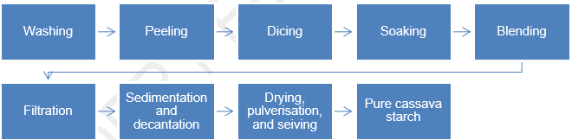
Figure 3: Cassava starch extraction process

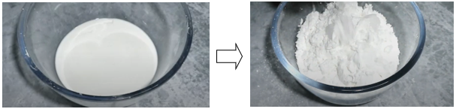
Figure 4: Starch sample extracted

Cassava Starch-Based Bioplastic Film Production
Pure cassava starch was modified to reduce hydrophilicity using an acetate buffer (44.52 g sodium acetate in 50 mL distilled water, adjusted to pH 7 with acetic acid, diluted to 1 L). A 100 g starch sample was stirred in 200 mL of this solution at 40°C temperature until thickened, then allowed to cool at room temperature. The resulting modified starch was pulverised, sieved through 80-mesh, and weighed, resulting in a yield of 62 g.
To produce cassava starch-based bioplastic film, a casting method is employed as detailed:
- Gelatinisation: 2.5 g modified starch was dissolved in 50 mL distilled water (1:20 ratio), heated at 75°C for 1 h with stirring until gelatinised.
- Plasticisation: 0.3% glycerol (w/w starch) was added as plasticiser.
- PVA incorporation: Dissolved separately (50% of starch dry weight in 50 ml distilled water).
- Crosslinking: 5% citric acid solution (w/w starch) introduced to enhance bonding.
- Stirring and Colouring: 10 min of stirring and two drops of food colouring added
- Film casting: The coloured mixture was poured into thin trays, spread evenly, and air-dried for 72 hours at ambient conditions to form bioplastic films.
The bioplastic films produced and tested as pea packaging, as presented in Figure 5, were subsequently analysed to evaluate their physicochemical and structural characteristics.

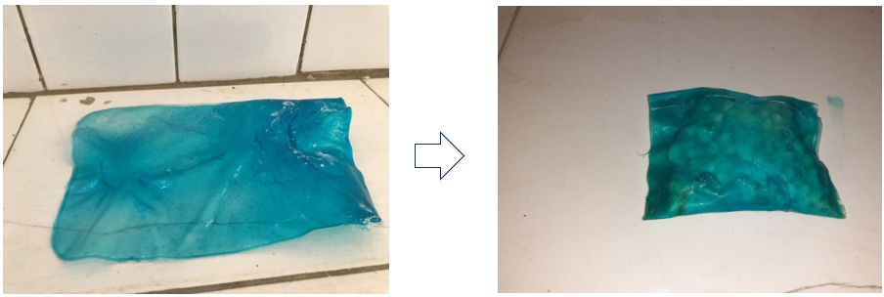
Figure 5: Biodegradable plastic film/ biodegradable packaging material

Physico-chemical Characterisation of the Films
The films produced were subjected to the following analyses:

2.2.3.1 Starch Yield
The starch yield represents the amount of starch extracted from a given weight of cassava on a dry weight basis. The yield is calculated as a percentage of the original sample weight as expressed in Eq. (1).
$Yield \left(\%\right)= \left(\frac{W_{e,s}}{W_{i,c}}\right)x 100$ (1)
where, $W_{e,s}$ is the weight of extracted starch and $W_{i,c}$is the initial weight of cassava.

Water Absorption Test
The water absorption capacity of the biodegradable films was evaluated following standard procedures. Film samples (5 cm × 5 cm) were initially dried in a desiccator for 24 hours at low heat and weighed to determine the initial dry weight ($W_{d}$). Samples were subsequently immersed in distilled water at ambient temperature for 72 hours to achieve equilibrium moisture absorption. After the immersion period, specimens were carefully removed, surface moisture was gently blotted with absorbent cotton pieces, and samples were immediately weighed to obtain the wet weight ($W_{w}$). The water absorption is calculated as a percentage of initial dry weight as shown in Eq. (1).
$Water absorption \left(\%\right)= \left(\frac{W_{w}-W_{d} }{W_{d}}\right)x 100$ (2)
where, $W_{d} is the initial dry weight {and W}_{w}$ is the final wet weight of the sample.

Fourier Transform Infrared Spectroscopy (FTIR)
FTIR can be used to analyse solids, liquids, and gases, and is often used in materials science, pharmaceuticals, polymers, food science, and environmental analysis. Some specific applications of FTIR include identifying contaminants in a sample, analysing the chemical composition of polymers and plastics, and identifying the presence of drugs or other compounds in biological samples. The prepared films were analysed using Fourier Transform Infrared Spectroscopy (FTIR). Samples were isolated for a prompt result regarding the bio mineral, where a few crystals were mixed with KBr (Merck for spectroscopy) and pulverised in an agate mortar to form a homogenous powder. An appropriate pellet was then prepared under a pressure of 7 tons. Spectra were recorded using the Pelkin Elmer 3000 MX spectrometer, with 4000 – 400 cm⁻¹, 32 scans, 4 cm⁻¹ resolution. The IR spectra were analysed using the spectroscopic software Win-IR Pro Version 3.0, with a peak sensitivity of 2cm⁻¹.

Scanning Electron Microscopy (SEM) Analysis
Scanning Electron Microscopy (SEM) is an advanced imaging technique used to observe the surface and microstructural characteristics of a sample at a very high magnification. It is a type of electron microscopy that utilises a focused beam of high-energy electrons to interact with the sample surface, creating a high-resolution image of the sample. Surface morphology and microstructural characteristics of the biodegradable films were examined using SEM technique to evaluate film homogeneity, surface texture, and structural integrity. Film specimens were prepared by mounting on aluminium specimen stubs using conductive carbon tape. To prevent charging artifacts and enhance image resolution, samples were sputter-coated with a thin layer (approximately 10-15 nm) of platinum using a Quorum Q150R sputter coater under argon atmosphere (10⁻¹ mbar pressure, 20 mA current) for 60 seconds.
SEM imaging was conducted using a JEOL JSM-6390LV scanning electron microscope operated at an accelerating voltage of 15 kV with working distance of 10-12 mm. Multiple representative areas of each sample were examined at various magnifications (×100 to ×5000) to obtain comprehensive morphological information.

Biodegradability Assessment
To assess the biodegradability of polymeric materials, three primary methodologies are employed: laboratory tests, simulation tests, and field (or burial) tests. Among these approaches, field testing represents the most practically feasible and cost-effective method for determining biodegradation timeframes of polymeric films under real environmental conditions. The biodegradation assessment of bio-films is commonly conducted using the soil burial test method, where the degree of aerobic-driven biodegradation of plastic materials is quantified using established mathematical equations. This approach provides direct measurement of material breakdown under natural soil conditions, offering realistic degradation profiles that closely mirror actual environmental scenarios.
To carry out the biodegradability test, test specimens were prepared by cutting films into 3 samples of standardised dimensions (7.5 cm × 7.5 cm) and recording initial weights of each sample as 5.50 g using an analytical balance. The soil used for testing was characterised garden soil of sandy-loam composition (pH 6.8 ± 0.2, organic content 3.2%, moisture holding capacity 45%) obtained from local farm. Samples 1, 2, and 3 were buried in soil-filled containers at a depth of 7.5cm, 10cm, and 12.5cm deep respectively, under controlled environmental conditions (temperature 25 ± 2°C, relative humidity 60 ± 5%) with periodic moisture adjustment to maintain 60% water holding capacity, as recommended by Pires et al. (2022) for biodegradation testing of bio-based materials in soil. The burial container was maintained under aerobic conditions with periodic aeration to sustain microbial activity. Film specimens were carefully excavated at predetermined intervals (4, 8, 12, 16, 20, 24 and 28 days), gently cleaned of adhering soil particles using a soft brush and distilled water rinse, dried at 40°C for 24 h, and immediately weighed to determine residual weight. The percentage weight loss, indicating biodegradation progress, was calculated using Eq. (3).
$Soil Biodegradation (\%)= \left[\frac{(W_{o}-W_{t} )}{W_{o}}\right]x 100$ (3)
where, $W_{o}$ is the initial weight and $W_{t}$ is the weight of film sample at time t. Biodegradation kinetics were analysed by plotting percentage weight loss against burial time, and rates of biodegradation were determined using first-order kinetic modelling (Lucas et al., 2008)
Thermal Gravimetric Analysis (TGA)
TGA is a technique used to measure the weight changes of a sample as it is heated or cooled in a controlled environment, the technique is widely used in materials science, chemistry, and other fields to study the thermal behaviour and stability of various materials. Thermo gravimetric analysis (TGA) and derivative thermo analysis (DTA) were carried out to predict the thermal stability of the Bioplastics film. Both thermal analyses were performed simultaneously by placing film samples in platinum holders and subjected to controlled heating from 30°C to 950°C at a constant heating rate of 10°C/min under nitrogen atmosphere (flow rate: 50 mL/min) to prevent oxidative degradation, using a PerkinElmer Pyris 1 TGA system.
Weight loss as a function of temperature was continuously monitored and recorded with data acquisition every 0.5°C. The derivative thermogravimetric (DTG) curves were automatically generated to identify specific degradation temperatures and thermal transition events.

Thickness
Film thickness uniformity was evaluated using a precision micrometer. For each film sample, thickness measurements were taken at three predetermined points following a systematic pattern to ensure representative sampling across the entire film area. Measurements included two corner positions and one center point.
Prior to measurement, film samples were conditioned for 24 hours to equilibrate moisture content. Care was taken to avoid areas with visible defects, air bubbles, or surface irregularities that could affect measurement accuracy. The arithmetic mean of all three measurements was calculated and reported as the average film thickness.

3. results and discussion
3.1 Cassava Starch Yield
The extracted cassava starch yield was 80.06%, aligning well with literature values ranging from 63.84–84.17% (AOAC, 2006; Journal of Food Science and Technology, 2021). This confirms cassava as a high-starch crop with strong potential for bioplastic production due to its abundance and ease of extraction.

3.2 Water Absorption
The bioplastic film exhibited 4% water absorption, reflecting low hydrophilicity attributed to the incorporation of polyvinyl alcohol (PVA). Similar findings by Galotto et al. (2021) indicate that PVA significantly enhances moisture resistance by reducing water uptake. This property is particularly beneficial for food packaging applications, where maintaining product integrity and preventing moisture transmission are crucial.

3.3 Biodegradability of Films
The biodegradability assessment of three samples over a 28-day period revealed distinct degradation kinetics. Sample 1 exhibited the most rapid biodegradation, achieving over 50% weight loss by day 16, and reaching complete decomposition by day 20. This suggests a highly biodegradable material with an early onset of microbial activity and efficient breakdown. In contrast, Sample 2 demonstrated a more gradual degradation curve, with its acceleration phase occurring between days 16 and 20. Although it reached full degradation by day 28, the slower rate implies moderate resistance to microbial decomposition compared to Sample 1. Sample 3 showed the slowest degradation rate, maintaining higher values for a longer duration and only reaching complete decomposition at day 28. Its delayed acceleration phase and extended persistence suggest lower biodegradability, potentially due to burial depth. Figure 6 shows the biodegradation test results for Sample 1, Sample 2, and Sample 3.
These findings clearly show that burial depth influences the rate of biodegradation. Sample 1, buried at the shallowest depth (7.5 cm), decomposed the fastest, suggesting greater microbial activity or oxygen availability. Sample 2 and Sample 3, buried deeper, showed slower degradation rates, with Sample 3 being the slowest, as reported in Table 5. This indicates that oxygen diffusion, temperature, microbial density, and possibly moisture content at different depths play a significant role in accelerating or retarding biodegradation.

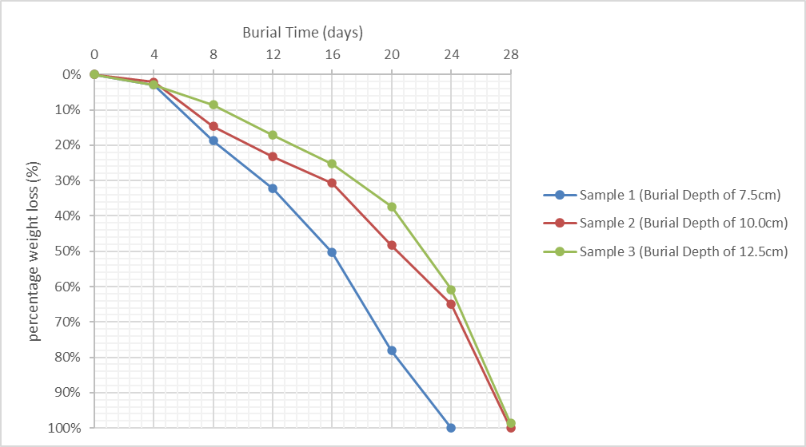
Figure 6: Biodegradation test results for Sample 1, Sample 2, and Sample 3

Table 5:Comparative insights revealing distinct decomposition acceleration phases
Sample | Acceleration Phase | Degradation Speed | Completion Time
Sample 1 | Day 8–20 | Fastest | Day 24
Sample 2 | Day 12–20 | Moderate | Day 28
Sample 3 | Day 12–20 | Slowest | Day 28

This high biodegradability contrasts sharply with petroleum-based plastics that persist for decades.

3.4 FTIR Analysis
The FTIR spectrum result for the cassava starch–PVA bioplastic film shown in Figure 7 revealed characteristic absorption peaks corresponding to key functional groups, as summarised in Table 6. A strong, broad band at 3391 cm⁻¹ indicates O–H stretching vibrations of hydroxyl groups from both starch and glycerol, confirming the presence of intermolecular hydrogen bonding. The peaks at 2925.87 cm⁻¹ and 1451.40 cm⁻¹ are attributed to C–H stretching and bending vibrations of methylene and methyl groups, suggesting partial interaction between PVA and starch molecules. The medium peaks at 1743.50 cm⁻¹ and 1652.21 cm⁻¹ correspond to C=O stretching of carbonyl groups from ester linkages, indicating chemical modification during film formation. Peaks at 1165 cm⁻¹ and 1025 cm⁻¹ represent C–O stretching of ether and ester bonds, confirming crosslinking between starch and plasticisers. Weak absorptions between 871–580 cm⁻¹ are associated with C–C bending in the pyranose ring, confirming the retention of starch’s cyclic structure.
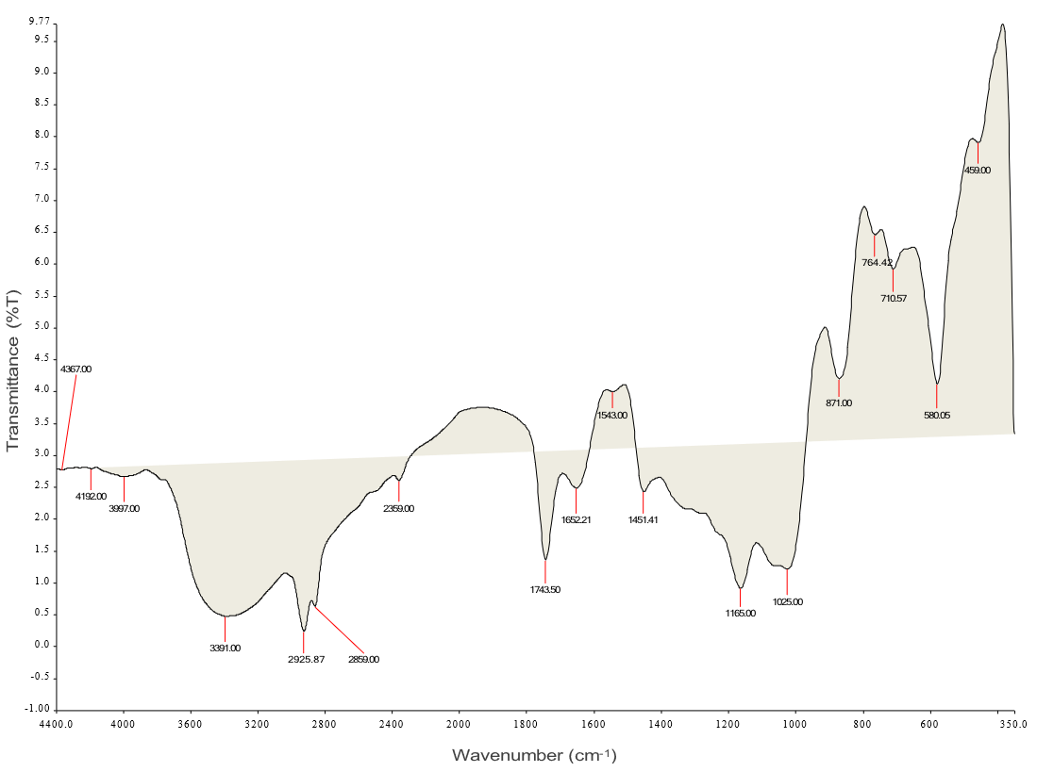
Figure 7: FTIR spectrum of cassava starch-based biodegradable film
The broad O-H peak (3391 cm⁻¹) indicates extensive hydrogen bonding between starch, PVA, and glycerol. The presence of both carbonyl peaks (1744 and 1652 cm⁻¹) suggests esterification reactions and intact starch structure. The fingerprint region (1500-600 cm⁻¹) displays characteristic C-O-C and C-O stretching vibrations, confirming the polysaccharide network. The preservation of the pyranose ring peak (580 cm⁻¹) indicates that starch maintains its native cyclic structure throughout film processing.
Table 6: FTIR spectral analysis of cassava starch-based biodegradable film
S/N | Major Spectral Peak (cm⁻¹) | Appearance | Assignment
1 | 3391.00 | Strong, very broad | O-H stretching vibration (hydroxyl groups from starch and PVA; hydrogen bonding)
2 | 2925.87 | Strong, sharp | C-H stretching vibration (methylene -CH₂- and methyl -CH₃ groups)
3 | 1743.50 | Medium, sharp | C=O stretching vibration (carbonyl group of carboxylic acid from plasticiser)
4 | 1652.21 | Medium, sharp | C=O stretching vibration (carbonyl group in starch; amorphous region)
5 | 1451.40 | Medium, sharp | C-H bending vibration (methylene -CH₂- and methyl -CH₃ groups)
6 | 1165.00 | Strong, sharp | C-O-C stretching vibration (ether linkage in starch glycosidic bonds)
7 | 1025.00 | Strong, broad | C-O stretching vibration (ester linkage; C-O-H groups in starch)
8 | 871.00 | Weak, sharp | C-H bending vibration (methyl -CH₃ group; out-of-plane deformation)
9 | 764.42 | Weak, sharp | C-H bending vibration (rocking vibration of methylene -CH₂- groups)
10 | 710.57 | Weak, sharp | C-H bending vibration (methyl -CH₃ group deformation)
11 | 580.05 | Weak, sharp | C-C bending vibration (pyranose ring structure of starch backbone)

3.5 SEM Analysis
The surface morphology of the produced bioplastic film was examined using Scanning Electron Microscopy as shown in Figure 8. Image (A) showed a smooth but slightly Cracked surface, likely resulting from the incorporation of glycerol, which reduce brittleness and enhance flexibility. Image (B) revealed a rougher and more fractured structure, suggesting higher amylopectin content and greater surface area, features beneficial for applications such as tissue scaffolding or drug delivery. Image (C) displayed a uniformly smooth surface, indicative of a well-blended starch–glycerol matrix suitable for food packaging, as a smooth morphology limits bacterial adhesion and improves printability. Similar findings were reported by Thuppahige et al. (2023) and Omoike et al. (2024), who observed minimal surface defects in optimised bioplastic films containing starch–glycerol composites.
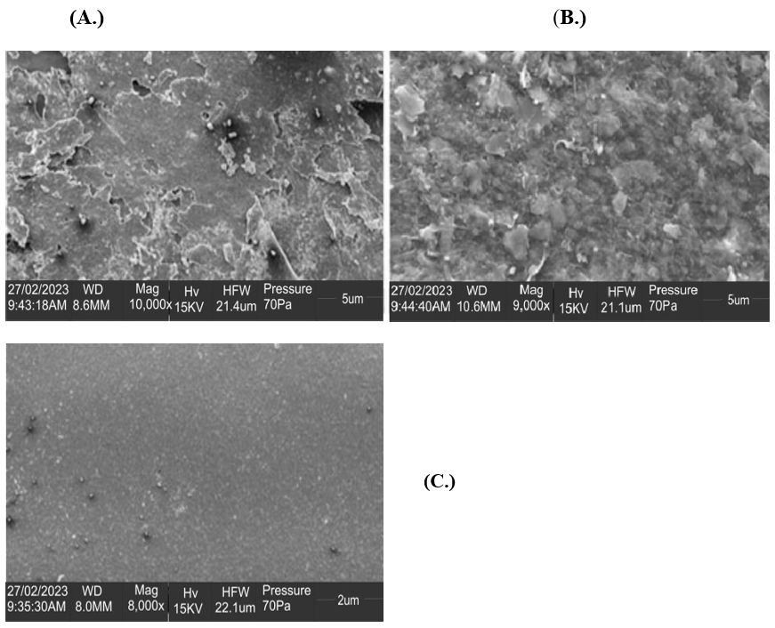
Figure 8: Surface morphology of starch-based bioplastic films
3.6 Thermal Stability (TGA/DTG)
The results in Figure 9 indicates an initial stability with negligible mass loss (approximately 5%) up to approximately 150°C, followed by a pronounced decomposition phase between 200°C and 400°C, where approximately 70% of the total mass was lost, resulting in a residual weight of approximately 20%. Beyond 400°C, a gradual decline ensues, stabilising at approximately 10% residue by 1000°C, indicative of inorganic ash or char formation. The DTG curve corroborates these stages, showing a minor peak below 150°C, a dominant peak at about 400°C, and a secondary shoulder at about 520°C. Breaking this into stages, the first stage (<150°C) is attributed to the volatilisation of adsorbed moisture, residual solvents, and low-boiling plasticisers such as glycerol. The dominant second stage (200 - 400°C) involves the thermal decomposition of the starch matrix, encompassing dehydration of hydroxyl groups, cleavage of glycosidic linkages, and depolymerisation into volatile organics (e.g., CO₂, H₂O, and aldehydes), augmented by PVA chain scission and glycerol pyrolysis. The third stage (>400°C) reflects oxidative degradation of carbonaceous residues and carbonisation, consistent with char oxidation in oxygenated atmospheres as reported by Thuppahige et al. (2023).
These observations align with ASTM E1131-20 standards released in 2020 for compositional analysis by thermogravimetry and are comparable to reported profiles for cassava starch-PVA blends, where modifications enhance onset temperatures by 20 - 50°C relative to native starch. The film's thermal stability below 150°C supports its viability for ambient-temperature packaging applications, such as food wrappers, but precludes use in high-heat scenarios (e.g., microwaveable or hot-fill processes) due to accelerated degradation risks.
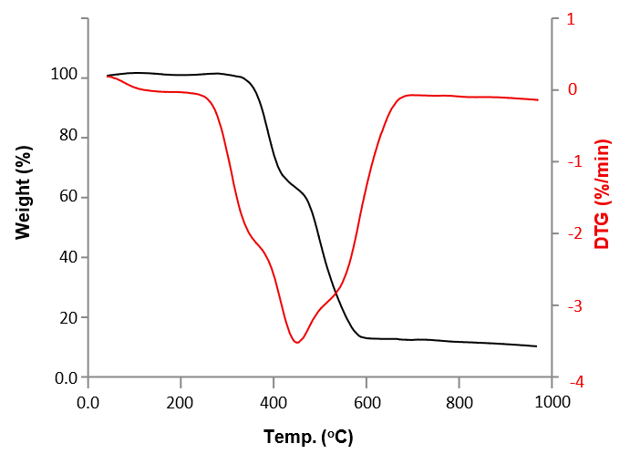
Figure 9: TGA/DTG results of starch-PVA film

3.7 Thickness
The cassava starch–PVA bioplastic films exhibited thickness values ranging from 0.18 to 0.28 mm as presented in Table 7. The relatively reduced thickness suggests a more flexible and lightweight material, ideal for short-term or low-load packaging applications. An increase in starch concentration led to thicker films due to higher solid content and greater paste viscosity, which produced denser and less porous structures after drying. Similarly, glycerol concentration had a pronounced effect on film thickness. At low glycerol levels (10%), films were thin and brittle; at moderate levels (20%), thickness increased but reduced mechanical integrity due to higher plasticisation and more moisture absorption.
Table 7: Thickness of Cassava Starch–PVA Bioplastic Films
Sample | Film Composition | Thickness (mm)
Film 1 | Starch–PVA (2:1) | 0.18
Film 2 | Starch–PVA (2:1) + 10% Glycerol | 0.21
Film 3 | Starch–PVA (2:1) + 20% Glycerol | 0.22
Film 4 | Starch–PVA (3:1) + 10% Glycerol | 0.25
Film 5 | Starch–PVA (3:1) + 20% Glycerol | 0.27

Optimising film thickness is therefore essential to balance strength, flexibility, biodegradability, and cost-effectiveness. The results corroborate thicknesses reported by Zavareze et al. (2012) and Fonseca et al. (2015), confirming the direct correlation between starch concentration, plasticiser content, and bioplastic film thickness.
4. Conclusion
This study demonstrated the effective synthesis and comprehensive characterisation of cassava starch–PVA bioplastic films, confirming their potential as sustainable alternatives to petroleum-based plastics. The cassava starch yield of 80.06% underscores the crop’s suitability as a renewable raw material for polymer production. The films exhibited low water absorption (4%), indicating enhanced hydrophobicity due to PVA incorporation, which is advantageous for food and packaging applications. Biodegradation studies revealed complete decomposition within 20 – 28 days, strongly influenced by burial depth and microbial activity, signifying excellent environmental degradability. FTIR analysis verified intermolecular interactions, including hydrogen bonding, esterification, and crosslinking, through prominent O–H, C–H, C=O, and C–O functional groups among starch, PVA, and glycerol. SEM imaging confirmed smooth, uniform surface morphologies indicative of good film homogeneity, while TGA/DTG revealed a characteristic three-stage decomposition profile with satisfactory thermal stability up to approximately 150°C. Film thicknesses of 0.18 – 0.28 mm further support lightweight and flexible characteristics appropriate for short-term applications. Collectively, these results affirm cassava starch–PVA–glycerol composites as promising eco-friendly materials with desirable hydrophobicity, rapid biodegradability, structural uniformity, and thermal resilience for sustainable packaging and allied applications.
Mechanical properties (e.g., tensile strength and elongation at break) were not evaluated in the present work, limiting full assessment of durability and practical performance under stresses. Although the observed hydrophobicity, morphology, and thickness suggest adequate structural integrity for short-term uses, quantitative mechanical assessment is required to fully substantiate direct comparisons with commercial plastics. Future work should include standard tensile testing (e.g., ASTM D882) to address this gap and strengthen applicability claims.
COMPETING INTERESTS DISCLAIMER:
Authors have declared that they have no known competing financial interests OR non-financial interests OR personal relationships that could have appeared to influence the work reported in this paper.
Disclaimer (Artificial intelligence)

Author(s) hereby declare that NO generative AI technologies such as Large Language Models (ChatGPT, COPILOT, etc.) and text-to-image generators have been used during the writing or editing of this manuscript.

References
Al-Ademi , R. (2020). The National Sword Policy of China and its Effect on Global Policy. ResearchGate. https://www.researchgate.net/publication/340439578_The_National_Sword_Policy_of_China_and_its_Effect_on_Global_Policy
Anagor-Ewuzie, A. (2020). NASS pushes bill to ban plastics, eliminate sources of Marine Litters. Businessday NG. https://businessday.ng/maritime/article/nass-pushes-bill-to-ban-plastics-eliminate-sources-of-marine-litters/?utm
Baršauskaitė, I., Roy, D., Paterson, M., & Templeton, J. (2025). A Guide to the Global Agreement to End Plastic Pollution. In International Institute for Sustainable Development. https://www.iisd.org/system/files/2025-07/guide-to_global-agreement-end-plastic-pollution.pdf
Bertuzzi, M. A., Castro Vidaurre, E. F., Armada, M., & Gottifredi, J. C. (2007). Water vapor permeability of edible starch based films. Journal of Food Engineering, 80(3), 972–978. https://doi.org/10.1016/j.jfoodeng.2006.07.016
BEWI. (2024). Understanding the EU Packaging and Packaging Waste Regulation (PPWR) proposal. BEWI. https://www.bewi.com/news/understanding-the-eu-packaging-and-packaging-waste-regulation-ppwr-proposal/
Brooks, A. L., Wang, S., & Jambeck, J. R. (2018). The Chinese Import Ban and Its Impact on Global Plastic Waste Trade. Science Advances, 4(6). https://doi.org/10.1126/sciadv.aat0131
Chamas, A., Moon, H., Zheng, J., Qiu, Y., Tabassum, T., Jang, J. H., Abu-Omar, M., Scott, S. L., & Suh, S. (2020). Degradation rates of plastics in the environment. ACS Sustainable Chemistry & Engineering, 8(9), 3494–3511. https://doi.org/10.1021/acssuschemeng.9b06635
Chamorro, A. F., Palencia, M., & Lerma, T. A. (2025). Physicochemical Characterisation and Properties of Cassava Starch: A Review. Polymers, 17(12), 1663. https://doi.org/10.3390/polym17121663
Di Bartolo, A., Infurna, G., & Dintcheva, N. T. (2021). A Review of Bioplastics and Their Adoption in the Circular Economy. Polymers, 13(8), 1229. https://doi.org/10.3390/polym13081229
Dilshad, E., Waheed, H., Ali, U., Amin, A., & Ahmed, I. (2021). General Structure and Classification of Bioplastics and Biodegradable Plastics. Bioplastics for Sustainable Development, 61–82. Springer. https://doi.org/10.1007/978-981-16-1823-9_2
Diyana, Z. N., Jumaidin, R., Selamat, M. Z., Ghazali, I., Julmohammad, N., Huda, N., & Ilyas, R. A. (2021). Physical Properties of Thermoplastic Starch Derived from Natural Resources and Its Blends: A Review. Polymers, 13(9), 1396. https://doi.org/10.3390/polym13091396
Dokl, M., Copot, A., Krajnc, D., Fan, Y. V., Vujanović, A., Aviso, K. B., Tan, R. R., Kravanja, Z., & Čuček, L. (2024). Global projections of plastic use, end-of-life fate and potential changes in consumption, reduction, recycling and replacement with bioplastics to 2050. Sustainable Production and Consumption, 51, 498–518. https://doi.org/10.1016/j.spc.2024.09.025
Ellen MacArthur Foundation. (2022). Global Commitment 2022: Progress needs fresh acceleration as key target aimed at tackling plastic pollution set to be missed. Www.ellenmacarthurfoundation.org. https://www.ellenmacarthurfoundation.org/press-release-progress-needs-fresh-acceleration
Ellen MacArthur Foundation. (2023). The Global Commitment: a common vision for a circular economy for plastics. Ellenmacarthurfoundation.org. https://www.ellenmacarthurfoundation.org/global-commitment/overview?utm_source=chatgpt.com
European Bioplastics. (2024). Bioplastics market development update 2024: Global production capacities of bioplastics 2024-2029. European Bioplastics E.V. https://www.european-bioplastics.org/market/
European Commission. (2018). Legal documents on the strategy for plastics in a circular economy. European Commission. https://commission.europa.eu/publications/legal-documents-strategy-plastics-circular-economy_en
European Union. (2022). Circular economy. Publications Office of the EU. https://op.europa.eu/en/publication-detail/-/publication/65f65729-709e-11ed-9887-01aa75ed71a1/language-en
European Union External Action. (2025). Circular Economy: Commission welcomes Council final adoption of new rules on single-use plastics to reduce marine plastic litter. EEAS. https://www.eeas.europa.eu/node/63274_en
Fonseca, L. M., Gonçalves, J. R., El Halal, S. L. M., Pinto, V. Z., Dias, A. R. G., Jacques, A. C., & Zavareze, E. da R. (2015). Oxidation of potato starch with different sodium hypochlorite concentrations and its effect on biodegradable films. LWT - Food Science and Technology, 60(2), 714–720. https://doi.org/10.1016/j.lwt.2014.10.052
Gesley, J. (2021). European Union: Ban on Single-Use Plastics Takes Effect. Library of Congress, Washington, D.C. 20540 USA. https://www.loc.gov/item/global-legal-monitor/2021-07-18/european-union-ban-on-single-use-plastics-takes-effect/
Geyer, R., Jambeck, J. R., & Law, K. L. (2017). Production, use, and fate of all plastics ever made. Science Advances, 3(7). https://doi.org/10.1126/sciadv.1700782
Goitom, H. (2017). Kenya: Notice Outlawing Plastic Bags Issued. Library of Congress, Washington, D.C. 20540 USA. https://www.loc.gov/item/global-legal-monitor/2017-03-31/kenya-notice-outlawing-plastic-bags-issued/
Government of Canada. (2019). Proposed Roadmap to Extend the Life of Plastics in End-of-Use Electronics: Consultation document - Canada.ca. Canada.ca. https://www.canada.ca/en/environment-climate-change/services/managing-reducing-waste/consultations/roadmap-plastics-end-use-electronics/proposed-extend-life-plastics-end-use-electronics.html
Government of Canada. (2021). Zero plastic waste: Canada’s actions. Www.canada.ca. https://www.canada.ca/en/environment-climate-change/services/managing-reducing-waste/reduce-plastic-waste/canada-action.html
Gureser, G. (2025). The Plastics Pollution Point: Strategic Pathways for Global Business and Policy. Carbonze. https://www.carbonze.com/post/global-plasticspollution-outlook-oecd-2060
Hilary, L. N., Sultana, S., Islam, Z., Sarker, Md. K. U., Abedin, Md. J., & Haque, M. M. (2021). Recycling of waste poly(vinyl chloride) fill materials to produce new polymer composites with propylene glycol plasticizer and waste sawdust of Albizia lebbeck wood. Current Research in Green and Sustainable Chemistry, 4, 100221. https://doi.org/10.1016/j.crgsc.2021.100221
India Briefing. (2022). Single Use Plastic Ban in India from July 1, 2022: Key Points. India Briefing News. https://india-briefing.com/news/india-new-plastic-waste-management-rules-single-use-plastic-ban-effective-from-july-1-2022-25398.html/
International Energy Agency. (2018). Roadmap on plastic waste management (2018-2030). International Energy Agency (IEA). https://www.iea.org/policies/26016-roadmap-on-plastic-waste-management-2018-2030
International Institute for Sustainable Development (IISD). (2022). Global Outlook Details Scenarios to Decrease Plastic Pollution by 2060. SDG Knowledge Hub. https://sdg.iisd.org/news/global-outlook-details-scenarios-to-decrease-plastic-pollution-by-2060/
Invest India. (2022). Understanding the Plastic Waste Management (Amendment) Rules, ... Www.investindia.gov.in. https://www.investindia.gov.in/team-india-blogs/understanding-plastic-waste-management-amendment-rules-2022
Jambeck, J. R., Geyer, R., Wilcox, C., Siegler, T. R., Perryman, M., Andrady, A., Narayan, R., & Law, K. L. (2015). Plastic Waste Inputs from Land into the Ocean. Science, 347(6223), 768–771. https://doi.org/10.1126/science.1260352
Jamoh, B. (2021). Understanding NIMASA’s marine litters and micro plastic action plan. The Guardian Nigeria News - Nigeria and World News. https://guardian.ng/business-services/understanding-nimasas-marine-litters-and-micro-plastic-action-plan/?utm
Lackner, M. (2015). Bioplastics. Kirk-Othmer Encyclopedia of Chemical Technology, 1–41. https://doi.org/10.1002/0471238961.koe00006
Lau, W. W. Y., Shiran, Y., Bailey, R. M., Cook, E., Stuchtey, M. R., Koskella, J., Velis, C. A., Godfrey, L., Boucher, J., Murphy, M. B., Thompson, R. C., Jankowska, E., Castillo, A. C., Pilditch, T. D., Dixon, B., Koerselman, L., Kosior, E., Favoino, E., Gutberlet, J., & Baulch, S. (2020). Evaluating scenarios toward zero plastic pollution. Science, 369(6510), 1455–1461. Science. https://doi.org/10.1126/science.aba9475
Lebreton, L., Slat, S., Ferrari, F., Sainte-Rose, B., Aitken, J., Marthouse, R., Hajbane, S., Cunsolo, S., Schwarz, A., Levivier, A., Noble, K., Debeljak, P., Maral, H., Schoeneich-Argent, R., Brambini, R., & Reisser, J. (2018). Evidence that the Great Pacific Garbage Patch is rapidly accumulating plastic. Scientific Reports, 8(1). https://doi.org/10.1038/s41598-018-22939-w
Li, B., & Mu, Y. (2024). Impact of China’s National Sword Policy on Waste Import Margins: A Difference-in-Differences Approach. Sustainability (Basel), 16(2), 776–776. https://doi.org/10.3390/su16020776
Lin, C., Paengsri, P., & Yang, Y. (2023). Impact of China’s National Sword Policy on waste import: A difference-in-differences approach. Economic Analysis and Policy, 78. https://doi.org/10.1016/j.eap.2023.04.033
Ministry of Environment, Science, Technology and Innovation (MESTI). (2020). National Plastic Management Policy. Accra: Government of Ghana. Ministry of Environment, Science, Technology and Innovation (MESTI).
Ministry of the Environment Japan. (2022). Plastic Resource Circulation Strategy. Tokyo: Government of Japan. https://www.env.go.jp/en/recycle/plastic/strategy.html
NCM. (2020). Executive Summary: Possible elements of a new global agreement to prevent plastic pollution. In Nordic Council of Ministers. https://norden.diva-portal.org/smash/get/diva2:1481924/FULLTEXT01.pdf
Ncube, L. K., Ude, A. U., Ogunmuyiwa, E. N., Zulkifli, R., & Beas, I. N. (2021). An overview of plastic waste generation and management in food packaging industries. Recycling, 6(1), 12. https://doi.org/10.3390/recycling6010012
OECD. (2022). Global plastic waste set to almost triple by 2060, says OECD. OECD. https://www.oecd.org/en/about/news/press-releases/2022/06/global-plastic-waste-set-to-almost-triple-by-2060.html
OECD. (2023). Global Plastics Outlook - Plastics waste by region and end-of-life fate. Processed by Our World in Data. “Annual plastic waste by disposal method, World, 2000 to 2019”. Our World in Data. https://ourworldindata.org/grapher/plastic-fate
OECD. (2024). Policy Scenarios for Eliminating Plastic Pollution by 2040. OECD Environment Policy Papers (Vol. 34). https://doi.org/10.1787/76400890-en
Omoike, B. A., Okieimen, F. E., Imoisi, C., & Abubakar, M. A. (2024). Characterisation and Evaluation of Properties of Cassava Starch/Poly(Vinyl Alcohol) Films for Food and Pharmaceutical Packaging Applications. Singapore Journal of Scientific Research, 14(1), 34–42. https://doi.org/10.3923/sjsr.2024.34.42
Osamu, S. (2022). Concerning the Act on Promotion of Resource Circulation for Plastics . Www.gov-Online.go.jp. https://www.gov-online.go.jp/eng/publicity/book/hlj/html/202205/202205_09_en.html
Our World in Data. (2019). Global Plastics Production. Part of the following publication: Hannah Ritchie, Veronika Samborska, and Max Roser (2023) - “Plastic Pollution”. Data adapted from Geyer et al., OECD. Our World in Data. https://ourworldindata.org/grapher/global-plastics-production
Ozibo, R. (2025). Lagos State to begin full enforcement of single use plastics ban from July 1. Nairametrics. https://nairametrics.com/2025/05/19/lagos-state-to-begin-full-enforcement-of-single-use-plastics-ban-from-july-1/
Pires, J. R. A., Souza, V. G. L., Fuciños, P., Pastrana, L., & Fernando, A. L. (2022). Methodologies to Assess the Biodegradability of Bio-Based Polymers—Current Knowledge and Existing Gaps. Polymers, 14(7), 1359. https://doi.org/10.3390/polym14071359
Plastics Europe. (2019). Plastics - the Facts 2019. Plastics Europe. https://plasticseurope.org/knowledge-hub/plastics-the-facts-2019/
Plastics Europe. (2022). ReShaping Plastics: Pathways to a Circular, Climate Neutral Plastics System in Europe. Plastics Europe. https://plasticseurope.org/changingplasticsforgood/reshaping-plastics/
Raubenheimer, K., & Urho, N. (2020). Rethinking Global Governance of Plastics – the Role of Industry. Marine Policy, 113, 103802. https://doi.org/10.1016/j.marpol.2019.103802
Republic of South Africa DFFE. (2021). Registration in terms of the: Regulations regarding extended producer responsibility, 2020. Department of Forestry, Fisheries and the Environment (DFFE). https://www.dffe.gov.za/registration-terms-regulations-regarding-extended-producer-responsibility-2020
Segalla, G. (2022). California Implements Legislation to Reduce Plastic Pollution and Extend Producer Responsibility Laws. Environmental Law Monitor. https://environmentallawmonitor.com/california/california-implements-legislation-to-reduce-plastic-pollution-and-extend-producer-responsibility-laws/
Simon, N., Raubenheimer, K., Urho, N., Unger, S., Azoulay, D., Farrelly, T., Sousa, J., van Asselt, H., Carlini, G., Sekomo, C., Schulte, M. L., Busch, P.-O., Wienrich, N., & Weiand, L. (2021). A binding global agreement to address the life cycle of plastics. Science, 373(6550), 43–47. https://doi.org/10.1126/science.abi9010
Siracusa, V., & Blanco, I. (2020). Bio-Polyethylene (Bio-PE), Bio-Polypropylene (Bio-PP) and Bio-Poly(ethylene terephthalate) (Bio-PET): Recent Developments in Bio-Based Polymers Analogous to Petroleum-Derived Ones for Packaging and Engineering Applications. Polymers, 12(8), 1641. https://doi.org/10.3390/polym12081641
Thailand Department of Pollution Control. (2023). Thailand pushes Action Plan Phase 2 for plastic waste management: Successful declaration reduces over 100,000 tons of plastic bag usage. SAWASDEE Thailand.go.th. https://www.thailand.go.th/issue-focus-detail/001_04_084
Thompson, R. C., Gall, S. C., & Moore, C. J. (2015). Microplastics in the Marine Environment: Sources, Consequences and Solutions. Marine Anthropogenic Litter, 185–200. https://doi.org/10.1007/978-3-319-16510-3_7
Thuppahige, V. T. W., Moghaddam, L., Welsh, Z. G., & Karim, A. (2023). Investigation of Morphological, Chemical, and Thermal Properties of Biodegradable Food Packaging Films Synthesised by Direct Utilisation of Cassava (Monihot esculanta) Bagasse. Polymers, 15(3), 767. https://doi.org/10.3390/polym15030767
Tran, T., Goto, H., & Matsuda, T. (2021). The Impact of China’s Tightening Environmental Regulations on International Waste Trade and Logistics. Sustainability, 13(2), 987. https://doi.org/10.3390/su13020987
UNEP. (2017). Notice No. 2356 of 2017 on Plastic Bags. UNEP Law and Environment Assistance Platform. https://leap.unep.org/en/countries/ke/national-legislation/notice-no-2356-2017-plastic-bags?
UNEP. (2019). Law No. 17/2019 relating to the Prohibition of manufacturing, importation, use and sale of Plastic Carry Bags and Single-use Plastic Items. UNEP Law and Environment Assistance Platform. https://leap.unep.org/en/countries/rw/national-legislation/law-no-172019-relating-prohibition-manufacturing-importation-use
UNEP. (2020). National Plastic Management Policy. UNEP Law and Environment Assistance Platform. https://leap.unep.org/en/countries/gh/national-legislation/national-plastic-management-policy
UNEP. (2021). From Pollution to Solution: A global assessment of marine litter and plastic pollution. UNEP - UN Environment Programme; UNEP. https://www.unep.org/resources/pollution-solution-global-assessment-marine-litter-and-plastic-pollution
UNEP. (2022). End plastic pollution: towards an international legally binding instrument. Resolution adopted by the United Nations Environment Assembly, UNEP/EA.5/Res.14. United Nations Digital Library System; United Nations. https://digitallibrary.un.org/record/3999257?v=pdf
UNEP. (2023). Intergovernmental Negotiating Committee on Plastic Pollution. UNEP - UN Environment Programme. https://www.unep.org/inc-plastic-pollution
US EPA. (2024). Biden-Harris Administration Announces National Strategy to Prevent Plastic Pollution. US Environmental Protection Agency (EPA). https://www.epa.gov/newsreleases/biden-harris-administration-announces-national-strategy-prevent-plastic-pollution?
Wang, Z., & Praetorius, A. (2022). Integrating a Chemicals Perspective into the Global Plastic Treaty. Environmental Science & Technology Letters, 9(12), 1000–1006. https://doi.org/10.1021/acs.estlett.2c00763
Wongphan, P., Panrong, T., & Harnkarnsujarit, N. (2022). Effect of different modified starches on physical, morphological, thermomechanical, barrier and biodegradation properties of cassava starch and polybutylene adipate terephthalate blend film. Food Packaging and Shelf Life, 32, 100844. https://doi.org/10.1016/j.fpsl.2022.100844
World Bank. (2020). Stemming the Plastics Tide in Indonesia: Policy, Investments, and Research. World Bank. https://www.worldbank.org/en/news/feature/2020/10/06/stemming-the-plastics-tide-in-indonesia
World Economic Forum. (2020). Indonesia unveils action plan to prevent 16 million tonnes of plastic from entering the ocean. World Economic Forum. https://www.weforum.org/press/2020/04/indonesia-unveils-action-plan-to-prevent-16-million-tonnes-of-plastic-from-entering-the-ocean/
Yoshida, A. (2021). China’s ban of imported recyclable waste and its impact on the waste plastic recycling industry in China and Taiwan. Journal of Material Cycles and Waste Management, 24, 73–82. https://doi.org/10.1007/s10163-021-01297-2
Zavareze, E. da R., Pinto, V. Z., Klein, B., El Halal, S. L. M., Elias, M. C., Prentice-Hernández, C., & Dias, A. R. G. (2012). Development of oxidised and heat–moisture treated potato starch film. Food Chemistry, 132(1), 344–350. https://doi.org/10.1016/j.foodchem.2011.10.090
Zheng, J., & Suh, S. (2019). Strategies to reduce the global carbon footprint of plastics. Nature Climate Change, 9(5), 374–378. https://www.nature.com/articles/s41558-019-0459-z?utm_source=feedburner&utm_medium=feed&utm_campaign=Feed%3A+nclimate%2Frss%2Fcurrent+%28Nature+Climate+Change+-+Issue%29

