Original Research Article

Enhancing Prediction Accuracy of Gas Viscosity Correlations for the Niger Delta Basin by Parameter Calibration using Nonlinear Optimization Algorithms

.
ABSTRACT

Accurate prediction of natural gas viscosity is essential for reliable reservoir engineering calculations, fluid flow analysis, and production system design. Although laboratory measurements provide accurate viscosity values, they are often expensive and time-consuming, leading to widespread reliance on empirical correlations. However, commonly used industry-standard correlations developed from global datasets often fail to accurately represent the thermophysical behavior of natural gas systems in the Niger Delta Basin, while existing region-specific correlations show limited accuracy, and their accuracy has not been optimized through model calibration techniques. In this study, a nonlinear least squares model fitting technique built on the Levenberg–Marquardt optimization algorithm via Python’s scipy.optimize.curve_fit was used to optimize the Lee-Gonzalez-Eakin correlation and the Carr-Kobayashi-Burrows correlation (modified by Dempsey and Standing), using 5,511 experimental PVT data points obtained from Niger Delta gas fields. The dataset was divided into training, testing, and validation datasets to assess performance robustness. Model performance was evaluated using the coefficient of determination (R²), Root Mean Squared Error (RMSE), and Mean Absolute Error (MAE). The calibrated models showed good improvements in predictive accuracy. The R² increased significantly for both Lee-Gonzalez-Eakin and Carr-Dempsey-Standing correlations from approximately 0.88 to greater than 0.9999. The MAE and RMSE for the Lee-Gonzalez-Eakin correlation reduce to zero from 0.001310 and 0.001315, while the Carr-Dempsey-Standing correlation also reduces to zero from 0.001014 and 0.001327. In contrast, the existing region-specific correlation developed by Azubuike et al. for the Niger Delta Basin gave a moderate R² of 0.58025 and was significantly outperformed by the calibrated global models. The results show that while global correlations for gas viscosity provide a useful starting point, model calibration using region-based datasets significantly enhances their accuracy and reliability for petroleum engineering applications in the Niger Delta.

Keywords: Natural Gas, Gas Viscosity, Niger Delta, Correlation Calibration, Model Validation.

1. INTRODUCTION

“Natural gas possesses physical properties whose knowledge must be gained to understand and predict the behavior of gas reservoirs and solve problems related to natural gas reservoir engineering. These properties include apparent molecular weight (Ma); specific gravity (γ_{g}), gas compressibility factor (z); gas density (ρ_{g}), specific gas volume (v); isothermal gas compressibility coefficient (c_{g}), gas formation volume factor (B_{g}), gas expansion factor (E_{g}) and viscosity (µ). It is important to understand these properties in the study of reservoirs and the design of optimum production systems because their accurate prediction is central to the design, development, and optimization of petroleum reservoirs. The physical properties of interest in this study are the gas viscosity (μ_{g}), which is fundamental thermodynamic and transport property required for material balance calculations, gas flow in pipes, well analysis, reservoir simulation, and production forecasting” [1].
“Sampling and measuring the gas viscosity has many inherent difficulties. The industry standard method of measuring this property is through laboratory experiments; nevertheless, studies have shown that this experimental process is quite expensive and time-consuming” [2, 3]. This approach has led to the development of numerous implicit and explicit correlations for z-factor and viscosity.
According to Ahmed [1], gas viscosity is described completely as a function of pressure, temperature, and gas composition as expressed in equation 1 and is not often measured in the laboratory because its precise value can be determined empirically. Londono et al. [4] expressed gas viscosity as a function of density, pressure, molecular weight, and temperature.

1

Standard industry correlations [5, 6, 7], among many others, have gained worldwide industry applicability in reservoir and production engineering for gas viscosity. However, these correlations were originally developed using data from distant regions that are geologically, geochemically, geographically, and thermodynamically different in characteristics compared to the Niger Delta region. Using these correlations without adjusting the parameters to match the properties of gas deposits in this region may introduce errors in the analysis of Nigerian gas reservoirs. Researchers such as Ohirhian and Abu [8], Anyiador et al. [9] and Azubuike et al. [10] have attempted to “develop different empirical correlations that are more suited for Niger Delta gas reservoirs. Therefore, this study is carried out to calibrate and validate the industry-accepted standard correlations for gas viscosity using empirical PVT data from the Niger Delta, to improve the accuracy of the existing standard gas property prediction correlations and ensure their reliability in petroleum engineering decision making in Niger Delta Basin”.
Carr et al. [5] developed “the popularly known Carr-Kobayashi-Burrows correlation for estimating natural gas viscosity as a function of gas gravity, temperature, and pressure. This correlation used a two-step technique to estimate hydrocarbon gas viscosity. This includes the determination of the gas viscosity at atmospheric conditions and the adjustment of the estimated viscosity at atmospheric pressure to desired temperature and pressure conditions using a second correlation”. They created a graphical correlation, which is a function of reduced pressures and temperatures from their experimental data. The gas viscosity can therefore be estimated using graphical correlations or using equations derived from these figures. Al-Nasser and Al-Marhoun [11] claimed that “simplicity and corrections for the existence of non-hydrocarbon gases such as CO₂, N₂, and H₂S are the main advantages of the Carr-Kobayashi-Burrows correlation. The correlation is applicable to gases with a temperature range of 100 and 300°F and a specific gravity of 0.55 and 1.22”. Dempsey [6] obtained his equation from the Carr-Kobayashi-Burrows correlation viscosity ratio chart.
Standing [12] developed “expressions that account for the presence of H₂S, CO₂, and N₂ in natural gas at one atmospheric pressure”. “A combination of Standing's and Dempsey's equations makes the estimation of gas viscosity more convenient” [11]. Jossi et al. [13] developed “the Jossi-Stiel-Thodos gas viscosity correlation for pure gases such as methane, ethane, propane, butane, pentane, nitrogen, oxygen, carbon dioxide, sulfur dioxide, and argon. The Jossi-Stiel-Thodos correlation for gas viscosity is expressed as function of reduced density: Their correlation is applicable for values of reduced density below 2.0 and has an average absolute error of 4%”.
Based on the Starling and Ellington equation, Lee et al. [7] developed the widely acceptable and simple semi-empirical equation for predicting natural gas viscosity known as the Lee-Gonzalez-Eakin correlation.
The Lee-Gonzalez-Eakin correlation has a standard deviation of 2.7% and a maximum deviation of 8.99%. Lee et al. [7] pointed out that “the correlation is less accurate for gases with specific gravities greater than 1.0 and cannot be used for sour gases”. In 1970, Gonzalez et al. [14] revised Lee et al. correlation for pressure ranges between 100 and 8000 psia and temperature ranges between 100 and 340°F, and it can be used in the presence of carbon dioxide for concentrations up to 3.2 mol%. Over practically wide ranges of temperature, pressure, and gas composition, ^{[4]} optimized some of the existing correlations (Jossi-Stiel-Thodos and Lee-Gonzalez-Eakin) and also presented new approaches for predicting viscosity and density of natural gas. “They developed a large-scale database that meets the applicability of various models for gas viscosity and density. The optimized Jossi et al. and Lee et al. have average absolute errors of 4.43% and 2.29%, respectively, compared to the 5.26% and 3.34% obtained from their original form when used with their developed database. The new implicit gas viscosity correlation developed by Londono et al. has an average absolute error of 3.05% and works well for both pure gases and gas mixtures over a wide range of pressure, temperature, and molecular weight” [12]. Sutton [15] combined the Lucas equation with the Lee-Gonzalez-Eakin correlation to develop a new correlation for estimating gas viscosity as a function of P_{pr}, T_{pr}, P_{pc}, T_{pc}, and M_{a}. Using about 5881 data points, he recorded a standard deviation of 4.9 and an average absolute error of 4.2%.
While the accuracy of existing gas viscosity correlations was questioned due to the limited amount of data, Al-Nasser and Al-Marhoun [11] developed a new correlation that is applicable over a wide range of gas specific gravity (up to 1.55) with fewer coefficients. They claimed that the model is simple and more accurate than existing models. They also built a model using Artificial Neural Networks (ANN) in order to compare its results with those obtained from the new correlation. They predicted gas viscosity using the existing correlations (Carr et al.– Dempsey– Standing, Jossi-Stiel-Thodos, Dean and Stiel, Lee-Gonzalez-Eakin, and Sutton correlations) and pointed out most of these correlations gave high errors with the large dataset used for this study. They optimized these correlations using the linear and non-linear regressions to improve their accuracy. Despite this, their new correlation and ANN model outperform the improved existing correlations. Heidaryan and Jarrahian [16] optimized the K, X, and Y parameters of the Lee-Gonzelez-Eakin correlation through multiple regression analyses on temperature, density, and molecular weight. Yang et al. [17] derived a new model for gas viscosity based on the kinetic theory of gases as a function of temperature and density. To develop a model that is simple, fast, accurate, and directly applicable to CO₂-bearing gas samples, they optimized their model parameters using a large experimental database. In their study, they showed that the gas viscosity increases with the increase of density as well as the increase of temperature in the low-density region and that gas viscosity increases with the decrease of temperature in the high-density region.
Behesht Abad et al. [18] developed a model that uses the multiple extreme learning machine (MELM) and particle swarm optimizer (PSO) to predict condensate viscosity in the near wellbore regions from pressure, temperature, initial gas to condensate ratio, gas specific gravity, and condensate gravity. Their analysis showed that pressure, gas gravity, and initial gas-to-oil condensate ratio are the most influential variables in terms of condensate viscosity based on the large dataset studied.
Deumah et al. [19] assess “the predictability of gas viscosity of Yemeni gas fields using machine learning techniques. They investigated the performance K-nearest neighbors, random forest, multiple linear regression, and decision tree using 440 data points collected from different Yemeni gas fields. They found that the decision tree model predicted the gas viscosity with higher accuracy and outperformed other models”.
Al-Gathe et al. [20] used “hybridized ANN and PSO algorithms to estimate gas viscosity using a total of 868 data points experimentally obtained from Yemen gas field. The PSO algorithm was employed to search for optimal connection weights and thresholds for the neural networks (NN), then the back-propagation learning rule and training algorithm were used to adjust the final weights. Their study showed that the hybridized model is more reliable and accurate when compared to ANN and other models, with an absolute percentage relative error and mean square error of 2.76 and 5.49, respectively”.
Daniel [21] developed “support vector machine (SVM) model that is adapted to specific reservoir conditions and found out that SVM trained with a polynomial kernel exhibits superior performance compared to SVM trained with linear and RBF kernels”.
Gomaa et al. [22] predicted “the viscosities of methane, nitrogen, and natural gas mixture from more than 4304 experimental data points using decision trees, Nu support vector regression (NuSVR), random forest (RF), artificial neural networks (ANN), gradient boosting, linear regression, and K-nearest neighbors. Their results revealed that RF, ANN, and gradient boosting performed better with a coefficient of determination (R²) of 0.99, while the linear regression and NuSVR performed poorly with a coefficient of determination (R²) of 0.07 and −0.01, respectively”.

1.1 Limitations of Existing Correlations in the Niger Delta Context
Despite being reported as accurate and reliable on a global scale, the applicability of these correlations has been found to be less accurate to the Niger Delta gas reservoirs. These inaccuracies can be a result of variation in data quality and quantity used in the development of the model, different geological settings, gas composition, and pressure-temperature conditions.
1.2 Studies on Gas Viscosity Correlation for the Niger Delta Region
According to Ohirhian and Abu [8], the Carr-Kobayashi-Burrows correlation gave, on average, an absolute error that ranged from 0.00 to 10.68% for Nigeria's natural gas system, while the Lee-Gonzalez-Eakin correlation even gave higher absolute errors. Based on this claim, they developed a new equation for estimating the viscosity of Nigerian natural gas under reservoir conditions of 144–4100 psia and 130–220°F. “Using experimental PVT data of associated gas reservoirs sourced from renowned oil and gas companies in Nigeria, their developed correlation for gas viscosity gave an average absolute error of 1.55%, a maximum absolute error of 4.878%, and a standard deviation of 1.29. To also test for universal applicability of the developed correlation, the developed correlation was used to solve two problems for which solutions by the Carr-Kobayashi-Burrows correlation were available in textbooks and calculated equal values” [23, 24]. Anyiador et al. [9] evaluated gas viscosity correlations for the Niger Delta gas reservoirs. The following correlations: Dempsey, 1965; Lee et al., 1966; Londono et al., 2002; and Ohirhian and Abu, 2009, were evaluated using statistical analysis, the Multiple Statistical Optimization Model (MULSON), and performance plots of 319 experimental PVT data obtained from Niger Delta gas reservoirs. Dempsey's correlation was ranked best with the numerical value of 0.705 and the best performance plot. They reported that their work is valid for a data range of 1.4 ≥ Tr ≥ 1.90 and 0.2 ≥ Pr ≥ 10.08, and based on the analyzed Dempsey correlation for the Niger Delta region, they developed charts of viscosity against pseudo-reduced pressure and temperature as well as viscosity ratio versus pseudo-reduced pressure and temperature.
Azubuike et al. [25] researched “the applicability of existing gas viscosity correlations for high-pressure and high-temperature (HPHT) gas reservoirs. To justify their claim that existing correlation models were derived using experimental data at low to moderate pressure and temperatures and that using the extrapolation approach is not reliable, they presented a comparative study of some existing gas viscosity correlations” (Dempsey, 1965; Lee et al., 1966; and Ohirhian and Abu, 2009) against gas viscosity at 6000–14000 psia and 270–370°F experimentally determined in the laboratory using a capillary electromagnetic viscometer. Their research showed that ^{[8]} outperform other evaluated correlations for the temperature of 270°F with the relative mean error of -5.22 and absolute mean error of 8.752, while [6] predicts gas viscosity better for 370°F with a relative mean error of -16.88 and absolute mean error of 16.88. They concluded that the comparative study proved that the existing gas viscosity correlations commonly used in the industry are not very reliable at HPHT conditions and that the oil and gas industry needed new gas viscosity correlations that can predict gas viscosity in the HPHT region better. Azubuike et al. [10], at HPHT conditions (above 10,000 psia and 300°F), developed a comprehensive model that predicts the viscosity of natural gas using Microsoft Excel Solver as the development tool. They obtained 154 data sets from the Niger Delta region of Nigeria and carried out quantitative and qualitative assessments to evaluate the degree of accuracy of the developed model to the experimental data relative to existing empirical correlations. They reported that, using the same data, the developed gas viscosity correlation outperformed other selected existing correlations and gave an average mean error of 3.4443, a coefficient of correlation of 0.9556, and a rank of 2.004. Their developed correlation depends on temperature (°R), pressure (psia), and gas density (lb/ft³), and it is applicable to 1.8 ≤ Tr ≤ 3.0 and 10 ≤ Pr ≤ 20.
Azubuike and Ikiensikimama [26] acted on the reports of many scholars that intelligent predictive models like Artificial Neural Network (ANN) and Adaptive Neuro-fuzzy System (ANFIS) give better accuracy compared to empirical models. They developed a model that predicts gas viscosity at HPHT conditions (above 10,000 psia and 300°F) using an artificial neural network (MATLAB ANN tool) on 154 laboratory-measured data from the Niger Delta. They divided the data into training, validation, and testing datasets in a 3:1:1 ratio and assessed the accuracy of the new model compared to the existing empirical correlations. The ANN gas viscosity model outperformed other models, having a correlation coefficient (R) of 0.995, a mean absolute error of 4.3416, and a rank of 2.4639. Fortune and Mbachu [27] developed a natural gas viscosity prediction model using support vector machines (SVMs). The MATLAB SVMs module was employed in building the model using 332 data sets from the Niger Delta region of Nigeria. Quantitative and qualitative assessments were employed to evaluate the accuracy of the model for both artificial neural networks (ANNs) and some of the existing empirical correlations. The new SVM gas viscosity model gave an excellent prediction when compared to other natural gas viscosity models, with a mean relative error of 1.0937 and a rank of 1.0934. It also gave the best forecast over the artificial neural network model, which has a mean relative error of 2.6126 and a rank of 1.0937.

2. material and methods

2.1 Selection of industry-standard correlation
Carr-Kobayashi-Burrows correlation (modified by Dempsey and Standing) and Lee, Gonzalez, and Eakin correlation were selected for evaluation based on their sound theoretical basis and recommendations from research works reviewed in the study area.
2.2 Data Acquisition and Processing
The datasets used in this study comprise gas reservoir parameters (5,511 data points) experimentally obtained from fields in the Niger Delta basin. The datasets were subjected to data cleaning, preprocessing, feature engineering, and feature selection before applying to evaluate the original correlations and optimized. Table 1 shows the descriptive statistics of the processed dataset for gas viscosity and Figures 1 and 2 visualize the relationships existing in the datasets. The dataset was then divided into training and testing dataset in ratio of 80/20. Python programs were written for each correlation to compute the gas viscosity.

Table 1: Descriptive Statistics for Gas Viscosity Dataset
Variable | Count | Mean | Std | min | 25% | 50% | 75% | Max
Temp (°R) | 5511 | 639 | 13.28 | 618 | 626.40 | 639 | 651.60 | 660.0
Pressure (psia) | 5511 | 2264.7 | 1012.47 | 514.7 | 1389.7 | 2264.7 | 3139.7 | 4014.7
Tpr | 5511 | 1.6877 | 0.0351 | 1.632 | 1.6544 | 1.6876 | 1.7209 | 1.7431
Ppr | 5511 | 3.4266 | 1.5319 | 0.778 | 2.1027 | 3.427 | 4.7505 | 6.0745
Z-Factor | 5511 | 0.8424 | 0.0375 | 0.775 | 0.8145 | 0.836 | 0.8683 | 0.9417
Gas Viscosity | 5511 | 0.0179 | 0.0038 | 0.012 | 0.0144 | 0.0175 | 0.0212 | 0.0257
Gas Density | 5511 | 8.4648 | 3.7516 | 1.657 | 5.1668 | 8.797 | 11.840 | 14.8700
Mol. Wt | 5511 | 19.3160 | 1.073e-12 | 19.316 | 19.316 | 19.316 | 19.316 | 19.3163
Atm. Viscosity | 5511 | 0.0118 | 1.958e-04 | 0.012 | 0.0116 | 0.0118 | 0.0120 | 0.0121

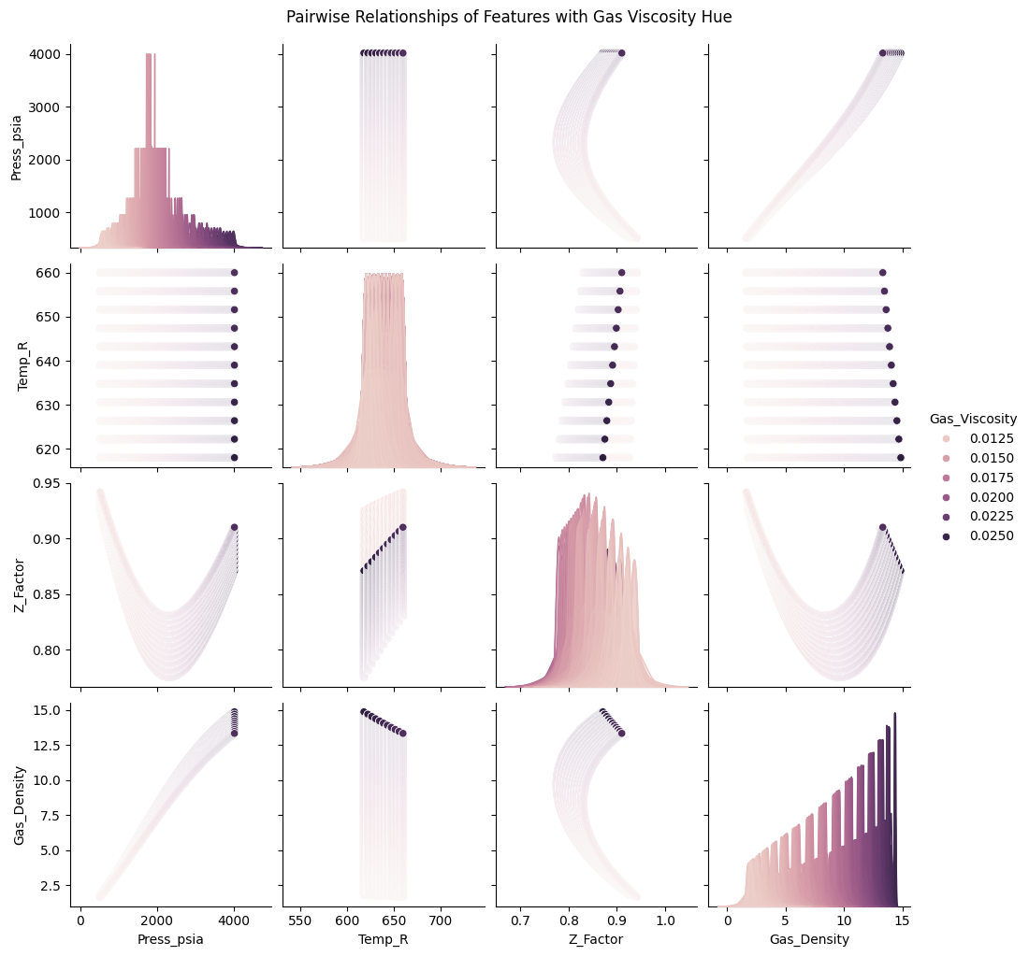
Figure 1: Pairwise Relationship of Features for Gas Viscosity Dataset
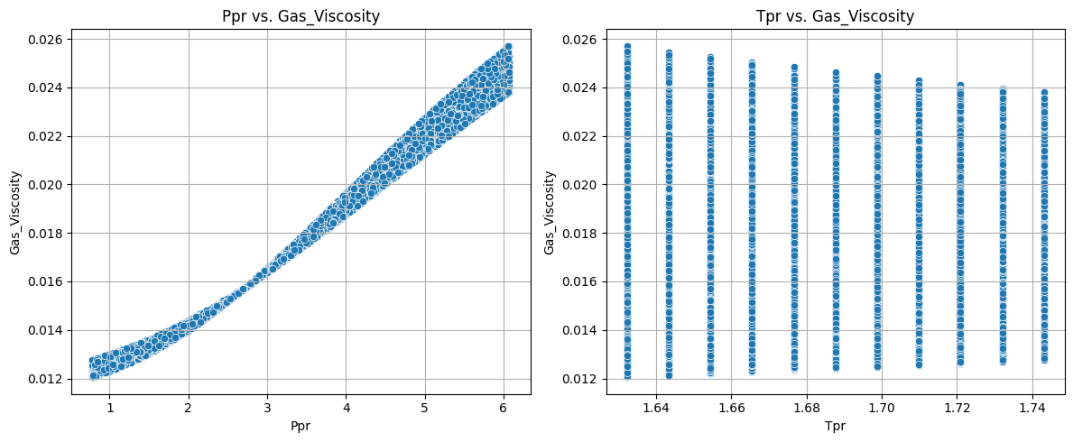
Figure 2: Cross-plot Relationship Between Ppr, Tpr, and Gas Viscosity

2.3 Model Calibration: Curve Fitting (Regression-Based Calibration)
The collected field data from the study area were fitted into the selected existing correlation equations using nonlinear regression analysis. To achieve this, a function used for nonlinear least squares fitting called “curve_fit” inside the scipy library submodule “scipy.optimize,” used for model optimization, will be used to optimize model parameters.
Curve_fit uses a non-linear least squares approach to internally fit a model to a given dataset. It does so by minimizing the least square error between the predicted model value and observed field data, and it is very effective for models whose output depends on several parameters.
2.4 Model Performance Metric Evaluation
To validate and quantify the accuracy of the calibrated correlation equations, the following statistical metrics were used:

2.4.1 Mean Absolute Error (MAE)
It measures the mean value of the differences in predictions without paying attention to their direction. For a better statistical model, it is required to have as minimal MAE as possible (close to zero is preferred).

2
Where $y_{i}=$ $the true value$; $ӯ=the predicted value$

2.4.2 Root Mean Squared Error (RMSE)
It tells how concentrated the data is around the line of best fit. It is very sensitive to large errors and good to use if the dataset has a lot of outliers. The lower the RMSE (i.e., close to zero), the better the prediction.

3

2.4.3 Coefficient of determination, ${(R}^{2}$ score)
This tells how well the data fits the model (the goodness of fit). It ranges between values of zero and one. The value of 1 represents perfect prediction, while 0 implies that the model does no better than the mean. An R² value less than 0 implies worse than the mean.
Mathematically, the coefficient of determination can be found using:

4
$SS_{regression}$is the sum of squares due to regression i.e.
$SS_{total}$is the total sum of squares i.e.
$f_{i} is$the mean of the predicted value(s).

The evaluation procedure compared the performance of unmodified industry-standard correlations, calibrated correlation equations for the region, and the developed machine learning models.
3. results and discussion

3.1 Performance of Original Industry-Standard Correlations
Table 2 summarized the predictive performance of the Carr-Kobayashi-Burrows correlation modified by Dempsey and Standing and the Lee-Gonzalez-Eakin correlation. Figures 3 (a-b) showed the actual versus predicted gas viscosity for the evaluated model. The Carr et al.-Dempsey-Standing correlation achieved a high R² of 0.877897 with a corresponding RMSE of 0.001327 and MAE of 0.001014. The Lee-Gonzalez-Eakin correlation equally achieved a high R² of 0.8801 with corresponding RMSE and MAE of 0.001315 and 0.00131, respectively. These results show that the selected industry-standard correlations have realistic predictive ability when applied to Niger Delta gas systems.

Table 2 Performance Metrics for Selected the Gas Viscosity Correlations
Correlation | MAE | RMSE | R²
Carr et al.-Dempsey-Standing | 0.001014 | 0.001327 | 0.877897
Lee-Gonzalez-Eakin | 0.001310 | 0.001315 | 0.880114

However, figures 3(a-b) clearly show that the predicted gas viscosity values deviate from the experimental values at certain pseudo-reduced temperatures and pressures despite the relatively high value of R². The figures also show that the selected globally developed correlations capture the general trend of gas viscosity. These observations support the claim that these correlations do not fully represent the composition and thermodynamic behavior of the Niger Delta gas system despite capturing the general trend, and there is a need to systematically calibrate the model parameters rather than replacing them.

(a) (b)
Figure 3(a-b): Actual Versus Predicted Gas Viscosity
(a) Carr et al.-Dempsey-Standing Correlation (b) Lee-Gonzalez-Eakin Correlation

3.2 Performance of Calibrated Gas Viscosity Correlations
Table 3 summarized the predictive performance of the calibrated Carr et al.-Dempsey-Standing and Lee-Gonzalez-Eakin correlations. The table shows that the predictive accuracy of both correlations was significantly improved following the application of the Levenberg-Marquardt algorithm for nonlinear least-squares optimization. As shown in the table, the Carr et al.-Dempsey-Standing and Lee-Gonzalez-Eakin correlations achieved near-unity R² (≈ 0.9999) with significantly reduced RMSE and MAE compared to their original forms.

Table 3: Performance Metrics for the Calibrated and Validated Gas Viscosity Correlations
Correlation | MAE | RMSE | R²
Optimized Carr et al.-Dempsey-Standing (Training) | 0.0000250000 | 0.0000290000 | 0.9999400000
Optimized Carr et al.-Dempsey-Standing (Validation) | 0.0000250000 | 0.0000290000 | 0.9999390000
Optimized Lee-Gonzalez-Eakin (Training) | 0.0000006100 | 0.0000007500 | 0.9999999600
Optimized Lee-Gonzalez-Eakin (Validation) | 0.0000006124 | 0.0000007501 | 0.9999999606

The original versions of the Carr et al.-Dempsey-Standing and Lee-Gonzalez-Eakin correlations are presented in equations 5 and 6, respectively. The modified coefficients for both correlations support the claim that parameter calibration of globally developed gas viscosity correlation to region-specific gas systems would improve the predictive accuracy of the correlation.
$In\left[T_{pr}\left(\frac{μ_{g}}{μ_{1}}\right)\right]=a_{0}+a_{1}P_{pr}+a_{2}P_{pr}^{2}+a_{3}P_{pr}^{3}+T_{pr}(a_{4}+a_{5}P_{pr}+a_{6}P_{pr}^{2}+a_{7}P_{pr}^{3}+T_{pr}^{2}\left(a_{8}+a_{9}P_{pr}+a_{10}P_{pr}^{2}+a_{11}P_{pr}^{3}\right)+{T_{pr}^{3}(a}_{12}+a_{13}P_{pr}+a_{14}P_{pr}^{2}+a_{15}P_{pr}^{2})$ 5

where T_{pr} = pseudo-reduced temperature of the gas mixture, °R
Ppr = pseudo-reduced pressure of the gas mixture, psia
$a_{0} to a_{15}$ = coefficients of the equations

The optimized coefficients for a₀ to a₁₅ are as follows:

a₀ = 91.4775917777; a₁ = -107.4217748829; a₂ = 35.5431074981;
a₃ = -3.3342750901; a₄ = -163.6733863001; a₅ = 191.0335685249;
a₆ = -62.4996387484; a₇ = 5.8410089218; a₈ = 97.6547235155;
a₉ = -113.1129624657; a₁₀ = 36.7059840310; a₁₁ = -3.4190284761;
a₁₂ = -19.3223868796; a₁₃ = 22.3090355383; a₁₄ = -7.1937758482;
a₁₅ = 0.6681258658.
Similarly, the numerical constants K, X and Y expressed in equation 6 by Lee-Gonzalez-Eakin [7] can be replaced with the optimized values (equations 7, 8 and 9) as follows:

$μ_{g}={10}^{-4}K exp\left[X{\left(\frac{ρ_{g}}{62.4}\right)}^{Y}\right]$ 6

where $K=\frac{(9.4+0.02M_{a})T^{1.5}}{209+19M_{a}+T}$, $X=3.5+\frac{986}{T}+0.01M_{a}$, $Y=2.4-0.2X$
$ρ_{g}$= gas density at reservoir pressure and temperature, lb/ft³; T = reservoir temperature, °R
M_{a} = apparent molecular weight of the gas mixture, lb/lb-mole

$K=\frac{(9.05459 + 0.000314M_{a})T^{1.513196}}{273.41738+22.24694M_{a}+T}$ 7
$X=3.583696+\frac{959.33534}{T}+0.015478M_{a}$ 8
$Y=2.54243-0.223175X$ 9

Additionally, performance metrics for the training and validation datasets reflect that the model optimization process maintained internal consistency within the used data. Nevertheless, proper caution must be taken when interpreting the extremely high values of the reported coefficient of determination because these values may also mirror high flexibility of the optimized models when applied to a new but thermodynamically related dataset. More importantly, the predictive performance of the calibrated models cannot be guaranteed outside the gas composition, temperature, and pressure range used in the model optimization without further independent testing within the study area.
3.3 Model Validation, Generalization, and Overfitting Considerations
The model validation technique used shows that the optimized gas viscosity correlations retained the predictive accuracy of the training dataset for the validation dataset rather than memorizing it. However, this does not establish universal generalizability of the optimized parameters because they are region-specific, and usage beyond this region should be approached cautiously.
Calibration of nonlinear models with multi-parameters is potentially prone to overfitting, especially when the coefficient of determination obtained is extremely high. The optimized version of the Carr et al.-Dempsey-Standing and Lee-Gonzalez-Eakin correlations should be regarded as region-specific gas viscosity predictive tools rather than universal replacements for the original version of these models. The robustness of these models can be strengthened by testing them against datasets outside the used temperature and pressure range, gas composition, and basis.
3.4 Comparison with Region-Specific Correlations
To have a standardized benchmark, the Azubuike et al. correlation developed for the Niger Delta gas system was evaluated against the same experimental dataset. As shown in Figure 4, the correlation gave a moderate predictive accuracy, with an R² of 0.5803, an RMSE of 0.00216, and an MAE of 0.00246. The predictive accuracy of the original and calibrated industry-standard correlations outperformed that of Azubuike et al.

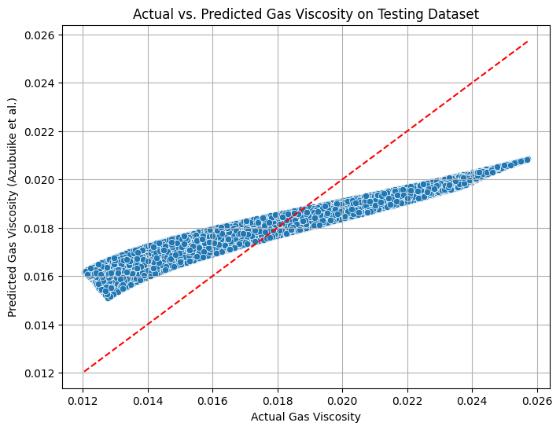
Figure 4: Actual Versus Predicted Gas Viscosity for Azubuike et al. ^{[10]}

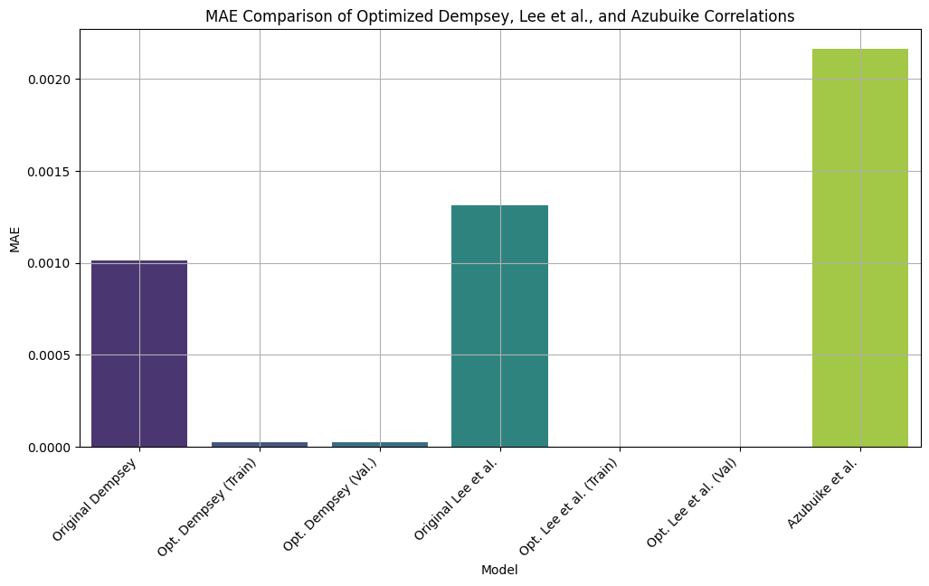
Figure 5a: MAE Comparison of the Original and Optimized Model and Azubuike Correlation

Figures 5(a–c) provide a comparative visualization of mean absolute error, root mean squared error, and the coefficient of determination across all evaluated models. The outcomes show that leveraging robust existing global correlations and improving their predictive accuracy through parameter calibration result in better performance of the global correlations in a specific region. This highlights that while region-specific models have relevance, their predictive strength may depend on the representativeness and quantity of the dataset used in their development. The discoveries of this study validate that parameter calibration of model through nonlinear optimization algorithm gives a realistic and effective method for enhancing gas viscosity estimation in geochemically different basins. Instead of modelling an entirely new empirical correlations with limited datasets, parameter optimization of established global correlations using can yield better predictive accuracy while maintaining physical interpretability and industry familiarity.

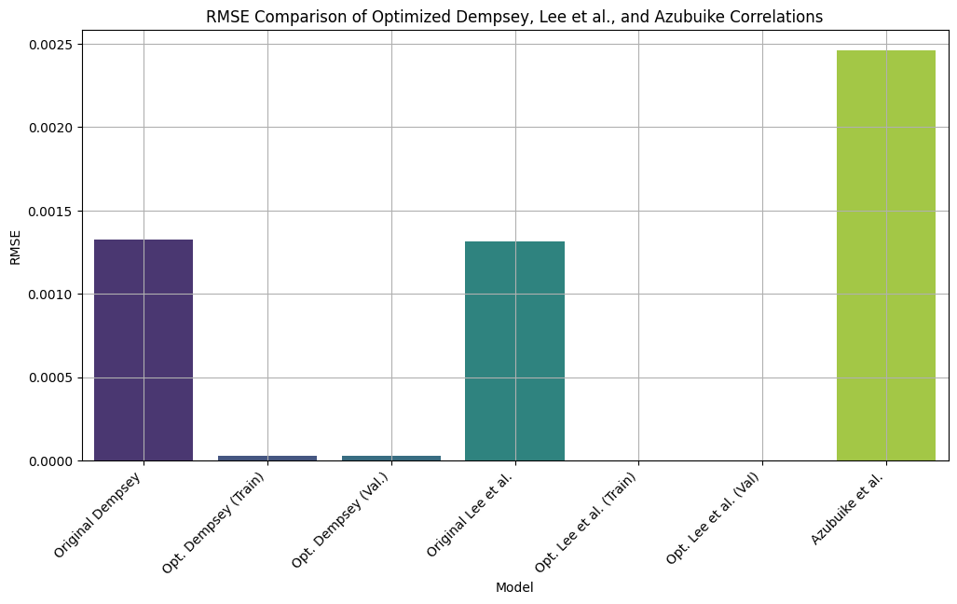
Figure 5b: RMSE Comparison of the Original and Optimized Model and Azubuike Correlation

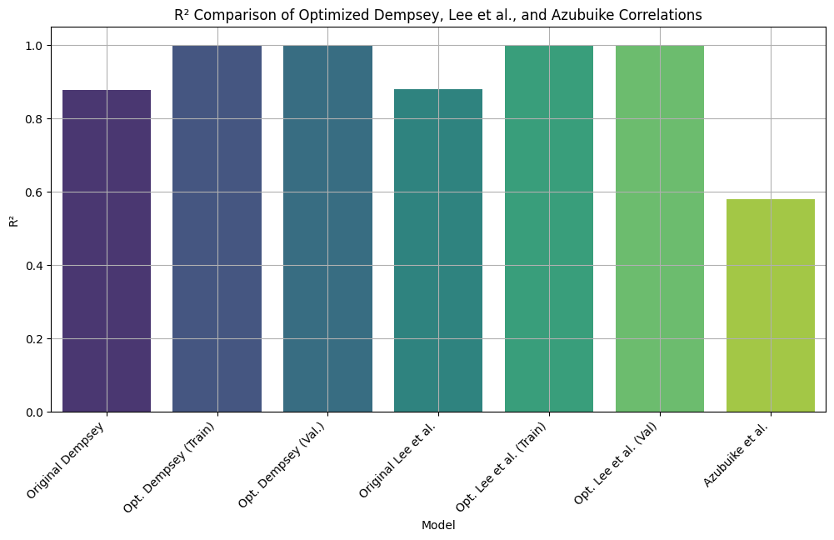
Figure 5c: R² Comparison of the Original and Optimized Model and Azubuike Correlation
4. Conclusion

This research work successfully calibrated and validated globally accepted industry-standard correlations for predicting natural gas viscosity using Niger Delta field PVT data. The results showed that:
- The performance of the selected industry standard correlations gave relatively high errors which make their suitability for predicting gas property in the Niger Delta basin limited without modification.
- Optimized gas viscosity correlations achieved near-perfect accuracy with zero error.
- Although Azubuike et al. [10] correlation gave moderate predictions, the modified and originally selected correlations outperformed it. This implies that the region-based models still require model refinement.

AcknowledgEments

The authors gratefully acknowledge and appreciate Department of Petroleum Engineering, University of Ibadan, Ibadan, Nigeria and Petroleum Trust Development Fund (PTDF) for the facilities made available during the course of this work

Disclaimer (Artificial intelligence)
Author(s) hereby declare that NO generative AI technologies such as Large Language Models (ChatGPT, COPILOT, etc.) and text-to-image generators have been used during the writing or editing of this manuscript.

References

1. Ahmed, T. (2001). Reservoir engineering handbook (2nd Edition). London, Gulf Professional Publishing. pp.29-74.
2. Okoro, E. E., Dike, H., Igwilo, K. C., & Mamudu, A. O. (2017). Measurement of the Best Z-Factor Correlation Using Gas Well Inflow Performance Data in Niger-Delta. International Journal of Applied Engineering Research, 12(12), 3507–3522.
3. Ekechukwu, G. K., & Orodu, O. D. (2019). Novel mathematical correlation for accurate prediction of gas compressibility factor. Natural Gas Industry B, 6(6), 629–638.
4. Londono, F. E., Archer, R. A., & Blassingame, T.A., (2002). Simplified Correlations for hydrocarbon Gas Viscosity and Gas Density-validation and correlation of Behaviour using a large-scale Database. SPE 75721, Calgary, Canada.
5. Carr, N. L., Kobayashi, R., & Burrows, D. B. (1954). Viscosity of hydrocarbon gases under pressure. Journal of Petroleum Technology, 6, 47–55.
6. Dempsey, J. R. (1965). Computer routine treats gas viscosity as a variable. Oil and Gas Journal, 141.
7. Lee, A. L., Gonzalez, M. H., & Eakin, B. E. (1966). The viscosity of natural gases. Journal of Petroleum Technology, 18(8), 997–1000.
8. Ohirhian, P. U., & Abu, I. N. (2008). A new correlation for the viscosity of natural gas. Advanced Materials Research, 62(64), 474-483.
9. Anyiador, O. M., Ikiensikimama, S. S., & Azubuike, I. I. (2015). Evaluation of viscosity correlation for Niger Delta gas reservoir. International Journal of Science and Engineering Investigations, 4(46). ISSN: 2251-8843.
10. Azubuike, I. I., Ikiensikimama, S. S., & Orodu, O. D. (2019). Predictive tool for high pressure high temperature gas viscosity. American Journal of Engineering Research (AJER), 8(3), 177-187.
11. Al-Nasser, K. S., & Al-Marhoun, M. A. (2012). Development of New Gas Viscosity Correlations. SPE International Production and Operations Conference and Exhibition Held in Doha Qatar, 14–16 May 2012, 1(SPE 153239). https://doi.org/10.2118/153239-MS
12. Standing, M. B. (1977). Volumetric and phase behavior of oil field hydrocarbon system (pp. 125-126). SPE.
13. Jossi, J. A., Stiel, L. I., & Thodos, G. (1962). The viscosity of pure substances in the dense gaseous and liquid phases. AIChE Journal, 8(1), 59–62.
14. Gonzalez, M. H., Eakin, B. E., & Lee, A. L. (1970). Viscosity of natural gases. API Monograph on API Research Project 65.
15. Sutton, R. P. (2005). Fundamental PVT Calculations for associated and gas/condensate natural gas system. Paper SPE 97099, presented at the SPE Annual Technical Conference and Exhibition, Dallas, Texas.
16. Heidaryan, E., and Jarrahian, A. (2012). Natural gas viscosity estimation using density based models. The Canadian Journal of Chemical Engineering, 91(6), 1183–1189. https://doi.org/10.1002/cjce.21715
17. Yang, X. H., Zhang, S., & Zhu, W. (2017). A new model for the accurate calculation of natural gas viscosity. Natural Gas Industry B.
18. Al-Gathe, A., Baarimah, S. O., Al-Khudafi, A. M., Bawahab, M., & Dmour, H. (2023). Hybrid approach for gas viscosity in Yemeni oil fields. Earth Science Informatics. https://doi.org/10.1007/s12145-023-01121-5
19. Behesht Abad, A. R., Mousavi, S., Mohamadian, N., Wood, D. A., Ghorbani, H., Davoodi, S., Alvar, M. A., & Shahbazi, K. (2021). Hybrid machine learning algorithms to predict condensate viscosity in the near wellbore regions of gas condensate reservoirs. Journal of Natural Gas Science and Engineering, 95, 104210. https://doi.org/10.1016/j.jngse.2021.104210
20. Daniel, G. V. V. (2023). Machine Learning Applied to Viscosity Prediction: A Case Study. WSEAS TRANSACTIONS on COMPUTERS, 22, 277–283. https://doi.org/10.37394/23205.2023.22.31
21. Deumah, S. S., Yahya, W. A., Al-khudafi, A. M., Ba-Jaalah, K. S., & Al-Absi, W. T. (2021). Prediction of Gas Viscosity of Yemeni Gas Fields Using Machine Learning Techniques. Paper Presented at the SPE Symposium: Artificial Intelligence - towards a Resilient and Efficient Energy Industry, Virtual, October 2021. https://doi.org/10.2118/208667-ms
22. Gomaa, S., Abdalla, M., Salem, K. G., Nasr, K., Emara, R., Wang, Q., & El-hoshoudy, A. N. (2024). Machine learning prediction of methane, nitrogen, and natural gas mixture viscosities under normal and harsh conditions. Scientific Reports, 14(1), 15155. https://doi.org/10.1038/s41598-024-64752-8
23. Katz, D. L. (1959). Handbook of natural gas engineering. McGraw-Hill.
24. Ikoku, C. U. (1992). Natural gas production engineering. Krieger Publishing Company. pp 24-65.
25. Azubuike, I. I., Ikiensikimama, S. S., & Orodu, O. D. (2016). Gas viscosity measurement and evaluation for high pressure and high temperature gas reservoir. International Journal of Science and Engineering Investigation, 5(54), July. ISSN: 2251-8843.
26. Azubuike, I. I., & Ikiensikimama, S. S. (2020). Modeling gas viscosity of high-pressure high temperature conditions using artificial neural network. American Journal of Engineering Research, 9(5), 1–9.
27. Fortune A.A & Mbachu I.I., (2022). Modeling Natural Gas Viscosity for Niger Delta Region Using Support Vector Machine (SVM) Algorithm. International Journal of Research in Engineering and Science, 10(3), 51-61

