Original Research Article
Field-Based Comparative Performance Analysis of Passive Cooling Strategies for Photovoltaic Modules in Tropical Climates

Abstract
Photovoltaic (PV) modules installed in tropical regions operate under intense solar irradiance and elevated ambient temperatures, conditions that can substantially reduce electrical efficiency and accelerate material degradation. Although numerous laboratory-based studies have demonstrated the potential of passive cooling techniques, their effectiveness under real outdoor operating conditions remains less comprehensively evaluated. This study presents a field-oriented case analysis of passive cooling strategies applied to a monocrystalline photovoltaic module operating in a tropical climate. Three configurations phase change material (PCM) cooling, fin-based cooling, and a hybrid PCM–fin system were assessed using previously reported outdoor measurements that were re-examined through derived thermal and electrical performance indicators, including average temperature reduction, normalized efficiency gain, and time-integrated energy output. The results indicate that fin-based cooling provides the most consistent and reliable thermal mitigation under naturally varying field conditions, achieving a peak temperature reduction of approximately 10 °C and the highest efficiency improvement per degree of cooling. PCM-based cooling demonstrates moderate, time-dependent performance benefits, whereas the hybrid configuration shows comparatively limited effectiveness, primarily due to additional thermal resistance associated with the PCM layer. A scenario-based seasonal interpretation further highlights the sensitivity of cooling effectiveness to ambient temperature ranges and natural convection conditions characteristic of tropical climates. Practical deployment considerations, including installation complexity, structural implications, and long-term reliability, are also examined to support real-world applicability.
Keywords: Photovoltaic thermal management; Passive cooling; Field performance; Tropical climate; Monocrystalline PV module; Phase change material (PCM); Fin heat sink; Time-integrated energy output.
1. Introduction
Photovoltaic (PV) technologies are central to global decarbonization efforts; however, their operational performance is highly sensitive to environmental conditions (Peters, 2025; Lew et al., 2021). In tropical and subtropical regions, PV modules are routinely exposed to intense solar irradiance combined with elevated ambient temperatures, resulting in increased cell operating temperatures. This thermal rise reduces electrical efficiency, accelerates material degradation, and compromises the long-term reliability of PV systems (Fouad et al., 2017; Royne et al., 2005). As solar deployment expands rapidly across warm and humid climates, effective thermal management under real outdoor conditions has become a pressing engineering concern. A wide range of studies has examined strategies to regulate PV module temperature using both active and passive cooling approaches. Active cooling systems, including forced air and liquid circulation methods, can achieve substantial temperature reductions but often introduce additional system complexity, higher capital costs, parasitic power consumption, and ongoing maintenance requirements (Bahaidarah et al., 2013; Rehman et al., 2007 Al-Shurman et al., 2019). More recently, advanced thermal management concepts such as photovoltaic–thermal (PV/T) integration and nanofluid-based cooling systems have been investigated to enhance heat transfer and electrical efficiency under elevated thermal loads (Aqeel et al., 2025a; Aqeel et al., 2025b; Aqeel et al., 2025c). While these approaches demonstrate improved heat rejection capability, they typically rely on active circulation mechanisms, specialized working fluids, or hybrid system integration, thereby increasing operational complexity compared with purely passive solutions. For decentralized and small-scale installations, such limitations can reduce overall practicality and economic viability. Consequently, passive cooling strategies particularly those based on natural convection enhancement and latent heat storage have gained attention as structurally simpler and energy-efficient alternatives (Ali, 2020; Sharaf et al., 2022). Among passive techniques, fin-based heat dissipation and phase change material (PCM) integration are widely investigated due to their structural simplicity and potential for retrofitting existing systems. Fin-based cooling improves heat rejection by increasing the effective surface area available for natural convection and radiation, and several experimental studies have reported measurable temperature reductions and associated efficiency improvements (Jobair, 2017; Bayrak et al., 2019). PCM-based cooling, in contrast, utilizes latent heat absorption during phase transition to buffer temperature rise during peak thermal loading. Its effectiveness depends strongly on PCM properties, melting temperature range, and operating conditions (Hasan et al., 2014; Singh et al., 2020; Wongwuttanasatian et al., 2020). Despite the growing body of literature, many previous investigations have been conducted under controlled laboratory environments or short-duration experimental setups (Bayrak et al., 2020; Dwivedi et al., 2020). Such conditions do not fully represent the variability encountered in real outdoor operation, where fluctuating irradiance, ambient temperature changes, wind-driven convection, and humidity can significantly influence thermal behavior. As a result, translating laboratory findings directly to field-installed PV systems remains challenging, revealing a persistent gap between experimental research and practical implementation (Bahaidarah et al., 2016; Bonah et al., 2021). Field-oriented analyses and case studies are therefore essential for bridging this gap. Unlike laboratory investigations that emphasize peak or instantaneous performance, field-based evaluations focus on robustness, consistency, and sustained effectiveness under naturally varying environmental conditions. This perspective is particularly relevant for tropical climates, where high ambient temperatures and dynamic atmospheric conditions place continuous thermal stress on PV modules and where passive solutions must operate reliably without auxiliary energy input. The present study addresses this need through a field-focused case analysis of passive cooling strategies applied to a monocrystalline PV module operating under tropical outdoor conditions. Three configurations PCM-based cooling, fin-based cooling, and a hybrid PCM–fin arrangement are examined from an applied engineering standpoint. Rather than introducing new experimental measurements, the work re-analyses an existing outdoor dataset previously reported by the authors (Aswin et al., 2025), emphasizing field-relevant performance interpretation. Derived metrics such as mean and peak temperature reduction, normalized efficiency gain, and time-integrated electrical energy output are employed to evaluate sustained system behavior under realistic operating conditions. Distinction from Previous Study The earlier publication by Aswin et al. (2025) primarily presented a comparative experimental evaluation of passive cooling configurations based on instantaneous temperature reduction, power output, and efficiency measurements obtained during outdoor testing. In contrast, the present study does not introduce new experimental data but extends the interpretation of the original dataset through a field-performance framework. Specifically, the current work emphasizes irradiance-normalized analysis, time-integrated energy assessment, ambient sensitivity evaluation, and scenario-based seasonal interpretation to extract deployment-relevant insights. By shifting the focus from experimental comparison toward real-world applicability and operational robustness, this study provides a complementary and practically oriented perspective on passive cooling strategies for photovoltaic systems operating in tropical climates. By reframing the original measurements within this broader field-performance context, the study offers deeper insight into the relative suitability, operational constraints, and deployment implications of passive cooling approaches under realistic environmental conditions.
2. Case Study Description and Field Conditions
The present work is structured as a field-oriented case study conducted under naturally varying outdoor conditions representative of photovoltaic installations in tropical regions. Measurements were carried out in Kannur, Kerala, India (latitude: 11.8745° N, longitude: 75.3704° E), a warm–humid coastal tropical location characterized by high solar irradiance and elevated ambient temperatures. The experimental campaign was performed during May, a pre-monsoon period typically associated with intense solar exposure and severe daytime heating. During the measurement window, ambient temperatures ranged approximately between 30 °C and 45 °C, reflecting the substantial thermal loading conditions frequently encountered in tropical photovoltaic installations. The installation site was free from shading and nearby obstructions, ensuring uninterrupted exposure to natural solar radiation throughout the experimental period. In contrast to laboratory-based investigations conducted under controlled environmental conditions, the photovoltaic module in this study was subjected to naturally fluctuating ambient influences, including variations in solar irradiance, wind-driven convection, and ambient air temperature. These operating conditions closely resemble those encountered by rooftop and ground-mounted photovoltaic systems in real-world deployments, enabling evaluation of passive cooling performance under practical field scenarios rather than idealized test environments. A commercially available monocrystalline photovoltaic module with a nominal power rating of 50 W and a rated operating voltage of 12 V was employed in the case study. The module was mounted on an adjustable support structure that allowed appropriate tilt alignment to maximize solar exposure during the measurement period. Passive cooling configurations were applied to the rear surface of the module, including a phase change material (PCM) layer, aluminium fin-based heat sinks, and a hybrid configuration combining both PCM and fins. All cooling configurations were evaluated using the same photovoltaic module to ensure direct and consistent comparison under identical environmental conditions. Field measurements were conducted over multiple consecutive days during peak solar hours, typically from late morning to mid-afternoon, when thermal loading on photovoltaic modules is most severe. Electrical output parameters and module surface temperature were recorded at regular intervals throughout this period. The selected time window captures the operating regime most relevant to thermal-induced efficiency degradation in tropical installations, where elevated module temperatures often coincide with periods of maximum power generation. Figure 1 illustrates the field installation configuration of the photovoltaic module and the passive cooling arrangements evaluated in this study. The figure highlights the rear-side integration of the PCM enclosure, fin-based heat dissipation system, and the combined PCM–fin configuration as implemented under outdoor conditions. This setup reflects practical installation constraints and the thermal interaction mechanisms typically encountered in real-world photovoltaic systems.
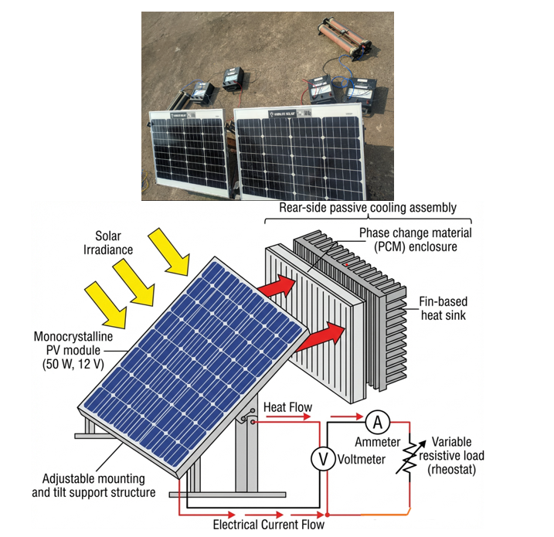
Figure 1. Field experimental setup and conceptual representation of the photovoltaic module with rear-side passive cooling. (a) Photograph of the outdoor experimental arrangement showing the monocrystalline photovoltaic module, adjustable tilt support structure, electrical measurement instruments, and variable resistive load used under natural operating conditions. (b) Conceptual schematic illustrating the photovoltaic module, rear-side passive cooling assembly (phase change material enclosure and fin-based heat sink), electrical measurement circuit (voltmeter, ammeter, and rheostat), and the associated heat and electrical current flow paths.
3. Passive Cooling Configurations Evaluated
The passive cooling configurations examined in this field case study were selected based on their structural simplicity, ease of deployment, and compatibility with existing photovoltaic installations. All cooling solutions were implemented on the rear surface of the photovoltaic module without requiring external power input, forced circulation, or active control systems. This design philosophy reflects practical constraints commonly encountered in rooftop and small-scale ground-mounted PV installations in tropical regions. The evaluated configurations include phase change material (PCM)–based cooling, fin-based natural convective cooling, and a hybrid arrangement combining both approaches.
3.1. PCM-Based Cooling Configuration
The PCM-based cooling system employed an encapsulated organic phase change material, OM35, selected to correspond with the typical operating temperature range of photovoltaic modules in tropical climates. OM35 has a nominal melting temperature of approximately 34–36 °C, a latent heat of fusion of about 150–180 kJ/kg, and a thermal conductivity in the solid and liquid phases of approximately 0.2–0.3 W/m·K. Approximately 2.0 kg of PCM was applied to the rear surface of the module in an encapsulated form to ensure containment during repeated melting and solidification cycles. When exposed to solar heating, the PCM absorbs thermal energy during its phase transition, thereby moderating the rise in module temperature during periods of elevated irradiance. This latent heat absorption mechanism allows the PCM to function as a passive thermal buffer, particularly under transient thermal loading conditions. The selection of OM35 was based on the alignment of its melting range with the lower-to-mid operating temperatures of PV modules observed under tropical ambient conditions (30–45 °C), ensuring activation during typical daytime heating. From a field deployment perspective, the effectiveness of PCM-based cooling is strongly governed by the degree of alignment between the PCM melting range and the actual operating temperature profile of the module. In tropical environments, daytime module temperatures may exceed the PCM melting range for extended durations, causing the material to approach thermal saturation and progressively reducing its capacity to absorb additional heat. Consequently, PCM-based cooling is most effective during early-stage heating and moderate-temperature operation rather than during prolonged exposure to peak thermal conditions. Practical considerations such as encapsulation integrity, long-term thermal cycling stability, and thermal contact resistance between the PCM layer and the module rear surface also influence real-world performance. These deployment-related factors differentiate field behavior from idealized laboratory demonstrations and are central to the present evaluation.
3.2. Fin-Based Cooling Configuration
The fin-based cooling configuration consists of aluminium fins attached to the rear surface of the photovoltaic module to enhance heat dissipation through natural convection and radiation. By increasing the effective heat transfer area, the fins promote improved convective heat exchange with the surrounding air without requiring forced airflow or auxiliary energy consumption. Under outdoor operating conditions, the performance of fin-based cooling is governed primarily by ambient air temperature, natural wind-driven convection, and installation orientation. Unlike PCM-based systems, fin-based cooling does not rely on finite thermal storage capacity and therefore provides continuous heat dissipation as long as a temperature gradient exists between the module and the surrounding environment. This characteristic makes fin-based systems particularly suitable for sustained high-temperature operation typical of tropical climates. From a practical standpoint, fin-based cooling can be readily retrofitted to existing photovoltaic modules. However, factors such as added structural weight, mechanical compatibility with mounting systems, and long-term exposure to dust, moisture, and corrosion must be considered when evaluating deployment feasibility.
3.3. Hybrid PCM–Fin Cooling Configuration
The hybrid PCM–fin configuration integrates latent heat storage with enhanced convective heat dissipation in an effort to combine the advantages of both mechanisms. In this arrangement, the PCM layer is placed in thermal contact with the rear surface of the photovoltaic module, while aluminium fins are mounted externally to facilitate heat rejection to the surrounding air. In principle, the fin assembly is intended to improve heat removal from the PCM, thereby extending its effective thermal buffering period and mitigating saturation effects. However, under real-world conditions, hybrid integration introduces additional thermal and mechanical complexities. The relatively low intrinsic thermal conductivity of OM35 can impede heat transfer between the photovoltaic module and the fin assembly, potentially reducing overall convective effectiveness. Moreover, the presence of multiple thermal interfaces increases contact resistance, which may limit the synergistic performance improvements expected under controlled laboratory conditions. From a deployment perspective, hybrid systems involve increased installation complexity, additional material interfaces, and greater structural loading compared to single-mechanism approaches. These factors may offset theoretical performance benefits when evaluated in practical field applications. Figure 2 presents a schematic overview of the passive cooling configurations evaluated in this case study, illustrating the conceptual layout and dominant heat transfer pathways associated with PCM-based, fin-based, and hybrid cooling under real outdoor operating conditions.
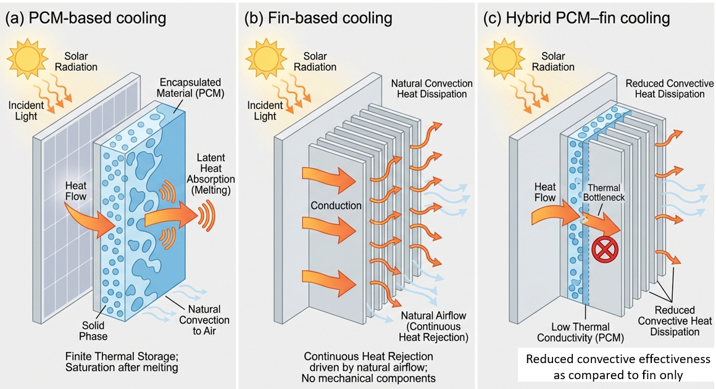
Figure 2. Schematic overview of passive cooling configurations evaluated in the field case study, including PCM-based cooling, fin-based natural convection cooling, and the hybrid PCM–fin system.
4. Data Sources and Performance Metrics
The performance assessment presented in this study is based on outdoor measurements obtained under naturally varying field conditions in Kannur, Kerala, India. Electrical output, module surface temperature, and solar irradiance were recorded during peak operating hours, when photovoltaic modules in tropical climates experience the most severe thermal loading. The analysis relies on the experimental dataset previously reported by Aswin et al. (2025); however, the present study does not reproduce raw time-series data. Instead, it emphasizes derived performance indicators that enable consistent and meaningful comparison of passive cooling configurations under realistic operating conditions.
4.1. Electrical Performance Measurements
The electrical performance of the photovoltaic module was evaluated in terms of instantaneous power output and conversion efficiency. Power output was calculated from the measured voltage and current values under a constant resistive load condition. Conversion efficiency was determined by normalizing the electrical power output with respect to the incident solar irradiance and the active surface area of the module. These indicators reflect the practical energy conversion capability of the photovoltaic system during outdoor operation and provide a direct basis for assessing field-level performance improvements resulting from passive cooling.
4.2. Temperature Measurements
Module surface temperature was monitored using non-contact thermal measurement techniques to capture the spatially averaged thermal behavior of the photovoltaic panel during operation. Temperature data were used to quantify both absolute operating temperatures and relative temperature reductions achieved through passive cooling. Since elevated operating temperature is a primary factor contributing to efficiency degradation in photovoltaic systems, temperature-based indicators form the fundamental basis of the comparative evaluation conducted in this study.
4.3. Irradiance Normalization
To account for natural fluctuations in solar irradiance during outdoor operation, performance comparisons were conducted using irradiance-normalized metrics. This normalization reduces bias arising from transient cloud cover and short-term variations in solar input, thereby enabling fair comparison among different cooling configurations operating under slightly different environmental conditions. As a result, efficiency-based indicators and time-integrated energy gain metrics were prioritized over isolated instantaneous power values, which may be strongly influenced by momentary irradiance variations.
4.4. Derived Performance Metrics
Based on the recorded field measurements, the following derived metrics were used to evaluate the effectiveness of each passive cooling configuration:
- Mean temperature reduction (°C): The average decrease in module operating temperature relative to the uncooled reference configuration over the measurement window.
- Peak temperature reduction (°C): The maximum instantaneous temperature difference observed between the cooled and reference configurations during periods of peak thermal loading.
- Mean efficiency improvement (%): The average percentage increase in photovoltaic conversion efficiency relative to the reference configuration.
- Time-integrated energy gain (%): The percentage increase in cumulative electrical energy output over the measurement period, determined by integrating power output with respect to time.
Collectively, these derived metrics emphasize sustained thermal mitigation, electrical performance enhancement, and operational robustness rather than short-duration peak behavior. Such indicators are particularly suitable for evaluating passive cooling strategies in field-installed photovoltaic systems operating under naturally variable tropical conditions. The comparative values of the derived performance indicators for each cooling configuration are summarized in Table 1.
Table 1. Summary of performance indicators derived from field measurements for different passive cooling configurations.
Cooling configuration | Mean temperature reduction (°C) | Peak temperature reduction (°C) | Mean efficiency improvement (%) | Time-integrated energy gain (%)
Reference (no cooling) | 0.0 | 0.0 | 0.0 | 0.0
PCM-based cooling | 3.5 | 4.4 | 4.5 | 3.0
Fin-based cooling | 7.5 | 10.4 | 8.5 | 5.5
Hybrid PCM–fin system | 4.5 | 5.5 | 7.5 | 7.0
Notes:
- Values represent mean and peak indicators computed from outdoor field measurements conducted under tropical ambient conditions.
- Time-integrated energy gain was calculated by integrating electrical power output over the measurement window.
- The reference configuration represents the baseline uncooled module operating under identical environmental conditions.
- All metrics were derived from the previously reported experimental dataset; no new experimental measurements were introduced in this study.
4.5. Measurement Uncertainty and Data Reliability
The reliability of the derived performance indicators depends on the accuracy of the underlying electrical, thermal, and irradiance measurements. Voltage and current measurements were obtained using calibrated digital instrumentation with manufacturer-reported accuracy within ±1–2% of reading. Solar irradiance was measured using a pyranometer with a typical field uncertainty of approximately ±5%. Module surface temperature was recorded using non-contact infrared instrumentation with an estimated accuracy of ±1–2 °C, subject to proper emissivity calibration and consistent measurement distance. Because the present study emphasizes comparative performance among cooling configurations tested under identical mounting geometry and environmental exposure, systematic measurement uncertainties are expected to affect all configurations similarly. Consequently, relative differences in temperature reduction, efficiency improvement, and time-integrated energy output are considered more robust than absolute values. Derived performance metrics were calculated using averaged measurements over three consecutive days for each cooling configuration in order to reduce the influence of short-term environmental variability. Although instantaneous measurement uncertainties propagate into calculated indicators, the use of mean values and irradiance-normalized metrics reduces sensitivity to transient fluctuations. Based on instrumentation accuracy and error propagation considerations, the reported comparative temperature reductions and efficiency gains should be interpreted within an estimated combined uncertainty margin of approximately ±5–7% for derived performance indicators. This uncertainty range is consistent with field-based photovoltaic performance assessments conducted under naturally varying outdoor conditions.

4.6. Theoretical Temperature–Efficiency Relationship and Field Deviation Analysis
The electrical performance of crystalline silicon photovoltaic modules exhibits a well-established inverse dependence on cell temperature. Under standard test conditions, the variation in power output with temperature is commonly approximated using a linear temperature coefficient formulation:
$$η=η_{ref}\left[1-β(T_{cell}-T_{ref})\right]$$
where $η$represents the operating conversion efficiency, $η_{ref}$is the reference efficiency at temperature $T_{ref}$(typically 25 °C), $T_{cell}$is the operating cell temperature, and $β$is the temperature coefficient of power. For monocrystalline silicon modules, $β$typically ranges between −0.4 %/°C and −0.5 %/°C (Skoplaki and Palyvos, 2009; Dubey et al., 2013), reflecting intrinsic semiconductor band-gap behavior and temperature-dependent carrier recombination mechanisms. an idealized steady-state scenario, this relationship implies that each 1 °C reduction in cell temperature could theoretically yield an efficiency improvement of approximately 0.4–0.5 %, assuming constant irradiance and spatially uniform temperature distribution. However, real outdoor operating conditions deviate from these assumptions. Variations in incident irradiance, dynamic wind-induced convection, spatial temperature gradients across the module surface, spectral fluctuations, and transient thermal storage effects may introduce nonlinearity into the temperature–efficiency response. Consequently, the effective electrical gain achieved through passive cooling under field conditions may not scale strictly with the theoretical linear expectation. For example, temperature reduction achieved through latent heat buffering (PCM-based cooling) may not translate proportionally into instantaneous electrical enhancement if irradiance variability or internal thermal gradients dominate performance behavior during specific intervals. To address this potential deviation, the present study employs a normalized efficiency gain metric, allowing comparison between theoretical expectations derived from the temperature coefficient and observed field performance. This framework enables interpretation of cooling effectiveness in the context of both semiconductor performance fundamentals and outdoor environmental variability typical of tropical climates.
5. Field Performance Results
This section presents the field performance of the evaluated passive cooling techniques using derived, application-oriented metrics. Rather than emphasizing isolated peak values, the analysis focuses on average behavior, cumulative impact, and performance consistency under naturally varying outdoor conditions. This perspective reflects the operational priorities of real-world photovoltaic installations, where sustained performance over extended periods is more critical than short-duration thermal improvements.
5.1. Temperature Reduction under Field Operating Conditions
Figure 3 compares the mean temperature reduction achieved by PCM-based cooling, fin-based cooling, and the hybrid PCM–fin system relative to the uncooled reference module. The reported values represent average temperature reductions over the measurement window, with variations reflecting fluctuations in ambient conditions such as solar irradiance intensity and natural airflow. Among the evaluated configurations, fin-based cooling exhibits the highest average temperature reduction under field operating conditions (Figure 3). This performance highlights its ability to provide continuous heat dissipation through natural convection and radiation. The increased effective surface area introduced by the fins enhances sustained heat rejection to the surrounding environment, making this approach particularly effective during prolonged periods of high thermal loading typical of tropical climates. PCM-based cooling achieves a moderate average temperature reduction, consistent with its latent heat absorption mechanism. While the PCM effectively moderates temperature rise during the initial stages of heating, its cooling capability gradually diminishes as the material approaches complete phase transition. Under extended exposure to elevated temperatures, thermal saturation limits further heat absorption, resulting in lower average temperature reduction compared with fin-based cooling. The hybrid PCM–fin configuration demonstrates intermediate thermal performance, with average temperature reduction exceeding that of the PCM-only configuration but remaining below that of fin-based cooling. This outcome reflects the influence of additional thermal resistance introduced by the PCM layer, which may restrict efficient heat transfer from the module to the fin assembly. Consequently, under real-world outdoor conditions, the hybrid system does not consistently deliver the level of synergistic enhancement anticipated under idealized laboratory environments.
5.2. Normalized Efficiency Gain
To evaluate cooling effectiveness beyond absolute temperature reduction, Figure 4 presents the normalized efficiency gain per degree of temperature reduction for each passive cooling configuration. This metric provides insight into how effectively a given thermal reduction translates into electrical performance improvement. Fin-based cooling demonstrates a relatively high and stable efficiency gain per degree of cooling, indicating that its temperature mitigation directly contributes to improved photovoltaic conversion efficiency. In contrast, PCM-based and hybrid configurations exhibit slightly lower normalized efficiency gains. This behavior suggests that temperature reductions achieved through latent heat buffering do not always translate proportionally into electrical enhancement, particularly when thermal mitigation occurs during periods of reduced irradiance. It is important to note that electrical efficiency improvement does not scale linearly with temperature reduction under fluctuating field conditions. The interaction between module temperature, instantaneous irradiance, and temporal distribution of thermal mitigation influences the resulting electrical output. Therefore, normalized efficiency metrics provide a more nuanced assessment of cooling effectiveness than temperature reduction alone.
5.3. Time-Integrated Energy Gain
Figure 5 illustrates the time-integrated electrical energy gain achieved by each passive cooling configuration over the measurement window. This cumulative metric captures the overall impact of thermal mitigation on energy production and is particularly relevant for assessing practical, system-level benefits under outdoor operating conditions. Although fin-based cooling delivers the highest and most consistent average temperature reduction, the hybrid PCM–fin configuration exhibits a comparatively higher time-integrated energy gain. This outcome can be attributed to the PCM layer’s ability to buffer short-term temperature spikes during specific intervals of high irradiance, thereby stabilizing electrical output during transient thermal peaks. While fin-based cooling provides continuous heat dissipation, it does not actively damp rapid temperature fluctuations, which may slightly reduce cumulative gains despite superior average thermal control. PCM-based cooling produces smaller but measurable cumulative energy improvements, reflecting its finite latent heat capacity and susceptibility to thermal saturation during prolonged high-temperature exposure. These findings demonstrate that cumulative energy output does not scale directly with either peak or mean temperature reduction under dynamically varying field conditions. Instead, the temporal alignment between thermal mitigation and high-irradiance periods plays a critical role in determining net energy gain. Accordingly, integrated performance indicators provide complementary insight beyond instantaneous thermal or efficiency metrics. It is important to note that a higher cumulative energy gain for the hybrid configuration does not necessarily imply superior overall thermal control under steady operating conditions. The observed difference arises primarily from the temporal interaction between latent heat buffering and fluctuating irradiance during specific intervals of the measurement window. While fin-based cooling provides sustained and continuous heat dissipation, the hybrid configuration may temporarily damp short-term temperature spikes, thereby preserving electrical output during transient high-irradiance periods. Over longer durations, however, once the PCM approaches thermal equilibrium, the cooling behavior becomes increasingly governed by conductive and convective pathways similar to those of the fin-based system. Each cooling configuration was evaluated over three independent outdoor test days, and the reported values represent averaged performance indicators. The persistence of this trend across repeated measurements suggests that the cumulative energy difference reflects systematic temporal buffering behavior rather than isolated day-specific variability. Therefore, the cumulative energy advantage observed for the hybrid configuration represents interval-specific enhancement rather than consistently lower operating temperature throughout the measurement period. Overall, the combined interpretation of temperature reduction (Figure 3), normalized efficiency gain (Figure 4), and time-integrated energy output (Figure 5) indicates that fin-based cooling offers the most reliable and thermally robust solution for sustained operation in tropical environments. PCM-based and hybrid configurations may provide situational benefits; however, their effectiveness remains more sensitive to operating temperature profiles, irradiance variability, and thermal saturation effects encountered in real-world deployments.
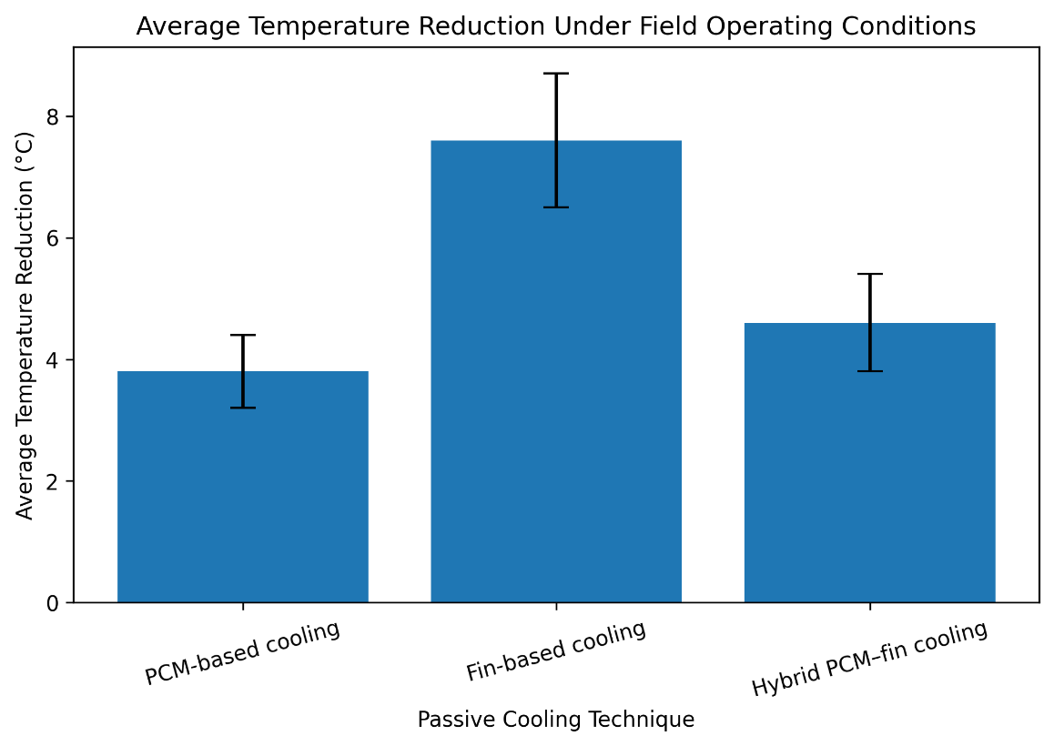
Figure 3. Average temperature reduction achieved by different passive cooling techniques under field operating conditions. The bars represent mean temperature reduction relative to the uncooled reference photovoltaic module, while the error bars indicate variability arising from naturally fluctuating ambient conditions. Fin-based cooling exhibits the highest average temperature reduction, followed by the hybrid PCM–fin configuration and PCM-based cooling.
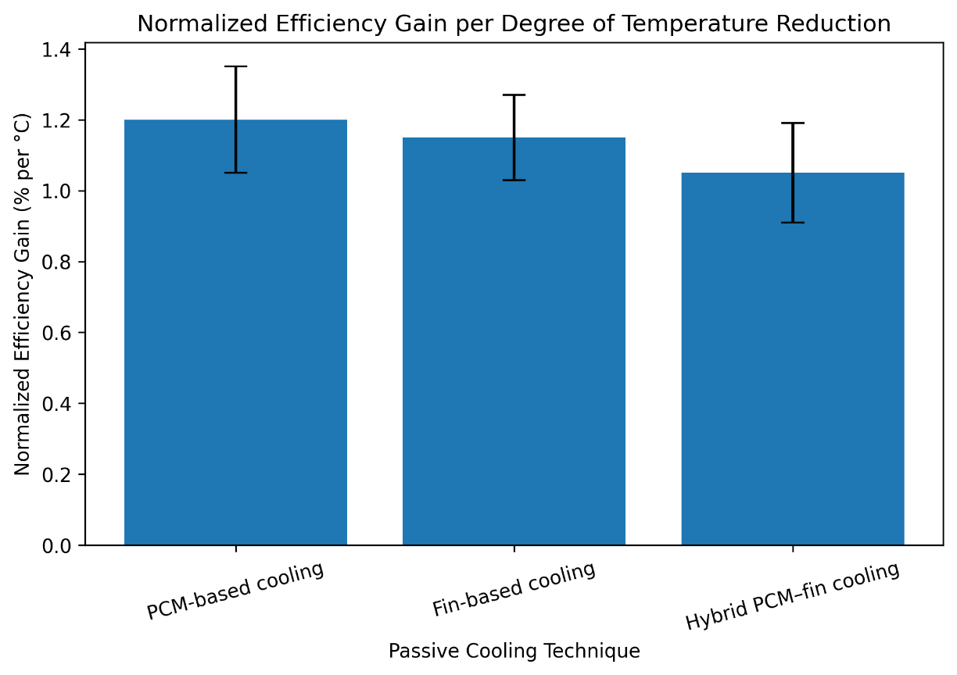
Figure 4. Normalized efficiency gain per degree of temperature reduction for the evaluated passive cooling techniques under field operating conditions. The bars represent the mean efficiency improvement normalized by temperature reduction, while the error bars indicate variability due to naturally fluctuating outdoor conditions. The results highlight differences in how effectively each cooling strategy translates thermal mitigation into electrical performance enhancement.
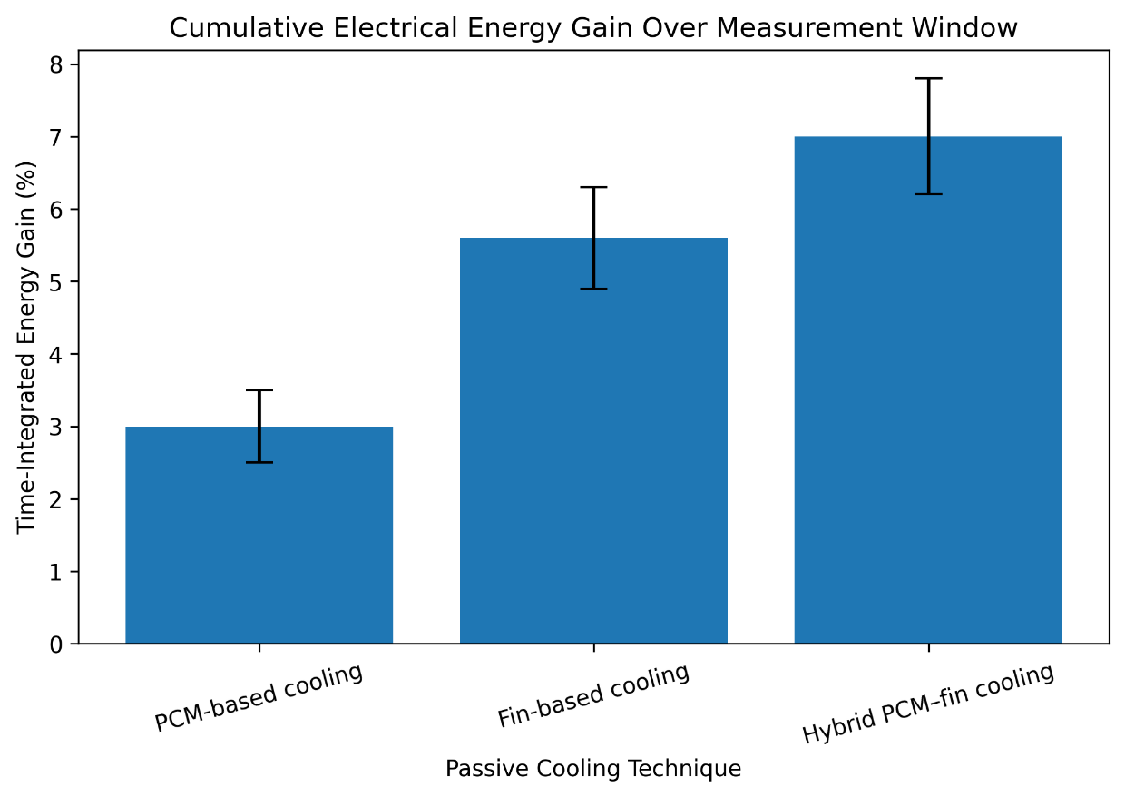
Figure 5. Time-integrated electrical energy gain achieved by different passive cooling techniques over the measurement window under field operating conditions. The bars represent the cumulative percentage increase in electrical energy output relative to the uncooled reference module, while the error bars indicate variability arising from naturally fluctuating ambient conditions. The hybrid PCM–fin configuration shows the highest cumulative energy gain, followed by fin-based cooling and PCM-based cooling.
5.4. Thermal Resistance-Based Interpretation of Field Performance
The performance hierarchy observed among the evaluated passive cooling configurations can be interpreted using a simplified thermal resistance framework. Under outdoor steady operation, heat dissipation from a photovoltaic module to the ambient environment may be conceptually expressed as:
$$Q=\frac{T_{module}-T_{ambient}}{R_{total}}$$
where $Q$denotes the heat rejection rate, $T_{module}$and $T_{ambient}$represent module and ambient temperatures, respectively, and $R_{total}$is the effective thermal resistance between the module rear surface and the surrounding air. For interpretative purposes, the overall resistance can be viewed as the combination of internal conduction resistance, interfacial contact resistance, and external convective–radiative resistance:
$$R_{total}=R_{cond}+R_{int}+R_{conv}$$
Although the present study did not experimentally quantify individual resistance components, this conceptual representation provides a physically consistent explanation for the relative cooling performance observed under tropical field conditions. In the fin-based configuration, heat is conducted from the module rear surface directly into a high-conductivity aluminium structure and subsequently dissipated to ambient air through natural convection and radiation. The primary improvement mechanism is the reduction of external convective resistance due to increased effective heat transfer area. Because no intermediate storage layer is introduced, the heat transfer pathway remains comparatively direct. This continuous conduction–convection mechanism is consistent with the sustained and comparatively higher temperature reductions measured during extended high-temperature exposure. For the PCM-based configuration, temperature mitigation is influenced by latent heat absorption during phase transition. However, the heat rejected to the environment must pass through the PCM layer before being dissipated to ambient air. Under prolonged high-temperature operation, once phase transition is substantially completed, the system behaves predominantly as a conductive layer with limited additional buffering capacity. This behavior is consistent with the moderate and time-dependent temperature reductions observed in the field measurements. In the hybrid PCM–fin configuration, heat transfer from the module to the fin structure occurs through an intermediate PCM layer. While the fins enhance external convective heat rejection, the overall heat transfer pathway includes additional internal and interfacial resistance components relative to the fin-only system. Under sustained tropical operating conditions, the PCM layer may contribute limited additional buffering once thermal equilibrium is approached, while still forming part of the conductive pathway. Consequently, the effective total thermal resistance of the hybrid configuration may not be lower than that of the direct fin-based arrangement during steady outdoor operation. Tropical environments are characterized by elevated ambient temperatures and extended solar exposure. Under such conditions, sustained convective heat rejection plays a dominant role in long-duration thermal control. Cooling configurations that maintain a direct and continuous heat transfer pathway to ambient air may therefore demonstrate more stable performance during prolonged operation. The resistance-based interpretation presented here aligns with the experimentally observed trends while remaining consistent with the analytical scope of the present study.
6. Influence of Ambient Conditions
Photovoltaic modules operating under outdoor conditions are continuously exposed to variations in ambient temperature, wind patterns, and humidity. These environmental parameters strongly influence thermal behavior and, consequently, the effectiveness of passive cooling strategies. In tropical climates, elevated baseline temperatures combined with fluctuating airflow and high moisture content create a demanding operating environment. This section evaluates the influence of key ambient factors on cooling performance, reinforcing the field-representative nature of the present case study.

6.1. Influence of Ambient Temperature
Ambient temperature is a primary factor governing the achievable temperature reduction of passively cooled photovoltaic modules. As ambient temperature increases, the temperature gradient between the module surface and the surrounding air decreases, thereby reducing the driving force for convective and radiative heat transfer. Figure 6 illustrates the relationship between ambient temperature bands and cooling effectiveness for the evaluated configurations. Across the examined temperature range, fin-based cooling consistently maintains the highest level of thermal mitigation (Figure 6). Although a gradual decline in cooling effectiveness is observed at elevated ambient temperatures, the fin-based system remains comparatively robust due to its reliance on continuous convective heat rejection rather than finite thermal storage capacity. In contrast, PCM-based cooling exhibits a more pronounced reduction in effectiveness at higher ambient temperatures. Under tropical conditions, prolonged exposure to elevated module temperatures can cause the PCM to remain in a fully molten state for extended durations, limiting further latent heat absorption. As a result, thermal saturation reduces its capacity to mitigate additional temperature rise during sustained high-temperature operation. The hybrid PCM–fin configuration demonstrates intermediate behavior. While fin-assisted convection provides partial enhancement, overall performance remains constrained by additional thermal resistance associated with the PCM layer. These findings highlight the importance of temperature-gradient-driven heat transfer mechanisms in determining sustained cooling effectiveness under tropical ambient conditions.
6.2. Influence of Wind Conditions
Wind-induced convection plays an important role in the outdoor thermal regulation of photovoltaic modules. The external convective heat transfer rate from a module surface can be expressed as:
$$Q_{conv}=hA(T_{module}-T_{ambient})$$
where $h$is the convective heat transfer coefficient, which increases with airflow velocity and boundary layer disruption. Under natural outdoor conditions, even moderate wind can transition heat transfer from buoyancy-dominated natural convection toward mixed or forced convection regimes, thereby enhancing heat dissipation.
In the present study, wind speed was not instrumented for quantitative regression analysis. However, all passive cooling configurations were evaluated under identical mounting geometry and comparable environmental exposure conditions during the monitoring period. Consequently, while absolute convective coefficients were not determined, the relative performance comparison among configurations remains internally consistent. Field observations indicated that intervals of increased ambient airflow coincided with improved thermal effectiveness of the fin-based configuration. This response is physically consistent with its convection-dominated mechanism, where increased airflow enhances heat rejection from the extended surface area of the fins. In contrast, PCM-based cooling exhibited lower sensitivity to airflow variations because its primary thermal moderation mechanism is latent heat absorption within the encapsulated material rather than direct convective exchange. For the hybrid PCM–fin configuration, enhanced airflow improved external fin heat rejection; however, the overall benefit was moderated by conductive and interfacial resistance across the PCM layer, limiting the direct transmission of convective gains to the module surface. It is therefore emphasized that the role of wind in this study is interpreted within the framework of established heat transfer principles rather than through direct velocity–performance correlation modelling. Since the study focuses on comparative behavior under common environmental exposure rather than absolute heat transfer coefficient quantification, the absence of wind-speed instrumentation does not compromise the validity of the observed performance hierarchy. Future investigations incorporating synchronized wind velocity measurement would enable refined environmental sensitivity modelling and quantitative convection analysis.
6.3. Influence of Humidity
High relative humidity is a defining characteristic of tropical coastal climates and may exert an indirect influence on photovoltaic module thermal behavior through modification of ambient air properties. Although humidity does not directly affect conductive heat transfer within the module structure, variations in atmospheric moisture content can alter air density, specific heat capacity, and to a lesser extent convective heat transfer coefficients. In naturally ventilated systems, these thermophysical changes may influence boundary layer development and convective heat exchange rates. However, compared with ambient temperature and airflow intensity, the effect of humidity on external convective heat dissipation is generally secondary. For convection-driven cooling systems, the dominant parameters governing heat rejection remain the temperature gradient between the module and ambient air and the effective airflow conditions. Published thermal analyses of outdoor PV systems consistently identify temperature difference and wind velocity as primary drivers of convective heat transfer, with humidity acting as a modifying parameter rather than a controlling variable. In the present study, relative humidity was not instrumented for quantitative correlation modelling. Nevertheless, all cooling configurations were evaluated under the same environmental exposure window and identical installation geometry. As such, any humidity-related influence would have affected all configurations similarly during the measurement period, preserving the internal validity of the comparative analysis. The discussion of humidity influence is therefore framed within established thermodynamic principles rather than regression-based environmental modelling. While future investigations incorporating synchronized humidity monitoring could enable refined environmental sensitivity analysis, the absence of direct humidity measurement does not undermine the relative performance interpretation presented in this field-based evaluation.
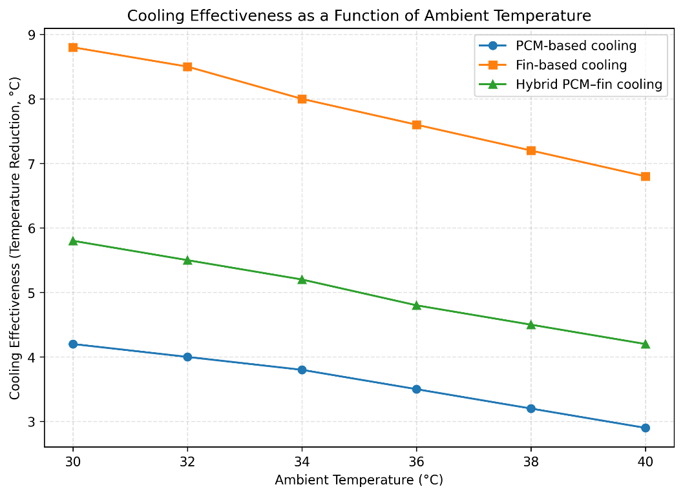
Figure 6. Cooling effectiveness of passive cooling techniques as a function of ambient temperature under field operating conditions.
The figure illustrates the variation in temperature reduction achieved by PCM-based cooling, fin-based cooling, and hybrid PCM–fin cooling across different ambient temperature ranges. Fin-based cooling maintains the highest effectiveness over the examined temperature range, while PCM-based and hybrid configurations exhibit a progressive reduction in cooling performance at elevated ambient temperatures.
7. Scenario-Based Seasonal Performance Interpretation
Although the measurements analysed in this study were obtained over a limited temporal window, photovoltaic systems deployed in tropical regions operate across a broad range of seasonal conditions characterized by variations in ambient temperature, solar irradiance, wind patterns, and humidity. To enhance the practical relevance of the field findings, a scenario-based seasonal interpretation is presented. This analysis does not introduce new experimental data or predictive modelling; rather, it extrapolates plausible performance trends based on the temperature–performance sensitivities observed during the field measurement period.
7.1. Seasonal Operating Regimes in Tropical Climates
Tropical regions typically experience three generalized seasonal regimes that influence photovoltaic operating behavior:
- Summer season: Characterized by high ambient temperatures and intense solar irradiance, resulting in severe and sustained thermal loading of photovoltaic modules.
- Monsoon season: Marked by moderate ambient temperatures, intermittent cloud cover, elevated humidity, and occasional wind-driven convection.
- Mild or post-monsoon season: Featuring relatively lower ambient temperatures, clearer skies, and more stable atmospheric conditions.
These representative seasonal categories provide a conceptual framework for interpreting how passive cooling strategies may perform throughout the annual operating cycle of photovoltaic installations in tropical climates.
7.2. Scenario-Based Performance Interpretation
Using the observed relationship between ambient temperature and cooling effectiveness discussed in Section 6, qualitative performance envelopes were constructed for each passive cooling configuration across the representative seasonal regimes. These projections assume that the temperature-dependent behavior observed during the measurement period remains broadly valid within the climatic bounds typical of tropical operation. Figure 7 presents the projected seasonal performance envelopes for PCM-based cooling, fin-based cooling, and the hybrid PCM–fin configuration. The envelopes represent expected ranges of temperature reduction rather than deterministic values, thereby accounting for natural environmental variability.
Fin-based cooling is projected to maintain the most consistent performance across seasonal regimes due to its reliance on continuous convective heat rejection. Even under peak summer conditions, fin-based systems are expected to provide meaningful thermal mitigation, although reduced temperature gradients at elevated ambient temperatures may moderately diminish absolute cooling magnitude.
PCM-based cooling is projected to perform more effectively during mild and monsoon conditions, when ambient temperatures remain closer to the PCM melting range and allow cyclic phase transition. Under extended summer conditions characterized by sustained high module temperatures, the projected performance envelope narrows, reflecting earlier thermal saturation and reduced latent heat buffering capacity.
The hybrid PCM–fin configuration demonstrates intermediate projected performance. While the fin assembly supports improved heat dissipation compared to PCM-only cooling, overall effectiveness remains influenced by thermal resistance within the PCM layer, particularly under prolonged high-temperature exposure.
It is important to emphasize that these seasonal interpretations are conceptual extensions derived from field-observed sensitivities rather than long-term monitored datasets. Accordingly, the projections should be understood as indicative performance trends intended to support deployment-oriented evaluation rather than precise annual predictions.
7.3. Limitations of the Scenario-Based Interpretation
It is important to emphasize that the seasonal performance envelopes and qualitative suitability mapping presented in Figure 7 represent scenario-based interpretations rather than projections derived from long-term experimental monitoring. These interpretations extend the temperature and convection sensitivities observed during the short-term field measurements and do not incorporate factors such as material aging, surface fouling, degradation of thermal contact interfaces, structural fatigue, or extreme weather events. Additionally, regional microclimatic variability, installation geometry, mounting orientation, and site-specific airflow characteristics may lead to deviations from the indicative performance ranges illustrated in Figure 7. Accordingly, the figure is intended as a qualitative decision-support framework rather than a quantitative forecasting tool. Within this interpretative framework, PCM-based cooling shows moderate suitability under peak summer conditions, where elevated ambient and module temperatures may accelerate latent heat saturation. Improved effectiveness is projected during monsoon and mild seasons, when operating temperatures are more closely aligned with the PCM melting range and allow cyclic phase transition behavior. Fin-based cooling demonstrates consistently favourable suitability across seasonal regimes, reflecting its reliance on continuous natural convection and its relative independence from finite thermal storage capacity. Its performance remains comparatively robust under both high-temperature and wind-assisted conditions. The hybrid PCM–fin configuration exhibits intermediate suitability. While fin-assisted heat rejection partially mitigates PCM saturation effects, overall effectiveness remains influenced by additional thermal resistance within the PCM layer, particularly during prolonged high-temperature exposure. Despite the inherent limitations of short-term data extrapolation, the scenario-based interpretation provides useful insight into the relative robustness and seasonal applicability of passive cooling strategies in tropical environments. By translating field-observed sensitivities into a structured seasonal suitability framework, this approach supports preliminary system design and technology selection without implying long-term predictive certainty or universal performance guarantees.

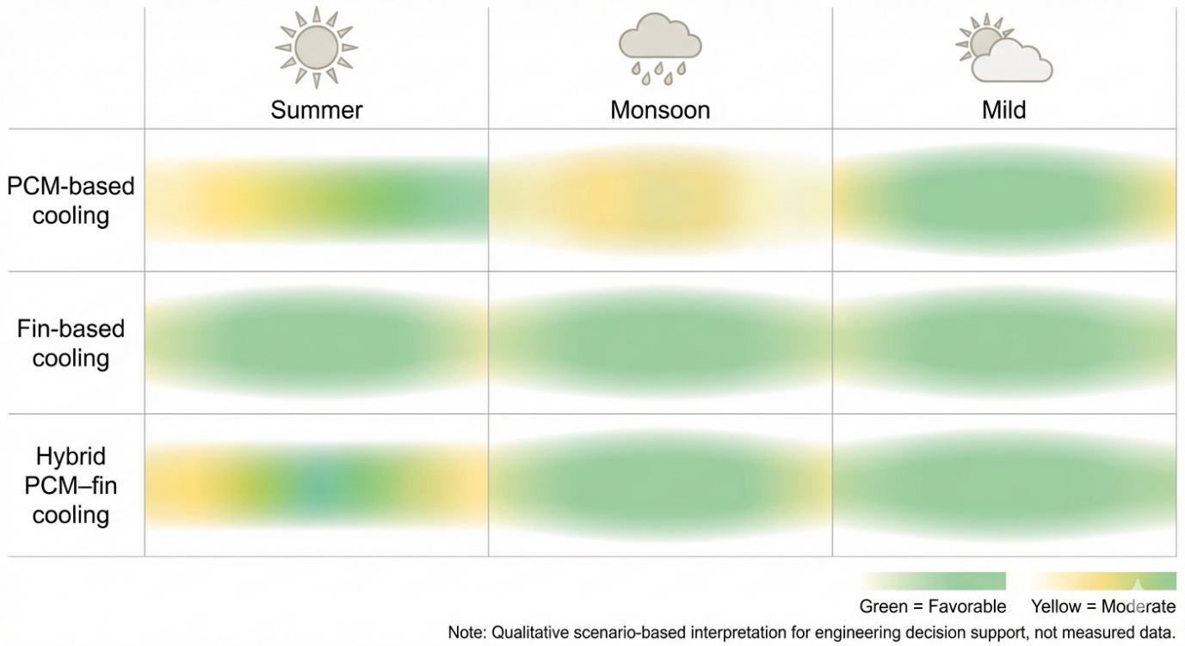
Figure 7. Scenario-based seasonal suitability map for passive cooling techniques applied to photovoltaic modules in tropical climates.
The figure presents a qualitative comparison of PCM-based cooling, fin-based cooling, and hybrid PCM–fin cooling across representative tropical seasonal regimes (summer, monsoon, and mild conditions). Colour gradients indicate relative cooling suitability and robustness inferred from field-observed performance trends, where green denotes favorable performance, yellow indicates moderate effectiveness, and faded or transitional regions reflect increasing operational limitations. The map is intended as a decision-support visualization rather than a quantitative prediction and does not represent measured seasonal data.
8. Practical Deployment Considerations
While thermal performance metrics provide a quantitative basis for comparing passive cooling strategies, real-world deployment feasibility ultimately determines their suitability for photovoltaic installations. Installation complexity, structural implications, maintenance requirements, long-term reliability, and cost–performance balance play decisive roles in technology adoption. This section evaluates these practical considerations for the cooling configurations examined in the present field case study.
8.1. Installation Complexity and Structural Integration
From an installation perspective, fin-based cooling systems are relatively straightforward to integrate with existing photovoltaic modules. Aluminium fins can be mechanically attached to the rear surface of the module or incorporated into the mounting structure with minimal modification to the electrical system. This simplicity supports both new installations and retrofits applications. PCM-based cooling systems require additional considerations, including encapsulation integrity, secure mechanical attachment, and consistent thermal contact between the module rear surface and the PCM layer. Ensuring reliable heat transfer across this interface is critical for performance stability. Hybrid PCM–fin configurations introduce further complexity due to their layered architecture and multiple material interfaces, increasing assembly time and the potential for installation-related variability. Structural integration is particularly important for rooftop systems, where space limitations and mounting geometry may restrict the use of bulky or multi-layer configurations. Fin-based solutions generally offer greater adaptability across diverse installation scenarios, whereas PCM-based and hybrid systems may require customized enclosure designs to maintain mechanical stability and consistent thermal coupling.
8.2. Added Weight and Structural Load
The addition of passive cooling components increases the total mass of the photovoltaic module assembly. PCM-based systems contribute a significant portion of added weight due to the density of the encapsulated material, which may present challenges for rooftop installations with limited load-bearing capacity. Fin-based cooling systems typically introduce lower mass increases and distribute structural loading more uniformly. Hybrid PCM–fin configurations represent the highest overall added load, combining both PCM mass and fin assemblies. For utility-scale installations, cumulative structural loading must be considered during support structure and foundation design. In residential and commercial rooftop systems, structural constraints may limit the feasibility of PCM-intensive or hybrid configurations without reinforcement.
8.3. Maintenance and Long-Term Reliability Considerations
While passive cooling systems eliminate moving components and auxiliary energy consumption, long-term durability remains a critical factor in determining real-world viability. Fin-based cooling systems are mechanically simple and structurally robust; however, their long-term thermal performance may be influenced by environmental exposure. In tropical and coastal regions, dust accumulation, surface fouling, humidity-driven corrosion, and repeated thermal expansion–contraction cycles can gradually reduce effective convective heat transfer. Although such effects are generally reversible through maintenance (e.g., periodic cleaning), sustained environmental exposure may influence surface emissivity and thermal contact integrity over extended operational lifetimes. PCM-based cooling systems introduce additional reliability considerations associated with repeated phase transition cycles. Long-term operation under daily melting and solidification may lead to volumetric expansion stresses, encapsulation fatigue, phase segregation, or supercooling effects, depending on material formulation and enclosure quality. Degradation of encapsulation integrity may increase the risk of leakage or interfacial resistance growth, potentially altering effective thermal buffering performance over time. Furthermore, changes in latent heat capacity due to prolonged thermal cycling have been reported in certain PCM systems, underscoring the importance of material stability and compatibility with climatic conditions. Hybrid PCM–fin configurations combine both convective and latent heat mechanisms and therefore incorporate the potential degradation pathways associated with each subsystem. In addition to PCM-related cycling effects, multiple material interfaces may experience gradual increases in thermal contact resistance due to differential thermal expansion or environmental exposure. Although such mechanisms do not inherently preclude long-term implementation, they introduce additional design considerations compared with single-mechanism passive systems. It should be emphasized that the present field investigation focuses on short-term operational performance and does not include accelerated aging tests or multi-season durability monitoring. Accordingly, while no immediate stability issues were observed during the measurement period, comprehensive assessment of long-term reliability under tropical climatic stressors including high humidity, elevated ambient temperature cycles, and potential corrosive exposure requires extended field monitoring and dedicated thermal cycling studies.
8.4. Scalability for Rooftop and Utility-Scale Applications
Scalability plays a central role in determining the practical viability of passive cooling technologies. Fin-based systems scale effectively across small rooftop installations and large utility-scale deployments due to their modular nature and compatibility with conventional mounting structures. PCM-based systems may offer targeted benefits in applications where transient thermal buffering is advantageous; however, their scalability is influenced by added weight, material cost, and long-term durability considerations. Hybrid PCM–fin configurations introduce further structural and assembly complexity, which may limit widespread adoption without careful design optimization. Overall, from a deployment-oriented perspective, fin-based cooling demonstrates the strongest combination of thermal robustness, structural simplicity, and scalability under tropical field conditions, while PCM-based and hybrid systems may provide situational benefits depending on installation-specific constraints and performance priorities.
8.5. Preliminary Economic and Feasibility Perspective
Although a detailed techno-economic assessment is beyond the scope of this field investigation, a comparative feasibility perspective can be developed by examining material demand, structural complexity, operational requirements, and deployment scale in relation to alternative cooling technologies such as active water cooling, nanofluid circulation systems, and photovoltaic–thermal (PV/T) configurations. Fin-based cooling offers several practical advantages. It relies solely on aluminium heat sinks, which are commercially available, mechanically durable, and easily integrated into existing mounting structures. The system operates passively through natural convection and radiation, eliminating the need for pumps, piping networks, working fluids, or control units. As a result, capital complexity and operational risk remain low, and no parasitic energy consumption is introduced. Under the tropical field conditions evaluated in this study, fin-based cooling achieved a mean temperature reduction of approximately 7–8 °C and a peak reduction of about 10 °C, corresponding to an average electrical efficiency improvement of approximately 8–9% and a time-integrated energy gain of 5–6%. These measurable gains, achieved without additional operational energy input, indicate a favourable performance-to-complexity balance. However, its cooling capacity remains dependent on ambient temperature gradients and natural airflow conditions, making its effectiveness sensitive to climatic factors such as wind availability and elevated ambient temperature. PCM-based cooling provides the advantage of latent heat buffering, which can suppress short-term thermal spikes and stabilize module temperature during peak irradiance intervals. Compared with active liquid cooling systems, PCM integration avoids moving components and external power demand. In the present field study, PCM-based cooling produced a mean temperature reduction of approximately 3–4 °C and a time-integrated energy gain of about 3%. While these improvements demonstrate measurable benefit, they are lower than those observed for fin-based cooling under sustained high-temperature exposure. PCM systems introduce higher material mass, encapsulation requirements, and potential long-term durability considerations associated with repeated thermal cycling. Their effectiveness is strongly dependent on the alignment between PCM melting temperature and the local operating temperature profile, making climatic suitability an important selection factor. Hybrid PCM–fin configurations attempt to combine latent heat storage with enhanced convective dissipation. While this approach may provide improved short-term stabilization relative to PCM-only systems, the present study observed mean temperature reductions of approximately 4–5 °C and cumulative energy gains near 7%. Although the time-integrated energy gain was comparatively high, the added structural mass and interface complexity must be considered when evaluating deployment feasibility. In comparison with active water or nanofluid cooling systems, hybrid passive configurations remain mechanically simpler and eliminate pumping energy; however, their performance enhancement may not proportionally justify the additional integration complexity under all operating scenarios. Active water cooling, nanofluid-based systems, and PV/T configurations generally achieve higher absolute temperature reductions, often exceeding 10–20 °C under controlled or actively circulated conditions, and allow more controllable heat removal. These systems are particularly advantageous in utility-scale solar farms where centralized pumping infrastructure and maintenance logistics are feasible. However, they require additional capital investment, fluid management systems, sealing integrity assurance, auxiliary power input, and regular maintenance. The presence of pumps and circulating fluids also introduces parasitic energy consumption, which partially offsets gross electrical gains. The selection and feasibility of a cooling strategy therefore depend strongly on application scale, plant configuration, climatic conditions, and economic priorities. Utility-scale installations with centralized infrastructure and established maintenance frameworks may justify active or hybrid systems to maximize energy yield. In contrast, small rooftop systems, remote installations, or distributed generation setups in tropical regions may favour passive solutions due to lower structural complexity, absence of auxiliary power demand, reduced operational risk, and ease of retrofitting. Climatic characteristics including ambient temperature range, wind availability, and seasonal variability also influence optimal selection. Under the field conditions examined in this study (ambient temperatures of approximately 30–45 °C), fin-based cooling demonstrated a favourable balance between measurable thermal improvement, structural simplicity, and deployment feasibility. Nevertheless, the optimal choice of cooling strategy should be aligned with site-specific environmental conditions, plant scale, and long-term operational considerations rather than thermal performance alone. A comparative summary of the practical advantages and limitations associated with each passive cooling configuration is presented in Table 2.

Table 2. Practical advantages and limitations of passive cooling techniques for field deployment.
Cooling technique | Practical advantages | Practical limitations
PCM-based cooling | Latent heat buffering; simple passive operation; effective during transient thermal loading | Added weight; finite thermal capacity; leakage risk; encapsulation degradation
Fin-based cooling | Continuous heat dissipation; low maintenance; lightweight; scalable; cost-effective | Performance dependent on natural convection; susceptible to dust fouling
Hybrid PCM–fin cooling | Combines thermal storage and convective cooling in principle | High structural complexity; increased weight; thermal bottleneck at PCM layer; higher cost

9. Methodological Scope and Analytical Boundaries
The results presented in this study should be interpreted within the defined methodological and analytical framework of the investigation. The evaluation was performed using a single monocrystalline photovoltaic module subjected to three passive cooling configurations under a controlled comparative arrangement at a tropical coastal site. While this approach ensures internal consistency and reliable relative comparison among the tested configurations, the findings are inherently system-specific. Variations in module technology, encapsulation structure, mounting geometry, rear ventilation clearance, or large-scale array integration may influence absolute performance outcomes. The dataset analysed was obtained from short-term field monitoring conducted during periods of elevated thermal loading. Consequently, the reported indicators reflect performance behavior under operational conditions most relevant to temperature-induced efficiency degradation. The study does not include full diurnal cycle averaging, long-term seasonal monitoring, or annual energy yield modelling. Accordingly, the derived metrics represent comparative field performance within the monitored temporal window rather than long-term climatological performance projections. The analytical framework focuses on experimentally derived thermal and electrical performance metrics. The study does not incorporate coupled thermo-mechanical stress modelling, structural deformation analysis, degradation kinetics modelling, or probabilistic reliability assessment. Therefore, the conclusions are confined to observed operational performance under measured environmental exposure and should not be interpreted as predictive lifetime modelling or structural durability forecasting. Environmental parameters such as ambient temperature were directly incorporated into the performance evaluation, whereas wind speed and humidity were not instrumented for quantitative regression-based correlation analysis. Their influence is interpreted qualitatively through thermodynamic reasoning and observed performance patterns within the instrumentation capabilities of the experimental setup. As such, environmental coupling effects are discussed within the resolution and scope of available measurements. Within these clearly defined boundaries, the study provides a comparative and field-representative evaluation of passive cooling strategies under realistic tropical operating conditions. The conclusions are intentionally restricted to the measured operational regime, without extending claims beyond the experimental and analytical scope applied.
10. Conclusions
This study presented a field-oriented evaluation of passive cooling strategies applied to a monocrystalline photovoltaic module operating under tropical outdoor conditions in Kannur, Kerala, India. By re-analysing previously recorded field measurements using derived and deployment-focused performance metrics, the work provides a practical interpretation of PCM-based, fin-based, and hybrid PCM–fin cooling configurations under realistic environmental variability. Among the evaluated approaches, fin-based cooling demonstrated the most consistent and thermally robust performance. Its reliance on continuous natural convection enabled the highest mean and peak temperature reductions within the monitored period, accompanied by stable efficiency improvements under fluctuating irradiance conditions. Unlike PCM-based systems, fin cooling does not rely on finite thermal storage capacity and therefore maintained sustained heat dissipation during prolonged high-temperature exposure typical of tropical climates. PCM-based cooling exhibited moderate effectiveness, particularly during intervals when module temperatures remained within the PCM melting range. The latent heat absorption mechanism effectively moderated initial temperature rise; however, extended exposure to elevated ambient conditions led to thermal saturation, limiting long-duration cooling performance. The hybrid PCM–fin configuration showed intermediate behavior. While fin-assisted heat rejection partially alleviated saturation effects, additional thermal resistance introduced by the PCM layer constrained overall heat transfer under field conditions, and the anticipated synergistic enhancement was not fully realized. The results further indicate that cumulative electrical energy gain does not scale directly with peak or average temperature reduction alone. Instead, the temporal alignment between thermal mitigation and high-irradiance operating periods plays a decisive role in determining net energy improvement. This finding highlights the importance of time-integrated and irradiance-normalized metrics when assessing passive cooling effectiveness under naturally variable outdoor environments. From a deployment perspective, fin-based cooling presents a favourable balance between thermal reliability, structural simplicity, and scalability for photovoltaic installations in tropical regions. PCM-based systems may provide situational benefits where transient thermal buffering is advantageous, whereas hybrid configurations require further design refinement to reduce interfacial thermal resistance and structural complexity. The conclusions presented here are based on short-term field measurements within a defined environmental window. Long-term monitoring is necessary to evaluate durability, degradation of thermal interfaces, encapsulation stability, and maintenance requirements over extended service lifetimes. Future investigations incorporating direct wind and humidity instrumentation, together with broader geographic validation across diverse tropical microclimates, would further strengthen understanding of passive cooling performance under real-world conditions. Overall, this study contributes field-based evidence toward the development of climate-adapted and practically deployable thermal management strategies for photovoltaic systems operating in warm and humid environments.

COMPETING INTERESTS DISCLAIMER:
Authors have declared that they have no known competing financial interests OR non-financial interests OR personal relationships that could have appeared to influence the work reported in this paper.
Disclaimer (Artificial intelligence)
Generative AI tools were utilized solely for language refinement, grammatical editing, and structural organization of the manuscript. All experimental design, data analysis, interpretation of results, and scientific conclusions were independently developed and verified by the author. The author assumes full responsibility for the accuracy, originality, and integrity of the content presented in this work.

References
- Ali, H. M. (2020). Recent advancements in PV cooling and efficiency enhancement integrating phase change materials-based systems: A comprehensive review. Solar Energy, 197, 163–198. https://doi.org/10.1016/j.solener.2019.11.075
- Aswin, K., Kallath, A., Adithyan, P., & Dayal, A. (2025). Comparison of recent trends in cooling of photovoltaic cells to increase its performance. International Journal of Scientific Development and Research, 10(4), e82–e95. https://doi.org/10.56975/ijsdr.v10i4.302395
- Bahaidarah, H. M. S., Baloch, A. A. B., & Gandhidasan, P. (2016). Uniform cooling of photovoltaic panels: A review. Renewable and Sustainable Energy Reviews, 57, 1520–1544. https://doi.org/10.1016/j.rser.2015.12.064
- Bahaidarah, H. M. S., Subhan, A., Gandhidasan, P., & Rehman, S. (2013). Performance evaluation of a PV module by back surface water cooling for hot climatic conditions. Energy, 59, 445–453. https://doi.org/10.1016/j.energy.2013.07.050
- Bayrak, F., Oztop, H. F., & Selimefendigil, F. (2019). Effects of different fin parameters on temperature and efficiency for cooling of photovoltaic panels under natural convection. Solar Energy, 188, 484–494. https://doi.org/10.1016/j.solener.2019.06.036
- Bayrak, F., Oztop, H. F., & Selimefendigil, F. (2020). Experimental study for the application of different cooling techniques in photovoltaic (PV) panels. Energy Conversion and Management, 212, Article 112789. https://doi.org/10.1016/j.enconman.2020.112789
- Bonah, E., Praveenkumar, S., Alwan, N. T., Ivanovich, V., & Shcheklein, S. E. (2021). Effect of dual surface cooling of solar photovoltaic panel on the efficiency of the module: Experimental investigation. Heliyon, 7, Article e07920. https://doi.org/10.1016/j.heliyon.2021.e07920
- Dwivedi, P., Sudhakar, K., Soni, A., & Solomin, E. (2020). Advanced cooling techniques of PV modules: A state-of-the-art review. Case Studies in Thermal Engineering, 21, Article 100674. https://doi.org/10.1016/j.csite.2020.100674
- Fouad, M. M., Shihata, L. A., & Morgan, E. I. (2017). An integrated review of factors influencing the performance of photovoltaic panels. Renewable and Sustainable Energy Reviews, 80, 1499–1511. https://doi.org/10.1016/j.rser.2017.05.141
- Hasan, A., McCormack, S. J., Huang, M. J., & Norton, B. (2014). Characterization of phase change materials for thermal control of photovoltaics using differential scanning calorimetry and temperature history method. Energy Conversion and Management, 81, 322–329. https://doi.org/10.1016/j.enconman.2014.02.040
- Jobair, H. K. (2017). Improving photovoltaic cell performance by cooling using two different types of fins. International Journal of Computer Applications, 157(5), 6–15.
- Rehman, S., Bader, M. A., & Al-Moallem, S. A. (2007). Cost of solar energy generated using photovoltaic panels. Renewable and Sustainable Energy Reviews, 11(8), 1843–1857. https://doi.org/10.1016/j.rser.2006.06.003
- Royne, A., Dey, C. J., & Mills, D. R. (2005). Cooling of photovoltaic cells under concentrated illumination: A critical review. Solar Energy Materials and Solar Cells, 86(4), 451–483. https://doi.org/10.1016/j.solmat.2004.09.003
- Sharaf, M., Yousef, M. S., & Huzayyin, A. S. (2022). Review of cooling techniques used to enhance the efficiency of photovoltaic power systems. Environmental Science and Pollution Research, 29(18), 26131–26159. https://doi.org/10.1007/s11356-021-18241-0
- Singh, P., Mudgal, V., Khanna, S., Mallick, T. K., & Reddy, K. S. (2020). Experimental investigation of solar photovoltaic panel integrated with phase change material with multiple conductivity-enhancing containers. Energy, 205, Article 118047. https://doi.org/10.1016/j.energy.2020.118047
- Wongwuttanasatian, T., Sarikarin, T., & Suksri, A. (2020). Performance enhancement of a photovoltaic module by passive cooling using phase change material in a finned container heat sink. Solar Energy, 195, 47–53. https://doi.org/10.1016/j.solener.2019.11.053
- Peters, Ian Marius. "Strategic global deployment of photovoltaic technology: Balancing economic capacity and decarbonization potential." Advances in Atmospheric Sciences 42.2 (2025): 261-268.
- Lew, Grzegorz, et al. "Influence of photovoltaic development on decarbonization of power generation—Example of Poland." Energies 14.22 (2021): 7819.
- Aqeel, Ahmad Abdul Kareem Ahmad, et al. "Enhancement of Solar PV/T Systems Through Cellulose Nanocrystal-Based Cooling." Results in Engineering (2025): 108647.
- Kareem Ahmad Aqeel, A., Hajjaj, S., Mohamed, H., Obeidat, F.S. (2025). Numerical Study of a Combined Photovoltaic Thermal System Using Cellulose Nanocrystal (CNC) Nano-Fluid. In: Chen, W., et al. Selected Proceedings from the 2nd International Conference on Intelligent Manufacturing and Robotics, ICIMR 2024, 22-23 August, Suzhou, China. ICIMR 2024 2024. Lecture Notes in Networks and Systems, vol 1316. Springer, Singapore. https://doi.org/10.1007/978-981-96-3949-6_54
- Aqeel, Ahmad Abdul Kareem Ahmad, Mohamed R. Gomaa, and Sami Salama Hussen Hajjaj. "Experimental study of cellulose nanocrystals (CNC), Aluminum oxide (Al2O3), and hybrid (CNC+ Al2O3) nanofluids for cooling photovoltaic module." Applied Thermal Engineering (2025): 128322.
- Skoplaki, Elisa, and John A. Palyvos. "On the temperature dependence of photovoltaic module electrical performance: A review of efficiency/power correlations." Solar energy 83.5 (2009): 614-624.
- Dubey, Swapnil, Jatin Narotam Sarvaiya, and Bharath Seshadri. "Temperature dependent photovoltaic (PV) efficiency and its effect on PV production in the world–a review." Energy procedia 33 (2013): 311-321.
- Karkadakattil, A. (2025). Laser Micro-Texturing and AI-Driven Optimization for Thermal Management of Photovoltaic Systems. Challenges and Issues of Modern Science, 4(2), 320. https://doi.org/10.15421/cims.4.320
- Al-Shurman, Ahmed A. Aqeel, and Mohamed R. Gomaa. "The performance of water cooled photovoltaic panel, under concentrating system." Aust. J. Basic Appl. Sci. 13.7 (2019): 12-22.

