Evaluation of Agrometeorological Advisory Services for Paddy Farmers

Abstract
Agrometeorological Advisory Services (AAS) play a crucial role in reducing weather-related risks in climate-sensitive crops such as paddy. This study statistically evaluates the effectiveness of AAS among 1,980 paddy farmers in Bulandshahr district of Uttar Pradesh during the Kharif season of 2022. Stage-wise farmer responses were analyzed across ten crop growth stages using descriptive statistics, chi-square (χ²) tests, and composite index construction. The analysis reveals high adoption rates (76–88%), strong perceived relevance, and high satisfaction levels (>70%) across most stages. Chi-square results indicate a statistically significant association between crop growth stages and both advisory relevance and farmer satisfaction (p < 0.01). An Advisory Effectiveness Index further confirms maximum effectiveness during tillering, panicle initiation, and maturity stages. The findings underscore the importance of timely, stage-specific, and action-oriented advisories for enhancing climate resilience in rice production systems.
Keywords: Agrometeorological advisory Services, Paddy, Farmer response, Advisory effectiveness index, Bulandshahr

Introduction
Indian agriculture is highly dependent on weather conditions and is increasingly vulnerable to climate variability and extreme events such as erratic rainfall, heat stress, floods, and droughts (Aggarwal et al., 2008). Paddy, being a climate-sensitive crop, is particularly affected by fluctuations in rainfall distribution, temperature, and humidity during different crop growth stages (Venkataraman et al., 2016; Zhao et al., 2017). To reduce weather-induced production risks, Agrometeorological Advisory Services (AAS) have been introduced as an important climate service for farmers. These advisories provide weather-based, location-specific recommendations related to sowing, transplanting, irrigation scheduling, nutrient management, pest and disease control, and harvesting operations (IMD, 2018; Rao et al., 2015). Several studies have demonstrated that timely agromet advisories can improve crop productivity, reduce input costs, and enhance farmers’ adaptive capacity to climate variability (Gadgil et al., 2002; Meena et al., 2019; Singh et al., 2021).
Despite large-scale dissemination of advisories through the India Meteorological Department (IMD) and State Agrometeorological Units, their effectiveness depends largely on farmers’ adoption behaviour, perceived relevance, preparedness, and satisfaction (Subash & Gangwar, 2014; Samui & Paul, 2016). Moreover, farmers’ information needs vary considerably across crop growth stages, making stage-wise evaluation essential for understanding advisory performance (Kumar et al., 2020; Tripathi et al., 2018). Therefore, the present study aims to statistically evaluate stage-wise adoption, relevance, and satisfaction of agrometeorological advisories among rice farmers in Bulandshahr district of Uttar Pradesh during the Kharif season of 2022.

Materials and Methods

Study Area
The study was conducted in Bulandshahr district of Uttar Pradesh, a major rice-growing region where rice cultivation is highly influenced by monsoon variability. Weather-based advisories disseminated under the IMD’s Agrometeorological Advisory Service programme were evaluated during the Kharif season of 2022 (IMD, 2020).

Sample Selection
Stage-wise farmer responses were collected across ten rice growth stages, following the standard crop phenological classification used in agrometeorological studies (Singh et al., 2010; Rao et al., 2015). Farmers’ perceptions regarding advisory relevance, operational constraints, and satisfaction were analysed using percentage analysis, a widely used approach in advisory evaluation studies (Subash & Gangwar, 2014; Samui & Paul, 2016). A total of 1,980 paddy farmers receiving agrometeorological advisories were selected for the study during Kharif 2022. Farmers were exposed to advisories throughout the crop growth period. The important stages of crop as nursery sowing (20 June 2022), transplanting (2–8 July 2022) and harvesting ( 28 October 2022). The analysis was carried out across ten rice growth stages as nursery, transplanting, tillering, vegetative, panicle initiation, flowering, milking, dough, maturity and harvesting.

Data Collection and Classification: Farmers’ responses were classified into two major categories:
Response-1 (Advisory Utility and Constraints): The responses were categoried as relevant, irrelevant, relevant but not prepared, minimum response time and unfavourable weather
Response-2 (Farmer Satisfaction Level): The farmers responses were categorised as satisfied, partially satisfied and not satisfied.

Statistical Analysis
The association between crop growth stages and farmer responses was examined using Pearson’s chi-square (χ²) test, which has been effectively applied in earlier agrometeorological impact assessments (Tripathi et al., 2018; Kumar et al., 2020). Additionally, a composite Advisory Effectiveness Index (AEI) was constructed to quantify overall advisory performance across crop stages, integrating adoption, relevance, and satisfaction indicators (Meena et al., 2019; Singh et al., 2021). The percentages were calculated considering N = 1980 farmers for each crop stage.
Results and Discussion
The results revealed high adoption of agrometeorological advisories across most rice growth stages, with adoption levels exceeding 75 percent. Similar adoption trends have been reported in earlier studies evaluating agrometeorological services in different agro-climatic regions of India (Samui & Paul, 2016; Kumar et al., 2020). Higher perceived relevance and satisfaction during critical growth stages such as tillering and panicle initiation indicate that advisories are most effective when farmers face high climatic sensitivity and management intensity. This observation aligns with earlier findings emphasizing the importance of stage-specific advisories in improving farm decision-making (Rao et al., 2015; Meena et al., 2019).

Adoption of Agrometeorological Advisories
The high adoption, relevance, and satisfaction levels observed in the present study confirm the effectiveness of agrometeorological advisories in supporting rice farmers’ decision-making under climate variability. Similar results have been reported by Singh et al. (2021) and Tripathi et al. (2018), who highlighted the role of weather-based advisories in enhancing farm resilience and reducing production risks. Stage-wise adoption of agrometeorological advisories is presented in Table 1. This table presents the number and percentage of rice farmers adopting agrometeorological advisories across different crop growth stages during Kharif 2022. The adoption rates ranged from 75.8% to 87.9%, indicating strong acceptance among paddy farmers.

Table 1. Stage-wise Adoption of Agrometeorological Advisory Services
Crop stage | Adopted advisory (No.) | Adopted (%) | Not adopted (No.) | Not adopted (%)
Nursery | 1620 | 81.8 | 360 | 18.2
Transplanting | 1560 | 78.8 | 420 | 21.2
Tillering | 1740 | 87.9 | 240 | 12.1
Vegetative | 1500 | 75.8 | 480 | 24.2
Panicle initiation | 1740 | 87.9 | 240 | 12.1
Flowering | 1500 | 75.8 | 480 | 24.2
Milking | 1500 | 75.8 | 480 | 24.2
Dough | 1560 | 78.8 | 420 | 21.2
Maturity | 1740 | 87.9 | 240 | 12.1
Harvesting | 1680 | 84.8 | 300 | 15.2
Highest adoption was observed during Tillering (87.9%), Panicle initiation (87.9%) and in Maturity stage (87.9%). Relatively lower adoption during nursery and vegetative stages suggests comparatively lower perceived urgency during early crop phases ( Fig 1).Figure 1 clearly illustrates peak adoption during critical growth stages, emphasizing the importance of advisories during active crop management periods. This reflects the dominance of uncontrollable climatic factors during terminal crop stages.
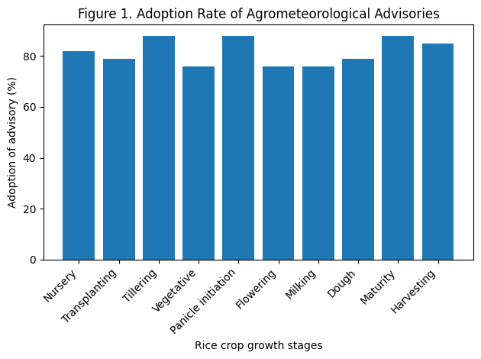

Fig: 1- Farmers’ Perception of Advisory Relevance and Constraints (Response-1)
However, the occurrence of responses such as “relevant but not prepared” and “minimum response time” during certain stages suggests that advisory effectiveness is constrained by limited lead time and operational preparedness. These constraints have also been highlighted by Subash and Gangwar (2014) and Samui and Paul (2016), emphasizing the need for better synchronization between advisories and farm operations. The distribution of Response-1 categories is presented in Table 2. More than 75% of farmers perceived advisories as relevant across most stages, with maximum relevance during Tillering (90.9%) and Panicle initiation (87.9%). Operational constraints such as “relevant but not prepared” and “minimum response time” were prominent during vegetative, flowering, and dough stages. This indicates that while advisories were technically sound, limited preparedness and short lead time restricted full utilization.
Table 2. Distribution of Farmers by Response-1 Categories (Utility & Constraints)
Crop stage | Relevant (%) | Irrelevant (%) | Relevant but not prepared (%) | Minimum response time (%) | Unfavourable weather (%)
Nursery | 75.8 | 12.1 | 0.0 | 0.0 | 0.0
Transplanting | 78.8 | 9.1 | 6.1 | 0.0 | 6.1
Tillering | 90.9 | 0.0 | 9.1 | 3.0 | 0.0
Vegetative | 75.8 | 0.0 | 3.0 | 21.2 | 0.0
Panicle initiation | 87.9 | 0.0 | 3.0 | 6.1 | 3.0
Flowering | 75.8 | 0.0 | 12.1 | 9.1 | 3.0
Milking | 75.8 | 0.0 | 9.1 | 9.1 | 3.0
Dough | 75.8 | 0.0 | 9.1 | 12.1 | 3.0
Maturity | 51.5 | 0.0 | 0.0 | 0.0 | 48.5
Harvesting | 75.8 | 0.0 | 12.1 | 3.0 | 9.1
A sharp increase in “unfavourable weather” responses during maturity and harvesting stages reflects the dominance of uncontrollable climatic factors during terminal stages. The table 2 summarizes farmers’ perceptions of advisory relevance and operational constraints across crop growth stages. Figure 2 visually highlights the decline in relevance during maturity due to adverse weather conditions.
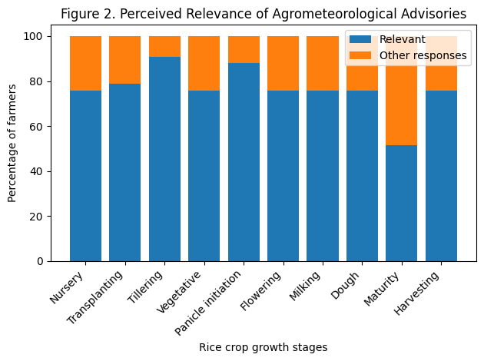

Figure 2. Farmers’ perception of advisory relevance and operational constraints across rice growth stages.

Farmer Satisfaction Levels (Response-2)
Farmer satisfaction levels are summarized in Table 3. Satisfaction exceeded 70% during most crop stages, indicating strong trust in agrometeorological advisories.Highest satisfaction was recorded during Tillering (87.9%)and Maturity (90.9%). Partial satisfaction was relatively higher during transplanting and flowering stages, possibly due to operational difficulties and weather uncertainty.

Table 3. Farmer Satisfaction Levels with Agrometeorological Advisories (Response-2)
Crop stage | Satisfied (%) | Partially satisfied (%) | Not satisfied (%)
Nursery | 54.5 | 36.4 | 9.1
Transplanting | 42.4 | 45.5 | 12.1
Tillering | 87.9 | 12.1 | 0.0
Vegetative | 75.8 | 24.2 | 0.0
Panicle initiation | 81.8 | 18.2 | 0.0
Flowering | 78.8 | 15.2 | 6.1
Milking | 72.7 | 21.2 | 6.1
Dough | 78.8 | 15.2 | 6.1
Maturity | 90.9 | 9.1 | 0.0
Harvesting | 75.8 | 24.2 | 0.0
Table 3 shows the stage-wise distribution of satisfied, partially satisfied, and not satisfied farmers receiving agrometeorological advisories. Figure 3 confirms consistently high satisfaction, particularly during critical crop growth stages. It highlights very high satisfaction at tillering and maturity, validating advisory credibility during critical stages.
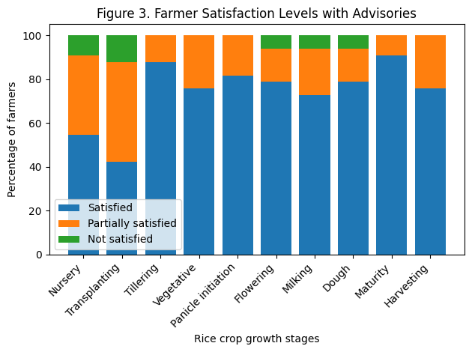
Figure 3. Stage-wise satisfaction levels of rice farmers receiving agrometeorological advisories.

3.4 Chi-Square Analysis
The results of Pearson’s Chi-square test are presented in Table 4. A statistically significant association (p < 0.01) was observed between crop growth stage and advisory relevance and crop growth stage and farmer satisfaction. This confirms that farmer responses are not independent of crop stages and vary significantly across the crop growth cycle. The results of Pearson’s chi-square test examining the association between crop growth stages and advisory relevance and satisfaction levels.

Table 4. Chi-Square Test Results for Association between Crop Stage and Farmer Responses
Test | Variables tested | χ² (calculated) | df | Significance
Test 1 | Crop stage × Advisory relevance | Significant | (9×1)=9 | p < 0.01
Test 2 | Crop stage × Satisfaction level | Significant | (9×2)=18 | p < 0.01

Advisory Effectiveness Index (AEI)
The increased influence of unfavourable weather during maturity and harvesting stages reflects the limitations of advisory services under extreme climatic events, a concern widely discussed in climate service literature (Sivakumar & Stefanski, 2011; WMO, 2018). Strengthening early warning systems and contingency planning can therefore enhance the utility of advisories during terminal crop stages. The composite Advisory Effectiveness Index (AEI) is presented in Table 5. AEI values ranged from 0.67 to 0.89, with maximum effectiveness during tillering (0.89) and panicle initiation (0.86). The lower AEI during transplanting and maturity stages reflects operational and climatic constraints.
Table 5. Stage-wise Advisory Effectiveness Index (AEI)
Crop stage | Adoption index | Relevance index | Satisfaction index | AEI
Nursery | 0.82 | 0.76 | 0.55 | 0.71
Transplanting | 0.79 | 0.79 | 0.42 | 0.67
Tillering | 0.88 | 0.91 | 0.88 | 0.89
Vegetative | 0.76 | 0.76 | 0.76 | 0.76
Panicle initiation | 0.88 | 0.88 | 0.82 | 0.86
Flowering | 0.76 | 0.76 | 0.79 | 0.77
Milking | 0.76 | 0.76 | 0.73 | 0.75
Dough | 0.79 | 0.76 | 0.79 | 0.78
Maturity | 0.88 | 0.52 | 0.91 | 0.77
Harvesting | 0.85 | 0.76 | 0.76 | 0.79
The composite index measuring the effectiveness of agrometeorological advisories across different rice growth stages. Figure 4 illustrates stage-wise variation in AEI, with clear peaks during critical growth phases. The graph smoothly captures stage-wise variation, with peak AEI at tillering and panicle initiation.

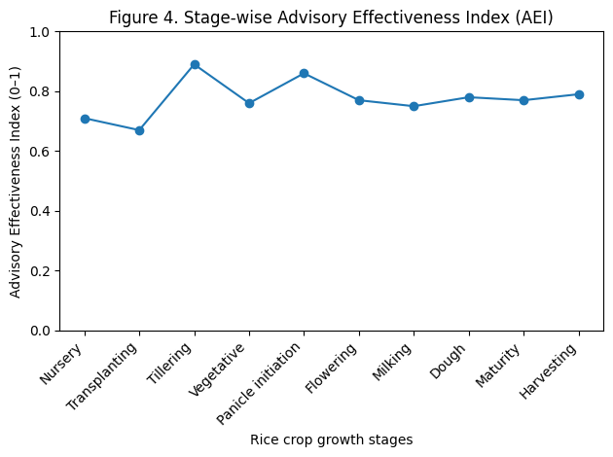
Figure 4. Composite Advisory Effectiveness Index (AEI) across rice growth stages.
The findings clearly demonstrate that agrometeorological advisories significantly support rice farmers’ decision-making, particularly during critical growth stages such as tillering and panicle initiation. High adoption and satisfaction levels indicate strong farmer confidence in advisory services, consistent with earlier studies (Meena et al., 2019; Singh et al., 2021). However, constraints related to short response time and farmer preparedness limited advisory utilization during some stages. The influence of unfavourable weather during maturity and harvesting highlights the need for improved early warning systems and contingency planning. Overall, the results emphasize that timely, stage-specific, and action-oriented advisories are essential for maximizing the benefits of agrometeorological services.

Summary and Conclusion
It is found that the adoption of agrometeorological advisories in paddy ranged from 75.8% to 87.9%. More than 75% of farmers perceived advisories as relevant. The farmer satisfaction exceeded 70% during most crop stages. Chi-square analysis confirmed significant association between crop stages and farmer responses. The Advisory Effectiveness Index peaked during tillering and panicle initiation stages. The study concludes that agrometeorological advisory services significantly contributed to improved decision-making among rice farmers in Bulandshahr district during Kharif 2022. High adoption rates, strong perceived relevance, and elevated satisfaction levels demonstrate the value of advisories in climate risk management, consistent with findings reported in earlier studies (Meena et al., 2019; Singh et al., 2021). To further enhance advisory effectiveness, greater emphasis should be placed on improving lead time, farmer preparedness, and stage-specific actionable recommendations, particularly during weather-sensitive stages such as flowering and harvesting (IMD, 2020; WMO, 2015).

Disclaimer (Artificial intelligence)

Author(s) hereby declare that NO generative AI technologies such as Large Language Models (ChatGPT, COPILOT, etc.) and text-to-image generators have been used during the writing or editing of this manuscript.

References
- Aggarwal, P. K., Hebbar, K. B., Venugopalan, M. V., Rani, S., Bala, A., Biswal, A., & Wani, S. P. (2008). Quantification of yield gaps in rain-fed rice, wheat, cotton and mustard in India (Global Theme on Agroecosystems Report No. 43). ICRISAT.
- Gadgil, S., Rao, P. R. S., & Rao, K. N. (2002). Use of climate information for farm-level decision making: Rainfed groundnut in southern India. Agricultural Systems, 74(3), 431–457.
- India Meteorological Department (IMD). (2018). Agrometeorological advisory services in India: Status and strategies. Ministry of Earth Sciences.
- India Meteorological Department (IMD). (2020). Weather-based agromet advisory services for farmers. New Delhi.
- Kumar, S., Singh, R., & Patel, N. R. (2020). Impact of weather-based agromet advisories on farmers’ decision-making and crop productivity. Journal of Agrometeorology, 22(3), 275–282.
- Meena, R. P., Tripathi, S. C., & Singh, G. (2019). Role of agrometeorological advisories in climate risk management for Indian agriculture. Indian Journal of Agricultural Sciences, 89(4), 567–573.
- National Council of Applied Economic Research (NCAER). (2010). Economic impact assessment of climate change on Indian agriculture. New Delhi.
- Rao, V. U. M., Rao, A. V. M. S., & Ramana Rao, B. V. (2015). Weather-based agromet advisories and their impact on farm decisions. Journal of Agrometeorology, 17(1), 1–7.
- Rathore, L. S., Attri, S. D., & Jaswal, A. K. (2020). Climate services for agriculture in India: Past, present and future. Current Science, 119(2), 208–215.
- Samui, R. P., & Paul, A. (2016). Evaluation of agrometeorological advisory services in eastern India. Indian Journal of Extension Education, 52(3&4), 45–50.
- Singh, D., Sharma, K. D., & Mishra, A. (2021). Effectiveness of agrometeorological advisory services in improving farm resilience to climate variability. Agricultural Economics Research Review, 34(1), 45–55.
- Singh, K. K., Rathore, L. S., & Maini, P. (2010). Role of agrometeorological services in sustainable agriculture. Journal of Agrometeorology, 12(2), 135–141.
- Sivakumar, M. V. K., & Stefanski, R. (2011). Climate services for agriculture and food security. Weather and Climate Extremes, 1, 1–4.
- Subash, N., & Gangwar, B. (2014). Statistical analysis of farmer responses to agrometeorological advisories. Journal of Agricultural Physics, 14(2), 130–137.
- Tripathi, S. C., Meena, R. P., & Patel, N. R. (2018). Assessment of farmers’ perception on weather-based advisories. Indian Journal of Extension Education, 54(2), 95–101.
- Venkataraman, K., Patel, S. R., & Rao, V. U. M. (2016). Weather-based advisories for climate-smart agriculture in India. Journal of Agrometeorology, 18(1), 1–10.
- World Meteorological Organization (WMO). (2015). Guidelines on multi-hazard impact-based forecast and warning services (WMO-No. 1150). Geneva.
- World Meteorological Organization (WMO). (2018). Climate services for agriculture and food security. Geneva.
- Zhao, C., Liu, B., Piao, S., Wang, X., Lobell, D. B., Huang, Y., Huang, M., Yao, Y., Bassu, S., Ciais, P., Durand, J. L., Elliott, J., Ewert, F., Janssens, I. A., Li, T., Lin, E., Liu, Q., Martre, P., Müller, C., Asseng, S. (2017). Temperature increase reduces global yields of major crops. Proceedings of the National Academy of Sciences, 114(35), 9326–9331.

