Deciphering host preference and resistance of basmati rice varieties against Sitophilus oryzae (L.) (Coleoptera: Curculionidae)
Abstract
Sitophilus oryzaeis a significant and devastating pest of stored cereal grains such as rice, wheat, barley and maize, causes damage to about 10-80 % under prolonged suitable conditions. The research investigation on host preferences of Sitophilus oryzae in unhusked rice, husked rice, barley, wheat, maize, and eight basmati rice varieties. Parameters such as adult emergence (AE), median development period (MDP), growth index (GI), susceptibility index (SI), grain weight loss (%), and grain damage (%) were evaluated. Experiment revealed that the rate of adult emergence was higher in unhusked rice signifying the suitability of the host over maize followed by barley, wheat, and husked rice. Among all basmati rice varieties tested PB-1509 (SI=4.81) showed moderate resistance compared to other varieties. Positive significant correlations were observed among SI and adult emergence (r = 0.967), growth index (r = 0.968), grain weight loss (r = 0.945), and grain damage (r=0.841) but it showed a negative significant correlation with median developmental time (r = − 0.696) indicating that resistance mechanisms can prolong developmental periods, reduce pest generations, and limit damage. These findings emphasize the importance of incorporating resistance traits into breeding programs to enhance storage stability and minimize post-harvest losses in Basmati rice-growing regions.
Keywords: Sitophilus oryzae, post-harvest losses, cereal grains, basmati rice, sustainable management.
Introduction
Cereal grains are cultivated on over 73% of the world’s cultivated area and contribute more than 60% of global food production, providing essential dietary fiber, proteins, energy, minerals, and vitamins (Das et al., 2012). Among cereals, rice, wheat, barley, and maize account for approximately 85% of total global production (Sofi et al., 2009). India holds a prominent position in global agriculture, particularly in cereal productions and export. The country's diverse agro-climatic conditions and adoption of advanced agricultural practices have enabled it to achieve remarkable milestones with a total cereal production of 304.36 million tonnes from 103.30 million hectares (APEDA, 2024). Among the cereal grains, basmati rice, known for its aromatic quality and superior grain characteristics, holds significant economic and cultural importance, particularly in export markets (Rani et al., 2006). Basmati rice is endemic to the Indian subcontinent and has been cultivated for over 250 years (Singh and Singh, 2009). In India basmati rice was being cultivated over 1,514 thousand hectares, producing 5,024 thousand tonnes in 2018-19. It is primarily grown in states like Haryana, Punjab, Delhi, Jammu & Kashmir, Himachal Pradesh, and Western Uttar Pradesh (APEDA, 2018). “Cereal grains are typically stored for extended periods, making them vulnerable to insect pests, which cause significant quantitative and qualitative losses” (Yadav et al., 2025). In India, post-harvest losses are estimated at 3.89-5.92 % with the majority attributed to damage from insect pests (NABCONS, 2022). Rice weevil, Sitophilus oryzae is a significant and devastating pest of stored cereal grains such as rice, wheat, barley, sorghum, millet, and maize etc., causing losses in grain weight, nutritional value, and marketability, often damaged by secondary fungal and mite infestations (Souza et al.,2012). S. oryzae causes 10–65% damage under moderate storage conditions, escalating to 80% during prolonged storage conditions. Females lay their eggs inside cereal grains (Ungsunantwiwat and Mills, 1985; Athanassiou et al., 2007) where a hole in the grains facilitates the progeny development. The grubs, feeding on the endosperm, pass through four molting stages before pupation (Campbell, 2002). Both grubs and adults cause substantial damage and weight loss by feeding both inside and on the surface of grains (Park et al., 2003). Managing S. oryzae is particularly challenging due to its ability to feed internally within intact seeds (Trematerra et al., 1999). Current management of S. oryzae relies heavily on chemical fumigants like phosphine, but resistance to these chemicals is increasingly reported, limiting their efficacy (Kumar et al., 2022). The use of resistant crop varieties offers a sustainable alternative, with resistance mechanisms such as antibiosis and antixenosis reducing S. oryzae damage and supporting environmentally friendly pest management strategies (Smith, 2005; Kalsa et al., 2019). This study investigated the host preferences of S. oryzae across unhusked rice, husked rice, maize, wheat, and barley and evaluated basmati rice varieties for host plant resistance. The findings aim to provide insights into host preference, identify resistant varieties, to minimize storage losses in Basmati rice.
Materials and methods
The experiment was conducted in the Department of Entomology at Sardar Vallabhbhai Patel University of Agriculture & Technology, Meerut, (29.0850311°N 77.6974459°E), located in the Western part of Uttar Pradesh, India, during 2020-21. A total number of five host grains were procured from the local market of Daurala, Meerut (29.113°N 77.703°E), and 8 basmati rice varieties were obtained based on popularity and availability from APEDA-Basmati Export Development Foundation (BEDF), 250110, Meerut (Table 1). One kilogram of each host and basmati rice varieties were taken, thoroughly cleaned and disinfected by putting them in a 55°C oven for four hours, killing the juvenile stages of insects without compromising their viability. The host grains and basmati rice varieties were maintained in desiccators with KOH solution (51g of KOH per 100 ml of water) for 21 days after killing or removing immature stages of weevils to bring moisture percentage to nearly 10-12%. Healthy basmati rice grains were hulled and milled in a grain mill (Mini Rice Mill 3 hp, Micro active 6N40). Sound and healthy grains were selected for the experimenting without any prior treatment.
Test insect and rearing
The test insect species (S. oryzae) were collected from the Indian Grain Storage Management and Research Institute (IGMRI), Hapur, Uttar Pradesh, India, and insect culture was maintained in a Biological Oxygen Demand (B.O.D) incubator at 26 ± 2 °C, 70 ± 5% RH and 8 Hours of light, to obtained same aged weevils for the experiment. Three sets of 500 g of a local rice variety were kept in 1 kg-capacity plastic jars and covered with a muslin cloth to avoid the escape of the weevils and for proper ventilation (Stevens and Mills, 1973). Twenty pairs of weevils were first put in a plastic jar with rice grains in it. Weevils were removed from the jars after they had been left for seven days to allow for mating and oviposition. Each jar's leftover contents, which included freshly laid eggs and rice grains, were stored for future growth. Experiments were conducted on the weevils' offspring. Periodically, insects and grains were eliminated and sieved. Fresh grains and removed insects were once more put in the identical containers. Using a binocular microscope, adult weevils were sexually identified based on the type of rostrum (Nikon EI) (Reddy, 1951).
Characterization of Biological Parameters of S. oryzae
Adult emergence (AE)
In no-choice tests, 300 g of each host grains and basmati rice varieties were divided into three replicates of 100 g each; they were kept in 300 ml capacity of plastic jars and closed with muslin cloth. A completely randomized design (CRD) was used to organize the treatments. Five pairs of newly emerged weevils of the same age were housed in a Biological Oxygen Demand (B.O.D.) incubator and placed on test host grains and basmati rice varietals. The weevils were taken out of the grain after a week, and plastic jars were left undisturbed and observed frequently until the first adult emerged from the grains. Every day, the progenies were inspected, and each time, they were removed and counted. The observations persisted for ten days in a row until no adults appeared (Nwana and Akibo-Betts, 1982).
Median development period (MDP)
It is the time taken for 50% of adults to emerge. It was calculated using the formula (Howe, 1971)
D1A1 + D2A2 + D3A3 +…………………….Dn An
MDP =
The total number of adults emerged

Where, D1-day at which the adults started emerging (First day) (Siwale et al., 2009), A1-number of adults emerged on D1st day.
Susceptibility index (SI)
One significant trait that indirectly influences weevil development is the index of susceptibility. It was computed using Dobie's (1974) approach. This includes information from the mean developing period and adult emergence. For each replication, the SI, was determined as below:

Log e F
I = x 100
D
Where, F = Total number of adults emerged, D = Mean developmental period, I = Index of susceptibility.
The test varieties were classified into five categories based on the index of susceptibility suggested by Mensah (1986), where 0–2.5 (resistant), 2.6–5 (moderately resistant), 5.1–7.5 (Moderately susceptibility), 7.6-10.0 (Susceptibility) and > 10.0 (highly susceptibility)
Growth index (GI)
GI, a crucial component in assessing host appropriateness, was computed as adult emergence (%) divided by the mean development period (days). Each replication's S. oryzae growth index was calculated using the formula provided by Naveena et al. (2011).
Percent adult emergence
Growth Index =
Mean development period (days)
Grain weight loss (%)
After completing the experiment, all insect stages and frass were removed, and the final weight of each replicate was measured using an analytical weighing balance. The percentage of weight loss was calculated using the formula:

Initial weight loss- final weight loss
Percent weight loss = × 100
Initial weight loss
Grain damage (%)
At the end of the experiment, the number of damaged grains in each treatment replication was counted, and this formula was used to convert the number of damaged grains into a percentage of damaged grains.
Number of damaged grains
Percent grain damage = × 100
Total number of grains
Statistical analysis
The data on adult emergence (AE), median development period (MDP), susceptibility index (SI), growth index, grain weight loss, and grain damage were computed by one-way ANOVA in a Completely Randomized Design and relation among the parameters was quantified using correlation analysis, with computations performed in XLSTAT software (Lumivero) at a 5%% probability level and principal component analysis (PCA) analyzed by using PAST 2.0 software.
Result
Adult emergence
Adult weevil emergence varied widely among the host grains, ranging from 9.33 in husked rice to 75.33 in unhusked rice (Table 2). The higher weevil emergence in unhusked rice indicates its high preference as a host, due to its nutritional composition or physical attributes. A significant positive correlation was observed between adult emergence and the growth index (r = 0.999), grain weight loss (r = 0.969), and grain damage (r = 0.962). Conversely, AE showed a significant negative correlation with MDP (r = -0.570), suggesting faster development in highly susceptibility hosts (Table 3, Fig.1&2).
Basmati rice types ranging from 6.67 to 82.45 showed significant heterogeneity in weevil emergence (Table 4). Weevil emergence was shown to be positively and significantly correlated with grain damage (r = 0.897), weight loss (r = 0.956), and growth index (r = 0.991). The correlation was substantial and negative for the median development period (r = -0.634) (Table 5; Fig. 3 & 4).
Median development period (MDP)
The MDP ranged from 35.30 days (maize) to 39.60 days (wheat) (Table 2). A shorter MDP in maize indicates its favorable conditions for weevil development. Negative correlations were observed between MDP and adult emergence (r= -0.570), susceptibility index (r = -0.552), growth index (r = -0.603), grain weight loss (r = -0.526), and grain damage (r = -0.518). These correlations suggest that faster development is associated with higher susceptibility (Table 3, Fig.1 &2). In basmati rice cultivars, the MDP of S. oryzae varied from 34.00 to 43.196 days (Table 4). MDP and weevil emergence (r = -0.634), susceptibility index (r = -0.696), growth index (r = -0.721), weight loss (r = -0.788), and grain damage (r = -0.421) were found to be negatively correlated (Table 5; Fig. 3 & 4).
Growth index (GI)
The growth index values varied significantly, with the highest recorded in unhusked rice (2.099) and the lowest in husked rice (0.253) (Table 2). GI positively correlated with adult emergence (r = 0.999), susceptibility index (r = 0.972), grain weight loss (r = 0.970), and grain damage (r = 0.963) (Table 3, Fig.1 & 2). Based on GI, variations in the susceptibility and resistance of the basmati rice cultivars to S. oryzae were noted. According to Table 4, it varied between 0.169 for variation PB-1509 and 2.42 for PB-1. Weevil emergence (r = 0.991), susceptibility index (r = 0.968), grain weight loss (r = 0.976), and grain damage (r = 0.845) all showed a positive and substantial correlation with growth index. A negative connection (r = -0.721) was found between it and the median development period (Table 5; Fig. 3 & 4).
Susceptibility index (SI)
The susceptibility index ranged from 6.06 in husked rice to 12.04 in unhusked rice (Table 2). Unhusked rice was the most susceptibility host, while husked rice exhibited moderate resistance. SI showed a positive significant relationship with AE (r = 0.973), GI (r = 0.972), grain weight loss (r = 0.911), and grain damage (r = 0.889). In contrast, SI was negatively correlated with MDP (r = -0.552), reaffirming that faster development aligns with higher susceptibility (Table 3, Fig.1 & 2). According to Table 4, the susceptibility index varied between 4.81 for variation PB-1509 and 12.98 for variety PB-1. PB-1509 was the only one of the eight basmati rice varieties to be rated as moderately resistant using Dobie's (1974) system. SI and median developmental time had a strong negative correlation (r = -0.696). However, the susceptibility index was positively and significantly correlated with weevil emergence (r = 0.967), growth index (r = 0.968), grain weight loss (r = 0.945), and grain damage (r = 0.841) (Table 5; Fig 3&4).
Grain weight loss (%)
Grain weight loss was highest in unhusked rice (31.4%) and lowest in husked rice (1.49%) (Table 2). The positive correlation of grain weight loss with AE (r = 0.970), GI (r = 0.970), SI (r= 0.911), and grain damage (r = 0.997) indicates a strong link between infestation intensity and physical loss. It had a negative correlation with MDP (r=-0.525) (Table 3, Fig.1&2). The highest percentage of weight loss was found in genotype PB-1(24.00), while PB-370 (6.57) was reported to have a minimum (Table 4). Weevil emergence (r = 0.956), growth index (r = 0.976), susceptibility index (r = 0.945), and grain damage (r = 0.841) were all significantly positively correlated with weight loss. The median development period showed a negative correlation (r = -0.788) (Table 5; Fig 3&4).
Grain damage (%)
Grain damage followed a similar trend, with unhusked rice suffering the most damage (38.91%) and husked rice the least (1.97%) (Table 2). Damage was significantly and positively related to AE (r = 0.963), GI (r = 0.963), SI (r= 0.889) and, grain weight loss (r = 0.997), while it showed a negative correlation with MDP (r = -0.518) (Table3, Fig.1&2). The highest per cent of grain damage was found in genotype PB-1(18.4), while PB-370 (9.6) reported least (Table 4). Grain damage had significant positive relation with the weevil emergence (r = 0.897), growth index (r=0.847), susceptibility index (r=0.841) and, grain weight loss (r=0.841). Negative correlation was observed with the median development period (r = − 0.421) (Table 5; Fig. 3 &4).
Discussion
In present study, the results revealed that the host grains (husked rice, unhusked rice, wheat, maize, and barley) and basmati rice vaieties showed significant variations in their susceptibility to Sitophilus oryzae. Our results are in conformity with Keba, & Gobena, (2013) where they revealed that “weevil progenies emergence is significantly and positively associated with seed damage and weight loss but inversely with median development time”. It also aligns with Singh et al. (1984), who reported that “the number of emerging adults determines the extent of damage; grains that allowed faster and higher levels of adult emergence suffered significantly more damage”. Similarly, Mohammad et al. (1988) and Gowda et al. (2019) emphasized that “grain weight loss is closely tied to the number of adults emerging and the extent of grain damage”. The current findings suggest that resistant grain varieties prolong the developmental period of the weevil (indicated by a negative correlation between SI and MDP) and result in greater larval mortality within the grains. This is consistent with Dobie (1984), who observed that “resistant maize cultivars extended the development period of S. zeamais, thereby reducing the number of generations and subsequent damage”. Tripathi et al. (2017) study indicated that GI had a significant positive relation with length × width (r = +0.573) and test weight. “Varieties with a higher susceptibility index allow for decreased development time of weevils” (Abebe et al., 2009). These results corroborate with Horber (1988), who reported that the susceptibility index depends on adult emergence rates and development duration; grains that permit rapid and increased adult emergence are more susceptibility. “Grain weight loss has also been correlated with the susceptibility and resistance of host grains” (Garcia-Lara et al., 2004; Derera et al., 2014). Suleiman et al. (2015) reported a significant positive correlation between the number of live Sitophilus zeamais individuals and key damage parameters, including seed damage, percentage seed weight loss, and the weight of powder produced, highlighting the direct impact of pest population density on postharvest losses. However, highlighted that the extent of storage damage is determined by the number of adults emerging in each generation and the generation duration; grains facilitating faster and higher adult emergence experience heavier damage (Tadese, 1991; Tefera et al., 2011). To date, breeding programs in India have focused primarily on field insect pests, with limited efforts directed toward developing S. oryzae-resistant lines. The outcomes of this study can serve as a valuable resource for breeding programs aimed at developing resistant basmati rice cultivars. Such efforts could provide a sustainable, cost-effective, and eco-friendly solution for managing this devastating storage insect pests.
Conclusion
Variation in host grain susceptibility significantly influenced the biological performance and damage potential of Sitophilus oryzae. Grains that permitted rapid development and higher adult emergence suffered greater weight loss and damage, while resistant grains restricted progeny production and extended the developmental period of the insect. The strong association between adult emergence, susceptibility index, and damage parameters confirms that pest population dynamics are central to storage loss severity. These findings align with earlier studies demonstrating that host resistance operates through delayed development and reduced reproductive success. Given the limited focus on storage pest resistance in Indian breeding programs, the present results offer valuable insights for the development of resistant basmati rice cultivars and improved postharvest pest management strategies.
Authorship Contribution:
Shubham Srivastav: Conceptualization, Methodology, Writing – Original Draft, Review & Editing. D. V. Singh: Supervision. Sushant Kumar: Review & Editing, Software.
Sachin Sharma: Review & Editing. Ankit Kumar: Review & Editing, and Devindrappa M.: Review & Editing.
Acknowledgement
The authors express their heartfelt gratitude to the late Dr. D. N. Mishra, former Professor and Head of the Department of Entomology, SVPUA&T, Meerut, India for his invaluable support and for ensuring the availability of research facilities, which greatly contributed to the successful completion of this study.

Sr. No. | Category | Varieties/Grains | Characteristics
1. | Host grains  (Local variety) | Husked Rice | Susceptible to Sitophilus oryzae
2. | Host grains  (Local variety) | Unhusked rice | -
3. | Host grains  (Local variety) | Wheat | -
4 | Host grains  (Local variety) | Maize | -
5. | Host grains  (Local variety) | Barley | -
6. | Basmati rice varieties | PB-1121 | About 120 cm tall, extra-long slender grains, good cooking quality, photoperiod insensitive, high yield, and better-quality characters.
7. | Basmati rice varieties | PB-1 | Semi-dwarf plant, grain elongation, rich fragrance, presence of awns, globally demanded. Known as "todal" rice.
8. | Basmati rice varieties | PB-6 | Semi-dwarf plant type, tolerant to lodging, less than 4% chalky grains, uniform cooking shape, strong aroma, and an improvement over Pusa 1121 in yield, agronomy, and cooking quality.
9. | Basmati rice varieties | PB-1637 | Blast-resistant variety and an improved form of Pusa Basmati-1.
10. | Basmati rice varieties | PB-1718 | Long slender grains (8.1 mm), occasional grain chalkiness, excellent kernel length after cooking (17.0 mm), intermediate amylose content (22.2%), and strong aroma.
11. | Basmati rice varieties | PB-1509 | Early maturing basmati rice variety
12. | Basmati rice varieties | PB-370 | Tall photoperiod-sensitive variety with long slender grains, highly aromatic, and almost doubles upon cooking.
13. | Basmati rice varieties | PB-1728 | Extra-long slender grains, occasional chalkiness, excellent kernel length after cooking, and very strong aroma.
Table 1 Characteristics of host cereals grains and basmati rice varieties

Table 2. Adult emergence and host suitability parameters of Sitophilus oryzae on different cereals grains
Sr. No. | Host grains | AE | MDP | SI | GI | WT (%) | GD (%)
1 | Husked Rice | 9.33 | 36.84 | 6.062601 | 0.253333 | 1.49 | 1.97
2. | Unhusked rice | 75.33 | 35.89 | 12.04286 | 2.099133 | 31.4 | 38.91
3. | Wheat | 25.67 | 39.60 | 8.194126 | 0.648084 | 9.27 | 10.46
4. | Maize | 54.33 | 35.30 | 11.31624 | 1.538993 | 20.95 | 23.54
5. | Barley | 44.33 | 36.75 | 10.3179 | 1.206379 | 10.93 | 12.46
S. EM= |  | 3.392 | 1.231 | 0.450 | 0.066 | 0.907 | 1.085
SE. d= |  | 4.797 | 1.741 | 0.637 | 0.094 | 1.283 | 1.535
CV= |  | 14.055 | 5.782 | 8.134 | 9.984 | 10.608 | 10.761
CD (0.05) = |  | 11.062 | 4.015 | 1.468 | 0.216 | 2.958 | 3.539

AE Adult emergence, MDP Mean Development Period, SI Susceptibility index, GI Growth Index, WT Grain Weight Loss, GD Grain Damage
Table 3 Correlation(r) coefficient matrix of adult emergence with host suitability parameters in different cereals grains due to Sitophilus oryzae infestation
Variables | AE | MDP | SI | GI | WT (%) | GD (%)
AE | 1
MDP | -0.570 | 1
SI | 0.973 | -0.552 | 1
GI | 0.999 | -0.603 | 0.972 | 1
WT (%) | 0.970 | -0.526 | 0.911 | 0.970 | 1
GD (%) | 0.963 | -0.518 | 0.889 | 0.963 | 0.997 | 1
AE Adult emergence, MDP Mean Development Period, SI Susceptibility index, GI Growth Index, WT Grain Weight Loss, GD Grain Damage

Table 4 Adult emergence and susceptibility parameters of Sitophilus oryzae on different basmati rice varieties
Sr. No. | Basmati rice varieties | AE | MDP | GI | SI | WT (%) | GD (%) | Category
1 | PB-1121 | 27.67 | 39.8 | 0.695 | 8.3502 | 11.43 | 14.1 | S
2. | PB-1 | 82.45 | 34 | 2.425 | 12.9862 | 24.04 | 18.4 | HS
3. | PB-6 | 43.67 | 38.336 | 1.139 | 9.8658 | 12.67 | 16.1 | S
4. | PB-1637 | 58.67 | 35.835 | 1.637 | 11.3938 | 19.98 | 17.8 | HS
5. | PB-1718 | 22 | 40.103 | 0.549 | 7.7101 | 7.25 | 9.8 | S
6. | PB-1509 | 6.67 | 39.444 | 0.169 | 4.8120 | 6.66 | 10.1 | MR
7. | PB-370 | 16.33 | 42.62 | 0.383 | 6.5583 | 6.57 | 9.6 | MS
8. | PB-1728 | 52.67 | 43.196 | 1.219 | 9.1906 | 13.05 | 19 | S
S. EM= |  | 1.583 | 1.259 | 0.042 | 0.2349 | 0.497 | 0.523
SE. d= |  | 2.239 | 1.781 | 0.060 | 0.3322 | 0.703 | 0.739
CV= |  | 7.075 | 5.568 | 7.118 | 4.5932 | 6.773 | 6.304
CD (0.05) = |  | 4.803 | 3.819 | 0.128 | 0.713 | 1.507 | 1.586
AE Adult emergence, MDP Mean Development Period, SI Susceptibility index, GI Growth Index, WT Grain Weight Loss, GD Grain Damage

Table 5 Correlation(r) coefficient matrix of adult emergence with susceptibility parameters in different basmati rice varieties due to Sitophilus oryzae infestation
Variables | AE | GI | MDP | SI | WT (%) | GD (%)
AE | 1
GI | 0.991 | 1
MDP | -0.634 | -0.721 | 1
SI | 0.967 | 0.968 | -0.697 | 1
WT (%) | 0.956 | 0.976 | -0.788 | 0.945 | 1
GD (%) | 0.897 | 0.848 | -0.421 | 0.842 | 0.842 | 1

AE Adult emergence, MDP Mean Development Period, SI Susceptibility index, GI Growth Index, WT Grain Weight Loss, GD Grain Damage
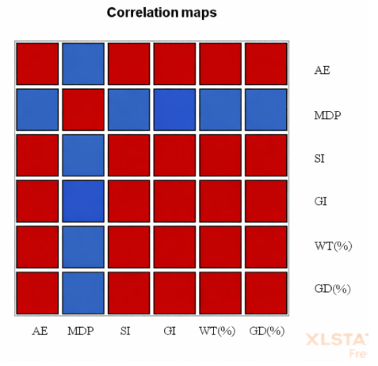
Fig 1. Correlation(r) coefficient map of adult emergence with host suitability parameters in different cereal grains due to Sitophilus oryzae infestation

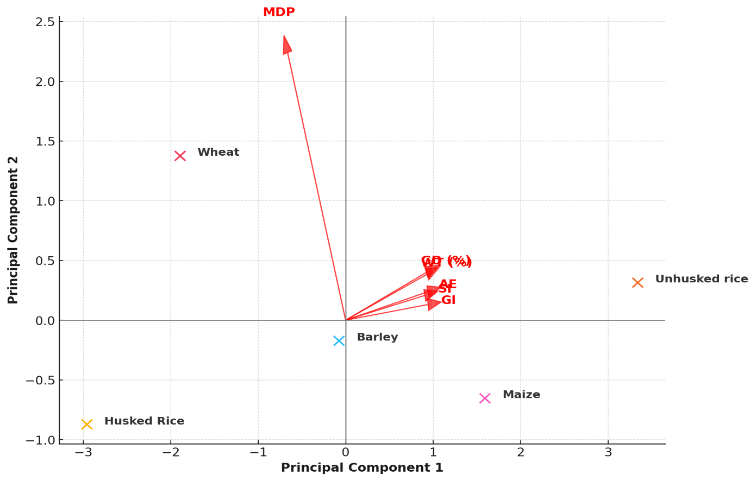
Fig 2: Multivariate models of principal component analysis (PCA) of adult emergence and host suitability parameters of Sitophilus oryzae on different cereal grains

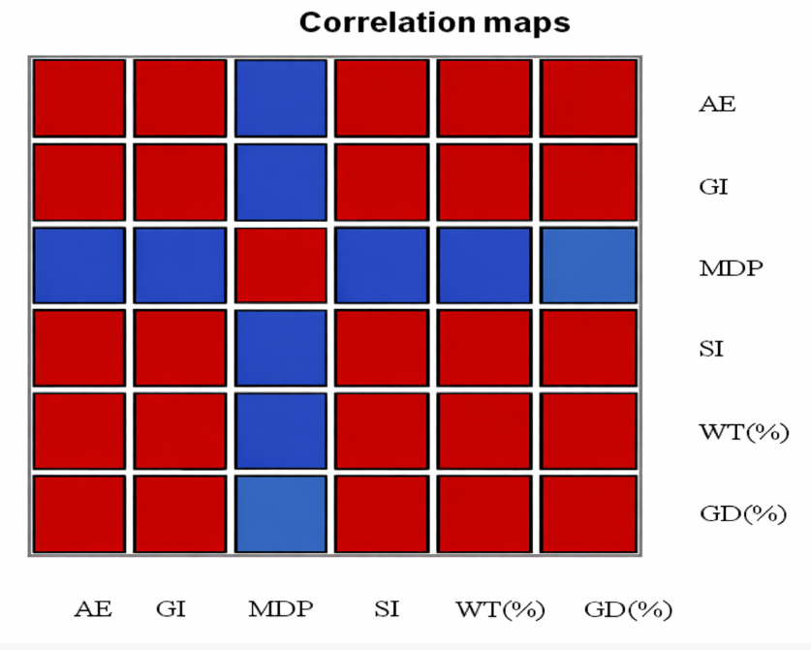
Fig 3. Correlation(r) coefficient map of adult emergence with susceptibility parameters in different basmati rice varieties due to Sitophilus oryzae infestation

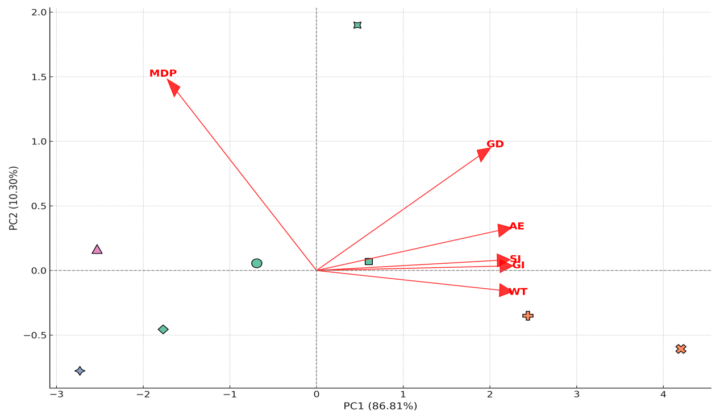
Fig 4. Multivariate models of principal component analysis (PCA) of adult emergence with susceptibility parameters in different basmati rice varieties due to Sitophilus oryzae infestation.

Disclaimer (Artificial intelligence)

Author(s) hereby declare that NO generative AI technologies such as Large Language Models (ChatGPT, COPILOT, etc.) and text-to-image generators have been used during the writing or editing of this manuscript.
References:
- Abebe, F., Tefera, T., Mugo, S., Beyene, Y., & Vidal, S. (2009). Resistance of maize varieties to the maize weevil Sitophilus zeamais (Motsch.) (Coleoptera: Curculionidae). African Journal of Biotechnology, 8, 5937–5943.
- APEDA. (2018). Report on basmati acreage and yield estimation in Punjab, Haryana, Delhi, Uttarakhand, Himachal Pradesh, Western Uttar Pradesh and parts of Jammu & Kashmir. Agricultural and Processed Food Products Export Development Authority, 6.
- APEDA. (2024). Cereals. Agricultural and Processed Food Products Export Development Authority.
- Athanassiou, C. G., Kavallieratos, N. G., Vayias, B. J., & Panoussakis, E. C. (2007). Influence of grain type on the susceptibility of different Sitophilus oryzae (L.) populations obtained from different rearing media to three diatomaceous earth formulations. Journal of Stored Products Research, 44, 279–284.
- Campbell, J. (2002). Influence of seed size on exploitation by the rice weevil, Sitophilus oryzae. Journal of Insect Behavior, 15, 429–445.
- Das, A., Raychaudhuri, U., & Chakraborty, R. (2011). Cereal-based functional food of the Indian subcontinent: A review. Journal of Food Science and Technology, 49, 665–672.
- Derera, J., Pixley, K. V., Giga, D. P., & Makanda, I. (2014). Resistance of maize to the maize weevil: III. Grain weight loss assessment and implications for breeding. Journal of Stored Products Research, 59, 24–35.
- Dobie, P. (1974). The laboratory assessment of the inherent susceptibility of maize varieties to post-harvest infestation by Sitophilus zeamais. Journal of Stored Products Research, 10, 183–197.
- Dobie, P. (1984). Biological methods for integrated control of insects and mites in tropical stored products: I. The use of resistant varieties. Tropical Stored Products Information, 48, 4–8.
- Garcia-Lara, S., Bergvinson, D. J., Burt, A. J., Ramputh, A. I., Diaz-Pontones, D. M., & Arnason, J. T. (2004). The role of pericarp cell wall components in maize weevil resistance. Crop Science, 44, 1560–1567.
- Gowda, G. B., Patil, N., Adak, T., Govindharaj, Guru, P. P., Basak, N., Dhali, K., Annamalai, M., Prasanthi, G., Mohapatra, S. D., Jena, M., Pokhare, S., & Rath, P. (2019). Physico-chemical characteristics of rice (Oryza sativa L.) grain imparting resistance and their association with development of rice weevil, Sitophilus oryzae (L.). Environment, Development and Sustainability, 2, 1–12.
- Horber, E. (1988). Methods to detect and evaluate resistance in maize to seed insects in the field and in storage. In Toward insect resistant maize for the Third World (pp. 140–150). CYMMYT, El Batan, Mexico.
- Howe, R. W. (1971). A parameter for expressing the suitability of an environment for insect development. Journal of Stored Products Research, 7, 63–65.
- Kalsa, K. K., Subramanyam, B., Demissie, G., Worku, A. F., & Habtu, N. G. (2019). Major insect pests and their associated losses in quantity and quality of farm-stored wheat seed. Ethiopian Journal of Agricultural Sciences, 29, 71–82.
- Keba, T., & Gobena, W. (2013). Differential resistance of maize varieties to maize weevil (Sitophilus zeamais Motschulsky) under laboratory conditions. Journal of Entomology, 10, 1–12.
- Kumar, S. S., Rajan, T. S., & Mohankumar, S. (2022). Resistance to phosphine in rice weevil, Sitophilus oryzae (L.) from South India. Indian Journal of Entomology, 84, 340–344.
- Mensah, G. W. K. (1986). Infestation potential of Callosobruchus maculatus (F.) (Coleoptera: Bruchidae) on cowpea stored under subtropical conditions. Insect Science and Its Application, 7, 781–784.
- Mohammad, I., Waseem, A. G., & Azam, K. (1988). Maize grain resistance to Sitotroga cerealella and Sitophilus oryzae. Pakistan Journal of Agricultural Research, 9, 15–21.
- NABARD Consultancy Service Pvt. Ltd. (2022). Study to determine post-harvest losses of agricultural produce in India.
- Naveena N.L., Jagadeesh Babu, C.S., Sudhirkumar, S., Prakash, K. (2011) Performance of Callosobruchus theobromae on different genotypes of fieldbean. Lablab purpureus L. J Entamol Res 35:75–79
- Nwana, I. E., & Akibo-Betts, D. T. (1982). The resistance of some rice varieties to damage by Sitophilus zeamais Motsch. during storage. Tropical Stored Products Information, 43, 10–15.
- Park, I. K., Lee, S. G., Choi, D. H., Park, J. D., & Ahn, Y. J. (2003). Insecticidal activity of constituents identified in the essential oil from leaves of Chamaecyparis obtusa against Callosobruchus chinensis (L.) and Sitophilus oryzae (L.). Journal of Stored Products Research, 39, 375–384.
- Rani, N., Pandey, M., Prasad, G. S. V., & Sudharshan, I. (2006). Historical significance, grain quality features and precision breeding for improvement of export quality basmati varieties in India. Indian Journal of Crop Science, 1, 29–41.
- Reddy, D. B. (1951). Determination of sex in adult rice and granary weevils (Coleoptera: Curculionidae). Pan-Pacific Entomologist, 25, 13–16.
- Singh, B. B., Singh, S. R., & Adjadi, O. (1984). Bruchid resistance in cowpea. Crop Science, 25, 736–739.
- Singh, V. P., & Singh, A. K. (2009). History of basmati rice research and development in India. Indian Farming, 59(1), 4–6.
- Siwale, J., Mbata, K., McRobert, J., & Lungu, D. (2009). Comparative resistance of improved maize genotype and landraces to maize weevil. African Crop Science Journal, 17, 1–16.
- Smith, C. M. (2005). Plant resistance to arthropods: Molecular and conventional approaches. Springer.
- Sofi, P. A., Wani, S. A., Rather, A. G., & Wani, S. H. (2009). Quality protein maize (QPM): Genetic manipulation for the nutritional fortification of maize. Journal of Plant Breeding and Crop Science, 1, 244–253.
- Souza, A. R., Silva, T. M., & Santos, J. F. L. (2012). Seleção e desenvolvimento de Sitophilus oryzae (Linné, 1763) em três substratos. Magistra, 24, 160–163.
- Stevens, P. A., & Mills, R. B. (1973). Comparison of techniques for screening sorghum grain varieties for resistance to rice weevil. Journal of Economic Entomology, 66, 1222–1223.
- Suleiman, R., Rosentrater, K., & Bern, C. (2015). Evaluation of maize weevils Sitophilus zeamais Motschulsky infestation on seven varieties of maize. Journal of Stored Products Research, 64, 97–102.
- Tadesse, A. (1991). The biology, significance and control of the maize weevil, Sitophilus zeamais (Motsch.) (Coleoptera: Curculionidae) on stored maize (M.Sc. thesis). Alemaya University of Agriculture, Ethiopia.
- Tefera, T., Mugo, S., & Likhayo, P. (2011). Effects of insect population density and storage time on grain damage and weight loss in maize due to the maize weevil Sitophilus zeamais and the larger grain borer Prostephanus truncatus. African Journal of Agricultural Research, 6, 2249–2254.
- Trematerra, P., Fontana, F., & Mancini, M. (1999). Influence of intact and damaged cereal kernels on the behaviour of rice weevil, Sitophilus oryzae (L.) (Coleoptera: Curculionidae). Journal of Stored Products Research, 35, 265–276.
- Tripathi, K., Chauhan, S. K., Gore, P. G., Mehta, P. S., Bisht, I. S., & Bhalla, S. (2017). Evaluation of wheat landraces of north-western Himalaya against rice weevil, Sitophilus oryzae L. vis-à-vis physical seed parameters. Plant Genetic Resources, 15, 321–326.
- Ungsunantwiwat, A., & Mills, R. B. (1985). Influence of rearing medium on size and weight of adults of four Sitophilus populations and on weight loss of host kernels. Journal of Stored Products Research, 21, 89–93.
- Yadav, S., Kumar, M., Kaur, P., Sidhu, G. K., & Singh, S. (2025). Comparative Analysis of Hermetically and Conventionally Stored Paddy (Basmati-1121). Journal of Biosystems Engineering, 1-10.

