Identification of Sweet Potato Accessions Tolerant to Water Deficit

Abstract
Water deficit is a major constraint to sweet potato (Ipomoea batatas L.) production, particularly in tropical regions characterized by high climatic variability. This study evaluated the agronomic response of 40 sweet potato accessions under two water regimes (irrigated and water deficit) to identify drought-tolerant genotypes.
The experiment was conducted at the research station of the Centre National de Recherche Agronomique (CNRA) in Bouaké, characterized by a humid tropical climate, an average temperature of approximately 28 °C, and gravelly ferralitic soils. A split-plot experimental design was adopted to evaluate the main agronomic traits, while drought tolerance indices were determined and complemented by multivariate analyses.
Water deficit resulted in a reduction of storage root weight and total yield by more than 40%, whereas emergence and the percentage of productive plants were less affected (<20%). Marked variability was observed among accessions. Accession CNRA PD19/000030 stood out with a yield reduction of less than 20% and tolerance indices above 70%, while several accessions experienced nearly complete yield losses under water stress conditions. Multivariate analysis clearly discriminated tolerant genotypes from sensitive ones.
These findings reveal substantial genetic variability in drought response and identify promising accessions for breeding programs aimed at enhancing sweet potato resilience to increasing water scarcity.
Keywords: Sweet potato; water deficit; tolerance index; yield; varietal selection
1. Introduction
Sweet potato (Ipomoea batatas L.), a member of the Convolvulaceae family, is a root and tuber crop consumed by more than two billion people worldwide (Lebot et al., 2009). In recent years, its importance has increased due to its contribution to food and nutritional security, particularly its high β-carotene content, a precursor of vitamin A (Laurie et al., 2018; Abewoy, 2023). Its adaptability to diverse agro-ecological conditions and high yield potential make sweet potato a strategic crop for sustainable agriculture (Sapakhova et al., 2023).
However, sweet potato production is increasingly threatened by abiotic stresses associated with climate change, especially water deficit, which can lead to substantial yield losses (Huang et al., 2025). Water stress remains one of the most limiting factors for sweet potato productivity and may reduce yields by up to 60%, depending on the severity and duration of the stress (Kivuva et al., 2014). Recent studies suggest that irregular rainfall patterns and rising temperatures are likely to intensify drought events in tropical regions.
Although sweet potato is often considered relatively drought tolerant, significant variability in response to water stress exists among accessions. This variability provides important opportunities for breeding programs aimed at developing drought-tolerant varieties (Mourtala et al., 2023). Moreover, modern agronomic approaches have shown potential to mitigate the negative effects of water deficit and improve crop performance (Amin et al., 2025).
In this context, the present study aims to evaluate the impact of water deficit on the agronomic performance of 40 sweet potato accessions in order to identify drought-tolerant genotypes.
2. MATERIALS AND METHODS
2.1. Study site
The study was conducted at the Food Crops Research Station (SRCV) of the National Center for Agronomic Research (CNRA) in Bouaké, located in the Gbèkè region of Côte d’Ivoire. Bouaké is situated at 7°69′ N latitude and 5°03′ W longitude and covers an area of approximately 72 km² (Allouko, 2011). The site lies within a transition zone between the southern forest climate and the northern savanna climate, with average temperatures around 27 °C and variations of 3–5 °C (Kouame et al., 2018). The climate is humid tropical with a four-season rainfall pattern, and the soils are gravelly ferralitic, moderately saturated, reworked, and shallow.
2.2. Plant material
The plant material consisted of 40 sweet potato accessions obtained from the SRCV collection of the CNRA in BOUAKE.
2.3. Experimental design and treatments
The experimental period lasted five months, from August to December 2023. The experiment was conducted under SRCV conditions using a split-plot design with two factors: accession (40 sweet potato accessions) and water regime (irrigated and water deficit), with two replications.
Plants were established from healthy vine cuttings. Uniform irrigation was applied during the first two months after planting to ensure proper crop establishment.
Water deficit treatment was imposed from the onset of storage root formation and bulking (two months after planting) by withholding irrigation, while the control treatment was maintained at field capacity. Accessions were randomly distributed within each experimental plot.
2.4. Data collection
Agronomic evaluation was based on eight measured variables (Table 1).
Table 1. Agronomic traits measured
Traits | Code | Description
Number of plants emerged | NP | Total number of plants emerged per plot
Percentage of productive plants (%) | PPP | Proportion of plants producing storage roots
Number of marketable storage roots | NRTC | Number of storage roots > 200 g
Weight of marketable storage roots (g) | PRTC | Weight of storage roots > 200 g
Total storage root weight (g) | PRTT | Total weight of storage roots
Storage root yield (t ha⁻¹) | RENDt | Total yield at harvest
Aboveground biomass weight (g) | PBA | Weight of aboveground biomass
Stress tolerance index | IT | IT = (Ps / Pt) × 100
Stress sensitivity index | IS | IS = 1 − (Ps / Pt)
Ps : parameter under water stress conditions; Pt: parameter under non-limiting water conditions (Fischer and Maurer, 1978; Fernandez, 1992; Bouslama and Schapaugh, 1984).
2.5. Statistical analysis
Data were subjected to a two-factor analysis of variance (ANOVA) considering accession and water regime, using the R software. Mean comparisons were performed using Fisher’s least significant difference (LSD) test at the 5% significance level.
Principal component analysis (PCA) and hierarchical cluster analysis (HCA) were conducted to discriminate accessions based on their agronomic performance and water stress tolerance indices.
3. RESULTS AND DISCUSSION
3.1. Results
3.1.1. Impact of water deficit on agronomic parameters
Figure 1 shows the impact of water deficit on the evaluated agronomic parameters. Water deficit slightly affected plant establishment (NP and PPP, reduction < 20%), whereas it caused a strong decrease in yield and its components (> 30%). The number of marketable storage roots was the most sensitive parameter, with a reduction greater than 50%.
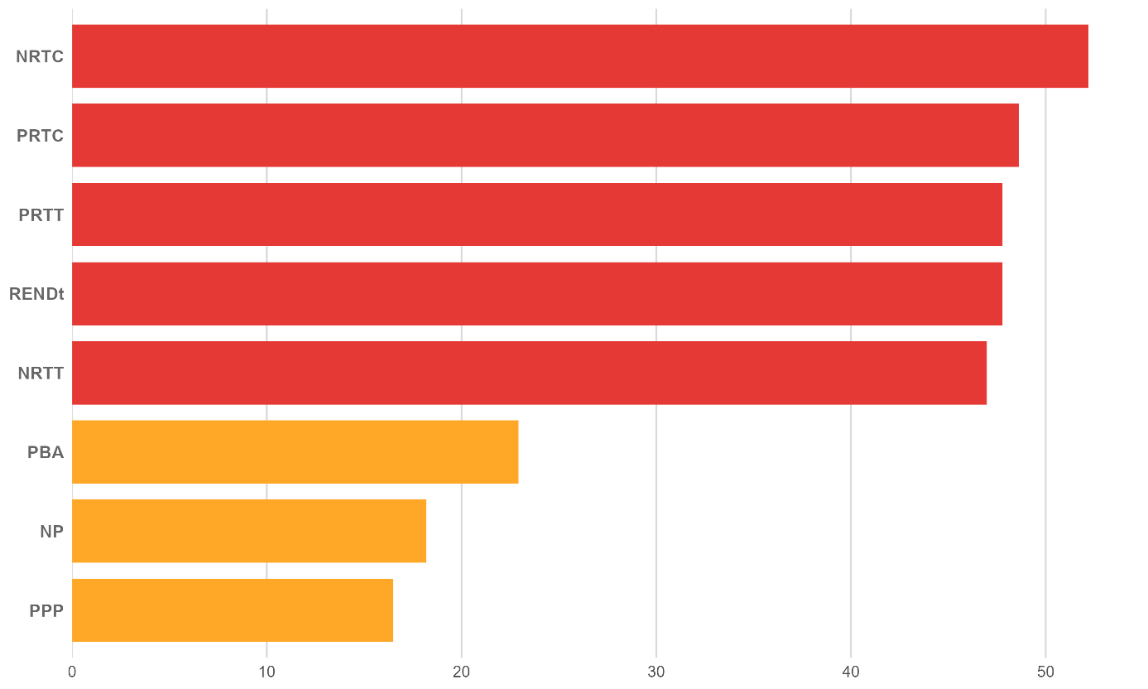
Figure 1. Impact of water stress on agronomic parameters
3.1.2. Tolerance and sensitivity indices
The tolerance and sensitivity indices applied to yield revealed a high variability among accessions (Table 2). Nine accessions showed a high tolerance index (≥70%) and a low sensitivity index (≤0.30), namely CNRAPD19/00003, CNRAPD19/00030, CNRAPD17/00004, CNRAPD19/00016, CIP4 (BF52XCIP4), CIP-196062-1, WOSSO WELEMENT, SONGRE, and ALEDA OKLOE. Conversely, some accessions (ABLI, GBAGBO2, LIBERIA, TU ORANGE, and WOSSO BROU) recorded an almost total loss of yield under water stress.
Table 2. Tolerance and sensitivity indices relative to yield
No | ACCESSIONS | REND_Pt (t ha⁻¹) | REND_Ps (t ha⁻¹) | IT_REND  (%) | IS_REND
1 | CNRAPD19/00003 | 31.56 | 25.26 | 80.04 | 0.2
2 | CNRAPD19/00030 | 15.15 | 12.1 | 79.85 | 0.2
3 | CNRAPD17/00004 | 35.29 | 27.97 | 79.26 | 0.21
4 | CNRAPD19/00016 | 35.21 | 26.46 | 75.16 | 0.25
5 | CIP4 (BF52XCIP4) | 37.95 | 28.32 | 74.63 | 0.25
6 | CIP-196062-1 | 33.85 | 25.18 | 74.39 | 0.26
7 | WOSSO WELEMENT | 42.33 | 31.14 | 73.57 | 0.26
8 | SONGRE | 10.21 | 7.53 | 73.69 | 0.26
9 | ALEDA OKLOE | 6.8 | 4.77 | 70.2 | 0.3
10 | CNRAPD19/00111 | 13.6 | 9.41 | 69.17 | 0.31
11 | CNRAPD17/00003 | 33.13 | 21.87 | 66 | 0.34
12 | MAN LOUEZIN | 5.92 | 3.79 | 64.08 | 0.36
13 | INCONNU 8 | 20.69 | 12.55 | 60.68 | 0.39
14 | POURPRE | 6.327 | 3.79 | 59.96 | 0.4
15 | IRENE | 12.75 | 7.35 | 57.64 | 0.42
16 | FATONI2 | 53.02 | 30.34 | 57.22 | 0.43
17 | ALEDA OFFOUE | 32.61 | 14.04 | 43.06 | 0.57
18 | CNRAPD19/00110 | 18.39 | 7.86 | 42.73 | 0.57
19 | AFFOU1 | 12.39 | 5.27 | 42.52 | 0.57
20 | CNRAPD17/00007 | 19.933 | 8.44 | 42.34 | 0.58
21 | CNRAPD19/00001 | 12.45 | 5.23 | 41.99 | 0.58
22 | J21 | 38.49 | 15.88 | 41.26 | 0.59
23 | TIB-440060 | 46.91 | 17.69 | 37.71 | 0.62
24 | WELEMENT GBASSOLHON | 42.59 | 15.79 | 37.09 | 0.63
25 | CNRAPD17/00010 | 26.65 | 9.82 | 36.85 | 0.63
26 | CNRAPD19/00036 | 21.63 | 7.83 | 36.21 | 0.64
27 | CNRAPD17/00015 | 15.53 | 5.58 | 35.92 | 0.64
28 | WOSSO GBE | 7.91 | 2.75 | 34.74 | 0.65
29 | GOTCHAN GOUN | 17.99 | 4.9 | 27.68 | 0.72
30 | CNRAPD17/00013 | 11.15 | 3.07 | 27.5 | 0.73
31 | ABOBO GARAGE | 4.587 | 1.26 | 27.47 | 0.73
32 | CNRAPD19/00085 | 24.01 | 6.55 | 27.26 | 0.73
33 | LAHO DANGHO | 5.1 | 0.867 | 16.99 | 0.83
34 | PATATE RAPIDE | 35.33 | 5.86 | 16.59 | 0.83
35 | LOMOKAHA | 13.57 | 0.27 | 2.015 | 0.98
36 | ABLI | 4.16 | 0 | 0 | 1
37 | GBAGBO2 | 3.16 | 0 | 0 | 1
38 | LIBERIA | 1.74 | 0 | 0 | 1
39 | TU ORANGE | 2.07 | 0 | 0 | 1
40 | WOSSO BROU | 4.19 | 0 | 0 | 1
IT_REND : yield tolerance index; IS_REND: yield sensitivity index
REND_Pt : yield under normal conditions; REND_Ps: yield under water stress conditions

3.1.3. Principal component analysis (PCA) and hierarchical cluster analysis (HCA) of accessions
PCA and HCA made it possible to distinguish three distinct groups (Figure 2), explaining 89% of the total variance. The tolerant group includes accessions with high yield and high tolerance index, notably FATONI2, CIP4 (BF52XCIP4), WOSSO WELEMENT, CNRAPD17/00003, CIP-196062-1, CNRAPD19/00003, CNRAPD17/00004, and CNRA19/00016, whereas the sensitive group exhibited low performance under water stress.
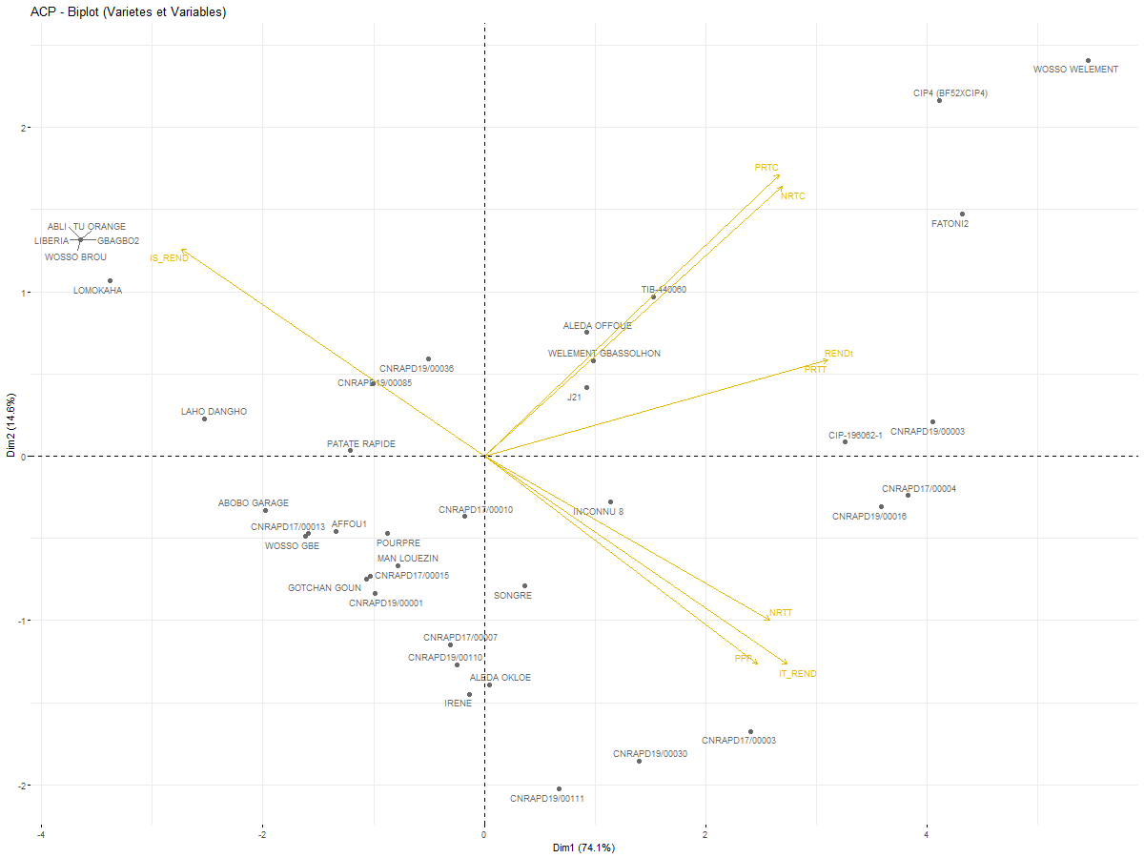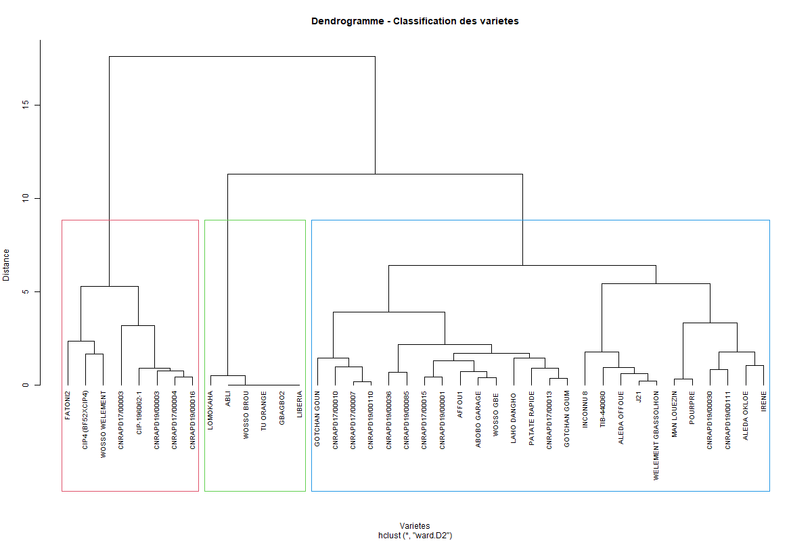
b
a
a. PCA b. HCA
Figure 2. Representation of agronomic traits and accessions in the F1 and F2 factorial plane
3.1.4. ANOVA results of the effects of accession and treatment
ANOVA (Table 3) revealed a highly significant effect of water regime, accession, and their interaction on all evaluated agronomic parameters (p < 0.05).
Table 3. Impact of water regime, accession, and their interaction on assessed agronomic parameters
Parameter | Source of variation | df | SS | F | p-value
NP | Water regime | 1 | 0.73 | 0.989 | < 0.0001
NP | Accession | 14 | 30.42 | 2.931 | < 0.0001
NP | Water regime x Accession | 14 | 9.75 | 0.939 | < 0.0001
NP | Residuals | 29 | 21.5 | - | -
PPP | Water regime | 1 | 259.78 | 0.411 | < 0.0001
PPP | Accession | 14 | 15054.03 | 1.703 | < 0.0001
PPP | Water regime x Accession | 14 | 7371.35 | 0.834 | < 0.0001
PPP | Residuals | 29 | 18308.33 | - | -
NRTC | Water regime | 1 | 2.46 | 1.41 | < 0.0001
NRTC | Accession | 14 | 115.25 | 4.727 | 0.0002
NRTC | Water regime x Accession | 14 | 17.73 | 0.727 | < 0.0001
NRTC | Residuals | 29 | 50.5 | - | -
NRTT | Water regime | 1 | 1228.2 | 10.62 | < 0.0001
NRTT | Accession | 14 | 6072.74 | 3.751 | < 0.0001
NRTT | Water regime x Accession | 14 | 886.69 | 0.548 | < 0.0001
NRTT | Residuals | 29 | 3354 | - | -
PRTC | Water regime | 1 | 228740.3 | 1.053 | < 0.0001
PRTC | Accession | 14 | 21918841 | 7.204 | < 0.0001
PRTC | Water regime x Accession | 14 | 2618268 | 0.861 | < 0.0001
PRTC | Residuals | 29 | 6302267 | - | -
PRTT | Water regime | 1 | 5137761 | 12.783 | < 0.0001
PRTT | Accession | 14 | 47715625 | 8.48 | < 0.0001
PRTT | Water regime x Accession | 14 | 2319911 | 0.412 | < 0.0001
PRTT | Residuals | 29 | 11655859 | - | -
REND | Water regime | 1 | 913.38 | 12.783 | < 0.0001
REND | Accession | 14 | 8482.78 | 8.48 | < 0.0001
REND | Water regime x Accession | 14 | 412.43 | 0.412 | < 0.0001
REND | Residuals | 29 | 2072.15 | - | -
PBA | Water regime | 1 | 0.78 | 1.322 | < 0.0001
PBA | Accession | 14 | 2627655 | 3.475 | < 0.0001
PBA | Water regime x Accession | 14 | 306215.5 | 0.405 | < 0.0001
PBA | Residuals | 29 | 1566408 | - | -

3.2. Discussion
The study aimed to evaluate 40 sweet potato (Ipomoea batatas) accessions under two water regimes: normal conditions and water deficit applied two months after planting. The results revealed strong variability in agronomic parameters and tolerance indices, confirming the existence of exploitable genetic diversity for improving tolerance to water stress (Lebot, 2009; FAO, 2021).
Water deficit had a negative effect on growth and production parameters. The magnitude of this reduction is comparable to that reported in several studies on crops subjected to moderate to severe water stress (Wang et al., 2023; Huang et al., 2025). Yield sensitivity is mainly explained by the dependence of the tuberization process on water availability, as stress affects photosynthesis, assimilate translocation, and the initiation of storage roots. In contrast, the percentage of productive plants and the number of emerged plants were less affected by water stress (less than 20%), likely because irrigation was provided during the first two months to stabilize feeder roots. However, storage root weight and total yield were strongly impacted by water stress, with reductions exceeding 40%. These findings confirm that the timing of stress application plays a determining role in the severity of yield reduction, as also highlighted by Wang et al. (2023). Furthermore, rainfall irregularity constitutes a major limiting factor for agricultural production (Belkhodja & Bidai, 2004; Toumi, 2022).
The evaluation of the Fischer and Maurer tolerance indices made it possible to classify the accessions according to their sensitivity. Accession CNRA PD19/000030 exhibited a yield reduction of less than 20% under water deficit conditions, indicating greater tolerance. Varieties possess different genetic characteristics, supporting the observations of Lebot (2010), who reported that genetic variability within Ipomoea batatas cultivars strongly influences yield performance. Some varieties are able to develop resistance mechanisms to water deficit (Diallo, 2009). Conversely, accessions such as ABLI, GBAGBO2, LIBERIA, TU-ORANGE, and WOSSO BROU experienced nearly 100% yield loss under water deficit conditions, making them highly sensitive to drought. These varieties may carry genes associated with susceptibility to water stress. According to Toumi (2022), in studies conducted on Robinia pseudoacacia, the application of water stress through irrigation cessation caused a significant reduction in stem growth exceeding 70% as well as a halt in new leaf formation from the second week without watering. Tolerance and sensitivity indices therefore represent essential tools to assist breeders in selecting suitable varieties.
Yield and its components were higher under non-limiting water conditions than under water stress and varied among varieties. This result can be explained by the contrasting water regimes imposed during the experiment. These findings are consistent with those of Diallo (2009), who investigated rice resistance to water stress and showed that the evaluated varieties displayed highly variable responses depending on the assessment parameters. Variations in the number and weight of storage roots observed in these sweet potato cultivars under reduced water availability have also been reported in recent studies (Huang et al., 2025), confirming the significant impact of water stress on yield components. Water shortage induces morphological, anatomical, physiological, biochemical, and molecular changes that affect yield and may lead to plant death when stress persists (Khoudour & Mebarek, 2023). Adaptation strategies vary among genotypes and may involve mechanisms of drought escape, avoidance, or tolerance (Blum, 2011; Clavel et al., 2005), which explains the diversity of responses observed.
These results confirm the existence of exploitable genetic variability and highlight accessions capable of maintaining high yields under water deficit, thereby constituting priority candidates for breeding programs.

4. CONCLUSION
This study made it possible to highlight the variability among the 40 sweet potato accessions evaluated under water deficit applied two months after planting. The results showed that water stress leads to a significant reduction in yield and its components, confirming the sensitivity of this crop. However, some accessions exhibited high tolerance indices and higher yields even under stress conditions. These genotypes constitute promising candidates for varietal selection and for strengthening the resilience of agricultural systems in the face of climatic variability.
Future research should focus on multi-location and multi-season trials to evaluate the stability of drought-tolerant accessions under diverse agro-ecological conditions. Further physiological and molecular investigations are also needed to better understand the mechanisms of drought tolerance and support breeding programs.

DISCLAIMER (ARTIFICIAL INTELLIGENCE)

Author(s) hereby declare that NO generative AI technologies such as Large Language Models (ChatGPT, COPILOT, etc.) and text-to-image generators have been used during the writing or editing of this manuscript.

REFERENCES
- Abewoy D. (2023). Response of Sweet Potato (Ipomoea batatas) to Drought Stress: Review. Global Academic Journal of Agriculture and Biosciences. 107-112. 10.36348/gajab.2023.v05i05.001.
- Allouko J. R. (2011). Study of the pre-fattening of Oreochromis niloticus in rice-fish farming ponds. Advanced Agronomy Diploma Thesis, Félix Houphouët-Boigny National Institute, Yamoussoukro, Côte d'Ivoire, 50p.
- AMIN M., EL-SHINAWY., EL-GAWAD H, ALOMRAN M., ABDELAAL K, EL-FLAAH R., ALI M. (2025). Mitigation of drought stress effects on sweet potato plants by application of γ-Aminobutyric acid. Agrobo Notulae Botanicae Horti Agrobotanici Cluj-Napoca journal. 53(3):14549
- Belkhodja M. & Bidai Y. (2004). Response of Atriplex halimus L. seeds to salinity at the germination stage. Sécheresse, 15(4): 331–335.
- Blum, A. (2011). Plant breeding for water-limited environments. Springer Science & Business Media.
- Clavel D., Drame N. K., Diop N. D. & Zuily-Fodil Y. (2005). Adaptation to drought and varietal creation: the case of groundnut in the Sahelian zone. Fundamental Review, 12(3): 248–260.
- Diallo D. (2009). Physiological evaluation of water stress resistance in NERICA rice (Oryza spp L.): case of WAB 450 IBP 28HB and WAB 450 IBP 91HB cultivated in the Republic of Guinea. Single doctoral thesis, University of Ouagadougou, Burkina Faso.
- FAO. (2021). Sweet potato production. Food and Agriculture Organization of the United Nations, http://www.fao.org/faostat/fr/#data (accessed September 1, 2021).
- Huang S., Wang J., Wang H. (2025). Effects of Drought Stress on Photosynthetic Characteristics and Endogenous Hormone Levels in the Sweet Potato (Ipomoea batatas). Horticulturae , 11(5), 456; https://doi.org/10.3390/horticulturae11050456
- Kivuva M., Musembi J., Githiri M., Yencho C G.; Sibiya, Julia. (2014). Assessment of production constraints and farmers' preferences for sweetpotato genotypes. Journal of Plant Breeding and Genetics, 2(1), 15–29.
- KHOUDOUR K. & MEBAREK A. (2023). Study of some effects of water and salt stress on the morphology, physiology, and biochemistry of durum wheat (Triticum durum Desf.). Master’s thesis, Mohammed El Bachir El Ibrahimi University, B.B.A.
- Kouamé B., Ehounou J.-N., Kassin K. E., Dekoula C. S., Yao G. F., N'goran E. K., Kouakou B. J., Koné B. & Soro N. (2018). Characterization of key agroclimatic parameters of the growing season in the forest-savannah contact zone of Ivory Coast. European Scientific Journal, 14(36).
- Laurie M.; Faber M., Claasen N. (2018). Incorporating orange-fleshed sweet potato into the food system as a strategy for improved nutrition: the context of South Africa. Food Research International, 104, 77–85.
- Lebot V., Champagne A., Malapa R. & Shiley D. (2009). NIR determination of major constituents in tropical root and tuber crop flours. Journal of Agricultural and Food Chemistry, 57(22): 10539–10547.
- MOURTALA I. , Oselebe H, Baina D-J, Innocent I., Houdegbe A., Oumarou S., Chukwu S., Moussa B. (2023). Selection of new sweetpotato hybrids for West Africa using accelerated breeding scheme and genotype × environment interaction under drought stress. Sci Rep ;13:6489. doi: 10.1038/s41598-023-33593-2
- Sapakhova Z. , Raissova N. , Zhapar D., Daurova A, Andrey Zhigailov, Zhambakin K., Shamekova M. (2023). Sweet Potato as a Key Crop for Food Security under the Conditions of Global Climate Change. Plants 2023 Jun 30;12(13):2516. 10.3390/plants12132516
- Toumi M., Barris S., Berka S. & Aid F. (2022). Effects of water stress on the physiology and morphology of black locust (Robinia pseudoacacia) plants from Algeria. Bois et Forêts des Tropiques, 354: 7–17.
- Wang W., Vinocur B. & Altman A. (2023). Plant responses to drought, salinity and extreme temperatures: towards genetic engineering for stress tolerance. Planta, 218(1): 1–14.

