The potential Bacillus sp. KITA and Bacillus sphaericus OP6 as Effective Biocontrol Agents Against Fusarium sp. in Jatropha (Jatropha curcas) in Mali

.
ABSTRACT

Backgroud and Aims: Jatropha curcas L. is a species native to Mexico that has lately been identified as a significant crop for producing biofuel. This study aimed to evaluate the biocontrol potential of Bacillus sp. Kita and Bacillus sp. OP6 against Fusarium sp., a major pathogen affecting Jatropha curcas in Mali.
Study Design: Randomized complete block design with six treatments: Fusarium (F); Bacillus sp Kita (K); Bacillus sp.OP6 (OP6); K + F; OP6 + F: Control (C) and three replications.
Place and Duration of Study: Conducted at the greenhouse research area of the LaboREM-Biotech, Faculty of Sciences and Techniques, USTTB, Mali. Methodology: Fusarium sp. was isolated from diseased Jatropha leaves and identified morphologically. Bacillus strains were tested in vitro for antagonistic activity and in vivo for plant growth promotion. Treatments included Fusarium alone; Bacillus strains alone, combinations, and control. Growth parameters were measured and analyzed using SAS software.
Results: Bacillus sp. Kita and OP6 significantly inhibited Fusarium growth in vitro (>70% inhibition). In vivo, co-inoculation with Bacillus strains improved seed germination, leaf number, plant height, and biomass compared to Fusarium-only and control treatments. Statistical analysis confirmed significant differences (P < .05) among treatments.
Conclusion: Bacillus sp. Kita and OP6 exhibit strong biocontrol and plant growth-promoting properties, offering a sustainable alternative to chemical pesticides for managing Fusarium in Jatropha cultivation

1. INTRODUCTION
Jatropha curcas L. is a perennial tropical species native to Mexico that has recently received much attention because of its role in the production of bio-diesel, an eco-friendly, biodegradable, and non-toxic fuel (Toledo et al., 2021). In Africa, mainly in Mali, the cultivation of Jatropha curcas faces several constraints, including insect pests and fungal diseases that attack different plant organs (roots, stems, leaves, and fruits), thereby reducing productivity or even causing plant death (Mignon et al., 2012; Abubakar, 2021). Field surveys have reported significant plant mortality in production areas, which represents a major loss in seed yield, oil production, and farmers’ income (Sanou, 2015). Similar studies on Jatropha curcas pathogens have been conducted in Mexico and Korea, where Fusarium species were identified as causal agents of crown, root, and leaf rots (Espinoza-Verduzco et al., 2012; Kwon et al., 2012; Hernández-Cubero et al., 2017).
To control these pathogens, farmers often rely on chemical pesticides, which pose risks to human health and the environment (Nandhini et al., 2021; Pathak et al., 2022). Therefore, eco-friendly alternatives are urgently needed (Nasiru et al., 2015; Nasiru et al., 2018). Recent research has shown that endophytes and rhizosphere microorganisms can produce bioactive compounds such as antibiotics, enzymes, and secondary metabolites with strong biocontrol potential (Rabiey et al., 2019; Ghosh et al., 2020; Khan et al., 2018; Sriwati et al., 2023). Biological control using bacterial antagonists, particularly Bacillus species, has emerged as a promising solution that meets economic, toxicological, and ecological requirements (Dicko et al., 2018; Kassogué et al., 2016; Nantoumé et al., 2023; Ouattara et al., 2023). In natural environments, the rhizosphere of healthy plants harbors beneficial bacteria capable of protecting crops against phytopathogenic fungi in a sustainable manner (Serrão et al., 2024; Boulahouat et al., 2023). We hypothesize that Bacillus sp. Kita and Bacillus sphaericus OP6 exhibit strong antagonistic activity against Fusarium sp., the major pathogen of Jatropha curcas in Mali. Their application will suppress pathogen development and simultaneously enhance seed germination, vegetative growth, and biomass accumulation, thereby providing a sustainable and eco-friendly alternative to chemical pesticides for Jatropha disease management.

2. material and methods

2.1 Study area
To determine the pathogenicity of a pathogenic fungus newly isolated on Jatropha curcas cultivated in Kati (Mali), an experiment was conducted in vitro and in vivo in a greenhouse under artificial conditions at the Laboratory of Research in Microbiology and Microbial Biotechnology (LaboREM-Biotech), Faculty of Sciences and Techniques; University of Sciences, Techniques and Technologies of Bamako in Mali.

2.2 Jatropha varieties
In this study, jatropha (Jatropha curcas) varieties the most cultivated in Mali used were obtained from the ″Institute d’Economie Rural (IER)″ du Mali.

2.3 Isolation of the pathogenic fungus
For pathogens isolation, Jatropha leaves showing disease symptoms were collected from fields in Kita (Mali). The diseased parts were cut into small fragments with a sterile scalpel. They were then disinfected by soaking in 5% sterile bleach for 5 minutes, then rinsed five times with sterile distilled water. Pathogens were isolated on Rose Bengal solid medium containing chloramphenicol as antibacterial, and incubated at 25ºC for four days. All the grown fungus colonies were purified, before identification using the method described by [4].

2.4 Pathogenicity test of isolated fungus strains
To verify the postulate of Koch. Each fungus isolate was used to inoculate healthy Jatropha leaves. The inoculated Jatropha leaves were incubated and observed each days for disease development. Isolates showing typical disease on the healthy leaves were selected and considered as pathogens.

2.5 Selection of antagonist bacterial strain
The effect of some bacterial strains against mycelial growth was studied by the direct confrontation method. The technique used is that described by Benhamou and Chet (1997) modified by Berber et al. (2009). This technique consists of placing in the same Petri dish (85 mm in diameter) containing the medium at 5 cm along a diametral axis) the pathogen and the biological control agent. Incubation is performed at 25°C in the dark for six days. Control dishes containing only the pathogen were incubated under the same conditions.

To determine the rate of inhibition of the mycelial growth of the pathogen caused by the antagonist agent, daily measurements of the colony diameter were taken. The rate of growth inhibition is calculated according to the following formula (Hewish et al, 1968)
$$GI\%=\frac{DGC-DGP}{DGC}X100$$
DGC : Diameter growth of the control, DPA : Diameter growth of the pathogen in presence of the antagonist, GI : Growth Inhibition of the fungus mycelium.

2.6 Effect of antagonists Bacillus sp. OP6 and Bacillus sp. Kita on the activity of the growth of Jatropha plants in presence of isolated Fusarium sp.

2.6.1 Inoculum preparation

Bacillus sp. Kita and Bacillus sp. OP6 strains were inoculated each in 250 ml flasks containing 100 ml of liquid nutrient broth medium. The vials were incubated at 37 ° C with shaking at 200 rpm for 7 days. After incubation, the different cultures were centrifuged at 10,000 rpm for 15 minutes to separate the pellet from the supernatant. For each strain, the inoculum was adjusted to 1,108 bacteria per ml by estimating them by spectrophotometry (ie OD = 0.1 at 600 nm). To prepare the adhesive inoculum, gum arabic was added to the pellet / supernatant mixture (1: 1) to obtain a final concentration equivalent to 2% gum to fix the bacteria well on the seeds (Babana et al., 2012).

2.6.2 Experimental design

In this experiment, we used a complete randomized bloc design (Figure 1). The hours of shunshine represent the blocking factor, which gave us three blocks. The bacteria isolates (with high antifungal activities, Bacillus sp. Kita and Bacillus sp.OP6, the fungus and the different combinations bacteria-fungus represent the six treatments studied. Each treatment was replicated four times. Five of each treated Jatropha seeds were seeded directly in a plastic pot filled with 10 kg of soil at 2 cm depth. To avoid confusion between the yellowing associated with disease development and that due to malnutrition, recommended dose of NPK fertilizer was applied to each plant. After germination, the young plants were thinned to one per pot. These pots were watered every day at 1/9 of the maximum retention capacity of the substrate.

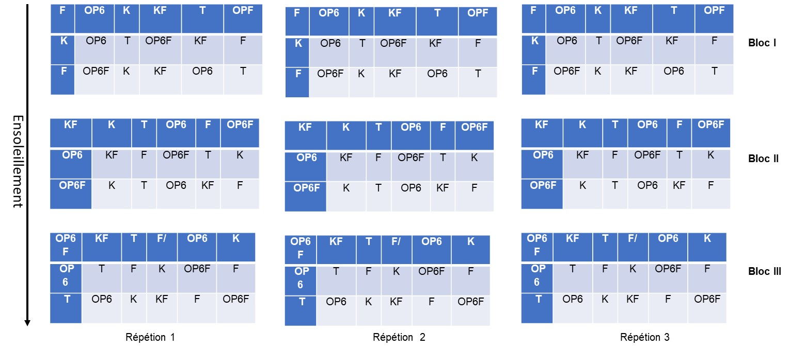
Figure 1. Experimental design in blocks with random distribution of the treatments in each block (3 blocks, 6 treatments and 3 repetitions).

2.6.2.1 Data collection
The number of germinated seeds was noted for one to two weeks. In the second month after sowing, the plants were removed and the various agronomic parameters: number of leaves, leaf width and length; the length of roots, stem size, fresh weight of aboveground and belowground biomass were determined and recorded.

2.6.2.2 Data analysis
Analysis of variance was performed for each parameter (antagonists bacteria and pathogen fungus) according to the General Linear Model (GLM) procedures using SAS software (version 9.2). Whenever the Fisher test indicates a significant effect at a probability of 0.05, Fisher's Protected Least Significant Difference (LSD) test was used to compare the means.

3. results and discussion

3.1 Results
3.1.1 Fungal pathogen of Jatropha curcas isolation and identification
Twelve (12) fungi were isolated from different parts of Jatropha plants, sampled in different fields investigated in Kita (Mali). Based on the ability of one fungus isolate to produce the disease on the Pourghere (Jatropha curcas) leaves (Figure 2), this fungal isolate was retained as the main Jatropha disease pathogen in fields in Kita.

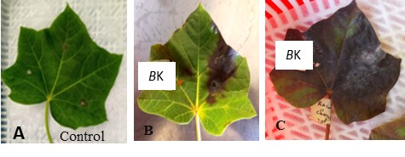
Figure 2. Reproduction of disease observed in field by the retained fungal isolate: Control (A); pathogenic fungus, 3 after inoculation (B) and the pathogenic fungus 7 after inoculation (C).

Based on the macroscopique, microscopique characteristiques, the retained fungal isolates was identified as Fusarium (Figure 3). A molecular identification to confirm precisely the identity of the fungal isolate is ongoing.
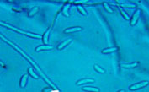
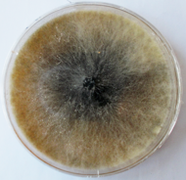

- (B)
Figure 3. Macroscopique (A) and microscopic (B) characteristics of the Fusarium isolate

3.2 Effect of antagonist bacteria on the aerial growth of Fusarium sp. Kita isolate

Bacillus sp. Kita showed strong inhibitory activity against the fungal pathogen with a zone of inhibition greater than 70% in vitro.

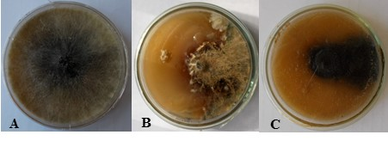

Figure 4. Effect of Bacillus sp. Kita on the growth of Fusarium sp. Pathogen on Jatropha curca: (A) Fusarium sp., B and C (Fusarim sp., and Bacillus sp. Kita).
Table 1. Analysis of variance for Jatropha percentage germination (%Germ), leaf number (Ln), plant height (Ph), root length (Rl), leaf fresh weight (lfw) and root fresh weight
 |  |  | Mean squares
Sources of variation | Df | %Germ | Ln | Ph | Rl | Lfw | Rfw
Treatments | 5 | 4.68** | 158,40*** | 121,13*** | 115,60*** | 46,63** | 73,33**
Repetitions | 1 | 0.26ns | 0,75ns | 1,08ns | 1,92ns | 2,08ns | 0,40ns
Df= Degree of freedon; %Germ = Percentage of germination; degree of freedom; Ln: Leaf number, Ph: Plant height, Rl: Root length; Lfw: Leaves fresh weight; Rfw: Root fresh weight; **Very significant; ***Highly significant; ns not significant

The analysis of data in table 2 showed that the best germination rates were observed then the Fungus is present. Jatropha plants treated with the combination of Bacillus sp. Kita and Fusarium sp., give the highest leaf number, and the treatment with Fusarium alone showed the lowest leaf number. Plant height was greater with the mixture of combinaisons of Bacillus sp. Kita and Fusarium sp., and Bacillus sp.OP6 + Fusarium sp. treatments, while it was low with. Observation of the root condition of transplanted plants with the K + F mixture showed the best result compared to other treatments. While the root condition of plants transplanted only with Fusarium showed poor root growth. The weight of the fresh aerial parts of the plants was high with the OP6 treatment and low with that of Fusarium. The weight of the fresh underground part was high with the K treatment and low with that of Fusarium.

Table 2. Effect of antagonist treatments on the percentage germination (%Germ), leaf number (Ln), plant height (Ph), root length (Rl), leaf fresh weight (lfw) and root fresh weight of Jatropha plants
Treatments | %Germ | Ln | Ph | Rl | Lfw | Rfw
K | 3.33bc | 31c | 54b | 37b | 195,5b | 25,3a
F | 4.61a | 20f | 36d | 21e | 83,4e | 9,7d
K+F | 3.83ab | 46a | 55a | 45a | 121,15d | 24,4b
OP6 | 3.00c | 35b | 54b | 33d | 203,8a | 18,5b
OP6+F | 3.50abc | 26e | 55a | 35c | 192b | 18,6c
Control | 1.50d | 28d | 45c | 35c | 165,8c | 25,1 a
F=Fusarium sp; K= Bacillus sp. Kita; OP6=Bacillus sp.; T=Control

For plants inoculated with the pathogenic Fusarium sp., compared to the control, a high sensitivity to the pathogen was observed as well as an inhibition of Jatropha plant growth was observed. Plants inoculated with Fusarium sp. and treated with Bacillus sp. OP6 or Bacillus sp. Kita, showed had a greater vegetative development compared to those of the control (non-inoculated and non-treated) (Figure 5).

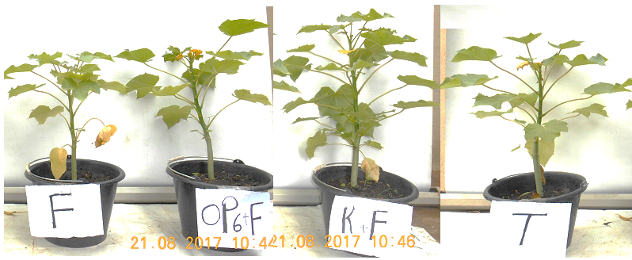

Figure 5. Effect of the bacteria Bacillus sp. OP6 and Bacillus sp. Kita (K), on the growth of jatropha plant infected with the pathogenic Fusarium

3.2 Discussion
The pathogenicity or virulence test of the pathogenic fungus, Fusarium sp., tested on healthy jatropha leaves showed total rotting of jatropha leaves in less than a week. This result is consistent with those of Nwogwugwu et al., (2022) who isolated Five genera (Curvularia, Colletotrichum, Fusarium, Lasiodiplodia, and Oidium) of which were confirmed as pathogenic on J. curcas. The symptoms expressed after leaf inoculation correlated with the symptoms described in the literature (Zarafi and Abdulkadir 2013; Wu et al., 2024). Experiments in different jatropha leaves of these tests recording the severity of symptoms would be useful to determine the best conditions that influence pathogenicity; (Hernández-Cubero et al., 2017) demonstrated this. Bacillus sp. OP6 showed a strong antagonistic activity on Fusarium sp. with an inhibition zone in Petri dishes greater than 70%. This result is significantly higher than that obtained by Ghorri, (2015) who used fungal isolates to control Fusarium sp. with an inhibition rate around 65%. However, this result is lower than that of Hamel, (2016) who obtained in this work an inhibition rate of 100% on Fusarium spp., with Trichoderma spp. after four days of incubation. The differences observed in these cases may be due to the fact that they used fungi as biocontrol agents, while bacteria were used in this study. The observed differences showed also that the control efficacy vary with the biocontrol fungus used. Bacillus sp. Kita isolated from Jatropha curcas and Bacillus sp. OP6 from the bacterial collection of the LaboREM-Biotech, positives for most of the FCP properties, managed to significantly inhibit the pathogenic Fusarium tested in this study. Amaresan et al. (2013) confirmed that several strains of Bacillus have a suppressive effect against some phytopathogens. The antifungal activity of the Bacillus strains may be due to the production of extracellular enzymes, as well as the production of phytohormones Dicko et al., 2018; Babana et al., 2011). Indeed, the Bacillus sp. Kita isolated from the Jatropha curcas plant is capable of producing enzymes as catalase, oxidase, protease and amylase. According to Sriwati et al. (2023), Khan et al. (2018), and Yadav et al. (2018); these enzymes are responsible the control of the pathogen’s growth through the degradation of its cell wall. Various studies have explained the abundance of Bacillus species in ecosystems, by their ability to produce various bioactive substances and enzymes, they are therefore an important link in biological chains (Dicko et al., 2018; Nantoumé et al., 2023; Ouattara et al., 2023). During this greenhouse experiment, diseased jatropha plants co-inoculated with the pathogen and Bacillus sp. OP6 or Bacillus sp. Kita were better compared to the control as well as those inoculated with only the pathogen, Fusarium sp. Aboton et al. (2015) proved this during the study on agromorphological evaluation and selection of the best accessions of Jatropha curcas L. introduced in Benin.

4. Conclusion
The study demonstrated that Jatropha curcas varieties cultivated in Mali are highly vulnerable to diseases caused by Fusarium species. These varieties, particularly those grown in Kita, remain central to biofuel production and are widely valued by smallholder farmers. Our findings identified two bacterial strains, Bacillus sp. Kita and Bacillus sp. OP6, with strong biocontrol potential. Among them, Bacillus sp. Kita showed the most consistent ability to suppress Fusarium growth while enhancing seed germination and overall plant development. These results highlight the promise of using these strains, especially Bacillus sp. Kita, as the basis for developing an effective biopesticide to support healthier Jatropha cultivation and improve productivity in Mali.
Disclaimer (Artificial intelligence)

Author(s) hereby declare that NO generative AI technologies such as Large Language Models (ChatGPT, COPILOT, etc.) and text-to-image generators have been used during the writing or editing of this manuscript.

References

- Aslam, S., Baber, M., Naqqash, T., Javed, M., Bredenbruch, S., Grundler, F. M. W., & Schleker, A. S. S. (2025). Rhizospheric Bacillus isolates control Fusarium wilt on cotton and enhance plant biomass and root development. Frontiers in Microbiology, 16, 1580937. https://doi.org/10.3389/fmicb.2025.1580937
- Babana, A. H., Dicko, A. H., Maïga, A., & Traoré, D. (2012). Use of gum arabic as adhesive for bacterial inoculum in seed treatment. African Journal of Biotechnology, 11(45), 10377–10383. https://doi.org/10.5897/AJB11.3450
- Benhamou, N., & Chet, I. (1997). Cellular and molecular mechanisms involved in the interaction between Trichoderma harzianum and Pythium ultimum. Applied and Environmental Microbiology, 63(5), 2095–2099. https://doi.org/10.1128/aem.63.5.2095-2099.1997
- Berber, I., Yildirim, N., & Yildirim, M. (2009). Antagonistic effect of some bacteria on fungal pathogens. World Journal of Microbiology and Biotechnology, 25(6), 1105–1111. https://doi.org/10.1007/s11274-009-9981-4
- Cantoro, R., Palazzini, J. M., Yerkovich, N., Miralles, D. J., & Chulze, S. N. (2021). Bacillus velezensis RC 218 as a biocontrol agent against Fusarium graminearum: Effect on penetration, growth and TRI5 expression in wheat spikes. BioControl, 66(3), 259–270. https://doi.org/10.1007/s10526-020-10031-9
- Gharsallah, H., Cheffi, M., Mallek, R., Omri, N., Triki, M. A., & Zarai, Z. (2025). Antifungal potential of Bacillus strains: Implications for biocontrol strategies in food safety and sustainable agriculture. Frontiers in Microbiology, 16, 1615252. https://doi.org/10.3389/fmicb.2025.1615252
- Hernández-Cubero, J., Chacón-Cerdas, R., & Murillo, R. (2017). Pathogenicity of fungal isolates associated with leaf spots in Jatropha curcas. Tropical Plant Pathology, 42(5), 375–383. https://doi.org/10.1007/s40858-017-0156-2
- Hewish, D. R., Noble, R. J., & Sutherland, J. (1968). Growth inhibition assays in fungal antagonism studies. Journal of General Microbiology, 53(2), 231–238. https://doi.org/10.1099/00221287-53-2-231
- Khan, N., Martínez-Hidalgo, P., Ice, T. A., Maymon, M., Humm, E. A., Nejat, N., Sanders, E. R., Kaplan, D., & Hirsch, A. M. (2018). Antifungal activity of Bacillus species against Fusarium and analysis of the potential mechanisms used in biocontrol. Frontiers in Microbiology, 9, 2363. https://doi.org/10.3389/fmicb.2018.02363
- Nwogwugwu, J. O., Adewale, D. B., Batcho, A. A., Osunlaja, O. A., & Ekpo, E. N. (2022). Occurrence and pathogenicity of fungal genera on Jatropha curcas L. in Southwestern Nigeria. Journal of Plant Pathology, 104(2), 295–303. https://doi.org/10.1007/s42161-021-01014-w
- Patel, J. K., Mistry, Y., Soni, R., & Jha, A. (2024). Evaluation of antifungal activity of endophytic Bacillus spp. and identification of secondary metabolites produced against phytopathogenic fungi. Current Microbiology, 81(4), 128. https://doi.org/10.1007/s00284-024-03428-9
- Sriwati, R., Suryadi, Y., & Susilowati, A. (2023). Antifungal activity of Bacillus spp. producing extracellular enzymes against phytopathogenic fungi. Microbial Pathogenesis, 174, 105892. https://doi.org/10.1016/j.micpath.2023.105892
- Wu, H., Liang, Z., Gu, Q., Liu, X., Sun, H., & Gao, X. (2024). Biocontrol mechanism of Bacillus thuringiensis GBAC46 against diseases caused by Fusarium verticillioides. Biomolecules, 15(4), 519. https://doi.org/10.3390/biom15040519
- Yadav, A. N., Verma, P., Kumar, V., Sangwan, P., Mishra, S., & Saxena, A. K. (2018). Biodiversity of the genus Bacillus in agricultural and non-agricultural habitats
- Abubakar, M. N. (2021). An overview of Jatropha curcas pests, diseases and management in North Western Nigeria. International Journal of Science and Research Archive, 3(1), 56–61.
- Dicko, A. H., Nantoumé, D., Ouattara, D., Kassogué, A., Fané, R., Mallé, I., Doumbia, B., & Babana, A. H. (2021). Screening of rice endophytic natives biofertilizers with plant growth-promoting characteristics. African Journal of Agricultural Research, 17(10), 1336–1342.
- Espinoza-Verduzco, M. A., Santos-Cervantes, M. E., Fernandez-Herrera, E., Espinoza-Mancillias, M. G., Aliciachaez-Medina, J., Bermudez-Alvarez, E. M., Martinez-Ayala, A. L., Mendez-Lozano, J., & Leyva-Lopez, N. E. (2012). First report of Alternaria alternata causing inflorescence blight in Jatropha curcas in Sinaloa, Mexico. Canadian Journal of Plant Pathology, 34(3), 455–458.
- Ghosh, S. K., Chaudhary, M., & Manjunatha, N. A. K. (2020). Endophytes: A potential bio-agent for plant protection. In Chakravarthy (Ed.), Innovative Pest Management Approaches for the 21st Century (pp. 273–297). Springer. https://doi.org/10.1007/978-981-15-0794-6_14 (doi.org in Bing)
- Hernández-Cubero, L., Ampofo, P., Montes, J. M., & Voegele, R. T. (2017). Identification of pathogenic fungi and preliminary screening for resistance in Jatropha curcas L. germplasm. European Journal of Plant Pathology, 149(2), 325–336.
- Kassogué, A., Dicko, A. H., Traoré, D., Fané, R., Valicente, F. H., & Babana, A. H. (2016). Bacillus thuringiensis strains isolated from agricultural soils in Mali tested for their potentiality on plant growth promoting trait. British Microbiology Research Journal, 14(3), 1–7.
- Khan, N., Martínez-Hidalgo, P., Ice, T. A., Maymon, M., Humm, E. A., Nejat, N., Sanders, E. R., Kaplan, D., & Hirsch, A. M. (2018). Antifungal activity of Bacillus species against Fusarium and analysis of the potential mechanisms used in biocontrol. Frontiers in Microbiology, 9, 2363. https://doi.org/10.3389/fmicb.2018.02363 (doi.org in Bing)
- Kwon, J.-H., Choi, O. O., Kim, J.-H., & Kwak, Y.-S. (2012). First report of anthracnose disease on Jatropha curcas caused by Colletotrichum gloeosporioides in Korea. Journal of Phytopathology, 160(5), 311–314. https://doi.org/10.1111/j.1439-0434.2012.01890.x (doi.org in Bing)
- Mignon, T. J., Declerck, C. D. H., Savery, S., de Haveskercke, P. J., Winandy, S., & Mergeai, G. (2012). Principal diseases and insect pests of Jatropha curcas L. in the Lower Valley of the Senegal River. Tropicultura, 30(4), 222–229.
- Nandhini, A., Muthukumar, H., & Gummadi, S. N. (2021). Chlorpyrifos in environment and foods: A critical review of detection methods and degradation pathways. Environmental Science: Processes & Impacts, 23(8), 1255–1277. https://doi.org/10.1039/D1EM00142A
- Nasiru, A. M., Shehu, K., Mani, U., & Yerima, M. B. (2015). In vivo evaluation of fungicides on Fusarium equiseti foliar blight of Jatropha curcas L. International Journal of Agriculture and Environment Research, 1(1), 79–87.
- Nasiru, A. M., Salau, I. A., & Muhammad, A. S. (2018). In vitro efficacy of fungicides concentration on mycelia radial growth of Phomopsis viticola. In Proceedings of the Sixth Biennial National Conference of the Forest and Forest Products Society (pp. 263–269). Usmanu Danfodiyo University, Sokoto.
- Rabiey, M., Hailey, L. E., Roy, S. R., Grenz, K., Al-Zadjali, M. A. S., Barrett, G. A., & Jackson, R. W. (2019). Endophytes vs tree pathogens and pests: Can they be used as biological control agents to improve tree health? European Journal of Plant Pathology, 155(3), 711–729. https://doi.org/10.1007/s10658-019-01814-y (doi.org in Bing)
- Sanou, H. (2015). Étude sur les causes de la mortalité chez le pourghère Jatropha curcas. Bamako: IER Mali.
- Serrão, C. P., Ortega, J. C. G., Rodrigues, P. C., & Souza, C. R. B. (2024). Bacillus species as tools for biocontrol of plant diseases: A meta-analysis of twenty-two years of research. World Journal of Microbiology and Biotechnology, 40, 110. https://doi.org/10.1007/s11274-024-03710-9 (doi.org in Bing)
- Sriwati, I., Maulidia, V., Intan, N., Oktarina, H., Syamsuddin, K., & Mahmud, T. (2023). Endophytic bacteria as biological agents to control Fusarium wilt disease and promote tomato plant growth. Physiological and Molecular Plant Pathology, 125, 101994. https://doi.org/10.1016/j.pmpp.2023.101994
- Wu, L., Hwang, S.-F., Strelkov, S. E., Fredua-Agyeman, R., Oh, Y., Bélanger, R. R., Wally, O., & Kim, Y.-M. (2024). Pathogenicity, host resistance, and genetic diversity of Fusarium species from soybean in Canada. Journal of Fungi, 10(5), 303. https://doi.org/10.3390/jof10050303
- Toledo-Hernández, E., Peña-Chora, G., Toribio-Jiménez, J., Romero-Ramírez, Y., Bolaños-Dircio, A., Velázquez-del Valle, M. G., ... & Vero, S. (2021). Isolated rhizobacteria of Jatropha curcas L.: antagonistic activity of phytopathogens and plant growth promoter. Revista Chapingo serie ciencias forestales y del ambiente, 27(2), 181-198.

