Characterization of Chlorosis and Evaluation
of its Impact on the Phenology of the
Cashew Tree in the Bagoué Region,
Northern Côte d’Ivoire

.
Abstract
The cashew tree (Anacardium occidentale L.) occupies an important place in the economy of Côte d’Ivoire, which has become the world's leading producer of cashew nuts since 2015. However, orchards are characterized by low yields, in the order of 350 to 500 kg/ha, attributable to various constraints including foliar chlorosis. This chlorosis, which appears to affect cashew tree remains poorly documented. This study aims to determine the effect of chlorosis on the phenology of the cashew tree in the Bagoué region, in northern Côte d'Ivoire. The experiment consisted of monitoring chlorosis, flowering, and fruiting for 24 months on cashew trees aged 20-25 years. Statistical analyses (Student's t-test, ANOVA, Newman-Keuls, α = 5%) indicated that dominant nutritional deficiencies were linked to nitrogen (47.25%), phosphorus (18.99%), and potassium (18.24%), representing 84.48% of cases. Chlorosis has no effect on the type of flower. Zinc and iron deficiencies have caused significant dried flowers. Increased chlorosis severity reduced fruit number by 75% and decreased the mass of apples during the two production seasons. For nuts, only their mass was influenced by chlorosis during the 2023 - 2024 season, with an average value of 8.61 ± 0.69 g versus 6.63 ± 2.48 g, respectively for high and very high severity levels. Deficiencies in nitrogen, phosphorus, potassium and sulfur were associated with significantly lower production levels. Chlorosis is mainly expressed during the vegetative phase with a prevalence of 88 to 89%, between May and October, and disappears almost completely during the flowering and fruit-setting phase which occurred from November to February of each year. Severe deficiencies in several mineral elements negatively impact flower and fruit production of cashew trees.

Keywords: Cashew tree, Chlorosis, Mineral elements, Phenology, Bagoué, Côte d'Ivoire.

1. INTRODUCTION

Introduced to Côte d'Ivoire in the 1960s for ecological purposes, the cashew tree (Anacardium occidentale L.) has undergone a radical functional mutation, transitioning from a reforestation tool to a cash crop with high socio-economic value (Basset, 2009). This dynamic has propelled the country to the rank of the world's leading producer, since 2015 (CCA, 2016), with production increasing exponentially from 1.225.000 tons in 2023 (CNE, 2023) to 1.549.221 tons in 2025 (Sika Finance, 2026). Now the third-largest national export product, cashew plays a structural role in the Ivorian economy, generating rapidly rising 380 billion CFA Francs, in 2018, that actively contribute to rural poverty reduction (FIRCA and CCA, 2025). The cashew sector now plays a central role in the rural economy due to the significant income generated for producers.

However, cashew cultivation is practiced extensively. This does not translate into a proportional improvement in productive performance. Observed yields remain low, in the range of 350 to 500 kg/ha (Djaha et al., 2014), compared to yields of 700 kg to 1172 kg per hectare in India (NHB, 2022). They reveal structural constraints related to orchard management, mineral nutrition, and tree physiology (FAO, 2020). Furthermore, the competitiveness of the sector is also affected by nut characteristics (RONGEAD, 2014). In this context, the frequent appearance of chlorosis in orchards in northern Côte d'Ivoire, particularly in the Bagoué region, constitutes a concerning signal. These symptoms appear to be associated with disturbances in the reproductive functions of the cashew tree (Diomandé et al., 2021). However, the impact of the severity and types of chlorosis on production remains poorly documented. Thus, this study specifically aims to contribute to the determination of the effect of chlorosis on the phenology of the cashew tree in the Bagoué region.

2. material and methods

2.1 Presentation of the Study Area

The Bagoué region with Boundiali as capital, is located in the far north of Côte d'Ivoire. Extending between 9°00' and 10°40' north latitude and between 6°00' and 7°10' west longitude, it covers an area of ​​approximately 10,668 km². It is bordered to the north by the Republic of Mali, to the east by the Poro region, to the west by the Kabadougou region, and to the south by the Worodougou and Béré regions (BNETD, 2016).

2.2. Plant Material

The plant material consists of various organs of the cashew tree (leaves, apples, and cashew nuts).

2.3. Methods

2.3.1. Evaluation of the prevalence of chlorosis types and their influence on flowering and fruiting of cashew trees

The expression of chlorosis was evaluated on the yellow and conical apple morphotype, which is the most representative in the plantations. Three cashew orchards aged between 20 and 25 years (the predominant age class) were selected in each of the three departments (Boundiali, Kouto, and Tengréla) of the Bagoué region. Within each plot, on ten (10) retained trees, three twigs were chosen at random per cardinal direction, according to the cluster sampling method of Madden and Hughes (1996) adapted, totaling 12 twigs per tree, 120 per orchard, 360 per department, and 1080 at the regional scale. Observations were made on these twigs for 24 months.

2.3.1.1. Prevalence of chlorosis types

The prevalence of chlorosis was assessed at the beginning of the experiment on chlorotic trees. A tree was considered to have chlorosis if at least one leaf on a branch showed symptoms. The identification of the different types of leaf chlorosis (Figure 1) was carried out according to the method of Shamsudheen (2018). Observations were made on all leaves of the selected branches. Each tree was considered to have a mineral deficiency when its deficiency symptom was most pronounced on the observed leaves. The mean prevalence (MP) of chlorosis was calculated as the percentage of twigs showing at least one symptom of chlorosis relative to the total number of twigs observed, according to the following formula:

$$MP (\%)=\frac{\sum{Number of chlorotic leaves for a given mineral element}}{Total number of leaves observed}×100$$
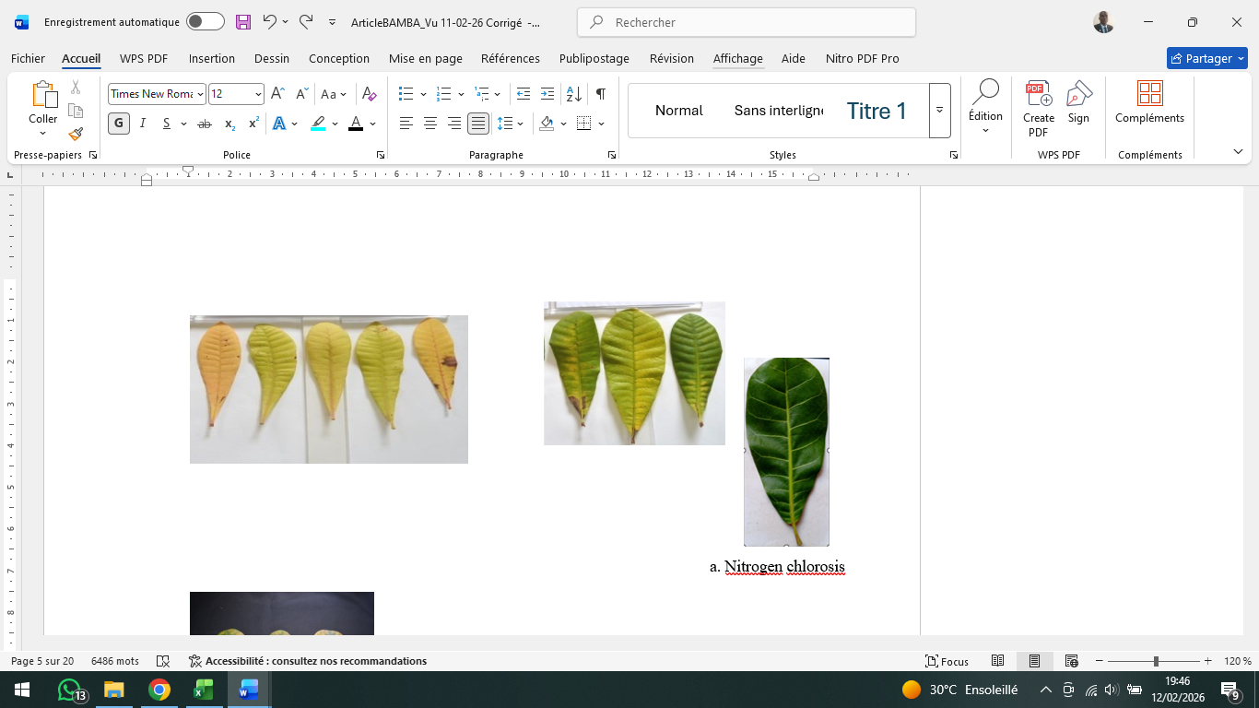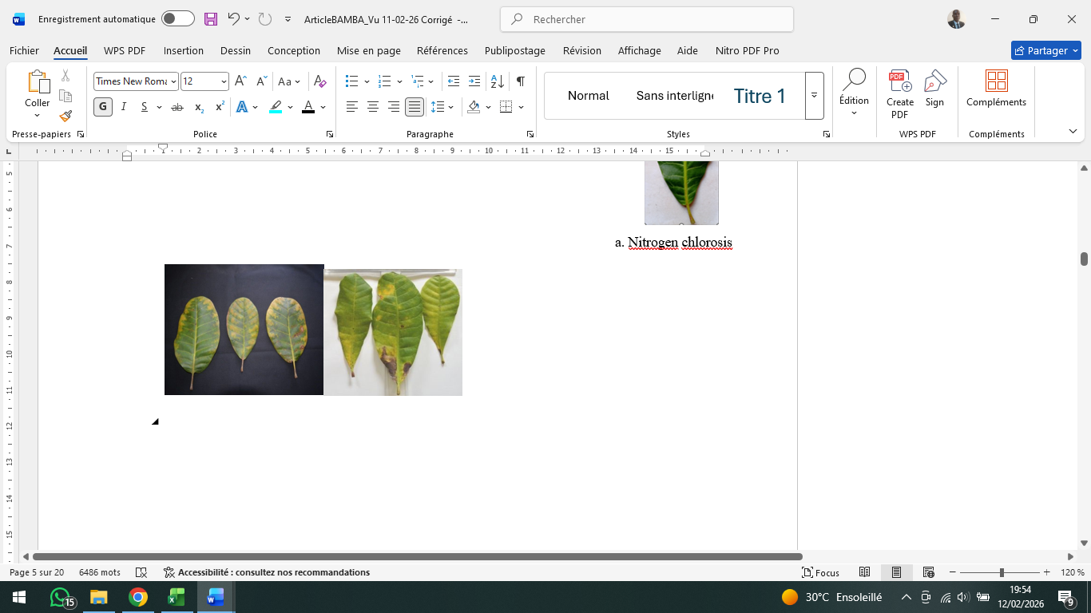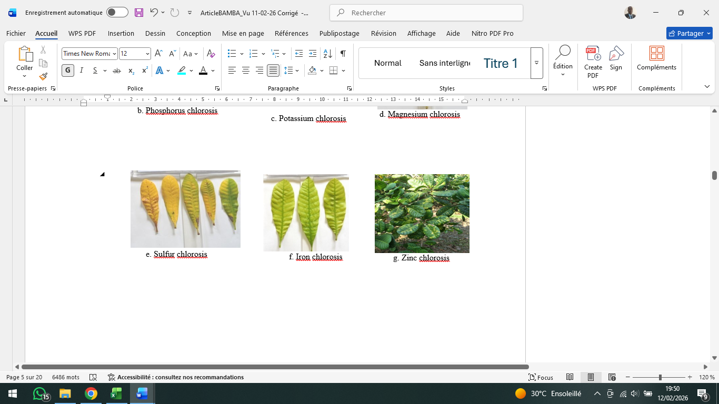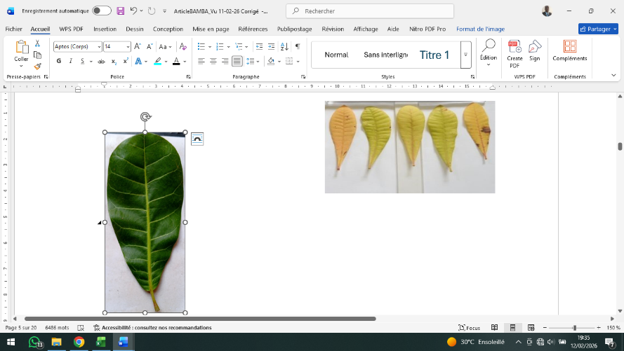
Fig. 1. Healthy leaf (a) and chlorotic leaves (b - h) of the cashew tree
Source : Shamsudheen (2018)

b. Nitrogen chlorosis
d. Potassium chlorosis
c. Phosphorus chlorosis
f. Iron chlorosis
g. Zinc chlorosis
e. Magnesium chlorosis
h. Sulfur chlorosis
a. Healthy leaf
(Absence of chlorosis)

2.3.1.2. Influence of the type of chlorosis on flowering and fruiting

Chlorosis, as well as flowering and fruiting parameters, were observed on the same plots, trees, and branches previously selected, over a period of twenty-four (24) months, corresponding to two consecutive production cycles (2023 - 2024 and 2024 - 2025), at regular intervals of fifteen (15) days. Observations were conducted on all leaves borne by the selected twigs throughout their life cycle, from emergence to senescence. On each observation date, the number of leaves affected by chlorosis, as well as the number of flowers and young fruits formed, if any, were counted on the branches selected according to cardinal directions. The variables assessed at the flowering stage included the number of flower buds (NbBoutFlor), the number of drying flowers (NbFlSéch), the number of hermaphroditic flowers (NbFlHerm), the number of male flowers (NbFlMâles), and the number of sterile flowers (NbFlStér), all determined by counting. The parameters related to fruiting were: the number of fruits (NbFr), determined by counting; the diameter at the base of the apples (DBasPom), the diameter at the top of the apples (DHautPom), the length of the apples (LgPom), the diameter at the base of the nuts (DBasNoix), the diameter at the top of the nuts (DHautNoix), and the length of the nuts (LgNoix), all measured using digital calipers. Finally, the mass of the apples (MPom) and nuts (MNoix) was measured using an electronic balance.

2.3.2. Determination of the effect of chlorosis severity on the flowering and fruiting of the cashew tree

The effect of chlorosis severity was assessed globally over the two years of experimentation, without considering its different types, using the method of Masood et al. (2010) which has been adapted. This method, based on a five-level scale (0 to 4), allows for an estimation of severity based on the proportion or extent of the affected leaf area :
  - Level 0: absence of symptoms (0%) ;
  - Level 1: mild chlorosis (< 25%) ;
  - Level 2: moderate chlorosis (25 - 49%) ;
  - Level 3: high chlorosis (50 - 75%) ;
  - Level 4: very high chlorosis (> 75%).

Based on this scale, the severity index (SI) was calculated according to the method proposed by Galanihe et al. (2010), according to the following equation:

$$SI (\%)=\frac{\sum{Xi ×Ni}}{N ×Z}×100$$
Where Xi represents the assigned severity class ; Ni the number of trees showing class Xi;
N the total number of evaluated trees; and Z the maximum value of the severity scale (Z = 4).

2.3.3. Monitoring the annual dynamics of leaf chlorosis

The annual dynamics of chlorosis were monitored every fifteen (15) days during the two years of experimentation, as previously described using the method of Bhargava and Raghupathi (1989) that was adapted to our study conditions. However, in this study, chlorosis was assessed globally, without considering its different types. The start and end dates of flowering and fruiting were recorded, as well as the number of branches bearing flowers or young fruit. These data allowed for the determination of flowering and fruiting durations, and the flowering and fruit set rates, respectively.

2.4. Statistical Analyses

Collected data were entered into a spreadsheet (Microsoft Excel) to perform descriptive statistics, including means, standard deviations, frequencies, and the construction of evolution curves. Inferential statistical analyses were performed using XLSTAT 2018 software. The normality of distributions and homogeneity of variances were verified by Shapiro-Wilk and Levene tests, respectively. Variables not meeting the normality assumption were transformed by logarithm or arcsine square root for proportions before statistical analysis. The factors studied concerned the severity level (Levels 0 to 4) and the type of chlorosis. The Student's t-test was used to study the effect of chlorosis severity on yield components due to the number of severity levels obtained (2 levels). Analysis of variance (ANOVA) was used for the effect of chlorosis types on yield components. In case of a statistically significant difference (p<0.05), mean separation was performed using the Newman-Keuls post-hoc test.

3. results and discussion

3.1 Results

3.1.1. Prevalence of chlorosis types and their influence on flowering and fruiting of cashew trees

3.1.1.1. Prevalence of identified types of chlorosis

Typological analysis of foliar chlorosis at the regional scale revealed notable disparities (Table 1). Results showed a clear predominance of nitrogen chlorosis, representing 47.25% of observed cases, constituting the modal category. Phosphorus (19.08%) and potassium (18.31%) chloroses follow in order of importance. In total, primary macronutrient deficiencies (N+P+K) account for 84.48% of cases. Conversely, deficiencies in secondary nutrients such as magnesium (4.67%), sulfur (7.28%), iron (2.48%), and zinc (0.85%) represent only 15.28%.

Table 1. Tree frequencies in percentages (%) according to chlorosis types
Mineral elements | Fe | K | Mg | S | N | P | Zn
Frequencies (%) | 2.48 | 18.31 | 4.67 | 7.28 | 47.25 | 19.08 | 0.85
Fe: iron; K: potassium; Mg: magnesium; S: sulfur; N: nitrogen; P: phosphorus; Zn: zinc

3.1.1.2. Effect of the type of chlorosis on flowering and fruiting

Regarding flowering (Table 2), zinc and iron deficiencies are distinguished by their particularly pronounced effect on the number of dried flowers (NbFlSéch). In 2023 - 2024, these two deficiencies generated the highest values, with 2891.89 ± 286.86 for zinc and 2255.64 ± 132.82 for iron. These values significantly exceed those observed for other types of chlorosis. Conversely, sulfur deficiency produced the minimum number of dried flowers (760.96 ± 190.47). This hierarchy was maintained during the 2024 - 2025 campaign, although absolute values were slightly lower: 1795.5 ± 193.84 for zinc and 1824.87 ± 152.68 for iron, compared to 1178.26 ± 168.17 for sulfur. The number of hermaphrodite flowers (NbFlHerm) also presents variable sensitivity according to the type of deficiency. During the 2024 - 2025 period, the maximum production of hermaphrodite flowers was observed in trees presenting a magnesium deficiency, with an average of 334.41 ± 46.63 flowers per tree. In contrast, zinc deficiency is associated with minimal production, reaching only 203.5 ± 39.48 hermaphrodite flowers.

Moereover, the number of fruits produced (NbFr) reveals particularly marked disparities between chlorosis types (Table 3). Zinc and iron deficiencies consistently distinguished themselves by the highest fruit productions over both campaigns. In 2023 - 2024, these deficiencies generated 103.25 ± 6.18 and 99.92 ± 3.26 fruits per tree, respectively. This trend amplified in 2024 - 2025, with productions reaching 168 ± 9.82 fruits for zinc deficiency and 154.93 ± 9.22 fruits for iron deficiency. Conversely, sulfur and phosphorus deficiencies are associated with the lowest fruit productions. Depending on the production cycles, these deficiencies generated only 26.44 to 48.96 fruits per tree (p ≤ 0.004). Dimensional parameters of apples and nuts present relative stability across chlorosis types. Basal and apical diameters of apples (DBasPom, DHautPom) as well as those of nuts (DBasNoix, DHautNoix) generally do not show significant differences according to the deficient element. Apple length (LgPom) and nut length (LgNoix) follow the same trend. Statistical significance values, ranging between p = 0.10 and p = 0.81, confirm the absence of a major differential effect of deficiency types on these dimensional parameters (Table 3). Apple mass (MPom) constitutes a notable exception to this uniformity. This parameter shows significant variations depending on the type of chlorosis encountered. In 2023 - 2024, three deficiencies stand out for their association with the highest apple masses, namely iron (111.25 ± 7.88 g), magnesium (107.52 ± 17.76 g), and zinc (107.37 ± 3.15 g). These values contrast sharply with those observed for deficiencies in sulfur (80.92 ± 3.3 g), potassium (90.2 ± 2.19 g), and phosphorus (85.56 ± 3.18 g). This hierarchy was reproduced during the 2024 - 2025 campaign, demonstrating the stability of these relationships. It also emerged that the types of chlorosis had a significant influence on nut mass (0.016 < p < 0.164). Indeed, only sulfur and phosphorus stood out in 2023 - 2024 with low values, at 6.55 ± 2.6 g and 6.81 ± 2.65 g respectively, compared to the others which recorded masses between 7.23 ± 2.22 g and 8.79 ± 0.48 g. However, during the 2024 - 2025 season, nuts weights were all statistically identical (7.24 ± 0.78 g and 8.27 ± 0.68 g).

Table 2. Effects of chlorosis types on the floral parameters of cashew trees

Campaigns | Parameters | Fe | K | Mg | S | N | P | Zn | P*
2023 - 2024 | NbBoutFlorx | 1205.07 ± 178.27 ^{b} | 1301.78 ± 141.75 ª | 1343.24 ± 100.23 ª | 1288.89 ± 125.78 ^{b} | 1323.28 ± 189.67 ª | 1104.1 ± 171.44 ^{b} | 1405.89 ± 187.76 ª | 0.001
2023 - 2024 | NbFlSéch | 2255.64 ± 132.82 ^{b} | 1332.52 ± 121.37 ^{d} | 1773.68 ± 150.46 ^{c} | 760.96 ± 190.47 ^{e} | 1588.06 ± 133.06 ^{c} | 1109.76 ± 128.83 ^{d} | 2891.89 ± 286.86 ª | 0.001
2023 - 2024 | NbFlHerm | 300.21 ± 32.76 ª | 259.45 ± 39.38 ^{b} | 292.11 ± 31.16 ª | 214.89 ± 21.89 ^{b} | 275.69 ± 36 ª | 221.86 ± 22.22 ^{b} | 282.44 ± 31.17 ª | 0.016
2023 - 2024 | NbFlMâles | 1470,11 ± 187.48 ^{b} | 1527.08 ± 131.44 ^{b} | 1508.18 ± 173.66 ^{b} | 1533.48 ± 123.25 ^{b} | 1496.94 ± 171.48 ^{b} | 1437.84 ± 140.72 ^{b} | 2274.56 ± 283,06 ª | 0.001
2023 - 2024 | NbFlStér | 113.54 ± 60 ^{b} | 114.09 ± 78.67 ^{b} | 114.71 ± 7.62 ^{b} | 119.78 ± 7.61 ª | 120.46 ± 7.49 ª | 106.18 ± 7.7 ^{b} | 126.44 ± 5.58 ª | 0.004
2024 - 2025 | NbBoutFlorx | 1403.4 ± 131.67 ª | 1454.95 ± 152.96 ª | 1483.85 ± 162.92 ª | 1337.78 ± 145.86 ^{b} | 1447.43 ± 113.1 ª | 1089.57 ± 178.59 ^{c} | 1524.1 ± 138.7 ª | 0.007
2024 - 2025 | NbFlSéch | 1824.87 ± 152.68 ª | 1452.1 ± 164.7 ^{b} | 1558.68 ± 116.29 ^{b} | 1178.26 ± 168.17 ^{c} | 1534.58 ± 172.65 ^{b} | 1323.74 ± 179.72 ^{b} | 1795.5 ± 193.84 ª | 0.003
2024 - 2025 | NbFlHerm | 258.93 ± 39.12 ^{b} | 284.85 ± 30.46 ^{b} | 334.41 ± 46.63 ª | 285.93 ± 30.32 ^{b} | 275.19 ± 31.97 ^{b} | 245.05 ± 30.41 ^{b} | 203.5 ± 39,48 ^{c} | 0.020
2024 - 2025 | NbFlMâles | 1183.3 ± 149.69 ^{b} | 1513.01 ± 149.92 ª | 1337.59 ± 123.69 ^{b} | 1647.59 ± 141.28 ª | 1381.9 ± 173.33 ^{b} | 1598.1 ± 161.3 ª | 1311.2 ± 241.4 ^{b} | 0.016
2024 - 2025 | NbFlStér | 96.03 ± 5.85 ^{b} | 119.47 ± 10.85 ª | 107.46 ± 8.66 ^{b} | 135.04 ± 8.31 ª | 117.46 ± 8.74 ª | 108.09 ± 8.23 ^{b} | 95.6 ± 6.45 ^{b} | 0.020
NbBoutFlor: Number of flower buds; NbFlSéch: Number of dried flowers; NbFlHerm: Number of hermaphrodite flowers; NbFlMâles: Number of male flowers; and NbFlStér: Number of sterile flowers.
Fe: iron; K: potassium; Mg: magnesium; S: sulfur; N: nitrogen; P: phosphorus; Zn: zinc ; P* : Probability. For the same production cycle and for the same parameter, values ​​followed by the same letter are not significantly different (Newman-Keuls, 5%).

Table 3. Influence of mineral elements deficiency on fruit parameters

Campaigns | Parameters | Fe | K | Mg | S | N | P | Zn | p*
2023 - 2024 | NbFr | 99.92 ± 3.26 ª | 61.14 ± 4.28 ^{c} | 83.56 ± 4.68 ª | 33.13 ± 2.95 ^{d} | 65.52 ± 4.96 ^{c} | 48.96 ± 4.43 ^{d} | 103.25 ± 6.18 ª | 0.004
2023 - 2024 | DBasPom (cm) | 3.66 ± 0.36 ª | 3.66 ± 0.36 ª | 3.66 ± 0.34 ª | 3.79 ± 0.31 ª | 3.76 ± 0.34 ª | 3.64 ± 0.32 ª | 3.93 ± 0.04 ª | 0.772
2023 - 2024 | DHautPom (cm) | 5 ± 0.22 ª | 4.56 ± 1.31 ª | 5.02 ± 0.37 ª | 4.37 ± 1.65 ª | 4.67 ± 1.11 ª | 4.37 ± 1.62 ª | 5.15 ± 0.14 ª | 0.401
2023 - 2024 | LgPom (cm) | 8.16 ± 0.48 ª | 7.06 ± 2.14 ª | 7.81 ± 0.58 ª | 6.42 ± 2.49 ª | 7.18 ± 1.79 ª | 6.64 ± 2.53 ª | 7.65 ± 0.43 ª | 0.207
2023 - 2024 | MPom (g) | 111.25 ± 7.88 ª | 90.23 ± 2.19 ^{b} | 107.52 ± 17.76 ª | 80.92 ± 3.3 ^{b} | 93.92 ± 26.67 ^{b} | 85.56 ± 3.18 ^{b} | 107.37 ± 3.15 ª | 0.024
2023 - 2024 | DBasNoix (cm) | 2.13 ± 0.28 ª | 1.87 ± 0.6 ª | 1.87 ± 0.34 ª | 1.82 ± 0.73 ª | 1.92 ± 0.51 ª | 1.79 ± 0.72 ª | 2.04 ± 0.56 ª | 0.381
2023 - 2024 | DHautNoix (cm) | 2.5 ± 0.37 ª | 2.24 ± 0.7 ª | 2.5 ± 0.33 ª | 2.21 ± 0.88 ª | 2.42 ± 0.64 ª | 2.27 ± 0.89 ª | 2.48 ± 0.47 ª | 0.573
2023 - 2024 | LgNoix (cm) | 3.42 ± 0.24 ª | 3.27 ± 0.95 ª | 3.54 ± 0.31 ª | 3.2 ± 1.23 ª | 3.26 ± 0.8 ª | 3.01 ± 1.12 ª | 3.38 ± 0.4 ª | 0.474
2023 - 2024 | MNoix (g) | 8.69 ± 0.83 ª | 7.23 ± 2.22 ª | 8.45 ± 1.14 ª | 6.55 ± 2.6 ^{b} | 7.63 ± 2.03 ª | 6.81 ± 2.65 ^{b} | 8.79 ± 0.48 ª | 0.016
2024 - 2025 | NbFr | 154.93 ± 9.22 ª | 68.14 ± 7.71 ^{c} | 109.65 ± 8.35 ^{b} | 26.44 ± 2.24 ^{d} | 82.41 ± 8.46 ^{b} | 43.34 ± 4.5 ^{d} | 168 ± 9.82 ª | 0.001
2024 - 2025 | DBasPom (cm) | 3.6 ± 0.4 ª | 3.65 ± 0.3 ª | 3.54 ± 0.3 ª | 3.62 ± 0.37 ª | 3.55 ± 0.34 ª | 3.52 ± 0.34 ª | 3.42 ± 0.23 ª | 0.241
2024 - 2025 | DHautPom (cm) | 4.64 ± 0.42 ª | 4.9 ± 0.38 ª | 4.93 ± 0.51 ª | 4.79 ± 0.29 ª | 4.82 ± 0.39 ª | 4.78 ± 0.32 ª | 4.58 ± 0.36 ª | 0.332
2024 - 2025 | LgPom (cm) | 8.89 ± 0.96 ª | 7.82 ± 1.11 ª | 8.51 ± 1.17 ª | 7.31 ± 0.65 ª | 7.86 ± 1.18 ª | 7.62 ± 1.06 ª | 7.74 ± 0.99 ª | 0.20
2024 - 2025 | MPom (g) | 109.01 ± 12.49 ª | 96.42 ± 14.4 ^{b} | 106.61 ± 21.27 ª | 87.8 ± 11.39 ^{b} | 104.68 ± 8.14 ª | 93.45 ± 15.73 ^{b} | 113.94 ± 6.65 ª | 0.008
2024 - 2025 | DBasNoix (cm) | 2.05 ± 0.15 ª | 2.07 ± 0.22 ª | 2.08 ± 0.22 ª | 2 ± 0.28 ª | 2.06 ± 0.23 ª | 2.04 ± 0.29 ª | 2.19 ± 0.06 ª | 0.10
2024 - 2025 | DHautNoix (cm) | 2.63 ± 0.18 ª | 2.58 ± 0.23 ª | 2.58 ± 0.17 ª | 2.57 ± 0.29 ª | 2.58 ± 0.23 ª | 2.48 ± 0.25 ª | 2.75 ± 0.09 ª | 0.81
2024 - 2025 | LgNoix (cm) | 3.68 ± 0.29 ª | 3.67 ± 0.31 ª | 3.76 ± 0.23 ª | 3.8 ± 0.37 ª | 3.67 ± 0.3 ª | 3.56 ± 0.23 ª | 3.94 ± 0.21 ª | 0.13
2024 - 2025 | MNoix (g) | 8.18 ± 1.08 ª | 7.41 ± 0.86 ª | 7.77 ± 1.03 ª | 7.24 ± 0.78 ª | 7.72 ± 1.02 ª | 7.54 ± 0.98 ª | 8.27 ± 0.68 ª | 0.164
NbFr: Number of fruits; DBasPom: Diameter at the base of the apples; DHautPom: Diameter at the top of the apples; LgPom: Length of the apples; DBasNoix: Diameter at the base of the walnuts; DHautNoix: Diameter at the top of the walnuts; LgNoix: Length of the walnuts; MPom: Mass of the apples; MNoix: Mass of the walnuts. Fe: iron; K: potassium; Mg: magnesium; S: sulfur; N: nitrogen; P: phosphorus; Zn: zinc ; P* : Probability. For the same production cycle and for the same parameter, values ​​followed by the same letter are not significantly different (Newman-Keuls, 5%).

3.1.2. Effect of chlorosis severity on flowering and fruiting

Analysis of variance showed that during the 2023 - 2024 production cycle (Table 4), there was no significant difference between severity levels regarding the studied variables, except for the number of dried flowers (NbFlSéch). Trees characterized by a high level of chlorosis produced an average of 2185.89 ± 147.97 dried flowers compared to 856.78 ± 171.59 for those with very high chlorosis. But, during the 2024 - 2025 production cycle, results showed significant difference between severity levels regarding the studied variables, with the exception of the number of hermaphrodite flowers (NbFlHerm). The very high severity of chlorosis resulted in a decrease in the number of flower buds (NbBoutFlor: 1343,7 ± 155,88), and the number of dried flowers (NbFlSéch: 1221.59 ± 139.42) compared to the high severity level.

The number of fruits (NbFr) constitutes the parameter presenting the most pronounced gap between the two severity levels (Table 5). For the 2023 - 2024 campaign, high severity allowed for a production of 99.73 ± 4.97 fruits compared to only 37.59 ± 2.63 for very high severity. These results were confirmed in 2024 - 2025 with 137.68 ± 8.3 fruits for high severity, while very high severity only yielded 33.65 ± 4.47 fruits, representing a reduction of approximately 75% in fruit production.

Regarding apple characteristics (Table 5), length (LgPom) stands out in 2023 - 2024 with 8.04 ± 0.43 cm for high chlorosis versus 6.43 ± 2.33 cm in trees with very high chlorosis. However, this difference is non-significant in 2024 - 2025. Apple mass (MPom) presents a similar pattern with 111.74 ± 7.3 g versus 78.77 ± 3.14 g in 2023 - 2024, and 116.76 ± 8.73 g versus 88.66 ± 1.28 g in 2024 - 2025, where differences remained significant. For nuts, only the mass (MNoix) revealed a significant difference in 2023 - 2024 (8.61 ± 0.69 g versus 6.63 ± 2.48 g); this difference faded during the following season.

Table 4. Impact of chlorosis severity on floral parameters
Campaigns | 2023 - 2024 |  | 2024 - 2025
Parameters | High severity | Very high severity | High severity | Very high severity
NbBoutFlor | 1280.06 ± 192.92 ª | 1287 ± 121.21 ª | 1450.23 ± 181.78 ª | 1343.7 ± 155.88 ^{b}
NbFlSéch | 2185.89 ± 147.97 ª | 856.78 ± 171.59 ^{b} | 1769.23 ± 148.64 ª | 1221.59 ± 139.42 ^{b}
NbFlHerm | 299.83 ± 39.58 ª | 231.57 ± 23.12 ª | 251.31 ± 36.86 ª | 299.83 ± 37.39 ª
NbFlMâles | 1539.11 ± 181.67 ª | 1477.18 ± 163.46 ª | 1252.79 ± 168.36 ^{b} | 1610.47 ± 154.86 ª
NbFlStér | 116.7 ± 5.23 ª | 116.68 ± 9.49 ª | 98.22 ± 5.05 ^{b} | 132.34 ± 15.5 ª
NbBoutFlor: Number of flower buds; NbFlSéch: Number of dried flowers; NbFlHerm: Number of hermaphrodite flowers; NbFlMâles: Number of male flowers; and NbFlStér: Number of sterile flowers. For the same production cycle and for the same parameter, values ​​followed by the same letter are not significantly different (Newman-Keuls, 5%). For the same production cycle and the same parameter, values followed by the same letter are not significantly different (Student's test, 5%).

Table 5. Impact of chlorosis severity on fruiting parameters
Campaigns | 2023 - 2024 |  | 2024 - 2025
Parameters | High severity | Very high severity | High severity | Very high severity
NbFr | 99.73 ± 4.97 ª | 37.59 ± 2.63 ^{b} | 137.68 ± 8.3 ª | 33.65 ± 4.47 ^{b}
DBasPom (cm) | 3.8 ± 0.33 ª | 3.65 ± 0.33 ª | 3.55 ± 0.33 ª | 3.58 ± 0.34 ª
DHautPom (cm) | 5.02 ± 0.25 ª | 4.34 ± 1.54 ª | 4.83 ± 0.48 ª | 4.81 ± 0.29 ª
LgPom (cm) | 8.04 ± 0.43 ª | 6.43 ± 2.33 ^{b} | 8.71 ± 1.04 ª | 7.2 ± 0.72 ª
MPom (g) | 111.74 ± 7.3 ª | 78.77 ± 3.14 ^{b} | 116.76 ± 8.73 ª | 88.66 ± 1.28 ^{b}
DBasNoix (cm) | 2.06 ± 0,26 ª | 1.77 ± 0.68 ª | 2.05 ± 0.19 ª | 2.07 ± 0.27 ª
DHautNoix (cm) | 2.57 ± 0.3 ª | 2.21 ± 0.83 ª | 2.61 ± 0.16 ª | 2.54 ± 0.27 ª
LgNoix (cm) | 3.45 ± 0.24 ª | 3.09 ± 1.11 ª | 3.75 ± 0.25 ª | 3.61 ± 0.32 ª
MNoix (g) | 8.61 ± 0.69 ª | 6.63 ± 2.48 ^{b} | 8.2 ± 0.86 ª | 7.2 ± 0.85 ª
NbFr: Number of fruits; DBasPom: Diameter at the base of the apples; DHautPom: Diameter at the top of the apples; LgPom: Length of the apples; DBasNoix: Diameter at the base of the walnuts; DHautNoix: Diameter at the top of the walnuts; LgNoix: Length of the walnuts; MPom: Mass of the apples; MNoix: Mass of the walnuts. For the same production cycle and for the same parameter, values followed by the same letter are not significantly different (Newman-Keuls, 5%).
3.1.3. Annual Dynamics of Leaf Chlorosis

The analysis of chlorosis and its link with cashew tree phenology highlighted a marked antagonism between foliar health status and reproductive activity (Figure 2). Flowering and fruit set occur in a distinct temporal window from that of chlorosis. Chlorosis manifests during the period from May to October of each of the two years or study campaigns; whereas flowering only begins in November, with a rapid progression from 44% in mid-November 2023 to nearly 100% between January and February. Inter-annual variability was observed. During the second cycle, flowering was earlier and more intense, reaching 78% in early November 2024, compared to 0% at the same time the previous year. Fruit set follows this dynamic with a time lag (December - February of each sutdy year). The chlorosis rate presents a recurring annual cycle, progressing from May to September, peaking at 89% in mid-August 2023 and 88% in August-September 2024. It then regresses rapidly from October to finally be null during the period from November to February.
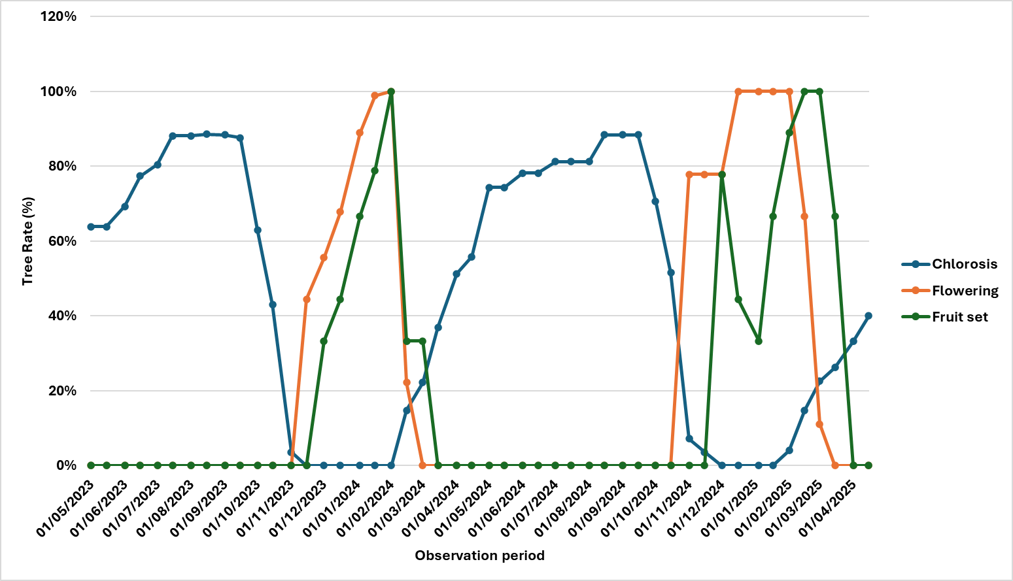

Fig. 2. Presentation of the annual dynamics of chorosis and phenological phases
of cashew trees during the two production seasons

3.2. Discussion

On the edaphic level, the typological analysis in the Bagoué region reveals a massive predominance of nitrogen deficiency (47.25%), a direct consequence of sandy soils that are poor in organic matter and have low nitrogen retention, characteristic of the zone. Concurrently, the low incidence of Iron chlorosis (2.48%) contrasts with tropical standards (Marschner, 1995), suggesting either local pedological specificity or a potential bias in visual diagnosis, masked by other deficiencies. The impact of these physiological constraints on productivity illustrates the fundamental "source-sink" relationship. The aggravation of chlorosis severity (from high to very high) leads to a yield drop of 75%, confirming the inability of a degraded foliar apparatus to support a high fruit load. Specific nutrient analysis raises a physiological paradox: Zinc and Iron deficiencies, although associated with a numerical fruit production superior to that of macronutrients, generate a high rate of floral abortion. This phenomenon is explained by the role of Zinc in pollen viability and auxin biosynthesis (Ndibanya et al., 2025); its deficiency does not inhibit induction but causes massive abscission. Conversely, Phosphorus deficiency induces the lowest production, validating its critical role in energy transfer and structural development (Kadyampakeni et al., 2019), with its deficiency limiting physiological processes well upstream of fruiting. Magnesium (Mg) deficiency, a central element of chlorophyll, favors the number of hermaphrodite flowers (NbFlHerm). This result suggests a role of Mg in hormonal or energetic balance influencing the sexual differentiation of flowers, meriting further investigation (Ruan et al., 2012). Finally, the relative stability of fruit morphometric parameters (lengths, diameters) in the face of different types of deficiencies contrasts with the high variability of floral parameters. This indicates that, once the fruit is initiated, it is not very susceptible to the specific nature of the deficiency.

Results showed that chlorosis intensity is a major determinant of final production. The transition from "high" to "very high" severity entailing a production collapse exceeding 75%. This drop is explained by the reduction of photosynthetically active leaf area. Chlorosis, characterized by chlorophyll degradation, limits the tree's capacity to fix carbon. During the fruiting phase (fruit set and nut filling), the demand for photo-assimilates is maximal ("source-sink relationship"). "Very high" chlorosis indicates a severely compromised vegetative apparatus, incapable of providing the carbohydrates necessary for nut filling, likely causing increased fruit abscission or a drastic reduction in unit nut weight (Stander et al., 2017). Low production associated with N, P, and K deficiencies confirm their status as major elements limiting primary production. Nitrogen is essential for vegetative growth and fruit protein synthesis, while phosphorus plays a key role in energy transfer (ATP) necessary for flowering and fruiting. Our results corroborate the work of Marschner (2012), who established that macronutrient deficiencies (N, P, K) impact total biomass more severely than micronutrient deficiencies, except in cases of toxicity or lethal deficiency. Regarding the cashew tree specifically, Diomandé et al. (2021) had already reported in the same region that nutritional deficiencies disrupted reproductive functions. However, the results of the present study indicate that production remains possible under Zn/Fe constraint, while it collapses under N/P/K constraint. These observations also align with FAO (2020) reports highlighting that soil fertility management, and particularly the N-P-K balance, remains the priority lever to close the "yield gap" in extensive West African farming systems.

The phenological analysis of the cashew tree, conducted over two annual cycles (2023 - 2025), highlights a strict temporal dichotomy between the vegetative phase, marked by intense chlorosis from May to October, and the reproductive phase, which extends from November to February. This temporal segregation suggests an adaptive strategy in the face of nutritional stress, aligning with the concept of phenological synchronization described by Theobald et al. (2022), where biological cycles adjust to environmental optimums. In this context, the desynchronization observed between chlorosis and flowering resembles a strategy of "phenological escape". By ensuring immediate foliar renewal before floral initiation, the tree mobilizes its reserves for reproduction before the critical expression of deficiencies. This is a mechanism that allows the tree to modulate natural selection on flowering (Fogelström et al., 2017).

4. Conclusion

This study demonstrates that in cashew orchards of the Bagoué region, nutritional constraint is a key factor limiting production, with a predominance of nitrogen deficiency. Chlorosis does not affect the type of flower. However, its severity negatively impacts flower and fruit formation. The increased severity of chlorosis resulted in a 75% reduction in the number of fruits. For nuts, only the mass was affected by chlorosis. Deficiencies in nitrogen, phosphorus, potassium, and sulfur were associated with significantly lower production levels. Chlorosis is observed primarily during the vegetative phase, between May and October, and virtually disappears during flowering and fruit set, which occur from November to February. Finally, the fact that different mineral elements distinctly affect the components of reproduction (floral viability, fruit initiation, etc.), underscores the need for accurate diagnosis and balanced fertilization, targeting not only nitrogen but also micro-elements like zinc and iron, whose deficiencies have subtle but potentially serious effects on fertility.

DISCLAIMER (ARTIFICIAL INTELLIGENCE)

Author(s) hereby declare that no generative AI technologies such as Large Language Models (ChatGPT, COPILOT, etc.) and text-to-image generators have been used during writing or editing of this manuscript.

ACKNOWLEDGEMENTS

The study was carried out at the Plant Physiology Laboratory of the Department of Plant Biology at Peleforo GON COULIBALY University (Korhogo). We would like to thank the various researchers and technicians who participated in this study.

References

- Basset, T. J. (2009). Mobile pastoralism on the brink of land privatization in northern Côte d’Ivoire. Geoforum, 40(5), 756 - 766.
- Bhargava, B. S., and Raghupathi, H. (1989). "Analysis of Plant Materials for Macro and Micronutrients". In: Methods of Analysis of Soils, Plants, Waters and Fertilizers. H. L. S. Tandon (Ed.), Fertilizer Development and Consultation Organisation (FDCO), New Delhi, Inde, pp. 49-82.
- BNETD (2026). Atlas of Côte d’Ivoire: Mapping of regions and districts. National Bureau of Studies and Development, Abidjan, Côte d’Ivoire, pp. 5-15.
- CCA (2016). Activity Report: Review of the Cashew Nut Marketing Campaign. Abidjan: CCA. P. 12.
- CNE (2023). Potential markets of Côte d’Ivoire for the cashew sector: Shelled cashew nuts. July 2023 (National Export Council), MPCI002, 10 p.
- Diomandé, L. B., Fofana, S., Ouattara, G. M., & Yao-Kouamé, A. (2021). Soil fertility management: Incidence of nutrient deficiencies on cashew tree (Anacardium occidentale L.) production in the Bagoué region, northern Côte d’Ivoire. Am. J. Innov. Res. Appl. Sci., 13(5), 550–557.
- Djaha, A. J. B., N'da, H. A., Koffi, K. E., Adopo, A. N., & Aké, S. (2014). Morphological diversity of cashew (Anacardium occidentale L.) accessions introduced in Côte d'Ivoire, Revue Ivoirienne des Science et Technologie, 23, 244 - 258.
- FAO (2020). Plant and animal products: country by product. FAOSTAT. Food and Agriculture Organization of the United Nations. www.fao.org
- FIRCA & CCA (2025). Capacity building for researchers in the field of cashew: Specifications for the selection of researchers for a national cashew research program. Interprofessional Fund for Agricultural Research and Advisory Services (FIRCA) / Cotton and Cashew Council (CCA), Abidjan, Côte d’Ivoire, 15 p.
- Fogelström, E., Olofsson, M., Posledovich, D., Wiklund, C., Dahlgren, J. P., & Ehrlén, J. (2017). Plant–herbivore synchrony and selection on plant flowering phenology. Ecology, 98(3), 703–711.
- Galanihe, L. D., Jayasundera, M. U. P., Vithana, A., Asselaarachchi, N., & Watson, G. W. (2010). Occurrence, distribution and control of papaya mealybug, Paracoccus marginatus (Hemiptera: Pseudococcidae), an invasive alien pest in Sri Lanka. Trop. Agri. Res. Ext., 13(3), 81–86. https://doi.org/10.4038/tare.v13i3.3143
- Kadyampakeni, D. M., Morgan, K. T., Schumann, A. W., Nkedi-Kizza, P., & Mahmoud, K. (2019). Phosphorus (P) for citrus trees (EDIS Publication No. SL463). Soil and Water Sciences Department, University of Florida, IFAS Extension. edis.ifas.ufl.edu, 5 p.
- Madden, L. V., & Hughes, G. (1996). Sampling for plant disease incidence. Phytopathology, 86(3), 256-267. www.apsnet.org
- Marschner, H. (1995). Mineral nutrition of higher plants (2e éd.). Academic Press, Londres, Royaume-Uni, pp. 229 – 299.
- Marschner, H. (2012). Marschner's mineral nutrition of higher plants (3rd ed.). Academic Press.
- Masood, A., Shafqat S., Naeem I., Muhammad T. M., & Munawer, R. K. (2010). Methodology for the evaluation of symptom severity of mango sudden death syndrome in Pakistan. Pak. J. Bot., 42(2), 1289–1299.
- Ndibanya, K. N., Kabanza, A. K., Mzena, G. P., Nene, W. A., Andrea, S. M., Makale, A. R., & Mbasa, W. V. (2025). Cashew agronomic practices for research and improving productivity in Tanzania. Tanzania Agricultural Research Institute (TARI), Naliendele, 84 p.
- NHB (2022). Horticultural Statistics at a Glance 2021 (National Horticulture Board). Ministry of Agriculture & Farmers Welfare, Government of India. P. 188.
- RONGEAD (2014). Cashew Nut Buyer's Manual: Understanding, Evaluating and Analyzing the Quality of Raw Cashew Nuts. Cashew Nut Sector Support Program (PAFA), 36 p.
- Ruan J., Gerendás, J., & Härdter, R. (2012). Effect of nitrogen form and root-zone pH on growth and nitrogen uptake of tea (Camellia sinensis) plants. Ann. Bot., 99(2), 301 - 310.
- Shamsudheen, M. (2018). Ad hoc recommendations on nutrient deficiency management in cashew. ICAR-Directorate of Cashew Research, E-publication no. 1/2018, Puttur, 7 p.
- Sika Finance (2026). Cashew nuts: Ivorian production exceeded 1.5 million tons in 2025. www.sikafinance.com, paragraph 3.
- Theobald, E. J., Breckheimer I., & Hille, R. L. J. (2017). Climate drives phenological reassembly of a mountain wildflower meadow community. Ecology, 98(11), 2799 - 2812.
- Stander, O. P. J., Theron, K. I., & Cronje, P. J. R. (2017). "Foliar applications of cytokinins and gibberellins alleviate photoinhibition and enhance yield of ‘Nadorcott’ mandarin". Journal of Applied Botany and Food Quality, vol. 90, pp. 248 - 256.

