Early-Stage Screening of Drought Tolerant Rice Seedlings Using Mannitol-Induced Stress and PCA
ABSTRACT
Drought stress is a major limitation to rice productivity, and its increasing frequency under changing climatic conditions necessitates the identification of drought-tolerant genotypes. The present study investigated the mannitol induced drought response of 20 rice genotypes grown under hydroponics system at the seedling stage. After 21 days stress imposition parameters were analyzed. An increased root elongation but contrastingly decreased root dry weight due to altered carbon allocation was reported in 1% mannitol treated seedlings. While a marked reduction in root and shoot growth and chlorophyll content, reflecting impaired cell expansion and reduced photosynthetic efficiency in 2% mannitol. Further more the principal component analysis was used to screen the genotypes which explained 53.8% of the total variation, and separated genotypes into tolerant, moderately tolerant, and susceptible groups. Genotypes Vandana, FL478, Binnaful, and Katakchikon consistently maintained superior root performance, biomass retention, and physiological stability under stress, whereas IR29, AC-35678, IC-516366, Ravana, and Kangri were highly sensitive. Overall, the integrated evaluation of morphological and physiological traits proved effective for early-stage drought screening and identified promising donor genotypes for rice drought-tolerance breeding programs.
Keywords: Drought stress, Drought-tolerant genotypes, Principal component analysis, Biomass retention

INTRODUCTION
Rice is a primary staple food for more than half of the world’s population and contributes over 75% of the caloric intake in several developing countries (Rahman and Zhang, 2016). Global rice production reached approximately 787.3 million tons in 2021 (FAO, 2024) largely due to advances in agrotechnologies and genetic improvement. However, enhancing rice tolerance to environmental stresses remains crucial for sustaining productivity under changing climatic conditions (Dhankher & Foyer, 2018). Rice is predominantly cultivated in warm and humid regions, where climate-related extremes such as flooding and drought frequently disrupt plant growth and development, leading to substantial yield losses worldwide. At present, more than one-third of the global rice-growing area is affected by drought stress, including 33% in developing countries, 25% in developed countries and 42% in underdeveloped regions (FAO, 2014). There are growing concerns about whether the current rate of rice production growth in certain regions of the world, along with existing technologies, will be sufficient to meet the projected global demand for rice by 2050 (Samal et al., 2022).

India experienced an exceptional drought during the 2022 monsoon season, marked by a pronounced rainfall deficit across the Gangetic plains between July and August. This event led to an estimated 5% reduction in the area under rice cultivation and a projected decline of about 6.3 million tons in rice production (USDA, 2022). Notably, nearly 68% of India’s cultivable land is susceptible to drought and moderate to severe droughts recur across the country every three to four years (Rao et al., 2019). Between 2002 and 2016, India alone faced six major drought episodes (Kala et al., 2017), while the 2014-2015 drought caused a 4.7% reduction in total agricultural output and severely disrupted the livelihoods of approximately 330 million farming households during 2015–2016 (Bhatt et al., 2024).
The impacts of drought are especially pronounced in vulnerable states such as Chhattisgarh, Jharkhand, and Odisha, where average production losses reached nearly 40%, resulting in economic damages estimated at around USD 800 million (Bhandari et al., 2007). Recurrent droughts not only reduce crop yields but also influence farmers’ decisions regarding investment in agricultural inputs and discourage the adoption of improved technologies, thereby constraining productivity growth and income enhancement (Ward et al., 2018). At a broader scale, droughts intensify economic instability, deepen rural poverty, increase indebtedness, and pose serious threats to national food and nutritional security. For example, the drought of 2014 caused economic losses of nearly USD 30 billion and contributed to a 1.7% decline in India’s GDP (Carpena et al., 2019).
Screening rice genotypes for drought tolerance at the seedling stage provides a rapid, reliable, and cost-effective means to differentiate drought-adaptive lines early in the breeding pipeline. Early drought responses influence plant establishment, root development, and physiological resilience, which are predictive of later performance under water deficit (Blum, 2011). The use of mannitol to induce osmotic stress creates a controlled simulation of drought conditions, allowing clear discrimination between tolerant and sensitive genotypes without field variability (Verslues et al., 2006). Combining seedling screening with advanced phenotyping and physiological assessments improves the accuracy and efficiency of identifying superior genotypes for breeding programmes (Swamy et al., 2012). Developing drought-tolerant rice varieties through these methods can enhance yield stability under water-limited conditions and reduce production risks for farmers in drought-prone environments, contributing to sustainable food security (Singh et al., 2025).
Material and Method
The experiment was conducted at department of Plant Physiology, College of Basic Sciences and Humanities, GBPUA&T, following a factorial completely randomized design (CRD) using two factors, rice genotypes (20) and concentrations of mannitol (1% and 2%) with three replications. The genotypes were obtained from Indian Institute of Rice Research, Hyderabad and screened at seedling level for drought tolerance in hydroponic panel. Before commencement of experiment seeds were surface sterilized for 30 seconds using 1% sodium hypochlorite (NaOCl), followed by thorough rinsing and then incubated for 48 hours to promote uniform germination. Pre-germinated seeds were transferred to hydroponics panel having Hoagland solution (Yoshida et al, 1976) for 5 days and then stress was imposed for 21 days which was comprised two drought stress level (1 and 2% mannitol). To maintain the pH, the solution was checked every day and replaced if the pH shifted too far.
The shoot length (SL) and root length (RL) were measured using a scale in centimeters. The seedling dry weight was measured in (mg) using digital weighing balance. The total chlorophyll was estimated by following formula using DMSO method described by Hiscox et al, 1979 .
Total chlorophyll= $\frac{\left(20.2X A645)+(8.02XA663\right)X V}{Weight \left(g\right)X 1000}$
To determine the significance of treatment effects, data were subjected to statistical evaluation using analysis of variance. Data processing and preliminary analyses were carried out in Microsoft Excel, while graphical representation and Pearson’s correlation analysis among measured traits were performed using OriginPro software.
3. Result
3.1 Effect of mannitol simulated drought stress on root length and root weight and root weight
Root length of twenty rice genotypes varied significantly under control and mannitol-induced drought stress conditions (Table 1; Figure 1). Under control conditions, root length ranged from 4.00 cm in NAVEEN to 9.33 cm in KATAKCHIKON, indicating substantial inherent variability among the genotypes. Imposition of 1% mannitol-induced drought stress resulted in diverse responses, with several genotypes exhibiting enhanced root elongation, while others showed a decline in root growth. At 1% mannitol, pronounced increases in root length were recorded in Fl478 (76.4%), VANDANA (70.8%), KANGRI (60.0%), BINNAFUL (51.4%), IC-516 366 (51.85%), CR-3439-4-E-17-2-1-B-1-S-1 (44.51%), and MORISHAL (42.22%) compared to the control. This enhancement in root length under drought stress suggests an adaptive response that may facilitate improved access to available moisture. In contrast, genotypes such as IET-18716, AC-35678, KATAKCHIKON, and NICRA 17 exhibited a reduction in root length, indicating sensitivity to drought stress at this concentration. Under 2% mannitol-induced drought stress, a general reduction in root length was observed in most genotypes relative to the control. The maximum decrease was recorded in IET-18716 (61.40%), followed by NICRA 17 (59.64%), CR-3439-4-E-17-2-1-B-1-S-1 (52.60%), RAVANA (48.79%), and AC 85 (47.37%), reflecting a strong inhibitory effect of increased drought stress on root growth. Nevertheless, certain genotypes maintained comparatively higher root length under 2% mannitol. BINNAFUL recorded the highest root length (11.80 cm) with a 44.43% increase over control, followed by VANDANA (60.0% increase) and Fl478 (55.73% increase). The ability of these genotypes to sustain root elongation under drought stress indicates superior adaptive potential.
Table 1: Effect of Mannitol simulated drought stress on root length (cm) in different rice genotypes
S.no | Name of the genotypes | Root length (cm)
S.no | Name of the genotypes | (Control) | (1% Mannitol) | % Change | (2% Mannitol) | % Change
1 | IET-18727 | 6.17 ± 0.29 | 7.23± 0.25 | 17.30 ↑ | 3.20±0.20 | 48.11↓
2 | NAVEEN | 4.00 ± 0.00 | 4.17±0.29 | 4.25↑ | 4.33±0.12 | 1.67↓
3 | IET-18716 | 7.17 ± 0.29 | 5.83±0.29 | 18.60↓ | 2.77±0.25 | 61.40↓
4 | AC-35678 | 5.17 ± 0.29 | 4.17±0.29 | 19.35 ↓ | 3.00±0.00 | 41.94↓
5 | Fl478 | 5.67 ± 0.58 | 10.00±0.20 | 76.4↑ | 8.83±0.29 | 55.73↑
6 | IC-516 366 | 4.50 ± 0.50 | 6.83±0.58 | 51.85↑ | 3.13±0.15 | 30.37↓
7 | AC 85 | 6.33 ± 0.29 | 6.50±0.50 | 2.63↑ | 3.33±0.29 | 47.37↓
8 | RAVANA | 8.27 ± 0.25 | 9.47±0.35 | 14.52↑ | 4.23±0.21 | 48.79↓
9 | MORISHAL | 7.50 ± 0.50 | 10.67±0.58 | 42.22↑ | 5.17±0.15 | 31.11↓
10 | SUGA PANKHA | 6.57 ± 0.12 | 7.52±0.00 | 6.60↑ | 4.30±0.26 | 34.52↓
11 | RASHPANJOR | 7.17 ± 0.29 | 7.00±0.00 | 2.33↓ | 4.07±0.12 | 43.26↓
12 | AUS 301 | 5.93 ± 0.12 | 8.07±0.12 | 35.96↑ | 3.57±0.51 | 39.89↓
13 | KATAKCHIKON | 9.33 ± 0.58 | 8.00±0.00 | 14.29↓ | 6.67±0.58 | 28.57↓
14 | KANGRI | 5.00 ± 0.00 | 8.25±0.00 | 60.00↑ | 4.63±0.32 | 7.33↓
15 | BINNAFUL | 8.17 ± 0.29 | 12.37±0.58 | 51.40↑ | 11.80±0.20 | 44.43↑
16 | NICRA 16 | 5.33 ± 0.58 | 7.30±0.36 | 36.88↑ | 4.73±0.35 | 11.25↓
17 | VANDANA | 5.27 ± 0.25 | 9.00±0.58 | 70.8↑ | 8.43±0.40 | 60.0↑
18 | NICRA 17 | 7.43 ± 0.12 | 5.67±0.58 | 23.77↓ | 3.00±0.30 | 59.64↓
19 | CR-3439-4-E-17-2-1-B-1-S-1 | 5.77 ± 0.25 | 8.33±0.58 | 44.51↑ | 2.73±0.25 | 52.60↓
20 | IR29 | 5.17 ± 0.29 | 7.17±0.29 | 38.68↑ | 4.10±0.17 | 20.69↓
 |  | Genotype |  | Treatment |  | TXG
 | S.Em± | 0.115 |  | 0.045 |  | 0.560
 | CD at 5 % | 0.323 |  | 0.125 |  | 0.200

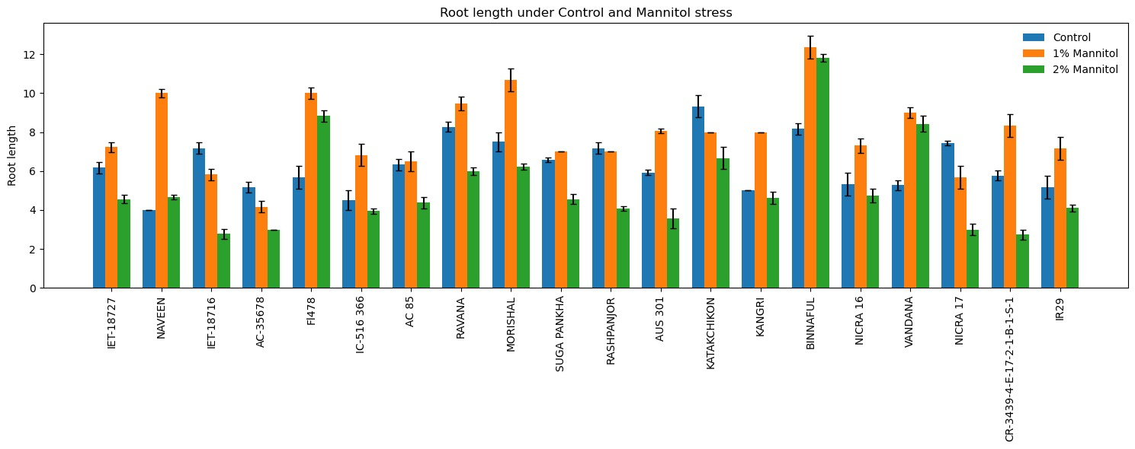
Fig. 1: Graph showing the Effect of Mannitol simulated drought stress on root length (cm) in different rice genotypes.
3.2 Effect of mannitol simulated drought stress on root dry weight
Root dry weight (RDW) of twenty rice genotypes showed significant variation under control and mannitol-induced drought stress conditions (Table 2; Figure 2). Under control conditions, RDW ranged from 5.26 mg in NICRA 16 to 19.22 mg in BINNAFUL, indicating wide inherent variability in root biomass accumulation among the rice genotypes. Imposition of mannitol-induced drought stress resulted in a progressive reduction in RDW in most genotypes, with the magnitude of reduction increasing with mannitol concentration. At 1% mannitol, RDW reduction varied from 4.94% (NICRA 16) to 44.80% (AC-35678) compared to the control. Genotypes such as AC 85 (15.60%), SUGA PANKHA (15.82%), KATAKCHIKON (16.67%), VANDANA (18.28%), BINNAFUL (19.15%), and KANGRI (19.52%) exhibited relatively lower reductions, indicating better maintenance of root biomass under drought stress. In contrast, substantial reductions were recorded in IET-18716 (41.15%), AC-35678 (44.80%), Fl478 (39.01%), NICRA 17 (39.30%), and CR-3439-4-E-17-2-1-B-1-S-1 (37.00%), reflecting higher sensitivity at this stress level. Under 2% mannitol-induced drought stress, a pronounced decline in RDW was observed across most genotypes. The highest reduction was recorded in KANGRI (77.69%), followed by IR29 (76.17%), NICRA 17 (75.72%), BINNAFUL (75.44%), and MORISHAL (71.25%), indicating strong inhibition of root biomass accumulation under drought stress. Comparatively lower reductions were observed in AC 85 (33.68%), VANDANA (32.10%), KATAKCHIKON (34.22%), and RASHPANJOR (39.99%), suggesting relatively better root dry matter retention under drought conditions.
Table 2: Effect of Mannitol simulated drought stress on Root dry weight (RDW) in different rice genotypes
S.no | Name of the genotypes | RDW (mg)
S.no | Name of the genotypes | Control | 1% Mannitol | %  Reduction | 2% Mannitol | % Reductio n
1 | IET-18727 | 6.37±0.45 | 5.13±0.23 | 19.36 | 3.39±0.40 | 46.74
2 | NAVEEN | 5.41±0.36 | 3.68±0.41 | 31.92 | 2.44±0.10 | 54.78
3 | IET-18716 | 6.37±0.34 | 3.75±0.39 | 41.15 | 2.56±0.41 | 59.84
4 | AC-35678 | 8.73±0.13 | 4.82±0.23 | 44.80 | 3.50±0.19 | 59.96
5 | Fl478 | 10.70±0.28 | 6.52±0.27 | 39.01 | 4.85±0.17 | 54.66
6 | IC-516 366 | 7.72±0.09 | 5.12±0.08 | 33.65 | 4.04±0.06 | 47.73
7 | AC 85 | 7.54±0.50 | 6.36±0.27 | 15.60 | 5.00±0.00 | 33.68
8 | RAVANA | 12.37±0.04 | 9.02±0.45 | 27.07 | 6.66±0.16 | 46.12
9 | MORISHAL | 7.10±0.17 | 5.27±0.25 | 25.74 | 2.04±0.07 | 71.25
10 | SUGA PANKHA | 8.42±0.32 | 7.09±0.08 | 15.82 | 4.25±0.11 | 49.58
11 | RASHPANJOR | 8.57±0.21 | 6.07±0.12 | 29.15 | 5.14±0.17 | 39.99
12 | AUS 301 | 7.56±0.25 | 5.12±0.08 | 32.33 | 3.11±0.19 | 58.87
13 | KATAKCHIKON | 6.00±0.00 | 5.00±0.00 | 16.67 | 3.95±0.06 | 34.22
14 | KANGRI | 9.46±0.27 | 7.62±0.34 | 19.52 | 2.11±0.19 | 77.69
15 | BINNAFUL | 19.22±0.19 | 15.54±0.11 | 19.15 | 4.72±0.36 | 75.44
16 | NICRA 16 | 5.26±0.23 | 5.00±0.00 | 4.94 | 3.11±0.19 | 40.85
17 | VANDANA | 10.28±0.25 | 8.40±0.45 | 18.28 | 6.98±0.26 | 32.10
18 | NICRA 17 | 8.24±0.21 | 5.00±0.00 | 39.30 | 2.00±0.00 | 75.72
19 | CR-3439-4-E-17-2-1-B-1-S-1 | 7.36±0.39 | 4.64±0.20 | 37.00 | 2.71±0.12 | 63.18
20 | IR29 | 8.39±0.21 | 5.48±0.37 | 34.68 | 2.00±0.00 | 76.17
 |  | GENOTYPE |  | TREATMENT |  | TXG
 | S.Em± | 0.083 |  | 0.032 |  | 0.143
 | CD at 5 % | 0.231 |  | 0.090 |  | 0.401

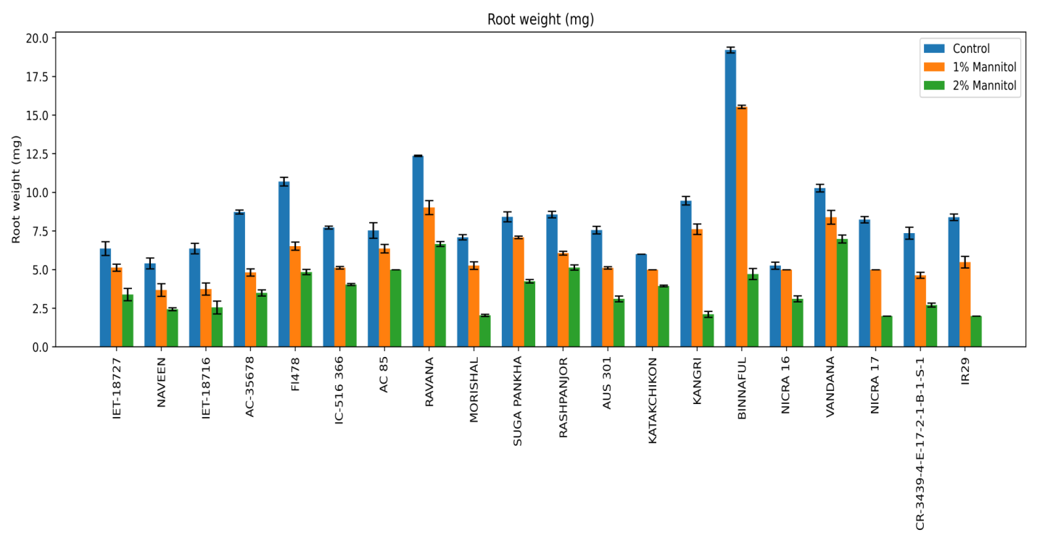
Fig. 2: Graph showing the Effect of Mannitol simulated drought stress on Root dry weight (RDW) in different rice genotypes
3.3 Effect of mannitol simulated drought stress on shoot length
Shoot length of rice seedlings was significantly affected by mannitol-induced drought stress across all twenty genotypes (Table 3; Figure 3). Under control conditions, substantial variation in shoot length was observed among the genotypes, reflecting inherent differences in seedling growth potential. The shoot length ranged from 13.30 cm in Fl478 to 29.17 cm in Binnaful, indicating wide genetic variability under non-stress conditions. Exposure to 1% mannitol resulted in a clear reduction in shoot length in all genotypes when compared with the control. However, the magnitude of reduction varied considerably among genotypes, indicating differential responses to drought stress. The percentage reduction in shoot length ranged from 12.28% in Fl478 to 77.12% in IR29. Genotypes such as FL478, Binnaful, Vandana and Kangri showed comparatively lower reductions in shoot length, suggesting better maintenance of shoot growth under drought stress. In contrast, IR29 exhibited the highest reduction, followed by Suga Pankha and Rashpanjor, indicating greater sensitivity to drought stress. A further decline in shoot length was observed at 2% mannitol in all genotypes. The percentage reduction under this treatment ranged from 43.33% in Kangri to 84.19% in IR29. Several genotypes, including Kangri, Vandana, Binnaful and Katakchikon, maintained relatively higher shoot length under increased drought stress conditions, whereas IR29, Rashpanjor, Nicra 17, Morishal and CR-3439-4-E-17-2-1-B-1-S-1 recorded substantial reductions in shoot growth, indicating poor tolerance. The graphical representation (Fig. 3) clearly demonstrates a progressive decrease in shoot length with increasing mannitol concentration across all genotypes. Although all genotypes exhibited growth inhibition under drought stress, the extent of reduction differed markedly, highlighting considerable genetic variability in drought response at the seedling stage.
Table 3: Effect of Mannitol simulated drought stress on shoot length (cm) in different rice genotypes
S.no. | Name of the genotypes | Shoot length (cm)
S.no. | Name of the genotypes | (Control) | (1% Mannitol) | % Reduction | (2% Mannitol) | % Reductio n
1 | IET-18727 | 24.77±0.35 | 14.93±0.12 | 39.70 | 10.17±0.76 | 58.95
2 | NAVEEN | 23.33±0.58 | 15.33±0.58 | 34.29 | 9.00±0.00 | 61.43
3 | IET-18716 | 22.87±0.32 | 13.33±0.58 | 41.69 | 8.50±0.50 | 62.83
4 | AC-35678 | 17.93±0.12 | 9.77±0.25 | 45.54 | 7.27±0.31 | 59.48
5 | Fl478 | 13.30±0.30 | 11.67±0.58 | 12.28 | 5.17±0.29 | 61.15
6 | IC-516 366 | 16.47±0.50 | 9.83±0.29 | 40.28 | 5.83±0.29 | 64.57
7 | AC 85 | 23.93±0.31 | 16.77±0.25 | 29.94 | 10.43±0.51 | 56.41
8 | RAVANA | 15.47±0.42 | 11.00±0.50 | 28.88 | 7.90±0.26 | 48.92
9 | MORISHAL | 19.50±0.50 | 11.00±0.00 | 43.59 | 5.77±0.68 | 70.43
10 | SUGA PANKHA | 18.67±0.58 | 8.37±0.40 | 55.18 | 5.87±0.15 | 68.57
11 | RASHPANJOR | 25.10±0.17 | 12.33±0.58 | 50.86 | 6.10±0.17 | 75.70
12 | AUS 301 | 22.50±0.50 | 13.00±0.00 | 42.22 | 7.53±0.45 | 66.52
13 | KATAKCHIKON | 24.50±1.00 | 17.33±0.58 | 29.25 | 11.67±0.58 | 52.38
14 | KANGRI | 21.00±0.00 | 16.17±0.29 | 23.02 | 11.90±0.56 | 43.33
15 | BINNAFUL | 29.17±0.76 | 24.97±0.15 | 14.40 | 14.50±0.50 | 50.29
16 | NICRA 16 | 21.70±0.30 | 12.00±0.50 | 44.70 | 7.00±0.62 | 67.74
17 | VANDANA | 18.67±0.58 | 14.83±0.76 | 20.57 | 10.23±0.32 | 45.20
18 | NICRA 17 | 18.17±0.76 | 13.67±0.29 | 24.77 | 5.57±0.12 | 69.36
19 | CR-3439-4-E-17-2-1-B-1-S-1 | 24.10±0.17 | 12.53±0.25 | 47.99 | 7.27±0.25 | 69.85
20 | IR29 | 24.03±0.25 | 5.50±0.50 | 77.12 | 3.80±0.35 | 84.19
 |  | Genotype |  | Treatment |  | TXG
 | S.Em± | 0.150 |  | 0.058 |  | 0.259
 | CD at 5 % | 0.420 |  | 0.163 |  | 0.727

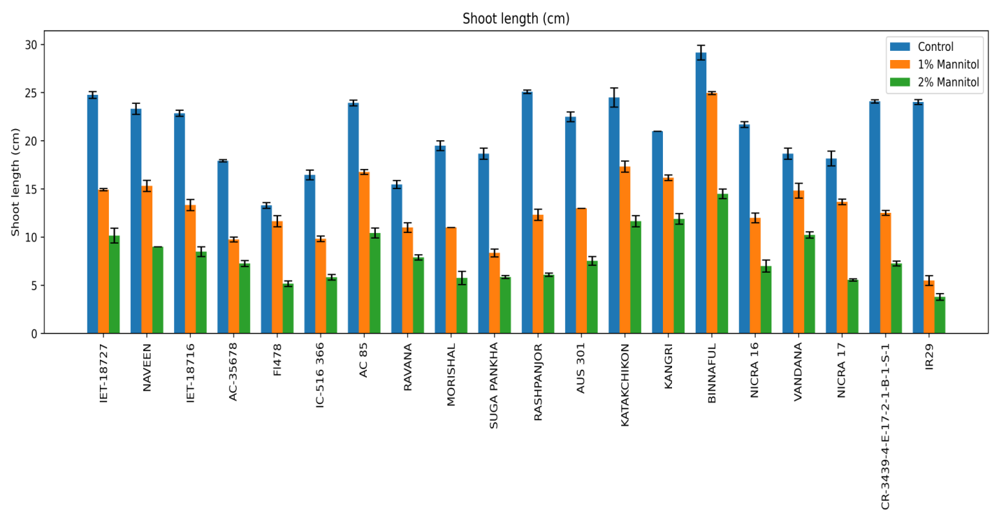
Fig. 3: Graph showing the Effect of Mannitol simulated drought stress on shoot length (cm) in different rice genotypes
3.4 Effect of mannitol simulated drought stress on shoot dry weight
Shoot dry weight of rice seedlings was significantly influenced by mannitol-induced drought stress across all twenty genotypes (Table 4; Figure 4). Under control conditions, considerable variation in shoot dry matter accumulation was observed among the genotypes, reflecting inherent differences in biomass production at the seedling stage. Shoot dry weight ranged from 10.21 mg in CR-3439-4-E-17-2-1-B-1-S-1 to 33.42 mg in Binnaful, indicating substantial genetic variability under non-stress conditions. Exposure to 1% mannitol resulted in a significant reduction in shoot dry weight in all genotypes when compared with the control. However, the extent of reduction varied among genotypes, with percentage reductions ranging from 13.49% in Rashpanjor to 31.20% in Morishal. Several genotypes, including Ravana, Katakchikon, Aus 301 and Binnaful, exhibited comparatively lower reductions in shoot dry weight, indicating better maintenance of biomass under drought stress. In contrast, Morishal, Fl478, Nicra 17 and CR-3439-4-E-17-2-1-B-1-S-1 recorded relatively higher reductions, suggesting greater sensitivity of dry matter accumulation to drought conditions. A further decline in shoot dry weight was observed at 2% mannitol in all genotypes. The percentage reduction under this treatment ranged from 26.38% in Katakchikon to 66.54% in Fl478. Genotypes such as Katakchikon, Kangri, Vandana, AC 85 and Suga Pankha maintained comparatively higher shoot dry weight under increased drought stress, whereas Fl478, IET-18727, AC-35678, Morishal and IR29 showed pronounced reductions, indicating poor ability to sustain dry matter accumulation under stress conditions. The graphical representation (Fig. 4) illustrates a consistent decline in shoot dry weight with increasing mannitol concentration across all genotypes. Although all genotypes exhibited reduced biomass under drought stress, the magnitude of reduction differed significantly, demonstrating clear genotypic variation in dry matter partitioning under limited water availability.
Table 4: Effect of Mannitol simulated drought stress on Shoot dry weight (mg) in different rice genotypes
S.no. | Name of the genotypes | Shoot Dry Weight (mg)
S.no. | Name of the genotypes | (Control) | (1% Mannitol) | % Reducti on | (2% Mannitol) | % Redu ction
1 | IET-18727 | 24.55±0.12 | 19.38±0.33 | 21.04 | 10.25±0.23 | 58.22
2 | NAVEEN | 26.12±0.21 | 20.54±0.30 | 21.39 | 12.55±0.53 | 51.97
3 | IET-18716 | 14.26±0.27 | 11.26±0.17 | 21.03 | 9.11±0.19 | 36.12
4 | AC-35678 | 19.76±0.11 | 15.26±0.33 | 22.77 | 8.32±0.37 | 57.88
5 | Fl478 | 25.64±0.19 | 18.18±0.31 | 29.10 | 8.58±0.08 | 66.54
6 | IC-516 366 | 26.43±0.11 | 21.00±0.35 | 20.57 | 15.39±0.35 | 41.79
7 | AC 85 | 12.32±0.46 | 10.00±0.00 | 18.83 | 8.57±0.51 | 30.47
8 | RAVANA | 21.21±0.18 | 17.66±0.11 | 16.72 | 13.00±0.00 | 38.70
9 | MORISHAL | 19.53±0.28 | 13.44±0.30 | 31.20 | 8.59±0.33 | 56.04
10 | SUGA PANKHA | 15.16±0.17 | 12.36±0.14 | 18.51 | 9.95±0.09 | 34.40
11 | RASHPANJOR | 12.26±0.06 | 10.61±0.28 | 13.49 | 8.00±0.00 | 34.77
12 | AUS 301 | 18.03±0.05 | 15.41±0.36 | 14.55 | 10.37±0.28 | 42.50
13 | KATAKCHIKON | 20.32±0.32 | 17.00±0.00 | 16.34 | 14.96±0.61 | 26.38
14 | KANGRI | 25.75±0.08 | 20.40±0.22 | 20.76 | 17.41±0.22 | 32.40
15 | BINNAFUL | 33.42±0.09 | 27.70±0.34 | 17.11 | 18.54±0.47 | 44.54
16 | NICRA 16 | 13.35±0.37 | 10.42±0.31 | 21.97 | 8.63±0.09 | 35.38
17 | VANDANA | 22.39±0.34 | 18.14±0.25 | 18.97 | 15.22±0.39 | 32.02
18 | NICRA 17 | 12.28±0.26 | 8.70±0.17 | 29.15 | 7.58±0.23 | 38.32
19 | CR-3439-4-E-17-2-1-B-1-S-1 | 10.21±0.28 | 7.27±0.47 | 28.79 | 6.24±0.21 | 38.94
20 | IR29 | 11.56±0.12 | 9.40±0.23 | 18.65 | 7.00±0.00 | 39.44
 |  | GENOTYPE |  | TREATMENT |  | TXG
 | S.Em± | 0.092 |  | 0.036 |  | 0.159
 | CD at 5 % | 0.257 |  | 0.100 |  | 0.446

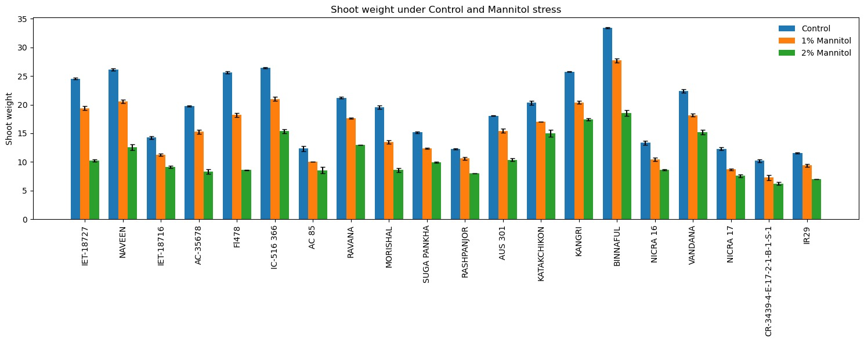Fig. 4: Graph showing the Effect of Mannitol simulated drought stress on Shoot dry weight (mg) in different rice genotypes
3.5 Effect of Mannitol simulated drought stress on Total Chlorophyll Content
Total chlorophyll content of rice seedlings was significantly affected by mannitol-induced drought stress across all twenty genotypes (Table 5; Figure 5). Under control conditions, considerable variation in chlorophyll content was observed among the genotypes, indicating differences in photosynthetic pigment accumulation. The total chlorophyll content ranged from 0.436 µg mg⁻¹ FW in Fl478 to 3.162 µg mg⁻¹ FW in Vandana, reflecting substantial genetic variability under non-stress conditions. Application of 1% mannitol caused a marked decline in total chlorophyll content in all genotypes when compared with the control. The percentage reduction ranged from 25.99% in AUS 301 to 94.23% in Nicra 17, indicating wide variation in chlorophyll stability under drought stress. Relatively lower reductions were observed in AUS 301, Ravana and Morishal, suggesting a comparatively better ability to retain chlorophyll pigments under stress conditions. In contrast, genotypes such as Nicra 17, AC 35678, AC 85, Suga Pankha and Binnaful exhibited pronounced losses in chlorophyll content, indicating higher sensitivity of the photosynthetic apparatus to drought stress. A further decrease in total chlorophyll content was recorded at 2% mannitol across all genotypes. The percentage reduction under this treatment ranged from 52.03% in Kangri to 98.18% in AC 85. Genotypes such as Kangri and Nicra 16 showed comparatively lower reductions in chlorophyll content, suggesting better pigment retention under increased drought stress. However, most genotypes exhibited severe depletion of chlorophyll, with marked reductions observed in AC 85, Vandana, Suga Pankha, Ravana, Morishal and AUS 301, indicating strong inhibition of chlorophyll biosynthesis or enhanced pigment degradation under stress conditions. The graphical representation clearly illustrates a progressive decline in total chlorophyll content with increasing mannitol concentration in all genotypes. Although a consistent reduction trend was evident, the magnitude of decrease differed significantly among genotypes, highlighting considerable genetic variation in photosynthetic pigment stability under drought stress.
Table 5: Effect of Mannitol simulated drought stress on Total Chlorophyll Content (µg/mg FW) in different rice genotypes
S.no | Name of the genotypes | Total Chlorophyll Content (µg/mg FW)
S.no | Name of the genotypes | (Control) | (1% Mannitol) | % Reduction | (2% Mannitol) | % Reduction
1 | IET-18727 | 0.643±0.027 | 0.187±0.005 | 70.908 | 0.154±0.004 | 76.10
2 | NAVEEN | 0.884±0.017 | 0.165±0.002 | 81.392 | 0.137±0.004 | 84.54
3 | IET-18716 | 0.576±0.008 | 0.285±0.001 | 50.570 | 0.057±0.005 | 90.18
4 | AC-35678 | 2.436±0.494 | 0.213±0.005 | 91.235 | 0.132±0.002 | 94.59
5 | Fl478 | 0.436±0.017 | 0.085±0.003 | 80.494 | 0.034±0.000 | 92.28
6 | IC-516 366 | 0.438±0.086 | 0.085±0.004 | 80.602 | 0.072±0.001 | 83.47
7 | AC 85 | 1.561±0.224 | 0.166±0.003 | 89.352 | 0.028±0.001 | 98.18
8 | RAVANA | 0.902±0.129 | 0.312±0.003 | 65.380 | 0.039±0.006 | 95.71
9 | MORISHAL | 1.458±0.303 | 0.470±0.004 | 67.761 | 0.085±0.004 | 94.14
10 | SUGA PANKHA | 1.085±0.015 | 0.263±0.003 | 75.793 | 0.035±0.003 | 96.77
11 | RASHPANJOR | 0.645±0.040 | 0.108±0.006 | 83.267 | 0.065±0.002 | 89.90
12 | AUS 301 | 0.954±0.041 | 0.706±0.002 | 25.991 | 0.044±0.003 | 95.40
13 | KATAKCHIKON | 1.274±0.023 | 0.376±0.006 | 70.533 | 0.138±0.039 | 89.18
14 | KANGRI | 1.685±0.074 | 0.215±0.003 | 87.226 | 0.808±0.002 | 52.03
15 | BINNAFUL | 1.921±0.048 | 0.290±0.002 | 84.886 | 0.124±0.002 | 93.56
16 | NICRA 16 | 0.853±0.016 | 0.185±0.004 | 78.289 | 0.324±0.002 | 62.01
17 | VANDANA | 3.162±0.057 | 0.448±0.002 | 85.831 | 0.082±0.001 | 97.40
18 | NICRA 17 | 1.185±0.025 | 0.068±0.001 | 94.232 | 0.084±0.002 | 92.93
19 | CR-3439-4-E-17-2-1-B-1-S-1 | 0.855±0.030 | 0.317±0.005 | 70.908 | 0.154±0.004 | 76.10
20 | IR29 | 0.449±0.032 | 0.165±0.002 | 81.392 | 0.137±0.004 | 84.54
 |  | GENOTYPE |  | TREATMENT |  | TXG
 | S.Em± | 0.028 |  | 0.011 |  | 0.049
 | CD at 5 % | 0.079 |  | 0.031 |  | 0.137

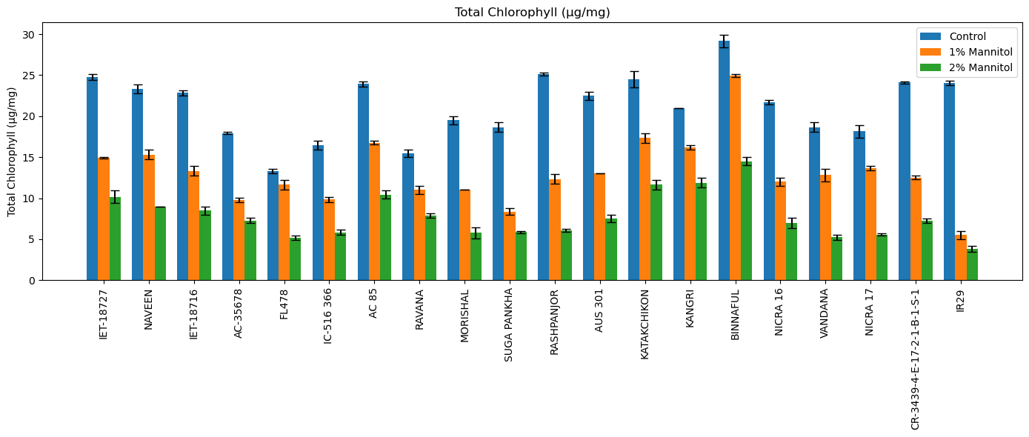
Fig. 5: Graph showing the Effect of Mannitol simulated drought stress on Total Chlorophyll Content (µg/mg FW) in different rice genotypes
3.5 Principal component analysis
To screen the genotypes against mannitol induced drought, Principal component analysis (PCA) was used as software based integrated approach which effectively summarized the multivariate response of rice genotypes by integrating morphological, biomass, and physiological traits. Out of two principal components PC1 was mainly associated with drought tolerance–related traits, including superior root performance, biomass retention, and physiological stability, whereas PC2 represented secondary variation in growth and stress sensitivity. The principal components explained 53.8% of the total variation, with PC1 accounting for 38.8% and PC2 for 15.0%. Based on PCA scores and biplot clustering (Fig. 6), genotypes were grouped into three distinct clusters. The tolerant group, located on the positive side of PC1, comprised Vandana, Fl478, Binnaful, and Katakchikon. The clustering of Vandana (tolerant check) with Fl478 and Binnaful corroborates results from individual trait analyses, indicating superior adaptive responses under drought stress. Genotypes in this cluster consistently maintained better root growth, higher biomass, and improved physiological performance across stress levels. An intermediate cluster near the origin included AUS 301, Morishal, AC 85, NICRA 16, Suga Pankha, Rashpanjor, CR-3439-4-E-17-2-1-B-1-S-1, and IET-18716, reflecting moderate drought tolerance with stable performance under mild stress but reduced resilience under severe stress. In contrast, the susceptible cluster on the negative side of PC1 comprised IR29, AC-35678, IC-516366, Ravana, and Kangri, which exhibited pronounced reductions in growth, biomass, and physiological traits under stress.
By integrating multiple morphological, biomass, and physiological traits into a reduced number of principal components, PCA effectively captured the complex, multivariate nature of drought responses under mannitol-induced stress. The strong concordance between PCA grouping and trait-level performance confirms that drought tolerance can be accurately predicted at the seedling stage, thereby accelerating selection efficiency, reducing time and resource requirements, and enabling rapid advancement of promising genotypes without the necessity of prolonged field evaluation up to crop maturity.

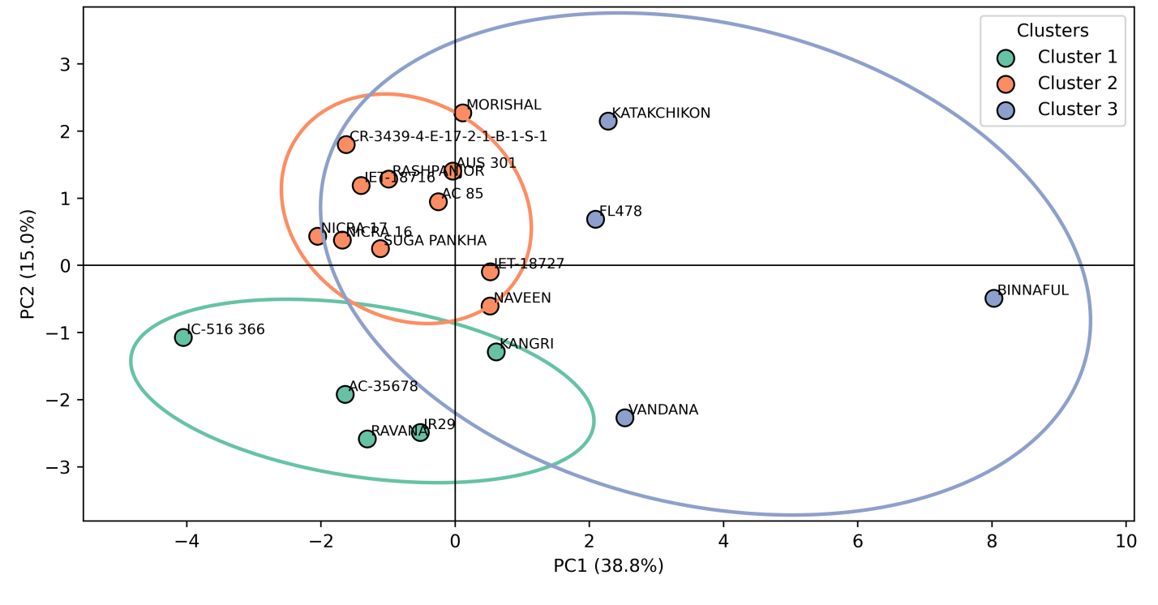

Fig. 6: Principle component analysis based selection of rice genotypes under mannitol-simulated drought stress
Discussion
These trends witnessed in our study for root length and root weight align with earlier reports showing that mild drought can stimulate root elongation (≈15–40%) as an adaptive water-foraging response, whereas severe stress leads to marked inhibition (30–60%) due to reduced turgor, hydraulic conductance, and carbon availability (Kim et al., 2020; Maurel and Nacry, 2020). The substantial reductions observed at 2% mannitol are consistent with declines reported under prolonged water deficit in rice (Veronica et al., 2024). The transient increase in root length at 1% mannitol observed in select genotypes supports the concept of drought avoidance through enhanced root elongation under moderate stress (Jarin et al., 2024). Additionally, drought stress suppresses cell division while maintaining cell elongation, resulting in enhanced axial root growth without substantial biomass gain (Yamaguchi & Sharp, 2010). The observed decrease in root dry weight may also reflect reduced lateral root formation and secondary growth, which contribute significantly to total root biomass but have limited influence on primary root length (Koevoets et al., 2016). The observed reduction in shoot length under osmotic stress is attributable to decreased cell turgor and restricted cell expansion, processes highly sensitive to plant water status. Consistent with earlier reports, moderate drought typically reduces shoot elongation by 20–35%, while severe stress can cause declines exceeding 50% in sensitive genotypes (Li et al., 2023). The concomitant decrease in shoot dry weight reflects reduced photosynthetic carbon assimilation caused by drought-induced stomatal closure and limited CO₂ availability (Chaves et al., 2009; Farooq et al., 2009). Previous studies have reported biomass reductions ranging from 25–60% under moderate to severe drought, depending on genotype and stress intensity (Kumar et al., 2025).
The observed decline in chlorophyll content under mannitol stress is consistent with earlier reports showing that osmotic and drought stress accelerate chlorophyll degradation through oxidative damage, impaired chlorophyll biosynthesis, and destabilization of thylakoid membranes. Mannitol-induced stress has been reported to reduce chlorophyll content by 40–70% under moderate stress and by >80–90% under severe stress in rice (Hassan et al., 2025). Severe drought-induced chlorophyll losses of 70–95%, accompanied by reduced photosystem II efficiency and net photosynthesis, have also been documented (Kumar et al., 2021). The high percentage reductions observed at 2% mannitol in the present study closely align with these findings, confirming chlorophyll content as a sensitive indicator of drought stress severity in rice. The clear separation of genotypes into tolerant, moderately tolerant, and susceptible groups is consistent with previous drought screening studies in rice and confirms the utility of PCA as an effective tool for integrating multiple traits and identifying promising donor genotypes for drought-tolerance breeding (Kim et al., 2020).
Conclusion
Multivariate analysis through PCA effectively integrated the traits like root traits, shoot growth, chlorophyll content and clearly separated genotypes into tolerant, moderately tolerant, and susceptible groups. However, overall study revealed significant genotypic variation in rice responses to mannitol-simulated drought stress across morphological and physiological traits. Genotypes such as Vandana, FL478, Binnaful, and Katakchikon consistently maintained better root performance, root and shoot growth, and physiological stability under stress, identifying them as drought-tolerant, while IR29, AC-35678, IC-516366, Ravana, and Kangri were highly sensitive.

Disclaimer (Artificial intelligence)

Author(s) hereby declare that NO generative AI technologies such as Large Language Models (ChatGPT, COPILOT, etc.) and text-to-image generators have been used during the writing or editing of this manuscript.

References
Bin Rahman, A.R. and Zhang, J., 2016. Flood and drought tolerance in rice: opposite but may coexist. Food and Energy Security, 5(2), pp.76-88.
Dhankher, O.P. and Foyer, C.H., 2018. Climate resilient crops for improving global food security and safety. Plant, cell & environment, 41(5), pp.877-884.
Samal, P., Babu, S.C., Mondal, B. and Mishra, S.N., 2022. The global rice agriculture towards 2050: An inter-continental perspective. Outlook on Agriculture, 51(2), pp.164-172.
U S Department of Agriculture. Rice outlook: August 2022. 2022. Retrieved from: https://ers.usda.gov/publications/pub-details?pubid¼104481.

Bhatt SC, Singh VK, Singh MM. Perspectives of drought in Bundelkhand, Central India; causes, effects, and mitigation: A review. In: Ghute BB, Diwate P, editors. Geospatial technologies for integrated water resources management. Switzerland: Springer; 2024. p. 103–14.

Rao CS, Kareemulla K, Krishnan P, Murthy GRK, Ramesh P, Ananthan PS, et al. Agro-ecosystem based sustainability indicators for climate resilient agriculture in India: a conceptual framework. Ecol Indic 2019;105:621–33.

Kala CP. Environmental and socioeconomic impacts of drought in India: Lessons for drought management. Appl Ecol Environ Sci 2017;5(2):43–8.

Bhandari H, Pandey S, Hardy B. Economic Costs of drought and rice farmers’ coping mechanism: A cross-country comparative analysis. Los Ba~nos: International Rice Research Institute; 2007. p. 203.

Ward PS, Makhija S. New modalities for managing drought risk in rainfed agriculture: Evidence from a discrete choice experiment in Odisha, India. World Dev 2018;107:163–75.

Carpena F. How do droughts impact household food consumption and nutritional intake? A study of rural India. World Dev 2019;122:349–69.

Blum, A., 2011. Drought resistance–is it really a complex trait?. Functional Plant Biology, 38(10), pp.753-757.
Verslues, Paul E., Manu Agarwal, Surekha Katiyar‐Agarwal, Jianhua Zhu, and Jian‐Kang Zhu. "Methods and concepts in quantifying resistance to drought, salt and freezing, abiotic stresses that affect plant water status." The Plant Journal 45, no. 4 (2006): 523-539.
Swamy, B.M. and Kumar, A., 2012. Sustainable rice yield in water short drought prone environments: conventional and molecular approaches. Irrigation systems and practices in challenging environments. INTECH Publishers, Croatia, pp.149-168.
Singh, S.K., Katara, J.L., Parameswaran, C., Jagadev, P.N., Bastia, D.N., Jeughale, K. and Samantaray, S., 2025. Assessment of Drought Tolerance Degree (DTD) method as a reliable tool for early-stage screening for drought tolerance in indica rice. BMC Plant Biology, 25(1), p.1630.
Hiscox, J.D. and Israelstam, G.F., 1979. A method for the extraction of chlorophyll from leaf tissue without maceration. Canadian journal of botany, 57(12), pp.1332-1334.
Kim, Y., Chung, Y.S., Lee, E., Tripathi, P., Heo, S. and Kim, K.H., 2020. Root response to drought stress in rice (Oryza sativa L.). International journal of molecular sciences, 21(4), p.1513.
Maurel, C. and Nacry, P., 2020. Root architecture and hydraulics converge for acclimation to changing water availability. Nature plants, 6(7), pp.744-749.
Veronica, N., Srinivas, T. and Suneetha, Y., 2025. Response of Diverse Rice Genotypes to High Temperature Stress During the Reproductive Phase. Archives of Current Research International, 25(11), pp.313-320.
Jarin, A.S., Islam, M.M., Rahat, A., Ahmed, S., Ghosh, P. and Murata, Y., 2024. Drought stress tolerance in rice: physiological and biochemical insights. International Journal of Plant Biology, 15(3), pp.692-718.
Yamaguchi, M., Valliyodan, B., Zhang, J., Lenoble, M.E., Yu, O., Rogers, E.E., Nguyen, H.T. and Sharp, R.E., 2010. Regulation of growth response to water stress in the soybean primary root. I. Proteomic analysis reveals region‐specific regulation of phenylpropanoid metabolism and control of free iron in the elongation zone. Plant, Cell & Environment, 33(2), pp.223-243.
Koevoets, I.T., Venema, J.H., Elzenga, J.T.M. and Testerink, C., 2016. Roots withstanding their environment: exploiting root system architecture responses to abiotic stress to improve crop tolerance. Frontiers in plant science, 7, p.1335.
Li, Y., Hassan, M.A., Zhu, Q., Fang, W., Yi, Y., Duan, S., Yu, H. and Wang, S., 2024. Evaluation of Drought Resistance and Quality of Different Rice Hybrid Combinations. Journal of Ecological Engineering, 25(7), pp.371-383.
Chaves, M.M., Flexas, J. and Pinheiro, C., 2009. Photosynthesis under drought and salt stress: regulation mechanisms from whole plant to cell. Annals of botany, 103(4), pp.551-560.
Hassan, A.A., Elsherif, A.I. and Kalboush, Z.A., 2025. Exploring resistance-related physiological and molecular responses of rice genotypes against blast disease: Unraveling defense mechanisms and implications for breeding. Physiological and Molecular Plant Pathology, 136, p.102569.
Food and Agriculture Organization of the United Nations (2024) FAOSTAT: Statistical Database. Available at: https://www.fao.org/faostat/en/ (Accessed: 23 January 2026).
Farooq, M., Wahid, A., Lee, D.J., Ito, O. and Siddique, K.H., 2009. Advances in drought resistance of rice. Critical Reviews in Plant Sciences, 28(4), pp.199-217.
Kumar, V., Singh, V., Gupta, A., Gupta, V. and Singh, G.P., 2025. Multivariate analysis of drought stress indices to assess bread wheat (Triticum aestivum L.) germplasm under rainfed conditions. INDIAN JOURNAL OF GENETICS AND PLANT BREEDING, 85(04).
Kumar, N., Chhokar, R.S., Meena, R.P., Kharub, A.S., Gill, S.C., Tripathi, S.C., Gupta, O.P., Mangrauthia, S.K., Sundaram, R.M., Sawant, C.P. and Gupta, A., 2022. Challenges and opportunities in productivity and sustainability of rice cultivation system: a critical review in Indian perspective. Cereal research communications, 50(4), pp.573-601.

