Management Behaviour of Stakeholders in the Cotton Value Chain in Telangana Region, India

Abstract
The cotton value chain involves various stakeholders, including farmers, ginners, traders, manufacturers, retailers and consumers. Effective management is key to sustaining the industry and ensuring its economic viability. The study explores how stakeholders make decisions, manage operations and respond to market dynamics, regulations, technology and social factors. It also highlights challenges and opportunities for better collaboration. The study conducted in Telangana, randomly selected 120 stakeholders-80 farmers and 40 others. Findings show that 50% of farmers had low management awareness, while 55% of other stakeholders had a medium level. Most profile factors influenced stakeholder understanding, except for annual income. (Multiple linear regression value: 64.25). To sustain the sector, adopting innovative technologies and resources is essential.
These findings have direct practical implications for strengthening the cotton value chain. The high proportion of farmers with low management awareness indicates the need for targeted capacity-building programmes focusing on managerial skills such as input planning, cost management, quality control, record maintenance and market-oriented decision-making. Extension agencies and KVKs can use these results to design differentiated training modules for farmers and non-farmer stakeholders rather than adopting a uniform approach. The medium level of awareness among other stakeholders suggests scope for improving inter-stakeholder coordination mechanisms, such as structured platforms for information sharing, price discovery and demand forecasting. Since income was not a significant determinant, interventions should prioritise knowledge access, institutional linkages and behavioural change communication over financial incentives alone. Additionally, promoting the adoption of digital tools, traceability systems and innovative technologies can enhance transparency, efficiency, and collaboration across the cotton value chain, thereby contributing to its long-term economic viability.
Keywords: Management, Performance, Porter value chain, Stakeholders
Introduction:
Cotton is the most important natural fiber due to its fast growth and diverse applications in clothing and home furnishings (Naveen et al., 2024). Its demand depends on the global textile market and plays a vital role in the economies of developing countries, supporting millions of small-scale farmers. The performance of the cotton sector is shaped by national policies and programs (FAO, 2023).
The cotton value chain is a complex network of stakeholders, including farmers, ginners, traders, manufacturers and retailers, each playing a crucial role. Effective management of this value chain is essential for sustainability, competitiveness and economic growth in cotton-producing regions (Tschirley et al., 2009; Tschirley et al., 2010). Porter (1985) described a value chain as a series of activities that create value for customers and contribute to a company’s competitive advantage. Understanding this framework helps analyze costs, differentiation and efficiency in cotton production and trade.

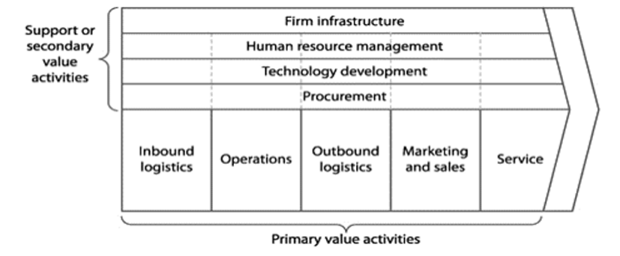
Fig.1.A generic value chain (Porter, 1985)
“The processing of cotton is a business which is undertaken for the purpose of value addition to the product. The value addition to cotton takes place at three main stages of processing viz., ginning, spinning and weaving. The end product in cotton processing is the cloth which will result at the weaving stage of cotton processing. The cotton processing industry, in fact, is the largest labour-intensive economic activity next to agriculture and provides employment to Indian population either directly or indirectly. It is the largest organized and unorganized sector and constitutes an integral part of the urban and rural life of the country. India like other countries in the world, preserves its ancient and time-honoured traditions of ginning, spinning, weaving, dyeing and printing crafts” (Pravallika et al., 2023).
Management Behaviour of Stakeholders in Cotton value chain
Management behaviour refers to how stakeholders plan, organize, coordinate, and control activities throughout the cotton value chain. It plays a pivotal role in enhancing productivity, quality, and profitability from farm to fabric. By moving beyond a farmer-centric approach, the study adopts a holistic, stakeholder-oriented behavioural framework, thereby enriching the theoretical and methodological discourse in agricultural extension, agribusiness management, and rural development research. It is using the Porter’s Value Chain framework in agricultural systems, which strengthens the connection between management science and agribusiness research. The study shows data-driven insights into behavioral gaps that impact productivity, coordination, and sustainability. Its findings support policies based on evidence and strategies for extension. It also shares the regional analysis also provides lessons that can be applied to other cotton-producing economies.
“The channels through which cotton flows helps us in identifying different actors involved in the value chain, their relationships, information flows, product flows, the level of coordination, constraints involved, awareness of chain actors on quality standards, decision making, planning and scheduling of operations etc., all of which eventually make up the chain”. (Parveen, 2021)
Major Cotton value chains involved in management behavior of stakeholders
Recently, researchers and policymakers have focused on how stakeholders manage challenges such as fluctuating prices, changing consumer preferences and evolving regulations (Shwetha et al., 2023). Additionally, concerns about environmental impact, social equity and economic viability emphasize the need for responsible value chain management. In Africa, the state plays a key role in economic development by regulating markets, enforcing laws, and providing infrastructure (McCormick et al., 2001). However, market liberalization has weakened quality monitoring and stock control, affecting international trade and producer organizations (Larsen, 2001; Ponte & Sturgeon, 2014).
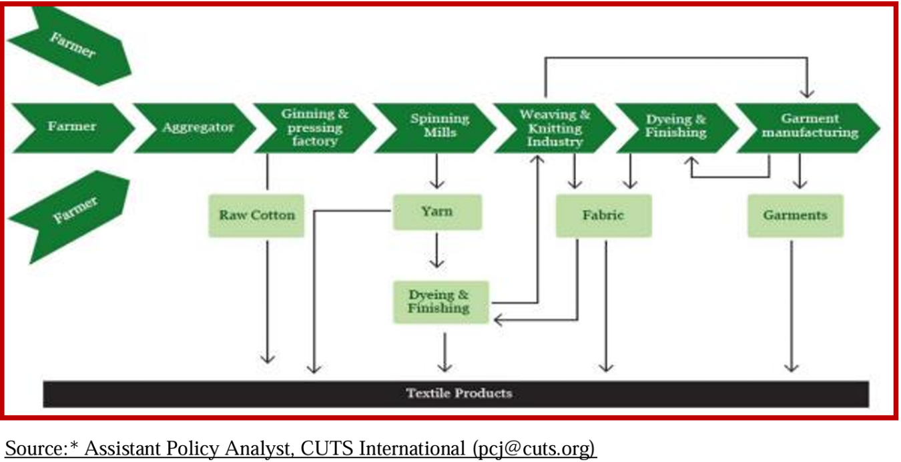
Fig.2. Cotton Value Chain in Telangana state.
Importance:
Behavioral study with respect to value chain in agriculture is seldom made. Also, there are very few attempts that analyzed management behavior of different chain stakeholders in agriculture. The studies on impact and worth of value chain management have not been considered for empirical importance in agriculture. This investigation will therefore contribute to the body of knowledge pertaining to value chain management in agriculture and management behavior of stakeholders in chain add to existing studies made on analysis of value chain.
An elaboration of its importance:
- Efficient resource utilization
- Improved productivity and profitability
- Strengthened linkages among stakeholders
- Enhanced Adoption of Extension services and innovations
- Value addition and quality control
- Financial planning and risk management
- Data recording and reporting for decision making
- Sustainability and Environment management
- Market Competitiveness
- Empowerment and Leadership

Therefore, the management behaviour of stakeholders is the engine of operational success in the cotton value chain. It determines how efficiently resources are used, how effectively coordination happens, and how successfully value is added across stages. Strengthening this behaviour through capacity building, extension and institutional support is crucial for a sustainable and profitable cotton sector.

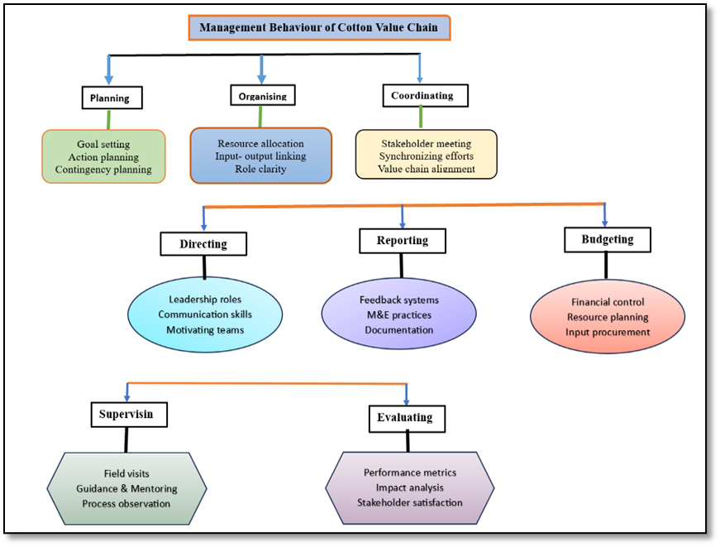

Fig.3.Thematic Framework of Stakeholder Management Behaviour in the Cotton Value Chain
The POSDCORB acronym—Planning, Organizing, Staffing, Directing, Coordinating, Reporting, and Budgeting—was introduced by Luther Gulick as a concise summary of the executive functions required for effective administration. When mapped onto the cotton value chain, POSDCORB offers a structured lens for diagnosing how diverse stakeholder groups (farmers, input suppliers, extension agents, traders, ginners, spinners, garment manufacturers, financial institutions, and regulators) behave and interact while managing their segment of the chain. The thematic model you created positions each POSDCORB element as a behavioural domain, clarifying both what stakeholders do and why these actions matter for chain performance, resilience, and sustainability. Below is an analytical discussion of each domain and its relevance.
The thematic diagram not only visualizes functional domains but also surfaces leverage points—such as strengthening digital reporting or fostering horizontal farmer coordination—for targeted interventions. By situating traditional extension mandates within a modern managerial framework, the model offers both scholars and practitioners a common language to advance efficiency, equity and sustainability across the cotton ecosystem.
A major challenge for cotton producers is maintaining competitiveness amid declining global prices. Many countries have stopped production due to high costs (Chaudhry, 2001). To counter this, access to skills training in marketing, management and finance, along with technical support from cooperatives, can help strengthen the sector (Cotton Incorporated, 2001; Salinger et al., 1999).
This research aims to guide policies, business strategies and development efforts to build a more resilient, inclusive, and sustainable cotton value chain (Goreux, 2003). By identifying best practices, addressing key challenges and fostering collaboration, stakeholders can work toward a fairer and more sustainable cotton industry—benefiting everyone from farmers to fashion brands.
Material and methods
The study follows a mixed-methods approach with an Ex-post facto research design, combining qualitative and quantitative techniques to analyze stakeholder management behavior in the cotton value chain.
For qualitative sampling, purposive sampling will be used to select key informants, including farmers, ginners, traders, manufacturers and retailers in Adilabad, Telangana. Selection will consider diversity in location, organization size, and market orientation. Semi-structured interviews and group discussions will provide insights into management practices, decision-making, and strategies.
For quantitative sampling, stratified random sampling will be used to survey stakeholders across Telangana, categorizing them by organization type (e.g., small farms, large manufacturers) and region. A structured questionnaire will assess management behavior, sustainable practices, market response and collaboration within the value chain.
Porter’s value chain framework guides the study, examining eight key traits:
- Collaborative planning & demand forecasting
- Negotiations between partners
- Competitor analysis
- Production planning & control
- Purchase management
- Inventory management
- Marketing & sales management
- Technology/resource management
Data analysis will be conducted using SPSS, applying mean, standard deviation, correlation, and multiple regression analysis to derive insights.
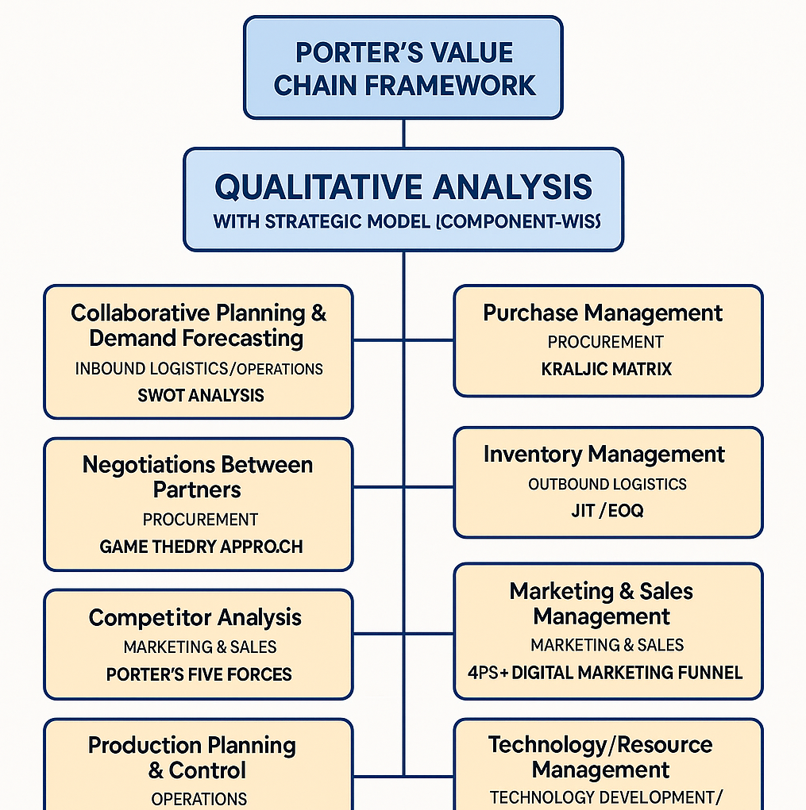
FIG 4. Porter’s Value Chain Framework
The study defines management behavior of stakeholders in the cotton value chain as the observable and strategic decision-making actions undertaken by various actors—such as farmers, processors, buyers and marketers—across eight key dimensions.
These dimensions are analyzed using Porter’s Value Chain Framework to categorize them under primary and support activities, and are further examined through suitable strategic models (e.g., SWOT, Game Theory, Kraljic Matrix, JIT, 4Ps, TOE Framework) to understand stakeholder roles, strengths, gaps and performance.
The operational assessment focuses on qualitative parameters such as coordination level, negotiation capability, market responsiveness, planning efficiency, procurement quality, stock turnover, promotion effectiveness, and technological adaptability as they contribute to the overall value creation and competitiveness of the cotton value chain.
Locale of the study
This study was carried out in Adilabad district, Telangana. Adilabad district is located in the northern part of Telangana. It is having 19.67° N& 78.53° E latitude and Longitude. Adilabad district in Telangana has a predominantly agrarian economy, with major crops grown based on its climate and soil conditions. The district receives moderate to high rainfall and has black and red soils. The district is predominantly grown are commercial crops (cotton, soyabean), Food grains (Paddy, Maize) and Pulses and Oilseeds (Redgram, green gram, groundnut). Table.1 describes the selection of mandals and villages with sample size of stakeholders involved in the cotton value chain. Table.2 describes the selection of the textile industries available in selected district.
Table 1: Mandal wise distribution of respondents.
District | Mandal | Village | No. of cotton Growers | No. of stakeholders
Adilabad | Tamsi | Uddadi | 20 | 10
Adilabad | Tamsi | Ponnari | 20 | 10
Adilabad | Talamadugu | Talamadugu | 20 | 10
Adilabad | Talamadugu | Kottur | 20 | 10
 | Total |  | 80 | 40
Table 2: Distribution of textile industries in Adilabad district.
S. No. | Name of the industry | Location
1. | Dharani cotton mill | Khursheed nagar
2. | Mahadev Sitharam cotton mills India Pvt. Ltd | Bhainsa
3. | Devdoot gin mill | Rampur

4. Results and Discussion
Management Behaviour of stakeholders of activities in cotton value chain management:
Management behavior refers to the series of activities a business undertakes to deliver value to the end customer. It is shaped by cumulative outcomes at each stage of the value chain.
Component wise results of management behaviour of value chain stakeholders:
1. Collaborative Planning and Demand Forecasting
As per Table 3, 52.5% of cotton growers had a low level of collaborative planning and demand forecasting, while 31.25% had a medium level and 16.25% a high level. This was mainly due to farmers' limited interest in engaging with other stakeholders, as they focused primarily on cultivation and marketing. Demand forecasting with chain partners was minimal, and many growers disregarded government advisories on cotton sowing.
Among other stakeholders, 50% exhibited a medium level of collaborative planning, indicating their willingness to coordinate with value chain partners. However, specific groups like CCI, PACS, and DCMS officials (Table 3b) had low collaboration levels (69.23%), as they primarily followed government procurement directives. In contrast, ginners and industry firms (Table 4) showed medium collaboration levels (71.42%), suggesting their potential to integrate better into value chain networks. Improved alignment of production, distribution, and inventory management can help reduce costs, minimize uncertainties, and enhance efficiency in the cotton value chain.
2. Negotiations Between Chain Partners
Since 100% of cotton growers sold their produce to CCI under MSP operations, price negotiations were minimal. However, 65% exhibited medium negotiation levels, mainly engaging with procurement managers on aspects like increasing the allowed yield per acre or accepting damaged seeds (Table 4).
Among other stakeholders, 52.5% reported medium negotiation levels, indicating a moderate level of discussions within the value chain.
3. Competitor Analysis
Majority (45%) of cotton growers had a low level of competitor analysis. Farmers typically do not see peers as competitors in farming but show competitive traits in non-farming activities. When a farmer starts a new business, others often seek insights on market value, success factors, and risks.
Among other stakeholders, majority (60%), especially industry firms and processors, exhibited high competitor analysis. They actively track competitors by monitoring storage issues, industry trends via mass media, and diversification strategies of fellow firms.
4. Production Planning and Control
Table 6a depicted that majority (55%) of cotton growers had a medium level of production planning, likely due to their farming experience. Among stakeholders, 40% had a high level of production planning, as they must coordinate between producers and buyers while following government directives.
Retailers had a high level (57.14%) of planning, adjusting operations based on available resources and store capacity (Table 6b). Industry firms showed medium to high planning, though 57.15% had a low level, possibly due to technical uncertainties affecting production.
5. Purchase Management
Table 7a represented that, majority (73.75%) of cotton growers had low purchase management, relying on a single input dealer for supplies without exploring alternatives or obtaining invoices for quality assurance. Farmers’ dependence on regular dealers for credit limited their purchasing control. Extension programs could help raise awareness about diverse input sources and cost-effective purchasing.
Among other stakeholders, majority 52.50% had high purchase management, efficiently handling supplier selection and record-keeping. Logistics and distribution partners (76.93%) followed government procurement directives (Table 7b). Retailers and industry firms reported medium to high levels, ensuring proper procurement, record maintenance, and transport planning.
6. Inventory Management
Table 8a identified that, most (72.50%) of cotton growers had a medium level of inventory management, ensuring precise input quantities to minimize waste and considering shelf life.
Among stakeholders, 50% had high inventory management. CCI/PACS/DMCS managers took measures to maintain warehouse stocks and reduce transit costs. Retailers and ginners (57.14%) and industry firms (71.43%) emphasized stock management as critical for production and market stability (Table 8b). However, some industry firms showed low inventory management, indicating less focus on stock control.
7. Marketing/Sales Management
Table 9a demonstrated that, most 76.25% of cotton growers had low marketing management, showing little awareness of crop surplus, customer demand, or market trends. Only 15% had medium and 8.75% had high marketing skills.
Among other stakeholders, 42% had medium, 35% had low, and 22.50% had high marketing orientation. Limited options and lack of contingency plans may explain this. Processors, seed companies, and industry firms followed government directives, resulting in medium sales orientation. Retailers mostly had low to medium sales management due to restricted marketing strategies (Table 9b).
8. Technology/Resource Management
As depicted in Table 10, majority (81.25%) of cotton growers had low resource management, overusing inputs and hesitating to adopt innovations. Only 10% had medium and 8.75% had high levels.
Among other stakeholders, 45% reported low technology/resource management, indicating limited adoption of advanced machinery, automation, and digital tools. However, industry processors and ginners exhibited a higher level of technological adaptation, integrating modern processing equipment and optimizing workflows to improve efficiency. Processing firms particularly stood out for their commitment to continuous improvements—investing in energy-efficient machinery, waste reduction strategies, and employee training programs to enhance performance.
Despite these advancements, gaps remain in the broader cotton value chain. Limited awareness, high investment costs, and resistance to change hinder widespread adoption of innovative solutions, particularly among smallholder farmers. Expanding access to training programs, digital extension services, and financial incentives for technology adoption could significantly improve resource utilization, sustainability, and competitiveness across the sector.
Table 3a. Distribution of respondents according to their level of collaborative planning and demand forecasting.
S. No. | Category | Cotton growers |  |  | Category | Other stakeholders
S. No. | Category | C.I | F | % | Category | C.I | F | %
1. | Low | 9-11 | 42 | 52.50 | Low | 10-11 | 11 | 27.20
2. | Medium | 11-13 | 25 | 31.25 | Medium | 11-12 | 20 | 50.00
3. | High | 13-15 | 13 | 16.25 | High | 12-13 | 09 | 22.50
 | Total |  | 80 | 100.00 | Total |  | 40 | 100.00

Table 3b. Categorization of stakeholders according to their collaborative planning and demand forecasting excluding traders. (n= 32)
S.No. | Category | Logistics& Distribution partners(n=13) |  |  | Retailers(n=07) |  |  | Processors/ Seed Companies/ Industry firms (n=14)
S.No. | Category | C.I. | F | % | C.I. | F | % | C.I. | F | %
1. | Low | 6-8 | 09 | 69.23 | <8 | 02 | 28.57 | <8 | 02 | 14.29
2. | Medium | 9-11 | 03 | 23.08 | 8-10 | 04 | 57.15 | 8-10 | 10 | 71.42
3. | High | 12-14 | 01 | 07.69 | >10 | 01 | 14.28 | >10 | 02 | 14.29
 | Total |  | 13 | 100.00 |  | 07 | 100.00 |  | 14 | 100.00
Table 4. Distribution of respondents according to the level of negotiations between chain stakeholders. (n=120)
S. No. | Category | Cotton growers |  |  | Category | Other stakeholders
S. No. | Category | C.I. | F | % | Category | C.I. | F | %
1. | Low | 10-11 | 15 | 18.75 | Low | 10-12 | 06 | 15.00
2. | Medium | 11-12 | 52 | 65.00 | Medium | 12-14 | 21 | 52.50
3. | High | 12-13 | 13 | 16.25 | High | 14-16 | 13 | 32.50
 |  |  | 80 | 100.00 |  |  | 40 | 100.00
Table 5. Distribution of respondents according to the level of competitor analysis.
S.No | Category | Cotton growers |  |  | Category | Other Stakeholders
S.No | Category | C.I. | F | % | Category | C.I. | F | %
1. | Low | 7-9 | 43 | 45.00 | Low | 12-13 | 05 | 12.50
2. | Medium | 9-11 | 19 | 30.00 | Medium | 13-14 | 11 | 27.50
3. | High | 11-13 | 18 | 25.00 | High | 14-15 | 24 | 60.00
 |  |  | 80 | 100.00 |  |  | 40 | 100.00
Table 6a. Distribution of respondents according to the level of production planning and control.
S.No. | Category | Cotton growers |  |  | Category | Other stakeholders
S.No. | Category | C.I. | F | % | Category | C.I. | F | %
1. | Low | 13-15 | 30 | 15.00 | Low | 12-14 | 09 | 22.50
2. | Medium | 15-17 | 35 | 55.00 | Medium | 14-16 | 15 | 37.50
3. | High | 17-19 | 15 | 30.00 | High | 16-18 | 16 | 40.00
 | Total |  | 80 | 100.00 | Total |  | 40 | 100.00

Table 6b. Distribution of other stakeholders excluding traders (n=32).
S.No | Category | Logistics& Distribution partners (n=13) |  |  | Retailers(n=07) |  |  | Processors/ Seed companies/ Industry firms (n=14)
S.No | Category | C.I. | F | % | C.I. | F | % | C.I. | F | %
1. | Low | 8-10 | 03 | 23.08 | <10 | 02 | 28.58 | 7-9 | 08 | 57.15
2. | Medium | 11-13 | 08 | 61.54 | 10-12 | 01 | 14.28 | 10-12 | 04 | 28.57
3. | High | 14-16 | 02 | 15.38 | >12 | 04 | 57.14 | 13-15 | 02 | 14.28
 | Total |  | 13 | 100.00 |  | 07 | 100.00 |  | 14 | 100.00

Table 7a. Distribution of respondents according to the level of purchase management.
S.No. | Category | Cotton growers |  |  | Category | Other stakeholders
S.No. | Category | C.I. | F | % | Category | C.I. | F | %
1. | Low | 12-13 | 59 | 73.75 | Low | 15-16 | 07 | 17.50
2. | Medium | 13-14 | 10 | 12.50 | Medium | 16-17 | 12 | 30.00
3. | High | 14-15 | 11 | 13.75 | High | 17-18 | 21 | 52.50
 | Total |  | 80 | 100.00 | Total |  | 40 | 100.00

Table 7b. Distribution of other stakeholders excluding traders (n=32).
S.No. | Category | Logistics & Distribution partners (n=13) |  |  | Retailers (n=07) |  |  | Processors/ Seed  companies/ Industry  firms (n=14)
S.No. | Category | C.I. | F | % | C.I. | F | % | C.I. | F | %
1. | Low | 14-15 | 02 | 15.38 | 11-13 | 01 | 14.29 | 17-18 | 08 | 57.14
2. | Medium | 16-17 | 10 | 76.93 | 14-16 | 02 | 28.57 | 18-19 | 04 | 28.57
3. | High | 18-19 | 01 | 07.69 | 16-19 | 04 | 57.14 | 19-20 | 02 | 14.29
 | Total |  | 13 | 100.00 |  | 07 | 100.00 |  | 14
Table 8a. Distribution of respondents according to the level of inventory management.
S.No. | Category | Cotton growers |  |  | Category | Other stakeholders
S.No. | Category | C.I. | F | % | Category | C.I. | F | %
1. | Low | 12-14 | 10 | 12.50 | Low | 13-14 | 08 | 20.00
2. | Medium | 14-16 | 58 | 72.50 | Medium | 14-15 | 12 | 30.00
3. | High | 16-18 | 12 | 15.00 | High | 15-16 | 20 | 50.00
 | Total |  | 80 | 100.00 | Total |  | 40 | 100.00
Table 8b. Distribution of other stakeholders excluding traders (n=32).
S.No. | Category | Logistics & Distribution partners (n=13) |  |  | Retailers (n=07) |  |  | Processors/ Seed companies/ Industry firms (n=14)
S.No. | Category | C.I. | F | % | C.I. | F | % | C.I. | F | %
1. | Low | 11-13 | 03 | 23.08 | 11-13 | 02 | 28.57 | <12 | 10 | 71.43
2. | Medium | 14-16 | 04 | 30.77 | 14-16 | 01 | 14.29 | 12-15 | 01 | 07.14
3. | High | 17-19 | 06 | 46.15 | 17-19 | 04 | 57.14 | >15 | 03 | 21.43
 | Total |  | 13 | 100.00 |  | 07 | 100.00 |  | 14 | 100.00
Table 9a. Distribution of respondents according to the level of marketing/sales management.
S.No. | Category | Cotton growers |  |  | Category | Other stakeholders
S.No. | Category | C.I. | F | % |  | C.I. | F | %
1. | Low | 7-8 | 61 | 76.25 | Low | 15-16 | 14 | 35.00
2. | Medium | 8-9 | 12 | 15.00 | Medium | 16-17 | 17 | 42.00
3. | High | 9-10 | 07 | 08.75 | High | 17-18 | 09 | 22.50
 | Total |  | 80 | 100.00 | Total |  | 40 | 100.00

Table 9b. Distribution of other stakeholders excluding traders (n=32).
S.No. | Category | Logistics &  Distribution  partners (n=13) |  |  | Retailers (n=07) |  |  | Processors/ Seed  companies/ Industry  firms (n=14)
S.No. | Category | C.I. | F | % | C.I. | F | % | C.I. | F | %
1. | Low | 10-11 | 01 | 7.69 | <11 | 04 | 57.14 | 8-9 | 03 | 21.43
2. | Medium | 11-12 | 02 | 15.39 | 11-13 | 02 | 28.57 | 10-11 | 09 | 64.29
3. | High | 12-13 | 10 | 76.92 | >13 | 01 | 14.29 | 12-13 | 02 | 14.28
 | Total |  | 13 | 100.00 |  | 07 | 100.00 |  | 14 | 100.00
Table 10. Distribution of respondents according to the level of Technology/resource management.
S.No. | Category | Cotton growers |  |  | Category | Other stakeholders
 |  | C.I. | F | % |  | C.I. | F | %
1. | Low | 14-16 | 65 | 81.25 | Low | 10-12 | 10 | 25.00
2. | Medium | 16-18 | 08 | 10.00 | Medium | 12-14 | 18 | 45.00
3. | High | 18-20 | 07 | 08.75 | High | 14-16 | 12 | 30.00
 | Total |  | 80 | 100.00 | Total |  | 40 | 100.00
Table 11. Relationship between profile characteristics of farmers with management behaviour of stakeholders of cotton value chain.
S. No. | Independent variables | Correlation coefficient (r)
1. | Age | 0.147^{NS}
2. | Education | 0.234^{NS}
3. | Unit size | 0.564**
4. | Annual Income | 0.06^{NS}
5. | Farming Experience | 0.642**
6. | Information seeking behavior | 0.542**
7. | Creative potential | 0.651**
8. | Quality consciousness | 0.334*
9. | Economic motivation | 0.487**
10. | Innovativeness | 0.359*
11. | Risk taking ability | 0.492**
12. | Achievement motivation | 0.521**

**Significant level at 1% *Significant level at 5% NS = Non- significant
Relationship between selected profile characteristics with Management behaviour of stakeholders of cotton value chain
In order to study the relationship between the management behaviour of stakeholders in value chain and their profile characteristics, the correlation co-efficient (r) values were computed and findings are furnished here under.
The relationship between the management behaviour of stakeholders in value chain and their profile characteristics was tested by relevant null and empirical hypotheses.
Table.12. Relationship between profile characteristics with Management behaviour of stakeholders of cotton value chain.
S. No. | Independent variables | Correlation coefficient (r)
1. | Age | 0.147^{NS}
2. | Education | 0.534**
3. | Unit size | 0.642**
4. | Annual Income | 0.326*
5. | Farming Experience | 0.745**
6. | Information seeking behavior | 0.576**
7. | Creative potential | 0.671**
8. | Quality consciousness | 0.454**
9. | Economic motivation | 0.567**
10. | Innovativeness | 0.659**
11. | Risk taking ability | 0.482**
12. | Achievement motivation | 0.651**
**Significant level at 1% *Significant level at 5% NS = Non- significant
Multiple linear regression analysis of profile characteristics of farmers with management behaviour of stakeholders in value chain management.
Multiple regression analysis allows respondents to allow strength of the relationship between the Management Behaviour of stakeholders and the profile characteristics of farmers as well as importance of each of profile characters of the relationship, often with the effect of the other variables statistically eliminated.
Table 13. Multiple linear regression analysis between profile characteristics of farmers with management behaviour of stakeholders of cotton value chain.
S. No. | Independent variables | Regression coefficient | Standard error | ‘t’ value
1. | Age | 0.347** | 0.644 | 0.538
2. | Education | 2.534** | 0.962 | 2.633
3. | Unit size | 6.800** | 6.800 | 2.634
4. | Annual Income | 0.231* | 0.859 | 2.696
5. | Farming Experience | 1.505** | 0.219 | 0.686
6. | Information seeking behavior | 0.351* | 0.868 | 0.404
7. | Creative potential | 0.147^{NS} | 0.112 | 1.312
8. | Quality consciousness | 0.274* | 0.138 | 1.981
9. | Economic motivation | 0.583** | 0.261 | 2.233
10. | Innovativeness | 0.351* | 0.224 | 1.561
11. | Risk taking ability | 0.276* | 0.750 | 3.682
12. | Achievement motivation | 0.561** | 0.801 | 0.699

**Significant level at 1% *Significant level at 5% NS = Non- significant
R² = 0.735 F=6.425
Table 14. Multiple- linear Regression analysis between independent variables with Management Behaviour of stakeholders of cotton value chain.
S. No. | Independent variables | Regression coefficient(r²) | Standard error | ‘t’ value
1. | Age | 0.116^{NS} | 0.615 | 1.886
2. | Education | 0.902** | 1.031 | 0.874
3. | Unit size | 4.276** | 2.867 | 1.491
4. | Annual Income | 0.632** | 0.111 | 0.567
5. | Farming Experience | 1.358** | 4.465 | 0.419
6. | Information seeking behavior | 0.974** | 0.362 | 0.821
7. | Creative potential | 0.138* | 0.755 | 1.838
8. | Quality consciousness | 0.852** | 0.142 | 0.597
9. | Economic motivation | 0.927** | 0.435 | 0.641
10. | Innovativeness | 0.682** | 0.581 | 1.174
11. | Risk taking ability | 0.476** | 0.101 | 0.471
12. | Achievement motivation | 0.878** | 0.375 | 0.766

**Significant level at 1% *Significant level at 5% NS = non-significant
R² = 0.686 F=7.266
Conclusion:
The study highlights key gaps in stakeholder management behavior across different aspects of the cotton value chain. Farmers, as the primary producers, exhibit challenges in areas such as collaborative planning, marketing strategies, and technology adoption. Meanwhile, other stakeholders, including processors, traders, and retailers, show relatively better management capabilities, but opportunities exist to enhance coordination and efficiency.
To improve value chain performance and sustainability, the following recommendations are proposed:
- Enhancing Stakeholder Collaboration – Strengthening partnerships through organized farmer cooperatives, digital platforms, and industry alliances can improve planning, demand forecasting, and negotiation processes.
- Capacity Building and Training – Conducting skill-based training programs for farmers and stakeholders on market trends, competitor analysis, and resource management can improve decision-making and efficiency.
- Technology Integration – Encouraging the adoption of precision farming techniques, IoT-based inventory management, and digital marketing tools can enhance productivity and market responsiveness.
- Policy Support and Market Regulations – Government interventions should focus on stabilizing cotton prices, ensuring fair trade practices, and promoting export competitiveness.
- Sustainability and Environmental Considerations – Implementing eco-friendly farming practices, sustainable processing methods, and circular economy principles can reduce the environmental impact and ensure long-term industry viability.

Consent

As per international standards or university standards, respondents’ written consent has been collected and preserved by the author(s).

Disclaimer (Artificial intelligence) :

Author(s) hereby declare that NO generative AI technologies such as Large Language Models (ChatGPT, COPILOT, etc.) and text-to-image generators have been used during the writing or editing of this manuscript.
References:
21(1), 195-223. http://dx.doi.org.
90.2013.809596
- Baffes, J. 2004. Cotton: Market setting, trade policies, and issues. In Global Agricultural Trade and Developing Countries (pp. 259-274). The World Bank.
- Chaudhry, M. R. 2001. Cotton production under stress: Challenges and opportunities. International Cotton Advisory Committee (ICAC) Review, 54, 1-12
- Cotton Incorporated. (2001). The cotton industry: Challenges and opportunities. Cotton Incorporated Reports, 23, 45-56.
- Food and Agriculture Organization (FAO). (2023). Cotton: Market trends and policy impacts. Retrieved from https://www.fao.org/markets-and-trade/commodities/cotton/en
- Goreux, L. 2003. Reforming the cotton sector in sub-Saharan Africa. Africa Region Working Paper Series No. 62. The World Bank.
- Larsen, M. N. 2001. Zimbabwe’s cotton sector: Liberalization and its consequences. World Development, 29(4), 701-717.
- McCormick D and Schmitz H. 2001. Manual for Value Chain Research on Home workers in the Garment Industry.
- Ponte, S and Sturgeon, T. 2014. Explaining governance in global value chains: A modular theory-building report. Review of International Political Economy. 21(1), 195-223. http://dx.doi.org.nwulib.nwu.ac .za/10.1080/09692290.2013.809596.
- Porter, M. E. 1985. Competitive advantage: Creating and sustaining superior performance. Free Press.
- Salinger, L., Baffes, J and Cotton, A. 1999. Structural reforms and cotton markets: Impacts and adjustments. World Bank Discussion Papers, 407, 78-92.
- Shwetha, M. N., Shakuntala Devi, I., Lavanya, T and Meena, A. 2023. Value Chain of Cotton Industry: A Study in Adilabad and Nalgonda Districts of Telangana. International Journal of Environment and Climate Change, 13(10), 1402-1410.
- Tschirley, D., Poulton, C and Labaste, P. (Eds.). 2009. Organization and performance of cotton sectors in Africa: Learning from reform experience. The World Bank.
- Naveen M, Srinivasan S, Angayarkanni A, & Arun Kumar S. (2024). Enhancement of Growth and Yield of Cotton by Organic and Inorganic Nutrients with Phytohormone. International Journal of Plant & Soil Science, 36(5), 594–604. https://doi.org/10.9734/ijpss/2024/v36i54557
- Pravallika, K., Chandra Shekar, S., Madhu Babu, K., & Shakuntala Devi, I. (2023). Knowledge of stakeholders of cotton value chain management in Telangana State. Biological Forum – An International Journal, 15(6), 105–114.
- Tschirley, D. L., Poulton, C., Gergely, N., Labaste, P., Baffes, J., Boughton, D., & Estur, G. (2010). Institutional diversity and performance in African cotton sectors. Development Policy Review, 28(3), 295-323.

