Ecofreindly management of Ash weevil, Myllocerus viridanus Fabr. (coleoptera: curculionidae) in Moringa concanensis Nimmo seedlings raised from diverse seed sources

ABSTRACT
A reconnaissance survey was conducted in Barmer, Pali, Churu and Jodhpur District of Rajasthan to document the occurrence of the Konkan Moringa, Moringa concanensis Nimmo and collection of seeds for multiplication as this tree is categorised under threatened species in Rajasthan. Seeds were collected from the marked trees and raised seedlings in poly house with an overall germination of 62%. Physical parameters of pods like pod length, pod width, seeds per pod were also recorded. Findings revealed that average pod length varied from 10.3cm to 24.0cm with an average of 17.03 cm. Pod width varied from 1.1-2.6cm with an average of 1.63cm. Number of seeds per pod varied from 5.0-14.0 with an average of 8.73. Seedlings of approximately 45-60 days old exhibited notable infestation by the Ash weevil Myllocerus viridanus Fabr. (Coleoptera: Curculionidae), a defoliating pest was recorded. The occurrence of this Ash weevil M. viridanus Fabr. on M. concanensis reported here represents a new host association not previously described in the literature. The adult of Ash weevils caused characteristic marginal and interveinal notching on tender leaves, whereas larvae fed on fine roots, leading to stunted growth and poor plant vigour. Preliminary damage assessment revealed significant leaf loss in infested plants. All seedlings examined exhibited the presence of the pest, resulting in a 100% infestation incidence across the population. The mean number of damaged leaves per seedling was approximately 25.29, corresponding to percent infested leaves of 77.6% relative to total foliage, indicating that more than three-fourths of the foliage was affected. This high proportion of damage showed that plants were in severe infestation pressure, with the majority of seedlings experiencing substantial defoliation. An eco-friendly management approach using neem oil was evaluated and application at 1% concentration proved highly effective in significantly reducing foliar damage.
KEYWORDS: Ash Weevil, damage, Defoliators, Ecofriendly Management, Infestation
1 INTRODUCTION
Moringa concanensis (Nimmo) is an important medicinal plant species of Rajasthan belonging to the family Moringaceae. This species is an important native tree species distributed mainly in Pakistan, Asia Minor, Africa and Arabia (Mughal et al., 1999; Balakumbahan et al., 2023), and in the dry regions of India. In India it is mainly found in the hilly region of Eastern Ghats (Pullaiah and Chennaiah, 1997; Rao et al., 2008), Western Ghats (Prasanna, 2000), Rajasthan, Gujarat, and parts of southern peninsular India. In Rajasthan, it is found in Jodhpur, Barmer (Bhandari, 1990); Churu, Jhalawar, Jaisalmer, Pali and Tonk (Shetty and Singh, 1987), Nagaur, Pali, Bundi, Jalore (Kumar and Purohit, 2015). This species holds potential as a genetic resource for tree improvement due to its resilience to drought and high temperatures. It is a large tree having bipinnate leaves, leaflets 15-30 mm long and petals with red streaks at base (Figure 1). This species possesses significant potential for agroforestry, soil conservation, and nutraceutical applications. Despite its ecological and medicinal significance, it remains poorly documented and faces threats from habitat loss, overharvesting, and hybridization. This species is a lesser-known relative of the widely cultivated Moringa oleifera and categorized as threatened plant in Rajasthan. To support the conservation and propagation of M.concanensis, a systematic improvement programme was initiated to document its distribution, examine phenological behaviour and morphological characteristics of M. concanensis across selected populations and establish seedlings under nursery conditions. During the seedling stage, a severe infestation of the Ash weevil Myllocerus viridanus Fabr., (Coleoptera: Curculionidae), was observed, indicating the susceptibility of this species to insect pests (Shanmugam et al., 2018). However, information on the insect pest problems associated with this species is extremely limited. Therefore, the present study was undertaken to quantifying the extent of damage caused by Ash weevil and to explore eco-friendly management strategies that can be integrated into conservation and nursery production practices.
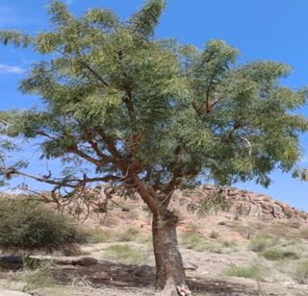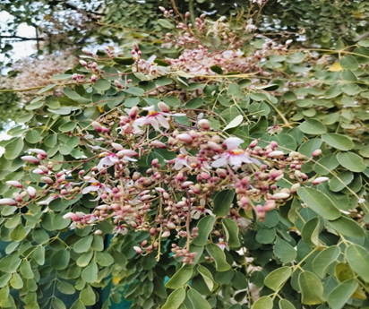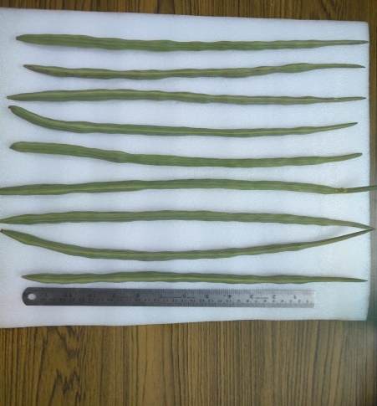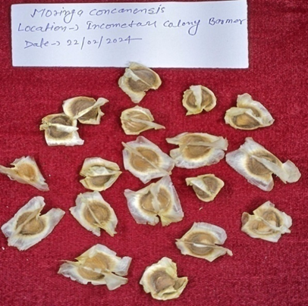
Figure 1: Tree, seeds, pods and fruits of M.concanensis
2 MATERIALS AND METHODS
2.1 SURVEY AND IDENTIFICATION OF TREES: An extensive survey was carried out during 2023-2024 in Barmer, Pali, Churu and Jodhpur district of Rajasthan to identify and select natural populations or individuals of M.concanenesis. The data on height, girth at breast height (GBH), crown diameter, health of the trees and the flowering and fruiting patterns were recorded for the marked trees. Thereafter, seeds were collected from identified trees in the month of February-March, 2024 and seed morphometric characters like pod length (cm), pod width (cm) were estimated using Leica Q win and 100 seed weight (g) using electronic balance followed by sowing seeds under nursery conditions in April,2024. When the seedlings were 45-60 days old in the month of mid-June, 2024, a notable infestation of Ash weevil M. viridanus Fabr. was recorded.
2.2 MANAGEMENT TRIAL: To record the foliar damage occurred by Ash weevil on M.concanensis, the management trial in completely randomised design (CRD) was performed by taking three different concentrations of neem oil (0.5%, 0.75%, 1.0%) and water as control against 25 seedlings per treatment.
Each seedling served as an experimental unit. The commercially available neem oil (Dabur Neem Tail) available in the market of Jodhpur was used at different concentration 90.5%, 0.75% and 1% (v/v)) and water as control against M.concanensis seedlings to record the damage caused by infestation.
Each seedling was uniformly sprayed using a hand sprayer. Three replications of each treatment were made. Day 0 was when the initial spray was applied. Observations were made seven days following the initial spray (7th Day of treatment). Accordingly, the second spray was given on 21st Day of treatment and observations were recorded for seventh, fourteen, and twenty-one days later.
2.3 Data Collection and Analysis: For each seedling, the observations on total number of leaves, number of damaged leaves were recorded at 7th,14th and 21st day of initial spray and foliar damage or percent infested leaves (%) was calculated using the following formula: -
Percent infested leaves (%) = (Damaged Leaves/Total Leaves) ×100
The data collected were then analysed using one way ANNOVA and Tukey HSD test to study the significant differences of different concentrations of neem oil tested upon.
3 RESULTS AND DISCUSSION
3.1 Fruit and seed characteristics: A total 20 trees were identified and marked from four districts (Barmer, Pali, Churu and Jodhpur) of Rajasthan. The data on height, girth, crown diameter, health of the trees were recorded and the fruiting behaviour of the selected trees was scored on a scale of 1 to 5. Morphometric analysis of M. concanensis pods collected from different individuals in Rajasthan revealed substantial variation across all measured traits (Table 1). The pod length showed a mean of 17.3 cm, with individual pods ranging from 10.3 cm to 24.0 cm, indicating considerable size diversity within the sample. The standard deviation of approximately 4.1 cm highlights moderate variability in pod length, suggesting differences in growth conditions, genetic makeup, or both. Pod width also exhibited noticeable variation. The average width was 1.63 cm, but values spanned from 0.9 cm to 2.6 cm, with a standard deviation of about 0.35 cm. This variation, though smaller in absolute terms compared to length, reflects morphological heterogeneity in pod girth that may influence seed development and dispersal.
Table 1: Variation in morphometric traits in M.concanensis pods collected from Rajasthan
Traits | Mean | Minimum | Maximum | Std. Dev.
Pod Length (cm) | 17.3 cm | 10.3 | 24.0 | ~4.1
Pod Width (cm) | 1.63 cm | 0.9 | 2.6 | ~0.35
Seeds per Pod | 8.9 seeds | 5.0 | 14.0 | ~2.2

Similarly, seeds per pod varied from 5 to 14, with a mean of 8.9 seeds and a standard deviation of approximately 2.2 seeds. This trait showed relative variation, suggesting differences in reproductive output among individual plants or populations. Overall, pod length exhibited the greatest absolute variation, followed by seed number and then pod width. These morphometric differences within Rajasthan of M. concanensis collection could be attributed to environmental gradients, ecological adaptation, or underlying genetic diversity. Such variability is important for conservation, selection, and breeding programs, as it may reflect adaptive potential and resource allocation strategies within the species.
3.2 Seedling Growth: Seeds collected from different locations were raised in root trainers and poly bags containing a mixture of 30:40:30 ratio of sand, compost, and soil and overall, 62% of germination was recorded (Figure 2). After approximately 45-60 days of germination, a substantial infestation of the Ash weevil M. viridanus Fabr. was found on the leaves of all the seedlings of M. concanensis (Figure 3).

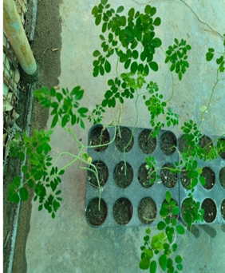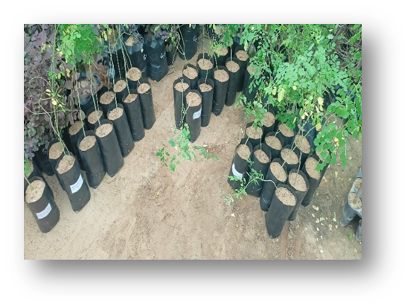
Figure 2: Seedlings raised in root trainers and polybags in nursery conditions

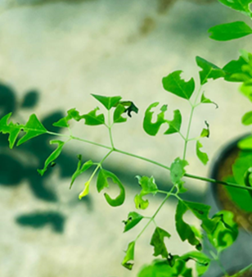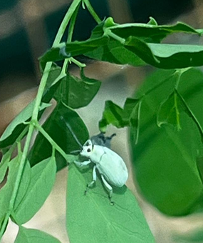
Figure 3: M. concanensis seedlings infected with Ash weevil M. viridanus Fabr.
3.3 Infestation of insects: Infestation of the weevil was recorded during middle of the June, 2024 when the seedlings were 45-60 days old. It was also observed that the infestation became severe in the month of September-October, 2024. Adult weevils produced characteristic marginal and interveinal notching on young leaves, resulting in considerable reduction of photosynthetically active leaf area. Seedlings examined were found to be infested, indicating a 100% incidence level. Quantitative damage evaluation showed an average of 25.29 damaged leaves per seedling, corresponding to an average foliar damage of 77.6% (percent infested leaves) relative to total leaf number (Figure 4). Thus, present findings identify the species M. viridanus Fabr. as a significant defoliator of early juvenile stage of M. concanensis and suggest its eco-friendly management approaches.

Figure 4: Graphical representation of damage percentage
3.4 Insect Morphology: The adult measures approximately 3–4.5 mm in body length and exhibits a pale greenish-white coloration with a characteristic chalky efflorescent coating. The head tapers anteriorly, with the eyes positioned dorsally and the forehead bearing a rounded impression. The rostrum is distinctly longer than the head and the mandibles are reddish brown. Antennae are black to piceous. The prothorax is subconical, and the elytra display very narrow striae. The legs are black and covered with green scales.
3.4.1 Symptoms: Its adults bite the edges of the leaves and the grubs (larva) eat the roots due to which the plant withers and dies. When the infection becomes severe, the growth of the plants gets restricted and the plant starts weakening from the roots.
3.4.2 Assessment of Management trial: The current study shows that neem oil is very effective in reducing leaf damage in infested seedlings. The initial damage level of 77.6% indicated severe pest pressure, which made this experiment appropriate for testing plant-based insecticides. To test this, experiments were designed with four treatments having Control (water), Neem 0.5%, Neem 0.75%, and Neem 1%, with 25 seedlings in each group. A one-way ANOVA showed significant differences among the treatments (F = 582.94, p < 0.0001). Tukey HSD test revealed that all concentrations of neem oil significantly reduced foliar damage compared to the control. It was noticed that the percent infested leaves 21 days after second treatment was 78% in the control, 50%, 35%, and 20% in concentration of 0.5%, 0.75% and 1% neem oil as represented in Figure 5. The lowest damage was found in 1% concentration of neem oil. The data showed that the higher concentration of neem oil enhances protection against leaf-damaging pests. Neem oil contains Azadirachtin as the main active ingredient which has antifeedant, toxic and growth regulating action on insects thus makes the neem of utmost importance (Schmutterer, 1990). Neem oils are ecofriendly and biodegradable and thus are less toxic to the environment. The use of neem oil is proved to be suitable for integrated pest management because of the non-toxic behaviour to the non-targeted organisms, easy preparation and it doesn’t leave any residues on plant (Devi and Gogoi, 2023). The results of the present study validate the use of neem oil as a safe, nature-friendly, and effective botanical pesticide for the control of foliar pests in nursery seedlings. Neem oil, being a broad-spectrum pesticide, affordable and environmentally compatible, provides a promising alternative to synthetic pesticides especially in sustainable and low-input production systems.

Figure 5: Graphical representation of mean damage (percent infested leaves) 21 days after second treatment

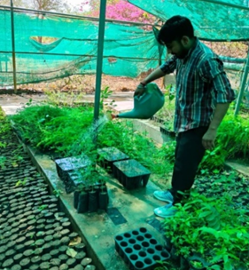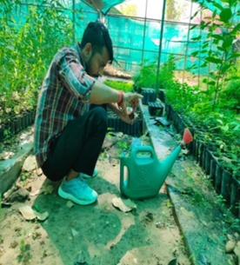
Figure 6: Use of botanicals for management of Ash weevil on M.concanensis seedlings
The outcomes of the present study align well with the observations reported by Arthanari et al. (2021). In their investigation, neem oil (Azadirachta indica) was tested at five concentrations ranging from 1 to 5 ml/L, against M. viridanus Fabr. in controlled laboratory conditions. Their bioassay identified lethal concentration values of LC₃₀ (3.096 ml/L), LC₅₀ (3.471 ml/L), and LC₉₀ (4.589 ml/L), following the direct application of neem oil sprays to adult insects. They recorded a clear dose-responsive trend, with mortality progressively increasing from 34% to 100% as the neem oil concentration rose. This gradual escalation in insect mortality mirrors the pattern observed in the current experiment, further supporting the effectiveness of neem oil as a botanical insecticide. Thacker et al. (2003) also reported the similar impact of neem oil on the feeding behaviour of the large pine weevil (Hylobius abietis L.), a major pest of regenerating conifer plantations across northern Europe. Their evaluations, carried out under both laboratory and field conditions, consistently demonstrated that neem oil substantially reduced feeding activity in the weevils. This strong antifeedant response observed in their study aligns with our results, further highlighting the broad-spectrum deterrent potential of neem-based formulations against various herbivorous pests.
4 CONCLUSIONS
The present study demonstrates the high efficacy of neem oil in reducing foliar damage in infested seedlings. Neem oil at 1% concentration proved most effective, showing the lowest damage percentage. The results demonstrate that increasing neem oil application enhances protection against leaf-damaging pests. These findings support the use of neem oil as a nature friendly management measure against insect pest of nurseries, especially in sustainable and low-input production systems.

Disclaimer (Artificial intelligence)

Author(s) hereby declare that NO generative AI technologies such as Large Language Models (ChatGPT, COPILOT, etc.) and text-to-image generators have been used during the writing or editing of this manuscript.
ACKNOWLEDGEMENT:
The authors are thankful to the Director, ICFRE-Arid Forest Research Institute, Jodhpur (Rajasthan) for their kind support and freedom for undergoing research. We acknowledge the financial support from National Medicinal Plant Boards (NMBP), New Delhi under the project “Survey, Inventorisation, Documentation, Propagation and Conservation of rare, endangered and threatened medicinal plants of Arid and Semi-Arid Regions. The Authors are also grateful to Dr. R.Bano, Senior Scientist, Zoolgical survey of India for identification of the insect.

REFERENCES
- Arthanari, M., Senthilkumar, D., & Jayachandran, R. (2022). Combined toxicity effects of neem oil and mild soap on Myllocerus viridanus in Morus alb. Journal of Biopesticides, 14,119-124.
- Bhandari, M.M. (1990). Flora of the Indian Desert. Scientific Publishers, Jodhpur (Revised Edition).
- Devi, D., & Gogoi., R. (2023). Neem as a Potential Biopesticide and Biofertilizer - A Review. Research Journal of Pharmacy and Technology 2023; 16(4):2029-4. doi: 10.52711/0974-360X.2023.00334
- Kumar, S., & Purohit, C.S. (2015). Conservation of Threatened desert plants. Scientific Publishers
- Mughal, M.H., Ali, G., Srivastava, P.S., & Iqbal, M. (1999). Improvement of Drumstick (Moringa
- pterygosperma Gaertn.)- unique source of food and medicine through tissue culture. Hamdard Med., 42, 37–42.
- Prasanna, P.V. (2000). Moringaceae In: N.P. & S. Karthikeyan (Ed.) Flora of Maharashtra state Dicotyledones. Botanical Survey of India, Kolkata, 1,589–590.
- Pullaiah, T., & Chennaiah, E. (1997). Flora of Andhra Pradesh. Vol.1, Scientific Publishers, Jodhpur
- Shashikala, M., Bhavana, B., Geethasree, M.S., Sirisha, E., Prabhas, K.G., & Mathew,C.(2025). Exploring Moringa concanensis: A Hidden Plant with Medicinal and Pharmacological Properties. International Journal of Pharmaceutical and Bio-Medical Science, 05,06.
- Shetty, B.V., & Singh, V. (1988). Flora of India Series 2. Flora of Rajasthan. Botanical Survey of India, 1,196–197.
- Thacker, J. R. M., Bryan, W. J., McGinley, C., Heritage, S., & Strang, R. H. C. (2003). Field and laboratory studies on the effects of neem (Azadirachta indica) oil on the feeding activity of the large pine weevil (Hylobius abietis L.) and implications for pest control in commercial conifer plantations. Crop Protection, 22(5),753–760. https://doi.org/10.1016/S0261-2194(03)00041-3.
- Schmutterer, H. (1990). Properties and potential of natural pesticide from neem tree, Azadirachta indica. Annu. Rev. Entomol. 35: 271-297.
- Balakumbahan , R., V. Sivakumar, and C. Ravindran. 2023. “Fertigation Studies in Moringa (Moringa Oleifera Lam) under High Density Planting System for Leaf Biomass”. International Journal of Plant & Soil Science 35 (13):214-20. https://doi.org/10.9734/ijpss/2023/v35i133007.
- Rao, B. R. P., Reddy, M. S., & Pullaiah, T. (2008). Flora and vegetation of Andhra Phradesh. New Delhi Akademy of Sciences, 12, 1-13.
- Shanmugam, P. S., Indhumathi, K., & Sangeetha, M. (2018). Management of ash weevil Myllocerus subfasciatus Guerin-Meneville (Coleoptera; Curculionidae) in Brinjal. Journal of Entomology and Zoology Studies, 6(6), 1230-1234.

