Characterization and In vitro Management of Anthracnose of Fishtail Palm (Caryota mitis) Caused by Colletotrichum manihotis in India: A preliminary Study

ABSTRACT
Fishtail palm (Caryota mitis), characterized by its distinctive goldfish tail like leaflets, is a popular ornamental plant that is frequently affected by anthracnose disease. The present study, conducted during 2022, investigated disease symptomatology, pathogen isolation, pathogenicity, and identification, along with the evaluation of growth media, temperature effects, growth characteristics, biomass production, and fungicide efficacy. The causal pathogen was identified as Colletotrichum manihotis based on conidial dimensions and cluster analysis. Among the four-culture media evaluated, potato dextrose agar (PDA) resulted in the highest mycelial expansion, and an incubation temperature of 28 °C was found to be optimal for growth. On PDA, oat meal agar (OMA), and Czapek–Dox agar (CDA), C. manihotis produced whitish, cotton-like mycelia, whereas no such growth was observed on malt extract agar (MEA). In terms of biomass yield, potato dextrose broth (PDB) proved to be the most effective medium when incubated at 24 °C and 28 °C. Among the fungicides evaluated, difenoconazole 25% EC was the most effective, completely inhibiting mycelial growth at 100 ppm with an EC₅₀ value of 13.3 ppm, whereas mancozeb 50% WP required 400 ppm with an EC₅₀ value of 38.5 ppm. Based on the available literature, this appears to be the first documented scientific evidence of anthracnose in fishtail palm caused by Colletotrichum manihotis in India, thus addressing a critical knowledge gap and offering foundational insights for future disease management strategies.
Keywords: fishtail palm, anthracnose, isolation, identification, media, temperature
INTRODUCTION
The fishtail palm (Caryota mitis) is an attractive ornamental palm species extensively used in landscape decoration worldwide, distinguished by its medium-sized green fronds that are deeply segmented and resemble the tail of a goldfish (Sarwar et al., 2020). Despite aesthetic appeal, the palm is susceptible to various diseases viz. Wilt caused by Fusarium oxysporum (Bhanwar et al., 2016), brown leaf spot caused by Fusarium equisetii (Ashfaq et al., 2017), dieback and canker caused by Botryosphaeria ribis (Pereira et al., 2023), several leaf spots caused by Lasiodiplodia sp. (Zhu et al., 2015), Pestalotia and Pestalotiopsis sp. (Sarwar et al., 2020, Bhanwar et al., 2012), and bacterial blight caused by Acidovorax avenae (Nelson, 2009), a common challenge among ornamental palm varieties. Such diseases can markedly impair plant vigor, restrict normal growth and reduce both aesthetic appeal and economic value (Nelson, 2009). In recent years, fishtail palm plantations in West Bengal have faced a serious outbreak of an anthracnose like disease. However, prior investigations had neither documented the disease symptoms nor successfully isolated and identified the responsible pathogen. Owing to the absence of pathogen isolation, studies on suitable growth media, optimal temperature conditions, biomass production and EC₅₀ values of commonly used fungicides were also lacking. In view of these existing knowledge gaps, particularly in the eastern region of India and at the national level, the present study was undertaken with the objectives of characterizing disease symptoms, isolating and identifying the causal organism based on morphological features, determining appropriate culture media and temperature for optimal growth and biomass production, and evaluating its EC₅₀ against selected fungicides.

MATERIALS AND METHODS

Collection of infected samples and isolation of the causal pathogen

Symptomatic leaf samples of fishtail palm were collected from Pallishree Nursery, Arambagh, Hooghly district, West Bengal, India (22°53′ N, 87°78′ E) and promptly transported to the Mycology Laboratory, Department of Plant Pathology, Bidhan Chandra Krishi Viswavidyalaya, Mohanpur, Nadia, West Bengal. Isolation of the associated pathogen was carried out according to the procedure outlined by Thilagam et al. (2018), with minor modifications. Diseased leaf portions were excised into small segments and surface sterilized using 0.1% mercuric chloride (HgCl₂) for 30–45 seconds, followed by 5–6 rinses with sterile distilled water. After removing excess moisture by blotting, the tissue segments were placed on water agar medium in Petri dishes and incubated at 28 ± 1 °C until fungal hyphae emerged. Actively growing hyphal tips were subsequently transferred to fresh potato dextrose agar (PDA) slants and incubated for 6–7 days. The resulting pure cultures were preserved at 5 °C for use in further experiments.

Identification of the associated pathogen

Microscopic slides were prepared from infected plant samples for morphometric examination. Microphotographs were captured using a Karl Zeiss phase-contrast microscope, and measurements of conidia and conidiophores were obtained with Axio Vision image analysis software. Preliminary identification of the fungus was performed at the genus level based on standard taxonomic keys (Sutton, 1981). Subsequent species level identification was achieved by comparing conidial dimensions with published morphometric data of related species within the genus, following the nearest neighbour approach in cluster analysis as described by Sangpueak et al. (2018).

Effects of culture media and temperatures on radial growth and colony morphology

The experiment was conducted using four liquid culture media, viz. potato dextrose broth (PDB), oat meal broth (OMB), malt extract broth (MEB), and Czapek Dox broth (CDB) in combination with three incubation temperatures (21 °C, 24 °C and 28 °C), each treatment replicated three times. For each medium, 40 ml was dispensed into 250 ml conical flasks and inoculated with a 5 mm diameter mycelial disc excised from the actively growing margin of a six-day old culture. The inoculated flasks were incubated at the respective temperature regimes for a period of six days. Upon completion of the incubation period, the fungal biomass developed in each medium was harvested and separately filtered through pre weighed and oven dried Whatman No. 1 filter papers. The collected mycelial mass was dried at 65–70 °C for 96 hours until a constant dry weight was achieved, with repeated measurements taken to confirm weight stability. Dry biomass data were subjected to two-factor statistical analysis.

Assessment of fungal biomass production

Four growth media viz. Potato dextrose broth (PDB), Oat meal broth (OMB), Malt extract broth (MEB) and Czapek dox broth (CDB) and three temperatures viz. 21⁰C, 24⁰C, and 28⁰C were considered with three replications. 40 ml broth of above mentioned four media were taken into 250 ml conical flasks and inoculated with a 5 mm mycelial disc taken from active growing tip region of 6 days old culture. Both the flasks and plates were incubated at above mentioned three temperatures. The conical containing broths were incubated for 6 days. After 6 days the mycelial mat formed by fungi on 4 growth media were collected and filtered separately through previous dried and pre-weighted Whatman No. 1 filter paper. Filter paper containing the fungal mass was then kept in drier for drying at 65⁰C-70⁰C for 96 hours to a constant weight. Weighing was repeated till constant weight was obtained. 2 factor analysis was done for fungal dry biomass production.

Fungicide sensitivity analysis

The in vitro response of the pathogen to two fungicides—mancozeb 50% WP and difenoconazole 25% EC was evaluated at eight concentrations (0, 10, 25, 50, 100, 200, 400, and 800 µl ml⁻¹) using the poisoned food technique (Vanani et al., 2024). Fungicide amended potato dextrose agar (PDA) medium (20 ml) was poured into sterilized Petri dishes for each treatment, while control plates received an equal volume of PDA without fungicide. A 5 mm diameter mycelial disc, excised from the actively growing margin of the culture using a sterile cork borer, was centrally placed on each plate. The inoculated plates were incubated in a BOD incubator at 28 ± 2 °C until complete mycelial coverage was observed in the control treatment (Golakiya et al., 2020). All treatments, including controls, were arranged in triplicate. Radial colony growth was measured, and mycelial growth inhibition relative to the control was calculated. The effective concentration required to inhibit 50% of mycelial growth (EC₅₀) for each fungicide was estimated by regressing probit transformed inhibition values against the logarithm of fungicide concentrations (Ren et al., 2020). A regression model (Y = a + bx) was fitted and evaluated for goodness of fit, and treatment effects were assessed using the simple correlation coefficient (r) at 5% and 1% significance levels. Percentage inhibition of radial growth was computed using the following formula.

C –T
Percent inhibition (%) = –––––– X100
C
(Where C represents radial growth in the control and T denotes radial growth in the treated plates)

RESULTS AND DISCUSSIONS

Disease symptoms

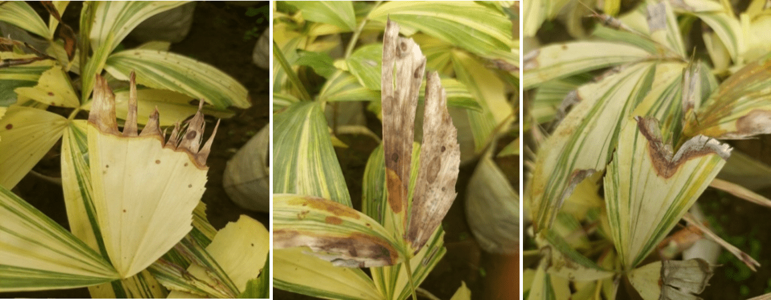
Disease symptoms first appear along the leaf margins or as minute lesions on the leaf lamina, which subsequently advance downward, leading to desiccation and a straw-yellow discoloration of the leaf edges. (Fig. 1). A distinct brown demarcation separates the affected tissue from the healthy areas. The spots may coalesce, leading to complete drying of the leaf. Notably, minute dot-like structures (acervuli) are frequently observed on the dried tissues.

Figure 1: Anthracnose symptoms on leaves of fishtail palm

Isolation of the causal organism and establishment of pathogenicity

Pathogenicity was established by inoculating detached fishtail palm leaves under laboratory conditions. The treated leaves exhibited disease symptoms similar to those recorded in the nursery (Fig. 2). The fungal pathogen was successfully reisolated from the symptomatic tissues and matched with the initially isolated culture, thereby confirming its pathogenicity (Xu et al., 2017).

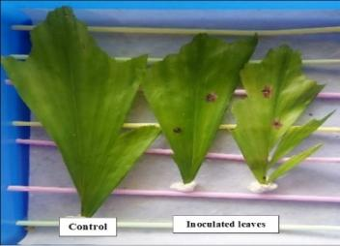

Figure 2: Pathogenicity establishment of Colletotrichum sp. of fishtail under laboratory condition

Morphological traits and identification of the pathogen

Slides prepared from infected tissues and pure cultures were examined for morphometric analysis. The pathogen formed short, cylindrical, hyaline, aseptate conidia with 3–4 guttules, rounded at one end and tapering at the other (Fig. 3), measuring 8.79 to 15.89 μm × 2.74 to 4.49 μm. The conidia were produced from acervuli bearing setae (Fig 4). Acervuli measured 180.46 to 244.7 μm in length and 160.88 to 190.39 μm in width, with 10-20 setae having 3-5 septa. Setae had a length of 28.77 to 54.83 μm, a base width of 1.23 to 3.41 μm, a middle width of 2.91 to 5.85 μm, and a tip width of 0.41 to 1.54 μm.
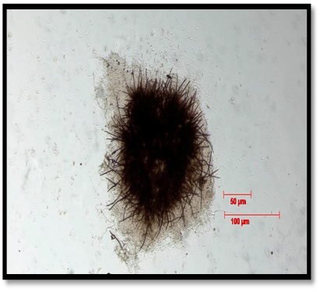
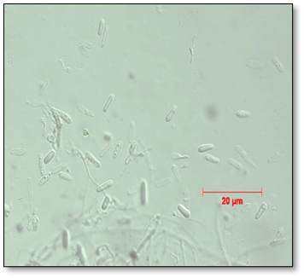
Figure 4: Microscopic view of acervuli bearing setae and conidia produced by Colletotrichum manihotis.

Figure 3: Microscopic view of conidia produced by Colletotrichum manihotis.

The anthracnose pathogen isolated from fishtail palm exhibited conidial features characteristic of the genus Colletotrichum. Hierarchical cluster analysis of conidial dimensions of representative Colletotrichum species (Fig. 5) (Salotti et al., 2022), performed using the nearest-neighbour method (Grahovac et al., 2012), placed the isolate in close association with C. manihotis. The isolate shared key morphological traits with C. manihotis, including short, cylindrical, hyaline, aseptate conidia bearing 3–4 guttules (Ehui et al., 2019). Although its spore dimensions overlapped with those of several Colletotrichum species, single-linkage analysis indicated the closest similarity with C. manihotis (8–15 µm × 4–6 µm) (Table 1), supporting its morphological identification as C. manihotis.
Table 1: Conidial and Acervular Dimensions of Colletotrichum sp. from Fishtail Palm Grown as Pure Culture on PDA

Name of the Pathogen | Length of Conidia (µm) | Width of Conidia (µm) | Length of Acervuli (µm) | Width of Acervuli  (µm) | Length of Setae  (µm) | Base width of setae (µm) | Mid width of septa (µm) | Tip width of septa (µm)
Colletotrichum sp. | 8.79-15.89 | 2.74-4.49 | 180.46-244.7 | 160.88-190.39 | 28.77-54.83 | 1.23-3.41 | 2.91-5.85 | 0.41-1.54
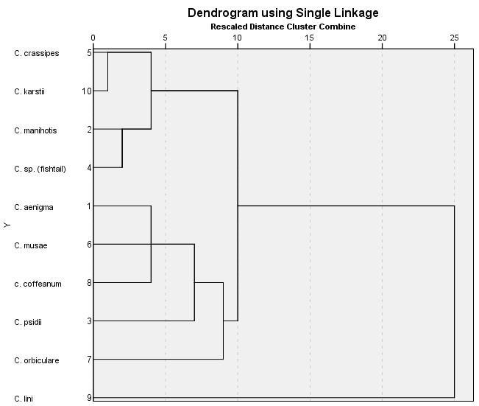

Figure 5: Dendrogram based on conidial characteristics of Colletotrichum manihotis obtained from fishtail palm

Response of radial growth to different culture media, temperature, and media x temperature interaction

The influence of four culture media viz. PDA, CDA, OMA and MEA and three incubation temperatures (21 °C, 24 °C and 28 °C) on radial growth of Colletotrichum manihotis was evaluated both individually and for their interaction effects (Table 2) over nine consecutive observation days. Across temperatures, radial growth was significantly enhanced on most observation days, except on day nine. On the eighth day, PDA outperformed OMA, MEA and CDA in promoting fungal growth, indicating its superior suitability as a culture medium. These findings are consistent with previous reports: Lokare and Fatima (2021) observed that PDA promoted the fastest mycelial growth of Colletotrichum gloeosporioides causing mango anthracnose, followed by CDA. Similarly, Thangeswari et al. (2024), Bhagat et al. (2022), and Soltani et al. (2014) reported PDA as the most favorable medium for mycelial growth of various Colletotrichum species. Majumdar and Mandal (2019) noted PDA and OMA as optimal for mycelial growth and sporulation, respectively, of C. gloeosporioides on banana. In another study, Joshi et al. (2024) screened twelve nutrient media for Colletotrichum capsica and found PDA and carrot dextrose agar to be the most effective for growth and sporulation. Khare et al. (2025) also demonstrated that PDA supported the fastest early growth of C. truncatum. Collectively, these studies highlight PDA as a highly suitable medium for growth and sporulation of various Colletotrichum species.
The radial growth of the fungus irrespective of media when examined, it was found significantly enhanced in all dates of observation. Out of 3 temperatures tested, the radial growth was significantly highest and lowest at 28⁰C and 21⁰C respectively. However, the performance of the radial growth of the fungus at 24⁰ C looked intermediate. At day 9, the tested fungus covered the entire diameter of the Petri plates at all the temperatures viz. 21⁰C, 24⁰C and 28⁰C. In the present experiment, out of 3 temperatures tested, the radial growth was significantly highest and lowest at 28⁰C and 21⁰C respectively. This finding was in agreement with the findings of Pandey et al. (2012), Soltani et al. (2014), Sajili et al. (2017), Prajapati et al. (2015) who identified 28°C as the most suitable temperature for mycelial growth of different Colletotrichum species.

When radial growth was analyzed irrespective of culture media, the fungus showed significant growth enhancement across all observation days. Among the three tested temperatures, the highest radial growth was observed at 28 °C, while the lowest occurred at 21 °C, and 24 °C showing intermediate growth. By day nine, the fungus had completely colonized the diameter of the Petri plates at all temperatures (21 °C, 24 °C, and 28 °C). These results are consistent with previous studies reporting 28 °C as the optimal temperature for mycelial growth of various Colletotrichum species (Pandey et al., 2012; Soltani et al., 2014; Sajili et al., 2017; Prajapati et al., 2015).

The combined effects of the four culture media and three temperatures on radial growth of C. manihotis were evaluated across multiple observation days and significant differences were observed at all time points. On day eight, both 24 °C and 28 °C supported greater radial growth compared to 21 °C. Among the media, PDA consistently promoted the highest growth across all temperatures, followed by OMA, MEA and CDA. By day nine at 28 °C, the fungus achieved complete radial coverage of the Petri plates in all media. Overall, radial growth was significantly highest at 28 °C, lowest at 21 °C and intermediate at 24 °C.

Table 2: Effect of Media*Temperature Interaction on Radial Growth (cm) of C. manihotis over Time

 | D1 | D2 | D3 | D4 | D5 | D6 | D7 | D8 | D9
Media | T1 (21^{O}C)
PDA | 0.83 | 1.93 | 3.37 | 4.23 | 5.33 | 5.97 | 7.30 | 8.90 | 9.00
CDA | 0.87 | 1.67 | 2.93 | 3.37 | 4.27 | 5.37 | 6.30 | 7.23 | 8.83
OMA | 0.53 | 2.17 | 3.33 | 4.07 | 5.00 | 5.77 | 7.03 | 8.07 | 9.00
MEA | 0.67 | 1.67 | 2.47 | 3.40 | 4.83 | 5.57 | 6.53 | 7.77 | 8.94
Temperature mean irrespective of media | 0.73 a | 1.86 a | 3.03 a | 3.77 a | 4.86 a | 5.57 a | 6.79 a | 7.99 a | 8.94 a
Media | T2 (24ºC)
PDA | 1.07 | 2.43 | 3.40 | 4.67 | 5.80 | 6.70 | 7.87 | 8.97 | 9.00
CDA | 1.03 | 2.07 | 3.13 | 3.70 | 4.73 | 5.70 | 6.77 | 7.57 | 8.91
OMA | 1.13 | 2.37 | 3.30 | 4.10 | 5.63 | 6.33 | 7.43 | 8.73 | 9.00
MEA | 1.13 | 2.17 | 3.53 | 3.90 | 5.07 | 6.03 | 7.03 | 8.03 | 9.00
Temperature mean irrespective of media | 1.09 b | 2.26 b | 3.34 b | 4.09 b | 5.31 b | 6.19 b | 7.27 b | 8.32 b | 8.98 a
Media | T3 (28ºC)
PDA | 2.63 | 3.73 | 4.73 | 5.87 | 6.77 | 7.90 | 8.87 | 9.00 | 9.00
CDA | 2.13 | 3.07 | 4.20 | 4.87 | 5.87 | 6.73 | 7.23 | 8.13 | 9.00
OMA | 2.43 | 3.67 | 4.57 | 5.77 | 6.53 | 7.27 | 8.50 | 8.97 | 9.00
MEA | 2.43 | 3.47 | 4.37 | 5.23 | 6.17 | 6.97 | 8.03 | 8.77 | 9.00
Temperature mean irrespective of media | 2.41 c | 3.48 c | 4.47 c | 5.43 c | 6.33 c | 7.22 c | 8.16 c | 8.72 c | 9.00 a
Media Mean across all temperatures
PDA | 1.51 b | 2.70 c | 3.83 c | 4.92 d | 5.97 d | 6.86 d | 8.01 d | 8.95 d | 9.00 b
CDA | 1.34 a | 2.27 a | 3.42 a | 3.98 a | 4.95 a | 5.93 a | 6.77 a | 7.64 a | 8.92 a
OMA | 1.37a | 2.73 c | 3.73 b | 4.64 c | 5.72 c | 6.46 c | 7.66 c | 8.59 c | 9.00 b
MEA | 1.41 a | 2.43 b | 3.46 a | 4.18 b | 5.35 b | 6.19 b | 7.20 b | 8.19 b | 9.00 b
SEm±for temperature | 0.02 | 0.02 | 0.02 | 0.03 | 0.02 | 0.03 | 0.03 | 0.03 | NS
CD^{.05} for temperature | 0.04** | 0.08** | 0.07** | 0.08** | 0.06** | 0.07** | 0.07** | 0.09** | -
SEm± for media | 0.02 | 0.02 | 0.03 | 0.04 | 0.02 | 0.03 | 0.03 | 0.04 | NS
CD_{.05} for media | 0.05** | 0.05** | 0.08** | 0.09** | 0.07** | 0.08** | 0.08** | 0.10** | -
SEm± for temp*media | 0.04 | 0.04 | 0.05 | 0.07 | 0.05 | 0.06 | 0.06 | 0.07 | NS
CD_{.05} for temp*media | 0.09** | 0.09** | 0.13** | 0.16** | 0.12** | 0.14** | 0.14** | 0.18** | -

D = Days; PDA = Potato dextrose Agar; OMA = Oat meal Agar; MEA = Malt extract agar; CDA = Czapek dox Agar; SEm = Standard error of mean; CD = Critical difference; ** = Significance at 0.01%; NS = non-significant
Growth characteristics or colony morphology of C. manihotis
Colletotrichum manihotis from fishtail palm showed differences in colony appearance when grown on four media at 21 °C, 24 °C, and 28 °C (Table 3). At 21 °C and 28 °C, the fungus grew whitish, cottony, and fluffy on all media. At 24 °C, dense cottony growth occurred on PDA, CDA, and OMA, while MEA supported only thin mycelial growth (Fig. 6).
At the back side of the Petri plates, it showed distinct mycelial growth on different media. At 21 °C, thin whitish growth appeared on CDA, thick whitish cottony growth on PDA, yellowish-white thick growth on OMA and light brownish thick growth on MEA. At 24 °C, CDA and OMA supported thick whitish and yellowish white growth respectively, while PDA and MEA showed thin whitish and yellowish white mycelia. At 28 °C, PDA, CDA, and MEA exhibited thick whitish growth, whereas OMA showed thin light yellow mycelial growth (Fig. 7).
The growth characteristics of Colletotrichum musae isolates were studied by Ranjitham et al. (2011) on seven different solid media and blakish white coloured colonies were observed on PDA medium and OMA medium. Grahovac et al. (2012) and Lee et al. (2020) reported that Colletotrichum isolates developed velvety, gray colonies with slightly undulating margins on PDA. Initially, the mycelium appeared snow-white, gradually turning pale gray as the culture aged. The colony’s underside ranged from cream to pale gray or tan and never became dark, consistent with the colony characteristics of C. acutatum described by Strandberg and Chellemi (2002).
Admassie et al. (2015) classified Colletotrichum colony colors into three categories: whitish, gray, and black to white. Among the isolates studied, three exhibited whitish colonies, three showed gray colonies, and one displayed a black-to-white colony coloration.

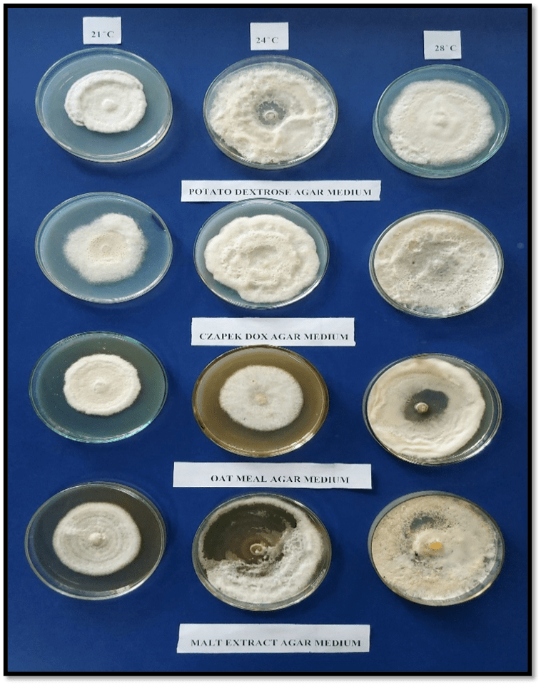
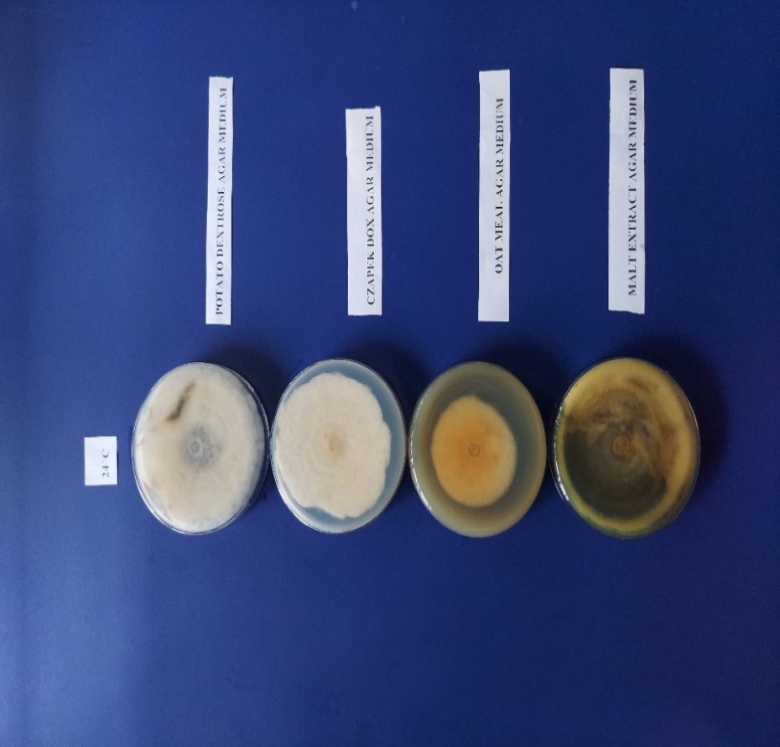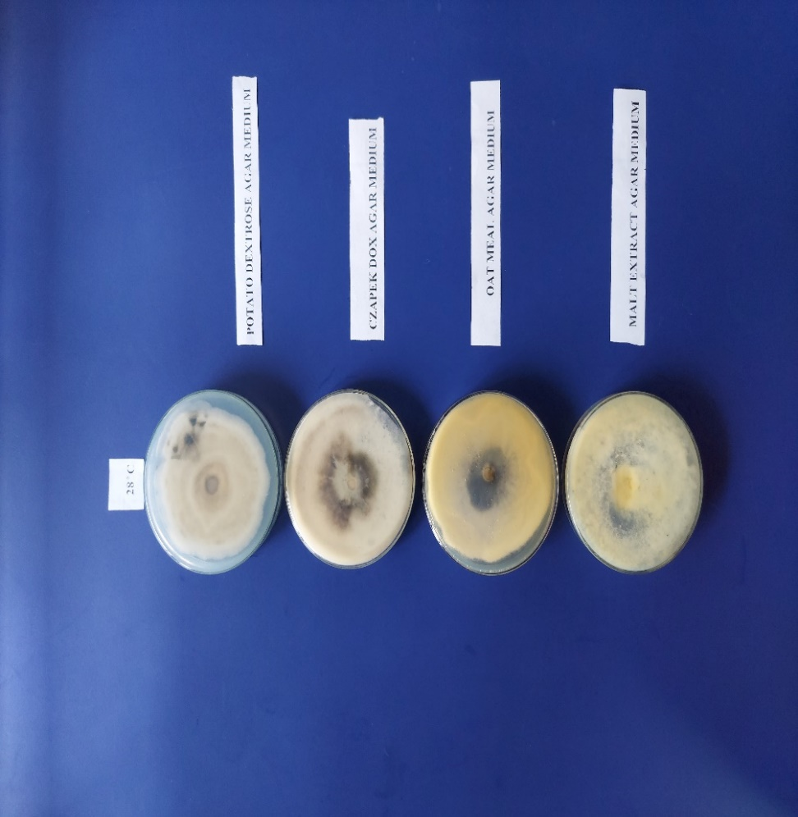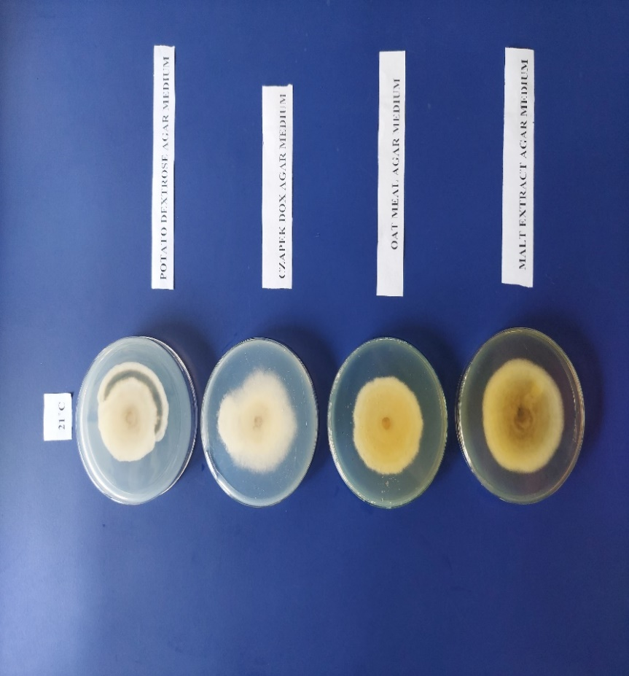

Figure 7: Colony morphology of Colletotrichum manihotis in different media at different temperature (Back side).
Figure 6: Colony morphology of Colletotrichum manihotis in different media at different temperature (Front side).

Table 3: Colony characteristics of Colletotrichum manihotis in different media at different temperatures
Growth media | Colony morphology  (Front side) | Colour of colony  (Front side) | Colony morphology (Back side) | Colour of colony (Back side)
21⁰C
PDA | Very thick, cottony, appressed growth with irregular margin. | Whitish. | Thick cottony mycelial growth. | Whitish with a blackish ring.
CDA | Cottony fluffy mycelial growth. | Whitish. | Thin cottony mycelial growth. | Whitish.
OMA | Cottony thick mycelial growth with concentric rings with irregular margin. | Whitish. | Thick mycelial growth. | Yellowish whitish.
MEA | Thick, cottony growth with concentric rings towards the margin. Margin is irregular. | Whitish. | Thick mycelial growth. | Light brownish white colour.
24⁰C
PDA | Thick, cottony, fluffy mycelial growth with irregular margin. | Whitish. | Thin mycelial growth. | Whitish.
CDA | Thick, cottony growth with irregular margin and more fluffiness compared to other media. | Whitish. | Thick mycelial growth with concentric rings towards centre. | Whitish.
OMA | Fluffy uniform growth of mycelia. | Whitish growth with yellowish centre. | Thick mycelial growth. | Yellowish white.
MEA | Very thin mycelial growth surrounding the point of inoculation with regular margin. | Whitish. | Very thin mycelial growth. | Yellowish.
28⁰C
PDA | Fluffy mycelial growth with concentric rings and margin is irregular. | Whitish. | Thick mycelial growth with a circle at the centre. | Greyish white.
CDA | Compressed, cottony mycelial growth with regular margin. | Whitish. | Thick mycelial growth with dark coloured centre. | Whitish colour with blackish centre.
OMA | The mycelia surrounding the point of inoculation are very thin, non-fluffy and appressed to the medium. Beyond this zone the mycelia are thick, fluffy and cottony. | Whitish. | Very thin growth at the surrounding the point of inoculation. Beyond this zone the mycelial growth is cottony. | Light yellowish.
MEA | Thin appressed mycelial growth with regular margin. | Whitish mycelia with yellow centre. | Thin mycelial growth. | Whitish.

Influence of media, temperature and media × temperature on fungal biomass production of C. manihotis across temperatures
The effect of four different growth media viz PDB, CDB, OMB and MEB on the biomass production of Colletotrichum manihotis was assessed at six days, irrespective of temperature (Fig. 8). Among the media tested, PDB proved to be the most suitable for promoting fungal dry biomass after six days of incubation (Udhayakumar et al., 2010; Sandhya et al., 2005; Juarez et al., 2000). In comparison, CDB, OMB and MEB supported similar levels of biomass, with no significant differences observed among them (Table 4). These results indicate that PDB provides a more favorable nutrient environment for the growth and biomass accumulation of C. manihotis.

Figure 8: Effect of media on biomass production (g) of Colletotrichum manihotis irrespective of temperatures at 6 days after inoculation
Table 4: Effect of media on biomass production (g) of Colletotrichum manihotis irrespective of temperatures at 6 days after inoculation.
Growth media | Fungal biomass (g)
PDB | 0.303b
CDB | 0.221a
OMB | 0.204a
MEB | 0.242a
SEm± | 0.012
CD_{0.5} | 0.035

PDB = Potato dextrose broth; CDB = Czapek dox broth; OMB = Oat meal broth; MEB = Malt extract broth; SEm = Standard error of mean; CD = Critical difference
The impact of three temperatures (21 °C, 24 °C and 28 °C) on the biomass production of Colletotrichum manihotis was evaluated, independent of the four growth media (PDB, CDB, OMB, and MEB), with dry fungal biomass measured up to six days after inoculation (Fig. 9). Results indicated that temperature had no significant effect on the dry biomass production of the fungus (Table 5).

Figure 9: Impact of temperature on fungal Biomass (g) of C. manihotis at Day 6, across media
Table 5: Effect of temperatures (⁰C) on biomass production (g) of Colletotrichum manihotis irrespective of media at 6 days after inoculation
Temperatures | Dry biomass (g)
21⁰C | .24a
24⁰C | .24a
28⁰C | .25a
SEm± | NS
CD_{0.5} | -

‘SEm' refers to the standard error of the mean, and ‘CD’ denotes the critical difference.
The combined effect of four media (PDB, CDB, OMB and MEB) and three temperatures (21 °C, 24 °C, and 28 °C) on the biomass production of Colletotrichum manihotis at six days after inoculation was found to be significant (Table 6). Among the combinations tested, PDB at 28 °C and 24 °C produced the highest fungal dry biomass compared to the other media and temperature conditions (Fig. 10).
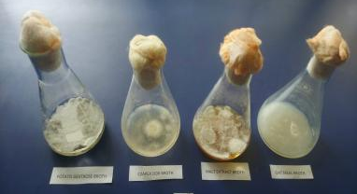
Figure 10: Growth of Colletotrichum manihotis on 4 broth media (PDB, CDB, OMB and MEB)
Table 6: Effect of media*temperatures on biomass production (g) of Colletotrichum manihotis, at 6 days after inoculation .
Growth media | Biomass (g)
21ºC
PDB | 0.291
CDB | 0.202
OMB | 0.194
MEB | 0.241
24⁰ C
PDB | 0.315
CDB | 0.214
OMB | 0.192
MEB | 0.241
28⁰ C
PDB | 0.312
CDB | 0.243
OMB | 0.224
MEB | 0.255
SEm± | 0.031
CD_{0.5} | 0.090

PDB = Potato dextrose broth; CDB = Czapek dox broth; OMB = Oat meal broth; MEB = Malt extract broth; SEm = Standard error of mean; CD = Critical difference

Fungicide sensitivity analysis

Mancozeb 50% WP inhibited the mycelial growth of Colletotrichum manihotis by 20.1%, 32.4%, 64.3%, 72.3%, and 88.2% at 10, 25, 50, 100, and 200 ppm, respectively, with complete inhibition observed at 400 ppm and higher (Fig. 11). In comparison, Difenoconazole 25% EC caused 44.5%, 63.2%, and 81.2% inhibition at 10, 25, and 50 ppm, respectively, achieving full inhibition at 100 ppm and above (Fig. 12; Table 7). Overall, Difenoconazole 25% EC was more effective than Mancozeb 50% WP against the anthracnose pathogen. The EC₅₀ values were 38.5 ppm for Mancozeb 50% WP and 13.3 ppm for Difenoconazole 25% EC (Table 8). These results align with previous studies, where Gao et al. (2017) reported that systemic difenoconazole inhibited Colletotrichum acutatum more effectively than mancozeb. Similarly, Mahesh et al. (2020) found that difenoconazole 25% EC completely suppressed the mycelial growth of Colletotrichum gloeosporioides, the causal agent of anthracnose in pomegranate.

Table 7: Inhibition (%) of Colletotrichum manihotis Mycelial Growth by Two Fungicides Compared to Control

Fungicides Tested | percentage inhibition of fungal growth relative to control at
Fungicides Tested | 0 ppm | 10 ppm | 25 ppm | 50  ppm | 100 ppm | 200 ppm | 400 ppm | 800 ppm
Mancozeb 50% WP | 0 | 20.1 | 32.4 | 64.3 | 72.3 | 88.2 | 100 | 100
Difenoconazole 25% EC | 0 | 44.3 | 63.2 | 81.2 | 100 | 100 | 100 | 100

Table 8: Regression and correlation analysis of fungicidal toxicity against Colletotrichum manihotis and determination of ec₅₀ values
Fungicides Tested | Chemical name | Regression equation (RE) | Simple correlation (r) | EC₅₀ (ppm)
Indofil M-45 | Mancozeb 50% WP | Y= 1.5312x + 2.5736 | 0.98* | 38.5
Score 25 EC | Difenoconazole 25% EC | Y= 1.4596x + 3.36 | 0.99* | 13.3

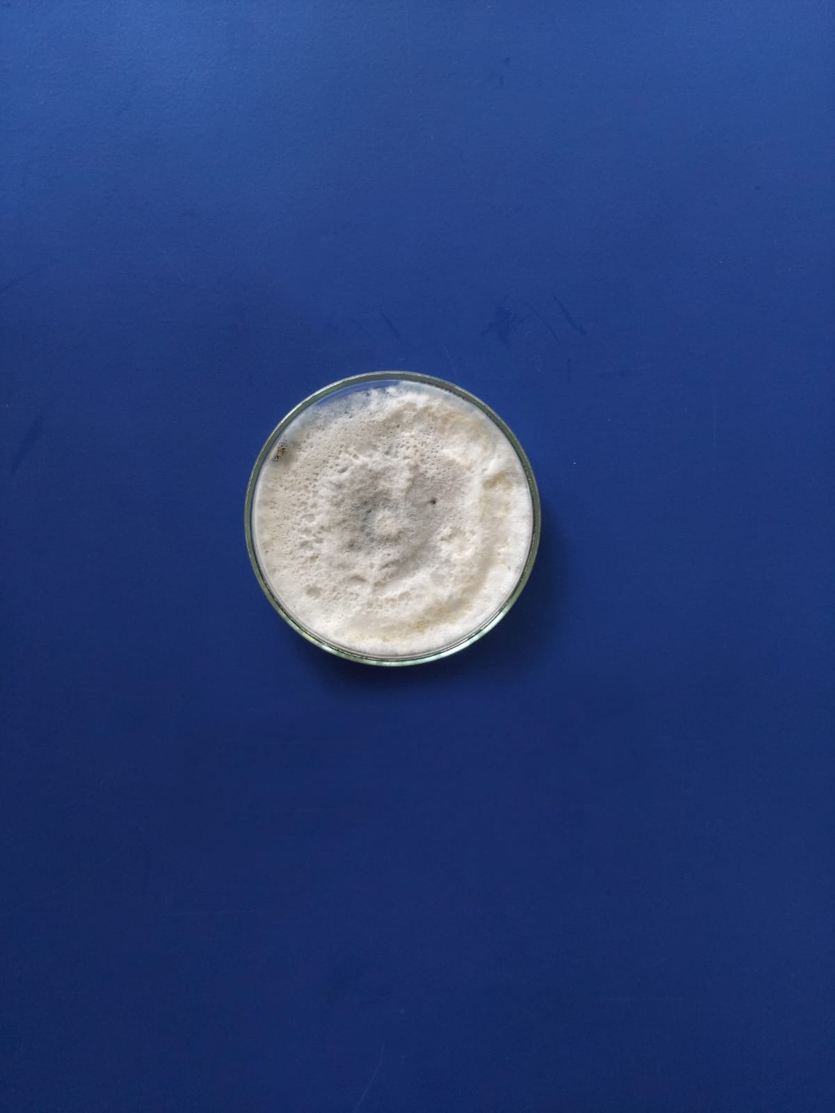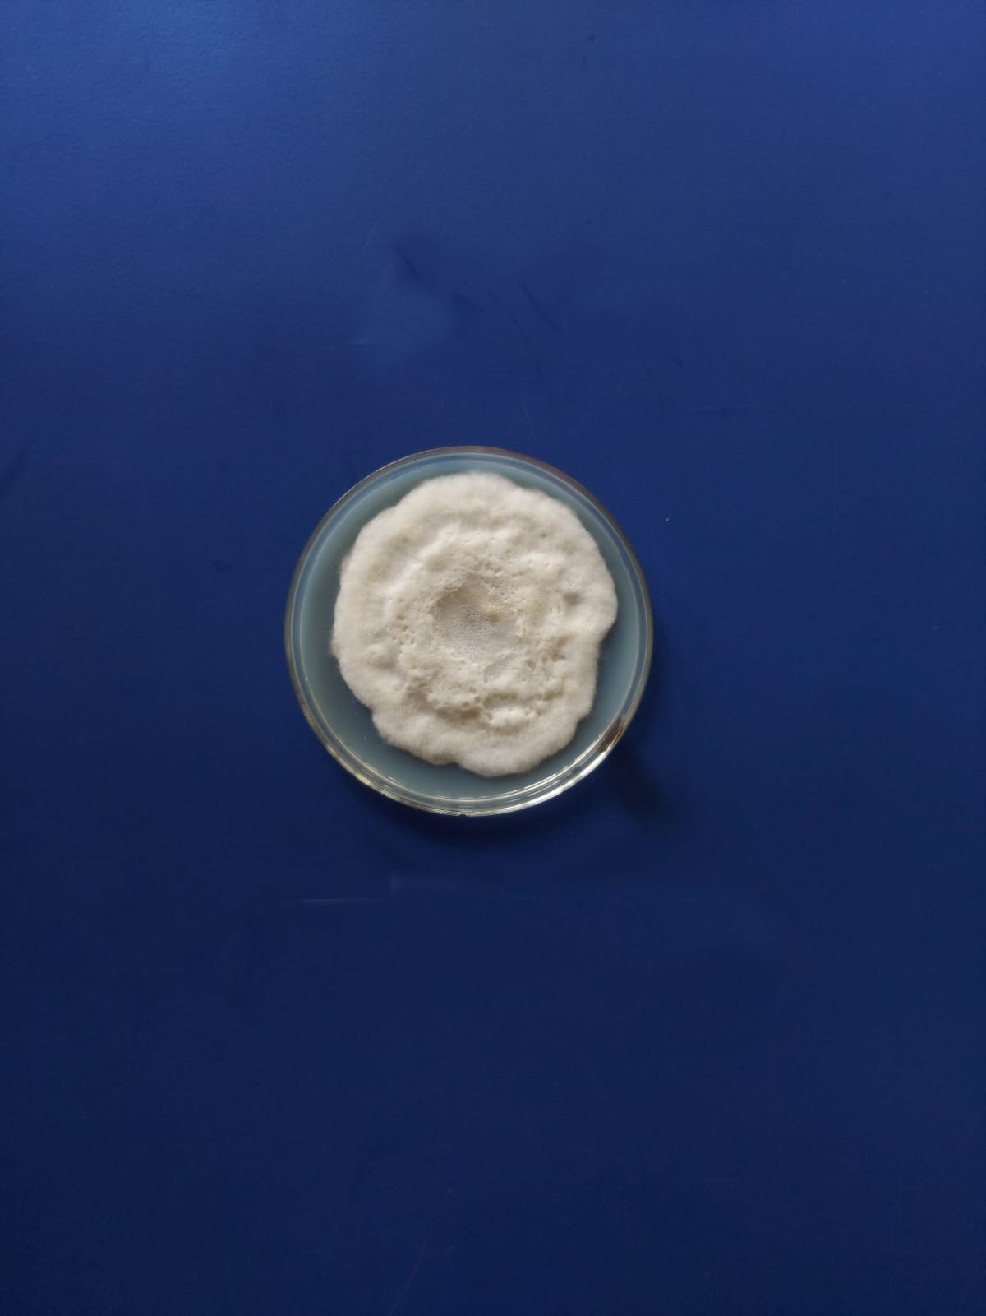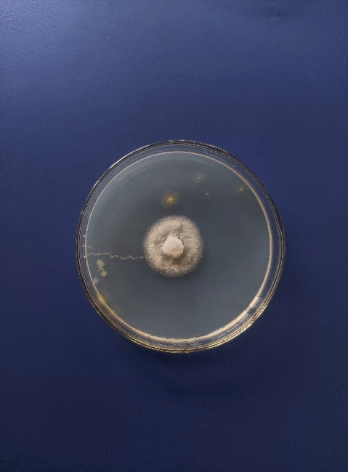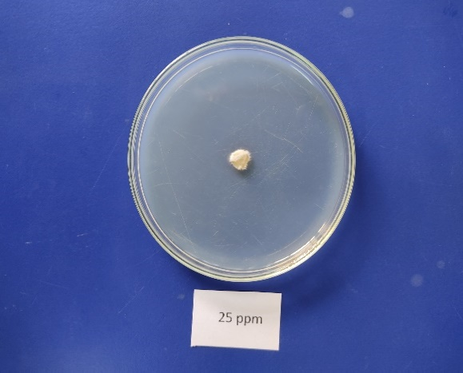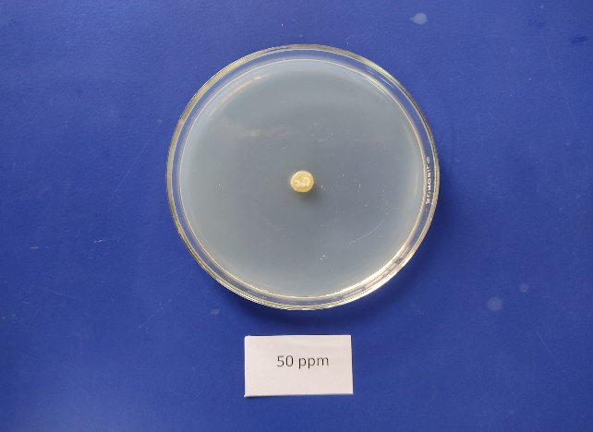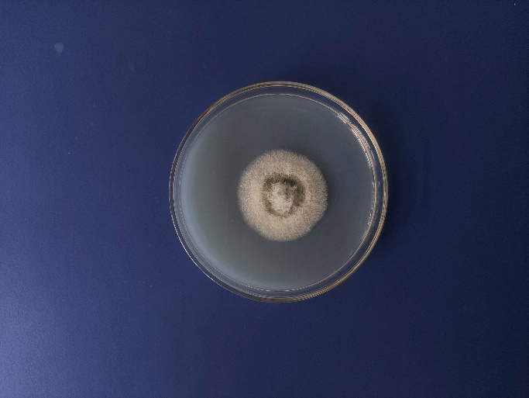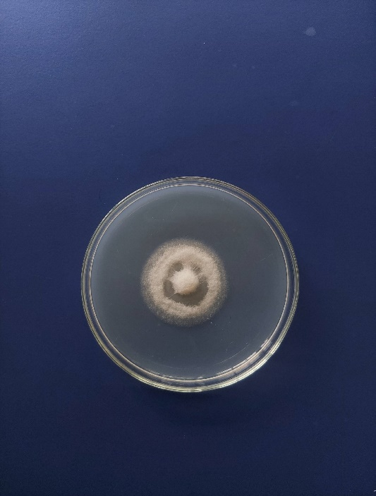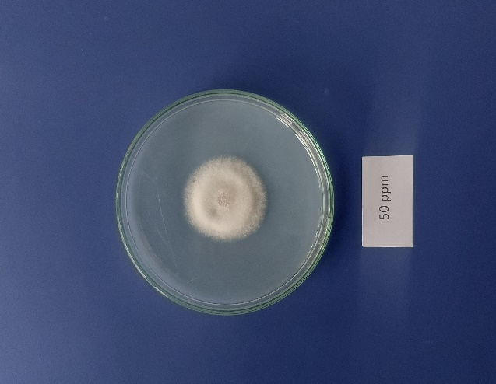

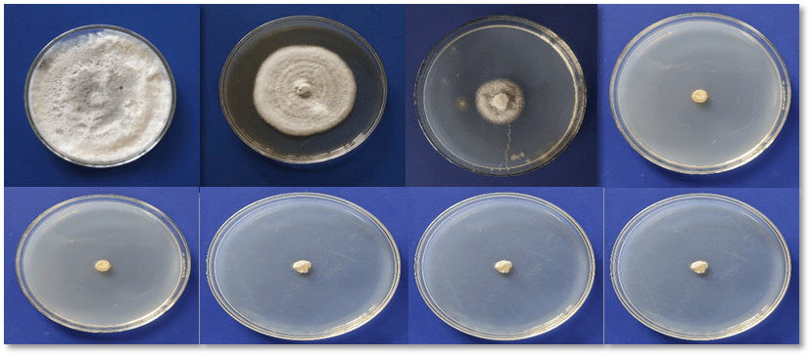
Figure 11: Fungal Growth Inhibition (%) of C. manihotis at Seven Mancozeb concentrations

Figure 12: Fungal Growth Inhibition (%) of C. manihotis at Seven Difenoconazole concentrations

CONCLUSION

The pathogen responsible for severe anthracnose on fishtail palm leaves was identified as Colletotrichum manihotis based on conidial measurements and cluster analysis. Among the culture media tested, PDA supported the highest mycelial growth, followed by OMA, MEA and CDA. Radial growth varied with temperature, with 28 °C promoting maximum growth and 21 °C the minimum. For biomass production, Potato Dextrose Broth (PDB) outperformed CDB, OMB and MEB after six days of inoculation. Of the fungicides evaluated, Difenoconazole 25% EC was more effective than Mancozeb 50% WP, exhibiting dose dependent inhibition with EC₅₀ values of 13.3 ppm and 38.5 ppm, respectively.This study represents the first scientific report of anthracnose of fishtail palm caused by Colletotrichum manihotis from India, providing baseline information for the development of effective disease management strategies.

Disclaimer (Artificial intelligence)

Author(s) hereby declare that NO generative AI technologies such as Large Language Models (ChatGPT, COPILOT, etc.) and text-to-image generators have been used during the writing or editing of this manuscript.

CONFLICTS OF INTEREST

The authors have declared that no conflicts of interest exist.

REFERENCES

Admassiea M, Handisob S, Alemua A. 2015. Physiological and Morphological Studies of Colletotrichum capsici under Different Culture Media Temperature and Light Regimes. International Journal of Environmental Sciences. 6(3):78-86.
Ashfaq M, Anjum MA, Hafeez R, Ali A, Haider MS, Ali M, Chattha MB, Ahmad SR, Ahmad F, Khan F, Sajjad M. 2017. First report of Fusarium equiseti causing brown leaf spot of fishtail palm (Caryota mitis) in Pakistan. Plant Disease. p.840.
Bhagat S, Singh SK, Choudhary S, Singh R, Singh VB, Singh AK, Vaid A. 2022. Studies on the Effect of different Media on the Mycelial Growth of Colletotrichum lindemuthianum. Biological Forum. 14(4):143-145.

Bhanwar RR, Prahlad Singh PS, Thakur AK, Sajeevan Kumar SK. 2012. Identification and characterization of Pestalotiopsis spp. causing leaf spot of fishtail palm in India.

Bhanwar RR, Singh P, Thakur AK. 2016. First Report of Wilt Disease Caused by Fusarium oxysporum spp on Fishtail Palm in India. Journal of Pure & Applied Microbiology. 10(3).

Devi KS, Misra DK, Saha J, Devi PS, Sinha B. 2018. Screening of suitable culture media for growth, cultural and morphological characters of Pycnidia forming fungi. International Journal of Current Microbiology and Applied Sciences. 7(08):4207-4214.

Ehui KJ, Toure HM, Kouame KG, Abo K, Kone D. 2019. Pathogenic characterization and morphocultural structuring of populations of Colletotrichum gloeosporioides Penz manihotis, the causal agent of cassava anthracnose, in Ivory Coast. Journal of Animal and Plant Science. 40(1): 6514-6525.

Gao YY, He LF, Li BX, Mu W, Lin J, Liu F. 2017. Sensitivity of Colletotrichum acutatum to six fungicides and reduction in incidence and severity of chili anthracnose using pyraclostrobin. Australasian Plant Pathology. 46:521-528.

Golakiya B, Akbari LF, Marakna NM. 2020. In vitro evaluation of different fungicides against pomegranate anthracnose caused by Colletotrichum gloeosporioides. International Journal of Chemical Studies. 8:3669-3674.
Grahovac M, Inđić D, Vuković S, Hrustć J, Gvozdenac S, Mihajlović M, Tanović B. 2012. Morphological and ecological features as differentiation criteria for Colletotrichum species.
Joshi R, ST Y, DS A, Chavan SS. 2024. Influence of Different Culture Media on Growth and Sporulation of Colletotrichum capsici. International Journal of Environment and Climate Change. 14(2):555-561.
Juarez M, Juarez D, Russo VM. 2000. Growth and protein content in Colletotrichum circinans, Fusarium solani and Rhizoctonia solani in liquid culture. Biologia plantarum. 43:577-582.

Khare, A. K., Kumar, A., Chouhan, A., Sharma, R., Namdeo, P., Dubey, R. K., ... & Laha, D. (2025). Morphological Characterization of Colletotrichum truncatum from Diverse Agro-climatic Zones of Madhya Pradesh, India. Journal of Scientific Research and Reports, 31(10), 733-744.
Lee, D. M., Hassan, O., & Chang, T. (2020). Identification, characterization, and pathogenicity of Colletotrichum species causing anthracnose of peach in Korea. Mycobiology, 48(3), 210-218.
Lehner MS, Paula Júnior TJ, Silva RA, Vieira RF, Carneiro JE, Schnabel G, Mizubuti ES. 2015. Fungicide sensitivity of Sclerotinia sclerotiorum: A thorough assessment using discriminatory dose, EC₅₀, high-resolution melting analysis, and description of new point mutation associated with thiophanate-methyl resistance. Plant Disease. 99(11):1537-1543.

Lokare P, Fatima S. 2021. Effect of different solid media on the growth of Colletotrichum gloeosporioides (PENZ.) PENZ. & SACC. Causing anthracnose disease of mango (Mangifera indica L.). International Journal of Botany Studies. 6(3): 611-615.

Mahesh M, Venkataravana P, Narasa Reddy G, Devaraja R. 2020. In vitro evaluation of different fungicides against Colletotrichum gloeosporioides causing anthracnose of pomegranate. Journal of Entomology and Zoology Studies. 8(4):642-645.
Majumdar N, Mandal NC. 2019. Influence of culture media on mycelial growth, sporulation and spore size of quiescent pathogen Colletotrichum gloeosporioides isolated from banana. Pharma Innovation. 8(5): 385-390.
Nelson S. 2009. Bacterial Leaf Blight of Fishtail Palm. College of Tropical Agriculture and Human Resources. Honolulu, USA
Pandey A, Yadava LP, Manoharan M, Chauhan UK, Pandey BK. 2012. Effectiveness of cultural parameters on the growth and sporulation of Colletotrichum gloeosporioides causing anthracnose disease of mango (Mangifera indica L.). Journal of Biological Sciences. 12(4):123-133.
Pereira DS, Phillips AJ. 2023. Botryosphaeriaceae on palms—A new species of Neodeightonia, N. chamaeropicola, and new records from diseased foliage of ornamental palms in Portugal. Phytotaxa: 627(1):1-64.

Prajapati RK, Singh SR, Gangwar RK. 2015. "Effect of climate change on plant diseases in Bundelkhand zone leading to changing in cropping pattern." 120-138.
Ranjitham Thangamani P, Kuppusamy P, Peeran MF, Gandhi K, Raguchander T. 2011. Morphological and physiological characterization of Colletotrichum musae the causal organism of banana anthracnose. World Journal of Agricultural Sciences. 7(6):743-754.
Ren L, Wang SF, Shi XJ, Cao JY, Zhou JB, Zhao XJ. 2020. Characterisation of sensitivity of Colletotrichum gloeosporioides and Colletotrichum capsici, causing pepper anthracnose, to picoxystrobin. Journal of Plant Diseases and Protection. 127:657-666.
Sajili MH, Wahida WN, Badaluddin NA, Khandaker M, Mohammed S, Kadir J. 2017. Influence of Culture Media, Temperature and pH on Colletrotrichum gleosporioides, Isolated from Carica papaya in Besut, Terengganu, Malaysia. Journal of Agrobiotechnology. 8(2): 49-55.
Salotti I, Ji T, Rossi V. 2022. Temperature requirements of Colletotrichum spp. belonging to different clades. Frontiers in Plant Science. 13:953760.
Sandhya C, Binod P, Nampoothiri KM, Szakacs G, Pandey A. 2005. Microbial synthesis of chitinase in solid cultures and its potential as a biocontrol agent against phytopathogenic fungus Colletotrichum gloeosporioides. Applied biochemistry and biotechnology. 127:1-15.

Sangpueak R, Phansak P, Buensanteai N. 2018. Morphological and molecular identification of Colletotrichum species associated with cassava anthracnose in Thailand. Journal of Phytopathology.166(2): 129-142.

Sarwar MK, Naheed R, Ijaz S, Ul Haq I. 2020. Fungal diseases of Lady palm (Rhapis excelsa) and Fishtail palm (Caryota mitis). Etiology and Integrated Management of Economically Important Fungal Diseases of Ornamental Palms. 237-249.
Soltani J, Haghighi MY, Nazeri S. 2014. Light, temperature, and aging dependent vegetative growth and sporulation of Colletotrichum gloeosporioides on different culture media. Journal of Medicinal Plant Research. 8(4): 208-216.
Strandberg JO, Chellemi DO. 2002. Limb dieback of flowering dogwood caused by Colletotrichum acutatum. In Proceedings of the Florida State Horticultural Society. pp. 259-262.Sutton BC. 1981. The Coelomycetes. Fungi imperfecti with pycnidia, acervuli and stromata. Commonwealth Mycological Institute. Kew, UK, pp. 696.
Thangeswari S, Deivamani M, Paramasivam M, Indra N, Latha TKS, Govindan K, Sasikumar K. 2024. Effect of Nutritional and Environmental Conditions on Growth of Colletotrichum gloeosporioides Causing Anthracnose of Anthurium. Journal of Experimental Agriculture International. 46(9):890-898.

Thilagam R, Kalaivani G, Hemalatha N. 2018. Isolation and identification of phytopathogenic fungi from infected plant parts. International Journal of Current Pharmaceutical Research.10(1): 26-28.

Udhayakumar R, Rani SU. 2010. Effect of pH levels, carbon and nitrogen sources on the mycelial growth and bio-mass production of Colletotrichum gloeosporioides (Penz.) Penz. and Sacc.

Vanani KD, Rakholiya KB, Purushotham P. 2024. Prospecting the Effectiveness of Fungicides and Bioagents against Colletotrichum gloeosporioides (Penz.) Penz &Sacc. Journal of Advances in Biology & Biotechnology. 27(2):216-225.

Xu S, Christensen MJ, Li Y. 2017. Pathogenicity and characterization of Colletotrichum lentis: A causal agent of anthracnose in common vetch (Vicia sativa). European Journal of Plant Pathology. 149:719-731.
Zhu H, Qin WQ, Liu L, Yan W. 2015. First report of leaf spot of clustering fishtail palm (Caryota mitis) caused by Lasiodiplodia jatrophicola in China. Plant disease. 99(7):1038-1038.

