Development and Performance Evaluation of the Neem Fruit Winnower
ABSTRACT
Neem (Azadirachta indica) fruits are an important source for oil extraction and biopesticide production; however, post-harvest cleaning is predominantly carried out manually due to the lack of crop-specific winnowing machines. The physical and aerodynamic characteristics of neem fruits differ considerably from those of cereal grains, making conventional paddy winnowers unsuitable for effective cleaning. In the present study, a power-operated neem fruit winnower was designed, developed and evaluated to improve cleaning efficiency and reduce labour dependency. The machine operates on the combined principles of airflow separation and mechanical sieving. The physical, mechanical, and aerodynamic properties of neem fruits were studied to guide the development of the winnower. Performance evaluation of the developed prototype was carried out under controlled conditions by assessing cleaning efficiency and cost economics. The winnower achieved a cleaning capacity of 125 kg h⁻¹ with a maximum cleaning efficiency of 92%. The operating cost of the neem fruit winnower was found to be Rs. 0.87 kg⁻¹, compared to Rs. 30 kg⁻¹ for conventional manual ground collection of neem fruits, resulting in a cost saving of approximately 97%. The results indicate that the developed neem fruit winnower is efficient, economical, and suitable for large-scale neem fruit processing, and can be effectively integrated with mechanised harvesting systems.
Keywords: Winnowing machine, neem tree, cleaning efficiency, physical properties, impurities.
1. INTRODUCTION
The incredible plant, neem (Azadirachta indica A. Juss), is referred to as the “tree of the 21st century” by the United Nations[1]. Azadirachta indica is a tree species of the Meliaceae (mahogany) family. It is a tropical evergreen tree native to South and Southeast Asia, widely found in India, thriving in arid to subtropical climates, and now extensively distributed across the tropical and subtropical regions of Africa, America, and Australia [2, 3]. Neem, commonly called Indian lilac or Margosa, is a fast-growing evergreen or deciduous tree that can attain a height of up to 25 m [4]. It grows best in tropical regions receiving annual rainfall between 400 and 800 mm with a prolonged dry season. The annual production of neem seeds in India is around 442,300 tons of neem cake [5]. It is estimated that India has 18 – 20 million trees, of which 40 – 45 percent in Uttar Pradesh (55.7%), followed by Maharashtra, Rajasthan and Tamil Nadu (17.8%) [6, 7]. In Tamil Nadu, the districts of Virudhunagar and Thoothukudi rank first and second in terms of neem plantations, with 643 hectares and 427 hectares of cultivated area, respectively [8].
The life span of this tree is more than 200 years, and it can grow on soils of almost all kinds and in adverse climatic conditions except long-lasting cold and freezing conditions [3]. Neem is highly tolerant of harsh conditions, including severe drought and poor, shallow, or even saline soils [4]. Neem is commonly used as a traditional Indian medicine for household remedies against various human diseases [2]. Neem seeds are a crucial source of non-edible vegetable oil and bio-pesticide compounds, housing various limonoids like Azadirachtin, Nimbin, Salanin and Meliantriol [9]. The ripening time of fruits is from May to August [10]. Neem fruits are the primary source of bioactive compounds that affect insects in various ways [11]. The fruits are borne in drooping panicles, typically once a year and occasionally twice. They are oval in shape, measuring about 1.4 - 2.4 cm in length, and when mature, they contain a yellowish, sweet pulp surrounding a brown seed kernel enclosed within a hard white shell [12]. A neem tree normally starts fruiting after 3 - 5 years. In about 10 years, it will become fully productive. From the tenth year onwards, it can produce up to 50 kg of fruits annually [13]. Neem oil yield is about 20 – 25% from whole seeds and 40 – 50% from kernels, and on a dry weight basis, the oil content of neem seed generally ranges between 40 and 43% [11, 14]. It is estimated that India produces around 3.5 million tonnes of neem kernels annually, from which nearly 0.7 million tonnes of oil can potentially be extracted [16].
After detachment of fruits using the neem tree branch shaker harvester, a winnowing machine is essential for effective post-harvest cleaning and separation of neem fruits from field impurities. The shaking operation results in a mixture of neem fruits along with leaves, twigs, dust, and other extraneous materials collected beneath the tree canopy. To ensure the quality of the harvested produce and to improve subsequent handling, storage, and oil extraction efficiency, a dedicated winnowing system is required. The winnowing machine operates on the combined principles of airflow separation and mechanical sieving, enabling efficient removal of lighter impurities while allowing the heavier neem fruits to be collected separately. The integration of this winnowing process with the neem tree branch shaker harvester enhances overall harvesting efficiency, reduces manual labour requirements, and ensures uniform, clean produce suitable for further processing in neem-based industries.
According to the literature, several winnowers have been developed for cleaning paddy, but none specifically for neem fruits. Samreen [15] developed a solar-powered paddy winnower operated by a 186 W DC motor and supported by a 150 W photovoltaic panel, and reported a maximum cleaning efficiency of about 94% at a feed rate of 171.43 kg h⁻¹. Bhupendra [16] also developed a solar-operated paddy winnower and achieved an average cleaning efficiency of 94 - 97%. Shrestha [17] designed and fabricated a low-cost paddy winnowing machine with a productivity of 966.10 kg h⁻¹ and an electric power consumption of 3.10 units per hour.
However, these paddy winnowers cannot be effectively used for neem fruits because of the significant differences in their physical and aerodynamic properties. At present, neem fruits are generally cleaned manually to remove leaves and twigs, which is labour-intensive and time-consuming. Considering these limitations, a dedicated neem fruit winnower was developed and evaluated.
2. MATERIALS AND METHODS
2.1 Conceptual framework
The conventional method of neem fruit cleaning practised by most Indian farmers involves manual separation of fruits from leaves, twigs, and other field impurities after ground collection, which is labour-intensive, time-consuming, and inefficient. The collected fruits are manually sorted, cleaned, and bagged, resulting in high labour requirements and low productivity. To overcome these limitations and to replace manual cleaning practices, a neem fruit winnower was developed by studying existing designs of winnowing and cleaning machines used for different crops. The functional requirements of the developed mechanical neem fruit winnower are listed below.
Functional requirements
- Feeding - The mixture of harvested neem fruits and field impurities should be fed uniformly into the hopper without causing overloading.
- Air separation – Lighter impurities such as leaves, dust and small twigs should be separated from the neem fruits using controlled airflow generated by the blower.
- Sieving – The vibrating perforated sieve should allow neem fruits to pass through while retaining larger unwanted materials on the sieve surface.
- Collection – The cleaned neem fruits should be collected in a separate collection tray free from foreign matter.
The conceptual drawing of the prototype neem fruit winnower is shown in Fig.1.
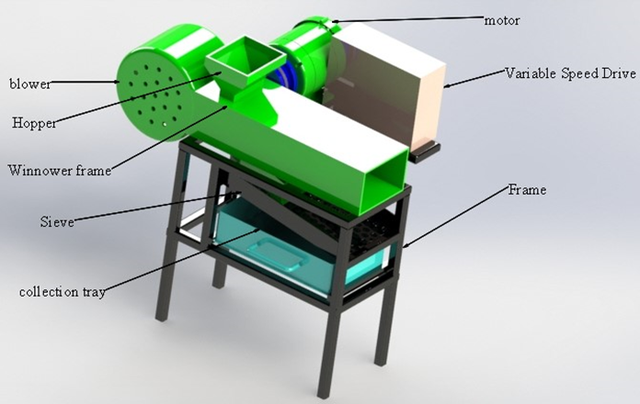
Fig. 1. Conceptual drawing of the neem fruit winnower

2.2 Physical properties of neem fruit
The cleaning efficiency of neem fruits is significantly affected by their physical, mechanical and aerodynamic properties. For this study, neem fruits were collected from the Pathamadai region of Tirunelveli district, Tamil Nadu. The physical properties of neem fruits, such as length, width, thickness, arithmetic mean diameter and geometric mean diameter, were measured. The mechanical properties, such as bulk density and angle of repose, were also measured. Additionally, terminal velocity was examined as an aerodynamic property.
2.2.1 Axial dimensions of neem fruit
A total of fifty neem fruits were randomly taken from the bulk sample, and their three main perpendicular dimensions viz Major diameter, L (length), Intermediate diameter, W (width), and Minor diameter, T (thickness), were measured. Each fruit was placed between the calliper jaws (Fig. 2) along its major axis, with the remaining two dimensions measured at right angles. All measurements were taken using a digital vernier calliper with an accuracy of ±0.01 mm. The Arithmetic mean diameter was calculated using the following equation 1 [18].
${ D}_{a}, mm=\frac{L+W+T}{3}$ (1)
Where,
Da = Arithmetic mean diamter, mm
L = length of the neem fruit, mm
W = width of the neem fruit, mm
T = thickness of the neem fruit, mm
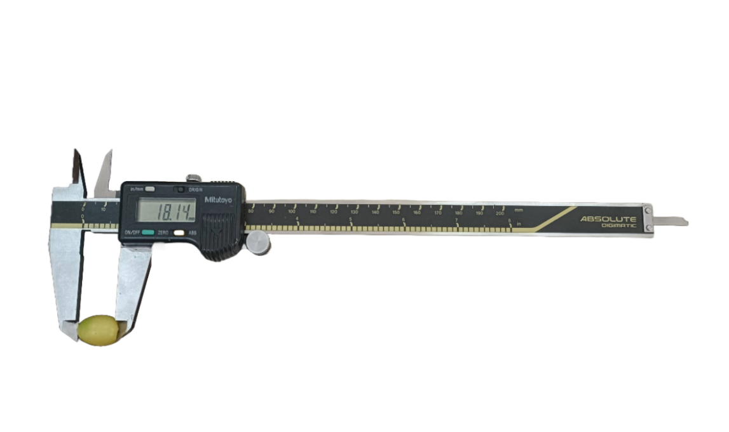
a. Major diameter
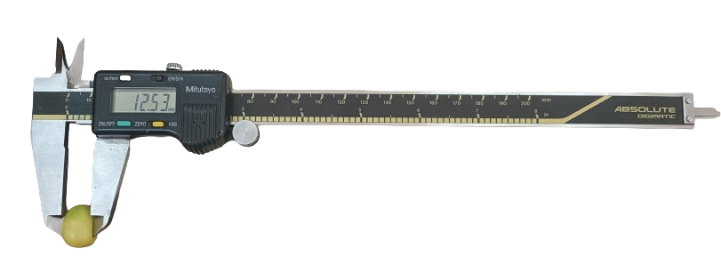
b. Intermediate diameter
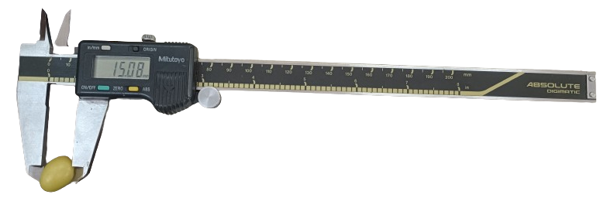
c. Minor diameter
Fig. 2 (a,b&c). Measurement of axial dimensions of neem fruits
2.2.2 Angle of repose
The angle of repose is defined as the highest inclination relative to a horizontal plane at which a heap of neem fruits remain stable without shifting or collapsing. The base diameter (D) and the height (h) of the heap were measured, and the angle of repose of the neem fruits was computed using the following equation 2 [19].
$θ=\tan^{-1}\frac{2h}{D}$ (2)
Where,
$θ$ = Angle of repose
D = base diameter, mm
h = height of the heap, mm
2.2.3 Terminal Velocity
The terminal velocity was measured using an air column consisting of a vertical wind tunnel with a diameter of 44.48 mm and a height of 600 mm (Fig. 3a). Air velocity within the column was recorded using a digital anemometer (Lutron, Model AM-4201), as shown in (Fig. 3b). Individual neem fruit was released from the top of the air column into the airflow, and the air speed was gradually adjusted until the fruit remained suspended in the airstream. The air velocity at the point of suspension was then measured using the anemometer, which had an accuracy of ±0.1 m s⁻¹. Each air velocity measurement was repeated ten times to ensure reliability [20].
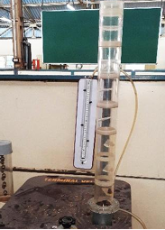 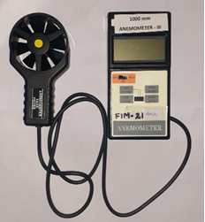 Fig. 3a. Vertical wind tunnel Fig. 3b. Anemometer
2.3 Development of the prototype
The neem fruit winnower had the following major components: winnower frame, blower, power transmission system, sieve assembly and variable speed drive. A prototype of a neem fruit winnower (Fig. 4) was developed, consisting of the following essential functional systems. The specification of the neem fruit winnower is furnished in Table 1.
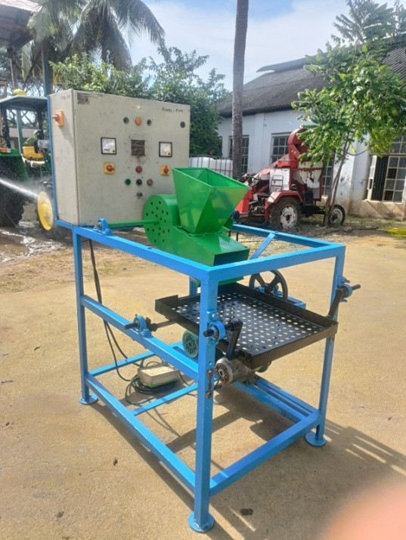
Fig. 4. Neem fruit winnower
Table 1. Specification of the developed prototype
S. No. | Particular | Specifications
1. | Type of machine | Power-operated neem fruit winnower
2. | Motor type and power | Three-phase induction motor, 1 hp
3. | Speed control | Variable Speed Drive (VSD)
4. | Blower fan | 180 mm diameter, ABS (3D printed)
5. | Hopper capacity | 2 kg
6. | Sieve material | 16-gauge mild steel
7. | Sieve perforation size | 15 mm (circular)
8. | Sieve tray size | 50 × 60 cm
9. | Sieve drive mechanism | Eccentric cam (10–12 mm offset)
10. | Principle of operation | Airflow separation and mechanical sieving

2.3.1 Mainframe
The main frame was made of 140 mm × 6 mm mild steel L-angles to provide strength and stability. It was set at a height of 91 cm for easy feeding and collection, with round plates welded to the legs for support. The frame housed the motor, blower, variable speed drive, and sieve assembly.
2.3.2 Winnower frame
The winnower consisted of a cylindrical drum mounted on a 19.5 mm diameter shaft supported by pillow block bearings to ensure smooth operation. The drum had a diameter of 250 mm and an overall length of 320 mm. A trapezoidal-shaped hopper was fixed at the top of the drum for feeding neem fruits, while an outlet was provided at the lower end for material discharge. The entire assembly was inclined at 35° to facilitate gravity-assisted movement of neem fruits, as this angle is higher than the angle of repose of neem fruits, thereby preventing stagnation and ensuring smooth material flow. The hopper was positioned 215 mm from one end of the drum, and the outlet was located 90 mm from the same end. The hopper was fabricated from 16-gauge mild steel sheet with a trapezoidal profile, 40° wall inclination, and a capacity of 2 kg. The wall inclination of 40°, being greater than the angle of repose of neem fruits, ensured uninterrupted flow without clogging. A sliding gate was provided at the hopper outlet to regulate the feed rate uniformly.
2.3.3 Blower assembly
The blower fan was fabricated using a Flash Forge Creator 3D printer with ABS filament and soluble support material, enabling accurate printing of complex blade geometry. The fan, with a 180 mm blade diameter and blades set at 90°, was integrated into the winnower to generate the required airflow for neem fruit cleaning and separation.
2.3.4 Power transmission
A 1 hp three-phase induction motor with a variable speed drive was mounted on the main frame to power the system. Power was transmitted from the motor (5’’) to the blower (2’’) and sieve (10’’) through a series of pulleys using ‘V’-belts of 137 cm and 163 cm length.

2.3.5 Variable Speed Drive
The Variable Speed Drive (VSD) is an electronic device that controls the speed, torque and rotation direction of an induction motor. The variable speed drive was connected to a three-phase, 1 HP induction motor to allow flexible control during operation.
2.3.6 Sieve assembly
The sieve assembly, made of 16-gauge MS sheet with 15 mm perforations, acted as the main separation unit by allowing neem fruits to pass through while retaining larger impurities. The perforation size was selected based on the arithmetic mean diameter of neem fruits (14.92 mm), ensuring that the fruits could readily pass through the openings, while larger impurities such as leaves, twigs, and unthreshed material were retained on the sieve surface. It consisted of a 50 × 60 cm rectangular tray with 8 cm side walls, supported on an MS angle frame and mounted with adjustable inclinations of 8°, 9°, and 10° for controlled fruit flow. Reciprocating motion was provided by an eccentric cam (10–12 mm eccentricity), enabling effective separation of fruits from leaves and twigs during operation.
2.4 Performance evaluation of the developed prototype
The developed prototype of the mechanical neem fruit winnower was evaluated to assess its cleaning efficiency under controlled operating conditions. During the performance evaluation, neem fruits with field impurities such as leaves, twigs, and dust were fed into the winnower at feed rates. The cleaning efficiency of the machine was determined by measuring the weight of clean neem fruits obtained after winnowing and comparing it with the initial weight of the uncleaned fruit mixture.
2.4.1 Cleaning efficiency
Cleaning efficiency can be calculated using the following expressions (Eqn. 3).
Cleaning efficiency = $\frac{Weight of clean neem fruits collected}{Total weight of neem fruits fed into the machine}$×100% (3)
2.4.2 Cost economics
The cost analysis of the developed neem fruit winnower was carried out in accordance with the standards prescribed in IS: 9164 – 1979. The cost of operation of the developed neem fruit winnower was estimated by considering both fixed and variable cost components and was subsequently compared with the conventional method of manual collection of neem fruits.
3. RESULTS AND DISCUSSION
The pertinent physical properties of neem fruits for the development of the neem fruit winnower were studied and measured in the Farm Machinery Workshop at the Agricultural Engineering College and Research Institute, Coimbatore. The results obtained are tabulated in Table 2.
Table 2. Properties of neem fruit
S. No | Properties | Mean | Standard deviation
1 | Length, mm | 17.82 | 0.40
2 | Width, mm | 12.12 | 0.31
3 | Thickness, mm | 14.82 | 0.22
4 | Arithmetic mean diameter, mm | 14.92 | 0.13
5 | Geometric mean diameter, mm | 14.76 | 0.14
6 | Bulk density, g cm⁻³ | 576.13 | 15.07
7 | Angle of repose, ˚ | 41.87 | 0.63
10 | Terminal velocity, m s⁻¹ | 9.0 | 0.15

The physical, mechanical, and aerodynamic properties of neem fruits were essential for designing the neem fruit winnower. The average fruit dimensions, viz., length (17.82 mm), width (12.12 mm), and thickness (14.82 mm), resulted in an arithmetic mean diameter of 14.92 mm, which was used to select a 15 mm sieve perforation. This ensured the smooth passage of neem fruits while retaining larger impurities such as twigs. The small variation in fruit size helped achieve uniform sieving and reduced clogging during operation. Neem fruits had an angle of repose of 41.87°, indicating poor flowability compared to cereal grains. Therefore, the drum and hopper were inclined beyond this angle to allow continuous gravity-assisted movement and prevent material accumulation. The terminal velocity of neem fruits was 9.0 m s⁻¹, which guided the airflow design of the blower. Operating the blower at 1500 rpm effectively removed lighter impurities without causing significant fruit loss.
A neem fruit winnower was designed and fabricated for cleaning the neem fruits from the field. The operational view of the developed neem fruit winnower is shown in Fig. 5. The performance evaluation of the developed neem fruit winnower is furnished in Table 3.
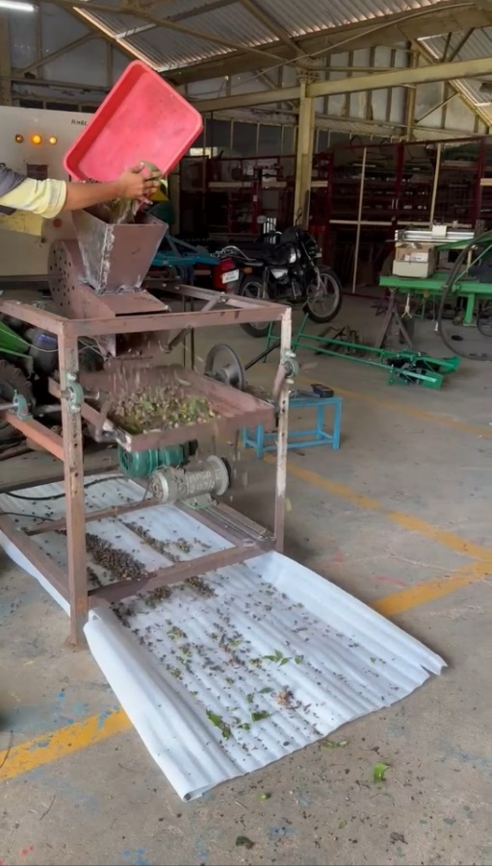
Fig. 5. Operational view of the neem fruit winnower
Table 3. Performance evaluation of the neem fruit winnower
S. No | Performance Parameter | Observed value
1 | Feed rate, kg h⁻¹ | 125
2 | Blower fan speed, rpm | 1500
3 | Sieve oscillation speed, rpm | 250
4 | Moisture content of neem fruits, % (w.b.) | 39.5
5 | Time required for winnowing, h (25 kg) | 0.4
6 | Cleaning capacity, kg h⁻¹ | 125
6 | Cleaning efficiency, % | 92
7 | Uncleaned material, % | 8
10 | Fruit loss during winnowing, % | 3
11 | Labour requirement, person | 1

The performance evaluation results presented in Table 3 show that the developed neem fruit winnower achieved a cleaning capacity of 125 kg h⁻¹ with a maximum cleaning efficiency of 92% under optimized operating conditions. This level of performance was achieved due to the combined effect of regulated airflow and mechanical sieving, which enabled efficient separation of impurities of varying sizes and densities.
The sieve oscillation speed of 250 rpm, produced using an eccentric cam mechanism, provided adequate vibration to promote proper material stratification. As a result, heavier neem fruits passed through the sieve openings, while lighter and larger impurities were retained on the sieve surface. The selected oscillation speed also minimised excessive fruit bouncing, thereby reducing losses. Fruit loss during the winnowing process was limited to 3%, which falls within acceptable limits for post-harvest machinery and is considerably lower than losses associated with manual cleaning.
During testing, the moisture content of neem fruits was 39.5% (wet basis), which closely represents actual field conditions immediately after harvesting. Even at this relatively high moisture level, the winnower maintained high cleaning efficiency, demonstrating the robustness of the machine and its suitability for direct integration with mechanised harvesting systems. Although high moisture content generally increases the adhesion of dust and plant residues to fruits, the combined airflow and sieving action effectively removed such impurities.
The operating cost of the developed neem fruit winnower was calculated using the straight line method for depreciation according to the test code IS: 9164 – 1979 [21]. The prototype is assumed to be utilised for 250 h per annum at eight hours of operation per day [22].
1. Neem fruit winnower
Cost of operation of, Rs./h = 109.1
Cleaning capacity, Kg/h = 125
Cost of operation, Rs./kg = 0.87
2. Cost of operation for neem fruit collection from the field, Rs.kg⁻¹ = 30
The comparison of harvesting capacity and the cost of operation between manual and mechanical methods are represented in (Fig. 6 and Fig. 7).
The cost of operation of the neem fruit winnower was Rs. 109.1 h-1. The collection capacity of the neem tree branch shaker harvester was 125 kg h-1 with 92 % cleaning efficiency. The cost of neem fruit collection from the field was Rs. 30 kg-1. The developed neem fruit winnower achieved 97% savings in cost compared with neem fruit collection from the field for the tree branch shaker, which harvested neem fruits.

Fig. 6. Comparison of cleaning capacity of the prototype

Fig. 7. Comparison of the cost of operation of neem fruits
The relevant physical and mechanical properties of neem fruits, including length (17.82 mm), width (12.12 mm), thickness (14.82 mm), moisture content (39.3%), bulk density (576.13 g cm⁻³), angle of repose (41.87˚) and terminal velocity (9.0 m s⁻¹) were determined and utilized for the development of neem fruit winnower. The fruit size parameters were used to determine the sieve perforation dimensions, the angle of repose guided the selection of sieve and frame inclinations, the bulk density and moisture content informed structural design and load calculations, and the terminal velocity was considered in establishing the airflow requirements for effective winnowing. The collection capacity of the neem fruit winnower was 125 kg h⁻¹, whereas the collection capacity of neem from the conventional manual method was 1.25 kg h⁻¹. The cost of operation of the neem fruit winnower was Rs. 12.9 per kg. The cost of neem fruit collection with convention manual method was Rs. 45 per kg. The developed prototype neem fruit winnower resulted in 97% saving in cost when compared with the conventional method of collection.

4. Conclusion
The development of the neem fruit winnower represents a significant advancement in post-harvest processing of neem fruits. The present study was undertaken to develop and evaluate a neem fruit winnower for efficient cleaning and separation of fruits from field impurities. The developed prototype achieved a cleaning capacity of 125 kg h⁻¹ with a cleaning efficiency of 92% at 1500 rpm speed and 125 kg h ¹ feed rate. The cost of operation of the neem fruit winnower was Rs. 0.87 kg⁻¹, whereas the cost of conventional manual cleaning was Rs. 30 kg⁻¹. The developed system resulted in a cost saving of about 97% and a substantial reduction in cleaning time compared to the manual collection method. Owing to its simple construction, ease of operation, and effective performance, the neem fruit winnower is farmer-friendly and suitable for large-scale neem fruit processing.
ACKNOWLEDGEMENT
The author gratefully acknowledges the financial support provided by M/s. Coromandel International Ltd., Chennai, for funding this research. The author also extends sincere thanks to the Department of Farm Machinery and Power Engineering, AEC&RI, Tamil Nadu Agricultural University, Coimbatore, for providing the necessary facilities and support to carry out the research work.
Disclaimer (Artificial intelligence)
Author(s) hereby declare that NO generative AI technologies such as Large Language Models (ChatGPT, COPILOT, etc.) and text-to-image generators have been used during the writing or editing of this manuscript.

References
1. Balakrishnan, S., et al., EFFECT OF MACHINE AND OPERATIONAL PARAMETERS ON PICKING AND CONVEYING EFFICIENCY IN AN EXPERIMENTAL TEST RIG FOR THE DEVELOPMENT OF A PNEUMATIC SUCTION-TYPE GROUND COLLECTION SYSTEM FOR NEEM (Azadirachta indica) FRUIT. Environmental Engineering & Management Journal (EEMJ), 2024. 23(12).
2. Balakrishnan, S., et al., Effect of picker roller diameter and bristle length in the experimental test rig and the development of mechanical type neem fruit (Azadirachta indica) picker collector. RANGE MANAGEMENT AND AGROFORESTRY, 2025. 46(1): p. 137-144.
3. Suthakar, B., et al., Tree fruit harvesting: Recent developments and future challenges for robotic harvesting. Plant Science Today, 2025. 12: p. 8239.
4. Girish, K. and B.S. Shankara, Neem–a green treasure. Electronic journal of Biology, 2008. 4(3): p. 102-111.
5. India, T.o., Need to sustain neem production: Experts in Times of India. 2018, Times of India.
6. Govt branches out: One highly beneficial neem tree for 10 Indians in Bussiness Standard. 2025.
7. Nithya, R., et al., Technological advances in fruit collection from the ground: a review. The Journal of Horticultural Science and Biotechnology, 2025: p. 1-14.
8. Tripathi, A.V., et al., Design and development of ground collection system for neem fruit. International Journal of Environment and Climate Change, 2022. 12(11): p. 2095-2104.
9. Balakrishnan, S., et al., Effects of Forward Speed and Fruit Density on Picking and Collection Efficiency of a Neem Fruit Collector in Test Rig: EFFECTS OF VARIABLES ON NEEM FRUIT COLLECTION. Journal of Scientific & Industrial Research (JSIR), 2025. 84(04): p. 468-477.
10. Masilamani, P., et al., Effect of different methods of depulping on viability, germination, seedling vigour and its economic analysis in neem (Azadirachta indica A. Juss.). Range Management and Agroforestry, 2023. 44(1): p. 95-101.
11. Lokanadhan, S., P. Muthukrishnan, and S. Jeyaraman, Neem products and their agricultural applications. Journal of Biopesticides, 2012. 5: p. 72.
12. Kumar, S., et al., Neem oil and its nanoemulsion in sustainable food preservation and packaging: Current status and future prospects. Journal of Agriculture and Food Research, 2022. 7: p. 100254.
13. Tomar, A., et al., Neem: An Introduction. Neem: A Treatise, 2008: p. 546.
14. Gowtham, M., et al., Design, Development and Evaluation of Neem (Azadirachta indica) Fruit Picker Cum Collector. Journal of Experimental Agriculture International, 2024. 46(2): p. 35-45.
15. Samreen Madhavan, M. and A. Rao, Performance evaluation of solar power operated paddy winnower. International Journal of Engineering Technology Science and Research, 2017. 4(8): p. 1088-94.
16. Bhupendra, G., et al., Development and testing of solar operated paddy winnower. J. Pharmacogn. Phytochem, 2019. 8(5): p. 1368-1370.
17. Shrestha, K.P., et al., Mathematical modeling, simulation and analysis of rice grain movement for design and fabrication of low-cost winnowing machine. Journal of Mechanical Engineering Research, 2017. 9(1): p. 1-14.
18. Adedeji, M. and O. Owolarafe, Some Physical Properties of Neem Seeds & Kernels (Azandirachta indica) as a Function of moisture Content. Carbon, 2015. 86(74.45): p. 78-92.
19. Kishore, S.G., et al., Engineering properties of neem (Azadirachta indica) fruit and seed for the development of depulper and decorticator. Emergent Life Sciences Research, 2022. 8: p. 207-223.
20. Shah, K., N. Vibhakar, and S. Channiwala. Unified design and comparative performance evaluation of forward and backward curved radial tipped centrifugal fan. in Proceedings of the International Conference on Mechanical Engineering. 2003.
21. Rosnawintang, R., et al., Effects of crude oil prices volatility, the internet and inflation on economic growth in ASEAN-5 countries: A panel autoregressive distributed lag approach. International Journal of Energy Economics and Policy, 2021. 11(1): p. 15-21.
22. Tajuddin, A., M. Parthiban, and B. Suthakar, Computing the Cost Economics of Agricultural Machinery in Farms. Madras Agricultural Journal, 2023. 110(september (7-9)): p. 1.

