Original Research Article
AMELIORATIVE EFFECTS OF THE ETHANOLIC EXTRACT OF BRASSICA OLERACEA ON NAPHTHALENE-INDUCED CEREBELLAR TOXICITY IN ADULT MALE WISTAR RATS

ABSTRACT
Aim: To investigate the ameliorative effects of Brassica oleracea against naphthalene-induced oxidative stress in the cerebellum of adult male Wistar rats.
Methodology: Twenty five (25) adult male Wistar rats were randomly divided into five groups (A–E, n = 5). Group A served as control and received only feed and distilled water ad libitum. Group B received 15mg/kg of naphthalene. Group C received 15mg/kg of Naphthalene and 200mg/kgbw Brassica oleracea, Group D received 15mg/kg of Naphthalene and 400mg/kgbw Brassica oleracea while Group E received 400mg/kgbw Brassica oleracea only. The treatment lasted for 28 days and all administration was via oral gavage. At the end of the experiment, blood samples were collected for oxidative stress markers analysis, and cerebellum were excised for histopathological evaluation.
Results: Exposure to naphthalene caused significant (p < 0.05) increase in MDA and SOD levels (3.95±0.06 vs. 2.32±0.39 in controls and 25.83±0.53 vs. 17.33±0.59 in control, respectively) while the administration of Brassica oleracea significantly (p < 0.05) reduced their levels. Histopathological analysis of the cerebellum showed pyknotic pyramidal cells and severe degeneration and vacoulation in the different layers while the Brassica oleracea treated groups showed moderate regeneration in the different layers and active cells in a dose-dependent manner.
Conclusion: Ethanolic extract of Brassica oleracea exhibits ameliorative effects against naphthalene-induced oxidative stress and histopathological changes in the cerebellum of adult male Wistar rats. These findings suggest its potential as a natural therapeutic agent for neurotoxicities caused by naphthalene and other toxic agents.
Keywords: Brassica oleracea, naphthalene, oxidative stress, cerebellum.

BACKGROUND OF THE STUDY
Oxidative stress is a pathological condition resulting from an imbalance between the production and accumulation of reactive oxygen species (ROS) in cells and tissues and the capacity of biological systems to detoxify these reactive intermediates or repair the resulting damage (Yao et al., 2021). Oxidative stress is often described as a self-propagating phenomenon, as excessive ROS generation can initiate cellular injury, leading to further ROS production. Damaged macromolecules may themselves act as sources of ROS, thereby amplifying oxidative damage. Consequently, the brain, owing to its high lipid content, elevated metabolic demand, and relatively low antioxidant defense capacity, is particularly vulnerable to oxidative insults (Schweighofer et al., 2004).
Biochemical evidence indicates that neuronal populations exhibit differential susceptibility to oxidative stress. Neurons in the hippocampus, amygdala, and cerebellar granule layer have been reported to be among the most vulnerable to oxidative damage, and are therefore considered to be early sites of functional impairment (Martens et al., 2021). Accordingly, increased oxidative damage in the brain has been implicated in the pathogenesis of several central nervous system disorders, including neurodegenerative diseases such as Alzheimer’s disease and Parkinson’s disease, cerebrovascular disorders, demyelinating diseases, and various psychiatric conditions (Dash et al., 2025).
Chronic disruption of the balance between ROS generation and antioxidant defense mechanisms has been strongly associated with the development of numerous chronic diseases. These include cancer, atherosclerosis, nephritis, diabetes mellitus, rheumatic diseases, ischemic and cardiovascular disorders, as well as neurodegenerative diseases such as Alzheimer’s and Parkinson’s diseases (Jomova et al., 2023; Pizzino et al., 2017; Pham-Huy et al., 2008)
Epidemiological studies provide compelling evidence that regular consumption of fruits and vegetables confers significant health benefits, largely attributed to the antioxidant phytonutrients they contain (Rahaman et al., 2023; Jideani et al., 2021). Micronutrients such as vitamin C, vitamin E, carotenoids, and dietary flavonoids play critical roles in human nutrition, and diets rich in these compounds are associated with improved health outcomes (Rahaman et al., 2023). Consequently, there is increasing interest in edible plants and vegetables that possess antioxidant and health-promoting phytochemicals.
Brassica oleracea (family: Cruciferae), commonly known as cabbage, is rich in biologically active compounds, including polyphenols such as hydroxycinnamic acid esters, kaempferol and quercetin glucosides, as well as trace amounts of isorhamnetin (Cartea et al., 2010). Numerous epidemiological and clinical studies have demonstrated the health-promoting properties of Brassica oleracea (Podsędek, 2007; Cartea et al, 2010). High dietary intake of Brassica oleracea has been associated with a reduced risk of degenerative diseases, age-related chronic conditions and several types of cancer (Zhang et al., 2024). These protective effects are largely attributed to its rich content of vitamins, provitamins such as folic acid, diverse phenolic compounds, and organosulfur constituents (Khanam et al., 2012; Cartea et al., 2010). Phenolic compounds, in particular, have been strongly correlated with antioxidant activity in numerous studies (Leja et al., 2013).
Naphthalene (NAP) is an organic compound with the chemical formula C₁₀H₈ and represents the simplest polycyclic aromatic hydrocarbon (PAH). It is a white crystalline solid with a characteristic odor detectable at concentrations as low as 0.08 ppm (Buckpitt et al., 2010). Naphthalene is widely used as an insecticide and pest repellent and was first registered as a pesticide in the United States in 1948. PAHs may bind to airborne particulate matter, and they can also be generated during high-temperature cooking of meat and other foods. Naphthalene is commonly detected in wastewater systems (Sampaio et al., 2021). Due to its chemical stability and lipophilic properties, NAP is resistant to biodegradation, facilitating its accumulation and biomagnification along the food chain (Berríos-Rolón et al., 2025). Exposure to naphthalene vapors has been associated with adverse health effects, including headache, nausea, dizziness, and vomiting.
Therefore, the present study aims to investigate the protective effects of Brassica oleracea against naphthalene-induced oxidative stress in the cerebellum of adult male Wistar rats.
MATERIALS AND METHODS
Location of Study
The study was conducted in the animal house of Faculty of Basic Medical Sciences, Chukwuemeka Odumegwu Ojukwu University, Uli, Anambra state.
Ethical Consideration
The experimental procedure was approved by the ethics committee of Chukwuemeka Odumegwu Ojukwu University Uli. The approval number is COOU/BMS/010.
Plant Collection and Extract Preparation
Fresh samples of Brassica oleracea (cabbage) were purchased from the School Market, Uli, Anambra State. Authentication was obtained from the Department of Biological Sciences, Faculty of Natural Sciences, Nnamdi Azikiwe University, Awka, Anambra State. The ethanolic extract of Brassica oleracea was prepared with slight modifications to a previously reported method (Sundrarajan et al., 2015). Approximately 12 g of cabbage leaves were carefully washed with distilled water, air-dried, and pulverized. The pulverized leaves were then collected and stirred at low rpm in a pot containing ethanol for 1 hour. Thereafter, the ethanolic extract was cooled and filtered using Whatman No. 1 filter paper (pore size 25 µm) and stored in a refrigerator for further use.
Experimental Animals
Twenty five (25) male Wister rats weighing 250-260g were obtained from an Animal Farm, located at Nnewi, Anambra State, and used for this study. The animals were obtained and housed in the Animal House of the Faculty of Basic Medical Sciences, Chukwuemeka Odumegwu Ojukwu University, Uli, under standard laboratory conditions (temperature 25 ± 2°C, 12 h light/dark cycle, and adequate ventilation). They were fed standard commercial rat pellets and given water ad libitum for two weeks to allow for acclimatization prior to the commencement of the experiment. After acclimatization, the rats were randomly allocated into six (5) experimental groups of five (5) animals each as follows:
Group A served as the control group, so only distilled water was given to them.
Group B was administered only 15mg/kg of naphthalene dissolved in 10mls of soya oil.
Group C was administered 15mg/kg of naphthalene dissolved in 10mls of soya oil and 200mg/kg of ethanolic extract of Brassica oleracea
Group D was administered 15mg/kg of naphthalene dissolved in 10mls of soya oil and 400mg/kg of ethanolic extract of Brassica oleracea
Group E was administered 400mg/kg of ethanolic extract of Brassica oleracea
All administration was via oral gavage. The experiments was terminated on the 28th day and 24 hours after administration of the last treatment, the animals were euthanized with under 40mg/kg of ketamine. Blood samples were collected for oxidative stress markers analysis while the cerebellum were excised for histological examination using H&E.
Statistical Analysis
All statistical were presented as mean ± standard deviation (SD) and statistical analysis was carried out using GraphPad Prism software (8.01). For comparison involving groups, one-way ANOVA followed by Turkey’s multiple comparison test was employed. Results with (P < 0.05) were considered as statistically significant.

RESULTS AND DISCUSSION
Effect of ethanolic extract of Brassica oleracea on oxidative stress markers in naphthalene induced cerebellar toxicity in adult male Wistar rats
Evaluation of oxidative stress markers following naphthalene-induced toxicity and concomitant administration of Brassica oleracea revealed a significant (p < 0.05) increase in serum malondialdehyde (MDA) and superoxide dismutase (SOD) levels in Group B, which received 15 mg/kg body weight of naphthalene only, compared with Group A (control). In contrast, Groups C and D, treated with 200 mg/kg and 400 mg/kg body weight of Brassica oleracea extract, respectively, showed a significant (p < 0.05) attenuation of MDA and SOD levels when compared with Group B. Group E exhibited a slight elevation in MDA and SOD levels relative to the control group; however, these levels were significantly lower than those observed in Group B.
Table 1: Effect of ethanolic extract of Brassica oleracea on oxidative stress markers in naphthalene induced cerebellar toxicity in adult male Wistar rats
 | Group A (Control) | Group B (15mg/kg of naphthalene) | Group C (15mg/kg of Naphthalene and 200mg/kgbw Brassica oleracea ) | Group D (15mg/kg of Naphthalene and 400mg/kgbw Brassica oleracea ) | Group E (400mg/kgbw Brassica oleracea )
MDA(nmol/mL) | 2.32±0.39 | 3.95±0.06* | 3.65±0.40* | 3.14±0.42* | 2.41±0.31*
SOD(U/L) | 17.33±0.59 | 25.83±0.53* | 22.76±0.33* | 21.03±0.01* | 18.17±0.22*
MDA= Malondialdehyde, SOD= Superoxide Dismutase

Histopathological evaluation
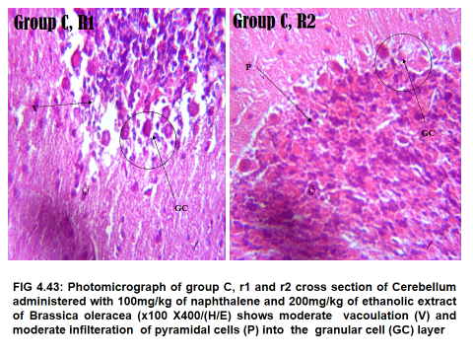
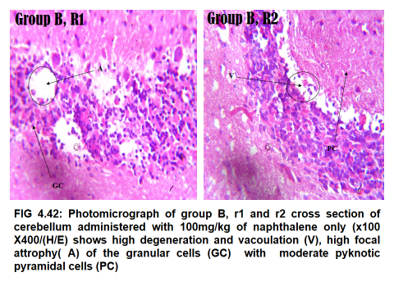
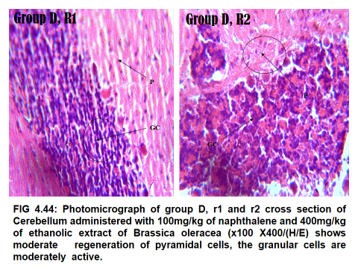
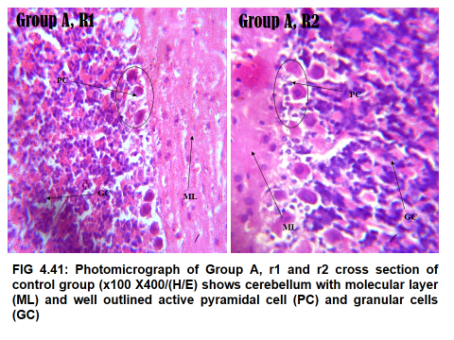
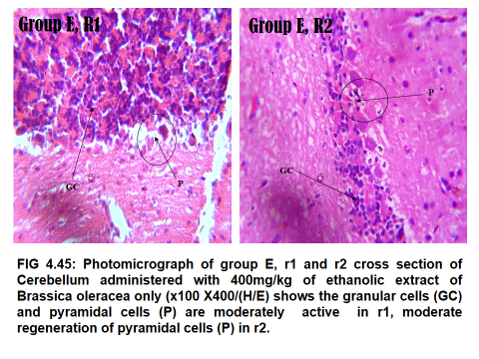
The histoarchitecture of the cerebelulum of each group was evaluated and the photomicrographs presented in Fig 1 below.
Plate 1: Photomicrograph of Group A, R1 and R2 cross section of control group (x100 x400) H&E. Shows cerebellum with molecular layer (ML) and well outlined active pyramidal cell (PC) and granular cells (GC)
Plate 2: Photomicrograph of Group B, R1 and R2 cross section (x100 x400) H&E. Shows high degeneration and vacaolation (V), high focal atrophy (A) of the granular cells (GC) with moderate pyknotic pyramidal cells (PC).
Plate 3: Photomicrograph of Group C, R1 and R2 cross section (x100 x400) H&E. Shows moderate vacoulation (V) and moderate infiltration of pyramidal cells (P) into the granular cell (GC) layer.
Plate 4: Photomicrograph of Group D, R1 and R2 cross section (x100 x400) H&E. Shows moderate regeneration of pyramidal cells, the granular cells are moderately active.
Plate 5: Photomicrograph of Group E, R1 and R2 cross section of control group (x100 x400) H&E. Shows cerebellum that the granular cells (GC) and pyramidal cells (P) are moderately active in R1 and moderate regeneration of pyramidal cells (P) in R2.

Fig. 1. Histopathological evaluation

The present study demonstrates that naphthalene exposure induces significant oxidative stress and cerebellar histopathological damage, while concomitant administration of the ethanolic extract of Brassica oleracea confers measurable neuroprotection in adult male Wistar rats. These findings are consistent with existing evidence implicating oxidative stress as a major mechanism underlying naphthalene-induced neurotoxicity.
In this study, naphthalene administration resulted in a significant elevation of MDA, a widely accepted index of lipid peroxidation, indicating enhanced oxidative degradation of neuronal membrane lipids. Similar increases in MDA following naphthalene exposure have been reported by Şehirli et al. (2008) and Yost et al. (2021), who attributed such effects to excessive reactive oxygen species (ROS) generation during xenobiotic metabolism. Given the high lipid content of cerebellar neurons, particularly within myelinated regions, lipid peroxidation represents a critical pathway of neuronal injury (Milatovic & Aschner, 2011).
The observed increase in SOD activity in the naphthalene-treated group aligns with previous studies reporting antioxidant enzyme upregulation as an adaptive response to oxidative challenge (Olufunmilayo et al., 2023; Chen et al., 2012). However, despite this compensatory increase, the concomitant rise in MDA suggests that endogenous antioxidant defenses were insufficient to counteract ROS-mediated damage, resulting in oxidative imbalance rather than effective neuroprotection.
Administration of Brassica oleracea extract significantly attenuated both MDA and SOD levels, particularly at higher doses, indicating reduced lipid peroxidation and normalization of antioxidant responses. These findings are in agreement with Podsędek (2007) and Cartea et al. (2010), who reported strong antioxidant and cytoprotective properties of Brassica oleracea, attributed to its high content of polyphenols, flavonoids, vitamins, and organosulfur compounds. Similarly, Chidimma et al. (2025) demonstrated that various plant-derived materials possess strong neuroprotective effects against toxicant-induced neuronal damage.
Histopathological evaluation provided morphological confirmation of the biochemical findings. The presence of pyknotic pyramidal cells, widespread degeneration, and vacuolation in the cerebellum of naphthalene-treated rats is consistent with reports of oxidative stress-induced neuronal apoptosis and necrosis (Yao et al., 2021). Conversely, cerebellar sections from Brassica oleracea -treated groups showed moderate regeneration, reduced degenerative features, and the presence of morphologically active neurons. These observations are consistent with studies by Chidimma et al. (2025), Khanam et al. (2012), and Leja et al. (2013), which demonstrated that phenolic-rich plant extracts not only reduce oxidative damage but also preserve tissue architecture and cellular integrity. The dose-dependent histological improvement observed in the present study further supports a protective role of Brassica oleracea against toxin-induced neurodegeneration.
Conclusion
The findings of this study demonstrate that Brassica oleracea extract significantly attenuates ROS generated by naphthalene-induced oxidative stress, thereby mitigating both biochemical and structural cerebellar damage. This protective effect is most likely mediated through antioxidant mechanisms, supporting the potential application of Brassica oleracea as a natural neuroprotective agent against environmental and chemical neurotoxicants. Future studies should investigate the specific phytochemicals responsible for these effects and elucidate their molecular mechanisms of action.
DECLARATIONS
Competing interests disclaimer
Authors have declared that they have no known competing financial interests OR non-financial interests OR personal relationships that could have appeared to influence the work reported in this paper.
Disclaimer (Artificial Intelligence)
Authors hereby declare that NO generative AI technologies such as Large Language Models (ChatGPT, COPILOT, etc.) and text-to-image generators have been used during the writing or editing of this manuscript.

REFERENCES
Aguwa, U. S., Ogbuokiri, D. K., Eze, C. S., Obinwa, B. N., Ovie, F. O., Obi, K. C., Onwuelingo, S. F., Okonkwo, D. I., Obiesie, I. J., Agulanna, A. E., & Umezulike, A. J. (2020). Evaluating the Neuroprotective Effects of the Aqueous and Methanolic Extracts of Vernonia amygdalina on the Hippocampus of Adult Male Wistar Rats. International Journal of Pathogen Research, 1–16. https://doi.org/10.9734/ijpr/2020/v5i230127
Berríos-Rolón, P. J., Cotto, M. C., & Márquez, F. (2025). Polycyclic Aromatic Hydrocarbons (PAHs) in Freshwater systems: A Comprehensive review of sources, distribution, and ecotoxicological impacts. Toxics, 13(4), 321. https://doi.org/10.3390/toxics13040321
Buckpitt A, Kephalopoulos S, Koistinen K, et al. Naphthalene. In: WHO Guidelines for Indoor Air Quality: Selected Pollutants. Geneva: World Health Organization; 2010. 4. Available from: https://www.ncbi.nlm.nih.gov/books/NBK138704/
Cartea, M. E., Francisco, M., Soengas, P., & Velasco, P. (2010). Phenolic compounds in Brassica vegetables. Molecules (Basel, Switzerland), 16(1), 251–280. https://doi.org/10.3390/molecules16010251
Chen, X., Guo, C., & Kong, J. (2012). Oxidative stress in neurodegenerative diseases. Neural regeneration research, 7(5), 376–385. https://doi.org/10.3969/j.issn.1673-5374.2012.05.009
Chidimma, A. A., Ofoego, U. C., Ezejindu, D. N., Demshimeno, P. M., Obinwa, M. F., & Obinwa, B. N. (2025). Neuroprotective effects of Vernonia amygdalina and Moringa oleifera in alloxan-induced diabetic Wistar rats. European Journal of Clinical and Experimental Medicine, 23(4). https://doi.org/10.15584/ejcem.2025.4.20
Dash, U. C., Bhol, N. K., Swain, S. K., Samal, R. R., Nayak, P. K., Raina, V., Panda, S. K., Kerry, R. G., Duttaroy, A. K., & Jena, A. B. (2025). Oxidative stress and inflammation in the pathogenesis of neurological disorders: Mechanisms and implications. Acta pharmaceutica Sinica. B, 15(1), 15–34. https://doi.org/10.1016/j.apsb.2024.10.004
Jideani, A. I. O., Silungwe, H., Takalani, T., Omolola, A. O., Udeh, H. O., & Anyasi, T. A. (2021). Antioxidant-rich natural fruit and vegetable products and human health. International Journal of Food Properties, 24(1), 41–67. https://doi.org/10.1080/10942912.2020.1866597
Jomova, K., Raptova, R., Alomar, S. Y., Alwasel, S. H., Nepovimova, E., Kuca, K., & Valko, M. (2023). Reactive oxygen species, toxicity, oxidative stress, and antioxidants: chronic diseases and aging. Archives of toxicology, 97(10), 2499–2574. https://doi.org/10.1007/s00204-023-03562-9
Khanam, U. K. S., Oba, S., Yanase, E., & Murakami, Y. (2012). Phenolic acids, flavonoids and total antioxidant capacity of selected leafy vegetables. Journal of Functional Foods, 4(4), 979–987. https://doi.org/10.1016/j.jff.2012.07.006
Leja, M., Kamińska, I., Kramer, M., Maksylewicz-Kaul, A., Kammerer, D., Carle, R., & Baranski, R. (2013). The content of phenolic compounds and radical scavenging activity varies with carrot origin and root color. Plant foods for human nutrition (Dordrecht, Netherlands), 68(2), 163–170. https://doi.org/10.1007/s11130-013-0351-3
Martens M, Filippini N, Masaki C, Godlewska BR. Functional Connectivity between Task-Positive Networks and the Left Precuneus as a Biomarker of Response to Lamotrigine in Bipolar Depression: A Pilot Study. Pharmaceuticals (Basel). 2021;14(6):534.
Milatovic, D., & Aschner, M. (2011). Neuronal Oxidative Injury and Biomarkers of Lipid Peroxidation. Neuromethods, 56, 349–363. https://doi.org/10.1007/978-1-61779-077-5_17
Olufunmilayo, E. O., Gerke-Duncan, M. B., & Holsinger, R. M. D. (2023). Oxidative stress and antioxidants in neurodegenerative disorders. Antioxidants, 12(2), 517. https://doi.org/10.3390/antiox12020517
Pham-Huy, L. A., He, H., & Pham-Huy, C. (2008). Free radicals, antioxidants in disease and health. International journal of biomedical science : IJBS, 4(2), 89–96.
Pizzino, G., Irrera, N., Cucinotta, M., Pallio, G., Mannino, F., Arcoraci, V., Squadrito, F., Altavilla, D., & Bitto, A. (2017). Oxidative Stress: Harms and Benefits for Human Health. Oxidative medicine and cellular longevity, 2017, 8416763. https://doi.org/10.1155/2017/8416763
Podsędek, A. (2007). Natural antioxidants and antioxidant capacity of Brassica vegetables: A review. LWT, 40(1), 1–11. https://doi.org/10.1016/j.lwt.2005.07.023
Rahaman, M. M., Hossain, R., Herrera-Bravo, J., Islam, M. T., Atolani, O., Adeyemi, O. S., Owolodun, O. A., Kambizi, L., Daştan, S. D., Calina, D., & Sharifi-Rad, J. (2023). Natural antioxidants from some fruits, seeds, foods, natural products, and associated health benefits: An update. Food science & nutrition, 11(4), 1657–1670. https://doi.org/10.1002/fsn3.3217
Sampaio, G. R., Guizellini, G. M., Da Silva, S. A., De Almeida, A. P., Pinaffi-Langley, A. C. C., Rogero, M. M., De Camargo, A. C., & Torres, E. a. F. S. (2021). Polycyclic aromatic hydrocarbons in foods: biological effects, legislation, occurrence, analytical methods, and strategies to reduce their formation. International Journal of Molecular Sciences, 22(11), 6010. https://doi.org/10.3390/ijms22116010
Schweighofer N, Doya K, Kuroda S (March 2004). "Cerebellar aminergic neuromodulation: towards a functional understanding". Brain Research. Brain Research Reviews. 44 (2–3): 103–16.
Şehirli, Ö., Tozan, A., Omurtag, G. Z., Cetinel, S., Contuk, G., Gedik, N., & Şener, G. (2008). Protective effect of resveratrol against naphthalene-induced oxidative stress in mice. Ecotoxicology and Environmental Safety, 71(1), 301–308. https://doi.org/10.1016/j.ecoenv.2007.08.023
Yao, Z., Bai, Q., & Wang, G. (2021). Mechanisms of Oxidative Stress and Therapeutic Targets following Intracerebral Hemorrhage. Oxidative medicine and cellular longevity, 2021, 8815441. https://doi.org/10.1155/2021/8815441
Yost, E. E., Galizia, A., Kapraun, D. F., Persad, A. S., Vulimiri, S. V., Angrish, M., Lee, J. S., & Druwe, I. L. (2021). Health Effects of Naphthalene Exposure: A Systematic Evidence Map and Analysis of Potential Considerations for Dose-Response Evaluation. Environmental health perspectives, 129(7), 76002. https://doi.org/10.1289/EHP7381
Zhang, X., Jia, Q., Jia, X., Li, J., Sun, X., Min, L., Liu, Z., Ma, W., & Zhao, J. (2024). Brassica vegetables-an undervalued nutritional goldmine. Horticulture research, 12(2), uhae302. https://doi.org/10.1093/hr/uhae302

