Ovarian cancer incidence in Uzbekistan (2016–2024): national trends, regional heterogeneity, and age-specific patterns

Abstract
Background. Age strongly influences ovarian cancer incidence and outcomes; however, contemporary age-specific profiles from Central Asia are rarely documented.
Objective. To describe national and regional patterns of ovarian cancer incidence in Uzbekistan (2016–2024), with emphasis on age-specific crude incidence rates and changes over time.
Methods. We conducted a retrospective analysis of aggregated, de-identified population-based cancer registry data (ICD-10 C56), organised by year, administrative region, and five-year age groups. Age-specific crude incidence rates (CR per 100,000 women) were calculated using official female population denominators. Temporal trends were summarised as annual percentage change (APC) from log-linear models; differences in broad age-group distributions were assessed using Pearson’s χ² test.
Results. A total of 8,150 cases were recorded between 2016 and 2024. The share of cases aged 60–79 increased from 24.0% in 2016 to 43.6% in 2024 (+19.6 percentage points), while ages 40–59 decreased from 57.3% to 42.0% (−15.3 points) (p < 0.001). In 2024, incidence peaked at ages 75–79 (CR 44.71) and 70–74 (CR 40.76). Trend analysis showed the steepest increases in ages 70–74 (APC 9.60%/year, 95% CI 2.71–16.96), 75–79 (12.93%, 0.57–26.80), and 80+ (13.45%, 8.65–18.45), whereas ages 40–44 declined (−2.75%, −4.79 to −0.66).
Conclusion. The ovarian cancer burden in Uzbekistan shifted towards older women with marked regional heterogeneity. These findings support strengthening timely diagnostic pathways and referral capacity for postmenopausal women, while interpreting trends in the context of aggregated registry data and potential variation in completeness.
Keywords: ovarian cancer; cancer registry; age structure; age-specific incidence; crude incidence rate; annual percentage change; Uzbekistan.

Introduction
Ovarian cancer remains a significant cause of mortality among gynecologic malignancies, primarily owing to diagnoses at advanced stages and the absence of a comprehensive screening assay that offers conclusive evidence of mortality benefit for the general population. International data demonstrate considerable geographic variations in both incidence and mortality rates, reflecting differences in demographic factors, reproductive histories, and access to specialised oncological gynaecological services [1–4].
Age remains the principal factor influencing incidence and prognosis. In all regions, the age-specific incidence increases sharply after menopause and peaks in older women; the exact timing and size of this peak vary depending on population structure and risk factor distribution [2–5]. Hormonal and reproductive factors (parity, oral contraceptive use, breastfeeding), endometriosis, and genetic susceptibility all contribute to this pattern [5,6]. Diagnosis based on symptoms—such as abdominal distension, early satiety, pelvic pain—is common; however, these symptoms are non-specific and often encountered in primary care, which can delay definitive investigation and referral to specialists [7–9].
Long-duration randomised trials have not shown a reduction in mortality from general population screening (transvaginal ultrasound and/or CA-125 algorithms), reinforcing the policy focus on the timely assessment of symptomatic women rather than mass screening [7–9]. In this context, health service planning benefits from direct examination of age-specific crude rates (CR) and shifts in the distribution of cases across age groups, even when age-standardised rates (ASR) are used for international comparisons [2,3,10].
Contemporary, registry-based descriptions from Central Asia remain limited. We therefore characterised national age-specific profiles for ovarian cancer in Uzbekistan from 2016 to 2024, quantified temporal changes, and assessed regional heterogeneity using harmonised indicators suitable for service planning (age mix, CR, APC).

Materials and Methods

Study design and data sources
We conducted a retrospective, population-based descriptive–analytical study using aggregated, de-identified counts of incident ovarian cancer in women from 2016 to 2024 obtained from the national cancer registry (ICD-10 C56). Data were organised by calendar year, administrative region (the Republic of Karakalpakstan, Tashkent city, and 12 provinces), and five-year age groups. Only malignant neoplasms of the ovary (C56) were included; other female genital tract malignancies were excluded.

Population denominators
Female population denominators by region and age group were obtained from official population estimates and used to calculate CR (per 100,000). Mid-year estimates were preferred; end-of-year figures were used when mid-year denominators were unavailable. Small gaps in denominators were filled using linear interpolation between adjacent years.

Measures
We summarised the age structure using five broad categories (0–19, 20–39, 40–59, 60–79, 80+). Primary endpoints were age-specific CR by five-year bands and changes over time. ASR is referenced for context but not used as the primary outcome for planning.

Statistical analysis
Differences in broad age-group distributions across years and regions were assessed with Pearson’s χ² tests. Temporal trends in age-specific CR were evaluated using log-linear models, ln(CR) ~ year; slopes were summarised as annual percentage change (APC, %/year) with 95% confidence intervals (CI). For sparse strata, estimates were interpreted with caution. Two-sided tests used α=0.05.

Quality assurance and sensitivity checks
Quality assurance. We performed internal consistency checks on the aggregated dataset (e.g., impossible age–year combinations, strata with non-zero populations but zero cases across all years, and abrupt denominator discontinuities). Sensitivity analyses included pooling ages ≥70 years, excluding boundary years (2016 and 2024), and recalculating rates without denominator interpolation; the main patterns were unchanged.

Results & Discussion

National age structure and its evolution
Between 2016 and 2024, cases were concentrated among individuals aged 40–59 and 60–79. A clear ageing shift took place: the 60–79 share increased from 24.0% in 2016 to 43.6% in 2024 (+19.6 percentage points), while the 40–59 share decreased from 57.3% to 42.0% (−15.3 points); the 20–39 share fell from 15.0% to 10.6% (−4.4 points). The annual differences in age distribution were statistically significant (χ² test, p < 0.001). The dominance of the 40–59 and 60–79 age groups remained consistent each year, and no year saw younger ages (<40) account for more than a minor fraction of cases. (Table 2; Figure 1.)

Regional heterogeneity in age structure
Regions varied markedly in their age composition (p < 0.001). A common pattern was the dominance of ages 40–59 and 60–79, although the extent differed. Tashkent city demonstrated a particularly concentrated profile, with 87.3% of cases in the combined 40–59 and 60–79 age groups. This aligns with an urban case mix skewed towards postmenopausal ages. Most provinces also showed high proportions from these two groups, generally ranging from about three-quarters to nine-tenths of all cases. (Table 1.)

Age-specific crude incidence levels
The age-specific incidence increased with advancing age and became more pronounced in the upper tail in later years. In 2024, CR reached 40.76 for ages 70–74 and 44.71 for ages 75–79. Middle-aged cohorts demonstrated moderate levels (e.g., 17.57 for ages 50–54 and approximately 17.13 for ages 55–59 to 60–64), while younger women consistently exhibited low rates (≤1.84 in the 30–34 age group). Relative to 2016, the largest absolute increases occurred in older cohorts (+26.11 in ages 70–74 and +36.72 in ages 75–79), whereas ages 40–44 decreased by 2.06. The oldest cohort (80+) increased from 4.49 in 2016 to 15.67 in 2024. (Table 3; Figures 2–3).

Temporal trends (APC) in age-specific incidence
Log-linear trend models showed the highest APC in older ages: 70–74 (APC 9.60%/year, 95% CI 2.71–16.96), 75–79 (12.93%, 0.57–26.80), and 80+ (13.45%, 8.65–18.45). In midlife (40–59), trends were flat to slightly negative; ages 40–44 showed a statistically significant decrease (−2.75%/year, −4.79 to −0.66). Complete APC estimates by age group are presented in Table 4 and visualised in Figures 4–5.

Robustness checks
Pooling ages 70–74 and 75–79 reduced uncertainty without changing the main pattern of higher incidence among older women. Removing boundary years slightly lowered APC magnitudes but kept the trend the same (older ages increasing, midlife stable, younger ages low and steady). Recomputing without denominator interpolation caused minimal differences in mid-period CR estimates.
The Uzbek national profile indicates a consistent shift of ovarian cancer burden towards older women, with regionally diverse age structures. This aligns with global patterns in which postmenopausal women experience the highest incidence, influenced by reproductive histories, hormonal factors, and the organisation of specialist services [2–6]. Large randomised trials have shown no mortality benefit from population screening; therefore, optimising symptom-based pathways and improving access to specialist assessment remains crucial [7–9].
Practically, health systems should implement rapid evaluation for postmenopausal women with persistent abdominal or pelvic symptoms, increase availability of transvaginal ultrasonography and tumour markers at primary and district levels, and ensure prompt referral to higher-volume oncogynecologic centres—where adherence to guidelines and surgical outcomes are better [9–12]. Monitoring a select set of indicators (age-specific CR, broad age-group shares, APC) can offer actionable feedback on pathway efficiency and help reduce regional disparities.

Strengths and limitations
Strengths include nationwide coverage over nine years and harmonised metrics directly relevant to service planning. Limitations include aggregation (no stage, histotype, or treatment data), instability in small strata at extreme ages, and possible regional variation in diagnostic intensity and registration completeness; under-ascertainment in the oldest age groups cannot be excluded. These constraints prevent causal inference and highlight the need for individual-level linkage to evaluate trends in stage at diagnosis and histologic subtype. Our results contribute data from Central Asia to recent global assessments of ovarian cancer burden and inequalities in access to care [13,14].

Conclusion
Between 2016 and 2024, Uzbekistan’s ovarian cancer burden shifted towards older women, particularly those aged 70 years and above, while incidence in younger women remained low and midlife patterns were stable or slightly decreasing. Regional heterogeneity was evident and should inform resource allocation and referral planning. Interpretation should consider the use of aggregated registry data and potential variation in completeness across regions and years.

Ethics and data availability
The study analysed aggregated, de-identified registry data; no individual-level identifiers were accessed. In accordance with institutional and national policies for secondary analysis of anonymised routine data, formal informed consent was not required. Access to aggregated data is available on reasonable request, subject to the data holder’s approval.

Funding
No specific funding was received for this work.
Disclaimer (Artificial intelligence)
Option 1:
Author(s) hereby declare that NO generative AI technologies such as Large Language Models (ChatGPT, COPILOT, etc.) and text-to-image generators have been used during the writing or editing of this manuscript.

References
1. World Cancer Report 2020. Lyon: International Agency for Research on Cancer; 2020.
2. Bray F., Colombet M., Mery L., et al. Cancer Incidence in Five Continents, Vol. XI (CI5). IARC Scientific Publication No. 166. Lyon: IARC; 2017.
3. Sung H., Ferlay J., Siegel R.L., Laversanne M., Soerjomataram I., Jemal A., Bray F. Global cancer statistics 2020: GLOBOCAN estimates of incidence and mortality worldwide. CA Cancer J Clin. 2021;71:209–249.
4. Arnold M., Karim-Kos H.E., Coebergh J.W.W., et al. Ovarian cancer incidence and mortality patterns and trends. Int J Cancer. 2014;134:1133–1143.
5. Torre L.A., Trabert B., DeSantis C.E., et al. Ovarian cancer statistics, 2018. CA Cancer J Clin. 2018;68:284–296.
6. Reid B.M., Permuth J.B., Sellers T.A. Epidemiology of ovarian cancer: a review. Cancer Biol Med. 2017;14:9–32.
7. Menon U., Gentry-Maharaj A., Burnell M., et al. Ovarian cancer screening and mortality in the UKCTOCS trial: long-term follow-up. Lancet. 2021;397:2182–2193.
8. Buys S.S., Partridge E., Black A., et al.; PLCO Project Team. Effect of screening on ovarian cancer mortality: the PLCO trial. JAMA. 2011;305:2295–2303.
9. Goff B.A., Mandel L.S., Drescher C.W., et al. Development of an ovarian cancer symptom index. Cancer. 2007;109:221–227.
10. Ahmad O.B., Boschi-Pinto C., Lopez A.D., et al. Age Standardisation of Rates: A New WHO Standard. GPE Discussion Paper Series No.31. Geneva: WHO; 2001.
11. Cress R.D., O’Malley C.D., Leiserowitz G.S., et al. Survival and treatment of ovarian cancer: does rural–urban residence matter? Cancer. 2010;116(14):3737–3745.
12. Bristow R.E., Chang J., Ziogas A., Anton-Culver H. Adherence to treatment guidelines and impact of hospital volume in ovarian cancer. J Clin Oncol. 2013;31(28):3562–3569.
13. Cabasag C.J., Fagan P.J., Ferlay J., Vignat J., Laversanne M., Liu L., van der Aa M.A., Bray F., Soerjomataram I. Ovarian cancer today and tomorrow: A global assessment by world region and Human Development Index using GLOBOCAN 2020. Int J Cancer. 2022;151(9):1535–1541. doi:10.1002/ijc.34002.
14. Bray F., Laversanne M., Sung H., Ferlay J., Siegel R.L., Soerjomataram I., Jemal A. Global cancer statistics 2022: GLOBOCAN estimates of incidence and mortality worldwide for 36 cancers in 185 countries. CA Cancer J Clin. 2024;74(3):229–263. doi:10.3322/caac.21834.

Table 1. Age structure of cases by region (aggregated age groups), 2016–2024.
Regions | 0–19,  N = 207 ¹ | 20–39,  N = 1 069 ¹ | 40–59,  N = 4 027 ¹ | 60–79,  N = 2 716 ¹ | 80+,  N = 131 ¹ | p²
Tashkent City | 22 (1.4%) | 116 (7.4%) | 712 (45.6%) | 652 (41.7%) | 61 (3.9%) | <0.001
Andijan Region | 20 (3.2%) | 77 (12.2%) | 333 (52.8%) | 198 (31.4%) | 3 (0.5%) | <0.001
Bukhara Region | 14 (2.5%) | 50 (8.8%) | 297 (52.1%) | 203 (35.6%) | 6 (1.1%) | <0.001
Jizzakh Region | 17 (6.2%) | 57 (20.9%) | 119 (43.6%) | 79 (28.9%) | 1 (0.4%) | <0.001
Kashkadarya Region | 20 (3.4%) | 83 (14.0%) | 291 (49.1%) | 190 (32.0%) | 9 (1.5%) | <0.001
Navoi Region | 1 (0.5%) | 33 (17.6%) | 102 (54.3%) | 52 (27.7%) | 0 (0.0%) | <0.001
Namangan Region | 14 (2.8%) | 69 (13.7%) | 274 (54.4%) | 144 (28.6%) | 3 (0.6%) | <0.001
Samarkand Region | 25 (3.9%) | 100 (15.5%) | 292 (45.1%) | 222 (34.3%) | 8 (1.2%) | <0.001
Surkhandarya Region | 22 (4.8%) | 104 (22.5%) | 218 (47.2%) | 110 (23.8%) | 8 (1.7%) | <0.001
Syrdarya Region | 3 (1.6%) | 33 (17.9%) | 96 (52.2%) | 51 (27.7%) | 1 (0.5%) | <0.001
Tashkent Region | 19 (2.0%) | 126 (13.3%) | 442 (46.7%) | 343 (36.3%) | 16 (1.7%) | <0.001
Fergana Region | 17 (2.1%) | 99 (12.0%) | 430 (52.3%) | 268 (32.6%) | 8 (1.0%) | <0.001
Khorezm Region | 5 (1.4%) | 57 (16.0%) | 191 (53.5%) | 101 (28.3%) | 3 (0.8%) | <0.001
Karakalpakstan | 8 (2.0%) | 65 (15.9%) | 230 (56.1%) | 103 (25.1%) | 4 (1.0%) | <0.001
¹ (n, %)
² Pearson’s chi-squared test

Table 2. Dynamics of the age structure of cases by year (aggregated age groups), 2016–2024.
Years | 0–19,  N = 207 ¹ | 20–39,  N = 1 069 ¹ | 40–59,  N = 4 027 ¹ | 60–79,  N = 2 716 ¹ | 80+,  N = 131 ¹ | p-value²
2016 | 20 (2.8%) | 108 (15.0%) | 413 (57.3%) | 173 (24.0%) | 7 (1.0%) | <0.001
2017 | 27 (3.5%) | 125 (16.1%) | 385 (49.6%) | 225 (29.0%) | 14 (1.8%) | <0.001
2018 | 23 (2.8%) | 109 (13.1%) | 445 (53.7%) | 241 (29.1%) | 11 (1.3%) | <0.001
2019 | 21 (2.5%) | 98 (11.5%) | 449 (52.8%) | 267 (31.4%) | 15 (1.8%) | <0.001
2020 | 23 (2.8%) | 124 (14.9%) | 430 (51.6%) | 243 (29.1%) | 14 (1.7%) | <0.001
2021 | 27 (2.7%) | 132 (13.4%) | 490 (49.7%) | 324 (32.9%) | 12 (1.2%) | <0.001
2022 | 25 (2.4%) | 139 (13.5%) | 490 (47.4%) | 363 (35.1%) | 16 (1.5%) | <0.001
2023 | 21 (2.1%) | 114 (11.5%) | 450 (45.4%) | 387 (39.1%) | 19 (1.9%) | <0.001
2024 | 20 (1.8%) | 120 (10.6%) | 475 (42.0%) | 493 (43.6%) | 23 (2.0%) | <0.001
¹ (n, %)
² Pearson’s chi-squared test

Table 3. Age-specific crude incidence rates (CR, per 100,000) by year, 2016–2024.
Age group | 2016 | 2017 | 2018 | 2019 | 2020 | 2021 | 2022 | 2023 | 2024
0-4 | 0.19 | 0.06 | 0.00 | 0.00 | 0.23 | 0.16 | 0.10 | 0.10 | 0.10
5-9 | 0.14 | 0.20 | 0.27 | 0.33 | 0.13 | 0.31 | 0.12 | 0.12 | 0.12
10-14 | 0.46 | 0.37 | 0.36 | 0.57 | 0.34 | 0.40 | 0.52 | 0.46 | 0.31
15-19 | 0.66 | 1.36 | 1.08 | 0.62 | 0.93 | 1.00 | 0.98 | 0.76 | 0.80
20-24 | 1.19 | 1.34 | 1.04 | 1.42 | 1.26 | 1.61 | 1.83 | 1.30 | 1.32
25-29 | 1.62 | 0.89 | 1.07 | 0.75 | 1.44 | 1.12 | 1.59 | 1.02 | 0.91
30-34 | 2.42 | 2.74 | 2.01 | 2.14 | 2.24 | 2.79 | 2.11 | 1.60 | 1.84
35-39 | 2.91 | 4.62 | 4.03 | 2.73 | 3.89 | 3.71 | 4.11 | 4.04 | 3.94
40-44 | 7.94 | 7.11 | 7.27 | 8.04 | 6.52 | 7.24 | 7.55 | 6.14 | 5.88
45-49 | 10.01 | 9.67 | 9.78 | 10.98 | 10.27 | 10.71 | 11.41 | 9.35 | 9.23
50-54 | 15.86 | 14.83 | 19.09 | 13.97 | 13.96 | 17.90 | 16.67 | 17.03 | 17.57
55-59 | 16.21 | 13.80 | 15.77 | 17.96 | 17.42 | 18.39 | 17.30 | 16.59 | 17.13
60-64 | 21.56 | 24.55 | 26.67 | 25.34 | 21.53 | 30.82 | 27.54 | 27.02 | 25.22
65-69 | 15.35 | 17.78 | 15.80 | 16.79 | 15.38 | 19.39 | 16.50 | 21.43 | 24.93
70-74 | 14.65 | 19.04 | 16.75 | 27.35 | 18.22 | 14.73 | 25.68 | 28.14 | 40.76
75-79 | 7.99 | 15.44 | 18.25 | 12.45 | 12.76 | 7.71 | 23.70 | 17.42 | 44.71
80+ | 4.49 | 8.53 | 6.48 | 8.51 | 7.48 | 9.04 | 11.39 | 13.52 | 15.67
Table 4. Annual percentage change (APC) in age-specific crude incidence rates, 2016–2024.
Age group (years) | APC (%/year) | 95% CI | p-value
0-4 | -2.17 | -14.50 to 11.93 | 0.762
5-9 | -6.19 | -15.72 to 4.41 | 0.281
10-14 | -0.90 | -6.18 to 4.67 | 0.755
15-19 | -1.15 | -7.55 to 5.70 | 0.745
20-24 | 2.67 | -1.36 to 6.86 | 0.238
25-29 | -1.17 | -8.12 to 6.31 | 0.761
30-34 | -3.84 | -7.51 to -0.02 | 0.089
35-39 | 1.94 | -2.42 to 6.50 | 0.417
40-44 | -2.75 | -4.79 to -0.66 | 0.037
45-49 | -0.24 | -2.18 to 1.74 | 0.820
50-54 | 1.34 | -1.50 to 4.27 | 0.388
55-59 | 1.65 | -0.34 to 3.68 | 0.149
60-64 | 1.98 | -0.79 to 4.82 | 0.205
65-69 | 4.66 | 1.58 to 7.82 | 0.020
70-74 | 9.60 | 2.71 to 16.96 | 0.028
75-79 | 12.93 | 0.57 to 26.80 | 0.079
80+ | 13.45 | 8.65 to 18.45 | <0.001
Note: APC was estimated from log-linear models ln(CR) ~ year using years with non-zero CR.

Figure 1. Age structure of cases by year (aggregated age groups, proportions, %).
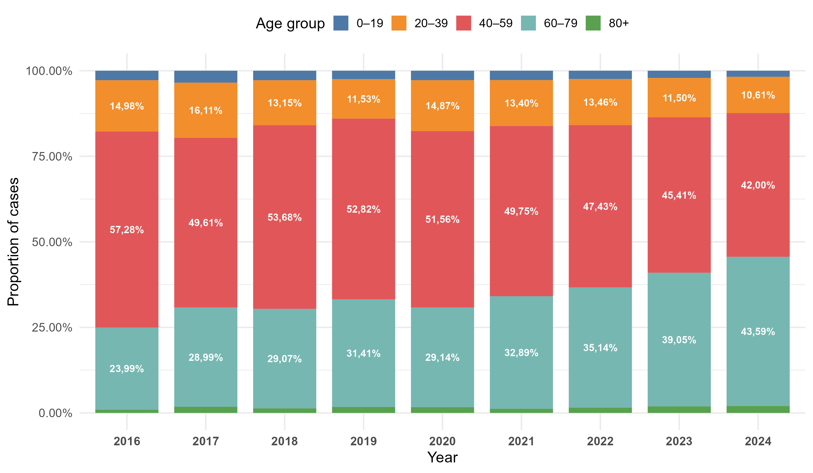
Figure 2. Crude incidence rates by age group, cumulative for 2016–2024.
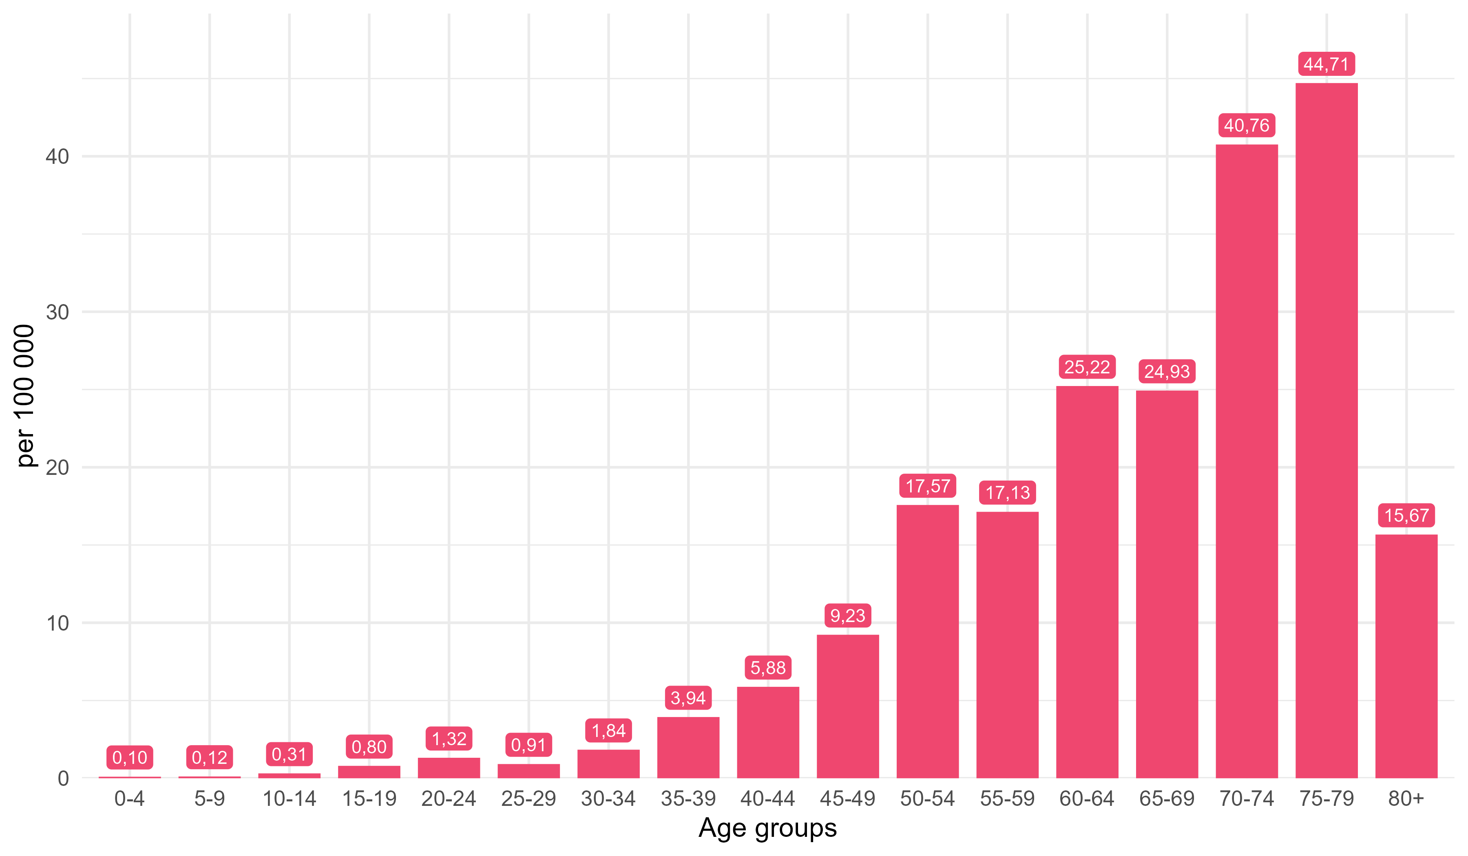
Figure 3. Crude incidence rates by age group, 2016–2024.

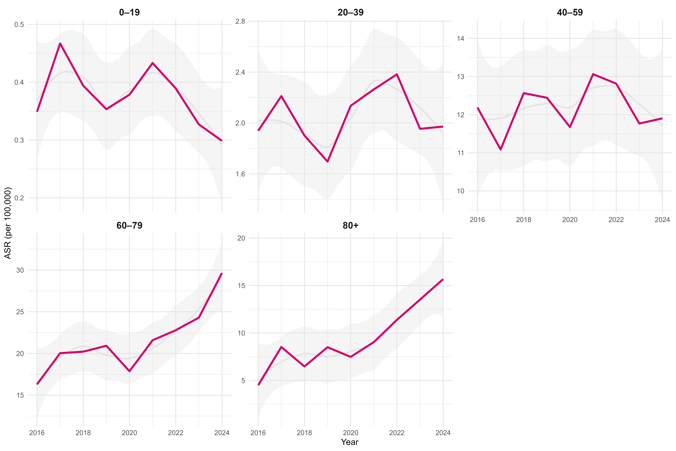

Figure 4. Average annual change in incidence rates by age group, 2016–2024.
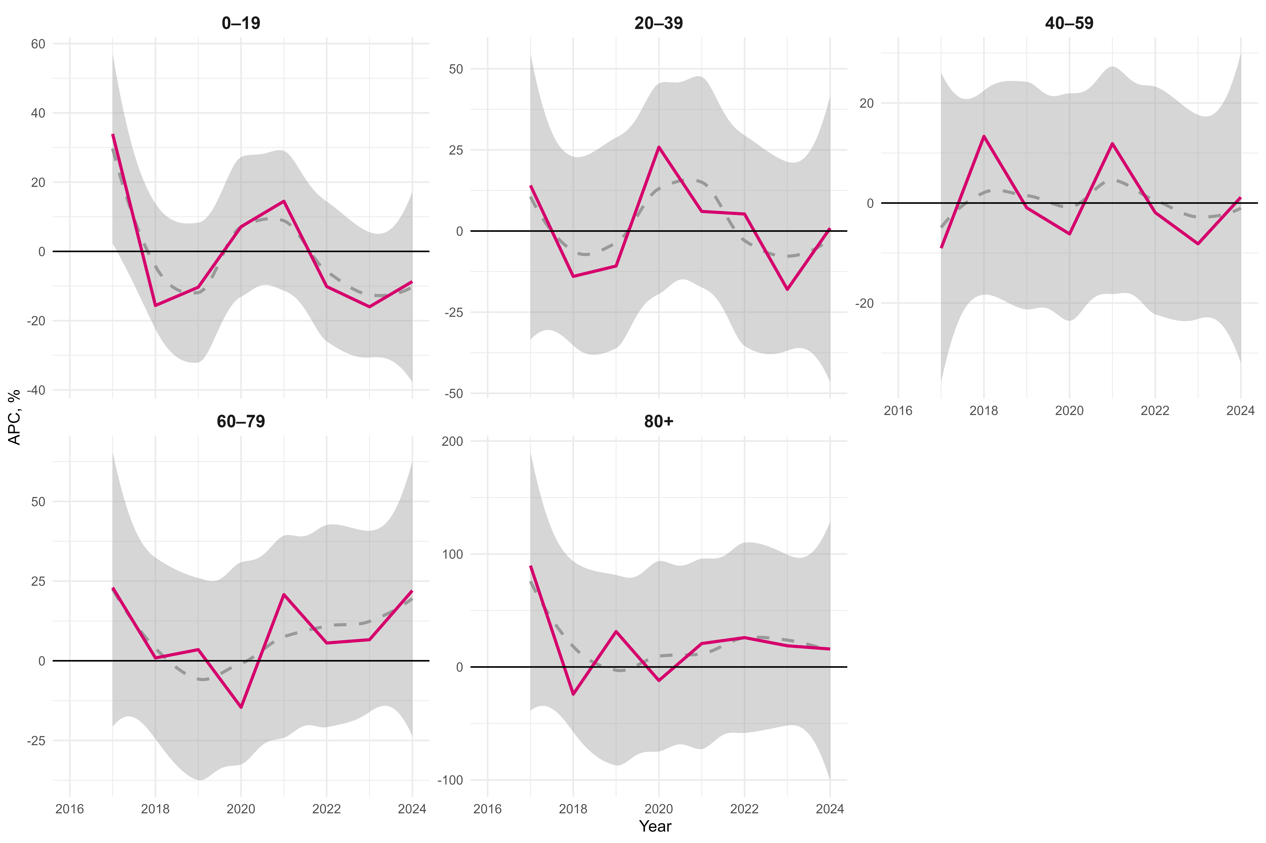

Figure 5. Average annual change in incidence rates by age group, cumulative for 2016–2024.
