Performance Analysis of Gaussian–Edge Feature Extraction Pipelines for Imbalanced Image Classification

Abstract
Modern supervised learning pipelines for image classification rely heavily on preprocessing decisions, including feature extraction, noise reduction, and class imbalance handling. In high-dimensional and heterogeneous image data, these choices can substantially influence classifier behavior, yet the combined effects of Gaussian smoothing and classical edge detection operators remain insufficiently characterized within statistical learning pipelines.This study presents a systematic performance analysis of Gaussian–edge feature extraction pipelines for imbalanced binary image classification. Gaussian filtering is combined with four widely used edge operators—Sobel, Prewitt, Laplacian of Gaussian, and Canny—and evaluated using classical learning algorithms, including Logistic Regression, Support Vector Machines, Random Forests, and Gradient Boosting. To address class imbalance, both class weighted learning and SMOTE oversampling are examined.Using a heterogeneous bee image dataset as an illustrative case study, the results demonstrate that preprocessing choices have a pronounced impact on minority class performance, while overall accuracy alone provides a misleading assessment under severe imbalance. First-order gradient operators (Sobel and Prewitt), particularly when combined with Gradient Boosting and SMOTE, consistently yield more balanced and interpretable performance than second-order or threshold-based detectors. The best-performing pipeline achieves a macro F1-score of approximately 0.55 and a minority class (Apis) F1-score of approximately 0.25, highlighting the importance of preprocessing design in classical image classification pipelines and providing interpretable baselines for imbalanced learning scenarios where complex deep-learning architectures may be impractical.

Keywords: Gaussian smoothing; Edge based feature extraction; Imbalanced image classification; Classical machine learning; SMOTE oversampling; Statistical image analysis

1. Introduction

Large-scale image collections produced through citizen-science initiatives have become an increasingly important data source for ecological and statistical research, providing extensive spatial and temporal coverage for studying pollinator populations [1,2,3]. However, such datasets often exhibit substantial heterogeneity, arising from uncontrolled acquisition conditions, variable lighting, motion blur, and inconsistent contributor expertise. These factors introduce persistent observational noise and complicate statistical classification, especially when the underlying class distribution is markedly imbalanced—a well-documented feature of volunteer-based biodiversity data [4,5]. The BeeSpotter dataset associated with the “Naive Bees’’ challenge provides a representative example of these challenges and has been widely reused as a benchmark for studying visual discrimination tasks under real-world noise constraints.

In image based statistical learning, the success of a classifier depends critically on how raw pixel intensities are mapped into covariates. Preprocessing steps such as smoothing, normalization, and differentiation alter the geometry of the feature space and hence the separability of the classes. Gaussian smoothing, one of the most widely used approaches in early vision models, reduces high-frequency noise and stabilizes derivative estimates used in feature extraction [6]. When combined with classical edge operators—such as Sobel [7,8], Laplacian of Gaussian [6], and the Canny detector [9]—Gaussian filtering yields structured gradient-based representations that capture contours, boundary transitions, and local morphological patterns. These operators form the foundation of modern feature engineering, yet their joint behavior within supervised statistical pipelines remains insufficiently characterized in the.

Research on species identification has been dominated by deep learning methods, with convolutional neural networks achieving state-of-the-art results on bee and insect imagery[10,11]. Neural-network approaches have also been used to classify honey bee subspecies, recognize Bombus species under field conditions, and support real-time insect monitoring systems. Although these architectures yield strong performance, they require large labeled datasets, careful hyperparameter tuning, and computationally intensive training. Consequently, they offer limited insight into how specific preprocessing steps influence class separability, noise behavior, or minority class detection—questions that are better addressed using classical statistical models.

Classical classifiers—such as Logistic Regression, Support Vector Machines, Random Forests, and Gradient Boosting—remain important tools because they provide interpretability, computational efficiency, and sensitivity to the structure of the feature space [12]. Their performance is highly dependent on preprocessing decisions, particularly in the presence of class imbalance, which is known to distort decision boundaries and degrade minority class recall [13-15]. For this reason, imbalance-aware evaluation strategies and performance metrics have been widely recommended in the literature [19].Oversampling techniques such as SMOTE [16] and related synthetic-instance methods can mitigate this problem, while evaluation metrics such as the F1-score and precision–recall curves have been recommended over ROC curves in highly skewed settings [17]. Despite substantial research on imbalance handling, little work has explored how Gaussian–edge feature constructions interact with these adjustments in practical classification pipelines.

The present study addresses this methodological gap by providing a structured statistical assessment of Gaussian filtered, edge based feature representations in a binary classification setting. Using the BeeSpotter dataset as an illustrative example, we evaluate four edge operators in combination with classical classifiers and two imbalance-correction strategies—class weighted fitting and SMOTE oversampling. The results clarify how smoothing and edge extraction choices shape the feature structure and downstream classifier performance, particularly for the minority class. By isolating the effects of preprocessing, the analysis offers interpretable baselines for future work in statistical image analysis, pattern recognition, and imbalanced learning.

2. Materials and Methods
This section outlines the statistical framework used to examine how Gaussian based preprocessing and classical supervised learning models perform in genus-level classification of bee images. The methodology integrates image preprocessing, smoothing, edge extraction, feature construction, classification, imbalance adjustment, and performance evaluation within a unified analytical pipeline.

2.1 Image Preprocessing and Covariate Construction
Citizen-science images exhibit substantial variability in illumination, background, and camera conditions. Each RGB image I(x,y) is converted to grayscale using the luminance transformation:
$$G\left(x,y\right)=0.299R+0.587G+0.114B,$$
which preserves perceptual contrast while reducing dimensionality. Grayscale intensities are normalized to [0,1]:
$G^{*}(x,y)=\frac{G(x,y)}{255}$,
ensuring numerical comparability across images. No additional contrast enhancement or nonlinear transformations are applied so that the effects of Gaussian smoothing and edge detection remain isolated.

2.2 Gaussian Smoothing
To stabilize gradient estimation and reduce high-frequency noise, each normalized grayscale image is smoothed using a Gaussian kernel:

$K(x,y)=\frac{1}{2πσ^{2}}exp⁡(-\frac{x^{2}+y^{2}}{2σ^{2}})$,
where σ\sigmaσ determines the level of smoothing. This step increases the robustness of subsequent derivative-based edge extraction and ensures that performance differences across pipelines reflect edge operator behavior rather than noise artifacts. Accordingly, a 3×3 Gaussian kernel was selected as a conservative smoothing level to suppress high-frequency noise while preserving fine morphological details relevant for edge detection.
2.3 Edge Based Feature Extraction
Four classical edge detectors are applied to the smoothed images:

- Sobel operator: first-order horizontal and vertical gradients.
- Prewitt operator: finite-difference approximation with isotropic smoothing.
- Laplacian of Gaussian (LoG): second-order derivative emphasizing closed contours and texture transitions.
- Canny detector: a multistage detector combining smoothing, gradient magnitude, non-maximum suppression, and hysteresis thresholding.
Each operator produces a 200×200 gradient-based representation capturing morphological cues relevant for genus-level discrimination.

2.4 Feature Vector Representation
Each edge map is reshaped into a 40,000-dimensional feature vector, forming the covariate matrix $X$. Retaining the full pixel-level gradient structure enables a direct comparison across edge operators without introducing additional transformations such as pooling or PCA. Although dimensionality reduction techniques could reduce sparsity, they were intentionally omitted to isolate the effect of Gaussian–edge preprocessing on classifier performance. Genus labels (Apis vs. Bombus) form the response vector $Y$.

2.5 Statistical Classification Models
Four supervised learning models are evaluated:
Logistic Regression (LR)
$$P\left(Y=1 ∣ X\right)=\frac{1}{1+\exp\left[-\left(β_{0}+X^{⊤}β\right)\right]}$$
Support Vector Machines (SVM)
Both linear and radial basis function (RBF) kernels are used. Linear SVM evaluates separability in the original feature space, while RBF captures nonlinear interactions.
Random Forests (RF)
Bootstrap-aggregated ensembles of decision trees, robust to nonlinearities and noise.
Gradient Boosting Machines (GBM)
Additive models that iteratively minimize a loss function by fitting shallow trees to residuals.
These models span linear, kernel-based, and ensemble paradigms, enabling a broad assessment of how Gaussian–edge features interact with classical classifiers.

2.6 Class Imbalance Adjustment
The dataset exhibits a strong class imbalance, with Bombus substantially outnumbering Apis. Two correction strategies are used:
- Class weighted fitting, which increases the loss contribution of minority class (Apis) misclassifications and shifts the decision boundary toward improved sensitivity.
- SMOTE oversampling, which generates synthetic minority examples through feature-space interpolation and is applied exclusively to the training data to prevent information leakage into the test set.

2.7 Evaluation Metrics
Performance is assessed using threshold-based and global metrics. Precision, recall, and F1-score are computed for both classes, with emphasis on Apis due to its minority status. Overall accuracy is reported but interpreted cautiously under imbalance. Confusion matrices are inspected to identify systematic misclassification patterns. For probability-based classifiers (LR, GBM), ROC–AUC is computed to summarize discrimination across decision thresholds. All evaluations are performed on an independent test set.
2.8 Analysis Pipeline Overview
The workflow integrates preprocessing, smoothing, edge detection, feature construction, and classification in a consistent experimental design. Images are converted to grayscale, normalized, and smoothed with a Gaussian kernel before applying one of four edge detectors. Processed images are flattened into high-dimensional feature vectors and used to train LR, SVM, RF, and GBM models under class weighted and SMOTE-augmented settings. This structure forms a factorial comparison across four edge operators × four classifiers × two imbalance strategies, enabling a systematic evaluation of how preprocessing choices influence statistical classification performance.

2.9 Experimental Implementation
All experiments were conducted in Python using NumPy, Pandas, OpenCV, scikit-learn, and the imbalanced-learn library. Analyses were performed in a cloud-based environment (Google Colaboratory) using standard CPU hardware without GPU acceleration, reflecting a low-to-moderate computational setting suitable for classical statistical workflows. Random seeds were fixed to ensure reproducibility of preprocessing operations, train–test splits, and model-fitting procedures.
The dataset contains 3,969 labeled bee images (Apis = 827, Bombus = 3,142) obtained from the publicly available BeeSpotter citizen-science project [18]. A stratified 70/30 split was used for all experiments, with models trained exclusively on the training set and evaluated on the held-out test set. Preprocessing—including grayscale conversion, normalization, Gaussian smoothing, and edge extraction—was applied uniformly across the dataset. Gaussian smoothing employed a 3×3 kernel with OpenCV’s default standard deviation. Sobel and Prewitt operators applied 3 ×3 derivative masks, whereas LoG combined Gaussian smoothing with a discrete Laplacian. The Canny detector used hysteresis thresholds of 100 and 200. Each processed image generated a 200 ×200 edge map, later flattened into a 40,000-dimensional feature vector.
Classifier configurations followed scikit-learn defaults with minor adjustments. LR used $L_{2}$ regularization with a maximum of 500 iterations. SVMs employed RBF kernels with default hyperparameters. RF consisted of 200 trees with bootstrap sampling, and Gradient Boosting models used default learning-rate and depth settings. Hyperparameter tuning was intentionally limited to focus on the comparative influence of preprocessing strategies and imbalance corrections.
Three imbalance treatments were evaluated: (i) unadjusted models trained on the original distribution, (ii) class weighted fitting using inverse-frequency weights, and (iii) SMOTE oversampling applied only to the training set. The same stratified split was used for all conditions, ensuring direct comparability across edge operators, classifiers, and imbalance strategies.

3. Results
This section summarizes the empirical findings obtained from evaluating a full factorial set of preprocessing and classification pipelines. Gaussian smoothing was combined with four classical edge detection operators (Sobel, Prewitt, LoG and Canny) and four supervised learning models (LR, SVMs, RF, and GB). Each pipeline was further assessed under three imbalance-handling strategies—no adjustment, class weighting, and SMOTE. The complete results are reported in Table 1–Table 4, and key comparative patterns are visualized in Figures 1–4.

3.1 Overall Accuracy and Macro F1 Performance
Across all Gaussian–edge combinations, classification accuracy ranged approximately from 0.71 to 0.80, with SVM and RF frequently achieving the highest values. The Gaussian + Sobel and Gaussian + Prewitt pipelines, in particular, reached accuracies near 0.79–0.80 when coupled with SVM or RF (see Table 1 and Table 2).

Table 1. Results for Gaussian + Sobel preprocessing
Model | Imbalance | Accuracy | F1_macro | F1_Apis | F1_Bombus
LR | None | 0.7439 | 0.5194 | 0.191 | 0.8479
LR | Class_weight | 0.7305 | 0.5437 | 0.2517 | 0.8356
LR | Smote | 0.7288 | 0.534 | 0.2328 | 0.8353
SVM | None | 0.7935 | 0.4503 | 0.016 | 0.8846
SVM | Class_weight | 0.7842 | 0.4815 | 0.0854 | 0.8777
SVM | Smote | 0.7943 | 0.4693 | 0.0541 | 0.8846
RF | None | 0.7918 | 0.4646 | 0.0462 | 0.8831
RF | Class_weight | 0.796 | 0.4627 | 0.0395 | 0.8859
RF | Smote | 0.78 | 0.5032 | 0.1325 | 0.874
GB | None | 0.7884 | 0.4804 | 0.0803 | 0.8805
GB | Class_weight | 0.7884 | 0.4804 | 0.0803 | 0.8805
GB | Smote | 0.7481 | 0.5475 | 0.2462 | 0.8488

Table 1 summarizes classification performance under the Gaussian + Sobel preprocessing pipeline across all models and imbalance strategies. A comparable analysis for the Gaussian + Prewitt pipeline is provided in Table 2, where minority class performance is generally improved relative to Sobel.

Table 2. Results for Gaussian + Prewitt preprocessng
Model | Imbalance | Accuracy | F1_macro | F1_Apis |  | F1_Bombus
LR | None | 0.7456 | 0.5205 |  | 0.192 |  | 0.849
LR | Class_weight | 0.7271 | 0.5413 |  | 0.2494 |  | 0.8332
LR | Smote | 0.7263 | 0.5306 |  | 0.2275 |  | 0.8337
SVM | None | 0.7935 | 0.4503 |  | 0.016 |  | 0.8846
SVM | Class_weight | 0.7842 | 0.4783 |  | 0.0789 |  | 0.8778
SVM | Smote | 0.7935 | 0.469 |  | 0.0538 |  | 0.8841
RF | None | 0.7935 | 0.469 |  | 0.0538 |  | 0.8841
RF | Class_weight | 0.796 | 0.4627 |  | 0.0395 |  | 0.8859
RF | Smote | 0.7783 | 0.4966 |  | 0.12 |  | 0.8732
GB | None | 0.7918 | 0.4982 |  | 0.1143 |  | 0.882
GB | Class_weight | 0.7918 | 0.4982 |  | 0.1143 |  | 0.882
GB | Smote | 0.7523 | 0.5505 |  | 0.2494 |  | 0.8517

However, accuracy mainly reflects performance on the majority class (Bombus). To obtain a more balanced evaluation, macro F1-scores were compared across pipelines. As illustrated in Figure 3, first-order gradient operators (Sobel and Prewitt) consistently produced higher macro F1 values than LoG and Canny.
The best macro F1 performance was observed when Gaussian smoothing was combined with Sobel or Prewitt and when SMOTE was applied to the training set. For example, Gaussian + Sobel + GB + SMOTE and Gaussian + Prewitt + GB + SMOTE achieved macro F1 values around 0.55 (see Table 1 and Table 2). In contrast, pipelines based on LoG and Canny yielded lower macro F1-scores due to reduced recall for Apis (Table 3–4).
Table 3 summarizes the results for the Laplacian of Gaussian operator, which provides only marginal improvements for Apis relative to the unadjusted models but still performs noticeably worse than the Sobel- and Prewitt-based pipelines.

Table 3. Results for Gaussian + Laplacian of Gaussian (LoG) preprocessing
Model | Imbalance | Accuracy | F1_macro | F1_Apis | F1_Bombus
LR | None | 0.7708 | 0.5085 | 0.1495 | 0.8675
LR | Class_weight | 0.7548 | 0.5308 | 0.2065 | 0.855
LR | Smote | 0.754 | 0.5281 | 0.2016 | 0.8546
SVM | None | 0.7926 | 0.4461 | 0.008 | 0.8842
SVM | Class_weight | 0.7926 | 0.4613 | 0.0389 | 0.8838
SVM | Smote | 0.796 | 0.4627 | 0.0395 | 0.8859
RF | None | 0.7943 | 0.462 | 0.0392 | 0.8848
RF | Class_weight | 0.796 | 0.4627 | 0.0395 | 0.8859
RF | Smote | 0.7893 | 0.46 | 0.0383 | 0.8817
GB | None | 0.7851 | 0.4618 | 0.0448 | 0.8789
GB | Class_weight | 0.7851 | 0.4618 | 0.0448 | 0.8789
GB | Smote | 0.717 | 0.4947 | 0.1596 | 0.8299
Table 4 summarizes the results for the Canny operator, which—similar to LoG—consistently underperforms for the minority class despite maintaining strong Bombus accuracy.

Table 4. Results for Gaussian + Canny preprocessing
Model | Imbalance | Accuracy | F1_macro | F1_Apis | F1_Bombus
LR | None | 0.7834 | 0.4843 | 0.0915 | 0.877
LR | Class_weight | 0.7783 | 0.4786 | 0.0833 | 0.8739
LR | Smote | 0.7817 | 0.4896 | 0.1034 | 0.8757
SVM | None | 0.7935 | 0.4503 | 0.016 | 0.8846
SVM | Class_weight | 0.796 | 0.4627 | 0.0395 | 0.8859
SVM | Smote | 0.796 | 0.4627 | 0.0395 | 0.8859
RF | None | 0.7951 | 0.5062 | 0.1286 | 0.8839
RF | Class_weight | 0.796 | 0.4627 | 0.0395 | 0.8859
RF | Smote | 0.7943 | 0.4693 | 0.0541 | 0.8846
GB | None | 0.7825 | 0.4743 | 0.0717 | 0.8768
GB | Class_weight | 0.7825 | 0.4743 | 0.0717 | 0.8768
GB | Smote | 0.7834 | 0.4541 | 0.0301 | 0.8781

3.2 Apis (Minority Class) Performance
Minority class discrimination is the central statistical difficulty of this task. Model-specific performance patterns under the Gaussian + Prewitt pipeline are visualized in Figure 1, while Apis-specific F1-scores are shown in Figure 2.

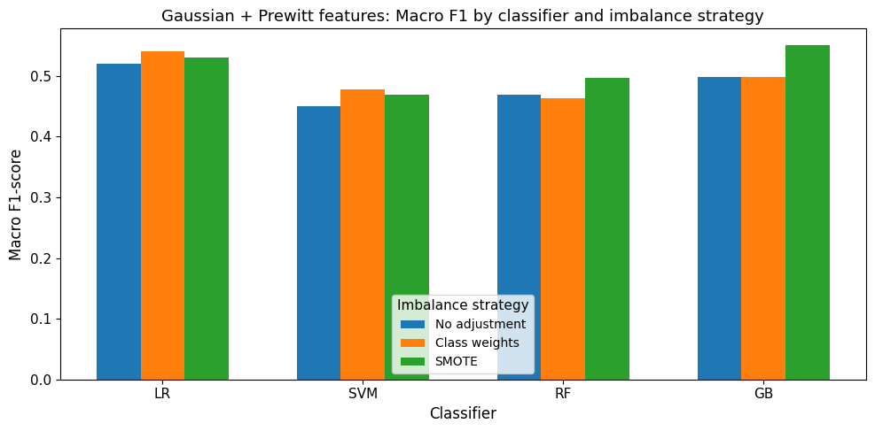
Figure 1. Macro F1-scores for Gaussian + Prewitt features across classifiers and imbalance strategies. While LR and RF show moderate improvements under class weighting and SMOTE, GB with SMOTE achieves the most balanced and robust performance.
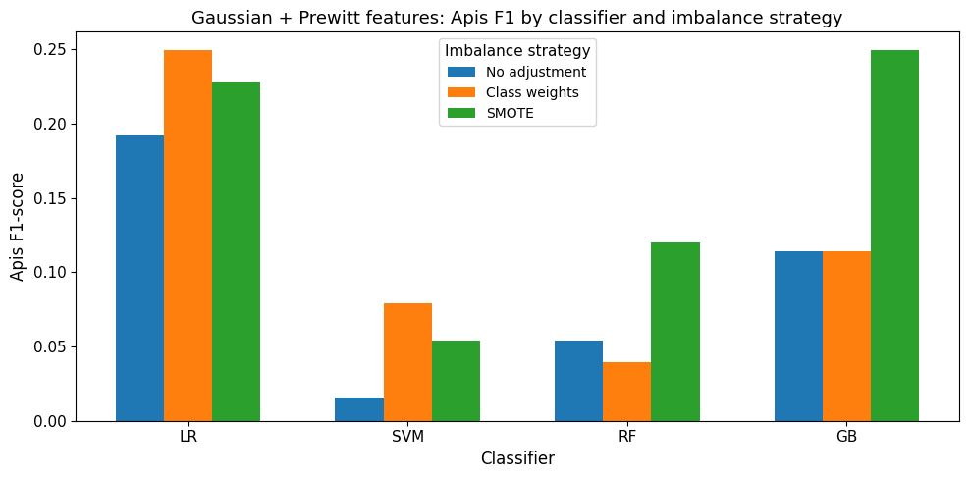
Figure 2. Apis (minority class) F1-scores obtained using Gaussian + Prewitt features across four classifiers (LR, SVM, RF, GB) and three imbalance-adjustment strategies (no adjustment, class weights, SMOTE). SMOTE substantially improves minority class performance, with Gradient Boosting achieving the highest Apis F1-score.

(i) Effect of SMOTE
SMOTE substantially improves minority class performance for LR, RF, and GB. For example, under the Gaussian + Sobel pipeline, the RF model improves from an Apis F1-score of 0.0462 (no adjustment) to 0.1325 when SMOTE is applied (Table 1). A similar trend is observed in the Gaussian + Prewitt configuration, where GB improves from 0.1143 to 0.2494 with SMOTE (Table 2).

(ii) Best-performing configuration for Apis
Across all examined pipelines and classifiers, the strongest Apis performance is achieved by the Gaussian + Prewitt + GB + SMOTE combination, yielding an Apis F1-score of 0.2494 and a macro F1-score of 0.5505 (Table 2). This configuration also appears prominently as the peak minority class performer in Figure 2. The Gaussian + Sobel + GB + SMOTE pipeline produces comparable results (Apis F1 = 0.2462, Table 1), whereas Gaussian + LoG + GB + SMOTE performs substantially worse (Apis F1 = 0.1596, Table 3). Pipelines based on the Canny operator consistently yield the weakest minority class performance, with Apis F1-scores rarely exceeding 0.10 (Table 4).
(iii) SVM behaviour
SVM models show excellent Bombus discrimination but extremely poor Apis recall in all settings. As shown in Tables 1–4, SVM frequently produces Apis F1 values between 0.01 and 0.09, even under class weighting or SMOTE. This systematic behaviour suggests that standard RBF SVMs are ill-suited to the high-dimensional, severely imbalanced feature space.
3.3 Bombus (Majority Class) Performance
Performance for the majority class (Bombus) is uniformly high across all preprocessing pipelines. As reported in Table 1–Table 4, Bombus F1-scores typically range from 0.83 to 0.99, with SVM and RF consistently delivering the strongest results. For instance, both the Gaussian + Sobel + RF and Gaussian + Canny + RF configurations achieve Bombus F1 values of 0.88 or higher (Table 1 and Table 4). Importantly, SMOTE has minimal effect on Bombus performance, indicating that oversampling primarily reshapes the minority class decision boundary without degrading majority-class accuracy.
3.4 Comparison of Edge Operators Under Gaussian Smoothing
A global comparison of edge operators under Gaussian smoothing reveals several systematic trends.
Sobel & Prewitt (Tables 1–2): Best overall performers
These first-order gradient operators offer the most favourable balance between noise suppression and structural edge preservation. Their combination with GB and SMOTE yields the highest macro F1 values and the largest improvements for Apis.
LoG (Table 3): Moderate minority class performance
LoG maintains strong Bombus accuracy but provides weaker Apis improvements. Second-derivative features appear more sensitive to background textures and noise.
Canny (Table 4): Weakest minority class performance
Despite its multi-stage sophistication, Canny consistently underperforms for Apis, likely because non-maximum suppression removes weak gradients associated with Apis morphological features, particularly in heterogeneous lighting conditions.These systematic differences are clearly consolidated in Figure 3, where Sobel and Prewitt dominate across most classifiers.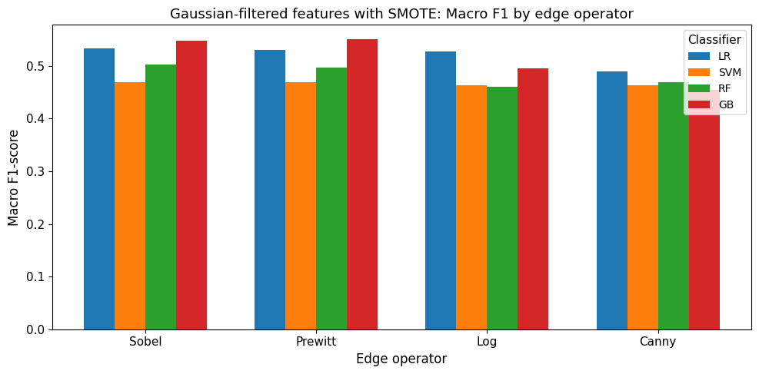
Figure 3. Macro F1-scores for Gaussian filtered features extracted using Sobel, Prewitt, LoG, and Canny operators under the SMOTE strategy. First-order gradient operators (Sobel and Prewitt) consistently outperform LoG and Canny, with Prewitt combined with GB yielding the highest overall performance.

3.5 Best Gaussian Based Pipeline
Considering both minority and majority class performance, the most effective Gaussian based pipeline is Gaussian smoothing + Prewitt edge detection + GB+ SMOTE. This configuration achieves an Apis F1-score of 0.2494, a Bombus F1-score of 0.8517, and a macro F1-score of 0.5505, representing the most balanced trade-off between edge preservation, noise reduction, and adaptation to class imbalance. As such, it provides the primary reference point for interpreting the comparative behavior of the remaining preprocessing pipelines.
These patterns are also clearly visible in the performance heatmap (Figure 4), where the Gaussian + Prewitt + GB + SMOTE combination appears as the global optimum across all pipelines, while SVM-based configurations cluster consistently at the lower end of the minority class performance range.
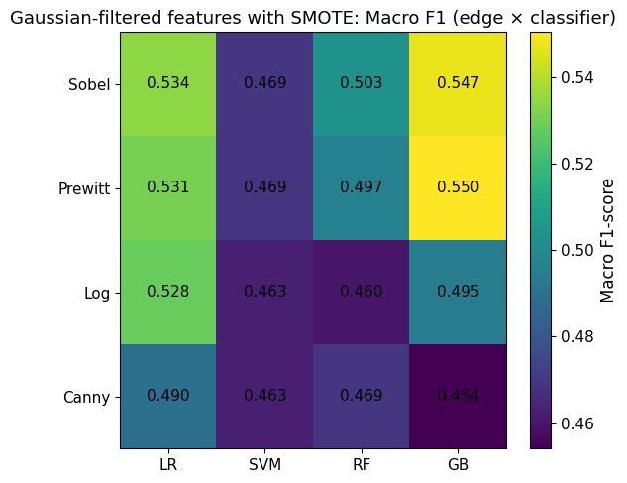
Figure 4. Macro F1-scores for Gaussian filtered features extracted using four edge operators (Sobel, Prewitt, Laplacian of Gaussian, and Canny) under the SMOTE imbalance-adjustment strategy. Each cell represents the Macro F1-score achieved by a specific classifier (LR, SVM, RF, GB). The best performance is observed for the Gaussian + Prewitt + GB pipeline.

4. Discussion
This study investigated how Gaussian smoothing, classical edge detection operators, and traditional statistical learning algorithms jointly shape genus-level classification performance in a large citizen-science bee image dataset. The findings highlight that preprocessing decisions play a decisive role—particularly for the minority class (Apis)—while majority-class (Bombus) performance remains uniformly high across all configurations. Although overall accuracy is relatively high due to the dominance of Bombus samples, macro-F1 and class specific F1-scores provide a more reliable measure of classifier behavior under severe class imbalance. This discrepancy between accuracy and F1 reflects the inherent difficulty of identifying Apis in heterogeneous, noisy citizen-science imagery.
A key result is the consistent advantage of first-order gradient operators, specifically Sobel and Prewitt, over more complex detectors such as the LoG and Canny. As reflected in Table 1 and Table 2, these operators preserve fine-scale morphological cues—including thorax–abdomen boundaries, banding structure, and wing curvature—without suppressing low-contrast gradients that are critical for distinguishing Apis. By contrast, LoG and Canny (Tables 3–4) introduce stronger smoothing or thresholding operations that tend to weaken or remove precisely the subtle gradient patterns associated with Apis morphology. The poor minority class recall observed for Canny-based pipelines aligns with the known sensitivity of the detector to illumination variability and low-contrast edges in natural imagery.
Imbalance-handling methods also had substantial influence. Class weighting produced moderate improvements in minority class recall for LR and SVM; however, SMOTE consistently delivered the strongest gains across nearly all preprocessing pipelines. In the Gaussian + Prewitt configuration, for example, GB combined with SMOTE increased the Apis F1-score from 0.1143 to 0.2494—the largest improvement observed in the study. The effectiveness of SMOTE reflects its ability to populate sparsely represented regions of the feature space, enabling classifiers to form more flexible decision boundaries around minority samples.
Classifier performance patterns were similarly systematic. GB emerged as the most reliable model for minority class prediction when paired with first-order edges. RFs also performed competitively but tended to overfit the majority class in the absence of imbalance adjustments. SVMs achieved high macro accuracy but consistently failed to identify Apis, yielding F1-scores near zero in many pipelines (Tables 1–4). This is consistent with the challenges SVMs face in extremely high-dimensional feature spaces where minority samples occupy narrow, heterogenous regions. LR showed moderate sensitivity to imbalance corrections but was ultimately less effective than tree-based methods.
These findings carry broader implications for image based ecological monitoring. Although Gaussian smoothing reduced high-frequency noise, even the most successful pipeline—Gaussian + Prewitt + GB + SMOTE—achieved an Apis F1-score of only 0.2494. This underscores the inherent difficulty of genus-level identification in uncontrolled, real-world imagery, where pose variation, occlusion, blur, and background clutter obscure diagnostic features. The results are consistent with prior work showing the limitations of classical machine-learning models in fine-grained species classification unless substantial feature engineering or high-quality annotations are available.
Finally, this study provides an interpretable and computationally lightweight baseline against which more sophisticated approaches, such as deep convolutional models, can be compared. While deep learning methods generally outperform hand-engineered pipelines, classical approaches remain valuable in resource-limited settings or applications requiring transparent, easily deployable models. The present results clarify which combinations of filters, edge operators, and classifiers offer the most statistically robust performance within this framework.

5. Conclusions
This study provides a comprehensive statistical evaluation of Gaussian based smoothing, edge detection operators, and classical learning algorithms for genus-level bee classification. The results demonstrate that preprocessing steps—particularly the choice of edge operator—have a central influence on classification outcomes. Among all tested pipelines, Gaussian smoothing followed by Prewitt edge detection, combined with GB and SMOTE, produced the strongest minority class performance, with the highest Apis F1-score (0.2494) and the most balanced macro F1-score (0.5505).
Although overall accuracy remained high across all configurations due to the dominance of Bombus samples, such metrics obscured substantial weaknesses in minority class recall. The difficulty of identifying Apis in heterogeneous, real-world images highlights the need for improved data quality, targeted sampling efforts, or more advanced algorithms capable of detecting fine-scale morphological cues.
The study establishes an interpretable baseline for classical statistical models in automated pollinator monitoring. Thoughtful preprocessing, feature construction, and imbalance mitigation significantly enhance model reliability, offering practical value in ecological applications where deep learning may not be feasible due to annotation constraints, computational limitations, or transparency requirements. Future research may explore hybrid approaches—such as cost-sensitive learning, adaptive loss functions, or lightweight convolutional feature extractors—to further improve performance for minority pollinator taxa.
Supplementary Materials: The source code used for image preprocessing, model training, and loss-function evaluation is openly available at: https://github.com/elifkozanstat/bee-gaussian-edge-classification (accessed on 7/12/2025). A permanent archived version with a DOI will be provided upon acceptance of the manuscript.
Data Availability Statement: The image data used in this study are publicly available from BeeSpotter citizen-science project (https://beespotter.org). No new datasets were generated by the authors.
Abbreviations
The following abbreviations are used in this manuscript:
LR | Logistic Regression
LoG | Laplacian of Gaussian
RF | Random Forests
SVM | Support Vector Machines
GB | Gradient Boosting

Disclaimer (Artificial intelligence)

Author(s) hereby declare that NO generative AI technologies such as Large Language Models (ChatGPT, COPILOT, etc.) and text-to-image generators have been used during the writing or editing of this manuscript.

References
- Potts, S.G.; Imperatriz-Fonseca, V.; Ngo, H.T.; Aizen, M.A.; Biesmeijer, J.C.; Breeze, T.D.; et al. Safeguarding pollinators and their values to human well-being. Nature 2016, 540, 220–229.
- Goulson, D.; Nicholls, E.; Botías, C.; Rotheray, E.L. Bee declines driven by combined stress from parasites, pesticides, and lack of flowers. Science 2015, 347, 1255957.
- Potts, S.G.; Imperatriz-Fonseca, V.L.; Ngo, H.T., Eds. The Assessment Report of the Intergovernmental Science-Policy Platform on Biodiversity and Ecosystem Services on Pollinators, Pollination and Food Production; IPBES Secretariat: Bonn, Germany, 2016; 552 pp.
- Kullenberg, C.; Kasperowski, D. What is citizen science?—A scientometric meta-analysis. PLOS ONE 2016, 11, e0147152.
- Ratnayake, A.M.B.; Yasin, H.M.; Naim, A.G.; Abas, P.E. Buzzing through data: Advancing bee species identification with machine learning. Appl. Syst. Innov. 2024, 7, 62.
- Marr, D.; Hildreth, E. Theory of edge detection. Proc. R. Soc. Lond. B 1980, 207, 187–217.
- Sobel, I.; Feldman, G. A 3×3 Isotropic Gradient Operator for Image Processing; Stanford Artificial Intelligence Project Technical Report; Stanford University: Stanford, CA, USA, 1968.
- Prewitt, J.M.S. Object enhancement and extraction. In Picture Processing and Psychopictorics; Lipkin, B., Rosenfeld, A., Eds.; Academic Press: New York, NY, USA, 1970; pp. 75–149.
- Canny, J. A computational approach to edge detection. IEEE Trans. Pattern Anal. Mach. Intell. 1986, 8, 679–698.
- Buschbacher, K.; Ahrens, D.; Espeland, M.; Steinhage, V. Image-based species identification of wild bees using convolutional neural networks. Ecological Informatics 2020, 55, 101017.
- Spiesman, B.J.; Gratton, C.; Hatfield, R.G.; Hsu, W.H.; Jepsen, S.; McCornack, B.; Patel, K.; Wang, G. Assessing the potential for deep learning and computer vision to identify bumble bee species from images. Sci. Rep. 2021, 11, 7580.
- Hastie, T.; Tibshirani, R.; Friedman, J. The Elements of Statistical Learning, 2nd ed.; Springer: New York, NY, USA, 2009.
- He, H.; Garcia, E. Learning from imbalanced data. IEEE Trans. Knowl. Data Eng. 2009, 21, 1263–1284.
- Wang, S.; Yao, X. Multiclass imbalance problems: Analysis and solutions. IEEE Trans. Syst. Man Cybern. B 2012, 42, 1119–1139.
- Japkowicz, N.; Stephen, S. The class imbalance problem: A systematic study. Intell. Data Anal. 2002, 6, 429–449.
- Chawla, N.; Bowyer, K.; Hall, L.; Kegelmeyer, W. SMOTE: Synthetic minority oversampling technique. J. Artif. Intell. Res. 2002, 16, 321–357.
- Saito, T.; Rehmsmeier, M. The precision–recall plot is more informative than the ROC plot when evaluating binary classifiers on imbalanced datasets. PLOS ONE 2015, 10, e0118432.
- BeeSpotter Project. Available online: https://beespotter.org (accessed on 7 December 2025).
- Johnson, J.M.; Khoshgoftaar, T.M. Survey on deep learning with class imbalance. Journal of Big Data 2019, 6, 27.

