Vertical dynamics of culturable heterotrophic bacteria concentrations in the water column of hydroelectric reservoirs: A case study of Kossou, Taabo and Faé in Côte d’Ivoire

.
ABSTRACT
Background and Aims: Bacteria play a critical role in trophic chains, particularly by decomposing organic matter into minerals that are required for phytoplankton. They are also actively devoured by zooplankton, allowing carbon to flow through the trophic chain. Several studies have examined the distribution of bacteria in the water column of marine environments, whereas far fewer investigations have focused on freshwater systems. This study aimed to characterize the distribution of heterotrophic bacteria in the water column of the Kossou, Taabo, and Faé hydroelectric reservoirs in Côte d’Ivoire.
Methodology: Water samples were collected at each sampling site over a one-year period during eight field campaigns, in 1 L bottles at the surface, at 1 m depth, and at 2 m depth using hydraulic bottles. During January (dry season) and July (rainy season) campaigns, samples were additionally collected every four (4) hours to study the nycthemeral dynamics of bacterial abundance. Heterotrophic bacteria were analyzed using culture methods.
Results: Heterotrophic bacteria concentrations were high at the water surface, at depths of 1 meter and 2 meters in April, June, July and September, which correspond to the rainy seasons. The bacterial nycthemeral distribution in the water column remained relatively similar for both the dry and rainy seasons. The only difference was that during the dry season at 18 hours, heterotrophic bacteria concentrations remained higher at the water surface and at a depth of 1 meter, whereas during the rainy season at 18 hours, bacterial concentrations generally remained low throughout the water column. Weak correlations were observed between bacteria and environmental variables, suggesting the involvement of other factors.
Conclusion: Thus, heterotrophic bacteria concentrations in the water column of the hydroelectric reservoirs studied are higher during the rainy season, and their nycthemeral distribution varies. However, this nycthemeral variation remains relatively similar for the dry and rainy seasons.

Keywords: Environmental variables, Heterotrophic bacteria, Hydroelectric reservoirs, Nycthemeral rhythm, Water column
1. INTRODUCTION
Bacteria play a key role in trophic chains, particularly by degrading organic matter into minerals that are essential for phytoplankton, and by being actively consumed by zooplankton, thereby allowing carbon to circulate through the trophic chain. They constitute the dominant biomass in terms of carbon in reef waters (Hu et al., 2022). These microorganisms therefore represent an important stock that can help compensate for the nutrient limitations of benthic populations in coral environments characterized by limited mineral resources (Torréton, 2000). In addition, these bacteria are also involved in biogeochemical cycles. Collectively, these functions govern their distribution in aquatic environments.
Bacterial distribution has long been the subject of numerous studies in marine environments (Shan et al., 2015; Richa et al., 2017; Cordone et al., 2022). In contrast, freshwater systems, which remains more disturbed, very few studies have been carried out to date. Freshwater ecosystems are subject to numerous anthropogenic pressures, including dam construction, water transport, industry, plantations and runoff. The presence and structure of bacteria, particularly heterotrophic bacteria, can be influenced by various factors. These include water movements linked to natural phenomena and/or human activities, inputs of organic matter and upwelling phenomena (Baquero et al., 2022). Among these many factors, there are also nutrients, temperature, pH and dissolved oxygen (Qureshimatva et al., 2015; Pomati et al., 2020; Shan et al., 2024). All these factors can be amplified by human activities (Alfonso et al., 2016; Atherholt et al., 2016). Understanding the structure of heterotrophic bacteria in water is crucial because it helps identify sources of contamination and enables the implementation of appropriate treatment and prevention measures. It also enables us to understand their role in the aquatic ecosystem, their impact on human and animal health, and their influence on water quality. Studying their presence and distribution can help assess water potability and identify potential health risks. The study of bacterial ecology could also help us understand bacterial resistance to antibiotics (Baquero et al., 2022).
The Kossou, Taabo and Faé hydroelectric reservoirs in Côte d'Ivoire are subject to human pressures. Recently, Tiémoko et al. (2020) reported fecal contamination in these waters, and Tiémoko et al. (2025) found elevated bacterial levels. Such pressures may influence planktonic bacterial dynamics, which remain essential for trophic functioning in these reservoirs. However, no studies have yet examined heterotrophic bacteria and the factors determining their spatial distribution within the water column of these hydroelectric reservoirs. The objective of this study is therefore to characterize the structure of culturable heterotrophic bacteria in the water column of these reservoirs. Although these bacteria represent only approximately 1% of the total heterotrophic bacterioplankton, this study will provide a better understanding of the dynamics of the viable and cultivable fraction in reservoirs ecosystems.
2. material and methods
2.1 Study area
The study site comprises three hydroelectric reservoirs located in Côte d'Ivoire: Kossou, Taabo and Faé (Figure 1), as described by Tiémoko et al. (2020; 2025). Briefly, the Taabo, Kossou and Faé reservoir dams cover areas of 62 km², 1,700 km² and 16.28 km² respectively, with watersheds of 58,700 km², 32,400 km² and 2,424 km². These watersheds are mostly composed of urban areas, livestock breeding, and agriculture and farming activities.

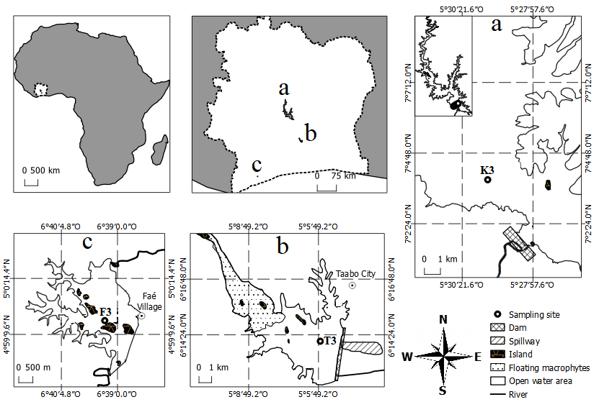
Fig. 1. Location of hydroelectric reservoirs with sampling stations. a: Lake Kossou; b: Lake Taabo; c: Lake Faé (Tiémoko et al., 2025)
2.2 Sample collections
Water sampling was carried out over a one-year period during eight field campaigns, from November 2017 to October 2018: November (N), January (J), February (F) corresponding to the dry season, and April (A), June (J), July (J), September (S), October (O) corresponding to the rainy season, for the temporal study. Three sampling stations were selected in the deep areas of each reservoir, particularly in the Kossou (K3), Taabo (T3) and Faé (F3) reservoirs (Figure 1). At each sampling site, water samples were collected in 1 L bottles at the surface, at 1 m depth, and at 2 m depth using hydraulic bottles. During the January (dry season) and July (rainy season) campaigns, water samples were collected every 4 hours, following a nycthemeral rhythm. A total of 102 samples were collected. The bottles were labeled and transported to the laboratory in a cooler (4°C) for microbiological analysis within a maximum of 8 hours after sampling.
2.3 Analysis of environmental variable parameters
Temperature and dissolved oxygen were measured in situ using an oxygen meter (HANNA HI 9146) and pH was measured using a pH meter (HANNA HI 991001) equipped with specific probes (Tiémoko et al., 2020). The analytical methods used to determine these parameters are described by Rodier et al. (2009).
2.4 Culture-based bacteria enumeration
Following the ISO 7218 (2007) method, culturable heterotrophic bacteria were enumerated in the water samples using Plate Count Agar (PCA) (Difco™, 5350859, France). The plates were incubated at 37°C for 24 hours. After incubation, heterotrophic bacterial concentrations were expressed as colony-forming units per 100 milliliters (CFU per 100 mL) and relative abundance was calculated separately.
2.5 Statistical analysis
Statistical tests were performed to analyze the data on bacterial distribution in the water column. Focused Principal Component Analysis (FPCA) was used to graphically represent the correlations between the variable Xi and the other parameters. The graph indicates the direction (positive or negative) of the correlation. FPCA was used to identify the variables influencing bacterial abundance. RStudio (version 4.1.2) was used to perform these tests.
3. RESULTS
3.1 Environmental variables variation
Median values for environmental variables in the water column are shown in Table 1. Median values of temperature (T), pH, and dissolved oxygen (DO) varied from 27.2 to 30.0°C, from 7.36 to 7.99, and from 3.97 to 7.24 mg/L, respectively. Thus, overall, environmental variables varied weakly throughout the year.
Table 1. Median values of environmental variables in the water column of hydroelectric reservoirs. T=Temperature; pH=Potential hydrogen; DO=Dissolved Oxygen
Parameter | Sampling | Lake Kossou | Lake Taabo | Lake Faé
T (°C) | Surface | 28.2 | 29.6 | 27.2
T (°C) | 1m of depth | 28.3 | 29.35 | 27.55
T (°C) | 2m of depth | 28.0 | 30.0 | 27.5
pH | Surface | 7.59 | 7.77 | 7.68
pH | 1m of depth | 7.99 | 7.36 | 7.51
pH | 2m of depth | 7.81 | 7.72 | 7.60
DO (mg/L) | Surface | 7.24 | 7.01 | 3.97
DO (mg/L) | 1m of depth | 5.57 | 5.69 | 4.58
DO (mg/L) | 2m of depth | 5.30 | 5.50 | 4.21

3.2 Monthly variation of culturable heterotrophic bacteria
Overall, bacterial concentrations ranged from 10⁵ to 7.4 × 10⁸ CFU per 100 mL during the sampling months in the three hydroelectric reservoirs. Figure 2 shows the relative abundance of heterotrophic bacteria. Bacterial abundance were highest in April, June, July, September and October, while the lowest abundance were recorded in November, January and February.

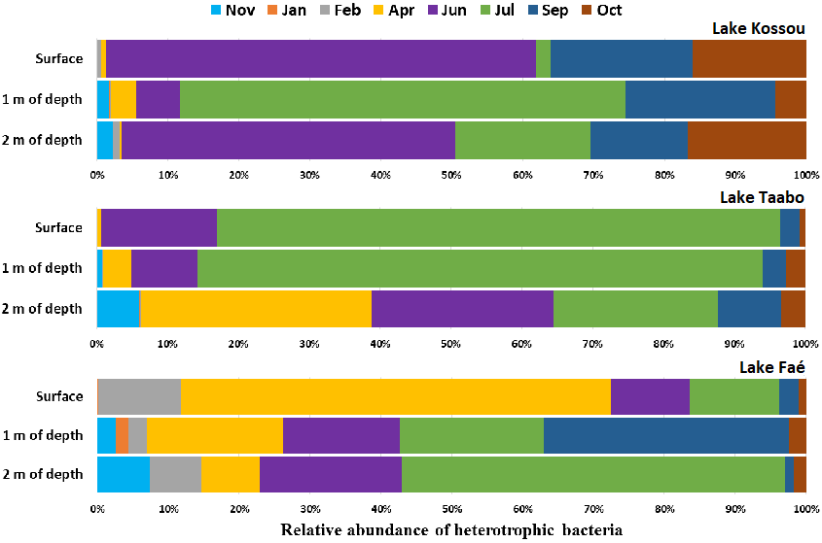
Fig. 2. Variation of culturable heterotrophic bacteria in water column of hydroelectric reservoirs during sampling periods. Nov=November; Jan=January; Feb=February; Apr=April; Jun=June; Jul=July; Sep=September; Oct=October
3.3 Seasonal nycthemeral rhythm of culturable heterotrophic bacteria
Figures 3 and 4 show the nycthemeral variation of heterotrophic bacterial during the dry and the rainy seasons. During the dry season, bacterial abundances at the water surface were generally high between 18 hours and 02 hours, thus at sunset and during the night (Figure 3). At a depth of 1 meter, bacteria were generally abundant either at night (22 and 02 hours), early in the day (06 hours), or late in the day (18 hours). At a depth of 2 meters, bacteria were more elevated during the day, between 10 and 18 hours. Concerning the rainy season, bacterial abundances were only higher at the water surface at 02 hours during the night (Figure 4). At a depth of 1 meter, bacterial levels were higher at the start of the day (06 and 10 hours), and at a depth of 2 meters, bacterial abundances were higher during the day, from 06 to 22 hours. Thus, the bacterial distribution in the water column remained relatively similar in both seasons. The only difference was that during the dry season at 18 hours, heterotrophic bacterial abundances remained higher at the water surface and at a depth of 1 meter, whereas during the rainy season at 18 hours, bacterial abundances generally remained low throughout the water column.
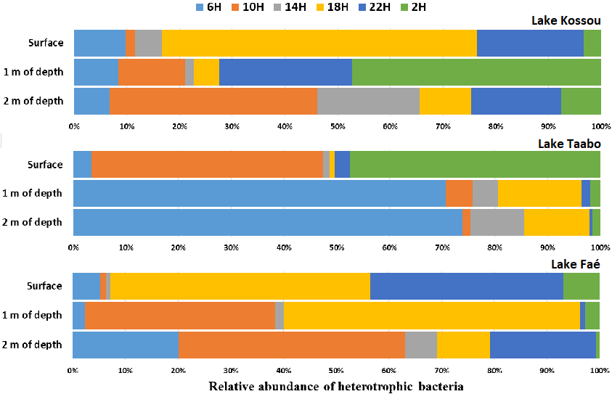
Fig. 3. Nycthemeral rhythm of culturable heterotrophic bacteria in the hydroelectric reservoirs water column during the dry season
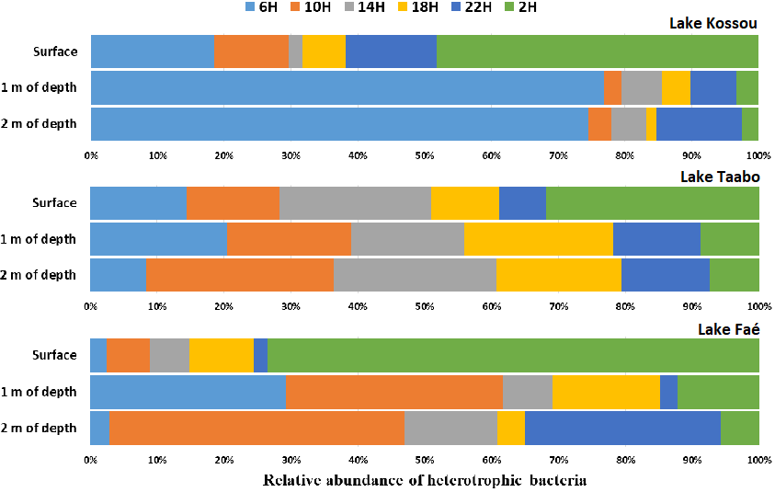
Fig. 4. Nycthemeral rhythm of culturable heterotrophic bacteria in the hydroelectric reservoirs water column during the rainy season
3.4 Relationship between culturable heterotrophic bacteria and environmental variables
Figure 5 shows the relationship between heterotrophic bacterial concentrations and environmental variables in the reservoir water column. Only dissolved oxygen (DO) was negatively correlated with culturable heterotrophic bacteria at a depth of 2 meters. These results indicate that heterotrophic bacterial distributions were weakly influenced by environmental variables.
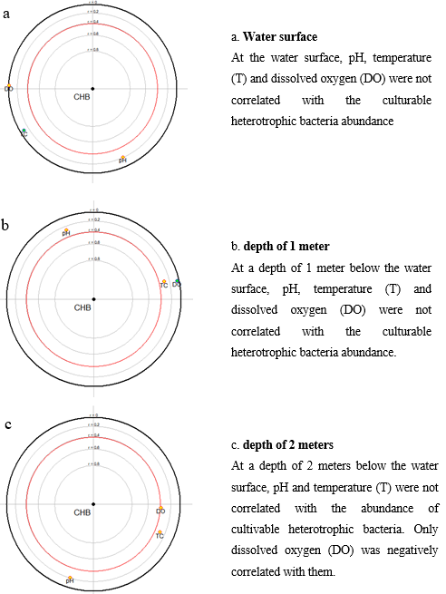
Fig. 5. Relation between heterotrophic bacteria and environmental variables. CHB=Culturable Heterotrophic Bacteria; T=Temperature; pH=potential Hydrogen; DO=Dissolved Oxygen; The parameter located in the red circle is significantly correlated with CHB; The red point indicates a negative relationship and the green point indicates a positive relationship

4. DISCUSSION
Environmental variables varied weakly throughout the year. According to the WHO (2008), these pH and temperature ranges were favorable for bacterial growth. Overall, variations in median values for environmental variables in the water column were similar, with the exception of dissolved oxygen (DO), which decreased in the water column of Lakes Kossou and Taabo and increased in Lake Faé. Espín et al. (2021) also showed a decrease in DO in Lake Alboraj in Spain.
Concerning the sampling months, bacterial concentrations were highest in June, July and September, which could be related to the rainy season. Indeed, June, July and September correspond to the rainy season in Côte d'Ivoire. During these seasons, runoff and wastewater are more frequent and flow rapidly into surface waters. Torréton (1999) and Bharathi et al. (2018) showed that runoff and wastewater contain high concentrations of organic matter and bacteria. Tiémoko et al. (2020; 2025) showed that bacteria are present in high quantities in these Kossou, Taabo and Faé reservoirs during the rainy season. At the water surface, bacterial concentrations were higher in April, June and July, while at depths of 1 and 2 meters, concentrations were higher in July and September. The sunlight intensity could explain the high concentrations in the water column during these sampling months, which correspond to the rainy season. During these rainy seasons, heavy cloud cover could also reduce sunlight intensity. Sunlight contains UV rays, which are divided into UVA, UVB and UVC. In particular, UVC rays are the most effective at killing bacteria (Bansaghi & Klein, 2024). They penetrate bacterial cells and damage their DNA and RNA, preventing the bacteria from replicating and surviving (Rifna et al., 2019; Nigel & Dylan, 2003). Shan et al. (2024) noted that high temperature significantly decreased bacterioplankton diversity and shifted its community compositions. Wang et al. (2021) obtained a different structuring of the bacterial community between surface waters and deep waters. Furthermore, bacterial abundance in the water column could be linked to the grazing effect of zooplankton. The intensity of bacterial grazing by zooplankton in the water column can be amplified depending on variations in environmental variables such as temperature, nutrients and light (Torréton, 1999; Pomati et al., 2020; Ji et al., 2025).
Regarding the seasonal nycthemeral rhythm, the bacterial distribution in the water column remained relatively similar for both seasons. The only difference was that during the dry season at 18 hours, heterotrophic bacteria concentrations remained higher at the water surface and at a depth of 1 meter, whereas during the rainy season at 18 hours, bacterial concentrations generally remained low throughout the water column. Although the waters appear more disturbed during the rainy season, this does not change the fact that during the day, whether in the dry season or the rainy season, the effect of the sun's rays eliminates bacteria in the water, particularly at the surface (Torréton, 1999). Magnólia & Mira (2008) showed that bacterioplankton abundance did not exhibit a typical temporal variation, presenting only small oscillations between the rainy and dry periods. However, these small differences in the distribution of bacteria observed between the two seasons could be linked to nutrient availability, the grazing effect by zooplankton, circadian rhythm, sunlight intensity, production of specific antimicrobial compounds, temperatures and the small differences in brightness caused by cloud cover (Carl et al., 2017; Hande et al., 2020). Nycthemeral variations could be influenced by factors including light intensity, temperature, humidity, and human activity, which can affect the survival and proliferation of bacteria (Gao et al., 2022; Shan et al., 2024). Rubio et al. (2022) suggested that the lower temperatures and higher humidity during the night lead to higher bacterial concentrations. Furthermore, the high bacterial concentrations at the surface during the night could be linked to an increase in anthropogenic discharges during the night (Gao et al., 2022). Jiao et al. (2024) showed that human activities strongly influenced the structure and composition of bacteria in water.
The results of the relationship study showed that bacterial distributions were weakly related to environmental variables. This could suggest the involvement of other factors (Carl et al., 2017; Hande et al., 2020; Shan et al., 2024). However, the weak correlation observed between heterotrophic bacteria and DO could be explained by the use of DO by heterotrophic bacteria to degrade organic matter present in the water. Contrary to our results, Magnólia & Mira (2008) showed strong positive correlations between water temperature and oxygen with bacterioplankton, but in lagoon water.
5. CONCLUSION
This study aimed to determine the distribution of cultivable heterotrophic bacteria in hydroelectric reservoirs influenced by human activities. Overall, environmental variables varied weakly throughout the year. During the sampling months, bacterial concentrations were highest into hydroelectric reservoirs waters column in April, June, July, September and October, while the lowest concentrations were recorded in November, January and February. Concerning the seasonal nycthemeral rhythm, the bacterial distribution in the water column remained relatively similar for the dry and rainy seasons. Bacteria concentrations were generally higher at the surface than at depth during the night and lower at the surface than at depth during the day. The results of the relationship study showed that bacterial distributions were weakly related to environmental variables. This suggests that other factors may influence bacterial distributions, warranting further investigation.
Disclaimer (Artificial intelligence)
Authors hereby declare that no generative AI technologies such as Large Language Models (ChatGPT, COPILOT, etc.) and text-to-image generators have been used during the writing or editing of the manuscript.

References
Alfonso, E., Michael, E., Sonia, C., Luca, D., Daniele, P., Francesco, C., Stefan, Z., & Lorenzo, B. (2016). Spatial and temporal variability of bacterial communities in high alpine water spring sediments. Research in Microbiology, 167(4), 325-333. https://doi.org/10.1016/j.resmic.2015.12.006
Atherholt, T. B., Procopio, N. A., & Goodrow, S. M. (2016). Seasonality of Coliform Bacteria Detection Rates in New Jersey Domestic Wells. Groundwater 55(3), 346–361. https://doi.org/10.1111/gwat.12482
Bansaghi, S., & Klein, J. (2024). Evaluation of the antimicrobial effect of a far-uv radiation lamp in a real-life environment. Infection Prevention in Practice 6, 100390. https://doi.org/10.1016/j.infpip.2024.100390
Baquero, F., Coque, T. M., Guerra-Pinto, N., Galán, J. C., Jiménez-Lalana, D., Tamames; J., & Pedrós-Alió, C. (2022). The Influence of Coalescent Microbiotic Particles From Water and Soil on the Evolution and Spread of Antimicrobial Resistance. Frontiers in Environmental Science, 10:824963. https://doi.org/10.3389/fenvs.2022.824963
Bharathi, M. D., Sundaramoorthy, S., Patra, S., Madeswaran, P., & Sundaramanickam, S. (2018). Seasonal and spatial distribution of heterothophic bacteria in relation to physico-chemical properties along Ennore coastal waters. Indian Journal of Geo Marine Science, 47 (03), 587-597.
Carl, H. J., Chi, Z., Yao, X., & Tetsuya, M. (2017). Timing the day: what makes bacterial clocks tick? Nature Reviews Microbiology 15(4), 232–242. https://doi.org/10.1038/nrmicro.2016.196
Cordone, A., D’Errico, G., Magliulo, M., Bolinesi, F., Selci, M., Basili, M., de Marco, R., Saggiomo, M., Rivaro, P., Giovannelli, D., & Mangoni, O. (2022). Bacterioplankton Diversity and Distribution in Relation to Phytoplankton Community Structure in the Ross Sea Surface Waters. Frontiers in Microbiology, 13:722900. https://doi.org/10.3389/fmicb.2022.722900
Espín, Y., Menchén, A., Moreno, J. L., Sanz, D., Álvarez-Ortí, M., Fernández, J. A., & Gómez-Alday, J. J. (2021). Water and Sediment Bacterial Communities in a Small Mediterranean, Oxygen-Stratiﬁed, Saline Lake (Lake Alboraj, SE Spain). Applied Sciences, 11, 6309. https://doi.org/10.3390/app11146309
Gao, F-Z., He, L-Y., Hu, L-X., Chen, J., Yang, Y-Y., Zou, H-Y., He, L-X., Bai, H., Liu, Y-S., Zha, J-L., & Ying, G. Y., (2022). Anthropogenic activities and seasonal properties jointly drive the assemblage of bacterial communities in subtropical river basins. Science of the Total Environment, 806 (4), 151476. https://doi.org/10.1016/j.scitotenv.2021.151476
Hande, M., Saniye, B., & Tarkan, K. (2020). The circadian disruption of night work alters gut microbiota consistent with elevated risk for future metabolic and gastrointestinal pathology. Chronobiology International, https://doi.org/10.1080/07420528.2020.1778717
Hu, X., Li, X., He, M., Long, A., & Xu, J. (2022). Regulation of bacterial metabolic activities and community composition by temperature in a fringing coral reef. Journal of Geophysical Research: Oceans, 127, e2022JC018823. https://doi.org/10.1029/2022JC018823
Ji, L., Zhang, H., Wang, Z., Tian, Y., Tian, W., & Liu, Z. (2025). Trace Elements and Temperature Combined to Regulate Zooplankton Community Structures in Mountain Streams. Biology, 14, 183. https://doi.org/10.3390/biology14020183
Jiao, G., Huang, Y., Tang, H., Chen, Y., Zhou, D., Yu, D., Ma, Z., & Ni, S. (2024). Unveilling the hidden impact: How human disturbances threaten aquatic microorganisms in cities. Sciences of The Total Environment, 950, 175305. https://doi.org/10.1016/j.scitotenv.2024.175305
Magnólia, F. F. A., & Mirna, J. L. G. (2008). Seasonal and Spatial Distribution of acterioplankton in a Fluvial-lagunar System of a Tropical Region: Density, Biomass, Cellular Volume and Morphologic Variation. Brazilian Archives of Biology and Technology, 51(1), 203-212.
Nigel, D. P., & Dylan G-J. (2003). Ecological roles of solar UV radiation: towards an integrated approach. Trends in Ecology & Evolution, 18 (1), 48-55. https://doi.org/10.1016/S0169-5347(02)00014-9
Pomati, F., Shurin, J. B., Andersen, K. H., Tellenbach, C., & Barton, A. D. (2020). Interacting Temperature, Nutrients and Zooplankton Grazing Control Phytoplankton Size-Abundance Relationships in Eight Swiss Lakes. Frontiers in Microbiology, 10:3155. https://doi.org/10.3389/fmicb.2019.03155
Qureshimatva, U. M., Maurya, R. R., Gamit, S. B., Patel, R. D., & Solanki, H. A. (2015). Determination of physico-chemical parameters and water quality index (Wqi) of Chandlodia Lake, Ahmedabad, Gujarat, India. Journal of Environmental Analysis and Toxicology, 5 (288), 1-6. https://doi.org/10.4172/2161-0525.1000288
Rodier, J., Legube, B., Merlet, N., & Brunet, R. (2009). Microbiological analysis of waters, In:The analysis of water, 9th Edn., Enforcement of obstruction, Paris, France, , pp.717-869.
Richa, K., Balestra, C., Piredda, R., Benes, V., Borra, M., Passarelli, A., Margiotta, F., Saggiomo, M., Biffali, E., Sanges, R., Scanlan, D. J., & Casotti, R. (2017). Distribution, community composition, and potential metabolic activity of bacterioplankton in an urbanized Mediterranean Sea coastal zone. Applied Environmental Microbiology 83:e00494-17. https://doi.org/10.1128/AEM.00494-17
Rifna, E. J., Ratish Ramanan, K., & Mahendran, R. (2019). Emerging technology applications for improving seed germination. Trends Food Sciences and Technology, 86, 95-108. https://doi.org/10.1016/j.tifs.2019.02.029
Rubio, S. J., Gering, S. M., & Fierer, N. (2022). Diurnal and Nocturnal Microbial Concentrations in the Air. AGU Fall Meeting 2022, held in Chicago, IL, 12-16 December 2022, id ED35D-0574.
Shan, D., Wei, G., Li, M., Wang, W., Li, X., Gao, Z., & Shao, Z. (2015). Distribution and diversity of bacterioplankton communities in subtropical seawater around Xiamen Island, China. Microbiology Research, 175: 16–23. https://doi.org/10.1016/j.micres.2015.02.005
Shan, Z., Chen, H., Deng, Y., He, D., & Ren, L. (2024). An abrupt regime shift of bacterioplankton community from weak to strong thermal pollution in a subtropical bay. Frontiers in Microbiology, 15:1395583. https://doi.org/10.3389/fmicb.2024.1395583
Tiémoko, G. J-L., Ouattara, N. K., Kouamé, C-K. Y., Ouattara, A., & Gourène, G. (2020). Spatial and temporal variation of faecal indicator bacteria in three reservoirs in Ivory Coast (Taabo, Kossou and Fae). Journal of Environmental Sciences and Pollution Research, 6 (2), 408-411. https://doi.org/10.30799/jespr.185.20060101.
Tiémoko, G. J-L., Ouattara, N. K., Kouamé, C-K. Y., & Ouattara, A. (2025). Spatial and temporal variation of culturable heterotrophic bacterioplankton and their response to nutrient inputs in hydroelectric reservoirs: Case of Kossou, Taabo and Faé in Côte d’Ivoire. World Journal of Advanced Research and Reviews 27(02), 1797-1806. https://doi.org/10.30574/wjarr.2025.27.2.3004
Torréton, J-L. (1999). Intervention du bactérioplancton dans les réseaux trophiques. Chargé de Recherche de 1ière classe à l’Institut de Recherche pour le Développement. 49p.
Torréton, J-P. (2000). Importance du bactérioplancton dans la transformation et le devenir de la matière organique en milieu corallien. Océanis, 26 (3), 389-425.
World Health Organisation (WHO) (2008). Guidelines for drinking-water quality. Third edition incorporating the first and second addenda, Vol. 1 recommandation, OMS, Geneva.
Wanga, J., Fanb, H., Hec, X., Zhanga, F., Xiaoa, J., Yanb, Z., Fenga, J., & Li, R. (2021). Response of bacterial communities to variation in water quality and physicochemical conditions in a river-reservoir system. Global Ecology and Conservation, 27, e01541. https://doi.org/10.1016/j.gecco.2021.e01541

